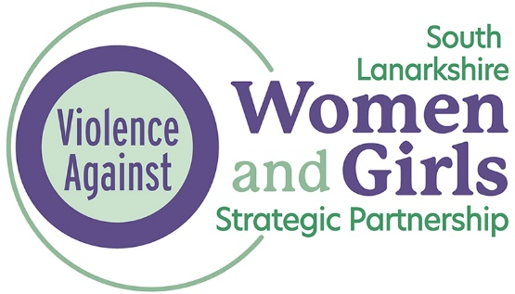

Adult Support and Protection and Domestic Abuse
Good Practice Guidance

Published: July 2023
Updated: December 2025
To be reviewed: December 2027

1. Purpose of the Guidance
This guidance is for multi-agency managers and practitioners in adult services, children’s services and specialist domestic abuse services, working in all statutory and third sector organisations in South Lanarkshire.
The Adult Protection Committee and Violence Against Women Partnership recognise the themes that span across the public protection agenda and as a result, this guidance has been developed to support practitioner’s understanding of the impact of domestic abuse in the context of Adult Support and Protection. Further, it will provide information regarding risk assessment and will support practitioner’s understanding of safety planning and best practice.

2. Context
Gender based violence (often referred to as Gender-Based abuse or violence against women and girls (VAWG)) is an umbrella term that encompasses a spectrum of abuse experienced mostly by women and girls and perpetrated mainly by men (Equally Safe Strategy). This spectrum of abuse includes:
- Physical, sexual and psychological abuse including domestic abuse and rape.
- Sexual harassment and stalking
- Commercial sexual exploitation, including prostitution, pornography, and trafficking.
- Harmful cultural practices, including so called ‘honour’ based violence, forced marriage and female genital mutilation.

It is recognised that men can also be victims of domestic abuse and a sensitive approach which follows the principles contained within this guidance is required. It is noted however that the majority of victims of domestic abuse are women, and the language used within this guidance reflects that. (Domestic Abuse Police Statistics)

The Scottish Government definition of domestic abuse:
Domestic Abuse (as Gender-Based abuse), can be perpetrated by partners or ex-partners and can include physical abuse (assault and physical attack involving a range of behaviour), sexual abuse (acts which degrade and humiliate women and are perpetrated against their will, including rape) and mental and emotional abuse (such as threats, verbal abuse, racial abuse, withholding money and other types of controlling behaviour such as isolation from family or friends).

3. Impact and Demographics
In 2023-24, 63,867 incidents of domestic abuse were recorded by Police Scotland, 3831 of which took place in South Lanarkshire. We know that domestic abuse is underreported, especially amongst older people with only 2% of recorded incidents in Scotland relating to victims aged 61 and over. (Domestic Abuse Police Statistics)
Domestic abuse seriously impacts upon victims of all ages, and research suggests that certain groups experience additional challenges and barriers (Safe Later Lives). For example, the pool of research which exists on domestic abuse and older people suggests that “older women’s experiences of domestic abuse are markedly different from those in younger age groups and that these differences have not been adequately acknowledged or accounted for”. This includes older people not being well represented within domestic abuse services. SafeLives (2016) engagement with frontline practitioners highlighted that “people have the idea that domestic abuse affects younger women or women with young children, and that it doesn’t really affect people over 65”. Some frontline practitioners gave examples of where this had led professionals to link injuries, confusion or depression to age related concerns rather than domestic abuse.
SafeLives Insights dataset also found that clients over 60 are less likely to have attempted to leave than those under (17% vs 29%).
SafeLives research also found that older victims of domestic abuse are likely to have lived with the abuse for prolonged periods before getting help. For example, of the older adults that were visible to services, a quarter had lived with abuse for more than 20 years. Women noted feeling increased anxiety about leaving behind a “lifetime of contributions to the family business, homes, and other assets” such as pets or treasured possessions. Often the expectation is that women leave, and this could potentially lead to them becoming destitute or in poverty in older years, this is also exacerbated by lack of access to pensions, time off work having children, part time work patterns over the lifespan for some, etc. For many older women it does not feel feasible to leave.
People with a long-standing illness or disability are twice as likely to experience domestic abuse as those with no long-standing illness or disability. For a disabled person, the abuse they experience is often directly linked to their impairments and perpetrated by the individuals they are most dependent on for care, such as intimate partners and family members. Our national data shows that disabled victims are much more likely to be suffering abuse from a current partner (31%) than non-disabled victims (18%). (Safe Lives - Disabled Survivors Too)
People with mental health needs were more likely to have experienced each type of abuse and had also visited their GP and A&E more times on average compared to those without. 40% of high-risk victims of domestic abuse report having mental health issues whilst 16% of victims report that they have considered or attempted suicide as a result of the abuse, and 13% report self-harming. It is important to recognise that mental health problems can create additional vulnerabilities that people perpetrating abuse may seek to exploit, such as threats of institutionalisation, withholding medication, threats to have children taken away, or to ‘out’ their mental health problems to family and friends. (Safe Lives - Safe and Well)
1 in 5 high-risk victims of domestic abuse report having attended A&E as a result of their injuries in the year before getting effective help. (Safe Lives - Facts)
As well as short term injuries, victims of abuse suffer long-term physical health consequences. Physical health conditions that can be aggravated by abuse include: asthma, bladder and kidney infections, cardiovascular disease, fibromyalgia, chronic pain syndromes, central nervous system disorders, gastrointestinal disorders, migraines/headaches.
Domestic abuse often causes reproductive health consequences too, including gynaecological disorders, sexually transmitted infections, pre-term difficulties and pregnancy difficulties.
Domestic abuse has significant psychological consequences for victims, including anxiety, depression, suicidal behaviour, low self-esteem, inability to trust others, flashbacks, sleep disturbances and emotional detachment.
Domestic abuse victims are at risk of complex post-traumatic stress disorder (CPTSD) – as many as two-thirds of victims of abuse (64%) developed CPTSD in one study.
Between 30 and 60% of psychiatric in-patients had experienced severe domestic abuse. (Safe Lives - Facts)

4. Domestic Abuse within the context of Adult Support and Protection
4.1 Adult Support and Protection (Scotland) Act 2007

The Adult Support and Protection (Scotland) Act 2007 was implemented in October 2008 and specifies measures to identify and protect “adults at risk of harm.”

Adults at risk of harm are (aged 16 and over) who –

- are unable to safeguard their own well-being, property, rights or other interests; and
- are at risk of harm; and
- because they are affected by disability, mental disorder, illness or physical or mental infirmity, are more vulnerable to being harmed than adults who are not so affected.

Adults who meet the above criteria and the harm is perpetrated by a partner or ex-partner, and is characterised by a pattern of coercive control, require a response which follows both legislation and policy in relation to Adult Support and Protection and is also reflective of best practice in relation to domestic abuse (see section 6).

The Adult Support and Protection (Scotland) Act 2007 gives Councils and in particular Social Work Resources lead responsibility for undertaking inquiries, with or without investigative actions, into the circumstances of adults at risk who are being harmed.

While Councils have the statutory lead role in adult support and protection, effective intervention will only come about as a result of multi-agency cooperation and communication. What one person or public body knows may only be part of a wider picture. The multi-agency nature of adult support and protection is crucial to safeguarding adults at risk of harm.

Section 5(3) of the Act places a duty on certain public bodies or office holders who know or believe that a person is an adult at risk of harm to report the facts and circumstances of the case to the council for the area in which the person is considered to be located. Public bodies should ensure that their staff are aware of the duty to refer and co-operate, and to encourage vigilance in relation to adults who may be at risk of harm.

If a practitioner knows or believes that an adult is at risk of harm as per the Adult Support and Protection (Scotland) Act 2007, they should report their concerns immediately to their line manager and complete an AP1 referral form (Appendix 1). The AP1 should detail what actions have been taken in relation to the domestic abuse. The AP1 should be sent to Social Work within 1 working day. The AP1 should be emailed directly to the relevant social work team, where the adult currently resides:

swlohamilton@southlanarkshire.gov.uk

swloeastkilbride@southlanarkshire.gov.uk

swlorutherglen@southlanarkshire.gov.uk

swloclydesdale@southlanarkshire.gov.uk

In addition, multi-agency staff should also refer to and comply with their own agency processes and protocols.

Consent of the adult is not required to make an Adult Support and Protection referral.

4.2 Unable to Safeguard

The first point of the three-point criteria set out in section 3(1) of the Act relates to whether the adult is unable to safeguard their own well-being, property, rights or other interests. Most people will be able to safeguard themselves through the ability to take clear and well thought through decisions about matters to do with their health and safety, and as such could not be regarded as adults at risk of harm within the terms of the Act. However, this will not be the case for all people, and when a person is deemed unable to safeguard themselves, they will meet the first point of the three-point criteria.

All adults who have capacity have the right to make their own choices about their lives and these choices should be respected if they are made freely. However, for many people the effects of trauma (caused by example, from someone’s ongoing exposure to domestic abuse) and/or adverse childhood experiences may impact upon both their ability to make informed choices and enact free will. In this context it should be considered whether situations in which these experiences, and the cumulative impact of them through life, may impact on the ability of some people to safeguard themselves.

Similar considerations apply to coercive control, which if perpetrated by a partner or ex-partner, can be defined as domestic abuse. In such situations the control exercised over a vulnerable person may also impact on their ability to take or action decisions that would protect them from harm.

It is therefore important to understand the person’s decision-making processes. This should include an understanding of any factors which may have impacted upon them with the effect of impinging on, or detracting from, their ability to make and action free and informed decisions to safeguard themselves. If you believe this means they are unable to safeguard themselves, and they meet the other two criteria for ASP referral, you must refer.

It is strongly emphasised that the three-point criteria above makes no reference to capacity. For the purposes of the Act, capacity should be considered on a contextual basis around a specific decision and not restricted to an overall clinical judgement. It is recognised that, due to many factors in an individual’s life, capacity to make an authentic decision is a fluctuating concept. Thus, even if deemed to possess general capacity, attention must be paid to whether a person has clear decisional and executional ability (i.e. to both make and action decisions) to safeguard themselves in the specific context arising.

4.3 At Risk of Harm

To meet the second point of the three-point criteria the adult must be assessed as being at risk of harm. Section 3(2) of the Act defines an adult as being at risk of harm if:

- another person’s conduct is causing (or is likely to cause) the adult harm; or
- the adult is engaging (or is likely to engage) in conduct which causes (or is likely to cause) self-harm.

Adults can be at risk of harm in various settings, be it in their own home or in the wider community. They also may be placed at risk through inappropriate arrangements for their care in a range of social or health care settings.

Section 53 states that “harm” includes all harmful conduct and gives the following examples:

- conduct which causes physical harm;
- conduct which causes psychological harm (for example by causing fear, alarm or distress);
- unlawful conduct which appropriates or adversely affects property, rights or interests (for example theft, fraud, embezzlement or extortion);
- conduct which causes self-harm.

The list is not exhaustive, and no category of harm is excluded simply because it is not explicitly listed. In general terms, behaviours that constitute harm to a person can be physical, sexual, psychological, financial, or a combination of these and therefore these can align with domestic abuse when it is facilitated or carried out by a partner or ex-partner.

5. Good Practice
5.1 Considerations for Practice
If you know or believe that the adult meets the 3-point criteria as set out in the Adult Support and Protection (Scotland) Act 2007, you have a duty to refer to the appropriate Council as detailed in section 4.1. Please refer to your agencies Adult Support and Protection policy.
If the adult is experiencing domestic abuse from a partner or ex-partner, an appropriate response which is mindful of the dynamics of domestic abuse, is also required whether or not they meet the criteria for referral under ASP Legislation.

In all cases involving domestic abuse, you should consider:

- What is the full spectrum of abuse being experienced by the adult?
- Does the adult meet the 3-point criteria for intervention under the ASP Act? (Consent is not required to make an ASP referral).
- What does the adult want to happen?
- Which family members are safe and appropriate to be involved in the ASP inquiry with or without investigative actions?
- Has a DASH Risk Identification Checklist been considered? *
- Has a referral to Multi Agency Risk Assessment Conference (MARAC) been considered? (Although consent is not required to make a referral to MARAC, it is best practice to discuss this with the adult if safe to do so).
- What is the adult already doing to keep themself safe?
- What safety options have you discussed with the adult? (See section 7) *
- Have the various specialist services been discussed? (See section 8) *
*Consent is required from the adult to complete a DASH RIC assessment and refer to specialist services.

5.2 Responding to a disclosure of Domestic Abuse

5.3 Domestic Abuse Risk Assessment
Principles of a good Risk Assessment:
- Recognition of the full spectrum of abuse and controlling behaviours used by the perpetrator towards both current and previous partners.
- Recognition of how this pattern of controlling behaviour is impacting and harming the victim.
- An understanding within the assessment that domestic abuse is intentional and used to gain power and control over their partner.
Language used within assessments should reflect this.
Carrying out a risk assessment for people experiencing domestic abuse is a complex process. It includes not only the use of an appropriate risk assessment framework and tool, but also the knowledge base and skills to inform professional analysis.
In cases of domestic abuse, it is imperative that a specific domestic abuse risk assessment tool is used. The nationally recognised tool has been developed by SafeLives, called Domestic Abuse, Stalking, Harassment, and “Honour” Based Abuse (DASH) Risk Identification Checklist– referred to as the DASH, or the RIC. South Lanarkshire’s Violence Against Women & Girls Partnership deliver training to support all multi agency staff to use this risk assessment tool. Information on how to access the training can be found here.
There is also a Young Person’s RIC developed for use with people aged 16-18, however this can also be utilised for use with those who have learning disabilities.
The questions on the checklist should be asked of the adult survivor and will identify the risk posed by the person perpetrating the abuse.
Full practice guidance for the DASH RIC and a blank copy can be found here: Resources for identifying the risk victims face | Safelives.
5.4 MARAC
Multi agency Risk Assessment Conference (MARAC) is a forum that brings together multi agency partners to develop a co-ordinated and shared response to manage risk and safety for cases of domestic abuse that are assessed as being at risk of serious assault or homicide. Crucially, MARAC ensures that no one agency is holding the information or risk on their own and that all relevant partners are aware of the full picture of risk being posed to the adult survivor.
Criteria for referring to MARAC is as follows:
- Any professional can refer to MARAC on the basis of professional judgement. If a professional is concerned that an adult is at risk of serious assault or domestic homicide, they should refer the adult to MARAC.
or
- A referral can also be made to MARAC following 14 or more positive (yes) answers on completion of the Safelives DASH RIC.
or
- Repeat incident - where an agency is aware of a repeat incident (i.e. if ANY agency receives report of a further incident, within 12 months of the case being heard at MARAC, even if the incident hasn’t been reported to the Police).

- Escalation – 3+ incidents in 12 a month period*

*This criteria is not currently used in South Lanarkshire, cases where the escalation criteria is met should be referred using Professional Judgement.

Any multi-agency partner/professional can refer into MARAC where any of the criteria is met.

To make a referral to MARAC, contact: lanarkshiremaracs@wasler.org

6. Safety Planning
Principles of Safety Planning
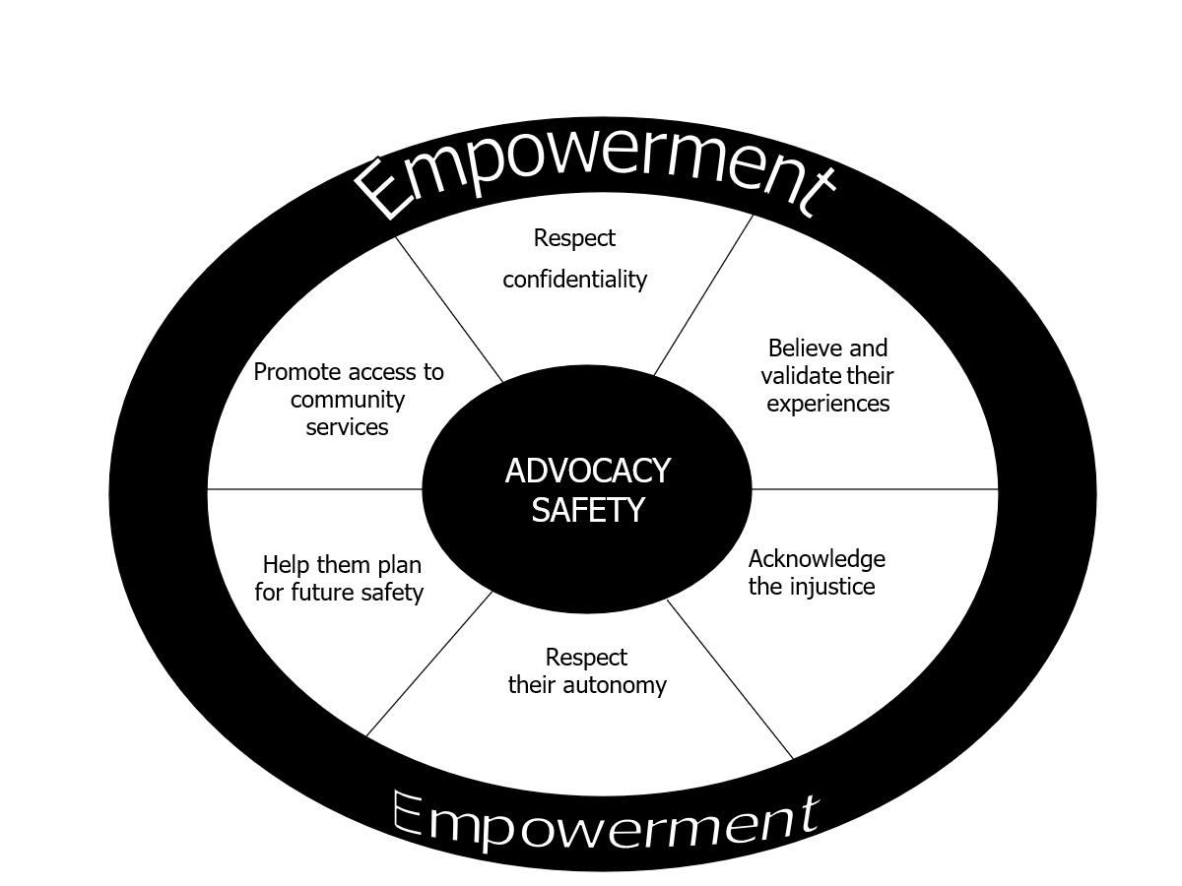

Here are some useful questions and points to include in the discussion about safety plans:
• What is she already doing to keep herself safe?
• What has she done or considered in the past to keep safe?
• What does she need to be safe?
• Who would she like to contact now? What can you do to help that happen?
• What are the available options?
• What does she want to do to protect herself and any child/ren?
• How will we go about the process of drawing up a safety plan?
• How will this be monitored- and how often? Ensure that plans are made for further contact and information is provided on local and national sources of support.
It is important to remember that the reason the safety plan is needed is because of the perpetrator’s pattern of abusive behaviour.
If a protection plan under ASP legislation is required, an action in relation to domestic abuse safety planning, must be clearly recorded.

Safety Planning Suggested Actions:
- Agree a “safe word” for use with professionals.
- Plan an escape route – think about where she will go so that she can call the police or alert a neighbour.
- Move to lower-risk parts of the home, where there is an escape route or access to a phone.
- Avoid rooms like the kitchen or garage, which contain objects that could be used to harm.
- If she is not able to get out of the house, she can barricade or lock herself into a room, from which she can call the police and contact friends/family or neighbours.
- Tell a neighbour to call the police if they hear anything or see their partner/ex-partner around the house.
- Keep a record or diary of incidents. Consider the FollowItApp
- Download Hollie Guard app (Hollie Guard – Personal Safety App)
- Keep mobile phone always charged and on person.
- Make a copy of the house/car key and always keep it in their pocket.
- Keep important documents together and in a safe place.
- Pack a bag of essentials and store somewhere safe.
- Keep some cash or a separate bank account with funds available and hidden.
- Referral to local services such as Women’s Aid or Rape Crisis.
- Consider a referral to the Disclosure Scheme for Domestic Abuse Scotland (DSDAS)
A full and comprehensive guide to safety planning and a sample safety plan template can be found here: safety-planning.pdf

7. Protection Orders
The Adult Support and Protection (Scotland) Act 2007 can also use Protection Orders such as a Banning Order or a Temporary Banning Order which are granted by a Sheriff. Where the adult has the capacity to make decisions, the application cannot be granted by the Sheriff if the adult does not consent to the order unless it can be proved that the adult has been subject to undue pressure to refuse consent. Protection orders can:

- Ban a perpetrator who is the subject of the order from being in a specified place,
- Ban the subject from being in a specified area in the vicinity of the specified place,
- Authorise the ejection of the subject from the specified place and the specified area,
- Prohibit the subject from moving any specified thing from the specified place,
- Direct any specified person to take specified measures to preserve any moveable property owned or controlled by the subject which remains in the specified place while the order has effect,
- Be made subject to any specified conditions,
- Require or authorise any person to do, or to refrain from doing, anything else which the sheriff thinks necessary for the proper enforcement of the order.

Other legal routes can also be considered such as Exclusion Orders, Civil Interdicts with power of arrest, Non-Harassment Orders or Anti-Social Behaviour Orders. All available options should be considered alongside the victim/survivor as part of the safety plan (Scottish Women’s Rights Centre).

8. Local and National Resources
Resources - Centre For Age Gender and Social Justice (dewischoice.org.uk)
Resources for identifying the risk victims face | Safelives
https://safeandtogetherinstitute.com/
https://www.adultprotectionsouthlanarkshire.org.uk/adultprotection/
Adult Support and Protection (Scotland) Act 2007 (legislation.gov.uk)
Adult Support and Protection (Scotland) Act 2007: Code of Practice - gov.scot (www.gov.scot)

Name | Description | Opening Hours | Website | Phone Number
Local:
ASSIST | Specialist court advocacy service providing support to victims of domestic abuse where there are criminal court proceedings against their partner or ex-partner. | Monday – Friday 9am-5pm |  | 0141 276 7710
NHS GBV Services | Provides advice and consultancy to NHS Lanarkshire staff to support them in their role. | Monday – Friday 9am-5pm | https://www.nhslanarkshire.scot.nhs.uk/services/gbv-services/
Lanarkshire Rape Crisis Centre | Specialist service offering emotional, practical and justice advocacy support to women and girls (12ys+) who have been subjected to any form of sexual violence no matter how long ago it happened. | Monday – Friday  9am-5pm | https://lanrcc.org.uk/ | 01698 527003
Victim Support | Confidential, free support for victims and witnesses of crime, appointments available to meet with support team. | Monday-Friday 9am-5pm  Monday-Friday 8am-8pm | https://victimsupport.scot/locations/victim-support-south-lanarkshire/ | 01698 301 111  0800 160 1985
Women’s Aid South Lanarkshire & East Renfrewshire | Confidential support, information and access to temporary accommodation for women experiencing domestic abuse. | Monday- Friday  9am-5pm | https://www.wasler.org.uk/ | 01355 249897
National:
Domestic Abuse Helpline | Confidential & sensitive support to anyone who calls | 24/7 | https://www.sdafmh.org.uk/en/ | 0800 027 1234
Hemat Gryffe Women’s Aid | Specialist refuge, crisis & outreach support for Asian, Black and Minority Ethnic women and children | Monday -Friday  9am-4pm | https://hematgryffe.org.uk/ | 0141 353 0859
National Rape Crisis Helpline | Helpline offers confidential short-term, crisis and initial support by phone, email, webchat and text. | Daily 5pm-Midnight | https://www.rapecrisisscotland.org.uk/help-helpline/ | 0808 801 0302
Scottish Women’s Rights Centre | Offer free & confidential legal advice and advocacy support to women affected by violence and abuse in Scotland, | Monday 10am - 12:30pm  Tuesday 12pm – 3pm  Wednesday 10am -1pm | https://www.scottishwomensrightscentre.org.uk/ | 08088 010 789
Men’s Advice Line | Support men affected by domestic abuse. | Monday – Friday 10am – 5pm | https://mensadviceline.org.uk/ | 0808 8010327

Appendix 1

Adult Support and Protection Referral/Inquiry Form (AP1)

- all staff working in public agencies (Council, Health, Police, and Care Inspectorate) must report suspected or actual harm to an adult at risk to Social Work Resources
- while it is preferable to have the consent of the adult at risk prior to referring to Social Work Resources, it is not necessary
- all sections of the AP1 require to be completed within one working day of the concerns arising
- if you do not have all the information required, do not delay in passing your concerns to Social Work Resources
- AP1 should be completed and uploaded into the adult’s case file

NB: if you do not have all the information required in SECTION A please do not delay and send the referral information you have. Social Work Resources will follow up on your referral and add any additional information.

Section A
Adult at Risk Details:
Name: |  |  | Known as:
Date of birth:
Address:

Postcode:
Phone number:
Gender:
Any known communication needs: Yes/No
If yes, please provide details including communication aids that the adult may use:

Living situation for example, lives alone, with spouse etc, type of accommodation, any known supports, caregivers their details etc.
GP details:

Name: |  |  |  | Phone number:
Address:

Referrer details:
Name of referrer: |  |  |  |  | Status:
Address:
Phone contact:
Email contact:
Relationship to the adult being referred:

DETAILS OF THE CONCERN/S

Please provide details of the situation leading to the referral (include details of any specific incidents (suspected/witnessed/disclosed/reported), dates, times, injuries, witnesses, evidence such as bruising etc), actions taken (use a separate sheet if required):-

In your opinion, is the adult able to safeguard their well-being, property rights or other interests?
In your opinion is the adult at risk of harm? (if yes, please state the reason)
In your opinion is the adult affected by a disability, mental disorder, illness or physical or mental infirmity and are more vulnerable to being harmed the adults who are not so affected? (if yes, please specify)
Describe why you believe the action is needed to safeguard the adult from harm (unless set out previously)
Other Information:
Do you believe the adult at risk is capable of understanding what has happened to them?
Have you discussed the making of this referral with the adult or relevant person? If not please explain why not, if yes, please set out any views expressed by the adult or that relevant person

(Note: the relevant person would be where the adult is incapable of expressing any views
(a) The adult’s nearest relative
(b) Any primary carer, guardian or attorney of the adult or,
(c) Any other person who has an interest in the adult’s well-being or property
(provide details)

If you believe that a crime may have been committed has Police Scotland been notified? Detail below Yes/No/NA - include Police contact details
What action if any, have you taken to ensure the adult at risk is now safe?
Details of the alleged harmer if known:
Name:
Address:
Relationship to adult:
Is there any further additional information that you consider relevant to this referral?
(You should include any previous concerns/incidents that you are aware of).
Referrer signature:
Print name:
Designation:
Contact details:
Email address:
Date:

