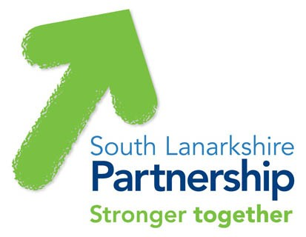

Community Led Planning

Neighbourhood Plans can create long lasting positive change within communities
Getting people involved and working together to achieve the priorities of local people

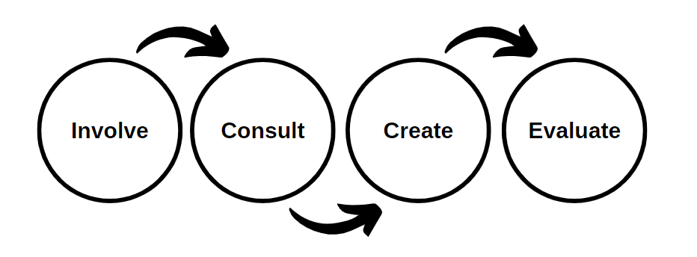

If you need this information in another language or format, please contact us to discuss how we can best meet your needs.
Phone: 0303 123 1015 Email: equalities@southlanarkshire.gov.uk

Introduction:
The purpose of this document is to give everyone including community members, voluntary organisations and practitioners the information and tools needed to plan, prepare and deliver effective Neighbourhood Plans across South Lanarkshire Council. It contains information, guidance and templates that will be helpful when creating a Neighbourhood Plan.
South Lanarkshire Council has many great examples of good practice in Neighbourhood Planning that can be found here (Community Planning (southlanarkshirecommunityplanning.org)). The toolkit aims to increase knowledge of good community engagement to ensure people are effectively consulted in decisions that affect them. Effective engagement can gather the views of people to shape and change how services are delivered and will improve the lives of people living in South Lanarkshire.
This resource has been designed by South Lanarkshire Council’s Community Engagement Team.

What is a Community Led Plan? –
A Community led Plan is a plan created by the community to identify assets and priorities to shape services to deliver on the needs of the community.
- Community Led – The community will own the plan and will be responsible for its progression.
- Based on the needs of communities - focusing meeting the needs and aspirations identified by local people through consultation.
- Inclusive and transparent – the process will include everyone who wants to take part within the community. All documents/meetings will be made public for anyone to access/attend.
- Flexible – The plan can be adapted/changed to suit the community and priorities will be revisited/re-evaluated throughout the duration of the plan.
- Sustainable – The plan will be sustainable as it is driven by the community and is not constrained by any political agendas, organisational agendas or funding.
- Co-production – Communities, agencies, groups and local authorities all working together to create positive change.

Getting Started with Your Neighbourhood Plan

Involve:
The first step in creating a neighbourhood plan is involving the community at the earliest opportunity. Getting to know the community using both qualitative (peoples experiences) and quantitative (statistical) information.

Stakeholders:
A stakeholders group should be created and this should include active community members, Community Groups, Community Councils and relevant Partner Agencies who are operating in the area. Stakeholders should agree a common goal/vision and this could be done in a terms of reference document stating location, time, frequency, levels of attendance (% of Community/Partners) of meetings.
The first task of the stakeholders group would be to agree the boundaries of the community in terms of the geographical area. A mapping exercise should then be completed highlighting the services available, population, demographics, any significant statistical information, etc. This will give a current picture of the community and can be used as a reference point later in the process.
Design the consultation ensuring it complies with GDPR regulations. This will include:
- Content of consultation – What is the purpose of the engagement, what questions will be asked and how will they be worded.
- Planning - timescales for completion and decide a minimum % of population that should take part in the process for it to progress into a plan. Ensuring representativeness of responses compared with the demographics of the population is important.
- Methods of Delivery – With the community in mind the group should decide on which methods will be use to carry out this survey.
- Platform of Consultation – Which platform will the survey be designed and hosted through? (Survey Monkey, Snap, place standard?)

Useful documents for Involve
  - 1.1 - Steering Group Terms of Reference
  - 1.2 - Blank Steering Group Terms of Reference
  - 2.0 - Steering Group sign-up sheets
  - 3.0 - Stakeholder Communication
  - 4.0 – Meeting Record
  - 5.0 – Task List Check sheet
  - 6.0 - Community Mapping Document
  - 7.0 - Letter of Introduction to Community Groups

Consult:
The next step in creating a neighbourhood plan is to find out what is important to the community by finding out what they like, improvements they would like to see and assets that are important to them.

Community Engagement:
This section will look at what we mean by community engagement. Community Engagement is a term used to describe an ongoing process which encourages people to get involved in decisions that affect their lives.

National Standards for community engagement:
- Inclusion - We will identify and involve the people and organisations that are affected by the focus of the engagement.
- Support - We will identify and overcome any barriers to participation.
- Working Together – We will work effectively together to achieve the aims of the engagement.
- Planning - There is a clear purpose for the engagement, which is based on a shared understanding of community needs and ambitions.
- Methods - We will use methods of engagement that are fit for purpose.
- Communication - We will communicate clearly and regularly with the people, organisations and communities affected by the engagement.
- Impact - We will assess the impact of the engagement and use what we have learned to improve our future community engagement.
http://www.voicescotland.org.uk

What Community Engagement is not
- Asking people opinions on a decision that has already been made and people have little or no influence over the matter.
- A mandatory process that forces people to be involved.
- A one off event or discussion.

Consultation Methods:

Methods could include:
- Door to Door Conversation which would ensure everyone has the opportunity for engagement especially with some of the harder to reach groups within communities. It is a good idea to have a calling card for people who are not available at the time of visit. This method is resource intensive and relies heavily on volunteers from the community. This requires a lot of planning and should always be done in pairs for health and safety reasons.
- Online Survey which gives people the opportunity to fill the consultation in in their own time in any location. Possibility for static access points with in staffed community hotspots such as community/sports facilities. A good social media campaign can also compliment this method by raising awareness of the cause.
- Paper copy that can be picked up in various locations throughout the community and handed back in to a safe location which is monitored at all times. Paper copies must be picked up regularly and stored in a safe location as they may contain personal data.
- Focus Groups are a great way to gain opinions with a large group of individuals such as young people in schools and community groups. This option encourages discussion and healthy debate to dig deeper into the community priorities and any underlying issues.
- Phone Conversation can also be done by leaving calling cards and publicity campaigns with a phone no and relevant time for people to call and complete the consultation.

Useful documents for Consult
- 8.0 – Questionnaire
- 9.1 – Questionnaire Young Persons (with drawing)
- 9.2 – Questionnaire Young Persons (without drawing)
- 10.0 – Focus Group Session Plan

Create:
The next step in creating a neighbourhood plan is to use the information gathered through the conversations with local people to create a document highlighting the priorities from the findings. Once the document is created it is important to feed this information back to the community.

Validity
For this engagement to progress into being a valid community led plan the community has to be widely represented in the data. It would be recommend that at least 40% of the population should take part in the consultation process. This is not an easy task but will give the plan validity and will represent the views of the wider community.

Representativeness
It is important to set goals to ensure the data gathered is representative of the community that it is focusing on. Using the community profile document that has been created to identify demographics of the community. Indicators for this will be based on any significant demographics of the population for example age, gender, deprivation and ethnicity. For a consultation to be representative the data should represent a similar demographic to the area + or – 10%. For example if there is a 60% male population within a community then the returned data should represent between 50-70%.

Data Analysis:
Once the engagement process has come to an end and the data has been gathered the stakeholders group can then begin to analyse the returns.
Top Tips:
- No. the returns to keep them in order
- Identify trends/themes emerging from the data
- Take your time and read over the data thoroughly

Neighbourhood Plan:
When the consultation and feedback stages have been completed the stakeholders group will be responsible for creating/designing a community led plan that reflects the priorities identified by residents. With clear objectives for any future developments that will focus on the priorities which have been identified and who is responsible for achieving this.
This can be presented to communities through launch events, display boards, presentations, online or leaflets. It is important to use a variety of methods to ensure everyone in the community has the opportunity to get involved. To read current plans please look at https://www.southlanarkshirecommunityplanning.org/info/26/community_plan_and_neighbourhood_plans

Useful Documents for Create

- 11.0 – Data Summary Sheet
- 12.0 – Representativeness Checklist
- 13.0 – Event Management Plan
- 14.0 – Event Budget Plan
- 15.0 – Community Led Plan Information Sheet

Evaluate:
Plans should be revisited by the stakeholder group on an agreed timescale and they should look to evaluate the progress that has been made on the priorities highlighted in the plan and feed back to the community using a progress report.
When agreed/necessary the priorities within the plan should be reviewed by the community to allow re prioritisation for the future.
To view current progress reports please look at https://www.southlanarkshirecommunityplanning.org/info/26/community_plan_and_neighbourhood_plans

Useful documents for Evaluate

- 16.0 - Evaluation for Steering Groups

