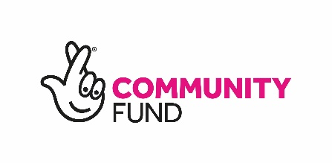

Funding conditions in Whitehill 2023-2024
Please read the following conditions carefully before applying.
- Individuals and groups can apply for up to £4,000 for each proposal.
- Individuals and groups can submit more than one proposal, but only if this is unique and for separate activities.
- Projects or proposed activities must address at least one of the neighbourhood plan priority themes and be community led.

Whitehills neighbourhood planning priorities
- Play park and sports park improvements
- More leisure and social opportunities
- Stronger and better communities
- Physical environment and housing improvements
- Easier to get about/moving around
- Better education, training and employment opportunities
- Greater community safety
- Health improvements
- Financial wellbeing
- More shops/businesses

Criteria
- Neighbourhood plan funded activity must directly benefit people living in Whitehill.
- The project should be planned and/or delivered by March 2024.
- The project must provide added value, award funding should not be used to replace any mainstream budgets.
- A grant acceptance form and conditions of grant form must be completed by all successful projects.
- Funds can only be used for the purposes detailed in the above application form unless a formal request has been submitted to amend priorities/expenditures.
- If you or your organisation become aware of or suspect any irregular or fraudulent activity that may have any impact on the project or the use of the monies, or any part of it, you must notify our Community Engagement Team immediately and provide relevant information in relation to the impact on the project and the use of the monies.
- All receipts and invoices for any goods or services that have been supplied or purchased must be kept. We may ask for any receipts for audit purposes.
Some or all of the grant may be reclaimed if:
- The above conditions are not met
- The project is not carried out
- Progress is deemed to be unsatisfactory by us
- The funding is used for purposes other than specified in your application
- Your organisation/group is wound up or otherwise ceases to function.

What we can't fund
- Activities or events that are targeted to people who do not live in South Lanarkshire.
- Retrospective events or purchases
- Foreign trips (bus travel to or from airports/ferry ports can be considered)
- Profitable activities.
- Insurance and licence fees (with the exception of temporary public entertainment licences)
- Please feedback to us on how many people have taken part and supported your project. We are keen to see any photographs of activities, we would like to hear about what you achieved through quotes, stories, photos, and videos as this will help us contribute to the overall story throughout the neighbourhood planning area.
- All information received from the project or activity will be collated and a full report produced to inform funders and wider stakeholders of progress and developments. assistance can be provided to your project or activity with this.
- Residents of all ages will be encouraged to take part in a public vote. The vote will be face-to-face, online and via pop-ups in key settings to maximise participation.

Further information
To find out further information please contact the Community Engagement Team by calling 0303 123 1017 or by email communities@southlanarkshire.gov.uk

If you need this information in another language or format, please contact us to discuss how we can best meet your needs. Phone: 0303 123 1015 Email: equalities@southlanarkshire.gov.uk

