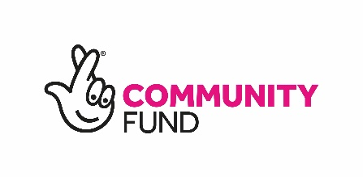

Participatory Budgeting online application questions
To aid with your application, we have listed the main questions that will be asked on the online form. Please ensure you have all information for the online application. Once your application has been submitted you will receive an electronic copy to the email address you used on the application.

About your organisation
- Name of your group or organisation.
- Organisation type
- Please provide charity number
- Address
- Lead contact name
  - Help: This person must be contactable to discuss your application
- Lead contact Email
- Lead contact phone number

Application details
- Activity summary (What is your project idea)
- Key outcomes (How will this make a difference in your neighbourhood)
- Who are you targeting?
  - Help: Children and young people, Adults, Older people, Specific group, Other (if other, let us know in the next box)
- Who will help you deliver this project in your neighbourhood?
  - Help: participants, residents, partner agencies, community engagement, other services
- How will this project be maintained and sustained?

Details of project costs
- Please list any match funding/or any in-kind contributions made by your group or organisation (if applicable)
- Full cost of project
- Money applied for

Project costs
- Please provide us with any costs that relate to your project that you wish to deliver
  - Description
  - Cost

Payment details
If successful we will pay the award monies into your nominated back account. To ensure that this is a smooth process, please provide details of your account below.
- Bank name
- Address of bank
- Account name
- Bank sort code
- Bank account number

Further information
To find out further information please contact the Community Engagement Team by calling 0303 123 1017 or by email communities@southlanarkshire.gov.uk

If you need this information in another language or format,
please contact us to discuss how we can best meet your needs.
Phone: 0303 123 1015 Email: equalities@southlanarkshire.gov.uk

