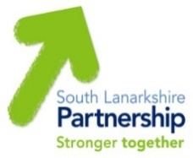

South Lanarkshire Community Planning Partnership

Working together to improve the quality of life for all in South Lanarkshire

Community Plan for South Lanarkshire 2022-2032

Annual Outcome Improvement Report 2022-23

Contents
Chapter

Introduction to Community Planning South Lanarkshire (Section 1)
- Preface
- What are we?
- Who are we?
- What are we trying to achieve?
- How do I get involved?

Our Ambitions (Section 2)
- Our New Community Plan

Community Plan (Section 3)
- Performance Highlights
- Overall Performance at a glance

Places for Wellbeing (Section 4)
How we are making a difference
- Thriving Businesses and Fair Jobs – Town Centres
- Caring, connected communities – Community Partnerships
- People live the healthiest lives possible – South Lanarkshire Alcohol and Drug Partnership
- Putting learning at the centre – Community Learning and Development
- Our children and young people thrive – Participatory Budgeting in South Lanarkshire Schools
- Good quality, sustainable housing for everyone – Fuel Poverty

Working with Communities (Section 5)
How you can get involved
- Community Participation and Engagement
- Neighbourhood Planning
- Sustainable Development and Climate Change
- Community Led Planning
- Local Place Plans
- Participatory Budgeting
- Volunteering (VASLan)
- Community Asset Transfer
- Participation Requests

Appendices
- Links to the National Performance Framework and UN Sustainable Development Goals
- Community Planning Partnership Structure

Section 1 - Introduction to Community Planning in South Lanarkshire

Preface
This document is for you, and everyone else who lives or works in South Lanarkshire. It shows the progress of the South Lanarkshire Community Planning Partnership during 2022-23 and gives example of the work that we are doing to make a difference; and how this has impacted on local people and communities.

What are we?
All our Community Planning Partners are working together to make South Lanarkshire a better place to live and work. We work with each other and with communities to provide the best possible services that local people want and need. Further information can be found on the Community Planning Partnership website www.southlanarkshirecommunityplanning.org.

Who are we?
Our partnership includes a wide range of national and local organisations. Some of these organisations you will know well. Our community partners lead on local planning and area-based Community Partnerships. A full list can be found on our website.

What are we trying to achieve?
Our Community Planning Partners are working together to make South Lanarkshire a better place to live, learn, play and work. Our aim is to work with communities to deliver better services targeted at reducing poverty and tackling inequalities and deprivation across South Lanarkshire.
Further information can be found on the Community Planning Partnership website www.southlanarkshirecommunityplanning.org.

How do I get involved?
There are many ways to get involved in your local community and influence the work of the partnership, for example, through volunteering, joining a local action group, helping to find out what matters in your area or getting involved in how decisions are made. More information can be found on the Community Planning website www.southlanarkshirecommunityplanning.org.

Section 2 – Our Ambitions: Our New Community Plan

In June 2022, the partnership’s new Community Plan was ready to share with our communities. We started gathering the information for this plan during 2021. Over 3,300 people answered our survey about what mattered to them; we held conversations with 27 different groups to explore this a bit more. As part of this, we took information from lots of different sources including looking at what matters to people about where they live. At the time of writing the plan, 17 communities had their own local action plan and were taking action to improve the lives of everyone living in their community, and more are being created.
Our Shared Vision, Principles and Priorities
Our vision is that we improve the lives and prospects of everyone in South Lanarkshire.
We will do this by making sure our communities are at the heart of community planning in South Lanarkshire.
Our shared principles set out how we plan to work better, together:-
Added Value and Continuous Improvement: We will work together to achieve more and become better at doing so.
Clarity of Purpose: We will attempt to avoid duplication of effort, developing agreed priorities to maximise our impact and focussing on the actions that will make the most difference;
Communication and Empowerment: We will talk to and listen to each other in a meaningful way, helping individuals, families and communities to take positive action to improve their wellbeing;
Embracing Change: We work in a rapidly changing world. We are committed to making the most of this, shaping the direction of these changes to benefit local people and communities, taking innovative approaches and always questioning how and why we are doing things;
Focused Delivery: We will not lose sight of the fact that we need to make a positive difference. We will work creatively and build on what we are already doing, focusing our services and actions to meet future needs; and
Openness and Trust: We will do more together, from planning to delivery, ensuring openness and transparency in how we work; trusting each other to fulfil our roles; and working in harmony.
Our Ambitions
Our plan sets out how we will continue to support the people living in our communities to participate in Community Planning and puts the places where our communities live at the centre of change. We will continue to focus on improving how we work better together to deliver local needs and priorities.
This work will happen across three key ambitions: People; Progress; and Planet.
People – Together, we will take a people first approach to improving everyone’s wellbeing. People told us that empowerment comes from the community and it’s not something that is given to them. We understand that long-lasting change will only be achieved if we all work together, putting our communities at the heart of community planning. We will continue to have community conversations that matter. We will work with communities to ensure that their voices are heard and support them to act on the things that are important to them through a “Can Do” approach.
Progress – Together, we will build on what we have learned to improve how we do things and the wellbeing of everyone. Delivering the right things that matter to people, in the right place and at the right time. We have been inspired by the phenomenal community response to the global pandemic and have seen how our communities “Can Do” do more with the right information and support from us. Our focus will be to continue to grow and develop the relationships and the excellent partnership working that has supported our communities to maintain and improve their wellbeing throughout the pandemic.
Planet - Together, we will act in ways that protect our natural world for a healthier future. We will work together to develop local solutions to protect nature and to take action on climate change and support our young people to lead the way.
The ambitions set out where we want to see change happening across the themes of Progress, People and Planet. From your feedback, we know that there are six other priorities are important to you. We are already working to improve services in these areas and have plans that show how this is being done. Our Places for Wellbeing model shows how the plan connects though place, ambitions and priorities.
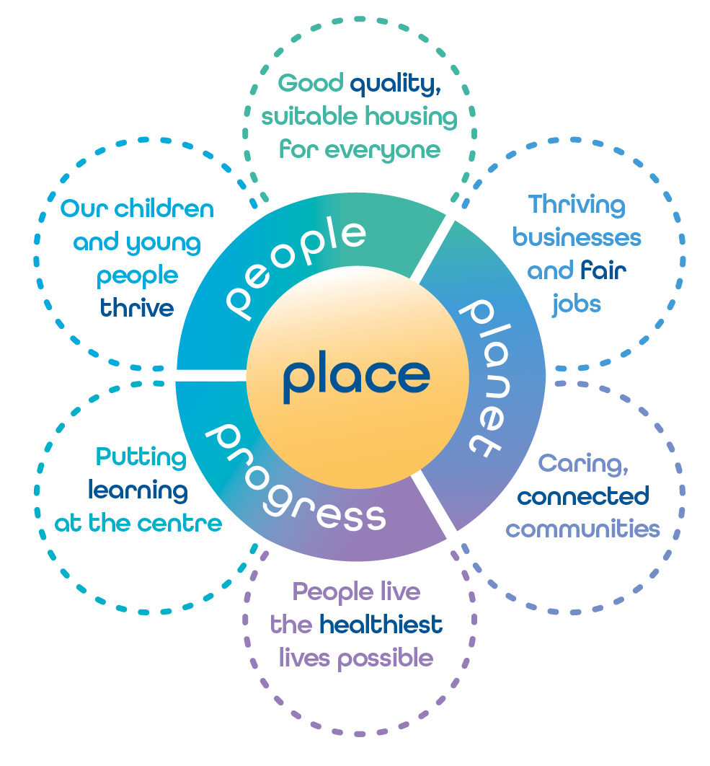
You can read the full Community Plan on the Community Planning website www.southlanarkshirecommunityplanning.org.
Delivering the ambitions in this plan will need our local communities, partnership and other stakeholders to work together. The next stage of our work during 2023-24 is to write a plan that shows what we want to do ‘together’ to deliver on these ambitions. If you would like to get involved in this, please get in touch. Give us a call on 0303 123 1017 or email us at contact@southlanarkshirecommunityplanning.org. We look forward to working with you.
Section 3 - Community Plan Performance Highlights

There is a significant amount of work being undertaken in our communities and by our partners across South Lanarkshire to make places fairer, better and greener. This report highlights some of the work that has been done.

The following are examples of key areas of work.
- Thriving Businesses and Fair Jobs: 536 clients undertook vocational training, including the Making It Work and GATEWAY Employment programs.
- Caring, connected communities: 18 participants finished the first course of the Activate Community Learning Course around community involvement run by Glasgow University; and 12 participants are scheduled to finish the second course.
- People live the healthiest lives possible: 88 Lanarkshire GP surgeries were provided sessional input by the Primary Care Mental Health and Wellbeing Service and Assessment Plus was rolled out in three localities, East Kilbride, Clydesdale and Hamilton. This delivers earlier access to Psychological Services.
- Putting learning at the centre: South Lanarkshire’s school leaver positive destination rate is 96.2% (0.5% above the Scottish average of 95.7%).
- Our children and young people thrive: Action for Children has achieved 100% in both involving young carers in identifying their outcomes and reporting yes to having received appropriate support.
  - Good quality, sustainable housing for everyone: The percentage of former homeless households, provided with a social rented tenancy that maintain their home for more than 12 months, has increased from 88% to 90.5%.

Community Plan Overall Performance at a glance

The following provides a summary of our performance against our priority measures. These are:-

- Putting learning at the centre
- Our children and young people thrive
- Thriving businesses and fair jobs
- Caring, connected communities
- People live the healthiest lives possible
- Good quality, sustainable housing for everyone

The full CPP performance report can be accessed using the following link: https://tinyurl.com/4z5xcd3y

Status of priority measures
26666
3
1
2
0B
28 Improved or Maintained 4 Slippage or Deteriorated

Status | Definition
Blue | The action to achieve change has been completed
Green | On course to achieve the target or complete the action as planned/the timescale or target has been met as per expectations
Amber | There has been minor slippage against timescale or minor shortfall against target
Red | There has been major slippage against timescale or major shortfall against target
To be reported later | For some measures, the statistics are not yet available to allow us to say whether the target has been reached or not. These will be reported when available

Most improved measures | Least improved measures
Increase positive destination rate for young people progressing from the post-school AspireWorks programme | Percentage of kinship carers who are surveyed at their kinship assessment will score a level of satisfaction of 4 or more with the support they received
Percentage of young carers feel involved in identifying their outcomes and receive appropriate support | Hold a networking event for representatives of community led plans to come together and discuss progress and next steps across South Lanarkshire
Deliver responsive employment support and measure the number of successful employment outcomes | Increase the number of people accessing Housing Options Services
Increase engagement of those within neighbourhood planning areas in place based participatory budgeting programme | Reduce the level of Homeless Households (homelessness caseload at year end)

Section 4 – Places for Wellbeing: How we are making a difference

Thriving Businesses and Fair Jobs - Town Centres

Why is this important?
The nature of town centres across the UK is in a transitional stage. The range of issues involved in the challenges town centres are facing are broad and complex. Factors such as the economic downturn, internet shopping, the growth of out-of-town shopping, changes in retailers’ business models and customer expectations have resulted in less people using them.

Supporting town centres remains a council priority and officers continue to work in partnership with groups and organisations in each town to achieve our common goals.

The contribution town centres make to our communities cannot be overstated. They support and contribute to people’s lives across our communities, for example to access essential services, visiting for shopping or enjoying leisure time. Around 70% of businesses and jobs in the economy are located in town centres and they are often the main location for leisure and hospitality. They are vital for social gatherings too like meetings, events and concerts.

How are we doing?
Town Centre strategies and action plans have been prepared and approved for Hamilton, Cambuslang, Larkhall and Blantyre with work now underway in Rutherglen. Similar plans are being progressed by the communities in Lanark and Carluke along with work being undertaken by the owners of East Kilbride.

These strategies and action plans are closely aligned with the Scottish Government’s approach to town centres captured in the New Future for Scotland’s Town Centres report and action plan.

Council Officers are working with all key stakeholders across our towns and have commissioned two key pieces of work to set the direction of the council’s work around town centres going forward. These will inform and align with existing and new funding opportunities for town centres.

  - Town Centre Visioning – this will set out how the council delivers on its strategic aims and objectives at a local level. As noted above, while all towns have similar challenges, the solutions are not always the same. This work will set out how the council, communities and partners should deliver meaningful and sustainable change within our town centres through a series of projects and action plans.

  - Transition to Net Zero – town centres are major contributors to pollution and although a number of early wins have been achieved, the ways to deliver long term meaningful and sustainable reductions are complex and not always appealing to businesses or customers. This work will set out a practical approach to working towards net zero across our towns.

Partners are working with colleagues in the Improvement Service on a pilot project in Rutherglen called Shaping Places for Wellbeing. The project takes a multi-agency approach to placemaking. Work is still in the early stages; however, it is hoped that we can use this process when working with partners and communities across South Lanarkshire. A number of Shaping Places for Wellbeing Assessments have been undertaken including one of our Neighbourhood Planning communities. The learning from these will be used to deliver improvement actions and shape key plans, including the Rutherglen Town Centre Plan.
Priority Next Steps
There are a number of key areas of work underway in support of our town centres which will inform the investment strategies and priorities going forward for the next 5 to 10 years. This work will also support and inform bids for funding.

  - East Kilbride Town Centre Masterplan
  - Hamilton Town Centre Masterplan
  - Place Based Investment Programme (PBIP)

East Kilbride United – Kirktonholme Pavillion
East Kilbride United Football Club have embarked on a 3-phase plan to develop their Kirktonholme site, creating a more disabled friendly pavilion and sports areas to support local groups and widen their use.

Phase 1 - was a feasibility study for £10k funded by PBIP used to engage with local groups and organisations to gauge their interest in the project. This has been completed and support for the work is overwhelming.

Phase 2 - is a refurbishment of the entrances, changing facilities and exits to the sports field funded by PBIP totalling 180k. This is currently under construction and going to plan.

Phase 3 - is the resurfacing of the parks with artificial turf to allow greater use by all including disabled users. This has been supported by the Scottish Football Association, Sport Scotland, council’s Community Benefit Fund and PBIP providing £300k with a project value of £875k.

The combination of these works will open up the facility to a number of additional organisations who otherwise are not able to take part in social sports activities. The new playing surface will provide a safer environment to use in all conditions, increasing the frequency of use.

PBIP value £490K project value £1,065k.

Further information
Town Centre and Place Based Investment Programme - Update
Shaping Places for Wellbeing Programme | Improvement Service

Caring, connected communities - Community Partnerships

Why is this important?
The Community Planning Partnership (CPP) is committed to ensuring that communities are fully engaged and can participate in the process of community planning.

To achieve this, and to strengthen local democracy and community led decision making, locality-based Community Partnerships have been created. Three have already been formed in the Cambuslang/Rutherglen, Clydesdale and East Kilbride localities and a partnership for Hamilton and its surrounding areas is being developed. Community Partnerships act as an intermediary between the Neighbourhood Planning Stakeholder Groups, Community organisations and the CPP Board.

There are three key commitments highlighted within the Community Plan which are supported and delivered by the council’s Community Engagement Team in partnership with Community Planning Partners, and other key stakeholders. These are:-

- We will continue to support and encourage every community to identify and act on their local priorities;
- We will bring communities together to share priorities and work jointly on them; and
- We will involve local representatives in community planning at all levels, including on the CPP Board.

How are we doing?
Community Partnerships are led by communities with support from the council’s Community Engagement Team. They have set their own terms of reference; agendas for each meeting; identify local priorities; invite partners along to present information/updates on areas of interest; and prepare and present reports to the CPP Strategic Board. For example, the current priority for the rural Community Partnership in Clydesdale is transport. Since June 2022, representatives from each Community Partnership have taken up their place as a member of the CPP Strategic Board. They attend meetings, advocating on behalf of their local area and present quarterly update reports outlining current challenges and progress.

Intensive engagement with Community Councils, area Stakeholder Groups including Development Trusts, and other partners, has taken place in each area. The membership of the Clydesdale Community Partnership continues to increase and has significant coverage of communities across its rural area; and the Cambuslang/Rutherglen group are reviewing their membership. All groups are focussing on increasing their membership, as well as ensuring that they are fully representative of the communities within their locality.

Discussions have taken place about how best to communicate the work of the partnership across the communities in their area. All members receive a monthly Register of Information which includes information shared by partners and national information of interest. Consideration is being given to how the Community Planning website can be used to share information about the work of the group and how people can get involved.

Priority Next Steps
- To strengthen the membership of all established Community Partnerships
- To create a new Partnership for the Hamilton, Blantyre and Larkhall areas.

“I think what’s really important is the contacts and making the connections, so knowing who to go and speak to.” Clydesdale Community Partnership Member

Further information
South Lanarkshire Council Public Performance Reports: https://www.southlanarkshire.gov.uk/info/200173/council_performance/1478/public_performance_reports/18

What is Community Planning?: https://www.southlanarkshirecommunityplanning.org/info/1/what_is_community_planning

People live the healthiest lives possible - South Lanarkshire Alcohol and Drug Partnership

Why is this important?
South Lanarkshire Alcohol and Drug Partnership (SL ADP) is committed to reducing the harms caused by problematic alcohol and drug use. Scotland continues to see high numbers of drug related and alcohol related deaths reported. In 2021, 1,330 deaths in Scotland resulted from drug misuse, indicating a slight decrease of nine deaths from the previous year, however this still remains the second highest annual total ever recorded. Within Scotland’s NHS Board areas, Lanarkshire has the fourth highest rate per population of drug misuse deaths in Scotland and remains above the Scottish average. The work undertaken by the SL ADP assists in meeting national and local strategies with the aim of working together to improve the health and wellbeing of everyone affected by alcohol and drugs in South Lanarkshire.

How are we doing?
Over the past year, SL ADP have commissioned a range of services targeted at the whole population across South Lanarkshire. Priority areas of focus are: Early Intervention and Prevention; Developing Recovery Orientated Systems of Care (ROSC); Getting it right for children, young people and families affected by substance use; Public health approach; and Alcohol framework. The service operates using an outreach model to maximise engagement and retention in care and support services. There continues to be growth and development towards making recovery visible across South Lanarkshire through the effective delivery of The Beacons, a set of four Recovery Hubs based in South Lanarkshire, and implementation of a young person’s recovery community.

SL ADP have worked with partners to implement the new national Medication Assisted Treatment (MAT) Standards, which aims to improve the experiences of people in need of treatment services. As a result, an urgent response team has been established to provide same day prescribing and access to treatment, and a residential rehabilitation pathway has also been implemented for those most in need of this method of recovery.

John* attended Blantyre Beacons for an initial appointment and assessment. He displayed underlying trauma due to his early childhood, long-term addiction and years spent in prisons and institutions. He was also isolated, disconnected with his local community and looking for positive recovery opportunities as previous attempts were unsuccessful.

A range of supports were offered to John to provide routine and structure, and to enable him to invest in a positive support network through the men’s group before engaging in the wider Beacons therapeutic programme.

John said “I started attending the Beacons whilst on home leave from prison. Initially I was only attending recovery meetings but after a while I realised this place could really help me with all aspects of my recovery, from helping me stay drug free to Citizen’s Advice helping me get my benefits sorted. I also participated in trauma informed practice which helps to deal with past traumas that would have caused a relapse before I started attending the Beacons. I am now waiting to start an emotional regulation course that will help me deal with all the emotions that you get back in recovery. After being released from prison on parole I threw myself into my recovery. I completed the volunteer training course, and I am now a full-time recovery volunteer within the Beacons.”

Name changed*

Priority Next Steps
In the next year, SL ADP will publish a revised local strategy and will continue to work with partners, those with lived/living experience as well as family members, to continue to reduce the harms and impact of problematic alcohol and substance use across the communities of South Lanarkshire.

Further information
South Lanarkshire Alcohol and Drug Partnership

Putting learning at the centre - Community Learning and Development

Why is this important?
Community Learning and Development (CLD) supports individuals and groups to improve their skills and reach their full potential. CLD in South Lanarkshire is rooted in a commitment to the principles of social justice, empowerment, inclusion, and access to services and opportunities irrespective of life circumstances. The vision for CLD in South Lanarkshire is to: ‘Improve the quality of life for people in South Lanarkshire by offering vibrant learning and development opportunities that lead to personal development and community empowerment’.

How are we doing?
Learners have been helped to re-engage with education and learning or to improve their employability skills. As a result of this, learners are reporting improved confidence in their skills and abilities and are better able to support the learning of their children. They are accessing award programmes and achieving recognition for their learning towards improving their chances of gaining employment.

The Platform School which is bespoke curricular programmes for referred pupils in second and third year of High School, was delivered in East Kilbride Universal Connections by the Youth, Family and Community Learning Service. There were five themed programmes of learning which included Art and Media; Sports Leadership; Hospitality; Music and Sound Production; and Outdoor and Adventure. It is vital when implementing a youth work approach that the young people choose to participate and therefore through meaningful feedback the team focused on the delivery of programmes that would result in the most meaningful engagement for the pupils involved. These programmes ran over 26 weeks and involved 44 pupils. This approach developed trusting relationships and supported pupils to address many of the underlying and negative issues affecting their education and life, resulting in re-engagement with education, increased attainment, volunteering and increased resilience to address the issues in their lives.

Feedback from participants:
“I enjoyed going to the Hampden Sports Clinic because I learned a lot about health and recovery in sports”.
“Meeting new people on the course has helped my confidence”.
“I learned to be more confident and how to work better with others”.
“I really enjoyed meeting new people and doing the course with them”.

The Blueprint programme was the first school learning programme set up in partnership with Carluke High School. Working with the Head of the Social, Emotional and Behavioural Needs (SEBN) department in the school we identified pupils who we felt really needed support and would be the perfect candidates for the programme. The group comprised of six individuals in their second year who were really struggling to cope with the school environment, had low attendance rates, struggled with self-confidence and had next to no future aspirations. The programme was designed to help them improve their confidence, develop team work and leadership skills, maximise their attainment and help them re-engage with education.

Feedback from the 4 secondary schools in East Kilbride and Strathaven has been remarkable on what the programme offers, the delivery and on the positive impact it has had on participants. Whilst partaking in the Sports Leaders Platform Group, the participants have been afforded the opportunity to speak with an Active Schools Co-ordinator where they learned more about the service they delivery and additional learning/volunteering programmes they can access. Also, the participants in the programme have been given the opportunity to assist and lead on the delivery of the Primary 7 transition programmes that will take place in Universal Connections, this is a huge development and step forward for all individuals.

Priority Next Steps
- Further embed recognised youth work practice from the recent HMIe Inspection of Stonelaw High School to enhance the offer for learners.
- Enhance delivery of learning for adult learners through the MULTIPLY theme of the Shared Prosperity Fund.

Further information
Community Learning and Development Partnership - South Lanarkshire Council

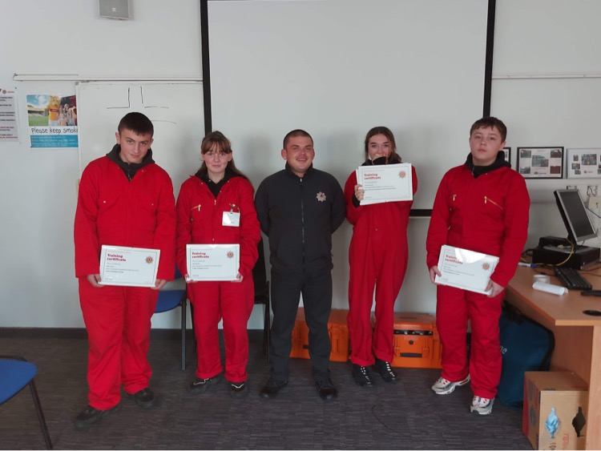
Participants of the Fire Reach Programme (Platform)

Our children and young people thrive - Participatory Budgeting in South Lanarkshire Schools

Why is this important?
South Lanarkshire are the only local authority in Scotland who have dedicated as much as 5% of Pupil Equity Funding (PEF) from every school. The work of our schools on Participatory Budgeting activity (PB) has been recognised nationally as good practice.

How are we doing?
In 2021-2022, schools allocated £607,136.95 of their Pupil Equity Funding (PEF), approximately 6% of the £9.9m South Lanarkshire Council allocation for PB. Of those schools, 81% allocated 5% of the funding to PB activity, whilst 19% of schools allocated more than this, with two schools allocating as much as 15% of their funding.

During 2022-2023, schools allocated £568,643.65, 6% of the £8.9m funding allocation for PB activity. 66% of schools allocated the minimum 5%, whilst 34% allocated more than this. As a result of the benefits of taking a PB approach to allocating funding in the first year, 38 schools allocated a larger percentage of their funding allocation to PB than they did the previous year.

In 2021-22, 27,972 young people and 9,689 parents/carers voted as part of the process. This increased in 2022-23 with 40,106 pupils and 10,214 parents voting as part of the process, demonstrating how much schools have built on the success from year one. The following links show the spend and outcome of the vote per school within South Lanarkshire:

2021-2022:
- Clydesdale
- East Kilbride
- Cambuslang and Rutherglen
- Hamilton

2022-2023:
- Clydesdale
- East Kilbride
- Cambuslang and Rutherglen
- Hamilton

This video (https://tinyurl.com/PBSchoolsVideo) shows the impact of PB for children and young people across South Lanarkshire during 2021-22.

Holy Cross High School
Holy Cross High School sourced help from a local company who provided materials and supported a group of young people to build outdoor seating which was voted for. These young people received an additional Scottish Credit and Qualifications Framework certified qualification due to their involvement in this PB work.

Carluke High School
Carluke High School had a record number of pupils and parents participate in 2021-22, and as a result committed more money than the minimum required to PB in 2022-23. Their project focused on improving the uptake of free school meals. 51 young people did not use their free school meal entitlement at the start of the project and they reduced this to just 3 young people.

Rigside Primary School
Rigside Primary School voted for better playground equipment and games. This has improved engagement of pupils at playtimes and lunchtimes and improved wellbeing for targeted pupils. It has also helped some pupils feel a greater sense of belonging in school.

David Livingstone Memorial Primary School
David Livingstone Memorial Primary School listened to stakeholders who were very much about supporting families affected by poverty with issues around the Cost of the School Day. Following the PB voting process it was announced that widening the access to extra-curricular clubs was the favoured choice. It is hoped that pupil wellbeing and engagement of pupils affected by poverty at after-school clubs will improve.

Additional Support Needs Schools:

Sanderson High School
Sanderson Primary School voted for pupils to have better outdoor learning experiences through an external provider, Outdoor Resource Base (ORB). ORB experiences have provided pupils with complex needs much needed opportunities to engage safely in a bespoke outdoor learning experiences beyond the school environment. Additional work in school has built on the skills and experiences gained at the ORB. Six targeted learners have achieved Curriculum for Excellence attainment outcomes at an accelerated rate as a result of the ORB experience. There has also been an increase in learning engagement levels, a reduction of violent incidents and an increase in skills developed.

Victoria Park Primary School
Victoria Park Primary School focused on widening access to learning experiences. Pupils and parents reported during the consultation that access to such experiences is often difficult within the community due to lack of availability of appropriate local clubs for pupils with complex learning needs and a lack of transport to access those further away. A range of specialists were brought in, such as music therapy, Equitots and Therapeutic Clowning, which have had a positive impact on pupils’ health and wellbeing and skills for learning, life and work.

Further information:
Education and Learning: https://www.southlanarkshire.gov.uk/info/200140/education_and_learning

Good quality, sustainable housing for everyone - Fuel Poverty

Why is this important?
Addressing fuel poverty is important as it impacts on every member of the community whether they are young or old. It impacts on the ability to cook hot meals, to heat homes, to avoid ill health caused by the cold weather and to operate medical devices for those living at home with significant issues. Fuel poverty also has an impact on mental and physical health. It is well publicised that people choose to heat or eat and often parents of families will refrain from eating nourished meals to ensure that their children have meals.

How are we doing?
The partnership has a Fuel Poverty Group which is part of the wider Financial Inclusion Network. The purpose of this group is to share ideas, discuss initiatives and identify solutions which will help South Lanarkshire residents who are experiencing fuel poverty. The membership of the group is diverse with officers representing different services from South Lanarkshire Council (SLC) including: Community Engagement, Employability, Housing, Money Matters Advice Service, etc. as well as external organisations such as the Citizens Advice Bureau, NHS Lanarkshire, Housing Associations, Energy Action Scotland and Home Energy Scotland.

The group have been focusing on the increasing energy costs and the limited options for residents to shop around (switch) for better deals. This was a result of the price cap that was introduced by the UK Government in an attempt to restrict excessive energy charges. This meant that the energy companies charged the same price therefore there was not any competition between energy companies for residents to try and get cheaper deals.

In October 2022, the group attended a Community Networking Event which was held in East Kilbride as part of the activities during Challenge Poverty Week.

Due to its role in dealing with debts and welfare rights issues, Money Matters Advice Service has been dealing with energy poverty and helping residents access funds, grants and emergency energy vouchers to help alleviate financial difficulty by making referrals to a variety of initiatives such as South Lanarkshire Council Financial Wellbeing Fund. Other members of this group also promote and engage with similar initiatives to ensure that South Lanarkshire residents can access help with energy issues.

Energy Action Scotland and Home Energy Scotland provide information on energy issues and initiatives to all members of the group as well providing training/seminars for staff of the group members.

All members of the group share information on any local initiatives that they can provide to the community. For example, periodically some of the housing associations can access funds that can help their tenants so this is promoted through the group members. NHS Lanarkshire ensures that information on energy issues and initiatives are cascades to their staff who are dealing with vulnerable patients. SLC departments will report on Energy Company Obligations that will have an impact on communities.

The collective sharing of information and promoting energy schemes through the Fuel Poverty Sub-Group has proved to be an effective platform for helping deal with fuel poverty in the SLC community.

Priority Next Steps
The uncertainty of energy costs and future assistance provided by the UK and Scottish Governments means that fuel poverty will continue for the foreseeable future.

Accordingly, it is vital that the Fuel Poverty Sub-Group continues to share information on energy assistance schemes and initiatives that will benefit the South Lanarkshire community.

Mr M, a client of Money Matters, was no longer able to work due to cancer and his only income was from benefits. The client’s central heating system broke down due a boiler which was over 25 years old and difficult to repair. A referral was made to an energy charity who installed a new boiler. There was also a referral to a second energy charity which replaced old inefficient kitchen appliances with new energy efficient ones and a new washing machine and tumble drier were installed.

The four Citizens Advice Bureaus in South Lanarkshire between them dealt with 3,614 enquiries relating to energy advice/energy debt/ reducing energy costs during 2022-23, an increase of 36% on 2021-22.

Financial benefits/awards to clients from energy interventions by Money Matters during 2022-23 was in excess of £0.5m (£538,690.64), while a further £0.38m (£378,041) in financial gains was secured for MMAS clients through energy debt interventions during 2022-23.

Foodbanks across South Lanarkshire issued 842 fuel/energy vouchers (from various funding sources) to clients during 2022-23 in addition to emergency food parcels.

Further information
Money is not the only problem:
https://www.southlanarkshire.gov.uk/info/200134/benefits_and_money_advice/2050/money_is_not_the_only_problem

Fuel Poverty Sub Group:
https://www.southlanarkshire.gov.uk/cp/info/4/thematic_groups/107/fuel_poverty_sub_group

Financial Inclusion Network:
https://www.southlanarkshire.gov.uk/cp/info/4/thematic_groups/71/financial_inclusion_network

Section 5 – Working with Communities: How you can get involved

Community Participation and Engagement

Why is this important?
Our work as a partnership is intended to improve outcomes for people who live, play and work in South Lanarkshire, particularly in those areas that experience the poorest outcomes. There is a lot of evidence that shows that when people are involved in decisions about services which affect them, outcomes are improved. As a partnership, we want to find ways to speak to communities and encourage them to act themselves and to have an influence on how services are delivered where they live.

The Community Empowerment Act 2015 (www.gov.scot/publications/community-empowerment-scotland-act-summary/) means that legally the partnership has to place communities at the centre of its work, and work together with them to produce locality plans which we call Neighbourhood Plans in areas which have the poorest outcomes. In South Lanarkshire we are ambitious and work to extend this beyond the legal requirements and listen to and involve communities in a real and meaningful way. The Act also sets out other requirements for public organisations, for example, in relation to Community Asset Transfers and Participation Requests.

During the year, many consultation and engagement activities were carried out by partners with communities in the South Lanarkshire area. The following sections in the report highlight some areas of this work.

Working with Communities: Neighbourhood Planning

Why is this important?
Neighbourhood Planning is where both residents and local agencies and organisations are committed to working together to develop local plans for their communities.

This work aims to reduce the inequalities that exist in our most deprived communities and improve outcomes for residents. Key to this is supporting communities to drive the process and work alongside partners and service providers. Together they build a shared understanding of local needs and priorities and respond to these making the most of our shared resources.

Collaboration with communities across South Lanarkshire and ongoing priority setting has been a key feature of our work. Sustaining existing support to these communities to maintain and monitor the level of progress and success gained through Neighbourhood Planning is important to continue to improve outcomes for these areas.

Neighbourhood planning involves communities in real and meaningful ways and has created positive change in these communities. To see the progress that has been made in these neighbourhood planning areas please see the Annual Reports that are generated to highlight the progress being made on the top ten priorities within each plan. https://www.southlanarkshire.gov.uk/cp/downloads/26/community_plan_and_neighbourhood_plans

How are we doing?
We are working with nine communities to progress Neighbourhood Planning and a further two areas are in progress. The following is a snapshot of current activity in some of the areas that we are working with communities.

Hamilton South
Officers have been working in the areas of Eddlewood, Low Waters and Fairhill in Hamilton. The current focus is on the development of a plan for the wider area of the Hamilton South ward. Plans include the development of a new stakeholder group and the Neighbourhood Plan will still recognise each of the distinct areas within Hamilton South, whilst working together for the good of all communities.

Whitehill, Hamilton
The Whitehill Stakeholder Group are in the process of reviewing their plan, creating new priorities and starting a Participatory Budgeting process. They are keen to engage with local residents and take forward their identified priorities in the year ahead.

Blantyre
Activity in this area includes re-establishing the stakeholder group and setting an agenda for the months ahead. This work will include identifying local assets, relationship building and community involvement and Participatory Budgeting activity in autumn 2023.

Burnhill
Burnhill Stakeholder Group has been working to deliver the priorities in their plan and have reported the progress in their recent annual report. The group have also delivered a successful Participatory Budgeting programme in which 254 people voted on how they would like the money to be spent in the area. Work to deliver the projects that were funded is underway. The group are also working within their wider community to review the priorities in their plan. The findings of this work will be published in March 2024. Members of the group took part in the national Shaping Places for Wellbeing programme. This focussed on reviewing their action plan; and they hosted various sessions with community members to find out what they thought. A report on the findings from this work has been produced and the group will be supported by the Project and Community Link Leads and partners to embed the priority recommendations which is a key part of the project’s approach to create lasting positive change.

Cambuslang East
Cambuslang East Stakeholder Group has been working to deliver the priorities in their plan and have reported the progress in their recent annual report including successes in Participatory Budgeting projects that were awarded last year. The group has also been supporting other groups within the area to build capacity to allow them to potentially consider community ownership of some of the assets within the area. This work is ongoing and will continue to strengthen groups and organisations within Cambuslang East. The group are now in the process of organising a new Participatory Budgeting process that will allow community members to identify projects/activities they would like to see happen in the area. Some of the ideas generated through this exercise will proceed to public vote and the activities that receive the most votes will be funded.

Fernhill
Fernhill Stakeholder Group has been working to deliver the priorities in their plan and have reported the progress in their recent annual report including successes in Participatory Budgeting projects that were awarded last year. The group are now in the process of organising a new Participatory Budgeting process that will allow community members to identify projects/activities they would like to see happen in the area. Some of the ideas generated through this exercise will proceed to public vote and the activities that receive the most votes will be funded.

Priority Next Steps
- Develop a Neighbourhood Plan for the Lanark area
- Develop a Neighbourhood Plan for the Greenhills, Whitehills and Crosshouse area in East Kilbride
- Expand the reach of Neighbourhood Planning in the Hamilton South area

“I enjoy volunteering to help my community get better. I like helping people and seeing their reactions. It makes me happy being involved in my community”. Summer, young volunteer (Burnhill).

“The modernised hall and library, the nursery, the Cage and the progress made on recladding and back court improvements have all helped make Springhall a brighter, more attractive area for local people. Still more to do of course but great to see improvements taking shape in Springhall”. Stakeholder Group Member.

“As a resident of Blantyre, I want to do more than just belong, I want to participate in making this town a better place to live, gaining a sense of community spirit, get involved with local groups to help tackle poverty and inequalities. I want to encourage others to join local groups already doing great work and helping our community, get to know their neighbours and make this a place to be proud of”. Local Resident.

Strutherhill and Birkenshaw
For the last year the Strutherhill and Birkenshaw Action Group have been working to design and deliver a neighbourhood-based bike “campaign” aimed at inspiring more people to take up or return to cycling.

A launch event is planned to bring the community together and a programme of activities is in place including a bike amnesty allowing bikes to be repaired, redistributed, or recycled, bike safety and maintenance checks and training has been organised across a range of levels. Play on pedals training (for toddlers) Bikeability and cycle proficiency training, on road training plus confidence building activities for beginners or those who haven’t cycled for a while plus mountain biking “car park” skills workshops.

The group also hope to recruit volunteers for “Rock Up and Ride” a programme promoting cycle proficiency within Robert Smillie and Craigbank Primary Schools and have purchased balance bikes to support nursery-based activities and adult bikes for training and loan.

The group are confident that activities meet the needs of local people because ideas have developed in direct response to consultation work undertaken with residents who identified the following priorities:-

The need for cycle safety sessions;
Organised cycling groups and trips;
Bike repairs and bike maintenance;
Guided cycles;
Learn to ride sessions for all ages and abilities;
Refurbishment and distribution of second-hand bikes;
Bike health checks;
Bike borrowing or bike share; and
Family focused activities.

“I think the Bike Initiative is going to make a massive difference in the area. Beyond the health and wellbeing benefits I think it will create real opportunities to bring the community together. The training programme means that there is something for everyone”.

Partnership working has been at the forefront of this project and the Action Group have worked closely with the wider community, South Lanarkshire Leisure and Culture, Robert Smillie and Craigbank Primary Schools, local nursery schools, Clydesdale Colts Cycling Club, Bike Town and Head in the Sky on this project. A launch event will take place Summer 2023.

Further information
Neighbourhood Plans: https://www.southlanarkshire.gov.uk/cp/info/26/community_plan_and_neighbourhood_plans
Annual Progress Reports: https://www.southlanarkshire.gov.uk/cp/downloads/26/community_plan_and_neighbourhood_plans
South Lanarkshire Community Planning Partnership: https://www.southlanarkshire.gov.uk/cp/site/index.php
Community Empowerment (Scotland) Act 2015: www.gov.scot/publications/community-empowerment-scotland-act-summary/
National Standards for Community Engagement: https://www.scdc.org.uk/what/national-standards

Working with Communities: Sustainable Development and Climate Change

Why is this important?
Climate change and sustainable development are important considerations for Community Planning because they have significant implications for the well-being of communities, the environment, and future generations. This has been identified as a priority in the new Community Plan and can only be delivered through working together, with our communities. Community Planning partners can help to ensure that development is resilient, sustainable, fair, and that legal requirements are met. The following sets out some examples of current challenges and how the partnership currently is and can make a difference:-

Protecting communities from climate risks which have increased in frequency and severity, for example floods, droughts, and storms. These events can cause damage to infrastructure, homes, and businesses, and disrupt community services. Community Planning can help ensure that communities are prepared for these risks by identifying vulnerable areas, developing emergency response plans, and investing in resilient infrastructure.

Ensuring a sustainable future: Community Planning can help ensure that development is sustainable and that natural resources are used in a way that meets the needs of the present without compromising the ability of future generations to meet their own needs. This can include strategies to reduce carbon emissions, promote energy efficiency, and support the development of green industries.

Promoting social equity: Climate change and unsustainable development can have disproportionate impacts on individuals, families and communities that experience the poorest outcomes. Community Planning can help ensure that development is fair and that the needs of all members of the community are considered. This can include ensuring access to affordable housing, public transport and green spaces.

How are we doing?
The delivery of people and place-based approaches are at the core of the new South Lanarkshire Community Plan. Work has been undertaken to map the Community Plan to the United Nation’s 17 Sustainable Development Goals, with a commitment to localising the global goals. Part of this work is to identify any gap which will inform future action. Moreover, the process will also assist in the creation of local performance indicators which will be reviewed voluntarily on an annual basis. These actions will assist in mainstreaming sustainable development and climate change across all Community Planning Partnership plans. All partnership work moving forwards will be considered through a climate change lens. This aim is to refocus current planning arrangements, prioritise and align policy and delivery with the statutory requirements of community planning whilst taking action to address the climate crisis which focuses on climate, nature change and ensuring that no-one is left behind.

Priority Next Steps
- A Community Planning Partnership Climate and Nature event will be held in October 2023, featuring guest speakers, climate cnversation cafes and networking opportunities.
- A Community Planning Partnership Board Development Session focussing on Climate and Nature will be facilitated by young people in October 2023.
- Creation of a new webpage detailing easy to access resources for communities and groups to access, which will be launched towards May/June 2023.

Further information
United Nations Sustainable Development Goals: https://sdgs.un.org/goals

Working with Communities: Community Led Planning

Why is this important?
The Community Led Planning process enables communities to identify local priorities and produce an action plan that helps people to take realistic steps towards the change they want to see. By bringing everyone together to think about what is needed, this process highlights the skills and resources already available in the community, as well as identifying the gaps and the support required from others to make it happen.

How are we doing?
Communities across South Lanarkshire in the Clydesdale, East Kilbride and Larkhall areas have created their own Community Action Plans. These plans have been developed through extensive community engagement activity delivered by local people, for the benefit of the whole community to take ownership of and work together to achieve the priorities set out in the plan. You can find more information about the communities that have their own plans and view their latest plans on the Community Planning website: - https://www.southlanarkshire.gov.uk/cp/downloads/file/436/local_community_plans

How can you get involved?
If you live, work, visit or have an interest in any of the communities that already have a local action plan you can get involved by supporting delivery of the plan. If you live or work in a community that would like to create their own action plan, please see our local Community Planning Toolkit for further information. If you would like more information or would like to get more involved in your community please get in touch. Give us a call on 0303 123 1017 or email us at communities@southlanarkshire.gov.uk

Further information
Community Planning Toolkit: https://www.southlanarkshire.gov.uk/cp/info/26/community_plan_and_neighbourhood_plans/104/neighbourhood_planning
If you would like a copy of the toolkit, including template documents, please email: contact@southlanarkshirecommunityplanning.org

Case Study - Larkhall Community Plan
The Larkhall Plan Partnership, consisting of local third sector organisations, have produced an action plan from their community survey carried out in 2019. In the past year, the partnership have continued to raise awareness of the Larkhall Community Plan, it’s value and the strong network structures that have been built in Larkhall.
The partnership also continues to lobby for acknowledgement and support, exploring potential partnerships to deliver necessary improvements in their local area. Progress on their priorities for the future include:

The Open Space Action Plan
A meeting was held with senior staff within South Lanarkshire Council’s Planning and Countryside and Greenspace Resources on 7 February 2023 to secure the commitment of the council to develop an Open Space Strategy for Larkhall. A joint workshop is planned with all relevant stakeholders.

The Health Action Plan
A meeting was held with the Chairs of NHS Lanarkshire and Health and Social Care Partnership where a number of issues were raised that are being progressed with partners.

Leisure Centre project
A visit to the new Helensburgh leisure complex, allowed the partnership to see what a modern centre could look like. £11.5m has been identified by South Lanarkshire Council for a new leisure centre, leaving a gap of £10m or so. A public meeting attended by all local party leaders agreed that the development is a priority and all effort will be made to make up the shortfall.

King Street Community Space
An exploratory meeting with personnel from the council’s Planning, Economic Development, Roads and Funding and Development Services provided an opportunity to discuss the outcome of the feasibility study into the partial pedestrianisation of King Street as a community space.

One of the key goals is for the ward of Larkhall to become a pilot area in South Lanarkshire (and Scotland) for effective Participatory Budgeting. The partnership have made the Community Planning Partnership and its partners aware of this in all presentations, meetings and discussions. It was recognised from the outset, that additional support was needed to help the partnership move this along and discussions have taken place at a national level with personnel from the Scottish Community Development Centre (SCDC) and the Convention of Scottish Local Authorities (COSLA).

Working with Communities: Local Place Plans

Why is this important?
Local Place Plans (LPP’s) are community-led plans which set out the proposal for the development and use of land; and for local communities to explore the needs for their area and set priorities for the future of their communities. This can assist in the development of local collaborations and grow community capacity and contribute to reducing the many challenges being faced today including climate change, nature crisis and reducing inequalities.

LPP’s are required to be registered by the local Planning Authority (South Lanarkshire Council’s Planning Services) who have a legal responsibility to take these into account in the preparation of the Local Development Plan (LDP).

How are we doing?
The council’s Planning Service is about to start preparation of its third Local Development Plan (SLLDP3) which will set out planning policies and proposals for the development and use of land across South Lanarkshire for the next ten years. Communities can start developing LPP’s at any time, however, the council will formally invite community bodies to prepare a Local Place Plan once the SLLDP3 process starts.

There has been no LPPs registered to date, however, to help communities consider whether they wish to prepare one, a toolkit and guidance is being prepared to raise awareness in communities including details on the council’s website and meeting have taken place with Community Partnerships to advise of the option to do this work.

How can you get involved?
If you are interested in preparing a Local Place Plan, you can contact the council’s Planning Policy Team by emailing lpp@southlanarkshire.gov.uk. We will be happy to provide advice or assist in submitting a Local Place Plan.

Further information
Local Place Plans - South Lanarkshire Council
Local place plans: literature review and final report - gov.scot (www.gov.scot)

Working with Communities: Participatory Budgeting

Why is this important?
Participatory Budgeting (PB) actively engages residents in local priority setting, decision making and the allocation of elements of public funds.

How are we doing?
The PB process has been adopted across nine neighbourhood planning areas who are sharing a bigger budget than usual this year thanks to match funding from the national lottery. £286,000 (allocation based on population size) was shared between these neighbourhoods and a variety of approaches are being used based on local circumstances. Three of our neighbourhoods have undertaken their PB processes already while our other communities are still working towards this.

So far this year 2,425 local people have had their say on how money should be spent within their community, with only one third of our communities having completed the process.

Completed PB processes:

Burnhill  (£28,278 – 254 votes cast) | - The installation of Solar Panels in the High Backs to support community activity;  - Funding to enable the High Backs group to capture rainwater in a water butt and water their plants sustainably and to investigate the option of having running water; and  - Projects to support people with the cost-of-living crisis.
Hillhouse, Udston and Burnbank  (£44,870 – 1,649 residents voted and 4,946 votes cast) | - A weekend supported study programme in John Ogilvie High School;  - Upgrade of a family room in St Cuthbert’s Primary School; and  - A residential guide’s camp.
Springhall and Whitlawburn  (£27,053 – 522 residents voted and 2,610 votes cast) | - A community fun day, Springhall and Whitlawburn - Youth Development Team in partnership with Cathkin Award Group;  - Sports, dance and movement programme - REACH Lanarkshire Autism; and  - A warm spaces initiative – Whitlawburn Community Resource Centre.
Strutherhill/Birkenshaw  (£24,389) | - Chosen funding to continue to invest in current priorities such as the bike initiative.

Officers are working with Stakeholder Groups in Blantyre (£36,164); Cambuslang East (£38,901); Fernhill (£25,172) Whitehill, Hamilton (£22,786) Hamilton South (previously Eddlewood and Low Waters and Fairhill) (circa £38,000) to develop the most appropriate PB voting process for their communities.

For a full list of projects awarded, please view the Community Planning Partnership Board regarding an ‘Update on Neighbourhood Planning across South Lanarkshire’ (Item 10/Page 69): https://www.southlanarkshire.gov.uk/cp/downloads/file/390/community_planning_partnership_board_papers_-_7_june_2023

How can you get involved?
If you would like more information or would like to get more involved in your community please get in touch. Give us a call on 0303 123 1017 or email us at communities@southlanarkshire.gov.uk

Further information
Participatory Budgeting Scotland: https://pbscotland.scot/
The Participatory Budgeting Charter for Scotland: https://pbscotland.scot/charter
South Lanarkshire Community Planning Partnership: https://www.southlanarkshire.gov.uk/cp/site/index.php

Working with Communities: Volunteering

Why is this important?
Volunteers continue to give their time, energy, and commitment every day across South Lanarkshire to support our communities. A wide range of activities and services would not be available if not for the kind and generous support offered by volunteers. The benefits of volunteering have never been more evident, volunteers have a direct impact on better mental health, less social isolation, and an increase in wellbeing for themselves and those they support. The impact volunteering makes on our society is immeasurable, the effect of volunteering is far reaching and recognising and valuing volunteers has never been more important.

How are we doing?
As part of a post covid learning and evaluation exercise, the Community Planning Partnership recognised the benefit of a collaborative approach to volunteering. This resulted in the introduction and launch of a shared South Lanarkshire Volunteering Strategy, endorsed by all partners through signing a Volunteering Pledge. As the Third Sector Interface for South Lanarkshire, Voluntary Action South Lanarkshire (VASLan) have taken the lead on the delivery of key components within the Volunteering Strategy.

We have worked in partnership with referral agencies to focus on the removal of barriers to volunteering by offering support in areas such as confidence building, life, and social skills along with assistance to find suitable volunteering. The number of people supported through this new programme has exceeded our expectations with three times more people than originally estimated receiving support.

Supporting partners and voluntary organisations in good volunteering practice remains one of our main priorities and working in partnership with Volunteer Scotland, we continue to promote the Quality Standards Pipeline and to support organisations to sign the Volunteer Charter, achieve Volunteer Friendly or Investing in Volunteers accreditation. We are well on the way to achieve our ambitious two-year target of supporting one hundred voluntary organisations to achieve one of these standards.

Working with partners and the Third Sector to create more flexible, inclusive, and diverse volunteering opportunities has also been an essential part of our work over the last year and has resulted in twice as many new and exciting opportunities on offer to potential volunteers. In addition, work has been started to implement a Training Portal to support learning, knowledge sharing and enhance employability prospects for volunteers and staff across the Third Sector.

The following are some of the highlights of 2022-23:-

- 614 new volunteers registered;
- 75 volunteers given tailored pre-volunteering support;
- 1,525 volunteering placements facilitated;
- 97 new volunteering opportunities created;
- 24 organisations working towards a Quality Standard with a further 20 indicating interest;
- 9 Saltire Group administrators approved;
- 364 new Saltire volunteer registrations;
- 355 Saltire Certificates issued; and
- 17,299 Saltire hours logged.

Fatima Afzal - supported by VASLan to find a volunteer role at ST MARY'S FOR ALL (Receptionist)

St Mary's is a lovely place to volunteer and I am enjoying my time here. Meeting new people and interacting with the community made me feel a part of the community.

St Mary's offers an opportunity to connect with people with different cultural and religious backgrounds. This is worth dedicating my time at St Mary's because this has helped me strengthen my knowledge and social skills.

Volunteering is the best way to make a positive difference in people's life and definitely it makes a massive difference in yours. Life feels more purposeful and contented. Even helping a little and providing a listening ear is satisfying and rewarding.
Volunteering is the best way to escape from day-to-day work and to restore our energy.
It feels so good to provide a listening ear and listen to other people's life experiences which is helping me to improve my problem-solving skills".

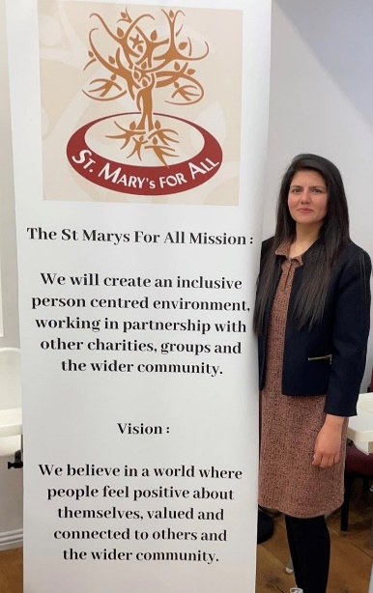

Further Information:
Voluntary Action South Lanarkshire (VASLan): www.vaslan.org.uk
South Lanarkshire Volunteering Strategy:
http://www.vaslan.org.uk/sites/default/files/2022-11/CPP%20Volunteering%20Strategy%20-%20for%20Website.pdf
South Lanarkshire Volunteering Pledge: http://www.vaslan.org.uk/sites/default/files/2023-03/CPP%20Pledge%20-%20A0%20Size.pdf

Working with Communities: Community Asset Transfer

Why is this important?
Local councils, the Scottish Government and other public authorities, own or rent lots of land and buildings, like schools, hospitals, parks and forests. The Community Empowerment Act gives community organisations a right to ask to take over control of land or a building. If the community organisation’s plan is better for people, they will be allowed to buy, rent or have the use of it. This is called Community Asset Transfer. The Act sets out specific criteria that needs to be met by community organisations. The ownership or control of community assets is a powerful tool for communities to drive change and achieve their goals.

The Community Asset Transfer (CAT) process allows statutory partners including the council to work closely with their communities to develop local services and provision that are responsive to the needs of residents. The legislation which was introduced in 2015 allows community bodies to apply to lease and purchase public sector assets including those belonging to the council. By capitalising on the local knowledge and expertise of those who live in these communities we can assist in the flexible usage of SLC assets and work together to make the greatest impact possible in the communities in which we serve.

How are we doing?
South Lanarkshire Council’s Community Asset Transfer Officer has been focusing on improving the internal process to make it more responsive to applicant organisations as well as redesigning the website and producing an animation video to make the process easier to understand.

In 2022-23, South Lanarkshire Council was the only Community Planning partner that dealt with Community Asset Transfer requests. Two Community Asset Transfers were approved during 2022-23 (Blantyre Victoria Football Club for Stonefield Park, Blantyre and Carluke Men’s Shed for Wilton Cemetery House, Carluke). The number of ongoing enquiries, which have been supported, has also grown greatly, with over 50 organisations working on proposals from community growing spaces to community football pitches.

How can you get involved?
CAT is open to any community-controlled body which has the relevant constitution or governance documentation and is open to all members of the community they serve. Any group applying for a CAT must show they have organisational strength to take on and manage an asset, and that they are supported by the community which they serve. The CAT process is an exciting opportunity which can benefit any community but involves a lot of time and effort. In recognition of this, the CAT Officer can provide tailored support to each organisation. This support can be augmented by assistance from other organisations, such as Voluntary Action South Lanarkshire (VASLan), Community Enterprise, Just Enterprise, Community Ownership Support Services and the Scottish Council for Voluntary Organisations (SCVO).

Carluke Men’s Shed

The CAT Officer has worked closely with Carluke Men’s Shed (CMS) to assist in their application to lease the former cemetery keepers house at Wilton Cemetery in Carluke. The group have existed for a few years and have grown steadily whilst working from container accommodation within the High Mills site in Carluke. As the group has grown, their need for a larger and more permanent base has become a priority. The site was identified as vacant and ideal for their purposes with a former bungalow being repurposed and one of their storage containers being placed adjacent to allow them to continue their diverse activities. The group’s application has been approved and the lease is in the process of being finalised.

Tom Kennedy, Treasurer of Carluke Men’s Shed

“Once the keys have been formally handed over to the CMS then we will begin to upgrade the internal carpeting, walls, furnishings, etc., to make it fully suitable for our members to start their activities which will also benefit the wider community, combating isolation and loneliness to help improve their health and well-being.

The CAT process has run smoothly as SLC has been diligently helping the CMS for the new plans to proceed. It should be noted that this has been an excellent arrangement working really well together in tandem“.

Further Information
For South Lanarkshire Council, anyone wishing to know more about the process is encouraged to contact the Community Asset Transfer Officer at: communityassets@southlanarkshire.gov.uk
Community Empowerment Asset Transfer: https://www.gov.scot/policies/community-empowerment/asset-transfer/
Community Ownership Support Service: https://dtascommunityownership.org.uk/

Working with Communities: Participation Requests

How are we doing?
Participation requests are a formal way for community bodies to request to be involved in decisions and put forward their ideas on how services could be changed to improve outcomes for the community. Requests can be made to a range of public bodies including South Lanarkshire Council, NHS Lanarkshire, Police Scotland, Scottish Fire and Rescue, etc.

During 2022-23, South Lanarkshire Council received one participation request: Annual report 2022-2023 - South Lanarkshire Council

To make a participation request, your group must meet some requirements including having a membership open to your community and working for community benefit. Your first step should be getting in touch with the public body you would like to work with for assistance in getting started.

This can identify if they are the right public body to contact and they can also help you to get advice and information about any existing consultations or decision-making processes that you could be involved in without needing to make a formal participation request.

Further information
Participation Requests: www.gov.scot/policies/community-empowerment/participation-requests

Appendix 1
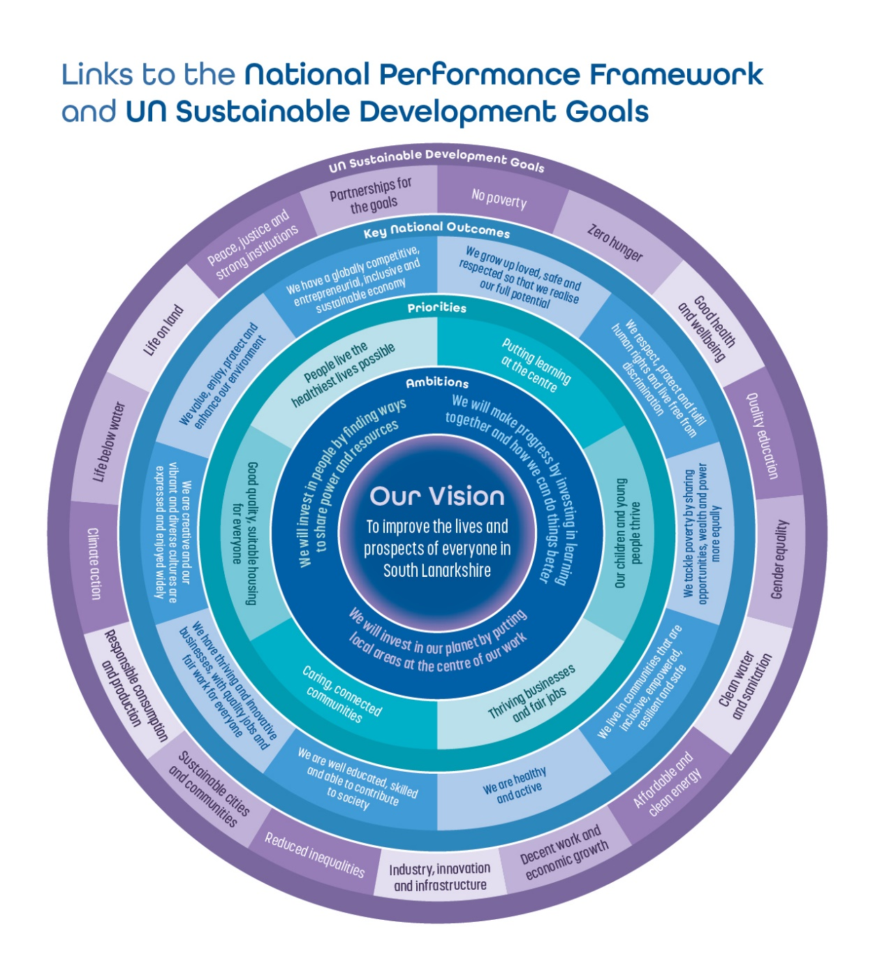

Appendix 2

CPP Structure Diagram



