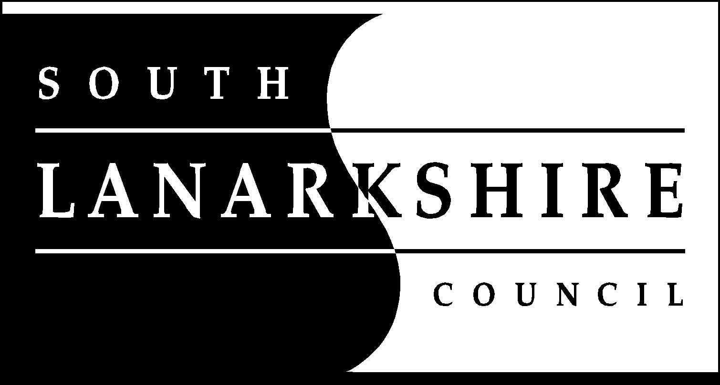
Finance and Corporate Resources

Debt Recovery Policy

If you need this information in another language or format, please contact us to see how we can best meet your needs. Phone 0303 123 1015 or email equalities@southlanarkshire.gov.uk

Contents

Introduction
Aims and objectives
Service standards
Recovery of Council Tax arrears
Recovery of Non-domestic rates
Recovery of Sundry debt
Recovery of Housing Benefit overpayments
Debt enforcement
Income collection performance monitoring
Write off of outstanding debts
Legal framework
Equal opportunities
Complaints

Introduction

This policy will become effective from 1 February 2016. While an element of the council’s overall spending is supported by Government grant, council services are also funded through taxes and a range of statutory and non-statutory service charges. Customers, citizens and businesses within South Lanarkshire Council have a responsibility to pay for the services they receive and the charges and taxes they are liable for. It is essential that all monies due to the council are actively pursued, and this document sets out the general principles to be applied in doing so.

This policy excludes the collection of council house rents which is subject to a separate policy.

The key components of this policy are: -

- Aims and objectives
- Service standards
- Recovery of arrears
- Performance monitoring and reporting

Detailed procedures have been developed to guide staff through the key processes involved.

Aims and objectives

The overall objective of the council’s debt recovery policy is to maximise income to the council by ensuring that all billing, collection and recovery action is undertaken in an economic, effective and efficient manner in accordance with legislation.

The specific aims and objectives of the policy are: -

- to ensure all customers pay in accordance with their bills/invoices or statutory instalment schemes or by agreement in accordance with regulations
- to ensure bills/invoices and adjustment notices are issued at the earliest opportunity in accordance with regulations
- to take prompt action to reduce the risk of arrears escalating and becoming unmanageable for the customer
- that the council’s approach to debts/arrears is ‘firm but fair’ and consistent for all customers
- to take appropriate and proportionate action to recover outstanding monies
- to recognise that failure to recover monies due, impacts on the council’s ability to provide key services

Service standards

A summary of South Lanarkshire Council service standards are set out below: -

- have detailed procedures that are applied consistently across the service
- ensure staff are trained to enable them to carry out their roles effectively
- ensure a wide range of accessible payment methods are available
- provide advice and guidance to customers about claiming any reduction, discount or exemption they may be entitled to
- ensure customers are aware of their responsibility to report any change in their circumstances
- ensure that customers are given the opportunity to agree an arrangement to repay arrears
- involve stakeholders, including service users, in the ongoing development of policy and procedures through consultation
- signpost customers to money advice agencies as appropriate

Recovery of Council Tax arrears

Council Tax is levied on all eligible domestic dwellings. The amount of Council Tax levied is dependent on the Council Tax band of a property. The full rate of tax is liable to be paid unless the property, owner or occupier is eligible for a reduction, discount or exemption determined by legislation. The main reasons for reduced bills include empty property and single occupancy discounts, exemptions for students and Council Tax Reduction for residents on low incomes.

The council also has a statutory duty to bill and collect domestic water and waste water charges on behalf of Scottish Water within the Council Tax demand notice.

Council Tax arrears recovery will be based on a staged escalation process in accordance with legislation.

The stages involved in this process are:-

- demand notices will be issued in accordance with regulations
- a recovery timetable will be drawn up at the beginning of each financial year
- a reminder notice will be issued after an instalment becomes overdue for payment
- a summary warrant will be issued by the Sheriff Court if full payment has not been made in accordance with previously issued notices or an appropriate payment arrangement has not been made and maintained by the Council Tax payer

Following the granting of a summary warrant the council will pass accounts to their debt management contractor for recovery of the arrears.

If a debtor is in receipt of an appropriate welfare benefit, the council will request the Department for Work and Pensions make Third Party Deductions from the debtor’s benefit, at a rate determined by legislation, to repay their arrears. This will include Water Direct requests for ongoing charges and arrears relating to Scottish Water charges which are included in the bill.

Recovery of Non-domestic rates

Non-domestic rates are levied on eligible business properties based on the rateable value of the property and the rates poundage set nationally by the Scottish Government. The full rates are liable to be paid unless the property, owner or occupier is eligible for a reduction, relief or exemption. The main reasons for reductions include empty property discounts and exemptions and charitable relief. Non-domestic rates are payable in line with the statutory instalment scheme or by agreement.

The council will ensure that all billing, collection and recovery action is undertaken
in an economic, effective and efficient manner in accordance with legislation and best practice.

- demand notices will be issued in accordance with regulations
- a reminder notice will be issued 7 days after the payment becoming due
- a final notice will be issued in accordance with statute
- a summary warrant will be sought from the Sheriff Court if full payment has not been received in accordance with the previously issued notice

Following the granting of a summary warrant the debtor will be given an opportunity to make a suitable payment arrangement. Should the debtor not make, or keep to, a payment arrangement then recovery action can be taken by the debt management contractor.

Recovery of Sundry debt

Sundry Debt is the collective term for non-statutory accounts including: -

- invoices for goods and services, such as Social Work care charges and commercial property rents
- factoring charges
- lock-up rents

Each Resource within the council is responsible for the raising and issuing of invoices to customers for payment. Each Resource must ensure that the evidence of service provided is fully validated and that the invoice is accurate and contains sufficient detail for both billing and recovery.

The council will ensure that all billing, collection and recovery action is undertaken in an economic, effective and efficient manner in accordance with legislation and that:-

  - bills will be issued timeously
  - reminder notices will be issued after 7 days of the payment becoming due
  - outstanding accounts with no repayment arrangement will be passed to the council’s debt management contractor to pursue payment on the council’s behalf
  - the council will consider raising a court action to obtain a decree

A decree is a money judgement that a creditor can obtain at court to prove that a debt exists.

Following the granting of a decree the debtor will be given an opportunity to make a suitable payment arrangement. Should the debtor not make, or keep to, a payment arrangement then recovery action can be taken by the debt management contractor.

Recovery of Housing Benefit overpayments

A Housing Benefit overpayment is an amount of Housing Benefit received by a claimant or a landlord to which that person is not entitled under the regulations. The regulations governing overpayments are set out in statute, case law and Commissioners’ decisions.

Recoverable overpayments should be sought from the person to whom benefit has been paid. This is generally the claimant, but in cases of direct payment, recovery can be sought from the landlord.

The council will ensure that all invoicing, collection and recovery action is undertaken in an economic, effective and efficient manner in accordance with legislation. Housing Benefit claimants will be issued with a decision notice advising the amount of overpaid benefit.

In the first instance overpayments will be recovered through weekly deductions from any ongoing Housing Benefit entitlement at a rate not exceeding the latest Department for Work and Pensions guidance.

In circumstances where there is no ongoing entitlement to benefit and as such it is not possible to apply a weekly deduction, the council will write to the Housing Benefit claimant requesting repayment of the debt in full. If they are unable to pay the debt in full immediately an opportunity to agree an appropriate repayment arrangement will be given.

Where no payment or contact has been made, the case will be passed to the council’s debt management contractors to pursue payment.

If a debtor is in receipt of an appropriate welfare benefit, the council may request the Department for Work and Pensions make Third Party Deductions from the debtor’s welfare benefit at a rate determined by legislation for repayment of the overpaid Housing Benefit.

The Social Security Administration Act 1992 (Section 75(7)(b)) states that:-

‘Where an amount recoverable under this section is to be recovered otherwise than by deduction from prescribed benefits, If he resides in Scotland, it may be enforced in the same manner as an extract registered decree arbitral bearing a warrant for execution issued by the sheriff court of any sheriffdom in Scotland’

The above permits a Scottish Local Authority to take measures to enforce a decision that a sum of Housing Benefit has been overpaid without having to first obtain a court decree. Should the debtor not make, or keep to, a payment arrangement then recovery action can be taken by the debt management contractor.

Debt enforcement

The different processes of debt enforcement which are available under Scottish law are referred to as diligence. A person or organisation (the creditor) can use diligence if someone who owes them money (the debtor) has failed to pay a sum due.

Where appropriate, a debtor will be served with a Charge for Payment by a Sheriff Officer, prior to the execution of diligence, on behalf of the council. The council will utilise all forms of diligence including, but not limited to:-

- attachment of Earnings – deductions are made from debtor’s wages at a rate determined by legislation
- funds attachment – attachment placed on debtor’s bank account on any funds in excess of the statutory minimum
- money attachment – permits the seizure of money belonging to the debtor (at business premises) in satisfaction of the debt

If the amount of arrears meets the statutory minimum requirement, the council may petition for sequestration or liquidation.

The council may arrange for an inhibition order to be placed on a property to prevent a debtor from disposing of the property before making payment of an outstanding debt.

Income collection performance monitoring

Income collection performance is monitored through the following reporting arrangements: -

- monthly performance report circulated to the Chief Executive, the Leader of the council and Executive Directors of Finance and Corporate Resources and Housing and Technical Resources.
- collection performance reported quarterly to the Finance and Corporate Resources Committee and Housing and Technical Resources Committee.
- collection performance reported bi-annually to Scottish Government.
- Council tax collection performance and the cost of collection of Council Tax are reported annually through the Local Government Benchmarking Framework.
- collection performance in Council Tax, Non-domestic rates and Sundry debt is reported annually through the Chartered Institute of Public Finance Accountants (CIPFA) Director of Finance Performance Indicators.

Write off of outstanding debts

The practice of writing off debts due is permitted in accordance with the council’s Financial Regulations.

Outstanding debts may be written off for deceased, sequestrated and liquidated estates and where prescribed under legislation. Debts may also be considered for write off where it is deemed uneconomical for the council to pursue. Outstanding debts may also be written off in respect of specific cases subject to the approval of the Revenues and Benefits Manager and/or the Head of Service.

All write-offs must be approved by the Finance and Corporate Resources Committee and write-offs submitted for approval quarterly.

Legal framework

The council will ensure that the Debt Recovery Policy adheres to the legislative and good practice requirements for the collection of council income. This will include complying with the following: -

- The Local Government Finance Act 1992
- The Council Tax (Administration and Enforcement) Act 1992 (Scotland)
- Local Government (Scotland) Act 1947 (as amended).
- Debtors (Scotland) Act 1987
- The Social Security Administration Act 1992
- The Bankruptcy and Diligence etc. (Scotland) Act 2007

Equal opportunities

In relation to debt recovery, this policy is consistent with our Equal Opportunities Policy and aims to ensure that we act fairly and lawfully on all occasions. We will not discriminate against anyone on the grounds of race, colour, ethnic origin, nationality, gender, sexuality, disability, age, religion or other belief.

An Equality and Diversity Impact Assessment has been carried out to ensure that the policy is inclusive and does not unfairly disadvantage any groups within the community.

A Privacy Impact Assessment has been carried out to ensure that the policy does not unfairly impact on the privacy of any groups within the community.

Ongoing monitoring of the policy will be undertaken to ensure equality objectives are achieved.

Complaints

The council operates a Complaints Procedure that is available to anyone who is not satisfied with the way in which their case has been dealt with. Details of the Complaints Procedure will be made available and accessible through our local offices, Customer Service Centre and council website.

