



The State of South
Lanarkshire’s environment

2019
Summary
The quality of the environment in which we live is important for our health and wellbeing. South Lanarkshire has a very rich and diverse environment which gives the area its unique character. Such an environment requires careful management in order to maintain and improve the area.
This is the sixth comprehensive biennial State of the Environment Report for South Lanarkshire. The aim of the report is to provide quality data that facilitates evaluation of a range of environmental issues, identifies trends and provides an overall picture of the condition or state of South Lanarkshire’s environment.
The state of the environment across South Lanarkshire is in many aspects relatively good. However, there are certain environmental issues where there is potential for improvement. These include those that can affect human health and the natural and built environment.

The health of South Lanarkshire’s people is relatively poor and below the Scottish average for some key indicators. This is particularly evident within communities identified as economically, socially and environmentally deprived. However, the difference between South Lanarkshire and the national average continues to narrow. There is well documented evidence that environmental deprivation is related to health and health behaviour. Access to good quality greenspace and the wider countryside are important in promoting healthy lifestyles. The provision of greenspace and access to the core path network varies considerably across South Lanarkshire but is generally improving.

Air quality within South Lanarkshire is considered relatively good, however, there are specific ‘hotspot’ areas closely associated with heavily congested roads where levels are poor. Traffic growth, particularly use of the private car directly contributes to poor air quality and the release of other emissions associated with climate change.

The quality of our water environment continues to improve. The Water Framework Directive illustrates the difficulties in achieving good status by some river networks. The main concerns for the water environment within South Lanarkshire are associated with diffuse pollution from historical industries and agriculture. Changes in river flows associated with higher rainfall have increased the potential for flooding, particularly in vulnerable areas.
The level of waste generated per household in South Lanarkshire is steadily reducing. The council has invested in kerbside services and is now collecting quality recycling material directly from households instead of extracting low quality materials from residual waste. This and other initiatives has resulted in a reduction of waste being landfilled. Street litter and fly-tipping is considered an environmental eyesore, affecting people’s views on the condition of their local environment. Street cleanliness continues to improve in South Lanarkshire and satisfaction levels remain higher than the Scottish average. However, incidences of abandoned vehicles reported to the council have significantly increased in recent years.

Data gaps identified in previous State of the Environment Reports continue to reduce but are still evident particularly within environmental issues relating to soils and biodiversity. Although these data gaps prevent a detailed review in those specific areas, it is hoped this will be rectified in future reports through improved monitoring. This iteration of the Report provides additional data and context relating to households, invasive non-native species and cycle data counts.
The data reported within this report will allow detailed Strategic Environmental Assessments to be conducted, inform future policy areas and, therefore, deliver sustainable policies that drive future environmental benefits.

The list of environmental issues within the summary provides an overview on each of the environmental areas covered. Further information on each of the indicators can be obtained by referring to the relevant chapter in the report.

Environmental issue | Overall status
 | Poor Fair Good
Population and human health
Scotland’s health is poor by international standards and the health of South Lanarkshire people is generally below the national average, particularly in deprived communities. There is a link between environmentally deprived areas and social-economically deprived areas. Further work is required to link wellbeing with  environmental exposure. | 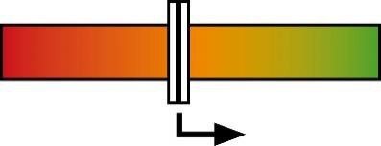
Biodiversity, fauna and flora
Most habitats across South Lanarkshire suffer from historical fragmentation and decline. The priority remains to arrest further decline and reinstate habitat connectivity, in order to sustain levels of biodiversity for the future. | 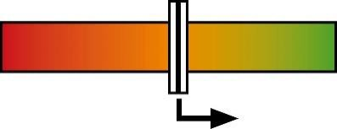
Historic and cultural heritage
The number of designated historic and built heritage assets remains generally constant, offering sustained protection. Development pressures remain the largest threat to historical  assets but processes are in place to minimise potential negative impacts. | 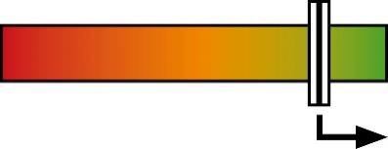
Material assets and landscape
Modernisation and redevelopment have improved local assets. Access to recreational space is promoted through cycle and path networks. Further improvements will encourage residents to make more use of the outdoors. | 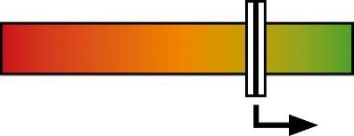
Waste
There has been a reduction in both the amount of waste generated per household and the amount disposed of via landfill. New initiatives have resulted in the collection and recycling of higher quality materials directly from households. Environmental  waste services are well used by residents. | 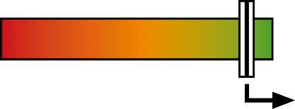
Soils
Soil quality is generally good, with continual investigation and remediation of historically contaminated sites. However, the lack of robust data reduces the ability to assess the sustainability of soil use across the area. | 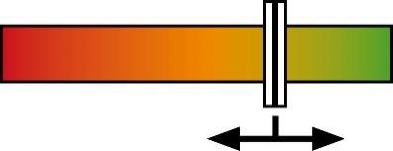
Air, noise and light
Air quality in South Lanarkshire is generally good but there are local ‘hotspot’ areas closely associated with road traffic. In total, three Air Quality Management Areas have been declared across South Lanarkshire. Noise complaints, particularly related to domestic noise, have increased in recent years. | 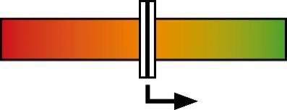
Water
Water quality is generally good and improving. Changes in river flow patterns potentially increase the flooding risk in some areas. The condition of standing water requires to be monitored. | 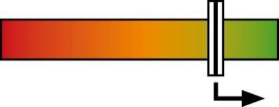
Climate change
Carbon emissions continue to decrease in South Lanarkshire and remain below the national average. Household energy consumption also decreased but is above the Scottish average.  The area’s renewable energy capacity continues to significantly increase. | 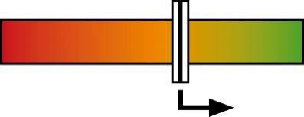
Transport
The condition of the road network is improving due to long-term maintenance investment and walking and cycling networks continue to be expanded. Continued focus is required to facilitate shifts in transport modes to more sustainable forms. | 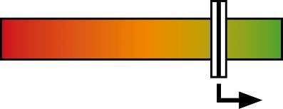

Contents

 | Introduction
 | Background
 | Strategic Environmental Assessment
 | Community Planning
 | Structure and purpose of the Report
 | South Lanarkshire area
1. | Population and human health
1.1 | General population
1.2 | Deprivation and health
1.3 | Mortality
1.4 | Mental health, learning disability, substance abuse and obesity
1.5 | Environmental deprivation
1.6 | Environmental recreation
2. | Biodiversity, fauna and flora
2.1 | Designations
2.2 | Local authority designated sites
2.3 | Woodland
2.4 | Peatland
2.5 | Invasive, non-native species
3. | Historic and cultural heritage
3.1 | Built heritage
3.2 | Gardens and Designed Landscapes
3.3 | Archaeological sites (statutory and non statutory)
3.4 | Battlefields
3.5 | Historical heritage
4. | Material assets and landscape
4.1 | Vacant and derelict land
4.2 | Recreational land
4.3 | Outdoor access
4.4 | Built facilities
4.5 | Housing
4.6 | Landscape
4.7 | Minerals
5. | Waste
5.1 | Waste generation
5.2 | Waste treatment
5.3 | Waste disposal
5.4 | Environmental waste
6. | Soils
6.1 | Soil quality
6.2 | Soil capacity
6.3 | Contaminated land
7. | Air, noise and light
7.1 | Local air quality
7.2 | Point source emissions
7.3 | Long range pollutants
7.4 | Airborne nuisance
7.5 | Noise complaints
7.6 | Light
8. | Water
8.1 | Principal watercourses
8.2 | Water quality
8.3 | River flow
8.4 | Groundwater and wetlands
8.5 | Water pollution
8.6 | Flooding
9. | Climate change
9.1 | Climate change commitments
9.2 | Greenhouse gas emissions
9.3 | Energy
9.4 | Renewable capacity
9.5 | Home energy efficiency
9.6 | Potential impacts of climate change
9.7 | Environmental awareness
10. | Transport
10.1 | Local transport issues
10.2 | Road network condition
10.3 | Traffic growth
10.4 | Congestion
10.5 | Road safety
10.6 | Public transport
10.7 | Walking and cycling
10.8 | Travel patterns of schoolchildren

Tables

1. | Population and human health
1.1 | Alcohol specific deaths in South Lanarkshire
1.2 | Drugs related deaths in South Lanarkshire
1.3 | Deaths related to probable suicide in South Lanarkshire
2. | Biodiversity, fauna and flora
2.1 | Sites of Special Scientific Interest within South Lanarkshire
2.2 | Condition status of SSSI partially or exclusively owned by SLC
2.3 | Potential Local Nature Reserves
2.4 | Woodland types in South Lanarkshire
2.5 | Lowland raised bog sites identified within South Lanarkshire
2.6 | Japanese knotweed in South Lanarkshire, September 2019
3. | Historic and cultural heritage
3.1 | Designated sites and monuments in South Lanarkshire, June 2019
3.2 | Listed Building records by category, June 2019
3.3 | Scheduled Monuments in South Lanarkshire by category, June 2019
3.4 | Buildings at Risk in South Lanarkshire
3.5 | Historic Garden and Designed Landscapes in South Lanarkshire, April 2019
3.6 | Consultations with West of Scotland Archaeology Service
3.7 | Battlefield sites in South Lanarkshire
3.8 | Visitors to museum and historic attractions in South Lanarkshire
3.9 | Visitors to Country Parks in South Lanarkshire
4. | Material assets and landscape
4.1 | Vacant and derelict land (ha) in South Lanarkshire, 2018
4.2 | Classification of greenspace per settlement area, 2008
4.3 | Provision of greenspace ha/1,000 population within settlements, 2008
4.4 | Distribution of network paths across the council areas, 2019
4.5 | Summary of path network use
4.6 | Summary of cycling path location and usage
4.7 | Undertaken and planned capital access projects by SLC, 2018 - 2020
4.8 | Housing stock by tenure and area, December 2018
4.9 | Areas covered by individual landscape character types within South Lanarkshire
4.10 | Principal mineral resources within geological areas in South Lanarkshire
5. | Waste
5.1 | Municipal solid waste collected by SLC Waste Services, (tonnes)
5.2 | Household recycling rates, (financial years)
5.3 | Household materials recycled or composted in South Lanarkshire (tonnes)
5.4 | Household and Waste Recycling Centres in South Lanarkshire
5.5 | Street cleanliness scores for South Lanarkshire
5.6 | Waste and flytipping enquiries
5.7 | Abandoned cars reported in South Lanarkshire
7. | Air, noise and light
7.1 | Air quality objectives as set out within the national Air Quality Strategy
7.2 | New diffusion tube sites for 2018
7.3 | PM10 concentrations across automatic monitoring sites, 2012 - 2018
7.4 | Annual mean NO2 monitoring results
7.5 | Designated sites that exceed critical loads in South Lanarkshire
7.6 | SSSI that exceed critical loads for both acid and nutrient deposition in South Lanarkshire
7.7 | Airborne nuisance complaints received by South Lanarkshire Council
7.8 | Noise complaints reported to SLC by area
7.9 | Type and number of complaints received regarding residential noise
7.10 | Type and number of complaints received regarding environmental noise
7.11 | Complaints about artificial light pollution
8. | Water
8.1 | Principal watercourses in South Lanarkshire
8.2 | Burns of strategic significance in South Lanarkshire
8.3 | Principal reservoirs in South Lanarkshire
8.4 | Smaller water bodies in South Lanarkshire, including covered reservoirs
8.5 | WFD water classifications for river surface water bodies (overall status), 2017
8.6 | Water bodies designated as HMWB in South Lanarkshire, 2017
8.7 | WFD water classifications for HMWB in South Lanarkshire, 2017
8.8 | WFD classifications in South Lanarkshire, 2017
8.9 | River gauging stations in South Lanarkshire, 2019
8.10 | Annual mean water flow rates
8.11 | Properties in South Lanarkshire at flood risk during medium likelihood (1:200yr) flooding scenario
8.12 | Flooding occurrences reported in South Lanarkshire
9. | Climate change
9.1 | Local CO2 emission estimates based on local consumption and capture
9.2 | Local CO2 emission estimates based on local consumption (subset)
9.3 | Carbon emissions from SLC activities and buildings, (tCO2e)
9.4 | Electricity generation and sources in Scotland (GWh)
9.5 | Hydro-electric generating capacity on the River Clyde, South Lanarkshire
9.6 | Operating and consented wind farms (4 or more turbines) in South Lanarkshire
9.7 | Participation in the Eco-schools programme in South Lanarkshire, 2018
10. | Transport
10.1 | Carriageway condition - % of network that should be considered for maintenance treatment
10.2 | Rail patronage for all South Lanarkshire stations (entries/exits)
10.3 | People who walk or cycle as main mode of transport (%)
10.4 | School pupils’ journey to school

Figures

1. | Population and human health
1.1 | National ranking on the SIMD of South Lanarkshire data zones, 2016
1.2 | Death rates for less than 75 years of age, per 10,000 population, 2017
2. | Biodiversity, fauna and flora
2.1 | Designated nature conservation sites throughout South Lanarkshire
2.2 | Distribution of woodland types in South Lanarkshire
2.3 | Distribution of ancient semi-natural woodland in South Lanarkshire
2.4 | Distribution of peatland areas throughout South Lanarkshire, 2016
3. | Historic and cultural heritage
3.1 | Distribution of culturally important designated sites and individual properties
4. | Material assets and landscape
4.1 | Total vacant and derelict land in South Lanarkshire (ha)
4.2 | Landscape character types across South Lanarkshire
4.3 | Expansion of the greenbelt within South Lanarkshire, July 2018
5. | Waste
5.1 | Municipal solid waste collected by SLC Waste Services (tonnes)
5.2 | Household materials collected in South Lanarkshire (tonnes)
5.3 | Waste sent to landfill by South Lanarkshire Council (tonnes)
6. | Soils
6.1 | Land classification across South Lanarkshire
6.2 | Progress in Environmental Protection Act 1990 (Part IIA) site investigations
6.3 | Progress of Part IIA area investigations
7. | Air, noise and light
7.1 | NO2 annual mean concentrations
7.2 | Industrial point source emissions, Part A and B processes, 2019
7.3 | Main sources of sulphur deposition on Cranley Moss SAC, 2012
7.4 | Main sources of nitrogen deposition on Cranley Moss SAC, 2012
7.5 | Total number of noise complaints reported to SLC
8 | Water
8.1 | WFD water classifications for river surface water bodies (overall status), 2017
8.2 | Distribution of WFD status of water bodies in South Lanarkshire, 2017
8.3 | Trends in annual mean water flow rates
8.4 | Main sewage treatment works in South Lanarkshire, 2015
8.5 | Potentially Vulnerable Areas of flooding in South Lanarkshire

9. | Climate change
9.1 | UK’s greenhouse gas emissions as reported against the Kyoto Protocol
9.2 | Scotland’s greenhouse gas emissions, 2017
9.3 | Electricity generation in Scotland, 2005 – 2017
9.4 | Generation by fuel type in Scotland, 2017
9.5 | Total gas consumption within South Lanarkshire, (GWh)
9.6 | Average gas consumption per metered household (kWh)
9.7 | Total electricity consumption within South Lanarkshire (GWh)
9.8 | Average electricity consumption per metered household (kWh)
9.9 | Road transport energy consumption within South Lanarkshire (tonnes of fuel)
9.10 | Total road transport energy consumption in South Lanarkshire (tonnes of fuel)
9.11 | Trends in yearly mean rainfall of two river gauging stations monitoring the River Clyde and the contributing river Duneaton Water
9.12 | United Nations Sustainable Development Goals
10. | Transport
10.1 | All fatal casualties in South Lanarkshire, 2004 - 2018
10.2 | All serious casualties in South Lanarkshire, 2004 – 2018
10.3 | Child under 16 fatal casualties in South Lanarkshire, 2004 – 2018
10.4 | Child under 16 serious casualties in South Lanarkshire, 2004 – 2018

Introduction
Welcome to this, the sixth biennial report on the different aspects of South Lanarkshire’s environment. Prepared by South Lanarkshire Council, the report uses the most recent data available from a number of internal and external sources. The data is presented to provide, where possible, time trends to assess the overall condition of the area’s environment, with narrative providing a brief description of the main environmental issues. The report extends on the initial baseline developed in 2009, provides information on the current state of South Lanarkshire’s environment and the progress being made towards a sustainable South Lanarkshire.

Background
The report provides data across a range of environmental issues, allowing individual indicators to be monitored and reported against. It, therefore, provides an ideal mechanism for monitoring the implementation of the council’s strategies, policies, plans and programmes, identifying the potential impacts these have on the local environment. The environmental issues covered in the report represent areas considered important for the Strategic Environmental Assessment (SEA) of strategies, policies, plans and programmes as set out in the Environmental Assessment (Scotland) Act 2005 (referred to as the SEA Act), and indicators include those identified within the South Lanarkshire Community Plan and Local Outcomes Improvement Plan.

Strategic Environmental Assessment
Scotland implemented the requirements of the European Council SEA Directive (2001/42/EC) through the Environmental Assessment (Scotland) Act 2005. The SEA Act requires the council to undertake a Strategic Environmental Assessment (SEA) on a wide range of plans to ensure that all aspects of the environment are considered during the decision-making and plan-making processes.
‘SEA is a means to judge the likely impact of a public plan on the environment and to seek ways to minimise that effect, if it is likely to be significant. SEA therefore aims to offer greater protection to the environment by ensuring public bodies and those organisations preparing plans of a ‘public character’ consider and address the likely significant environmental effects’. SEA Guidance, The Scottish Government, 2013

The data presented in this report provides the environmental baseline for identifying local issues and provides an overview of environmental conditions. This allows individual policy areas to be appraised against locally identified environmental issues. The use of indicators and the analysis of the trends within, and across the datasets provide a monitoring mechanism which enables the council to monitor the environmental consequences of individual plans.

Community Planning
The Community Empowerment (Scotland) Act, 2015 placed a duty on the South Lanarkshire Community Planning Partnership to prepare and implement a Local Outcomes Improvement Plan (LOIP) and associated Locality Plans (known as Neighbourhood Plans in South Lanarkshire) from 1 October 2017. The LOIP replaces the South Lanarkshire Community Plan and the Single Outcome Agreement.
The Scottish Government’s single overarching purpose is ‘to focus government and public services on creating a more successful country, with opportunities for all of Scotland to flourish, through increasing sustainable economic growth’. National Performance Framework

The principal aim of the Community Plan is set out in the Partnership’s vision, ‘To improve the quality of life for all in South Lanarkshire by ensuring equal access to opportunities and to services that meet people’s needs’. The overarching objective of the Community Plan is to ‘Tackle deprivation, poverty and inequality’.
Many of the challenges and opportunities facing South Lanarkshire and its communities can only be delivered through a longer-term approach. The Community Plan and Neighbourhood Plans will help to deliver improvements in those areas of activity seen as presenting the greatest challenges and opportunities. This report can be used to identify appropriate environmental challenges facing South Lanarkshire, reflecting the environmentally-based ‘National Indicators’. It, therefore, provides a means of reporting on information covered within the Community Plan and associated plans. The council’s other reports, EASL (Economic Audit of South Lanarkshire) and HASSSL (Health and Social Situation in South Lanarkshire) provide information covering the economic and social indicators.

Structure and purpose of the Report
The report is structured around chapters which consider the environmental issues that affect South Lanarkshire. These reflect the environmental factors within the SEA process as well as transport. These cover all the relevant aspects of the environmental baseline that support the monitoring and environmental appraisal of local issues within SEAs and council plans, policies and strategies. The individual chapters are:
- Chapter 1: Population and human health
- Chapter 2: Biodiversity, fauna and flora
- Chapter 3: Historic and cultural heritage
- Chapter 4: Material assets and landscape
- Chapter 5: Waste
- Chapter 6: Soil
- Chapter 7: Air, noise and light
- Chapter 8: Water
- Chapter 9: Climate change
- Chapter 10: Transport

Data in the report is primarily from information held within the council. Further information has been accessed from the Scottish Government and other agencies, including the Scottish Environment Protection Agency (SEPA), Scottish Natural Heritage (SNH), Historic Environment Scotland (HES) and Scottish Passenger Transport (SPT). The data presented is the most recent available in order to provide a clear baseline assessment of the state of South Lanarkshire’s environment for the period covered by this report.

South Lanarkshire area
South Lanarkshire spans through central and southern Scotland, straddling the upper reaches of the River Clyde from the City of Glasgow boundary extending into the Southern Uplands. Covering 1,772 square kilometres, South Lanarkshire is the eleventh largest authority area in Scotland and with an estimated population of 318,170 people is the fifth largest population-based local authority in Scotland.

South Lanarkshire’s environment is diverse, ranging from the more urbanised landscape in the north through to a mixture of rolling farmland and river valleys and down to the southern fringes dominated by the Lowther hills. This diverse mix of urban and rural environments covers four main areas:

- Clydesdale
- East Kilbride
- Hamilton
- Cambuslang and Rutherglen.
The major settlements are in the north of the area and include the former county town of Hamilton, the ‘new town’ of East Kilbride, the Royal Burgh of Rutherglen and the towns of Cambuslang and Blantyre. Historical market towns include Lanark and Strathaven. There are a number of historic villages including Douglas and Biggar and former mining settlements such as Forth and Carluke.

Figure 1: Map of South Lanarkshire

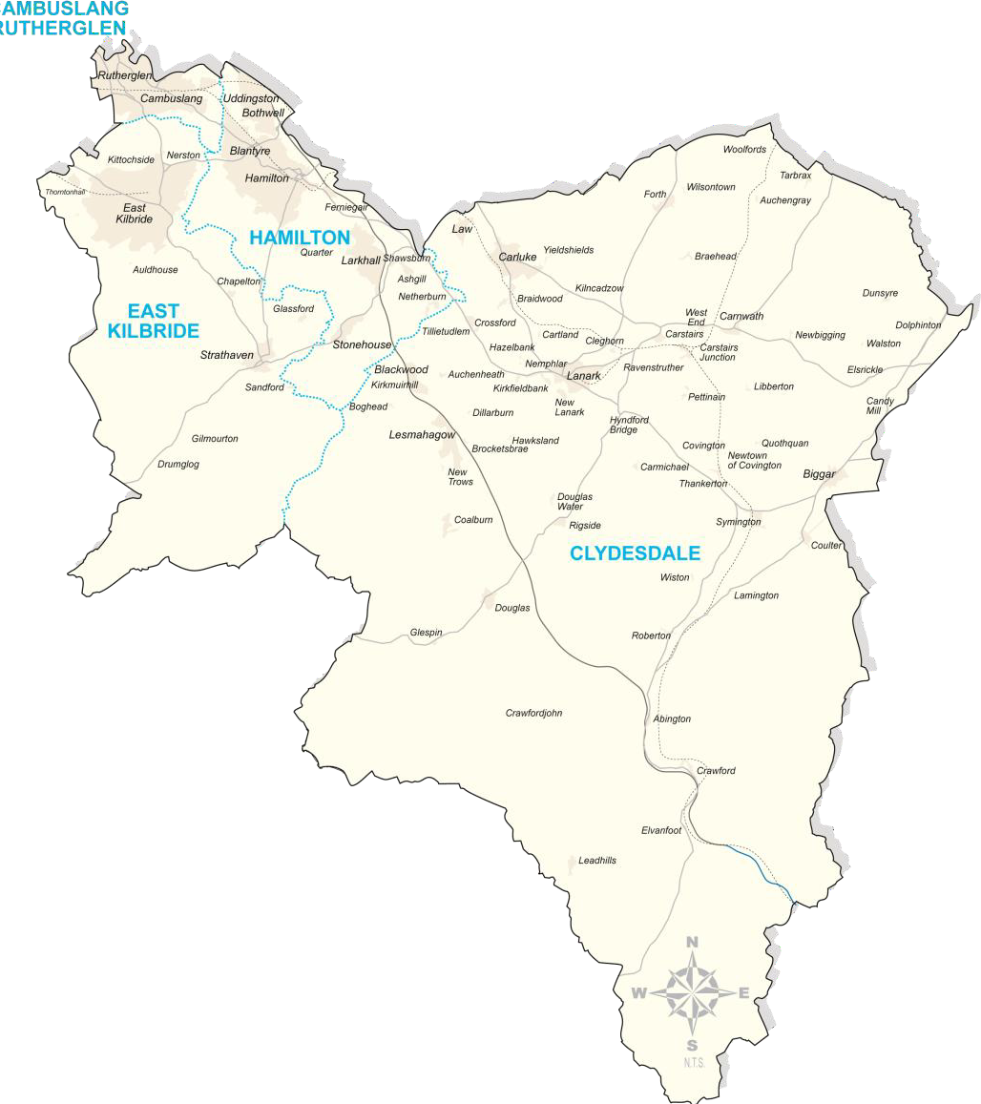
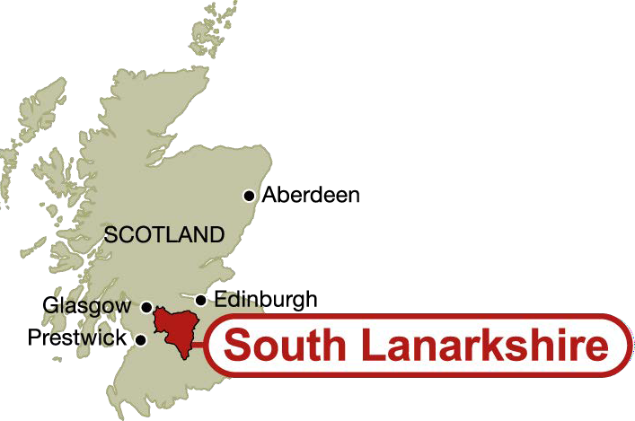

Population and human health
SEA objectives that relate to human health
Protect and sustain human health.
Improve human health and community wellbeing.
South Lanarkshire is one of Scotland's most diverse areas. It has a population of about 319,020 and covers 1,772 square kilometres of land. It consists of heavily populated urban areas to the north and an extensive rural area to the south and west. Many parts of the area experience an excellent quality of life with good employment prospects, high standards of health care and low levels of crime. However, some areas of South Lanarkshire bear testimony to the legacy of heavy industrialisation which has impacted on the physical, social and economic environment. There are pockets of serious deprivation within both urban and rural areas where people may experience disadvantage and encounter problems associated with low income, poor health, low educational attainment, lack of access to learning opportunities and employment and low expectations.

Human health depends on a number of general and local environmental factors, including access to services such as health, education, safety, access to good quality outdoor recreational facilities and a high quality environment, with good quality air, soil and water. Influences such as income, nutrition, occupation, housing conditions, sleep, weight and culture can additionally make a difference to the overall good health and wellbeing of the population.

Health and social care in South Lanarkshire is co-ordinated through the Integration Joint Board (IJB). Collectively, and under the direction of the IJB, the South Lanarkshire Health and Social Care Partnership have an agreed vision – ‘Working together to improve health and wellbeing in the community – with the community’.
Supporting people to improve their health and wellbeing sits within the context of ‘Equally Well’, the ‘Early Years Framework’ and ‘Achieving Our Potential’ which set out the Scottish Government’s approach to tackling the major and intractable social problems that affect the people of Scotland. It has been recognised that to tackle health inequalities a range of early interventions and initiatives that are person centred and delivered through an empowering self-management approach are necessary. Tackling health inequalities and increasing physical activities remain as priority themes within the Local Outcomes Improvement Plan for the residents of South Lanarkshire.
‘To improve the quality of life for all in South Lanarkshire by ensuring equal access to opportunities and to services that meet people’s needs’.
South Lanarkshire Community Plan, Vision

It is recognised that people living in more deprived areas suffer greater health inequalities and that those inequalities have a clear link to their overall health and wellbeing with significant differences in people’s health across those communities. Programmes such as Weigh to Go, Physical Activity Prescriptions, Keep Well Anticipatory Health Screenings and Get Walking Lanarkshire all create opportunities to support good health.
A summary of the indicators used in assessing the state of South Lanarkshire is presented, highlighting the current status of each indicator and the directional trend.
The Current status is shown by the following colours: The trend direction is shown with the following arrows:
G | Good | F | Fair | Improving
 |  |  |  | No change
P | Poor |  | Limited data | Deteriorating
Note: The most recent data available was used in assessing the
environmental indicators

Indicator | Current status | Trend direction | Explanation
General Population | F |  | Population – The area’s population is growing at a faster rate than the Scottish average, with the proportion of older  population showing the greatest increase. However, the population of people aged less than 25 years is declining.
General Population | G |  | Life Expectancy (male) – Life expectancy for men has  increased over recent years and is comparable with the Scottish average.
General Population | G |  | Life Expectancy (female) – Life expectancy for women has increased in recent years, and is just below the Scottish average.
Health | P |  | Coronary heart disease – Remains a major source of early  or premature deaths. The South Lanarkshire mortality ratio is slightly lower than the Scottish average.
Health | P |  | Cancer – Continues to be the main cause of death for those  aged less than 75 years. Death rates are slightly higher than the Scottish average.
Health | P |  | Stroke – Remains a major cause of death for those aged  less than 75 years. Strokes accounted for fewer deaths in South Lanarkshire when compared to Scotland as a whole.
Alcohol Related Deaths | P |  | The number of alcohol related deaths has remained consistent over recent years.
Healthy Lifestyles | F |  | Lifestyle – No new data is available on the number of residents who report on their health condition/status.
Healthy Lifestyles | F |  | Environmental Deprivation – There is a relationship  between those areas suffering from environmental deprivation and low SIMD score. No new data is available.
Healthy Lifestyles | F |  | Environmental Recreation – Although the rate of South Lanarkshire residents undertaking recreation activities is low, there is continuous improvement in their rate of participation.

Baseline situation
Life expectancy is increasing in South Lanarkshire but remains slightly below the Scottish average. South Lanarkshire’s health status has improved compared to the Scottish average for many key indicators of health. Cancer, coronary heart disease and stroke account for the majority of deaths in South Lanarkshire. However, the proportion of deaths from cancer is lower than in Scotland overall. In South Lanarkshire the number of alcohol related deaths has remained consistent over recent years, however, the proportion of drugs related deaths relative to the national average has significantly increased.
Similar to the national pattern there are significant differences between communities across South Lanarkshire in terms of health outcomes. These health inequalities pose a major challenge for all community planning partners as we look to improve health both at population level and within our more deprived communities. Within these communities, many people are physically disadvantaged with reduced physical activity. The local environment plays a key role in contributing to the overall wellbeing of the population.

General population
According to the 2018 mid year estimate, South Lanarkshire is home to around 319,020 people, with 77% living in urban and 23% in rural areas. The area’s population has grown over the past 20 years, although this has been slower than the Scottish average and is forecast to increase to 323,400 by 2024 and 327,965 by 2034.1 This overall growth masks proportionally higher growth rates for those aged over 70 and 80, and a decline in the population aged less than 25.

1 National Records of Scotland, Population projections by administrative area, based on 2016 mid year estimates
In the period since 2004 - 2006, life expectancy at birth has increased from 74.4 to 76.8 years for men and from 79.3 to 80.7 years for women. This compares to Scottish life expectancy of 77.1 years (74.6, 2004 - 2006) for men and 81.1 (79.5, 2004 - 2006) for women2.

Households
National Records of Scotland estimate that there are 147,4713 households in South Lanarkshire. 32.7% in Hamilton, 28.8% in East Kilbride, 19.3% in Rutherglen and Cambuslang and 19.1% in Clydesdale. Estimates indicate 3,635 vacant dwellings and 246 properties used as second homes.

Density of habitation
Overall, South Lanarkshire has a population density of 180 persons per square kilometre. However, this varies considerably across the area from a high of 2,429 persons per square kilometre in Rutherglen to 46 persons per square kilometre in Clydesdale4.

Ethnic composition
Of the population of South Lanarkshire on Census Day, (27th March 2011), the 7,205 people from minority ethnic communities accounted for 2.3% of the total. This compares to 4% in Scotland as a whole. In South Lanarkshire, 91.6% reported themselves as White Scottish, above the Scottish average of 87.4%. South Lanarkshire has relatively more of its population in the White Scottish and African: Non Scottish/British population than Scotland as a whole and significantly less from the Polish community and the African: Scottish or British and Arab communities. Of South Lanarkshire’s minority ethnic community population, 72% were from Asian ethnic backgrounds, compared to only 67% in Scotland as a whole.

Those from minority ethnic communities in South Lanarkshire tended to be significantly younger than those from the main white ethnic communities – only 4.2% were aged 65 or over, compared to 17% from the white ethnic communities. Unlike the overall situation, where the female population was greater than the male, for those from minority ethnic communities in South Lanarkshire, there were more men than women.

Economic activity and land use
The employment forecasts show that the number of jobs in South Lanarkshire is expected to grow over the 2019 to 2029 period by 1,800 to 133,600, an increase of 1.4%, against an increase of 3.6% over the same period in Scotland as a whole. Both part time and self employment are forecast to grow, with greater increases in self employment. Full time employment is forecast to decline. In relation to gender, the forecasts indicate that by 2024 more men will hold jobs in South Lanarkshire than women but the gap will decrease by 2029. Even so, men will predominately hold full time jobs, while a significant proportion of women will be in part time jobs.
Although the forecasts are for an increase of 1,800 in South Lanarkshire jobs over the 2019 to 2029 period, it is estimated that an additional 51,600 job opportunities will be generated through retirements and people progressing into higher skilled jobs and creating vacancies. This will create significant numbers of job opportunities in relation to professional occupations, personal service occupations and associate professional and technical occupations. Of the occupations created, only 5.5% will require people with no qualifications, with 30% requiring a degree and a further 8.3% requiring a professional qualification.

At an industry level, in absolute terms, the largest increase over the 2019 to 2029 period is forecast for residential and social care, up by 2,000, followed by increases of 900 in education, 700 in health, 400 in business support services, and 300 n both wholesale trade and in architectural and engineering services. The largest absolute falls are forecast for public administration and defence, down by 2,700, in metals and metal products, down by 400 and falls of 200 in media, land transport and in other manufacturing and repair.

2 National Records of Scotland, Life expectancy for areas in Scotland 2014 - 2016
3 National Records of Scotland, Household estimates 2018
4 National Records of Scotland, Based on 2018 mid year estimates
Over the 2019 to 2029 period, the largest increase in employment in South Lanarkshire is forecast to be in professional occupations, up by 3,200, with 2,000 more in personal service occupations and 1,700 in managerial and senior officer occupations. In percentage terms, the largest rises are of 15.9% for professional occupations, 14.5% in personal service occupations, 13.9% in, managerial and senior officer occupations, and 6.8% in associate professional and technical occupations. A total of 2,000 jobs are expected to be lost in skilled trade occupations in South Lanarkshire over this period, with a decline of 1,900 in the number of administrative, clerical and secretarial occupations and 1,500 in the number of process plant and machine operative jobs.
These represent declines of 12%, 13.1% and 14%, respectively.

In 2017, the number of people who were economically active (the proportion of people of working age who are in, actively seeking or available for work), aged 16 years and over in South Lanarkshire was estimated at 159,100, the lowest number recorded since 2008 and the second consecutive annual decline. This meant that 61.5% of the total 16 years and over population of South Lanarkshire were economically active in 2017, the lowest figure ever recorded since at least 2004. The South Lanarkshire rate in 2017 was slightly below the Scottish rate of 61.9%. This is the first time since 2009 that the South Lanarkshire rate has been below the Scottish average. For the first time ever recorded, there were more women who were economically active in South Lanarkshire than men but the male economic activity rate was higher than the female rate, as it has always been.

In 2017, nearly nine-tenths of the land area of South Lanarkshire was designated as being severely disadvantaged in agriculture terms, with just under a further tenth designated as disadvantaged. Just under half (45%) was cultivated grassland and a further 40% was used for rough grazing. The land used for growing grains and stock feed has been falling but recently the amount used to grow vegetates and potatoes has been rising. The area in woodland has increased over the longer term but over recent years it has been declining. The overall agricultural workforce rose in 2017 for the first time since 2012. There continues to be a shift towards fewer family members working on farms and more hired staff. In 2017, 34.6% of workers were hired non-family workers, the highest proportion ever recorded since at least 1995. Family involvement has become more part time and more hired and over the longer term, the number of full time farmers has declined significantly. The most recent figures show particular growth in casual and seasonal employment.

Deprivation and health
While it may be possible to demonstrate causal relationships between distinct elements of the environment, for example, air quality and health, there is a growing bank of evidence on the ways in which the wider social, economic and physical environment impacts on health. These in turn are linked to multiple deprivation as there is a direct correlation to multiple deprivation and poorer health status and health outcomes throughout life.
In recent years there has been a more pronounced interest in health inequalities, that is, the difference within and between communities in health and health outcomes. The stresses of everyday life associated with poverty and poor environments have a lasting impact on the body’s physiology which can result in poorer health and earlier death than those living in more affluent circumstances. This relationship between environment and health is recognised by the national Healthy Environment Network set up to examine ways in which health protection, environmental concerns and health improvement can work together to bring about improvements in health outcomes for individuals in our communities. This has led to the development of what is being termed ‘ecological public health’. This term has been used to characterise an era underpinned by the idea that, ‘when it comes to health and wellbeing, everything matters'.5

Work initiated by the Chief Medical Officer and the Glasgow Centre for Public Health examined the relationship between socio-economic status on health over the life course. The evidence was clear

5 Morris, G.M., “Ecological public health and climate change policy”, Perspectives in Public Health, Vol. 130, No. 1, 34-40 (2010)
that poorer health is more common in disadvantaged members of the community and this is consistent on an international basis. Part of this can be associated with lifestyle choices such as unhealthy diet, lack of exercise, tobacco and drug use and has become strongly associated with social disadvantage. However, this does not explain all of the differences in health outcomes.
‘Today’s issues (around place) are less about toxic or infectious threats but rather the capacity of ugly, scarred, threatening environments to foster hopelessness and stress, discourage active healthy lives and healthy behaviours’ Sir Harry Burns, former Chief Medical Officer for Scotland

Social inequality itself is consistently associated with higher levels of mortality regardless of the measure of social position used and even after controlling for other risk factors. Moreover, it also appeared that the risk of mortality builds up over the years and that exposure to risk factors may even occur many years before the development of the outcome. Studies note the importance of childhood as a predictor for health outcomes in adulthood6. The Glasgow study built on this research but focussed on the ways in which the body changed as a result of stresses inherent in the wider environments in which people lived, particularly those that resulted in higher risk factors for specific conditions and earlier death.
The study further reinforces the evidence that people in poorer communities have poorer health than people who live in more affluent areas. It shows that the impact of early life circumstances and low socio-economic status in childhood on the accumulation and development of risk factors for poor health outcomes as an adult. This was seen in terms of mortality from coronary heart disease and a number of tests for cognitive development. A main conclusion of the report is the need to recognise the conditions in which people are born, grow, live, work and age are fundamental to understanding the causes of health inequalities and how we can address them.
In general, the health of people living in South Lanarkshire and the Scottish population is similar. However, health inequalities can be significant when considered at smaller geographical levels. There are clear links between poor health and poverty and deprivation. Life expectancy is lower and people in deprived areas are more likely to die from coronary heart disease, stroke and cancer than those in more affluent areas. Some of this is linked to lifestyle as people in deprived circumstances are more likely to smoke, drink more than the recommended levels of alcohol, have a diet high in fat and low in fruit and vegetables and to take low levels of exercise. However, this alone does not account for the differences in either morbidity or mortality in more deprived areas.

Deprivation is measured nationally using the Scottish Index of Multiple Deprivation (SIMD). The most recent SIMD produced in 2016 (Figure 1.1) analyses deprivation using indicators across seven key domains:
- Employment
- Income
- Education, skills and training
- Health and disability
- Housing
- Access to services
- Crime.

6 Glasgow Centre for Population Health, http://www.gcph.co.uk/assets/0000/0406/GCPH_BP_8_concepts_web.pdf

Figure 1.1: National ranking on the SIMD of South Lanarkshire data zones, 2016
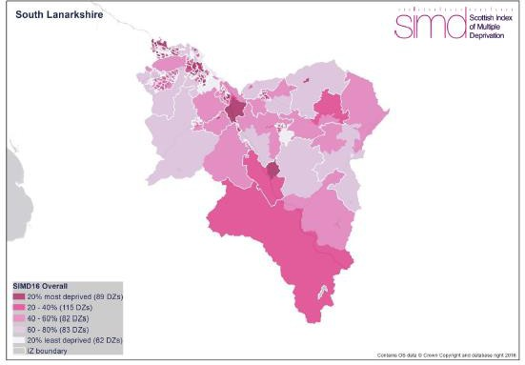

Key facts regarding South Lanarkshire:

    - 6,971 data zones have been identified in Scotland of which 431 (6.18%) are in South Lanarkshire.
    - SIMD 2016 shows that 62 (14.4%) data zones in South Lanarkshire are among the 15% most deprived in Scotland. The majority of these are in the Hamilton area (17), followed by Rutherglen (15), Cambuslang (10), Blantyre and Larkhall (7 each). This accounts for 5.94% of the worst 15% data zones in Scotland.
    - South Lanarkshire had more data zones in the 5% most deprived in Scotland than in any other previous SIMD.
Although environmental quality is not used as a measure, elements are implicit in a number of these domains, for example, housing, access to services and health.
In South Lanarkshire, life expectancy at birth in the 20% most deprived areas is 72.1 years for men. This is 5.2 years less than those born in the rest of the area (77.3 years). No matter where men are born they are expected to have shorter lives than women.

South Lanarkshire Health and Social Care Partnership data indicates that the number of people with one or more long term health conditions (LTHC) in South Lanarkshire has increased:

      - 21,827 people aged 65-74 had one or more LTHC in 2014/15 rising to 23,553 in 2017/18 (+7.9%).
      - 15,852 people aged 75-84 had one or more LTHC in 2014/15 rising to 16,628 in 2017/18 (+4.9%).
      - 6,060 people aged 85+ had one or more LTHC in 2014/15 rising to 6,703 in 2017/18 (+10.6%).
Within this, the long term health conditions with the most significant prevalence and projected increases between 2017/18 and 2022/23 were:
      - People with chronic liver disease are projected to increase by 6.6%
      - People with renal failure are projected to increase by 6.1%
      - People with asthma are projected to increase by 6%.
      - People with chronic obstructive pulmonary disease are projected to increase by 5.8%.
      - People with diabetes are projected to increase by 5.7%.

Mortality

Death rates
In Scotland, coronary heart disease, cancer and stroke continue to affect and shorten the lives of many people. South Lanarkshire’s profile echoes the national picture. The most recent figures indicate that hospital admissions for heart disease continue to be lower than the national average.
Within South Lanarkshire there are also differences in death rates between different areas. In terms of death rates for those under 75 years, South Lanarkshire is slightly above the national average per 10,000 for ischaemic heart disease, cerebrovascular disease and deaths from all causes but slightly below the national average for deaths from cancer. This is shown in Figure 1.2.

Figure 1.2: Death rates for less than 75 years of age per 10,000 population, 2018

50
43.9 43.4
South Lanarkshire
Scotland
15.5 15.8
5.45.0
2.11.7
45
Rate per 10,000 population
40
35
30
25
20
15
10
5
0
Total Deaths < 75 All Causes

Total Deaths < 75 Cancer

Total Deaths < 75 Ischaemic heart disease

Total Deaths < 75 Cerebrovascular
Source: National Records of Scotland

Source: National Records for Scotland

When used as a proxy measure for poor health, death rates for those less than 75 years of age are taken rather than those for all ages. This is because death for people aged less than 75 is taken to be early or premature death and a sign of poorer health during life. Despite improvements in health over recent years, Scotland continues to have higher than average death rates compared with the rest of the UK and Europe.

In 2017, 3.95% of all deaths in South Lanarkshire were due to strokes. This was the second lowest proportion recorded for South Lanarkshire since at least 1999 but the first increase since 2013.
Compared to Scotland (3.65%) as a whole, relatively more deaths in South Lanarkshire were accounted for by strokes in 2017 (3.95%). Only in 2009 and 2016 has this not been the case.

In 2017, cerebrovascular disease accounted for 7.24% of all deaths in South Lanarkshire. This is the lowest share ever accounted for since at least 1999 and is the third consecutive annual decline
in its share. In Scotland as a whole, cerebrovascular disease accounted for 6.8% of all deaths in 2017.

In 2017, deaths from cancer accounted for 28.1% of all deaths in South Lanarkshire. This was the third lowest percentage since 2009 but the share of deaths from cancer was still above its share in the early 2000s. Compared to Scotland as a whole, in 2017 cancer accounted for a higher proportion of all deaths in South Lanarkshire than in Scotland – 28.1% against 27.8% in Scotland as a whole.
In 2017, coronary heart disease accounted for 11.7% of all deaths in South Lanarkshire, the second lowest ever share since 2004 and the first increase since 2013. In Scotland as a whole, it accounted for 11.6% of all deaths. Since 2011 until 2017, coronary heart disease has accounted for slightly fewer deaths in South Lanarkshire than in Scotland as a whole but in 2017 the reverse was the case.

Alcohol related deaths
In 2017, a new definition of alcohol related deaths was introduced – ‘Alcohol Specific deaths’. These are deaths which are known to be direct consequences of alcohol misuse, meaning they are wholly attributable to alcohol misuse. The figures for alcohol deaths do not include all deaths which may be caused by alcohol, for example, they do not include deaths as a result of road accidents, falls, fires, suicide or violence involving people who had been drinking; or from some medical conditions which are considered partly attributable to alcohol, such as certain forms of cancer.
In 2018, there were 73 alcohol specific deaths in South Lanarkshire – the largest number since 2016 and equalling the second highest since 2011. South Lanarkshire accounted for 6.43% of all Scottish alcohol specific deaths in 2018, its second lowest share since 2013. Only 2017 was lower.

Table 1.1: Alcohol specific deaths in South Lanarkshire
Year | South  Lanarkshire | % Scotland
2000 | 56 | 4.90%
2001 | 56 | 4.56%
2002 | 78 | 5.85%
2003 | 74 | 5.47%
2004 | 94 | 7.06%
2005 | 91 | 6.72%
2006 | 81 | 5.72%
2007 | 71 | 5.54%
2008 | 77 | 5.85%
2009 | 68 | 5.76%
2010 | 65 | 5.49%
2011 | 76 | 6.70%
2012 | 67 | 6.92%
2013 | 56 | 5.59%
2014 | 73 | 7.05%
2015 | 69 | 6.60%
2016 | 85 | 7.46%
2017 | 69 | 6.16%
2018 | 73 | 6.43%
Source: National Records of Scotland

Drugs related deaths
In 2018, there were 58 drug related deaths in South Lanarkshire, the second highest number ever recorded since at least 1996, only 2016 was greater. South Lanarkshire accounted for 4.89% of all Scottish drug related deaths in2018, its lowest share since 2015 and the second consecutive decline in its share. Its share in 2018 was the second lowest since 2009, as reflected in Table 1.2.

Table 1.2: Drugs related deaths in South Lanarkshire
Year | South  Lanarkshire | Scotland | % Scotland
2000 | 12 | 292 | 4.11%
2001 | 16 | 332 | 4.82%
2002 | 14 | 382 | 3.66%
2003 | 8 | 317 | 2.52%
2004 | 17 | 356 | 4.78%
2005 | 16 | 336 | 4.76%
2006 | 22 | 421 | 5.23%
2007 | 31 | 455 | 6.81%
2008 | 23 | 574 | 4.01%
2009 | 19 | 545 | 3.49%
2010 | 26 | 485 | 5.36%
2011 | 34 | 584 | 5.82%
2012 | 29 | 581 | 4.99%
2013 | 37 | 526 | 7.03%
2014 | 34 | 613 | 5.55%
2015 | 31 | 706 | 4.39%
2016 | 64 | 868 | 7.38%
2017 | 49 | 934 | 5.25%
2018 | 58 | 1,187 | 4.89%
Source: National Records of Scotland

Probable suicides
In 2017, there were 33 deaths in South Lanarkshire caused by ‘intentional self-harm or events of undetermined intent’. This is the lowest number recorded since 2012. In 2017, South Lanarkshire accounted for 4.85% of all such deaths in Scotland as a whole, its lowest share since 2013 and its second lowest ever since 2011. This is reflected in Table 1.3.

Table 1.3: Deaths related to probable suicide in South Lanarkshire
Year | South Lanarkshire | Scotland | % Scotland
2011 | 49 | 889 | 5.51%
2012 | 46 | 830 | 5.54%
2013 | 34 | 795 | 4.28%
2014 | 40 | 696 | 5.75%
2015 | 34 | 672 | 5.06%
2016 | 44 | 728 | 6.04%
2017 | 33 | 680 | 4.85%
Source: National Records of Scotland

Mental health, learning disability, substance abuse and obesity
The prevalence of substance abuse and smoking is also more pronounced in the most deprived areas, impacting on the overall health and wellbeing outcomes for people who live in these areas. Preventative services that include Stop Smoking reach into these and other communities to encourage people to quit the habit. For example:

    - There were 571 referrals for drug/alcohol treatment in 2018 – 2019 across South Lanarkshire with 93% of those starting treatment within three weeks of the referral.
    - Smoking rates for mothers-to-be was 27.4% (2017 – 2018) in the 15% most deprived areas, significantly higher than the South Lanarkshire average of 16.5%.

Similarly, the occurrence of mental health issues is more frequent in the most deprived areas. One in four people will experience poor mental health at some point in their life and there are no age, culture or gender barriers to being affected by mental health issues. For example:
    - In South Lanarkshire 21.4% (2017 – 2018) of the population are being prescribed drugs for anxiety, depression or psychosis, 2.9% above the Scottish average.
    - The 2011 Census reports that 4.4% of the area’s population have mental health issues and
3.1% are recorded as having a learning disability.

Obesity is associated with the development of a range of illnesses, including diabetes, coronary heart disease and cancer. Research informs us that obesity in South Lanarkshire is a significant issue, and that there are, on average, more people overweight or obese in the area that in the rest of Scotland. The Healthy Weight Strategy promotes a range of locality and South Lanarkshire wide projects and programmes to support and engage people to achieve a healthy weight. The council is currently preparing the South Lanarkshire Food Strategy which will also encourage healthy eating. In South Lanarkshire:
    - Over 65% of the population are overweight or obese. It is projected that 40% of the adult population will be obese by 2035.
    - In the most deprived areas just 30% of children eat fruit and vegetables every day compared to 50% in least deprived areas.

Environmental deprivation
The evidence linking environmental improvements to improved health outcomes is mixed. For example, there is limited evidence to demonstrate a causal relationship between improvements to quality housing and illness such as asthma. However, other evidence is more robust. The Healthy Environment Network noted clear evidence between exposure to elements such as pollutants from industrial or transport sources, tobacco smoke, allergenic agents and the level of household warmth to coronary heart disease, stroke and some cancers. Work on mental health and wellbeing also demonstrates the relationship between the natural environment and positive mental health.
The following environmental issues may have an impact on human health:
    - Environmental Incivilities, such as noise, litter and rubbish, and dog fouling, leading to environmental injustice.
    - Noise, dust and nuisance elements relating to development or improvement work.
    - Availability of fuel as a result of fuel poverty or rural isolation which can increase the risk of heart attack and stroke especially among older people.
    - Fear of crime and wider community safety issues, including home safety.
    - Access to greenspace and the quality of that greenspace, safe areas to play, walking and cycling paths for commuting and leisure and the need to feel safe while enjoying, for example, country areas, urban parks and woodlands.
    - The volume of traffic and associated noise and pollutants.
    - Access to services, including public transport, medical centres, shops, is an issue for rural areas and new urban/sub-urban developments.

Environmental recreation
Recreation has many health benefits, with recreational therapy taking advantage of this through care of the elderly, the disabled, or people with chronic diseases. Physical activity through recreational activities is important to reduce obesity and other health risks. Recreation is an essential part of human life and finds many different forms which are shaped naturally by individual interests but also by the environment we live in. Therefore, public space such as parks and the correct level of access to the wider countryside are essential for many recreational activities.
Recreation is considered as an activity of leisure, which is a form of discretionary time for individuals and therefore the ‘need to do something for recreation’ is an essential element of human biology and psychology, and is often pursued for enjoyment, amusement, or pleasure.

Scottish Natural Heritage measures the levels of participation in walking and other outdoor recreational activities through Scotland’s People and Nature Survey (SPANS). The survey was first undertaken in 2013 and repeated in 2017/ 2018 when the survey content was reduced to include
only questions on participation in outdoor recreation and the associated health and wellbeing benefits. Unfortunately, data is not available to local authority level.

Both iterations of the survey found that 82% of the Scottish adult population had visited the outdoors for recreation in the twelve months prior to being interviewed. This is an increase from the proportion reported in the 2012 Scottish Recreation Survey (79%). The estimated volume of visits to the outdoors taken by adults in Scotland between May 2017 and April 2018 was 546.5 million, a significant increase on the 2013/2014 figure of 395.8 million and the highest annual figure ever recorded.

The Scottish Household Survey indicates that in 2017, in South Lanarkshire, 34% of respondents said they had visited the outdoors for recreation at least once a week in the previous twelve months. Although this participation rate is lower than the Scottish average (52%), it reflects an improvement from previous years when South Lanarkshire had the lowest participation level of all 32 Scottish local authorities. In 2017, the increase in participation levels meant that South Lanarkshire improved its position to 30th, nationally.

NHS Lanarkshire, in partnership with North and South Lanarkshire Councils introduced a ‘Get Walking Lanarkshire’ initiative to improve the health and wellbeing of residents by getting more people walking more often. In 2016, 2,500 South Lanarkshire residents participated in these health walks, with 3,295 participants in 2017 and 3,713 participants in 2018. Get Walking Lanarkshire is part of the Lanarkshire Green Health Partnership which is helping to make more use of Scotland’s outdoors as Our Natural Health Service. Our Natural Health Service is a national initiative led by Scottish Natural Heritage and supported by national and local partners including: Transport Scotland, Scottish Forestry and NHS Health Scotland, and locally by the health board, North and South Lanarkshire Councils and voluntary sector organisations.

Biodiversity, fauna and flora
SEA objectives that relate to biodiversity
Enhance local biodiversity.
Protect and promote the favourable conditions of designated and locally important habitats.
Biodiversity plays a key role in the functioning of ecosystems and supports our lives through the provision of crucial resources like fresh air, clean water and food. 'Biological diversity' encompasses all the species of plants, animals, and micro-organisms within an ecosystem, as well as the places they live. The individual components that contribute to the diversity of an ecosystem can be subject to a number of pressures and threats, globally and locally, including pollution, fragmentation, land use and changes in climate.

The distribution and diversity of the ecological resource within South Lanarkshire is influenced by the variety in the geography and topography of the area. There are a series of distinct landscape character areas, each with varied and valuable biodiversity assets. Some of these biodiversity assets are internationally important, with others of national or local significance.

The natural environment is an asset which can contribute to the economic growth of South Lanarkshire if it is managed and used in a sustainable manner. Its continuing health and improvement is vital to sustainable economic growth. Many of Scotland’s growth sectors, such as tourism and food and drink, depend on the provision of ecosystem services from a high quality natural environment. There are many other less tangible ways in which nature sustains us, contributing to our health, wellbeing, enjoyment, sense of place and our cultural identity.
A summary of the indicators used in assessing the state of South Lanarkshire is presented, highlighting the current status of each indicator and the directional trend.

G | Good | F | Fair | Improving
 |  |  |  | No change
P | Poor |  | Limited data | Deteriorating
Note: The most recent data available was used in assessing the environmental indicators
Indicator | Current  status | Trend  direction | Explanation
Designated areas | F |  | Not many sites have been surveyed since the previous report. Although there has been some isolated improvement, in general the condition of the designated  features remains similar to previous reports.
Local Nature Reserves | G |  | The council’s Local Nature Reserve at Langlands Moss is in good condition. Considerable improvement continues at the Reserve in partnership with the Friends of Langlands Moss.  Further potential LNR sites have been identified.
Native woodland | F |  | Although total native woodland cover is increasing, further work is required to improve connectivity of habitats,  expanding native broadleaf woodland cover.
Ancient woodland | F |  | There is no change in the area of ancient semi-natural woodland cover. There is limited data on the overall condition of this habitat. However, 32 ha of plantation has  been removed from council owned ancient woodland sites.
Peatland |  |  | There is insufficient data on the overall condition of raised  and blanket bogs across the area, with only a small number of designated sites recorded as unfavourable.

Baseline situation
South Lanarkshire has a wide range of landscapes and habitats. Although the area is mainly agricultural land, there are pockets of natural and semi-natural habitats, including ancient woodland, peatland and upland moorland. The lack of detailed information on the range of habitats, their condition and the level of fragmentation between such habitats is of concern in determining the overall status of biodiversity within South Lanarkshire.

Although fragmentation is detrimental to the connectivity of habitat systems, the main environmental pressures having an adverse effect on biodiversity within the area include the invasion of non-native species and the inappropriate location of urban development or development that is insensitive to the local natural environment. Arguably, the greatest potential pressure on ecosystem function is climate change, with habitat fragmentation restricting the movement of species in response to this. Colonisation by non-native, invasive species is placing further pressure on remaining natural habitats.

The South Lanarkshire Biodiversity Strategy and the council’s Biodiversity Duty Implementation Plan set out targets and actions for a wide range of biodiversity related issues, including biodiversity assets, ecosystems, habitats, species and community engagement.

Designations
There are many different designations for preserving ecologically important habitats and species across South Lanarkshire (Figure 2.1), ranging from international to local designated sites.
Internationally important wetlands are designated under the Ramsar Convention. The European Wild Birds and the Habitats Directives designate sites of importance for birds, designated as Special Protection Areas (SPAs) or sites of importance for other species or habitats, designated as Special Areas of Conservation (SACs) under the EC Habitats Directive. Sites of Special Scientific Interest (SSSIs) are the main nature conservation designation in Great Britain, whilst locally important sites are designated as Local Nature Conservation Sites (LNCS) (formerly Sites of Importance for Nature Conservation) or Local Nature Reserves (LNR).

Ramsar Sites
Ramsar sites are designated under the terms of the Convention on Wetlands of International Importance (the Ramsar Convention), ratified by the UK Government in 1971. Under this convention, a wetland is considered internationally important if it either regularly holds 1% of the individuals within a bio-geographical population of one species of waterfowl or regularly holds a total of 20,000 waterfowl. There are no designated or proposed Ramsar sites in South Lanarkshire.

Special Protection Areas (SPAs)
Special Protection Areas are areas classified under Article 4 of the European Directive on the Conservation of Wild Birds, 1979 (Wild Birds Directive). In Great Britain, the designation is underpinned by the SSSI mechanism for terrestrial sites. SPAs are created to safeguard the habitats of migratory and certain particularly threatened species of birds. Along with SACs, they constitute the ‘Natura 2000’ network of protected areas. There is one SPA in South Lanarkshire.
Muirkirk and North Lowther Uplands SPA (26,832 ha)
The SPA is an extensive area of moorland extending south from near Darvel in South Ayrshire to near Kirkconnel in Dumfries and Galloway. Four areas of the SPA lie within South Lanarkshire – south of Glentaggart, west of Glespin, around Logan Reservoir and west of Glengavel Reservoir. It is of outstanding interest for its variety of upland habitats and breeding birds. There are large tracts of blanket bog, wet and dry heaths and upland grasslands which support a rich variety of moorland breeding birds. The SPA has been designated with international importance for its breeding short eared owl, hen harrier, merlin, peregrine and golden plover and its wintering population of hen harriers. The SPA takes in the Muirkirk Uplands Site of Special Scientific Interest (SSSI) and North Lowther Uplands SSSI together with Blood Moss and Slot Burn SSSI, Garpel Water SSSI and Ree Burn and Glenbuck Loch SSSI.
Site Condition: Golden plover: Unfavourable Declining (June 2015)
Hen harrier, breeding: Unfavourable Declining (July 2008)
Hen harrier, non-breeding: Unfavourable Declining (December 2004) Merlin, breeding: Unfavourable No change (July 2009)
Peregrine, breeding: Unfavourable No change (August 2004) Short-eared owl, breeding: Favourable Maintained (July 1998)

Figure 2.1: Designated nature conservation sites throughout South Lanarkshire
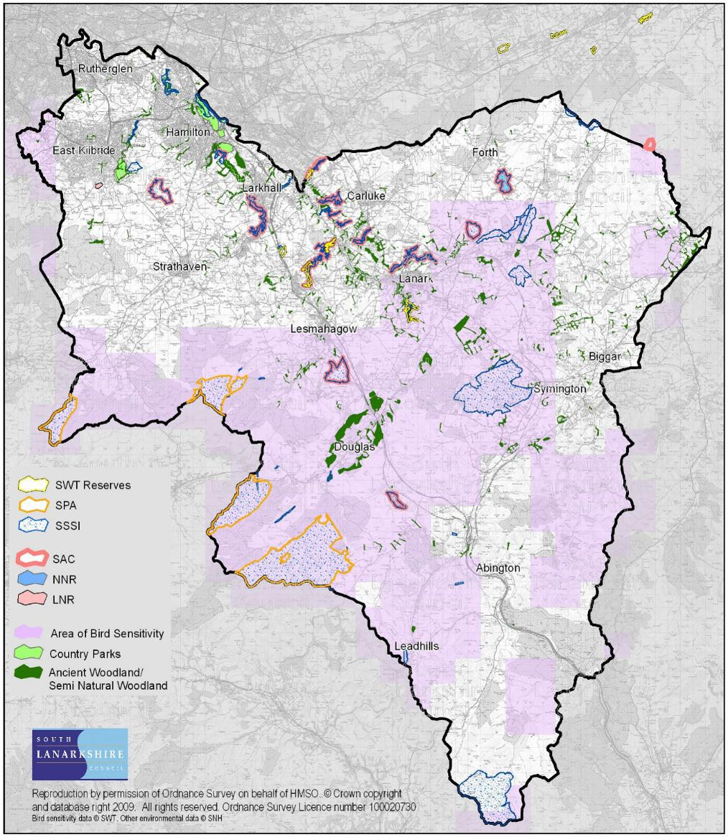
Source: South Lanarkshire Council

Special Areas of Conservation (SACs)
Special Areas of Conservation are areas designated under the European Directive on the Conservation of Natural Habitats and Wild Fauna and Flora (1992), known as the Habitats Directive, set out to protect all forms of wildlife and their habitats. These sites, together with SPAs, are called Natura sites and are internationally important for threatened habitats and species. There are 7 SACs spread out across South Lanarkshire.

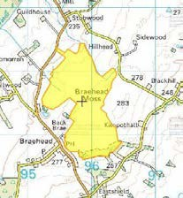
Braehead Moss (122.2ha). This site is designated for supporting extensive areas of active raised bog and areas of degraded bog that has potential for regeneration. The peat bog has arisen from peat developing in two separate basins which have fused. The upper and lower bogs are dominated by hummocks largely formed of Sphagnum species, including rusty bogmoss, and are rich in ling heather and cottongrasses. Feathery bogmoss also occurs in hollows.

Site Condition: Active raised bog: Unfavourable Recovering (September 2003) Degraded raised bog: Favourable Recovered (November 2012)
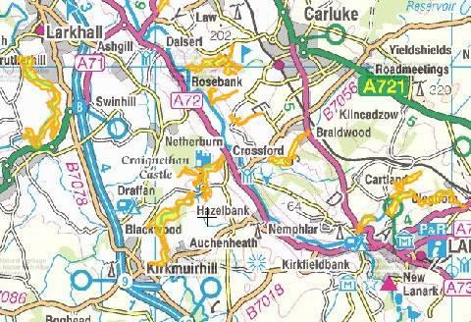
Clyde Valley Woods (432.89ha) This SAC is designated as it supports the Annex 1 habitat: Tilio-Acerion forests of slopes, screes and ravines. These are woods of ash, wych elm and lime, often with sycamore. The site represents the most extensive complex of woodland gorges with this type of forest in Scotland. Although, like all Scottish sites, Clyde Valley Woods is beyond the northern distribution limit of lime, it possesses otherwise characteristic features of this mixed woodland. Ground flora typical of this habitat can be found, with some southern species
such as herb Paris and pendulous sedge also present.

Site Condition: Broadleaved, mixed and yew woodland: Favourable Maintained (September 2002)

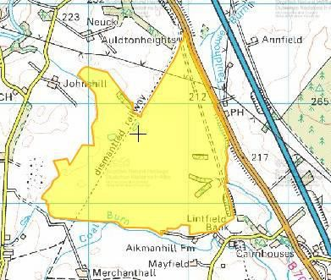
Coalburn Moss (223.65ha). This site supports extensive areas of the Annex 1 habitat, active raised bog and areas of degraded bog that has potential for regeneration. It retains an extensive primary dome confined by two abandoned railway lines. It has one of the larger tracts of vigorous bog-moss-dominated vegetation in central Scotland, with distinctive wet Sphagnum hollows. Typical bog- mosses include the papillose bogmoss and magellanic bogmoss. Hare’s-tail cottongrass, cranberry and reindeer-moss lichen are also common. The hollows, rich in feathery bogmoss are occasionally
fringed by great sundew. Some of the margins of the site support wetland communities.
Site Condition: Active raised bog: Favourable Maintained (August 2012) Degraded raised bog: Unfavourable Recovering (August 2012)

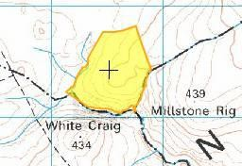
Craigengar (37.16ha). The majority of this site is situated in West Lothian with only small sections encroaching into South Lanarkshire. It maintains habitats present as a qualifying feature but the primary reason for site selection is that it has the largest population of marsh saxifrage in Scotland. It is the largest single colony outside the North Pennines, supporting in 1999, an estimated 9,666 plants in base-rich flushes in an area of upland heather moorland.
Site Condition: Dwarf shrub heath (dry heaths): Unfavourable No Change (May 2013) Vascular Plants (marsh saxifrage): Unfavourable No Change (October 2007) Calcareous Grassland (species rich grassland with mat-grass in upland areas: Unfavourable Declining (May 2013)

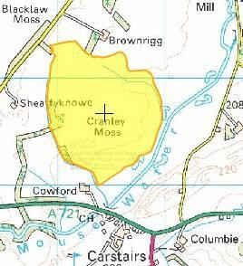
Cranley Moss (101.55ha). This site supports extensive areas of the Annex 1 habitat, active raised bog, as well as areas of degraded bog that has potential for regeneration. Situated in the central belt of Scotland it is important because it is a ‘classic’ raised bog, with a distinct and clearly defined active dome rising from a flat floodplain long since converted to agricultural use. Much of the bog margin is intact but although marshy ground surrounds parts of the site, most of the original lagg fen transition is thought to have been lost. The bog has extensive Sphagnum carpets, which show vigorous growth throughout.

Site Condition: Active raised bog: Unfavourable No change (September 2014) Degraded raised bog: Unfavourable Recovering (October 2002)
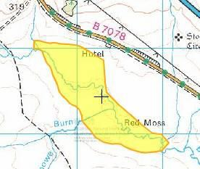
Red Moss (75.85ha). Red Moss is a small site in Clydesdale comprising three areas of active raised bog together with associated lagg fen communities. The slightly domed areas of mire support typical raised bog vegetation with a good cover of Sphagnum including frequent hummocks and occasional rusty bogmoss. Cranberry also occurs.

Site Condition: Active raised bog: Unfavourable Recovering (August 2015)

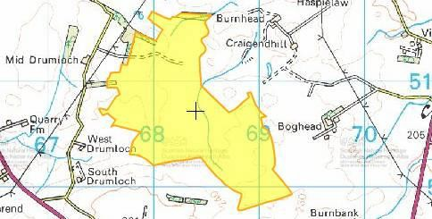
Waukenwae Moss (154.32ha). The site has extensive areas of active raised bog. It displays some of the best Sphagnum-hollow patterning found in bogs in this part of Scotland and also has several hummocks. The bulk of the site is relatively intact, having suffered little from marginal domestic peat- cutting.

Site Condition: Active raised bog: Favourable Recovered (February 2011) Degraded raised bog: Unfavourable Recovering (February 2011)

National Nature Reserves
Under the provisions of Section 35 of the Wildlife and Countryside Act 1981 (WCA 1981), SNH may designate as National Nature Reserves (NNRs), known sites of national importance already managed as a reserve. This designation confers additional protection for an area as specific byelaws can be created to protect the site. There is 1 NNR in South Lanarkshire at Clyde Valley Woodlands (318.42ha). Clyde Valley Woodlands is Scotland’s oldest and richest forest. Ancient woods of oak, ash, rowan and hazel grow here and the reserve is home to a rich diversity of birds, mammals and invertebrates.

Sites of Special Scientific Interest
Site of Special Scientific Interest (SSSI) is the main nature conservation designation in Great Britain. These sites are special for their plants, animals or habitats, their rocks or landforms or a combination of these. SSSIs are notified under the provisions of Section 28 of the Wildlife and Countryside Act 1981 (as amended).

SSSIs are chosen by virtue of the special interest of any of their flora, fauna, geological or physiological features, to represent the best national and regional examples of natural habitat, physical landscape features or sites of importance for rare or protected species. There are 45 SSSIs in South Lanarkshire and bordering with other local authorities (Table 2.1).

Table 2.1: Sites of Special Scientific Interest within South Lanarkshire
 | Site Name | Area (ha) | Designated Features | Site Condition
 | Avondale | 105.59 | Woodland | Unfavourable No change
 | Birk Knowes | 4.00 | Earth sciences | Favourable Maintained
 | Birkenhead Burn | 3.73 | Earth sciences | Favourable Maintained
 | Blantyre Muir | 51.18 | Raised bog | Unfavourable No change
 | Blood Moss and Slot Burn* | 162.49 | Blanket bog Earth sciences | Unfavourable No change Favourable Maintained
 | Bothwell Castle Grounds | 71.38 | Invertebrates Woodland | Favourable Maintained Unfavourable Declining
 | Braehead Moss | 122.6 | Intermediate bog (raised) | Unfavourable No change
 | Calder Glen | 10.24 | Earth sciences | Favourable Maintained
 | Cander Moss | 29.58 | Raised bog | Unfavourable No change
Site Name | Area (ha) | Designated Features | Site Condition
Carnwath Moss | 145.46 | Raised bog | Unfavourable No change
Carstairs Kames | 160.27 | Earth sciences | Favourable Maintained
Cartland Craigs | 16.67 | Woodland | Unfavourable No change
Cleghorn Glen | 70.72 | Invertebrates Woodland | Favourable Maintained Unfavourable No change
Coalburn Moss | 224.35 | Raised bog | Unfavourable Recovering
Cobbinshaw Moss* | 490.66 | Intermediate bog (blanket) | Unfavourable No change
Cobbinshaw Reservoir* | 61.87 | Open water transition fen (wetland) | Unfavourable Declining
Craigengar* | 303.5 | Blanket bog; Upland habitat Vascular plants  Spring-head, rill and flush (Upland) Sub-alpine dry heath (Upland) | Unfavourable No change Unfavourable No change Unfavourable Declining  Unfavourable No change
Craighead Hill Quarry | 4.27 | Earth sciences | Favourable Maintained
Cranley Moss | 101.27 | Raised bog | Unfavourable No change
Dunside | 1.19 | Earth sciences | Favourable Maintained
Falls of Clyde | 18.07 | Earth sciences Woodland | Favourable Maintained Unfavourable Recovering
Fiddler Gill | 29.85 | Invertebrates Woodland | Favourable Maintained Unfavourable No change
Garrion Gill* | 39.75 | Woodland | Favourable Maintained
Gills Burn and Mare Gill | 8.73 | Woodland | Favourable Maintained
Hamilton High Parks | 30.77 | Invertebrates Woodland (upland) Woodland (parkland) | Favourable Maintained Unfavourable No change Favourable Maintained
Hamilton Low Parks | 105.9 | Breeding birds (Grey heron) | Favourable Maintained
Jock’s Gill Wood | 55.07 | Woodland | Unfavourable No change
Kennox Water | 16.8 | Earth sciences | Favourable Maintained
Leadhills – Wanlockhead* | 48.77 | Earth sciences | Favourable Maintained
Millburn | 14.01 | Woodland | Unfavourable Recovering
Miller’s Wood | 12.75 | Woodland | Unfavourable Declining
Milton-Lockhart Wood | 11.89 | Invertebrates | Favourable Maintained
Muirkirk Uplands* | 19,154.0 | Blanket bog  Breeding bird assemblage Hen harrier (breeding) Hen harrier (non-breeding) Short-eared owl (breeding) Earth sciences  Upland assemblage | Unfavourable No change Favourable Maintained Favourable Maintained Unfavourable Declining Favourable Maintained  Favourable Maintained Favourable Maintained
Nethan Gorge | 39.8 | Invertebrates Woodland | Favourable Maintained Favourable Maintained
North Lowther Uplands* | 7,833.3 | Breeding bird assemblage Hen harrier (breeding) Earth sciences  Upland assemblage | Unfavourable No change Unfavourable No change Favourable Maintained Unfavourable Recovering
Raven Gill | 6.52 | Earth sciences | Favourable Maintained
Red Moss | 75.86 | Raised bog | Unfavourable Recovering
Ree Burn and Glenbuck Loch* | 8.25 | Earth sciences | Favourable Maintained
River Clyde Meanders | 140.91 | Earth sciences | Unfavourable Declining
Shiel Burn | 2.41 | Earth sciences | Favourable Maintained
Shiel Dod* | 1,187.78 | Upland assemblage | Favourable Maintained
Tinto Hills | 1,479.96 | Earth sciences  Sub-alpine dry heath Upland assemblage | Unfavourable Declining Unfavourable No change Favourable Maintained
Site Name | Area (ha) | Designated Features | Site Condition
Townhead Burn | 11.07 | Woodland | Favourable Maintained
Upper Nethan Valley Woods | 76.82 | Woodland (upland) Woodland (wet) | Favourable Maintained Favourable Maintained
Waukenwae Moss | 155.49 | Raised bog | Unfavourable No change
*Sites that cross between other local authority borders
Source: SNH

All the SSSI sites detailed in Table 2.2 are either within or adjacent to land owned by South Lanarkshire Council. Where the site is in its complete ownership the site condition is exclusively the responsibility of the council.

Table 2.2: Condition status of SSSI partially or exclusively owned by SLC
SSSI | Notified Feature | Note
Avondale | Upland mixed ash woodland (Avon Gorge) | Partially owned by SLC. Unfavourable condition does not imply the woodland is not of continuing importance.
Blantyre Muir (Calderglen Country Park) | Lowland raised bog | The site has areas of actively growing vegetation demonstrating regeneration of natural bog plant communities. The site is outwith the Country Park boundary.
Calder Glen (Calderglen  Country Park) | Earth sciences Geology (Stratigraphy) | The site is located within the Country Park and benefits from an active management programme  associated with the Park.
Hamilton High Parks (Chatelherault Country Park) | Beetle assemblage and wood pasture and parkland (Cadzow Oaks)  Upland mixed ash woodland (Avon Gorge) | Unfavourable condition does not imply that the woodland is not of continuing importance. Partially owned by SLC and managed within the Country Park.
Hamilton Low Parks (Chatelherault  Country Park) | Grey heron, breeding | Scotland’s largest mainland heronry. The active management in the area focuses on monitoring heronry and wider species and habitats.
Jock’s Gill Wood | Upland oak woodland | Unfavourable condition does not imply the woodland is not of continuing importance. Only partially owned by SLC.
Source: South Lanarkshire Council

National Scenic Areas
National Scenic Areas (NSA) are nationally important areas of outstanding natural beauty, comprising some of the best examples of Scotland’s finest landscapes. They were first identified by the Countryside Commission for Scotland (a predecessor body to SNH) in their report on ‘Scotland’s Scenic Heritage’ in 1978 and confirmed by the UK Government through the issue of Circular 20/1980. There are no designated or proposed NSAs in South Lanarkshire.

Regionally Important Sites
Although no statutory designation applies to regionally important sites, features such as Important Bird Areas (IBAs) identified by the Royal Society for the Protection of Birds (RSPB) are considered to be of regional importance. The IBA Programme of Bird Life International is a worldwide initiative aimed at identifying and protecting a network of sites critical for the conservation of the world's birds. There are no IBAs in South Lanarkshire.

Wet grassland and breeding waders
Some of the river valleys in South Lanarkshire hold regionally and, in some cases, nationally important numbers of breeding wading birds, including lapwings, redshanks and curlews. This suite of species has suffered dramatic declines across the UK, largely due to changes in agriculture. The maintenance of low intensity farming and open, unforested landscapes in key wader areas is critical to ensuring that populations of these birds still remain viable. RSPB Scotland, with
assistance from SAC Consulting is working with farmers in the area to try and safeguard these key habitats.

Local authority designated sites
There are two levels of local designations for sites of nature conservation interest, as either a nature reserve or as recorded sites of known nature conservation interest. The latter of these is the lowest level of site designation commonly found in Scotland.

Local Nature Reserves
Local Nature Reserves (LNRs) are designated by a local planning authority. Wildlife Trusts and other nature conservation bodies, such as the RSPB, may also own and manage them. There is currently 1 LNR in South Lanarkshire, at Langlands Moss, which comprises 20ha of peatland and grassland habitat
The Main Issues Report of the Local Development Plan 2, identified 16 additional sites (Table 2.3) which have the potential to be designated as LNRs. This includes Morgan Glen in Larkhall which awaits formal designation as a LNR and will be processed alongside the other new sites. An extension to the existing LNR at Langlands Moss is also proposed.

Improvements have been made to many of these sites in partnership with local community management groups. Designation of these sites is being progressed by discussing proposals with partners and preparing site management plans. Should all sites be designated, over 600 hectares of Local Nature Reserves will be provided.

Table 2.3: Potential Local Nature Reserves
Location | Location
- Backmuir Woods, Hamilton | - Blantyre, Bothwell and Uddingston
- Cadzow Glen, Hamilton | - Fernbraes Meadow, Fernhill/Cathkin
- Hamilton Low Parks, Hamilton | - Holmhills, Cambuslang
- James Hamilton Loch, East Kilbride | - Jock’s Burn, Carluke
- Millheugh and Greenhall, Hamilton | - Milton, Carluke
- Morgan Glen, Larkhall | - Mossneuk, East Kilbride
- Neilsland and Earnock, Hamilton | - Stonehouse Park, Stonehouse
- Udston and Glenlee, Hamilton | - Westburn Road, Cambuslang
Local Nature Conservation Sites
Local Nature Conservation Sites (LNCS) represent locally important biodiversity and/or geodiversity features. This includes sites previous named as Sites of Importance for Nature Conservation (SINC) and Wildlife Sites (identified by the Scottish Wildlife Trust). Many local sites contain habitats or features that cannot be recreated and it is important to ensure they are afforded special consideration in relation to the local planning process. The current suite of known sites of interest in South Lanarkshire is outdated and does not reflect the current status of locally important habitats and species. This system is, therefore, under review. A list of potential sites, with an initial focus on urban and greenbelt land has been created, and site selection criteria drafted. From 2019, desktop and site surveys will progress and the designation process of LNCS will be developed.

Biodiversity Assets
Many of South Lanarkshire’s most valuable biodiversity assets fall outwith designated sites and rely upon the planning system to conserve and protect them. The South Lanarkshire Biodiversity Partnership prepared guidance to ensure development proposals take cognisance of non designated sites and habitats in the area and this has been incorporated within the Local Development Plan.

Woodland
Woodlands and forests provide the most biologically diverse habitat in South Lanarkshire, mostly associated with the complex ecological communities in woodland soils. Woodland cover across southern Scotland has been greatly diminished over the last thousand years through the clearance of land for agriculture and other land use changes. The remaining ancient and semi-natural woodlands in South Lanarkshire are an irreplaceable resource but are fragmented and have suffered from mismanagement. Further clearance of tree-lined hedgerows and increased development has intensified the fragmentation of woodland habitats. Large areas of new woodland have been created over the past century, mostly in the form of upland conifer plantations but these, while economically important, do not support high levels of biodiversity.

Much of the remaining ancient, semi-natural woodland is found on the steep slopes and ravines of the River Clyde and its tributaries and is a nationally significant biodiversity resource. Some areas of this ancient woodland were felled and replanted with conifers in the mid 20th century and are listed as Plantation on Ancient Woodland Sites (PAWS). The restoration of these sites to native tree cover is a priority for both local and national biodiversity action plans.
The National Forest Inventory 2017 shows South Lanarkshire as having a total of 27,065 ha of woodland. The percentage cover of commercial conifers has reduced to 47%, due to the felling of a further 7,542 ha, some as part of wind farm developments but also reflecting crop maturation.
This has been compensated for to an extent by 5,114 ha of new planting (Table 2.4: Figure 2.2). Broadleaved and mixed woodland has increased by some 20% to 5,757 ha or 17% of the total woodland cover.

Table 2.4: Woodland types in South Lanarkshire
Woodland Type | NFI 2014  Area (ha) | NFI 2017  Area (ha) | % Total | % Change
Broadleaved and mixed woodland | 4,814 | 5,757 | 17 | +20
Coniferous and other plantation woodland | 21,112 | 16,194 | 47 | -23
Recently felled | 8,257 | 7,542 | 21 | -9
New Woodland (including permissions) | 4,846 | 5,114 | 15 | +6
Total woodland cover  (before felling) | 39,029 | 34,607
Woodland cover (less felled  areas) | 35,618 | 27,065
Source: South Lanarkshire Council and the Forestry Commission
The Scottish Native Woodlands Survey (2014) indicates a total of 4,765ha of native woodland in South Lanarkshire. This represents 99% of the total broadleaved woodland cover.
In South Lanarkshire, 1,528 ha of woodland is on the Ancient Woodland Inventory. Ancient, semi- natural woodland makes up 32% of all native woodlands but less than 4% of the area’s total woodland cover. There are 283 ha of Plantation on Ancient Woodland Sites in South Lanarkshire. A reduction in this figure through conversion back to native tree cover would be a positive indicator.

About 730 ha of woodland, particularly within the urban area are owned by the council. Of this holding, 575 ha (79%) is of predominately native, broadleaved woodland and 490 ha (67%) is ancient woodland. This means that the council owns more than 11% of the total area of native woodland in South Lanarkshire and 32% of the remaining ancient woodland. Of the council owned woodland, 63 ha is listed as PAWS, representing 22% of the South Lanarkshire total. Since 2004, approximately 32 ha has been felled and native tree cover is being restored. Data on the council’s woodland holding will continue to be refined by improving the council’s tree and Woodlands Policies and through delivery of the Biodiversity Duty Implementation Plan (BDIP).

Figure 2.2: Distribution of woodland types in South Lanarkshire
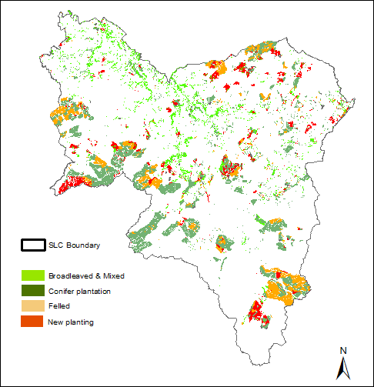
Source: South Lanarkshire Council

Ancient woodland contains a wide range of species and complex ecological processes developed over thousands of years. These cannot be replicated effectively. The current extent of ancient woodland in South Lanarkshire is the result of a long period of fragmentation, with the few remaining patches on the steeper slopes of the Clyde Valley and its tributaries (Figure 2.3). These are amongst the last remnants of native, broadleaved woodland in southern Scotland and make up the Clyde Valley Woodlands National Nature Reserve.

Ancient, native woodlands are by far the most diverse terrestrial habitats in Scotland, and hold many thousands of species. The complex associations of species in ancient woodland soils are the source of all of our agricultural soils and it is essential these irreplaceable resources are maintained for future generations.

Figure 2.3: Distribution of ancient semi-natural woodland in South Lanarkshire
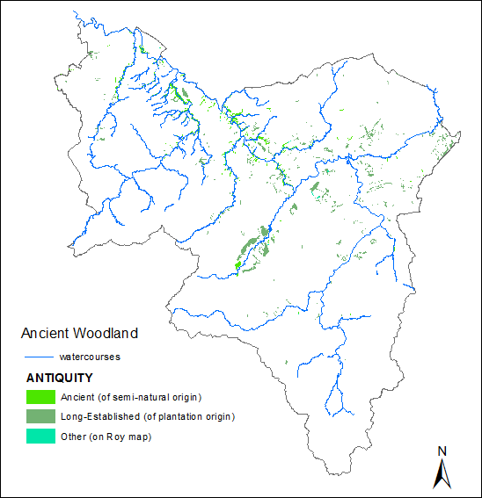
Source: South Lanarkshire Council

Peatland
Peatlands are a group of habitats such as bogs and fens which develop peat soils. They form important carbon stores and deliver key ecosystem services such as clean water and flood control. They are also important for biodiversity, supporting distinctive plant and animal communities. There are extensive areas of peatlands in South Lanarkshire (Figure 2.4), with some of the best quality areas protected under international and national legislation, (see section 2.1).

The condition of peatland is influenced by land management and affects its ability to function. In South Lanarkshire, many of the peatland areas are in less than favourable condition. A number of restoration projects are currently underway to improve peatland condition across South Lanarkshire. Safeguarding peatlands continues to be a high priority for the council. Protective policies are included in the South Lanarkshire Biodiversity Strategy, the Biodiversity Duty Implementation Plan, the Local Development Plan and the Sustainable Development and Climate Change Strategy.

Figure 2.4: Distribution of peatland areas throughout South Lanarkshire, 2016
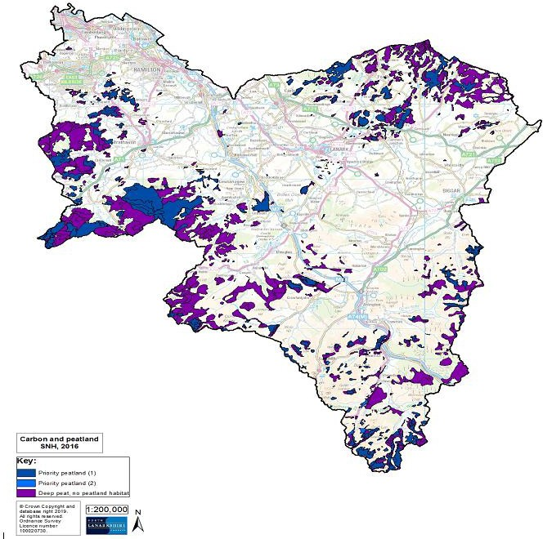

Source: South Lanarkshire Council

SNH has undertaken a programme of mapping the location, condition and potential threats to lowland raised bogs across Scotland, which is just one type of peatland habitat. This information is held within the Raised Bog Inventory. The precise value of each of these features is dependent upon the status and condition of individual sites.
There are 69 sites listed on the Lowland Raised Bog Inventory (1989) in South Lanarkshire (Table 2.5). South Lanarkshire supports a wide range and significant proportion of deep peat and peatland habitat. This is an irreplaceable resource.

Table 2.5: Lowland raised bog sites identified within South Lanarkshire
Site name | Grid reference | Site name | Grid reference
Carnwath Moss | NS967482 | Drumbuie (north) | NS647510
Torfoot | NS637377 | Drumbuie (south) | NS653506
Avonside | NS633368 | Brackenridge | NS777388
East Dykenook | NS658377 | Cleughhead | NS770372
High Drumclog | NS660487 | Blood Moss (west) | NS760399
Mid Drumclog | NS636397 | Blood Moss (east) | NS760399
Rench (north) | NS632388 | Cander Moss | NS781460
Rench (south) | NS633385 | By Red Moss | NS870267
Drumclog | NS626387 | Red Moss A | NS871263
Roughdiamond | NS623380 | Red Moss B | NS874260
Fieldhead | NS660435 | Red Moss C | NS882260
Cladance Moss NE | NS670488 | Crawick Moss | NS837204
Cladance Moss SW | NS660487 | Mountherrick (south) | NS853216
Cladence Moss N | NS660494 | Mountherrick (north) | NS855223
Scobieside | NS627400 | Auchren | NS830382
Westlinbank | NS672400 | Hollandbush | NS805362
Meadowhead (west) | NS643483 | Coalburn Moss | NS827365
Meadowhead (north) | NS649488 | Threepwood Moss | NS803474
Meadowhead (central) | NS649485 | Kingshaw Moss | NS865518
Meadowhead (south) | NS649484 | Gair Farm | NS873529
Rigfoot Moss | NS675471 | Crawford | NS960218
Maidenburn (north) | NS680462 | No data | NS948472
Maidenhead (south) | NS680458 | Carnwath Moss | NS978480
Stewartfield (NW) | NS668542 | Shodshill Moss | NS938488
Crutherland (east) | NS668514 | Cranley Moss | NS935475
Crutherland (west) | NS660513 | No data | NS958465
Drumloch | NS683514 | Burnfoot | NS988553
Drumloch | NS678518 | Forth | NS940541
Waukenwae (west) | NS680508 | Braehead Moss | NS959515
Waukenwae (east) | NS688504 | Cableburn south | NT038458
Whitefield | NS693498 | Cableburn | NT040463
Stewartfield | NS662537 | Cableburn north | NT040466
Westwood | NS613536 | Borland Moss west | NT060470
Shields Moss | NS623518 | Borland Moss | NT065472
Langlands Moss | NS635512
Source: Scottish Natural Heritage

Invasive, non-native species
Invasive, non-native species (INNS) are those that have been introduced to the UK by people, whether intentionally or accidentally, and are causing a problem. This may be because they have no natural predators and are able to spread easily as they come from similar climates. This can result in damage to our environment and economy. In Scotland, various species are noted as INNS, including North American signal crayfish, rhododendron and American mink.
In South Lanarkshire, priority species for control are Japanese knotweed and giant hogweed. Also of interest are Himalayan balsam and rhododendron. Chemical and physical control of various species takes place across the area. Table 2.6 details the council’s records for Japanese knotweed.

Table 2.6: Japanese knotweed in South Lanarkshire, September 2019
 | No.
INNS records | 360
Records on SLC land | 321
Records on private land | 39
Sites being treated | 305
Sites remaining to be treated | 55
Source: South Lanarkshire Council

Historic and cultural heritage
SEA objectives that relate to historic and cultural heritage
Protect and enhance the historic and cultural heritage of the area.
Maintain and conserve the historic setting of settlements and landscape form, particularly where such are locally distinctive.
The historic environment is made up of the physical evidence of past human activity as well as stories and traditions. South Lanarkshire encompasses a broad range of landscapes which have influenced the way man has used the land and dictated the growth of villages and towns. Within the broad, low-lying areas adjacent to the River Clyde the settlements are large while the rolling farmland beyond has a number of smaller settlements that grew either as market towns or as a result of a particular activity such as fruit growing. The upland hills are characterised by scattered farms and villages, with some settlements being there for simply one reason, such as lead mining at Leadhills.
The valley of the River Clyde, particularly in the south of the area has formed a transport route for centuries demonstrated by the large number of pre-historic and Roman remains that survive, reflecting its importance as a corridor from Carlisle through to the Highlands. The Clyde has also provided the power for industrial processes, such as the mills at New Lanark which were developed in association with philanthropic thinking on the provision of housing for mill workers. The importance of New Lanark is reflected in its UNESCO World Heritage Site status.

Throughout South Lanarkshire the sheer variety of historic buildings and towns provide a rich sense of cultural identity across a diverse landscape. These are important in enhancing the quality of life and sense of identity for our residents. Such a diverse range of historic and cultural assets is a vital contributor to the area’s economy through the attraction of visitors to South Lanarkshire. Our historic environment is irreplaceable and we should protect it for future generations.
A summary of the indicators used in assessing the state of South Lanarkshire is presented, highlighting the current status of each indicator and the directional trend.

The Current status is shown by the following colours: The trend direction is shown with the following arrows:
G | Good | F | Fair | Improving
 |  |  |  | No change
P | Poor |  | Limited data | Deteriorating
Note: The most recent data available was used in assessing the environmental indicators
Indicator | Current status | Trend direction | Explanation
Built heritage | F |  | The number of Scheduled Monuments and Conservation  Areas remain constant. The number of Listed Buildings and buildings on the ‘Buildings at Risk’ register have reduced.
Gardens and Designed  Landscapes | G |  | The number of Gardens and Designed Landscapes areas in South Lanarkshire remains unchanged since 2016.
Archaeological sites | F |  | The number of archaeological sites recorded across South Lanarkshire continues to increase year on year.
Battlefields | G |  | The number of registered battlefields on the Inventory of Historic Battlefields remains the same as the previous report.
Historical heritage | G |  | The area has a wealth of historic and tourist attractions, including the New Lanark World Heritage Site. These continue  to attract large numbers of visitors to South Lanarkshire.

Baseline situation
The historic and built heritage of South Lanarkshire is complex and varied, from medieval burghs such as Hamilton and Biggar through to planned villages such as New Lanark. There are numerous listed buildings ranging in size from castles to small agricultural cottages, with the greatest concentration of listed buildings being within the medieval burghs. In addition to those sites situated above ground, there are numerous buried or ruinous archaeological assets which may not be fully recorded.

Pressures on historic assets come from an increasing number of sources which may result in damage to, or the complete loss of, the building or site of cultural significance. However, incremental damage is far more common especially to individual buildings where adaptations or extensions have occurred without the full knowledge of its historic importance or by the use of inappropriate building styles or materials.

Built heritage
South Lanarkshire’s cultural heritage is protected and conserved through designation status set by national legislation, regional and local policy. There are four types of designation status for cultural sites or individual properties. The types and locations of these in South Lanarkshire are shown in Table 3.1 and Figure 3.1.

Table 3.1: Designated sites and monuments in South Lanarkshire, June 2019
Designation | Total
Scheduled Monuments | 181
Historic Gardens and Designed Landscapes | 6
Conservation Areas | 30
Listed Buildings  - Category A  - Category B  - Category C | 1,399  146  694  559
Total designated sites | 1,616
Source: Historic Environment Scotland:

Listed Buildings
Historic Environment Scotland is responsible for the designation of listed buildings and the council is responsible for maintaining the Statutory List, or public record of them. The term building is a generalisation as listing can, for example, include groups of buildings, bridges, fountains, statues or even telephone boxes. Listing covers both the interior and exterior of a building regardless of category. There are three categories of listing:
    - Category A: buildings of national or international importance
    - Category B: buildings of regional importance
    - Category C: buildings of local importance.
At June 2019, there are 1,399 listed buildings across South Lanarkshire. Table 3.2 shows the listed buildings by category and area. Of these records, 59% are in Clydesdale, 26% in Hamilton, 14% in East Kilbride and 5% in Cambuslang and Rutherglen.

Table 3.2: Listed Building records by category, June 2019
Category | A | B | C | Total
Cambuslang/Rutherglen | 4 | 43 | 19 | 66
Clydesdale | 107 | 377 | 300 | 784
East Kilbride | 10 | 95 | 95 | 200
Hamilton | 25 | 179 | 145 | 349
Total | 146 | 694 | 559 | 1,339
Source: Historic Environment Scotland: South Lanarkshire Council

Figure 3.1: Distribution of culturally important designated sites and individual properties
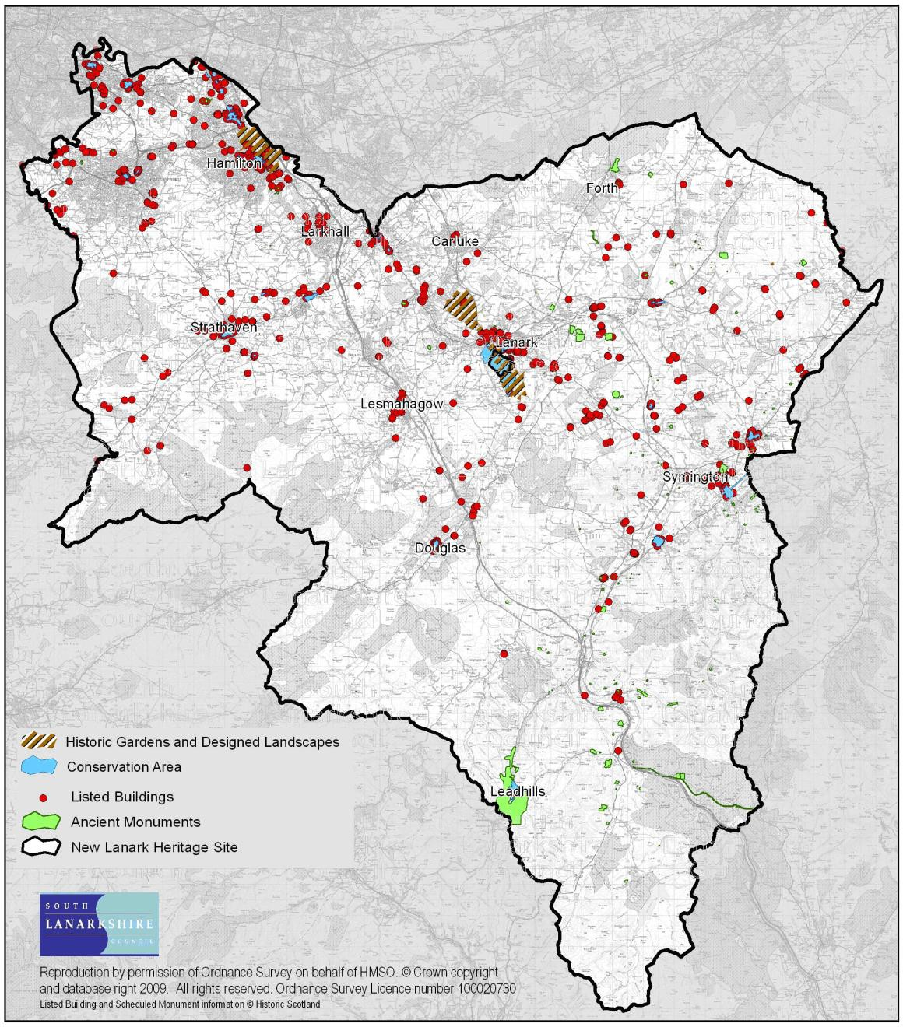
Source: South Lanarkshire Council

Scheduled Monuments
A Scheduled Monument is an archaeological site or monument of national importance to which Scottish Ministers have given legal protection under the Ancient Monuments and Archaeological Areas Act 1979. As such statutory ‘Scheduled Monument’ consent is required from Historic Environment Scotland prior to any works being carried out. Some sites and monuments are visible, such as prehistoric burial mounds, ruined castles or 20th century military remains but others are less obvious because they have no obvious trace on the surface and are sealed beneath peat or marshes. Buried archaeology may survive beneath the turf or plough-soil, and is likely to extend beyond any visible remains.

Historic Environment Scotland assesses monuments against published criteria and guidance set out by Scottish Ministers. In doing so, they take account of artistic, archaeological, architectural, historic, traditional, aesthetic, scientific and social factors. More detailed information can be found in the Historic Environment Policy for Scotland (2019).
Historic Environment Scotland records indicate that in June 2019 there were 181 Scheduled Monuments in South Lanarkshire (Table 3.3).

Table 3.3: Scheduled Monuments in South Lanarkshire by category, June 2019
Category | No. | %
Prehistoric ritual and funerary | 42 | 23.2
Prehistoric domestic and defensive | 76 | 42.0
Roman | 13 | 7.2
Crosses and carved stones | 3 | 1.7
Ecclesiastical | 3 | 1.7
Secular | 33 | 18.2
Industrial | 10 | 5.5
20th century military and related | 1 | 0.6
Total | 181 | 100%

Conservation areas
Conservation areas are areas of special architectural or historic interest, the character or appearance of which is desirable to preserve or enhance. This character may be created by individual buildings, by the use of a particular building style, or a specific building material. The designation of a conservation area covers not just the actual buildings but also their relationship with the street pattern and public and private spaces. Trees within a conservation area are also given extra protection.
There are 30 conservation areas within South Lanarkshire ranging in size from the large Hamilton town centre to the small rural village of Lamington.

Buildings at Risk
The Buildings at Risk Register, established in 1990, is maintained by Historic Environment Scotland. It highlights properties of architectural or historic merit throughout Scotland considered to be at risk or under threat and maintains records of their condition. It has proved to be a useful tool in the marketing of a property to potential restorers.
At April 2019, 93 buildings across South Lanarkshire were listed on the Buildings at Risk Register (Table 3.4). Of the buildings at risk in South Lanarkshire, 39 (42%) are in urban locations, 26 (28%) are in rural locations, 13 (14%) within small town locations and 15 (16%) are in rural settlements.

Table 3.4: Buildings at Risk in South Lanarkshire
Listed Status | March 2011 | March 2013 | March 2015 | March 2017 | April 2019
A | 19 | 18 | 19 | 18 | 16
B | 38 | 36 | 37 | 38 | 36
C | 13 | 12 | 12 | 12 | 9
Unlisted | 42 | 39 | 38 | 35 | 32
Total | 112 | 105 | 106 | 103 | 93
Source: Historic Environment Scotland

The Register defines the level of risk faced by each building based on its structural condition and the threats to its long term existence. In South Lanarkshire, 7 buildings (7.5%) are within the ‘critical’ category which means they are threatened with demolition and/or there may be structural concerns and there is a real or perceived conservation deficit which makes rescue unlikely. There are 22 buildings (23.7%) in South Lanarkshire, classed as being at ‘high’ risk because there is no immediate danger of collapse but remedial action is necessary to prevent further serious deterioration. Of the remaining buildings on the Register, 16 (17.2%) are classed as ‘moderate’ risk, 46 (49.5%) as ‘low’ risk and the remaining 2 (2.2%) buildings are considered to be at ‘minimal’ risk.
In South Lanarkshire, 31 (33.3%) of buildings on the Buildings at Risk Register are classed as being in fair condition and 1 (1.1%) in good condition. 38 (40.9%) are classed as being in poor condition, 10 (10.8%) in very poor condition and the remaining 13 (14.0%) as ruinous.

Gardens and Designed Landscapes
At April 2019, there are 6 Inventory gardens and designed landscapes in South Lanarkshire (Table 3.5). These sites are formally recognised as being important in their own right and are identified in the ‘Inventory of Gardens and Designed Landscapes’ maintained by Historic Environment Scotland. The gardens generally include ornamental designs which have been laid out in a planned manner, usually as part of the policies or estate accompanying a family home or institution. The key consideration in selection are the historical, horticultural and arboriculture value of the garden in association with nature conservation interests, scenic interests, and the quality or innovation of design of the garden and other ornamental features.

As an important feature in the historic environment, gardens and designed landscapes are sensitive to change either within their boundaries or to their landscape setting. A range of impacts from modern life can damage their intrinsic value and potential and as such the sites require protection to ensure their interest survives for future appreciation. Hamilton Palace was removed from the Inventory of Gardens and Designed Landscapes in April 2016 as it was determined that the site no longer met the criteria for inclusion.

Table 3.5: Historic Gardens and Designed Landscapes in South Lanarkshire, April 2019
Site | Area (Ha) | Site Description
Chatelherault (GDL00101) | 708 | Formerly one of Scotland’s grandest designed landscapes and closely associated with Hamilton Palace, Chatelherault has remnants of some formal gardens and impressive parkland designed for scenic effect,  ancient trees and some outstanding architecture. The High Parks and Avon Gorge are valuable wildlife habitats.
Lee Castle (GDL00257) | 366 | The woodland, parkland and gardens make an impressive setting for the  category A listed Lee Castle. The natural broad Lee valley is of outstanding nature conservation value.
The Falls of Clyde (GDL00358) | 399 | The Falls of Clyde are one of the most significant examples of the picturesque movement of the late 18th century in Scotland and is now of national importance. It incorporates New Lanark, and the estates of Corehouse, Bonnington, Braxfield and Castlebank Park. It is of  outstanding importance for historical, architectural, scenic and nature conservation reasons.
Scot’s Mining Company  House (GDL00339) | 2 | An outstanding example of a virtually unaltered, small, 18th-century garden layout connected with James Stirling, the development of the  profitable Leadhills mining enterprise in the vicinity, and possibly William Adam.
Little Sparta (Stonypath) (GDL00265) | 3.5 | A contemporary modern garden. It is an outstanding example of its type and contains works of art by the sculptor and poet Ian Hamilton Finlay.
Barncluith (GDL00048) | 4 | Formerly an outstanding work of art, the early terraces and gardens are still of special historical significance, and the designed landscape forms an impressive setting for a category A listed building.
Total Area | 1,902.5
Source: Historic Environment Scotland

Archaeological sites (statutory and non-statutory)
In June 2019, according to the West of Scotland Archaeology Service (WoSAS) Historic Environment Record, there are 4,966 archaeological sites across South Lanarkshire of various features such as burial cairns and archaeological finds through to the remains of buildings. Some archaeological sites may lack statutory protection but they are still valuable in maintaining the overall historic record of South Lanarkshire’s heritage. As pressures from development proposals continue, there is potential for more archaeological sites to be discovered. It is important such sites are recorded and ideally maintained in situ. However, it is likely that many will instead be fully excavated and recorded before their sites are developed. To prevent such sites being irrevocably
lost, it is important that WOSAS is consulted at the outset of development proposals and for site investigation and mitigation measures to be established to prevent unrecorded damage or loss.

In South Lanarkshire between 2009 and 2018, WoSAS were consulted on 700 planning applications. During that period, 194 applications were approved with archaeological conditions, representing 28% of applications. Table 3.6 illustrates these annual consultations.

Table 3.6: Consultations with West of Scotland Archaeology Service
 | No. consultations  with WoSAS | No. approved* | No. with archaeological  conditions | % of those approved with archaeological  conditions
2009 | 85 | 70 | 19 | 27.1
2010 | 56 | 44 | 14 | 31.8
2011 | 85 | 65 | 28 | 43.0
2012 | 69 | 37 | 11 | 29.7
2013 | 72 | 55 | 15 | 27.2
2014 | 52 | 40 | 14 | 35.0
2015 | 78 | 66 | 29 | 43.9
2016 | 83 | 72 | 33 | 45.8
2017 | 58 | 47 | 20 | 42.5
2018 | 62 | 43 | 11 | 25.5
*Excludes those withdrawn, refused or not determined.
Source: South Lanarkshire Council

Buried archaeological assets
The number of archaeological buried sites across South Lanarkshire is unknown. However, there are numerous crop-mark sites, (sites when soil conditions enable subsurface features to be visible), enabling the layout of sites and monuments to be periodically visible. In the absence of invasive excavation, the location and knowledge of the existence of such sites is extremely variable with the recorded crop-mark sites perhaps representing only about 1% of those that might exist below the surface.

Battlefields
In March 2011, Historic Scotland on behalf of the Scottish Government launched the Inventory of Historic Battlefields which identifies battlefields considered to be of national importance for the contribution they make to the archaeology and history of Scotland. As battlefields are a fragile and finite resource very susceptible to damage from a range of activities or developments the Inventory provides information to aid their protection, interpretation and promotion for future generations.
There are 2 registered battlefields in South Lanarkshire (Table 3.7). The Battle of Bothwell Bridge (1679) was added to the Inventory in March 2011 and the Battle of Drumclog (1679) was added in November 2011. No further sites within South Lanarkshire are currently being considered for inclusion to the Inventory.

Table 3.7: Battlefield sites in South Lanarkshire
Battlefield | Battle information
Battle of Bothwell Bridge 22 June 1679  (UKFOC 275) (BTL5) | Following the Battle of Drumclog a force of Covenanters marched on Glasgow but failed to take the city. A stunned government quickly sent a larger force from Edinburgh, led by the Duke of Monmouth to intercept the Covenanters who were positioned on the south side of the bridge at Bothwell over the River Clyde. Despite a valiant effort to defend the bridge, the Covenanters were eventually overwhelmed with Monmouth giving orders for quarter for the Covenanters but John Graham of Claverhouse seems to have taken revenge for his defeat at Drumclog and 400 men were killed in the rout. About 1,200 were taken prisoner, marched to Edinburgh and held at Greyfriars Kirk.
Battlefield | Battle information
Battle of Drumclog 1 June 1679  (UKFOC 276) (BTL21) | Due to religious persecution by Charles II, Scottish Presbyterians or Covenanters were forced to worship in secret, often gathering in remote areas in the hills. Having heard that such a gathering was taking place, John Graham of Claverhouse, a government officer and later Viscount of Dundee, found an armed force of Covenanters assembled on high ground to the north- west of Drumclog. After several skirmishes and using the advantage offered by the drier ground the Covenanter force charged down across the marsh to engage the government troops who were overwhelmed and fled. The Covenanter victory at Drumclog buoyed the hopes of even moderate non-  conformists and their ranks swelled with volunteers from all over south western Scotland.
Source: Battlefields Trust; Historic Scotland

Historical heritage
South Lanarkshire’s rich historical heritage is represented with 12 museums, 4 historical attractions and 1 World Heritage Site at New Lanark. These assets offer a rich and diverse insight into the historical heritage of South Lanarkshire and the impact the environment has played in shaping local communities.

Museums and historical attractions
Tourism is an important sector in South Lanarkshire with the high quality historical heritage and diverse local environment drawing visitors from both home and abroad. There is a need to manage visitor numbers in a way that lessens the impact on the environment and does not spoil the very thing the visitors have come to see. Table 3.8 illustrates the visitor attractions and visitor numbers.

Table 3.8: Visitors to museum and historic attractions in South Lanarkshire
Attraction Site | Description | Visitor Nos.
Museums
Albion Museum and Albion Motors Archive | The Biggar Albion Foundation is responsible for the Albion Club, the Albion Archive, the Biggar Rally and the Albion Museum at North Back Road which houses a collection of historic Albion vehicles and units. | Not known
Biggar Gasworks | Historic Environment Scotland. First small town gasworks to open in Scotland and among the last to close. | Not known
Biggar and Upper Clydesdale  Museum | The Biggar Museum Trust. Depicts the history of the area. | Not known
Brownsbank Cottage, Biggar | The home of the poet Hugh MacDiarmid. | Not known
Greenhill Covenanters' House | Reconstructed 17th Century farmhouse tells the story of ‘the killing time’ and the Covenanters. | Not Known
Crawfordjohn Heritage Venture | Located in the former 18th century church, the Venture  illustrates life in the Southern Uplands with farming displays (hill and sheep farming) and rural community life. | Not known
David Livingstone Centre, Blantyre | Illustrating Livingstone's life from his childhood in the Blantyre Mills to his explorations in the heart of Africa. | 2010 - 19,937  2012/13 – 24,677  2014/15 – 20,939  2015/16 – 20,412
Douglas Heritage Museum | Located in the old Dower House of Douglas Castle the  museum exhibits local village life, the Douglas family and the Cameronian Regiment. | Not known
Lanark Museum | Provides an illustrative collection of historical interest on various aspects of the Royal Burgh of Lanark's history. | Not known
Leadhills Miners Library | The Leadhills Reading Society is the oldest subscription library in the UK, founded in 1741. | Not known
Low Parks Museum, Hamilton | Features permanent displays and a programme of temporary displays on the history of South Lanarkshire. Showcases the history of the local regiment, the Cameronians (Scottish Rifles) which disbanded in 1968 after a 300 year history. | 2011/12 – 28,521  2012/13 – 33,636  2013/14 – 30,887  2014/15 – 36,602
Attraction Site | Description | Visitor Nos.
2015/16 – 34,377
2016/17 – 25,371
2017/18 – 27,507
2018/19 – 26,629
National Museum of Rural Life, East Kilbride | Provides an insight into past farming life and how that shaped the countryside we know today. | 2011 - 72,326  2012 – 71,583  2013 – 73,444  2014 – 82,573  2015 – 93,099  2016 – 102,708
Historical attractions
Bothwell Castle | Scotland's largest and finest 13th century castle. Part of the original circular keep survives. | Not known
Chatelherault Hunting Lodge | Built in the middle of the 18th century designed by the architect William Adam. The restored hunting lodge is set within the 500 acre Country Park, includes a Visitor Centre and illustrates life on the Hamilton Estate. | Visitor Centre:  2008/09 - 119,487  2009/10 – 131,934  2010/11 – 126,149  2011/12 – 151,640  2012/13 – 162,225  2013/14 – 206,152  2014/15 – 141,550  2015/16 – 136,863  2016/17 – 116,443  2017/18 – 131,552  2018/19 – 139,066
Craignethan Castle | Dating back to 1532, the Castle was an important artillery fortification, with defences including a caponier (a stone vaulted artillery chamber). The oldest part is the tower house built by Sir James Hamilton of Finnart. | Not known
Hamilton Mausoleum | The Hamilton Palace Mausoleum is a Roman-style domed structure standing at 37m in height, occupying a site close to the original Hamilton Palace. It was built for the 10th Duke of Hamilton between 1845 and 1858 and is famous for having the longest echo in the world at 15 seconds. | 2011/12 - 1,423  2014/15 - 1,476  2015/16 - 1,476  2016/17 – 902  2017/18 – 1,971  2018/19 – 1,127
Source: South Lanarkshire Council; Museum of Rural Life
Museums Association definition ‘Museums enable people to explore collections for inspiration, learning and enjoyment. They are institutions that collect, safeguard and make accessible artefacts and specimens which they hold in trust for society.’

UNESCO World Heritage Site
Inscribed as an UNESCO World Heritage Site in 2001, New Lanark is a restored 18th century cotton mill village located south of Lanark close to the Falls of Clyde. The village was founded in 1785 by David Dale and co-owned by the philanthropist and social reformer Robert Owen. New Lanark Conservation Trust, formed in 1974, is an independent registered charity dedicated to the restoration and development of the site. In March 2019, the Trust published its Management Plan which sets out how the Trust and its partners will work to conserve the Site for future generations.

Country Parks
Country Parks are designated and managed by South Lanarkshire Leisure and Culture Trust. They provide opportunities for people to enjoy open-air recreation facilities within a managed countryside setting. There are 3 Country Parks in South Lanarkshire (Table 3.9).

Table 3.9: Visitors to Country Parks in South Lanarkshire
Country Park | Description | Visitor numbers
Calderglen | Set within the former country estates of Torrance and Calderwood, the park offers a range of trails along the Rotten Calder Gorge. The wooded glen which extends for about 5km along the Rotten Calder river forms part of a SSSI site.  Calderglen children's zoo is located in the grounds, along with a tropical conservatory and several play areas. | 2008/09 – 407,170  2009/10 – 696,110  2010/11 – 906,999  2011/12 – 798,099  2012/13 – 874,074  2013/14 – 941,432  2014/15 – 909,799  2015/16 – 896,427  2016/17 - 1,069,223  2017/18 – 986,215  2018/19 – 1,006,655
Chatelherault | The Country Park is set around the main Chatelherault hunting lodge, and includes the ancient woodland Avon Gorge home to a huge variety of wildlife, including roe deer, otters, badgers and a wide range of woodland birds.  The ten mile of trails through the Gorge includes High Park SSSI, the famous Cadzow Oaks, some of the oldest trees in the UK thought to date back some 600 years, and the ancient ruin of Cadzow Castle which dates back to the 16th century. | 2008/09 – 618,930  2009/10 – 674,876  2010/11 - 669,744  2011/12 – 612,769  2012/13 – 659,261  2013/14 – 644,163  2014/15 – 602,138  2015/16 – 608,096  2016/17 – 602,501  2017/18 – 595,168  2018/19 – 665,765
Hamilton Low Park | Forming part of Strathclyde Country Park, Hamilton Low Park is situated on the edge of Hamilton, and offers a network of footpaths many across flat grassland which includes three ponds, which play host to wildfowl most of the year, and along the River Avon which is the haunt of kingfishers and otters.  The footpaths on North Haugh offer views into the low lying wet grassland which is the home of pheasant and roe deer. The Haugh is an extremely important breeding area for many species of migrant warblers, whilst the nearby Island Pond and Barmichael Plantation form part of the Nature Reserve. The soils within the area are rich, supporting a summer wildflower meadow populated with several species of butterflies and other attractive  insects. | Not known*
*Visitor numbers are difficult to obtain due to the Park being fully open with multiple entry points.
Source: South Lanarkshire Council

Material assets and landscape
SEA objectives that relate to material assets and landscape
Conserve natural and man-made resources.
Promote access to recreational activities.
Encourage sustainable use of material assets.
Encourage the protection and enhancement of landscape character.
Material assets can be described as the infrastructure of the council and the resource of the area. Landscape relates directly to land use and the area’s characteristics. This can include land reserved for development and the extent the public has access to facilities and services. These issues are closely related with particular overlap in some areas including land use and public access. It is logical, therefore, that both material assets and landscape are considered in this chapter and that the environmental issues are jointly considered. The council provides a range of services through managed facilities. It is important these facilities match the needs of the population and also conserve the character of the area.

South Lanarkshire has a diverse landscape rich in scenic value and characterised by its diverse range of land uses. The area is dominated by features such as the Lowther Hills and the Clyde Valley. The diversity of the landscape across the area is a key feature of South Lanarkshire and it is important it is preserved and promoted for wider public use through a range of opportunities.
A summary of the indicators used in assessing the state of South Lanarkshire is presented, highlighting the current status of each indicator and the directional trend.

G | Good | F | Fair | Improving
 |  |  |  | No change
P | Poor |  | Limited data | Deteriorating
Note: The most recent data available was used in assessing the environmental indicators
Indicator | Current status | Trend direction | Explanation
Vacant and derelict land | G |  | The area of vacant and derelict land decreased by 37% since 2003 through re-development. The number of these  sites also decreased.
Recreational land | F |  | Although redevelopment has increased specific recreational provision further greenspace improvements are required, particularly through linkage with other issues including biodiversity and habitat connectivity, health, social and environmental deprivation.
Countryside access | F |  | The extensive path network is deemed to meet the area’s needs, however, there remain concerns about the condition  and standards of paths and infrastructure.
Built facilities | G |  | The majority of schools have been renewed or modernised. There are a wide range of sport, leisure and cultural facilities in South Lanarkshire.
Landscape | G |  | The importance of quality landscapes in the area continues to be recognised and protected through the local planning process.
Minerals | F |  | Minerals remain an economically important resource across South Lanarkshire. Closed sites are being restored in a  manner that will help to enhance the environment.

Baseline situation
South Lanarkshire offers a wide variety of recreational activities, with many areas well serviced by both recreational greenspace and built facilities. Public access to the wider environment is promoted through the Country Parks and the Core Paths Network.

South Lanarkshire has areas of dense population, where development poses a risk to the very landscape that provides the area with its local characteristics. It is important that the green belt, local recreational and greenspace networks are maintained and appropriate vacant and derelict land developed.

Vacant and derelict land
There can be a blighting effect on the local environment associated with vacant and derelict land. One of the main environmental objectives considered in South Lanarkshire Council’s Local Development Plan is to address local vacant and derelict land, through reclamation and redevelopment in order to revitalise and regenerate the local environment. However, some sites can also provide localised pockets of wildlife habitat, providing their own beneficial effects on the local environment.

Between 2003 and 2018, vacant and derelict land increased by 1.75% in Scotland and decreased by 37% in South Lanarkshire (Figure 4.1). The Scottish increase is largely due to the inclusion of former open cast coal sites in East Ayrshire in 2014/2015. In 2003, there were 269 sites, totalling 635 ha in South Lanarkshire. In 2018, this decreased to 215 sites and a total of 397 ha, representing a decrease in both site numbers and total area of vacant land during that period.

Figure 4.1: Total vacant and derelict land in South Lanarkshire (ha)
800
700
600
500
400
300
200
100
0

Source: South Lanarkshire Council: The Scottish Government
2000
2001
2002
2003
2004
2005
2006
2007
2008
2009
2010
2011
2012
2013
2014
2015
2016
2017
2018

More than half (60%) of vacant and derelict land in South Lanarkshire is in urban areas (Table 4.1). There remains, however, a legacy of large rural derelict sites associated with the area’s mining and industrial past, particularly in Clydesdale.

Table 4.1: Vacant and derelict land (ha) in South Lanarkshire, 2018
 | Urban | Rural | Total | % Total Area
Clydesdale | 48.22 | 135.91 | 184.13 | 46.6
East Kilbride | 48.48 | 0 | 48.48 | 12.2
Hamilton | 54.06 | 24.14 | 78.17 | 19.7
Cambuslang/Rutherglen | 84.99 | 1.37 | 86.36 | 21.7
South Lanarkshire | 235.72 | 161.42 | 397.14 | 100%
Source: South Lanarkshire Council
The remediation and redevelopment of vacant and derelict land is a priority for the council. Such action is critical to the process of area renewal and regeneration, providing opportunities for economic development, new housing, recreation provision and enhancement of the environment. Between 2006 and 2018, 354.97 ha of previously vacant and derelict land have been taken forward for development or greening in South Lanarkshire. The 2018 take up figure includes the redevelopment of two large former industrial sites for housing/mixed use (Rolls Royce, East Kilbride, 5 ha and Hoover, Cambuslang, 9.9 ha).

Recreational land

Allotments and raised beds
Allotments and raised beds provide a range of benefits, from healthier lifestyle to greater diversity in the local environment. The opportunity to grow your own food gives access to regular outdoor physical activity as well as the added benefit of improving mental health and wellbeing and reducing isolation. In addition, these sites provide a habitat network for wildlife and plant species which will improve biodiversity. Creating more greenspace and growing your own fruit and vegetables will reduce the carbon footprint by providing locally produced food and reducing food waste.

Total plot numbers can vary depending on people requesting a reduction in plot size. However, at May 2019, there were 4 food growing sites owned and managed by South Lanarkshire Council, providing a total of 223 plots and the opportunity for approximately 359 people to grow food. The council’s provision is:
    - Allers Allotments, East Kilbride – There are 105 plots, covering an area of 17,500 m2. A planning application has been submitted to extend this site to provide up to 50 further allotments and 12 raised beds covering an area of 7,671 m2.
    - Richmond Place, Rutherglen – There are 18 plots, covering an area of 4,059 m2.
    - Fernbrae Meadows, Rutherglen – There are 100, 50 m2 plots and 4 raised beds covering an area of 6,660 m2.
    - Murray Recreation – Work is almost complete on 70 raised beds covering an area of 2,001 m2.

Recreational open space and greenspace
Good quality greenspace can improve urban neighbourhoods and offer many benefits to the people who live there. The converse is also true and the problems associated with poorly designed or neglected open spaces can have a significant, negative effect on people’s quality of life, their perceptions of safety and the way they view their community and the local environment.

In 2008, a greenspace audit was undertaken across all of South Lanarkshire’s larger settlements, using a classification and methodology recommended in Planning Advice Note (PAN) 65, Planning for Open Space. The audit identified ‘settlement profiles’ and was only conducted on open spaces within the boundaries of each settlement. Many of South Lanarkshire’s settlements are bordered by quite extensive areas of woodland and other accessible, semi-natural areas and these require to be built into future quality models if an accurate picture of public access to open space is to be maintained.

The total area and types of greenspace within South Lanarkshire’s main settlements and its breakdown among the four core greenspace components are shown in Table 4.2. East Kilbride has the highest area of greenspace (823 ha), reflecting its development as a ‘new town’ for which greenspace was a key component to the planning provisions.

Table 4.2: Classification of greenspace per settlement area, 2008
Settlement | Greenspace Type and Area (ha)
Settlement | Total area | Semi- Natural | Parks/ Gardens | Amenity | Sports
East Kilbride | 823 | 272 | 33 | 379 | 58
Cambuslang/Rutherglen | 408 | 143 | 12 | 135 | 69
Hamilton | 379 | 121 | 34 | 140 | 49
Blantyre | 122 | 31 | 13 | 51 | 4
Larkhall | 115 | 14 | 3 | 47 | 39
Carluke | 75 | 14 | 9 | 26 | 16
Uddingston | 75 | 26 | 0 | 24 | 25
Lanark | 69 | 7 | 9 | 48 | 1
Strathaven | 69 | 14 | 12 | 17 | 14
Bothwell | 51 | 1 | 0 | 18 | 31
Stonehouse | 39 | 6 | 12 | 17 | 3
South Lanarkshire | 2,225 | 649 | 137 | 902 | 309
Source: South Lanarkshire Council

There is variation in the area of greenspace components per 1,000 population across settlements (Table 4.3). Interestingly although East Kilbride has the greatest greenspace area, Uddingston has the highest concentration of greenspace per 1,000 population (13.4 ha/1000 population), thus suggesting more greenspace within the settlement boundary per head of population.

Table 4.3: Provision of greenspace ha/1,000 population within settlements, 2008
Settlement | Greenspace Area (ha/1000 population)
Settlement | Overall provision | Amenity greenspace | Semi-natural greenspace
East Kilbride | 11.0 | 5.1 | 3.5
Cambuslang/Rutherglen | 7.5 | 2.4 | 2.6
Hamilton | 8.0 | 3.0 | 2.5
Blantyre | 7.0 | 2.8 | 1.8
Larkhall | 7.5 | 3.1 | 0.9
Carluke | 5.6 | 2.0 | 1.1
Uddingston | 13.4 | 4.3 | 4.6
Lanark | 8.3 | 5.8 | 0.8
Strathaven | 8.3 | 5.8 | 1.8
Bothwell | 7.9 | 2.8 | 0.2
Stonehouse | 7.7 | 3.3 | 1.2
Source: South Lanarkshire Council

Figure 4.2 shows the total areas of each component within South Lanarkshire as a whole, expressed as a percentage. There is a high level of amenity greenspace (41%), with semi-natural greenspace equating to 29% of the total greenspace area.

These greenspace areas provide the greatest opportunity to improve the local environment and provide some facilities for wildlife. The enhancement of amenity areas to accommodate wider habitat forms could potentially increase biodiversity substantially on a local scale. This would increase the quality of the environment and potentially improve their amenity benefits.

The GCV Green Network is a partnership which aims to provide well connected, high quality, multi- functional greenspaces throughout the Glasgow City Region, including South Lanarkshire. The Network published its Green Network Strategy in 2017, followed by the publication in 2019 of ‘The Blueprint’, its framework for the creation of a strategic Green Network in the City Region. This incorporates both an ‘Access’ and a ‘Habitats’ network for facilitating the movement of people between communities through greenspace and wildlife through the landscape. The Blueprint also identifies for both networks:
      - Existing Green Network assets.
      - Where protection and enhancements are required.
      - Where there are gaps in the networks.
      - Opportunities to address those gaps.
The council is currently developing a new Open Space Strategy for South Lanarkshire which will embrace the strategic aims and ambitions set out within both the GCV Green Network strategy and blueprint.

Outdoor access
Outdoor access to the network of urban greenspace and the rural countryside is essential to provide residents and visitors with opportunities for recreational pursuits such as walking, cycling and horse riding. It is also important as it contributes to sustainable transport and health and wellbeing priorities by encouraging people to choose to walk or cycle for short journeys and adopt more active lifestyles. The network of paths and tracks identified in the South Lanarkshire Core Paths Plan is an important asset and contributes to the ability of individuals to enjoy the rich and diverse cultural and natural heritage of the area. Many of these footways and cycle path routes, particularly those in towns and villages also function as components of the sustainable transport network infrastructure providing people with alternative non-motorised routes for commuting and access to local services and facilities.

Rights of Way
There are 342 recorded Rights of Way across South Lanarkshire, representing 500 km of recognised access routes. The majority of these routes are located within rural areas and many are identified as core paths or wider network routes in the South Lanarkshire Core Paths Plan.

Core paths network
The Land Reform (Scotland) Act 2003 gives everyone statutory access rights to most land and inland water, however these rights must be exercised responsibly. This Act also places obligations and responsibilities on the council, including the duty to produce a 'Core Paths Plan'.

In undertaking these duties the council has produced and adopted a Core Paths Plan which identifies a network of core paths extending to 774 km. In addition, it identifies a network of aspirational core paths extending to 232 km, 1,211 km of existing wider network routes as well as 114 km of core water routes and 33 water access points. In total, this represents an existing and recorded land and water based access network of 2,341 km (Table 4.4).

Table 4.4: Distribution of network paths across the council areas, 2019
Category | Area | Length (km)
Core path | Clydesdale | 342
Core path | East Kilbride | 178
Core path | Hamilton | 187
Core path | Cambuslang/Rutherglen | 67
Core path | Total core path length | 774
Aspirational core path | Clydesdale | 148
Aspirational core path | East Kilbride | 56
Aspirational core path | Hamilton | 21
Aspirational core path | Cambuslang/Rutherglen | 7
Aspirational core path | Total aspirational core path length | 232
Wider network | Clydesdale | 747
Wider network | East Kilbride | 254
Wider network | Hamilton | 149
Wider network | Cambuslang/Rutherglen | 61
Wider network | Total wider network path length | 1,211
Category | Area | Length (km)
Core water routes | River Clyde: Abington to Falls of Clyde | 49
Core water routes | River Clyde: Stonebyres to Cambuslang | 46
Core water routes | Avon Water: Glassford Bridge to River Clyde | 19
Core water routes | Total core water routes length | 114
Source: South Lanarkshire Core Paths Plan
There is a more extensive network of paths and tracks including pavements, other informal or unrecorded routes which are available for public use under the general access rights provisions of the Land Reform (Scotland) Act, 2003.

On an area basis, Clydesdale has 20 km/1000 population of path network, however, due to the size of the area this equates to 9 km/1000 ha area. In contrast, the densely populated areas of Cambuslang and Rutherglen have 2 km/1000 population of path network but due to the actual size of the area this equates to 49 km/1000 ha area. The Core Paths Plan provides people with a network of 'key' paths that will be maintained and signposted. The path network has been selected in a manner that balances public access with the land-management and privacy needs of land and property owners while considering sensitive environmental constraints.

Footpath data counts
User counters have been installed across several of the key footpath and cycle networks within South Lanarkshire. The data is collected using either pressure sensitive pads or induction loops installed within the path surface or beam splitter counters which record the number of pedestrians or cyclists passing. As the data recorded includes the time and date during which a count is made it allows the information to be analysed in a number of ways including hourly, daily, monthly or yearly. As well as the absolute number of users at a particular location it is useful to see seasonal variations and annual trends in the level of path usage.
Table 4.5 provides a summary of the level of use of sections of the path network at various locations across South Lanarkshire. Based on the data available it appears that access activity has generally remained steady over recent years.

Table 4.5: Summary of path network use
Year | Clyde Walkway |  |  | Falls of Clyde |  |  | The Kerse Lesmahagow
Year | Rosebank | Crossford | West Brownlee | Reserve entrance  (New Lanark) | Bonnington Linn | Corra Linn | The Kerse Lesmahagow
2014 | - | 27.500 | 7,500 | 84,000 | 9,000 | 25,500 | 3,000  (July – Dec)
2015 | 16,500 | 44,000 | 12,000 | 99,500 | 10,000 | 27,000 | 18,500
2016 | 10,000 | 42,500 | 9,500 | 111,500 | 8,500 | 27,000 | 66,000
2017 | 9,000 | 23,500 | 3,000  (Jan – Mar) | - | 5,500  (Jan – Oct) | 38,000  (Jan – Oct) | -
2018 | 6,000  (Jan – Nov) | 35,500 | 11,000  (June – Dec) | - | - |  | -
Year | Chatelherault |  |  | Morgan Glen |  | Braidwood | Lower Nethan Reserve (Crossford)
Year | Riccarton Path | Old Avon  Bridge (NCR74) | Sunnyside Path | Avon Road entrance | Millheugh entrance | Braidwood | Lower Nethan Reserve (Crossford)
2014 | 66,500 | 83,000 | 17,000 | 14,000 | 23,000 | 6,500  (July – Dec) | -
2015 | 68,500 | 90,000 | 31,000 | 97,000 | 13,000 | 40,500 | -
2016 | 61,500 | 64,500 | 26,500 | 16,000 | 16,000 | 36,500 | 2,500  (June – Dec)
2017 | 66,000 | 38,500  (Jan – July) | 30,000 | 12,500 | 11,500 | 27,000 | 4,500
2018 | - | - | 39,000 | - | 25,000 | 21,500 | 5,000
Year | North Haugh (NCR74)  Strathclyde Park entrance |  | Redlees Park Blantyre |  |  | Langlands Moss LNR, East Kilbride |  | Ashgill Path Ashgill |  | Clatty Brae Rosebank
2014 | 91,000 |  | 8,000 |  |  | 25,500 |  | - |  | -
2015 | 46,500 |  | 19,000 |  |  | 27,000 |  | - |  | -
2016 | 77,500 |  | 25,000 |  |  | 23,500 |  | 4,000  (May – Dec) |  | 1,000  (May – Dec)
2017 | 81,000 |  | 17,000 |  |  | 12,500  (Jan – Aug) |  | 5,500 |  | 1,000
2018 | - |  | 18,500 |  |  | 9,000  (Apr – Dec) |  | 6,000 |  | 1,000
Year | Goose Pond South Haugh,  Hamilton | Law |  |  | The Ditches Nemphlar |  | Calderglen Country Park* |  | Whitelee Windfarm |  | Cambuslang Park
2014 | - | - |  |  | - |  | 910,000 |  | 51,500 |  | 158,500
2015 | - | - |  |  | - |  | 896,500 |  | 47,000 |  | 153,500
2016 | 26,500  (Apr – Dec) | 7,000  (May – Dec) |  |  | 1,500  (June – Dec) |  | 1,069,500 |  | 42,000 |  | 170,000
2017 | 32,000 | 12,000 |  |  | 3,000 |  | 986,500 |  | 104,000 |  | 147,500
2018 | 37,000 | 14,000 |  |  | 3,000 |  | 1,006,500 |  | 99,500 |  | 194,000
Figures rounded to the nearest 500 |  |  |  | Data not available for all locations due to some counters becoming inactive
*Visitor numbers to the Park |  |  |  | Some gaps in data due to equipment malfunctioning
Cycling network
The National Cycle Network, often known as the NCN, is a series of safe, traffic-free paths and quiet on-road cycling and walking routes that connect to every major town and city. The Network passes within a mile of half of all UK homes and now stretches over 14,000 miles across the length and breadth of the UK. Almost 5 million people use the NCN, and despite its name, it is also popular with walkers, joggers, wheelchair users and horse riders.

The council works with partners such as Strathclyde Partnership for Transport (SPT), Sustrans and Cycling Scotland to fund and develop cycling projects across the area. Recent projects include:
    - Completion of the National Cycle Route (NCR) 74.
    - Design and implementation of further phases of the East Kilbride Cycle Network.
    - Design of further phases of the Rutherglen and Cambuslang Cycle Network.
    - New cycle shelters in East Kilbride and Uddingston.
    - New cycle shelters at a further eight primary schools.
    - Additional cycle/pedestrian counters installed on the network bringing the total to 35 counters.
    - Publication and implementation of the South Lanarkshire Cycling Strategy 2015 – 2020.
    - Active Travel Studies for East Kilbride, Cambuslang and Uddingston.

Cycling data counts
Both the council’s Local Transport and Cycling strategies include actions relating to the monitoring of cycle routes and lanes. From an initial five monitoring sites established in 2014, further sites have been developed with a total of 24 sites identified by 2018. Table 4.6 provides a summary of the usage of these sites, located across South Lanarkshire.

Table 4.6: Summary of cycling path location and usage
Location | 2014 | 2015 | 2016 | 2017 | 2018
Pankhurst Road, East Kilbride | 5,173 | 4,406 | 5,188 | 5,581 | 5,141
Ferry Road, Uddingston (west of school) | 8,590 | 8,385 | 8,203 | 8,030 | 8,433
B7071, Bothwell Road, Hamilton | 8,095 | 7,395 | 8,568 | 10,082 | -
A72, Riccarton, Larkhall | 12,992 | 9,817 | 12,864 | 13,545 | -
A70, South of Hyndford Bridge, Lanark | 1,739 | 1,805 | 2,772 | 1,770 | 1,729
North British Road, Uddingston | - | - | 14,788 | 17,340 | 16,165
A749, North of Nerston, East Kilbride | - | - | 6,048 | 7,252 | 6,881
Location | 2014 | 2015 | 2016 | 2017 | 2018
A724, Dalton, north west of Blantyre (north bound) | - | - | 11,273 | 10,475 | -
A724, Dalton, north west of Blantyre (south bound) | - | - | 18,912 | 9,595 | -
A724, Glasgow Road, Cambuslang (north bound) | - | - | 11,820 | 10,946 | 10,629
A724, Glasgow Road, Cambuslang (south bound) | - | - | 7,160 | 8,137 | -
A730, Glasgow Road, Rutherglen | - | - | 26,376 | 31,209 | 32,908
Burnbrae Street, Larkhall (via Fairholm Park) | - | - | 9,344 | 14,394 | 12,735
B7078, Kirkmuirhill to Lesmahagow | - | - | 13,595 | 13,799 | 12,029
Cathkin Relief Road | - | - | - | 4,940 | 5,729
Calderwood Road, East Kilbride | - | - | - | 3,683 | 4,441
Main Street, High Blantyre | - | - | - | 6,998 | 6,566
Clyde Walkway, near Blantyrefarm Road, Uddingston | - | - | - | 8,314 | 8,203
A724, Glasgow Road, East of Blantyre | - | - | - | 13,099 | 11,114
A724, Clydesford Road, Cambuslang, (south bound) | - | - | - | 10,242 | 10,027
A724, Clydesford Road, Cambuslang, (north bound) | - | - | - | 11,948 | 11,937
A730, Mill Street, Rutherglen, (south bound) | - | - | - | 2,646 | -
B7078, Auldton, South of Lesmahagow | - | - | - | 11,958 | -
B7078, Cairnhouse, South of Coalburn | - | - | - | 12,517 | -

Access expenditure
Total spend on the management and development of the outdoor access infrastructure of South Lanarkshire is difficult to estimate as a variety of different functions and services within the council as well as external organisations, agencies and private landowners contribute to overall capital and revenue expenditure. In terms of employee costs associated with the two full time staff posts with responsibility for the access function, this revenue expenditure is currently estimated at £90,000 per annum. Capital expenditure on outdoor access related infrastructure projects undertaken by the council in the financial year 2018-2020 total £1.038m and is summarised in Table 4.7.
Table 4.7: Undertaken and planned capital access projects by SLC, 2018 - 2020
Project | Expenditure (£)
Path Network user monitoring – counter installation and management. | 5,000
Cycle Network user monitoring (phase 3) – counter installation and management. | 45,000
National Cycle Route 74 Bothwell/Uddingston section. | 50,000
Cycling/scooter parking provision at schools. | 30,000
East Kilbride Cycle Network development (phase 2). | 585,000
Footbridge inspection and repair programme. | 20,000
Active travel studies. | 65,000
Clyde Walkway maintenance, including development of mapping app and guide. | 25,000
Cycle route development (Clydesdale). | 20,000
Cathkin relief road cycle/footpath connections. | 100,000
Get Walking Lanarkshire programme | 30,000
Core Path Network management and small scale repair works. | 15,000
Access network route signage programme. | 10,000
Total | 1,038,000

Built facilities
South Lanarkshire has a number of purpose-built facilities ranging from sports facilities to community halls. The purpose of such facilities is to promote an active lifestyle, provide a sense of community identity and encourage learning. These facilities are important for promoting wellbeing and improving health of the general population in the area.

Arts and craft facilities
South Lanarkshire has 5 performing arts venues/theatres in East Kilbride, Hamilton, Lanark and Rutherglen.

Community centres and halls
There are 72 halls and community centres across South Lanarkshire for community use, from community groups to organised activity classes.

Nursery and Primary schools
The council has 124 primary schools for children aged 5-12 years throughout South Lanarkshire. Many of the schools contain integrated nursery class provision and some have bases to help provide support for children with additional needs. In addition, there are 12 standalone nursery establishments, providing care for children and babies aged 0-5 years. There are just over 25,000 children of primary age currently attending primary school in the area.

A major modernisation programme to upgrade all primary school is nearing completion and by the end of 2019 this project will have modernised the entire existing primary and nursery estate. Plans are underway to build an additional primary school in Jackton, on the outskirts of East Kilbride.
There are also some new build nursery projects underway and in the pipeline to cater for the expansion of the provision for Early Learning and Childcare in 2020.

Secondary schools
The council has 17 secondary schools which cater for about 18,500 pupils aged 12 to18 years. The secondary estate has also undergone a major school renewal programme which was completed in 2012, providing a modern environment for our young people to learn.

Additional support schools
In addition to support bases within schools, the council has 7 dedicated additional support needs schools as part of its provision. Some of these share a campus with other schools and provide specialist support for pupils of primary and secondary school age. These are:

- Greenburn School in East Kilbride caters for children with complex health needs as well as moderate to severe learning difficulties and shares a campus with Maxwellton Primary.
- Hamilton School for the Deaf caters for children with significant hearing impairment from both North and South Lanarkshire.
- KEAR Campus, Blantyre provides a modern facility designed to accommodate the specific educational needs of pupils with social, emotional and behavioural difficulties and incorporates a separate ‘cottage’ provision that offers more intensive support.
- Rutherglen High and Sanderson High cater for secondary pupils with a broad range of support requirements.
- Victoria Park School in Carluke focuses on children with severe and complex needs.
- West Mains School in East Kilbride caters for young children with speech, language and communication disorders and shares a campus with Halfmerke Primary.

Community learning and development
The Youth, Family and Community Learning Service operates a network of 9 dedicated centres delivering a wide range of learning activities, including youth work, adult learning, English for Speakers of Other Languages, adult literacy and numeracy, supported volunteering and participation/engagement activity, supporting learners to raise and take forward issues through groups such as the South Lanarkshire Youth Council and the Scottish Youth Parliament.

Colleges and Universities
South Lanarkshire College was founded in 1948. It is located in the Scottish Enterprise Technology Park in East Kilbride.
The University of the West of Scotland’s new Lanarkshire campus development located in Hamilton International Park opened to students in August 2018. The former Bell campus in Almada Street, Hamilton has closed. The main University campus is in Paisley.

Libraries
There are 23 public libraries across South Lanarkshire, offering a range of services to promote literacy development, support digital learning and encourage pastime reading. The council also provides 1 mobile library and a home delivery service for housebound readers.

Museums
South Lanarkshire is rich in heritage, reflected in the 10 museums across the area.

Sports and leisure facilities
The health of South Lanarkshire’s people is a continual concern, with Scottish health statistics indicating that two thirds of the Scottish adult population are at risk from physical inactivity and the health factors associated with this, including coronary heart disease. Therefore, it is important for the council to encourage adults and young people to become more active throughout their lives, whether through participation in active sports or by increasing their leisure activities.
Many of the sports and leisure facilities are managed by South Lanarkshire Leisure and Culture including:
- 22 sports and leisure facilities including health suites, gyms, fitness studios, sports halls and running tracks.
- 6 municipal golf courses: four 18-hole courses and two 9-hole courses including the mini golf course at Brancumhall, East Kilbride. There are also several private courses in the area.
- 1 ice rink that caters for skating and curling. The private ice rink in Hamilton allows public use.
- 57 outdoor recreation facilities, including tennis courts, football pitches, putting greens, bowling greens and boating ponds. In addition, a purpose-built outdoor recreational teaching facility at James Hamilton Heritage Park has a 16 acre loch and provides a range of water sports, from canoeing to windsurfing.
The South Lanarkshire Sports Pitch Strategy takes stock of the council’s existing grass and synthetic pitch portfolio and sets the broad direction for future pitch provision across the area.

Housing
Housing is one of the most basic human needs and having somewhere to live that is safe, warm and sustainable provides a firm basis for other aspects of life. There are around 150,000 homes in South Lanarkshire, with about 21% of households living in homes rented from a social landlord and 79% in homes which are privately owned or rented as set out in Table 4.8.

The Local Housing Strategy (LHS) sets out the council’s plans for the development and improvement of housing and related services in the area. The LHS links closely and aligns with other key plans and strategies including the Local Development Plan, the Health and Social Care Strategic Commissioning Plan and the Sustainable Development and Climate Change Strategy.

The main purpose for the LHS is to ensure that we have an effective local housing system which is defined as having a sufficient number of homes, of the right size, type and tenure, in the right locations to meet the current and future needs of households in South Lanarkshire.

The LHS priority outcomes are integrated and overlapping. They contribute towards meeting a wide range of national objectives with housing suitability and sustainability at the core of the strategy. For example, actions on housing quality and energy efficiency whilst important for addressing climate change, also contribute towards improving health and wellbeing and tackling potential fuel poverty and inequality.

Table 4.8: Housing stock by tenure and area, December 2018
Tenure | Clydesdale | East Kilbride | Hamilton | Rutherglen/ Cambuslang | South Lanarkshire
South Lanarkshire Council | 4,751  (15.9%) | 5,226  (12.7%) | 9,690  (19.4%) | 4,922  17.0% | 24,589 | 16.4%
Registered Social Landlord | 1,577  (5.3%) | 1,201  (2.9%) | 2,221  (4.5%) | 2,127  7.3% | 7,126 | 4.8%
Private Rented | 2,721  (9.1%) | 4,569  (11.1%) | 5,076  (10.2%) | 3,242  11.2% | 15,635 | 10.4%
Owner occupied | 20,915  (69.8%) | 30,099  (73.2%) | 32,893  (65.9%) | 18,712  64.5% | 102,619 | 68.4%
All tenures | 29,964 | 41,122 | 49,880 | 29,003 | 149,969 | 100%
Sources: National Records Scotland Household Estimates and Projections; National Landlord Registration Database; Local Housing Management Information System

Landscape
South Lanarkshire’s landscape is diverse. A mixture of rolling farmland and river valleys stretch across the majority of South Lanarkshire, the Lowther hills dominate its southern fringes and more urbanised landscapes are prevalent in the north of the area. The landscape and its subsequent components give South Lanarkshire its distinctive character. Landscapes enhance the quality of people’s lives and provide attractive settings which promote community wellbeing, local biodiversity and contribute to social development and the local economy.

Landscape is a significant asset and it is important to assess and understand our landscape resource to ensure their distinct identity, diverse character and scenic quality is safeguarded and enhanced. The South Lanarkshire Landscape Character Assessment (LCA) documents the individual characteristics of the area and provides a baseline to develop policies for the care, enhancement and sustainable use of the landscape. The Local Development Plan and other strategies and plans, such as forestry, agricultural and design, must take cognisance of the LCA which can be used for more detailed assessment of the sensitivity of landscapes to specific developments. The LCA is an important tool in understanding the landscape and the relationship with change and landscape management.

It is important to guide and manage change in the landscape, to safeguard the qualities of landscapes in accordance with broad principles:
    - Landscapes evolve but change should be guided.
    - Landscape change should be positive in effect.
    - All landscapes deserve care.
    - Some landscapes warrant special safeguard.
    - Quality should be the goal.
    - Landscapes are a shared responsibility.
An understanding and awareness of the landscape features and special qualities that make specific place distinctive is vital in giving communities a ‘sense of place’. Special Landscape Areas are part of this approach.

Landscape Character Areas
South Lanarkshire has a mosaic of distinct landscape types that inter-relate the natural, physical, cultural and historical characteristics of the area. Figure 4.3 illustrates the different landscape character types and Table 4.9 provides a summary of the area covered by each landscape character type. The majority of the area is dominated by upland landscapes (49%), which include;
plateau moorland, southern upland and foothills. The River Clyde and its tributaries account for
26% through upland glen, upland river valley, incised river valley and broad urban valley.

Table 4.9: Areas covered by individual landscape character types within South Lanarkshire
Landscape Characteristic | Area Covered | % of South Lanarkshire  Area
Broad urban valley | 1604* | 1%
Urban | 7239* | 6%
Foothills | 20575 | 16%
Incised river valley | 7880** | 6%
Plateau farmlands | 15745 | 12%
Upland river valley | 19855 | 15%
Rolling farmlands | 5616 | 4%
Old red sandstone hills | 4394 | 3%
Plateau moorland | 10427 | 8%
Upland glen | 5791 | 4%
Southern upland | 32144 | 25%
*includes areas shared with North Lanarkshire
**includes areas shared with North Lanarkshire and Glasgow
Source: South Lanarkshire Council

Landscape designations
Protected Landscapes are areas designated under UK or international status. Such designations in Scotland include National Parks and National Scenic Areas. There are no UK or international protected landscape areas defined in South Lanarkshire.

Special Landscape Areas
A landscape designation serves three main purposes which are interrelated:
    - Recognises quality: recognition that a specific area has special importance or value and should be celebrated and/or promoted.
    - Identifies policy priorities and objectives: recognition that decisions need to be made about the acceptability of landscape change.
    - Management tool: recognition of the need to prioritise effort and resources for management.
In 2010, the council approved a review of local landscape designations in South Lanarkshire. This review identified 6 Special Landscape Areas (SLA) (Figure 4.2) which replaced the former Regional Scenic Area (RSA) and Areas of Great Landscape Value (AGLV).

The SLAs are largely based on similar areas to the former RSA and AGLV. However, a new SLA was identified at Lower Clyde and Calderglen which recognised the local landscape value of the river valleys in the area. The Special Landscape Areas in South Lanarkshire are:

- Lower Clyde and Calderglen | - Middle Clyde Valley
- Upper Clyde Valley and Tinto | - Douglas Valley
- Pentland Hills and Black Mount | - Leadhills and the Lowther Hills

Approximately half of the land area of South Lanarkshire is designated as Special Landscape Areas, the majority concentrated in the west and south including most of upper Clydesdale.
Although local landscape designations do not afford any statutory protection of the landscape, the council recognises their importance and the quality of the landscape in these areas and policies in the Local Development Plan require that any new development must not adversely affect the quality for which these areas have been recognised.

Figure 4.2: Landscape character types across South Lanarkshire
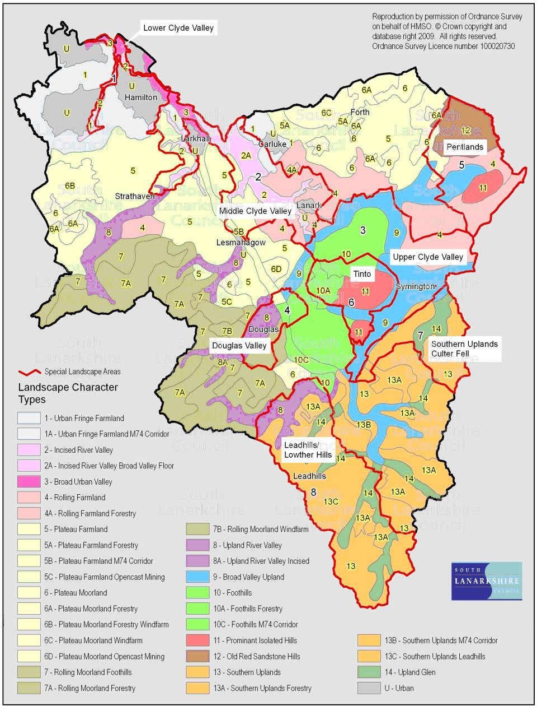
Source: South Lanarkshire Council

Greenbelt
Areas of greenbelt in South Lanarkshire are confined to areas surrounding larger settlements in the north. These areas are under pressure from further development. Although these areas are not defined as an environmental asset, they are important to the overall value of the area, particular in maintaining local access to the countryside. The greenbelt in South Lanarkshire surrounds East Kilbride and Hamilton, extending down to Strathaven and across to Carluke, covering an area of 217.759 km2 (Figure 4.3). This is a slight reduction from the coverage of 217.887 km2 in 2017 and 219 km2 in 2013. The change reflects the expansion of settlements as set out in the South Lanarkshire Local Development Plan 2, Proposed Plan published in July 2018.

Figure 4.3: Expansion of the greenbelt within South Lanarkshire, July 2018
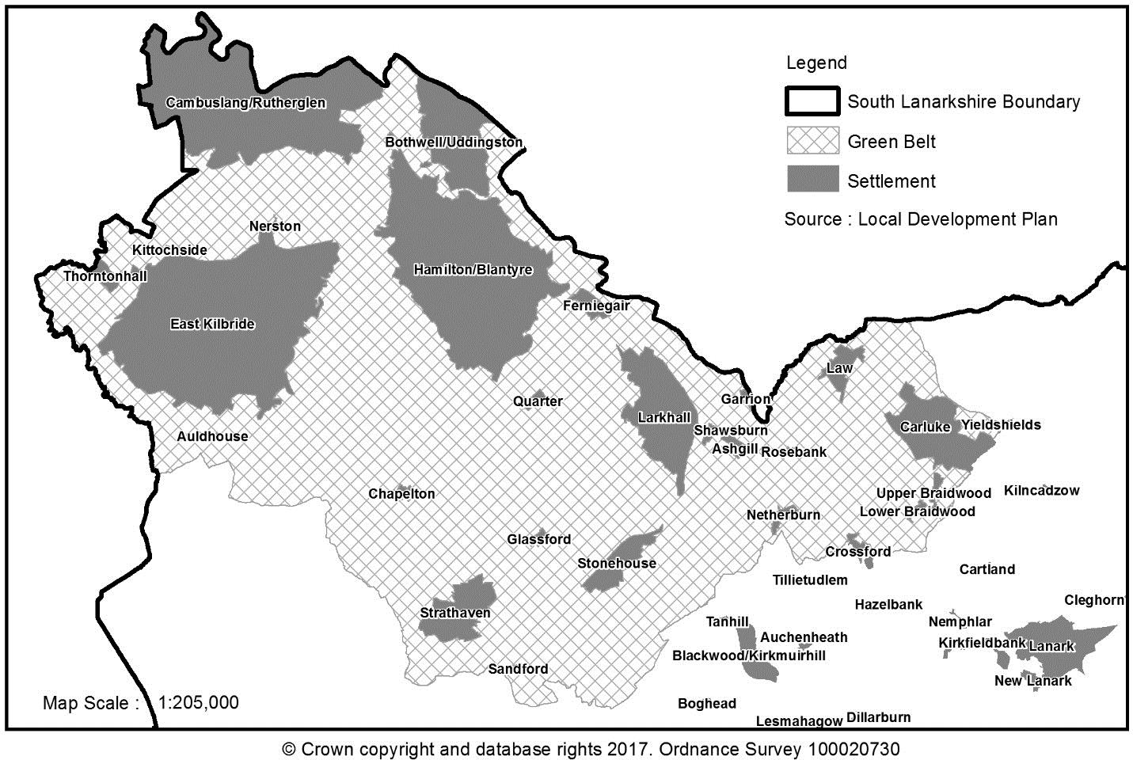
Historic Gardens and Designed Landscapes
Gardens and designed landscapes are grounds which have been laid out for artistic effect. They are formally recognised for their local historic and cultural importance. There are 6 designated gardens and designed landscapes in South Lanarkshire and these are described in Table 3.5.

Country Parks
There are 3 designated country parks in South Lanarkshire, which South Lanarkshire Council wholly or partially manage. These are Chatelherault Country Park, Calderglen Country Park and Hamilton Low Parks which forms part of Strathclyde Country Park. The country parks provide general outdoor access within a managed countryside setting.

Minerals
Minerals have an important role in the local economy. As well as for construction purposes they are used in a diverse range of processes and products including iron and steel smelting and the manufacture of glass, plastics, cements, medicines, food and cosmetics. They are required for all construction projects, including homes, schools, hospitals and maintenance of transport networks. In order to fully adopt the principles of environmentally sustainable development a reassessment of the use of finite and environmentally sensitive natural resources such as minerals is required.
However, until sustainable alternative material, particularly for aggregates, is identified and used, it is essential that the future extraction of minerals is carefully planned.

Geology
South Lanarkshire has a diverse geology consisting of sedimentary, igneous and metamorphic rocks. These are suitable for producing hard-rock aggregates, natural building stone and provide coal, fireclays and mudstones suitable for brick making. There are also deposits of sand and gravel which provide natural aggregates for construction industries. These are found particularly along the river valleys of the Avon, Mouse, Medwin and Clyde. South Lanarkshire can be divided into a number of discrete geographical areas, each having its own minerals resource potential (Table 4.10). Mineral extraction falls within the geological layout of the area.

Table 4.10: Principal mineral resources within geological areas in South Lanarkshire
Geological Area | Mineral Resource
Avon Valley | - Sand and gravel | - Clay | - Iron ore
Avon Valley | - Coal | - Peat
Douglas Valley | - Coal | - Fireclay | - Peat
Douglas Valley | - Sand and gravel
Forth Plateau | - Coal | - Fireclay
Mouse/Medwin Valley | - Sand and gravel | - Peat
Clyde Valley | - Sand and gravel | - Sandstone | - Whinstone
Clyde Valley | - Coal | - Clay | - Peat
Sand and gravel
South Lanarkshire contains extensive deposits of sand and gravel along the Clyde and Avon valleys and, to a lesser extent, deposits in the valley of Medwin and the Douglas Water valley. Current estimates for 2017 suggest that South Lanarkshire is producing 1.5 Mt of sand and gravel per annum from 7 operational sites, which is an increase on the 1.45 Mt produced in 2000/01.
The consented sites are estimated to have 18.2 Mt of sand and gravel in reserves. The growth of policy emphasis on sustainable development and the encouraged use of secondary and recycled aggregate materials, including construction and demolition waste as alternatives to primary aggregates have been widely adopted.

Hard rock
Aggregates are sourced from a variety of places. The majority of aggregates occur as natural materials, including hard rocks crushed to the required particle sizes. Crushed rock is used primarily as a road-stone and in concrete. South Lanarkshire is a net importer of hard rock materials because the quality and quantity of indigenous aggregates are unsuitable for use in road surfacing application. Sources of suitable aggregate are located to the immediate north of the authority area.
There are 3 operational hard rock quarries in South Lanarkshire providing aggregate material for a variety of end uses including concrete aggregate, rail ballast, building blocks and synthetic cobbles and paviors. These quarries are expected to produce approximately 1.6 Mt of aggregate per annum, with the sites estimated to have 55.5 Mt in reserve.

Coal
There are two main areas of coal deposits which, when taken together, account for approximately 40% of Scotland’s remaining surface coal resources. However, without the security of a local market (previously coal was used by the Longannet Power Station which closed in 2016) coal extraction in South Lanarkshire looks to have ceased for the foreseeable future, maybe even permanently.
Of the 4 sites that remain un-restored following liquidation of Scottish Coal, 3 (Glentaggart and Broken Cross North and South) have now been restored and are entering into their aftercare period. The restoration bond monies have been secured for the remaining site (Mainshill) with restoration work underway with the site expected to be restored before 2020. Total economic coal reserves in South Lanarkshire are estimated at about 27 Mt. Two ‘minded to approve’ planning permissions exist for coal surface mines at Glentaggart East, Glespin and Hardgatehead, Forth but it is unlikely that these will be progressed.

Peat
Although there are extensive areas of peat across South Lanarkshire, extraction is limited to 4 sites, one located near East Kilbride, one close to Douglas Water and two near Carnwath. The peat is principally used within the horticulture sector. These sites currently extract about 40,000 cubic metres (m3) of peat per annum.

Mineral recycling
The aim of sustainable development is to decrease the quantity of minerals used without slowing economic growth. This can be achieved by increasing the efficiency of use, increasing the recycling of inert material and using alternative material. Segregation of all recoverable materials helps to maximise efficient use of bulk mineral material. As well as mineral recycling, soil recycling and green composting provide efficient methods for increasing the recycling of inert material.
Within South Lanarkshire, there are 2 mineral recycling facilities, providing recycled mineral-based material, at Quay Industrial Estate, Rutherglen and Dovesdale Farm, Stonehouse. Proposals have been put forward for a further mineral recycling facility at Wellbrae Reservoir, Hamilton. This is currently under consideration.

Bings
Waste heaps or ‘bings’ arise from various types of mineral workings. The main bings found in South Lanarkshire are coal spoil from deep mining although other wastes such as spent oil shale, ironstone, slags, metal ore waste and lime wastes do occur. Bings are normally regarded as having a negative environmental impact in an area due to their visual intrusion and potential contamination to the land and water courses. However, bings can also be important in terms of nature conservation interest because of their highly distinctive environments (for example, acidic, nutrient poor, high heavy metal content) and can often support distinct vegetation or rare species worthy of protection. There is an increasing awareness that the material within existing bings have a mineral potential for use in road construction and building material.
There are 25 bings across South Lanarkshire, and these provide an additional mineral resource within the area. There are 4 bings with planning permission for the extraction of their mineral content, (Cadzow Bing in Hamilton, Ross Tip at Ferniegair, Douglas Water Bing near Rigside and Auchlochan Bing No. 9, Coalburn). Ross Tip, Ferniegair has now been fully restored and has been in agricultural use since May 2019.

Waste
SEA objectives that relate to waste
Minimise the generation of waste.
Maximise recycling and composting to reduce waste going to landfill.
The amount of waste generated and how it is treated is a growing social, economic and environmental concern. The types of waste produced, its transportation, treatment and/or disposal can all be detrimental to the environment. Adopting good integrated waste management practices is essential for minimising these environmental impacts and protecting human health. Waste can be regarded as a potential resource, with increased levels of reuse, recycling and energy recovery contributing to sustainable development.
The European Waste Framework Directive (2008/98/EC) sets out a waste hierarchy for the management of waste which is intended to drive waste prevention and reuse, significantly increase recycling rates and reduce the amount of waste sent to landfill. Article 4 of the Directive establishes the waste hierarchy of prevention, preparation for reuse, recycling, other recovery (for example, energy recovery) and finally, disposal. The council and other organisations must have regard to the hierarchy when considering their options for managing waste.

In June 2010, the Scottish Government published its Zero Waste Plan (ZWP). The Plan sets out the strategic direction for waste policy in Scotland until 2020 and contains a range of targets designed to assist the Scottish Government achieve its vision of a zero waste society.
The Zero Waste Plan vision ‘describes a Scotland where resource use is minimised, valuable resources are not disposed of in landfills, and most waste is sorted into separate streams for reprocessing, leaving only limited amounts of waste to go to residual waste treatment, including energy from waste facilities’.
Scottish Government Zero Waste Plan (page 3)

The majority of the waste collected by the council is municipal waste which is reducing year on year. It is important that the waste hierarchy is considered to ensure both a reduction in the amount of waste being generated and the amount being disposed of to landfill. It is important that the methods used to manage waste do not negatively impact on the environment. Poorly managed waste can impact the environment in several ways, including:
- The emissions of air pollutants such as greenhouse gases, dioxins and nitrogen oxides.
- The discharge of offensive odours.
- The discharge of landfill leachate to groundwater and surface water.
- The reduction in the amount of land available for development or amenity uses as a consequence of the presence of landfill sites.
- Localised litter problems.
The council is committed to meeting the Zero Waste Plan targets by reducing the amount of waste being disposed of to landfill and increasing re-use, recycling and composting rates.
A summary of the indicators used in assessing the state of South Lanarkshire is presented, highlighting the current status of each indicator and the directional trend.

The Current status is shown by the following colours: The trend direction is shown with the following arrows:
G | Good | F | Fair | Improving
 |  |  |  | No change
P | Poor |  | Limited data | Deteriorating
Note: The most recent data available was used in assessing the environmental indicators

Indicator | Current status | Trend direction | Explanation
Waste generation | G |  | The level of waste generated by households continues to  reduce with individual households now producing an average of 0.98 tonnes per annum.
Waste treatment | G |  | By recycling, composting and thermally treating waste, the council has increased the amount of waste being diverted from landfill.
Waste management | G |  | The council continues to record high levels of recycling at its Household Waste and Recycling Centres with 62.5% of material collected at the sites recycled or composted in  2018/2019.
Environmental waste | G |  | Street cleanliness in the area continues to improve and satisfaction levels remain above the Scottish average. The council continues to effectively respond to reports of abandoned cars and flytipping.

Baseline situation
Since 2001/2002 the amount of waste generated and collected in South Lanarkshire continues to reduce at the same time as the growth in the number of households. Although household recycling rates have reduced in recent years, this can be attributed to the council separately collecting high quality recycling material at the kerbside rather than extracting low quality/value from residual waste. There has been a significant increase in the number of flytipping enquiries and reports of abandoned vehicles received by the council.

Waste generation
Waste generated in South Lanarkshire has reduced significantly since 2001/2002 despite a steady increase in South Lanarkshire’s population (Table 5.1 and Figure 5.1). The economic downturn is likely to have been a factor in the reduction of waste generation. During 2018/2019, the council’s Waste Services managed a total of 159,132 tonnes of waste.

Table 5.1: Municipal solid waste collected by SLC Waste Services (tonnes)
 | Households | Total waste collected | Household waste | Commercial waste | Industrial waste | Waste per household
2001/2002 | 131,765 | 207,059 | 183,059 | 24,000 | - | 1.39
2002/2003 | 132,995 | 172,512 | 152,860 | 10,425 | - | 1.22
2003/2004 | 134,611 | 178,373 | 150,908 | 6,365 | - | 1.21
2004/2005 | 136,681 | 204,443 | 194,520 | 9,684 | 239 | 1.42
2005/2006 | 139,108 | 202,940 | 195,634 | 7,069 | 237 | 1.41
2006/2007 | 140,861 | 209,485 | 194,665 | 13,313 | 1,507 | 1.38
2007/2008 | 142,364 | 204,513 | 190,158 | 14,331 | 23 | 1.34
2008/2009 | 144,565 | 194,804 | 190,914 | 3,832 | 58 | 1.32
2009/2010 | 144,565 | 189,864 | 179,527 | 10,335 | 20 | 1.24
2010/2011 | 146,239 | 177,041 | 167,609 | 9,412 | 20 | 1.15
2011/2012 | 144,856 | 175,855 | 161,958 | 13,878 | 19 | 1.12
2012/2013 | 145,621 | 167,445 | 144,614 | 22,797 | 34 | 0.99
2013/2014 | 146,641 | 174,649 | 146,513 | 28,119 | 17 | 1.00
2014/2015 | 147,474 | 167,273 | 153,972 | 13,282 | 19 | 1.04
2015/2016 | 148,396 | 165,588 | 152,032 | 13,566 | - | 1.03
2016/2017 | 149,236 | 166,938 | 154,045 | 12,938 | - | 1.03
2017/2018 | 150,655 | 161,028 | 150,844 | 10,184 | - | 1.01
2018/2019 | 152,101 | 159,132 | 148,685 | 10,447 | - | 0.98
Source: South Lanarkshire Council
There has been a steady reduction in the amount of municipal waste collected by the council over recent years. As well as the economic downturn, other factors such as national initiatives to reduce packaging waste in the manufacturing sector and legislative drivers such as charges for single use carrier bags has contributed to the reduction in the amount of waste produced.

Figure 5.1: Municipal solid waste collected by SLC Waste Services (tonnes)

HouseholdCommercialIndustrial

250,000

200,000

150,000

100,000

50,000

0
2001/022004/052009/102010/112011/122012/132013/142014/152015/162016/172017/182018/19
Source: SEPA and South Lanarkshire Council

Household waste
South Lanarkshire Council managed 148,685 tonnes of household waste in 2018/2019 (Table 5.1 and Figure 5.1), a reduction of 24% from the peak levels of waste generated in 2005/2006. The number of households in South Lanarkshire has steadily increased in recent years, however, the amount of waste generated per household decreased from 1.41 tonnes in 2005/2006 to 0.98 tonnes in 2018/2019.

Commercial and industrial waste
Commercial and industrial waste includes business waste, construction and demolition waste and waste from agriculture, fishing and forestry. These range from sole traders to large industrial complexes. The council has data regarding the amount of commercial waste collected by Waste Services (Table 5.1), however, as it does not provide a collection service to other businesses, there is a data gap relating to the amount of this type of commercial and industrial waste generated in South Lanarkshire. This is compounded by the fact that there is no legal requirement for businesses to report on the quantities of waste they produce. Construction and demolition waste is important because it makes up between 40 – 50% of waste generated in Scotland.

Special and hazardous waste
Special waste poses particular risks to human health and to the environment. Waste is classified as hazardous if it displays one or more hazardous characteristics or properties such as being explosive, highly flammable, toxic or carcinogenic. SEPA maintains a register of the movement and disposal of special waste. There is no data available specifically for South Lanarkshire.

Waste treatment

Waste recycling
Kerbside recycling collection services were first introduced in South Lanarkshire in 2003 when, due to a successful bid to the Scottish Executive’s Strategic Waste Fund, a number of initiatives were introduced to allow residents to easily recycle/compost a variety of materials (dry recyclate, glass and compostable garden waste). The council commenced the roll out of new waste and recycling services to comply with the obligations of the Waste (Scotland) Regulations 2012 in April 2015.
The rollout was completed in December 2016. The majority of households in South Lanarkshire
now use a four bin service where ‘fibres’, ‘containers’ and co-mingled food and garden waste are collected alongside residual (non-recyclable) waste. Improved kerbside collection recycling coverage and other initiatives have led to a significant improvement in the council’s household recycling rate since 2011/2012 (Table 5.2). These initiatives are successfully diverting waste away from landfill.

Table 5.2: Household recycling rates, (financial years)
Year | Rate
2011 – 2012 | 35.7%
2012 – 2013 | 37.4%
2013 – 2014 | 39.7%
2014 – 2015 | 47.4%
2015 – 2016 | 48.8%
2016 – 2017 | 53.1%
2017 – 2018 | 44.3%
2018 – 2019 | 45.3%
Source: South Lanarkshire Council
Table 5.3 and Figure 5.2 shows the breakdown of household materials recycled or composted in South Lanarkshire since 2012/2013. The majority of dry recyclable material ends up at a Materials Recovery Facility where it is sorted and baled for onward transportation.

Table 5.3: Household materials recycled or composted in South Lanarkshire (tonnes)
Material | 2012/  2013 | 2013/  2014 | 2014/  2015 | 2015/  2016 | 2016/  2017 | 2017/  2018 | 2018/  2019
Kerbside glass | 6,023 | 6,058 | 6,330 | 5,490 | 1,384 | -* | -
Kerbside compostable | 4,400 | 5,240 | 5,957 | 6,619 | 17,068 | 19,379 | 19,268
Kerbside co-mingled | 18,475 | 18,822 | 19,176 | 15,061 | 4,020 | -** | -
Kerbside ‘fibres’ | - | - | - | 2,260 | 8,553 | 9,500 | 7,801***
Kerbside ‘containers’ | - | - | - | 1,848 | 6,388 | 11,891 | 12,239
Household Waste Recycling Centres | 23,480 | 25,149 | 28,984 | 29,679 | 27,103 | 24,527 | 26,376
Recycling points | 1,540 | 944 | 983 | 705 | 537 | 570 | 551
Bulky uplifts | 2,338 | 2,582 | 2,346 | 1,681 | 1,813 | 2,601 | 2,353
Total | 56,256 | 58,795 | 63,776 | 63,343 | 66,866 | 68,468 | 68,588
Notes: * Glass ceased to be collected separately ** No longer collected *** Excluding rejects

Figure 5.2: Household materials collected in South Lanarkshire (tonnes)
35000
30000
25000
20000
15000
10000
5000
0
2012/20132013/20142014/20152015/20162016/20172017/20182018/2019
Kerbside Glass
Kerbside compostable Kerbside co-mingledKerbside fibres
Kerbside containersHWRCsRecycling PointsBulky Uplifts
Source: South Lanarkshire Council and SEPA

Non kerbside facilities
There are six Household and Waste Recycling Centres located within South Lanarkshire (Table 5.4). Five of these are operated by a third party on behalf of the council. The site at Castlehill Industrial Estate, Carluke remains under council management. The sites collected 38,685 tonnes of waste in 2018/2019, of which 24,179 tonnes were recycled or composted. This provides a recycling rate of 62.5% for all sites.

Table 5.4: Household and Waste Recycling Centres in South Lanarkshire
Amenity/recycle site | Site description/waste accepted
East Kilbride Eastfield Hamilton Larkhall  Strathaven | Operated by a third party on behalf of the council. Skips for green waste, scrap metal, cardboard and general waste. Facilities for recycling bottles and jars, food and drinks cans, paper, textiles, books, used motor oil and car batteries. The site accepts waste electrical and electronic equipment for recycling.
Castlehill Industrial Estate Carluke | Managed by South Lanarkshire Council. Skips for green waste, cardboard, scrap metal and general waste. Recycling points for textiles as well as food and drinks cans. Car batteries and electronic  equipment are also accepted at the site.
Source: South Lanarkshire Council

Composting
The council composts the green waste from services such as grounds maintenance, as well as the material from its domestic garden waste collection service. The council has provided a food and garden waste collection service to householders since 2015. The food and garden waste collected is sent to an In-Vessel Composting facility where it is turned into PAS100 compliant compost. The service was introduced to comply with the council’s statutory duty to provide a domestic food waste collection service as set out by the Waste (Scotland) Regulations 2012.

The introduction of this service has seen a significant increase in the amount of material being composted and a decrease in the amount of waste being sent to landfill since 2015. In 2018/2019, the council composted a total of 24,179 tonnes of material. This compares to the 2014/2015 figure of 13,412 tonnes (an increase of 80%).

Energy recovery
As a consequence of the stringent landfill diversion targets contained within the Zero Waste Plan and the forthcoming ban on the landfilling of biodegradable municipal waste, the council awarded a contract for the treatment of its residual waste in 2016. In 2018, the council began to send residual waste to Viridor’s Energy from Waste facility in Dunbar to be thermally treated, a process that generates both heat and electricity. From 2019 onwards, the vast majority of the council’s municipal residual waste will be thermally treated at Dunbar rather than landfilled. This allows the council to comply with the Scottish Government’s ban on the landfilling of biodegradable municipal waste, originally scheduled to come into force on 1 January 2021, which is now due to be implemented in 2025.

Waste disposal

Landfill
There are currently 2 landfill sites operating in South Lanarkshire. These sites, Inland Engineering, near Quarter and Wm Hamilton and Sons, near Stonehouse, can accept inert waste materials.
Operations at Cathkin landfill site were completed in 2014 with landform restoration finished in early 2019. The amount of waste landfilled by the council is shown in Figure 5.3.

Figure 5.3: Waste sent to landfill by South Lanarkshire Council (tonnes)
160000
140000
120000
100000
80000
60000
40000
20000
0
2004/05 2009/10 2010/11 2011/12 2012/13 2013/14 2014/15 2015/16 2016/17 2017/18 2018/19
Source: South Lanarkshire Council

Environmental waste

Street litter
The quality of local surroundings is fundamental to a good quality of life. Individual perspectives on the state of their local environment can differ but, in general, people view street cleanliness as a major factor. Street cleanliness includes the level of litter, detritus, graffiti and fly posting. These factors are collectively known as ‘Environmental Incivilities’. A number of Scottish Government sponsored studies have identified that such incivilities are aspects which local residents feel have negative impacts on their local environment and sense of wellbeing. In general terms, those who believe the environment in their neighbourhood is poor are more likely to report anxiety, depression and a general poor state of health.

The council does not collect tonnage data for street litter. The success of the council’s street cleaning is assessed using a national performance indicator for cleanliness, Local Environmental Audit and Management System (LEAMS), was originally developed by Keep Scotland Beautiful (KSB) and is currently under review by Zero Waste Scotland as part of the new Code of Practice on Litter and Refuse (COPLAR) which was approved by the Scottish Government in June 2018. A new scoring mechanism is currently being trialled and is expected to go live in 2020.

In 2013/2014, the Improvement Service undertook a significant review of the Local Government Benchmarking Framework and the Statutory Performance Indicators. Following consultation, the Statutory Performance Indicator for street cleansing changed from the Cleanliness Index calculated from LEAMS to the following three indicators:

    - Street Cleanliness Score (% streets at an acceptable A, B+ or B grade standard from LEAMS assessments).
    - Net cost of street cleaning per 1,000 population (£).
    - Percentage of adults satisfied with waste collection and street cleaning.

The Street Cleanliness Score is collated by Keep Scotland Beautiful and includes two internal audits carried out by local authority and a further validation audit carried out independently by KSB. The percentage of streets assessed as acceptable (A or B COPLAR standard) moves away from attaining completely litter free sites, (considered impractical in areas of high footfall) to reducing the impact from more widespread litter problems within the street scene.

South Lanarkshire achieved a 95.5% satisfaction level which is in advance of the Scottish average (92.2%) and the family group average (93.2%). (Table 5.5). Comparative figures for 2018/2019 were not available at time of reporting.

Table 5.5: Street cleanliness scores for South Lanarkshire
Financial year | Score
2011/2012 | 97.8%
2012/2013 | 97.1%
2013/2014 | 98.9%
2014/2015 | 98.3%
2015/2016 | 97.9%
2016/2017 | 96.3%
2017/2018 | 95.5%
2018/2019 | 94.9%
Source: Keep Scotland Beautiful; The Improvement Service; South Lanarkshire Council

Illegal dumping – flytipping
Fly-tipping is the illegal dumping on land not licensed to receive it. This blights the landscape and can pose a serious threat to the environment. Most fly-tipping originates from households and consists of black bags, white goods, other electrical items and garden waste. The cost of clean-up and investigation for these incidents is difficult to quantify but are significant. These costs are expected to rise as landfill tax for commercial and industrial premises and other costs increase.

In the last three years there has been a steady increase in enquiries relating to waste and flytipping received by the council’s Environmental Crime Team, who continue to take action against offenders (Table 5.6).

Table 5.6: Waste and flytipping enquiries
 | Enquiries | Fixed penalty notices | Reported to  Procurator Fiscal
2014/2015 | 1893 | 53 | 15
2015/2016 | 2277 | 102 | 57
2016/2017 | 2356 | 79 | 59
2017/2018 | 2501 | 10 | 10
2018/2019 | 2889 | 82 | 29
Abandoned vehicles
Since 2002 more than 36,000 vehicles have been uplifted from the streets and land throughout Scotland. This has potentially cost Scottish council-tax payers in excess of £5m to deal with abandoned and nuisance vehicles. Such vehicles are a danger to the environment, through leaking fluids or potential fire risks and are a health hazard, particularly to younger children.
Within South Lanarkshire the number of reports of abandoned vehicles during 2017/2018 and 2018/2019 has been consistent with the jump recorded in 2016/2017 (Table 5.7). Similarly, the number of cars uplifted on the basis of being ‘abandoned’ has remained high which can partly be attributed to the relatively low monetary value for mixed scrap metal which has remained at £95 -
£100 per tonne since 2017. Locally, Environmental Services are aware of persons seeking to dispose of cars through car breaking companies being offered almost nothing for their vehicle. There are also reports that some contractors are now, for the first time in many years, seriously looking at introducing disposal charges for everything other than high market value makes of car.

Table 5.7: Abandoned cars reported in South Lanarkshire
 | Reported incidences | Further investigation | Uplifted
2007/2008 | 503 | 160 | 99
2008/2009 | 283 | 91 | 59
2009/2010 | 260 | 73 | 25
2010/2011 | 216 | 50 | 9
2011/2012 | 201 | 58 | 8
2012/2013 | 124 | 34 | 3
2013/2014 | 191 | 185 | 7
 | Reported incidences | Further investigation | Uplifted
2014/2015 | 220 | 202 | 6
2015/2016 | 344 | 266 | 25
2016/2017 | 716 | 524 | 64
2017/2018 | 718 | 261 | 51
2018/2019 | 712 | 324 | 40
Total to date | 4,488 | 2,228 | 396
Source: South Lanarkshire Council, Environmental Services

Soils
SEA objectives that relate to soils
Conserve and improve soil form and function.
Reduce soil contamination and the number of contaminated sites.
Soil is a complex, variable and living medium. It has a role in providing a habitat and gene pool, is important for human activities, landscape and heritage and acts as a provider of raw materials.
The European Union has defined soil as ‘…the top layer of the Earth’s crust and is formed by mineral particles, organic matter, water, air and living organisms’.

Soil performs many vital functions: as a growing medium for food, forestry and other biomass production, storage, filtration of water, carbon, and nitrogen. Soil in its many forms is considered as an important carbon store. Scottish soils are estimated to contain approximately 3,200 million tonnes (Mt) of carbon, which is more than half the UK’s soil carbon and 60 times as much as all the vegetation in Scotland. In particular, peat soils hold over 70% of Scotland’s carbon but only accounts for around 11% of its land area.

Scotland’s soils are generally in good health but there is a lack of national trend data from which evidence of change or damage to soils might be determined. There is some evidence that levels of organic matter in Scottish soils may be declining and this may result in a significant reduction in the UK stock of terrestrial carbon. The key cause of this decline is intensive agricultural practices which disturbs the soil and leads to changes in soil carbon levels. The rate of organic matter loss from soils is far quicker than the rate of organic matter gain meaning that once the organic matter is lost it is impossible to replenish.

The 2005 Scottish Greenhouse Gas Inventory estimated that soil carbon stock changes in land converted to cropland emitted 6.5 Mt carbon dioxide – about 15% of Scotland's net carbon dioxide emissions. In comparison, soil carbon stock changes in land converted from arable to grassland gave a sink of 2.8 Mt carbon dioxide even though the area was larger (1200 kha compared to 1000 kha for land converted to cropland). Many of these emissions/removals are due to historical land use change (pre-1990).

In 2006, a Soil Framework Directive was proposed to protect soils across the EU. The main issues identified included erosion, loss of organic matter and contamination. Soil damage and degradation can potentially have negative effects on human health, natural ecosystems and climate change and our ability to grow crops and other food sources for humans and animals.
There is a wide range of soil types in South Lanarkshire, some characterised by historical contamination from industrial activities, agricultural land, woodlands and peatlands. In 2006, it was estimated that approximately 361 kilo tonnes of carbon dioxide was removed from the atmosphere in South Lanarkshire through existing carbon sinks, including trees and other plants.
A summary of the indicators used in assessing the state of South Lanarkshire is presented, highlighting the current status of each indicator and the directional trend.

G | Good | F | Fair | Improving
 |  |  |  | No change
P | Poor |  | Limited data | Deteriorating
Note: The most recent data available was used in assessing the environmental indicators

Indicator | Current status | Trend direction | Explanation
Soil quality | G |  | Current data indicates good soil quality in a Scottish or  regional context. At present there is limited data on soil quality specifically within South Lanarkshire.
Soil capacity | G |  | There has not been a significant level of development within the green belt. As a result, there is no evidence to suggest that soil capacity has been affected.
Land use | F |  | The available data on soil use is limited and outdated. Work is ongoing nationally to address this data gap.
Contaminated land | F |  | Since 2005, 30% of potentially contaminated sites have been investigated and remediated under the planning  system.

Baseline situation
Soil quality in South Lanarkshire is considered to be generally good although baseline data is difficult to gather and is rarely updated. Human activity, land use and intensity and global climatic effects can be detrimental to soils, reducing their distribution, function and sustainability. Healthy and diverse soils are important for crop growth, carbon storage and sustaining biodiversity across a range of habitat types.

Soil quality

Geology and hydrology
South Lanarkshire’s diverse range of landscapes indicates the presence of an equally diverse geology. In terms of solid geology the area can be divided into five broad regions. The very south of the area around the Lowther Hills is indicated to be underlain by sandstone and shales with intrusions of mudstones. Further north into the lower central region the underlying geology is also sandstone and shales with volcanic intrusions.
The central region of South Lanarkshire is indicated to be predominantly underlain with sandstone, conglomerates and lavas. The western portion of the central region is shown to be underlain with coal measures and partly by millstone grit. The route of the River Clyde and its tributaries is defined by deposits of sands and gravels.

The north eastern region of South Lanarkshire is principally underlain by sandstone while further west there are more coal measures. The coal seams in the Hamilton area have been extensively worked by both open cast and deep mining methods in the past. In common with the majority of Scotland the drift geology comprises till, sand and gravel from the last and earlier ice sheets.
Additional deposits from rivers include substantial areas of peat.

In terms of hydrogeology coal measures are categorised as locally important aquifers where flow is dominantly in fissures and other discontinuities. Mine workings have been heavily pumped in the past, however, yields are typically low and water quality is poor. Sandstone provides locally important aquifers however borehole yields can vary significantly within the region.

Soil data
Soil quality can be considered as ‘fit for purpose’ for the range of functions we expect soils to perform. Based on existing information, Scottish soils are generally of good quality. Outwith the urban areas there is no indication that South Lanarkshire’s soils are radically different. Only a few soils located in the Cambuslang and Rutherglen area have high concentrations of contaminants due to industrial land uses with concentrations in the remainder being generally low. The area surrounding Leadhills has high concentrations of lead and other heavy metals naturally occurring in the soils as a consequence of the solid geology and historic metalliferous mining in the area. There is little evidence to suggest that South Lanarkshire suffers from serious soil erosion, compaction or other problems related to land management.
At present there is no valid data available to enable a robust assessment of the soil quality. The British Geological Society is ‘…developing data of direct relevance to improving our understanding of soils within the context of a diverse array of functions’. These datasets are not yet available but are developed for specific assessments.

Soil capacity
Soil capacity includes the ability to grow a range of crops, to catch and retain flood waters, carbon storage and to enhance biodiversity. Although available datasets detail soil capacity they are rarely updated making trend analysis impossible.

The Scottish Government has collected agricultural census statistics on a national and regional basis since 1982. There are no South Lanarkshire area specific figures and efforts should be made to close this identified data gap. These statistics will indicate whether soil capacity is changing (the amount of land being used for different types of crops) and the total area under cultivation. Topsoil carbon mapping is another area of research which potentially could be beneficial in terms of quantifying soil health.

Land use
The MacAulay Land Use Research Institute, now the James Hutton Institute, developed maps and datasets related to land use and agricultural capabilities. However, the available data is 20-30 years old and is being updated. The council’s Local Development Plan is an important source of information as it records current land use (at a certain point in time) and plots out the areas where development will take place over the life of the plan. Departures from the Local Development Plan can be used as indicators for both soil protection and capacity.
Agriculture is the single largest use of land across South Lanarkshire. However, there are limited areas that have high yield growing capacities within classifications 1 and 2. The majority of agricultural areas in South Lanarkshire are considered suitable for grazing (Figure 6.1).

Figure 6.1: Land classification across South Lanarkshire

600
31%
26%
21%
15%
7%
0%
<1%
<1%
<1%

500

400
Land Area (km 2)

300

200

100

0
1 2 3 4 5 6 7 Built-up
Area

Water

Source: The Scottish Government

Contaminated land
The contaminated land regime set out in Part IIA of the Environmental Protection Act 1990 as inserted by section 57 of the Environment Act 1995, came into force in Scotland in July 2000.
The council has a statutory duty to investigate its land area specifically to find and resolve contaminated land issues which relate to harm to people, pollution to the water environment or damage to property. Soil quality is improved through the remediation of sites by reducing its ability to cause harm or pollution and soil capacity may also be improved. Some remediation techniques are highly destructive with regard to soil structure, flora and fauna, and organic content. Although improvements to soil capacity and quality are not contaminated land regime aims the processes involved frequently favour them. The regime’s stated intent is to ensure land is suitable for its
intended use. This is achieved through an iterative process of creating a list of potential sites and investigating them in a methodical manner. A proportion of sites are remediated through the planning process using the same philosophy.
Statutory guidance defines ‘contaminated land’ as:
‘…any land which appears to the local authority in whose area it is situated to be in such a condition, by reason of substances in, on or under the land, that
significant harm is being caused or there is a significant possibility of such harm being caused; or
significant pollution of the water environment is being caused or there is a significant possibility of such pollution being caused’.
A list of potentially contaminated sites is compiled by the council and prioritised for inspection. This list has about 5,800 entries and to date some 5,100 sites have been initially investigated by way of a site walkover with some 43 sites progressing to further investigation (Figure 6.2). The areas of potential contamination are mainly centred on the urban areas with the majority of the industrial land uses based on mining, manufacturing and chemical works.

Progress of the contaminated land regime
The council through its Environmental and Strategic Services and Planning has been investigating these sites since 2000. Progress has been good with approximately 80% of the total number of sites investigated and remediated through the Part IIA regime (Figure 6.2). From 2005 – 2018, some 1,756 sites (30% of the total) have been, in whole or part, investigated and remediated under the planning system. Initial investigation is expected to continue until 2020 with the numbers of sites being investigated per annum falling from a high in 2007/2008 as sites become more difficult to access due to topography and remote location.

Figure 6.2: Progress on Environmental Protection Act 1990 (Part IIA) site investigations

7000

No. of Sites

Stage 1 Sites per annum
Total Investigated Sites
2020 Projected Investigation Sites

6000

5000

4000
Number of Sites

3000

2000

1000

0
1999
2018/19
2016/17
2015/16
2014/15
2013/14
2012/13
2011/12
2010/11
2009/10
2008/9
2007/8
2006/7
2005/6
2000/04

Source: South Lanarkshire Council

Similarly, the physical area investigated will decline each year as the larger sites are investigated leaving the smaller sites (sub 100m2) for later years. This is demonstrated in Figure 6.3.

Figure 6.3: Progress of Part IIA area investigations

5000
4500
4000
3500
3000
2500
2000
1500
1000
500
0
1999
2005/6
2000/04

Total Area of

Sites

Area of Sites
Investigated
per annum
Total Area
Investigated Projected sites
Area of Sites (Ha)

Source: South Lanarkshire Council
2018/19
2016/17
2015/16
2014/15
2013/14
2012/13
2011/12
2010/11
2009/10
22000087//98

In 2011, implementation of the contaminated land regime resulted in one area of land being identified as statutorily contaminated. This area was subsequently designated as contaminated land and a ‘Special Site’. This type of site is regulated by SEPA and consultation with them has resulted in the area being sub-divided into seven contaminated land sites which are also special sites. The location of these sites can be found on the council’s Contaminated Land Public Register.

Air, noise and light
SEA objectives that relate to air, noise and light
Improve air quality, reduce the level of pollutants and the impacts on receptors.
Reduce the level of nuisance and the impact of noise on sensitive receptors.
Minimise the level of light pollution.

Today, Scotland’s air is cleaner than at any time since before the Industrial Revolution, achieved mainly through tighter controls on pollutant emissions from industry, transport and domestic sources. Good air quality is an essential component to improving human health and the status of the environment. The quality of the air around us is dependent on what pollutants we release into the atmosphere through our transportation, energy generation, domestic heating and industrial activities and through the dispersal and deposition mechanisms associated with these pollutants. The release of pollutants such as nitrogen oxides (NOx), sulphur dioxide (SO2), volatile organic carbons (VOCs) and particulates (including PM10 and PM2.5) and the subsequent secondary pollutant generated, such as ozone (O3) can have a detrimental effect on:
- Human health: triggering respiratory problems such as asthma and bronchitis, reducing the quality of life and life expectancy.
- Habitats: changing the ecosystem through nutrient enrichment or acidification or through the direct effects of pollutants such as ozone on plant growth and development.
- Building material: oxidation of material by ozone or erosion through acidification, thus reducing the life expectancy or quality of the material.
- Climate change: release of greenhouse gases such as carbon dioxide, methane and nitrous oxide can result in global shifts in climate.
- Nuisance: including reduced visibility through haze and smoke and odour, reducing the overall amenity value of the area.
Within the urban environment the pollutants that cause the main concern are those found close to source, primarily emitted from transport, domestic and commercial heating and small-scale industrial activities, with NOx and Particulates of primary concern in South Lanarkshire. The main issue associated with such pollutants are the impacts they have on human health, particularly on ‘sensitive individuals’ such as the elderly, young and those suffering from respiratory conditions, with elevated levels along transport routes within urban areas of South Lanarkshire.
Pollutants emitted from large-scale industrial activities, energy generation and to a lesser extent transport and agriculture can potentially travel in the atmosphere over long distances. These pollutants are considered as long-range pollutants and in many cases can result in the formation of secondary pollutants, such as ozone or the formation of acid rain, causing potential damage to sensitive vegetation and habitats.
Noise and light pollution can have detrimental effects on the environment, people and communities particularly in the more densely populated urban areas of South Lanarkshire.
A summary of the indicators used in assessing the state of South Lanarkshire is presented, highlighting the current status of each indicator and the directional trend.
The Current status is shown by the following colours: The trend direction is shown with the following arrows:
G | Good | F | Fair | Improving
 |  |  |  | No change
P | Poor |  | Limited data | Deteriorating
Note: The most recent data available was used in assessing the environmental indicators

Indicator | Current status | Trend direction | Explanation
Local air quality | F |  | Air quality across South Lanarkshire is generally good and improving but there are a few areas in excess of national  limits set to protect human health. There are three Air Quality Management Areas in South Lanarkshire.
Point source emissions | F |  | The number of permits issued for industrial activities in South Lanarkshire by SEPA has remained consistent since  the last Report.
Long-range pollutants | P |  | There are no identified long range pollutant emitters in South Lanarkshire. Long-range pollutants originating outwith  South Lanarkshire remain a concern.
Airborne  nuisance | G |  | Airborne nuisance complaints remain low and variable. Odour remains the main nuisance reported to the council.
Noise | F |  | The number of noise complaints received by the council has increased in recent years. The majority of complaints relate to domestic noise. Two areas in South Lanarkshire have ‘Quiet Area’ status.
Light |  |  | There is little data on light pollution across South Lanarkshire. This is currently measured based on the number of complaints received by Environmental Services.

Baseline situation
Air quality across South Lanarkshire is generally below national air quality objectives, with ‘hotspot’ areas identified within the urban environment. Transport is one of the main sources for urban pollution, with elevated levels associated with the main transport corridors and busy road junctions. Within the rural environment, acidification and nutrient enrichment are the main concerns, particularly across elevated ground. Long-range pollutants, emitted outwith South Lanarkshire are mainly associated with these effects and therefore controlling such pollutants is more challenging.

Excessive noise is associated with a variety of adverse impacts including, hearing impairment, sleep disturbance, hypertension and stress. The council utilises its powers to deal with noise complaints and has an out-of-hours service to investigate and remedy complaints of noise from domestic, commercial and industrial premises.

Local air quality
Good air quality is essential for our health and the environment. The Environment Act 1995 introduced the Local Air Quality Management (LAQM) system, which requires local authorities to undertake regular review and assessment of air quality. These reviews are carried out under the framework of local air quality management and are intended to compare current and future concentrations of air pollutants with the standards and objectives outlined in the National Air Quality Strategy (Table 7.1) and Air Quality (Scotland) Regulations 2010.

Under the LAQM regime, local authorities have a legal duty to review and assess air quality within their areas against a set of health based objectives, and where required, take measures to work towards improving air quality.
Air quality objectives - Air pollution concentrations should be at a level considered to be acceptable in the light of what is known about the effects of each pollutant on health and on the environment.

The Scottish Government recommends that local authorities consider preparing a local air quality strategy which outlines their commitment to air quality management and improvement. South Lanarkshire Council’s Air Quality Action Plan has now been adopted. Work will commence on finalising South Lanarkshire’s first Local Air Quality Strategy. This high level strategy will help inform and support other policies across the wide range of services provided by the council. The
strategy is aimed at council staff, partners, local businesses, organisations and the general public, all of whom have a role in being aware of and contributing to air quality within South Lanarkshire.

Table 7.1: Air quality objectives as set out within the national Air Quality Strategy
Pollutant | Air quality objective |  | Date to be achieved by
Pollutant | Concentration | Measured as | Date to be achieved by
Benzene | 16.25 µg m-3 | Running annual mean | 31 December 2003
Scotland and N. Ireland | 3.25 µg m-3 | Running annual mean | 31 December 2010
1,3-Butadiene | 2.25 µg m-3 | Running annual mean | 31 December 2003
Carbon monoxide | 10.0 mg m-3 | Running 8-hour mean | 31 December 2003
Lead | 0.5 µg m-3 | Annual mean | 31 December 2004
Lead | 0.25 µg m-3 | Annual mean | 31 December 2008
Nitrogen dioxide | 200 µg m-3 not to be exceeded more than 18 times a year | 1-hour mean | 31 December 2005
Nitrogen dioxide | 40 µg m-3 | Annual mean | 31 December 2005
 | 50 µg m-3, not to be exceeded more | Daily mean | 31 December 2004
Particles | than 35 times a year
(PM10) | 50 µg m-3, not to be exceeded more | Daily mean | 31 December 2010
 | than 7 times a year
Scotland | 18 µg m-3 | Annual mean | 31 December 2010
Particles (PM2.5)* | 25 µg m-3 (target) | Annual mean | 2020
Particles (PM2.5)* | 15% cut in urban background exposure | Annual mean | 2010 – 2020
Scotland | 12 µg m-3 (limit) | Annual mean | 2010
Scotland | 10 µg m-3 (limit) | Annual mean | 2020
Sulphur dioxide | 350 µg m-3, not to be exceeded more than 24 times a year | 1-hour mean | 31 December 2004
Sulphur dioxide | 125 µg m-3, not to be exceeded more than 3 times a year | 24-hour mean | 31 December 2004
Sulphur dioxide | 266 µg m-3, not to be exceeded more than 35 times a year | 15-minute mean | 31 December 2005
* Not currently assessed by Scottish local authorities.
Local air pollutants
The reduction of local air quality within an urban environment is generally associated with primary pollutants emitted directly into the atmosphere from localised sources. The pollutants of main concern within South Lanarkshire include:

Nitrogen oxides: Nitric oxide (NO) is mainly derived from combustion processes including road transport and electricity generation. Once released to the atmosphere, NO is usually very rapidly oxidised to nitrogen dioxide (NO2). Although NO is not considered to be harmful to health, NO2 can induce respiratory problems. Both NO2 and NO are oxides of nitrogen and together are referred to as nitrogen oxides (NOx).
Particulates: Fine particles compose a wide range of materials arising from a variety of sources including:
    - combustion sources (mainly road traffic),
    - secondary particles, mainly sulphate and nitrate formed by chemical reactions in the atmosphere,
    - coarse particles, suspended soils and dusts, sea salt, biological particles and particles from construction work.
Particles are measured in a number of different size fractions with most monitoring currently focussed on PM10, with the finer fractions such as PM2.5 and PM1 increasing in interest in terms of health effects.

Local air quality management
The primary cause of poor air quality at the ‘hotspot’ areas is from road traffic emissions, particularly at busy junctions. There are no significant industrial sources of air pollution in South Lanarkshire.

Although air quality within South Lanarkshire generally meets the National Air Quality Objectives and European Limit Values, there are some ’hotspot’ areas where levels of pollution exceed the more stringent Scottish objectives, particularly for PM10, where the objective is 18 μg m-3 in Scotland, compared with 40 μg m-3 for the rest of the UK.

To date, three Air Quality Management Areas (AQMAs) have been declared. The first AQMA was declared at Whirlies Roundabout, East Kilbride on the basis of exceedance of the Scottish PM10 objective concentration. The second AQMA for Rutherglen was also declared due to exceedance of the PM10 objective. The town of Lanark was also declared an AQMA due to exceedance of the NO2 objective.

Concentrations of air pollution are measured on a regular basis using a variety of monitoring equipment and this data is used to determine whether the National Objectives are being achieved. The number of monitoring sites within South Lanarkshire has increased. PM10, PM2.5 and NO2 are continuously monitored at 8 sites using automatic monitoring units. Diffusion tubes are also used to monitor NO2 at 40 locations throughout South Lanarkshire, covering a mix of roadside and background locations. A black carbon monitor has also been installed at one of the council’s continuous monitoring sites and three portable, battery operated NO2 monitors have been deployed. The NO2 monitoring network has been reviewed with ten diffusion tube sites being decommissioned and ten new monitoring locations being deployed in 2018 (Table 7.2) and the number of continuous monitors has been increased, reflecting the priority afforded to air quality monitoring within the council.

Table 7.2: New diffusion tube sites for 2018
Greenhills Road, East Kilbride | Greenlees Road, Cambuslang
218 Eaglesham Road, East Kilbride | 190 Hamilton Road, Halfway
56 Maxwell Drive, East Kilbride | 289 Glasgow Road (Empire Bar)
Cambuslang Road (Smith Terrace) | Wellhall Road/Hillhouse roundabout
Hamilton Road/Clydeford Road junction | Bardykes Road, (West End Bar)
Particulates
Particulates (PM10) are periodically monitored at various locations within South Lanarkshire. Automatic monitoring for PM10 is ongoing at all eight sites with recent investment within the network undertaken to upgrade all sites to monitor the smaller fraction of particulate matter (PM2.5). Table 7.3 shows the results from the automatic monitoring sites against the 18 μg m-3 objective.

There are variations in the level of PM10 recorded across the automatic monitoring sites within South Lanarkshire. The annual mean in the AQMA at the Whirlies Roundabout breached the 2010 air quality objective in 2014 (18 μg m-3 PM10), however, levels have reduced each year since. The annual mean PM10 for Rutherglen Main Street remained above the air quality objective between 2012 and 2015, however, the annual mean level was below the objective from 2016 onwards.
Monitoring commenced in Cambuslang in 2015 and the Raith monitor was relocated to a new local location in the vicinity of the upgraded motorway intersection. In general, measured annual mean PM10 concentrations have reduced over the last few years.

Table 7.3: PM10 concentrations across automatic monitoring sites, 2014 – 2018
Site ID | Site Type | Valid Data Capture Monitoring  Period (%) (1) | Valid Data Capture 2018 (%) (2) | PM10 Annual Mean Concentration  (μg m-3) (3)
 |  |  |  | 2014 | 2015 | 2016 | 2017 | 2018
Rutherglen | Roadside | 99.7 | 99.7 | 20 | 18 | 17 | 12 | 13
East Kilbride Whirlies | Roadside | 99.5 | 99.5 | 18 | 16 | 16 | 10 | 10
Lanark | Kerbside | 95.2 | 95.2 | - | 15 | 11 | 10 | 11
Hamilton | Roadside | 99.8 | 99.8 | 16 | 17 | n/a | 11 | 11
Uddingston | Roadside | 99.8 | 99.8 | - | 11 | 9 | 11 | 12
Cambuslang | Kerbside | 99.8 | 99.8 | - | 16 | 15 | 12 | 12
Raith Interchange 2 | Kerbside | 86.3 | 86.3 | - | - | 16 | 13 | 11
Notes: Exceedance of the PM10 annual mean objective of 18 μg m-3 are shown in bold.
- Data capture for the monitoring period, in cases where monitoring was only carried out for part of the year.
- Data capture for the full calendar year (for example, if monitoring was carried out for six months, the maximum data capture for the full calendar year is 50%).
- All means have been annualised.4
Source: Environmental Services, South Lanarkshire Council

Nitrogen dioxide
All monitoring locations monitor NO2. The monitoring sites were selected to represent background urban levels against busy roadside levels. The overall data has been reviewed within the South Lanarkshire Council’s Progress Report, 2019. This report reviews all the air quality data collected by the council and assesses trends in the areas monitored.
All annual mean Nitrogen Dioxide concentrations measured at automatic monitoring sites within South Lanarkshire were below the annual mean objective of 40 μg m-3 during 2018. The last five years’ measurements indicate a downward trend in measured NO2 concentrations at all the automatic sites, this decline is more apparent since 2016.

During 2018, NO2 annual mean concentrations greater than the 40 μg m-3 annual mean objectives were measured at three diffusion tube monitoring locations (Table 7.4). An exceedance was measured at 24 Low Patrick Street, Hamilton. A detailed assessment will be undertaken in Hamilton. An exceedance was also recorded at 233 Glasgow Road, Blantyre. Further detailed monitoring is being undertaken in this area and, thereafter, a detailed assessment will be carried out. Farmeloan Road in Rutherglen also exceeded the objective, however, due to previous detailed assessment for levels in excess of the 2018 measurements it is deemed unlikely that there will be exceedance where residential properties are present.

Table 7.4: Annual mean NO2 monitoring results
Site ID/name | Site type | Monitor type | Valid data capture for  monitoring period (%)(1) | Valid data capture 2018  (%)(2) | NO2 annual mean concentrations  (μg m-3)(3)
 |  |  |  |  | 2014 | 2015 | 2016 | 2017 | 2018
Rutherglen | Roadside | Automatic | 98.5 | 98.5 | 40.6 | 37 | 48 | n/a | 38
East Kilbride Whirlies | Roadside | Automatic | 74.4 | 74.4 | 35 | 33 | 37 | 29 | 32
Lanark | Kerbside | Automatic | 99.8 | 99.8 | 22 | 21 | 24 | 20 | 19
Hamilton | Roadside | Automatic | 98.9 | 98.9 | 37 | 35 | 34 | 31 | 31
Uddingston | Roadside | Automatic | 99.8 | 99.8 | 29 | 29 | 29 | 27 | 24
Cambuslang | Kerbside | Automatic | 99.8 | 99.8 | - | 33 | 40.0  (25.0) | 36 | 35
Raith Interchange 2 | Roadside | Automatic | 97.6 | 97.6 | - | - | 31 | 24 | 24
1 | Kerbside | Diffusion tube | 83 | 83 | 23.7 | 32.3 | 36 | 23.9 | 25.9
2 | Roadside | Diffusion tube | 83 | 83 | - | - | - | - | 16.1
3 | Kerbside | Diffusion tube | 83 | 83 | 30.6 | 36.2 | 46.0  (37.0) | 27.3* | 33.9
4 | Kerbside | Diffusion tube | 83 | 83 | - | 34 | 34 | 29.7 | 30.3
Site ID/name | Site type | Monitor type | Valid data capture for monitoring  period (%)(1) | Valid data capture 2018  (%)(2) | NO2 annual mean concentrations  (μg m-3)(3)
 |  |  |  |  | 2014 | 2015 | 2016 | 2017 | 2018
5 | Urban background | Diffusion tube | 92 | 92 | - | 6.6 | 12 | 7.2 | 6.6
6 | Roadside | Diffusion tube | 92 | 92 | 34.1 | 38.2 | 36 | 36.1 | 37.3
7 | Kerbside | Diffusion tube | 92 | 92 | - | - | - | - | 22.4
8 | Kerbside | Diffusion tube | 83 | 83 | - | - | - | 36.8 | 31.7
9 | Kerbside | Diffusion tube | 83 | 83 | - | - | - | 34.2 | 34.3
10 | Kerbside | Diffusion tube | 75 | 75 | - | - | - | 31.5 | 35.5
11 | Roadside | Diffusion tube | 100 | 100 | - | - | - | - | 14.8
12 | Kerbside | Diffusion tube | 100 | 100 | 32.6 | 37.2 | 41.0  (39.0) | 39.6 | 42.2  (40.5)
13 | Kerbside | Diffusion tube | 92 | 92 | - | 28.8 | 31 | 25.2 | 26.0
14 | Roadside | Diffusion tube | 100 | 100 | 27.3 | 27.9 | 31 | 27.2* | 32.7
15 | Roadside | Diffusion tube | 100 | 100 | - | - | - | - | 33.7
16 | Kerbside | Diffusion tube | 100 | 100 | - | - | - | - | 28.4
17 | Roadside | Diffusion tube | 100 | 100 | - | No result | 30 | 27.6 | 26.0
18 | Roadside | Diffusion tube | 100 | 100 | - | - | - | - | 37.9
19 | Roadside | Diffusion tube | 100 | 100 | - | 32.4 | 37 | 31.1* | 36.7
20 | Kerbside | Diffusion tube | 100 | 100 | - | - | - | - | 23.4
21 | Roadside | Diffusion tube | 100 | 100 | - | 26.2 | 33 | 27.9* | 32.4
22 | Kerbside | Diffusion tube | 100 | 100 | - | 14.6 | 31 | 26.6* | 29.0
23 | Roadside | Diffusion tube | 100 | 100 | - | 31.6 | 35 | 29.9* | 29.0
24 | Roadside | Diffusion tube | 92 | 92 | - | 31.2 | 30 | 31.4* | 32.1
25 | Roadside | Diffusion tube | 100 | 100 | - | - | - | - | 36.9
26 | Roadside | Diffusion tube | 83 | 83 | - | 44.6 | 53.0  (47.0) | 47.0*  (42.3) | 66.9  (59.2)
27 | Roadside | Diffusion tube | 92 | 92 | 39.5 | 35.3 | 36 | 30.7* | 34.6
28 | Roadside | Diffusion tube | 100 | 100 | 12.5 | 17.8 | 14 | 17.1* | 12.7
29 | Urban background | Diffusion tube | 100 | 100 | 19.4 | 20 | 21 | 20.5 | 20.1
30 | Kerbside | Diffusion tube | 100 | 100 | - | 30.9 | 40.0  (29.2) | 32.9 | 35.0
31 | Roadside | Diffusion tube | 100 | 100 | - | No result | 31 | 29.2* | 25.3
32 | Roadside | Diffusion tube | 100 | 100 | - | No result | 56.0  (55.0) | 49.6  (48.5) | 54.2  (52.9)
33 | Roadside | Diffusion tube | 100 | 100 | - | 28.8 | 33 | 23.5 | 25.5
34 | Roadside | Diffusion tube | 100 | 100 | - | 24.8 | 27 | 19.8 | 22.8
35 | Urban background | Diffusion tube | 92 | 92 | - | - | - | - | 23.7
36 | Kerbside | Diffusion tube | 92 | 92 | - | - | - | - | 25.4
37 | Roadside | Diffusion tube | 100 | 100 | 26.5 | 24 | 28 | 26.3 | 31.3
38 | Roadside | Diffusion tube | 100 | 100 | 32.8 | 31.5 | 33 | 31.7 | 29.4
39 | Kerbside | Diffusion tube | 75 | 75 | 24.6 | 22.1 | 27 | 21.1 | 27.0
40 | Kerbside | Diffusion tube | 75 | 75 | - | - | - | 27.7 | 24.4
Notes:
Exceedances of the NO2 annual mean objective of 40 μg m-3 are shown in bold.
- Data capture for the monitoring period, in cases where monitoring was only carried out for part of the year.
- Data capture for the full calendar year (for example, if monitoring was carried out for six months, the maximum data capture for the full calendar year is 50%).
- Means for diffusion tubes have been corrected for bias. All means have been ‘annualised’ if valid data for the full calendar year is less than 75%.
() Distance corrected NO2 annual mean concentrations are presented in brackets.
* Data annualised
Source: Environmental Services, South Lanarkshire Council

All NO2 annual mean concentrations measured during 2018 at automatic sites were less than 40
μg m-3. The last five years of measurements indicate a downward trend in measure NO2 concentrations at all automatic sites. Exceedances of the NO2 annual mean objective were measured at three diffusion tube locations at 24 Low Patrick Street, Hamilton; 20 Farmeloan Road, Rutherglen and 233 Glasgow Road, Blantyre (Figure 7.1).

Figure 7.1: NO2 annual mean concentrations
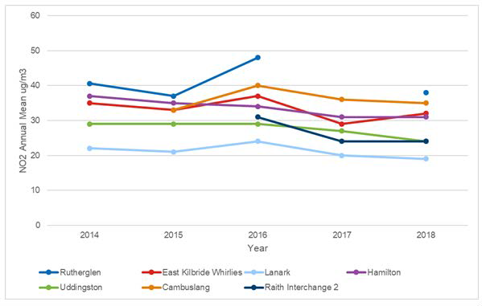
Source: Environmental Services, South Lanarkshire Council

Point source emissions
Many industrial activities emit pollutants into the atmosphere, from large-scale industrial complexes to local school boilers. SEPA currently regulate the emissions from industrial activities through the Pollution Prevention and Control (Scotland) Regulations 2000, commonly referred to as the PPC Regulations. These place control measures on the release of pollutants from large-scale industrial activities (regulated as Part A sites) and smaller scale activities such as garages and building and plant premises (regulated as Part B sites).
At 2019, in South Lanarkshire there were 17 Part A sites and 97 Part B sites (Figure 7.2).

Long range pollutants
Pollutants emitted from large-scale industrial activities can potentially travel in the atmosphere over long distances. These can cross countries and international boundaries and are often referred to as ‘transboundary’ pollutants. Once these long-range pollutants are released into the atmosphere, they are subjected to various atmospheric processes that control their transport, and can alter their chemical and physical form generating secondary pollutants such as ozone or the formation of acid rain. These pollutants are eventually deposited, where their overall impacts are dependent on their chemical changes.

Ground-level ozone
Ground-level Ozone (O3) irritates the airways of the lungs, increasing the symptoms of those suffering from asthma and lung diseases and disrupts plant growth and development. O3 measured at a particular location may have arisen from pollutants emitted hundreds or even thousands of miles away. There are no O3 monitoring stations in South Lanarkshire.

Figure 7.2: Industrial point source emissions, Part A and Part B processes, 2019
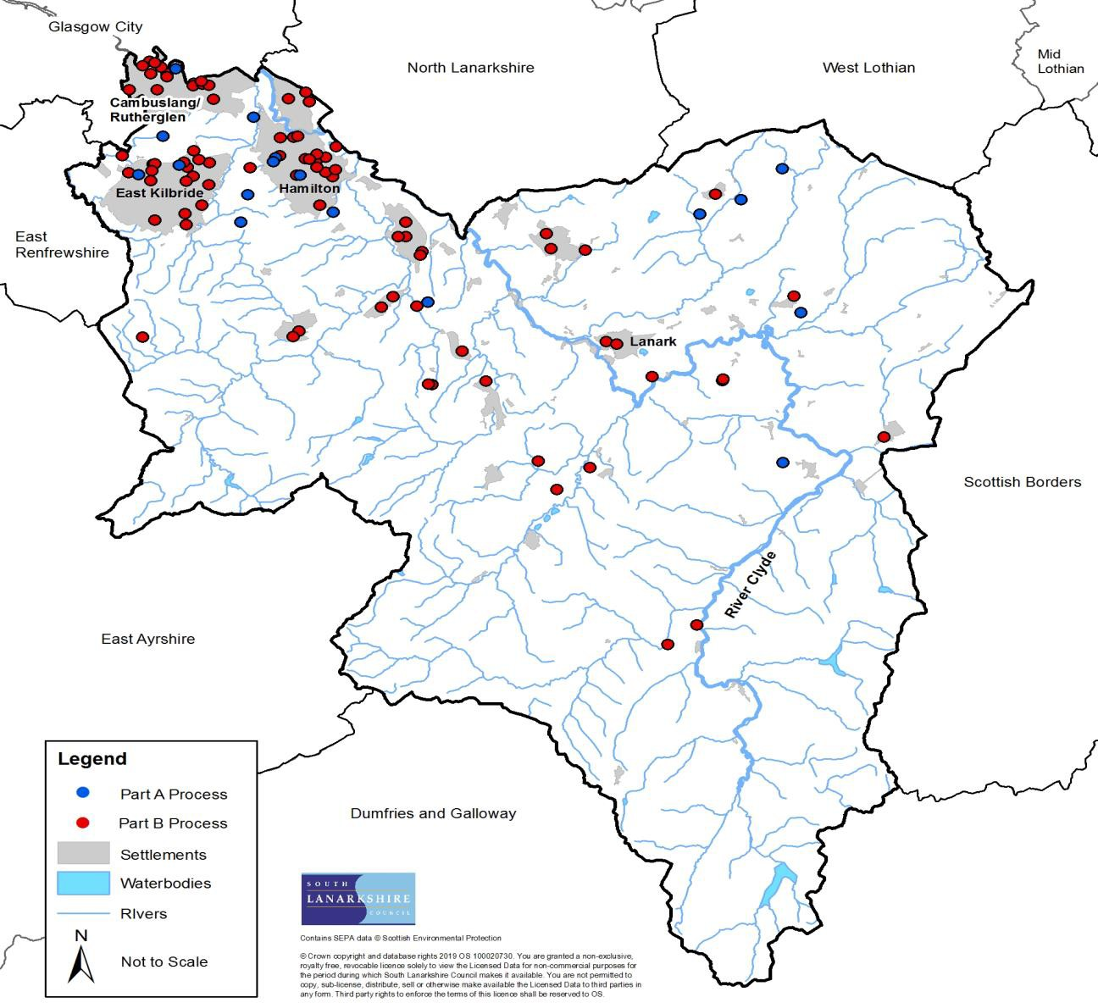

Acidification and nutrient enrichment
Acidification is a natural process in soils which can be accelerated by acidic pollutants through rain, cloud/mist or by gas/particle deposition onto the ground or absorbed by plants. These pollutants cause acidification of ecosystems, potentially damaging their biodiversity. Nitrogen rich pollutants also contribute to the nutrient enrichment of ecosystems thus altering the biodiversity within the habitats. The extent to which habitats are able to tolerate both excessive nutrient enrichment and accelerated changes in acidification is dependent on the habitat type and the sensitivity of individual species.
There are no acid and nitrogen deposition monitoring sites in South Lanarkshire. Modelling work conducted for SNIFFER focused on predicting the potential exceedance in critical loads across designated habitats in the UK. The modelling work estimated that in 2010 7 SAC and the SPA site within South Lanarkshire exceeded the critical load for acidification, whilst 6 SAC and the SPA site exceeded the critical load for nutrient enrichment (Table 7.5).
Table 7.5: Designated sites that exceed critical loads in South Lanarkshire
SAC Site | Site critical load exceedance
SAC Site | Acidification |  |  |  | Nutrient enrichment
SAC Site | 2003 | 2005 | 2010 | 2020 | 2003 | 2005 | 2010 | 2020
Braehead Moss | Yes | Yes | Yes | Yes | Yes | Yes | Yes | Yes
Clyde Valley Woods | Yes* | Yes* | Yes* | Yes* | Yes | Yes | Yes | Yes
Coalburn Moss | Yes | Yes | Yes | Yes | Yes | Yes | Yes | Yes
Craigengar | Yes | Yes | Yes | No | Yes* | Yes* | No | No
Cranley Moss | Yes | Yes | Yes | Yes | Yes | Yes | Yes | Yes
Red Moss | Yes | Yes | Yes | Yes | Yes | Yes | Yes | Yes
Waukenwae Moss | Yes | Yes | Yes | Yes | Yes | Yes | Yes | Yes
SPA Site
Muirkirk and North Lowther Uplands | Yes | Yes | Yes* | Yes* | Yes | Yes | Yes | Yes
*Exceedance of the lower critical limit for the most sensitive habitat.

The SNIFFER project also modelled the potential level of exceedance within SSSI sites across the UK, including the 31 SSSI sites in South Lanarkshire designated with priority habitats sensitive to atmospheric pollutants (Table 7.6). It was estimated that all sites will continue to exceed in nutrient enrichment by 2020 and 24 sites are predicted to exceed the critical load for acidification.
Table 7.6: SSSI that exceed critical loads for both acid and nutrient deposition in South Lanarkshire
SSSI Site | Site critical load exceedance
SSSI Site | Acidification |  | Nutrient enrichment
SSSI Site | 2005 | 2020 | 2005 | 2020
Avondale | Yes* | Yes* | Yes | Yes
Blantyre Muir | Yes | Yes | Yes | Yes
Blood Moss And Slot Burn* | Yes | Yes | Yes | Yes
Bothwell Castle Grounds | Yes* | Yes* | Yes | Yes
Braehead Moss | Yes | Yes | Yes | Yes
Cander Moss | Yes | Yes | Yes | Yes
Carnwath Moss | Yes | Yes | Yes | Yes
Cartland Craigs | Yes | Yes | Yes | Yes
Cleghorn Glen | Yes | Yes* | Yes | Yes
Coalburn Moss | Yes | Yes | Yes | Yes
Cobbinshaw Moss* | Yes | Yes | Yes | Yes
Cobbinshaw Reservoir* | Yes* | No | Yes* | Yes*
Craigengar* | Yes | Yes | Yes | Yes
Cranley Moss | Yes | Yes | Yes | Yes
Falls of Clyde | Yes | Yes | Yes | Yes
Fiddlers Gill | Yes* | No | Yes | Yes
Garrion Gill* | Yes | Yes* | Yes | Yes
Hamilton High Parks | Yes | No | Yes | Yes
Hamilton Low Parks | Yes | Yes | Yes | Yes
Jock’s Gill Wood | Yes* | No | Yes | Yes
Millburn | Yes* | No | Yes | Yes
Miller’s Wood | Yes* | No | Yes | Yes
Muirkirk Uplands* | Yes | Yes* | Yes | Yes
Nethan Gorge | Yes* | Yes* | Yes | Yes
North Lowther Uplands* | Yes* | Yes* | Yes | Yes
Red Moss | Yes | Yes | Yes | Yes
Shiel Dod* | Yes | Yes* | Yes | Yes
Tinto Hills | Yes* | Yes* | Yes | Yes
Townhead Burn | Yes* | No | Yes | Yes
Upper Nethan Valley Woods | Yes | Yes* | Yes | Yes
Waukenwae Moss | Yes | Yes | Yes | Yes
*Exceedance of the lower Critical Limit for the most sensitive habitat. Source: www.apis.ac.uk

The pollutants that contribute to both acid and nitrogen deposition travel long distances. Figures
7.3 and 7.4 illustrates the source contribution of these pollutants to Cranley Moss SAC, in 2012.

Figure 7.3: Main sources of sulphur deposition on Cranley Moss SAC, 2012
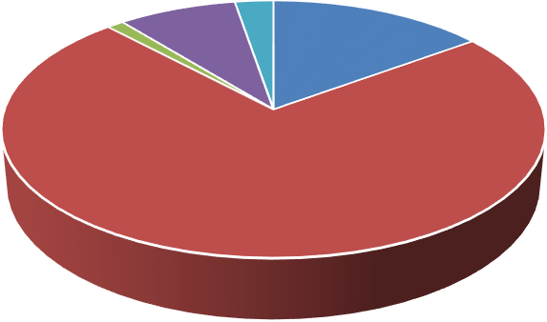
Sulphur deposition sources
19041, 8%
2719, 1%
6178, 3%
34800, 15%
Longannet Power Station
English Power Stations N Ireland Power Station
170350, 73%
Welsh Power Stations
Grangemouth Refinery
Source: www.apis.ac.uk
The main source of acid deposition within Cranley Moss SAC is from fifteen power stations and refineries in England (73%), with Drax power station in North Yorkshire being the largest contributor (16% for sulphur and 17% for Nitrogen). In Scotland, the largest contributor was Longannet Power Station (15% and 7%, respectively) which is now closed, followed by Grangemouth Refinery (3% and 1%, respectively).

Figure 7.4: Main sources of nitrogen deposition on Cranley Moss SAC, 2012
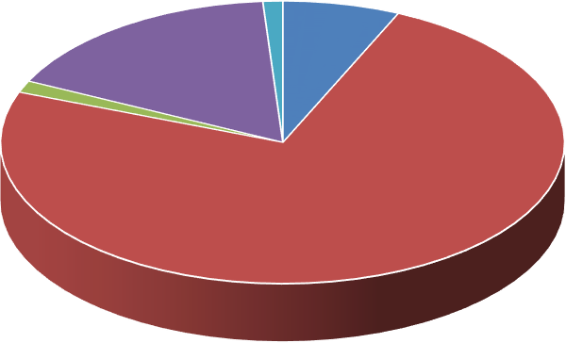
Nitrogen deposition sources
2815, 1%

16600, 7%
41405, 17%
3358, 1%
Longannet Power Station
English Power Stations N Ireland Power Station Welsh Power Stations
183366, 74%
Grangemouth Refinery
Source: www.apis.ac.uk

Airborne nuisance
Airborne nuisance can be pollutants emitted to air and can come in a variety of forms, including dark smoke, dust and odours. These emissions can reduce the overall value of the local environment, from impairing views to reducing the quality of outdoor air. Table 7.7 displays the number of complaints and their reasons received by the council between 2005 and 2019. Odour is the main reason of complaint during each recording period.

Table 7.7: Airborne nuisance complaints received by South Lanarkshire Council
 | Dust/grit | Smoke | Fumes | Dark smoke | Garden bonfires | Odour
2005/2006 | 7 | 24 | 20 | 15 | 24 | 214
2006/2007 | 5 | 24 | 14 | 21 | 37 | 186
2007/2008 | 12 | 30 | 34 | 23 | 31 | 189
2008/2009 | 5 | 31 | 32 | 21 | 32 | 154
2009/2010 | 15 | 23 | 19 | 17 | 44 | 203
2010/2011 | 5 | 45 | 18 | 9 | 33 | 170
2011/2012 | 9 | 34 | 5 | 7 | 54 | 164
2012/2013 | 9 | 41 | 23 | 3 | 27 | 157
2013/2014 | 8 | 51 | 31 | 4 | 44 | 133
2014/2015 | 15 | 58 | 34 | 8 | 29 | 170
2015/2016 | 8 | 50 | 35 | 11 | 42 | 138
2016/2017 | 10 | 45 | 26 | 9 | 37 | 120
2017/2018 | 10 | 49 | 23 | 17 | 44 | 123
2018/2019 | 14 | 56 | 27 | 18 | 76 | 116
Source: South Lanarkshire Council

Noise complaints
The definition of noise used by South Lanarkshire Council is provided in the Final Report of the Committee on the Problem of Noise. It is ‘sound which is undesired by the recipient’. This emphasises the subjective nature of noise, involving people and their feelings and recognises that different people have differed perceptions of what is acceptable.

Within South Lanarkshire the majority of noise complaints relate to domestic noise. Noise from domestic properties accounted for over 85% of the total noise complaints made over the past two financial years (2017/2018 and 2018/2019). Overall, 3,287 noise complaints were received in 2018/2019 which represents around a 13% increase in complaints over the previous peak noted in 2010/2011 (Figure 7.5 and Table 7.7).

Figure 7.5: Total number of noise complaints reported to SLC
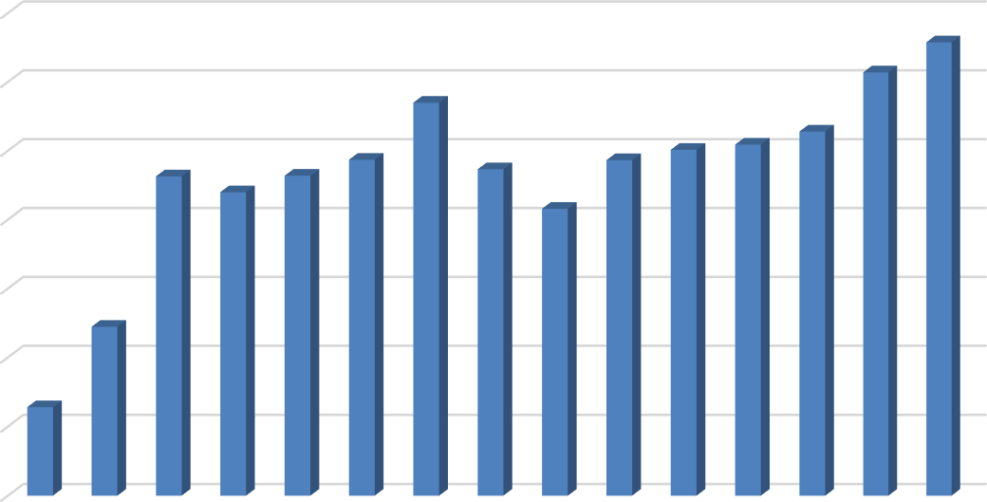

3500

3000

2500

2000

1500

1000

500

0
Source: South Lanarkshire Council

The distribution of noise complaints varies considerably across South Lanarkshire which reflects the differing areas. The majority of complaints arise from the more densely populated urban areas compared to the more rural area of Clydesdale (Table 7.8).

Table 7.8: Noise complaints reported to SLC by area
 | East Kilbride | Rutherglen | Clydesdale | Hamilton | Unspecified | Total
2004/2005 | 125 | 53 | 69 | 163 | 230 | 640
2005/2006 | 301 | 133 | 114 | 349 | 325 | 1,222
2006/2007 | 631 | 309 | 259 | 635 | 480 | 2,314
2007/2008 | 594 | 307 | 258 | 630 | 410 | 2,199
2008/2009 | 598 | 332 | 272 | 752 | 375 | 2,319
2009/2010 | 664 | 359 | 290 | 805 | 317 | 2,435
2010/2011 | 766 | 410 | 319 | 745 | 609 | 2,849
2011/2012 | 640 | 279 | 302 | 684 | 431 | 2,366
2012/2013 | 443 | 297 | 282 | 611 | 446 | 2,079
2013/2014 | 552 | 410 | 283 | 716 | 471 | 2,432
2014/2015 | 537 | 411 | 283 | 796 | 480 | 2,507
2015/2016 | 593 | 417 | 360 | 759 | 416 | 2,545
2016/2017 | 647 | 471 | 318 | 874 | 330 | 2,640
2017/2018 | 631 | 374 | 324 | 704 | 1,036 | 3,069
2018/2019 | 1,010 | 531 | 445 | 1,047 | 254 | 3,287
Source: Environmental Services, South Lanarkshire Council

Residential noise
Residential noise may arise from different sources, the most common being amplified music, loud televisions and the use of noisy household appliances during unsuitable hours of the night.
Complaints of dog barking also form a significant proportion of domestic noise complaints. The noise provision of the Antisocial Behaviour etc (Scotland) Act, 2004 sets out permitted levels of noise for different times of the day and night intended to reflect acceptable levels of noise within the home. The number of residential noise complaints received by the council has significantly increased since 2016/2017 and the overall number of complaints now exceeds the previous peak noted in 2010/2011 (Table 7.9). This is partly the result of a continuing upward trend in the number of complaints received regarding dog barking but also reflects a significant increase of around 35% in the number of reports of noise from neighbours over the course of the last two financial years.

Table 7.9: Type and number of complaints received regarding residential noise
 | Domestic  noise | Alarms  (intruder) | Dogs | Total
2004/2005 | 148 | 31 | 176 | 355
2005/2006 | 661 | 35 | 233 | 929
2006/2007 | 1,499 | 34 | 344 | 1,877
2007/2008 | 1,313 | 52 | 418 | 1,783
2008/2009 | 1,427 | 33 | 412 | 1,872
2009/2010 | 1,497 | 63 | 481 | 2,041
2010/2011 | 1,834 | 68 | 526 | 2,428
2011/2012 | 1,646 | 53 | 351 | 2,050
2012/2013 | 1,340 | 53 | 338 | 1,731
2013/2014 | 1,463 | 52 | 581 | 2,096
2014/2015 | 1,516 | 64 | 563 | 2,143
2015/2016 | 1,539 | 68 | 533 | 2,140
2016/2017 | 1,513 | 53 | 686 | 2,252
2017/2018 | 1,957 | 51 | 698 | 2,706
2018/2019 | 2,053 | 53 | 764 | 2,870
Note: Some numerical variation is possible due to categories being removed from complaint breakdown
Source: Environmental Services, South Lanarkshire Council

Environmental noise
Environmental noise is defined as ‘unwanted or harmful outdoor sound created by human activities, including noise emitted by means of transport, road traffic, air traffic and from sites of
industrial activity’. The number of complaints of environmental noise across South Lanarkshire has remained fairly consistent since 2006/2007 (Table 7.10).

Table 7.10: Type and number of complaints received regarding environmental noise
 | Commercial premises | Licensed premises | Construction noise | Industrial | Street noise | Traffic | Total
2004/2005 | 45 | 68 | 26 | 5 | 17 | 35 | 196
2005/2006 | 52 | 103 | 25 | 5 | 26 | 78 | 289
2006/2007 | 65 | 143 | 25 | 19 | 29 | 90 | 371
2007/2008 | 79 | 133 | 24 | 65 | 16 | 73 | 390
2008/2009 | 83 | 126 | 17 | 79 | 25 | 82 | 412
2009/2010 | 102 | 86 | 22 | 36 | 20 | 72 | 338
2010/2011 | 102 | 90 | 92 | 21 | 48 | 13 | 366
2011/2012 | 88 | 61 | 84 | 10 | 53 | 12 | 308
2012/2013 | 108 | 65 | 92 | 8 | 44 | 25 | 342
2013/2014 | 107 | 68 | 76 | 9 | 40 | 27 | 327
2014/2015 | 107 | 58 | 113 | 5 | 58 | 16 | 357
2015/2016 | 111 | 64 | 119 | 9 | 72 | 23 | 398
2016/2017 | 85 | 77 | 157 | 16 | 38 | 9 | 382
2017/2018 | 109 | 71 | 105 | 8 | 59 | 4 | 356
2018/2019 | 129 | 86 | 104 | 16 | 61 | 14 | 410
Note: some numerical variation is possible due to categories being removed from complaint breakdown
Source: Environmental Services, South Lanarkshire Council

Environmental noise mapping
The Environmental Noise Directive (2002/49/EC) was transposed into Scottish law by the Environmental Noise (Scotland) Regulations, 2006. The regulations require the Scottish Ministers, as the competent authority, to produce strategic noise maps for all relevant urban areas, roads and railways. South Lanarkshire, as a geographically small area is included in the larger urban area (of over 250,000 inhabitants) known as the ‘Glasgow Agglomeration’. Maps are also produced for major roads and major railways throughout South Lanarkshire. The strategic noise maps produced in 2007 can be viewed at http://www.scottishnoisemapping.org/public/view-map.aspx.
These noise maps are used to identify areas where the noise climate is deemed to be poor and in need of improvement (noise management areas) and areas where it is good and warrants protection (quiet areas). South Lanarkshire currently has 5 candidate noise management areas: two rail related within the Uddingston and Cambuslang areas and three road related within Rutherglen and Cambuslang. Maps can be accessed via http://scottishnoisemapping.org/public/action-planning_END_2.aspx.

Areas which have been granted quiet area status must be protected in terms of both size and noise climate. In April 2013, 2 quiet areas were approved in South Lanarkshire: Bothwell Castle grounds and Cambuslang Public Park. The second round of mapping was completed during 2014 and progress is being made to determine newly identified candidate noise management area(s) and newly identified quiet areas that will have to be considered during the council’s development planning process.

Light
Issues associated with the provision of outdoor lighting are becoming more recognised as a source of pollution and nuisance and can be detrimental to human health and the environment. Although the importance of artificial lighting for pedestrian and traffic safety and general security is recognised, lighting does have a marked impact on the night environment. Artificial light can significantly change the local character of the area, altering wildlife behavioural and ecological patterns and reducing visibility of the dark skies.

Light nuisance
In February 2013, the Public Health etc., (Scotland) Act, 2008 introduced new and amended statutory nuisance provisions to the Environmental Protection Act, 1990 which means that artificial lighting can be considered to constitute a statutory nuisance in Scotland. Table 7.11 sets out the number of complaints received annually by the council relating to artificial light pollution.
Table 7.11: Complaints about artificial light pollution

2013/2014 | 2014/2015 | 2015/2016 | 2016/2017 | 2017/2018 | 2018/2019
31 | 19 | 24 | 11 | 21 | 24

Water
SEA objectives that relate to water
Reduce pollution and improve water quality.
Promote sustainable water use.
Avoid, reduce and manage flood risk.
Scotland’s water provides a wide range of benefits, supporting our health and prosperity. These include the provision of drinking water, water for use in industry and agriculture and recreation opportunities. Our water supports a diverse array of habitats and nationally and internationally important species.
The River Clyde and its tributaries are essential to the character of the area. Rising in the Lowther Hills, the River Clyde meanders its way through South Lanarkshire towards the outer reaches of the City of Glasgow before flowing into the Clyde Estuary and Firth of the Clyde.
A summary of the indicators used in assessing the state of South Lanarkshire is presented, highlighting the current status of each indicator and the directional trend.

The Current status is shown by the following colours: The trend direction is shown with the following arrows:
G | Good | F | Fair | Improving
 |  |  |  | No change
P | Poor |  | Limited data | Deteriorating
Note: The most recent data available was used in assessing the environmental indicators
Indicator | Current status | Trend direction | Explanation
Water quality | F |  | The number of rivers achieving High/Good overall status  under the Water Framework Directive (WFD) has significantly increased since the last Report.
River flow | F |  | The annual water flow rates in the rivers across the region  have continually increased. This increase is closely linked to the increase in annual precipitation rates.
Groundwater and wetlands | F |  | The status of groundwater bodies in South Lanarkshire is  unchanged since the previous Report. The data available on ponds and wetlands remains limited.
Water pollution | G |  | Point source pollution remains a threat to the quality of the  water environment. This is closely monitored by SEPA. Licensed activities continue to increase year on year.
Flooding | P |  | Severe weather events have resulted in increased flood  incidents in the area. The council’s approach to flood management continues to improve.

Baseline situation
The water environment is important for South Lanarkshire in terms of the local economy, the health and wellbeing of the people who live, work and visit the area and for wildlife. Human activity can damage the water environment, affecting the quality of the water itself or through inputs associated with activities on land or the deposition of air pollutants.

Water quality in South Lanarkshire is relatively good and continues to improve with the number of surface water bodies classified with an overall status of either high or good increasing. Annual water flow rates remain high and consistent in line with increasing precipitation across the region. Although flooding occurrences remain high, the number reported to the council decreased in 2016 and 2017.

Principal watercourses
There are 25 principal watercourses which flow through South Lanarkshire. Many of these are tributaries of the River Clyde (Table 8.1).

Table 8.1: Principal watercourses in South Lanarkshire
Principal  watercourse | Span  (km) | General information
Avon Water | 46 | A tributary of the River Clyde, the Avon flows through Strathaven and Larkhall from its source on Weddle Hill, East Ayrshire.
Biggar Water* | 7 | The Biggar Burn rises at the southern end of the Pentland Hills and flows south through Biggar, turning into Biggar Water, flowing through Broughton  before joining the River Tweed.
Calder Water | 15 | Calder Water rises on the slopes of Laird’s Seat joining with the Rotten Burn to form the Rotten Calder. The river flows down through Calderglen joining the River Clyde west of Uddingston.
Camps Water | 6 | Flowing from Camps Reservoir, Camps Water joins the River Clyde north of Crawford.
River Clyde | 138 | Formed by two streams, the Daer and the Potrail Waters that meet at Watermeetings high in the Lowther Hills. The river flows down through many of  the main urbanised areas, including Hamilton, Blantyre and Rutherglen.
Culter Water | 8 | Culter Water rises in hills south of Biggar, flowing through the Culter Water Reservoir before passing Coulter and joining the River Clyde.
Daer Water | 16 | Daer Water rises on Queensberry Hill in the Lowther Hills and flows through the Daer Reservoir before joining Potrail Water to form the River Clyde.
Douglas Water | 32 | The Douglas Water rises in the hills in East Ayrshire, flowing through Douglas before joining the River Clyde.
Duneaton Water | 30 | A tributary of the River Clyde, Duneaton Water flows passed Crawfordjohn before joining the Clyde at Abington.
Elvan Water | 11 | From the Lowther Hills the Elvan Water joins the Clyde near Elvanfoot.
Evan Water | 19 | Evan Water rises in the south Lowther Hills and flows south to join the River Annan at Three Waters Foot.
Garf Water | 11 | Garf Water rises on the slopes of Robert Law and flows east to join the River Clyde near Wiston.
Glengavel Water | 6 | Glengavel Water passes through the Glengavel Reservoir before meeting the Avon Water.
Glengonnar Water | 11 | Glengonnar Water rises in the Lowther Hills and is a tributary to the River Clyde.
Kype Water | 10 | Kype Water flows from the Kype Reservoir joining River Avon near Strathaven.
Lochar Water | 7 | Flowing from Lambhill the Lochar Water joins the Avon Water before Strathaven.
Logan Water | 11 | Rising in Spirebush Hill the Logan Water flows through the Logan Reservoir before joining with the River Nethan and then the River Clyde.
Medwin Waters (North) | 17 | Rises in the Pentland Hills, close to West Lothian and flows south to join with the South Medwin to form Medwin Waters
Medwin Waters (South) | 25 | Rises in the Pentland Hills flowing south to form the border between South Lanarkshire and the Scottish Borders before joining the North Medwin to form Medwin Waters and then the River Clyde.
Midlock Water | 10 | Rising near Clyde Law the Midlock Water joins the River Clyde near Crawford.
Mouse Water | 26 | Mouse Water is a tributary of the River Clyde flowing from south of Forth to join the Clyde near Lanark.
Nethan Water | 27 | The River Nethan flows northwards to the River Clyde from the hills south of Lesmahagow. Its upper reaches are extensively afforested and there are also abandoned mines in the catchment. The main river passes along the edge of the huge Dalquhandy Opencast Coal Site. A tributary of the River Nethan, the Logan Water, is used to fill the Logan and Dunside reservoirs.
Potrail Water | 12 | Rises on Ballencleuch Law in the Lowther Hills and joins Daer Water near Elvanfoot to form the River Clyde.
Snar Water | 10 | Rising on the slopes of Wanlock Dod, Snar Water joins Duneaton Water near Crawfordjohn.
Principal watercourse | Span (km) | General information
White Cart Water** | 36 | Rises in the foothills of the Eaglesham Moors on the slopes of Corse Hill, flowing through the East Renfrewshire and South Lanarkshire border before joining Black Cart Water at Paisley.
* does not flow into Clyde catchment
** borders with East Renfrewshire and South Lanarkshire

In addition to the principal watercourses, there are a number of burns of strategic significance as shown in Table 8.2.

Table 8.2: Burns of strategic significance in South Lanarkshire
Cambuslang | Clydesdale | East Kilbride | Hamilton | Rutherglen
Black | Devon | Darngaber | Cadzow | Cityford/West
Kirk | Roberton | Kittoch Water | Covan | Scion
Lightburn/Newton |  | Powmillon | Earnock/Wellshaw
Whitelaw/Eastfield
There are 20 reservoirs across South Lanarkshire, (Table 8.3 and Table 8.4). SEPA is the Enforcement Authority for these reservoirs under the Reservoirs (Scotland) Act, 2011, responsible for ensuring the Statutory Undertakers (owners) comply with their statutory requirements. The council is ‘Reservoir Manager’ for the James Hamilton Heritage Loch and Lanark Loch.
Table 8.3: Principal reservoirs in South Lanarkshire
Principal water bodies | Area  (km2) | General information
Camps Reservoir | 0.71 | Provides drinking water to the Hamilton area
Cowgill Lower Reservoir Cowgill Upper Reservoir | 0.03  0.09 | Provides drinking water to the Lothians
Coulter Reservoir | - | Serves Motherwell, Wishaw and Biggar with drinking water
Daer Reservoir | 1.97 | Fed by Daer Water, the reservoir is the principal drinking water supply for South Lanarkshire
Kype Reservoir | 0.11 | South of Strathaven, serving the area with drinking water

Table 8.4: Smaller water bodies in South Lanarkshire, including covered reservoirs
Reservoir | National Grid Ref | Reservoir | National Grid Ref
Boghead | NS 764409 | James Hamilton Heritage Loch | NS 631559
Cleuch | NS 937355 | Kittoch Bridge Flood Storage | NS 589568
Dunside Lower | NS 749373 | Lanark Loch | NS 899431
Dunside Upper | NS 747373 | Loch Lyoch | NS 932357
East Rogerton Tank | NS 630567 | Logan | NS 745361
Glen Franka Dam | NS 890133 | Peden | NS 941124
Glengavel | NS 664350 | Springfield | NS 905520

Water quality
The quality of the water environment can have a significant effect on the health of people, flora and fauna. For example, pathogens derived from sewage effluent or livestock can enter watercourses and excessive nutrients in lochs and streams can lead to blue-green algae blooms which are toxic to humans and fauna.

Rivers support a wide variety of wildlife, providing important habitat corridors that enable the dispersion and migration of many species. The quality of river water is important for supporting wildlife and as a major resource for providing drinking water and water used by industry. The quality and flow of rivers is directly affected by the level of abstraction and discharge into the river
and from the quality of ground waters that support them. The Water Framework Directive provides the legal framework for the protection, improvement and sustainable use of waters.
The Water Framework Directive (WFD) (2000/60/EC) – The aim in implementing the WFD in Scotland is to achieve an effective balance between the protection of Scotland’s water environment and the interests of those who depend upon it for their prosperity and quality of life.
One of the principal aims of River Basin Management is the protection of the country’s high quality environment balanced against the need for sustainable development.

River water quality
SEPA monitors the quality of rivers across South Lanarkshire, collecting data and classifying the rivers in terms of their status. The WFD monitoring framework is aimed at improving and protecting the whole water environment. It introduced new parameters for recording the quality of the water environment including ecological status (natural and the presence of alien species), the natural and modified river flow, the presence of engineering works, such as culverting and flood defence or any other manmade barriers that affect the morphology and habitats of the river, for instance preventing migratory movements.

Surface water bodies are classified using a system of five quality classes – high, good, moderate, poor and bad. In general, the classification of water bodies describes by how much their condition or status differs from near natural conditions. Water bodies in a near natural condition are at high status, while those whose quality has been severely damaged are at bad status.
The WFD classification data for rivers across South Lanarkshire has been divided into Surface Water bodies and Heavily Modified Water bodies (HMWB) (Table 8.5 and Table 8.8 respectively). For surface water bodies, 47% were classified with an overall status of either high or good, with 11% being assessed as poor and only 1 recorded as bad (Malls Mire Burn/ Polmadie Burn/ City Burn on the River Clyde). The physico-chemical classification recorded 72% of river water bodies in South Lanarkshire as being either high or good, with only 3% recorded as poor. There was a wide range of classifications recorded for biological elements, with 61% recorded as either high or good, 27% as moderate and 12% with a poor or bad status. In terms of hydromorphology classification, 59 surface water bodies achieved either high or good status (81%). However, 1 was recorded as bad. These findings are further reflected in Figure 8.1.

Table 8.5 WFD water classifications for river surface water bodies (overall status), 2017
 | Overall status |  | Physico-  chemical |  | Biological element |  | Hydromorphology
 | No. | % | No. | % | No. | % | No. | %
High | 2 | 3 | 34 | 57 | 21 | 29 | 8 | 11
Good | 32 | 44 | 9 | 15 | 23 | 32 | 51 | 70
Moderate | 30 | 41 | 15 | 25 | 20 | 27 | 13 | 18
Poor | 8 | 11 | 2 | 3 | 8 | 11 | 0 | 0
Bad | 1 | 1 | 0 | 0 | 1 | 1 | 1 | 1
Source: SEPA

Heavily Modified Water Bodies are surface water bodies which have been substantially altered in character for purposes such as flood protection, navigation, hydroelectricity generation, public water supply, recreation, land drainage, other important human sustainable development activities and where their physical characteristics cannot be restored without significant adverse impacts on the uses served by the alterations or on the wider environment. For water bodies designated as HWMB, their classification is defined in terms of ecological potential, a measure of how the ecological quality of such a water body compares with the maximum quality achievable given the physical constraints imposed by its use.

Figure 8.1: WFD water classifications for river surface water bodies (overall status), 2017
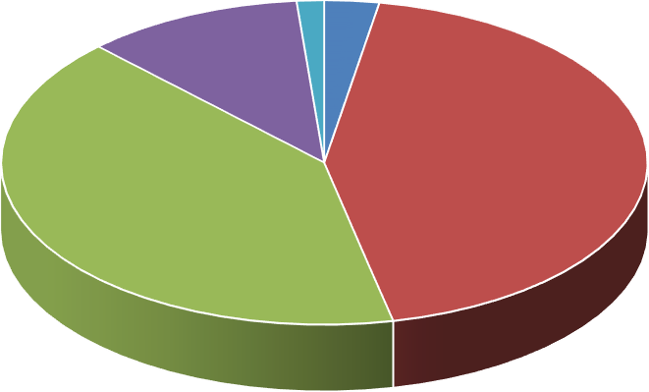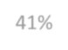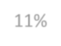
1, 1% 2, 3%

8, 11%

32, 44%

30, 41%

HighGoodModeratePoorBad
Source: SEPA

The water bodies designated as HMWB in 2017 in South Lanarkshire are set out in Table 8.6. Water bodies designated as HMWB cannot achieve ‘good ecological status’ as prescribed in the Directive, instead they must achieve ‘good ecological potential’.

Table 8.6: Water bodies designated as HMWB in South Lanarkshire, 2017
ID | Name | ID | Name
10002 | Kittoch Water | 10040 | River Clyde (North Calder to Tidal Weir)
10043 | Daer Water (d/s Daer Reservoir) | 10071 | Wellshaw/Earnock Burn
10107 | Culter Water | 10108 | Cow Gill/Eastside Burn/Duncan Gill
10117 | Camps Water | 10930 | Malls Mire Burn/Polmadie/Burn/Cityford Burn
Of the river water bodies designated as heavily modified, 2 achieved good ecological potential in 2015 (Culter Water and Cow Gill). Malls Mire Burn was assessed as having bad ecological potential and Kittoch Water was assessed as having poor ecological potential (Table 8.7).

Table 8.7: WFD water classifications for HMWB in South Lanarkshire, 2017
Class | Overall Status (ecological potential) | Physio-chemical | Biological element | Hydromorphology
High | 0 | 0 | 2 | 0
Good | 2 | 0 | 0 | 1
Moderate | 4 | 3 | 4 | 6
Poor | 1 | 1 | 1 | 0
Bad | 1 | 0 | 1 | 1
Source: SEPA

Figure 8.2 provides an overview on the location for WFD water classifications in South Lanarkshire. It is important to note that the classification tools for some elements of the WFD system continue to be refined which may result in a future change of status for some water bodies.

Figure 8.2: Distribution of WFD status of water bodies in South Lanarkshire, 2017
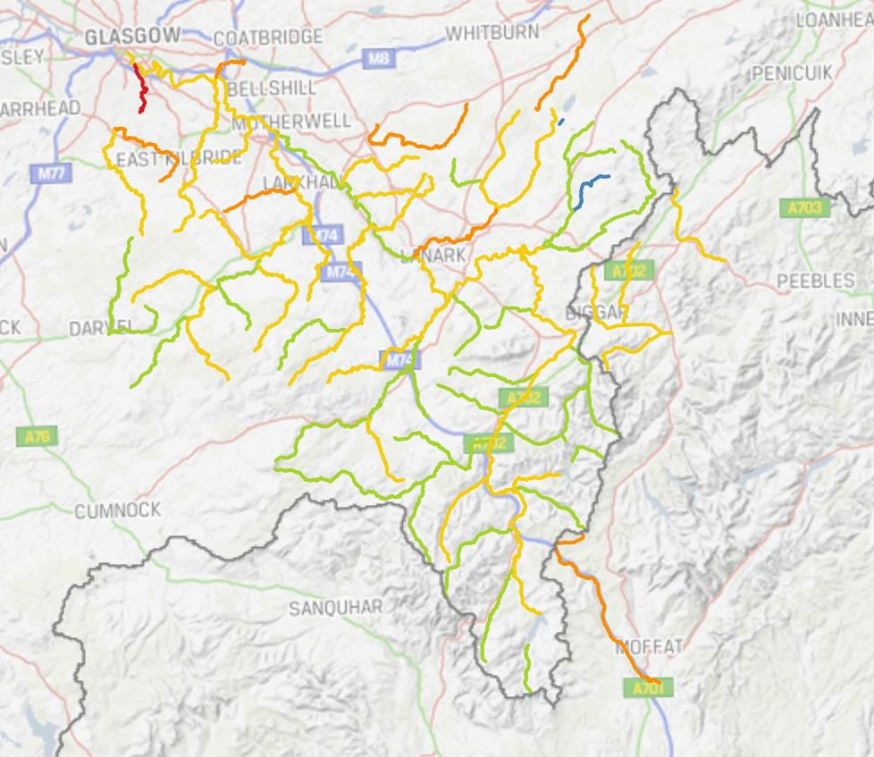
©Crown Copyright, SEPA Licence Number 100016991 (2015).
This map displays bodies of surface waters coloured by overall status for latest available year (2017). Condition: Blue = High, Green = Good, Yellow = Moderate, Amber = Poor, Red = Bad
Source: SEPA: Scotland’s Environment Web

Lochs and reservoirs
Similar to the river quality, the quality of standing waters (reservoirs and lochs) is assessed using the WFD classification system. This is based on chemical, biological/ecological and hydrological indicators. However, this classification is only applied to lochs larger than 1 km2 and smaller lochs of particular importance. In South Lanarkshire two standing water bodies, the Daer Reservoir and the Camps Reservoir fulfil the criteria.

Based on the WFD criteria, both the Daer and Camps Reservoirs are classified as HMWB. Both reservoirs have been classified as having good ecological potential. Both reservoirs have poor hydromorphology, a low ecological status in the water quality because of the physical characteristics of the water (Table 8.8). This is due to dam structures adversely affecting the natural flows in the catchment. However, both reservoirs have been classified as having good status for physico-chem, with Daer Reservoir being classed as having good biological elements and the Camps Reservoir being classified as high.

Table 8.8: WFD classifications in South Lanarkshire, 2017
Reservoir | Overall status | Physico- chem | Biological elements | Hydro- morphology
Daer | Good EP | Good | Good | Poor
Camps | Good EP | Good | High | Poor
Source: SEPA

River flow
There has been limited change over the years to the location of the principal watercourses across South Lanarkshire. Modifications to smaller watercourses including culverting have been done within urban areas (notably East Kilbride). No records exist to identify the extent of any such alterations to watercourses but these will rarely alter the overall flow of the rivers significantly.
A greater potential for influencing river flow rates is through an increased input (increasing the input from surface drainage) or extraction (extracting the water for general usage). Weirs and other physical barriers can alter the fluctuation within the flow rates but offer greater resistance to migration of fish upstream. Climate change offers the greatest threat to altering river flow rates, particularly with increasing annual rainfall.

Average annual rainfall varies across South Lanarkshire, from over 1,500mm across the Southern Uplands to around 1,100mm over the northern urbanised lowland areas. Most of the area is predominantly drained by the tributaries that flow into the River Clyde and precipitation changes within the Clyde catchment will have a significant effect on the flow characteristics of the rivers.
There are 15 gauging stations in South Lanarkshire. These are detailed in Table 8.9. Table 8.9: River gauging stations in South Lanarkshire, 2019
River Avon at Avonbank | Avon Water at Fairholm
Cander Water at Candermill | River Clyde at Abington
River Clyde at Blairston | River Clyde at Daldowie
River Clyde at Hazelbank | River Clyde at Kirkfieldbank
River Clyde at Sills of Clyde | River Clyde at Tulliford Mill
Douglas Water at Happendon | Duneaton Water at Maidencots
Kittoch Water at Waterside | River Nethan at Kirkmuirhill
Rotten Calder at Redlees

Source: SEPA
Two stations have been used to provide river flow data representing the lower River Clyde at Blairston (Station no. 84005), near Bothwell and the upper contributory Duneaton Water at Maidencots (Station no. 84022), near Abington.

The annual mean flow rates on both the River Clyde and Duneaton Water increased from 1970 to 2006 by approximately 15% and 25% respectively (Table 8.10 and Figure 8.3). Changes in river flow rates at the River Clyde gauging station closely correlate with annual rainfall. This could be due to the large catchment area associated with this river (1,704.2 km2), allowing a greater degree of buffering.

Table 8.10: Annual mean water flow rates
Year | River Clyde at Blairston |  | Duneaton Water at Maidencots
Year | Annual flow (m3 s-1) | Annual rainfall (mm) | Annual flow (m3 s-1) | Annual rainfall (mm)
1970 | 42.00 | 1198 | 3.06* | 1375
1971 | 30.36 | 936 | 2.55* | 1060
1972 | 32.12 | 952 | - | -
1973 | 27.09 | 875 | 2.02 | 1038
1974 | 41.13 | 1209 | 2.93 | 1637
1975 | 35.42 | 985 | 2.26* | 1254
1976 | 34.49 | 1021 | 2.32 | 1286
Year | River Clyde at Blairston |  | Duneaton Water at Maidencots
Year | Annual flow  (m3 s-1) | Annual rainfall  (mm) | Annual flow  (m3 s-1) | Annual rainfall  (mm)
1977 | 47.62 | 1269 | 3.22 | 1664
1978 | 42.64 | 1144 | 2.35* | 1394
1979 | 49.55 | 1244 | 3.04 | 1511
1980 | 45.03 | 1170 | 3.09 | 1411
1981 | 44.72 | 1169 | 3.32 | 1410
1982 | 52.77 | 1390 | 3.63 | 1673
1983 | 39.87 | 1138 | 2.58 | 1314
1984 | 42.80 | 1162 | 3.18 | 1352
1985 | 47.42 | 1252 | 3.29 | 1407
1986 | 53.02 | 1366 | 3.88 | 1660
1987 | 42.32 | 1124 | 3.12 | 1285
1988 | 47.55 | 1221 | 3.71 | 1475
1989 | 37.37 | 1077 | 2.79* | 1292
1990 | 58.80 | 1527 | 4.03 | 1783
1991 | 44.58 | 1211 | 2.21* | 1430
1992 | 52.33 | 1366 | 3.74 | 1562
1993 | 44.52 | 1203 | 3.32 | 1366
1994 | 52.31 | 1355 | 4.22 | 1560
1995 | 42.91 | 1154 | 3.43* | 1316
1996 | 32.89* | 962 | 2.50 | 1157
1997 | 47.30* | 1148 | 2.96 | 1368
1998 | 53.66 | 1421 | 3.75 | 1626
1999 | 51.57 | 1414 | 4.11 | 1624
2000 | 54.70 | 1439 | 4.19 | 1671
2001 | 31.35* | 1015 | 3.15* | 1195
2002 | 50.75 | 1419 | 3.67* | 1643
2003 | 27.57 | 917 | 2.21 | 1072
2004 | 48.28 | 1334 | 3.80 | 1485
2005 | 37.80 | 1110 | 2.93 | 1258
2006 | 44.75 | 1332 | 3.62 | 1571
2007 | 55.25 | 1260 | 3.99 | 1855
2008 | 51.62 | 1230 | 3.74 | 1460
2009 | 48.43 | 990 | 3.34 | 1381
2010 | 35.89 | 924 | 2.85 | 1162
2011 | 60.91 | Unavailable | 4.03 | Unavailable
2012 | 58.95 | Unavailable | 3.97 | Unavailable
2013 | 44.09 | Unavailable | 3.46 | Unavailable
2014 | 53.84 | Unavailable | 3.94 | Unavailable
2015 | 62.70 | Unavailable | 4.41 | Unavailable
2016 | 44.58 | Unavailable | 3.35* | Unavailable
2017 | 34.90** | Unavailable | 2.58** | Unavailable
*Annual mean flow calculated using monthly mean data – limitations in data due to missing monthly data
** To 30 September 2017
Source: CEH www.nwl.ac.uk/SEPA

Figure 8.3: Trends in annual mean water flow rates

River Clyde (at Blairston) River flow rate


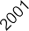

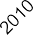
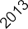
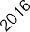
70

60

50
Water flow rate (m3 s-1)

40

30

20

10

0

Duneaton Water (at Maidencots) River flow rates

5
4.5
4
Water flow rate (m3 s-1)
3.5
3
2.5
2
1.5
1
0.5


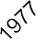













0

(Created using flow archive data CEH www.nwl.ac.uk)/SEPA

Groundwater and wetlands

Groundwater
Groundwater is water under the surface of the land. At 2015, there were 37 groundwater water bodies within or intersecting South Lanarkshire which vary in area from just under 7km2 to over 800km2. Of these, 25 have an overall status of good, while the remaining 12 are classified with a poor status. This trend has remained consistent since 2012.

Ponds
The Countryside Survey defines ponds as ‘a body of water between 25 m2 and 2 ha in area which usually holds water for at least four months of the year’. Ponds can be in many forms both, natural or man-made and can be permanent or seasonal (or temporary). Ponds are important habitats for a range of fauna and flora, including amphibians, invertebrates and ferns.

The 2007 survey estimates there are 198,000 ponds in Scotland, an increase of 6% since 1998. In total 9.9% of ponds met Priority Habitat status based on the quality criteria for plants. Pond quality measurement has not yet been developed for Scotland, however, findings from surveys such as the National Pond Survey suggest that, although there is likely to be degradation of some Scottish ponds, overall quality is likely to be higher than in England and Wales. Pond deterioration can be contributed to a combination of urban development and rural land use intensification. In South Lanarkshire, threats to pond quality mainly come from pollution, for example, agricultural and urban runoff and acidification and infilling for land development or agricultural use. Sustainable Urban Drainage Systems (SUDS) can use ponds and similar water bodies to prevent flooding.

Wetlands
Scotland’s wetlands, including peatlands, are home to a special range of plants and animals and contribute uniquely to storing carbon as well as sustaining clean water. They can help reduce flooding and provide valuable grazing. Wetlands are areas where water covers the soil, or is periodically present either at, or near, the surface of the soil. The prolonged presence of water promotes the development of characteristic wetland soils and favours the growth of specially adapted types of plant.

Pressures affecting wetlands include, intensive land management and change in use, land-take for development such as buildings, roads and windfarms, climate change, nutrient pollution from water and the atmosphere and drainage or removal of groundwater flow as a result of developments.
There is little survey data for South Lanarkshire, with only specific habitats monitored (such as Langlands Moss). There are no designated or proposed wetlands of international importance in South Lanarkshire as set out by the Ramsar Convention.

Water pollution

Point source
Water quality has continually got better through improvements in the treatment of sewage and effluent discharges but point source pollution still remains an important threat to water quality. Point sources of water pollution include discharges from municipal sewage treatment works and industrial installations. Discharges from sewage treatment works can contribute to water pollutants in the form of oxygen-depleting nutrients and pathogens that can be a serious health hazard.
Industrial discharges can contribute in the form of toxic chemicals and heavy metals. SEPA regulates point source discharges through licensing and by monitoring potential impacts on water bodies under the following legislation and their further amendments:
    - The Water Environment (Controlled Activities) (Scotland) Regulations 2011. Outlines the different levels of authorisations to allow for proportionate regulation depending on the risk an activity poses to the water environment. Some activities require authorisation including Point Source discharges, engineering activities, impoundments and abstractions.
    - The Pollution Prevention and Control (Scotland) Regulations 2012. Known as the PPC Regulations they regulate specified large-scale industrial activities.

At September 2019, there were around 2,697 CAR authorisations in South Lanarkshire covering a range of operations and licensed activities. These include 2,125 Registration level activities, 226 simple licenses and 204 complex license activities. This includes authorisations held by Scottish Water for a number of discharges ranging from village septic tanks, waste water treatment works and their associated sewerage networks (Figure 8.4).

Figure 8.4: Main sewage treatment works in South Lanarkshire, 2015
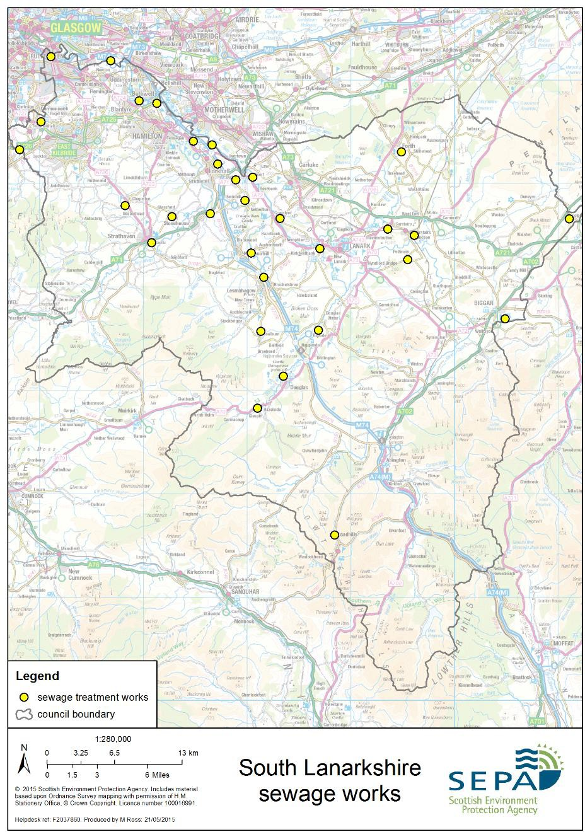
Source: SEPA

Diffuse pollution
Diffuse pollution into water bodies (including ground-waters) is usually associated with land use, with agricultural activity and urban runoff the most significant causes. Diffuse pollution from agriculture is derived from heavy and inappropriate fertiliser use including ammonia release, field runoff containing suspended soil particulates and other solids washed out during periods of high rainfall, phosphates and pesticide use. Urban runoff is associated with surface water contaminated with a range of suspended solids, sewage contamination and a mixture of chemicals including oils.
In rivers, the largest impacts are caused by diffuse pollution from farmland and urban areas and the disposal of sewage through small-scale septic tanks. Ground-waters are particularly vulnerable to a build-up of nitrate levels associated with fertiliser and pesticides washed down through the soil. Diffuse pollution from both agricultural and urban pollution has significant impacts on water quality in South Lanarkshire.

Nitrate Vulnerable Zones
Nitrate Vulnerable Zones (NVZ) are designated in accordance with the requirements of the Nitrates Directive which aims to reduce water pollution caused by nitrates from agricultural sources. In Scotland, there are five designated NVZs. None of these are in South Lanarkshire, however, the area does fall within zones identified for the catchments that drain to nutrient sensitive areas.

Flooding
Incidents of flooding can have devastating social and economic consequences for people, businesses and communities. In general terms, South Lanarkshire has experienced flooding. In recent years summer flash floods have tended to cause more problems than winter flooding.
Evidence suggests that flooding incidents have increased, particularly over the past few decades and this is the case in South Lanarkshire. The increased frequency and intensity of flooding is likely to continue because of the changes in local weather patterns associated with climatic change. Changes in weather patterns associated with climate change have been attributed to increased seasonal tidal surges, increased annual rainfall and increased river flow rates which can increase the risk and frequency of flooding in the future.

Current climate change predictions suggest Scotland will experience an increasing warmer and wetter weather shift. South Lanarkshire is predicted to have more intense or prolonged rainstorms resulting in greater water surges through our river networks, leading to an increase both in intensity and frequency of flooding episodes. In South Lanarkshire, there has been an increase in both rainfall and water flow rates across river networks. The increased threat of flooding can potentially cause further damage to South Lanarkshire’s economy and society, disruption to transport links, the public water supply and increased vulnerability to personal and commercial property.

The Flood Risk Management (Scotland) Act 2009 introduced new duties for the council, as a Responsible Authority under the Act, in relation to assessing and managing flood risk. The council were identified as a potential participant in four of the fourteen Local Flood Risk Management Districts proposed in Scotland, namely Forth, Clyde and Loch Lomond, Tweed and Solway (Figure 8.5). However, as there is no significant flood risk or any potentially vulnerable areas identified within South Lanarkshire in the Solway and Forth districts, it was proposed that the council would not actively participate in those areas.

Figure 8.5: Potentially Vulnerable Areas of flooding in South Lanarkshire
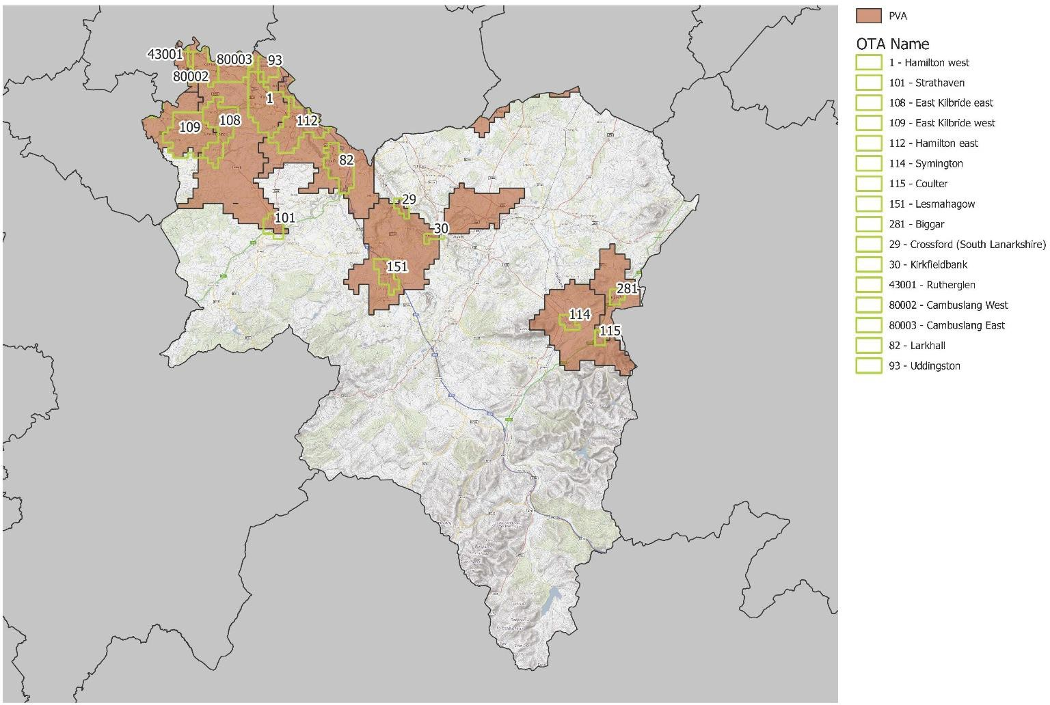
Source: SEPA and South Lanarkshire Council
Table 8.11 set out the properties predicted within SEPA’s 2018 National Flood Risk Assessment to be at flood risk within South Lanarkshire during the medium likelihood (1:200yr) flooding scenario. The figures stated identify more than twice as many homes, businesses and services to be at flood risk compared to figures published in 2015. Scientific knowledge and understanding of flood risk is constantly evolving. More comprehensive data and access to improved mapping and modelling has advanced our understanding of the location and properties at risk. This means that more properties which were previously unknown to us have been identified within SEPA’s 2018 National Flood Risk Assessment as being at flood risk.

Table 8.11: Properties in South Lanarkshire at flood risk during medium likelihood (1:200yr) flooding scenario
Homes |  |  | Businesses and Services |  |  | Homes, Businesses and Services
Total Number | Predicted number at  flood risk | Ratio | Total Number | Predicted number at  flood risk | Ratio | Total Number | Predicted number at  flood risk | Ratio
148,200 | 6600 | 1 in 22 | 17,500 | 1,900 | 1 in 9 | 165,700 | 8,500 | 1 in 19
Source: SEPA

Flooding incidents
In the eleven years between 2007 and 2017 there have been 7,030 recorded flooding incidents in South Lanarkshire. The majority of these incidents were relatively minor category 1 or 2 occurrences. However, 11.5% of incidents resulted in flooding of residential and/or commercial property. In the same period, there have been nine incidents of significant river flooding. The high level of reported flooding occurrences in 2008 was related to severe weather in that year (Table 8.12).

Table 8.12: Flooding occurrences reported in South Lanarkshire
 | Category 1  Choked gully | Category 2  Minor flooding | Category 3  Property flooding | Category 4  River flooding | Total
2007 | 229 | 234 | 48 | 1 | 512
2008 | 438 | 555 | 175 | 1 | 1,169
2009 | 296 | 270 | 60 | 1 | 627
2010 | 192 | 127 | 26 | 0 | 345
2011 | 290 | 413 | 118 | 1 | 822
2012 | 387 | 317 | 144 | 0 | 848
2013 | 334 | 192 | 59 | 2 | 587
2014 | 312 | 165 | 58 | 1 | 536
2015 | 379 | 222 | 57 | 0 | 658
2016 | 251 | 149 | 32 | 2 | 434
2017 | 266 | 195 | 31 | 0 | 492
Source: South Lanarkshire Council

Flood response work
South Lanarkshire Council has discretionary powers to promote flood protection schemes and a duty to assess water bodies. The council has established ‘Response to Flooding’ procedures which set out the level of action required at various priority locations to manage the risk of flooding across the council area. Historically the activation of the council’s flooding response was dependent upon forecast weather conditions, however, due to improvements in the council’s flooding infrastructure and remote monitoring capabilities, its ‘Managing Flood Risk’ procedure is now more proactive and consists of regular planned action at agreed frequencies at the most vulnerable flood sites. From 1 May 2016, the locations listed within the procedure which have implications for residential properties are attended to every two weeks, whereas all other locations are attended to monthly between September and March.

Climate change
SEA objectives that relate to climate change
Reduce contributions and vulnerability to climate change.
Adapt to avoid the risk associated with climate change.
Reduce greenhouse gas emissions and increase energy efficiency, where appropriate, utilise renewable energy sources.
The Earth’s climate goes through natural climatic cycles which human activities have disrupted resulting in shifts of instability never seen before. As a direct result, climate change is regarded as one of the greatest threats facing our environment.
Scotland’s climate is linked with the global climate. Therefore global changes have a consequence both nationally and locally. Over the past century Scotland’s climate has changed more rapidly than anything evident in the past, with global temperatures rising along with increased emissions of greenhouse gases. Average temperatures have increased by approximately 1°C, with an overall trend towards a warmer climate and more extreme weather phenomena. Such changes could be manifested by hotter summers and wetter winters. Scotland is currently experiencing fewer frosts and longer growing seasons.
A summary of the indicators used in assessing the state of South Lanarkshire is presented, highlighting the current status of each indicator and the directional trend.

The Current status is shown by the following colours: The trend direction is shown with the following arrows:
G | Good | F | Fair | Improving
 |  |  |  | No change
P | Poor |  | Limited data | Deteriorating
Note: The most recent data available was used in assessing the environmental indicators

Indicator | Current status | Trend direction | Explanation
Greenhouse gas emissions | G |  | Carbon emissions continue to decrease in South Lanarkshire year on year. Emissions per capita remain below the Scottish  average.
Energy consumption | F |  | Both gas and electricity consumption continue to decrease in South Lanarkshire. Average domestic consumption per  household is slightly above the national average.
Transport emissions | P |  | Fuel consumption and kilometres travelled have fallen for personal road use although at a slower rate than other sectors. There was an increase in freight consumption due to the rise in online retail consumerism. Vehicles are more  energy efficient and less polluting and the council continues to promote infrastructure for electric vehicles.
Renewable capacity | G |  | South Lanarkshire’s renewable energy capacity increased by over 88% since 2011. The area is an energy exporter.
Environmental awareness | G |  | The council is implementing its Sustainable Development and Climate Change Strategy. All schools are registered with the  Eco-Schools programme and work to promote environmental awareness and sustainability in schools continues.

Baseline situation
The climate in South Lanarkshire is changing with a rise in the average annual temperature and increased precipitation, particularly in the winter. These climatic shifts along with more extreme weather events will have a dramatic impact on South Lanarkshire’s environment as well as the population.
The main greenhouse gas (GHG) emitted in South Lanarkshire is Carbon dioxide (CO2), deriving from transport, industry and domestic sources (such as heating, lighting and cooking). In order to mitigate against climate change both the cause and consequence must be addressed. Scotland has an ambitious reduction target for greenhouse gas emissions for which South Lanarkshire must contribute as well as preparing and adapting to the impacts of climate change and enabling sustainable lifestyles.
Sustainable lifestyles in South Lanarkshire are supported in various ways, including through the Council’s Sustainable Development and Climate Change Strategy, the Carbon Management Plan and the work of the Sustainability Partnership and other groups. South Lanarkshire schools are involved in a wide range of activities aimed at promoting and raising awareness of environmental issues and the importance of sustainability in our home, work, school and leisure lives.

Climate change commitments
At the United Nations Climate Conference in Paris in December 2015, world leaders reached a landmark agreement to combat climate change and to accelerate and intensify actions and investments needed for a sustainable low carbon future. This agreement is known as ‘The Paris Agreement’. Its central aim is to strengthen the global response to the threat of climate change by keeping a global temperature rise this century well below 2oC above pre-industrial levels and to pursue efforts to limit the temperature increase even further to 1.5oC. Additionally, the agreement seeks to build resilience and reduce vulnerability to the adverse effects of climate change.

The Climate Change (Scotland) Act, 2009 introduced carbon reduction targets for Scotland of 42% by 2020 and 80% by 2050 compared to 1990 levels. The Act also place a requirement for Scotland to develop long term measures to adapt to changes in the climate which, according to the Intergovernmental Panel on Climate Change (IPCC), can be expected to occur even if global efforts to curb emissions are successful.
The IPCC issued a special report in May 2018 with the stark warning that the pace of action needs to be accelerated in order to avoid breaching 1.5oC warming which would have devastating consequences for people and nature around the world. This report sparked the global climate emergency as a 1.5oC warming could happen as early as 2030.

Following the IPCC report, the Scottish Government declared a climate emergency in May 2019 and announced new challenging reduction targets, of net-zero greenhouse gas emissions by 2045, in line with advice from the Committee on Climate Change. The Scottish Parliament passed a new Climate Change Bill on 25 September 2019 which replaces the targets in the Climate Change (Scotland) Act 2009 with the new target of net-zero emissions by 2045. This new legislation also introduces new interim targets of 75% reduction by 2030 and 90% reduction by 2040 based on 1990 levels.
The public sector has a crucial leadership role in the delivery of Scotland’s climate change ambitions. The Climate Change Act places duties on public bodies to:

- Contribute to carbon emissions reduction targets.
- Contribute to climate change adaptation.
- Act sustainably.
Further to the duties contained the Act the Scottish Government introduced annual statutory reporting in 2016 for public bodies on their compliance with the climate change duties. The reporting platform has improved the quality and consistency of climate change information reported across the public sector in Scotland. The reports and analysis are publicly available, thereby increasing accountability and transparency. The standardised format makes it easier for the public and other parties to understand an organisation’s climate performance. This, in turn, is helping to improve leadership and engagement, while raising awareness of the impact of climate change with senior management in public bodies, ensuring climate change objectives are integrated into corporate business plans and actions embedded across whole public organisations.
The council is a partner within Climate Ready Clyde. This is cross sector initiative which brings partners together to work strategically to minimise risks and seize opportunities climate change presents for the economy, society and environment in Glasgow and the Clyde Valley. Its aims are:

- People and communities benefit from actions to adapt to climate change.
- Adaptation helps to secure existing investment and generates new opportunities.
- To protect the area’s natural environment and uses it to help adapt to climate change.
Climate Ready Clyde was established in 2017 and will operate until 2020. It is leading the development and co-ordination of a Climate Change Adaptation Strategy and Action Plan for Glasgow and the Clyde Valley. The partnership is funded by the partners and includes healthcare providers, universities, transport providers, the private sector and local authorities.

Greenhouse gas emissions
Greenhouse gases are linked to climate. Greenhouse gases in the atmosphere trap energy and keep the Earth’s surface warmer than it would otherwise be. The increase in global temperature is linked to the rise in atmospheric CO2 and other greenhouse gases released by human activities, such as the burning of fossil fuels. The United States, China, and the European Union together account for more than half of the global greenhouse gas emissions, with the UK’s contribution at approximately 2%. However, most of the greenhouse gases remain in the atmosphere over a long period of time continually contributing to global warming.

UK emissions
In 2017, UK emissions of the seven greenhouse gases covered by the Kyoto Protocol were estimated to be 460.2 million tonnes7 carbon dioxide equivalent (MtCO2e). This was 2.7% lower than the 2016 figure of 473.1 million tonnes. It is estimated that greenhouse gas emissions were 42.1% lower in 2017 than in 1990. Carbon dioxide, (CO2) is the main GHG, accounting for 81% of total UK emissions in 2017, compared to 74% in 1990 (Figure 9.1).

Figure 9.1: UK’s greenhouse gas emissions as reported against the Kyoto Protocol
800.0
700.0

600.0
500.0
400.0
300.0
200.0
100.0
0.0
2000
2005
2010
2015
2016
2017
Carbon dioxide
Methane
Nitrous Oxide
Hydrofluorocarbons
PerfluorocarbonsSulphur hexafluoride Nitrogen trifluoride
Source: Department of Energy and Climate Change, 2019
By sector, transport accounted for 27% of emissions, the energy supply sector (24%), business (17%), residential (15%) and 10% of emissions were from agriculture. The remaining 7% of emissions are attributable to the waste management, industrial processes and the public sector.

7 Final UK greenhouse gas emissions national statistics: 1990 - 2017, Department of Energy and Climate Change, February 2019
The land use, land use change and forestry sector acted as a net sink in 2017 so emissions were effectively negative.

The largest decrease in emissions was in the energy supply sector (-7.6%) between 2016 and 2017 due to the continued decrease in power station emissions due to the change in the fuel mix for electricity, in particular, a reduction in the use of coal. A decrease in the residential sector
(-4.2%) was driven by a reduction in the use of natural gas for heating due to warmer weather in the first half of 2017.
The UK has met its emissions reductions targets in the Second Carbon Budget, covering the period 2013 – 2017. The UK also met its emissions reduction targets for the first commitment period of the Kyoto Protocol (2008 – 2012) and is currently exceeding its target for the 2020 commitment (524.3. million tonnes carbon dioxide equivalent).

Scottish emissions
Transition to a low carbon economy is one of the Scottish Government’s strategic priorities in their Economic Strategy. This, it believes, can support sustainable growth by helping households and businesses save money through energy and resource efficiency and by securing new jobs and investments.

In 2017, Scottish emissions of the seven greenhouse gases covered by the Kyoto Protocol were estimated to be 40.5 MtCO2e. This is 3.3% lower than in 2016 (41.9 MtCO2e). The main reason for this reduction was the complete removal of coal generation from the power generation sector.
Between 1990 and 2017, there was a 46.8% reduction in estimated emissions, a 35.6 MtCO2e decrease. These reductions in estimated emissions were:
- 73.5% reduction in Energy Supply (such as power stations).
- 39.7% reduction in Business and Industrial Process (such as manufacturing).
- 72.0% reduction in Waste Management (such as landfill).
- 29.4% reduction in Agriculture and Land Use.

Emissions in Scotland are also dominated by CO2 (73.0%) with significant contributions from Methane (CH4) (15.8%) and Nitrous oxide (N2O) (7.9%). The contributions from Hydrofluoro- carbons (HFC) (2.8%), Perfluorocarbons (PFC) (0.4%) and Sulphur hexafluoride (SF6) (0.1%) are relatively small (Figure 9.2).

Figure 9.2: Scotland’s greenhouse gas emissions, 2017
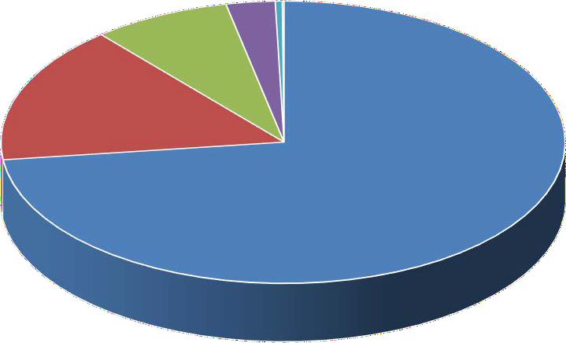
0.4%0.1%
7.9%
2.8%
15.8%
CO2
CH4 N2O HFC
73.0%
PFC
SF6
Source: The Scottish Government
In Scotland, the largest source of net greenhouse gas emissions was Transport (including International Aviation and Shipping) (14.9 MtCO2e), followed by Agriculture and Related Land Use (9.7 MtCO2e) and Business and Industrial Process (8.7 MtCO2e).

South Lanarkshire emissions
There are no local data sources that provide information for all the greenhouse gas emissions within South Lanarkshire. The local CO2 emission estimates available are based on local energy consumption (including gas, electricity and road transport) and land use. Estimates produced by the UK Department of Energy and Climate Change (DECC) indicate that emissions across South Lanarkshire decreased by 31.5% from 2,332.0.6 kt Co2 in 2005 to 1,591.1 kt Co2 in 2017. Over the same period, emission per capita fell by 34.2% from 7.6 tCO2 to 5.0 tCO2 (Table 9.1). However, there are considerable differences between council areas in terms of the presence of motorways, large industrial sites and their potential for carbon capture all of which have a major influence on their emissions data.

Table 9.1: Local CO2 emission estimates based on local consumption and capture
 |  | Local CO2 emission estimates, summary by sector (kt CO2) |  |  |  |  |  |  |  |  |  | Per capita emissions (t)
 |  | Industry and  Commercial |  | Domestic |  | Road and  Transport |  | Land  Use* |  | Total |  | South  Lanarkshire |  | Scotland
 | 2005 |  | 791.7 |  | 856.6 |  | 715.2 |  | -41.4 |  | 2,332.0 |  | 7.6 |  | 8.6
 | 2006 |  | 819.7 |  | 859.8 |  | 721.0 |  | -47.0 |  | 2,353.5 |  | 7.6 |  | 8.6
 | 2007 |  | 783.4 |  | 841.3 |  | 728.8 |  | -60.6 |  | 2,292.8 |  | 7.4 |  | 8.4
 | 2008 |  | 775.4 |  | 847.6 |  | 696.2 |  | -74.8 |  | 2,244.5 |  | 7.2 |  | 8.1
 | 2009 |  | 627.5 |  | 757.5 |  | 687.5 |  | -76.8 |  | 2,005.7 |  | 6.4 |  | 7.2
 | 2010 |  | 658.5 |  | 811.8 |  | 681.6 |  | -65.4 |  | 2,086.5 |  | 6.7 |  | 7.5
 | 2011 |  | 592.5 |  | 722.7 |  | 666.9 |  | -71.9 |  | 1,910.2 |  | 6.1 |  | 6.9
 | 2012 |  | 616.7 |  | 771.7 |  | 673.8 |  | -49.7 |  | 2,012.6 |  | 6.4 |  | 7.3
 | 2013 |  | 579.0 |  | 749.6 |  | 670.2 |  | -56.5 |  | 1,942.3 |  | 6.2 |  | 6.9
 | 2014 |  | 485.1 |  | 629.2 |  | 673.2 |  | -68.4 |  | 1,719.0 |  | 5.5 |  | 6.0
 | 2015 |  | 457.3 |  | 605.9 |  | 682.5 |  | -74.2 |  | 1,671.5 |  | 5.3 |  | 5.7
 | 2016 |  | 398.5 |  | 575.7 |  | 701.8 |  | -77.0 |  | 1,599.1 |  | 5.0 |  | 5.5
 | 2017 |  | 389.6 |  | 541.4 |  | 741.1 |  | -80.9 |  | 1,591.1 |  | 5.0 |  | 5.3
 | % reduction  (2005- 2017) |  | -50.8% |  | -36.8% |  | +3.6% |  | +95.4% |  | -31.5% |  | -34.2% |  | -38.4%
 | *overall carbon removal from soils, forestation and land use
Source: DECC

Within the industrial sector energy efficiency measures are in place through climate change agreements, emissions trading or energy efficiency measures within regulatory requirements. This sector has seen the greatest reduction in estimated emissions between 2005 and 2017 of 50.8%. Domestic emissions are directly related to household energy consumption and this reduced by over a third (36.8%) between 2005 and 2017. Domestic energy efficiency campaigns can be used to reduce domestic emissions. The levels of CO2 emissions from the transport sector increased by 3.6% over the same period.

South Lanarkshire Council emissions
The subset of greenhouse gas emissions estimates in Table 9.2 are those considered by DECC to fall within the scope of influence of local authorities, including South Lanarkshire Council. This subset excludes:
- Motorways.
- Sources covered by the EU emissions trading scheme.
- Diesel railways.
- Land use, land use change and forestry.
Emissions within this subset decreased by 35.8% between 2005 and 2017 compared to Scotland which saw a reduction of 32.4% over the same period. On a per capita basis emissions have also significantly decreased from 6.6 t CO2 in 2005 to 4.1 t CO2 in 2017, representing a fall of 37.9%.

The greatest reduction was within the industrial and commercial sector which seen a decrease in emissions of 51.6% for South Lanarkshire, significantly more than in Scotland overall (-43.0%). The domestic sector saw a decrease of 36.8% over the same timeframe, slightly lower than the national decrease of 38.6%. The transport sector emissions reductions continue to lag behind the other sectors with a decrease between 2005 and 2017 of 2.1% for both South Lanarkshire and Scotland.

Table 9.2: Local CO2 emission estimates based on local consumption (subset)
Year |  | Local CO2 emission estimates, summary by sector (kt CO2) |  |  |  |  |  |  |  | Per capita (t)
 |  | Industry and  commercial |  | Domestic |  | Roads and  transport |  | Total |  | Per capita (t)
 | 2005 |  | 778.3 |  | 856.6 |  | 390.6 |  | 2,025.5 | 6.6
 | 2006 |  | 806.2 |  | 859.8 |  | 401.5 |  | 2,067.5 | 6.7
 | 2007 |  | 764.7 |  | 841.3 |  | 410.5 |  | 2,016.6 | 6.5
 | 2008 |  | 762.3 |  | 847.6 |  | 387.1 |  | 1,997.0 | 6.4
 | 2009 |  | 614.9 |  | 767.5 |  | 386.5 |  | 1,768.9 | 5.7
 | 2010 |  | 645.4 |  | 811.8 |  | 383.7 |  | 1,840.9 | 5.9
 | 2011 |  | 580.0 |  | 722.7 |  | 373.0 |  | 1,675.7 | 5.3
 | 2012 |  | 605.4 |  | 771.7 |  | 365.5 |  | 1,742.7 | 5.5
 | 2013 |  | 566.1 |  | 749.6 |  | 361.0 |  | 1,676.6 | 5.3
 | 2014 |  | 469.2 |  | 629.2 |  | 361.7 |  | 1,460.1 | 4.6
 | 2015 |  | 444.6 |  | 605.9 |  | 365.3 |  | 1,415.7 | 4.5
 | 2016 |  | 385.7 |  | 575.7 |  | 373.9 |  | 1,335.3 | 4.2
 | 2017 |  | 377.0 |  | 541.4 |  | 382.3 |  | 1,300.7 | 4.1
 | % decrease 2005-2017 |  | -51.6% |  | -36.8% |  | -2.1% |  | -35.8% | -37.9%
Source: DECC

In 2008, the council produced its first Carbon Management Plan on how it will assess and reduce emissions associated with the delivery of services. Overall emissions for 2017 – 2018 were
114.185 tCO2, 26.8% lower than the council’s baseline year of 2005 – 2006 (Table 9.3).

Table 9.3: Carbon emissions from SLC activities and buildings (tCO2e)
Carbon Source | 2005 -  2006 | 2011-  2012 | 2012-  2013 | 2013-  2014 | 2014-  2015 | 2015-  2016 | 2016-  2017 | 2017-  2018
Buildings (gas, oil, electricity) | 69,427 | 64,901 | 70.857 | 64.902 | 59,821 | 59,162 | 56,271 | 57,101
Waste (municipal) | 61,320 | 46,741 | 45.334 | 46.724 | 41,392 | 39,072 | 37,297 | 42,079
Fleet | 10,418 | 9,704 | 9,338 | 9,760 | 9,789 | 9,511 | 9,148 | 8,894
Street lighting | 13,005 | 12,986 | 13.020 | 13.841 | 13,509 | 11,895 | 7,549 | 5,464
Employee travel | 1,795 | 924 | 891 | 789 | 692 | 635 | 630 | 646
Total | 155,965 | 135,256 | 139.441 | 136.015 | 125,202 | 120,276 | 110,894 | 114,185
Tonnes saved from baseline | - | 20,709 | 16,524 | 19,950 | 30,762 | 35,689 | 45,071 | 41,780
Variation to baseline |  | -13.3% | -10.6% | -12.8% | -19.7% | -22.9% | -28.9% | -26.8%
Employee numbers | 16,521 | 14,800 | 15.188 | 15.055 | 14,737 | 14,670 | 14,459 | 14,279
CO2 tonnes/ employee | 9.4 | 9.1 | 9.2 | 9.0 | 8.5 | 8.2 | 7.7 | 8.0

Energy

Scottish production
Electricity generation from the combustion of fossil fuels is a major contributor to CO2 emissions in Scotland. In order to deliver its 80% reduction target for CO2 emissions, Scotland needs to
continue to increase the generation of electricity from carbon-free or renewable sources. The amount of electricity generated from individual sources varies from year to year depending on several factors including the price of gas and oil and changes in demand. However, Scotland has consistently been an exporter of electricity, generating more than what is consumed.

In 2017, Scotland generated 48,678 GWh of electricity (Table 9.4). Of this total, 25,166 GWh (51.7%) was generated from renewable sources. In the same year, electricity generation using low carbon sources was 89.5%.The combustion of fossil fuels accounted for 10.5%, with coal, gas and oil providing 5,112 GWh, a significant reduction from 2005 (23,428 GWh) (Figure 9.3).

Table 9.4: Electricity generation and sources in Scotland (GWh)
Source | 2005 | 2010 | 2012 | 2014 | 2015 | 2016 | 2017
Nuclear | 18,681 | 15,293 | 17,050 | 16,633 | 17,763 | 19,631 | 17,827
Coal | 12,158 | 14,281 | 11.754 | 10,315 | 8,508 | 2,263 | 116
Gas and oil | 11,270 | 9,679 | 6,252 | 3,555 | 2,799 | 3,824 | 4,996
Hydroelectric (pump storage) | 643 | 779 | 610 | 494 | 523 | 486 | 573
Renewables | 6,486 | 9,501 | 14,667 | 19,045 | 21,744 | 19,568 | 25,166
Total | 49,238 | 49,533 | 50,333 | 50,042 | 51,337 | 45,772 | 48,678
% Low carbon | 52.4% | 51.6% | 61.7% | 72.3% | 78.0% | 86.7% | 89.5%
% Fossil fuels | 47.6% | 48.4% | 38.3% | 27.7% | 22.0% | 13.3% | 10.5%
Source: Energy Statistics Database. Note: Figures do not sum exactly due to rounding.

Figure 9.3: Electricity generation in Scotland 2005 – 2017
30,000
25,000
20,000
15,000
10,000
5,000
0
2005
2010
2012
2014
2015
2016
2017
Nuclear
Coal
Gas and Oil
Hydroelectric (pumped storage)
Renewables
Source Energy Statistics Database

Scotland generated 53% of electricity from renewable sources (including hydroelectric pumped storage) in 2017 (Figure 9.4). This is a significant increase from previous years. In terms of renewable electricity generation by local authority as a proportion of the total, South Lanarkshire had the second highest (10.64%) after the Highland Council (25.52%). Dumfries and Galloway Council had the third highest proportion at 10.02%

Figure 9.4: Generation by fuel type in Scotland, 2017
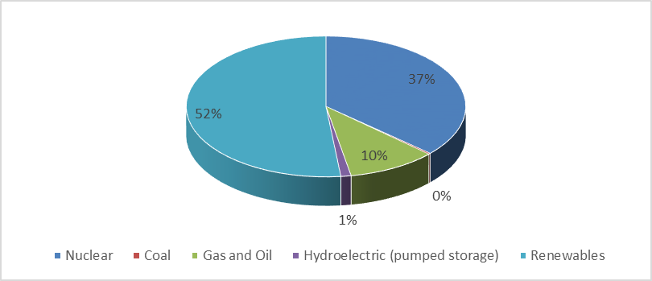
Source Energy Statistics Database

Local consumption
Local CO2 emission estimates for South Lanarkshire demonstrate that energy use through the consumption of gas, electricity or transport fuel are the main emitting sources for greenhouse gas emissions. Therefore, it is essential to consider these sources within the context of South Lanarkshire’s contribution to climate change. One element of reducing greenhouse gas emissions is through the reduction of energy use, through efficiency and conservation measures.

Gas
Domestic gas consumption in South Lanarkshire is far greater than commercial and industrial consumption rates. There has been a steady reduction in gas consumption in South Lanarkshire within both domestic and the commercial and industrial sectors in recent years, although there was a slight increase in the domestic sector in 2016 and the commercial and industrial sector in 2017 (Figure 9.5). In the domestic sector there has been a reduction of 16.5% in gas consumption between 2003 and 2016. In the commercial and industrial sector, the decrease has been greater at 40.3%. In 2016, South Lanarkshire’s domestic gas consumption rate slightly increased to 1,818 GWh. However, the domestic consumers are the 5th largest users in Scotland, illustrating a high dependency for gas in heating homes across the area.

Figure 9.5: Total gas consumption within South Lanarkshire (GWh)
2,500
2,000
1,500
1,000
500
0
2004 2005 2006 2007 2008 2009 2010 2011 2012 2013 2014 2015 2016 2017
Domestic
Commercial and Industrial
Source: DECC
Individual gas consumption rates continue to steadily decrease at a similar rate in South Lanarkshire and in Scotland (Figure 9.6). Indeed, between, 2003 and 2017, there has been a reduction of about 34% in gas consumption both locally and nationally to current consumption levels of 14,813 kWh and 13,721 kWh, respectively. Gas consumption data do not include gas supplied in bulk or bottled form (LPG).

Figure 9.6: Average gas consumption per metered household (kWh)
25,000

20,000

15,000

10,000

5,000

0
2003 2004 2005 2006 2007 2008 2009 2010 2011 2012 2013 2014 2015 2016 2017
South Lanarkshire Average
Scottish Average
Source: DECC

Electricity
Electricity consumption in South Lanarkshire has steadily reduced in both the domestic and the industrial and commercial sectors since 2003 as set out in Figure 9.7. In 2012, the gap between the industrial and commercial and the domestic sectors had all but closed but in 2014 and 2015 there was a sharp increase in consumption in the industrial and commercial sector. However, in 2016 total electricity consumption in the commercial and industrial sector was lower than the domestic sector for the first time since 2003. In the domestic sector there has been a decrease of 21.3% in electricity consumption between 2003 and 2016. In the industrial and commercial sector there has been an overall decrease of 35.5% in the same period.

Figure 9.7: Total electricity consumption within South Lanarkshire (GWh)
1000
900
800
700
600
500
400
300
200
100
0
2003 2004 2005 2006 2007 2008 2009 2010 2011 2012 2013 2014 2015 2016
Domestic
Commercial and Industrial
Source: DECC
In 2017, the South Lanarkshire average domestic consumption rate per metered household (3,642 kWh) was slightly higher than the Scottish average of 3,581 kWh (Figure 9.8). The overall trend for electricity consumption continues to be a reduction in usage, although there was a slight increase in 2014. In 2017, 15 other Scottish local authorities had higher consumption rates than South Lanarkshire.

Figure 9.8: Average electricity consumption per metered household (kWh)
6,000

5,000

4,000

3,000

2,000

1,000

0
2003 2004 2005 2006 2007 2008 2009 2010 2011 2012 2013 2014 2015 2016 2017
South Lanarkshire Average
Scottish Average
Source: DECC

Road and transport fuel
Vehicle emissions are a major source of atmospheric pollutants including nitrogen oxides (NOx), carbon monoxide (CO) and CO2. Fuel consumption for buses (-10.2%), petrol cars (-35.1%) and petrol light good vehicles (-51.2%) reduced between 2005 and 2017. However, the total road and transport fuel consumption in South Lanarkshire increased by 7.6% during the same time frame. This equates to a reduction in personal road and transport fuel consumption of -1.5% and an increase in freight consumption of 9.1% (Figures 9.9 and 9.10).

Figure 9.9: Road transport energy consumption within South Lanarkshire (tonnes of fuel)
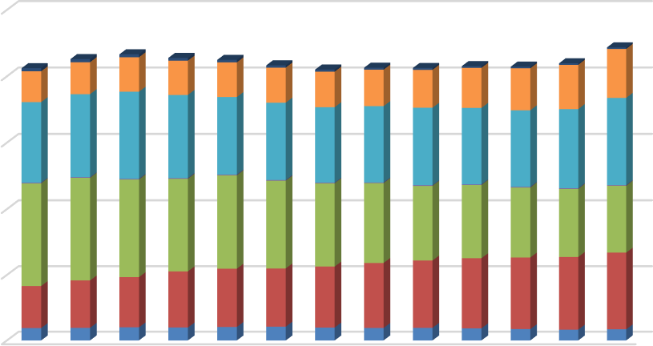

250,000

200,000

150,000

100,000

50,000

0
2005 2006 2007 2008 2009 2010 2011 2012 2013 2014 2015 2016 2017
BusesDiesel CarsPetrol CarsMotor CyclesHGVDiesel LGVPetrol LGV
Source: DECC

Figure 9.10: Total road transport energy consumption in South Lanarkshire (tonnes of fuel)
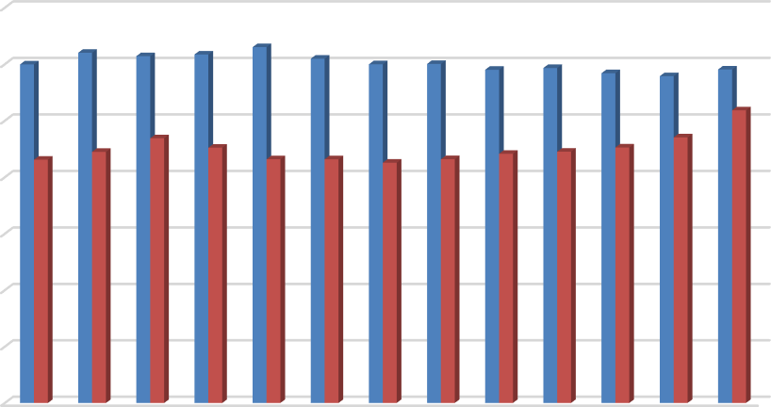

140,000
120,000
100,000
80,000
60,000
40,000
20,000
0
2005 2006 2007 2008 2009 2010 2011 2012 2013 2014 2015 2016 2017
PersonalFreight
Source: DECC

Renewable capacity
Renewable energy can help tackle the causes of climate change as well as support economic growth and so offers a sustainable approach to energy production. Increasing renewable energy generation as a means of reducing carbon emissions is pivotal in tackling climate change and an important component of the Scottish Government’s commitment in reducing CO2 emissions.
The Scottish Government has set clear targets for renewable electricity, with 100% of Scottish electricity consumption supplied from renewable sources by 2020. In 2011, electricity generated in Scotland by renewable sources equated to 28%, rising to 49.6% in 2014, 54.0% in 2016, 70.3% in
2017 and 74.6% in 2018.

The shift towards a diverse range of renewable technologies, including wind, biomass, tidal power, solar and hydro can secure significant investment in Scotland, provide export opportunities and create jobs in the manufacture and installation of generators and the associated infrastructure and supply chain. Households and community renewable projects can also engage people in sustainable development, empowering them to help meet their energy needs in a sustainable way.

The national strategy ‘Our Routemap for Renewable Energy in Scotland’ was developed in partnership with the Scottish Government and the renewables industry. Updated in 2013, it sets out a range of targets, including meeting 100% of Scotland’s electricity demand from renewables by 2020.

Scotland’s capacity
The most recent data available to compare Scotland’s performance against other counties with regards to renewable electricity relates to 2017 when Scotland’s proportion of renewable electricity from gross consumption was 70.3%. Scotland performed strongly compared to EU countries, ranking second behind Austria (72.2%). Scotland was significantly higher than the EU average of 30.8% and the UK figure of 28.1%.
Other key renewable electricity generation figures for Scotland at 20188 are:

- Renewable electricity generation in Scotland was 26,708 GWh, a 6.1% increase on 2017. This would power the equivalent of all households in Scotland for two and a half years.
- On shore wind generation was 17,808 GWh and off shore wind generation was 1,369 GWh, giving an overall total of 19,177 GWh by wind generation.

8 Energy Statistics for Scotland, The Scottish Government, March 2015
- Hydro generation was 4,982 GWh, a slight increase from 2016 (4,945 GWh).
- There were 13,517 GWh of net electricity exports, and increase of 36.58% from the level of exports in 2004 (8,573 GWh)
At December 2018, Scotland had 10.9 GW of operational renewable capacity, with an additional
8.3 GW of capacity either under construction or consented, the majority of which is expected from wind generation. Taking into account pipeline projects, the total renewable capacity either in operation or in planning, totals 23.5 GW.

South Lanarkshire area’s capacity
Government legislation, national greenhouse gas reduction targets and public concern about climate change has created the need to move towards more sustainable forms of energy supply. Despite the lack of large-scale hydro capacity, South Lanarkshire can still offer potential for renewable technology, with the greatest potential offered by wind energy and small-scale hydro. There is also growing interest in solar farms. There is 1 operational solar farm located at the Loch Coulter Water Treatment Works which consists of 30 photovoltaic panels. It is owned and managed by Scottish Water. There are, however, limitations that govern the amount of energy that can be generated from these sources, including water capacity, wind speed, visibility, landscape impacts and habitat constraints.

Onshore wind continues to be the most significant generator of renewable energy in South Lanarkshire. The most suitable areas for wind energy generation are identified in the Spatial Framework prepared as part of statutory Supplementary Guidance on Renewable Energy which supports the South Lanarkshire Local Development Plan.
There are 5 hydro-electric stations within South Lanarkshire, comprising of the Lanark Hydro- electric Scheme (Bonnington and Stonebyres Power Stations) and the smaller hydro stations at Blantyre, Camps Reservoir and Dripps Mill. The total operating capacity from hydro-electric in South Lanarkshire is currently 18.048 MW (Table 9.5).

Table 9.5: Hydro-electric generating capacity on the River Clyde, South Lanarkshire
Station Name | Location | Operator | Potential Output MW
Bonnington Power Station | Lanark – drawing water from above Bonnington Linn waterfall | Scottish Power | 11.000
Stonebyres Power Station | Kirkfieldbank – drawing water from above Stonebyres Linn waterfall | Scottish Power | 6.400
Blantyre Hydro Station | Blantyre – drawing water from a weir across the River Clyde. | NPower Renewables | 0.575
Camps Mini Hydro Power Station | Camps Reservoir, Camps Water Treatment Works, near Crawford | Scottish Water | 0.043
Dripps Mill | Dripps Mill, Waterfoot Road, Thorntonhall | Alexander’s Discretionary Trust | 0.030
Total Operating Capacity |  |  | 18.048
Source: www.scottishpower.co.uk/www.natwindpower.co.uk/South Lanarkshire Council

South Lanarkshire has proved to be an attractive location for wind energy developments. At September 2019, there were 17 operational wind farms and 11 schemes with planning consent, which, in total, could deliver an output of 1,596.4MW (Table 9.6). There were no wind energy developments under construction. In addition, there are undetermined applications with the potential output of about 250MW.

Table 9.6: Operating and consented wind farms (4 or more turbines) in South Lanarkshire
Name | Location | Operator | No. of Turbines | Potential Output MW
Operating
Hagshaw Hill | West of Douglas | Scottish Power | 26 | 16
Hagshaw Extension | West of Douglas | Scottish Power | 20 | 26
Blacklaw | West of Forth | Scottish Power | 48 | 111
Whitelee Forest | West of Strathaven | Scottish Power/ CRE | 42 | 97
Stallashaw Moss (Muirhall) | Auchengray, Tarbrax | Lomond Energy | 11 | 34
Clyde Windfarm | South East of Abington | Scottish Southern Energy (SSE) | 152 | 350
Clyde Extension | North East of Clyde Wind Farm | SSE Renewables | 51 | 162
Nutberry Hill | West of Coalburn | West Coast Energy | 6 | 18
Bankend Rigg | South West of Strathaven | I and H Brown | 11 | 14
Calder Water | West of Strathaven | Community Windpower | 13 | 39
West Browncastle | West of Strathaven | Falck Renewables | 12 | 36
Dungavel | South West of Strathaven | Eon Renewables | 13 | 30
Andershaw | South of Douglas | Andershaw Wind Farm Ltd | 11 | 42
Galawhistle | West of Douglas | Infinis | 20 | 50
Auchrobert | West of Lesmahagow | Falck Renewables | 12 | 48
Kype Muir | South of Strathaven | Banks Renewables | 26 | 88
Middle Muir | North of Crawfordjohn | Banks Renewables | 15 | 68
Total operating capacity |  |  | 489 | 1229
Planning consented (subject to Section 75 Agreement)
Penbreck | South of Glespin | Brookfield | 6 | 18
Dalquhandy | South West of Coalburn | Hargreaves | 15 | 49
Crookedstane | Adjacent to Clyde  Wind Farm near Watermeetings | 2020 Renewables | 4 | 9.2
Lion Hill | Adjacent to Clyde Wind Farm near  Watermeetings | 2020 Renewables | 4 | 9.2
Kennoxhead | South of Glespin | Brookfield | 19 | 64
Broken Cross | North West of Douglas | Hargreaves | 7 | 21
Douglas West | North East of Douglas | 3R Energy | 13 | 49
Cumberhead | South and West of Coalburn | Cumberhead Wind Energy Ltd | 11 | 33
Bankend Rigg II | South West of Strathaven | Wilson Renewables II LLP | 3 | 10
Kype Muir Extension | South of Strathaven | Banks Renewables | 15 | 83
Priest Gill | Abington | Priestgill Wind Farm Ltd | 7 | 22
Potential operating capacity |  |  | 104 | 367.4
Total potential output in South Lanarkshire area |  |  | 593 | 1,596.4
Source: South Lanarkshire Council

The operating and consented schemes can potentially meet the electricity needs of over 612,500 homes which is about four times the number of households in South Lanarkshire. This estimate excludes commercial and industrial users. There are a number of other proposals at the application stage, indicating the continued interest in South Lanarkshire as a location for onshore wind developments. The current pattern of large scale wind farm developments reflects the prevalence
of upland locations. At September 2019, there were 337 operating/consented single/small scale turbines in South Lanarkshire.
The landfill sites in South Lanarkshire currently generate approximately 10 MW of electricity through the capture of landfill gas. As part of the Schools Modernisation Programme, 48 schools had biomass boilers fitted between 2009 and 2019. A sheltered housing complex also had a biomass boiler installed. In total, the biomass boilers installed by the council have an operating capacity of 6.945 MW, a significant increase from 2012 when the overall operating capacity for biomass boilers fitted by the council was 2.687 MW. At September 2019, the current overall renewable generating capacity in South Lanarkshire is about 1,264 MW, a significant increase from 2017 when the overall capacity was 956 MW (32.2%), a 24.9% increase from 2015 when the overall capacity was 765.67 MW and significantly greater than in 2011 (88.4%) when the overall capacity was 146.575 MW. This was largely attributable due to the increase of operational wind farms in the area.

Planning permission has been granted to the British Geological Survey for trial boreholes as they look to try and extract heat from underground mine water. The project is in its infancy but is hoped to provide a viable new source of domestic heat from a currently unused asset in former coalfield areas. Drilling is expected to commence late 2019 with data monitoring starting in mid 2020.

Home energy efficiency
In 2013, the Scottish Government published a new Sustainable Housing Strategy, which brings together the all tenure aspects of housing quality, including the new Energy Efficiency Standard for Social Housing (EESSH) and sets out key milestones for achieving improvements in energy efficiency and climate change targets.

New building standards and regulations are driving significant improvements in the development of new housing to ensure a much lower impact on climate change, with energy efficient, low carbon homes that are sustainable. The council continues to support this approach and is committed to delivering 1,000 new homes by 2022.

A priority for the Local Housing Strategy (2017 – 2022) is to improve the energy efficiency of existing homes across all tenures. The direct intended outcome is to increase heat retention in homes and, therefore, reduce wasted energy use. This also addresses climate change as homes require less energy to maintain heat which can significantly reduce the amount of energy used and, therefore, carbon emissions.
For existing private sector homes, the council has secured substantial funding under the Scottish Government’s ‘Home Energy Efficiency Programme for Scotland: Area Based Schemes (HEEPS: ABS)’ to improve the energy efficiency of hard-to-treat homes, for example, solid wall (non-cavity) construction. Under this programme, the council attracts match funding from energy companies seeking to achieve the best possible returns in terms of carbon reductions to meet their responsibilities under ECO (Energy Company Obligation). Since 2013, over 1,800 homes across South Lanarkshire have benefitted from this programme.
The extent of investment in housing energy efficiency across all tenures is shown in the improvements measured by the most recent Scottish House Condition Survey (SHCS) Local Authority findings (2015 – 2017). This indicates that homes in South Lanarkshire have an average SAP energy rating of 64.7 compared with 63.6 for Scotland.

The SHCS also measures fuel poverty rates across Scotland based on income and energy costs. The latest findings highlight that 23% of households in South Lanarkshire are estimated to be in fuel poverty compared with an average of 27% across Scotland. Comparison with the previous 2013 – 2015 results illustrate general declines in fuel poverty rates across the country, giving an indication of the impact of investment and improvements made to the energy efficiency of housing.

Potential impacts of climate change
Climate change is happening now. Increasing global temperatures are resulting in changes to our climate and we are experiencing more extreme weather patterns, particularly increased rainfall.
The Scottish Government has focused on reducing greenhouse gas emissions and adaptation to tackle climate change and combat its effects.

Current climate changes across Lanarkshire
The river gauging stations at Duneaton Water and the River Clyde both show an increase in rainfall between 1970 and 2006 (Figure 9.11). Duneaton Water, in the Southern Uplands, experienced the highest level of annual rainfall but the lowest rate of increase (6%), whereas the River Clyde at Bothwell experienced an increase of 15% in annual rainfall.

The Scotland and Northern Ireland Forum for Environmental Research (SNIFFER) project (CC03: A handbook of climate trends across Scotland) reported an increase in the number of heavy rainfall days, particularly during winter in the north and west of Scotland. This increase is evident in the data presented on the council’s flood response work where there is a reported increase in the number of responses relating to heavy rain incidents.

Across the council the impacts of severe weather on the functionality and responsiveness of individual services is recognised. These range from flood defence management to local planning. The council’s Corporate Contingency Plan sets out how it will work with partners to deal with emergencies, including the impacts of severe weather events.

The UKCIP02 climate change scenarios indicate that the average temperature in Scotland will increase by 1.2oC to 2.6oC over the next century, with greater increase experienced through a rise in winter temperature. Annual precipitation is predicted to increase by 5% to 20% with autumn and winter experiencing the largest increase, with downpour intensity likely to increase, resulting in a greater risk of flooding. These scenarios illustrate the potential impact climate change could have on future council services.

Figure 9.11: Trends in yearly mean rainfall at two river gauging stations monitoring the River Clyde and the contributory river Duneaton Water
2000
Duneaton Water
River Clyde

1800

1600
Rainfall (mm)

1400

1200

1000

800

600
1970
1972
1974
1976
1978
1980
1982
1984
1986
1988
1990
1992
1994
1996
1998
2000
2002
2004
2006

(Created using archive CEH data www.nwl.ac.uk)
UKCP09 are new projections of UK climate change designed to help governments to effectively plan adaptation approaches. The use of climate prediction models such as UKCP09 could assist the council in managing future resource requirements in line with potential service demands.

Environmental awareness

Sustainable development
It is recognised we are living well outwith our global environmental limits with current lifestyles placing an increasing burden on the planet and our natural resources. The depletion of natural resources is not only damaging to the environment both globally and locally but also for people and the economy. A healthy environment provides us with natural resources like clean air, clean water, fertile soils, food, energy, medicine and building materials. Our long term economic and social wellbeing ultimately depends on the environment and our natural resources. Sustainable development is about achieving economic and social development in a way that also enables us to protect and enhance our environment both now and for the future.


Sustainable development is a set of fundamental value by which we make decisions and how we chose to live. These values are outlined in the 17 Global Sustainable Development Goals of the United Nations 2030 Agenda for Sustainable Development as set out in Figure 9.12.

Figure 9.12: United Nations Sustainable Development Goals

Sustainable development and climate change are both reflected in South Lanarkshire Council's plans and policies and are considered in its service delivery activities.

Sustainability in South Lanarkshire schools
In 2019, the council launched the South Lanarkshire State of the Environment Report to Glow, the digital learning platform used by all schools in South Lanarkshire. This educational resource also contains a ‘who’s who’ directory of council and partner staff who are able to assist schools with environmental lessons and projects.
The Brundtland Commission Report, Our Common Future defines sustainable development as, ‘Development which meets the needs of the present without compromising the ability of future generations to meet their needs’.

During 2018/2019, over 2,000 primary pupils across South Lanarkshire participated in 80 air quality educational workshops aimed at supporting a reduction in traffic around schools and improving air quality, through increasing the uptake of sustainable travel choices. The workshops encouraged children to think about alternative means of travel to school and included resources for pupils to take home to help spread the message to their families.

An evaluation of the project found that 25% of the pupils reported they had made positive changes to their travel choices as a result. It is anticipated that the air quality workshops will continue and a pilot is planned which will allow workshops to bridge the transition for Primary 7 pupils transferring into high school.
As part of South Lanarkshire’s action plan to improve air quality in the environment, approximately 5,500 residents in Lanark and Rutherglen towns participated in ‘Beat the Street’ a giant sustainable travel game which measured participants walking and cycling distances over a six week period in February/March 2019. Participation levels of pupils from the 11 local primary schools in the competition was outstanding with over 80% of pupils regularly taking part in walking, cycling and scooting over the duration of the initiative. The total distance covered by the residents and children over the period was calculated as over 75,000 miles. Plans are underway to repeat the competition in another area of South Lanarkshire over the next year to again promote and encourage positive travel choices.

A is for autumn leaves I smell
C is for the children cycling to school T is for ten thousand steps every day I is for inspiration to be healthy
V is for five (V) fruit and veg a day
E is for energy I gain from being healthy

T is for the trains I see
R is for runners I meet along the way
A is for air pollution which affects my asthma
V is for variety of exercises every day
E is for everyone working together
L is for ‘let’s make our world a healthy place to live’
Student from Spittal Primary School. Participant at the Active Travel/Air Quality Workshops commissioned by South Lanarkshire Council, 2018

The Eco-schools programme
Young people across South Lanarkshire have an interest in the environment in which they live and care about the impacts they have upon it. The Eco-Schools programme helps to motivate young people and offers them opportunities to help protect their environment. The programme is an international initiative designed to encourage whole-school community action on learning for sustainability. It is a recognised award scheme that accredits schools who make a commitment to continuously improve their environmental performance. It raises awareness of environmental and sustainable development issues throughout activities linked to curricular areas.

Managed by Keep Scotland Beautiful, the aim of the programme is to make environmental awareness and action an intrinsic part of the life and ethos of the school for both pupils and for staff and to engage the wider community. The programme encourages teamwork, creating a shared understanding of what it takes to run a school in a way that respects and enhances the environment. The aim is that this ethos in school is then expanded by the children to their home life (www.ecoschoolsscotland.org).

The Eco-Schools Scotland programme has seven elements, incorporating ten environmental topics. The award system associated with the programme has recently changed with the removal of both the Bronze and Silver Awards. Once a school has registered on the programme and implemented the seven elements it can, therefore, then apply to start the process of working towards the Eco-Schools ‘Green Flag’ award.

In Scotland, the majority of local authority schools are registered with the programme, as well as independent and ‘early years’ establishments, with over 840,000 young people involved in Eco- Schools Scotland in 2018. Table 9.7 sets out the current level of participation in the Eco-schools programme in South Lanarkshire.
All primary schools in South Lanarkshire are registered with Eco-schools and take part in a wide array of environmental activities through their eco committees and teams. A total of 67 establishments in South Lanarkshire currently hold the coveted Green Flag award.

Table 9.7: Participation in the Eco-Schools programme in South Lanarkshire, 2018
Organisation | Number of establishments | Green Flag status
Organisation | Number of establishments | No. | %
Primary | 125 | 46 | 36.8
Secondary | 18 | 4 | 22.2
Additional Needs | 7 | 3 | 42.9
Nurseries* | 60 | 14 | 23.3
*Includes independent school nurseries, Early Year partnership providers and council nurseries
Source: South Lanarkshire Council/Keep Scotland Beautiful

The John Muir Award
During the academic year 2017 – 2018 16 schools in South Lanarkshire have been involved in the John Muir Award, an increase of five schools from 2016. In this period, a total of 648 awards have been made, including 130 Inclusion Awards. The John Muir Award is used to help deliver Curriculum for Excellence outcomes and demonstrates Learning for Sustainability in action. Pupils are involved in taking responsibility for nature in school grounds and communities. It helps to reinforce healthy behaviours and improves wellbeing and educational attainment.

Transport
SEA objectives that relate to transport
Actively encourage and increase the use of public and alternative transport modes.
Reduce the potential for congestion and emissions associated with transport.
Maintain and enhance the quality of the transport network, whilst avoiding exacerbating associated pollutants.
South Lanarkshire has a diverse range of settlements located within the urban areas to the north or spread through the rural areas in the south and west. The distribution and population of these settlements determine the level and type of transport used which has a distinctive influence on the built and natural environment, human health and the impacts associated with vehicle emissions (including local air quality and climate change). The demand for transport has continually increased with individual vehicle ownership growing. This has resulted in the transport sector being one of the key concerns for atmospheric emissions.
A summary of the indicators used in assessing the state of South Lanarkshire is presented, highlighting the current status of each indicator and the directional trend.

G | Good | F | Fair | Improving
 |  |  |  | No change
P | Poor |  | Limited data | Deteriorating
Note: The most recent data available was used in assessing the environmental indicators
Indicator | Current status | Trend direction | Explanation
Road network condition | F |  | The condition of the road network continues to improve due  to additional funding from the council’s Roads Investment Plan.
Traffic growth | G |  | Road traffic growth is slowly increasing linked to economic improvements.
Congestion | G |  | There has been a decrease in residents experiencing congestion compared to baseline figures since completion of major road improvement works across the area.
Road safety | G |  | The council is on track to meet the Government’s 2020  casualty reduction targets. The overall number of casualties has reduced in the last two years.
Public transport | F |  | Bus – The bus patronage figures published in the Scottish Transport Statistics (2018) indicate a fall of 29% in the ten years between 2007/08 and 2017/18 in bus patronage within  the South West and Strathclyde area which also includes Dumfries and Galloway.
Public transport | G |  | Rail –The number of train passengers at South Lanarkshire rail stations has remained consistent year on year.
Walking and cycling | P |  | There has been a slight increase in the percentage of people walking and cycling. The council is implementing its Cycling Strategy and its Core Path Plan to promote active travel.

Baseline situation
South Lanarkshire is located at the heart of west central Scotland and its settlements have very diverse characteristics due to the physical environment. The north of South Lanarkshire is distinctly urban with surrounding greenbelt and is home to the majority of the population with an abundance of services that are well connected to the road and rail infrastructure. To the immediate south are the commuter settlements typified by the large numbers of daily commuters working in larger towns and Glasgow. However, the impact of this is that these centres have declined significantly to levels
where many no longer offer an essential range of services and dependence on private vehicle ownership is high.

Across the middle of South Lanarkshire some settlements have lost their traditional industries of mining or agriculture and to the south are rural centres where there is a higher than average number of retired people. Employment within these areas is largely reliant on the service sector, including tourism. In general the environmental quality of the area is high but public transport provision is relatively limited.

Local transport issues
The influence on transport issues is highly dependent on the area in which the individual lives and works because transport infrastructure differs considerably across South Lanarkshire. During consultation on the council’s Local Transport Strategy residents identified the following issues which were considered and taken account of in the final Strategy:

    - The condition of roads and footways need to be improved.
    - Improve road safety.
    - A need for new and improved walking and cycling routes.
    - Infrequent rural bus services.
    - Lack of bus shelters.
    - Poor train services at Carstairs Station.
    - Request for a new railway station at Symington.
    - Insufficient capacity at Blantyre Station Park and Ride.
    - The need to encourage children to walk or cycle to school.
    - The need for improvements to town centres for pedestrians with mobility difficulties.
    - Congestion, particularly in town centres.
    - The need for lower residential speed limits.
    - The need for increasing parking provision at stations.
    - The need to encourage low carbon vehicles.

Road network condition
South Lanarkshire Council is responsible for a road network that is 2,295 km in length and comprises of 290 km of A class roads, 250 km of B class roads, 407 km of C class roads and 1,348 km of unclassified roads. This excludes the motorway and trunk road network which is the responsibility of Transport Scotland. Information on the condition of local authority roads is collected in the Scottish Road Maintenance Condition Survey organised by the Society of Chief Officers of Transportation in Scotland (SCOTS). Results for South Lanarkshire and for Scotland as a whole are given in Table 10.1.

Table 10.1: Carriageway condition - % of network that should be considered for maintenance treatment
Year | South  Lanarkshire | Scotland  Average | Year | South  Lanarkshire | Scotland  Average
2018/2019 | 31 | 34 | 2010/2011 | 38 | 36
2017/2018 | 31 | 36 | 2009/2010 | 37 | 36
2016/2017 | 33 | 36 | 2008/2009 | 37 | 34
2015/2016 | 34 | 37 | 2007/2008 | 39 | 37
2014/2015 | 34 | 37 | 2006/2007 | 51 | 47
2013/2014 | 36 | 37 | 2005/2006 | 49 | 42
2012/2013 | 37 | 36 | 2004/2005 | 48 | 42
2011/2012 | 38 | 36 | 2003/2004 | 53 | 45
Source: South Lanarkshire Scotland; SCOTS

The roads across South Lanarkshire are undergoing an extensive maintenance programme which should result in a drop in the percentage of network requiring maintenance. SCOTS notes that when examining road condition results for individual local authorities it is important to recognise
that local road networks vary in character, carry different volumes of traffic and serve widely disparate communities. In SCOTS view, authorities should not be judged on the absolute values given in their survey but on their performance to improve the conditions of their road networks. The £126 million Roads Investment programme was completed in March 2019. Since its introduction in 2008, approximately 61% of the South Lanarkshire road network has been resurfaced. In 2018/2019, we resurfaced 3.4% of our road network. Improved roads range from local residential streets to strategic A class routes. A further annual investment of £11 million has been agreed for 2019/2020.

In the last decade, winters have been amongst the most severe ever recorded in Scotland and this type of weather is extremely damaging to the condition and structure of roads. However, the council has improved the condition of the network despite these conditions due to this additional and continuing investment.

Traffic growth
It is important to recognise that local road traffic contributes to national and global carbon emissions. This in turn is a contributory factor to global climate change. Traffic also leads to the build-up of levels of other harmful particulates which are responsible for air pollution. Transport, in particular private car use, puts pressure on our natural resources (land, air quality and especially energy, mainly fossil fuels) and makes a significant contribution to our global environmental impact.

In order to manage levels of private car use and operate a safe and efficient road network it is vital to have a traffic monitoring programme which provides information in relation to the volume and type of traffic using the various routes. The council has assessed the traffic growth rates and volumes over the last 20 years and in particular the change in the rate of traffic growth. South Lanarkshire can be split into two distinct geographical areas, notably urban to the north and west and rural to the south and east. In 2018, approximately 72% of the council’s strategic monitoring sites experienced a reduction in traffic growth with 28% of sites increasing in traffic growth. This compares to a 15% reduction in 2016.
Our traffic monitoring programme to date has also demonstrated the measurable effects of major alterations in terms of the road network as well as that of developments in South Lanarkshire.
Events which have had a significant effect on traffic flows can be clearly observed, including the opening of the M74 completion, the Glasgow Southern Orbital, the completion of the M74/A725 Raith Interchange Improvement and the Cathkin Relief Road. It is anticipated that similar patterns will be observed in future monitoring exercises on corridors subject to public transport improvements.

Analysis of the general trends from the data gathered so far has also been comprehensive enough to provide an indication of predicted future traffic levels if current circumstances continue. The council is keen to alleviate the adverse impacts of traffic and traffic growth, including the harmful effects on the environment, which is the underlying principle of the Road Traffic Reduction Act 1997. However, there are a number of external factors that make it unrealistic for the council to achieve a reduction in the level of traffic using its roads.

These include:
- The reducing cost of motoring in real terms.
- The increasing cost of public transport.
- The deregulation of bus services (taking them outwith the council’s control).
- Rail legislation is also outwith the direct control of the council.
- Availability of funding for transport improvements.
- The decline of traditional urban shopping and employment centres leading to people travelling further for the same services.
- Increased disparity between those who cannot afford to own a car and the more affluent people who increasingly depend on private car use and own multiple cars.
- No local control over fuel duty or road tax.
- The lack of national policy instruments to introduce road user charging on the trunk road network.
Although these factors make it difficult to reduce traffic levels there are other measures available to the council and its partners that could cumulatively slow down the rate of traffic growth. These are:

- Travel plans for all major generators of traffic, particularly the private car.
- School travel plans.
- Travel awareness and safety campaigns.
- Traveline, Transport Direct and other coordinated marketing initiatives.
- Improvements to the walking and cycling infrastructure.
- Introducing significant park and ride provision at rail stations.

Congestion
South Lanarkshire residents identified congestion, particularly in town centres and at certain pinch points as areas of concern. A baseline using combined data from 2005 – 2008 for congestion in South Lanarkshire has been established using data provided by the Scottish Household Survey. The number of South Lanarkshire residents who did not experience congestion in this period was 86%. For the period 2012 - 2013 this increased to 92.5% and reduced to 85.4% and 78.2% in 2013 – 2014 and 2014 – 2015, respectively. However, this coincided with the improvement works to the M74/A725 Raith Interchange which had a significant impact on journey times. In 2015 – 2017, this increased to 80.8%.

Road safety
As a local Roads Authority, the council has a duty to manage and maintain safe local public roads, footways, street lighting, street furniture and the power to improve infrastructure as necessary. This is achieved through road safety engineering and education, accident investigation and prevention as well as ongoing road maintenance.

For road safety measures to be effective, cooperation is needed across the various disciplines, the four ‘Es’ of road safety: education; engineering, enforcement and encouragement. At the heart of road safety planning, it is essential that casualty reduction strategies are identified and actions developed to implement these strategies. Travel awareness, the promotion of safe travel and road safety engineering measures that target specific areas where accidents occur all contribute to the target for reducing accident casualties in South Lanarkshire. Examples of road safety engineering measures carried out by the council include route action plans on our main, rural routes, our programme of installing vehicle actuated warning signs and a combination of mandatory and advisory 20 mph limits around all of the council’s schools.

Road safety education initiatives include the Children’s Traffic Club, Traffic Trails, Park Smart, Bikeability, Walk to School Week, Road Safety Theatre Productions and promotion of the educational projects Streetsense and Crash Magnets. Innovative new road safety training techniques introduced include the Junior Road Safety Officer Initiative, which involves peer learning, and the Kerbcraft Road Safety Training initiative. All of the above assist in reducing road casualties in South Lanarkshire.
The Scottish Government has set casualty reduction targets to 2020. Based on the average number of casualties from 2004 to 2008, these targets are a 40% reduction in road deaths and a 55% reduction in serious injuries, with the equivalent targets for children being 50% for deaths and 65% for serious injuries. Progress towards these targets is shown in Figure 10.1 to Figure 10.4.

Figure 10.1: All fatal casualties in South Lanarkshire, 2004 – 2018
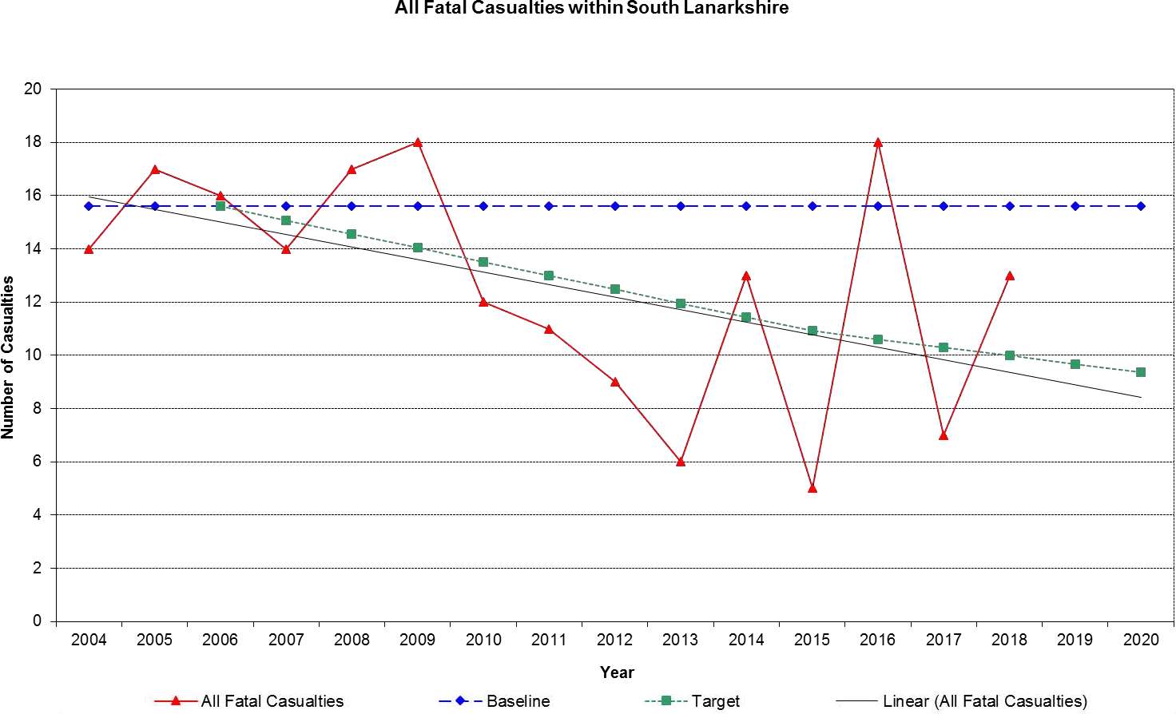
Source: South Lanarkshire Council

Figure 10.2: All serious casualties in South Lanarkshire, 2004 – 2018
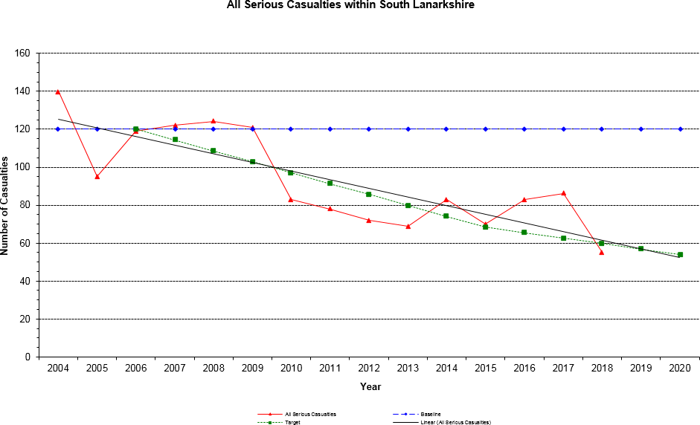
Source: South Lanarkshire Council

Figure 10.3: Child under 16 fatal casualties in South Lanarkshire, 2004 – 2018
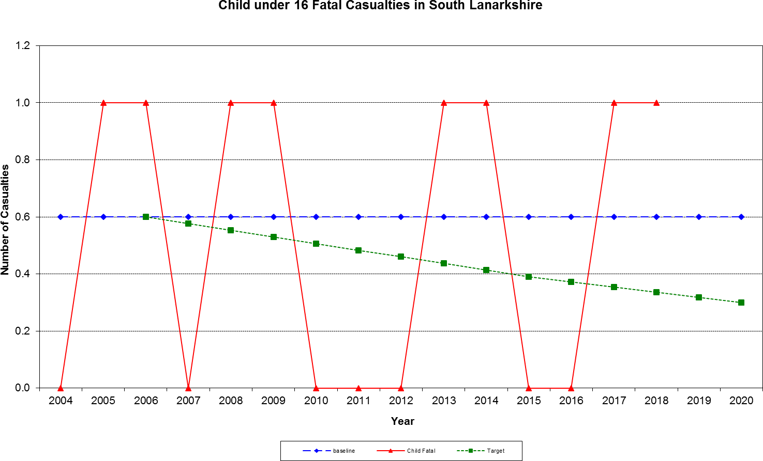
Source: South Lanarkshire Council

Figure 10.4: Child under 16 serious casualties in South Lanarkshire, 2004 – 2018
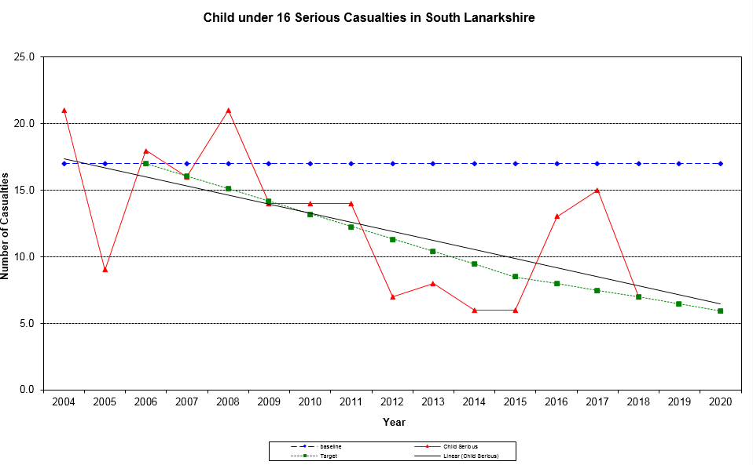
Source: South Lanarkshire Council

The council is making good progress towards the 2020 targets. However, these targets are challenging and our future policies must, therefore, continue to strive to reduce casualty numbers.

Public transport
Buses are the most important form of public transport in South Lanarkshire in terms of the number of passengers who use them. They are crucial to increase social inclusion through transportation. They are vitally important for people, especially those with no access to a car at the time they make the journey to get to the jobs and services they need. Unfortunately, the increase in car use
has not only led to reduced numbers of bus passengers but the resultant congestion has also made bus journeys longer and less predictable.

Services are at their most frequent and buses of the best quality on the corridors into Glasgow. They are less frequent and convenient on links between the towns in South Lanarkshire and also for trips around the residential areas of larger towns such as East Kilbride. In rural areas there are often only infrequent bus services on the main routes.

Buses are not provided by the council. Instead, most services are operated by private companies who receive no direct subsidy from the Government and so have to make a profit. The companies decide when and where buses run and the fares. Where a bus is not provided by a private company and a service is seen as socially necessary, one could be secured through subsidy from Strathclyde Partnership for Transport (SPT) but they only have limited funds to do this. They have to decide how to fund such services all over Strathclyde which means that they cannot fund all the bus services that people in South Lanarkshire require.
In South Lanarkshire the rail network is based on two main lines; Glasgow to London (the West Coast Main Line) and Glasgow to Edinburgh via Carstairs. There are also local lines from Glasgow to East Kilbride and Motherwell, Lanark and Larkhall via Hamilton, as well as the Cathcart Circle. In total there is 120 km of track and, apart from nine kilometres to East Kilbride, the entire track is electrified. South Lanarkshire has 19 railway stations, 17 of which have associated park and ride facilities and 5 offer bus and rail inter-links and many more have bus stops nearby. As of July 2019 there are a total of 2,683 park and ride spaces, an increase of 342% on April 1994.

The bus patronage figures published in the Scottish Transport Statistics (2018) indicate a fall of 29% in the ten years between 2007/08 and 2017/18 in bus patronage within the South West and Strathclyde area which also includes Dumfries and Galloway. Robust data at a South Lanarkshire area level is unavailable.

There is evidence that substantially more South Lanarkshire residents are travelling by train. The Office of Rail Regulation compiles a list of the number of passengers using railway stations in South Lanarkshire (Table 10.2).

Rail patronage in South Lanarkshire increased by more than 5.4 million journeys between 2002/2003 and 2016/2017, an increase of 133%. However, there was a slight decrease in 2017/2018. The notable increase to 2016/2017 indicates that the policies and investment, for example, park and ride by the council and its partners such as SPT, Scotrail and Network Rail are having a significant impact in encouraging more people to travel by train with the subsequent benefits for the environment.

Table 10.2: Rail patronage for all South Lanarkshire Stations (entries/exits)
Station | 2017/  2018 | 2016/  2017 | 2015/  2016 | 2014/  2015 | 2013/  2014 | 2012  /2013 | 2011/  2012 | 2010/  2011
Blantyre | 551,508 | 567,570 | 610,730 | 623,058 | 602,544 | 560,532 | 527,094 | 490,204
Burnside | 282,282 | 276,012 | 270,746 | 275,500 | 270,748 | 318,628 | 337,054 | 328,082
Cambuslang | 850,510 | 806,638 | 774,352 | 750,022 | 716,608 | 777,400 | 757,576 | 689,836
Carluke | 420,170 | 428,140 | 396,046 | 392,812 | 369,582 | 345,766 | 328,270 | 313,882
Carstairs | 84,166 | 95,864 | 84,796 | 43,388 | 33,398 | 20,610 | 13,548 | 10,680
Chatelherault | 111,076 | 105,464 | 85,898 | 74,934 | 66,948 | 62,526 | 59,538 | 57,116
Croftfoot | 256,420 | 299,346 | 219,538 | 207,322 | 194,964 | 196,202 | 188,794 | 172,158
East Kilbride | 1,031,100 | 1,020,364 | 1,136,980 | 1,153,648 | 1,079,531 | 988,832 | 985,456 | 909,914
Hairmyres | 647,622 | 640,866 | 719,260 | 727,414 | 692,092 | 569,386 | 542,390 | 492,028

Station | 2017/  2018 | 2016/  2017 | 2015/  2016 | 2014/  2015 | 2013/  2014 | 2012  /2013 | 2011/  2012 | 2010/  2011
Hamilton Central | 811,104 | 847,474 | 825,176 | 847,790 | 815,322 | 892,228 | 873,178 | 845,704
Hamilton West | 866,144 | 921,250 | 935,000 | 946,210 | 904,785 | 885,286 | 845,188 | 798,816
Kirkhill | 69,104 | 72,854 | 76,068 | 74,922 | 76,282 | 88,316 | 91,828 | 93,878
Lanark | 303,834 | 328,034 | 306,236 | 328,890 | 304,640 | 337,896 | 350,014 | 347,128
Larkhall | 385,942 | 434,494 | 420,366 | 420,130 | 406,074 | 342,704 | 327,070 | 317,462
Merryton | 107,220 | 123,066 | 113,546 | 116,234 | 111,384 | 113,088 | 106,308 | 102,650
Newton | 669,530 | 653,312 | 584,522 | 569,006 | 505,286 | 523,554 | 515,760 | 481,146
Rutherglen | 1,072,296 | 1,098,300 | 1,110,088 | 1,073,392 | 1,030,290 | 977,418 | 894,434 | 796,568
Thorntonhall | 21,310 | 16,748 | 19,094 | 18,314 | 18,394 | 21,624 | 19,348 | 18,290
Uddingston | 888,052 | 876,000 | 826,694 | 819,576 | 769,654 | 784,600 | 7695,18 | 731,600
Total | 9,429,390 | 9,541,795 | 9,515,136 | 9,463,102 | 8,968,526 | 8,806,596 | 8,532,366 | 7,997,142
Source: Office of Rail Regulation

Table 10.2: Rail patronage for all South Lanarkshire Stations (entries/exits) (continued)
Station | 2009/  2010 | 2008/  2009 | 2007/  2008 | 2006/  2007 | 2005/  2006 | 2004/  2005 | 2002  /2003
Blantyre | 459,820 | 460,462 | 410,401 | 382,883 | 340,118 | 272,911 | 207,174
Burnside | 312,644 | 309,398 | 289,795 | 281,779 | 273,199 | 265,978 | 249,715
Cambuslang | 655,394 | 660,234 | 604,899 | 579,420 | 557,494 | 481,858 | 419,258
Carluke | 282,252 | 291,128 | 274,252 | 267,376 | 253,635 | 225,687 | 189,146
Carstairs | 11,098 | 13,860 | 13,261 | 13,766 | 14,589 | 12,329 | 9,407
Chatelherault | 49,830 | 40,958 | 23,480 | 17,266 | 3,763 | 0 | 0
Croftfoot | 169,136 | 161,094 | 161,982 | 155,627 | 139,821 | 120,186 | 116,041
East Kilbride | 855,950 | 879,678 | 794,173 | 762,508 | 730,105 | 696,940 | 579920
Hairmyres | 464,910 | 478,732 | 411,756 | 373,428 | 334,077 | 300,602 | 218,263
Hamilton Central | 803,932 | 815,296 | 746,393 | 705,089 | 671,803 | 569,780 | 482,025
Hamilton West | 756,516 | 739,282 | 617,736 | 575,226 | 593,672 | 492,942 | 375,474
Kirkhill | 98,280 | 92,426 | 94,049 | 98,180 | 93,651 | 87,733 | 81,056
Lanark | 328,594 | 342,050 | 301,167 | 289,541 | 278,915 | 257,628 | 218,994
Larkhall | 323,080 | 334,308 | 307,910 | 268,707 | 0 | 0 | 0
Merryton | 103,972 | 99,506 | 97,588 | 81,114 | 19,998 | 0 | 0
Newton | 440,916 | 425,634 | 384,594 | 367,045 | 336,806 | 282,912 | 179,094
Rutherglen | 734,707 | 711,480 | 6139,83 | 579,169 | 526,337 | 422,752 | 308,164
Thorntonhall | 20,492 | 19,654 | 17,766 | 18,166 | 14,961 | 13,963 | 13,444
Uddingston | 702,484 | 723,332 | 647,248 | 615,598 | 580,677 | 533,333 | 446,373
Total | 7,574,007 | 7,598,512 | 6,812,433 | 6,431,888 | 5,763,621 | 5,037,534 | 4,093,548
Source: Office of Rail Regulation

Walking and cycling
Walking and cycling are the most sustainable forms of transport and can also be enjoyable leisure activities. It is also a crucial form of access to public transport. A high proportion of journeys in South Lanarkshire are made on foot. South Lanarkshire Council maintains an extensive path and
footway network but there are limited opportunities for walking and cycling between communities, especially in the rural areas.

The council’s Outdoor Access Strategy supports the core paths network and aims to expand a path network throughout the area, focussing specifically on both recreational and functional use by walkers, cyclists and equestrians and those seeking to access water bodies.
Information on walking and cycling is collected biennially in South Lanarkshire for the Scottish Household Survey. The 2007/2008 baseline data is shown in Table 10.3, along with information from previous years.

Table 10.3: People who walk or cycle as main mode of transport (%)
 | 1999/  2000 | 2001/  2002 | 2003/  2004 | 2005/  2006 | 2007/  2008 | 2009/  2010 | 2011/  2012 | 2013/  2014 | 2015/  2016 | 2017/  2018
Walking | 16 | 16 | 12 | 10 | 19 | 13 | 23 | 19 | 14 | 17
Bicycle | 0 | 0 | 0 | 0 | 0 | 0 | 1 | 1 | 0 | 0.5
Source: Scottish Household Survey

There may appear to be a substantial increase in the percentage of people walking since 2007/ 2008. However, prior to 2007, only journeys over a quarter of a mile or five minutes on foot were recorded. Since 2007 all journey lengths are recorded. There has been a decline in walking since 2011/2012, however, a slight improvement was noted in 2017/2018.
In 2013, Cycling Scotland published their National Assessment of Local Authority Cycling Policy in which they promoted the establishment of Cycling Partnerships. The South Lanarkshire Cycling Partnership was formed in January 2014 to ensure that partners could maximise the benefits cycling can bring to the area’s residents. Alongside this, the council is implementing its Cycling Strategy for South Lanarkshire 2015 – 2020 which accords with key aims within the Scottish Government’s Cycle Action Plan for Scotland.

Travel patterns of schoolchildren
The council encourages active travel in schoolchildren as a means of creating a lifelong change in residents’ travel habits through the promotion of school travel plans. The council employs a travel plan co-ordinator to encourage schools to develop and implement school travel plans to encourage more children to walk and cycle to school and to reduce the number of pupils travelling by car.
Fifteen schools had developed travel plans by 2005 and by June 2019 this increased to 69 schools and a further 64 schools had travel plans in development. As part of a national travel study, mode share data was collected from over 35,300 children in September 2017 and over 33,000 children in September 2018, who attended school in South Lanarkshire (Table 10.4).

Table 10.4: School pupils’ journey to school
Year | Walk | Cycle | Scooter/ Skate | Park  and Stride | Driven | Bus | Taxi | Other | Sample Size
Primary Pupils
2008 | 49.5% | 2.0% | 0.9% | 5.5% | 29.4% | 10.0% | 2.5% | 0.2% | 18,496
2009 | 45.5% | 1.3% | 0.5% | 9.0% | 31.7% | 9.4% | 2.2% | 0.2% | 17,358
2010 | 45.0% | 2.1% | 0.4% | 10.6% | 31.9% | 7.4% | 2.2% | 0.3% | 17,370
2011 | 45.7% | 1.9% | 0.7% | 10.7% | 29.6% | 9.3% | 2.0% | 0.2% | 20,000
2012 | 44.1% | 2.3% | 1.2% | 9.7% | 29.5% | 11.0% | 2.1% | 0.1% | 19,556
2013 | 43.1% | 3.3% | 3.8% | 9.0% | 26.2% | 12.0% | 2.4% | 0.1% | 20,894
2014 | 41.4% | 3.6% | 3.3% | 9.0% | 26.6% | 13.6% | 2.3% | 0.1% | 20,275
2015 | 40.9% | 4.3% | 3.6% | 9.4% | 29.2% | 9.7% | 2.8% | 0.1% | 20,292
2016 | 40.4% | 3.6% | 3.4% | 10.9% | 29.0% | 10.1% | 2.3% | 0.3% | 21,116
2017 | 40.1% | 3.8% | 4.1% | 11.3% | 30.5% | 8.1% | 2.1% | 0.1% | 18,838
2018 | 38.2% | 3.8% | 2.7% | 12.0% | 32.6% | 8.1% | 2.4% | 0.2% | 17,897
Year | Walk | Cycle | Scooter/ Skate | Park and  Stride | Driven | Bus | Taxi | Other | Sample Size
Secondary Pupils
2008 | 35.7% | 0.3% | 0.2% | 3.2% | 12.5% | 46.1% | 1.1% | 0.9% | 10,308
2009 | 41.2% | 0.3% | 0.2% | 8.5% | 14.4% | 33.2% | 1.2% | 1.0% | 10,758
2010 | 43.1% | 0.2% | 0.1% | 7.0% | 15.4% | 31.7% | 1.7% | 0.9% | 9,859
2011 | 42.1% | 0.2% | 0.1% | 6.6% | 17.2% | 30.9% | 1.7% | 1.2% | 11,827
2012 | 39.1% | 0.3% | 0.3% | 6.5% | 17.0% | 34.2% | 1.1% | 1.6% | 12,575
2013 | 42.2% | 0.3% | 0.2% | 6.5% | 14.5% | 33.5% | 1.5% | 1.2% | 12,684
2014 | 44.6% | 0.1% | 0.2% | 6.8% | 15.2% | 30.5% | 1.5% | 1.1% | 13,379
2015 | 42.4% | 0.3% | 0.2% | 6.5% | 17.1% | 30.5% | 1.9% | 1.1% | 12,371
2016 | 41.9% | 0.1% | 0.1% | 7.9% | 16.3% | 30.8% | 1.9% | 0.9% | 12,680
2017 | 41.5% | 0.1% | 0.2% | 7.8% | 17.5% | 30.4% | 1.7% | 0.8% | 12,004
2018 | 40.9% | 0.1% | 0.1% | 7.4% | 19.3% | 29.9% | 1.5% | 0.8% | 12,414
All Pupils
2008 | 43.7% | 1.4% | 0.7% | 4.7% | 24.3% | 22.9% | 2.0% | 0.5% | 29,398
2009 | 43.2% | 0.9% | 0.4% | 8.7% | 25.6% | 18.7% | 2.0% | 0.5% | 28,605
2010 | 43.2% | 1.4% | 0.2% | 9.2% | 26.6% | 16.5% | 2.3% | 0.5% | 27,968
2011 | 43.6% | 1.2% | 0.5% | 9.1% | 25.4% | 17.7% | 2.1% | 0.5% | 32,425
2012 | 41.0% | 1.5% | 0.8% | 8.3% | 25.3% | 20.4% | 2.1% | 0.7% | 33,081
2013 | 41.8% | 2.2% | 2.4% | 8.0% | 22.3% | 20.3% | 2.5% | 0.5% | 34,347
2014 | 41.7% | 2.2% | 2.0% | 8.1% | 22.7% | 20.5% | 2.2% | 0.5% | 34,467
2015 | 40.5% | 2.7% | 2.3% | 8.2% | 25.2% | 17.9% | 2.7% | 0.5% | 33,503
2016 | 40.0% | 2.2% | 2.1% | 9.6% | 24.8% | 18.1% | 2.4% | 0.7% | 34,646
2017 | 39.6% | 2.3% | 2.5% | 9.8% | 26.1% | 17.1% | 2.3% | 0.4% | 31,714
2018 | 38.4% | 2.3% | 1.6% | 9.9% | 27.7% | 17.4% | 2.4% | 0.4% | 31,118
Source: South Lanarkshire Council; Sustrans

The survey results demonstrate that walking to school is the most popular mode of transport, particularly with secondary pupils, with 38.4% of all pupils choosing this method. Park and stride proved popular with primary pupils (12.0%). More primary pupils (6.5%) than secondary pupils (0.2%) travelled to school by cycle or scooter and more secondary pupils used the bus (29.9%) compared to primary pupils (8.1%). However, 35.0% of primary pupils and 20.8% of secondary pupils were driven to school (including by taxi).

If you need this information in another language or format, please contact us to discuss how we can best meet your needs.
Phone 0303 123 1015 or email equalities@southlanarkshire.gov.uk

