Udston and Glenlee Wood Local Nature Reserve Management Statement 2018

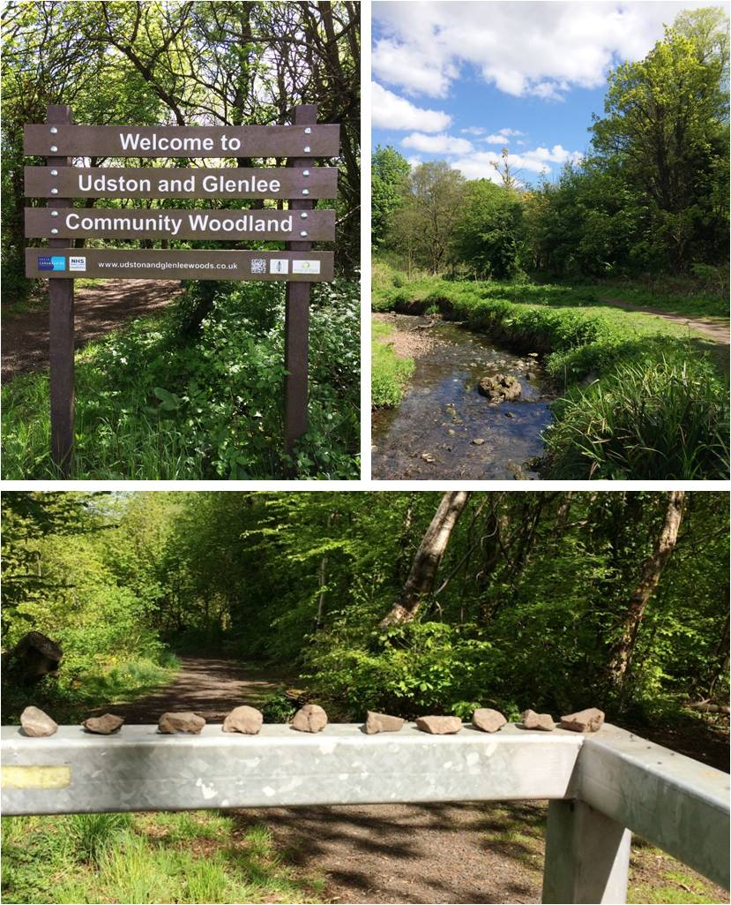

If you want this information in a different format or language, phone 0303 123 1015 or email equalities@southlanarkshire.gov.uk

Contents

Introduction
Vision statement
General information
Landscape
Cultural information
Site infrastructure
Recreation and access
Local community
Conclusion
Contacts
Appendix 1: Objectives and actions
Appendix 2: Maps

Introduction
heritage with opportunities for people to enjoy, learn about and experience nature close to their homes. LNRs are:

- Statutory designations made under the National Parks and Access to the Countryside Act 1949.
- Special places which are rich in wildlife.
- Generally, readily accessible and suitable for people to visit and enjoy.

In declaring these sites, South Lanarkshire Council (SLC) aims to:

- Protect them from unsuitable developments.
- Manage and enhance the habitats to help biodiversity flourish.
- Improve public access.
- Help people understand and become more aware of the importance of the LNR.
- Encourage community participation and volunteering.

SLC have identified sixteen new sites (and an extension to the existing LNR at Langlands Moss) to become designated as LNRs. These encompass a broad spectrum of habitats including ancient broadleaved woodland, open water, wetlands and grasslands. The site management statements are written in conjunction with the South Lanarkshire Biodiversity Strategy (2018 to 2022), SLC Sustainable Development and Climate Change Strategy (2017 to 22), SLC Local Development Plan (2013) and SLC Core Path Plan (2012).

Vision statement
Across South Lanarkshire, Local Nature Reserves are a resource for local communities that balance excellent recreational and educational opportunities with valuable habitats for wildlife that are rich in biodiversity.

General information
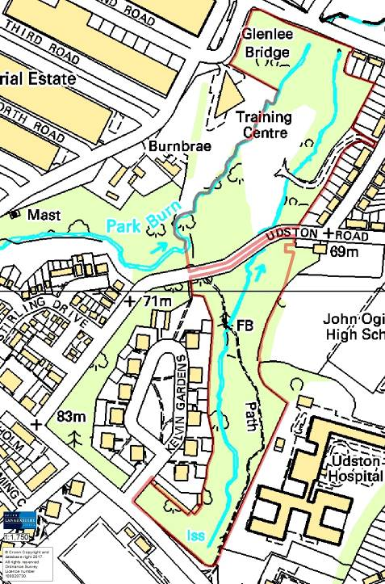
Location and site boundaries
Udston and Glenlee Woods proposed Local Nature Reserve can be found within the Hillhouse / Udston area, approximately two miles from the centre of Hamilton, South Lanarkshire. Please refer to the location map for details. The site is identified as a potential Local Nature Conservation Site (pLNCS).
Site name: Udston and Glenlee Woods
Grid reference: NS 69487 56034
Area: 6ha.
Current Ownership and Management: the boundary of the reserve is based upon the extent of land owned by South Lanarkshire Council (SLC).
Site description
This site is divided into two parts by a vehicle road. The northern section is Glenlee Woods, the southern section Udston. Both are remnants of old estate properties and their land which is particularly evidenced by the presence of estate planting such as the mature coastal redwood Sequoia sempervirens trees and a line of yews in Glenlee. Both woodlands exhibit a good age range of trees of diverse species with associated ground flora.
Under the National Vegetation Classification, the woodlands at Udston and Glenlee are characterised as: W9a Fraxinus excelsior Sorbus aucuparia Mercurialis perennis woodland with typical sub community. They trees are of mixed and amenity planting, with woodlands occupying both flat and sloping ground. The site is mostly freely draining to the Park Burn and its tributary. Wetter areas of woodland occur in the northeast of the site. Soils are classified as Brown Forest Soils.
A key habitat is the riparian zone along the Park Burn and its tributary. These burns are associated with areas of woodland, wet woodland and grassland. The woods also support some semi natural woodland and scrub. The variety of scrub and woodland areas with open and closed canopy structures across the site make the woodland useful for a variety of breeding birds.
Of high importance is the significance of the landscape in relation to its urban setting. The woodland provides a valuable break in the predominantly urban landscape of the area and, together with adjacent woodland areas and riparian habitat, forms a wildlife corridor.

Habitats, flora and fauna

The majority of Udston and Glenlee pLNR is covered with mixed woodland. There are small open areas with different habitat such as around the stream, where grassland is mixed with ruderals and scrub including greater woodrush and hawthorn.
Surveys carried out to write the original management plan for the woods (Dowse, 2006) note the following:
Udston Woods is characterised by highly disturbed woodland with planted broadleaf and coniferous trees. Sycamore, ash and common lime are abundant in the canopy. Horse chestnut, beech, yew and pedunculate oak are frequent with occasional Norway maple, silver, birch and holly. Goat willow, western red cedar and Leylandii are rare in the stand. The understorey, which is often dense, contains abundant hawthorn, frequent elder and wych elm, and frequent saplings of ash and horse chestnut. Occurring occasionally are hazel, holly, and ash regeneration. Downy birch occurs rarely.
The ground layer vegetation is often poor in species and cover. Ivy is abundant throughout the layer, which in more naturalistic areas also includes bramble, raspberry, male fern, broad buckler fern, ground elder, dog’s mercury, water avens, wood avens, lady fern, opposite leaved golden saxifrage, creeping buttercup, broad leaved willowherb, common hogweed, coltsfoot, tufted hair grass, hedge woundwort and wood sanicle.
Glenlee woods is qualified as amenity and broadleaf/conifer plantation woodland. The woodland on moist clay soils displays a fairly varied structure to canopy with abundant ash, sycamore, common lime and frequent beech, goat willow and horse chestnut. Alder, silver birch and yew are occasional and several Leylandii are present. The understorey contains an abundance of hawthorn, particularly towards the western and northern extremes of the compartment, where the woodland gets scrubbier. Elder and wych elm are frequent components of the understorey in which hazel, holly, downy birch and regeneration of ash, beech and sycamore are occasionally distributed.
The field and ground layer vegetation includes bramble, raspberry, male fern, broad buckler fern, rosebay willowherb, herb Robert, common nettle, ground elder, creeping buttercup, broad leaved willowherb, water avens, wood avens, ivy, hedge woundwort, common hogweed, opposite leaved golden saxifrage, dog’s mercury, figwort, golden creeping Jenny, coltsfoot, hairy brome, red currant, creeping thistle and false brome.
Later surveys of both areas, carried out by the SLC Countryside and Greenspace team have noted the following additional species:
- Butterbur sp.
- Cleaver
- Common dock
- Cow parsley
- Cuckoo flower
- Dandelion
- Greater plantain
- Greater woodrush
- Lesser celandine
- Meadow buttercup
- Nipplewort
- Privet
- Red campion
- Soft rush
- Spanish bluebells
- Wild garlic
- Wood anemone
- Wood millet
- Wood sorrel

The meadow area in Glenlee woods (mapped as semi improved neutral grassland) is the site of the original estate mansion house, which would have looked out over the embankment, towards the stream and surrounding farmland. This area has been part of various planting and management practices over the years and is currently displaying a good mix of species including:
- Black knapweed
- Common dock
- Common hogweed
- Creeping buttercup
- Cuckoo flower
- Grasses
- Meadow buttercup

Landscape
Udston and Glenlee woods is a small urban woodland, surrounded by houses and industrial areas. This site forms part of the burn valley woodland complex in the Hamilton area, which is a key ecological network.
To the east and then south, the woodland corridor follows the Red Burn upstream and out to the wider countryside. The Red Burn enters Glenlee woods on its western edge, and is then named Park Burn. Flowing out of the site, the stream goes through the wooded edge of a small greenspace, and then becomes culverted for a substantial distance. The Park Burn reemerges in Backmuir Woods pLNR; it then joins the River Clyde
Udston and Glenlee Woods is listed as a pLNCS. The area of interest as a locally important site includes the adjoined woodland to the west which is not owned by the Council and therefore not currently part of the pLNR. Nearby, other sites identified as pLNCS include:
- Hamilton Technology Park (0.27 miles southwest)
- Dykehead woodland (0.75 miles southwest)
- Wellbrae Resevoir and Earnock Glen (0.86 miles southeast)
- Backmuir woods pLNR (0.94 miles northeast)

Cultural information
Past Land use
Cultural heritage: past land use
The Ordnance Survey map (available online from the National Library of Scotland) from 1858 shows Udston House with estate offices, lodge house, formal pathways and gardens, an entrance drive, and parkland to the north and east. By 1898 the open grounds around the house had contracted and been replaced with woodland planting. Collieries and a quarry can be seen nearby. By 1914 the woodland had expanded to the west; otherwise the house and grounds remain surrounded by agricultural fields. In 1948 Udston House is shown as an “isolation hospital” with terraced housing taking up the land to the east.
Glenlee house is shown on the 1859 OS map, with a lodge house and entrance drive from what is now Hillhouse Road. The grounds look to be composed of pathways and a landscaped garden with trees along paths/roads. The 1899 map shows additional small buildings on the estate, as well as more trees and a path/road leading east to the church and local housing. Again, collieries can be seen nearby at this point. By 1914 there are houses and schools to the north of the site. In 1947, Glenlee House remains but the lodge house has been lost. The land to the east has been developed, giving the outline of the site that we see today.
Both houses were bought by Hamilton Town Council and used as hospitals for patients with infectious diseases such as tuberculosis from the 1920s. By 1966, Glenlee House was used as a boxing school by Joe Gans, the father of Walter McGowan (world Flyweight Champion). It was then used as a store and was demolished in the 1970s after falling into disrepair. Udston House remains in use as a hospital, forming part of a larger care complex.

Present land use
This urban woodland is regularly used by the local community for informal recreation and leisure pursuits such as walking, dog walking and cycling. The site is an important route that links communities with local amenities and transport. Udston and Glenlee Woods has various gated entrance points with accessible paths throughout the site.

Site infrastructure
The site is centred on the small Park Burn and its unnamed tributary which meet at the north of the site. The streams are surrounded by mixed woodland and occasional open grassland. There is a network of core and wider network paths with three bridges crossing the burns at various points. Access into the sites is through gates at various points which give links to the communities in and around Burnbank and Udston. The site is maintained by SLC Grounds Services.

Recreation and access
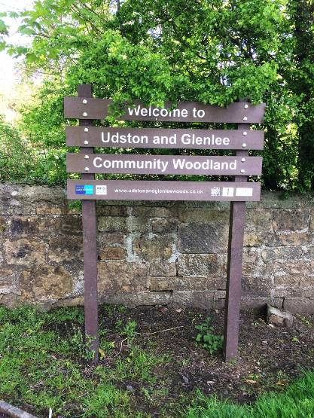
The proposed boundaries of the reserve are based upon the extent of land owned by SLC. Parking is available at the Jock Stein Centre on Hillhouse Road, on Russell Street, and at a layby on Second Road. Pedestrian access can also be gained at the entrance points on Udston Road which bisects the site.
The site is 1.1 miles from the nearest train station at Hamilton West. Bus stops along Udston Road and High Blantyre Road provide links to locations including Hamilton, East Kilbride and Glasgow.
There are ladder signposts at the three main entrances to the woods and on High Blantyre Road. There are also single sign posts on the two entrance gates on Udston Road. There are currently no interpretational facilities within the site. The installation of interpretation to highlight the path network and biological / historical interest of the site would be beneficial.

Local community
The Friends of Udston and Glenlee Woods became a formally constituted community group in 2011. The group carry out events and work with local schools and their community. Events and activities include litter picks, tree planting, wildflower planting, led walks and nature trails. The Friends are part of the SLC Environmental Volunteer Network; members of the group have attended various capacity building training courses including “Volunteer Health and Safety” and “Introduction to woodland management”.
The Friends have a Facebook page and continue to work with their community. Once Udston and Glenlee Woods is established as an LNR, the Friends will be invited to be part of a management committee.
There are a number of schools in close proximity to the woods, including:
- Glenlee Primary School (0.4 miles)
- St. Cuthbert’s Primary School (0.5 miles)
- St. John Ogilvie High School (0.2 miles)
- St. Ninians Primary School (0.1 miles)
- Udston Primary School (0.2 miles)

The Routes around Roots trail runs through the woods; the trail leaflet provides a map and information. Udston and Glenlee Woods has been and continues to be used by various local schools and nurseries for outdoor education such as river dipping, plant identification, storytelling and general wildlife walks.

Conclusion
It is the intention of the SLC CAG team to continue to work in partnership with the Friends of Udston and Glenlee Woods to ensure that the ecological quality of the site is maintained and managed. We aim to foster an understanding and facilitate enjoyment of the natural heritage of the woods and to increase public use through improved access, interpretation, education and promotion of the site.
The management statement will meet these objectives by seeking to deliver a number of practical health, environmental education and community outcomes in partnership with external organisations and the local community.

Contacts
For more information on this site, or LNRs in South Lanarkshire, please contact:
Countryside and Greenspace Service, Facilities, Waste and Ground Services, Community and Enterprise, South Lanarkshire Council, 18 Forest Street, Blantyre G72 0JP.
Email: CAG@southlanarkshire.gov.uk

Photographs taken by Louisa Maddison
Note that maps may not be to scale.

Appendix 1: Objectives and actions
Objective 1: Maintain, enhance and monitor the biodiversity value of the reserve.
Actions:
- Use management intervention where necessary to ensure the provision of a range of age and species diversity of tree species.
- Continue to retain mature trees and dead wood of various types.
- Contribute to national and local biological recording monitoring schemes.
- Investigate the potential to map and control invasive species.
- Assess the meadow area throughout the year for species diversity; intervene with management as necessary.

Objective 2: Maintain and increase the use of the access network.
Actions:
- Maintain the access network.
- Investigate the potential to add interpretation signage to the site.

Objective 3: Encourage and facilitate community involvement in the reserve.
Actions:
- Continue to support the Friends of Udston and Glenlee Woods and the surrounding community, including education establishments.

Appendix 2: Maps


