Cadzow Glen Local Nature Reserve Management Statement 2018

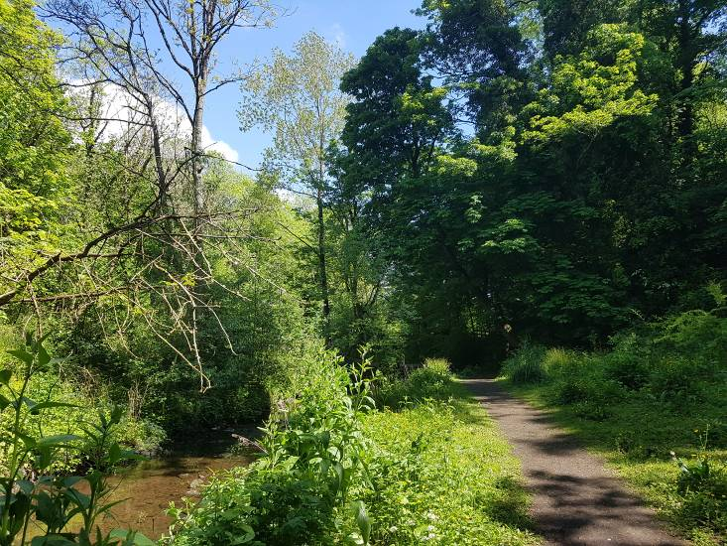
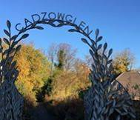

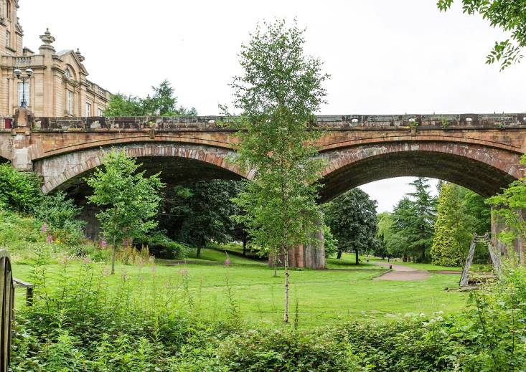
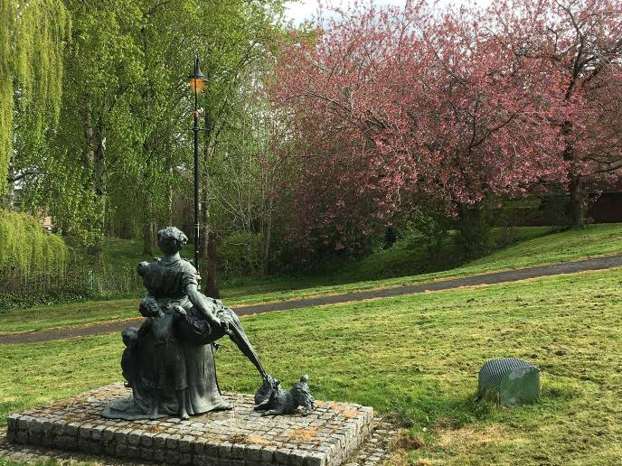

If you want this information in a different format or language, phone 0303 123 1015 or email equalities@southlanarkshire.gov.uk

Contents

Introduction
Vision statement
General information
Landscape
Cultural information
Site infrastructure
Recreation and access
Local community
Conclusion
Contacts
Appendix 1: Objectives and actions
Appendix 2: Maps

Introduction

Local Nature Reserves (LNRs) are valuable places as they combine protection of the natural heritage with opportunities for people to enjoy, learn about and experience nature close to their homes. LNRs are:
- Statutory designations made under the National Parks and Access to the Countryside Act 1949.
- Special places which are rich in wildlife.
- Generally, readily accessible and suitable for people to visit and enjoy.

In declaring these sites, South Lanarkshire Council (SLC) aims to:
- Protect them from unsuitable developments.
- Manage and enhance the habitats to help biodiversity flourish.
- Improve public access.
- Help people understand and become more aware of the importance of the LNR.
- Encourage community participation and volunteering.

SLC have identified sixteen new sites (and an extension to the existing LNR at Langlands Moss) to become designated as LNRs. These encompass a broad spectrum of habitats including ancient broadleaved woodland, open water, wetlands and grasslands. The site management statements are written in conjunction with the South Lanarkshire Biodiversity Strategy (2018 to 2022), SLC Sustainable Development and Climate Change Strategy (2017 to 2022), SLC Local Development Plan (2013) and SLC Core Path Plan (2012).

Vision statement
Across South Lanarkshire, Local Nature Reserves are a resource for local communities that balance excellent recreational and educational opportunities with valuable habitats for wildlife that are rich in biodiversity.

General information
Location and site boundaries: Cadzow Glen is located in the centre of the town of Hamilton in South Lanarkshire. The Cadzow Burn flows through the middle of the site.

Site name: Cadzow Glen

Grid reference: NS721555

Site area: 3.4ha

Site boundary: the boundaries of the park are based upon the extent of land owned by South Lanarkshire Council.

Site Description: Cadzow Glen runs from Union Street through the town centre of Hamilton to Muir Street. In the south of the site, it is a typical urban burn valley woodland with steep sided slopes and native vegetation. The woodland compartment is set in a steep sided valley with Cadzow burn meandering through the centre. The underlying rock of the glen is sandstone, which outcrops in a few areas and forms low cliffs along the side of the burn. To the north the site opens up to a more formal landscape offering open spaces for informal recreation.

The infrastructure, consisting of footpaths and boardwalk is in good condition. Over the last few years, participants in the Lanarkshire Association for Mental Health (LAMH) World of Work programme have repaired and replaced many areas of infrastructure throughout the park. A fairly recent upgrade of the sewer system by Scottish Water has seen the installation of new water work infrastructure, a service road and paths.

Access to the Glen has been closed or restricted from both access points on Cadzow Street for a number of years. There is good access from Muir Street and access points at Union Street, Back Row and Common Green (see access map).

Cadzow Glen is currently managed by SLC. Other parts of the site that are open to the public appear to be owned by residents backing on to Cadzow Glen, but it has perhaps been forgotten about or they are unaware of it. A potential action for the future would be to investigate ownership of gap areas on the site, and whether they can be brought into the LNR boundary. Site maintenance is undertaken by SLC.

Site boundary map

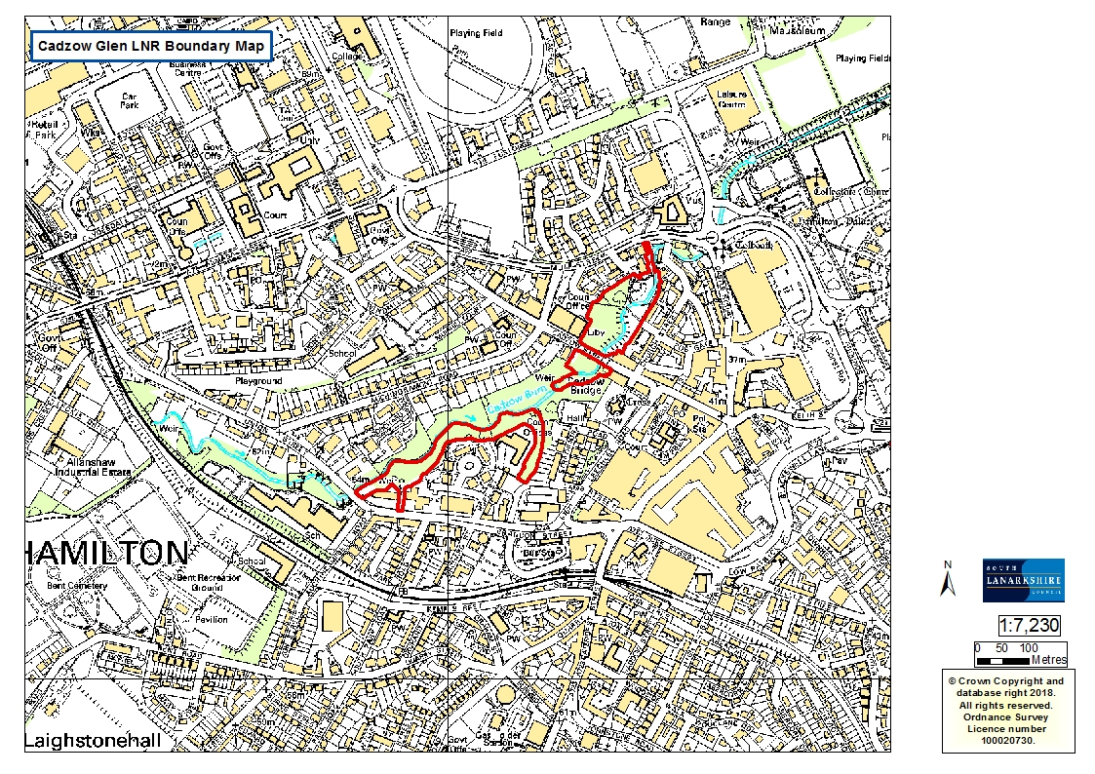

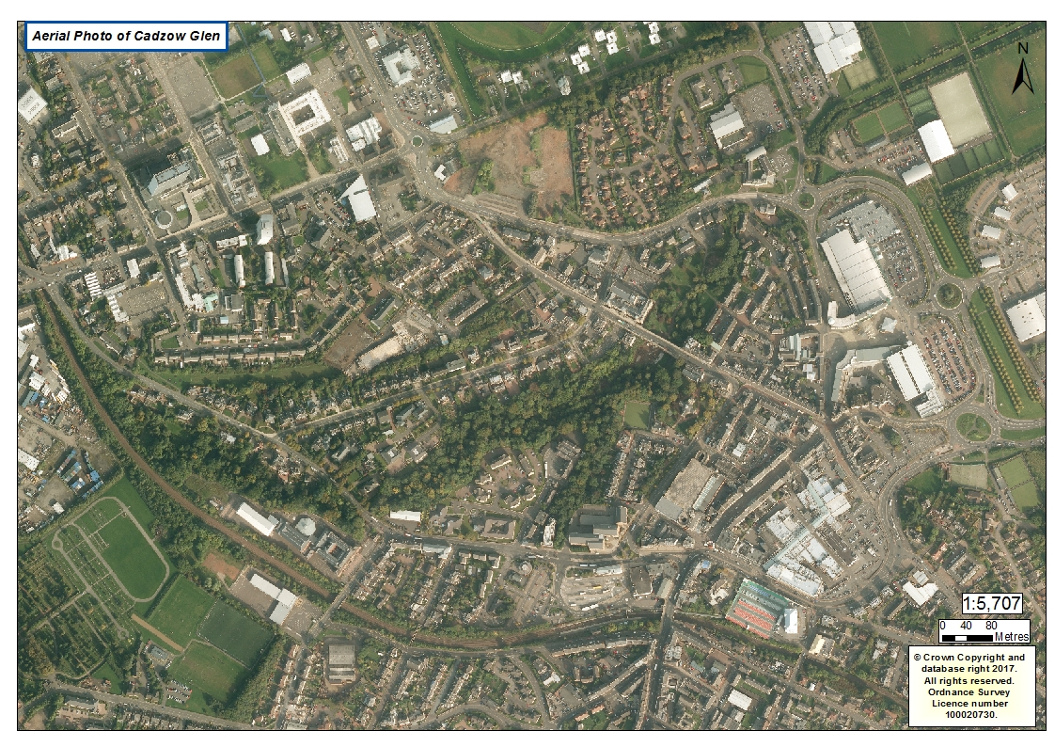

Habitats, flora and fauna
Habitat | Area (ha) | %
Broadleaved woodland | 1.67 | 49.1
Disturbed, damp grassland | 0.16 | 4.70
Amenity grassland | 1.57 | 46.2
Total | 3.40 | 100

The majority of habitat at Cadzow Glen is broadleaved woodland along the steep slopes of the Cadzow Burn. In 2006 the woodland was described by Dowse as W9a Fraxinus excelsior, Sorbus aucuparia, Mercurialis perennis woodland with typical subcommunity and planted broadleaved trees.

Ground flora is fairly varied and typically contains; ivy, dog’s mercury, wild garlic, bluebell, bramble, wood avens, water avens, creeping buttercup, enchanter’s nightshade, lesser celandine, raspberry, ground ivy, colt’s foot, foxglove, red campion, and broadleaved helleborine. Grasses include; tufted hair grass, hairy brome and false brome. Ferns include: broad buckler fern, male fern, soft shield fern and hart’s tongue fern.

The soil at Cadzow Glen is described as flushed (base rich) brown forest soil which is locally acidic. The woodland supports mature trees dominated by a canopy of ash, sycamore, lime and horse chestnut with a well established shrub layer of wych elm, hawthorn, elder and bramble. There are good examples of mature beech which occur in small pockets and as singular trees, along with horse chestnut, oak and elm. A Victorian garden bordering the wood includes examples of fruit trees, copper beech and Norway maple.

This woodland is dynamic and is regenerating spontaneously without any form of management, with ash and sycamore being dominant. At present the established woodland supports a good diversity of trees, a significant proportion of which are native species of mixed age, with high levels of young saplings throughout. Deadwood is abundant providing an important habitat for a variety of invertebrates.

The area of broadleaved woodland at Cadzow Glen is adjacent to several other habitats including the burn running through the site and disturbed damp grassland arising from works on site. Amenity grassland supports some interesting mature specimen trees as well as art sculptures.

Surveys undertaken in the summer growing season of 2017 identified 96 different types of plant species, including trees, ferns and higher plants. Species recorded include:

Alder
Annual meadow grass
Ash
Beech
Birch
Bistort
Bramble
Broadbuckler fern
Broadleaved dock
Broadleaved willowherb
Celandine
Cherry, wild
Cleaver
Coltsfoot
Common ragwort
Common comfrey
Common eyebright
Common hogweed
Common nettle
Common spotted orchid
Cow parsley
Creeping buttercup
Creeping thistle
Crested dog's tail
Cuckooflower
Cypress sp.
Daisy
Dandelion
Enchanter's nightshade
Field horsetail
Field speedwell
Germander speedwell
Greater plantain
Great woodrush
Ground elder
Hart’s tongue fern
Hawthorn
Hedge woundwort
Herb Robert
Himalayan balsam
Holly
Honeysuckle
Horse chestnut
Ivy
Japanese knotweed
Ladies mantle
Lady fern
Larch
Laurel
Lime
Male fern
Maple, field
Marsh marigold
Pendulous sedge
Pick a back (locally abundant)
Pineapple weed
Ramson (wild garlic)
Red campion
Redcurrant
Red fescue
Rhododendron
Ribwort plantain
Rosebay willowherb
Rose sp.
Russian comfrey
Snowberry
Soft rush
Sweet vernal grass
Sycamore
Tall fescue
Tufted hair grass
Wavy bittercress
Weeping willow
Wild angelica
White clover
Willow, goat
Wood anemone
Wood avens
Wood sorrel
Wych elm
Yew
Yorkshire fog

Invasive plants are present in the form of garden escape laurel, and isolated stands of Japanese knotweed. Several patches of snowberry are found in the burn compartment. Pick a back plant is also present along the burn compartment.

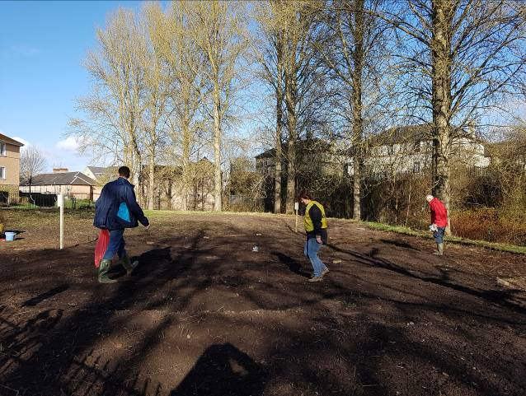
A wide variety of fauna has been noted throughout the site and includes over 20 species including roe deer, fox, grey squirrel, common pipistrelle bats, soprano pipistrelle bats, Daubenton’s bats and various bird species. A grey wagtail was recorded in 2017 which is encouraging considering there has been pollution in the burn in the past.

Annual surveys are carried out by Countryside Rangers with the data sent to national recording schemes.

In 2017 the Friends of Cadzow glen sowed numerous species of wildflower in the “Poplar” area of the amenity grassland, land which used to have children’s play equipment present.Landscape
Within Cadzow Glen, the large area of amenity grassland dominates one end of the site, with broadleaved woodland dominating the narrow burn valley area at the other. The site is characterised by the Cadzow Burn running through the centre. The wider landscape is predominately urban; the perimeter of the site is surrounded by private housing, council buildings, private businesses, and several churches and schools.

In terms of the wider greenspace network there are a number of burn valleys close to the site linked by the Cadzow burn corridor, namely Udston and Glenlee Woods, and Neilsland and Earnock, which are also proposed LNRs. Low Parks (pLNR and Site of Scientific Special Interest [SSSI]) is just over a mile from Cadzow Glen, with Chatelherault Country Park (Clyde Valley Woodlands National Nature Reserve) approximately two miles from the site. Both Hamilton Low Parks (pLNR) and Hamilton Park Racecourse woods are potential LNCS sites nearby.

Cultural information
Past Land use
The common green at Cadzow Glen was granted to the community by Lord James Hamilton in 1475. At this point it was stipulated that the area be reserved for the grazing of horses. For many years the site was mainly fields and grazing land, with little of the woodland we see today.

Since Victorian times there have been multiple owners of Cadzow Glen, with evidence of well established orchards and larger houses with more extensive grounds surrounding the site. The 1843 six inch Ordnance Survey map (available online from the National Library of Scotland) of the area south of Cadzow Bridge, indicates that the western banks of the burn were extensively used for orchard planting, with formal gardens on the north side of the burn, although little trace remains of these features today. The steeper, eastern banks of the watercourse have remained as natural, semi natural woodland.

By the early part of the 19th Century, the area had become known as the “Washing Green” and was used extensively by the local community for drying their laundry. By this time there was also a wool merchant and tanning works operating at the edge of the Green. A slaughterhouse was in operation from 1795 until 1929, when the new abattoir was opened at nearby Backmuir plantation. Hamilton Palace and stables (which is now Low Parks Museum) was situated directly behind this site. Photos taken at this time show a very open area at Cadzow Glen, devoid of trees or vegetation.

Present land use
A survey by Community Links was carried out in 2012 to ask the local community of Hamilton how they use Cadzow Glen. The evaluation was conducted through paper questionnaires, which were designed by Community Links and approved by the SLC Countryside and Greenspace team. The majority of those who took part (111 individuals) in the survey used the site for walking (51%) and peace and quiet or play (30%). Other activities listed included dog walking, observing wildlife and commuting to work/school/shops. Cadzow Glen is also used extensively for commuting by pupils from the nearby Hamilton Grammar secondary school, and as a link to the varied leisure and retail facilities at the south end of the site.

The survey also asked what would encourage them to access and use Cadzow Glen more. Comments and responses included:
- Better and maintained pathways.
- Area cleaned up and made safe (more wardens, police patrols and lighting).
- Reinstatement of facilities such as the play park.
- More advertising and information about the site.
- Introduction of events and activities.

Site infrastructure
In 2001 the Heritage Lottery Fund granted approximately £200,000 to improvements at Cadzow Glen. This was used to create and upgrade the path network, and to creating artwork entrances at the site. Several pieces of sculpture were also installed, with those remaining today being in good condition.
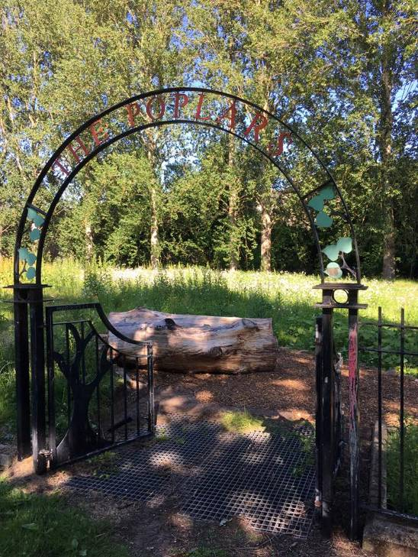
At this point a children’s play area was installed and was very popular, but over the years this deteriorated and was removed. The area enclosing this has been repaired and there are plans for this to be used as an education area which is safe for children and vulnerable people.

The paths and furniture of Cadzow Glen are generally still in good condition, due to recent repair and renovation works by LAMH World of Work Programme, known as the “Cadzow Crew”. SLC Grounds Services have recently installed new bins and the Community Payback team have cut back vegetation and trimmed and scraped overgrown paths. Some areas of boardwalk need attention in the near future, with the current regime consisting of ad hoc repairs by SLC’s Countryside and Greenspace team.

Sewage issues are apparent at Cadzow Glen, due to housing backing on to the glen. The Friends of Cadzow Glen (FOCG) have a good dialogue with SEPA and Scottish Water, with repairs ongoing.

The area of amenity grassland situated at the south side of the site was previously a drying green for local residents. This is currently maintained through regular mowing by South Lanarkshire Council’s Grounds Services.

The Friends of Cadzow Glen have obtained funding (May 2018) to install metal furniture within the amenity grassland area, namely several benches, bins and a notice board, plus raised beds situated in the enclosed ‘Poplars’ area for use by local educational establishments.

Recreation and access
The proposed boundaries of the park are based upon the extent of land owned by SLC. Parking is available to the south and north of the site. Pedestrian access can be gained to the site from five locations (refer to the location maps). Cadzow Glen is located centrally in the town of Hamilton which supports over 53,000 (SLC, 2001) people; the park provides a recreational resource for the local community.

The 877 metres of well maintained paths are also well used as a quick route between various shopping and leisure facilities and a main route in the town, plus a commuting route for the pupils of the neighbouring Hamilton Grammar High School.

There are currently no interpretational facilities within the site. Good quality entrances at several entry points and interpretation at the Muir Street entrance improve the external visibility of Cadzow Glen. The site is not signposted from the road network around the park; improvements should be made to highlight the site from the main roads. The installation of interpretation at the site would highlight the network of paths, along with features of historical and natural history interest.

Local community
The Friends of Cadzow Glen (FOCG) community group first met in 2017, but there has been community involvement for several years before that by the Rotary group, several local businesses and St. John’s church. The group, who have a Facebook page, are interested in raising the profile of the site and encouraging responsible behaviour. Their long term aims are to seek and identify funding opportunities to improve access, enhance the recreational value of both the more formal grassland and woodland areas, by encouraging several local nurseries to use the site for curriculum based activities.

Cadzow Nursery, a private nursery situated on nearby Auchingramont Road use the site extensively for Forest School and general outdoor education, in partnership with Scullions solicitors, who have provided storage for the Friends group and nursery. Hamilton Grammar Secondary School is located in the immediate vicinity and regularly utilise the site as a resource.

The FOCG along with the SLC Countryside Rangers develop, promote and carry out a number of events and activities throughout the year. These include regular practical conservation workdays, historic walks and events such as bat walks to highlight the wildlife in the area. These are linked to national schemes such as tree planting and citizen science projects. Biological records are sent to national and local recorders as appropriate.
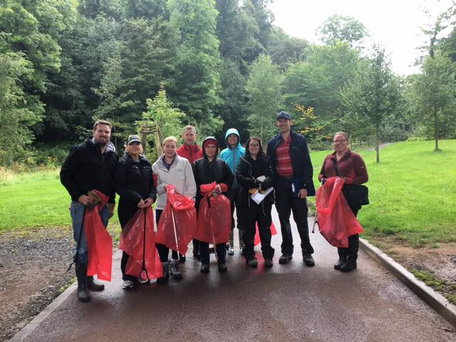

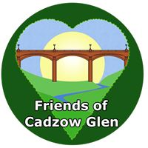

Conclusion
It is the intention of the SLC Countryside and Greenspace team to continue to work in partnership with the Friends of Cadzow Glen to ensure that the ecological quality of the park, especially the areas of native woodland, are maintained and managed. We aim to foster an understanding and facilitate enjoyment of the natural heritage of the park and to increase public use through improved access, interpretation, education and promotion of the site.

The management statement will meet these objectives by seeking to deliver a number of practical health, environmental education and community outcomes in partnership with external organisations and the local community. A full management plan for this site will be created in due course and will be updated every five years.

Contacts
For more information on this site, or LNRs in South Lanarkshire, please contact:
Countryside and Greenspace Service, Facilities, Waste and Ground Services, Community and Enterprise, South Lanarkshire Council, 18 Forest Street, Blantyre G72 0JP.
Email: CAG@southlanarkshire.gov.uk

Information sources:
Cadzow Glen: Linear Park Feasibility Study (SLC Planning Dept, 1995)
Cadzow Burn Ecological Survey (Beth Milner, 1996)
Cadzow Wood Woodland Management Plan (Langton Vaughan Assoc., 2001)
Hamilton and Blantyre Urban Woodland Regeneration 15. Cadzow Burn, Hamilton Grammar Woodland Management Plan (Robin Dowse: Central Environmental Surveys, 2006)

Photographs provided by K. Thomson (CAG) and A. Strang (FOCG)
Note that maps may not be to scale.

Appendix 1: Objectives and actions

Objective 1: Maintain, enhance and monitor the biodiversity value of the reserve.
Actions:
- Maintain and enhance the natural biodiversity of the park through appropriate management programmes and best practice.
- Allow the woodland to develop naturally; monitor where appropriate to ensure woodland communities are maintained and there is no loss of habitat.
- Maintain and/or increase the diversity of woodland species, tree age classes and deadwood provision.
- Survey for the presence of invasive species; establish a monitoring and control programme as appropriate.
- Contribute to national and local biological recording schemes.
- Investigate the development of long grass / meadow by changing the mowing regime in suitable areas.

Objective 2: Maintain and increase the use of the access network.
Actions:
- Maintain and improve paths and furniture.
- Investigate the potential to improve access to the park via the Town House and Cadzow Bridge.
- Consider the installation of interpretation panels highlighting paths and other key features.

Objective 3: Encourage and facilitate community involvement in the reserve.
Actions:
- Continue to provide support to the Friends of Cadzow Glen and local community.
- Raise awareness of the park; investigate possibilities of promoting the park in new and different ways.
- Review site information ensuring that it is up to date and relevant.
- Monitor and assess visitor numbers to the site; investigate effectiveness of any promotion.
- Encourage and promote the use of the park for the local community, education establishments, youth groups and other specialist interest groups.
- Identify further funding opportunities.

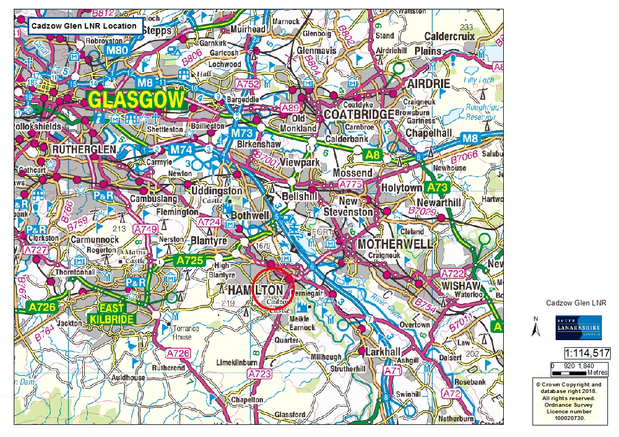
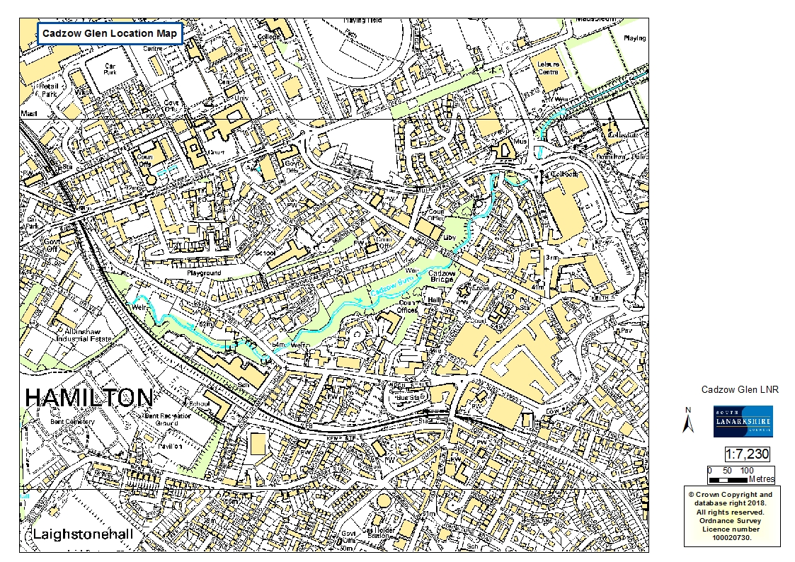
Appendix 2: Maps

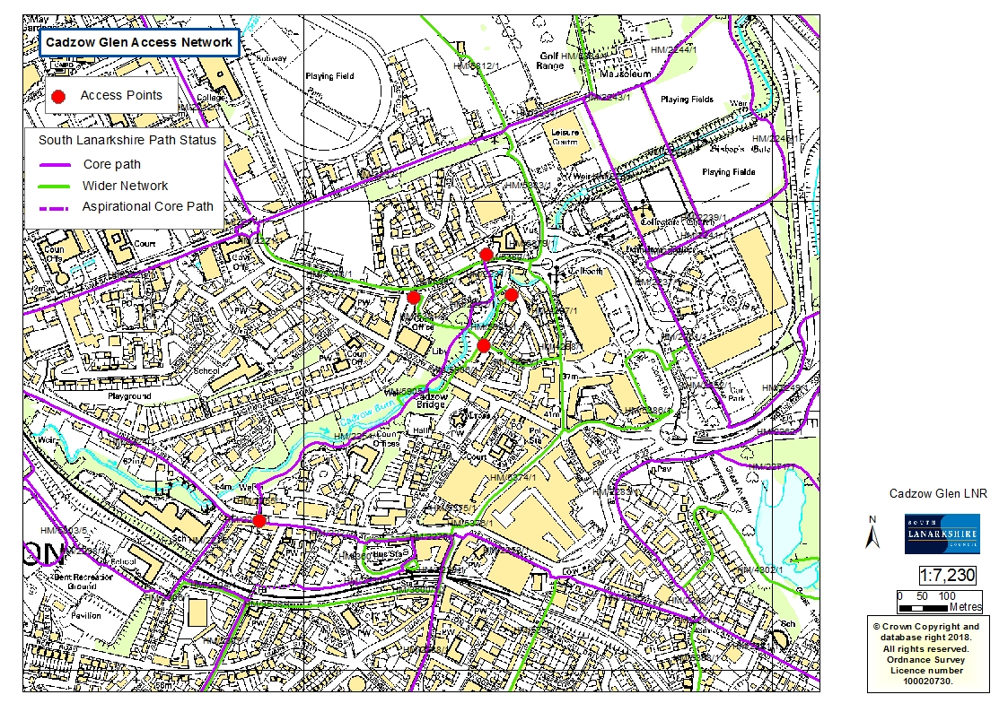
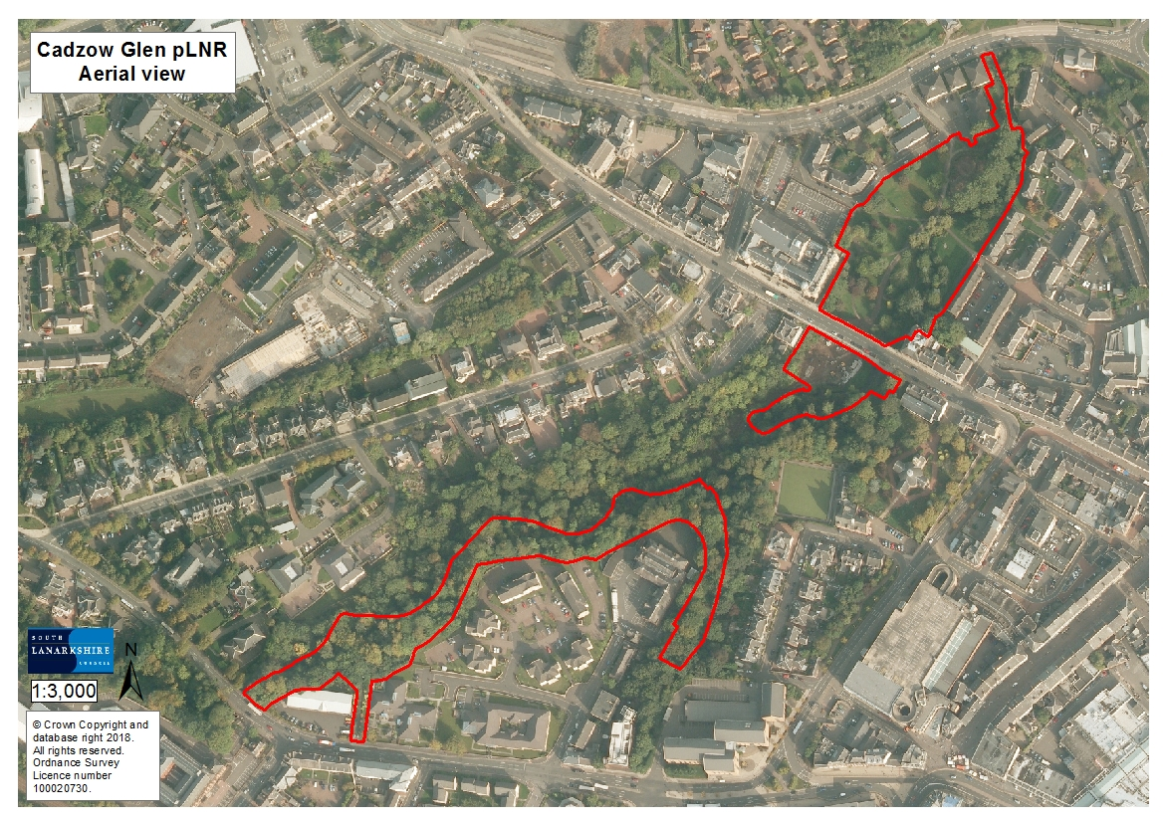
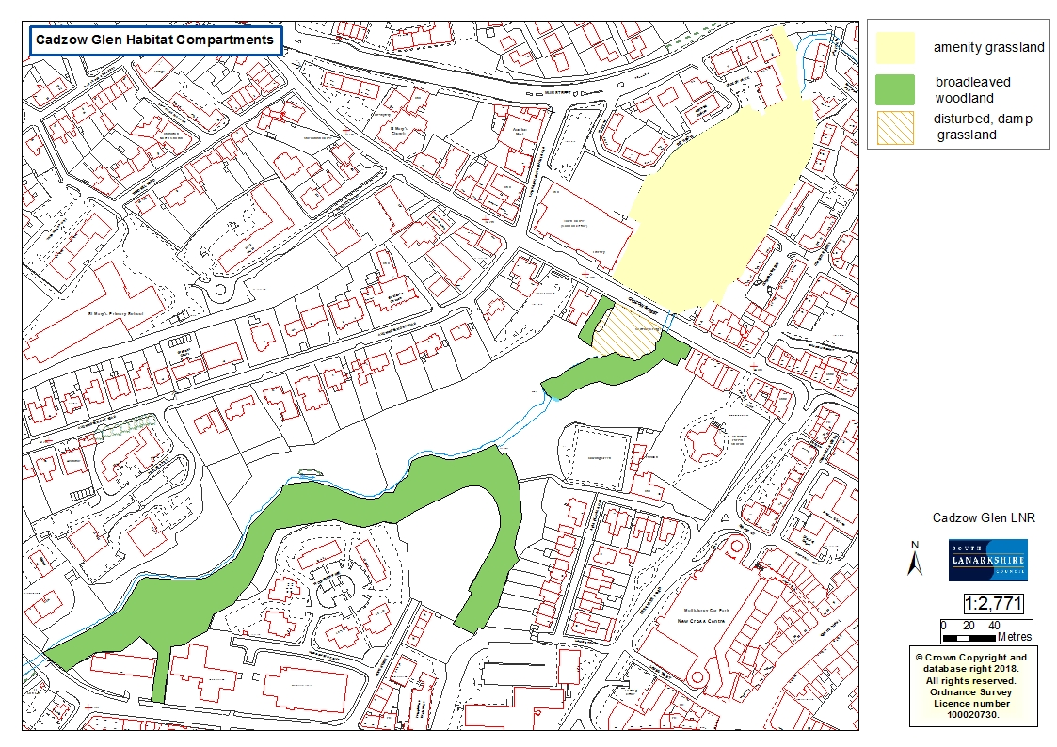

Hamilton and Blantyre Urban Woodland Regeneration 15. Cadzow Burn, Hamilton Grammar Woodland Management Plan, March 2006 Robin Dowse: Central Environmental Surveys

