Mossneuk Local Nature Reserve Management Statement 2018

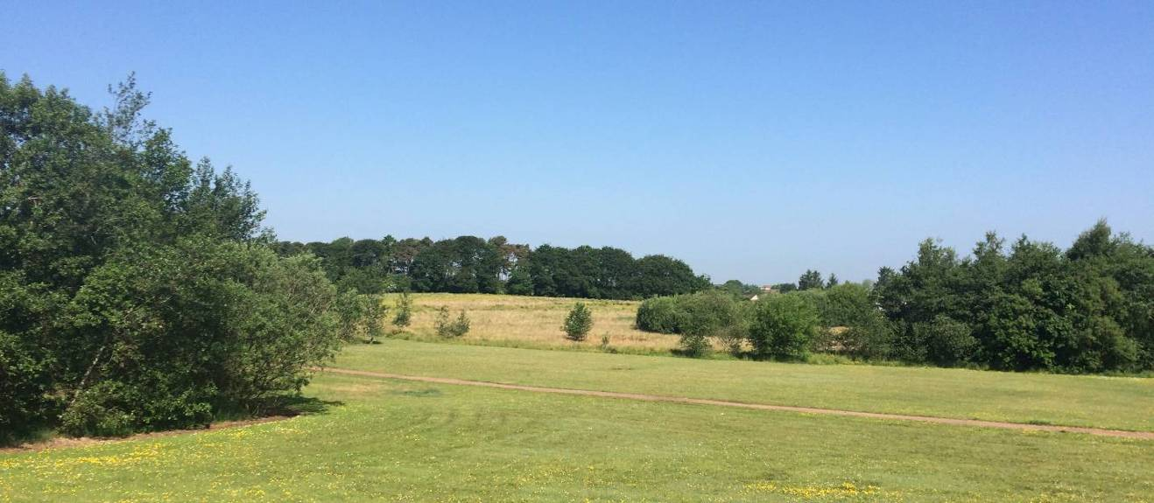

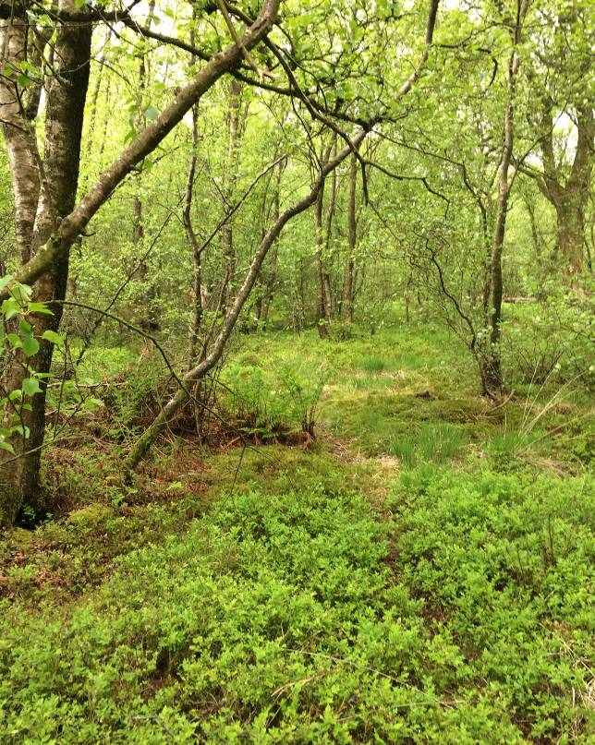
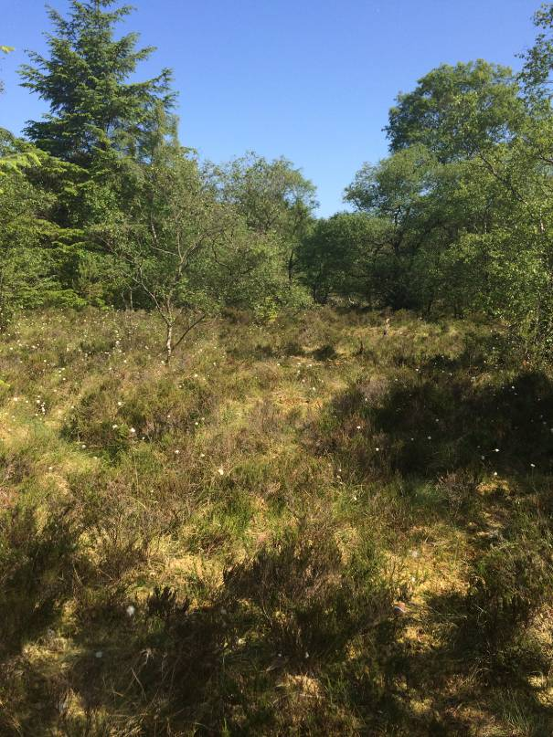

If you want this information in a different format or language, phone 0303 123 1015 or email equalities@southlanarkshire.gov.uk

Contents

Introduction
Vision statement
General information
Landscape
Cultural information
Site infrastructure
Recreation and access
Local community
Conclusion
Contacts
Appendix 1: Objectives and actions
Appendix 2: Maps

Introduction
heritage with opportunities for people to enjoy, learn about and experience nature close to their homes. LNRs are:

- Statutory designations made under the National Parks and Access to the Countryside Act 1949.
- Special places which are rich in wildlife.
- Generally, readily accessible and suitable for people to visit and enjoy.

In declaring these sites, South Lanarkshire Council (SLC) aims to:

- Protect them from unsuitable developments.
- Manage and enhance the habitats to help biodiversity flourish.
- Improve public access.
- Help people understand and become more aware of the importance of the LNR.
- Encourage community participation and volunteering.

SLC have identified sixteen new sites (and an extension to the existing LNR at Langlands Moss) to become designated as LNRs. These encompass a broad spectrum of habitats including ancient broadleaved woodland, open water, wetlands and grasslands. The site management statements are written in conjunction with the South Lanarkshire Biodiversity Strategy (2018 to 2022), SLC Sustainable Development and Climate Change Strategy (2017 to 22), SLC Local Development Plan (2013) and SLC Core Path Plan (2012).

Vision statement
Across South Lanarkshire, Local Nature Reserves are a resource for local communities that balance excellent recreational and educational opportunities with valuable habitats for wildlife that are rich in biodiversity.

General information

Location and site boundaries: Mossneuk proposed LNR can be found approximately two miles to the west of the centre of East Kilbride, South Lanarkshire. Access can be gained to the south from Newlandsmuir Road and from the north via Mossneuk Road. Part of the site to the north is listed as a potential Local Nature Conservation Sites (pLNCS).
Site name: Mossneuk
Grid reference: NS 61135330
Area: 23ha.
Current Ownership and Management: the boundary of the reserve is based upon the extent of land owned by SLC.
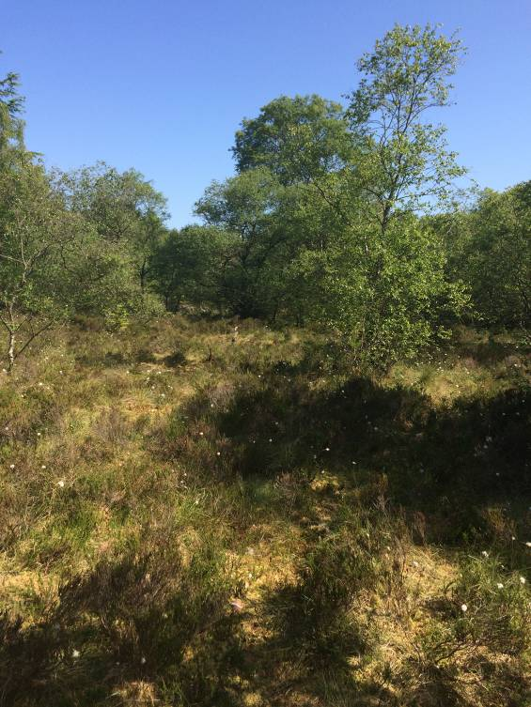
Site description: The northern section of Mossneuk was originally a small raised bog, but now supports an interesting mosaic of mature and young semi natural broadleaved woodland, wet woodland, mixed broadleaved and coniferous woodland and marshy grasslands. The original peatland vegetation is still present although altered in form and now supports broadleaved woodland dominated by birch. Where the birch woodland is more open, many typical and interesting bog species are still abundant. Wetter areas within the woodland give rise to a variety of mosses including hummocks of bog mosses (Sphagnum species).
The southern half of Mossneuk mainly consists of large expanses of marshy grassland dominated by soft rush, with patches of semi improved neutral grassland on higher ground. The elevated position of these open areas allows you to gain an overall view of the woodland to the north. The open grasslands support a variety of invertebrates particularly butterflies and bees. There are a number of drains and burns flowing through the site providing open water habitat. The small burn situated in the south flows from the south of Mossneuk under Greenhills Road and continues through greenbelt land towards Jackton.
The site lies well within the urban area of East Kilbride and is clearly used and enjoyed by the local people. Its close proximity to three schools makes it potentially important as a local educational resource.

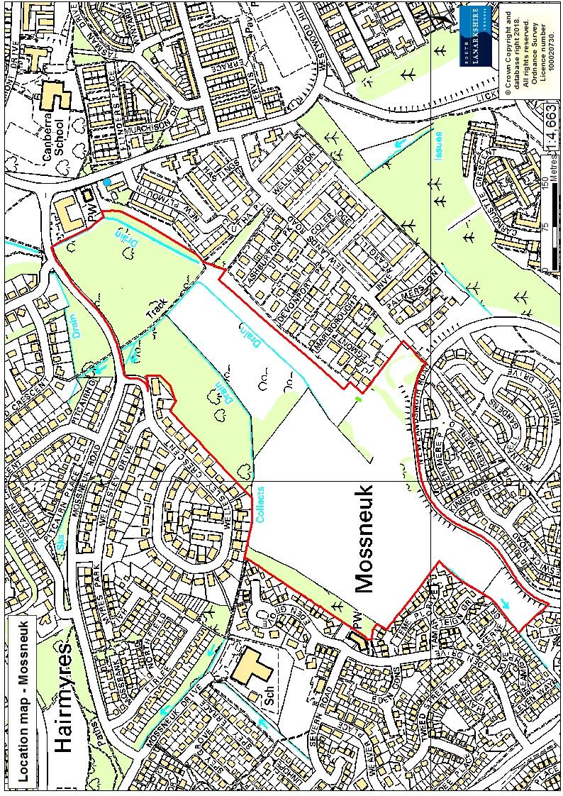
Habitats, flora and fauna
Habitat | Area (Ha) | %
Semi natural broadleaved woodland | 9.8 | 42
Marshy and semi improved grassland | 7.6 | 33
Mixed plantation woodland | 1.4 | 6
Amenity grassland | 3.4 | 15
Planted broadleaved trees | 1 | 4
Total | 23 | 100

Mossneuk supports semi natural broadleaved birch woodland, part of which is on the remnant of a raised bog. There is evidence that the bog has been drained by a network of deep ditches throughout the site. However, typical bog species persist, blaeberry, heather, tormentil, purple moor grass, bog mosses, common and hare’s tail cotton grasses.
The mature broadleaved wet woodland is dominated by birch with beech, rowan, willow, alder and sycamore throughout. The ground flora comprises of brambles, rosebay willowherb, creeping buttercup, common nettle, ferns and Polytrichum mosses. This woodland is split into two sections by an access path and adjacent drainage ditch, connecting the residential areas to the north and east of the site. In the centre of both halves of woodland the substrate becomes wetter. Here the ground flora resembles the former habitat of raised bog. Species noted include ling heather, blaeberry, tormentil, round leaved sundew, cranberry, meadowsweet, soft rush, common and hare’s tail cotton grasses and Sphagnum mosses. Ferns are abundant throughout the woodlands including broadbucker, scaly male, lady and male ferns.
The southern half of Mossneuk supports open grassland with the lower sections dominated by soft rush with marsh thistle, coltsfoot, common sedge, sweet vernal grass, greater bird’s foot trefoil and the occasional common spotted orchid. Drier, higher areas support semi improved neutral grassland dominated by Yorkshire fog, creeping buttercup, creeping thistle with patches of rosebay willowherb and gorse. To the northwest of the grassland is an area of mixed woodland with mature Scots pine, beech and hawthorn. The ground flora in this section is dominated by rosebay willowherb with creeping buttercup, cleaver, silverweed, cock’s foot, cow parsley and common hogweed. There are a few young oak, rowan and cherry trees planted throughout this section.
Separating the site from the residential housing are areas of mown amenity grassland, with frequent pockets of planted broadleaved trees such as rowan, lime, elder, sessile oak, field maple, horse chestnut, cherry and sycamore. Garden plant species were also recorded in this area and included snowberry, Spanish bluebells, cotoneaster, buddleia and crocosmia.
The wetter sections of woodland could be classified as wet woodland, which is one of the least common woodland habitats in South Lanarkshire and is rich in wildlife. South Lanarkshire supports 977ha of wet woodland, representing 26% of all woodland habitats within the area, with 63% of classified as natural. Many wet woodlands are recent in origin; even these are valuable for wildlife. They can be almost as valuable as ancient semi natural woods for nature conservation and scenic value. High humidity supports growth of mosses and ferns and the combination of dead wood and wet conditions provides ecological niches that are not found in drier woods.
At Mossneuk, wet woodland forms part of a mosaic of habitats. Often this type of habitat is transient, a stage in natural succession between open water and a drier woodland habitat. As time goes by, wet woodland may naturally become drier as water conditions vary and species composition changes. Much of our wet woodland has been lost or destroyed over recent decades due to massive clearances and land drainage for agricultural production.

Landscape
Mossneuk comprises a mosaic of woodland and grassland habitats in the centre of a residential area of East Kilbride. The northern section of the site is designated a pLNCS under the name of “Westwood”. Other notable sites within the surrounding landscape are Shields Moss pLNCS (1.27 miles to the south east) and Langlands Moss LNR (1.9 miles to the east). Kittoch Water Woods pLNCS is 1.49 miles to the north. In terms of wider greenspace network there are a number of woodlands to the north and east, with greenbelt to the south. A burn flows through the south of Mossneuk and flows under Greenhill Road and into woodland to the south. From Mossneuk the water flow into the Gill Burn which is a tributary of the White Cart Water.

Cultural information
Past Land use
The name Mossneuk can be found on Roys Military Survey of Scotland Maps (1747 to 55). At this time, there are no trees on site and the vegetation appeared different from the surrounding pasture fields which may indicate the presence of the moss or peat. The names around the site all refer to the bog in some way or another for example:
- Hairmyres: myres = near a bog
- Mossneuk: moss = marsh or bog; neuk = triangular piece of land
- Newlandmuir: muir = moorland

Maps from the 1800s (National Libraries of Scotland, Ordnance survey – Series Scotland) highlight the extent of the peat and marshy wetland ground of Mossneuk in more detail and show little development in the area, apart from a few farmsteads at Mossneuk, Newlandsmuir and Duncanrig. They also show the area and shape of woodland and peat that are still present today and have therefore influenced the shape of the Mossneuk reserve boundary. The main path that runs through the northern section of the site can be observed on maps dating back to 1931 which linked nearby farms to Hairmyres Hospital.
Until the end of World War ΙΙ, East Kilbride was a modest village with around 3,000 residents. It has grown dramatically from the 1960s onwards and by 2012 its population stood at just under 75,000.

Present land use
The greenspace at Mossneuk is regularly used for informal recreational and leisure pursuits such as walking, dog walking and cycling. The amenity fields to the south and east of the site are used for more formal recreational activities, such as football. Mossneuk is easily accessible from all sides of the site and has a network of paths and desire lines throughout.

Site infrastructure
There is a network of core paths and wider network paths throughout Mossneuk, connecting to the nearby residential communities of Hairmyres, Newlandsmuir and Westwood. The site contains 2,094 metres of paths and track in various forms, from formal pavements and tarmac paths to whin dust and desire lines. The areas of amenity grassland located near the residential housing are maintained and mown regularly in the summer months by SLC Grounds Services. Throughout the site are a series of drainage channels and to the south a burn which is culverted under Greenhills Road.

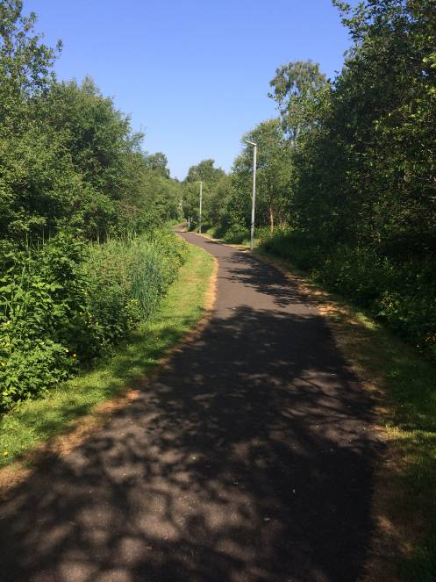
Recreation and access
Parking is available along Newlandsmuir Road; pedestrian access can be gained to the site from Mossneuk Road, Westwood Road and Newlandsmuir Road.

There is no on site interpretation and Mossneuk is not signposted from the network of roads around the site. Signage could be used to highlight access points to the site from the main roads. The addition of interpretation signs to provide information on the network of paths and biological / historical interest would be beneficial.

The site is 1.4 miles from the nearest train station at Hairmyres in East Kilbride. Buses pass every ten minutes to East Kilbride shopping centre and bus station (along Westwood Hill Road, to the south of Mossneuk).

Local community
There is currently no active community group associated with Mossneuk; a key objective of site management would be to engage with the local community.
There are a number of schools in close proximity to Mossneuk, including Mossneuk Primary (0.15 miles), Canberra Primary (0.1 miles) and Duncanrig Secondary school (0.28 miles).

Conclusion
It is the intention of SLC’s Countryside and Greenspace team to work in partnership with the local community to ensure that the ecological quality of the reserve is maintained and managed. We aim to foster an understanding and facilitate the enjoyment of the natural heritage of the reserve, by improving access, interpretation, education and promotion of the site.
The management statement will meet these objectives by seeking to deliver a number of practical health, environmental education and community outcomes in partnership with other organisations and the local community.

Contacts
For more information on this site, or LNRs in South Lanarkshire, please contact:
Countryside and Greenspace Service, Facilities, Waste and Ground Services, Community and Enterprise, South Lanarkshire Council, 18 Forest Street, Blantyre G72 0JP.
Email: CAG@southlanarkshire.gov.uk

Photographs taken by J. Birkin.
Note that maps may not be to scale

Appendix 1: Objectives and actions
Objective 1: maintain, enhance and monitor the biodiversity value of the reserve.
Actions:
- Maintain the woodland communities and ensure no loss of wet woodland.
- Maintain and increase woodland diversity and structure where appropriate to give a range of age classes of tree and representation of dead wood.
- Contribute to national and local biological recording and other monitoring schemes.
- Manage the site through appropriate management programmes and best practice.
- Investigate the opportunity to diversify open grassland communities by amending mowing regimes.

Objective 2: maintain and increase the use of the access network.
Actions:
- Investigate improvements to the access network through the creation of a circular route and incorporation of some desire lines into more formal paths.
- Maintain existing access routes.
- Investigate the opportunity to use signage to highlight access points and routes to the reserve, as well as interpretation

Objective 3: encourage and facilitate community involvement in the reserve.
Actions:
- Investigate the need to carry out community consultation to help direct future management of the site.
- Develop community involvement within the site
- Investigate and develop opportunities for conservation volunteering.
- Work with local people and other stakeholders towards meeting the objectives of the management plan.
- Identify and promote opportunities for people to enjoy the wildlife of the area.
- Investigate possibilities of promoting the reserve in new and different ways.
- Identify funding opportunities.
- Encourage and promote the use of the reserve for the local community, schools, colleges and other interest groups.

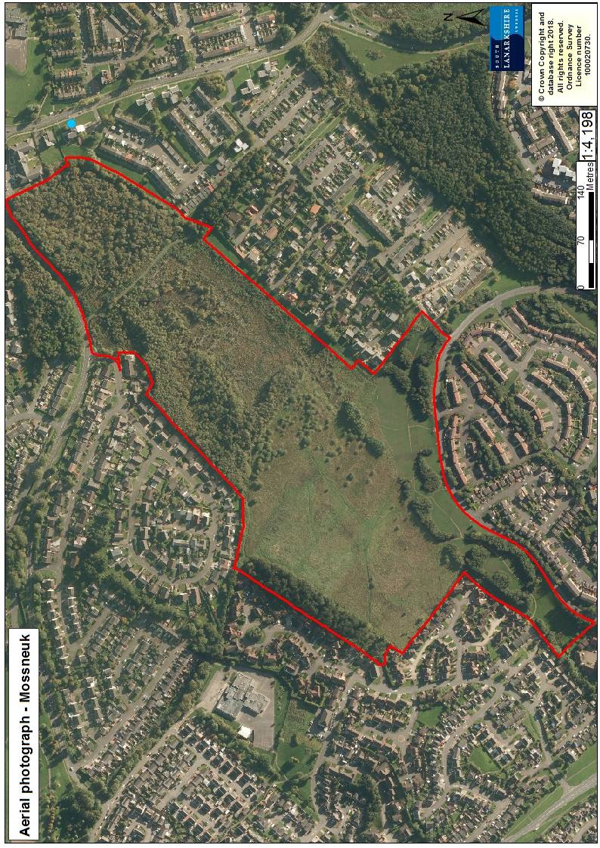

Appendix 2: Maps



