Morgan Glen Local Nature Reserve Management Statement 2018

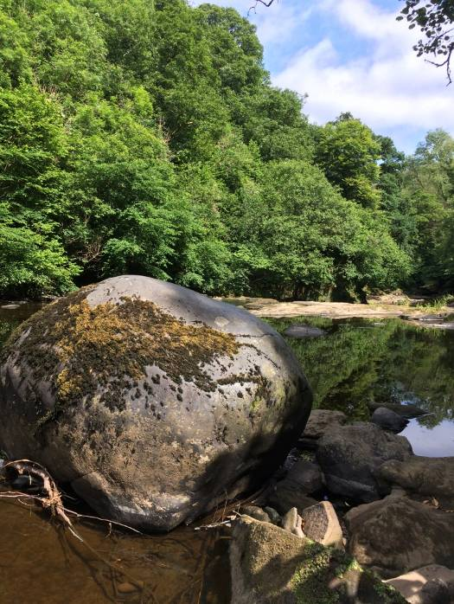
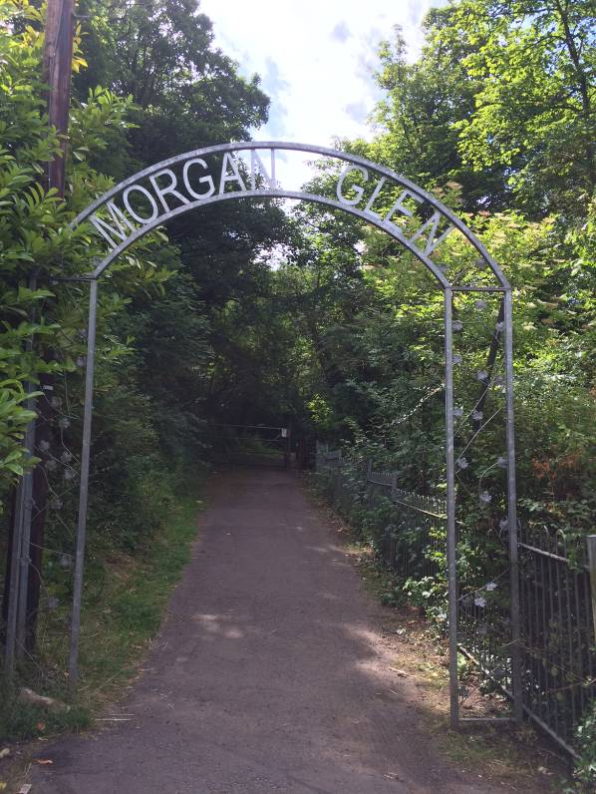

If you want this information in a different format or language, phone 0303 123 1015 or email equalities@southlanarkshire.gov.uk

Contents

Introduction
Vision statement
General information
Landscape
Cultural information
Site infrastructure
Recreation and access
Local community
Conclusion
Contacts
Appendix 1: Objectives and actions
Appendix 2: Maps

Introduction
heritage with opportunities for people to enjoy, learn about and experience nature close to their homes. LNRs are:

- Statutory designations made under the National Parks and Access to the Countryside Act 1949.
- Special places which are rich in wildlife.
- Generally, readily accessible and suitable for people to visit and enjoy.

In declaring these sites, South Lanarkshire Council (SLC) aims to:

- Protect them from unsuitable developments.
- Manage and enhance the habitats to help biodiversity flourish.
- Improve public access.
- Help people understand and become more aware of the importance of the LNR.
- Encourage community participation and volunteering.

SLC have identified sixteen new sites (and an extension to the existing LNR at Langlands Moss) to become designated as LNRs. These encompass a broad spectrum of habitats including ancient broadleaved woodland, open water, wetlands and grasslands. The site management statements are written in conjunction with the South Lanarkshire Biodiversity Strategy (2018 to 2022), SLC Sustainable Development and Climate Change Strategy (2017 to 22), SLC Local Development Plan (2013) and SLC Core Path Plan (2012).

Vision statement
Across South Lanarkshire, Local Nature Reserves are a resource for local communities that balance excellent recreational and educational opportunities with valuable habitats for wildlife that are rich in biodiversity.

General information

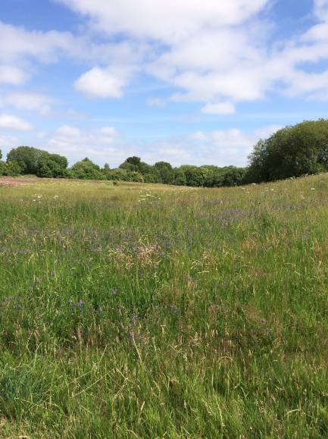
Location and site boundaries: Morgan Glen is located on the western edge of the town of Larkhall in South Lanarkshire. The site is bounded by houses and other development on its eastern edge and by the River Avon to the west.
Site name: Morgan Glen
Grid reference: NS 75861 49703
Area: 43ha.
Current ownership and management: the boundary of the reserve is based upon the extent of land owned by SLC.
Site description: Morgan Glen is a semi natural woodland gorge following the banks of the River Avon. Morgan Glen was named after John Morgan, the proprietor of the nearby Applebank Inn and owner of the glen before he gifted it to the people of Larkhall in 1939. In the past Morgan Glen was host to a number of events from gala days to regular dances.
Morgan Glen is one of the largest individual woodlands of its type (calcareous gorge woodland) in Scotland and a large section of the woodland is designated as Avondale Site of Special Scientific Interest (SSSI). It is also part of the Clyde Valley Woodlands Special Area of Conservation (SAC). This site is therefore a key element of a wider woodland habitat network, which includes riparian woodlands throughout the Clyde water catchment area. The site supports a number of rare and locally rare plants and animals and has a variety of woodland habitats.

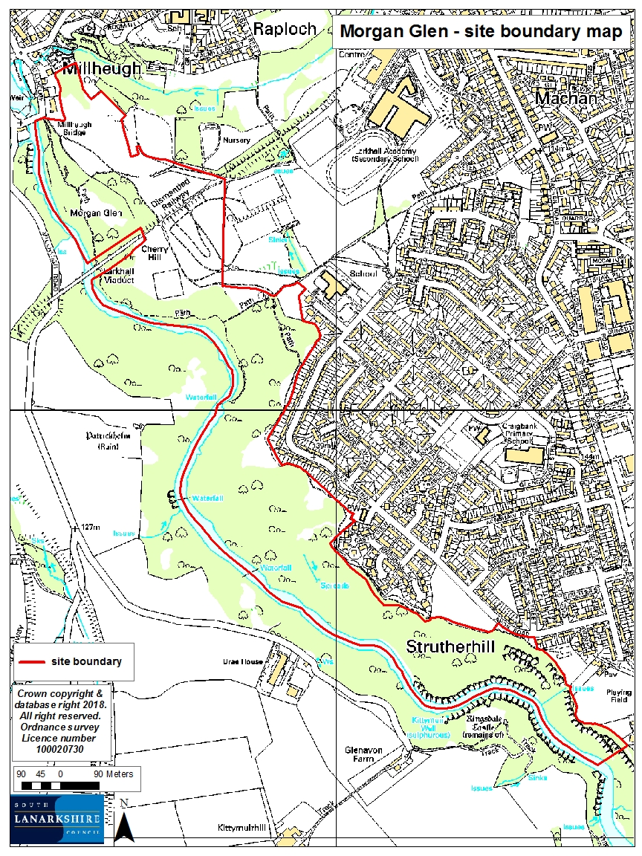

Habitats, flora and fauna
Habitat | Area (ha) | %
Broadleaved woodland | 35 | 82
Semi improved neutral grassland | 8 | 18
Total | 43 | 100

Morgan Glen is dominated by semi natural deciduous gorge woodland. The woodland is predominantly ash and elm (National Vegetation classification W9a). The dominant canopy species throughout most of the woodland is ash. Oak, sycamore and beech are locally dominant, with gean, birch and Scots pine also present throughout. The understorey includes hazel, blackthorn, bird cherry, hawthorn, holly, elder, rowan, willow and elm. Naturally regenerating ash of all ages is widespread and abundant.
Seedlings and saplings of other trees species occur in patches (sycamore, beech and birch).
There is an interesting ground flora associated with the ancient native woodland. The following plants occur within the larger area of the Avondale SSSI: wood fescue, broadleaved helleborine, hairy St John’s wort, alternate leaved golden saxifrage, bird’s nest orchid, toothwort and giant bellflower.
Within the woodland there are areas of open grassland areas with interesting flora. The following plants occur in the Avondale SSSI: fragrant orchid, greater butterfly orchid and yellow rattle. There is a large area of open grassland at the northern edge of the site. Some of this is being colonised by scrub, including hawthorn, broom and ash.
A number of notable invertebrates have been found in the Avondale SSSI, including a nationally scarce beetle (Cerylon fagi) and three locally scarce species of fungus beetle. Saproxylic invertebrates (species dependent on dead or decaying material associated with tree wood) include a notable species of beetle (Phyllodrepoidea crenata) and a scarce picture winged lauxanid fly (Peplomyza litura). Of further note are the otters and badgers that are present at the site.
Avondale SSSI is currently categorised as being in an unfavourable condition due to the high levels of non native trees present. However, the structure of the woodland is good and though clearings are occasionally present, the canopy is dense throughout the site. Evidence of grazing was recorded; however this grazing is such low intensity as to be having little significant effect on the woodland structure. Successful regeneration of native tree species can be found.
To the north of the proposed reserve are open areas of semi improved neutral grassland, with patches of tall ruderals and scrub. These areas provide habitat for invertebrates and provide a diverse mosaic of open, scattered and dense scrub, with a variety of young and mature trees. Species noted were gorse, broom, birch, willow, elder, greater bird’s foot trefoil, oxeye daisy and red bartsia.
A few small patches of Japanese knotweed can be found near the river and the viaduct. This invasive species has the capacity to continue to spread and threaten the integrity and character of the woodland thorough competition with native ground flora and understorey species. It is necessary to monitor the location and spread of such species with the aim of controlling them on site where possible.

Landscape
The majority of Morgan Glen pLNR is designated as a SSSI and SAC, both of which extend south along the River Avon to Stonehouse. The area is designated as a SSSI for “upland mixed ash woodland”. The statement on SNH’s Sitelink notes the following aspects:
“Avondale SSSI comprises an outstanding example of semi natural deciduous gorge woodland. The Avondale gorge cuts through a series of Carboniferous rocks that are predominantly calcareous but in some areas give rise to acidic soils. The calcareous nature of the soils is reflected in the woodland canopy where ash, wych elm and alder are common. The flushed upper slopes of the gorge support ash wych elm communities which grade into alder woodland in the lower wetter areas, whilst the level, waterlogged sites support springline alder woodland communities”.
Clyde Valley Woods is a composite SAC consisting of 13 sites. These areas are characterised as “Tilio Acerion forests of slopes, screes and ravines (priority habitat); mixed woodland on base rich soils associated with rocky slopes”. Maps and other information can be found on the Sitelink. The Joint Nature Conservation Committee provides the following information regarding this protected site:
“Clyde Valley Woods in southern Scotland represents the most extensive complex of woodland gorges with Tilio Acerion forests in Scotland. Although, like all Scottish sites, Clyde Valley Woods is beyond the northern distribution limit of lime Tilia spp. it possesses otherwise characteristic features of the Tilio Acerion. Ground flora typical of the Tilio Acerion is found in these woods, with some southern species such as herb Paris Paris quadrifolia and pendulous sedge Carex pendula also present.”

Potential Local Nature Conservation Sites (pLNCS) identified nearby include:
- Broomelton Woods (0.1 miles)
- Powforth Glen (0.1 miles)
- High Merryton (0.1 miles)
- Wellbog Glen (1.1 miles)
- Knowetop and Burnbrae Glen (1.1 miles)

These sites are mostly comprised of woodland habitat, which together with Morgan Glen, contribute significantly to the woodland ecological network in the area.

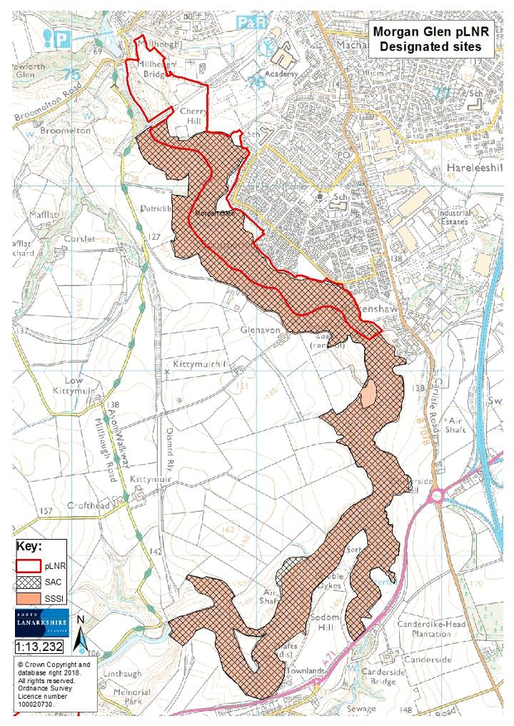

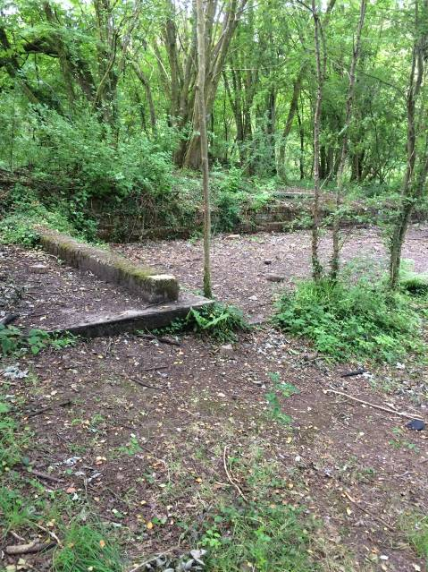
Cultural information
Past Land use
The rich woodland flora at Morgan Glen is evidence of a long period of woodland cover on much of the site, particularly on the steep slopes upstream of the Larkhall viaduct. Most of the site however has been affected by human activity, including coal mining, stone quarrying, stock grazing and woodland management. The area to the north of the viaduct was a public park in the 1940s and 50s; much of the woodland in this area is secondary woodland which has re colonised the site naturally. There is evidence of coppicing, particularly hazel.

Roy’s maps from the 1700s depict woodland and trees following the banks of the river Avon to Birkinshaws and Craigbank. Ordnance Survey maps were used to assess the history of Morgan Glen and the surrounding area from 1752 to 1967 (available online from the National Library of Scotland). Maps from 1843 to 82 show the woodland to follow the same outlines as today. The Applebank Public House is also featured in the map. The Avonbank bleachfields are to the north at Glengowan, with Broomhill House and formal gardens to the east. Morgan Glen was originally part of the Broomhill Estate. More information about this history and geology of the site can be found on the Community Action Lanarkshire website.
Later maps and photos from the 1940s show the viaduct crossing the river and the growth of surrounding residential housing developments. Maps from 1944 to 1967 show woodland paths along the east bank of the river from Millheugh Bridge to the woodlands in the south, with a small pavilion and lavatory in the woodlands.
There are a number of archaeological features of interest recorded in the surrounding landscape
- NS 75306 50678: Larkhall Millheugh Road bridge
- NS 75415 50312: Larkhall viaduct
- NS 76386 49308: Ringsdale Castle
- NS 76251 49287: St Patrickholm country house
- NS 75479 50733: Broomhillhouse country house
- NS 75241 51013: Avonbank bleachworks

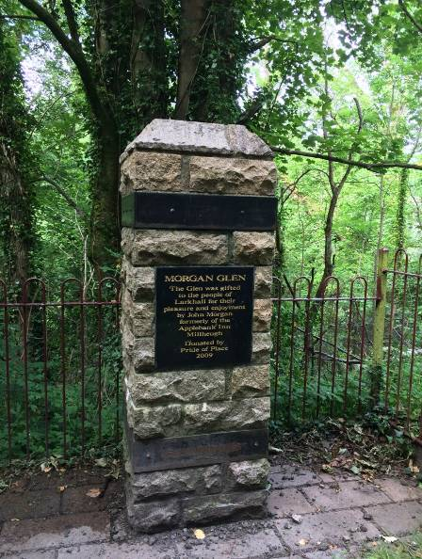
Present land use
Morgan Glen is currently used recreationally for activities such as walking, dog walking and cycling. It is also used by local schools and has hosted outdoor play sessions.
There is a Routes around Roots map for Morgan Glen which shows a walking route from the Leisure Centre, through part of Larkhall and into the site via the entranceway at Millheugh Bridge.
Heritage Lottery Funded Clyde and Avon Valleys Landscape Partnership promoted a series of walking routes in and around Larkhall during 2016/17 as part of the Make Your Way project. The “Broomhill trail” takes in part of Morgan Glen as well as the site of Broomhill House. “Doon the Braes” starts at the viaduct, goes up the 100 steps and follows trails to exit Morgan Glen on Avon Road.
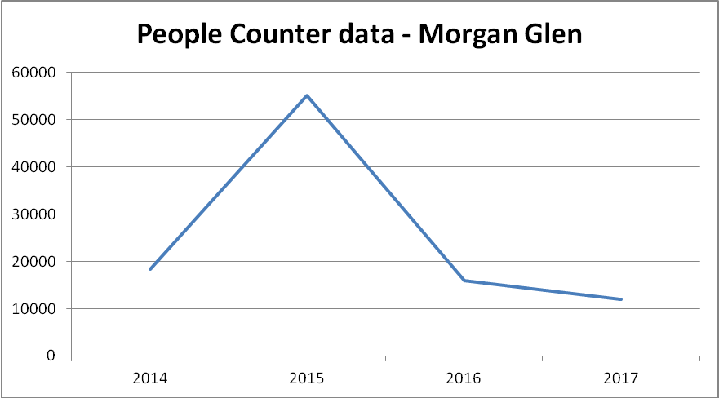
People counters are situated at the entrances at Avon Road and Millheugh (opposite ends of the site) and have been in place since 2013. The following graph shows the average results from these counters:
It is likely that the extreme spike in 2015 is due to a counter anomoly as this is the result over 8,000 counts in one month. Otherwise, annual data estimates visitor numbers of between 10,000 and 20,000

Site infrastructure

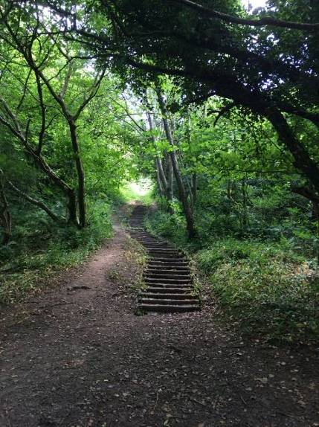
Morgan Glen supports 1.83 miles of core paths and 0.17 miles of wider network paths; there are 2.4 miles of paths throughout the reserve. In addition to this there are many desire lines, particularly in the northern and more open sections of the reserve. In areas the paths have become eroded due to poor drainage and lack of maintenance work; improvements are needed throughout the site.
The remains of an old viaduct can be found over the River Avon. This was built between 1898 and 1904 for the Caledonian Railway Company, by the Glasgow engineering company Arrol Brothers. The crossing has a span of 174ft and height of 170ft. The condition of the viaduct is poor and access has been fenced off for safety reasons.

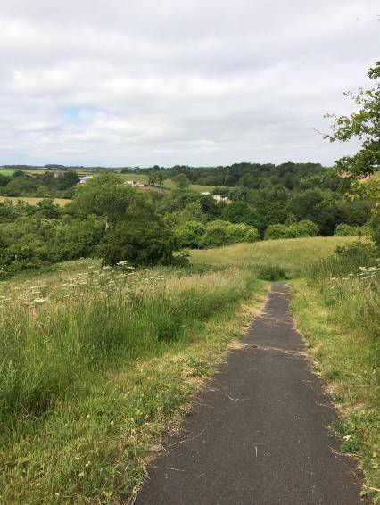
Recreation and access
The site is well used by the local community. The main entrance to the site is along Millheugh Brae at Millheugh Bridge. There are various other access points throughout the site:
NS 753 506: Millheugh Bridge (Millheugh Braes).
NS 757 505: Broomhill Road (at the junction of the disused railway).
NS 759 503: lane between Larkhall Academy and Robert Smillie Primary school.
NS 758 499: Glen Avenue.
NS 760 497: Glen Avenue and Craigbank Road junction at the playing field.
NS 765 494: Avon Road, via car parking behind the houses.
NS 767 493: Carlisle Road (B7078) via playing fields.
In addition to the access point listed above, pedestrian access can be gained along the Avon Water at the south end of the site and at numerous points along the north east edge of the site.
Nearby public transport links are available along Carlisle Road (0.7 miles from the Millheugh Bridge entrance point); there are regular bus links to Glasgow and Hamilton. Scotrail services at Larkhall Station run every half hour to Glasgow (Milngavie service).

Local community
The Friends of Morgan Glen community group were established in 1996 and became formally constituted in 2006. The group have regular meetings throughout the year and used to hold gala days and events in the glen. More recently the glen has been used for a variety of school projects, preschool and play activities.
There are three schools in close proximity to the pLNR: Robert Smillie Memorial Primary school (0.03 miles), Craigbank Primary school (0.2 miles) and Larkhall Academy School (0.19 miles). All the schools are linked to the site by wider network paths identified in South Lanarkshire’s Core Path Plan (2012).

Conclusion
It is the intention of the SLC CAG team to ensure that the ecological quality of Morgan Glen is maintained and managed. We aim to foster an understanding and facilitate enjoyment of the natural heritage of the woods and to increase public use through improved access, interpretation, education and promotion of the site.
The management statement will meet these objectives by seeking to deliver a number of practical health, environmental education and community outcomes in partnership with external organisations and the local community.

Contacts
For more information on this site, or LNRs in South Lanarkshire, please contact:
Countryside and Greenspace Service, Facilities, Waste and Ground Services, Community and Enterprise, South Lanarkshire Council, 18 Forest Street, Blantyre G72 0JP.
Email: CAG@southlanarkshire.gov.uk

Photographs taken by J. Birkin.
Note that maps may not be to scale.

Appendix 1: Objectives and actions
The management objectives include guidance from the Avondale SSSI Site Management Statement (site code 109).
Objective 1: Maintain, enhance and monitor the biodiversity value of the reserve.
Actions:
- To maintain and enhance, where possible, the natural species composition of the mixed ash woodland, by maintaining appropriate levels of grazing and removing non native regeneration.
- To maintain and conserve notable fauna, particularly invertebrates and badgers by ensuring dead and decaying wood remains within the site.
- Contribute to national and local biological recording and monitoring schemes.
- Investigate the potential to map and control invasive non native species.
- Assess the open ruderal and grassland areas for species diversity; intervene with management as necessary.

Objective 2: Maintain and increase the use of the access network.
Actions:
- Maintain and enhance the access network.
- Investigate the opportunity to use signage to highlight access points and routes to the reserve, as well as interpretation.

Objective 3: Encourage and facilitate community involvement in the reserve.
Actions:
- Develop community involvement within the site.
- Investigate and develop opportunities for conservation volunteering.
- Work with local people and other stakeholders towards meeting the objectives of the management plan.
- Identify and promote opportunities for people to enjoy the wildlife of the area.
- Investigate possibilities of promoting the reserve in new and different ways.
- Encourage and promote the use of the reserve for the local community, schools, colleges and other interest groups.

Appendix 2: Maps


