Backmuir Woods Local Nature Reserve Management Statement 2018

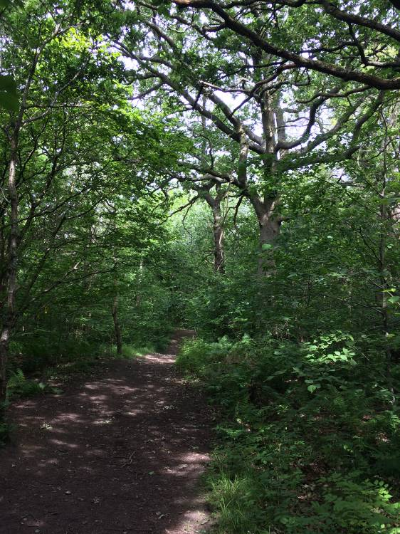

If you want this information in a different format or language, phone 0303 123 1015 or email equalities@southlanarkshire.gov.uk

Contents

Introduction
Vision statement
General information
Landscape
Cultural information
Site infrastructure
Recreation and access
Local community
Conclusion
Contacts
Appendix 1: Objectives and actions
Appendix 2: Maps

Introduction
Local Nature Reserves (LNRs) are valuable places as they combine protection of the natural heritage with opportunities for people to enjoy, learn about and experience nature close to their homes. LNRs are:

- Statutory designations made under the National Parks and Access to the Countryside Act 1949.
- Special places which are rich in wildlife.
- Generally, readily accessible and suitable for people to visit and enjoy.

In declaring these sites, South Lanarkshire Council (SLC) aims to:

- Protect them from unsuitable developments.
- Manage and enhance the habitats to help biodiversity flourish.
- Improve public access.
- Help people understand and become more aware of the importance of the LNR.
- Encourage community participation and volunteering.

SLC have identified sixteen new sites (and an extension to the existing LNR at Langlands Moss) to become designated as LNRs. These encompass a broad spectrum of habitats including ancient broadleaved woodland, open water, wetlands and grasslands. The site management statements are written in conjunction with the South Lanarkshire Biodiversity Strategy (2018 to 2022), SLC Sustainable Development and Climate Change Strategy (2017 to 22), SLC Local Development Plan (2013) and SLC Core Path Plan (2012).

Vision statement
Across South Lanarkshire, Local Nature Reserves are a resource for local communities that balance excellent recreational and educational opportunities with valuable habitats for wildlife that are rich in biodiversity.

General information
Location and site boundaries: Backmuir is located to the north east of the town of Hamilton in South Lanarkshire. The site is bound by residential housing to the west with industrial units to the north and east. To the north lies the East Kilbride expressway (A725) and to the south lies the grounds of Holy Cross High School and Bothwell Road Park.

Site name: Backmuir Woods

Grid reference: NS 7096 5713

Area: 21.14ha.

Current ownership and management: the boundary of the reserve is based upon the extent of land owned by South Lanarkshire Council (SLC).

Site description: Backmuir is an area of ancient, seminatural woodland and scrub following the banks of the Park Burn and Wellshaw Burn, nestled between Bothwell Road and Whitehills residential area in Hamilton. Broadleaved woodland can be found in this area on General Roy’s maps from the 1740s, including the central valley and eastern plateau. However, most of the current woodland cover originates from the 19th Century.

There is a diverse range of canopy species throughout the woodland. The ground flora includes bluebell, red campion and enchanter’s nightshade. Backmuir has long been recognised for its natural history interests with a nature trail created in the 1970s. A key habitat is the riparian zones of the Park and Wellshaw burns providing additional diversity to the site and forming an important wildlife corridor linking to woodland to the north of the site.

Of high importance is the significance of the landscape in relation to its urban setting. It is recognised that the woodlands play an important role as a general amenity resource with a high intrinsic, aesthetic and landscape appeal.

In recent years there has been some upgrading of the entrance points and paths to the woodland; the woodland forms a strategic access link between the surrounding housing, schools, public park and industrial estates.

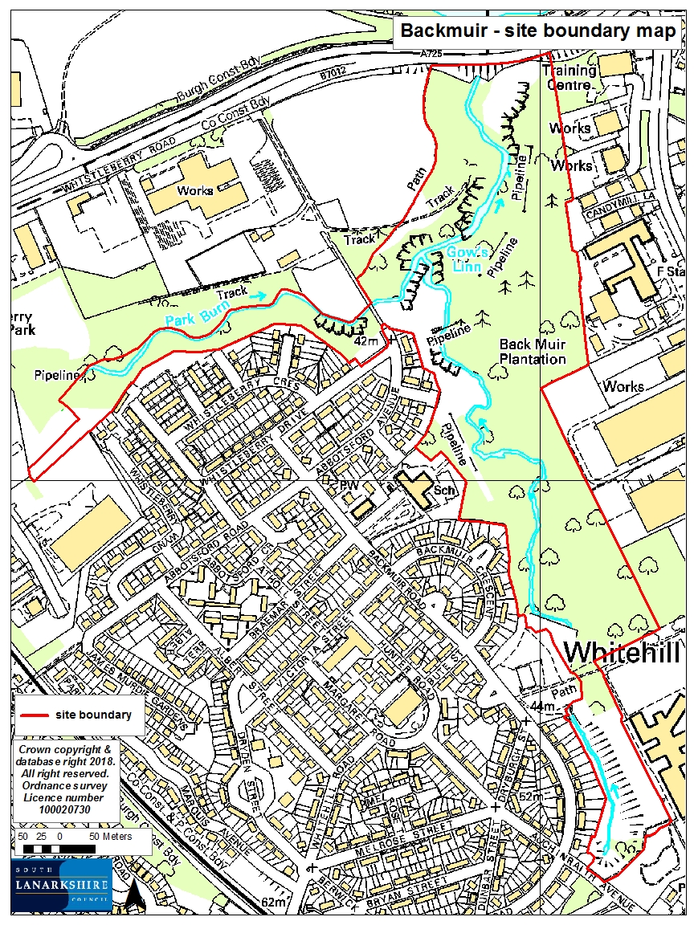

Habitats, flora and fauna

Habitat | Area (ha) | %
Broadleaved woodland | 20.02 | 95
Semi improved neutral grassland | 0.95 | 4.2
Amenity grassland | 0.15 | 0.7
Paths | 0.02 | 0.1
Total | 21.14 | 100

Within Backmuir Woods, the habitat can be split into three main zones; western and riparian woodland, eastern woodland and open areas.

Western and riparian woods: The woodland along the Park and Wellshaw burns can be classified as disturbed NCV (National Vegetation Classification) W9a ash / rowan / dog’s mercury woodland with many planted broadleaved trees. The soils are characterised as clay and moist soils of slopes.

The riparian woodland that follows the course of the two burns within the reserve supports ancient semi natural woodland. The woodland to the east of the burns supports a range of semi natural and planted woodland areas. This is dominated by oak but has planted conifer trees throughout the canopy. Tree and shrub species present include pedunculate oak, silver birch, ash, sycamore, Scot’s pine, beech, goat willow, common alder, hazel, hawthorn, wych elm, common lime, horse chestnut, yew, white willow, osier, elder and hybrid black poplar.

The canopy exhibits a fairly varied structure throughout the woodland and includes many planted trees. Ash, sycamore and silver birch are abundant throughout. Common lime and horse chestnut are particularly prevalent towards the south of the sub compartment but also occur elsewhere. Pedunculate oak, yew, alder and goat willow occur occasionally throughout. Beech is occasional and gains greatest prominence on top of the western slopes beside Park Burn where in small areas little ground flora exists other than great woodrush and bramble. White willow and osier occur very rarely. Several Italian poplar trees stand on the banks of Park Burn, near the western edge of the compartment.

The understorey is often dense and contains frequent hazel, wych elm, hawthorn and occasional yew and elder. Areas of the understorey suffer from the abundance of rhododendron and Japanese knotweed. Field and ground layer vegetation includes wood avens, water avens, ivy, dog’s mercury, red campion, broadleaved willowherb, enchanter’s nightshade, hedge woundwort and opposite leaved golden saxifrage. Scrubbier areas support vegetation such as rosebay willowherb, great willowherb, black knapweed and creeping thistle. The far north of the compartment supports more naturalistic woodland best described as developing towards W9a ash/rowan/dog’s mercury woodland. Goat willow tends to dominate this area alongside birch species, and ash is more abundant. A more diverse ground flora exists here, typical of the W9a community.

Eastern woods: the woodland to the east of the site can be characterised as W10e (pedunculate oak / bracken / bramble) woodland with sycamore / wood sorrel sub community, with similarities to W11 woodland. On flat to gently sloping ground, the woodland grades into the W9a (ash / rowan / dog’s mercury woodland) community. Oak and silver birch tends to dominate the canopy with occasional ash, sycamore, Scot’s pine and beech. Goat willow is abundant throughout the stand; alder is rare within the community. The understorey is fairly sparse and represented by frequent hazel, occasional hawthorn and wych elm together with saplings of ash, oak, beech and sycamore. Holly was recorded as rare within the community and occurs only in the understorey.

The field and ground layers of the community typically consists of an abundance of ferns including male fern and broad buckler fern with bramble constant throughout. Wood millet, honeysuckle, tufted hair grass, water and wood avens and raspberry are frequent. The following species are noted as occasional:

meadowsweet | wood sorrel | ground elder
hedge woundwort | broadleaved willowherb | wood dock
common nettle | creeping buttercup | ivy
red campion | wild strawberry | wood horsetail
dog’s mercury | enchanter’s nightshade | dog rose
opposite-leaved golden saxifrage | black knapweed | perforate St John’s wort

Throughout the site, over mature trees and standing deadwood contribute to a wide diversity of habitats within the woodland and increase the nature conservation value of the site.

Open areas: open areas of the reserve support semi improved neutral grassland, amenity grassland and marshy grassland. A small area of wet meadow / woodland near the expressway to the far north includes meadow vetch, tufted vetch, common hogweed, bramble, creeping soft grass, meadow buttercup, reed canary grass, sneezewort, tufted hair grass, angelica, coltsfoot, common spotted orchid and marsh thistle.

Invasive non native species including Japanese knotweed, rhododendron and laurel occur within the site. Japanese knotweed is becoming a particular problem in the north west and south of the site, with rhododendron frequently throughout. Aggressive colonisation by these species into new areas has the potential to seriously threaten the integrity and semi natural character of the woodlands. In order to prevent the spread of these species and to promote the native ground flora cover it will be necessary to introduce measures of control. This should be of high priority in the management of the site.

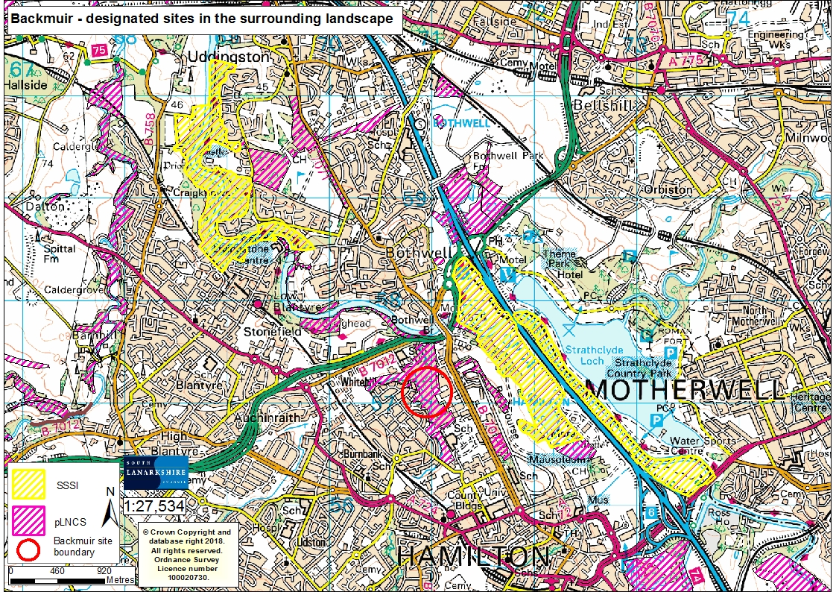
Landscape

Two Sites of Scientific Interest (SSSI) are located nearby:
- The wetland mosaic of Hamilton Low Parks (NS71305803) approximately 0.5 miles east
- Bothwell Castle Grounds (NS68816018): 1.1 miles north

Backmuir woods is noted as a potential Local Nature Conservation Site (pLNCS). Other pLNCS identified nearby include:
- Bothwell Park Industrial estate (NS70335969): 0.1miles
- Bothwell Castle Golf Club (NS69505932): 1.7 miles
- Rotten Calder (Blantyre to Redlees / Spittal Burn) (NS67795966): 2.15 miles
- Lower Blantyre (NS69835771): 0.37 miles
- South Haugh (NS73175532): 1.7 miles
- Bothwell Bing (NS71186008): 1.8 miles
- Bothwell Park / Laighland Wetland (NS71375876): 1.5 miles
- Cock’sburn (NS67195698): 2.3 miles
- Malcolmwood (NS67655725): 1.9 miles

The East Kilbride expressway to the north of the site separates the woodland from the nearby River Clyde at Bothwell Bridge. To the south is the open space and amenity grounds of Bothwell Road Public Park.

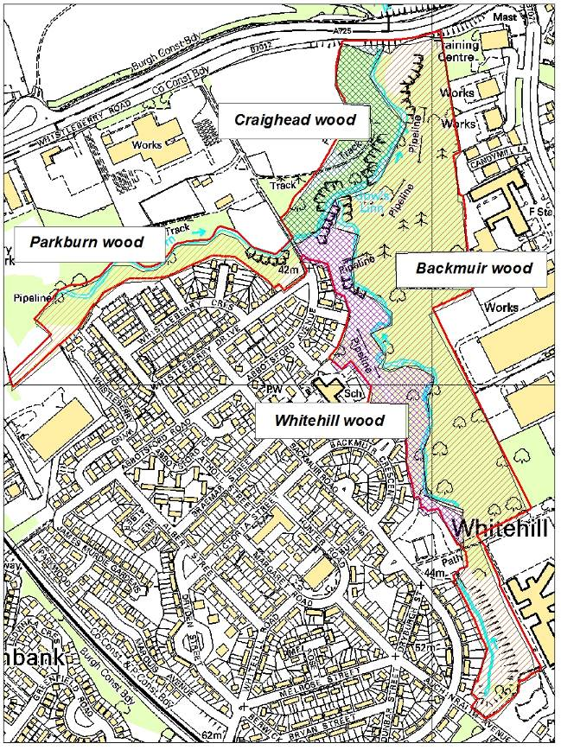
Cultural information
Past Land use
Backmuir Woods is made up of several adjoining woodlands, subdivided by the watercourses running through the site. The four woodlands were originally known as Craighead wood, Parkburn wood, Backmuir wood and Whitehill Wood.

Roy’s maps from the 1700s depicts a large area of woodland extending to the west following the banks of the Wellshaw Burn and Park Burn, with what looks like ploughed fields covering the land to the north. Ordnance Survey maps (available online from the National Library of Scotland) from the 1840s to late 1800s show the name Back Muir Plantation; a number of paths can be seen throughout the woodland. At this time, the woodland continues east across Bothwell Road to Barmichael plantation. Later maps and aerial photos from the 1930s to 1960s illustrate the growing development around the woodland, with housing to the west, industrial units to the east and the public park to the south.

In 2003 the Scottish Government awarded a Community Environmental Renewal Grant of £110,000 to improve Backmuir. The Whitehill Community Forum was integral to the development of this project. The primary management objective was to promote the conservation of the woodland habitat and to upgrade public access provision, all in order to enhance the woodland as a permanent viable feature of value to the local community.
The project was implemented by a team of mainly local trainees employed by AEL Enterprises Ltd. The scheme was supported by a number of other funding sources including the European Social Fund, the Forestry Commission, New Deal, South Lanarkshire Council (Access to Jobs), Blantyre / North Hamilton Social Inclusion Partnership, and the Glasgow and Clyde Valley Greenspace Trust.

Present land use
Backmuir is currently used recreationally for activities such as walking, dog walking, jogging and cycling. The site has been used by local schools and nurseries for outdoor education.

There is a routes around Backmuir map which shows a circular walk of approximately 2.5 miles. From the Whitehill neighbourhood centre the route continues north through the woodland and circles back along the two watercourses within the site. This project was funded by the Heritage Lottery Fund, South Lanarkshire Council and Pride of Place and hoped to encourage more people to get out and walk in their local areas. The project selected six sites within South Lanarkshire and produced a guide leaflet, route map and details on the local natural history.

Site infrastructure
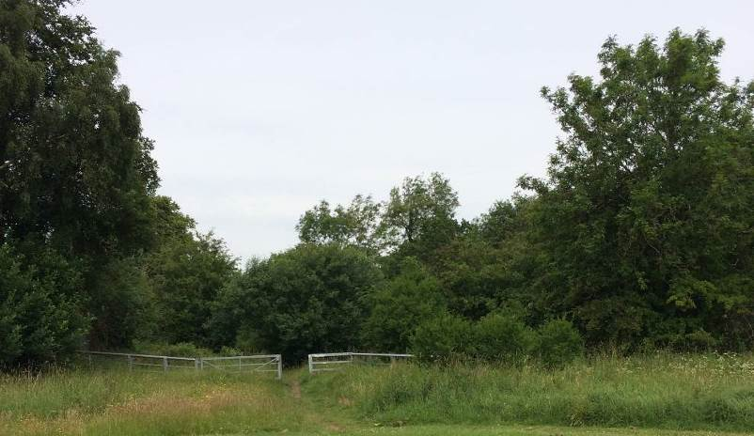
Backmuir woodlands support 1.57 miles of core path and 0.26 miles of wider network paths: 1.83 miles of path in total. In addition there are many desire lines throughout the reserve. The paths are generally in good condition, but sections have been damaged and blocked by fallen trees or have become eroded.

Four large sewage pipes pass through the woodland in the far north and west of Backmuir, they are quite visible and were installed in the mid-1980s.

A well maintained footbridge crosses over the Park Burn to allow access to the woodland in the north and link the paths to the eastern side of the woodland. The Wellshaw burn runs south to north, the Park Burn runs west to east, meeting the Wellshaw Burn within the woodland. The watercourse then passes underneath the East Kilbride expressway and joins the River Clyde.

Recreation and access
Access provision to and within the woodland is generally good with an extensive network of paths throughout. The paths appear to be well used by the public. Problems associated with public access to the woodland are frequent throughout the site including fly tipping of garden waste, littering, graffiti and vandalism. There is currently no signage or interpretation along the roads or at the entrance points for the site.

The main entrance points to the reserve are along Backmuir Road, Auchinraith Avenue, Whistleberry Drive and Abbortsford Avenue. Access to the reserve can be found throughout the site at:
- NS 7078 5721: Abbotsford Avenue and Whistleberry Drive
- NS 7104 5672 and NS 7097 5679: Backmuir Road
- NS 7111 5642: Auchinraith Avenue
- NS 7085 5711: Abbotsford Avenue
- NS 7082 5704: Abbotsford Avenue
- NS 7074 5728 and NS 7074 5728: Whistleberry Drive
- NS 7085 5758 and NS 7100 5759: East Kilbride expressway

Parking is available on the street around the edges of the site. The site is 0.39 miles from Hamilton West train station, located to the south of the pLNR. Buses to Hamilton town centre regularly pass along Bothwell Road, Melrose Terrace and Kenmar Road.

Local community
There is no active community group associated with Backmuir, however the park has been used in the past for outdoor events and activities involving the local schools and scouts groups. In 2008, a public consultation was commissioned by South Lanarkshire Council and carried out by Community Links to determine the local communities’ opinion on Backmuir woodland; how they utilise the site, barriers and suggested solutions on improving the area.

There are a number of schools in close proximity to Backmuir:
- Holy Cross High School (adjacent to the site)
- St. Paul’s Primary (0.03 miles)
- Beckford Primary School (0.54 miles)
- Hamilton College and nursery (0.56 miles)
- University of West Scotland (0.44 miles)

Conclusion
It is the intention of the SLC CAG team to ensure that the ecological quality of Backmuir Woods is maintained and managed. We aim to foster an understanding and facilitate enjoyment of the natural heritage of the woods and to increase public use through improved access, interpretation, education and promotion of the site.

The management statement will meet these objectives by seeking to deliver a number of practical health, environmental education and community outcomes in partnership with external organisations and the local community.

Contacts
For more information on this site, or LNRs in South Lanarkshire, please contact:
Countryside and Greenspace Service, Facilities, Waste and Ground Services, Community and Enterprise, South Lanarkshire Council, 18 Forest Street, Blantyre G72 0JP.
Email: CAG@southlanarkshire.gov.uk

Photographs taken by J. Birkin.
Note that maps may not be to scale.

Appendix 1: Objectives and actions

Objective 1: Maintain, enhance and monitor the biodiversity value of the reserve.
Actions:
- Use management intervention where necessary to ensure the provision of a range of age and species diversity of tree species.
- Continue to retain mature trees and dead wood of various types.
- Contribute to national and local biological recording monitoring schemes.
- Investigate the potential to map invasive species and control where possible.
- Assess the open grassland area for species diversity; intervene with management as necessary.

Objective 2: Maintain and increase the use of the access network.
Actions:
- Maintain and enhance the access network throughout the proposed LNR.
- Identify funding opportunities.
- Investigate the opportunity to use signage to highlight access points and routes to the reserve, as well as interpretation.

Objective 3: Encourage and facilitate community involvement in the reserve.
Actions:
- Develop community involvement within the site.
- Investigate and develop opportunities for conservation volunteering.
- Work with local people and other stakeholders towards meeting the objectives of the management plan.
- Identify and promote opportunities for people to enjoy the wildlife of the area.
- Investigate possibilities of promoting the reserve in new and different ways.
- Encourage and promote the use of the reserve for the local community, schools, colleges and other interest groups.

Appendix 2: Maps



