James Hamilton Heritage Loch Local Nature Reserve Management Statement 2018

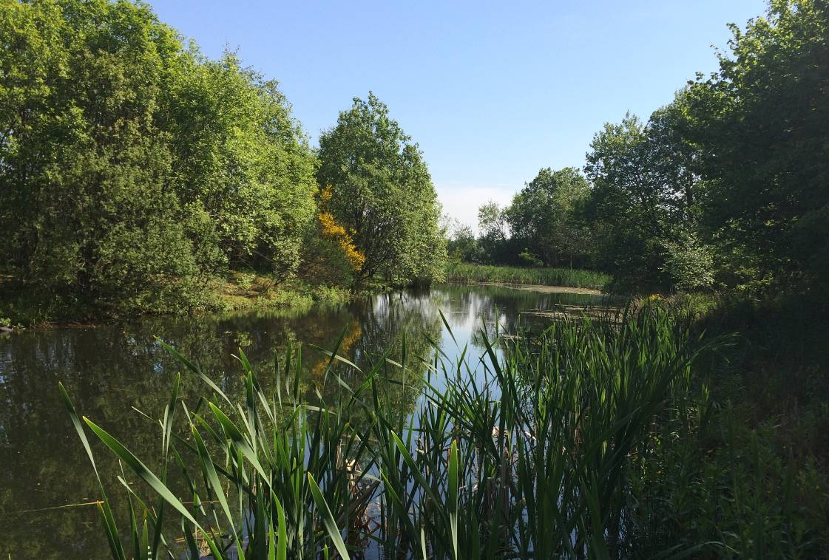

If you want this information in a different format or language, phone 0303 123 1015 or email equalities@southlanarkshire.gov.uk

Contents

Introduction
Vision statement
General information
Landscape
Cultural information
Site infrastructure
Recreation and access
Local community
Conclusion
Contacts
Appendix 1: Objectives and actions
Appendix 2: Maps

Introduction
heritage with opportunities for people to enjoy, learn about and experience nature close to their homes. LNRs are:

- Statutory designations made under the National Parks and Access to the Countryside Act 1949.
- Special places which are rich in wildlife.
- Generally, readily accessible and suitable for people to visit and enjoy.

In declaring these sites, South Lanarkshire Council (SLC) aims to:

- Protect them from unsuitable developments.
- Manage and enhance the habitats to help biodiversity flourish.
- Improve public access.
- Help people understand and become more aware of the importance of the LNR.
- Encourage community participation and volunteering.

SLC have identified sixteen new sites (and an extension to the existing LNR at Langlands Moss) to become designated as LNRs. These encompass a broad spectrum of habitats including ancient broadleaved woodland, open water, wetlands and grasslands. The site management statements are written in conjunction with the South Lanarkshire Biodiversity Strategy (2018 to 2022), SLC Sustainable Development and Climate Change Strategy (2017 to 22), SLC Local Development Plan (2013) and SLC Core Path Plan (2012).

Vision statement
Across South Lanarkshire, Local Nature Reserves are a resource for local communities that balance excellent recreational and educational opportunities with valuable habitats for wildlife that are rich in biodiversity.

General information
Location and site boundaries: James Hamilton Heritage Park (JHHP) is located to the north of the town of East Kilbride, in South Lanarkshire. The loch is surrounded by agricultural fields to the north and west, with a golf course to the east. To the south is the residential development of Stewartfield.
Site name: James Hamilton Heritage Park (JHHP)
Grid reference: NS 6262 5580
Site area: 0.87 ha
Site boundary: The boundary of the reserve is based upon the extent of land owned by South Lanarkshire Council (SLC).
Site description: JHHP lies on the northern edge of East Kilbride. The park was opened in April 1996; it is owned and managed by SLC. The loch of the pLNR and the larger adjacent loch were constructed from low lying marshy fields in 1995. The larger loch next to the nature reserve has a tree covered island, and is used for water sports in the summer months. The smaller pLNR loch was originally designed as a wetland nature reserve and bird sanctuary. This loch supports three small islands which provide shelter, feeding and nesting opportunities for wildlife away from the larger and more open body of water. The proposed reserve is separated from the main body of water by a causeway. At the southern edge of the loch a bird hide is located and is available on request for bird watching over the reserve.
The location of the proposed reserve lies close to the residential areas of East Kilbride and is easily accessible, well maintained and well positioned near local amenities including play parks, a sports centre, café, golf course and the Kingsgate retail park. The proposed reserve is popular throughout the year and enjoyed by the local community. The majority of visitors walk the circular route around the two lochs, observing the wildlife in the reserve and the surrounding landscape, especially the birds on the water.
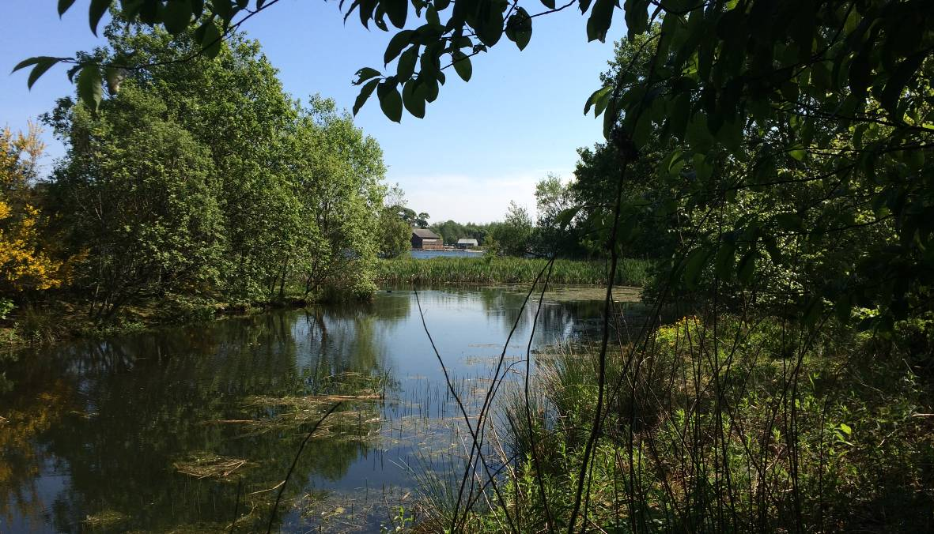

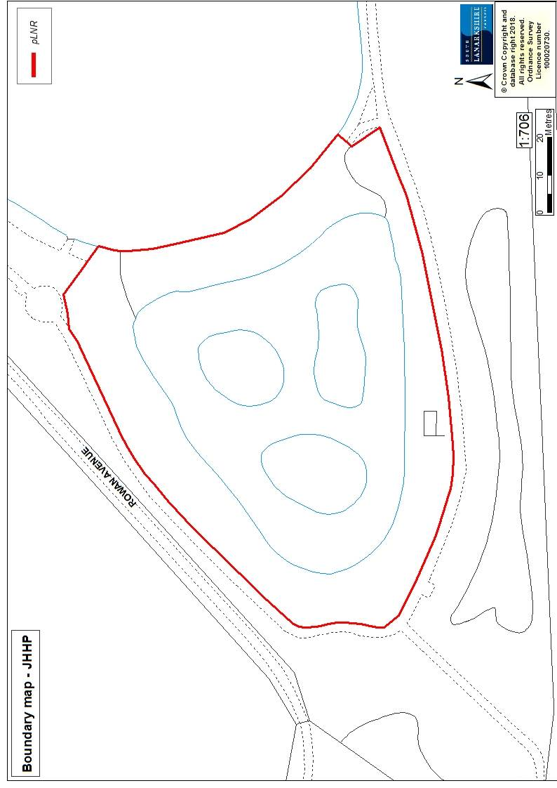

Habitats, flora and fauna
Habitat | Area (ha) | %
Trees and dense scrub | 0.38 | 44.0
Open water | 0.3 | 34.5
Marshy grassland | 0.14 | 16.0
Marginal vegetation and swamp | 0.05 | 5.0
Hide / building and grounds | 0.004 | 0.5
Total | 0.87 | 100
Observations of the flora and fauna, particularly waterfowl have been recorded since the creation of the loch in 1996.

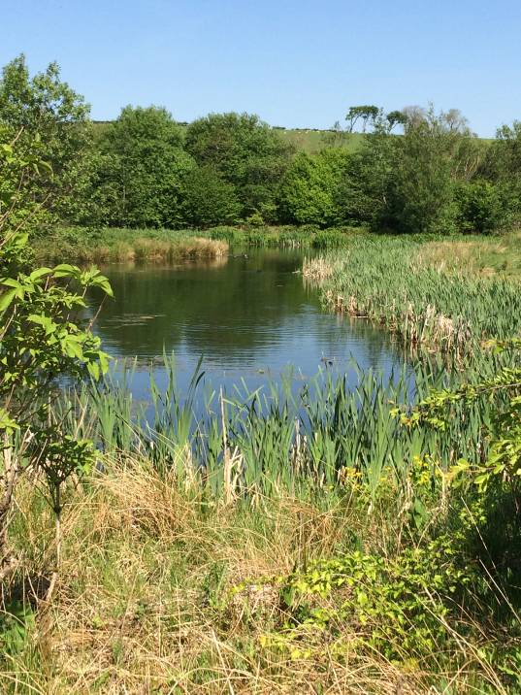
The banks of the loch are dominated by planted broadleaved trees and scrub over grassland and soft rush. Tree species include alder, hazel, ash, wych elm, cherry, silver and downy birch, with hawthorn, gorse and willow scrub. Ground flora comprises soft rush, coltsfoot, cleavers, broadleaved willowherb, cuckoo flower, red fescue and Yorkshire fog.

Marginal vegetation can be found along the banks and edges of the water. Large patches of soft rush were noted with meadowsweet, yellow flag iris, marsh marigold, water mint and water horsetail. There are dense stands of reedmace emerging from the edges of the open water. Two of the three small islands in the centre of the loch support mature trees and willow scrub, with the third island dominated by soft rush. The vegetation of the reserve provides valuable nesting, feeding and drinking habitats for local wildlife.
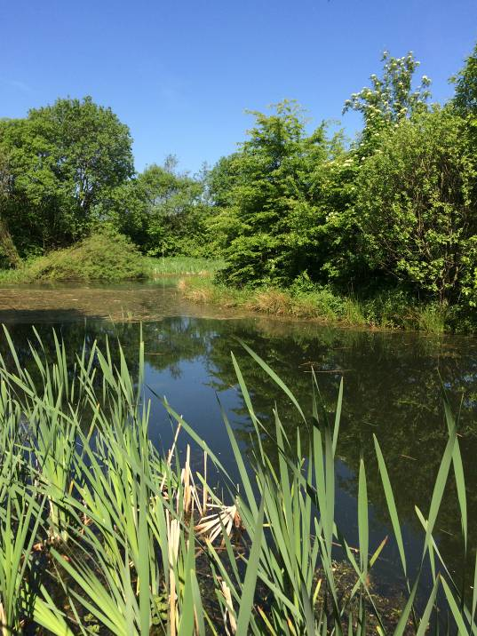

The site supports many wading birds, ducks, geese and gulls. Species noted include mute swan, greylag goose, Canada goose, moorhen, coot and lapwing. Skylark, swallow, swift, sand martin and house martin are common summer visitors. Other species of interest include cormorant, goosander, tufted duck and goldeneye. Kestrels hunt in the fields nearby and in the past have nested on the larger island in the adjacent loch. The smaller islands of the reserve have been managed in the past by selective strimming of dense vegetation to provide habitat for snipe. The site supports invertebrates especially dragonflies, damselflies and butterflies.

Landscape
The proposed LNR is located in the far north of East Kilbride and does not have any formal designation for conservation. However, there are a few potential Local Nature Conservation Sites (pLNCS) in the surrounding landscape:
- Kittoch Water Woods: (NS61445554) 0.4 miles to the west.
- Stoneymeadow Cutting: (NS66285667) 1.25 miles to the east.
- Stewartfield Housing Area: (NS63125510) 0.4 miles to the south.

The pLNR is situated to the west of a larger body of water both of which were created in 1996. The larger loch is a 5.8ha expanse of open water, with an artificial bank made up of medium to small rocks. The banks support little marginal vegetation, but the island in the centre of the loch provides shelter and nesting opportunities for wildlife. Agricultural fields are to the north and west of the pLNR, with a golf course to the east across Markethill Road. Immediately south lies a main road (Stewartfield Way) and the residential development of Stewartfield.
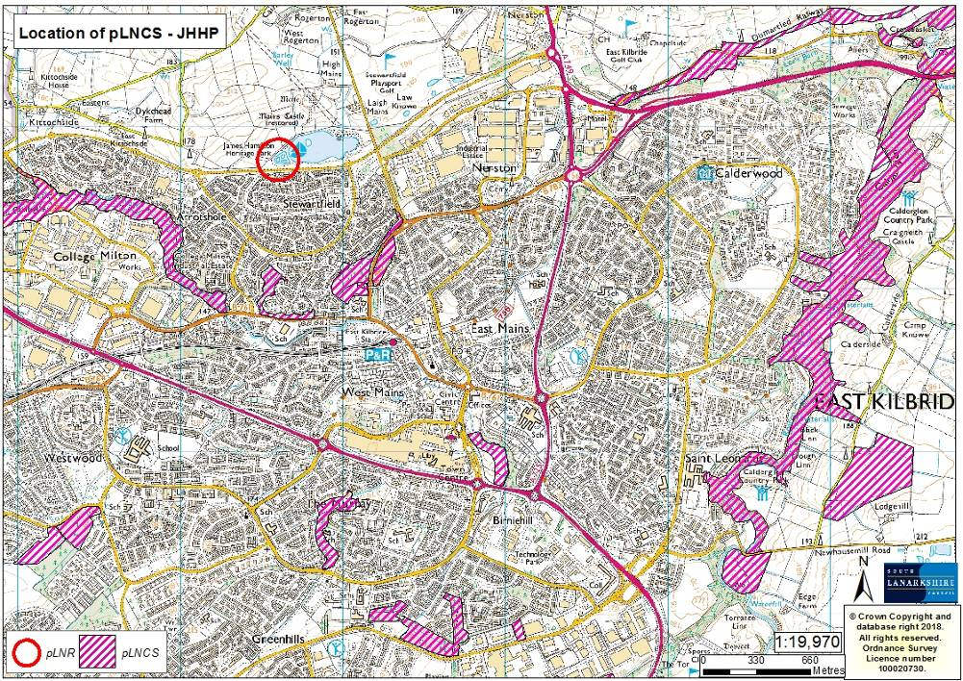

Cultural information
Past land use
Maps from the Ordnance Survey were used to look at the history of JHHP and the surrounding area (available online from the National Library of Scotland). Maps from 1752-55 show Mains Castle and associated motte to the north of the reserve. The surrounding landscape is dominated by open fields and hedgerows, with an area of wetland in the approximate location of where the loch is today. Later maps and aerial photos from the 1940s and 1950s show open fields, farm buildings and the remains of Mains Castle.

There are a number of features in the surrounding landscape that are of archaeological interest:
- NS62785603: Mains Castle tower, dating probably from the late 15th or early 16th century. It was habitable until circa 1723 and was later restored (1887-92) to a residence.
- NS62775616: medieval motte
- NS62795591: island in main loch (17th Century ornamental feature) linked to Mains Castle.
- NS62775615: Laigh Mains medieval moated site to the east of the pLNR
- NS63175613: cairn (period unassigned)
- NS63195609: lime kiln
- NS63285610: Law Known burial Cairn.

Further information on these and other sites can be found on the Canmore website.
Present land use
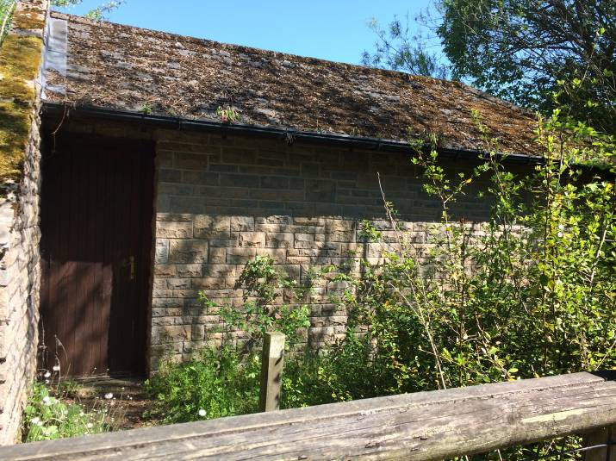
The reserve was created in 1995, as part of a larger water sports recreation facility for the residents of East Kilbride.
The majority of visitors to JHHP park at the main car park to the east of the main loch and walk the 1.25 km/0.78mile circuit. The fixed distance is appealing to joggers, walkers and people on bikes as part of a personal fitness route. The site is busy all year round, with people using the play parks, café and the water sport facilities particularly in the summer months. The pLNR and surrounding fields are attractive to bird watchers and the hide is available to groups.

Site infrastructure

The paths are located around the boundary of the pLNR and are regularly maintained. Fencing separates the reserve from the main path, limiting public access to the water and reducing disturbance to wildlife. A small gate provides access to the reserve’s hide. This is available to the public and interest groups; enquires can be made through SLC CAG team and staff based at the sports centre buildings at JHHP. There is no lighting or power to the hide.

Recreation and access
A core path is located directly around the reserve which links to the wider network of paths in the surrounding landscape. The tarmac paths are well maintained by SLC and are well use by the local community. Please refer to the access map for details on the path network around the pLNR.

Local community
There is currently no active community group dedicated to JHHP. The local Sea Scouts and volunteers from a local Church have carried out a number of conservation days to clear the vegetation around the hide. A key objective would be to engage with the local community in the management of the proposed reserve and to establish a management committee to oversee the management of all the pLNRs.

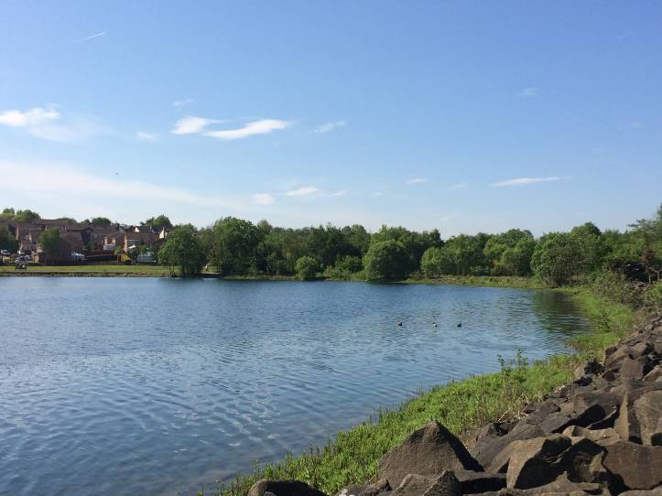
There are a number of local schools in close proximity to the pLNR: St Kenneth’s primary (0.6 miles), Kirktonholme primary (0.6 miles) and Duncanrig High school (1.32 miles).

Conclusion
It is the intention of SLC’s Countryside and Greenspace team to work in partnership with the local community to ensure that the ecological quality of the reserve is maintained and managed. We aim to foster an understanding and facilitate the enjoyment of the natural heritage of the reserve, by improving access, interpretation, education and promotion of the site.
The management statement will meet these objectives by seeking to deliver a number of practical health, environmental education and community outcomes in partnership with other organisations and the local community.

Contacts
For more information on this site, or LNRs in South Lanarkshire, please contact:
Countryside and Greenspace Service, Facilities, Waste and Ground Services, Community and Enterprise, South Lanarkshire Council, 18 Forest Street, Blantyre G72 0JP.
Email: CAG@southlanarkshire.gov.uk

Photographs taken by J. Birkin.
Note that maps may not be to scale.

Appendix 1: Objectives and actions

Objective 1: Maintain, enhance and monitor the biodiversity value of the reserve.
Actions:
- Gather baseline data on the hydrology of the loch, plant assemblage and the population of invertebrates and amphibians.
- Ensure appropriate management and actions that maintain and improve biodiversity and pond ecology. Raise awareness of the biodiversity value of non-amenity habitat with staff and visitors.
- Manage and maintain the buffer zone around the reserve.
- Contribute data to national and local biological recording schemes.

Objective 2: Maintain and increase the use of the access network.
Actions:
- Identify funding opportunities.
- Maintain and improve access around the proposed reserve.
- Maintain and clear vegetation to and around the bird hide.
- Consider the installation of interpretation panels highlighting key features of the pLNR.

Objective 3: Encourage and facilitate community involvement in the reserve.
Actions:
- Raise awareness of the pLNR to the local community.
- Investigate possibilities of promoting the park in new and different ways, such as to specialist interest groups.
- Review the information at the site ensuring that it is current and up to date.
- Monitor and assess visitor numbers.
- Investigate the possibility of linking JHHP to other greenspaces and wider network of paths in the surrounding landscape.
- Investigate the need for a trails guide of the routes, path networks and points of interest within the area.
- Encourage and promote the use of the pLNR for the local community, schools, colleges, universities, youth groups and other interest groups.
- Identify and promote opportunities for people to enjoy the wildlife of the pLNR.

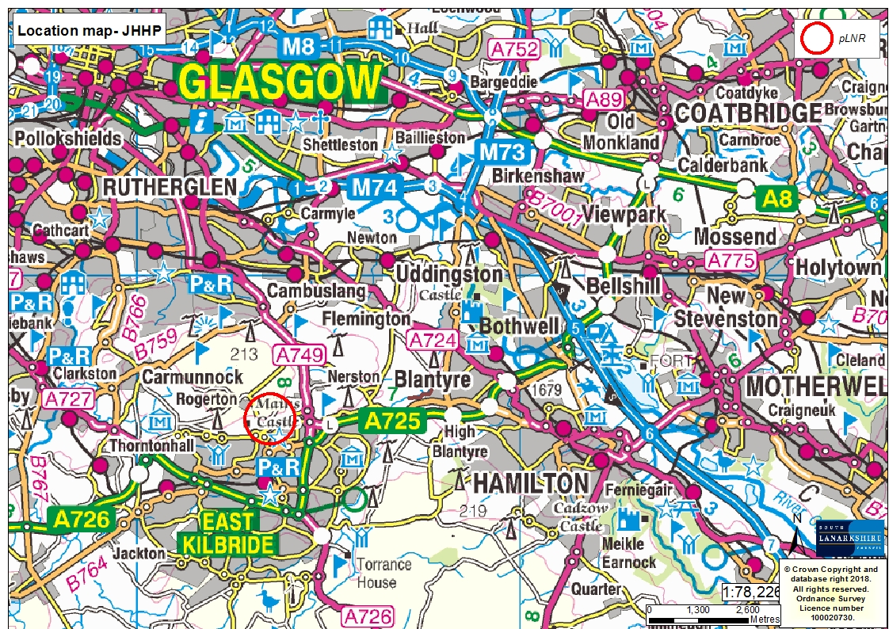
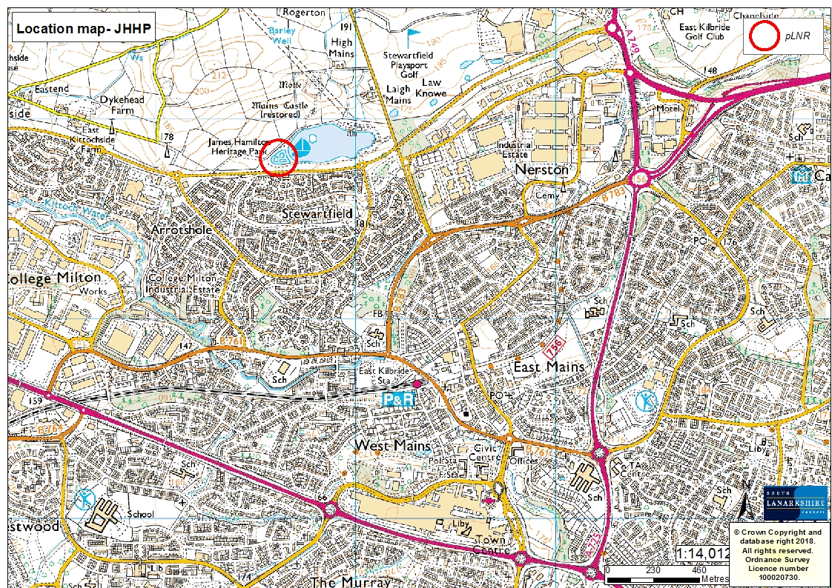
Appendix 2: Maps


