Westburn Local Nature Reserve Management Statement 2018

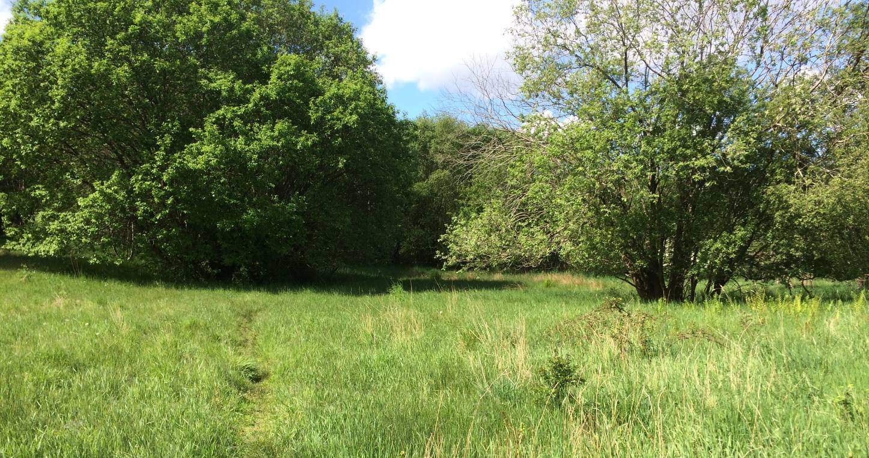

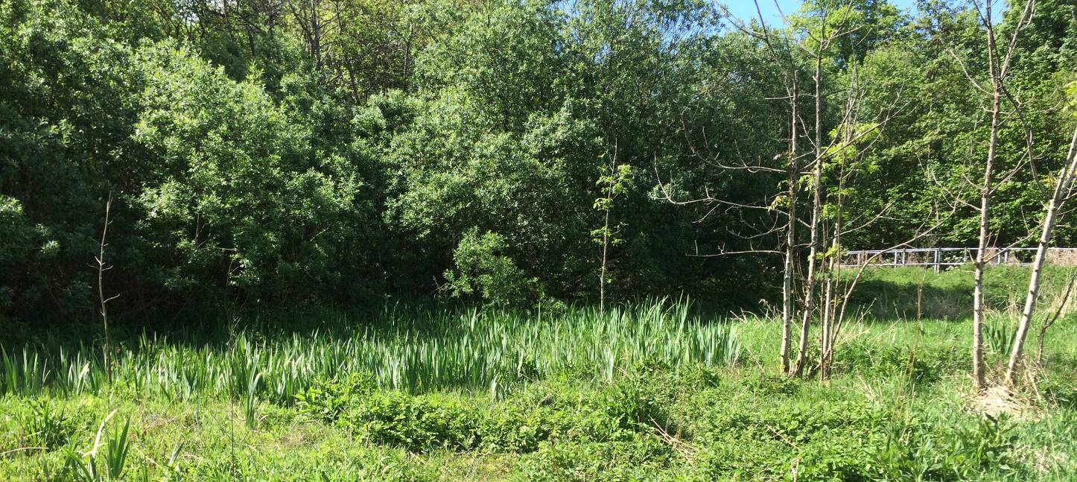

If you want this information in a different format or language, phone 0303 123 1015 or email equalities@southlanarkshire.gov.uk

Content

Introduction
Vision statement
General information
Landscape
Cultural information
Site infrastructure
Recreation and access
Local community
Conclusion
Contacts
Appendix 1: Objectives and actions
Appendix 2: Maps

Introduction
heritage with opportunities for people to enjoy, learn about and experience nature close to their homes. LNRs are:

- Statutory designations made under the National Parks and Access to the Countryside Act 1949.
- Special places which are rich in wildlife.
- Generally, readily accessible and suitable for people to visit and enjoy.

In declaring these sites, South Lanarkshire Council (SLC) aims to:

- Protect them from unsuitable developments.
- Manage and enhance the habitats to help biodiversity flourish.
- Improve public access.
- Help people understand and become more aware of the importance of the LNR.
- Encourage community participation and volunteering.

SLC have identified sixteen new sites (and an extension to the existing LNR at Langlands Moss) to become designated as LNRs. These encompass a broad spectrum of habitats including ancient broadleaved woodland, open water, wetlands and grasslands. The site management statements are written in conjunction with the South Lanarkshire Biodiversity Strategy (2018 to 2022), SLC Sustainable Development and Climate Change Strategy (2017 to 22), SLC Local Development Plan (2013) and SLC Core Path Plan (2012).

Vision statement
Across South Lanarkshire, Local Nature Reserves are a resource for local communities that balance excellent recreational and educational opportunities with valuable habitats for wildlife that are rich in biodiversity.

General information
Location and site boundaries
Westburn proposed LNR is located approximately one mile to the east of the town of Cambuslang in South Lanarkshire. Access to the site can be gained from Westburn Road at the junction of Westburn Drive and to the south along Birch Drive. The site is listed as a potential Local Nature Conservation Site (pLNCS) under the name “Westburn Skin and Hide”.
Site name: Westburn
Grid reference: NS 6510 6074
Site area: 4.14 ha
Site boundary: The boundary of the reserve is based upon the extent of land owned by SLC.
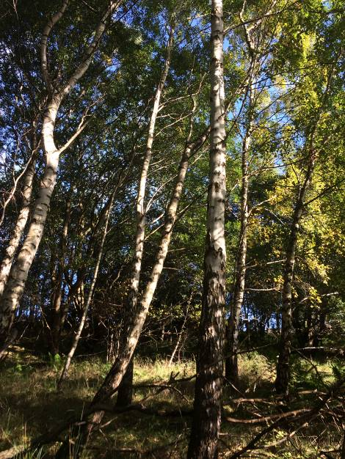
Site description
Westburn is a remnant of former farmland located in what was once a heavily industrialised landscape. A large steelworks and power station were located nearby, along the banks of the River Clyde. The steep embankment of the former Westburn colliery mineral railway line forms the eastern boundary of the site.
Westburn currently supports habitats of wetland vegetation, with swamp, marsh, marshy grassland, open water and running water. The northern half of the site is dominated by reedmace, with water mint, soft rush, meadowsweet, reed canary grass, tufted hairgrass, yellow flag iris, marsh thistle and water forget me not.
Mature broadleaved trees can be found throughout the site with plantation broadleaved woodland along the boundary consisting of aspen, blackthorn, rowan, hawthorn, cherry, oak, maple and white poplar. Semi natural broadleaved woodland can be found throughout the reserve comprising of silver birch, downy birch, goat willow, white willow, alder, hazel, ash, wych elm and sycamore. The ground flora is dominated by Yorkshire fog, with male ferns, ribwort plantain and wetter areas supporting soft rush and tufted hair grass.
Higher ground to the south of the site supports semi improved neutral grassland dominated by Yorkshire fog, with cock’s foot, ribwort plantain, soft rush, field horsetail, bush vetch, meadow vetchling and common knapweed. Other habitats include patches of gorse scrub and running water within the West burn, which flows along the western edge of the site.

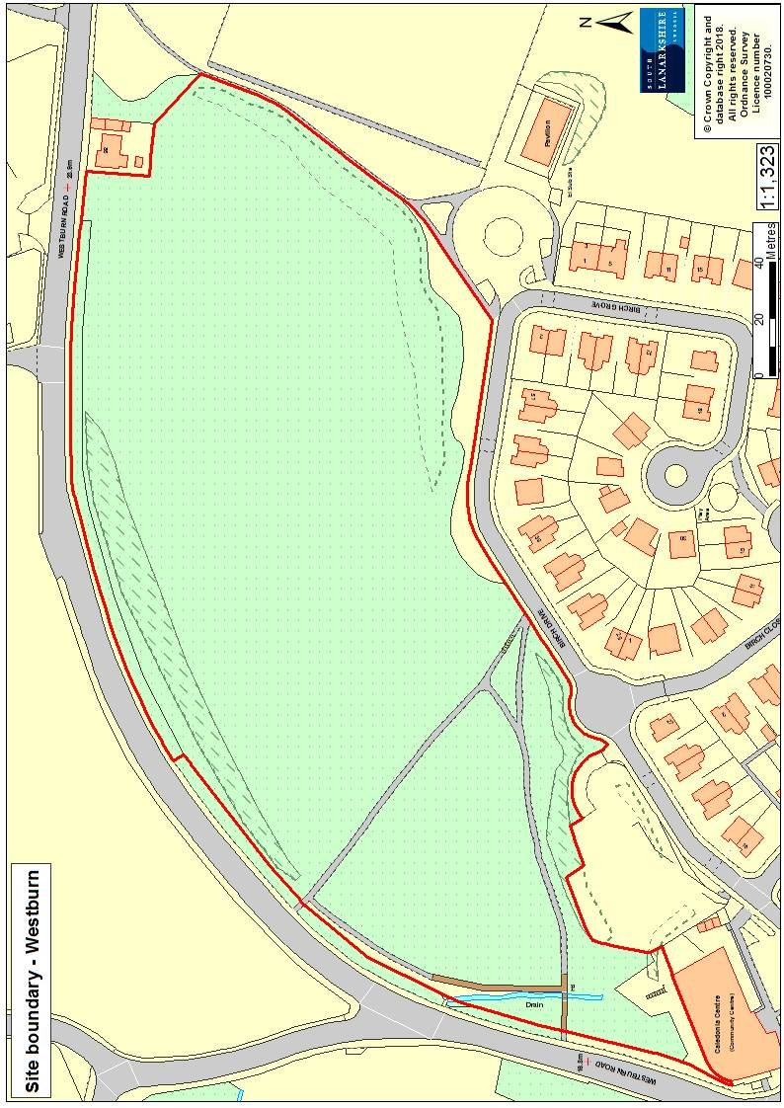
Habitats, flora and fauna
Habitat | Area (ha) | %
Semi natural broadleaved woodland | 2.11 | 51
Marshy grassland/swamp | 0.64 | 16
Semi improved neutral grassland | 0.68 | 16
Plantation woodland | 0.71 | 17
Total | 4.14 | 100

Westburn supports semi natural broadleaved woodland, plantation broadleaved woodland, open water, running water, marshy grassland, swamp and semi improved neutral grassland.
Wetland habitats cover the northern section of Westburn, with a large expanse of swamp vegetation dominated by reedmace with occasional pools of open water and marshy grassland. These areas support meadowsweet, reed canary grass, water mint, sharp flowered rush, jointed rush, soft rush and northern marsh orchid.
Broadleaved woodland dominates the boundary of the reserve, with a mixture of planted trees along the edges and more natural regeneration in the centre. Tree species include white willow, goat willow, birch, aspen, hazel, pedunculate oak, rowan and alder. High and drier ground to the south supports semi improved neutral grassland, dominated by Yorkshire fog with ribwort plantain, cock’s foot, common spotted orchid and the occasional hawthorn and birch. The edges of the site near the residential houses to the south support amenity grassland, with planted trees: mainly aspen, birch, white poplar and alder.
Running water flows along the West burn and can flood in wetter periods. The floral diversity of the open wetland and grasslands support numerous butterflies and other invertebrates, including green veined white, orange tip, small tortoiseshell and peacock. The areas of open ground within the reserve provide feeding opportunities for bats. Signs of roe deer were noted throughout the woodlands.

Landscape

Westburn is located to the east of Cambuslang. The residential communities of Westburn and Newton are to the south and east respectively. Westburn Road forms the northern boundary of the pLNR and separates the site from an industrial estate and areas of vacant and derelict land (Westburn Farm), which once housed the former steel works of Cambuslang. To the west is Cambuslang golf course, to the east are the formal recreation grounds of Peter Brownlee Park and Westburn cemetery. The south of the site is comprised of housing and a nursery.
Westburn is identified as a pLNCS for its wildlife interest, based on the Clyde Calders surveys from 1991. Other similar sites in the surrounding landscape include Westburn disused railway (NS654611) which connect this site with the Clyde Walkway and River Clyde. To the south are the woodlands of Borgie Glen and Cambuslang Park (NS644600), and Cairnshill (NS651595); and Newton West Bing to the east (NS666608). These sites are also identified as pLNCS and form a valuable woodland ecological network in this area.
In terms of wider greenspace network there are a number of woodlands and open greenspace to the east of Westburn, which eventually link to Cambuslang Park via the green network that follows the railway line. To the south of this is a large area of greenbelt land which separates Cambuslang from East Kilbride.

Cultural information
Past Land use
The National Libraries of Scotland maps from 1843 to 82 show Cambuslang Farm and Fram’s Folly (named after the person who built the farm outhouses) to the north of Westburn reserve. Westburn House and estate (1685) was located to the west, with associated grounds, walled garden, curling pond and dovecot. The house and farm were the property of John Graham Esq. of Craigallian who held lands in the parish since 1784. Graham also held estates and land in the surrounding landscape at Overton, Gilbertfield, Kirkhill and Chapel, so it is likely that he also owned the land of Westburn reserve.
Historical maps and aerial photographs show that the site has continuously supported agricultural land; Roy maps (1752 to 55) indicate farmland, with hedgerow and trees. Aerial photos from 1944 to 1950 show the land to be similar to the fields surrounding Westburn Farm. The Caledonian railway was located to the south, with the River Clyde and a corn mill to the north.
Later maps highlight Westburn colliery (1870s to 1905) located to the east of the site, with the mineral railway embankment forming the current eastern boundary of the pLNR. Westburn cemetery and a football ground are to the south east. Maps from the 1920s and 1930s show the Redpath Brown and Co steel works (1921), Hallside steel works (1903 to 1982) and power station (1903 to1982) to the north, which were once the main employers in the area.
Westburn house was demolished in the 1890s and the grounds are now home to Cambuslang golf course; the original octagonal dovecot survives on the golf course. Westburn farm and fields to the north with pumping windmill are now a go karting circuit. Little information can be found on the former name of “skin and hide” for the site, but information from the local community on social media recalls a tannery on the former Westburn Farm grounds around the 1980s.

Present land use
Locals currently use Westburn for informal recreation such as walking, exercising dogs, cycling and jogging. The neighbouring nursery has used the site for outdoor play. There have been problems with litter and small scale vandalism, which has impacted on the nursery school utilising the site fully.

Site infrastructure
There is a network of core paths throughout the site and along the surrounding pavements, linking the reserve to the local communities of Westburn, Cambuslang, Newton and Hallside. The footpaths and tracks are in various forms, from formal pavements to tarmac paths, with a few desire lines made by local walkers. There is a boardwalk over the West burn and steps to Birch Drive at the end of the main tarmac path running north south through the reserve. The paths within Westburn would benefit from maintenance work to encourage access throughout the site.

Recreation and access
Access to the site can be gained along Westburn Road to the north and from the south via Birch Drive. There are no formal car parking facilities, so parking is limited to the roads around the site. Pedestrian access can be gained along Westburn Road, Birch Drive and from Peter Brownlee Park. There are currently no interpretational facilities within the site and the reserve is not signposted from the surrounding roads. Access improvements should be made to highlight the site from the main roads, with the addition of signposts to highlight the path network. The paths within the site require maintenance and repair work. The tarmac paths are in reasonable condition, requiring some maintenance. The addition of paths to the east of the site would improve access throughout the reserve.
To the east of the site, Peter Brownlee Park supports more formal amenity areas for football and hockey. The Clyde Walkway is located along the river to the north of the site. The walkway connects Glasgow to the UNESCO World Heritage village of New Lanark in South Lanarkshire. Sustrans cycle route 74 connects to New Lanark, with route 75 linking to Uddingston and Edinburgh.
There are two train stations near to the site at Cambuslang (0.7 miles) and Newton (0.83 miles). There are bus stops on Westburn Road (0.1 mile) and along the A724 Hamilton Road (0.3 miles) to the south of the site.

Local community
There is currently no active community group associated with Westburn; a key objective of site management would be to engage with the local community.
Westburn nursery is adjacent to the site and the nearest primary schools are St Bride’s (0.85miles), Park view (1.97miles) and Cairn’s (1.7 miles); the nearest High schools are Trinity High (1.3 miles) and Stonelaw High (1.89 miles).

Conclusion
It is the intention of SLC’s Countryside and Greenspace team to work in partnership with the local community to ensure that the ecological quality of the reserve is maintained and managed. We aim to foster an understanding and facilitate the enjoyment of the natural heritage of the reserve, by improving access, interpretation, education and promotion of the site.
The management statement will meet these objectives by seeking to deliver a number of practical health, environmental education and community outcomes in partnership with external organisations and the local community.

Contacts
For more information on this site, or LNRs in South Lanarkshire, please contact:
Countryside and Greenspace Service, Facilities, Waste and Ground Services, Community and Enterprise, South Lanarkshire Council, 18 Forest Street, Blantyre G72 0JP.
Email: CAG@southlanarkshire.gov.uk
Photographs taken by J. Birkin.
Note that maps may not be to scale.

Appendix 1: Objectives and actions
Objective 1: maintain, enhance and monitor the biodiversity value of the reserve.
Actions:
- Maintain the woodland, wetland and grassland communities.
- Assess the wetlands in the northern section of the site, with the aim to create and maintain more permanent open pools of water throughout the year.
- Contribute to national and local monitoring schemes by recording natural history at the site.
- Maintain the site through appropriate management programmes and best practice.
- Investigate ability to diversify areas of open amenity grassland by altering the mowing regime.

Objective 2: maintain and increase the use of the access network.
Actions:
- Identify funding opportunities.
- Upgrade and maintain the main path running north to south and the boardwalk.
- Investigate the need for additional access routes
- Consider the installation of signage and interpretation panels

Objective 3: encourage and facilitate community involvement in the reserve.
Actions:
- Investigate the need for a community consultation to determine use of the site and potential improvements, in order to inform future management. Investigate the level of local interest in forming a community group for the reserve.
- Work with local people and other stakeholders towards meeting the objectives identified within the management plan.
- Encourage and promote the reserve for the local community and other interest groups.
- Investigate new ways of promoting the reserve.

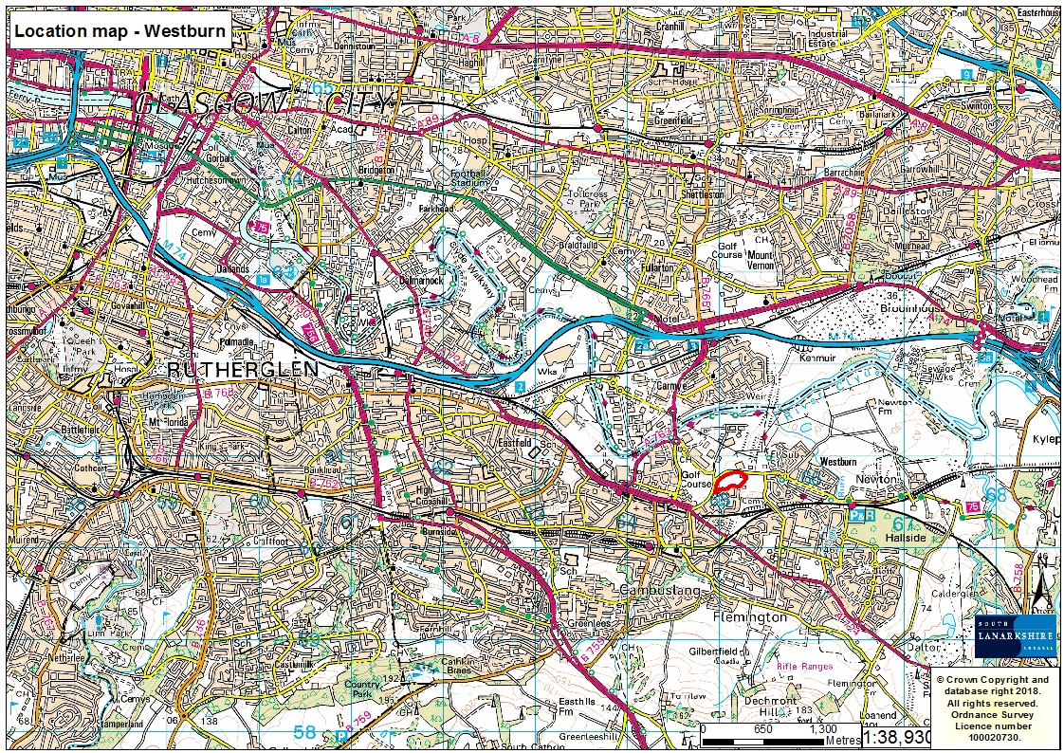
Appendix 2: Maps


