Holmhills Wood Community Park Local Nature Reserve Management Statement 2018
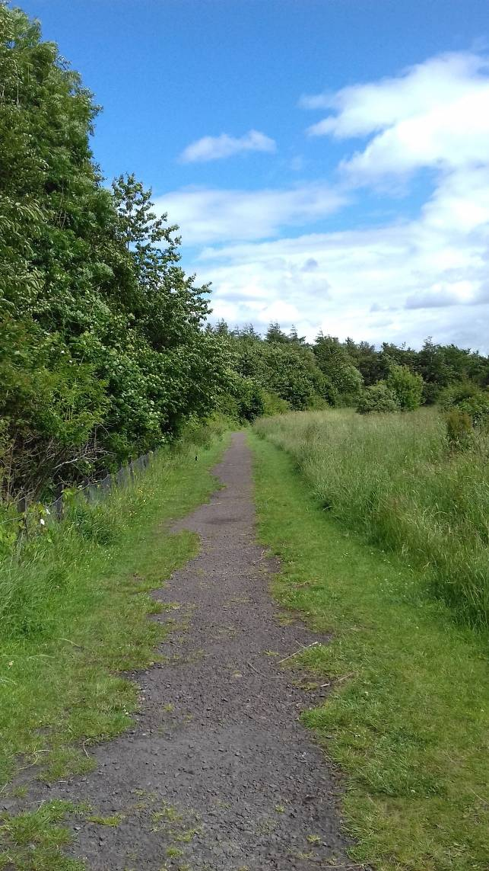
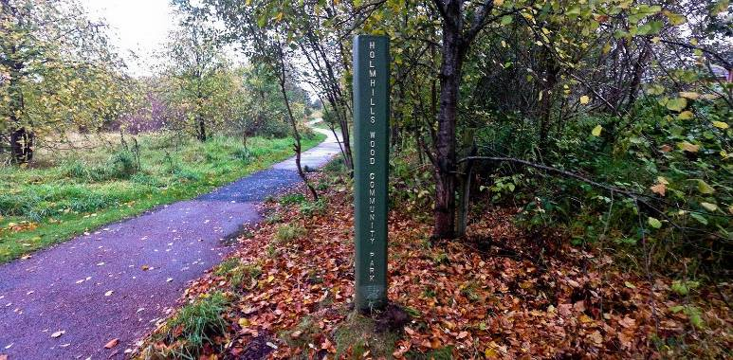

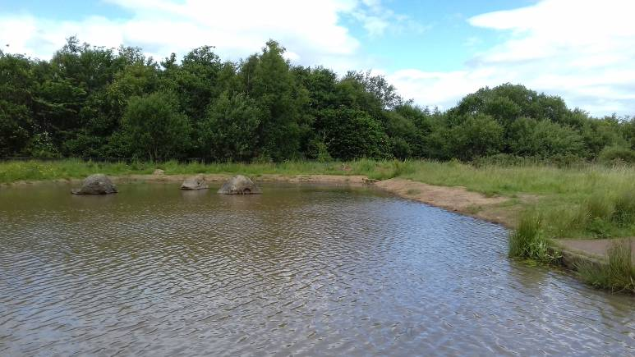

If you want this information in a different format or language, phone 0303 123 1015 or email equalities@southlanarkshire.gov.uk

Contents

Introduction
Vision statement
General information
Landscape
Cultural information
Site infrastructure
Recreation and access
Local community
Conclusion
Contacts
Appendix 1: Objectives and actions
Appendix 2: Maps

Introduction

heritage with opportunities for people to enjoy, learn about and experience nature close to their homes. LNRs are:

- Statutory designations made under the National Parks and Access to the Countryside Act 1949.
- Special places which are rich in wildlife.
- Generally, readily accessible and suitable for people to visit and enjoy.

In declaring these sites, South Lanarkshire Council (SLC) aims to:

- Protect them from unsuitable developments.
- Manage and enhance the habitats to help biodiversity flourish.
- Improve public access.
- Help people understand and become more aware of the importance of the LNR.
- Encourage community participation and volunteering.

SLC have identified sixteen new sites (and an extension to the existing LNR at Langlands Moss) to become designated as LNRs. These encompass a broad spectrum of habitats including ancient broadleaved woodland, open water, wetlands and grasslands. The site management statements are written in conjunction with the South Lanarkshire Biodiversity Strategy (2018 to 2022), SLC Sustainable Development and Climate Change Strategy (2017 to 22), SLC Local Development Plan (2013) and SLC Core Path Plan (2012).

Vision statement

Across South Lanarkshire, Local Nature Reserves are a resource for local communities that balance excellent recreational and educational opportunities with valuable habitats for wildlife that are rich in biodiversity.

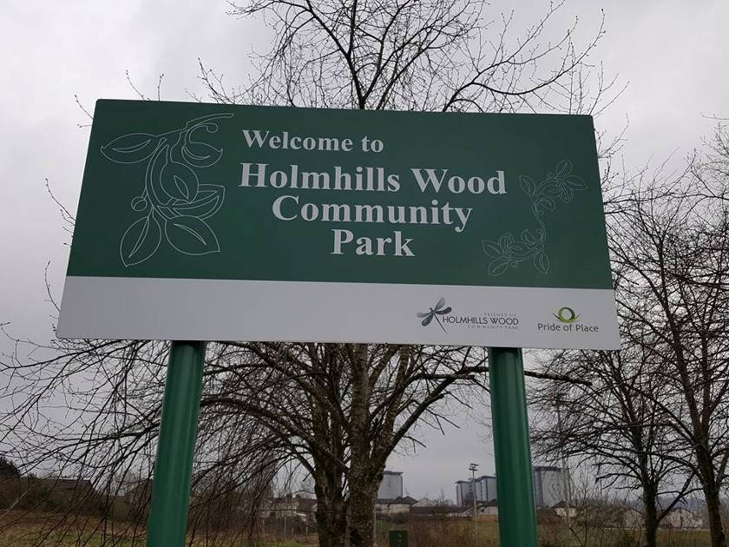
General information

Location and site boundaries
Holmhills Wood Community Park is located to the south of Cambuslang, on the south-east edge of Glasgow, in South Lanarkshire. The park lies 98 metres above sea level and offers panoramic views across Glasgow to the Campsie Fells and Ben Lomond. It is surrounded by urbanisation, but benefits from the presence of other nearby greenspaces and vacant land, notably Cambuslang Park. It is bounded by Greenlees Road to the east, Western Road to the south and Grenville Drive to the north. The site is listed as a potential Local Nature Conservation Site (pLNCS) under the name of Holmhills Plantation.

Site name: Holmhills Wood Community Park (HWCP)

Grid reference: NS 6393 5969

Site boundary area: 18ha

Current ownership and management: the boundaries of the park are based upon the extent of land owned by South Lanarkshire Council.

Site description
Holmhills Wood comprises areas of amenity grassland (playing fields), semi-improved neutral grassland, woodland, scrub and ponds. A network of paths, including those in the SLC core path network, runs through the site. Much of the present site, including the path infrastructure, pond creation and tree planting, was carried out in 2001.

The Park is well used for informal recreation and for access to local schools, transport and business in Cambuslang and its surrounding local communities.

Holmhills Wood appears on the OS First Edition six inch map (c1860) and on all subsequent maps but is absent from the Roy Military Survey of Scotland (1750s), suggesting that it was planted in the late 18th or early 19th century.

From the 18th century until the 1960s the area was farmland, under Whitlawburn Farm to the west and Holmhills Farm to the east. Hedgerows matching field boundaries from 19th century maps still exist. Agriculture ceased in the 1960s as the development of housing in the local area progressed, and the area remained undeveloped until 1999, when South Lanarkshire Council and Central Scotland Countryside Trust identified the land as a priority for a community park. Infrastructure works took place between 1999 and 2001 to create the Park in its present form.

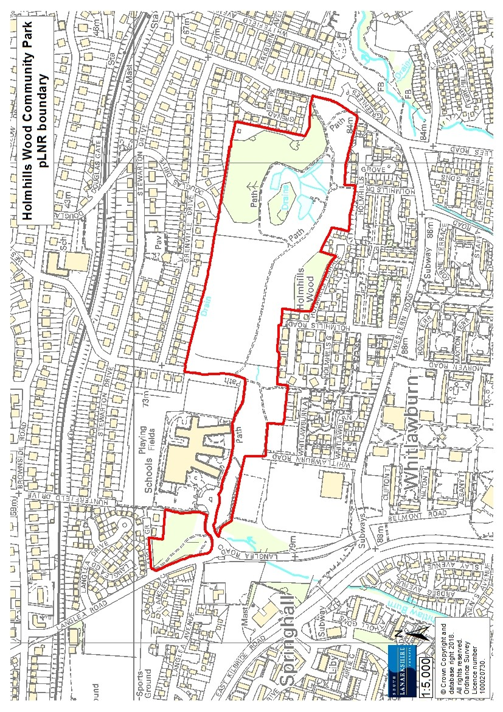
The Friends of Holmhills Wood community group formed in 2012 and is actively involved in the management of the park. Working in partnership with the South Lanarkshire Countryside and Greenspace team, the Friends run public activities and events. The group have fostered links with the local secondary and ASN (additional support needs) schools and other local volunteer and third sector groups and spend many volunteer hours on practical conservation and monitoring.

Habitats, flora and fauna

A range of habitats exist within Holmhills Wood Community Park. The dominant landscape feature is grassland (8 ha), although the amenity grassland is of low biodiversity value. A small area (2.7 ha) of neutral semi-improved grassland is high in diversity, with common spotted orchid (Dactylorrhiza fuchsia) locally frequent.

The woodland habitats are predominantly broadleaved and mixed plantation dating from the 1990s/2000. Native species dominate, including birch, oak, wych elm, alder, willow, cherry and rowan. The shrub layer hosts bramble, holly and hawthorn, with grasses, wood avens, speedwell, ferns, ivy and wood anemone present in the ground layer.

Holmhills Wood appears on OS maps from the 18th century and marks the highest point on the site. The canopy here comprises Scots pine, beech, sycamore, horse chestnut, oak and elm. Sycamore and ash regeneration and large bramble patches form the understorey, with ivy on the ground. Hawthorn and willow lead into scrub beyond. At the lower end of Holmhills Wood rowan, hawthorn, birch, elder and willow are present, along with standing and fallen dead wood, with several fungi species present. This area offers an important habitat for a variety of invertebrates that is not present in the rest of the HWCP. Due to the proximity of housing, this part of the site suffers from human impact in the form of fly-tipping and vandalism.

Two hedgerows matching field boundaries from 19th century maps are present, comprising hawthorn, ash, sycamore, elder, crab apple and bramble. While maintenance lapsed, probably in the 1960s, these provide shelter and food for birds and small mammals.

Areas of scrub are present across HWCP, providing important connectivity between the other habitats within the site. They are formed mainly of birch, willow, ash, gorse, broom, bramble and rose species. Willowherb, creeping thistle, dock, ragwort and ladies mantle are among the plants present. Common sedge and smooth rush appear in the wetter areas.

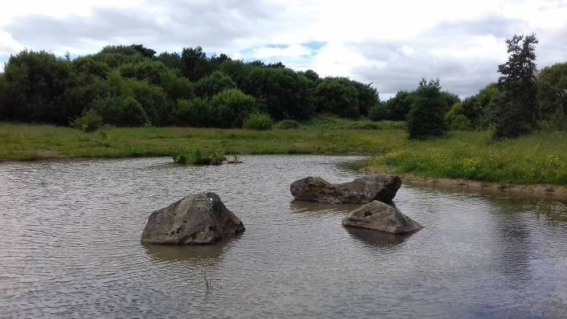
In 2016 as part of Froglife’s Living Waters project, the three ponds at Holmhills were restored, resulting in cleared ponds with permanent open water. Originally created around 2000, the ponds had become choked with vegetation, mainly bulrush and reed canary grass, resulting in less than 25% opens water in each. The ponds have been cleared of silt and vegetation and reprofiled for the benefit of amphibians. Some planting of water mint, water forget-me-not and rushes, and seeding with wildflower mixes (N7F and N8F) was undertaken. The presence of the invasive pondweed Crassula helmsii was noted prior to pond restoration and has been monitored since. A pond management plan was produced by Froglife in 2017.

A variety of fauna has been recorded on site, including 26 species of bird, fox, roe deer, common pipistrelle bat, and soprano pipistrelle bat. Common frog, common toad, smooth newt and common newt breed in the ponds.

Additional surveys carried out on site include:
- A preliminary tree assessment in August 2015 identified 32 tree species (not including willows).
- A Phase I Habitat Survey in August/September 2015 identified 178 plant species, including trees, higher plants and ferns.
- A wildlife site assessment by the Scottish Wildlife Trust in September 2000.

Landscape
The dominant landscape feature within HWCP is grassland. The majority of this is amenity grassland, with smaller areas of more diverse neutral semi-improved grassland succeeding into scrub. Broadleaved and mixed plantation woodland, ponds and wetland make up the remainder of the site. The adjacent landscape comprises residential areas of Cambuslang to the north, Whitlawburn to the south and Cathkin to the west. For the wider greenspace network, Cambuslang Park and Borgie Glen to the east offers connectivity with local burn networks to the adjacent local greenspaces and countryside, golf courses at Cambuslang and Kirkhill and nearby Cathkin Braes.

Cultural information
Past land use
HWCP was agricultural farmland from the 18th century until the 1960s, with most of the site managed under Whitlawburn Farm to the west and Holmhills Farm to the east. Whitlawburn Farm had formal gardens and an orchard, none of which has survived. Stonework by Langlea Road is possibly a remnant of farm buildings. The farm was sold to Lanark County Council in the 1960s when residential development began nearby. Holmhills Farm was also sold to the Council in the 1960s, with part of the land used as a Council plant nursery until the late 1990s before being sold off. The housing at Grenadier Park occupies the site of the former nursery. Coal mining was a major industry in the area and, although there were no mines on the site, it is believed to have suffered from previous shallow mineworking. In 1999, the site that is now HWCP was identified as a potential community woodland site to benefit both wildlife and the local community.

Present land use
A community consultation and public meeting were carried out in June 1999 by Central Scotland Countryside Trust to establish local needs, aspirations and preferences. A further consultation took place in autumn 2000, and a community action plan was developed. This informed the development and infrastructure of the site as it exists now and led to the employment of a dedicated Community Development Officer. The site is currently overseen by South Lanarkshire Council’s Countryside and Greenspace Service, with SLC Grounds Services providing routine grass cutting and litter picking.

Site infrastructure
HWCP contains approximately 2,875m of core and wider access network paths. The formal footpath infrastructure was installed by Ironside Farrar Ltd in the early 2000s. There are two hard stands for pond dipping at the large pond and fencing around the plantation woodland to the north-east of the site. Litter bins are located at the entrances to the park and at the large pond. Steel signposts are located at the entrances. Street lighting exists on part of the main tarmac path between Cathkin High School and Greenlees Road. The Friends of Holmhills Wood have raised funds for the installation of a bench at the viewpoint and carved wooden mushroom seating at the large pond. Grass cutting and maintenance is carried out by SLC Land Services.

Recreation and access

The boundaries of the proposed LNR are based on the extent of land owned by South Lanarkshire Council. There is no car park attached to the site; however, street parking is freely available. Located to the south of Cambuslang (population of 24,500), Holmhills Wood Community Park provides a recreational resource for the local community.

Local community
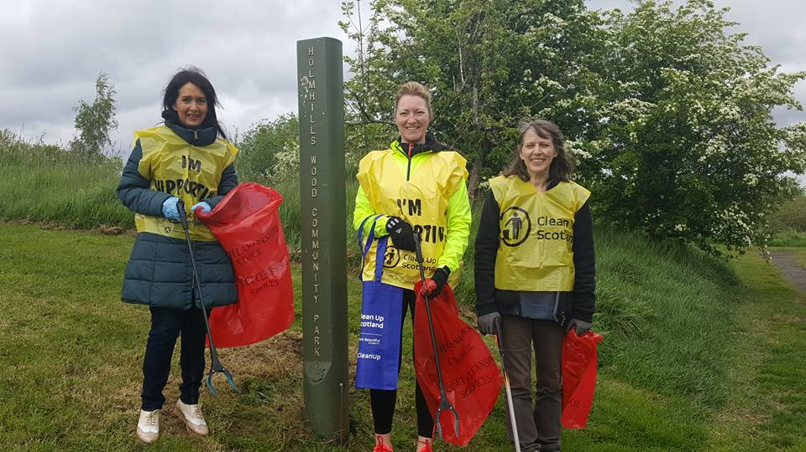
The Friends of Holmhills Wood is a sub-group of Cambuslang Community Council, and was formed in 2012 to promote the responsible use and enjoyment of the site. They meet every second month and have an active social media presence. With good infrastructure already in place, the Friends seek funding to allow them to run public events and purchase equipment for use with local schools, nurseries and other organisations. Rutherglen High School (ASN) uses the site for John Muir Award, while Cathkin High School utilises the area for various curriculum-related activities. Project 31, a local voluntary youth organisation, uses the woodland for Forest School sessions and other outdoor activities. Independent outdoor activity organisations and commercial dog walkers also use the area regularly. The Friends, along with SLC Countryside Ranger Service, offer events and activities throughout the year to the local community.

Conclusion

It is the intention of SLC’s Countryside and Greenspace team to work in partnership with the Friends of Holmhills Wood Community Park to ensure that the ecological quality of the park, especially areas of woodland and ponds, are maintained and managed, to foster an understanding and facilitate enjoyment of the natural heritage of the park and to increase public use through improved access, interpretation, education and promotion of the site.

The management plan will meet these objectives by seeking to deliver, in partnership a number of practical health, environmental education and community outcomes.

For more information on this site, or LNRs in South Lanarkshire, please contact:
Countryside and Greenspace Service, Facilities, Waste and Ground Services, Community and Enterprise, South Lanarkshire Council, 18 Forest Street, Blantyre G72 0JP.
Email: CAG@southlanarkshire.gov.uk

Photographs taken by J. Birkin, A Boyd.
Note that maps may not be to scale.

Appendix 1: Objectives and actions

Objective 1: Maintain, enhance and monitor the biodiversity value of the reserve.
Actions:
- To maintain and enhance the natural biodiversity of the park through appropriate management programmes and best practice.
- Encourage diversification of the amenity grassland areas by reducing the mowing regime
- Aim to manage the woodland areas to support a full range of age classes, including deadwood and dying trees.
- Manage ponds for the benefit of amphibians.
- Contribute data to national and local monitoring schemes, for example Bat Conservation Trust, British Trust for Ornithology and Butterfly Conservation.

Objective 2: Maintain and increase the use of the access network.
Actions:
- Identify funding opportunities.
- Improve and maintain paths and entrance points.
- Improve signage and on-site interpretation.
- Encourage and promote use of the park for the local community, schools, youth groups and other interested groups.

Objective 3: Encourage and facilitate community involvement in the reserve.
Actions:
- Identify and promote opportunities for people to enjoy the wildlife of the park.
- Provide support to the community group.
- Raise awareness of the park for the local community.
- Promote the site to specialist interest groups.
- Investigate possibilities of promoting the park in new and different ways.
- Monitor and assess visitor numbers to the site.
- Investigate effectiveness of any promotion.

Objective 4: Investigate ways of improving the park’s ecological, connectivity and accessibility, as a key link in South Lanarkshire’s Strategic Green Network.
Actions:
- Investigate other routes used by the local community within and outwith the park.
- Investigate the possibility of linking Holmhills Community Woodland Park to other greenspaces and wider network of paths in the surrounding landscape.
- Investigate the need for an interpretative publication showing the site and points of interest within and nearby.

Appendix 2: Maps
Map 1: Location of Holmhills Wood Community Park
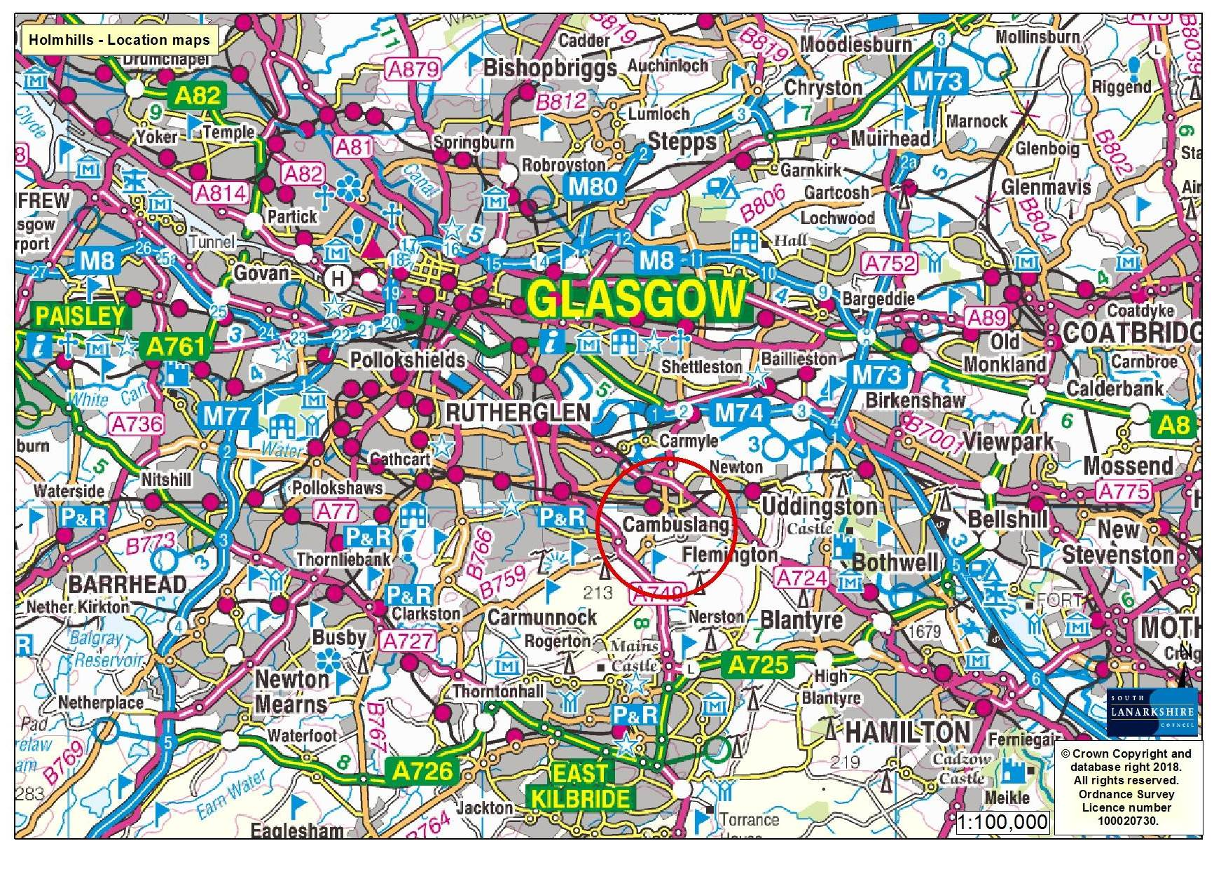

Map 2: Location of Holmhills Wood Community Park

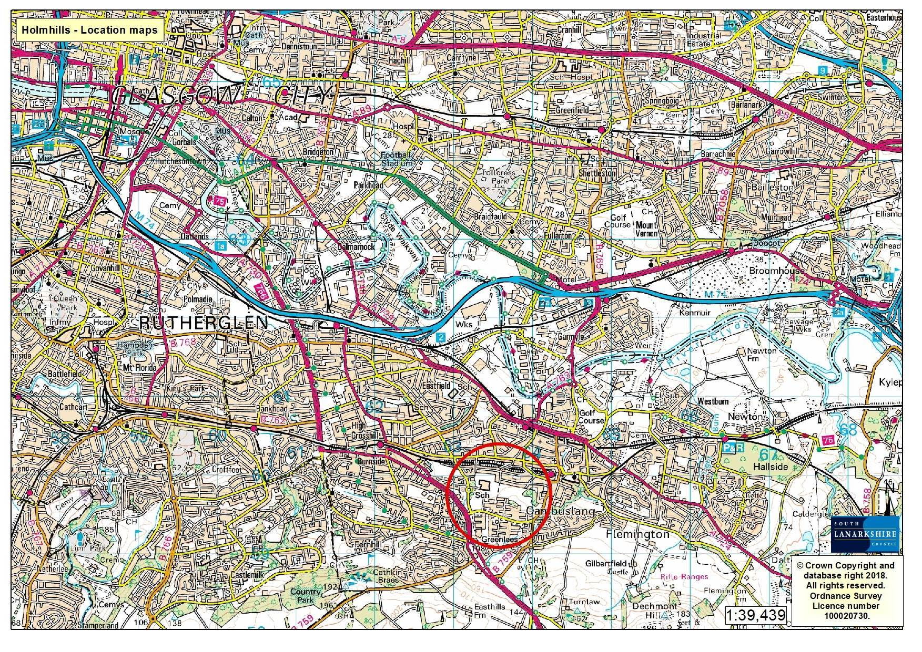

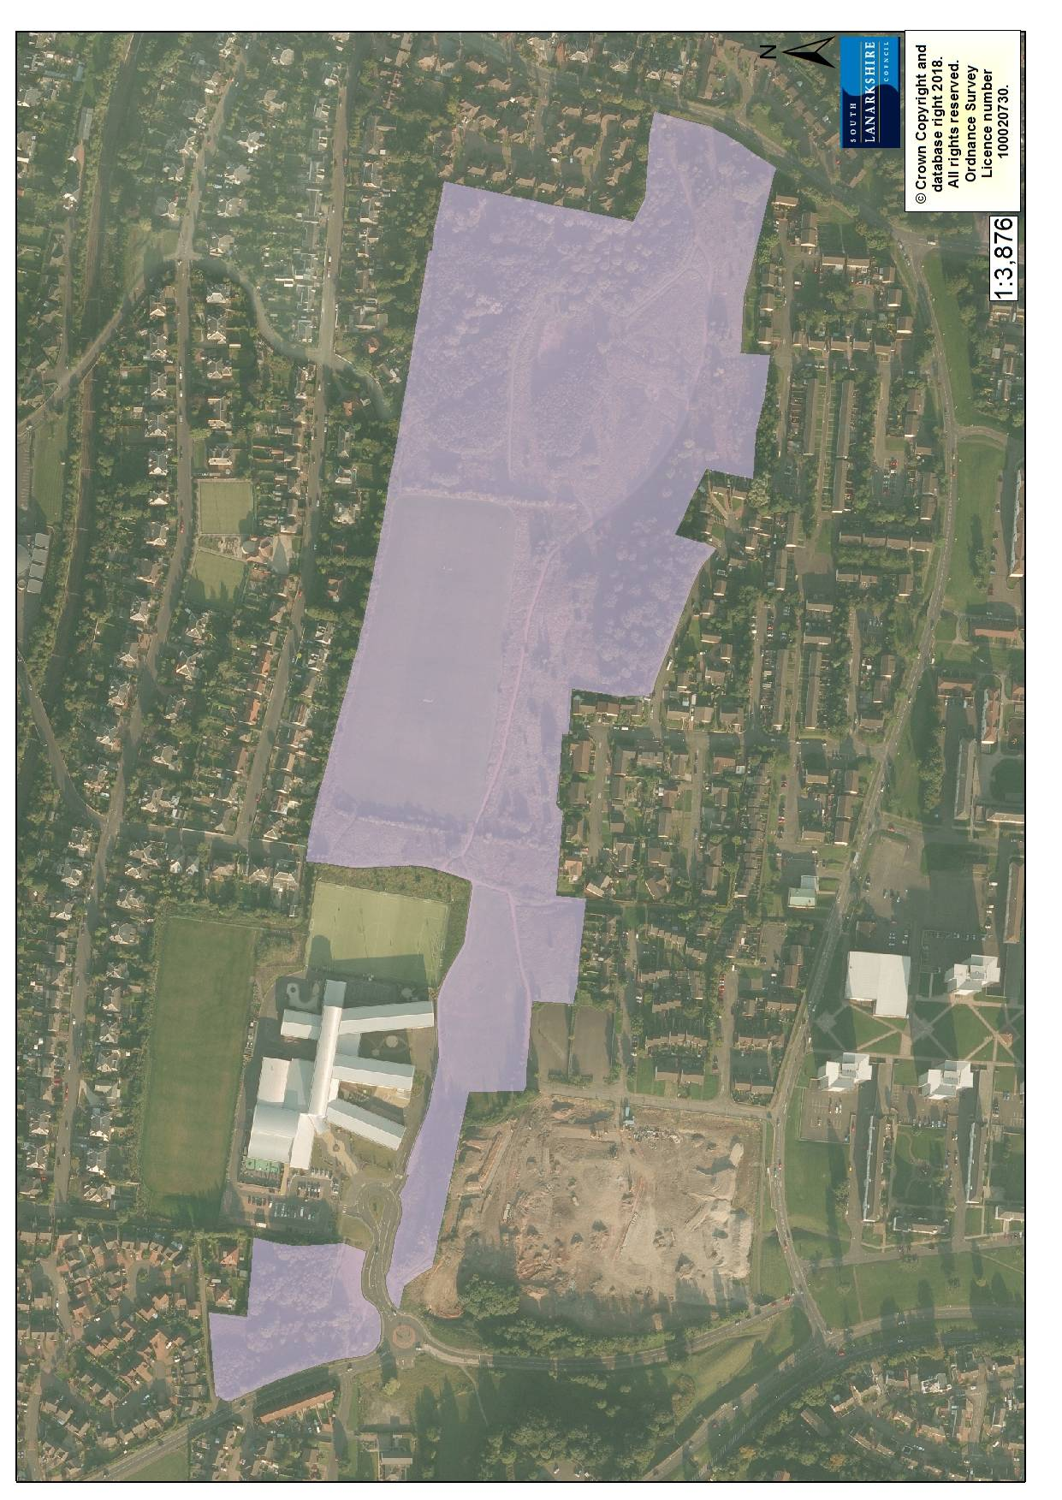
Map 3: Aerial photograph

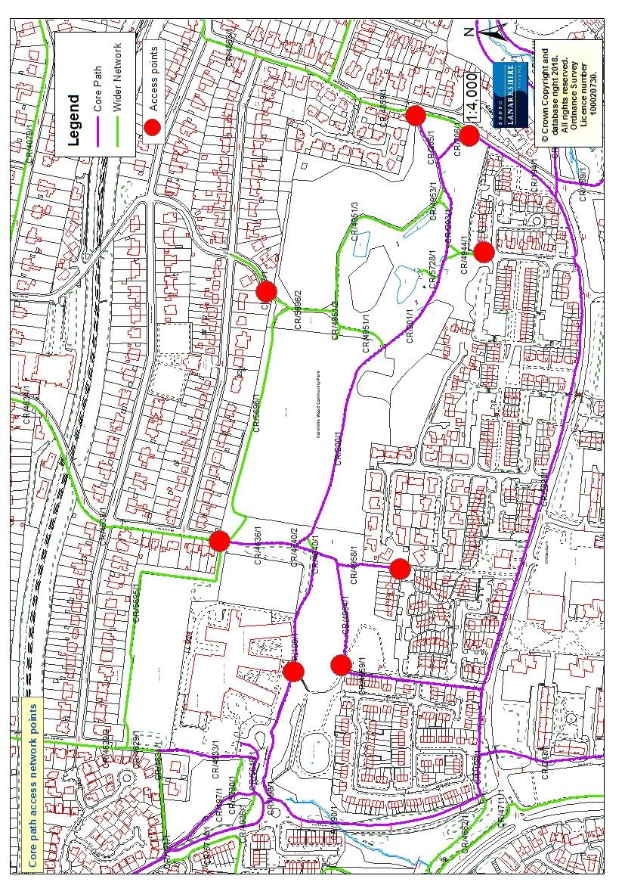
Map 4: Existing access network

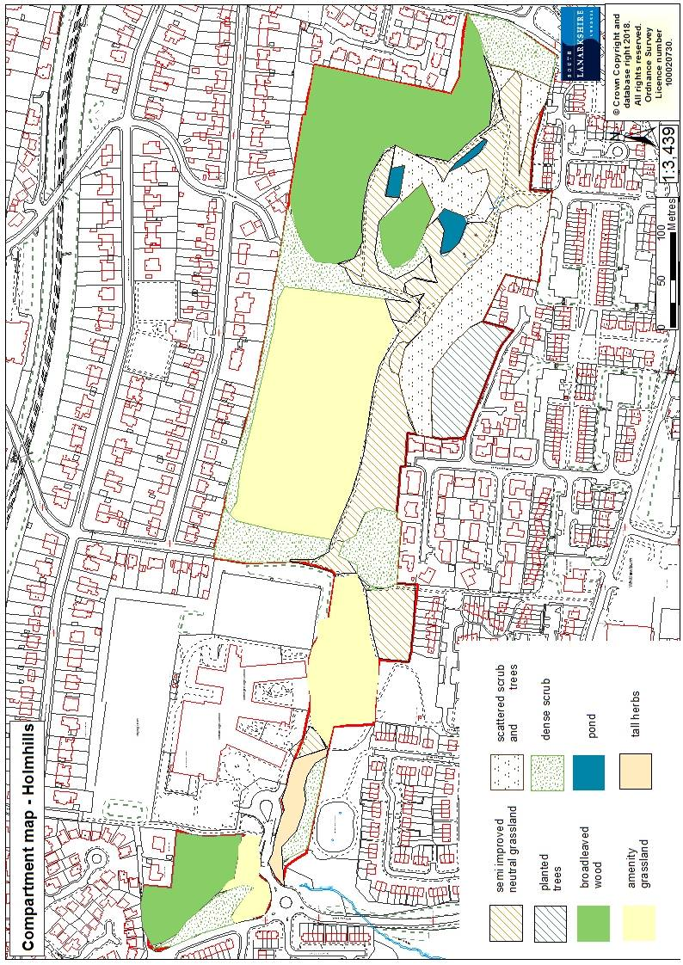
Map 5: Habitat compartmen

