Jock’s Burn Local Nature Reserve Management Statement 2018
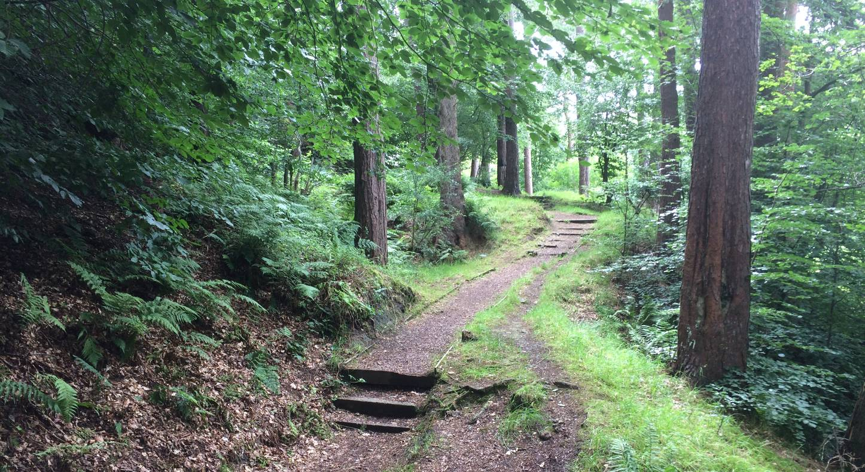

If you want this information in a different format or language, phone 0303 123 1015 or email equalities@southlanarkshire.gov.uk

Content

Introduction
Vision statement
General information
Landscape
Cultural information
Site infrastructure
Recreation and access
Local community
Conclusion
Contacts
Appendix 1: Objectives and actions
Appendix 2: Maps

Introduction
heritage with opportunities for people to enjoy, learn about and experience nature close to their homes. LNRs are:

- Statutory designations made under the National Parks and Access to the Countryside Act 1949.
- Special places which are rich in wildlife.
- Generally, readily accessible and suitable for people to visit and enjoy.

In declaring these sites, South Lanarkshire Council (SLC) aims to:

- Protect them from unsuitable developments.
- Manage and enhance the habitats to help biodiversity flourish.
- Improve public access.
- Help people understand and become more aware of the importance of the LNR.
- Encourage community participation and volunteering.

SLC have identified sixteen new sites (and an extension to the existing LNR at Langlands Moss) to become designated as LNRs. These encompass a broad spectrum of habitats including ancient broadleaved woodland, open water, wetlands and grasslands. The site management statements are written in conjunction with the South Lanarkshire Biodiversity Strategy (2018 to 2022), SLC Sustainable Development and Climate Change Strategy (2017 to 22), SLC Local Development Plan (2013) and SLC Core Path Plan (2012).

Vision statement
Across South Lanarkshire, Local Nature Reserves are a resource for local communities that balance excellent recreational and educational opportunities with valuable habitats for wildlife that are rich in biodiversity.

General information
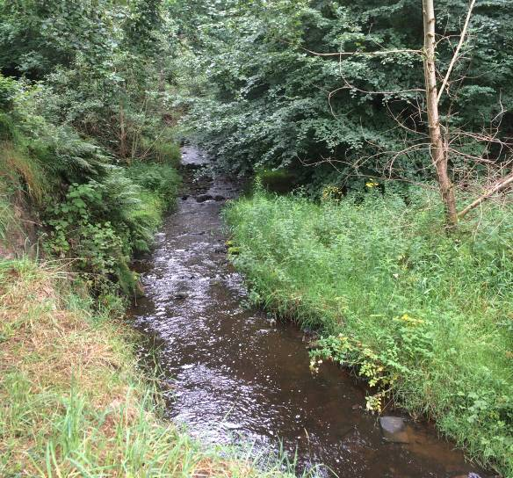
Location and site boundaries: Jock’s Burn proposed LNR is located in the centre of the town of Carluke in South Lanarkshire. The reserve is surrounded by residential housing, a public amenity park, Crawforddyke Primary School and playing fields. Glenafeoch Road runs through the centre of the reserve separating the two sections of woodland.

Site name: Jock’s Burn.

Grid reference: NS 85678 50186 (east section); NS 85123 50255 (west section).

Site boundary area: 7.84 ha.

Current ownership and management: the boundary of the reserve is based upon the extent of land owned by SLC.

Site description: Jock’s Burn flows through the centre of Carluke and eventually reaches the River Clyde at Rosebank, approximately two miles to the west of the pLNR. A key habitat is the riparian zone along the Jock’s Burn which provides a natural wildlife corridor through the adjacent residential developments. The banks of the burn support a mixture of native broadleaved species with planted conifer trees. The ground layer is abundant with a variety of ferns.

Other habitats found at the reserve include a dense stand of planted conifer in the far eastern section of the reserve and amenity grassland, which separates the woodland from the surrounding residential development.

Of high importance is the location of Jock’s burn within the landscape in relation to it urban setting. The woodland provides a valuable break in the urban landscape and together with neighbouring woodland and riparian habitats, forms a vital link and wildlife corridor to the surrounding countryside.

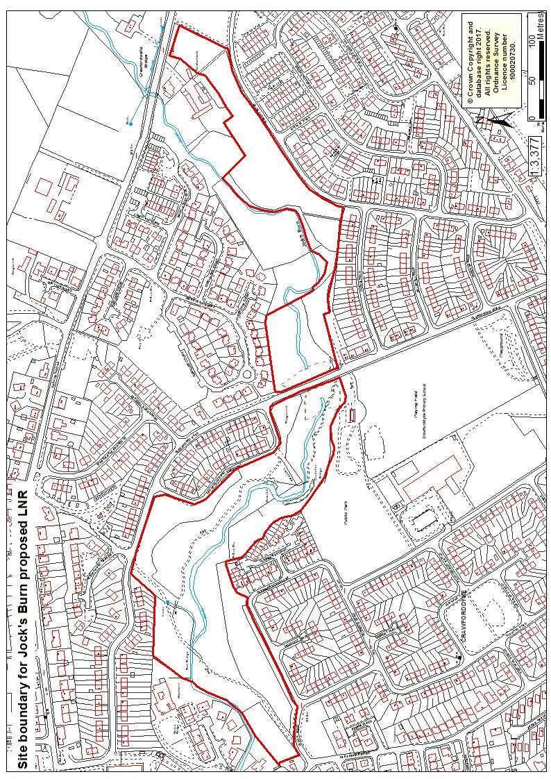

Habitats, flora and fauna
Habitat | Area (Ha) | %
Mixed woodland | 4.40 | 56
Planted conifer woodland | 1.61 | 21
Broadleaved wood | 0.70 | 9
Amenity grassland | 0.94 | 12
Tall ruderals | 0.19 | 2
Total | 7.84 | 100

The banks of the Jock’s Burn support mainly mixed broadleaved woodland with planted conifer trees. The woodland comprises mature semi-natural broadleaved woodland, with Scots pine and larch. Tree species observed within the woodland include ash, oak, rowan, beech, sycamore and hawthorn. The ground flora includes sanicle, wood avens, wild strawberry, bluebell, figwort, herb Robert, honeysuckle, wood sorrel, enchanter’s nightshade and ladies mantle. An abundance of ferns grow throughout the woodland including lady, male, hard shield and broad-buckler.

Spanish bluebells and snowberry were noted at the site; these non-native species have the capacity to continue to spread and threaten the integrity and character of the woodlands through competition with native ground flora and understorey species. It would be necessary to monitor the location and spread of these species with the aim to minimise their risk.

The reserve is divided into two parts by Glenafeoch Road; Jock’s burn is culverted under this main road. The eastern section is dominated by a dense stand of planted conifer trees, which supports very little ground vegetation. This part of the reserve supports tall ruderal vegetation along the banks of the burn and a mature, diverse hedgerow with hawthorn, beech and the occasional rowan along Ramage Road.

Other habitats within the proposed reserve include open areas of amenity grassland supporting Yorkshire fog, creeping buttercup, ladies mantle, red and white clover, selfheal and common spotted orchids. Planted trees and shrubs include blackthorn, privet, cherry, maple and apple. The open water of Jock’s Burn provides suitable habitat for wetter vegetation including patches of meadowsweet, soft rush, with the occasional marsh thistle and hart’s tongue fern. Dipper and grey wagtail have been observed in the burn, with signs of roe deer noted throughout the woodland

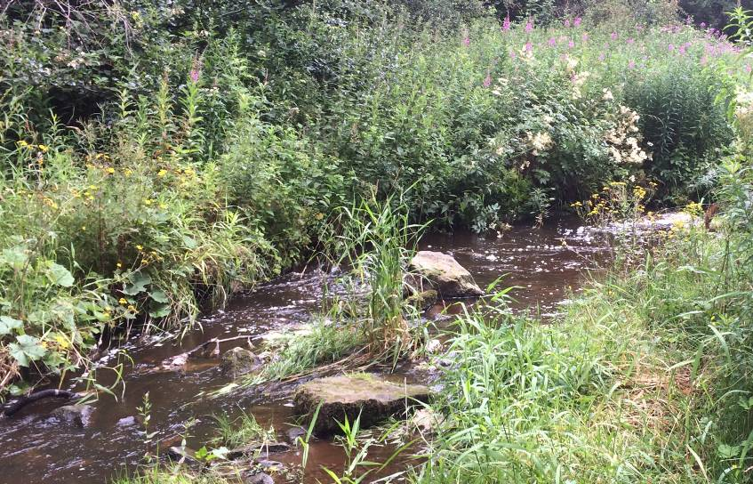

Landscape
Jock’s Burn runs through the centre of the town of Carluke in South Lanarkshire. The area proposed as a LNR supports a mixture of broadleaved and planted coniferous woodland. The site currently has no formal conservation designation but does provide an important wildlife corridor in a residential setting.

Jock’s Burn itself flows west through Carluke into Jock’s Gill which is designated as a Site of Special Scientific Interest (SSSI) before reaching the River Clyde. Jock’s Gill woodland (NS820501) is one of the largest (55.6ha) remaining areas of semi-natural gorge woodland within South Lanarkshire, supporting oak, ash, elm, bird’s nest orchids and broad-leaved helleborine (1.6 miles from the pLNR). To the south of Jock’s Gill lies Milton Lockhart wood (1.8 miles away: NS814496) which is also a SSSI, designated for its invertebrate assemblage. Both SSSI sites are part of the Clyde Valley Woodland Special Area of Conservation (SAC).
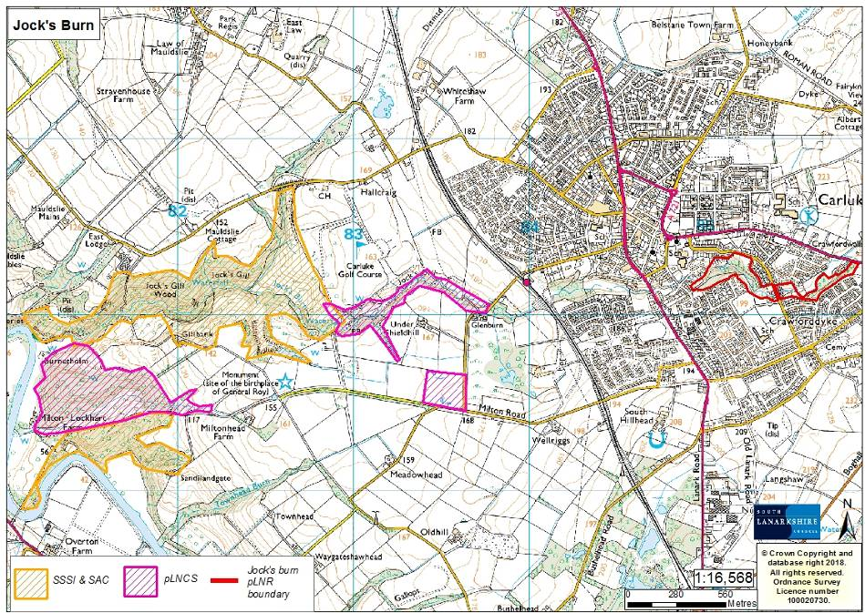

Nearby sites notes as potential Local Nature Conservation Sites (pLNCS) include:
- Upper Jock’s Gill and Jock’s Burn: NS830499 (0.7 miles)
- Undershieldhill marsh: NS835495 (0.9 miles)
- Townhead burn: NS824489 (1.4 miles)
- Upper Gillsburn: NS830484 (1.4 miles)

Cultural information
Past Land use

The Ordnance Survey maps of the surrounding area from 1888 to 1913 (available online from the National Library of Scotland) show Carluke to be a small agricultural parish stretching from the banks of the River Clyde to the lower uplands of Lanarkshire. At this time Jock’s burn is surrounded by agricultural land, with the occasional patch of trees and marshland. Buildings in the nearby landscape included Crawfordwall farm to the east and Oldbridge End School and Manse to the west of the burn. Maps dated 1913 show a similar picture of landscape, but with the addition of planted conifer trees to the north and west of the burn.

Carluke was chartered as a Royal Burgh in 1662 and by 1695 parish records report six families living in the area. By the 1800s the population had risen to 380 and the main industries were weaving and farming. The town exploded onto the map several years later with the building of the Glasgow to Carlisle trunk road and a train station. Over the next two centuries Carluke became a prosperous town through corn milling, cotton weaving, coal mining and the manufacture of bricks, glass, confectionery and jam. Maps from the 1940s to 1960s show housing developments to the west and northeast of Jock’s Burn with footpaths linking the two housing estates along the banks of the burn.

Present land use
The site is well known and used by the surrounding residents and local community of Carluke. The main use of the site is informal recreation and leisure pursuits for example walking, dog walking, jogging and cycling. The wood is an important route that links the communities to local amenities and transport. The woodland has numerous entrance points with accessible paths throughout and is adjacent to two schools and a play park.

Present land use
The site is well known and used by the surrounding residents and local community of Carluke. The main use of the site is informal recreation and leisure pursuits for example walking, dog walking, jogging and cycling. The wood is an important route that links the communities to local amenities and transport. The woodland has numerous entrance points with accessible paths throughout and is adjacent to two schools and a play park.

Site infrastructure
The site contains approximately 994 metres of wider network paths throughout the woodland and amenity grassland. The path in the western half of the site runs along the banks of Jock’s burn and is generally in good condition. Access in the eastern section of the reserve is mainly along roadside pavements, but there are a few paths and desire lines which require upgrading to improve access. There are two footbridges over Jock’s Burn and one bridge over another small burn within the site.

Recreation and access
Parking is available along the road network around the proposed reserve; there are no formal car parking facilities. Access can be gained on foot along Lagan Road and Ramage Road along the southern edge. To the north there are entrances along Glenafeoch Road and Carnwarth Road. There is no on site interpretation and Jock’s burn is not signposted from the network of roads around the site. Access improvements would highlight access points to the site from the main roads. The addition of interpretation signs to highlight the network of paths, biological and historical interest would be beneficial.

The site is 0.82 miles from the Carluke train station to the west of the reserve. Bus number 47 (Carluke circular route) regularly passes the entrances along Lagan Road and Glenafeoch Road. Buses to Hamilton and Glasgow are found along Lanark Road.

Local community
There is currently no active community group associated with Jock’s burn, however, there has been a few community events run by The Clyde and Avon Valley Landscape Partnership (CAVLP). A range of different activities were organised to allow as many community members as possible to join in. The sessions were managed by Clydesdale Community Initiatives (CCI) in partnership with Heritage Lottery Fund supported CAVLP. The work focused on de-littering, clearing debris from the burn, and tidying up and repairing some of the steps along the main pathway.

The CAVLP “Make Your Way” arts, heritage and active travel campaign team have delivered complimentary activities alongside the environmental volunteering activities. This project also worked with school children to highlight how Jock’s Burn could be used for outdoor learning, producing maps and developing signage to highlight it as a local greenspace as part of a wider walking and cycling network.

There are a number of schools near Jock’s Burn:
- St. Athanasius Primary and Nursery (0.2 miles)
- Crawforddykes Primary (0.1 miles)
- St Mary’s Primary (0.1 miles)
- Carluke High school (0.4 miles)

Conclusion
It is the intention of SLC’s Countryside and Greenspace team to work in partnership with the local community to ensure that the ecological quality of the reserve is maintained and managed. We aim to foster an understanding and facilitate the enjoyment of the natural heritage of the reserve, by improving access, interpretation, education and promotion of the site.

The management statement will meet these objectives by seeking to deliver a number of practical health, environmental education and community outcomes in partnership with other organisations and the local community.

Contacts
For more information on this site, or LNRs in South Lanarkshire, please contact:
Countryside and Greenspace Service, Facilities, Waste and Ground Services, Community and Enterprise, South Lanarkshire Council, 18 Forest Street, Blantyre G72 0JP.
Email: CAG@southlanarkshire.gov.uk

Photographs taken by J. Birkin.
Note that maps may not be to scale.

Appendix 1: Objectives and actions

Objective 1: maintain, enhance and monitor the biodiversity value of the reserve.
Actions:
- Remove the block of planted conifer trees to the east of the reserve and allow conversion to native woodland.
- Maintain and increase woodland diversity and structure where appropriate to give a range of age classes of tree and representation of dead wood.
- Investigate the opportunity to diversify the open grassland communities by amending mowing regimes.
- Contribute to national and local biological recording and other monitoring schemes.
- Maintain and enhance the natural biodiversity of the proposed LNR through appropriate management programmes and best practice.

Objective 2: to maintain and increase the use of the access network.
Actions:
- Identify funding opportunities.
- Upgrade and maintain the existing access routes throughout the reserve.
- Investigate the potential to connect the two parts of the reserve and incorporate some desire lines into formal paths.
- Investigate the opportunity to use signage to highlight access points and routes to the reserve, as well as interpretation.

Objective 3: To encourage and facilitate community involvement in the reserve.
Actions:
- Develop community involvement within the site.
- Investigate and develop opportunities for conservation volunteering.
- Work with local people and other stakeholders towards meeting the objectives of the management plan.
- Identify and promote opportunities for people to enjoy the wildlife of the area.
- Investigate possibilities of promoting the reserve in new and different ways.
- Encourage and promote the use of the reserve for the local community, schools, colleges and other interest groups.

Appendix 2: Maps



