Milton Tile Works Local Nature Reserve Management Statement 2018

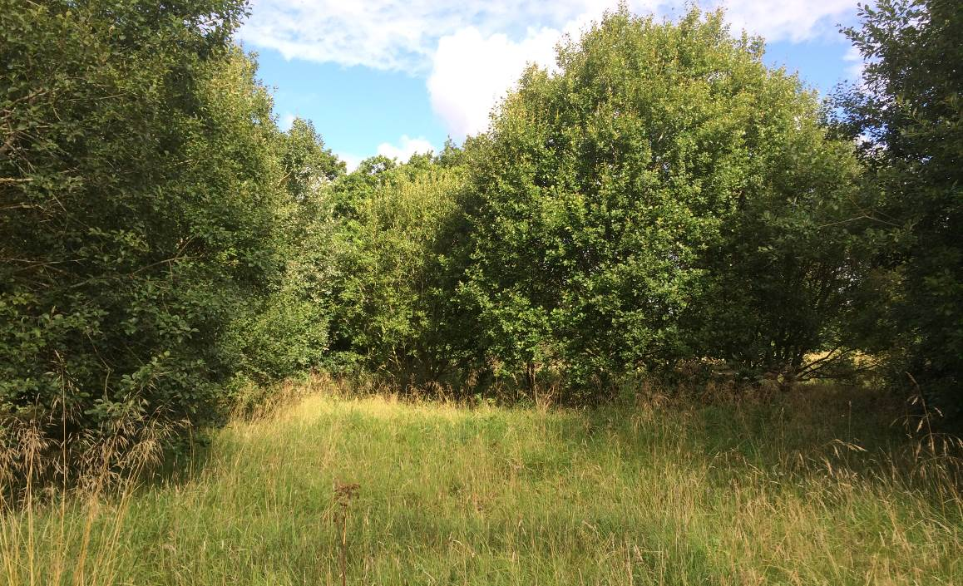

If you want this information in a different format or language, phone 0303 123 1015 or email equalities@southlanarkshire.gov.uk

Contents

Introduction
Vision statement
General information
Landscape
Cultural information
Site infrastructure
Recreation and access
Local community
Conclusion
Contacts
Appendix 1: Objectives and actions
Appendix 2: Maps

Introduction
heritage with opportunities for people to enjoy, learn about and experience nature close to their homes. LNRs are:

- Statutory designations made under the National Parks and Access to the Countryside Act 1949.
- Special places which are rich in wildlife.
- Generally, readily accessible and suitable for people to visit and enjoy.

In declaring these sites, South Lanarkshire Council (SLC) aims to:

- Protect them from unsuitable developments.
- Manage and enhance the habitats to help biodiversity flourish.
- Improve public access.
- Help people understand and become more aware of the importance of the LNR.
- Encourage community participation and volunteering.

SLC have identified sixteen new sites (and an extension to the existing LNR at Langlands Moss) to become designated as LNRs. These encompass a broad spectrum of habitats including ancient broadleaved woodland, open water, wetlands and grasslands. The site management statements are written in conjunction with the South Lanarkshire Biodiversity Strategy (2018 to 2022), SLC Sustainable Development and Climate Change Strategy (2017 to 22), SLC Local Development Plan (2013) and SLC Core Path Plan (2012).

Vision statement
Across South Lanarkshire, Local Nature Reserves are a resource for local communities that balance excellent recreational and educational opportunities with valuable habitats for wildlife that are rich in biodiversity.

General information
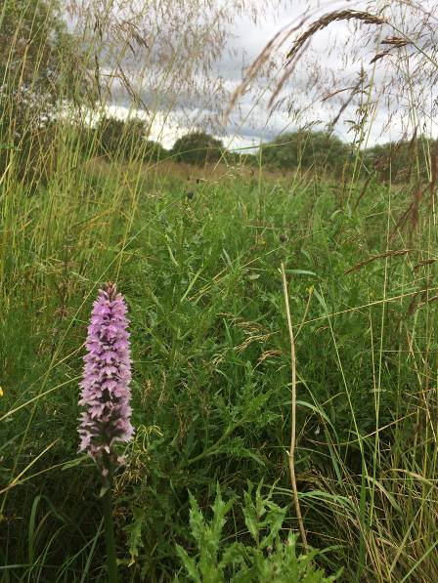
Location and site boundaries: Milton Tile Works lies to the west of the town of Carluke, in South Lanarkshire. The site comprises of two areas separated by Jock’s Burn, along Station Road.

Site name: Milton Tile Works.

Grid reference: NS 8380 4976

Site area: 14.37 ha

Site boundary: The boundaries of the reserve is based upon the extent of land owned by South Lanarkshire Council (SLC). The site is currently in two sections separated by Jock’s Burn and an area of woodland which is not owned by the council.

Site description: Milton Tile Works is the site of a former brick and tile works on the outskirts of the town of Carluke in South Lanarkshire. Identified by SLC as Vacant and Derelict land, it is around 14ha in size and has currently has no formal access. The site supports a mosaic of habitats from bare and previously disturbed ground of the former brick works, semi-improved neutral grassland, marshy grassland, scrub, woodland and open water associated with the former clay pits.

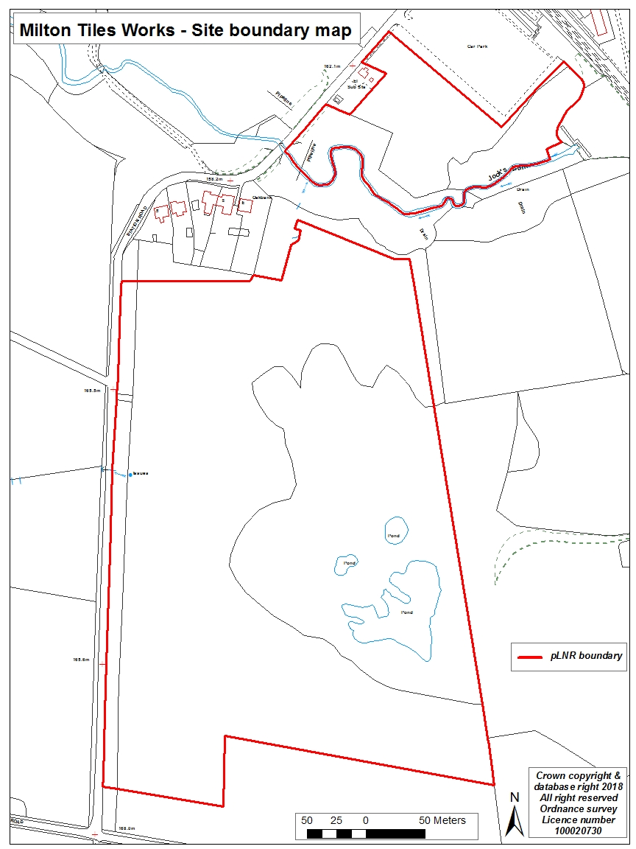
Habitats, flora and fauna
Habitat | Area (ha) | %
Broadleaved woodland | 7.87 | 56
Semi-improved neutral grassland with scattered trees and shrubs | 5.85 | 41
Standing open water | 0.47 | 3
Total | 0.87 | 100

The central and southern areas are generally open and grassy with small clusters of trees and shrubs. The ground supports false oat-grass, Yorkshire fog, numerous vetches, common hogweed, creeping buttercup, silverweed, common knapweed, ox-eye daisy, greater bird’s-foot trefoil and ladies mantle.

The eastern reaches of the site are overgrown with dense woodland and scrub. Access is difficult in places due to the dense vegetation, undulating and waterlogged ground. The woodland is abundant with willow species, but also oak, beech, cherry, silver birch, downy birch, alder, Scot’s pine, blackthorn and hawthorn. The ground flora includes false oat-grass, Yorkshire fog and tufted hair-grass with enchanter’s nightshade, male fern, broad-bucker fern and red campion. A few spikes of broad-leaved helleborine were also noted. Dense patches of common nettles, rosebay willowherb and brambles are found throughout the site.

Boggy and waterlogged ground can be found in several areas including the eastern boundary of the site and this is likely to be associated with the ponds. Access here is limited by tall vegetation and the undulating nature of the land. Wetter areas give rise to common sedge, common reed, soft rush, reedmace, reed canary grass, wild angelica, meadowsweet, compact rush and yellow flag iris.

To the west of the pond there are large stands of Japanese knotweed and snowberry. These invasive and non-native species have the capacity to continue to spread and threaten the integrity and character of the site through competition with native ground flora. It is necessary to monitor the location and spread of such species with the aim to minimise their risk.

The western boundary along Station Road supports a hawthorn hedgerow with mature trees of oak, beech, ash, willow and Scots pine.

Jock’s Burn surface water runs east to west to the north of the site and is a tributary of the River Clyde.
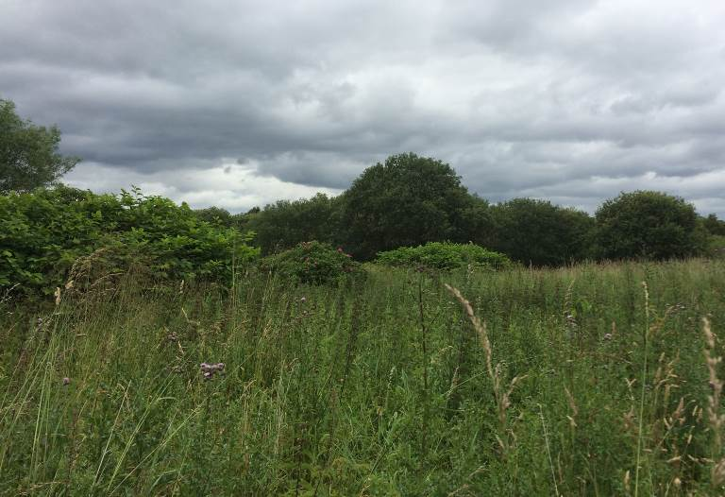
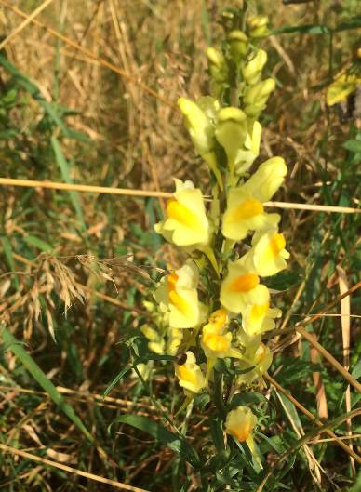

Landscape
The area surrounding Milton Tile Works is predominantly farm land. Carluke train station is located approximately 300m to the northeast of the site. The town of Carluke continues in this direction on the opposite side of the railway line.

Carluke Golf Club is located approximately 425m northwest of the site. At the edge of the northern section of the pLNR is Jock’s Burn, a waterbody that flows broadly east to west. The burn is a tributary of the River Clyde and joins this watercourse approximately 2.5 km west of the site.

Milton Tile Works does not have any formal conservation designation. The map below highlights nearby potential Local Nature Conservation Sites (pLNCS), Special Sites of Scientific Interest (SSSI), Special Areas of Conservation (SAC) and National Nature Reserve (NNR).
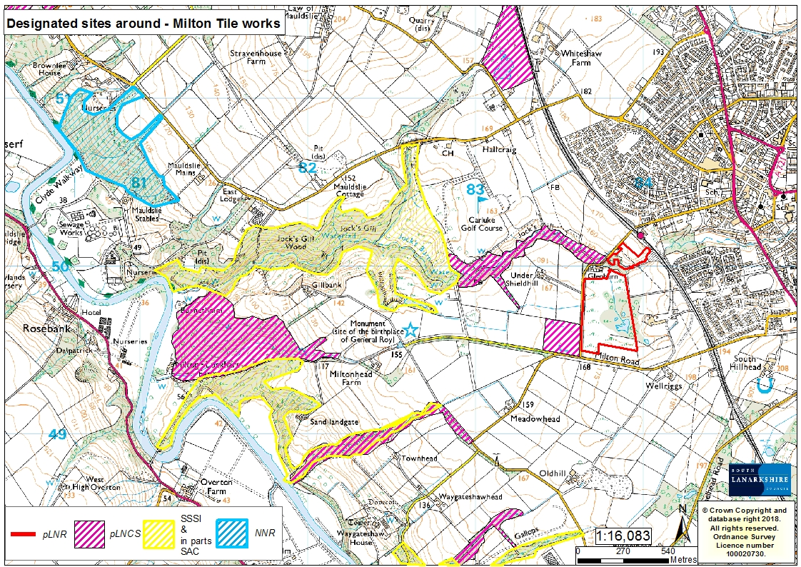
Nearby SSSI which are also part SAC include:
- Jock’s Gill: NS 820 501 (0.56 miles)
- Milton Lockhart Wood: NS 815 493 (1.2 miles)
- Townhead Burn: NS 822 489 (0.8 miles)
- Gill Burn and Mares Burn: NS 826 482 (0.9 miles)

pLNCS:
- Upper Jock’s Gill: NS 830 499 (0.1 miles)
- Undershieldhill Marsh: NS 835 495 (18 metres)
- Milton Lockhart: NS 814 496 (1.2 miles)
- Townhead Burn: NS 824 489 (0.7 miles)
- Upper Gills Burn: NS 830 438 (0.8 miles)
- Carluke Gasworks: NS 832 512 (0.8 miles)

Cultural information
Past Land use
Ordnance Survey maps were used to look at the history of Milton Tile Works and the surrounding area (available online from the National Library of Scotland). Maps from 1888-1913 highlight a mining shaft located to the east of the pLNR, with a brickworks and railway line linking the development to the main Carluke rail line. In maps dated 1937-1961 a larger brick and tile works covers a large proportion of the southern part of the pLNR, with associated buildings, roads and a large pond. Maps dated 1940-1960 depict an additional two ponds and a large clay pit.

The manufacture of clay products was a major industry around Carluke from the 18th to the 20th century when claypits, kilns and drying sheds could be seen all over the landscape. Brickmaking relied heavily on the building trade, with a boom at the turn of the 19th century and again after World War 2. By the 1980s only 20 brickworks were operating in the whole of Scotland. The use of concrete in building and the decline of heavy industries contributed to this decline. Milton Tile and brick works operated from 1897 to 1978.

There are a number of features in the surrounding landscape that are of archaeological interest, details of which can be found on the Canmore website:
- Milton tile works: NS 83933 49690
- Jock’s Burn mill: NS 834 501
- Carluke station: NS 839 500

The surrounding landscape hasn’t changed significantly over the last hundred years, being dominated by agricultural fields and associated farms. Under Shieldhill farm and lands is to the east and west, with Wellriggs to the south. The woodland gorge along the banks of Jock’s burn can be seen in maps from the late 1800s, with the northern section of the pLNR depicted as marshy and wetter land.

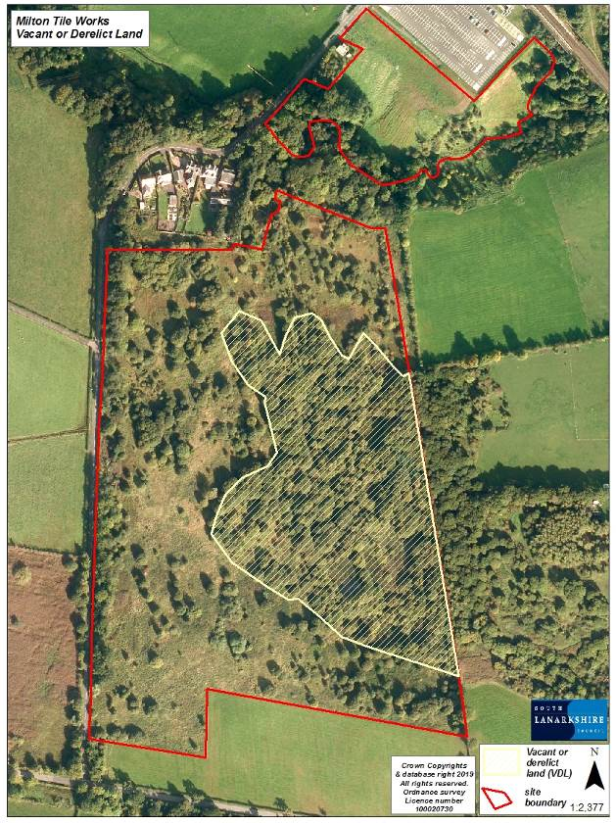
The former clay pit associated with brick works subsequently infilled with waste in the late 1980s and 1990s. Historical mapping confirms that prior to the site being a landfill it was an open clay pit. The site has since developed a thick covering of foliage including grasses, shrubs and trees. While pockets of litter considered likely to be associated with the former landfill are still visible at the surface, the overall appearance is that of natural land. The majority of the site is flat with mild undulation in the central and eastern reaches.

Present land use
A large section in the centre of the proposed reserve is currently on the vacant or derelict land (VDL) register for South Lanarkshire as the map here shows.

The site is fenced off from the public, but there are sections in the fencing and hedge that has become damaged and where fly-tipping has occurred. The grassland in the far north of the reserve are used for grazing livestock in the summer months. The two sections of the proposed reserve are currently separated by Jock’s Burn, which is in private ownership.

Site infrastructure
In 2018 Ironside Farrar Limited was instructed by SLl to undertake and report on an Environmental Survey and Monitoring project in respect of the former Milton Cottages landfill near Carluke. A programme of surveys and monitoring was developed by Ironside Farrar Limited to assess current environmental conditions at the site. The focus of the field work was on characterising the ground gas regime, although shallow soil sampling and water sampling was also undertaken. Boreholes, ground gas and groundwater monitoring wells were installed for monitoring purposes. Further details can be found in the following report entitled – Milton Cottages, Carluke Environmental Survey & Monitoring Report, Ironside Farrar 2019, refer 50347.

A pond is present to the east of the site, with boggy and waterlogged ground present in the vicinity.

Recreation and access
There is no formal access to the site. Station Road runs along the western parameter and Milton Road to the south. The nearest core path is to the north of the site along the Jock’s Burn and a wider network path links this path to Carluke Station and to Carluke. Station Road is well used by the local community, for walking, walking dogs, running and cycling. It connects the north west of Carluke to the south east of the town forming a circular walk.

Local community
There is currently no active community group associated with Milton Tile Works. A key objective would be to engage with the local community in the management of the proposed reserve and to establish a management committee to oversee the management of all the pLNRs.

There are a number of local schools in close proximity to the pLNR:
- Kirkton Primary school (0.38 miles)
- St Athanasius Primary and nursery school (0.6 miles)
- Victoria Park school (0.7 miles)
- Crawforddyke Primary School (0.86 miles)
- Carluke Primary 1.06 miles)
- Carluke High School (1.08 miles)

Conclusion
It is the intention of SLC’s Countryside and Greenspace team to work in partnership with the local community to ensure that the ecological quality of the reserve is maintained and managed. We aim to foster an understanding and facilitate the enjoyment of the natural heritage of the reserve, by maintaining and improving biodiversity, access, interpretation, education and promotion of the site.

The management statement will meet these objectives by seeking to deliver a number of practical health, environmental education and community outcomes in partnership with other organisations and the local community.

Contacts
For more information on this site, or LNRs in South Lanarkshire, please contact:
Countryside and Greenspace Service, Facilities, Waste and Ground Services, Community and Enterprise, South Lanarkshire Council, 18 Forest Street, Blantyre G72 0JP.
Email: CAG@southlanarkshire.gov.uk

Photographs taken by J. Birkin.
Note that maps may not be to scale.

Reference – Ironside Farrar (July 2019) Milton cottages, Carluke, Environmental Survey & Monitoring Report. I, Farrar Environmental Consultants.

Appendix 1: Objectives and actions

Objective 1: Maintain, enhance and monitor the biodiversity value of the reserve.
Actions:
- Contribute data to national and local biological recording schemes.
- Ensure appropriate management programmes improve and maintain biodiversity.
- Monitor and manage the invasive species found within the reserve.

Objective 2: Maintain and increase the use of the access network.
Actions:
- Further sampling, analysis and risk assessment will be required before any infrastructure is installed at the site and public access is encouraged.
- Work with neighbouring landowners in improving access to the reserve.
- Identify funding opportunities.

Objective 3: Encourage and facilitate community involvement in the reserve.
Actions:
- Raise awareness of the pLNR to the local community.
- Install signage and interpretation where appropriate.
- Investigate possibilities of promoting the reserve in new and different ways, such as to specialist interest groups.
- Monitor and assess local interest in the site.
- Investigate the possibility of linking Milton to other greenspaces and wider network of paths in the surrounding landscape.
- Identify and promote opportunities for people to enjoy the wildlife of the pLNR.

Appendix 2: Maps



