Langlands Moss Local Nature Reserve Management Statement 2018

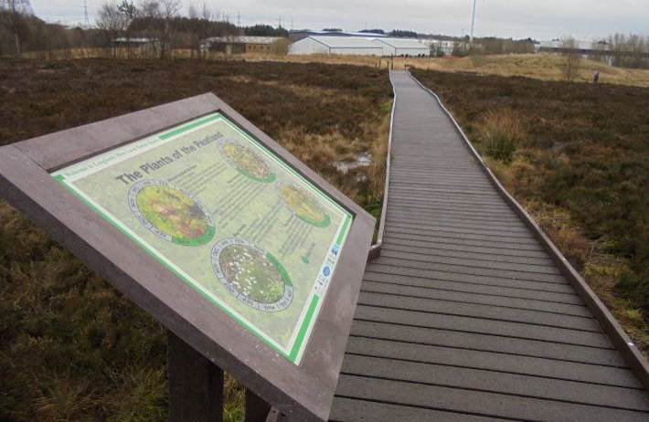
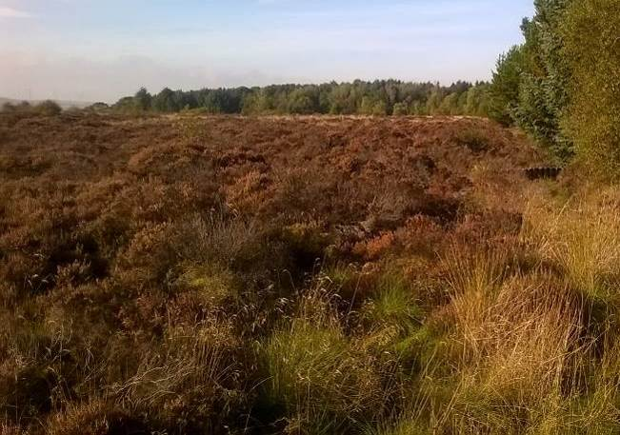

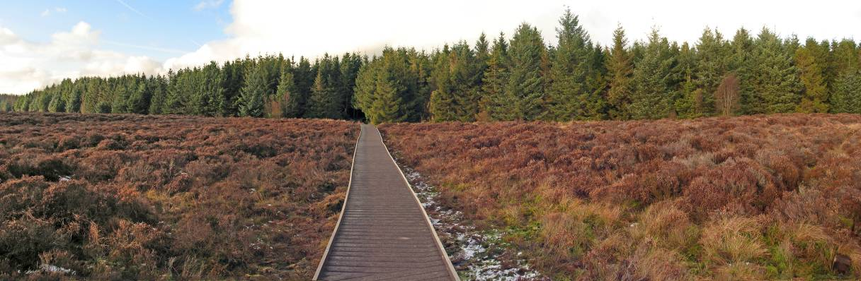

If you want this information in a different format or language, phone 0303 123 1015 or email equalities@southlanarkshire.gov.uk

Contents

Introduction
Vision statement
General information
Landscape
Cultural information
Site infrastructure
Recreation and access
Local community
Conclusion
Contacts
Appendix 1: Objectives and actions
Appendix 2: Maps

Introduction

heritage with opportunities for people to enjoy, learn about and experience nature close to their homes. LNRs are:

- Statutory designations made under the National Parks and Access to the Countryside Act 1949.
- Special places which are rich in wildlife.
- Generally, readily accessible and suitable for people to visit and enjoy.

In declaring these sites, South Lanarkshire Council (SLC) aims to:

- Protect them from unsuitable developments.
- Manage and enhance the habitats to help biodiversity flourish.
- Improve public access.
- Help people understand and become more aware of the importance of the LNR.
- Encourage community participation and volunteering.

SLC have identified sixteen new sites (and an extension to the existing LNR at Langlands Moss) to become designated as LNRs. These encompass a broad spectrum of habitats including ancient broadleaved woodland, open water, wetlands and grasslands. The site management statements are written in conjunction with the South Lanarkshire Biodiversity Strategy (2018 to 2022), SLC Sustainable Development and Climate Change Strategy (2017 to 22), SLC Local Development Plan (2013) and SLC Core Path Plan (2012).

Vision statement

Across South Lanarkshire, Local Nature Reserves are a resource for local communities that balance excellent recreational and educational opportunities with valuable habitats for wildlife that are rich in biodiversity.

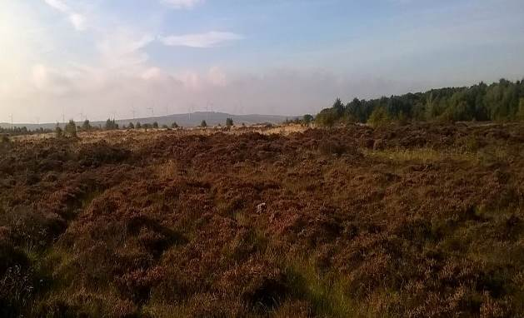
General information
Location and site boundaries: Langlands Moss LNR is located approximately two miles to the south of East Kilbride town centre, in South Lanarkshire. The residential district of Whitehills is to the north with the Kelvin / Langlands Industrial Estate closely adjacent to the east and north. The Moss is bordered by a coniferous plantation to the north-west, a minor road (Auldhouse Road) to the south-west, Langlands Golf Course to the south-east and Kelvin Industrial / Business Park to the north-east. Langlands Moss LNR is signposted from the A726 (Strathaven Road).
Site name: Langlands Moss
Grid reference: NS635511
Site area: The current reserve is 20ha; the Council aims to extend the boundary of the LNR to encompass the land to the north of the site, which would increase the size of the site to 47 ha.
Site boundary: The boundaries of the park are based upon the extent of land owned by SLC.
Site description: In 1992, Langlands Moss was identified as a potential LNR. It was officially designated in March 1996. The LNR is owned, managed and monitored by SLC. In 2006 the ‘Friends of Langlands Moss’ community group (FOLM) formed with the aim to protect and promote Langlands Moss LNR.
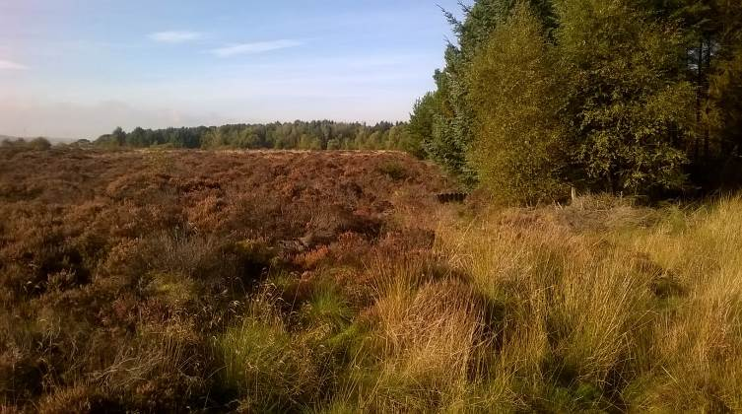
The current boundary of the LNR covers the extent of the raised bog; the proposed extension to the boundary will encompass the surrounding woodland.
One of the main management aims has been to restore and maintain the natural hydrology of the raised bog. A huge effort has taken place over the last ten years to replace many old and broken dams along the drainage ditches with new functioning ones.
It is proposed that the next step in restoring the natural hydrology of the raised bog is to fell and remove the large expanse of planted conifer trees along the northern and eastern side of the bog. This has the potential to restore and increase the cover of the lagg zone located at the bog margins; studies have shown that this area plays a critical part in the proper function of a raised bog. Restoring the natural hydrology of the bog will increase the growth of Sphagnum species and improve currently degraded areas.
To restore this natural ecotone, the installation of dams along the boundary ditches of the bog, adjacent to the conifer woodland will be required. This ought to help retain water in the raised bog itself and rewet the dry woodland areas, once the trees have been felled. The main aim would be to promote the growth of a lagg plant community along the edge of the raised bog, whilst allowing the surrounding land to naturalise into grassland, broadleaved scrub and wet woodland.
Local people continue to be actively involved in the management of the reserve, through the FOLM Community group, other volunteers, SLC’s Countryside and Greenspace Service (CAG) and many others. FOLM have strived to secure funding and accrued many volunteer hours in improving access and signage to the reserve, whilst continuing to raise the awareness of the LNR and the plight of raised bogs.

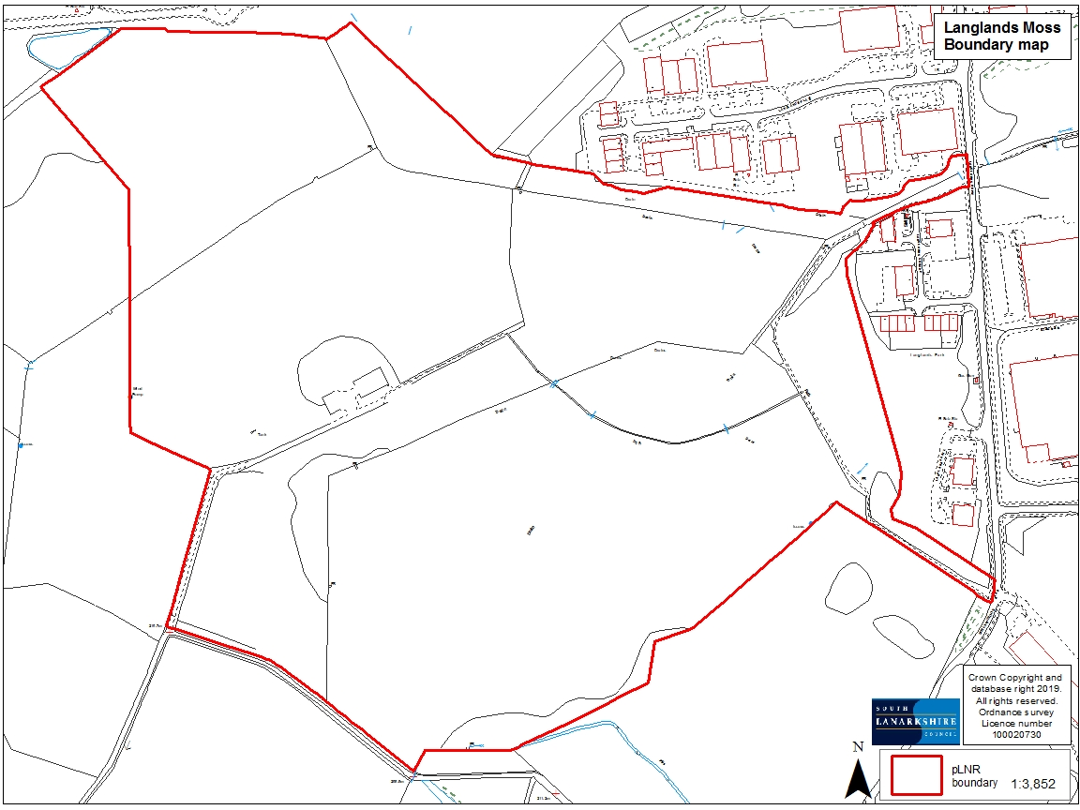

Habitats, flora and fauna
Habitat | Area (Ha) | %
Raised bog | 17 | 37
Coniferous plantation woodland | 21 | 45
Mixed woodland mainly conifer | 3.5 | 7.5
Mixed woodland mainly broadleaved | 0.8 | 1.7
Broadleaved woodland | 1.8 | 3.8
Marshy grassland | 2 | 4
Scrub | 0.6 | 1
Grassland (created meadow/amenity) | 0.08 | 0.1
Total | 47 | 100

Langlands Moss is a small, largely intact area of lowland raised bog, exhibiting a marked domed appearance. The western half of the site supported a commercial conifer plantation until March 1994, when it was felled and the trees removed by helicopter. The eastern half has never been afforested. The bog is surrounded by small industrial units, a golf course, conifer woodland and agricultural fields.
There has been some marginal peat cutting in the past and drainage has also occurred, leading to the loss of open pools and lawn communities. The bog surface is hummocky and despite being dominated by ling heather (Calluna vulgaris) remains relatively rich in Sphagnum mosses. On the marginal slopes, erosion runnels have developed, possibly encouraged by previous fire damage. The main damage to the site relates to previous forestation and associated drainage channels.
The plant assemblage is typical of raised bogs (M18 National Vegetation Classification), with bog mosses (Sphagnum magellanicum, S. papillosum, S. capillifolium, S. cuspidatum and S. recurvum), ling heather, cross-leaved heath (Erica tetralix), bog asphodel (Narthercium ossifragum), round-leaved sundew (Drosera rotundifolia) and cotton grasses (Eriophorum vaginatum, E. angustifolium). Old tree stumps and peaty ground support a wide variety of lichens, most notably the fruiting bodies of Cladonia species, and the nationally rare Vulpicidia pinastri.
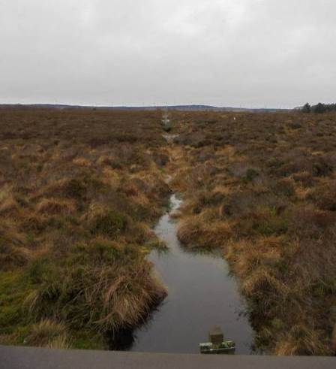
Good baseline data collected by the SLC Countryside Ranger Service and volunteers dates back to 1995. The species list includes 65 species of bird; 58 invertebrates; two amphibians; one reptile, eleven mammals, various plants; mosses (eight Sphagnum) and lichens. Species of particular interest include otter, barn owl, skylark, large heath butterfly, dark green fritillary, pipistrelle bats (common and soprano) and the Manchester treble-bar moth.
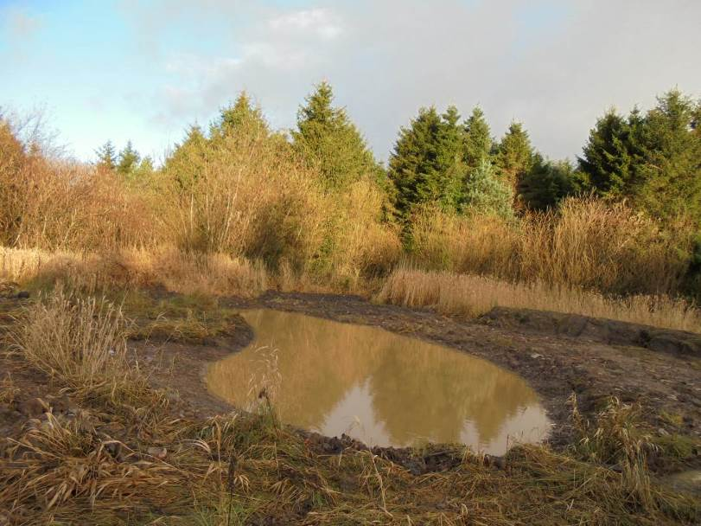
Other survey work has been carried out in the past at the reserve and includes five permanent vegetation quadrats, identified in 1994 and monitored by the Scottish Wildlife Trust until 1996. In 2005 SLC Countryside Rangers established a butterfly transect route. This route runs along the boardwalk at the reserve and continues along towards Calderglen Country Park. This survey was superseded in 2013 by a new transect over the bog, which is carried out by a member of the FOLM community group. Data from this survey continues to be sent to the UK Butterfly Monitoring Scheme run by Butterfly Conservation. Reptile tiles were placed over the bog in 2005 to determine the presence of the common lizard at the site.
In November 2015 three ponds were installed at Langlands Moss LNR as part of “Living Waters”, a wider pond creation and improvement programme run in partnership with Froglife. It is hoped that the addition of a wetland mosaic habitat will be a benefit to the wildlife of the reserve, increasing the diversity of habitats within the locality.
In 2018, Froglife ran a series of training days at the newly created ponds, to inform volunteers of survey techniques for amphibian monitoring.

Landscape
Langlands Moss is situated to the south of East Kilbride and is currently the only LNR within South Lanarkshire. There are small areas of degraded peat (class III) immediately west of the site (NS623518) and east (NS647510, NS653506), identified in the McTeague and Watson survey of 1989. Larger and less degraded mires can be found to the east of Langlands Moss at NS660513 and NS668514 respectively (both class II). Blantyre Muir (NS663525) (class I), a designated Site of Special Scientific Interest (SSSI) can be found to the northeast of Langlands Moss. The Calder Water is located to the south of the site.
Nearby sites of interest include:
- Blantyre Muir SSSI (NS66225269)
- Waukenwae Moss SSSI (NS67895086)
- Greenhill Road pLNCS (potential Local Nature Conservation Sites)
- Park Quarry pLNCS (NS63644975)
- Millwell pLNCS (NS65124976)
- Kelvin Industrial area pLNCS (NS64285255)
- Calderglen Grassland (NS65435302)
- Calderglen Country Park (NS65285314)

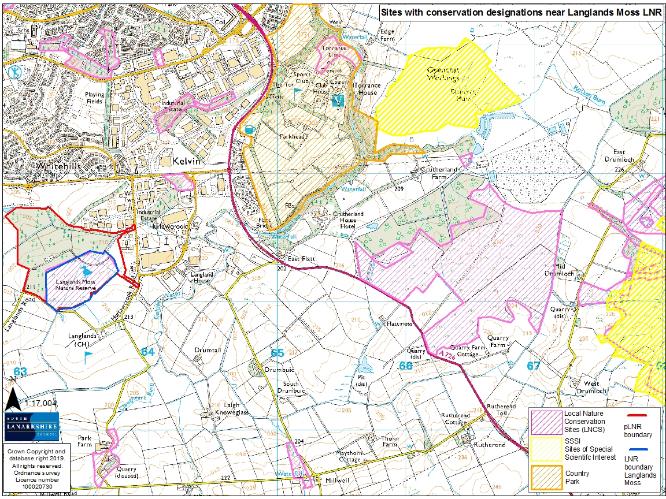

Cultural information

Past land use

Ten thousand trees were removed from the bog in November 1994. 150 dams were then constructed within the surface drains, with the aim to raise the water table and encourage the growth of Sphagnum mosses. Rigid vinyl sheet piling dams were installed by SWT volunteers in the larger drainage ditches.
Prior to and after the tree felling and installation of the dams in 1994, a hydrological monitoring programme was put in place at Langlands Moss. This comprised of two transects running from east to west across the bog. Dipwells were spaced every 30m, with seven water level range gauges (recording maximum and minimum water levels) placed at regular intervals along the two transects. Five permanent vegetation quadrats were also incorporated into the transects where indicator species were noted as percentage cover. At the same time an educational pack was developed by SLC Countryside Ranger Service aimed at the 5-14 National Curriculum.

Present land use
Langlands Moss LNR provides a recreational resource for the local community of East Kilbride as well as being a site of interest for wildlife. The site is only a few miles from the centre of East Kilbride which has a population of 75,220 people (2015 General Records of Scotland). The location of this unique and internationally important habitat makes it a suitable site to promote an understanding and appreciation of the natural environment in South Lanarkshire. People can and do regularly walk to Langlands from the adjacent residential developments of Whitehills, Lindsayfield and the village of Auldhouse. There is also a network of paths leading to Calderglen Country Park along the course of the Calder Water.

In 2012 a people counter was installed at the start of the boardwalk which records the number of visitors to the reserve every year. In 2012, 8,474 people were recorded visiting the site. This increased to a peak of 27,041 in 2015. In this period of time access was much improved throughout the reserve; the network of paths was upgraded and a new boardwalk installed over the main body of the raised bog. The chart above shows that the number of people visiting the reserve has declined since vandalism to the boardwalk occurred in June 2016. Loss of this access link restricts the ability to use the network of paths in the nature reserve and surrounding landscape.

Site infrastructure
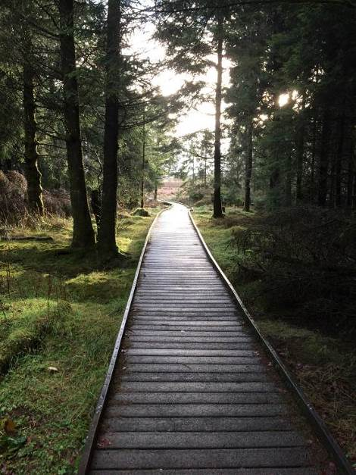
Prior to official designation as an LNR, extensive work was carried out to improve access to Langlands Moss. A 3km path was constructed to enable visitors to walk to the reserve from Calderglen Country Park. Signage and access points were installed along with a 372 metre long wooden boardwalk over the moss, with interpretation panels. Maintenance and repair work was carried out by SLC, however over time the interpretation became old, weather worn and damaged through vandalism.
From 2006 onwards grant aid, match funding and partnerships between South Lanarkshire Rural Trust and the South Lanarkshire Community Payback Unpaid Work Service have financed the materials and provided labour for path improvements at the reserve. In 2009/2010 FOLM were granted a “Developing Local Communities” fund (part of the Renewable Energy Fund) and worked with SLC CAG team to improve the condition of the approach paths to Langlands Moss LNR. The work was carried out by the SLC Community Payback team. The team also cleared the old car park, repainted and repaired signage and upgraded the path links between Calderglen Country Park and Langlands Moss.
In 2013 a new 374 metre long (1.3 metre wide) raised boardwalk was installed to replace the original wooden boardwalk. The latter being approximately 17 years old had become worn, undulated and very slippery in parts. The new boardwalk was made from Duraplas®, which is post-consumer high density polyethylene plastic waste that would otherwise be exported or sent to landfill. A total of £100,000 was raised in grants from the Heritage Lottery Fund and local community funds and the boardwalk was officially opened on 19th March 2013.
The new boardwalk had a viewing area and interpretation boards at numerous points along the walk. The new platform was closer to the peat than the previous boardwalk and provided safe access across the bog. It also provided the visitor with a different perspective of the landscape and allowed close viewing of wildlife.
Unfortunately, in the summer of 2016 a 30 metre section of the boardwalk was burnt. FOLM and the local community raised enough money to repair the missing section, however, in May 2017 a larger fire took out a further section of the boardwalk. The two fires have removed the majority of the boardwalk, reducing access across the raised bog and to the rest of the reserve.
The network of paths to the boardwalk and parts of the Langlands loop trail have been upgraded; boardwalks and bridges are regularly monitored and maintained. In November 2016 all the fingerposts at Langlands Moss were replaced, this has been a welcome addition to the interpretation found throughout the reserve.
It is proposed that improvements should be made to the existing access infrastructure and interpretation for the enjoyment of the local community, who live and visit the reserve. Visitors should be encouraged to the reserve, but this must be carefully managed and should not be detrimental to the wildlife value and interest of the reserve. The site should be promoted for its wildlife interest, learning potential and links with the local community, whilst encouraging responsible access to the reserve.

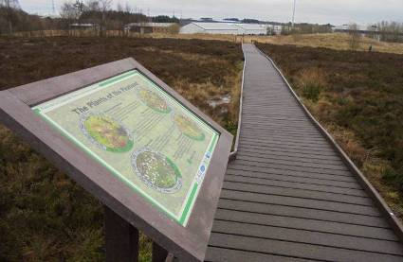
Recreation and access
The access map within this statement highlights the main access points and the network of footpaths within the reserve. SLC CAG are currently working with the FOLM community group to re-install the damaged boardwalk across the raised bog at Langlands Moss LNR and replace the missing interpretation boards.
The boardwalk is identified as a core path (EK/1415/1) and is part of the core path network around the reserve, linking to EK/1415/2 and EK/1415/3 to the east and north of the bog. The current condition of the boardwalk prevents access across the raised bog, which has been part of the reserve since it’s designation in 1996. A temporary alternative route through the conifer plantation woodland was created in December 2017, which allows members of the public to gain access to the rest of the reserve.

Local community
The FOLM run a programme of events throughout the year to promote the nature reserve. Events in the past have included bat and moth evenings, practical conservation days, dam installation, planting wildflowers and bird box making. More recently a local primary school has been using the site for Forest School. The FOLM group are hoping to explore the social history of the site in the near future, starting with Curlingmire Farm, which was once located near the old reserve car park and the Dickie windpump located to the west of the coniferous woodland.
The “Bog Squad” is a volunteer task force created by Butterfly Conservation Scotland to carry out rehabilitation works on damaged peat bogs across the Scottish Central Belt, with funding from Scottish Natural Heritage’s Peatland ACTION project. The FOLM have been working in partnership with the Bog Squad since April 2014. The joint efforts of the groups and local volunteers have resulted in the removal of large sections of invasive scrub and the installation of ditch-blocking dams. The effectiveness of the dams has been shown quickly with large pools of water being retained which is helping to re-wet the surrounding peat. The new dams installed have been mainly plastic, with a few peat dams. Common hawker dragonflies have been seen ovipositing into the new pools.

Conclusion
It is the intention of SLC’s Countryside and Greenspace team to continue to work in partnership with the Friends of Langlands Moss to ensure that the ecological quality of the reserve, especially the raised bog is maintained and managed. In addition, we aim to foster an understanding and facilitate enjoyment of the natural heritage of the park and to increase public use through improved access, interpretation, education and promotion of the site.
The management statement will meet these objectives by seeking to deliver a number of practical health, environmental education and community outcomes in partnership with external organisations and the local community.

Contacts
For more information on this site, or LNRs in South Lanarkshire, please contact:
Countryside and Greenspace Service, Facilities, Waste and Ground Services, Community and Enterprise, South Lanarkshire Council, 18 Forest Street, Blantyre G72 0JP.
Email: CAG@southlanarkshire.gov.uk

Photographs taken by J. Birkin.
Note that maps may not be to scale.

Appendix 1: Objectives and actions

Objective1: maintain, enhance and monitor the biodiversity value of the reserve.
Actions:
- Establish and maintain survey and monitoring regimes for indicator species.
- Identify and commission baseline surveys and train local staff and volunteers in future monitoring.
- Monitor / survey vegetation and wildlife within the newly created pond at the reserve.
- Continue to contribute to national and local biological recording schemes
- Ensure the use of appropriate management and mitigation projects, informed by monitoring programmes and best practice.
- Expand the LNR boundary to encompass additional surrounding land, paths and access points.

Objective 2: restore and maintain the water table within the peat body of Langlands Moss.
Actions:
- Complete a woodland management plan to determine the possibilities and implications of removing the conifer trees.
- Research case studies of similar conservation work.
- Carry out a hydrological survey to determine the potential impact of future management
- Investigate / secure funding opportunities.
- Carry out a public consultation if required as part of proposed changes to the site
- Investigate the potential to remove the woodland.
- Investigate the potential to install dams along the northern and western drainage ditches to create lagg habitat.
- Continue the installation, monitoring and maintenance of dams throughout the raised bog.
- Monitor the lagg zone vegetation
- Consider the implementation of fixed point photography to monitor changes in vegetation
- Assess the peripheral ditches along the golf course.

Objective 3: maintain and increase the use of the access network.
Actions:
- Continue to enhance and maintain access points and the path network.
- Improve and maintain interpretation and signage.
- Agree and adhere to a maintenance programme.
- Assess opportunities to create new pathways.
- Review the need for additional facilities at the reserve.

Objective 4: encourage and facilitate community involvement in the reserve.
Actions:
- Actively involve the local community in the management of the area.
- Continue to support the Friends of Langlands Moss.
- Investigate and develop opportunities for conservation volunteering.
- Work with local people and other stakeholders toward meeting the objectives of this plan.
- Identify and promote opportunities for people to enjoy the wildlife of the area.
- Continue to raise awareness of the reserve for the local community.
- Promote the reserve to specialist interest groups (birdwatchers, botanists).
- Investigate possibilities of promoting Langlands Moss in new and different ways.
- Review information at the site ensuring that it is current to date.
- Investigate visitor numbers and the effectiveness of current promotion.

Objective 5: encourage research, survey and monitoring on Langlands Moss LNR.
Actions:
- Continue to carry out research, surveys and monitoring proposals for Langlands Moss.
- Review the installation of the water table monitoring programme and include new techniques and technology if appropriate.
- Research the possibility of utilising the existing monitoring system and/or previous data.

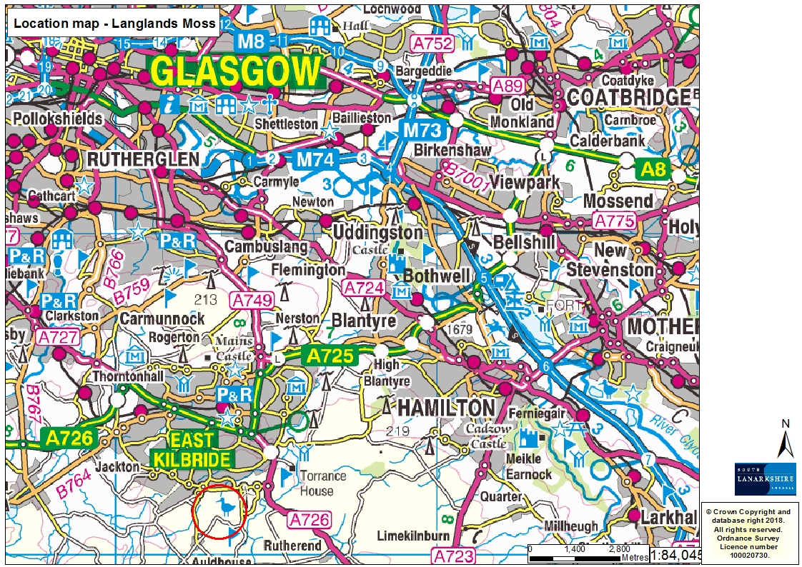
Appendix 2: Maps


