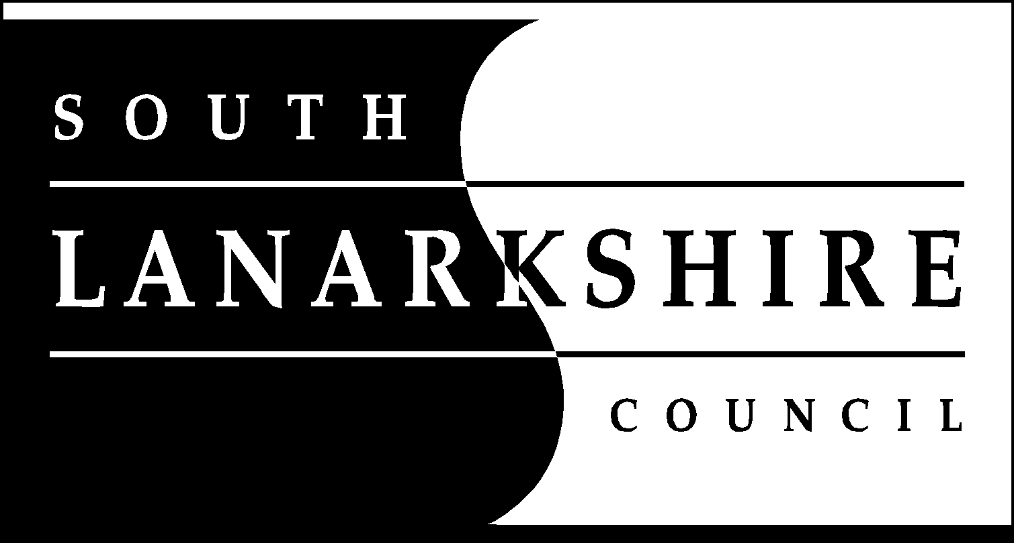

Procurement Strategy 2023-2028

If you need this information in another language or format, please contact us to discuss how we can best meet your needs. Phone 0303 123 1015 or email equalities@southlanarkshire.gov.uk

Contents

Section 1
Introduction by Executive Director of Finance and Corporate Resources

Section 2
National and local context

Section 3
Purpose and delivery of the Strategy

Section 4
Strategic objectives

Section 1: Introduction by Executive Director of Finance and Corporate Resources

This Strategy sets out the vision for council procurement for 2023-2028, demonstrating our commitment to achieving value for money and contributing to national and local priorities.

The council’s vision is to “improve the quality of life for everyone in South Lanarkshire”
and the works, supplies and services procured by the council have a direct impact on delivery of our services, from social care and educational supplies to new build housing.

The council’s spending power can play a key role in influencing a more prosperous and sustainable South Lanarkshire, including promoting jobs and growth, fair work and tackling climate change.

Our aim is to build on achievements delivered by the council’s previous procurement strategies and embed the principles of public procurement: equal treatment, transparency, competition and accountability.

This strategy will be reviewed annually, and our outcomes monitored in the annual procurement report. The strategic objectives will promote best practice in procurement activity across the council, supporting delivery of high quality, sustainable and efficient services from our suppliers.

Economic conditions post pandemic have proven to be challenging, with significant supply chain and inflationary pressures impacting on the council’s budgets for works, goods and services. Procurement will continue to support the council and our local economy during these economic circumstances and our strategic objectives reflect the wider remit for public procurement in responding to the Climate Change Emergency and Community Wealth Building. We will continue to focus on delivery of quality and value for money procured services while supporting local supply chains and quality employment opportunities.

The establishment of a new National Care Service during the term of this strategy is likely to impact the nature of the procurement work undertaken by the council to support the Health and Social Care Partnership. In a broader sense, we will actively contribute to discussions about the nature and role of any new National Care Service and the impact on the Social Care role of local government.

Paul Manning
Executive Director of Finance and Corporate Resources
South Lanarkshire Council

Section 2: National and local context

Public sector procurement in Scotland is valued at more than £11 billion per annum and the profile and remit of procurement activity continues to evolve and change.

The overarching aim of public sector procurement continues to be delivery of public value, as set out in the Scottish Model of Procurement below:
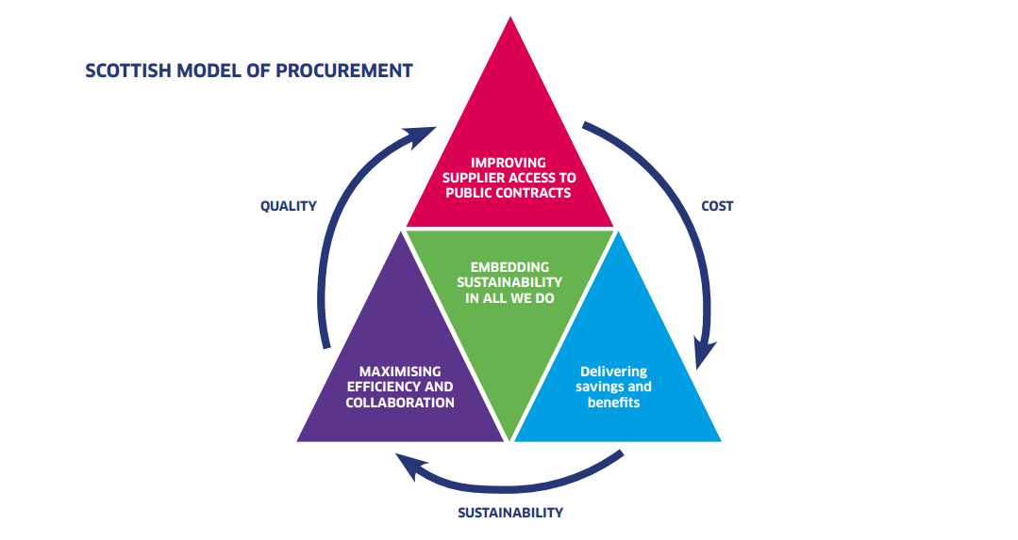
The council operates within the Scottish Government’s Procurement Journey, which ensures openness and transparency in our approach and clarity for stakeholders and suppliers.

The National Performance Framework sets out how local government can contribute to achievement of National Outcomes. The framework aims to implement sustainable procurement and obliges the council to consider how procurement will improve society, the economy and communities under the Sustainable Procurement Duty.

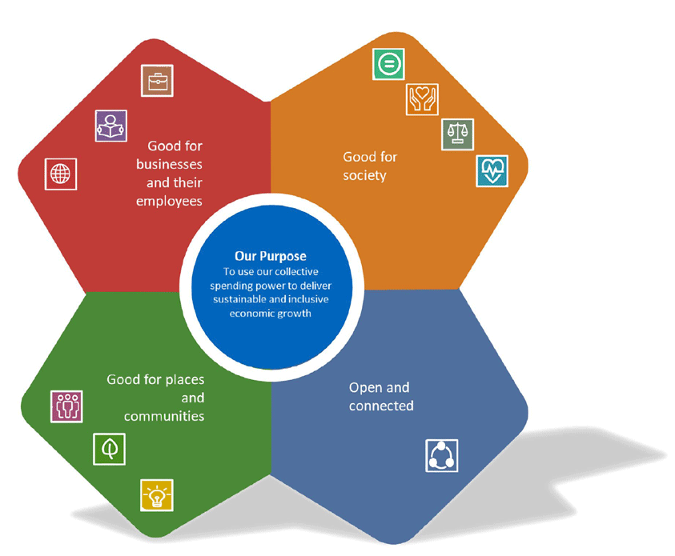

Local priorities

The council’s procurement strategy allows the council to set out how procurement activity will contribute to the council and Community Planning Partnership’s wider priorities and objectives, as set out in the council plan "Connect". Procurement is at the centre of the council’s Value of being “accountable, effective, efficient and transparent” and contribute to many of the council’s strategic outcomes, including:

Thriving business, fair jobs and vibrant town centres
Caring, connected, sustainable communities
Good quality, suitable and sustainable places to live
People live the healthiest lives possible

Our spend profile

The council spends in the region of £350m on externally procured goods, supplies and services annually, with significant areas of expenditure including construction and property (£137m) and social care (£112m).

Section 3: Purpose and delivery of strategy

Purpose of strategy

Under the Procurement Reform (Scotland) Act 2014, the council is required to publish a procurement strategy and review the objectives and outcomes annually.

The strategy should establish the council’s strategic approach to procurement, setting out how we will deliver value for money and support delivery of national outcomes and the objectives set out in the council’s strategic plan.

The council must also demonstrate how we will deliver the wider social, economic and environmental aims of procurement, as required by the sustainable procurement duty, while ensuring compliance with statutory duties and the council’s Standing Orders on Contracts.

The purpose of our procurement strategy is to:
- Set out clear objectives and provide a monitoring framework for reporting on our achievements and outcomes. Our strategic objectives are set out in Section 4.
- Focus on people, processes and systems to deliver an effective and continually improving procurement service.

Contracting activity

The council awards in the region of 200 contracts above £50,000 each year, working within procurement regulations and our own Standing Orders on Contracts to ensure a compliant approach to contracts. We focus on open and connected procurement by publishing our Procurement Strategy and our forward plan of future opportunities is published in the Annual Procurement Report and Contract Register.

We work with a range of collaborative partners in accessing framework opportunities, including Scotland Excel, Procurement for Housing, the Scottish Procurement Alliance, Crown Commercial Services and Hub South-West.

The Procurement Service seek continual improvement with the Procurement and Commercial Improvement Programme, where we are currently ranked in the highest performance band and have developed a quality in house Trainee Procurement Officer graduate programme to develop talent and grow professional capacity.

Strategic Objective 1 and 3

Our stakeholders

Procurement work closely with both internal and external stakeholders to ensure works, goods and services are procured in accordance with strategic objectives to support the council in delivering community services. Where appropriate, procurement arrangements will be determined by consultation feedback from community partners.

Community
To support delivery of council services to communities and contribute to positive economic growth, employment outcomes and net zero targets

Suppliers
Positive contract management approach with all suppliers and engagement with local SMEs and Supported Businesses for tender opportunities

Colleagues

Working with council Resources and collaborative partners to deliver works, goods and services

Value for money

In responding to challenging economic conditions, Procurement is focused on supporting the council to deliver Value for Money by:

- Working closely with Resources in specifying works, goods and services and embedding a demand management approach.
- Ensuring an open and competitive tendering approach to maximise value.
- Working with collaborative partners to maximise public spending power.

Strategic Objective 2

Supplier engagement

We are open and transparent in tendering activity and are committed to improving engagement with local SMEs and Supported Businesses under the council’s Community Wealth Building Strategy. This is a key strategic objective in supporting inclusive growth and fair employment opportunities: working closely with our partners in Economic Development and the Supplier Development Programme.

Supplier Engagement
Public Contracts Scotland
Tender Opportunities
  - Meet the Buyer events
  - Talking Tenders
  - Pre-tender events
  - Build Lanarkshire
  - Prior Information Notices
  - Market Engagement
  - Contract Notices
  - Award Notices
  - Contract Register
  - Annual Procurement Report
  - Social Media

The council has a number of performance measures in relation to supplier engagement and these are published in the Annual Procurement Report:

- core trade spend with local enterprises
- core trade spend across Lanarkshire and Glasgow City Region
- payment of contractors and sub-contractors within 30 days

Strategic Objective 4 and 7

Fair Work First and Real Living Wage

The council assesses all appropriate contracts in accordance with the Scottish Government’s seven Fair Work First criteria, being:

- Appropriate channels for effective voice, such as trade union recognition
- Investment in workforce development
- No inappropriate use of zero hours contracts
- Action to tackle the gender pay gap and create a more diverse and inclusive workplace
- Providing fair pay for workers, including payment of the Real Living Wage
- Offer flexible and family friendly working practices for all workers from day one of employment
- Oppose the use of fire and rehire practices

Strategic Objective 5

Sustainable Procurement Duty and the Sustainable Procurement Tools

The council recognises the key links between our Sustainable Development and Climate Change Strategy and the Sustainable Procurement Duty. This places a duty on each procurement process to consider how to improve the economic, social, and environmental wellbeing of the authority's area, facilitate the involvement of small and medium enterprises, third sector bodies and supported businesses in the process, and promote innovation.

The council works with the Scottish Government’s Sustainable Procurement Tools to optimise the economic, social and environment outcomes of procurement activity.

Flexible Framework
  - Continuous assessment of how effectively sustainable procurement duty is embedded within the organisation
Prioritisation Tool
  - Identifies risks and opportunities for sustainable procurement at category level and establishes sustainable priorities in future tendering activity
Sustainability Test
  - Determines sustainable procurement outcomes at individual tender level, including life cycle mapping

Strategic Objective 6

Procurement of food

The council has published a Good Food Strategy and our joint Good Food/Procurement objectives set out below seek to support positive social economic and environmental outcomes on production and consumption of food. The Procurement team work closely with council services who procure food and drink to ensure contractual arrangements are sustainable, reliable and meet nutritional standards while delivering Best Value.

Ensure that the council prepares, serves and promotes enjoyable, healthy and sustainable food in council properties and schools by seeking to meet the Soil Association Food for life standards
Engage with partners and the private sector to explore and research opportunities to improvement public procurement of food, including in relation to the provision of local food
Connect with the community, partners and the private sector to reduce the impacts of the food system on the environment and its contribution to climate change and promote animal welfare
Strategic Objective 6

Community benefits

The council seeks to maximise Community Benefits and will consider inclusion of Community Benefits in all suitable contracts above £50,000. We have developed a points menu to ensure that Community Benefits offered are commensurate with the value and term of the contract.

Our range of Community Benefits prioritises support for training and employment and support for young people and community groups. The council has a Community Wish-List process in place to match community requirements with contractual opportunities.
Strategic Objective 7

Section 4: Strategic objectives

The council has identified seven strategic objectives to support the Procurement Strategy. In this section, we set out how we will achieve each objective and what our target outcome will be.

Compliance

Value for Money

Collaboration

Contract and Supplier Management

Fair Work First

Sustainable and Ethical

Community Wealth Building

Objective 1: Compliance

Aim: Ensure compliance with Procurement Regulations and the council’s Standing Orders on Contracts

How to achieve
- Be open and transparent in our approach and monitor awareness of, and compliance with, Standing Orders and regulations.
- Procurement team members are capable, confident and empowered to support procurement activity across categories. Drive improvement in Procurement Team capability through the Scottish Procurement Competency Framework
- Continue to invest in Trainee Procurement Officer Programme to develop professional future capacity.
- Procurement processes and systems are efficient, cohesive, streamlined and fit for purpose.
- Monitor non-contractual spend and work with Resources to improve compliance.
- Monitor performance against target of paying invoices within 30 days.
- Quarterly meetings of the council’s Procurement Network to develop and review processes to ensure consistent standards council wide
- Aim for continual improvement in Scottish Government’s Procurement and Commercial Improvement Programme.
- Develop the council’s Oracle Fusion system to secure improvements in procure to pay processes.

Outcome: Improve compliance and mitigate risk of contract challenge

Objective 2: Value for Money

Aim: To secure Best Value, balancing cost and quality of service and support the council in achieving budget savings

How to achieve
- Support Resources in contract management, in recognition of challenging supply markets and inflationary pressures
- Recognise demand and cost drivers and work with Resources in identifying opportunities for efficiencies.
- Implement principles of demand management, starting with “whether to buy” before “what to buy and how to buy”.
- Consider Whole Life Costing approach to embed sustainability in long term value decisions.

Outcome: Improved Value for Money in support of the council’s Financial Strategy

Objective 3: Collaboration

Aim: Identify and influence collaborative opportunities to work with public partners and drive value through the power of public sector procurement

How to achieve:
- Engage with procurement partners to identify collaborative opportunities and influence development of collaborative working.
- Collaborative partners include Scotland Excel, Scottish Procurement Alliance, Procurement for Housing and Crown Commercial Services.
- Make an active contribution to the design of collaborative arrangements to reflect the council’s objectives.

Outcome: Improved levels of collaborative activity and delivery of efficiencies

Objective 4: Contract and Supplier Management

Aim: Support Resources to take a proactive approach to contract and supplier management to achieve sustainability, innovation and value in contract delivery

How to achieve
- Engage with suppliers to monitor contract performance and drive improvements and efficiencies.
- Influence suppliers to contribute to climate change and sustainability targets.
- Implement electronic process for contract and supplier management.

Outcome: Ensure suppliers meet contractual obligations, drive improvements in supplier performance and achieve efficiency improvements.

Objective 5: Fair Work First

Aim: Work with suppliers to implement Fair Work First standards, including payment of the Real Living Wage and compliance with council Charters.

How to achieve
- Assess Fair Work First and Real Living Wage in all appropriate contracts.
- Monitor compliance with Construction Charter, Ethical Care Charter and Fair Tax Charters adopted by the council.

Outcome: Improved Fair Work Practices and Real Living Wage for those involved in delivery of council contracts

Objective 6: Sustainable and Ethical

Aim: Secure wider social, economic and environmental benefits through contracts as set out in the Sustainable Procurement Duty

How to achieve
- Support the council’s response to the Climate Change Emergency by improving environmental outcomes from procurement, including net-zero and carbon reduction plans
- Embed sustainability measures in procurement through use of Scottish Government’s Sustainability Tools and life cycle costing in appropriate contracts
- Require supply chain transparency from contractors to ensure appropriate ethical standards, Modern Slavery and avoid use of sanctioned countries and individuals
- Work with Police Scotland in prevention of Fraud and Disruption of Serious and Organised Crime in all appropriate contracts
- Promote the highest standards in food procurement, including consideration of animal welfare standards, in our supply chains and in accordance with the council’s Good Food Strategy

Outcome: Meet the Sustainable Procurement Duty

Objective 7: Community Wealth Building

Aim: Support and encourage the local economy to grow sustainably through the effective use of procurement to develop local communities and maximise use of Community Benefits

How to achieve
- Expand the capability of local businesses and social enterprises to bid for public sector contracts with support from Economic Development and the Supplier Development Programme.
- Build on our knowledge of market supply through further analysis of local capacity to identify new opportunities for local business to grow.
- Increase levels of pre-market engagement before commissioning to shape the preparation of tender requirements and prepare potential local bidders.
- Increase promotion of tender opportunities to local sectors
- Encourage local suppliers to bid for Scotland Excel contract opportunities to increase local business share of collaborative contract spend by all Scottish public bodies.
- Work with anchor institutions to explore further opportunities for more local spend
- Maximise our approach to Community Benefits, including deliver of Community Wish List.
- Ensure contractors deliver social investment where appropriate.
- Review procurement practices to deliver more local spend where possible.

Outcome: Ensure the spending power of the council and Community Benefits contribute towards Community Wealth and achieve National Outcomes

Monitoring Framework

Delivery of the procurement strategy will be supported by an annual action plan. Each year the annual plan will be reviewed with new actions identified relevant to delivery of the strategic objectives.

A reporting and monitoring framework ensure high levels of governance surround the delivery of the procurement strategy.

- Annual review of the Procurement Strategy and six-monthly update on strategic action plan reported to Committee
- Procurement Update, including strategic action plan, Performance Indicators and High-Risk High Value projects reported to the council’s Corporate Management Team six-monthly
- Annual service planning exercise to plan procurement activity with Resources for the forthcoming year
- Review of Sustainable Procurement Flexible Framework every six months
- Quarterly Procurement Updates summarising progress across procurement activity to Resource Management Teams
- Resource committee reports on Contracts Awarded every six months in accordance with Standing Orders on Contracts
- Annual Procurement Report published annually in accordance with legislative requirements and approved by Committee
- Open and Transparent publication of the council’s Contract Register

