Local Nature Reserves: 2020/21 update

Contents
Introduction
Backmuir Woods
Bothwell, Blantyre and Uddingston
Cadzow Glen
Fernbrae Meadows
Greenhall, Milheugh and Barnhill
Hamilton Low Parks
Holmhills Wood Community Park
James Hamilton Heritage Park
Jock’s Burn
Langlands Moss
Milton
Morgan Glen
Mossneuk
Neilsland and Earnock
Stonehouse Park
Udston and Glenlee Woods
Westburn
Further information

Introduction

Across Scotland, Local Nature Reserves (LNRs) are diverse places from beaches to woodlands, and local greenspaces to lochs. In South Lanarkshire, we want to give people access to the outdoors in places that are valued for their relative wildness in an urban setting. These places will be usable for recreation and education as well as being biodiverse places where wildlife can thrive.

This document pulls together information about all the sites, and gives an update on the work done to date, community involvement, and plans for the future. Some sites have already had significant investment to improve their access and other infrastructure, some very little. Similarly some have excellent community groups who do a lot of work on their sites, and some have none. We are keen to continue and expand work on sites and to keep people interested and involved with their local greenspaces.

The designation of these new LNRs is part of the Local Development Plan (LDP) process by South Lanarkshire Council (SLC). Maps of identified sites have been provided for consultation throughout the LDP process, with residential neighbours to sites being directly notified of the LNR proposals. We have taken on board suggestions for expansions and new sites where possible. The current list of proposed new LNRs is as follows:
- Backmuir Woods, Hamilton
- Blantyre, Bothwell and Uddingston
- Cadzow Glen, Hamilton
- Fernbrae Meadows, Rutherglen
- Greenhall, Millheugh and Barnhill, Blantyre
- Hamilton Low Parks, Hamilton
- Holmhills Wood Community Park, Cambuslang
- James Hamilton Heritage Park, East Kilbride
- Jock’s Burn, Carluke
- Langlands Moss, East Kilbride (extension to existing LNR)
- Milton, Carluke
- Morgan Glen, Larkhall
- Mossneuk, East Kilbride
- Neilsland and Earnock, Hamilton
- Stonehouse Park, Stonehouse
- Udston and Glenlee Woods, Hamilton
- Westburn, Cambuslang

If all suggested sites were designated, SLC would be providing 17 LNRs with coverage of around 600ha.

Each site has a draft management statement which gives information on why it is important, and what we think are the aims for the site in the future. We want to work with the community to make sure local needs are met and that everyone is aware of why these sites are special. Each site has a Countryside Ranger who will work with the local community, groups and schools.

The draft management statements for each site can be found online, along with contact details to get in touch with us if you would like any more information.

Backmuir Woods

Backmuir Woods are located to the north east of Hamilton. The site is bound by residential housing to the west with industrial units to the north and east. To the north lies the East Kilbide Expressway (A725) and to the south the grounds of Holy Cross High School and Bothwell Road Park.

Habitat
Backmuir is an area of ancient, semi-natural woodland and scrub which is centred on the riparian (river or stream edge) zones of the Park and Wellshall Burns. The watercourses provide additional diversity to the site and form an important wildlife corridor linking to other nearby woodlands and waterways.
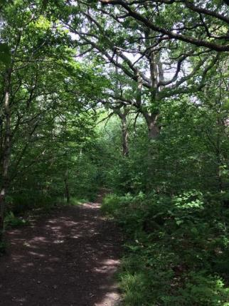

Community involvement
The Bothwell Road Action Group is a local community group who raise funds and run events to engage local people in Bothwell Road Park and Backmuir Woods. The have good local connections via their Facebook page. The group run various family orientated events and clean-ups throughout the year and hold monthly committee meetings. They are also keen to work in partnership with SLC Countryside and Greenspace team (CAG) and Clydesdale Community Initiatives (CCI) on their Heritage Conservation Programme with several conservation management work days in Backmuir Woods planned.

Through the Scottish Natural Heritage (SNH) Outdoor Learning in Nature fund, CAG are now working with a core of volunteers from this group to build their capacity to run woodland play sessions. They have helped to run summer holiday play sessions and other events. Through supporting the community to use these local greenspaces, the negative perception of them (due to anti-social behaviour) is changing.

Projects
Growing up Wild (South Lanarkshire Forest Schools): This project is running between 2019 and 2021 and is funded by the SNH Outdoor Learning in Nature Fund. 12 week Forest School programmes have been run in Backmuir Woods with each of the three schools which bound the site: Holycross High, Beckford Primary and St Paul’s Primary. The programme introduces the children and their families to their local woodland and models how to use the area respectfully and sustainably. 31 pupils and 8 staff members have taken part. 6 pupils from Holycross High are now involved in an extended Forest School to support them to gain their Forest and Outdoor Learning Award (a Scottish Credit and Qualification Framework approved qualification). This project is delivered in partnership with Outlet Play Resource and Laura Frood Community Arts.
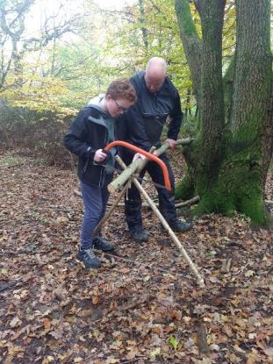
Films made by each of the primary schools can be viewed on the SLC YouTube channel via the links below.
- Beckford Primary: Sharing what we have learned
- Beckford Primary: Finding peace in nature
- Beckford Primary: Getting crafty in nature
- St Paul’s Primary: The pleasure of a puddle

Summer Holiday Play Sessions: The Growing Up Wild programme also involved summer holiday woodland play sessions in partnership with the Action Group. During summer 2019, four group members were involved in running summer holiday play sessions in partnership with Outlet Play Resource attended by 120 people.
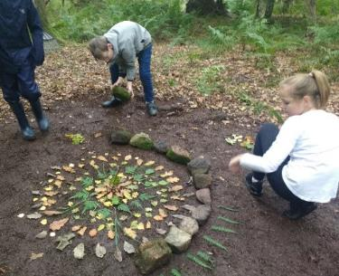
Covey Befriending: SLC Countryside Ranger Service worked in partnership with Outlet Play Resource and Covey Befriending to run outdoor events. 129 people participated in den building and woodland crafts.

Helping Hands for Butterflies: SLC Countryside Rangers are working in partnership with Butterfly Conservation to create and manage wildflower meadows. One event was carried out at Backmuir/Bothwell Road Park and over the next three years, volunteers will be involved with sowing meadows, planting wildflower plugs, etc.

Future Projects
- Three members of the Action Group have completed Fire and Tools training with Outlet Play resource. The longer-term aim is that the group will be confident to run their own woodland play session in Backmuir with sessions planned for the future.
- Four members of school staff are training as Forest School Leaders to enable them to run their own Forest School and outdoor learning programmes in future.
- St Paul’s Primary Nursery and the school’s Inside Out club are starting to use Backmuir Woods and plan to continue this.
- Holycross High are keen to further develop the delivery of the Forest and Outdoor Learning Award with the aim of timetabling it as part of the curriculum
- The CCI Heritage Conservation Programme will continue to work with local volunteers to manage the site and access training for volunteers.

Bothwell, Blantyre and Uddingston

Bothwell, Blantyre and Uddingston (BBU) pLNR is an extensive site consisting mainly of broadleaved woodland surrounding the Clyde river corridor, with several historical features on both sides of the corridor. The pLNR is effectively split in two by the River Clyde, with Bothwell and Uddingston on the east side of the river, and Blantyre on the west.

Habitat
Much of the habitat at BBU is broadleaved woodland, a small section of which can be seen on General Roy’s maps from 1755. The ground flora in this area is diverse and includes a number of ancient woodland indicator species such as bluebell, dog’s mercury, ramson and wood sanicle.
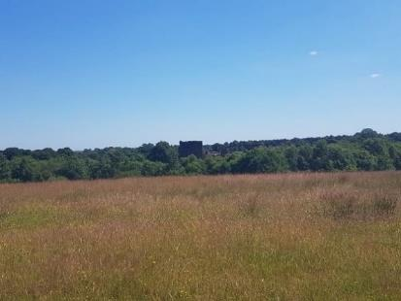

SSSI Woodland
A large section of BBU pLNR is designated as a Site of Special Scientific Interest (SSSI) at Bothwell Castle Grounds, both for its invertebrate assemblage and for upland mixed ash woodland. Other sites in the pLNR include:
- Priory Bing, a large semi-improved neutral grassland area with high biodiversity value.
- Redlees Urban Park supports open water in an old quarry pond that may have previously been stocked with fish. The shallow edges provide important habitat for amphibians and various species of dragonfly and damselfly.
- Craighead woodland, the southernmost section of the pLNR is a mixed plantation / policy woodland, with a varied native ground flora. To the east of the site, river edge woodland is classes as ancient. A diverse variety of tree species can be found on the site, with ash and sycamore being dominant with a varied ground flora.
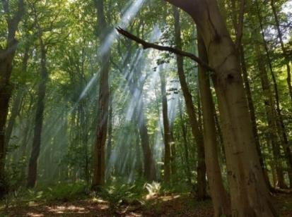

Community involvement
There are several community groups in the area, but no dedicated ‘Friends of’ group yet.
Blantyre Community Council and Priory Residents Association have an interest in the site and are located on the eastern side. Organisations on the west side of the site include the Bothwell Community Garden and Historic Society, and Brighter Bothwell who maintain the Bothwell Nature trail linking the pLNR with the main street of the town.

Uddingston High School and several local primary schools use the site for various activities, with David Livingstone Memorial Primary School using the site to deliver Forest School. Other groups in the area also include Friends of the Calder, Bothwell Organic Growers, Lanarkshire Mountain Bikers, with the area ‘stewarded’ by several enthusiastic individual volunteers who have a good relationship with both CAG and The Unpaid Work Service. The David Livingstone Centre have an enthusiastic team of volunteer gardeners.

A programme of local workdays has attracted volunteers which hopefully will manifest in a more formal way.

Projects
There has been a £6million investment to transform the David Livingstone Centre into a leading tourist attraction, appealing to visitors from across the world. The Heritage Lottery Fund (HLF) have provided £4.1m support for the project with the Scottish Government contributing £1.375m. Historic Environment Scotland has committed £575,000.

Despite falling into a poor condition, with problems including large muddy areas, water erosion, encroaching vegetation and decaying timber edging, a large section of the Clyde Walkway to the south of the site was still popular with walkers and visitors alike. With funding from SNH and Paths For All, 1.3km of pathway was upgraded in 2018. This work included new drainage, signs, timber ramped steps and a ramped path to allow path users to by-pass the steps.

2019 saw the start of an invasive removal scheme by the CAG team, in conjunction with SNH and The Conservation Volunteers (TCV), targeting Himalayan balsam and rhododendron. This will continue for the foreseeable and complement public events and any future larger scale invasive plant removal.
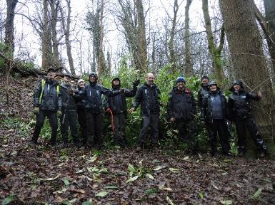
Finally, a management plan was commissioned by Central Scotland Green Network Trust (CSGNT) and Forestry Scotland, to update previous plans for the site and to provide a basis for applications to Woodland In and Around Towns (WIAT) funding and Woodland Improvement Grants. The plan consists of large scale access and biodiversity improvements and also provides support for future funding.

Future Projects
- Future projects will hopefully include woodland management recommended in phase 1 of the management plan mentioned above.
- In conjunction with CAG, volunteers will be investigating existing recorded scheduled monuments and archaeological/historic sites, and then surveying these known sites to update photographic and other information. There will also be walkover surveys to record any new features. This project aims to protect and enhance known and new historic features for pLNR sites.
- We will also continue to work with any community groups, partners such as SNH and volunteer agencies, SLC Grounds Services team, The Unpaid Work Service, and local school groups.

Cadzow Glen

Cadzow Glen runs from Union Street through the town centre of Hamilton to Muir Street. In the south of the site, it is a typical urban burn valley woodland with steep sided slopes and native vegetation. The woodland compartment is set in a steep-sided valley with the Cadzow burn meandering through the centre. The underlying rock of the glen is sandstone, which outcrops in a few areas and forms low cliffs along the side of the burn. To the north, the site opens up to a more formal landscape offering open spaces for informal recreation.

Habitat
The majority of habitat at Cadzow Glen is broadleaved woodland along the steep slopes of the Cadzow Burn. The ground flora is fairly varied and includes species characteristic of native woodlands, such as dog’s mercury, wild garlic, bluebell, enchanter’s nightshade, lesser celandine, and broad-leaved helleborine. Grasses include; tufted hair-grass, hairy brome and false brome. Ferns include: broad buckler fern, male fern, soft shield fern and hart’s tongue fern.

The area of broadleaved woodland at Cadzow Glen is adjacent to several other habitats including the burn running through the site and disturbed damp grassland arising from works on site. Amenity grassland supports some interesting mature specimen trees and a large Victorian garden contains examples of fruit trees, and specimens such as Norway maple and copper beech.
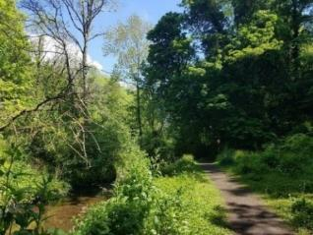

Community involvement
The Friends of Cadzow Glen community group first met in 2017, but there has been community involvement for several years before that by the Rotary group, several local businesses and St. John’s church. The Friends, who have a Facebook page, are interested in raising the profile of the site and encouraging responsible behaviour.
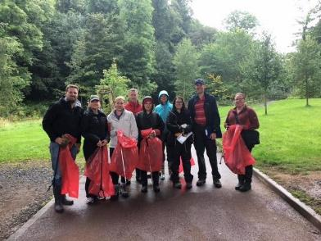
Nearby Cadzow Nursery use the site extensively for Forest School and general outdoor education, in partnership with Scullions solicitors, who have provided storage for equipment for the Friends group and nursery. Hamilton Grammar Secondary School is located in the immediate vicinity and regularly utilise the site as a resource. An Early Learning Unit for Additional Support Needs (ASN) nursery age children has been newly built backing on to the Glen; the Friends group ensured that the centre could use the site by working with the architect to incorporate direct access.

Projects
In 2001 the HLF granted approximately £200,000 for improvements at Cadzow Glen. This was used to create and upgrade the path network, and to creating artwork entrances at the site. Several pieces of sculpture were installed, with those remaining today being in good condition.

Around this time a children’s play area was installed and was very popular, but over the years this deteriorated and was removed. The area enclosing this has been repaired and is now used as an education and vegetable garden area for children and vulnerable people.

The Friends of Cadzow Glen obtained funding (May 2018) to install metal furniture within the amenity grassland area, namely several benches, bins and a notice board, plus raised beds situated in the enclosed ‘Poplars’ area for use by local educational establishments.
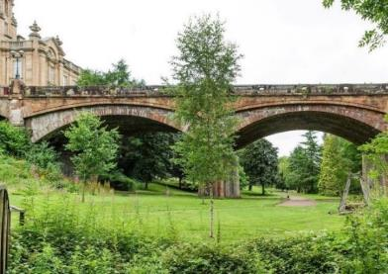

The paths and furniture of Cadzow Glen are generally still in good condition, due to recent repair and renovation works by Lanarkshire Association for Mental Health (LAMH) World of Work Programme, known as the ‘Cadzow Crew’. SLC Grounds Services have recently installed new bins and the Unpaid Work team have cut back vegetation and trimmed and scraped overgrown paths.
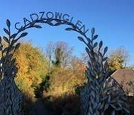

Future Projects
- Potential future projects include the development of a building overlooking the site that may allow the reinstatement of formal access to the site from Cadzow Bridge.
- The Town House are in discussions with the group to collaborate in having formal access from the library and to create a history trail to attract people across from the nearby Low Parks Museum.
- Interpretation is the next step; the group are investigating funding to commission signage.

Fernbrae Meadows

Fernbrae Meadows is on the western edge of South Lanarkshire at the boundary with Glasgow. It is situated between the Rutherglen communities of Fernhill and Cathkin and Castlemilk in Glasgow. Fernbrae Meadows comprises the former Blairbeth Golf Course and part of Cathkin Braes Country Park.

The closure of the golf course in 2015 left a large area of formal amenity grassland which has now been turned into a community greenspace. Newly created habitats include meadows, wetland and associated marshy grassland, orchard and native woodland planting to link to existing woodland in the south of the site. A new path network and points of interest have been installed. These physical improvements, in tandem with a programme of community engagement throughout 2018/19, were jointly funded by SNH’s Green Infrastructure Fund and SLC.
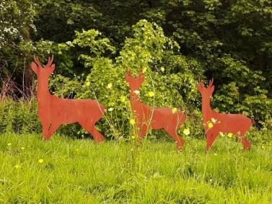

Habitat
Mature broadleaf woodland on the north facing slopes of the braes supports alder, ash, beech, lime, oak, sycamore, rowan and Scot’s pine. Native woodland planting on the redeveloped golf course provides a wildlife corridor to existing woodland. Mature hornbeam trees line the north west boundary and beyond.

Native wildflowers have been planted in large swathes of grassland in which can be found plants of interest including common spotted orchid, northern marsh orchid and greater butterfly orchid.

Wetland areas support meadowsweet, marsh marigold, soft rush and marsh thistle. A stream crosses the bottom half of the site from the south east side of the former golf course to the north west with a mature hedgerow alongside.
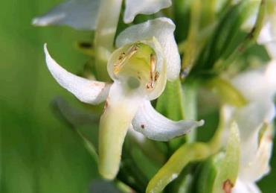

Community involvement
A new community group linked with Fernbrae Meadows emerged before the redevelopment of the urban greenspace was completed. A group of interested residents first met in April 2018 and became constituted as the Friends of Fernbrae Meadows in January 2019. Members and the public are invited to monthly meetings in Fernhill Community Centre. A CAG Countryside Ranger, local Councillors, school staff and Fernbrae Meadows Allotment Committee representatives also attend and work with the group.

Members of the Friends group worked as part of a wider steering group with a community engagement officer from Community Links to hold events and consult with the community on a name change for the space which was originally referred to as Blairbeth Urban Greenspace. Fernbrae Meadows was the overwhelming winner of a public vote and the adoption of a new name and community led activities have contributed to an identification and relationship with the space by the surrounding community.
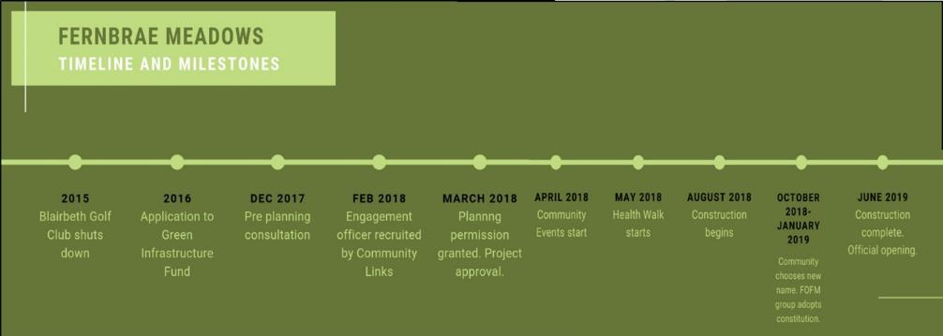

The Friends of Fernbrae Meadows organised an official opening event for the site with Councillor John Anderson in June 2019. The event was attended by representatives from SLC, SNH, local schools, Community Links, volunteers and 400 members of the public who were treated to a midsummer solstice tea party by aerial circus performers from Rowanbank Environmental Arts. An information leaflet about Fernbrae Meadows was created for the opening in a collaborative effort between the Friends and local school children who designed a logo for the group.

The group continue to plan small, regular community events focussing on community connection, taking care of the surroundings and developing the space for biodiversity while also researching the history of the landscape. Informal litter picking activity occurs daily by members of the community. The Friends engage the wider community through social media and have several volunteers interested in photography who have provided visual content through photographs and drone video footage.

Educational establishments have been actively engaged with the space throughout its development by helping to plant trees and wildflowers. Fernhill School uses the site for Forest Kindergarten, outdoor learning and cross country running. Cathkin Primary School teachers ran Mucky Boots after school play sessions. Support for Play and Early Learning Lanarkshire (SPELL) hosted Little Hedgehog Outdoor Play sessions for parents and pre-school children in early 2020. Oakwood and Ace Place Nurseries in Rutherglen use the space for Forest School. There are several spaces designed specifically as outdoor classroom areas, but groups visit on a flexible basis accessing the whole site.

Projects
- Wildflower meadow creation: The Friends secured a Volunteering Matters Action Earth Grant in 2019 to ‘Put the Meadows into Fernbrae Meadows’ and created a new wildflower meadow with volunteers.
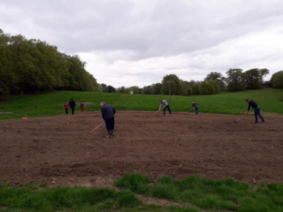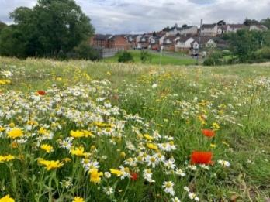
- Pond planting: The group worked with the British Dragonfly Society to develop an initial plan to improve the ponds for wildlife with marginal planting, also funded through the Action Earth grant.
- Health Walk: Local Paths for All trained volunteers have led a weekly health walk since May 2018.
- Community consultation: CAG staff and the Friends consulted with the public and local schools to name landmarks within the space.
- Green Health: Local health and social care practitioners gathered in Fernbrae Meadows in September 2019 to experience a range of green health activities including cycling, health walks, conservation, gardening, transient art and forest school.
- Citizen science: The group hosted a Big Garden Birdwatch event in January 2020 and volunteers have attended training on butterfly and dragonfly identification and recording.
- Orchard: The community has taken over maintenance of the newly planted orchard with members attending pruning and maintenance training.
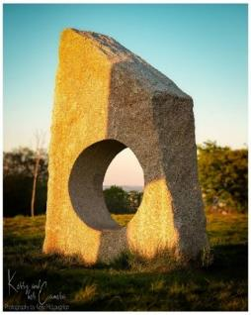

Future Projects
- Buggy walk: Two members of the community have embarked on training to lead weekly walks for new parents and children while links have been made with partner organisations to support the physical and mental wellbeing of local families through green activity and play.
- Butterfly transect: Members of the community have started to record butterflies using the iRecord Butterflies app and will build on this by establishing a transect route for volunteers to provide data for the UK Butterfly Monitoring Scheme.
- Community garden and orchard: An area within the adjacent allotments will be released as a community gardening area for groups and individuals to participate in food growing projects. The orchard will be maintained by the Friends with support from CAG and SLC Grounds Services.
- Conservation: Volunteer days supported by SLC Countryside Rangers in partnership with Glasgow City Council colleagues will be held to remove non-native invasive species: Himalayan balsam and rhododendron. Other conservation tasks will include tree planting and ongoing meadow management.
- Photo walk: Keen members of the community plan to create a monthly walking group to share photography techniques with local people as well as using photography as a mindful activity for wellbeing. This could be linked to recording species and promoting the space.

Greenhall, Milheugh and Barnhill

The Rotten Calder River flows through the two former estates of Milheugh and Greenhall, to the west of the town of High Blantyre, in South Lanarkshire. The landscape supports open parkland with mature trees, surrounded by woodland on the valley slopes.

Habitat
Much of the site is under broadleaved woodland with a diverse ground flora and many ancient woodland indicator species. Bluebells and ramsons dominated the woodland floor in the spring; other species of interest include broad-leaved helleborine, great woodrush, wood anemone, wood millet, wood sorrel, wood speedwell and sanicle. Other habitats found within the site include the running water of the Rotten Calder, a pond at Barnhill, semi-improved neutral grassland and mature parkland trees.

Community involvement
The Friends of the Calder first met in August 2012 and became formally constituted in 2013. The groups focus is on the conservation, community involvement and education of the area known locally as the Calder. They meet formally every two months with members of the local community, CAG staff, CSGNT, their local Member of Scottish Parliament (MSP), community councillors, landowners, local businesses and occasionally the community police.

The Friends have approximately twenty events throughout the year with the local primary, nursery schools and volunteers. Activities have included practical conservation tasks; wildflower meadow creation, planting trees, removing non-native species and improving access. They usually have one large event each year attracting around 300 people. In 2017 and 2018 this included a visit from the Wild about Scotland bus, from Edinburgh’s Zoological society.

The Friends have been involved in many campaigns through Keep Scotland Beautiful including the Upstream Battle project and have received many awards including the Spring Clean Hero award, and It’s your neighbourhood award (level 4). They are a very enthusiastic group and passionate about their local area. They have built up solid relationships with large organisations and businesses in their community and continue to pursue new funding streams and campaigns. They make use of the local press and social media to advertise and promote the work of the group.
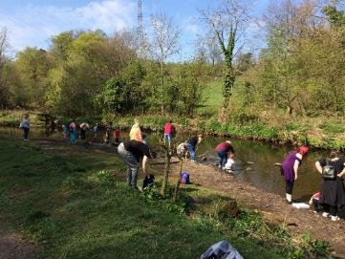

Projects
In 2016 grants from WIAT and WREN (renewable energy funding) allowed completion of Phase 1 of the site restoration project. The project was delivered in partnership with CSGNT and included:
- £160,000 worth of path and woodland improvements along the northern banks of the Rotten Calder Water. A total of 3km of path has been improved, with new steps, boardwalk entrance gates and fencing.
- In September 2017 1.6ha of dense over mature conifer plantation was removed from the banks of Greenhall; some sections have been replanted with oak trees and the rest has been left to regenerate naturally. The regeneration of the flora at Greenhall has been monitored since 2018 with many plants and trees arriving naturally.
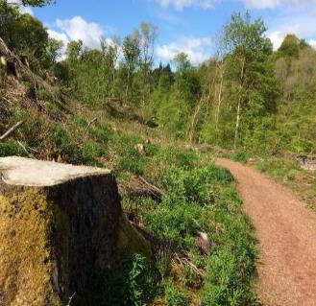

Orchard: In March 2019 the ‘White Gate’ community orchard was established at Milheugh, with donations and volunteer time from Babcock International and SLC. Installation included several fruit trees, planters, fencing, new pathway, gate, art installation and bird / bat boxes. The site is used by the local community and school groups. Is it maintained by The Unpaid Work Service and the Friends.
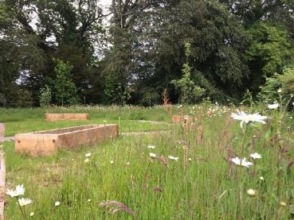

Wildflower meadows: Since 2018 approximately 3ha of amenity grassland has been managed for invertebrates. The grassland is now mown once a year and has been seeded with wildflowers including yellow rattle.

Froglife: In 2016 the Froglife Living Waters project enhanced the temporary pool of water at Barnhill to form a larger and deeper body of open water habitat. Local children and volunteers planted a variety of aquatic and marginal plants as part of the project.

Future Projects
The main future project will be Phase 2 of the WIAT project. Since improving the paths on the south side of the Rotten Calder in Phase 1 of the project, SLC and CSGNT are now working to continue to improve the area for people and wildlife, including developing and costing a programme of work to improve the path network. This had included securing funding to commission a bridge engineer to carry out a feasibility study and produce designs and costs for a new bridge to cross the river and form a circular walk route. The package of work will focus on:
- Building a new bridge across the Rotten Calder.
- Repairing and upgrading the path network on the northside of the river.
- Installation of benches, way markers and welcome signs at key entrances.

The CAG team will continue to work with the Friends of the Calder, SLC Grounds
Services, The Unpaid Work service, local school groups and the local community for the benefit of people and wildlife at Milheugh, Greenhall and Barnhill.

Hamilton Low Parks

Hamilton Low Parks forms part of the mid-Clyde haughs which together form a virtually continuous wetland complex along the River Clyde from Carbarns to Bothwell Bridge. This series of water bodies and associated wetlands was created primarily by mining subsidence. Low Parks is a series of discrete sites sandwiched between the major urban areas of Hamilton and Motherwell.

Habitat
Hamilton Low Parks is comprised of sections of the Clyde floodplain with open water bodies, grassland, wet and mixed woodland throughout. A large proportion of the site is designated a SSSI due to the presence of one of the largest tree nesting heronries in Scotland. Barmichael Woods is important not only for the heronry but for its veteran trees, comprising predominantly of beech, ash, sycamore, lime, horse chestnut and yew and a ground flora that includes bluebells, wild garlic and dogs mercury.

The wet grassland vegetation surrounding the ponds includes plants such as sedges, great reedmace, soft rush, water plantain, tufted hair grass, meadow sweet, common osier willow and birch.
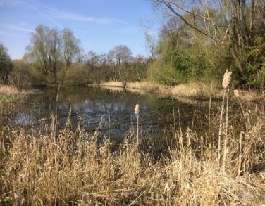

Community involvement
In 2013, posters were put up around South Haugh, inviting the local community and other interested parties to join in on a series of monthly Conservation Days. Initially there were a few volunteers but interest grew and a number of organisations (Enable Scotland, Right Tracks Scotland, LAMH, Phoenix Futures, Greensteps and Richmond Fellowship Scotland) began to bring their clients along or referred them onto the programme. Due to its popularity the sessions were increased to fortnightly in 2015. From January 2020 a new format sees the conservation days rotating around different sites (including Udston and Glenlee Woods and Westburn pLNRs) throughout the year but still running predominantly at South Haugh/Low Parks.

Volunteer tasks at Low Parks have included path maintenance, woodland management, invasive species removal, scrub clearing, litter picks and more technical projects such as bird screen repairs and bench and information board installation. To date (April 2020), there has been 153 conservation sessions with a total of 1,558 volunteer days.

A series of community engagement sessions in August/September 2019 led to a group of 20 people stating an interest in getting involved in the site. An initial meeting took place in October 2019. A programme of site visits and a further meeting will be set up to familiarise everyone with the site and discuss next steps.
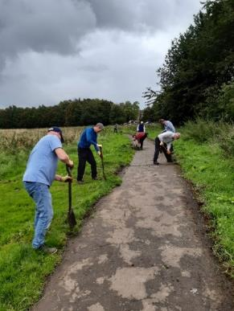

Projects
- In partnership with Froglife, two ponds were created in 2016 as part of the Living Waters project. There ponds were sited within the Mausoleum wetland site. Volunteers from LAMH planted a variety of aquatic and marginal plants as part of the project.
- TCV are contracted by SNH to undertake a number of work days per year on SSSI sites. For the last two years, we have partnered the conservation volunteers at Low parks with those from TCV to tackling Himalayan balsam.
- The Early Learning Unit, which is located directly next to South Haugh have been utilising the site for a weekly Forest School session for the last four years.
- A butterfly transect was established at South Haugh in 2005 and has been surveyed every year for 26 weeks of the year, since. Volunteers have been encouraged to get involved.
- BTO’s Wetland Bird Survey (WeBS) was set up at Hamilton Low Parks in 1997 and has been running every year on a monthly basis, ever since. A local community volunteer has assisted with the surveys for the last four years.
- The Heronry at Barmichael Estate has been monitored since 1975 by the Ranger Service. For the last four years there has been assistance from a local community volunteer.
- Since March 2021, Outlet Play Resource have been using South Haugh to run a number of outdoor play programmes with groups of children of various ages.
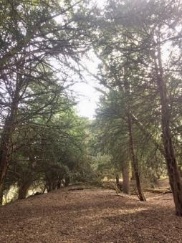

Future Projects
- A Heronry Ringing project will hopefully take place in 2021 in partnership with the Clyde Ringing Group and SLC Arboriculture team, with possible help from the Raptor Study Group and any interested volunteers.
- In conjunction with CAG, volunteers will be investigating existing recorded scheduled monuments and archaeological/historic sites, and then surveying these known sites to update photographic and other information. There will also be walkover surveys to record any new features. This project aims to protect and enhance known and new historic features for pLNR sites.
- Other projects will hopefully be decided on at future meetings with the potential ‘Friends of’ group.
- It is hoped more volunteers can be encouraged to get involved in biological surveying and public events.

Holmhills Wood Community Park

The site that is now Holmhills Wood Community Park was agricultural farmland from the 18th century until the 1960s. In 1999 the area was identified as a potential community woodland site to benefit both wildlife and the local community. Much of the present site work, including the path network, pond creation and tree planting, was carried out from 1999 to 2001. The Park is well used for informal recreation and for access to local schools, transport and business in Cambuslang and its surrounding local communities.

Habitat
Holmhills Wood Community Park comprises areas of amenity grassland, semi-improved neutral grassland, woodland, scrub and ponds.

Community involvement
The Friends of Holmhills Wood Community Park is a sub-group of Cambuslang Community Council, formed in 2012 to promote the responsible use and enjoyment of the site. They meet every second month, with meetings open to all. The Friends raise awareness of the Park through guided walks and events, a health walk programme, and conservation work throughout the year. They have an active social media presence, participate in Keep Scotland Beautiful and It’s Your Neighbourhood programmes, and have fostered links with the local secondary and ASN schools and other local volunteer and third sector groups.

With good infrastructure already in place on site, the Friends seek funding to allow them to run public events and purchase equipment for use with local schools, nurseries and other organisations. They also contribute significantly with volunteer time for habitat monitoring, biological recording and practical conservation work on site, contributing data on plants, birds, butterflies and dragonflies to local and national recording schemes.

Rutherglen High School (ASN) uses the site for the John Muir Award, while Cathkin High School utilises the area for various curriculum-related activities. Project 31, a local voluntary youth organisation, uses the woodland for Forest School sessions and other outdoor activities. Other independent outdoor activity organisations and commercial dog walkers also use the area regularly.
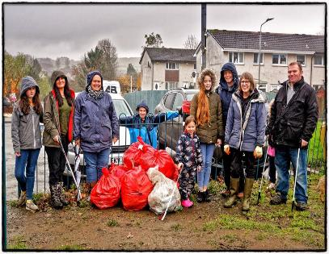

Volunteer hours
159 volunteer days from April 2019 to March 2020.

Projects
The Park was created 1999 - 2001, as a project to benefit both wildlife and the local community.
In 2016, as part of Froglife’s Living Waters project, the three ponds at Holmhills were restored, resulting in cleared ponds with permanent open water.

Future Projects
- Selective woodland thinning
- Hedgerow and scrub maintenance
- Pond management
- Wildflower sowing
- On-site and digital interpretation

In the future, the CAG team will continue to work with the Friends of Holmhills Wood Community Park, SLC Grounds Services, Unpaid Work Service, local schools and the local community.
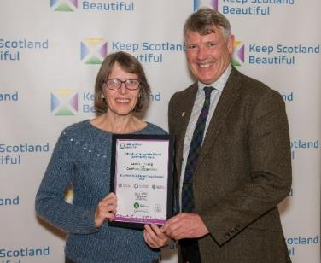

James Hamilton Heritage Park

The James Hamilton Heritage Park was created from low-lying marshy fields in 1995. It comprises a large loch used for watersports, and a smaller loch created as a wetland nature reserve and bird sanctuary. The two are separated by a causeway with the smaller loch fenced off to limit access and reduce disturbance. The area is served by well-maintained paths, which are part of the core path network, and are well used by the public. A bird watching hide is located at the southern edge of the smaller loch, with access available on request. The smaller loch is the site of proposed local nature reserve.

Habitat
The pLNR comprises a small loch with three islands. The banks are dominated by planted broadleaved trees and scrub over grassland and soft rush. Marginal vegetation is found along the banks. Two of the three islands support mature trees and willow scrub, with the third island dominated by soft rush. The site provides valuable nesting, feeding and drinking habitats for local wildlife, and supports many waders, ducks, geese and gulls, summer migrants including swift, swallow and sand martin, and invertebrates such as dragonflies, damselflies and butterflies.
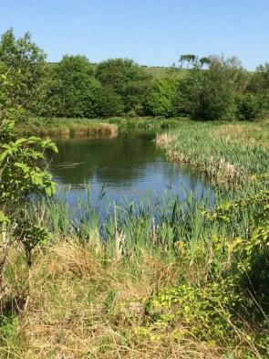

Community involvement
There is currently no active community group associated with JHHP. A key objective of the pLNR would be to foster links with the local community. East Kilbride Sea Scouts and Stewartfield Parish Church have both carried out conservation tasks to clear vegetation around the bird hide, and have ongoing contact with the Countryside Ranger Service.
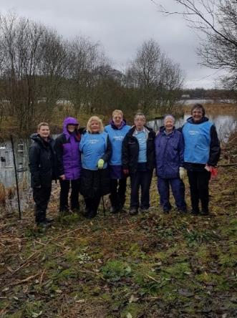

Volunteer hours
3.5 days from April 2019 to March 2020.

Projects
The site was created in 1995 and has been well maintained. The pLNR was actively managed for some years after creation, but this has since lapsed. Reinstatement of this management is a key objective.

Future Projects
- Foster links within the local community
- Reinstate management for nesting birds on the islands
- Management of trees and scrub
- Species recording and input to recording schemes
- Maintenance of the bird watching hide

Jock’s Burn

Jock’s Burn proposed LNR is located in the centre of the town of Carluke. The reserve is surrounded by residential housing, a public amenity park, Crawforddyke Primary School and playing fields. Glenafeoch Road runs through the centre of the reserve separating the two sections of woodland.

Habitat
Jock’s Burn flows through the centre of Carluke and eventually reaches the River Clyde at Rosebank, approximately two miles to the west of the pLNR. The site provides a valuable natural woodland in the middle of an urban area. The banks of the burn support a mixture of native broadleaved species with planted conifer trees. The ground layer is abundant with a variety of ferns. Other habitats include a dense stand of planted conifer in the far eastern section of the reserve and amenity grassland, which separates the woodland from the surrounding residential development.
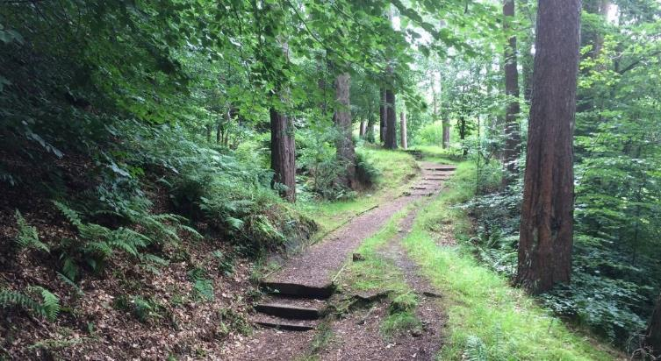

Community involvement
Currently there is no ‘Friends’ group attached to Jock’s Burn but there are several interested parties. Schools, local residents and local outdoor play groups have expressed an interest in using the site. The site suffers badly from vandalism and littering at the main entrance area making it difficult for schools and groups to use due to broken glass and burnt trees. Recent initiatives show potential to change this.
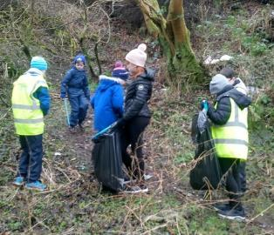

Projects
- CCI Heritage Conservation Programme 2019-20: Several clean ups and conservation days have been programmed as part of this initiative. The first clean-up took place on 5th February 2020 with Crawforddyke Primary, four local volunteers and a local company Complete Weed Control. The April event was cancelled due to Covid 19.
- Growing up Wild - South Lanarkshire Forest Schools: This project is funded by SNH Outdoor Learning in Nature Fund to raise awareness of the issues in Jock’s Burn. Crawforddyke Primary Eco group have been involved in a programme of site visits and filming/animation to create the following film: Mossy’s Revolution

Future Projects
- Healthy Rivers, Healthy Communities: A funding bid was submitted by SLC CAG to the SNH Plunge In! fund to enable a partnership project with the charity Clyde River Foundation to work with two local schools and community groups. The project would engage young people and community volunteers in ‘Meet your River’ sessions to work with biologists to assess river health and collect data through aquatic invertebrate surveying -kick sampling, pollution assessment, electrofishing demonstration, Invasive non- native plant species identification and a guided walk along the watercourse. The bid was unsuccessful but the potential to run a scaled-down project is being explored.
- Smarter Choices Smarter Places: Funding has been awarded via SLC’s allocation of Smarter Choices Smarter Places (Paths for All funding). This will allow a range of activities during 2020-2021, including Health walks and training, woodland activities and a youth arts/photography programme aimed at celebrating Jock’s Burn and encouraging people to actively travel in their local area.

Langlands Moss

Langlands Moss is a lowland raised bog situated approximately two miles to the south of East Kilbride. This distinct habitat is among one of our most important habitats nationally and internationally, providing a home for a variety of unique plants, animals and insects. Sections of the bog were planted with conifer trees in the 1960s, which have been gradually drying out the peat and destroying this rare habitat. In the early 1990s the conifer trees were removed from the raised bog, access was improved, and the site was declared an LNR.

Habitat
Langlands Moss is a small and largely intact area of lowland raised bog. The vegetation on the raised bog is typical of the habitat with Sphagnum bog mosses, heathers, cross-leaved heath, bog asphodel, round-leaved sundew and cotton grasses. Species of interest found at the site include large heath and green hairstreak butterflies, otter, badger, common frog, newts and common lizard. The nationally rare lichen, Vulpicidia pinastri can be found on deadwood within the raised bog.
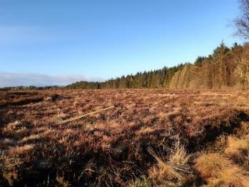

A feasibility survey was commissioned by SLC in 2018 through the SNH (now NatureScot) Peatlands Action Fund, to determine the potential of the site for eco-hydrological restoration. A large conifer plantation stood to the north and west of the raised bog and is part of the new proposed LNR extension. The report found sections of deep peat underneath the conifer plantation; average depth was found to be 139cm, with deeper pockets of over 9 metres. The volume of peat equates to 298,199.6m³ with an estimated carbon content of 2,925 tonnes of carbon (106,059 tonnes of CO²). With the results from the feasibility study, we decided to remove the large stand of conifer trees and dam the drains associated with the forestry plantation. This will help to increase the water level in and around the raised bog and will replace the planted conifer trees with a mosaic of wetland and wet woodland habitats.
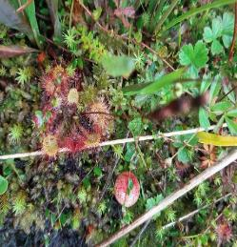

Community Involvement
The Friends of Langlands Moss formed and became constituted in 2006; their focus is to protect, promote and preserve the nature reserve. They have strived to secure funding in improving access and signage to the reserve, whilst raising awareness and the plight of raised bogs in the UK. They meet regularly throughout the year and work in partnership with many local and national organisations including SLC CAG team, CAT, The Unpaid Work Service, Butterfly Conservation (Bog squad), Bat Conservation Trust, local businesses and Volunteer Matters. The Friends use their Facebook page and website to share information on Langlands Moss.

In 2014 the Friends received a large grant from the Big Lottery Fund and SNH for damming materials to improve the hydrology of the raised bog. Many volunteer hours have been spent replacing old and broken dams along the forestry ditches on the raised bog. The Friends run a full programme of events each year and regularly accumulate 190 days of volunteer hours annually. Events include practical conservation days and bat and moth evenings; the local primary school and Boys Brigade regularly visit the site.

Projects
- Boardwalk: In 2013 a new 374m long and 1.3m wide raised boardwalk was installed to replace the original wooden boardwalk. The Friends raised a total of £100,000 from the Heritage Lottery Fund, the Renewable Energy Fund and Viridor. Unfortunately, in 2016 a 30m section of the walkway was burnt and a year later a larger section was vandalised. The two fires have removed the majority of the boardwalk, reducing access to the reserve. With help from The Land Trust, REF (Renewable Energy Fund), FOLM and GAT (Green Action Trust) we are aiming to reinstate the missing 170m section of boardwalk during 2021.
- Bog Squad: This volunteer task force, created by Butterfly Conservation carries out peatland restoration work across Scotland. They have been working at Langlands Moss since 2014 alongside the Friends and other volunteers to remove large sections of invasive scrub and install ditch blocking dams. The effectiveness of the dams has been quick with large pools of water being retained which is helping to re-wet the surrounding peat.
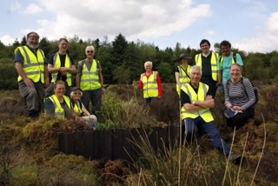
Froglife: in 2016 the Living Water’s project saw the creation of three new ponds at Langlands; this has resulted in a diverse mosaic of open water and marshy habitats. Local school children and volunteers planted a variety of aquatic and marginal plants as part of the project.
- Paths for All: A small grant to the Friends bought material to improve the main access route to the reserve, with practical work carried out by the Friends, and volunteers from the Boys Brigade and Sainsburys.
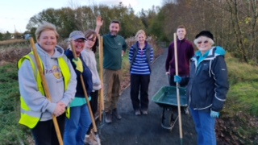

- Peat restoration: the Peatland Action Project has been running since 2012 and recognises the Scottish Governments commitment to restoring peatlands and the multiple benefits this can bring. At the start of 2020 Langlands Moss underwent a huge transformation, CAG and GAT (Green Action Trust) worked together for a few years to secure funding to remove the large stand of conifer trees at the site and preserve the peatland found underneath the conifer tree. The project involved removing an area of 20.15ha of over mature conifer trees located to the west of the raised bog, a protected mammal survey, removal of brash, installation of 18 plastic dams, 3 peat dams and 5 bunds.

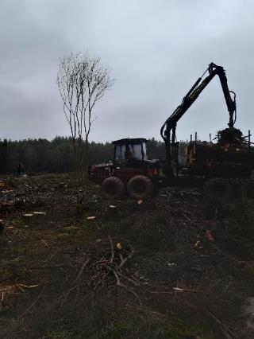

Future Projects
- To monitor and manage the development of the wetland vegetation and regeneration of the felled woodland area. Restoring and re-establishing peatland function associated ecosystem services and secure the storage of carbon already held within the peat.
- To reinstate the access network throughout the nature reserve, this will include identifying suitable funding resources, further community consultation and monitoring the development of the restored peatland, as this will in part determine where the access can be situated.
- Update sites management plan, to include the new proposed extension of the LNR.
- Continue to work in partnership with the FOLM and volunteers in restoring the peatland habitat.

Milton

Milton is the site of a former brick and tile works on the outskirts of the town of Carluke. The site comprises of two areas separated by Jock’s Burn, along Station Road. Identified by SLC as Vacant and Derelict Land (VDL), it is around 14ha in size. The site supports a mosaic of habitats from bare and previously disturbed ground of the former brick works, semi-improved neutral grassland, marshy grassland, scrub, woodland and open water associated with the former clay pits.
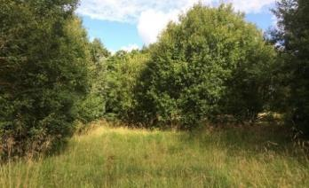

Habitat
The central and southern areas are generally open and grassy with small clusters of trees and shrubs. The ground supports numerous grasses and vetches along with common hogweed, silverweed, common knapweed, ox-eye daisy, greater bird’s-foot trefoil and ladies mantle.

The eastern reaches of the site are overgrown with dense woodland and scrub. The woodland is abundant with willow species, but also oak, beech, cherry, silver birch, downy birch, alder, Scot’s pine, blackthorn and hawthorn. The ground flora includes various grasses with enchanter’s nightshade, male fern, broad-bucker fern and red campion. A few spikes of broad-leaved helleborine can be seen.

A pond is present to the east of the site, with boggy and waterlogged ground present in the vicinity. Wetter areas give rise to common sedge, common reed, reedmace, reed canary grass, wild angelica, meadowsweet, compact rush and yellow flag iris.

The western boundary along Station Road supports a hawthorn hedgerow with mature trees of oak, beech, ash, willow and Scots pine. Jock’s Burn surface water runs east to west to the north of the site and is a tributary of the River Clyde.
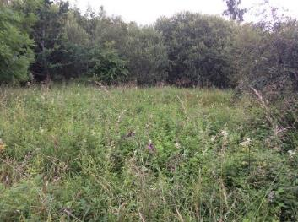

Community involvement
There is currently no active community group associated with Milton.

Projects
In 2018 Ironside Farrar Limited was instructed by SLC to undertake an Environmental Survey and Monitoring project at Milton. A programme of surveys and monitoring was developed to assess current environmental conditions at the site with an aim to characterise the ground gas regime, although shallow soil sampling and water sampling was also undertaken. Boreholes, ground gas and groundwater monitoring wells were installed for monitoring purposes.
In winter 2020, significant site works were undertaken at Milton thanks to the Vacant and Derelict Land Fund. New access points were created one of which has parking spaces. Paths and boardwalks were installed along with benches and a central design incorporating reclaimed bricks in a Celtic knot pattern. Wildflower seed has been sown in many areas to help improve grassland diversity and improve pollinator habitat.

Future projects:
- Work with neighbouring landowners in improving access to the reserve.
- Consider installing signage and interpretation.
- Develop community involvement with site use.
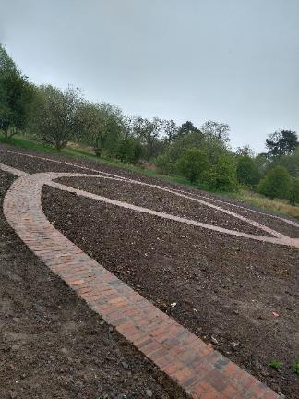

Morgan Glen

Morgan Glen is located on the western edge of Larkhall. The site is bounded by houses and other development on its eastern edge, and by the River Avon to the west. Morgan Glen is a semi-natural gorge woodland that follows the banks of the River Avon. It is named after John Morgan, the proprietor of the nearby Applebank Inn who gifted the glen to the people of Larkhall in 1939. The site has a long history of use for community gatherings including dances and gala days.

Habitat
Morgan Glen is one of the largest individual woodlands of its type (calcareous gorge woodland) in Scotland. A large section of the woodland is designated as Avondale SSSI; it is also part of the Clyde Valley Woodlands Special Area of Conservation (SAC).

Dominated by ash and elm, the gorge woodland supports a wide variety of ground flora including bluebell, ransoms and wood anemone. Badger are present and dippers, heron and otter can be spotted on the Avon. Areas of grassland within and on the northern edge of the woodland provide a home for invertebrates.
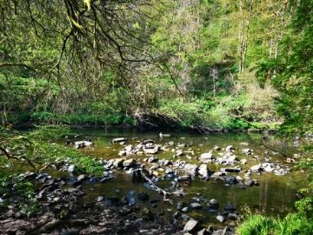

Community involvement
The Friends of Morgan Glen is a constituted group that have been working to protect and enhance the space since 1996. In the past they have arranged clean ups, held large community events including Gig in the Glen, participated in local gala days and published an annual photographic calendar of the Glen. In recent years, the group membership has declined, and remaining members are keen to engage with the wider community, recruit new volunteers and relaunch the group. Still meeting once every two months, the group has a great deal of affection for and knowledge about the history and ecology of the site and this passion has already attracted a few new participants.

A guided walk and land art event was held in October 2019 and participants expressed an interest in further events and volunteering. Members of the group shared their local knowledge in this event hosted with the Countryside Ranger Service.

The group created a Facebook page in 2020 to further interact with the local community. This page attracted over 450 followers in its first three months and is managed by two new volunteers. The group is working in partnership with local organisations to increase participation and to get the wider community more involved.

Strutherhill and Birkenshaw Our Place Our Plan group held a community clean up in May 2019 and volunteers ventured to the Glen to fill bags of rubbish during this wider neighbourhood litter pick. In June 2020, a group of Millheugh Community residents litter picked and arranged for new bins to be installed at the Millheugh entrance and surrounding area.
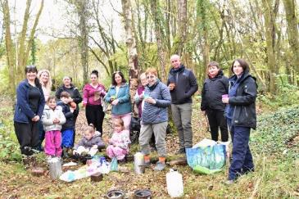

Projects
- Health Walks: Two local volunteers were trained to lead weekly Health Walks in a venture jointly run by the Friends and the Our Place Our Plan Strutherhill and Birkenshaw Group. A weekly Tuesday evening walking group started in October 2019 with routes in and around the Glen supported by Get Walking Lanarkshire.
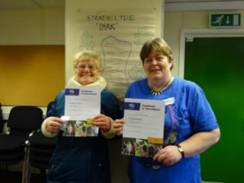

- Outdoor Learning: St Mary’s Primary School are spending regular time at Morgan Glen with Eolas Outdoor Learning at Forest School. They have captured video footage of the wildlife in the area and shared their sightings with the community through social media.
- The Unpaid Work Service: the team have worked on the site to improve drainage and clear paths and the ‘Hundred Steps’.

Future Projects
- Army Cadets clean up: The Countryside Ranger Service has been working with the Cadets in the community to raise awareness of how to enjoy and preserve greenspaces; they will now volunteer on site to help pick litter and cut back overgrown paths.
- Outdoor play: Until 2018 there was an outdoor playgroup for families with young children. There is interest from a local church group in running outdoor play sessions with a dads’ group which can be supported by local outdoor learning practitioners and the Countryside Rangers.
- Robert Smillie Primary School: The Nursery are currently taking early years groups out to Morgan Glen for woodland play. The space they use is limited and an adjacent site could be cleared of fencing and litter to be made safe enough for a group to gather and play. Involving the community police, the school community and local problem-solving groups in this will help to tidy and maintain the space for educational use.
- Eco health walk: The health walk group is hoping to add a second weekly eco walk with a focus on picking litter or doing some light conservation tasks as they travel through the Glen. We will work with SLC Grounds Service staff to facilitate the picking and collection of litter.
- Citizen Science: Volunteers hope to establish a transect to monitor butterflies and work with local outdoor learning practitioners to get schoolchildren involved in identifying and recording butterflies and improving grassland habitats for pollinators.
- Landslip: Access is hampered by subsidence in the paths along the banks of the Avon in places. Significant investment would be required to investigate solutions and restore the path network. A strengthened community group may be able to explore funding opportunities.

Mossneuk

Located approximately two miles to the west of the centre of East Kilbride, this 23ha reserve lies within the urban area of East Kilbride and is well used and enjoyed by local people. Its proximity to three schools makes it potentially important as a local educational resource.

Habitat
The northern section of Mossneuk was originally a small raised bog, which now supports an interesting mosaic of mature and young semi-natural broadleaved woodland, wet woodland, mixed broadleaved and coniferous woodland. The original peatland vegetation is still present although altered in form and now supports broadleaved woodland dominated by birch. Where the woodland is more open many typical and interesting bog species are still abundant; a variety of Sphagnum mosses can be found with clumps of blaeberry, heather, tormentil, purple-moor grass, common and hare’s-tail cotton grasses. Round-leaved sundew, cranberry, meadowsweet and soft rush can also be found.

To the south of the site, the more open areas support marshy and wet grassland, semi-improved neutral grassland and amenity grassland.
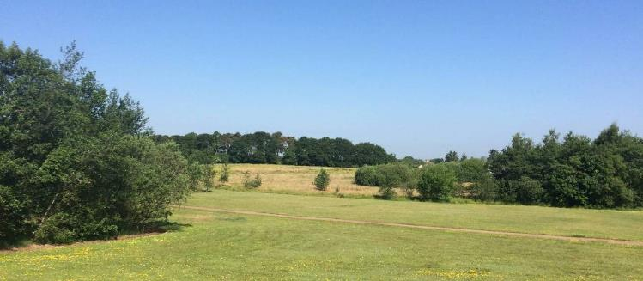

Community groups
There is currently no active community group associated directly with Mossneuk; a key objective of site management is to engage with the local community. The greenspace is well used for informal recreational and leisure pursuits such as walking, dog walking and cycling. The reserve is easily accessible to the surrounding residential communities and has a network of paths and desire lines throughout.
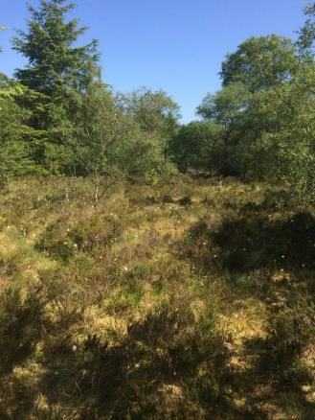

Projects
There are currently no projects at the reserve. The access network is maintained by SLC Grounds Services.
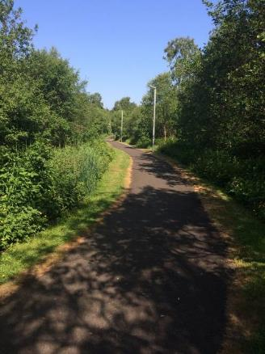

Future Projects
- Investigate, maintain, enhance and monitor the biodiversity value of the reserve including woodland and grassland areas.
- Carry out a community consultation to establish the level of interest in creating a local community group for the reserve.
- Investigate potential access improvements to infrastructure, signage and interpretation based on local need.
- Identify funding opportunities for future projects.
- Encourage and promote the use of the reserve through practical conservation workdays, events and social media.

Neilsland and Earnock

The Victorian estates of Neilsland and Earnock are a mixture of native woodlands, designed landscapes with ornamental features, and post-industrial sites which now form a mosaic of habitats types and heritage features high in biodiversity and cultural value. They are situated close to a number of residential areas and provide local access and links to South Lanarkshire’s Core Path Network.

Habitat
The woodlands are home to a huge array of plant and animal species, many of which are woodland specialists. Great spotted woodpeckers, spotted flycatchers, woodcock and a range of warblers benefit from a diverse insect fauna, which is supported by diverse habitats, with deadwood, open spaces and running water. Herons and dippers can be seen on the Earnock and Cadzow Burns, and a healthy population of badgers have excavated their setts in the rich woodland soils of the valley sides.
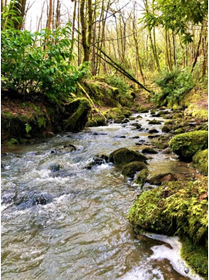

Community involvement
New Roots Neilsland and Earnock Heritage Group helped drive forward the initial Community Consultation (2010) and WIAT bid (2012). They continue to organise regular community fun days and work parties within the woodlands. Their Facebook group, set up in 2011, now has over 1000 members. Facebook is the main platform for sharing information and ideas with the local community.
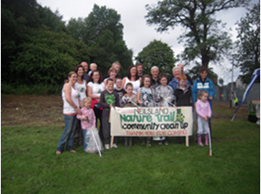

After the completion of WIAT works in 2013 community activity has seen a steady increase: Since 2010-11 there have been 766 volunteer days representing an economic value of over £70,000.

The provision of a high quality path network has also allowed local schools and nurseries to use the woodland resource as a place of study and learning. The health benefits are also apparent with Health Walks taking place weekly within the woodlands from the nearby Fairhill Lifestyles Community Centre as part of the ‘Get Walking Lanarkshire’ programme.

Local volunteer Path Surveyors monitor the path network as part of the Countryside Ranger Service’s ‘Adopt a Path’ scheme with weekly visits and reports on any issues that arise. Regular work parties from the New Roots community group as well as the ‘Cadzow Crew’ LAMH conservation volunteers ensure that the WIAT investment in the access and infrastructure of the site will leave a legacy for future generations who will enjoy our woodlands. The path asset is in great condition with small repairs and maintenance being carried out by volunteers.

Social media is playing a more and more important role within the community to help monitor and report site based issues, as well as a platform for sharing good -news stories. The New Roots Facebook page is a place where people can share information, carry out research and learn more about the local area. Since the start of the Covid-19 lockdown restrictions interest in discovering and using the local greenspaces by local residents has become very apparent. The Facebook group membership has grown by over 50% in the three months since March 2020 and there is a lot of renewed interest in becoming involved in community based activities, such as Nature Lovers in Lockdown.
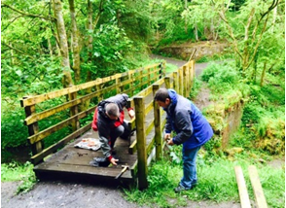

Projects
- Community Consultation: The restoration of the footpath network, bridges and access points, as well as the installation of entrance signs were identified as key management priorities after a community consultation carried out in 2010.
- WIAT works: Funding of over £100,000 allowed access points and entrance signs to be installed and 2km of footpath resurfaced. The restoration of the footpath network and replacement of two pedestrian bridges allows local residents to realise the full potential of the woodlands as places to relax and enjoy informal recreational opportunities.
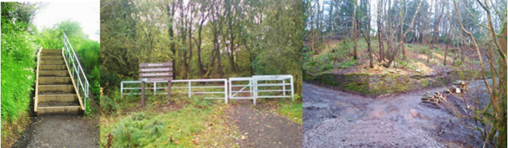
- LAMH Cadzow Crew: Volunteers working with the CAG Sites and Volunteer Officer have carried out numerous repairs on sections of the path network.
- Adopt A Path: A Volunteer Path Surveyor carries out weekly assessment of the path network and infrastructure reporting issues to the Countryside and Greenspace Service.
- Mushroom Trust: In September 2014, an additional £10,000 grant by The Mushroom Trust was awarded to the New Roots Community Group for improvements to historically important gateposts and masonry walls within the former Neilsland Estate.
- The Unpaid Work Service: In 2019 extensive resurfacing works were carried out on the ‘Black Path’ improving links between Strathaven Road and Meikle Earnock Road.

Future Projects
Future projects include formal LNR designation and continuing improvements to infrastructure in the area. New ideas are being shared by the local communities who continue to have aspirations to improve the visitor experience at Neilsland and Earnock.

Priorities for future work include:
- Installation of access controls to exclude motorised vehicles.
- Orientation signage to, and within, the pLNR.
- On site interpretation panels.
- Development of a plan for strategic cycling route from pLNR path network to Chatelherault Country Park.
- “Drawing on Greenspaces”, a community led Botanical Art project.

Stonehouse Park

Stonehouse Park is on the northern edge of the town of Stonehouse. The woodlands of the site are located along the steep sloping banks of the Avon Water, in the Avon Valley.

Habitat
The woodland types vary throughout the site, from mature broadleaved to mixed conifer and young woodland regeneration. The lower ground supports a mosaic of habitats including marshy grassland with small areas of fen and swamp associated with wetter ground. The Dunavon Burn runs through the centre of the site giving rise to wetter and more marginal vegetation.
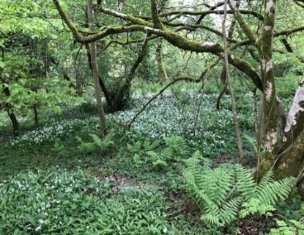

Community involvement
The Friends of Stonehouse Park, constituted in 2015, have a history of successfully engaging the community and in securing funding for regular events. The group meets monthly with a local councillor and CAG Countryside Ranger also in attendance. The group aims to raise awareness of the park and promote its use by holding free events and activities. The group is enthusiastic and works hard to involve the community and overcome the challenges and need for capital investment in the site, resulting in a strong sense of community ownership of Stonehouse Park.

The Friends use social media effectively to promote their activities and to take bookings for popular events. Members are involved in other local groups including the Scouts and heritage groups and they keep the park at the very heart of the Stonehouse community. Out with regular events the group hides pictures or fairy doors on the trails for families to enjoy on walks which change regularly to keep interest and relevance to the seasons.

The Friends have developed strong relationships with local businesses and partner organisations and are supported by Support for Play and Learning in Lanarkshire (SPELL), libraries, the Countryside Ranger Service and SLC Grounds Services.
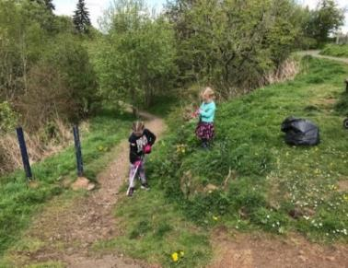

Projects
- Upstream battle: The group have been involved with the Keep Scotland Beautiful campaign keeping the banks of the Avon clean and are one of its Anchor Groups, adopting a stretch of the Avon and monitoring the types of litter found there.
- Community events: The group has an annual calendar of events and regular activities which is valued by the local community with attendances of up to 500 people. Events include: the annual Duck Race; Easter, Halloween and Christmas events; Bandstand Beatz; and outdoor storytelling events and activities with SLLC Libraries. There are also regular litter picking days and environmental volunteering days with CCI and CAG.
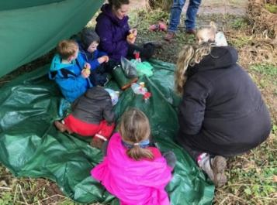

- Outdoor Play – Little Saplings and Mighty Oaks:
The group has held monthly outdoor play sessions led by volunteers trained in play, fire and tools since 2016. The success of Little Saplings for younger children has led to the creation in 2019 of a Mighty Oaks group for older children. In 2019 three additional community volunteers were trained in fire and tool use. This provides a vital role in the community giving free access to child-led experiences in nature that are crucial for children’s healthy development and long-term connection to the environment.
- Supermandy Inspiration Trail: The group commissioned wooden signs inscribed with inspirational quotes from local craftsmen Wull’s Wood with a donation from Supermandy. CAG and CCI provided materials and support to install the signs throughout the park in winter 2019/20.
- The group work regularly with local groups like the Scouts, Cubs and Beavers to pick litter and have supported them to have a safe campfire. SLC Countryside Rangers worked with the Guides on their Forest Challenge Badge, conducting a ‘How Good is your Park?’ biodiversity audit, making items from woodland materials and having a leave no trace fire.
- Feasibility Study: In 2016 the group commissioned a feasibility study to consult with the community and explore improvements to the park.
- Wildflower planting: Changes to the way SLC Grounds Services manage parts of the wider site has improved biodiversity with strips of the connected formal part of the park sown with wildflowers.
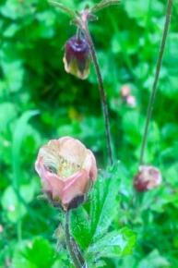

Future Projects
- Ranger led events: Some nature-based events will be introduced to develop interest in the wildlife on the site and to promote citizen science.
- Access to path along Avon: A major challenge is erosion on the path along the Avon. Engineers have inspected the landslip on the path and detailed costings will be needed to ascertain funding requirements. This path is currently closed and in a deteriorating state.
- Environmental volunteering: CCI, CAG and the Friends will support environmental volunteering sessions once every two months working on drainage, path clearing and removal of invasive plant species from the woodland.
- Links with schools: The Countryside Ranger Service will begin to work with nearby schools to see how they can make use of the space for health and wellbeing, play and learning.

Udston and Glenlee Woods

This site is divided into two parts by a vehicle road; the northern section is Glenlee Woods, the southern section Udston. Both are remnants of old estate properties and their land which is particularly evidenced by the presence of estate planting such as the mature coastal redwood trees and a line of yews in Glenlee.

Habitat
The majority of Udston and Glenlee pLNR is covered with mixed woodland; there is a good age range of trees of diverse species with associated ground flora. Small open areas provide different habitat such as the stream and its edges where grassland is mixed with ruderals and scrub including greater woodrush and hawthorn.

Udston Woods is characterised by planted broadleaf and coniferous trees; predominantly sycamore, ash, common lime, horse chestnut, beech, yew and pedunculate oak. The understorey and ground vegetation consists of species such as hawthorn, elder and wych elm, hazel, holly, bramble, raspberry, male fern, broad buckler fern, ground elder, dog’s mercury, water avens, wood avens and lady fern.

Glenlee woods is amenity and broadleaf/conifer plantation woodland with abundant ash, sycamore, common lime and frequent beech, goat willow and horse chestnut. The understorey and ground vegetation contains an abundance of hawthorn, elder and wych elm, hazel, holly, birch, bramble, raspberry, male fern, broad buckler fern, herb Robert, ground elder, water avens and wood avens.
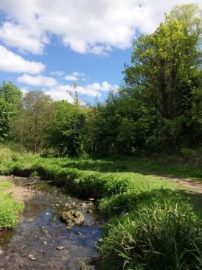

Community involvement
The Friends of Udston and Glenlee Woods became a formally constituted community group in 2011. The group carry out events and work with local schools and their community. Events and activities include litter picks, tree planting, wildflower planting, led walks and nature trails. The Friends are part of the SLC Environmental Volunteer Network; members of the group have attended various capacity building training courses including ‘Volunteer Health and Safety’ and ‘Introduction to woodland management’.

A programme of six Conservation Days a year was established in January 2020 with local community volunteers. Tasks to be completed include: litter picks, path maintenance, woodland management, invasive species removal, step installation and bridge repairs. One session has been completed in 2020, generating 10 days of volunteer time.
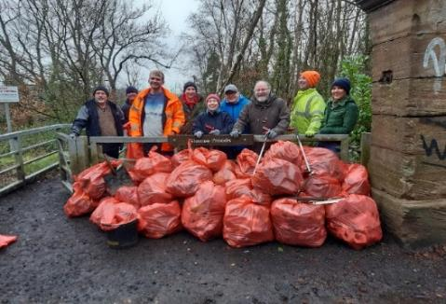

Future Projects
- An initial meeting with ‘Supporting Our Community’ has taken place to discuss future collaboration. It is planned that a number of Bushcraft events will be organised for ‘Promoting the Role of Father Figures’ during 2020.
- Discussions with the Parents Association at John Ogilvie High School have been initiated with a view to setting up a programme of sessions with pupils.
- Involvement with Hillhouse Community Council on site for community events and fun days.
- Membership of the Friends has dwindled recently; steps are being taken to continue to work with the Friends and the wider community for example by running public events.

Westburn

Westburn is a remnant of former farmland located in what was once a heavily industrialised landscape. A large steelworks and power station were located nearby, along the banks of the River Clyde. The steep embankment of the former Westburn colliery mineral railway line forms the eastern boundary of the site.

Habitat
Westburn supports semi-natural broadleaved woodland, plantation broadleaved woodland, open water, running water, marshy grassland, swamp and semi-improved neutral grassland.

Broadleaved woodland dominates the boundary of the reserve, with a mixture of planted trees along the edges and more natural regeneration in the centre. Tree species include white willow, goat willow, birch, aspen, hazel, pedunculate oak, rowan and alder.

The wetland habitats cover the northern section of the site, with a large expanse of swamp vegetation dominated by reedmace with occasional pools of open water and marshy grassland. These areas support meadowsweet, reed canary grass, water mint, sharp flowered rush, jointed rush, soft rush and northern marsh orchid. Running water flows along the West burn and can flood in wetter periods.

High and drier ground to the south supports semi-improved neutral grassland, dominated by Yorkshire fog with ribwort plantain, cock’s-foot, common spotted orchid and the occasional hawthorn and birch.
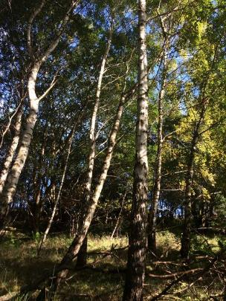

Community involvement
A programme of six Conservation Days a year was set up in January 2020 to work with local community volunteers at Westburn. Tasks to be completed include: litter picks, path maintenance, woodland management, invasive species removal, signage installation and boardwalk repairs. One session has been completed in 2020, generating 15 days of volunteer time.
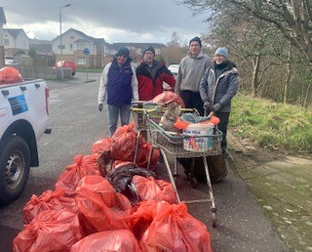

Projects
Steps are being taken to build community involvement and potentially a Friends of group.

Future Projects
- Initial contact has been made with Westburn Nursery with an informal conversation about a programme of sessions for the children on the site.
- Contact with a local Youth Group and Walking Group to discuss partnership working.
- Public events with and for the local community.

Further information

- More information on LNRs in Scotland
- Discover your local LNR, with maps
- More information on LNRs in South Lanarkshire, including draft management statements.
- SLC Local Development Plan

If you would like to get in touch with us to get involved with your local site, or find out more please email CAG@southlanarkshire.gov.uk

Acronyms

ASN: Additional Support Needs
BBU: Bothwell, Blantyre and Uddingston pLNR
BTO: British Trust for Ornithology
CAG: Countryside and Greenspace
CCI: Clydesdale Community Initiative
CSGNT: Central Scotland Green Network Trust
HLF: Heritage Lottery Fund
LAMH: Lanarkshire Association for Mental Health
LDP: Local Development Plan
LNR: Local Nature Reserve
MSP: Member of Scottish parliament
pLNR: proposed Local Nature Reserve
SAC: Special Area of Conservation
SLLC: South Lanarkshire Leisure and Culture
SNH: Scottish Natural Heritage
SLC: South Lanarkshire Council
WIAT: Woodland In and Around Towns
SPELL: Support for Play and Early Learning Lanarkshire
SSSI: Site of Special Scientific Interest
TCV: The Conservation Volunteers
VDL: Vacant and Derelict Land
WeBS: Wetland Bird Survey

If you need this information in another language or format, please contact us to discuss how we can best meet your needs. Phone 0303 123 1015 or email equalities@southlanarkshire.gov.uk

