
Community and Enterprise Resources

Building Standards Verification Annual Performance Report 2021-2022

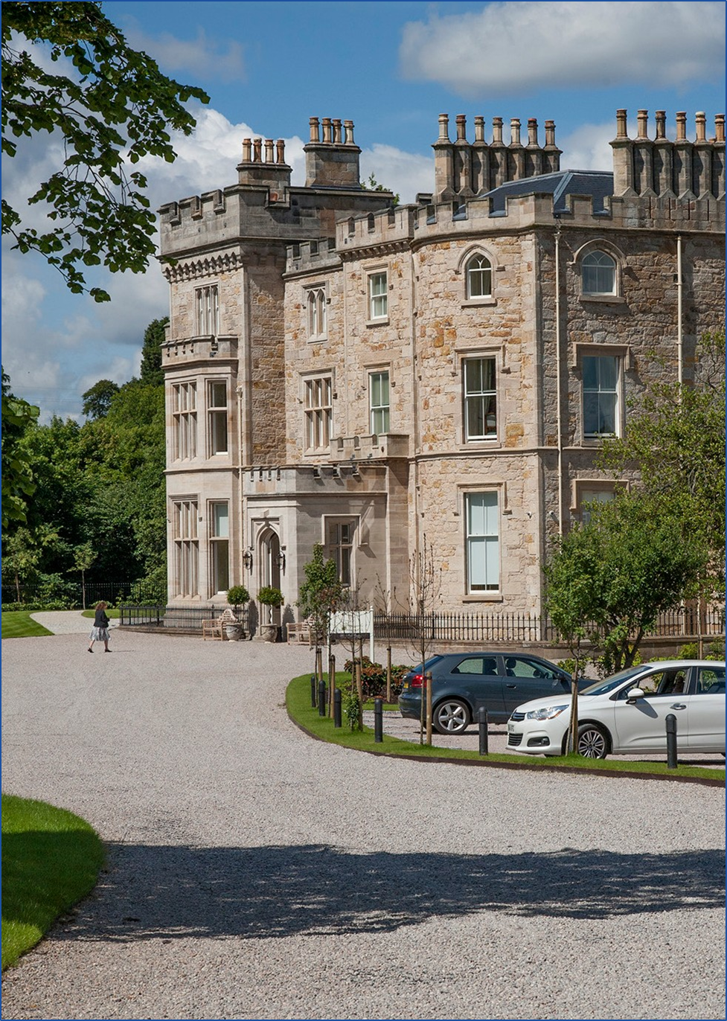

Contents

1. Introduction to South Lanarkshire Council as verifier
2. Building Standards Verification Service Information
3. Strategic Objectives
4. Key Performance Outcomes and Targets
5. Performance Data
6. Service Improvement and Partnership Working
7. Building Standards – Additional Data
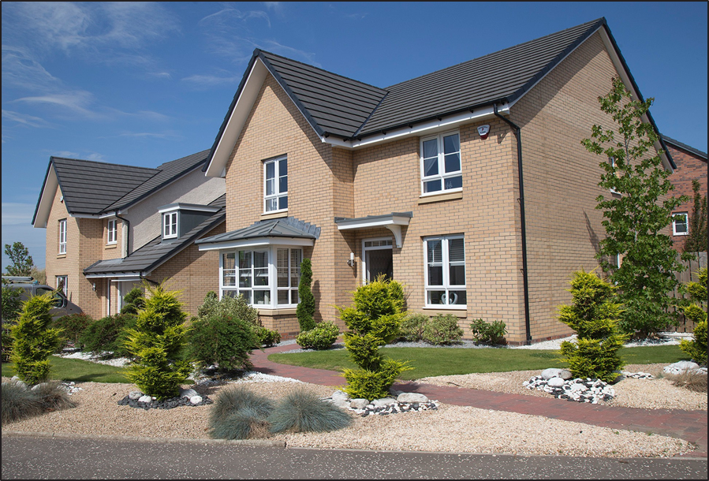

1.0 Introduction to South Lanarkshire Council as verifier
1.1 The verification performance report is a strategic planning and management tool that provides information about the local authority building standards service, communicates the vision and strategy, and sets out performance against strategic goals and targets.

1.2 Building standards verifiers in Scotland are required to utilise the performance report to manage, monitor, review and develop strategies for their business, and should focus on the performance framework’s core perspectives and cross-cutting themes.

1.3 South Lanarkshire is home to more than 316,000 people and is one of the largest and most diverse areas of Scotland. The council covers 180,000 hectares of land stretching from close to the centre of Glasgow to near the Scottish Borders. The area has a mix of urban, rural and former mining environments – almost 80% is classed and agricultural but 70% of the population live in the major settlements in the north.

1.4 There are four towns in South Lanarkshire with a population of more than 20,000 (East Kilbride, Hamilton, Rutherglen and Cambuslang) and a further 23 towns and settlements with a population of more than 1,000.

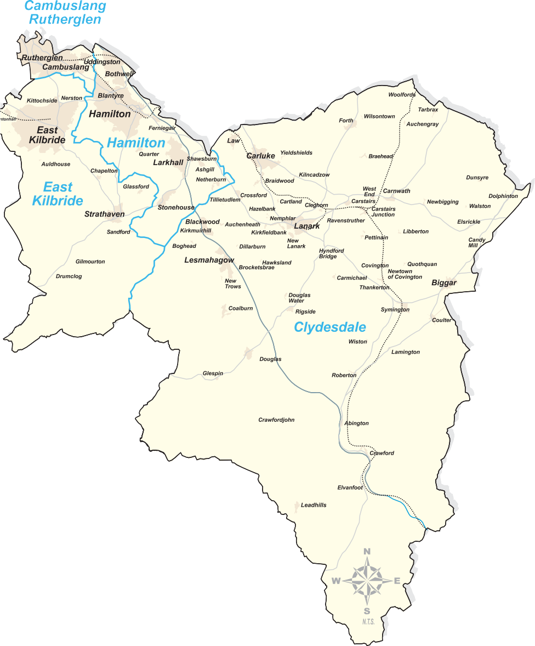
1.5 South Lanarkshire’s Building Standards Service is part of Community & Enterprise Resources. The Resource comprises four service areas – Facilities, Waste and Grounds Services; Roads and Transportation Services; Fleet and Environmental Services and Planning and Economic Development Services. Building Standards is part of the Planning and Economic Development Service.
1.6 The Resource is supported by a Performance and Development Team and Support Team. The Resource employs over 3,000 people who together provide a wide range of services for local communities.

High level organisational structure

Chief Executive
Executive Director Finance and Corporate Resources
Executive Director Housing and Technical Resources
Executive Director Education Resources
Executive Director Health and Social Care Partnership
Executive Director Community and Enterprise Resources
Head of Fleet and Environmental
Head of Roads and Transportation
Head of Facilities, Waste and Grounds
Head of Planning and Economic Development
Planning and Building Standards Manager HQ

2.0 Building Standards Verification Service Information

2.1 The council’s Building Standards Service work is undertaken by three teams comprising a Headquarters team and two Area Office teams. The total number of staff is 25.6 full time officers.
2.2 All three teams are located in the Community and Enterprise Resources HQ building in Hamilton. Each team is managed by a Planning and Building Standards Area Manager and each Building Standards Team is led operationally by a Building Standards Team Leader. The HQ Team deals with the strategic aspects of service delivery including setting policy, publishing guidance and monitoring performance. It also liaises with the Scottish Government, other councils and stakeholders as required.
2.3 The two area teams handle all the building warrant applications submitted in accordance with the requirements of the Building (Scotland) Acts, regulations and other associated legislation. The area teams work in partnership with the HQ team in terms of enforcement of matters in respect of dangerous buildings and unauthorised works. The HQ team also manage other activities such as licensing, houses in multiple occupation and safety at sports grounds. The Planning and Building Standards service is supported by a joint administration team.
2.4 The purpose of the building standards system is to protect the public interest. The system sets out the essential standards that are required to be met when building work or conversion of a building takes place in order to meet building regulations.
The building standards system checks that proposed building work or conversion of a building meets standards; inspections are limited to the minimal necessary to ensure that legislation is not avoided. The control of work on site is not down to the system but is a matter for contracts and arrangements in place between a builder and client.
Verifiers, appointed by Scottish Ministers are responsible for the independent checking of applications for building warrants to construct or demolish buildings, to provide services, fittings or equipment in buildings, or for conversions.

2.5 In his letter of 30th March 2017, the Minister for Local Government and Housing, Kevin Stewart MSP, appointed South Lanarkshire Council as verifier for a period of six years. This appointment for the maximum period of time recognised the continued strong performance of the council’s Building Standards service.

2.6 While the period 2021-2022 has again been significantly affected by the COVID-19 pandemic, during this time, the Building Standards service has continued to adapt and was able to provide a full range of services during the last 12 months.

Planning and Economic Development Structure
Community and Enterprise Resources Executive Director
Head of Planning and Economic Development
Planning and Building Standards East Area Manager
Planning and Building Standards West Area Manager
Planning and Building Standards HQ Manager
Building Standards East Area Team Leader
Building Standards West Area Team Leader
Building Standards HQ Team Leader x 2
East Building Standards Team
3 Advanced BS
Surveyors

3 BS Surveyors

West Building Standards Team
2 Advanced BS Surveyors
5 BS Surveyors

1 Trainee BS Surveyor (vacant)

HQ Building Standards Team
0.6 Advanced BS
Surveyor
3 BS Inspectors
1 Modern
Apprentice

2.7 The information provided below gives a snapshot of the staffing position on 31 March 2022.
 | Tier 1 | Tier 2 | Tier 3 | Tier 4
Head of Building Standards  Verification Service |  |  | X
Note: Tier 1= Chief Executive, Tier 2= Directors, Tier 3= Heads of Service, Tier 4= Managers

Building Standards Verification Service
 | Managers | Main grade posts | Technician posts | Office support (shared with Planning) | Totals
No. of posts | 4 | 18.6 | 3 | 6* | 31.6
Vacant | 0 | 5 | 1 | 0 | 6

Note: for the purposes of the above table, ‘managers’ are listed as the four area office Building Standards Team Leaders.
Each area team is managed by a Planning and Building Standards Manager.
*Shared with Planning.

Staff age profile | Number
Under 30 | 1
30-39 | 5
40-49 | 7
50 and over | 8
Total | 21

Note: Age profile does not include support/clerical officers.

3.0 Strategic objectives
3.1 The council’s vision to ‘improve the quality of life of everyone in South Lanarkshire’ remains at the heart of the council plan ‘Connect’. The vision and values of the Plan link to the key objectives of each Resource.
Community and Enterprise Resources is responsible for a wide range of services that enhance our quality of life within the council area. The Planning and Economic Development Service directly contribute to the work of the Resource through a number of objectives, key of which is to provide Planning and Building Standards services which guide and control physical development and land use in the area.
3.2 Specific actions for the Building Standards service are included within the Planning and Economic Development Service Action Plan 2021-22. These actions are noted in the table below along with associated measure and timescales.

Resource objective: Physical development and land use in the area is enabled, guided and controlled to help facilitate economic growth.
Action | Steps
Promote continued growth and regeneration through sustainable economic and social development  within a low carbon economy, and guide decision making on the location of new development and regeneration. | Review and update guidance for building standards surveyors in relation to climate change mitigation in new buildings and the adaptation of existing buildings, and develop service specific actions.
Provide effective and efficient Planning and Building Standards service. | Steps we will take to deliver our action -  - Percentage of Building Warrant applications receiving initial assessment within 20 working days (Target 95%).  - Number of Certificate of Completion submissions responded to within 3 working days (Target 80%).  - Retain Customer Service Excellence awards for both the Planning service and Building Standards service.  - Review and update local surveys and other forms of customer engagement carried out to measure customer satisfaction with both the Planning and Building Standards services and preparation of action plan to  address procedural and  performance issues raised.  - Maintain or improve the rating of the Building Standards service as reported through the annual national Scottish Government Customer Satisfaction Survey to Support the Building Standards Verification Performance Framework.  - Annual focus group event held for customers of both the Planning and Building Standards services and preparation of action plan to address procedural and performance issues raised.  - Explore potential mobile working solutions.
Resource objective - Other actions in support of delivering the Plan and achieving Best Value
Action | Steps
Work with internal and external partners to adopt the Scottish  Government’s Workforce Strategy for the Building Standards Verification Service | Deliver on local level commitments and actions within the Scottish Government’s Workforce Strategy in line with the required timescales.

4.0 Key performance outcomes and targets
4.1 The national verification performance framework is based on three core perspectives:
- Professional expertise and technical processes;
- Quality customer experience; and
- Operational and financial efficiency.

There are also three cross-cutting themes, comprising:
- Public Interest;
- Continuous Improvement; and
- Partnership Working.

Summary of key performance outcomes (KPOs)
Professional expertise and technical processes
KPO1 - Minimise time taken to issue a first report or issue a building warrant or amendment to building warrant.
KPO2 - Increase quality of compliance assessment during the construction processes.
Quality customer experience
KPO3 - Commit to the building standards customer charter.
KPO4 - Understand and respond to the customer experience.

Operational and financial efficiency
KPO5 - Maintain financial governance.
KPO6 - Commit to eBuilding Standards.
KPO7 - Commit to objectives outlined in the annual performance report.

KPO1 targets
1.1 95% of first reports (for building warrants and amendments) issued within 20 days
- all first reports (including BWs and amendments issued without a first report).

1.2 90% of building warrants and amendments issued within 10 days from receipt of all satisfactory information – all building warrants and amendments (not including BWs and amendments issued without a first report).

KPO2 targets
2.1 Targets to be developed as part of future review of KPO2.
KPO3 targets
3.1 National customer charter is published prominently on the website and incorporates version control detailing reviews (reviewed at least quarterly).
3.2 95% of BSD requests for information on a BSD ‘Verifier Performance Reporting Service for Customers’ case responded to by verifier within 5 days
KPO 4 targets
4.1 Minimum overall average satisfaction rating of 7.5 out of 10.

KPO5 targets
5.1 Building standards verification fee income to cover indicative verification service costs (staff costs plus 30%).

KPO 6 targets
6.1 Details of eBuilding Standards to be published prominently on the verifier’s website.

KPO 7 targets
7.1 Annual performance report published prominently on website with version control (reviewed at least quarterly).

7.2 Annual performance report to include performance data in line with KPOs and associated targets (annually covering previous year e.g. April 2016 – March 2017).

The performance data table in section 5.0 below includes a RAG status (red, amber, green) to indicate the progress towards meeting the performance target. Red means the target is not being met, amber means the result slightly deviates from the target and green means the target is met.

5.0 Performance data
5.1 Professional expertise and technical processes
KPO | Professional expertise and technical processes | RAG
KPO1 | Minimise time taken to issue a first report or issue a building warrant or amendment to building warrant.
1.1 | Target - 95% of first reports (for building warrants and amendments) issued within 20 days – all first reports (including BWs and amendments issued without a first report).
1.1 | SLC result – 79%
1.1 | Comment: The Building Standards Service has experienced a number of resourcing challenges this year including difficulties in recruiting surveyors with the appropriate skills and experience. Committee approval was given in December 2021 to add 3 no. surveyor, 1no. inspector and 1no. modern apprentice posts to the establishment and this will be implemented during 2022/23.
1.2 | Target - 90% of building warrants and amendments issued within 10 days from receipt of all satisfactory information – all building warrants and amendments (not including BWs and amendments issued without a first report).
1.2 | SLC result – 76%
1.2 | Comment: as 1.1 above.
KPO2 | Increase quality of compliance assessment during the construction processes.
It is noted the performance measure for this KPO is still under review.

Reporting for this measure shows that during 2020 - 21, 25% of CCNP’s were complied with.

 | Comment: The main reason for non-compliance was non notification of commencement and other stages outlined in the CCNP document by the applicant/relevant person. Consideration is being given to how notification can be improved.

5.2 Quality customer experience
KPO | Professional expertise and technical processes | RAG
KPO3 | Commit to the building standards customer charter.
3.1 | National customer charter is published prominently on the website and incorporates  version control detailing reviews (reviewed at least quarterly). Revised March 2022.
3.1 | SLC result – our charter remains published prominently on the council’s website.
3.1 | Comment: none
3.2 | Target - 95% of BSD requests for information on a BSD ‘Verifier Performance Reporting  Service for Customers’ case responded to by verifier within 5 days.
3.2 | SLC result – No requests received.
3.2 | Comment: none
KPO4 | Understand and respond to the customer experience.
4.1 | Target - Minimum overall average satisfaction rating of 7.5 out of 10.
4.1 | SLC Result – overall average satisfaction rating of 8.0 out of 10.
4.1 | Comment: In February 2021 South Lanarkshire Council was awarded Customer Service Excellence for the 8th year, the  service is fully compliant will all CSE criteria with 12 areas of ‘compliance plus’.

5.3 Operational and financial efficiency
KPO | Operational and financial efficiency | RAG
KPO5 | Maintain financial governance
5.1 | Target - Building standards verification fee income to cover indicative verification service costs (staff costs plus 30%).
5.1 | SLC result – Total verification of staff costs for 2021-2022 were £1,324,245. Total verification fee income for 2020-2021 was £1,925,773.
5.1 | Comment – none.
KPO6 | Commitment to eBuilding Standards
6.1 | Details of eBuilding Standards to be published prominently on the verifier’s website
6.1 | SLC result – the options open to customers are fully detailed in the council’s website. In addition, staff are encouraged to recommend that customers use the national portal for the submission of applications and application related mail. Currently around 90% of applications are submitted online.
6.2 | Target - 75% of each key building warrant related process being done electronically  • Plan checking  • Building warrant or amendments (and plans) being issued  • Verification during construction  • Completion certificates being accepted
6.2 | SLC result:  • Plan checking – electronic plan checking is undertaken for all applications with minor exceptions.  • Building warrant or amendments (and plans) being issued – electronic approval via email is in place for all applications containing 10 plans of less.  • Verification during construction – no electronic work being undertaken  • Completion certificates being accepted – all completion certificate acceptances are being issued electronically where an email address is provided for the relevant person.
6.2 | Comment: Work is underway to establish processes related to the acceptance of remote verification evidence, this is limited to photographic evidence at this time.
KPO7 | Commit to objectives outlined in the annual performance report.
7.1 | Annual performance report published prominently on website with version control (reviewed at least quarterly).
7.1 | SLC result – the Annual Performance Report for 2021-2022 is published on the council website and will be reviewed each quarter throughout 2022-2023.
7.1 | Comment - none.
7.2 | Annual performance report to include performance data in line with KPOs and associated targets (annually covering previous year e.g. April 2016 – March 2017).
7.2 | SLC result – This report includes comprehensive performance data for the period April 2021 to March 2022.
7.2 | Comment - none.

6.0 Performance improvement and partnership working
6.1 In the previous 12 months (2021 - 2022) we:
Number | Continuous improvement action | Status
1 | Continued to maintain and adapt processes, protocols and guidance as related to the delivery of building standards services in light of the COVID-19 pandemic. | Complete
2 | Continue to develop IDOX software solutions for the management of building warrant applications and associated processes. | Ongoing
3 | Worked towards retaining Customer Service Excellence award and undertaken customer engagement exercise. | Ongoing
4 | Review annual local customer satisfaction survey process. | Ongoing
5 | Submit all quarterly KPO reporting and update Annual Performance Report | Ongoing
6 | Respond to SG information requests and consultations. | As required
7 | Process local actions outlined within the National Building Standards Workforce Strategy | Ongoing
8 | Progress actions associated with the national program for digital transformation. | Ongoing
9 | Achieved targets as highlighted in the Planning and Economic Development  Service Action Plan for 2020-21. | Complete
10 | Contribute to the work of LABSS as required to ensure the delivery of a robust verification service nationally. | Ongoing

6.2 In the next 12 months (2022 - 2023 ) we will:
Number | Continuous improvement action | Timescale
1 | Continue to develop IDOX software solutions for the management of building warrant applications and associated processes | Ongoing
2 | Work to retain Customer Service Excellence award for 9th year and undertake customer engagement exercise. | December 2022
3 | Submit all quarterly KPO reporting and update Annual Performance Report. | Ongoing
4 | Respond to SG information requests and consultations | As required
5 | Process local actions outlined within the National Building Standards Workforce Strategy. | As required
6 | Progress actions associated with the national program for digital transformation. | As required
7 | Achieve targets as highlighted in the Planning and Economic Development Service Action Plan for 2022 - 2023. | March 2023
8 | Contribute to the work of LABSS as required to ensure the delivery of a robust verification service nationally. | Ongoing

6.3 In the previous 12 months (2021-22) we worked with:
6.3.1 Building Standards Division of Scottish Government – SLC participation within a number of national working groups looking at new national guidance and policy documents. This allows the Scottish Government to use our feedback based on customer insight to shape national direction.
  - Digital Transformation Working Group
  - Futures Board Compliance Plan Working Group (including quality of application sub group)
  - Enforcement and Sanctions Working Group
6.3.2 Provided response to Scottish Government consultations on energy/fire/compliance and enforcement.
6.3.3 Undertook improvements to charging orders processes to aid cost recovery.
6.3.4 Concluded Health and Safety risk assessment and safe system of work including updating of related training matrix.
6.3.5 Care and Repair in SLC - ongoing with Care and Repair in South Lanarkshire to maintain lines of communication for customer enquiries and also the service’s expectation in terms of assessment times and quality of warrant submission.
6.3.6 6.3.6 Care Inspectorate - SLC staff continue liaise with the Care Inspectorate and Local Authority Building Standards.
6.3.7 Continue to contribute to the Multi-agency Tactical Group - this forum allows local agency’s such as Police, SFRS and local authority departments to discuss matter of mutual interest.
6.3.8 Continue to contribute to the Safety Advisory Group- the SLC forum, considering applications for live events, such as concerts.
6.3.9 SLC Housing and Technical Resources – we continue to coordinate Scottish Government consultation responses with colleagues in H and T.
6.3.10 Continue to contribute to STAS and Registered Details - these services are provided by LABSS allow for pre-approval nationally of standard building designs.
6.3.11 Sharing house completion data with Waste services - monthly reports are provided to the councils’ Waste Services section to allow for a quicker and more effective consideration of customer needs with regards to bin collection services.
6.3.12 National Building Standards Portal-work remain ongoing on the promotion of this portal, during periods of lockdown around 90% of application are submitted via the national portal. Use of the portal supports the current approach to working from home.
6.3.13 Operation Doric - Our work in relation to this initiative remains ongoing. Promotion of this partnership has been presented as corporate evidence as part of the council’s Best Value Audit.
6.3.14 Adaptation fast tracking process - the existing standard warrant submission package continues to provide a template for the submission of adaptation applications. This allows for a quicker processing time which in turn benefits homeowners.
6.3.15 Alternative view process - a number of alternative view applications were considered and approved during 2021.
6.3.16 Local Authority Building Standards Scotland – In a similar way to the BSD, SLC are represented within LABSS in many strategic areas namely:
  - Member of Executive – Alan McAulay
  - Technical Director – Alan McAulay
  - Consortia technical representative – Andrew Turriff
6.3.17 Central Authorities Consortia – while linked with LABSS activities, this forum allows for discussion at a more local level, partners are North Lanarkshire, Stirling, Falkirk and Clackmannanshire councils.
6.3.18 South Ayrshire Council – SAC engineers are used as a backstop for checking structural calculations which are out with the scope of our own in-house engineers, thus providing customers with certainty of service response.
6.3.19 Environmental Health – Building Standards respond to weekly consultation requests from EH on building warrant application submissions thereby ensuring any applicant is aware of legislative requirements stemming from EH regulations.

6.3.20 Planning Service – Extensive joint working is undertaken on a daily basis through the cross-checking process.
6.3.21 Revised approach to Building Standards Customer Satisfaction engagement with new live reporting website and the addition of links to letters, emails and footers.
6.4 In the next 12 months (2022-2023) we will:
6.4.1 Continue to engage with our partners outlined above, including strengthening partnership working where necessary and consider new partnerships where opportunities exist.
6.4.2 We will seek to recruit a Building Standards Modern Apprentice.
6.4.3 We will seek to recruit additional Technician Posts (Building Standard Inspectors).

7.0 Building Standards – additional data
7.1 Verifiers provide returns to Scottish Government on their verification performance and workload. The performance data relates to the building standards verification performance framework and the workload data relates to the numbers of building warrant applications; completion certificates; fees; costs; certificates (certification, energy performance; sustainability); enforcement cases.

Building warrants and amendments to building warrant - 2567 applications, 2322 decisions
Completion certificates - 2825 applications, 2970 decisions
Certification - 1269 certificates of design submitted, 36 certificates of construction submitted
Energy performance certificates (EPCs) - 1704 copy certificates received (domestic), 12 copy certificates received (non-domestic)
Statements of sustainability - 1516 copy certificates received (domestic), 12 copy certificates received (non-domestic)
Enforcement - 0 notices served under sections 25 to 30
- 0 cases referred to procurator fiscal
- 0 cases where LA has undertaken work
- 5 cases of direct action under S29

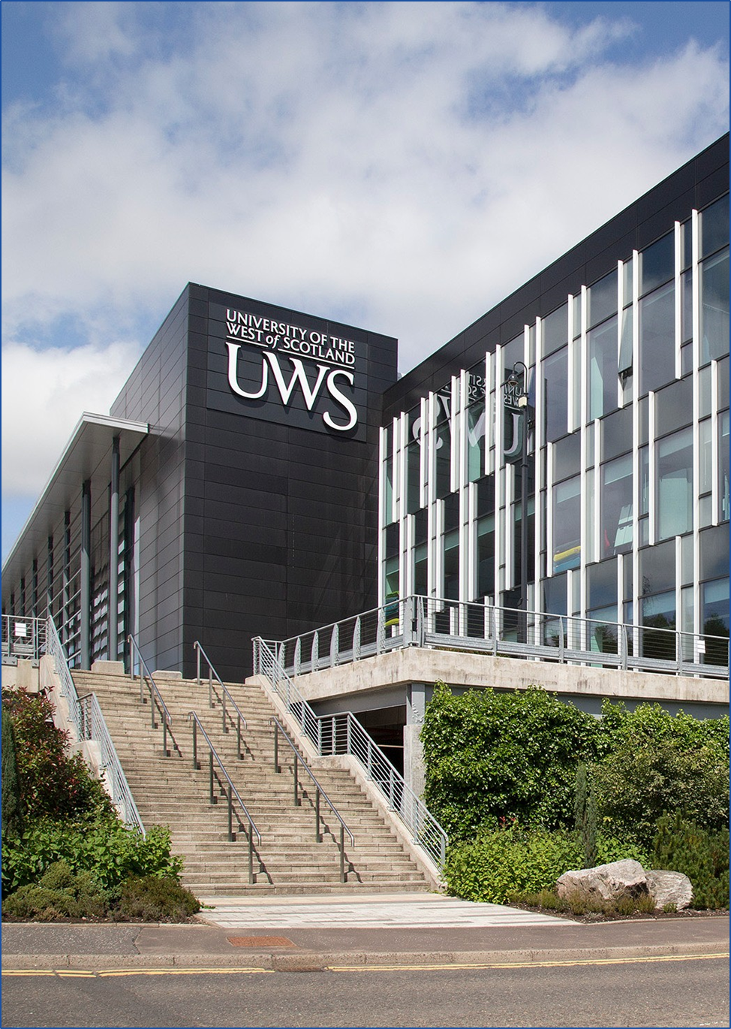

South Lanarkshire Council
Planning Performance Framework 2021-2022
South Lanarkshire Council Community and Enterprise Resources Planning and Regulatory Services
Floor 6, Council HQ, Almada Street, Hamilton ML3 0AA www.southlanarkshire.gov.uk

If you need this information in another language or format, please contact us to discuss how we can best meet your needs.
Phone: 0303 123 1015 or email: equalities@southlanarkshire.gov.uk

