Clydesdale Active Travel Study: Area 3 – South Clydesdale

South Lanarkshire Council

Project number: 60697310

March 2023

Quality information
Prepared by |  | Checked by |  | Verified by |  | Approved by
Guy Newham  Graduate Consultant |  | Stephen Clyne  Senior Engineer |  | Peter Leslie  Associate Director |  | Steven Smith  Principal Engineer
Jo Duck
Senior Consultant

Revision History
Revision | Revision date | Details | Authorized | Name | Position
00 | 16 March 2023 | Draft |  | Steven Smith | Principal Engineer
01 | 04 April 2023 | Draft Update |  | Steven Smith | Principal Engineer
02 | 14 April 2023 | Final Draft |  | Steven Smith | Principal Engineer

Prepared for:
South Lanarkshire Council
Almada Street
Hamilton
ML3 0AA

Prepared by:
‌AECOM Limited
1 Tanfield
Edinburgh EH3 5DA
United Kingdom

T: +44 131 301 8600
aecom.com

Printed on environmentally responsible paper. Made from 100% recycled post-consumer waste.

© 2023 AECOM Limited. All Rights Reserved.
This document has been prepared by AECOM Limited (“AECOM”) for sole use of our client (the “Client”) in accordance with generally accepted consultancy principles, the budget for fees and the terms of reference agreed between AECOM and the Client. Any information provided by third parties and referred to herein has not been checked or verified by AECOM, unless otherwise expressly stated in the document. No third party may rely upon this document without the prior and express written agreement of AECOM.
Table of Contents
1. Introduction 5
1.1 Aims of the Study 5
1.2 Approach 5
2. Context and Current Situation 6
2.1 Study Area and Local Context 6
2.2 Deprivation Indicators and Transport Poverty 7
2.3 Commuting Data 8
2.4 Key Trip Attractors 9
2.5 Planned and Future Developments 9
2.6 Current Active Travel Network 10
2.7 Current Network Use 10
2.8 Policy Framework 11
2.9 Clydesdale Way Project 17
2.10 Leadhills Village Active Travel Project 19
2.11 Make Your Way Project 19
3. Engagement and Consultation 28
3.1 Initial Online Questionnaire Survey 28
3.2 Placecheck Online Map 36
3.3 Follow-Up Engagement Activities 36
4. Public Life Survey 37
4.1 Crawford 37
4.2 Leadhills 40
5. Proposed Network and Phased Delivery 43
5.1 Principles of Proposed Network 43
5.2 Proposed Networks 44
5.3 Proposed Cycle Network – Delivery Phases 47
5.4 Key Delivery Principles 47
5.5 Next Steps 48

Figures
Figure 2.1: Map of the Study Area 6
Figure 2.2: SIMD Ranking Scale 7
Figure 2.3: Extract from the SIMD for Key Settlements 7
Figure 2.4: Key Trip Attractors 9
Figure 2.5: Core Path Network 10
Figure 2.6 Considered Strategic Fit Elements 12
Figure 2.7 - Clydesdale Way Overview Plan 18
Figure 2.8: Aerial map showing indicative actions for physical improvement in Abington 20
Figure 2.9: Aerial map showing indicative actions for physical improvement in Crawford 21
Figure 2.10: Aerial map showing indicative actions for physical improvement in Elvanfoot 22
Figure 2.11: Aerial map showing indicative actions for physical improvement in Crawfordjohn 23
Figure 2.12: Aerial map showing indicative actions for physical improvement in Leadhills 24
Figure 3.1: Age Group of Survey Respondents 28
Figure 3.2: Employment Status of Respondents 29
Figure 3.3: Purpose of Travel to Key Destinations 30
Figure 3.4: Method of Travel to Key Destinations 30
Figure 3.5: Quality of Walking and Cycling Facilities in Southern Clydesdale 31
Figure 3.6: Walking Frequency by Season 31
Figure 3.7: Cycling Frequency by Season 32
Figure 3.8: Benefits from Walking 32
Figure 3.9: Benefits from Cycling 33
Figure 3.10: Barriers to Walking and Cycling in Southern Clydesdale 33
Figure 3.11: Impact of General Traffic on Walking, Cycling and Wheeling 34
Figure 3.12: Respondents' Interest in Walking More Often 34
Figure 3.13: Respondents' Interest in Cycling More Often 35
Figure 3.14: Additional Survey Comments 36
Figure 4.1: Crawford Study Area 37
Figure 4.2: Typical Cross Section through Carlisle Road 38
Figure 4.3: Crawford Scoring Summary 38
Figure 4.4: Leadhills Study Area 40
Figure 4.5: Typical Cross Section through Main Street 41
Figure 4.6: Leadhills Scoring Summary 41
Figure 5.1: South Clydesdale Proposed Networks Overview 45
Figure 5.2: Leadhills Proposed Networks 46
Figure 5.3: Abington Proposed Networks 46
Figure 5.4: Crawford Proposed Networks 47
Figure 5.5: Crawfordjohn Proposed Networks 47

Tables
Table 2.1: Local Commuter Patterns (Datashine Scotland Commute) 8
Table 2.2: Scotland Census 2011 Method of Transport Summary 11
Table 2.3: Sustrans Hands Up Survey 2021 11
Table 2.4: Clydesdale Way Connections in South Clydesdale 18
Table 2.5: Crawford and Elvanfoot Speed Reduction and Pedestrian Safety Feasibility Study Recommendations 26
Table 4.1: Crawford Public Life Survey Observations 39
Table 4.2: Leadhills Public Life Survey Observations 42
Table 5.1: Design Principles 43

Introduction

Aims of the Study
AECOM was commissioned by South Lanarkshire Council to undertake an Active Travel Feasibility Study for the southern area of Clydesdale, including the communities of Abington, Crawford and Leadhills. The study aims to: identify both the actual and perceived barriers to walking, cycling, and wheeling (scooter, wheelchair, buggy / pram etc.) for everyday journeys in and around the area; help encourage more people to choose these active travel modes; and to promote the area as being active travel friendly. The study will:
- Identify key destinations and how well they are currently connected on foot or by bike;
- Create a proposed cycle network map which connects those key destinations and shows what a complete cycle network for the area could look like;
- Identify early priorities and recommendations to make active travel a viable option for everyday journeys in and around the area.
A number of similar Active Travel Feasibility Studies have previously been undertaken for other areas across South Lanarkshire. This study will use the general approach established in those studies. The results of this study and associated consultation exercises will be utilised to inform future funding applications to implement the recommendations identified.

Approach
The approach to developing the active travel network involved the key tasks set out below.
Technical Review:
- A review of current active and leisure travel routes, key destinations, and barriers to active travel; and
- A review of current policy at a national, regional and local level along with previous studies develop a greater understanding of the overall policy context.
Public and Stakeholder Engagement Phase 1:
- An online survey to collate public and stakeholder input and views; and
- Use of the online platform ‘Placecheck’ to gather views on potential desired improvements for specific locations.
Network Development and Recommendations:
- Identification of an aspirational active travel network for the area;
- Identification of other associated measures which will improve active travel and meet the needs of local communities; and
- Identification of short, medium and long-term projects, including their anticipated costs and benefits.
Public and Stakeholder Engagement Phase 2:
- A workshop with key stakeholders to discuss the results of the surveys and proposals from Phase 1 of Public and Stakeholder Engagement; and
- An online survey to collate feedback from the general public and share proposals.

Context and Current Situation

Study Area and Local Context
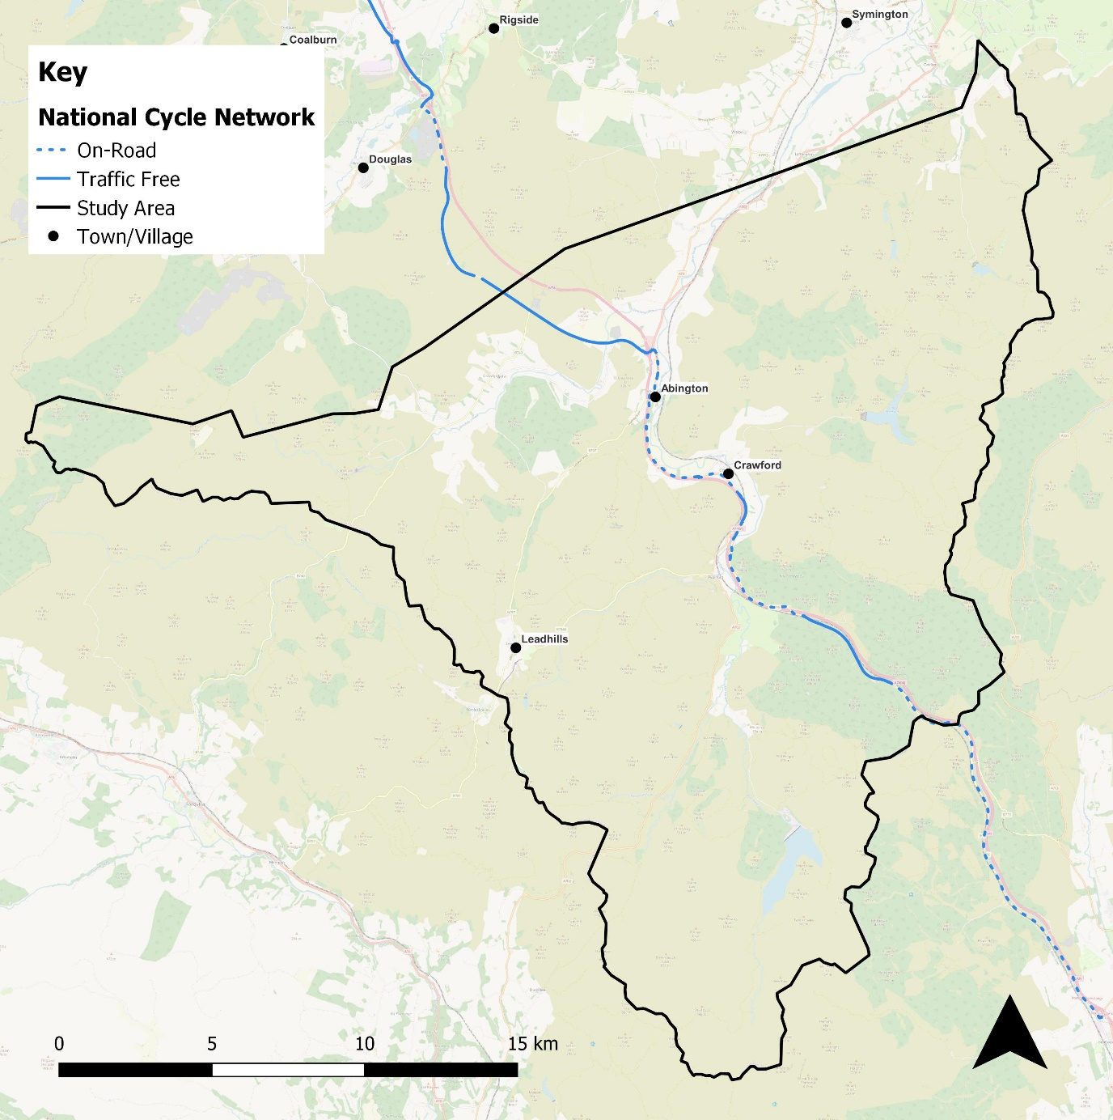
Figure 2.1: Map of the Study Area
The study area centres on a rural portion of Southern Clydesdale. The main settlements are Leadhills and the villages along the River Clyde, with large parts of the area being uplands with limited habitation.
Leadhills is a village located in the Lowther Hills, located in the southeast of the study area. The small community is served by a primary school and a medical centre. Other nearby attractions include Leadhills Golf Club and Lowther Hills Ski Centre.
The M74 motorway runs north-south through the study area, and its course is approximately followed by National Cycle Network (NCN) Route 74. The motorway is accompanied for some of its length by the River Clyde as well as the West Coast Main Line, although it should be noted that there are no rail stations within the study area.
There are two main settlements that lie on a stretch of the river accompanied by the rail line, motorway, and cycle route. Located south of Abington motorway services, Abington village contains a primary school. Further south, Crawford also has a primary school as well as a medical centre. Other significant settlements include Roberton (to the north) and Crawfordjohn (to the west), which has a pub.

Deprivation Indicators and Transport Poverty
The Scottish Index of Multiple Deprivation (SIMD) provides an indication of the areas which are the most and least deprived based on a number of factors which show where people are experiencing disadvantage across different aspects of their lives. The overall rank for each area is visually represented by the colour scale shown in Figure 2.2 and comprises a combination of income; employment; health; education/skills; housing; geographic access; and crime factors.
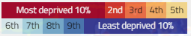
Figure 2.2: SIMD Ranking Scale
Figure 2.3 presents an overview of the overall SIMD (2020) rank for key settlements within the study area. A range of deprivation levels across the settlements are observed, although typical levels are close to the national average. Notably, the geographic access category for each of the areas ranks amongst most deprived 10% in Scotland.
High levels of deprivation are associated with transport poverty, which considers a variety of factors such as income, car availability, access to services by public transport, and access to essential services by cycle as well as current levels of cycling. The areas that suffer from high levels of deprivation often also suffer from low levels of accessibility to cars/vans and bicycles, whereas areas with low levels of deprivation will have high levels of access to cars, bicycles, and public transport. The level of deprivation, and potential link to transport poverty, for the key areas within the study area will form an important part of the decision for the active travel facilities and improvements.

Abington
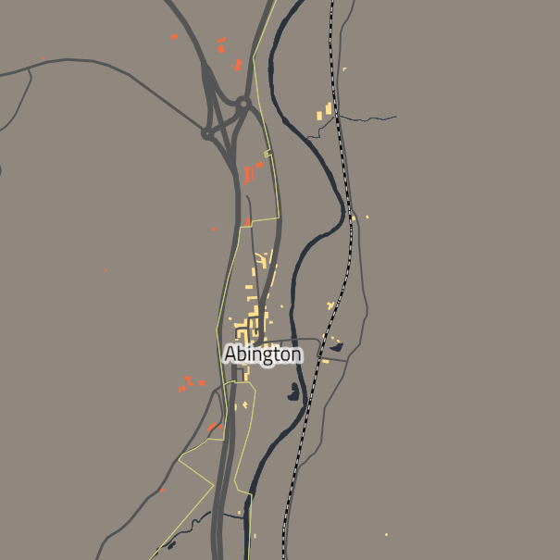
Leadhills
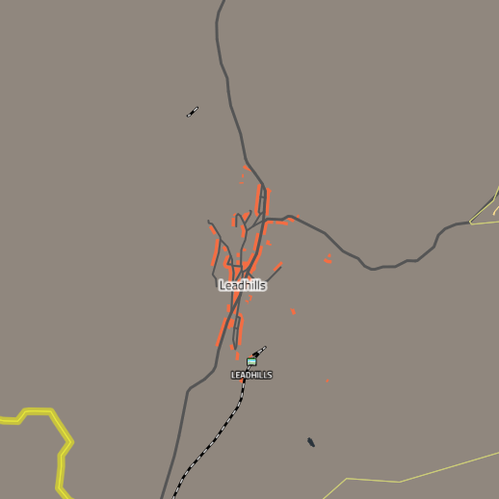
Figure 2.3: Extract from the SIMD for Key Settlements
Crawford
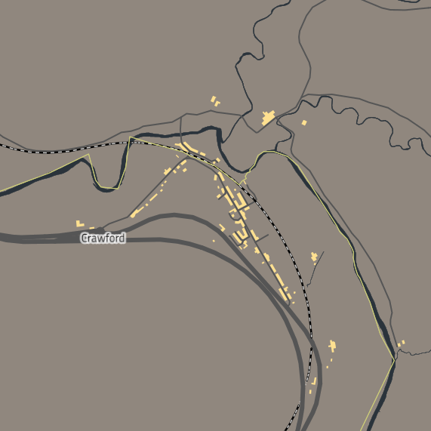
Roberton
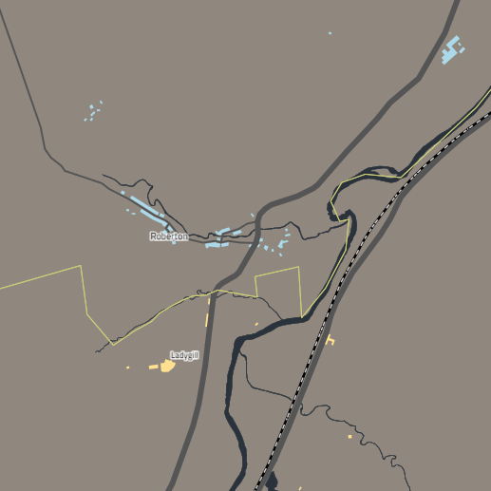

Commuting Data
Commuting data from the last census (provided by Data Shine Scotland Commute) show the most popular destinations for commuter trips away from Clydesdale South are to towns to the north, including Biggar, Lanark and Coalburn. In terms of commuting from other areas into Clydesdale South, trips are fewer overall (and generally shorter) compared to those in the opposite direction.
Table 2.1: Local Commuter Patterns (Datashine Scotland Commute)
Commuter Data: From Clydesdale South | Commuter Data: To Clydesdale South
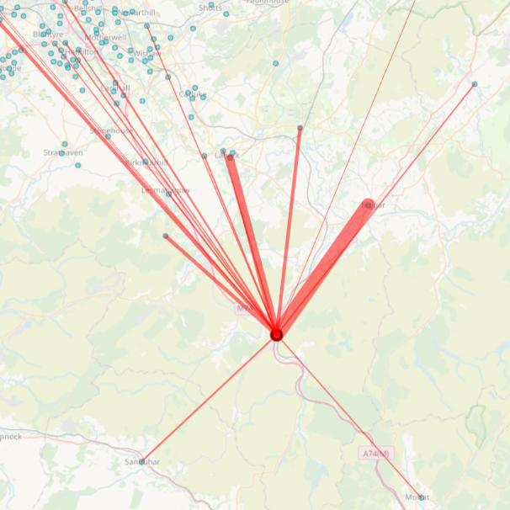 | 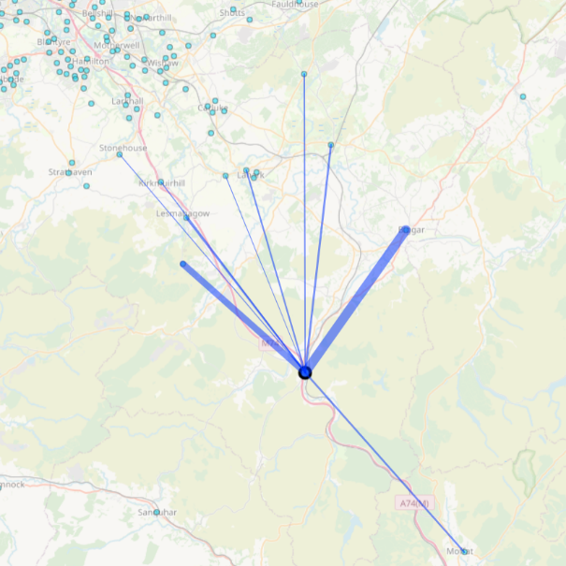

Key Trip Attractors
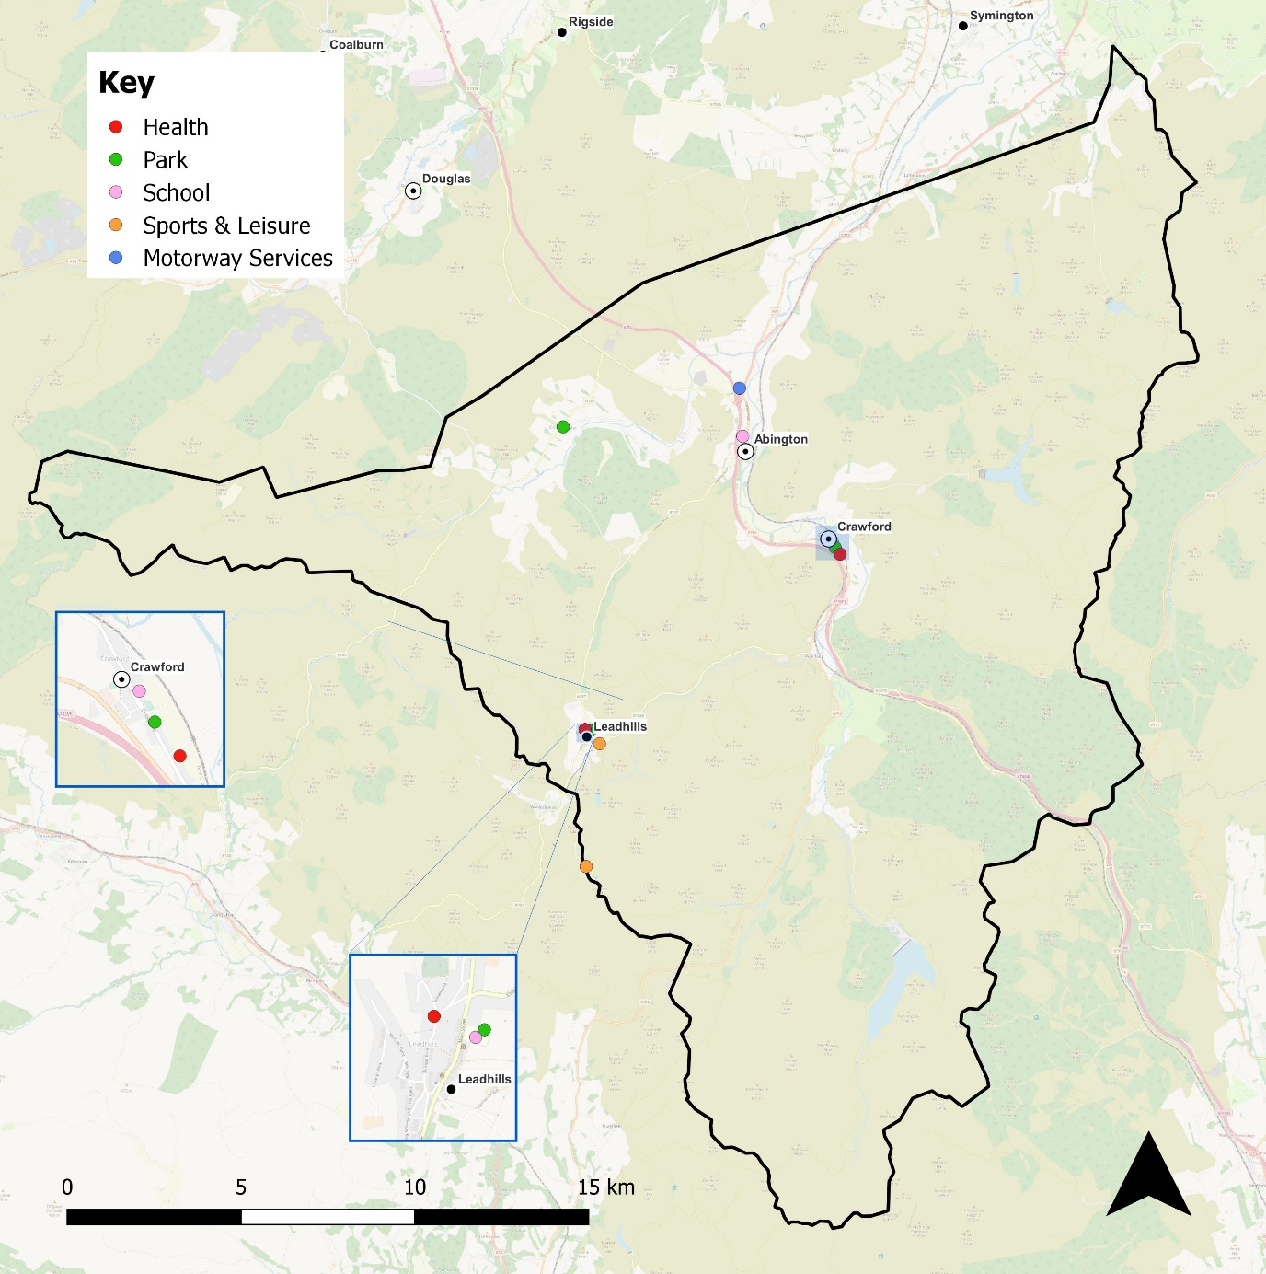
Figure 2.4: Key Trip Attractors
Most of the key trip attractors in the study area are in the villages of Crawford and Leadhills, and the most common types are primary schools and parks. As much of the area is sparsely populated, there are large portions that contain no significant trip attractors.

Planned and Future Developments
There are no developments set out for Southern Clydesdale within the Clydeplan Strategic Development Plan.

Current Active Travel Network
NCN Route 74 is the primary cycle route in the study area, and it overlaps with the core path network for much of its length as shown in Figure 2.5. As much of the area is rural, there are few existing core paths outwith the main settlements. South Lanarkshire Council’s aspirational core path network expands coverage in the area and promotes off road connections between settlements and the wider path network.
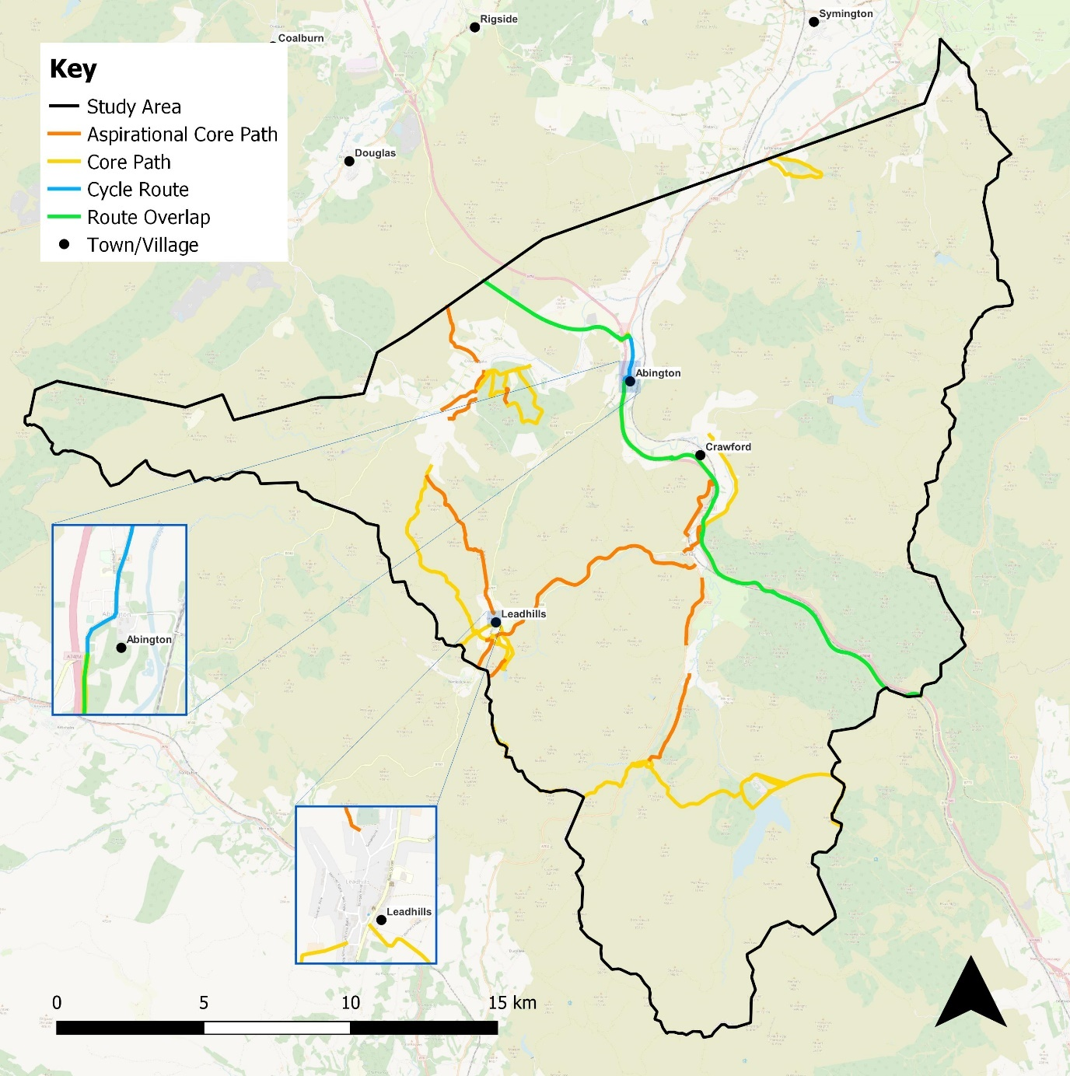
Figure 2.5: Core Path Network

Current Network Use
The Transport and Travel in Scotland 2019 data for South Lanarkshire shows that 73% of journeys were made by car or van either as a driver or as a passenger, with walking accounting for 17% and cycling 1%. The low uptake in walking and cycling as the main mode of transport in South Lanarkshire is in keeping with the 2019 national average with 22.1% of people walking and 1.2% of people cycling. Of those journeys made in South Lanarkshire, 67% were of 10km or less with the top three main purposes for travel in South Lanarkshire being shopping (26%), community (24%) and visiting friends/relatives (10%).
In 2020, during the Covid-19 pandemic, the national average uptake in walking and cycling increased to 37% and 1.5% respectively, reflected primarily against shopping and leisure travel purposes. Area specific breakdown of data for 2020 and post-Covid-19 study data is not currently available to inform further analysis of transport and travel behaviour. Therefore the 2019 Transport and Travel study remains the primary reference source.
With regards travelling to work in South Lanarkshire, 2019 data shows that only 1.8% of adults travel by bicycle. For primary school pupils, 3.8% travel to school by bicycle but only 0.1% of secondary pupils travel to school by bicycle. This is likely attributed to only 26% of households in the region having access to one or more bicycles for private use.
At the local level households in the combined area of Northeast and South Clydesdale with no access to a car or van is 15.0%. When comparing this to the Scottish Average which is 30.5%, it is notable that Northwest Clydesdale is above the national average. In addition, households with access to one car/van is 41.4% compared to the national average of 42.2%.

Scotland Census
The 2011 census data presented in Table 2.2 shows the primary method of transport to place of work or study for residents of the key population centres within South Clydesdale. Publication of 2022 census data is anticipated in 2023.
Table 2.2: Scotland Census 2011 Method of Transport Summary
Locality | Work or study mainly at or from home | Driving or Passenger in a car or van | Bicycle | On foot
Abington | 11.5% | 58.4% | 0.0% | 20.4%
Crawford | 19.7% | 60.1% | 0.5% | 5.6%
Leadhills | 21.2% | 53.0% | 0.0% | 13.2%

Hands Up Survey
The Sustrans Hands Up Survey results from 2021 provide a further indication of the current active travel network use for those travelling to nursery and school. The results show a clear trend that as pupils progress through school, less of those pupils are driven to school by an adult, while the use of public transport increases significantly. The uptake in walking remains high throughout all levels of education while those choosing to cycle remains low. The results are displayed in Table 2.3.
Table 2.3: Sustrans Hands Up Survey 2021
School Type | Walk | Cycle | Scooter / Skate | Park & Stride | Driven | Bus | Taxi | Other
Nursery | 30.8% | 0.0% | 2.1% | 3.2% | 57.3% | 3.0% | 1.9% | 0.0%
Primary | 40.6% | 4.3% | 3.4% | 10.9% | 32.1% | 6.5% | 2.1% | 0.1%
Secondary | 40.5% | 0.4% | 0.2% | 12.6% | 17.0% | 26.3% | 1.6% | 1.2%

Policy Framework
This section provides an overview of the Strategic Fit for active travel across the three areas of the Clydesdale Active Travel Strategy extent through consideration of policy, strategy, and legislation across various tiers of government.
Also detailed within this section is an overview of the relevant active travel network design guidance that should be considered when developing active travel solutions.

Policy, Strategy and Legislation
The Clydesdale Active Travel Strategy seeks to build upon previous workstreams and projects that have been developed recently, notably active travel feasibility studies including for Bothwell, Blantyre and Uddingston; Larkhall; Strathaven, Stonehouse and the Surrounding Villages. These studies have enabled a better understanding of problems and opportunities relating to walking, wheeling and cycling in these local communities in addition to allowing the identification of potential solutions that could be implemented to deliver more inclusive, integrated and accessible active travel networks in these areas.
Since these supporting studies and other complementary workstreams were published, there has been a further positive shift in active travel at a Scottish Government level with a commitment to invest a record amount of money in active travel for 2022/23 at £150 million and to deliver the following notable actions during the same financial year:
- Increasing the Cycling Walking and Safer Routes budget from nearly £24 million to £35 million;
- Double funding for the National Cycle Network to over £10 million; and
- Continuing to pilot the provision of free bikes for all children of school age.
These commitments demonstrate the importance of active travel to the Scottish Government, its wider commitment to meet its target of spending £320 million or 10% of the transport budget for active travel by 2024/25 and its aspiration to deliver a more active nation.
Further supporting development of the Strategic Fit for active travel in South Lanarkshire is the review of relevant and appropriate policy, strategy, and legislation at a National, Regional and Local level. These elements that have been considered for the Clydesdale Active Travel Strategy are set out in Figure 2.6.
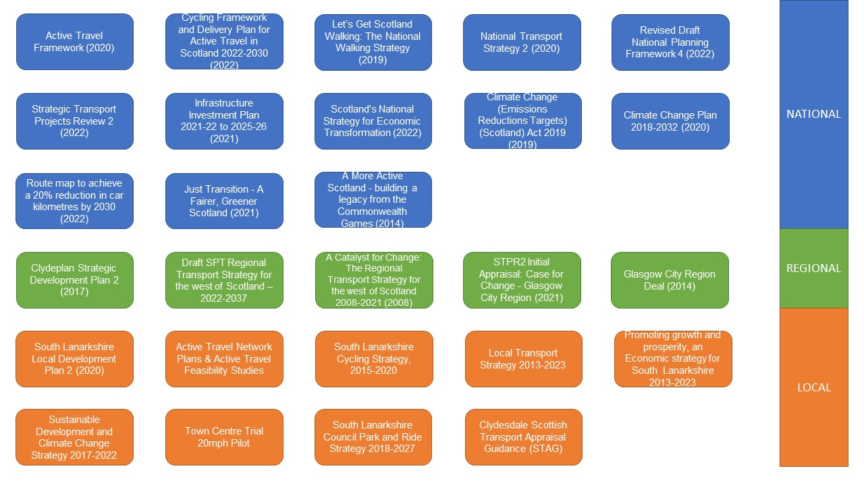
Figure 2.6 Considered Strategic Fit Elements

National
- Active Travel Framework: The Active Travel Framework which was published by Transport Scotland has the vision that by 2030 ‘Scotland’s communities are shaped around people, with walking or cycling the most popular choice for shorter everyday journeys’. The framework brings together a variety of key policy approaches and outlines five active travel outcomes: Increase the number of people choosing walking, cycling and wheeling in Scotland; high quality walking, cycling and wheeling infrastructure is available to all; walking, cycling and wheeling is safer for all; delivery of walking, cycling and wheeling is promoted and supported by a broad range of partners; and walking, cycling and wheeling is available to all.
- Cycling Framework and Delivery Plan for Active Travel in Scotland 2022-2030: This document builds on the progress made through three iterations of the Cycling Action Plan for Scotland (CAPS) between 2010 and 2020. It sets out the Scottish Government’s strategic priorities and shared actions to maximise cycling’s contribution in realising the long-term vision for active travel in Scotland – ‘that Scotland’s communities are shaped around people, with walking and cycling the most population choice for everyday short journeys’. The top priority for the achievement of the vision is for the delivery of more dedicated, high quality, safe cycling infrastructure, effectively sourced, where fair access is ensured, and uptake is supported with training and education.
- Let’s Get Scotland Walking: The National Walking Strategy: The National Walking Strategy was first launched in 2014 and then revised in 2019. It encompasses a vision for Scotland where ‘everyone benefits from walking as part of their everyday journeys, enjoys walking in the outdoors and where places are well designed to encourage walking’.
- National Transport Strategy 2: The second National Transport Strategy (NTS2) sets out an ambitious vision for Scotland’s transport system for the next 20 years. The strategy sets out four priorities: to reduce inequalities, take climate action, help deliver inclusive economic growth and improve our health and wellbeing. The strategy outlines the Sustainable Investment Hierarchy, which is used to form future investment decisions and ensure transport options focus on reducing inequalities and reducing the need to travel unsustainably. The Sustainable Travel Hierarchy places walking, wheeling, and cycling as the priority, followed by public transport, including buses; private cars are at the bottom of the hierarchy. Providing a transport system that promotes and helps facilitate active travel is a key policy set out within the strategy.
- National Planning Framework: National Planning Framework 4 (NPF4) is the national spatial strategy for Scotland. It is a long-term plan for Scotland that sets out where development and infrastructure is needed. NPF4 replaces NPF3 and Scottish Planning Policy and was adopted by Scottish Ministers in February 2023. NPF4 is a long-term plan looking to 2045 that guides spatial development, sets out national planning policies, designates national developments and highlights regional spatial priorities. The Framework highlights the target of achieving net zero emissions by 2045 whereby Scotland can be planned and developed to create sustainable places, with a reduction in emissions. The policy principles outlined in the Framework also highlight the importance of active travel infrastructure.
- Strategic Transport Projects Review 2 (STPR2): STPR2 will be used to inform the Scottish Government’s transport investment programme in Scotland over the next 20 years (2022-2042) and will help deliver the vision, priorities and outcomes for transport set out in the National Transport Strategy. The outcomes will aim to: enhance accessibility across Scotland for residents, visitors, and businesses; create better connectivity with sustainable, smart, and cleaner transport options; and highlight the vital contribution that transport investment can play in enabling and sustaining Scotland’s economic growth. STPR2 was published in December 2022 with a number of recommendations, including active freeways and cycle parking hubs, village-town active travel connections and improving active travel on trunk roads through communities.
- Infrastructure Investment Plan: The Infrastructure Investment Plan (IIP) sets out the Scottish Government’s plan for infrastructure over a 5-year period 2021/22 to 2025/26. The Plan’s Vision that ‘infrastructure supports Scotland’s resilience and enables inclusive, net zero and sustainable growth’ is underpinned through a desire to enable net zero emissions and environmental sustainability, driving inclusive economic growth, and building resilient and sustainable places. The Plan aims to provide over £500 million towards active travel over the five years, with a focus including reallocating road space for walking, wheeling, and cycling and the encouragement of active travel in shorter everyday journeys.
- Scotland’s National Strategy for Economic Transformation: The Strategy, published in 2022, sets out the vision for Scotland’s economy to significantly outperform the last decade both in terms of economic performance and tackling structural economic equalities. On the International front, Scotland will be recognised as a nation of entrepreneurs and innovators who embrace the opportunities of new technologies. This overarching vision will be underpinned by achieving a fairer, wealthier, and greener economy that builds on the internationally competitive economy Scotland currently has, whilst demonstrating leadership towards the net zero transition.
- In April 2019, the Scottish Government declared a Climate Emergency and set out targets to reduce Scotland’s emissions of all greenhouse gases to net zero by 2045 at the latest, with interim targets for reductions of at least 56% by 2020, 75% by 2030, and 90% by 2040. The targets are underpinned by the Climate Change (Emissions Reduction Targets) Act published by the Scottish Government in 2019 which amended the Climate Change Act 2009. In December 2020, the Scottish Government produced its Climate Change Plan 2018-2032 update, which sets out the approach to delivering a green recovery, with a focus on the period up to 2032. The transport-related components of the Plan build upon NTS2, with a specific commitment to reduce car kilometres by 20% by 2030. The bus network has an important role in helping to meet net zero targets and helping to lower emissions across the transport sector, which also supports the vision of the Cleaner Air for Scotland 2 Strategy, which is "to have the best air quality in Europe".
- Reducing car use for a healthier, fairer, and greener Scotland, which was published in January 2022 for consultation, is the route map to achieve a 20% reduction in car kilometres by 2030. It sets out national interventions to:
  - reduce the need to travel by using online options to access goods, services, amenities, and social connections if these cannot be accessed locally in a sustainable way;
  - help people live well locally, by choosing local destinations which can make it easier to switch to more sustainable modes and will reduce distances driven if a car is still used;
  - help people switch modes to walk, wheel, cycle, or public transport where feasible; and
  - help people combine trips or share journeys with another person (in line with prevailing public health guidance) if car use remains the only feasible option.
- Further elements which detail the Scottish Governments response to the Climate Emergency it declared in 2019 include the Just Transition – A Fairer, Greener Scotland which portrays a framework for how Scotland can deliver on its 2045 net zero targets and obligations. The Scottish Government also hopes to build on the success of the 2014 Commonwealth Games in Glasgow through the A More Active Scotland - building a legacy from the Commonwealth Games publication, with active lifestyles a key component of the net-zero goals.

Regional
- Clydeplan Strategic Development Plan 2 (SDP2): SPD2 was approved in 2017 and produced by the Glasgow and the Clyde Valley Strategic Planning Authority to provide strategic context for development in the wider Glasgow City Region. It aims to support economic competitiveness with a vision to support sustainable development through the creation of high-quality places. SDP2 has an element of focus on promoting sustainable transport, with increasing safe and convenient walking and cycling opportunities a key goal.
- Draft SPT Regional Transport Strategy for the west of Scotland: The draft sets out SPT’s Regional Transport strategy for the West of Scotland from 2022-2035 and seeks to build upon the previous Catalyst for Change 2008-2021 which formed part of the prior adopted strategy plan. The vision of the strategy is to develop a transport system that is high quality, sustainable, low carbon and for everyone. Increasing active travel is noted throughout the strategy, particularly as part of a transport system that improves quality of life and to assist in achieving the target of at least 45% of all journeys being made by means other than private car as the main mode of travel by 2030.
- STPR2 Initial Appraisal Case for Change – Glasgow City Region: Published in 2021, the Case for Change document encompasses the Glasgow City Region, which includes South Lanarkshire and therefore Clydesdale. The report outlines regional sub-objectives based on national objectives shown in STPR2. Within these sub-objectives active travel is highlighted on several occasions such as: Increase the share of active travel, particularly for shorter everyday journeys within the region and as part of longer multi-modal end-to-end journeys; Increase public transport mode share by improving the interchange opportunities for active travel and public transport modes to facilitate integrated journeys across the region; and increase the share of active travel, particularly for shorter everyday journeys within the region and as part of longer multi-modal end-to-end journeys.
- Glasgow City Region Deal: Published in 2014 and the first in Scotland, the Glasgow Region City Deal will benefit from a £1.13 billion fund to aid the delivery of improved transport infrastructure and connectivity across the Glasgow and Clyde Valley region. For South Lanarkshire, four community growth areas have been identified in Newton, Hamilton, Larkhall and East Kilbride.

Local
- South Lanarkshire Local Development Plan 2: The plan, published in 2021, has the aim to guide all future development and improve the quality of life for everyone in South Lanarkshire. The plan highlights supporting local active travel feasibility studies that have been undertaken to help enable identify active travel networks. Policy 15 in particular places an expectation on new development to include active travel and/or public transport facilities and access as fundamentals to the overall design and location with the overall long-term objective to promote a change from private to public modes of transport.
- South Lanarkshire Cycling Strategy: The South Lanarkshire Council Cycling Strategy 2015-2020 focuses on facilitating, encouraging, and increasing the use of cycling as a viable mode of transport. The overarching aims of the strategy include: to match The Cycling Action Plan for Scotland’s vision of 10% of everyday journeys by cycling; to improve health and wellbeing of South Lanarkshire residents; and to maximise the benefits to the local economy and environment from an increase in cycling levels.
- Local Transport Strategy 2013-2023: The Local Transport Strategy 2013-2023 published by South Lanarkshire Council, outlines the council’s strategy in transportation over this ten-year period. Objectives for this strategy include improving health and wellbeing through the development of safe and convenient walking and cycling networks. Of the six identified strategic objectives, the fourth seeks to improve health and wellbeing by facilitating and encouraging active travel, through the development of attractive, safe, and convenient walking and cycling networks. Of the four alternative future scenarios considered, the Integrated Transport System alternative future scenario emerged as the most suitable in which improved walking, cycling and public transport infrastructure will play a prominent role.
- Sustainable Development and Climate Change Strategy: The Sustainable Development and Climate Change Strategy 2017-2022 published by South Lanarkshire Council, sets out how sustainable development will be achieved, and climate change tackled over the 5-year period in the area. Its vision highlights the aim to have people live and work sustainably in South Lanarkshire while respecting and enjoying the benefits of a high-quality environment. Active travel is noted as a way of achieving the vision of the strategy as it would reduce the areas reliance on fossil fuels.
- South Lanarkshire Council Park and Ride Strategy 2018-2027: This strategy sets out South Lanarkshire Council’s strategic, rail-based Park and Ride objectives for the area. The strategy is a focused policy document which sets clear processes, outcomes and actions for the implementation of a defined Action Plan to increase and enhance Park and Ride provision at South Lanarkshire’s rail stations where it is acceptable, suitable, and feasible to do so.
- Clydesdale Scottish Transport Appraisal Guidance (STAG): From consultation on the Local Transport Strategy and Local Development Plan, connectivity issues in relation to travel in Clydesdale were identified. Following the STAG process, a transport appraisal study for Clydesdale has been undertaken, identifying a range of transport options to deliver short, medium and long-term projects. The pre-appraisal was completed in 2017, which identified a number of options to address problems and identify opportunities in the study area. The Part 1 appraisal was completed in 2019, which appraised the options identified at the pre-appraisal stage and recommended options to be taken forward for further consideration at Part 2. The Part 2 appraisal was recently completed, which appraised eight options focussed on rail improvements, bus service improvements, demand responsive transport, active travel infrastructure and improved interchange facilities. The study concluded that all options under consideration have merits in relation to the TPOs and STAG Criteria and is considered that each of the options could be delivered successfully.
- Other policies have been employed with the Clydesdale area at a local level such as a town centre trial 20mph pilot introduced by South Lanarkshire Council in February 2021 in six of its town centres: Bothwell, Carluke, Lanark, Larkhall, Strathaven and Uddingston.

Summary
There is a clear direction across all tiers of society of the role that active travel can play in not only supporting future economic growth in an inclusive, equitable and sustainable fashion but also in supporting the decarbonisation of the transport sector and improving wider health outcomes as a result of increased activity levels and improved environmental conditions.
At a national level, this is enshrined within National Transport Strategy 2 where walking, wheeling, and cycling form a key element of the Sustainable Travel Hierarchy. At a regional and local level, integrated active travel networks are critical to providing accessibility and connectivity to health, employment, education, and leisure opportunities, improve the overall mode share of active travel for journeys and reduce the volume of private cars on the transport network.
Across all levels of government, there has been impetus in addressing the transport sector’s impact in driving Climate Change and the role that public transport can play in enabling sustainable and low-carbon journeys. As the largest polluting sector in Scotland, transport, particularly buses, will play a key role in supporting a just and fair transition towards meeting ambitious net zero targets. This is reflected through the declaration of climate emergencies by South Lanarkshire Council and the Scottish Government in 2019 and the recent passing of legislation relating to improving air quality and the need to reduce vehicle kilometres across Scotland by 20% by 2030.
From a socio-economic perspective, walking, wheeling, and cycling is a relatively low-cost mode of transport when compared to others such as Public Transport and driving and sustained levels of activity have the potential to increase health outcomes for individuals and provide wider benefits. Improving routes and connections that can also be used for leisure purposes and for those wishing to visit to the area are also likely to benefit local communities.

Network Design Guidance
For active travel network design planning, there are several elements of guidance and best practice that are recommended by practitioners to be considered throughout the process to allow inclusive design principles to be embedded into any stages from the onset.
When approaching network design planning in Scotland, both Transport Scotland and Sustrans are recognised through experience and by best practice as a good point of reference.
For Transport Scotland, Cycling by Design provides guidance for permanent cycling infrastructure design on all roads, streets, and paths in Scotland. At its heart are six design principles which are Safety, Coherence, Directness, Comfort, Attractiveness and Adaptability.
A second good point of reference is the Places for Everyone scheme administered by Sustrans which at its core has six design principles that are the minimum criteria when submitting funding bids to the fund, these are:
- Develop ideas collaboratively and in partnership with communities.
- Facilitate independent walking, cycling, and wheeling for everyone, including an unaccompanied 12-year-old.
- Design places that provide enjoyment, comfort, and protection.
- Ensure access for all and equality of opportunity in public space.
- Ensure all proposals are developed in a way that is context-specific and evidence-led.
- Reallocate road space, and restrict motor traffic permeability to prioritise people walking, cycling, and wheeling over private motor vehicles.
Further to these design principles are two additional requirements which are for infrastructure to be of a specification where it remains of high functional quality for at least 15 years, that all projects are subject to Equality Impact Assessments and ecology appraisal and that any predicted negative equalities or ecological impacts of the development must be mitigated, and biodiversity enhancement should be delivered wherever possible.
Although outside of Scotland, Transport for London is a further noted good point of reference for active travel network design planning – particularly its streets toolkit which is a suite of documents to help decision makers create high quality streets and inclusive public spaces. The toolkit comprises numerous guidance documents which cover all elements of streetscape design with the London Cycling Design Standards (LCDS) being of particular note for active travel.
The LCDS sets out the requirements as well as advice for cycling network planning and is guidance that applies to all streets in London. Supporting it is New Cycle Route Quality Criteria that further assists decision makers through describing the quality that would be expected for proposed cycling routes which is based on best practice guidance as set out within the LCDS.

Clydesdale Way Project
South Lanarkshire Council have developed the Clydesdale Way project to create a complete network of local, regional, and national routes in partnership with Scottish Borders and Dumfries & Galloway Councils. The proposed Clydesdale Way will connect footways and cycleways through the Clyde River Corridor from the existing Clyde Walkway to join the Southern Upland Way to the South, the John Buchan Way to the east via Biggar and Broughton, and West to link to the River Ayr Way. This is promoted to transform access and connectivity within and between the communities of Leadhills, Abington, Douglas, Biggar, Broughton and New Lanark, and proposes to significantly add to the path network and visitor infrastructure. An overview plan of the network is shown in Figure 2.7.
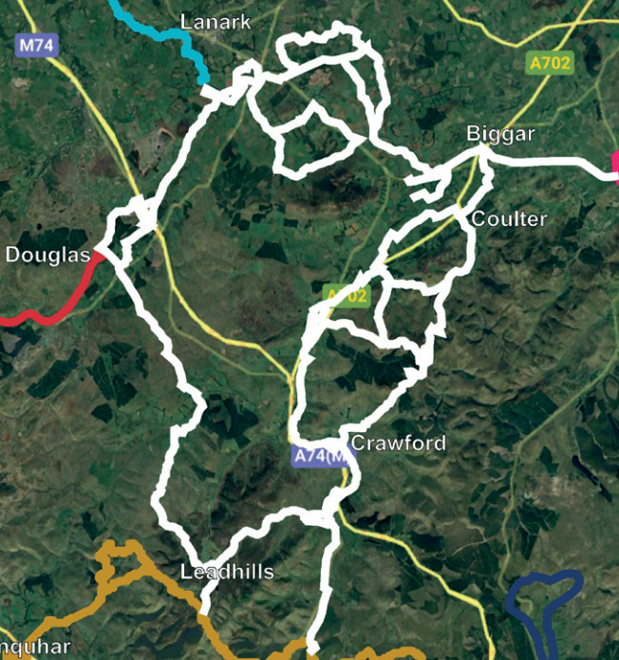
Figure 2.7 - Clydesdale Way Overview Plan
A summary of the links promoted as part of the Clydesdale Way that sit within the South Clydesdale study area is provided in Table 2.4.
Table 2.4: Clydesdale Way Connections in South Clydesdale
Route | Outline Summary
Cowgill to Crawford | Trail route through Lowther Hills and Clyde Wind Farm.
Crawford - Coulter High Level Link | Existing tracked route with steep terrain.
Lamington to Wandel | Off-road walking route along river Clyde.
Wandel High Level Link | Gravel wind farm access track with steep terrain, challenging for cycling.
Wandel to Abington | Quiet road route adjacent to the river.
Abington to Crawford | Quiet road route with direct connection to Crawford.
Crawford to Elvanfoot | Predominantly gravel/dirt track with steep terrain, challenging for cycling.
Elvanfoot Link | Route follows unclassified road under motorway with river crossing at Lodge Cottage suspension bridge.
Elvanfoot to Southern Upland Way | Direct link, primarily off-road with short section on A702.
Leadhills to Elvantfoot | Connects the settlements of Leadhills and Elvanfoot via the old dismantled railway.
Leadhills to Southern Upland Way | Aspirational core path route following good track over open moorland.
Crawfordjohn to Leadhills | Existing off-road track with steep terrain towards Leadhills.
Douglas to Crawfordjohn | Aspirational core path route across mixed terrain including bog.

Leadhills Village Active Travel Project
South Lanarkshire Council want to make it easier for residents to travel on foot and by bike more often for their local journeys, by improving the opportunities for, and tackling barriers to active travel.
The Leadhills Village Active Travel project includes the introduction of a 20mph speed limit within Leadhills, a painted pedestrian surface on Station Road, and enhanced village gateway features. Funding has been granted to progress the design of this project and South Lanarkshire Council recently consulted on the proposals.

Make Your Way Project

Overview
The Make Your Way Project is an active and sustainable travel focussed programme, enabling people to walk, wheel or cycle for everyday journeys in rural South Lanarkshire. Launching in 2016, Make Your Way has delivered 16 local active travel mapping initiatives, nine Sustainable Travel Action Plans, two Concept Designs and a Feasibility Study for rural active travel paths, a Feasibility for Speed Reduction and Pedestrian Safety measures, plus the installation of benches, bike racks and a solar powered bin.

Active Travel Mapping Initiatives
Of the 16 local active travel mapping initiatives, four were for settlements within Southern Clydesdale, including for Abington, Crawford and Elvanfoot, Crawfordjohn and Leadhills. These were created in collaboration with community members and highlights walking and cycling routes that are known to local people, which can be used for practical journeys, for leisure and for exercise.

Sustainable Travel Action Plans
In 2019, Sustainable Travel Action Plans for nine communities in rural South Lanarkshire were produced as part of the Make Your Way project, including for five communities within Southern Clydesdale – Abington, Crawford, Elvanfoot, Crawfordjohn and Leadhills.
The Action Plans explore various ways in which active and sustainable travel could be improved and explore priorities for each area, as well as ways that they can be achieved.
The proposed actions for Abington are split into physical and non-physical improvements. The proposed physical improvements are summarised in the aerial map below, as presented in the Action Plan.
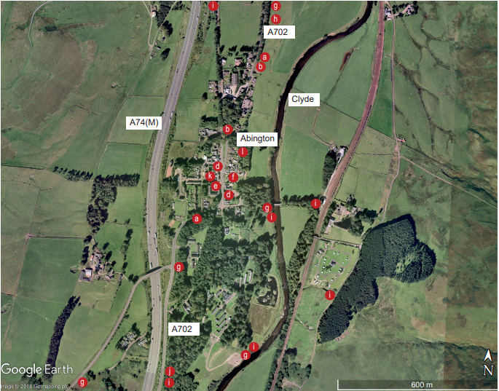
Figure 2.8: Aerial map showing indicative actions for physical improvement in Abington
Annotation key:
Ref | Action
 | Physical Improvements
P1 | Pedestrian + Cyclist Safety / Amenity
a | Options appraisal with budget costs for measures to reduce traffic speeds on A702.
b | Village wide detailed road and footpath repair and improvements audit including pavement widening, resurfacing and safer pedestrian crossing points, particularly in relation to primary school and village shop.
c | Provision of improved long stay car park and cycle parking at Abington Services to strengthen role as a sustainable public transport interchange.
d | Provision of cycle racks in key locations including village shop and hotel.
e | Provision of real time information at bus stops on A702 developed in consultation with bus providers and SLC.
f | Costed design proposals for the creation of a more attractive / pedestrian friendly central public space / village core at junction of A702 and Carlisle Road.
P2 | Walking + Cycling Routes
g | Masterplan / options appraisal with budget costs for improved path connections with the surrounding recreational walking/cycling/equestrian route network.
h | Options appraisal with budget costs for the provision of improved footpath and cycle links with Abington Services via A702/NCN Route 75.
i | Options appraisal with budget costs for the provision of improved footpath and cycle links to Crawford and Elvanfoot including repair of pedestrian suspension bridge.
j | Improved signage, interpretation and seating to recreational path network.
P3 | Other
k | Consideration to be given to the provision of EV charging points (cars + cycles) at key locations in the village, Abington Services and train station (if reopened).
l | Provision of ‘whole village’ Local Place Framework/Plan to steer and coordinate individual improvement initiatives.
The proposed actions for Crawford are split into physical and non-physical improvements. The proposed physical improvements are summarised in the aerial map below, as presented in the Action Plan.
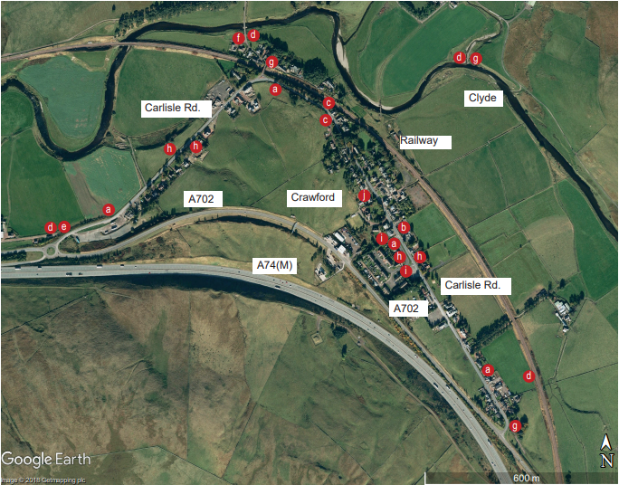
Figure 2.9: Aerial map showing indicative actions for physical improvement in Crawford

Annotation key:
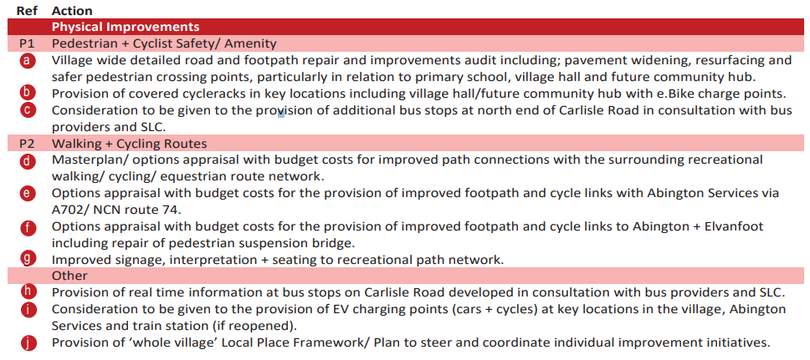
The proposed actions for Elvanfoot are split into physical and non-physical improvements. The proposed physical improvements are summarised in the aerial map below, as presented in the Action Plan.
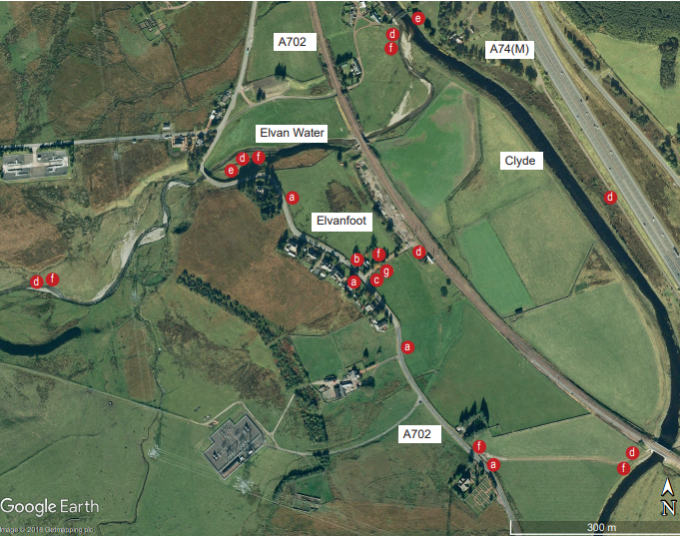
Figure 2.10: Aerial map showing indicative actions for physical improvement in Elvanfoot

Annotation key:
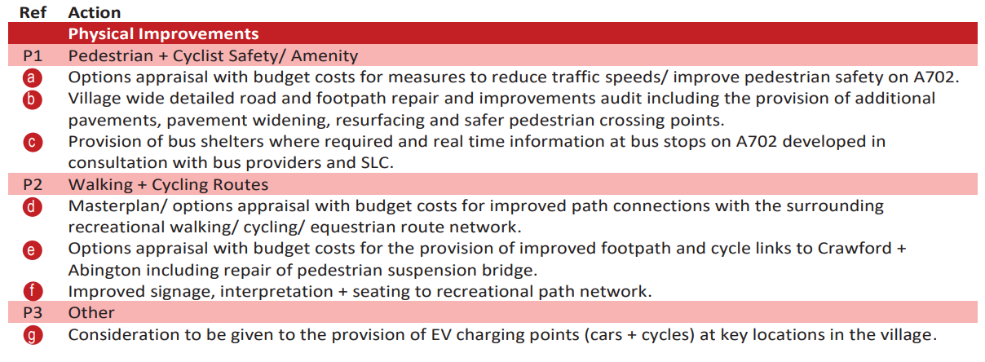
The proposed actions for Crawfordjohn are split into physical and non-physical improvements. The proposed physical improvements are summarised in the aerial map below, as presented in the Action Plan.
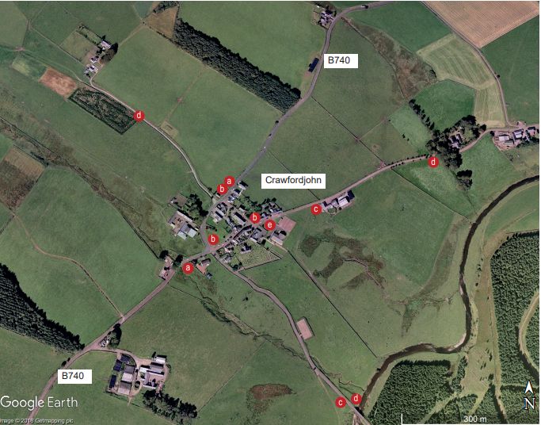
Figure 2.11: Aerial map showing indicative actions for physical improvement in Crawfordjohn

Annotation key:
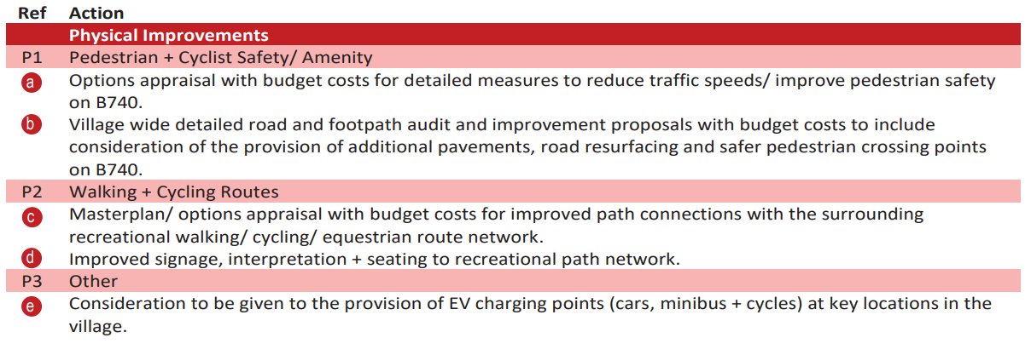
The proposed actions for Leadhills are split into physical and non-physical improvements. The proposed physical improvements are summarised in the aerial map below, as presented in the Action Plan.
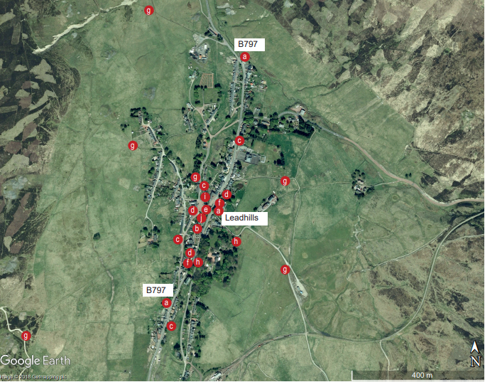
Figure 2.12: Aerial map showing indicative actions for physical improvement in Leadhills

Annotation key:
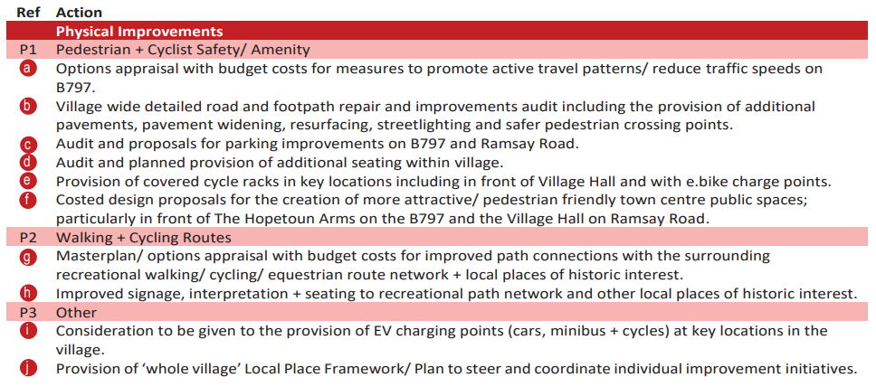

Crawford and Elvanfoot Speed Reduction and Pedestrian Safety Feasibility Study
The Rural Development Trust’s Community Action Lanarkshire programme commissioned an active travel focussed feasibility study for speed reduction and pedestrian safety in Crawford and Elvanfoot. This built on plans for traffic speed reduction and pedestrian safety improvements highlighted as priorities within the Sustainable Travel Action Plans (Figure 2.9 and Figure 2.10).
The study made a series of recommendations, which are summarised in the table below.
Table 2.5: Crawford and Elvanfoot Speed Reduction and Pedestrian Safety Feasibility Study Recommendations
Recommendation | Recommendation Details
1 | - Cutting back trees overhanging the pavement at the War Memorial Corner (Crawford).  - An additional pair of bus stops and hard standing areas are being provided between the Heathergyll and War Memorial bend on Carlisle Road through funding from SPT.  - 24-hour speed surveys will be undertaken in Crawford and Elvanfoot before April 2022. The Council will analyse these results to inform further actions which include a review of signage in Elvanfoot. There may be the potential to install concealed entrances signage, although it has been indicated that ‘Slow’ road paintings may be preferable due to the high volume of rural properties throughout the local authority.  - Traffic prioritisation at the bridge to the north of the Old Post Office in Elvanfoot is being considered.  - The provision of additional 40mph repeater signage and 40mph painted road markings throughout Elvanfoot.
2 | - A range of speed reduction and infrastructure improvements be raised with South Lanarkshire Council Roads and Transportation Services. In particular:  - Traffic speed surveys: it is recommended that South Lanarkshire Council carry out 24-hour traffic speed surveys in both Crawford and Elvanfoot and consider the implications of the results of these.  - Location of Carlisle Road speed sensor: it is recommended that this sensor be relocated closer to the centre of the village where there is likely to be more pedestrians, and where there is greater perceived issue with traffic speed.  - Safe road crossing in Crawford: it is recommended that further discussions are held with South Lanarkshire Council to consider providing a safe road crossing at the bus stop / Murray Drive / Dunalastair Road.  - Pavement widths and surfaces (Crawford): it is recommended that, where possible and practical, the widths of narrow pavements are extended, and the surfacing is upgraded to an acceptable standard.  - Drop kerbs (Crawford): it is recommended that a full review of the dropped kerbs in Crawford is carried out, and a programme of repositioning and upgrading these to meet the appropriate standards as set out by Transport Scotland is developed.  - Painted median line (centre of Carlisle Road, Crawford outside the school): it is recommended that this line be repainted on a regular basis to ensure efficiency.  - Eliminate overnight parking in the village car park by lorries and large vehicles: it is recommended that bollards and large boulders be installed along the grass verge to prevent vehicles illegally entering the car park.  - Amenity lighting: it is recommended that a motion activated photocell light be installed at Coronation Park to improve safety whilst moving around in the area.  - Road condition at Bellstane Road: it is recommended that the Community Council make representations to local elected members to ask them to resolve the impasse between South Lanarkshire Council and Scottish Water in relation to flooding and consequent damage to the road surface at Bellstane Road.  - It is recommended that repairs are made to the Variable Average Speed Calculator sign on the northern boundary of Elvanfoot.  - It is recommended that consideration is given to the installation of a fixed mirror at the junction of the B7040 and the A702 in Elvanfoot.
3 | - It is recommended that the Community Council commission a Road Safety Audit to progress Gateway Features for the entrances to both Crawford and Elvanfoot. The Road Safety Audit must be carried out by a Transport Scotland approved consultant.
4 | - On receipt of the Road Safety Audit, it is recommended that a planning application is prepared for Gateway Features at both villages.
5 | - It is recommended that the Community Council considers applying for funding to meet the costs of all discretionary infrastructure improvements whilst noting that South Lanarkshire Council will be responsible for providing and installing those aspects which are part of their statutory responsibilities.
6 | - It is recommended that residents make use of reporting tools relating to roads and lighting faults, fly tipping, dumping or litter issues as well as non-emergencies including speeding.
7 | - It is recommended that a community reporting system of incidents including near misses is set up by the Community Council / a specially formed sub-group in order to keep record of issues that go unreported and to help build evidence for future interventions.

Make Your Way – Leadhills to Wanlockhead Active Travel Pathway
In 2022/23, Community Action Lanarkshire is progressing Stage 3 Detailed Design and Stage 4 Technical Design of an active travel pathway from Leadhills to Wanlockhead, funded by Sustrans’ Places for Everyone programme.
The 2.8km path will improve everyday walking, wheeling and cycling opportunities between the two communities, linking key community facilities including local businesses, Leadhills Primary School, satellite GP surgery, the community halls, the Museum of Leadmining and onward bus travel. It will provide accessible provision by foot and by wheel where there currently is none and forms part of the Southern Upland Way Link and Mennock Pass, popular with outdoor enthusiasts.
South Lanarkshire Council are coordinating proposals for speed reductions and pedestrian / cyclist / accessible access within Leadhills village, creating safe access to the off-road route to the east of the B979. Project contractors are coordinating proposals for the off-road route into Wanlockhead which follows the existing path beside the Leadhills and Wanlockhead Railway. The programme includes a package of behaviour change initiatives which will be delivered alongside and after the construction of the path, bespoke to the needs of the communities.
Concept Designs of the route are provided in Appendix A.

Engagement and Consultation
This section presents the findings from engagement and consultation activities undertaken with stakeholders and the general public. An initial phase of engagement was undertaken in February 2023. The aim of the first phase of engagement was to gather information on the travel habits of local people and gain feedback on the conditions for active travel in the area to identify the most effective ways to develop an active travel network that meets the needs of the community.
The initial engagement programme included:
- An online questionnaire survey, to collate information on local travel;
- An online map for location-based comments and ideas (Placecheck); and
- Direct emails to key stakeholders.

Initial Online Questionnaire Survey
The online survey had 29 responses which provided an insight into the active travel infrastructure in Southern Clydesdale as well as existing issues, barriers and opportunities.

Respondent Profile
In terms of sex, 31% of respondents were male and 59% of respondents were female (with 10% preferring not to say). The vast majority of respondents did not consider themselves to be trans, or to have a trans history (90%), with 10% of respondents preferring not to say.
The diagram below displays the age range of respondents, with the highest represented categories being those aged 45-54 (38%) and those aged 55-64 (21%).
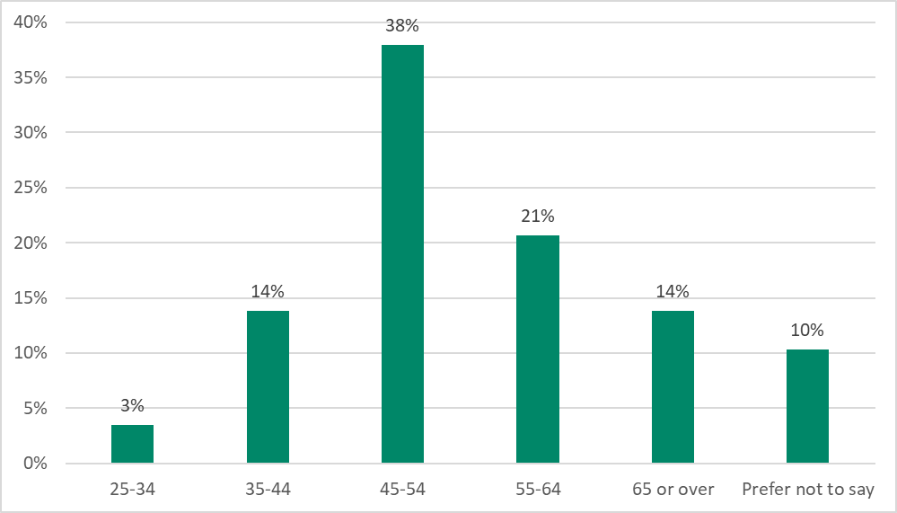
Figure 3.1: Age Group of Survey Respondents
In terms of health, the majority of respondents indicated that their day-to-day activities are not limited because of a health problem or disability (76%), with 14% noting that their activities are limited a little and 3% noting that their activities are limited a lot.
Figure 3.2 displays the employment status of respondents, showing that the majority of respondents were either working full time (45%) or retired (24%).
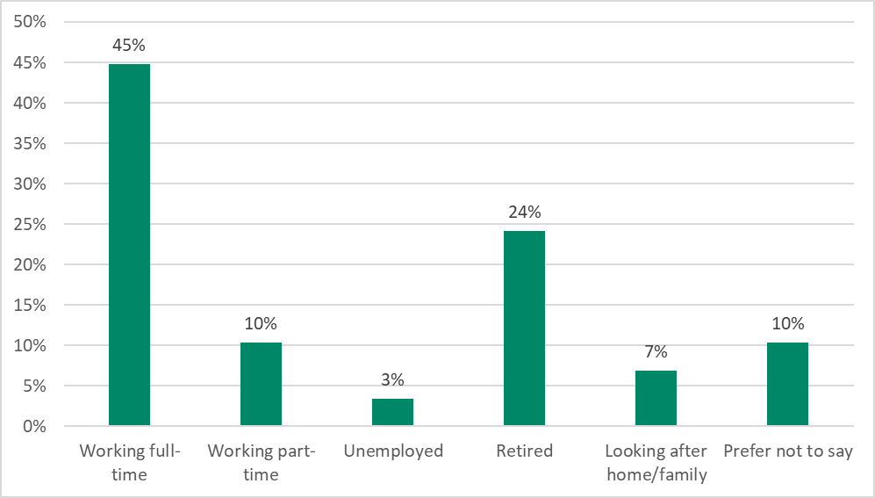
Figure 3.2: Employment Status of Respondents

Top Local Destinations
Survey respondents were asked to select the top three destinations in Southern Clydesdale that they travel to most regularly. The top recurring destinations selected included:
- Biggar (26%);
- Abington (18%);
- Lanark (9%);
- Leadhills (7%);
- Crawford (5%);
- Lesmahagow (4%);
- Hamilton (3%);
- Crawfordjohn (3%); and
- Coulter (3%).

Purpose for Travel to Top Local Destinations
The diagram below summarises the main purposes of travelling to the top local destinations. As shown, the most common reasons for travelling locally within Southern Clydesdale are for shopping or personal business (39%) and for leisure purposes (27%). Only 9% of responses indicated travelling within the local area for commuting purposes, suggesting that the majority of people leave the local area for work.
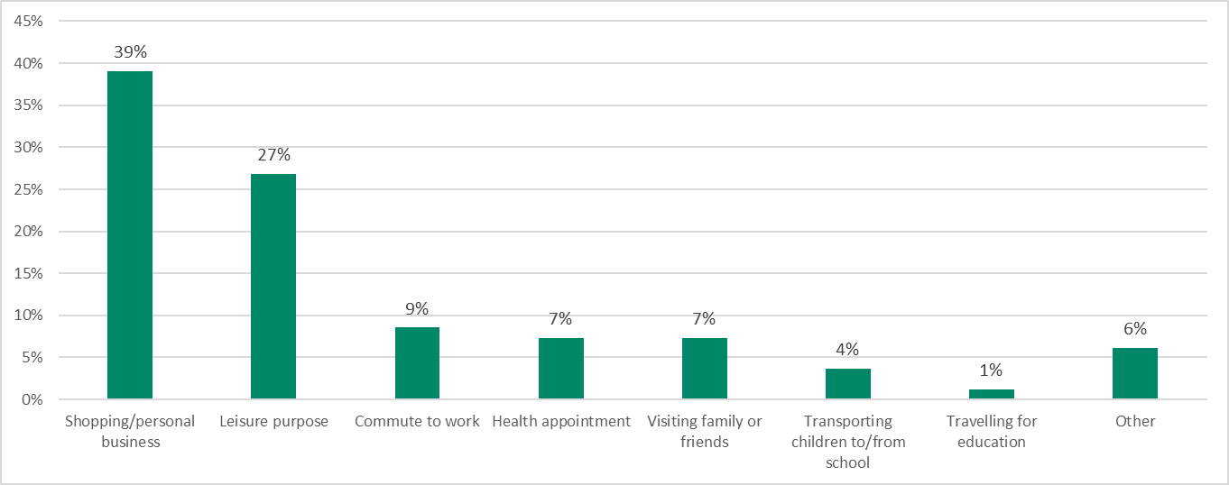
Figure 3.3: Purpose of Travel to Key Destinations

Method of Travel to Top Local Destinations
The diagram below summarises the main mode of transport used for travelling to the top local destinations. As shown, the most common method of travel to local destinations was driving a car or van, with passengers (33%) and without passengers (24%). A relatively high proportion of responses indicated that cycling was the main method of travel (23%).
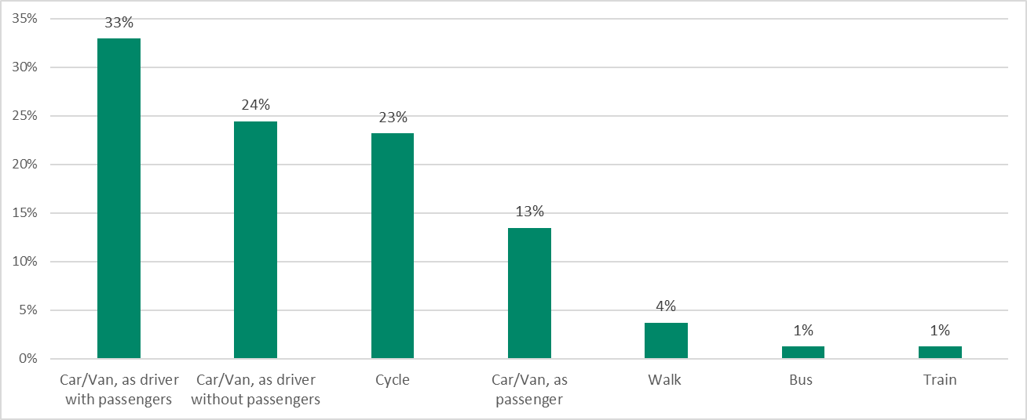
Figure 3.4: Method of Travel to Key Destinations

Walking and Cycling Facilities
The diagram below displays respondents’ rating of various walking and cycling facilities in Southern Clydesdale. As shown, respondents are generally not satisfied with the majority of facilities, particularly in terms of the condition of the surface of roads/paths/cycle routes; the lighting on roads/paths/cycle routes; the width of pavements/paths/cycle routes; and the amount of cycle parking.
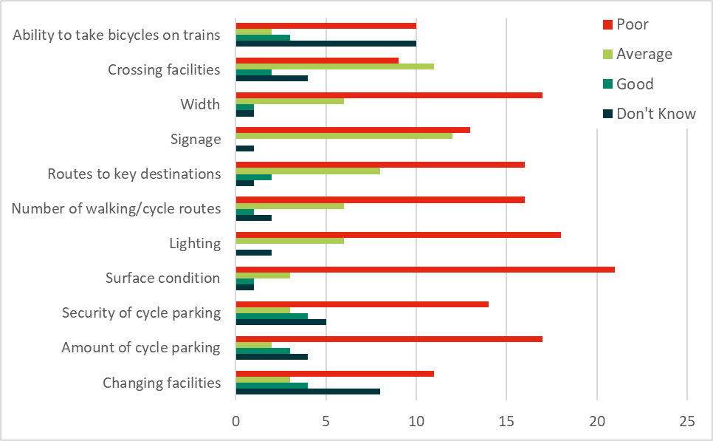
Figure 3.5: Quality of Walking and Cycling Facilities in Southern Clydesdale

Walking and Cycling Frequency
The diagram below highlights respondents’ frequency of walking during the different seasons of the year. As shown, slightly more survey respondents indicated that they walk more regularly during the winter months, with 75% walking a least once a week during the winter months compared to 71% during the summer months.
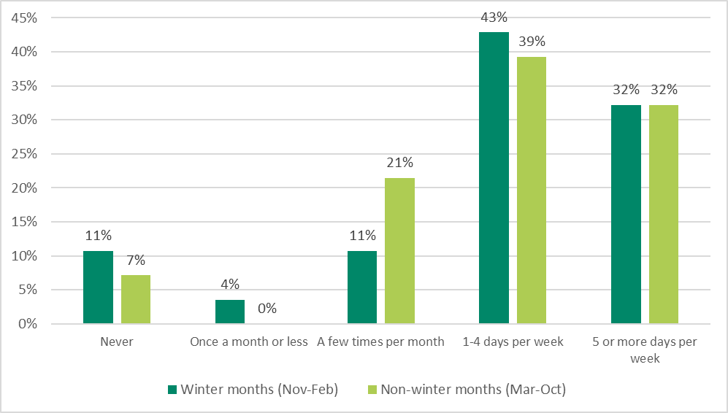
Figure 3.6: Walking Frequency by Season

In terms of cycling frequency:
- 83% of respondents stated that they own a bicycle; and
- 64% of respondents stated that they have used their bicycle in the last year.
The diagram below highlights respondents’ frequency of cycling during the different seasons of the year. As shown, survey respondents indicated that they cycle more regularly during the summer months compared to the winter months, with 61% cycling at least once a week during the summer months compared to 22% during winter months.
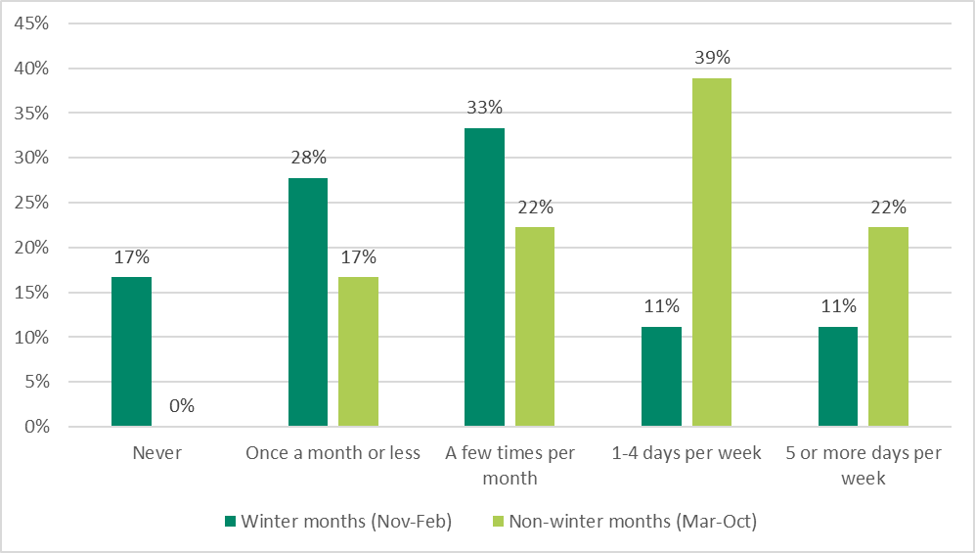
Figure 3.7: Cycling Frequency by Season

Benefits of Walking or Cycling
Respondents were asked to select what they consider to be the top three benefits from walking. The top three selected benefits were:
- Health benefits / exercise (33%);
- Pleasure / enjoyment (29%); and
- Better for the environment (18%).
The diagram below outlines the percentage of responses for each benefit.
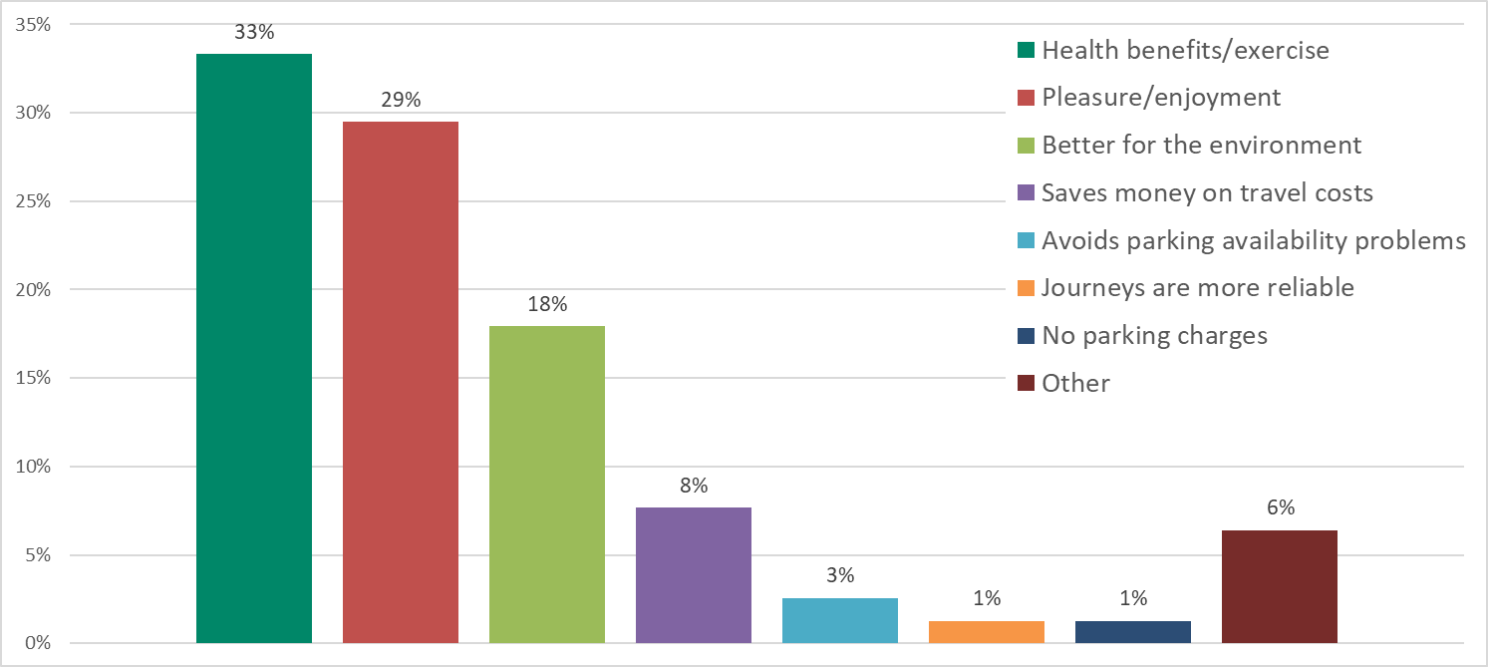
Figure 3.8: Benefits from Walking
Respondents were asked to select what they consider to be the top three benefits from cycling. The top three selected benefits were:
- Health benefits / exercise (34%);
- Pleasure / enjoyment (26%); and
- Better for the environment (25%).
The diagram below outlines the percentage of responses for each benefit.
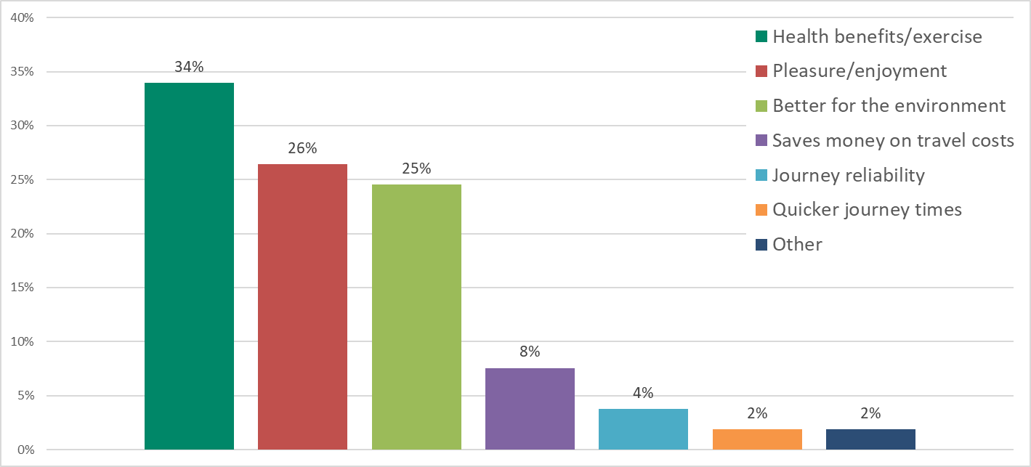
Figure 3.9: Benefits from Cycling

Main Barriers to Walking and Cycling
Respondents were asked to select what they consider to be the top three barriers to walking and cycling in Southern Clydesdale. The top three barriers selected were:
- Condition of roads, paths and cycle routes (20%);
- Lack of off-road/traffic-free cycle routes (19%); and
- Destinations not served by walking/cycle routes (12%).
The diagram below outlines the percentage of responses for each barrier.
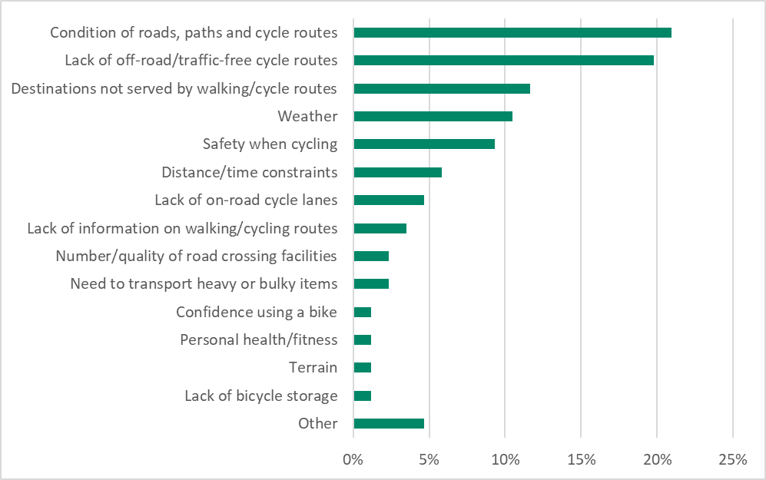
Figure 3.10: Barriers to Walking and Cycling in Southern Clydesdale
Respondents were additionally asked to what extent they think general traffic volumes, speeds or through traffic on residential streets prevents them from walking, cycling or wheeling for everyday journeys. The results are shown in the diagram below.
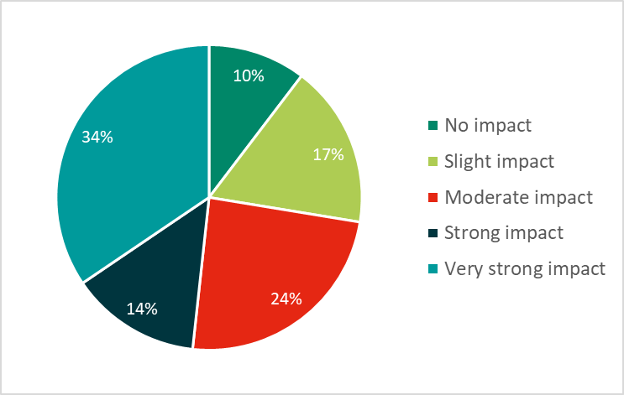
Figure 3.11: Impact of General Traffic on Walking, Cycling and Wheeling

Interest in Walking and Cycling More Often
The diagram below illustrates the proportion of respondents who indicated that they would be interested in walking more often. As shown, the majority indicated that they would want to walk more often (62%).
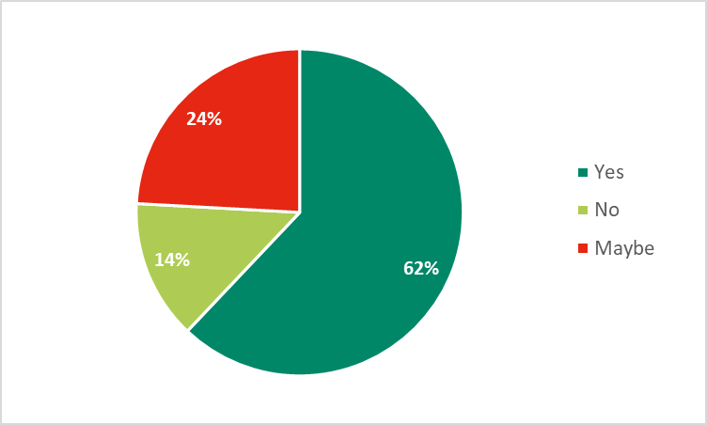
Figure 3.12: Respondents' Interest in Walking More Often

The measures that were most commonly selected as potentially encouraging people to walk more often included:
- More dedicated walking routes (32%);
- Better lighting of walking routes (17%);
- Better information on walking routes (17%); and
- Reduced number/speed of cars (10%).
The diagram below illustrates the proportion of respondents who indicated that they would be interested in cycling more often. As shown, over half of respondents indicated that they would want to cycle more often (55%).
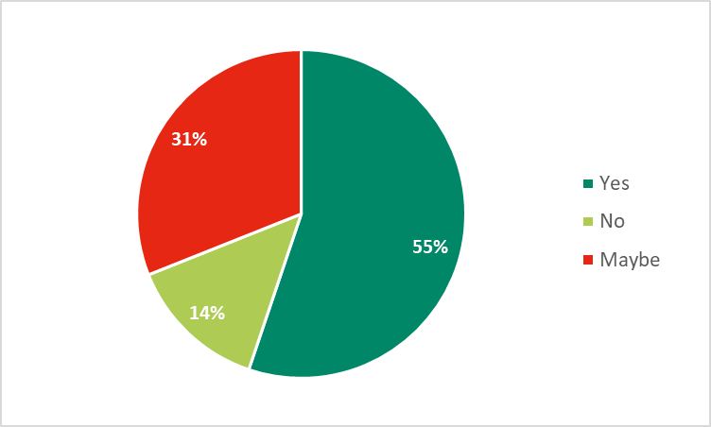
Figure 3.13: Respondents' Interest in Cycling More Often
The measures that were most commonly selected as potentially encouraging people to cycle more often included:
- More dedicated off-road/traffic free cycle routes (31%);
- More on-road cycle lanes (19%);
- Better lighting of roads/cycle routes (14%); and
- Reduced number/speed of cars (11%).

Additional Comments from Initial Survey
A number of additional comments were provided by respondents at the end of the survey. These comments provide an insight into the nature of the issues associated with active travel in the study area. The comments have been grouped into categories and are summarised in the diagram below.
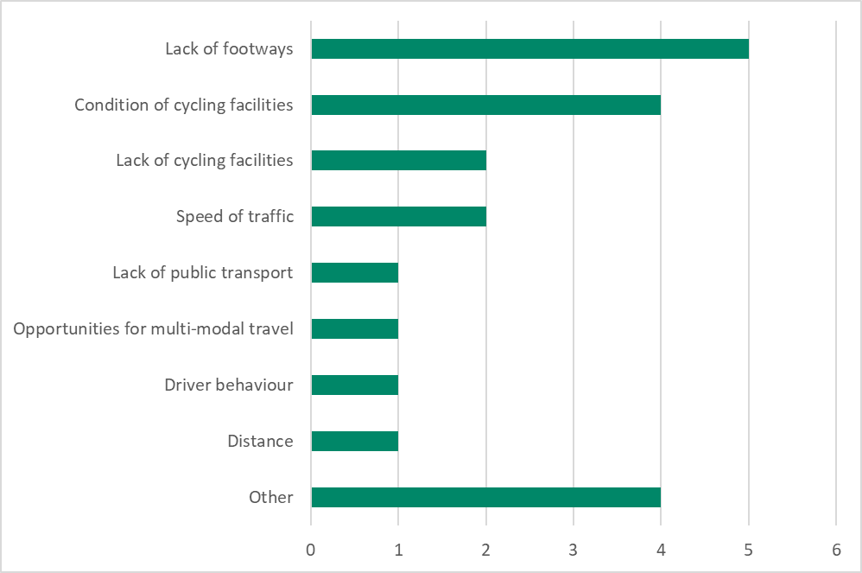
Figure 3.14: Additional Survey Comments

Placecheck Online Map
Alongside the initial online questionnaire survey, an online Placecheck Tool was available for respondents to highlight the location of specific issues and problems. No responses were received for Southern Clydesdale.

Follow-Up Engagement Activities

Public Life Survey
A Public Life Survey was undertaken in the areas of Crawford and Leadhills as part of this study. The Public Life Survey Tool method utilised for this study was the Twelve Quality Criteria Method which was developed as a tool for researching how public spaces are experienced by their users and to assess if a space has features which are protective, comfortable and enjoyable, as without these functions the quality of public space is reduced, and people are less likely to want to use the space. The Twelve Quality Criteria Method is part of a suite of Public Life Survey tools developed by Gehl.
This section of the report summarises information and the findings of the Public Life Survey. The full survey report and results can be found in Appendix B of this report.

Crawford
The study area within Crawford was centred along Carlisle Road, as the central area with amenities along its length. The study area is shown in the figure below.
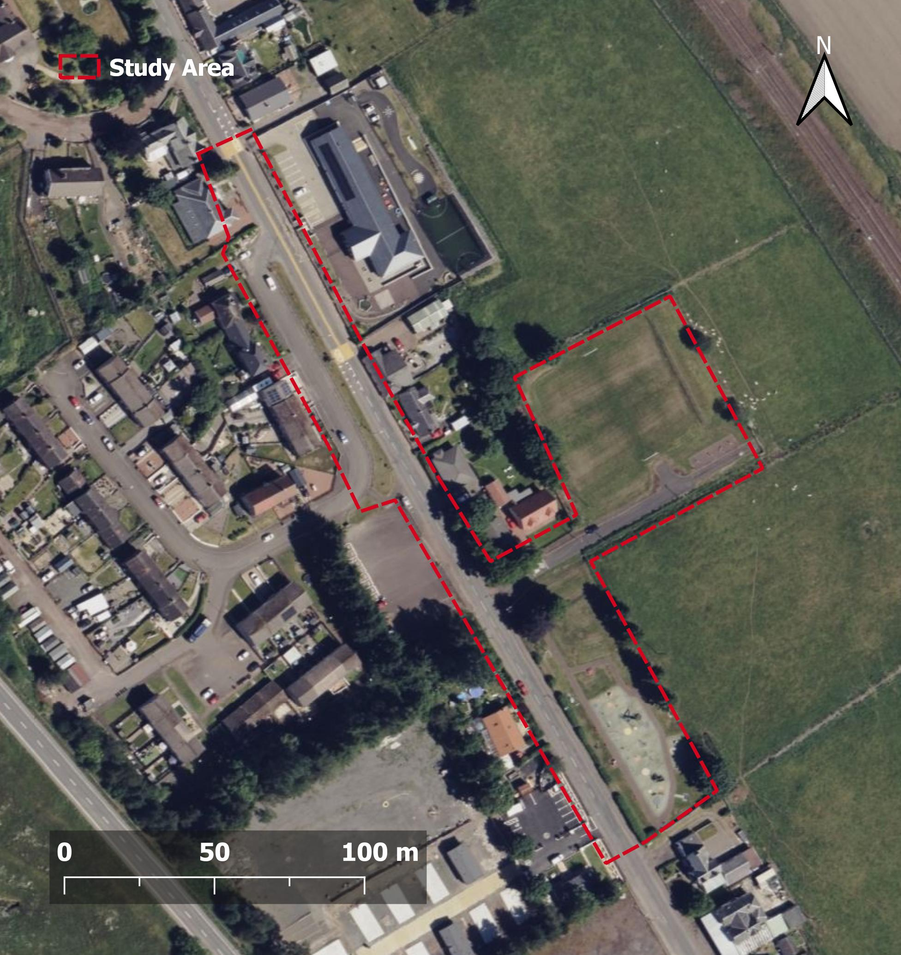
Figure 4.1: Crawford Study Area

Public Life Survey Observations
A typical cross section was taken of the main road within the study area – Carlisle Road – as shown in Figure 4.2.
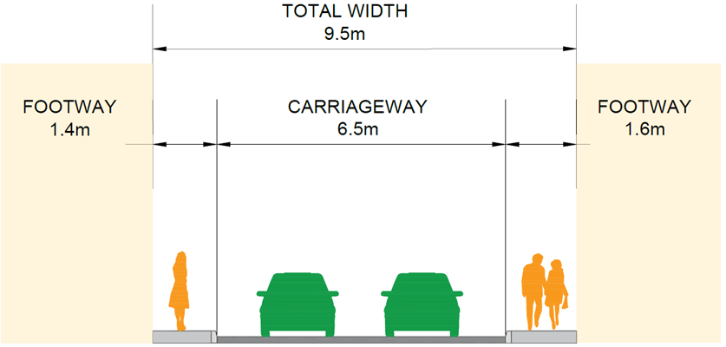
Figure 4.2: Typical Cross Section through Carlisle Road
The survey looked at the 12 criteria with the three themes of Protection, Comfort and Enjoyment. Each of the criteria were assessed and given a score of 1-3 depending on the criteria. The highest scores represent the qualities of the public space that are strongest. The diagram below shows a summary of the scoring.
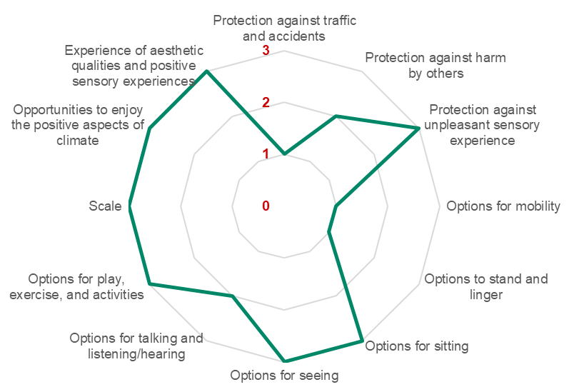
Figure 4.3: Crawford Scoring Summary

The table below shows some of the key observations on site.
Table 4.1: Crawford Public Life Survey Observations
Category | Summary Observations
Protection | Protection is limited throughout the study area with narrow footway provision and limited to one side of the road in part. Personal security concerns are likely to be low given the size of the community however there is limited daytime activity in terms of people passing by which may contribute to concerns. The adjacent transport infrastructure creates noise which is unobstructed by the surroundings.
Comfort | Comfort scores varied with options for mobility and to stand and linger impacted by the footway provision throughout the study area. The benches and the park area provide opportunities to sit, have conversations and engage in play and exercise.
Enjoyment | Overall, Crawford scored well against the enjoyment criteria with the scale of buildings, positive aspects of climate able to be appreciated and the open and rural nature of the area provides visual interest.

Public Life Survey Recommendations
Whilst Crawford generally performed well against the twelve quality criteria, it is noted that some aspects could be considered for improvement. Recommendations are as follows:
- Improved footway provision throughout, although it is noted that due to space constraints, footways may not be able to be provided on both sides of the carriageway, however, suitable crossing points e.g. dropped kerbs should be provided to allow access to the opposite footway.
- Further development of placemaking opportunities – planting has already been introduced within verge space however, it could be furthered with seating and potential use of existing car parking space.

Leadhills
The study area within Leadhills was centred along Main Street due to the proximity to Leadhills Primary School and local amenities. The study area is shown in the figure below.
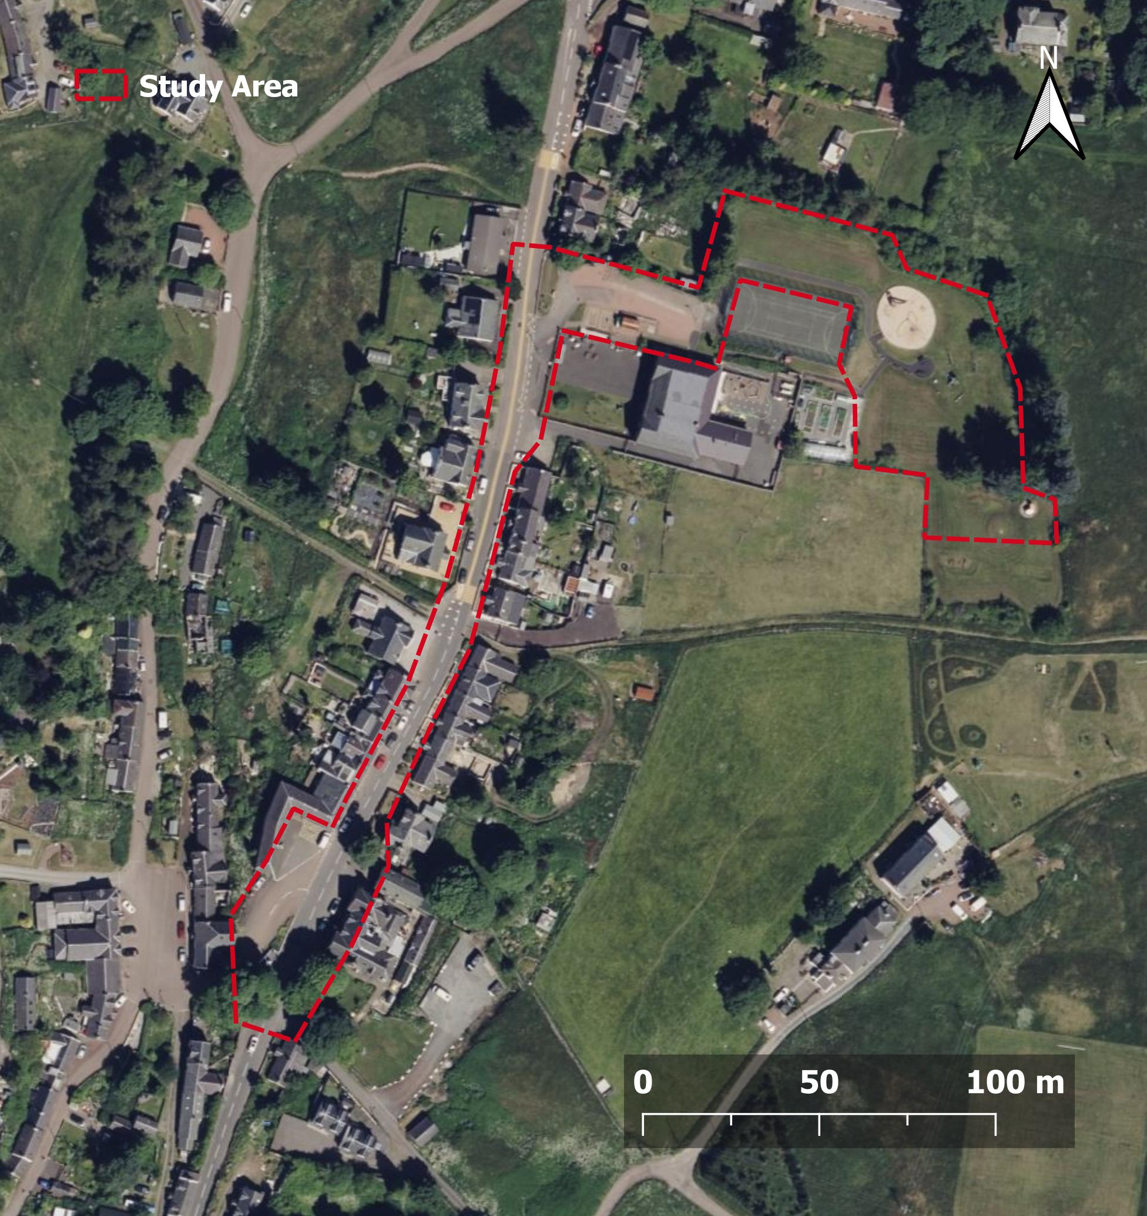
Figure 4.4: Leadhills Study Area

Public Life Survey Observations
A typical cross section was taken of the main road within the study area – Main Street – as shown in Figure 4.5.
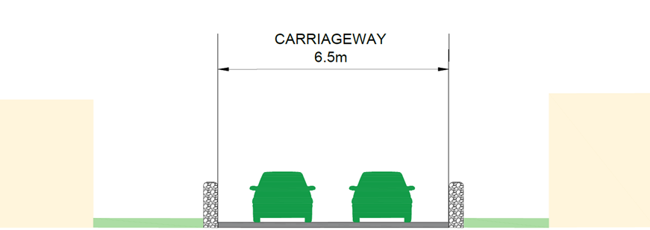
Figure 4.5: Typical Cross Section through Main Street
The survey looked at the 12 criteria with the three themes of Protection, Comfort and Enjoyment. Each of the criteria were assessed and given a score of 1-3 depending on the criteria. The highest scores represent the qualities of the public space that are strongest. The diagram below shows a summary of the scoring.
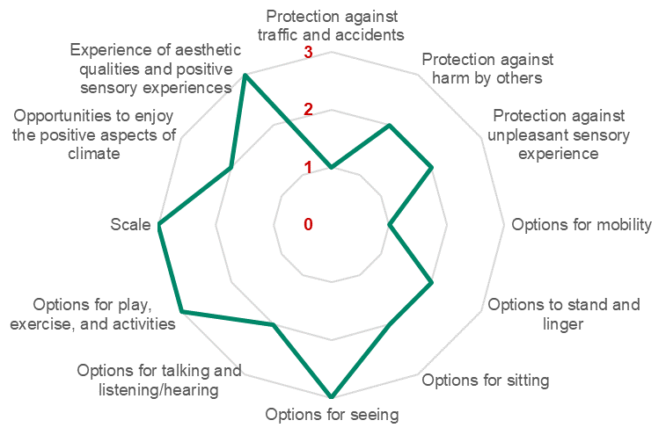
Figure 4.6: Leadhills Scoring Summary

The table below shows some of the key observations on site.
Table 4.2: Leadhills Public Life Survey Observations
Category | Summary Observations
Protection | Protection is limited due to a lack of footway provision throughout the study area and expected low levels of daytime and night time activity.
Comfort | Adjacent to carriageway, there are few options for congregating and having conversations. The play park to the east of the primary school supports these options as well as for play and exercise.
Enjoyment | The quiet nature of the village and its surroundings supports the enjoyment criteria with shelter also provided by trees and other foliage.

Public Life Survey Recommendations
Leadhills provides limited protection and comfort adjacent to the carriageway which could be improved on. Recommendations are as follows:
- Introduce traffic calming along Main Street to promote safer walking and cycling within the constrained corridor.
- Introduce placemaking measures such as planters and seating where space permits along Main Street for all to make use of.

Proposed Network and Phased Delivery

Principles of Proposed Network
A network of walking and cycling routes has been developed using the results from the engagement process, alongside the other associated investigations and consultation work undertaken for the study area. The proposed network demonstrates what a coherent, direct and attractive active travel network in south Clydesdale would look like. The network will consist of existing paths and routes that will be upgraded alongside with a range of new connections.
The aim was to develop a plan and identify opportunities which:
- Address the concerns raised, enabling walking and cycling as a convenient choice for all trip types;
- Support local businesses and the economy;
- Are aligned with best practice in designing people friendly streets and spaces;
- Are in line with policy objectives at all levels of government; and
- Are likely to attract funding and/or takes advantage of planned changes.
The focus has been on developing an active travel network for Clydesdale that provides safety and access to those who wish to cycle. The needs of those walking and wheeling will be considered as an essential part of any active travel project.
Some key points:
- At this early stage of development, the proposed routes are indicative connections and are not proposed alignments.
- Where a proposed connection is taken forward, different alignments options will be assessed against feasibility criteria and cycle network design principles, the most suitable alignment will be taken to the next design stage.
- When the design for a route is considered, connections to it and across it will be considered in addition to the route itself.
- Stakeholder and public consultation will take place at every stage of the development process.
Design principles for a good cycle network reflect the issues raised during the consultation period. The first five core design principles shown in Table 5.1 are taken from Cycling by Design guidance. While these were principally developed and applied to cycle networks and cycle infrastructure, the core principles are also highly relevant and applicable to walking infrastructure and networks.
In addition to the core design principles from Cycling by Design, the additional two core principles shown below at the bottom of Table 5.1 should be considered.
At this early stage of development, the most relevant principles are Cohesion and Directness. The other three principles become key criteria in the latter stages of the process through feasibility and design stages.
Table 5.1: Design Principles
Design Principle | Areas to Consider
- Cohesion | • Interconnections between routes  • Interconnections between modes  • Connections to the wider network (regional and national)
- Directness | • Time  • Distance
- Safety | • Road safety  • Personal safety  • Health
- Comfort | • Easy to navigate  • Reasonable gradient  • Smooth surface
- Attractiveness | • Varied, busy environment  • Personal safety
- Adaptability / Future Proofing | • Proposals should take into account potential growth in  walk and cycling and future expansion of networks.
- Accessibility | • Proposals should consider and cater for the needs of all  types of users including those with a range of disabilities.
South Lanarkshire Council intend to use the finalised study to inform future funding applications to implement the recommendations identified.

Proposed Networks
The proposed networks have been split into the following categories:
- Regional Routes – will include long distance cycle connections linking both within and beyond the study area along main arterial routes. These will primarily comprise connections on the National Cycle Network and could consist of fully segregated cycle infrastructure and traffic free links. Generally, most communities within the study area will be connected to regional routes by a network of Primary or Secondary Cross Town/Village Routes.
- Primary Cross Town/Village Routes – will include the proposed strategic cycle connections linking key destinations and communities within and beyond the study area. The Primary routes could consist of fully segregated cycle infrastructure along main roads, improvement of existing traffic-free links or on-road links on streets with low traffic volumes and speeds. Generally, key destinations and communities within the study area will be within 500m of one of the proposed Primary Routes.
- Secondary Cross Town/Village Routes – will include connections between other core destinations, communities and major trip attractors as well as connection to the wider network of Regional and Primary routes. Secondary routes could consist of fully segregated cycle infrastructure along main roads, improvement of existing traffic-free links or on-road links on streets with low traffic volumes and speeds. Most communities within the study area that are not within 500m of the Primary routes will be within 200m of a proposed Secondary Route.
- Local Links – will include additional links to local destinations and trip attractors such as schools, shopping centres and areas of employment where not directly facilitated by the Regional, Primary or Secondary route network. The local links could consist of new and improved traffic-free links, on-road links on streets with low traffic volumes and speeds or quiet, rural roads.
The proposed links above could utilise a range of the following toolkit of infrastructure improvements which could be implemented:
- Segregated cycle lanes
- Shared use paths and traffic-free links
- Traffic-calming and speed limit reduction
- Cycle-friendly neighbourhoods and quiet streets
- Filtered permeability and traffic management changes
- Contra-flow cycle lanes
- Improvement of active travel signage and wayfinding
- Improvement of existing access controls and barriers
- Secure cycle storage and parking
- Accessibility and crossing improvements
- Streetscape and urban realm improvements
The map below displays what a comprehensive and coherent active travel network could potentially look like for the southern area of Clydesdale.

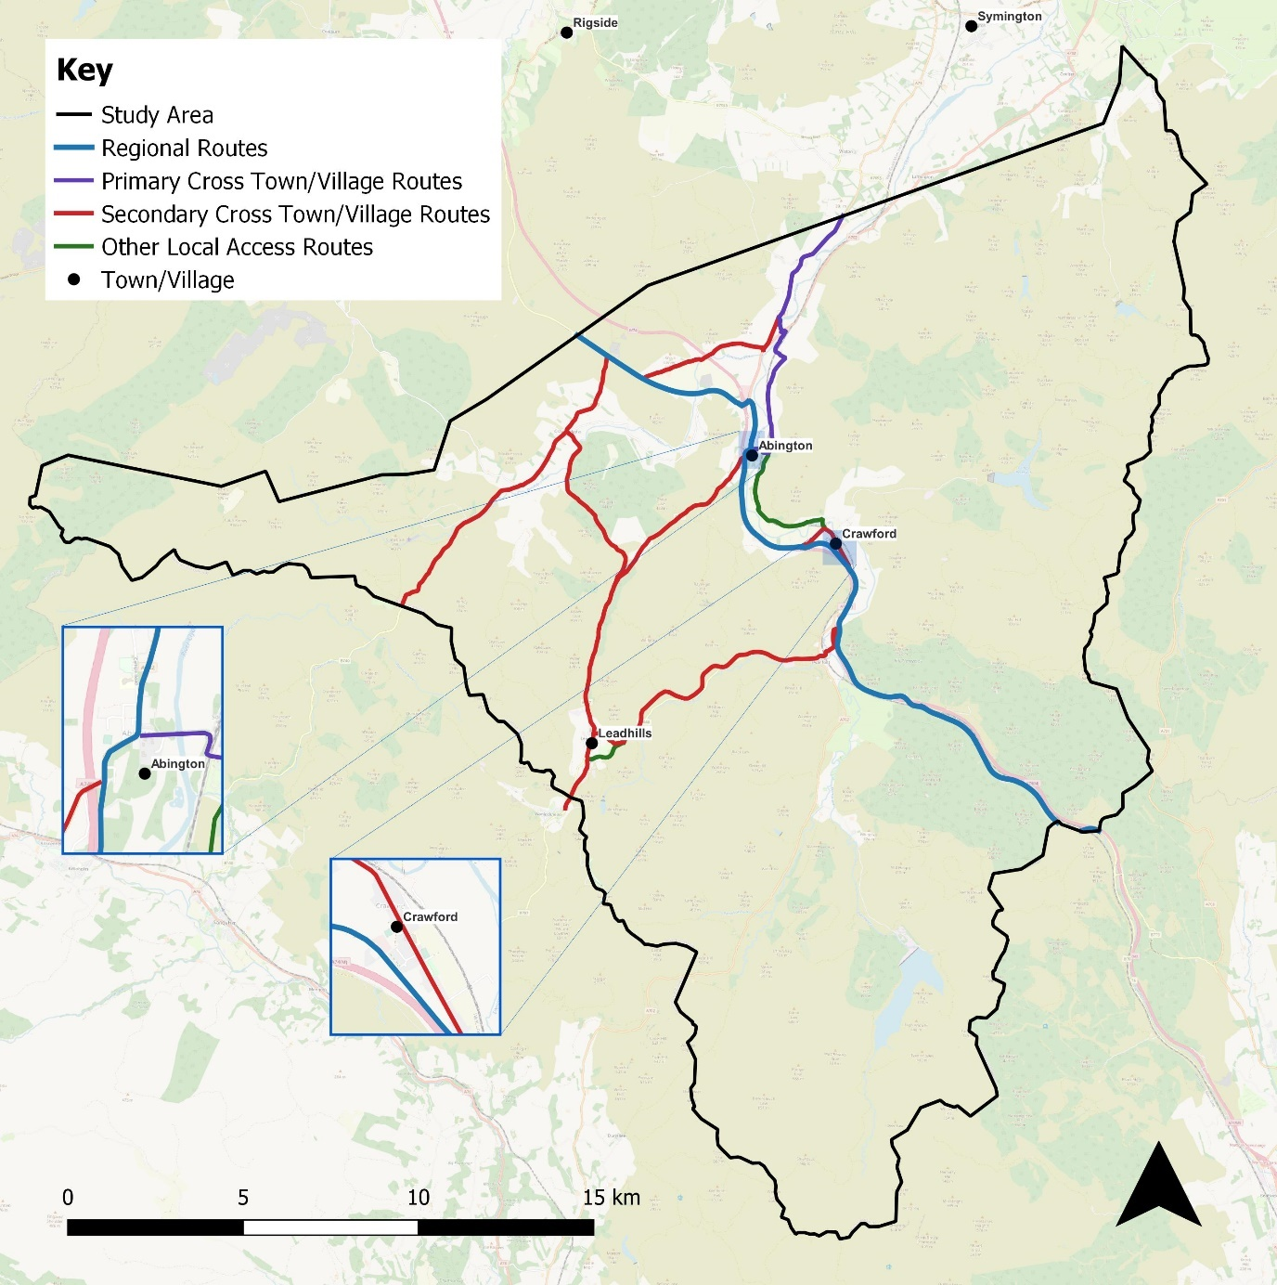
Local Links

Figure 5.1: South Clydesdale Proposed Networks Overview
The Regional Route would follow the existing National Cycle Network Route 74 which runs north-south through the study area, providing a central spine from which the wider active travel network can grow. It is recommended that consideration be given to provision of fully segregated facilities where the route is currently on road.
As a key destination and hub for access to the Regional Route, Abington would be connected to other key locations outside of the study area by a proposed network of Primary Cross Town/Village Routes. Other key locations connected by this network include Biggar, Carnwath, Lanark, Lesmahagow and Blackwood and Kirkmuirhill. Where not directly served by the Regional or Primary Routes, other communities and trip generators in the area would be served by a network of Secondary Cross Town/Village Routes with Local Links accommodating local trips on quiet routes.
The proposals are expanded on further based on their split into town and village areas.

Leadhills
Secondary Routes are proposed to follow the B797 and B7040 to connect Leadhills with the Regional Route and provide a link between Leadhills and Abington. Use of the former railway offers a potential direct off-road corridor as an alternative alignment to the B7040. Local Links are proposed to facilitate access Leadhills Golf Course and Leadhills surgery. A proposed Secondary Route would continue down Station Road towards Wanlockhead to provide a connection to the Lowther Hills Ski Centre and the wider area to the southwest. Proposed Local Links would complete a local circuit and serve community facilities.
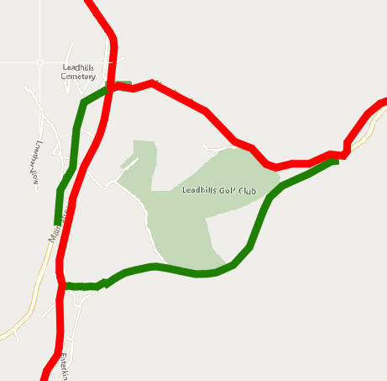
Figure 5.2: Leadhills Proposed Networks

Abington
The Regional NCN 74 Route runs through Abington Village which serves as a hub with connections to the wider Primary and Secondary route network linking through Roberton towards Biggar in the north-east, and Leadhills in the southwest. Local Links are proposed to provide a connection to Abington Primary School and an alternative route to Crawford as identified through the Clydesdale Way and Make Your Way projects.
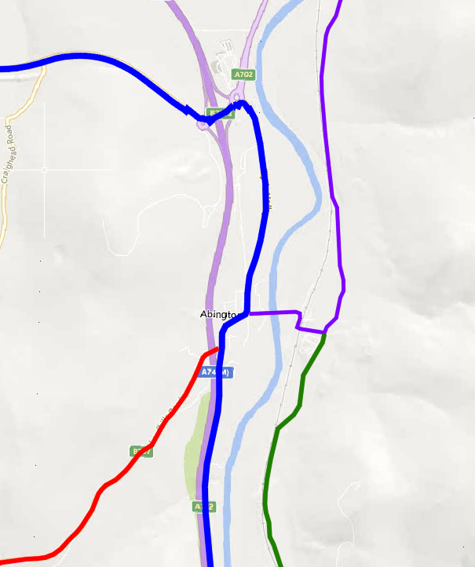
Figure 5.3: Abington Proposed Networks

Crawford
A Secondary Route is proposed through the village of Crawford to provide a connection form the Regional Route to Crawford Primary School. There are proposals to create a link from Crawford to Abington via the rural road network to the east of the NCN Route 74. This was identified through the Clydesdale Way and Make Your Way projects and could form the basis of a future rerouting of the NCN Route 74.
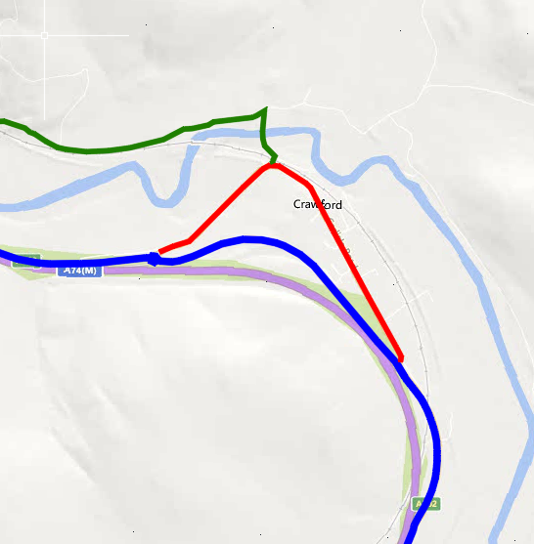
Figure 5.4: Crawford Proposed Networks

Crawfordjohn
A Secondary Route is proposed from Crawfordjohn on the B740 to provide a connection to the Regional Route in the north and the wider area to the southwest. A connection is also proposed south over Duneaton water to provide a more direct connection to Leadhills and the southwest. Local Links complete a circuit of local leisure routes.
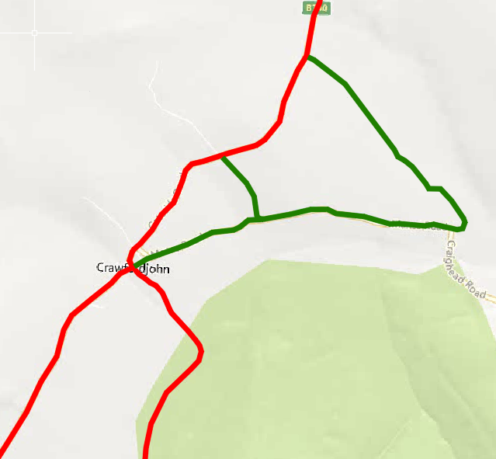
Figure 5.5: Crawfordjohn Proposed Networks

Proposed Cycle Network – Delivery Phases
To be completed following consultation. Network development to be driven by demand and be coherent and connected as it develops.

Key Delivery Principles
For people in South Clydesdale to see active travel as a natural choice for short everyday journeys, the network of routes needs to be coherent and direct. Routes also need to be (and feel) safe, comfortable and attractive as highlighted earlier in the Core Design Principles. The development of the network should also incorporate the following principles and considerations.

People-Focussed Design
Community engagement and stakeholder consultation activities will continue to be undertaken to ensure that proposals meet the needs of local communities. Design proposals must seek to deliver benefits to all users in a balanced way and deliver people-focussed designs. In the context of a motorised traffic dominated town, this will mean prioritising the needs of people travelling on foot and by bike and in accordance with the Sustainable Travel Hierarchy set out in the NTS2 and shown earlier in this report in Figure 9. The design should aim to support the needs of all categories of users, across age groups, or journey purposes.

Neighbourhood Permeability
Active travel networks must provide connectivity both to and within local neighbourhoods to facilitate journeys to local destinations schools, parks or local shops. These local journeys and local destinations which are often removed from key commuter corridors such as the school run have great potential to be undertaken through active travel. Walking, wheeling or cycling through a local neighbourhood should be easier, more direct and convenient than driving (if through traffic is allowed).

Multimodality
The proposed network and its design should facilitate connection and pay particular attention to interchange points with public transport, as well as considering the impact of any proposed changes on bus provision and journey times.

Information, Promotion and Behaviour Change Activities
Incomplete, missing or lack of signage and wayfinding along existing routes and local destinations has been highlighted by stakeholders as an issue within the study area.
Any proposed routes must be accompanied by a communications strategy to maximise their use and benefits. This could include engagement events during the design process, mapped information and signposting of the build route, and ongoing promotion and behaviour change campaigns to sustain growth in use.
Continued delivery of cycle training in schools, the Junior Road Safety Officer Programme and School Travel Plans across the area will also provide a key opportunity to provide information, promote proposals and deliver behaviour change activities.
The creation of dedicated cycle hubs within the local area could also be a valuable addition to promote active travel and provide opportunities for community-led initiatives.

Maintenance and Enforcement
A lack of maintenance of the existing walking and cycling network was also highlighted as an issue within the study area through the public surveys and stakeholder input. The design of active travel infrastructure should seek meet good quality standards after initial construction including surface condition, cleanliness, lighting, tree root encroachment, dropped kerbs etc.
Encroachment by vehicles on dedicated active travel infrastructure ideally should be prevented through design features and street layout to prevent obstructions to people walking and cycling. Where this is not possible, ongoing enforcement requirements should be considered at the design stage.

Next Steps
It is recommended that South Lanarkshire Council review the proposals outlined within this report and engage with key delivery partners to begin delivery of those proposals.
It is recommended that proposals are grouped together where possible and applications are made through the Sustrans Places for Everyone Framework when possible for a majority of the larger or more challenging projects. Officers should review corresponding proposals that have been developed for the other Active Travel Feasibility Studies and identify where there are potential cross-study boundary routes and interventions that could be combined or delivered together. It should be noted that other funding sources are available through the Scottish Government and external partners such as SPT.
While these applications are progressing and individual projects are developed through the Places for Everyone Design Stages, it is recommended that the Council continue to engage with the local communities, key stakeholders and key delivery partners identified throughout this study and seek opportunities to collaborate on the development of these proposals.

DataShine: Scotland Commute
https://ren.maps.arcgis.com/apps/webappviewer/index.html?id=ba679da637d34c87a452eab9c0d4b607
Transport and Travel in Scotland 2019 https://www.transport.gov.scot/publication/transport-and-travel-in-scotland-2019-results-from-the-scottish-household-survey/
Transport and Travel in Scotland 2020 https://www.transport.gov.scot/publication/transport-and-travel-in-scotland-2020-results-from-the-scottish-household-survey-pdf-version/
South Lanarkshire Council Area Profiling Tool https://improve.southlanarkshire.gov.uk:8443/CorVu/g?Area_Profile_Report_Map_2022
Scotland Census 2011 https://www.scotlandscensus.gov.uk/search-the-census#/
Hands Up Scotland Survey 2021 https://www.sustrans.org.uk/our-blog/projects/uk-wide/scotland/hands-up-scotland-survey
Bothwell, Blantyre and Uddingston Active Travel Feasibility Study, AECOM, 2021, https://www.southlanarkshire.gov.uk/downloads/file/15068/bothwell_blantyre_and_uddingston_active_travel_feasibility_study
Larkhall Active Travel Feasibility Study, AECOM, 2021, https://www.southlanarkshire.gov.uk/downloads/file/15067/larkhall_active_travel_feasibility_study
Strathaven, Stonehouse and the surrounding villages Active Travel Feasibility Study, AECOM, 2021, https://www.southlanarkshire.gov.uk/downloads/file/15066/strathaven_stonehouse_and_the_surrounding_villages_active_travel_feasibility_study
Funding boost for walking, wheeling and cycling, Transport Scotland, 2022, https://www.transport.gov.scot/news/funding-boost-for-walking-wheeling-and-cycling/
Active Travel Framework, Transport Scotland, 2020, https://www.transport.gov.scot/publication/active-travel-framework-1/
Cycling Framework and Delivery Plan for Active Travel in Scotland 2022-2030, Transport Scotland, 2022, https://www.transport.gov.scot/media/52035/draft-for-consultation-august-2022-cycling-framework-and-delivery-plan-for-active-travel-in-scotland-2022-2030.pdf
Let’s get Scotland walking – The National Walking Strategy, Scottish Government, 2014, https://www.gov.scot/publications/lets-scotland-walking-national-walking-strategy/
National Transport Strategy 2, Transport Scotland, 2020, https://www.transport.gov.scot/publication/national-transport-strategy-2/
https://www.gov.scot/publications/national-planning-framework-4/
STPR2 Final Summary Report, Prepared by Jacobs and AECOM for Transport Scotland, 2022, https://www.transport.gov.scot/publication/final-summary-report-december-2022-stpr2/
Infrastructure Investment Plan for Scotland 2021-22 to 2025-26, Scottish Government, 2021, https://www.gov.scot/publications/national-mission-local-impact-infrastructure-investment-plan-scotland-2021-22-2025-26/
Scotland’s National Strategy for Economic Transformation, Scottish Government, 2022, https://www.gov.scot/publications/scotlands-national-strategy-economic-transformation/
Climate Change (Emissions Reduction Targets) (Scotland) Act, Scottish Government, 2019, https://www.legislation.gov.uk/asp/2019/15/contents/enacted
Securing a Green Recovery on a Path to Net Zero: Climate Change Plan 2018–2032 - update, Scottish Government, 2020 https://www.gov.scot/publications/securing-green-recovery-path-net-zero-update-climate-change-plan-20182032/
Cleaner Air for Scotland 2 – Towards a Better Place for Everyone, Scottish Government, 2021, https://www.gov.scot/publications/cleaner-air-scotland-2-towards-better-place-everyone/
A route map to achieve a 20 per cent reduction in car kilometres by 2030, Transport Scotland, 2022, https://www.transport.gov.scot/publication/a-route-map-to-achieve-a-20-per-cent-reduction-in-car-kilometres-by-2030/
Just Transition – A Fairer, Greener Scotland, Scottish Government, 2021, https://www.gov.scot/publications/transition-fairer-greener-scotland/
A More Active Scotland: Building a Legacy from the Commonwealth Games, 2014, https://www.gov.scot/publications/more-active-scotland-building-legacy-commonwealth-games
Clydeplan Strategic Development Plan 2, Glasgow and Clyde Valley Strategic Development Planning Authority, 2017, https://www.clydeplan-sdpa.gov.uk/strategic-development-plan/current-plan/current-strategic-development-plan-july-2017
Draft Regional Transport Strategy for the west of Scotland 2022 – 2037, 2022, Strathclyde Transport Partnership, https://www.spt.co.uk/media/uzvintd5/spt_draft-regional-transport-strategy.pdf
STPR2 Initial Appraisal Case for Change – Glasgow City Region, Prepared by Jacobs and AECOM for Transport Scotland, 2020, https://www.transport.gov.scot/media/49124/initial-appraisal-case-for-change-glasgow-region-report.pdf
Glasgow City Region Deal, https://glasgowcityregion.co.uk/city-deal/
South Lanarkshire Local Development Plan 2, 2021, South Lanarkshire Council, https://www.southlanarkshire.gov.uk/developmentplan2
South Lanarkshire Cycling Strategy 2015-2020, 2015, South Lanarkshire Council, https://www.southlanarkshire.gov.uk/downloads/file/10930/cycling_strategy_2015-2020
South Lanarkshire Local Transport Strategy 2013-2023, 2013, South Lanarkshire Council, https://www.southlanarkshire.gov.uk/downloads/file/7420/local_transport_strategy_2013-23
Sustainable Development and Climate Change Strategy 2017-2022, 2017, South Lanarkshire Council, https://www.southlanarkshire.gov.uk/downloads/file/12055/sustainable_development_and_climate_change_strategy_2017-2022
South Lanarkshire Council Park and Ride Strategy 2018-2027, South Lanarkshire Council, https://www.southlanarkshire.gov.uk/downloads/file/13676/park_and_ride_strategy_2018-2027
Clydesdale Scottish Transport Appraisal Guidance (STAG), https://www.southlanarkshire.gov.uk/info/200230/public_and_community_transport/2065/clydesdale_scottish_transport_appraisal_guidance_stag
Cycling by Design, 2020, Transport Scotland, https://www.transport.gov.scot/publication/cycling-by-design/
Places for Everyone,2022, Sustrans, https://www.sustrans.org.uk/our-blog/projects/2019/scotland/places-for-everyone
Streets toolkit, Transport for London, https://tfl.gov.uk/corporate/publications-and-reports/streets-toolkit
https://www.southlanarkshire.gov.uk/info/200147/transport_and_streets/2115/active_travel_projects/2
https://www.makeyourwayclydesdale.com/about-make-your-way
https://www.makeyourwayclydesdale.com/_files/ugd/151393_bc30ddb92e144551ba12d698b85e2f89.pdf
https://www.makeyourwayclydesdale.com/_files/ugd/2cb5bf_b9a480e253ca457d9a37b5941109a61d.pdf
https://www.makeyourwayclydesdale.com/_files/ugd/151393_7548a3928ba44ce88b3d5658da3ad03b.pdf
https://www.makeyourwayclydesdale.com/_files/ugd/151393_6abd4c09cdc5453c887273c7999cd7a4.pdf
https://www.communityactionlan.org/news-hub/item/sustainable-travel-action-plans
Abington Sustainable Travel Action Plan: https://www.communityactionlan.org/files/CAL/STAPs/4006-AbingtonSTAP.pdf
Crawford Sustainable Travel Action Plan: https://www.communityactionlan.org/files/CAL/STAPs/4006-CrawfordSTAP.pdf
Elvanfoot Sustainable Travel Action Plan: https://www.communityactionlan.org/files/CAL/STAPs/4006-ElvanfootSTAP.pdf
Crawfordjohn Sustainable Travel Action Plan: https://www.communityactionlan.org/files/CAL/STAPs/4006-CrawfordjohnSTAP.pdf
Leadhills Sustainable Travel Action Plan: https://www.communityactionlan.org/files/CAL/STAPs/4006-LeadhillsSTAP.pdf
https://www.communityactionlan.org/files/CAL/MakeYourWay/CrawfordElvanfootSRPSFS2022.pdf
Road for All Good Practice Guide, Transport Scotland (https://www.transport.gov.scot/publication/roads-for-all-good-practice-guide-for-roads/)
Gehl, Public Life Tools, 2021, https://www.gehlpeople.com/

