
Community and Enterprise Resources

South Lanarkshire
Planning Performance Framework
2022 - 2023

If you need this information in another language or format, please contact us to discuss how we can best meet your needs. Phone 0303 123 1015 or email equalities@southlanarkshire.gov.uk

Introduction

The Planning Performance Framework (PPF) is the council’s annual report on its Planning Service and is used to highlight the activities and achievements of the service between 1 April 2022 to 31 March 2023 and how we plan to improve the service. In 2022, the Planning Service received ten green, one amber and two red markers, which indicates an improvement from the previous year and compares favourably to four, seven and two respectively for the first submission in 2013.
The new Council Plan was developed alongside the new ten-year Community Plan and covers the period from April 2022 to March 2027. This collaborative work resulted in a new shared vision to ‘improve the lives and prospects of everyone in South Lanarkshire’. This vision is supported by three shared priorities:
- People – putting people first and reduce inequality.
- Progress – recovery, progress and improvement.
- Planet – working towards a sustainable future in sustainable places.

The Council Plan has six overarching outcomes:
- Communities and environment: Caring, connected, sustainable communities.
- Education and learning: Inspiring learners, transforming learning, strengthening partnerships.
- Health and wellbeing: People live the healthiest lives possible.
- Children and young people: Our children and young people thrive.
- Housing and land: Good quality, suitable and sustainable places to live.
- Our economy: Thriving business, fair jobs and vibrant town centres.
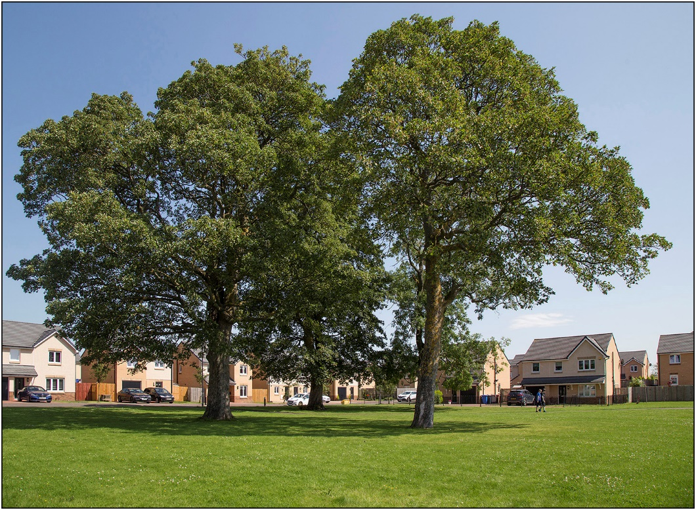
The vision, priorities and outcomes in the new Council Plan 2022-2027 - South Lanarkshire Council guides the work of the Planning Service. Resource and Service action plans establish a strong link (the ‘golden thread’) between the Council Plan and the delivery of services.

A review of the structure of the Community and Enterprise Resources - Resource Plan 2023-24 Council departments - South Lanarkshire Council within which the Planning service sits resulted in the creation of a new Planning and Regulatory Service which also includes Building Standards, Environmental Health and Trading Standards. A new head of service was appointed in early 2023.

The service continues to be a key partner in the development of other Council strategies including this year Sustainability and Climate Change, Community Wealth Building and the Local Housing Strategy which were approved this year. It is represented on the Community Planning Partnership Board and has a key role in the delivering the Community Plan through participation in a number of progress groups.

During 2022/23, the Service handled a significant increase in planning applications from developers, businesses and householders. Challenges relating to resourcing the service had an impact on performance levels however the latter part of the year saw the recruitment of a number of additional staff and the start of a comprehensive review of the service to reflect the requirements of the service to address legislative changes and the introduction of NPF4. Initial work started on the preparation of Local Development Plan 3 including scoping of the requirements in relation to the evidence report and engagement.

Part 1 – Qualitative narrative and case studies

Part 1 of the PPF provides an opportunity to show how the Planning Service is delivering a high quality planning service over four themes:

- Quality of outcomes: The added value delivered by planning.
- Quality of service and engagement: The positive actions to support sustainable economic growth, initiatives to work consistently with stakeholders and deliver a positive customer experience.
- Governance: Structures and processes are proportionate, effective and fit for purpose.
- Culture of continuous improvement: A culture of learning and improving is demonstrated.

Activities that have been carried out by the Service in this year are described below in respect of each of the four themes and case studies used to show how they have contributed to service delivery and improvement.
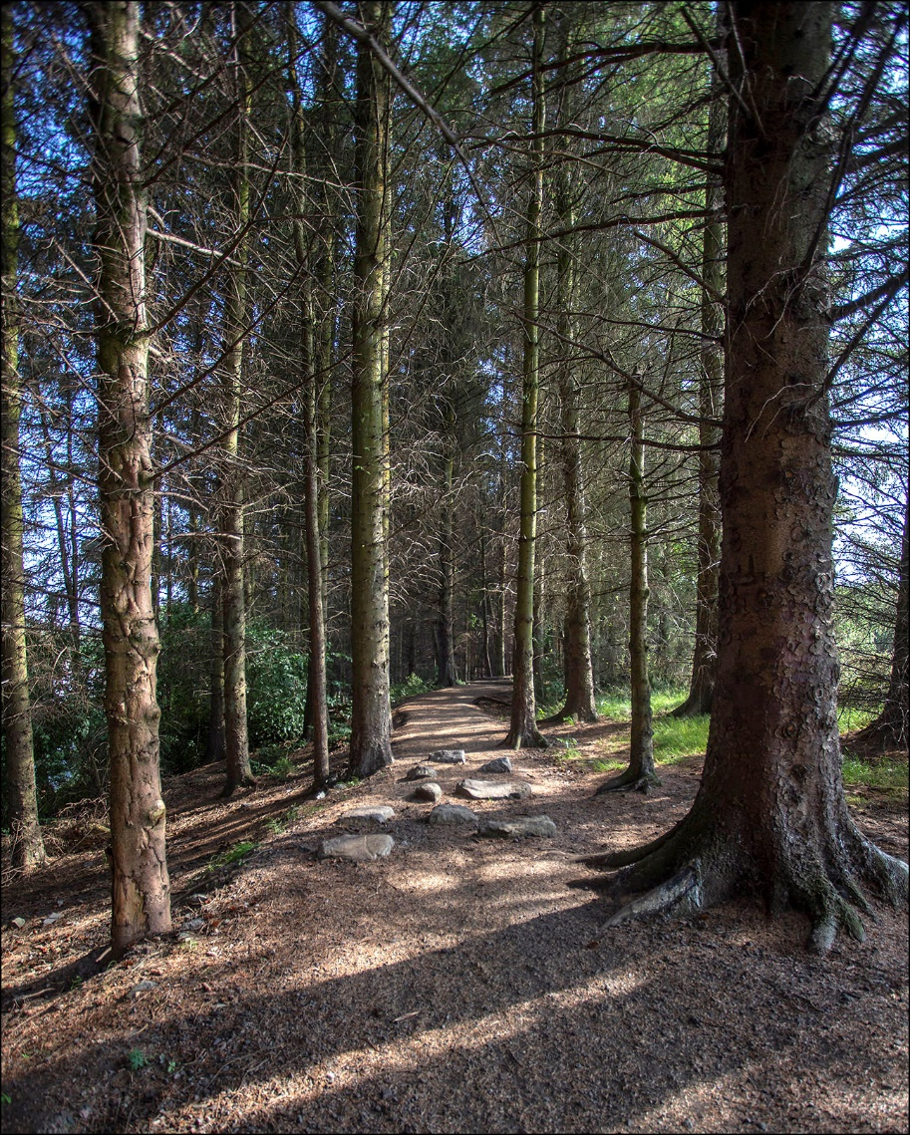

Quality of outcomes
The delivery of high-quality development on the ground contributes to meeting the needs of communities by providing a high quality of life for residents and creating conditions that encourage investment. This in turn contributes to the objectives of the council’s overall strategy.

The strategic vision of the South Lanarkshire Local Development Plan 2 seeks the promotion of continued growth and regeneration of South Lanarkshire by promoting sustainable economic and social development within a low carbon economy whilst protecting and enhancing the environment. The delivery of Community Growth Areas (CGA), Development Framework and Residential Masterplan Sites continue to play a significant role in achieving this vision.

Significant output has been maintained at the six CGAs throughout South Lanarkshire and there has been continuous progress on other allocated sites at East Overton in Strathaven, Shields Road in East Kilbride and Gilbertfield in Cambuslang. In the rural area, development is taking place at allocated sites, including the former Roadmeetings Hospital in Carluke, Edinburgh Road in Biggar and Muirhead Drive in Law.

A review of the Residential Design Guide started this year driven by the focus on improving the quality of places in NPF4.It is intended the document will deliver cross service outcomes including building standards, roads and environmental services.

In terms of economic development, achievements this year include collaborative working with Economic Development to carry out extensive remediation of contaminated land at Shawfield which will be redeveloped for a range of employment uses progressing City Deal projects for example, a new primary school in East Kilbride CGA. We have also worked collaboratively in meeting the challenges of town centres for working in partnership to develop schemes using Scottish Government funding to revitalise derelict land and buildings in a number of centres; working to produce a vision for town centres including a net zero ambition; and discussing the future of town centres in Hamilton and East Kilbride with their landowners.

The Planning Service has worked closely with Housing colleagues to identify appropriate sites throughout South Lanarkshire to achieve the council’s new target of 1,300 new homes for social rent in 2022-27. This includes redeveloping the council’s own land and working with developers to deliver on-site provision. Planning is represented on an officer working group which identifies new sites to be taken forward as part of the SHIP and constraints that need to be addressed at the detailed design stage.

Case study 1: Social housing and community care facility

Location and dates: Blantyre
Elements of a high-quality Planning Service this study relates to: Quality of outcomes.
Key markers: 12. Corporate working across services

Key areas of work
• Design,
• Regeneration,
• Affordable Housing,
• Interdisciplinary Working,
Stakeholders involved:
• Authority Planning staff
• Authority other staff

Overview
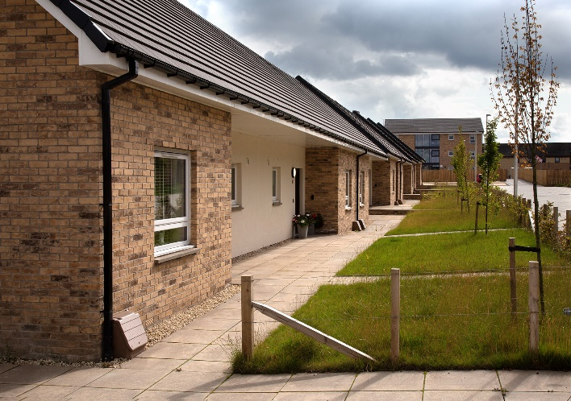
The proposals comprise the erection of 45 dwellings (single and two storey units and three blocks of 3 storey flats) and a two-storey community and care facility which represent a joint proposal that has been developed between the council’s Housing Services and South Lanarkshire Health & Social Care Partnership (SLH&SCP) for a mixed-use development of housing, technology enabled housing and a local community and care facility. The application site had remained following the redevelopment of the adjoining primary school. It is located on the edge of Blantyre town centre close to a wide range of services and facilities and public transport.
Eight of the houses and 12 of the flats are technology enabled and supported by the proposed care facility. The remaining houses and flats provide accessible mainstream housing for the council’s Housing Services. The proposed community and care facility provides transitional care to support those in need to rehabilitate before returning to their own homes.
An initial application was withdrawn following the receipt of 1092 representations raising issues in respect of traffic and access. This followed advice from the planning service to the applicant to amend their proposals and submit a revised planning application.
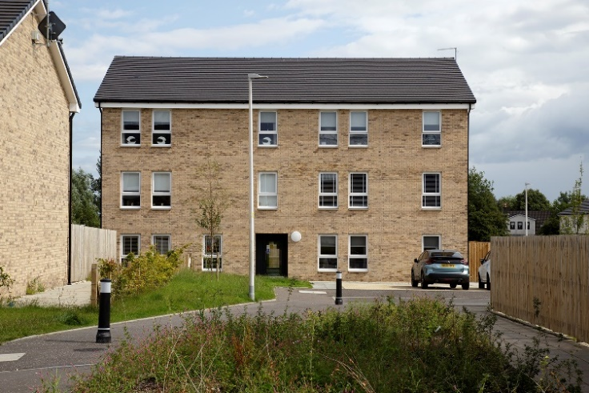

The proposed Community Care Facility is a new model for SLH&SCP which is based on a model of integrated care that will also connect with the wider community. It allows for the opportunity to co-locate and integrate services and amenities. The care facility provides intermediate / transitional care for adults and older people in the form of short-term support to allow people to return home following a period of ill health or crisis.
It includes a community-facing hub featuring a café; demonstration site (showcasing Telehealth/Telecare technology and how that can improve lives); guidance and support for unpaid carers; rehabilitation gym, treatment rooms, linkage and signposting into community-based voluntary and third sector support, with flexible opening times to accommodate public needs.
It also comprises a Centre of Excellence which host Telehealth/Telecare demonstration space, facilities to train and develop health and care staff, a staff base to enable the delivery of in-reach and outreach support, accommodation for students consisting of a two-bedroom trainee flat, community regeneration and intergenerational space to promote social enterprises such as community gardens, sensory garden and children’s play area which would be autism and disability friendly.
The technology enabled homes provide barrier living space to support adults and older people with complex needs to live independently in the community. Where support is required, this would be provided by community-based Health and Social Care teams.

Goals: The goal was to help deliver a mixed-use development including social rented housing and a high-quality community care facility within a sustainable location by making use of a brownfield site.

Outcomes: The case study demonstrates cross service, and department working to deliver a new form of community care and social rented housing. It involves a development of high quality on a long-vacant site within an urban neighbourhood.

Names of key officers: Jim Blake Planning Officer

Quality of service and engagement

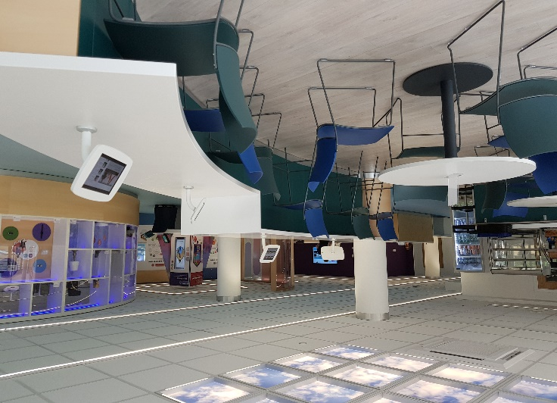

The Service seeks to positively engage with customers and stakeholders to understand their needs and expectations and keep them informed of the work it is carrying out. We continue to engage with communities and partners to seek and address their needs and put in place measures to enhance service provision.
This section focusses on demonstrating the positive actions we take to support sustainable economic growth, initiatives to work closely with stakeholders and communities and deliver a positive customer experience. This will be further developed as the service review continues into 2023/24 and the engagement strategy for Local Development Plan 3 is prepared.

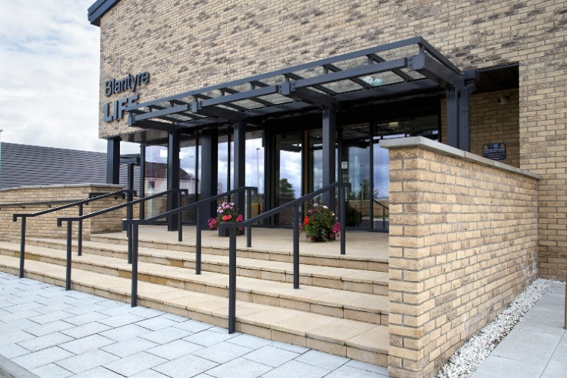

A service review started in early 2023 as a means of addressing performance issues over a number of years and reflecting legislative and national policy changes. It will also look at how planning and building standards especially, but also other services, can work more closely together and put in place a customer journey approach. This has involved seeking the views of officers as well as our customers.
A draft service improvement plan has been developed which will be the subject of consultation and the creation of a number of detailed action plans led by team leaders. Subjects include process review, customer care, digital, staff development and communications. The development management charter will be updated and combined with building standards and environmental services to create a service wide document to reflect the new Planning and Regulatory Service.

Early engagement with applicants and developers is encouraged to provide advice on whether a proposal is likely to be successful and changes that could be made to schemes to improve them and make them acceptable. They also cover the range of supporting information that will be required to assess the proposal. Online forms are available to enable this aspect of our work as well as dealing with general enquiries and potential enforcement cases.
The council has the facility for customers to make comments and complaints using an on-line form. The majority of the complaints received, are generally related to a failure to respond timeously to a customer’s enquiry or complaint rather than any failing in the process or service standard. 2022/23 was a challenging year due to resourcing issues recruitment during the latter part of the year has helped improve performance.

Case study 2: A Development Framework for the Hagshaw Energy Cluster: Planning for Net Zero

Location and dates: Hagshaw Wind Farm Cluster and surrounding communities including adjacent part of East Ayrshire

Elements of a high quality Planning Service this study relates to:
• Quality of outcomes
• Quality of service and engagement
• Culture of continuous improvement

Key markers:
1. Decision making
6. Continuous improvements
7. Local Development Plan
10. Cross sector Stakeholders
12. Corporate working across services

Key areas of work:
• Masterplanning
• Collaborative working

Stakeholders involved:
• Key Agencies
• Landowners

Overview
In 2020, NatureScot brought together a group of windfarm developers and operators with East Ayrshire Council and South Lanarkshire Council Planning Authorities, to discuss how the future of renewable energy development in the context for planning for, and delivering Net Zero in Scotland, could be progressed in collaboration. Focussed on the cluster of windfarms near Hagshaw Hill, and located between the communities of Coalburn, Douglas, Glespin, Lesmahagow, Muirkirk and Rigside, the Hagshaw Energy Cluster was born.
The Development Framework for the Hagshaw Energy Cluster: Planning for Net Zero was created by Land Use Consultants with 3R Energy, Architecture & Design Scotland, Bayware UK LTD., Energiekontor, NatureScot, Octopus Renewables and Scottish Power Renewables acting as key contributors. Together, they formed a project Steering Group which guided the development of the Framework.
A Landowner Forum was also set up as a consultee group and NatureScot and 3R Energy undertook community visits alongside two public consultations on the draft document. Scottish Government, Historic Environment Scotland, SEPA, Scottish Forestry, Forestry and Land Scotland and RSPB were also included in initial conversations.
The purpose of the framework is twofold.Firstly, it sets out, at a strategic level, the opportunities for the cluster in terms of maximising renewable energy output and provides guidance on the location and design of future renewable energy projects in the subject area. The surrounding landscape has undergone significant change as a result of the opportunities created by renewable energy projects and it is important that a shared and collaborative vision is taken to manage future so that the distinctive character of the area and its communities is retained, and where possible enhanced.

The Framework is also an opportunity to deliver a far greater range and scale of social, economic and environmental benefits for communities, the environment, and the local economy in a more collaborative and coordinated way while minimising any negative environmental impacts. The approach of bringing wind farm developers together in this way is the first time of its kind in Scotland. It provides a vision for the future of the area, with the flexibility to evolve in order to address future challenges and achieve net zero carbon emissions by 2045.
Using International, National, Regional and Local policies ranging from the United Nations 17 Sustainable Development Goals to NPF4 and the Local Development Plan, six key themes were identified as follows:

• Realising the renewable energy opportunity
• Resilient and connected communities
• Coordinated enhancement of nature
• A strong identity of heritage, people and place
• Inclusive, sustainable growth
• Outdoor recreation to support health and wellbeing

Key objectives sit under each of these and define what each theme seeks to achieve. A series of metrics have been identified for each theme, outlining how success will be measured. The Framework will be referred to as non-statutory guidance to inform decision making alongside NPF4, LDPs and relevant SG.
It will be in pace for at least ten years and will be updated as required, reflecting any changing baseline context, updated planning policies and the evolution of renewable energy technologies. An Economic Development Officer has been appointed to deliver the community and social benefits with the specific remit for the Douglas Valley which is one the council’s most disadvantaged areas. A series of action plans are being developed in this respect.

Goals: The purpose of the Development Framework is to provide a strategic Framework for which to collaboratively deliver a Just Transition to Zet Zero in and around the Hagshaw Cluster, with the Scottish Government target of Net Zero by 2045 in mind. Upon final amendments guided by the latest consultation, the Development Framework will be adopted by both East Ayrshire and South Lanarkshire Planning Authorities as non-statutory planning guidance, helping to shape future development within the cluster in a clear, coordinated way.
It creates an overarching design vision for the Hagshaw Energy Cluster and the surrounding area and seeks to deliver a wide range of potential benefits alongside existing committed renewable energy development and any future proposals, through identification of the key themes and objectives.

Outcomes: The process of creating the Development Framework for the Hagshaw Energy Cluster has facilitated partnership working with windfarm developers and landowners on the theme of Planning for Net Zero. Key stakeholders have now formed delivery focussed groups and are aligned to the strategic vision laid out by the document. An Economic Development Officer has been employed as part of SLC’s External Funding and Rural team, to work with communities on the delivery of the large-scale, strategic projects outlined in the Framework.
Funded by one of the developers, the Development Officer has set up a community-led Douglas Valley Advisory Group (DVAG) who are due to be constituted in July. Comprising ten members made up of local Community Council representation plus representatives from each of the communities, the DVAG prioritise key strategic projects as set out in the Framework, to be carried forward by SLC upon their request.
A Developer Group supports and prioritises delivery of opportunities highlighted in the Framework, and fosters collaboration between all partners including DVAG and the Landowner Forum. It is anticipated that the Landowner Forum will establish itself as a strategic Agri-Environment Group, responsible for driving forward nature and land-based projects within and around the cluster.
The Development Framework presents a new and innovative way of working in relation to the delivery of Net Zero and is thought to be the first time that a Development Framework has been applied to a cluster of windfarm developments. It is referenced as a Case Study in Scottish Government’s Onshore Wind Policy Statement 2022.

Names of key officers: James Wright, Planning Team Leader (HQ), Sarah O’Sullivan, Economic Development Officer

Governance
The Planning Service is involved in a range of cross resource working to deliver the objectives of the Council Plan. Weekly meetings of the Corporate Management Team, chaired by the Chief Executive, take place where current issues and policy changes from across the council are presented by officers. This year reports have been presented on National Planning Framework 4 and the Local Development Plan process.

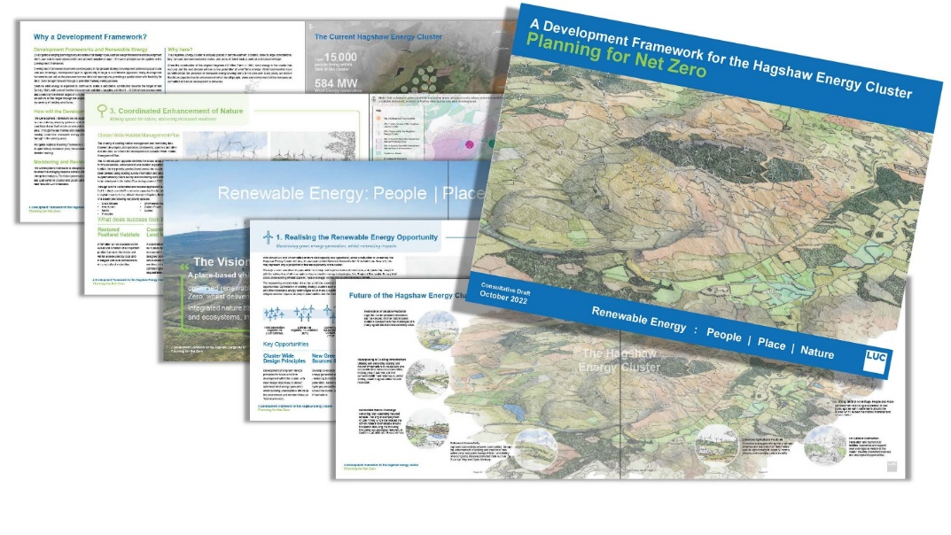

Council, Resource and Service Plans identify and programme delivery of the council’s priorities and outcomes. Key work objectives and performance targets are discussed and agreed with staff at annual individual performance and development review meetings. Progress is monitored quarterly by managers and officers and recorded within the council’s bespoke planning and performance platform. This approach to corporate planning and performance management helps ensure the council’s objectives are at the heart of all that the Planning Service does.

The Council’s key partnership working arrangements are through the Community Planning Partnership which has the overall aim of ‘improving the lives and prospects of everyone in South Lanarkshire’. Closer working between community and spatial planning activities continues to evolve and opportunities for joint working are being developed. This is particularly relevant with the introduction of Local Place Plans.

The Strategic Environmental Assessment (SEA) work in the council is led and facilitated by the Planning Officer (SEA) based within the Planning HQ team. As well as leading and facilitating SEAs for all Council led plans, including the LDP the SEA Officer is responsible for the production of the biennial State of the Environment Report which provides the SEA baseline for all plans and is an integral part of strategic planning within the Council. Through SEA, Planning has been able to influence the council’s strategic approach to a range of strategies and plans which may impact on the environment, including the review of the South Lanarkshire Community Plan, Council Plan, the Sustainable Development and Climate Change Strategy and the Local Housing Strategy.

Planning Officers are working closely with the council’s Sustainable Development and Climate Change team in terms of contributing to the delivery of the Sustainable Development and Climate Change Strategy. This included a significant input for the SEA Officer. Officers have been included in a working group seeking to embed achieving the UN Sustainable Development goals throughout the council’s decision making process.

A training programme for the new administration in May 2022 was carried out during the year. This included general awareness raising about the planning system and latterly on the implications of NPF4.

Case study 3 – Working with Community Planning Partnership

Location and dates: South Lanarkshire wide

Elements of a high-quality Planning Service this study relates to:
Governance

Key markers:
Corporate working across services

Key areas of work:
• Interdisciplinary working
• Collaborative working
• Community engagement

Stakeholders involved:
• General public
• Authority Planning staff
• Authority other staff

Overview:
The provisions of the 2019 Planning Act and the adoption of National Planning Framework 4 highlight the implicit link between spatial and community planning and the opportunities for both strands to work closely together to empower local people in the planning process and build better communities.
Planning officers were involved in developing public engagement on the review of the council Plan and the Community Plan.
This included a development session on Planning for Place for the Community Planning Partnership Board and included a presentation by officers from Planning and Economic Development. The planning presentation highlighted that communities would have a greater influence in planning for place but that further work is required to develop place making principles and policy at a Council level. At the same time, the role of members of the CPP Board in the preparation of the LDP3 was highlighted, particularly in terms of significant input from NHS Lanarkshire with preparing the evidence report to set the policy direction for improving health and inequality.
A consequence of the event was the agreement for the council to be involved in the funded ‘Shaping Places for Wellbeing’ Programme being led by the Improvement Service and Public Health Scotland which has the aim of developing long term preventative measures to tackle health inequalities. Rutherglen is one of 6 pilot town in Scotland and again planning officers are represented on the steering group. We have worked collaboratively with colleagues in North Lanarkshire Council to carry out joint presentations to NHS Lanarkshire, Public Health Scotland and the Lanarkshire Green Health Partnership. In addition planning had an input into the council’s Community Wealth Building Strategy and participates in an officer working group that meets every 6 weeks.

The above has helped develop an understanding on how concepts such as Community Wealth and Health and Wellbeing can be incorporated into planning policy. Consideration has also been given to how the relationship between Local Place Plans and Neighbourhood Plans is better addressed. Officers have been working with a Development Trust in one of the main towns to explore this.

A toolkit to help community bodies prepare Local Place Plans was developed following a joint workshop. A guidance document on the Planning system for community councils and other local groups has been prepared. Subsequently planning officers have attended various forums involving local communities including the Community Partnerships representing each of the four areas in South Lanarkshire; the Strutherhill local community action group; the Larkhall Community Action Group; and the Burnhill action group as part of their review of their neighbourhood plan.

Goals: The work to strengthen relationships with the Community Planning Service is fully aligned with the provisions of the Act in terms of empowering local communities in their role in the planning of their areas and the wider themes described in the position statement on NPF4. This is an evolving area of work and it is expected to broaden and gather momentum in the coming year as we carry out engagement on the preparation of the Evidence Report.

Outcomes: This case study recognises the need to develop partnership working with the CPP Board and other parts of the council including Community Planning and Economic Development to address national planning policy and the council’s own objectives in relation to community empowerment. This area of work will gain momentum as we start preparation of the Evidence Report and carry out extensive engagement using the contacts built up over a number of years.

Names of key officer(s): Planning Policy team, Community Participation team

Culture of continuous improvement

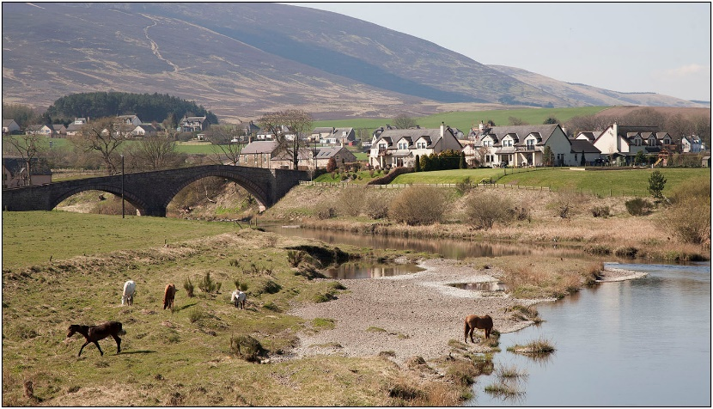

The annual Resource Plan reflects the key ambitions and priorities set out in the council Plan, summarises achievements in the previous year and describes proposals to improve and maintain performance. Action Plans are produced at a Service level which includes measures and timescales for individual areas of work. Outcomes are regularly reported online to inform customers of performance. In this way service improvements and issues are highlighted and actioned in a clear, transparent and timetabled manner.

Decision making timescales have not improved this year and the reasons for this are described in section 4 of this report. A review of practices is being carried out as part of a wider service review in order to streamline development management processes. This included changes to the duty officer rota so that the availability of officers has been reduced to four hours a day while at the same time enhancing the range of information on the website.
Work to retain the Customer Service Excellence accreditation led to a renewal of the award in November 2022 with the overall outcome again representing a year on year improvement. This in turn has led to identifying a number of changes set out in the Service Improvement Plan for 2022/23.

Elements of benchmarking have been carried out in the last year, including:

- Officers take an active role within Heads of Planning Scotland (HOPS) by attending and contributing to the work as part of the Executive and the Development Management, Development Planning and Energy and Resources Sub-Committees.
- Clydeplan Steering Group and various topic groups meet quarterly to share and benefit from best practice, for example, Housing Needs and Demand Assessment requirements.
- Improvement Service benchmarking group on Local Place Plans.
- Participation in a Peer Review Group looking at new procedures for the preparation of Local Development Plans.
- Involvement in a Scotland wide CSE benchmarking group

The age structure of staff within the Service and the need for succession planning continues to be recognised and the review of the Service has resulted in the creation of a number of graduate planner posts for those who have obtained a planning degree. Several officers have gained promotion this year.

Case study 4: Managing change

Location and dates: South Lanarkshire wide

Elements of a high-quality planning Service this study relates to:
• Governance
• Culture of continuous improvement

Key markers:
6. Continuous improvements
7. Local Development Plan

Key areas of work
• Local Development Plan and Supplementary Guidance
• Development Management processes

Stakeholders involved:
• Authority Planning staff

Overview
The 2021/22 Planning Performance Framework submission included case studies on succession planning within the Planning Service and the response to the Covid19 pandemic. The planning system continues to be severely impacted by budget constraints which, in conjunction with the unprecedented impact of the pandemic, has focused the importance of resilience and succession planning to ensure the Planning Service is able to successfully deliver its responsibilities. The case study this year highlights further succession planning that has taken place to maintain and enhance service delivery together with how working practices have developed over the year.

Succession Planning
This year has seen several more experienced officers including a team leader leaving the service due to early retirement. Recruiting at a senior officer level in Development Management has proven difficult in terms of attracting external candidates however this has created opportunities for three officers to gain promotion in the last year. This in turn led to two graduate officers moving into promoted posts to backfill those vacancies. In addition, the service has recruited a further 5 graduates in the last 12 months.
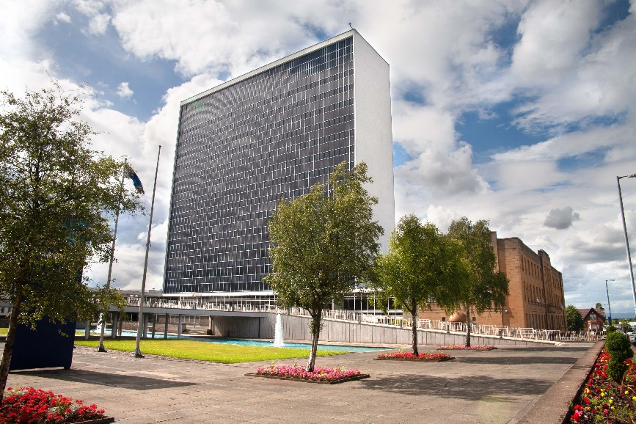

These changes have involved extensive recruitment activity throughout the year. The outcome did not lead to all posts being filled immediately and meant that there were several vacancies throughout the year. This was due to competition for candidates across Scotland and a reduction in the number of planners graduating. In order to address this, different approaches to attracting applicants have been undertaken including greater use of social media to highlight the availability of posts. A review of the needs of the service in early 2022/23 resulted in previous temporary posts being made permanent; the creation of a post dedicated to developer contributions work; and recruiting a planning assistant to deal with administrative tasks currently carried out by officers.

Integrating these new officers at a time when hybrid working has become embedded has been challenging and the new graduates especially have benefitted from working in the office on an almost full-time basis. In addition, a working group has been set to mentor the junior officers in order to progress to corporate membership of the RTPI.

Working practices
The planning service relocated from its former site to the main Council offices in summer 2022. Before that officers continued to work from home although opportunities remain to work in the office if required. Generally, day to day business has been managed well and contact with customers has been maintained to a high level.
The relocation resulted in a of ratio workstations available to the number of officers of about 1:3 which mean hybrid working has become the norm. The Planning and Building Standards Service does share workspace with colleagues in Economic Development which will allow working relationships developed over the last few years to be retained. The building also houses colleagues in Housing, Legal Services and Community Planning.

Goals: Succession planning has been on the agenda for several years and the approach of employing graduates and developing their skills in the longer term has in the main been successful. Challenges remain in terms of ongoing recruitment, however, practices will continue to evolve as the wider work environment undergoes change.

Outcomes: The case study demonstrates the difficulties in recruiting suitable candidates at a senior level to deliver a high-quality service and implement and manage the upcoming changes to the planning system. The Service will continue to review its processes to address this. Nevertheless, the outcomes have been very positive in terms of promoting existing officers and working with enthusiastic new planners in their first roles. The changes to working practices will continue to evolve as the planning service enters into a new era and, together with the upcoming relocation, will result in further development during the coming year.

Names of key officers: Tony Finn, Planning and Building Standards HQ Manager

Part 2 – Supporting evidence
This section provides weblinks to the evidence which supports Part 1 of the PPF.

Quality of outcomes

Development plans - South Lanarkshire Council
Approved Statutory Supplementary Guidance and Supporting Planning Guidance
Housing Land Audit
LDP2 - Final SEA Environment Report

Quality of service and engagement
Guide to the Decision Making Process
Consultation, Communication and Engagement Strategy
South Lanarkshire Council maps (arcgis.com)
Pre application discussions
Planning Process Agreements
Enforcement Charter
Customer Service Excellence

Governance
Community and Enterprise Resources Resource Plan
South Lanarkshire Council plans and policies
South Lanarkshire Community Planning Partnership
GCV Green Network Partnership ‘Blueprint’
Annual Performance Spotlights
South Lanarkshire Good Food Strategy

Culture of continuous improvement
Planning Portal

Case study synopsis

The following table sets out the various key areas of work covered within the case studies presented
Case Study Topics | Issue covered in PPF12 | Case Study Topics | Issue covered in PPF12
Design | N/A | Interdisciplinary working | 1, 2, 3
Conservation | N/A | Collaborative working | 1, 2, 3
Regeneration | 1 | Community engagement | 3
Environment | N/A | Placemaking | 1
Greenspace | N/A | Charrettes | N/A
Town centres | N/A | Place standard | N/A
Masterplanning | 2 | Performance monitoring | N/A
LDP and Supplementary Guidance | N/A | Process improvement | 4
Housing supply | N/A | Project management | N/A
Affordable housing | N/A | Skills sharing | N/A
Economic development | 2 | Staff training | 4
Enforcement | N/A | Online systems | N/A
Development Management processes | 1 | Transport | N/A
Planning applications | 1 | Active travel | N/A
Other: | 1, 2, 3, 4

Part 3 - Service improvements 2023/2024

This section details the key commitments and actions for the coming year for service improvements within the Planning Service.

- Customer events: This will be a joint planning and building standards action and will involve two events – one with the development industry and a second with local agents.

- Customer Service Excellence: Prepare a submission for re-assessment of Customer Service Excellence accreditation in the autumn of 2023. The key action this year will be to address the three areas of partial compliance noted in the assessment of the Service in order to achieve full compliance and to reaffirm CSE accreditation.

- Service review: Finalise the Service Improvement Plan following the service review and develop detailed action plans. Staff resources to be kept under review with opportunities to add to the establishment including the introduction of officers to deal with developer contributions and validation.

- Digital planning: Continue to review and develop essential IT systems, including further exploration of mobile working solutions. Consider amendments to processes and new software/hardware to address legislative change and the implementation of the Scottish Government’s digital transformation programme.

- Member training: A programme of training will be developed as the statutory duty for member training comes into effect

- Community Councils: Further develop awareness training for community organisations and other local stakeholders as part of the preparation of the LDP3 evidence report

- Internal stakeholders: Continue to review and develop better working practices with internal consultees. In particular planning officers and corporate colleagues will be invited to CPD events to widen their knowledge of the planning system and increase understanding of the changes in NPF4.

- Review of Residential Design Guide: This work reflects the emerging themes of placemaking, achieving high quality design and access to active travel options and quality open spaces.

- Planning Conditions: Carry out a review of planning conditions including through engagement with internal consultees

Delivery of Planning Service Improvement Actions 2022/2023

  - The Planning Service produces an annual Service Improvement Plan which sets out a series of actions for improvement in service delivery. The plan for 2022/2023 identified 13 actions of which nine were completed over the year and five were partially completed. The challenge to complete actions has largely been the result of restricted working arrangements due to the pandemic, however, they have been rolled over to 2023/2024 with an expectation they will be completed this year.

The following table provides our assessment of how we consider we have delivered on our service actions and objectives identified in PPF11. Additional details and information on many of these are reported in this PPF.

- Committed improvements and actions | - Comments
Local Forum: Subject to restrictions being lifted it is intended to re-introduce a Local Forum with agents and other key stakeholders. This will be attended by both Planning and Building Standards officers. It is intended this year to seek views on how developers can contribute to the council’s climate change and sustainability agenda. As an alternative an online meeting will be explored. | Due to Covid19 restrictions, this event was again postponed but it is intended to hold it in 2023/24.
Customer Service Excellence: Prepare a submission for re-assessment of Customer Service Excellence accreditation in the autumn of 2022. The key action this year will be to address the three areas of partial compliance noted in the assessment of the Service in order to achieve full compliance and to reaffirm CSE accreditation. | The CSE accreditation was renewed in November 2022 with a further year on year improvement in terms of the overall rating.
Service delivery: Continue to develop ways to improve the joint delivery of Planning and other Council services to customers in order to promote South Lanarkshire as a place to invest and grow and to reflect the needs of our communities. Planning will be closely involved with consultants looking at revisioning and creating net-zero town centres. | The Planning Service has continued to work closely with the Community Engagement team and delivery its aspirations in disadvantaged neighbourhoods. Officers are also involved in the town centre revisioning work and helping delivery the councils SHIP.
Service review: Carry out a review of existing procedures for assessing planning applications to identify ways in which the process can be streamlined. Staff resources to be kept under review with opportunities to add to the establishment including the introduction of officers to deal with developer contributions and validation. The review will also include looking at new ways of working as a return to office working takes place. | - A comprehensive review of the service commenced in early 2023 which will look at staff development, processes and performances, communications and digital. A draft service improvement has been developed which in turn will lead to the creation of detailed action plans.
Relocation of the Planning Service: The Service will be moving to a new location in the main Council building in Hamilton. It will be located on the same floor as Economic Development and the same building as colleagues such as Legal Services, Community Planning and Estates. This will result in a hybrid working pattern which is to be developed. | The move successfully took place in summer 2022. This has led to the return to the office after over 2 years which has necessitated the introduction of a rota system for booking desks.
Digital planning: Continue to review and develop essential IT systems, including consideration of mobile working solutions. Consider amendments to processes and new software/hardware to address legislative change and the implementation of the Scottish Government’s digital transformation programme. | A review of systems that will be necessary for the preparation of LDP3 has highlighted further update and changes required. Tablets for use on site have been introduced.
CPD: Organise and deliver a programme of CPD events for Planners, including re-arranging sessions postponed due to lockdown restrictions. Topics to be covered will include climate change, environmental health and strategic and corporate planning. | Awareness training in relation to the adoption of NPF4 has been carried out. Staff development forms part of the service review and further opportunities for training will be developed.
Member training: A programme of training for the new administration following the Local Government elections in May 2022. | - Member training has been provided in relation to the planning system and recently the implications of NPF4.
Community Councils: Further develop awareness training for community organisations and prepare and publish a guide in relation to the Planning and Building Standards Service. | The guide was published this year. A detailed engagement strategy for the preparation of LDP3 will be created.
Internal stakeholders: Continue to review and develop better working practices with internal consultees. In particular planning officers and corporate colleagues will be invited to CPD events to widen their knowledge of the planning system and increase understanding of the forthcoming changes in NPF4. | This action has been delayed and will form part of the service improvement plan developed following the service review. Stakeholders will be engaged in work.
Review of Residential Design Guide: This work reflects the emerging themes of placemaking, achieving high quality design and access to active travel options and quality open spaces. | This work has continued into 2023/24 with the aim of adopting it by the end of 2023. .

Part 4 - South Lanarkshire Council National Headline Indicators
The following table provides performance figures for key indicators within both development management and development planning. Within development planning the performance of the Planning Service can be measured through the assessment of key outcomes such as the age of the Local Development Plan and the number of housing units that can be delivered. Within development management performance can be measured through the assessment of key indicators such as the average number of weeks to make a decision on a planning application and the rate of planning approval.

A: National headline indicators (NHI) key outcomes – development planning

Development Planning | 2021 - 2022 | 2022 - 2023
Local and Strategic Development Planning  Age of local/strategic development plan(s) at end of reporting period  Requirement: less than 5 years  Will the local/strategic development plan(s) be replaced by their 5th anniversary according to the current development plan scheme?  Has the expected date of submission of the plan to Scottish Ministers in the development plan scheme changed over the past year?  Were development plan scheme engagement/ consultation commitments met during the year? (Y/N) | Strategic Plan will cease to exist in 2022. LDP2 was adopted in April 2021  Unknown – awaiting NPF4 and regulations and guidance for LDPs to be approved  N/A  As above | LDP2 was adopted in April 2021  This is unlikely due to the delay in the regulations and guidance being published  N/A  N/A
Effective land supply and delivery of outputs  Established housing land supply  5 year effective housing land supply programming  5 year effective land supply total capacity  5 year housing supply target  5 year effective housing land supply (year’s supply to one decimal place)  Housing approvals  Housing completions over the last 5 years  Marketable employment land supply  Employment land take-up during reporting year | 2021 - 2022  13,512  7,568  8,199  1,058 (758 private 300 social rented)  7.2  1,146  7,400  75.27 ha  2.75 ha | 2022 - 2023  No longer required  No longer required  No longer required  No longer required  No longer required  1,146  Not yet available  71.50 ha*  7.87 ha*
*2022 – 2023 final figures

B: NHI key outcomes – development management

Development Management | 2021 - 2022 | 2022 - 2023
Project planning
Percentage and number of applications subject to pre-application advice | 20% (331) | 17% (248)
Percentage and number of major applications subject to processing agreement | 1 (7.6%) | 0 (0.12%)
Decision making
Application approval rate | 98.9% | 98.4%
Delegation rate | 96.3% | 95.3%
Validation | 61.2% | 59%
Decision-making timescales
Major developments | 66.3 weeks | 47 weeks
Local developments (non-householder) | 23.2 weeks | 27.8 weeks
Householder developments | 13.1 weeks | 14 weeks
Legacy cases
Number cleared during reporting period | 54 | 107
Number remaining | 115 | 104

Part 5 – Scottish Government official statistics

A: Decision-making timescales (based on ‘all applications’ timescales)
Timescales | 2021 - 2022 | 2022 - 2023 | 2022 - 2023
Overall
Major developments | 13 | 12 | 47.0 weeks
Local developments (non-householder)  • Local: less than 2 months  • Local: more than 2 months | 437  (8.2%)  (91.8%) | 499  (15.9%)  (84.1%) | 26.0 weeks  6.8 weeks  29.6 weeks
Householder developments  • Local: less than 2 months  • Local: more than 2 months | 975  (33.3%)  (66.7%) | 728  (45.2%)  (54.8%) | 13.8 weeks  6.3 weeks  19.9 weeks
Housing developments
Major  Local housing developments  • Local: less than 2 months  • Local: more than 2 months | 7  206  (7.3%)  (92.7%) | 8  202  (11.9%)  (88.1%) | 51.9 weeks  29.5 weeks  7.3 weeks  32.5 weeks
Business and industry
Major  Local business and industry developments  • Local: less than 2 months  • Local: more than 2 months | 0  48  (0.0%)  (100.0%) | 1  73  (27.4%)  (72.6%) | 39.0 weeks  22.9 weeks  6.7 weeks  29 weeks
EIA developments | 2 | 0 | -
Other consents  • As listed in the guidance | 191 | 166 | 12.7 weeks
Planning/legal agreements | 6  9 | 3 | 95.4 weeks  92.9 weeks
  • Major: average time
  • Local: average time

B: Decision-making: local reviews and appeals
 |  | Original decision upheld
Type | Total number of decisions  No. | 2022 – 2023  No. % |  | 2021 – 2022  No. %
Local reviews | 7 | 6 | 85.7% | 5 | 100%
Appeals to Scottish Ministers | 2 | 1 | 50.0% | 3 | 60%

C: Context

Key points

Decision-making timescales: As set out in the NHI Key Outcomes for Development Management, South Lanarkshire managed to improve its decision-making timescales in the major development category but experienced increases in the time taken to determine householder and local non-householder applications. There was also a significant reduction in the percentage of those householder and local non-householder applications dealt with in two months. These timescales need to be considered in the context of the ongoing increase in numbers of applications received.

This year has been challenging and the performance in decision making timescales is largely attributable to difficulties in resourcing the Service. Recruitment drives has taken place over the previous 12 months; however, this has only been partially successful. This has meant that the capacity to deal with an increased workload has continued to be below what is appropriate.

Decision-making, local reviews and appeals: There has been a slight reduction in the number of local review cases (from 8 to 5) and a minor increase in those appeals to the Scottish Ministers (3 to 5). Overall, the numbers continue to remain low. The percentage of cases where the original decision was upheld increased for Planning Local Review Board cases from 88.9% to 100% and increased for appeals to Scottish Ministers from 42.9% to 60%.

Part 6 - Workforce information
South Lanarkshire’s Planning Service is part of Community and Enterprise Resources. The Service’s work is undertaken by three teams with a total of 44 staff. Support is provided by six administrative staff managed through the Resource’s Support Services. The council’s SEA Officer is also embedded in and managed through the Planning Service sitting within its HQ Team. The HQ team deals with Development Plan preparation, publishing and monitoring, and produces the associated Supporting Guidance (SG). The council’s input to the preparation and monitoring of the Strategic Development Plan (SDP), through the Glasgow and the Clyde Valley Strategic Planning Authority, is also co-ordinated through the HQ Team. It also handles all the minerals, waste, energy and large-scale windfarm applications and the enforcement function is located within the HQ team.

The two Area Teams handle the vast majority of all the applications submitted in accordance with the requirements of the Town and Country Planning (Scotland) Act 1997, the Planning (Listed Buildings and Conservation Areas) (Scotland) Act 1997 and other associated legislation. This includes applications for planning permission, listed building consent, conservation consent, advertisement consent and certificates of lawful use and associated appeals and reviews. They also assist the HQ team in the work on Development Plans, SGs and the SDP.

 | Tier 1 | Tier 2 | Tier 3 | Tier 4
Head of Planning Service |  |  | X
Note: Tier 1= Chief Executive, Tier 2= Directors, Tier 3= Heads of Service, Tier 4= Managers

Staffing | Headcount | FTE
Development Management | 28* | 26
Development Planning | 7 | 6.4
Enforcement | 3 ** | 3
Specialists | 3 | 3
Other | 3 | 2.6
Total | 44 | 37.2
RTPI Qualified Staff | 22
* Includes 4 vacancies; ** includes 1 vacancy

Part 7 - Planning committee information

Committee and site visits | Number per year
Full Council meetings | 4
Planning committees | 9
Area committees | 16*
Committee site visits | 1
Local Review Body | 5
Local Review Body site visits | 0
* SLC has four Area Committees

Appendix 1: Correlation of performance markers

 | Performance Marker | Part of PPF report demonstrating evidence
 | Driving improved performance
1 | Decision making: authorities demonstrating continuous evidence of reducing average timescales for all development types. | Parts 4 and 5
2 | Project management: offer of processing agreements (or other agreed project plan) made to prospective applicants in advance of all major applications and availability publicised on planning authority website. | What is a planning processing agreement? - South Lanarkshire Council
3 | Early collaboration with applicants and consultees on planning applications:  - availability and promotion of pre-application discussions for all prospective applications  - clear and proportionate requests for supporting information. | Before you apply - South Lanarkshire Council
4 | Legal agreements: conclude (or reconsider) applications within six months of ‘resolving to grant. | Reference made to this in committee reports
5 | Enforcement charter updated/ re-published. | Reporting an alleged breach - South Lanarkshire Council
6 | Continuous improvements:  - show progress/improvement in relation to PPF National Headline Indicators  - progress ambitious and relevant service improvement commitments identified through PPF report. | Quality of service and engagement  Culture of continuous improvement
 | Promoting the plan-led system
7 | LDP (or LP) less than 5 years since adoption. | See Quality of outcomes
8 | Development plan scheme demonstrates next LDP:  - on course for adoption within five year cycle  - project planned and expected to be delivered to planned timescale. | Development plan scheme - South Lanarkshire Council
9 | Elected members engaged early (pre-MIR) in development plan preparation. | N/A
10 | Cross-sector stakeholders, including industry, agencies and Scottish Government, engaged early (pre-MIR) in development plan preparation. | N/A
11 | Production of regular and proportionate policy advice, for example through supplementary guidance, on information required to support applications. | Supporting planning guidance - South Lanarkshire Council
 | Simplifying and streamlining
12 | Corporate working across services to improve outputs and services for customer benefit (for example, protocols; joined-up services; single contact; joint pre-application advice). | Case study 3
13 | Sharing good practice, skills and knowledge between authorities. | Case study 2
 | Delivering development
14 | Stalled sites/legacy cases: conclusion/withdrawal of planning applications more than one-year-old. | Parts 4 and 5
15 | Developer contributions: clear expectations  - set out in development plan (and/or emerging plan); and  - in pre-application discussions. | Community infrastructure assessment - SPG Planning for developers - South Lanarkshire Council

