
Community and Enterprise Resources

Building Standards Verification Annual Performance Report 2022-2023

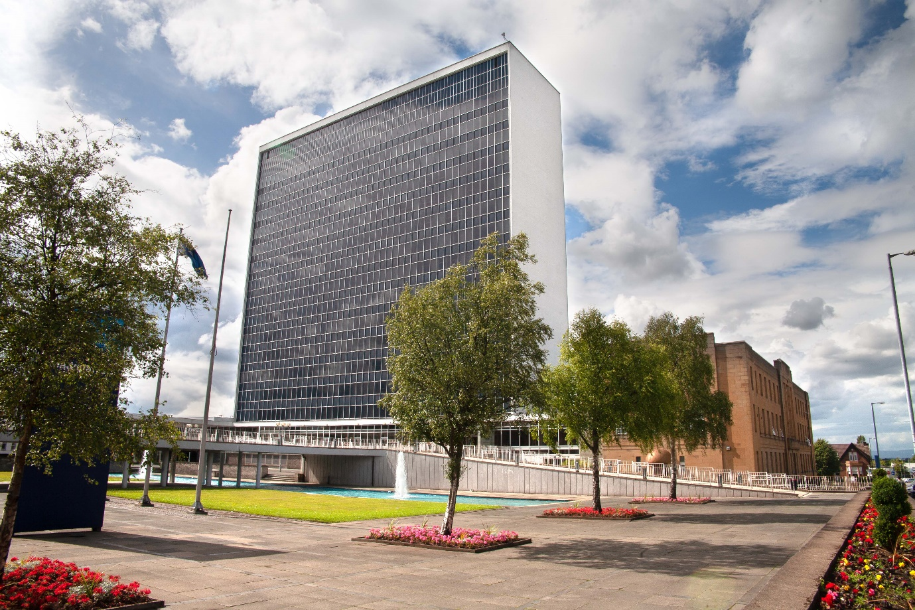

Contents

1.0 Introduction to South Lanarkshire Council as verifier

2.0 Building Standards verification service information

3.0 Strategic objectives

4.0 Key performance outcomes and targets

5.0 Performance data

6.0 Service improvement and partnership working

7.0 Building Standards – additional data

1.0 Introduction to the verifier

The verification performance report is a strategic planning and management tool that provides information about the local authority building standards service, communicates the vision and strategy, and sets out performance against strategic goals and targets.

Building standards verifiers in Scotland are required to utilise the performance report to manage, monitor, review and develop strategies for their business, and should focus on the performance framework’s core perspectives and cross-cutting themes.

South Lanarkshire Council

The council area of South Lanarkshire is located in central and southern Scotland. It borders the Glasgow City Council to the south-east and includes several rural towns and villages in addition to some suburban communities in the greater Glasgow area. Along with Dumfries and Galloway, East Ayrshire, East Renfrewshire, North Lanarkshire, the Scottish Borders, and West Lothian.

With 320,820 residents, South Lanarkshire Council represents slightly under 6% of Scotland's total population. It is ranked as Scotland's fifth-largest local authority in terms of population. It is predicted that our population will age and increase, the population of South Lanarkshire is anticipated to reach 325,243 by 2028, an increase of 2%.
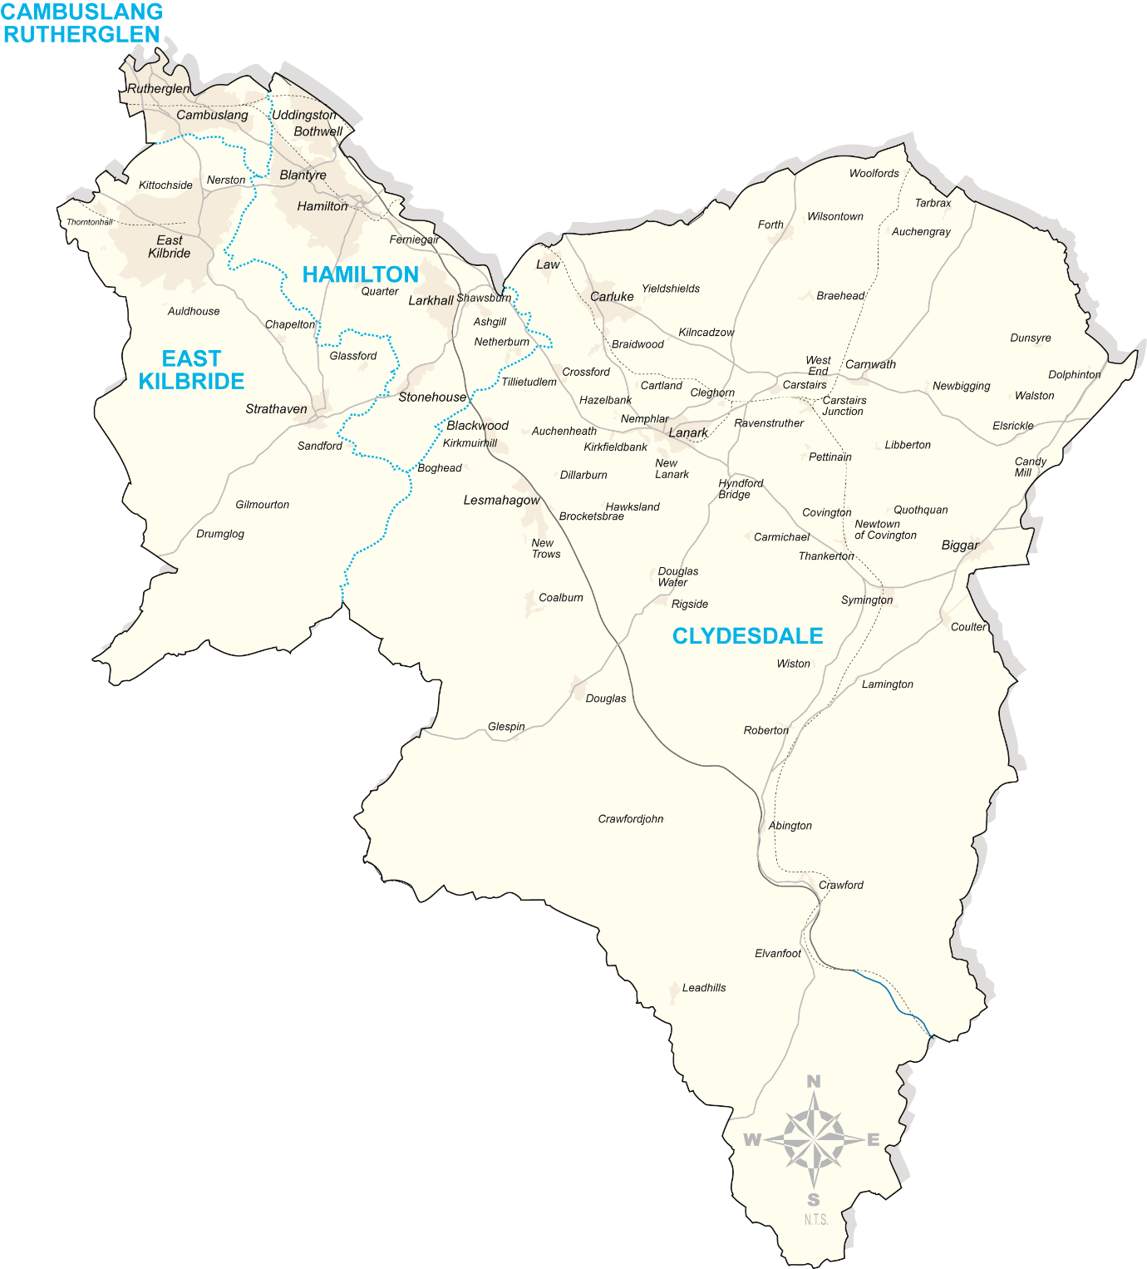

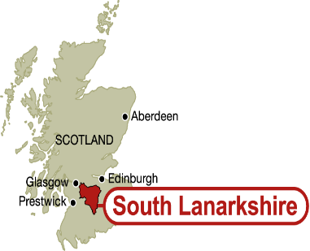

Almost 80% of South Lanarkshire's 1772 square kilometres is used for agricultural purposes, urban areas account for three out of every four residents. The major cities in the county are East Kilbride, Hamilton, Rutherglen, and Cambuslang, all of which are located to the north of the council district. The largest towns are Carluke, Lanark, Strathaven, Biggar, and Forth in the south.

At the centre of Scotland, South Lanarkshire has a lot to offer, from the prosperous, agricultural countryside in the south to the commercial and industrial hubs in the north. We have a long and diverse history, and we have evolved from an era of heavy industry, steel production, and coal mining to meet the problems of the present and the future.

Development sites such as Whitelees Wind Farm is currently the UKs largest onshore wind farm with a generating capacity of 539 Megawatts and is located within South Lanarkshire, East Ayrshire, and East Renfrewshire. South Lanarkshire itself currently has an estimated 1,700 MW of onshore wind generation either in operation, under construction or consented. We have several consented applications for battery storage and hydrogen production on both standalone sites with good national grid connections or on wind farm sites for direct electricity storage and hydrogen production form the turbines.

The economic benefits of renewable energy projects are seen form local employment and services at construction stage through to community benefit payments made based on megawatts generated.

Local development plan

The West area within South Lanarkshire is currently building a considerable amount of homes (of all tenures), mostly in the Community Growth Areas that were identified through our Local Development Plan. Private sector investments in community infrastructure are made in addition to this housing construction initiative. The construction of a new primary school, many private housing complexes by a number of national homebuilders, and several locations designated for affordable housing are all part of the East Kilbride Community Area, which is south of the town. The Newton Community Growth Area is still being built out and includes a primary school in addition to the new neighbourhood. At the current train station, there is a park and ride facility, and at the western end of the site, there is a projected commercial complex.

Larger commercial, industrial, and business projects are targeted towards sustainable urban areas including Cambuslang/Rutherglen, Hamilton/Blantyre, Larkhall, East Kilbride, Carluke, and Lanark.

The region contains a number of strategic economic investment locations (SEALs), notably Clyde Gateway, Scotland's largest regeneration project that sits on the border of Glasgow City and South Lanarkshire Council. At Cuningar Loop, a park with connections to Dalmarnock and Glasgow's east end has been constructed. Redevelopment of the Shawfield neighbourhood, which includes the former dog racing stadium, is the focus of current projects.

Whilst the East area of South Lanarkshire encompasses a variety of urban and rural locations and runs from Uddingston in the north to the Leadhills in the south. Numerous high-profile developments have been made in the area, ranging from significant housing developments in urban areas to commercial developments in rural areas. The conversion and preservation of historic buildings are part of important town centre regeneration projects.
Community growth areas with ongoing house development may be found at Hamilton, Larkhall, and Ferniegair. These developments range greatly in size. The Hamilton community growth area is the largest and will eventually house around 2000 additional dwellings. Construction on this phase of the complex is expected to start shortly following permission for about 800 homes was recently obtained. There will be accompanying infrastructural improvements in addition to the new dwellings.

Significant redevelopment initiatives involving listed structures have also been identified in popular urban areas. The redevelopment of Lanark Grammar, a B-listed structure that when finished will offer desperately needed social housing, has begun. This significant construction will not only improve the neighbourhood’s appearance, but it will also guarantee the preservation and reuse of a historic structure. The former Vogue Cinema, a B-listed building, will be transformed into 23 apartments as part of Hamilton Town Centre. This long empty abandoned structure is situated in a famous town centre area. This building's refurbishment will serve as an illustration of a nearly car-free future and make a substantial contribution to the town centre's regeneration.

Employment within South Lanarkshire

Public services (such as those in education, health, social work, police, and fire protection)
accounted for 44,200 jobs, or 27.4% of all employment in South Lanarkshire in 2022. Distribution was the next industry, with a 19.7% share (31,800), followed by financial and business services with a 20.1% share (32,400).

In South Lanarkshire, employment in financial and business services was more prevalent (20.1% vs. 16.6%) than it was in Scotland. Additionally, they were more likely to work in the transport and communications sector (10.4% vs. 8.0%). They had lower employment rates in the energy and water industry (2.0%) than in Scotland (3.8%), and in the public services sector (27.4% vs. 34.4%).

Percentage all in employment who work in:

Agriculture and fishing – 0.013%
Energy and water – 0.02%
Construction – 0.054%
Other Services – 0.058%
Manufacturing – 0.069%
Transport and communication – 0.104%
Distribution and hotels – 0.197%
Banking, finance and insurance – 0.201%
Public admin and education – 0.274%

Some of the main sector private employers include companies such as:
Over 70,000 people are employed by the Mitie group, a strategic outsourcing and energy services corporation with locations spread throughout South Lanarkshire.
One of Scotland's largest privately-owned auto dealership groups, Park's of Hamilton is a privately held family-run company that represents 26 different manufacturers and employs somewhere about 3000 employees.

The Hamilton-based Lightbody company, one of the UK's major suppliers of celebration cakes to UK shops, joined the Finsbury Food Group in 2007 and employs over 1,100 locals.

Operation structure

Our resource comprises the following four service areas – facilities, waste, and grounds services; roads, transportation, and fleet services; planning and regulatory services; and enterprise and sustainable development. The resource employs 3,413 people who together provide a wide range of services for local communities.

South Lanarkshire Council Senior Management Structure

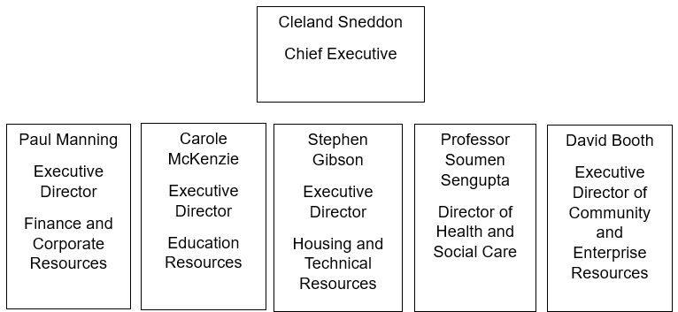

The Building Standards Team for South Lanarkshire is part of the Planning and Regulatory Services and is led by Fraser Carlin.

Planning and Regulatory Services Management Structure
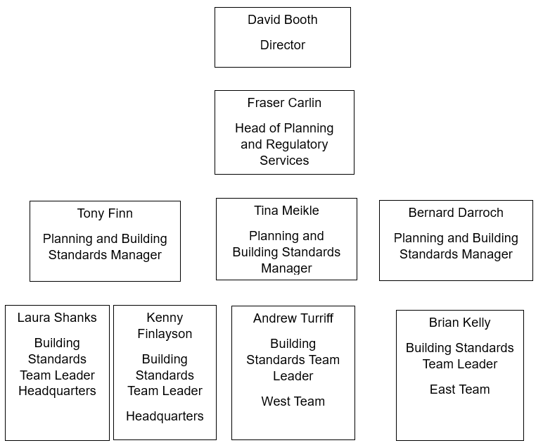

2.0 Building Standards verification service information

Where to find Building Standards

Early in 2023, the Building Standards Team moved from Montrose House into South Lanarkshire Council’s main HQ building in Almada Street, Hamilton, together with colleagues in Planning. The Building Standards Team operates under Agile arrangements from both their home and the sixth floor where they are located. To make sure that our customers' needs are always addressed, including performance, our agile working policy is continuously reviewed.

Address: South Lanarkshire Council, Building Standards, HQ Building (6th Floor), Almada Street, Hamilton, ML3 0AA
Building Standards roles and responsibilities within the South Lanarkshire area

The objectives, vision, and mission of our building standards team serve as a guide for providing outstanding customer service.

The purpose

The purpose of the building standards system is to protect the public interest. The system sets out the essential standards that are required to be met when building work or conversion of a building takes place to meet the building regulations.

The building standards system checks that proposed building work or conversion of a building meets standards; inspections are limited to a minimal necessary to ensure that legislation is not avoided. The control of work on site is not down to the system but is a matter for contract and arrangements in place between a builder and client.
Verifiers, appointed by Scottish Ministers, are responsible for the independent checking of applications for building warrants to construct or demolish buildings, to provide services, fitting or equipment in buildings, or for conversions.

Our vision

By building high-quality, safe, and sustainable environments, eliminating inequality in our communities, and placing our customers at the centre of everything we do, we will help the council achieve its ambition of improving the lives and prospects of everyone in South Lanarkshire.

Our mission

To deliver an outstanding customer experience for building standards and to be a leading local authority verifier, placing our customers at the heart of everything we do.

The application and enforcement of the Building (Scotland) Act 2003 and its related regulations is the main function provided by South Lanarkshire Building Standards.

To protect the health, safety, welfare, and convenience of residents as well as visitors to South Lanarkshire with regard to the built environment, the Building Standards Team at South Lanarkshire undertakes the following specific responsibilities to achieve this.

Verification role:
- Verification of all building warrant applications within the South Lanarkshire area.
- Verification of all completion certificate acceptances within the South Lanarkshire area and
- Verification of Completion submissions where no building warrant was obtained.

Enforcement role:
- Compliance with building regulations
- Work which is either unauthorised or in contravention of warrant approvals
- Dangerous buildings or defective buildings

Advisory role:
- Letter of Comfort under the Building (Scotland) Act 1959
- The Safety at Sports Ground Act 1976
- Processing of applications for raised structures under Section 89 of the Civic Government (Scotland) Act 1982
- Issuing of Section 50 applications in terms of the Licencing (Scotland) Act 2005
- Equality Act 2010
- The Fire (Scotland) Act 2005

Statutory role:
- Energy performance of Building (Scotland) Regulation 2008
- Providing and maintaining a publicly available electronic Building Standards Register

Non-statutory role:
- Copy document service
- Pre-application discussions and the issuing of exempt works letters under the Building (Scotland) Act 2003
- Processing of letters of comfort including inspections
Building Standards, the Team

Together with our colleagues in Development Management, Planning Policy, Environmental Health, and Trading Standards, Building Standards is a part of the Planning and Regulatory Services.

A Headquarters team and two Area Office teams make up the three teams that work delivering the Building Standards Service. 30 full-time officers make up the entire staff.
A Planning and Building Standards Area Manager oversees each team, and a Building Standards Team Leader oversees the day-to-day operations for each Building Standards Team. The HQ Team is responsible for managing the strategic aspects of service delivery, such as creating policy, issuing guidance, and keeping track of performance.

All submitted building warrant applications are dealt with by the two local teams. The area teams and the HQ team collaborate to comply with regulations pertaining to dangerous buildings and unauthorised development. The HQ team is additionally responsible for overseeing other tasks such as licencing, houses that have multiple occupants, and safety at sporting venues. A central administrative team provides support for the Planning and Building Standards service.

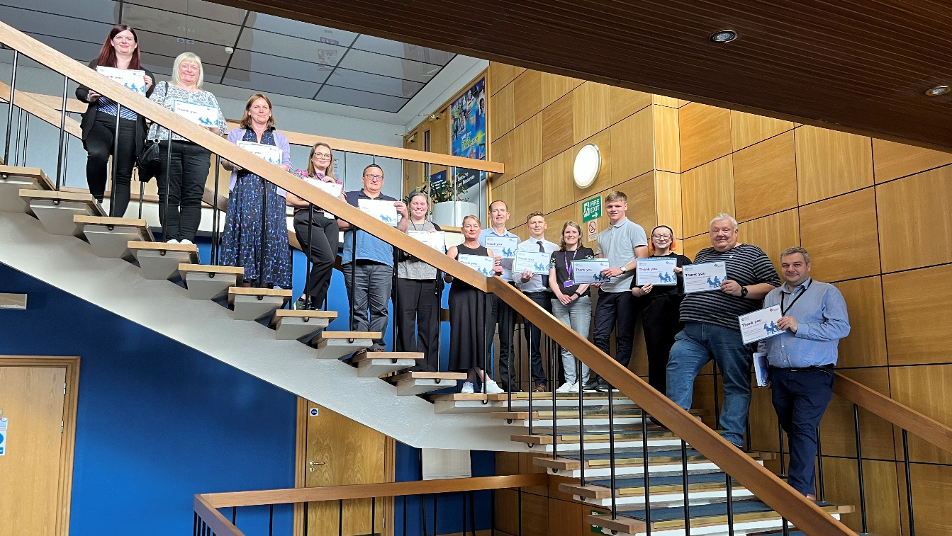
Planning and Building Service making history at South Lanarkshire Council as the first Dementia friends Team.

Building Standards structure
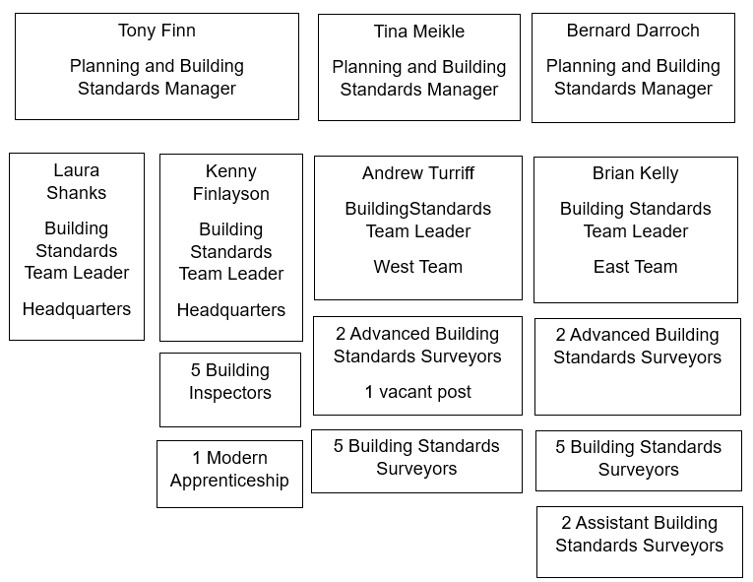
The information provided below gives a snapshot of the staffing position on the 01 July 2023.

- | Tier 1 | Tier 2 | Tier 3 | Tier 4
Head of Building Standards  Verification Service | - | - | 1 | -

Note: Tier 1= Chief Executive, Tier 2= Directors, Tier 3= Heads of Service, Tier 4= Managers

Building Standards Verification Service |  | Building Standards Verification Service
Managers | No. Posts | 3
Managers | Vacant | 0
Team Leaders | No. Posts | 4
Team Leaders | Vacant | 0
Advanced Surveyors | No. Posts | 4
Advanced Surveyors | Vacant | 1
Surveyors | No. Posts | 8
Surveyors | Vacant | 0
Assistant Surveyor | No. Posts | 2
Assistant Surveyor | Vacant | 0
Inspector | No. Posts | 5
Inspector | Vacant | 0
Modern Apprentice | No. Posts | 1
Modern Apprentice | Vacant | 0
Administrator  (Pooled) | No. Posts | 2
Administrator  (Pooled) | Vacant | 0

Note: Managers are those responsible for the operational management of a team/division. They are not necessarily line managers.

Staff age profile | Number
Under 30 | 3
30-39 | 5
40-49 | 7
50 and over | 15
Total | 30

3.0 Strategic objectives

South Lanarkshire Councils shared vision is:

“To improve the lives and prospects of everyone in South Lanarkshire”.

This plan sets out how we will deliver on that vision by focusing on what matters to the people of South Lanarkshire and the priorities they have identified for people, progress, and planet.

People – We need to put people first and reduce inequality.
Together, we will take a people first approach to reducing inequality and improving lives and life prospects.

Planet – We need to work towards a sustainable future in sustainable places.
We will act in ways that protect our natural world for a healthier future. We will work together to develop local solutions to protect nature and to take action on climate change and support our young people to lead the way.
Progress – We need people to recover, progress and improve.
Together we will build on what we have learned to recover from the pandemic, make progress in the things that matter for South Lanarkshire, and continuously improve how we do things.

The Community and Enterprise Resource, which is responsible for a wide range of services that improve our quality of life in the council area, includes the Building Standards Team at South Lanarkshire Council. The primary purpose of the Planning and Regulatory Service is to provide Planning and Building Standards services, which direct and regulate local physical development and land use. This directly supports the work of the Resource.

The overall council plan is supported by the provision of a Building Standards service that regulates and directs land use and physical development in the area, ensures the health and safety of people in or around buildings, promotes energy conservation, and promotes sustainable development.

Our Building Standards vision

Is building high-quality, safe, and sustainable environments, eliminating inequality in our communities, and placing our customers at the centre of everything we do, we will help the council achieve its ambition of improving the lives and prospects of everyone in South Lanarkshire.

Our mission

To deliver an outstanding customer experience for building standards and to be a leading local authority verifier, placing our customers at the heart of everything we do.
Our goals to achieve our vision and mission whilst striving to improve the service we deliver are.

To provide an outstanding verification service that satisfies the criteria established by Scottish Government Ministers in the Operating Framework, is customer-focused, considering the needs of the customer, and adheres to best practises in terms of consistency of interpretation and predictability of service.

In terms of fulfilling the objectives outlined in the Building Standards Performance Framework, deliver high levels of performance. review service delivery procedures as necessary to address any issues identified through national customer surveys.

Deliver specialised, pragmatic, and cost-effective services that address customer demand and operational needs.

Our customers:

Maintain our customer service award.
Develop improvements to performance that improve customer experience.
Continue to evaluate and put into practise the suggestions made by customers in the national customer survey.

Our staff:

Continue to grow our own staff through our Modern Apprentice and Building Standards Inspectors.
Further enhance the CAS toolset to satisfy our staff's needs for training.

Digital agenda:

Continue to promote e-Building Standards portal.
Continue to promote remote verification inspection to reduce our carbon footprint.
Continue to invest in technology to assist staff.

Our service:

Maintain verification and meet the terms of our conditions as set out by the Scottish Minister.
Embed our Planning & Building Standards Improvement Plan.
Continue to engage with LABSS to deliver consistency and enhance the verification process.
Participate in the Central Consortium with technical aspects.

4.0 Key performance outcomes and targets

Continuous improvement is recognised as key in ‘raising the bar’ for quality, compliance, consistency, and predictability of verification activities. This principle was at the core of the introduction of a best value Balanced Scorecard for verifiers in 2005. This approach was assessed by the Scottish Government when the appointment of verifiers was reviewed in 2011. As a result, a Building Standards Framework (BSPF) which set out 9 Key Performance Outcomes (KPO’s) that verifiers were required to achieve was introduced in 2017, following a further Scottish Government review, the framework was updated to bring it more in line with current practice and to reduce the KPOs in number from 9 to 7.

The verifier is required to complete and submit performance reports quarterly to the Scottish Government. The national verification performance framework is based on three core perspectives.

The national verification performance framework is based on three core perspectives:
- Professional expertise and technical processes.
- Quality customer experience; and
- Operational and financial efficiency.

There are also three cross-cutting themes, comprising:
- Public Interest.
- Continuous Improvement; and
- Partnership Working.

Summary of key performance outcomes (KPOs)

The table below sets out the current list of KPO’s for which targets are set by the Scottish Government. In section 5 more detailed information on these KPO’s is provided to explain the targets that have been set.

Professional expertise and technical processes
KPO1 | Minimise time taken to issue a first report or issue a building warrant or amendment to building warrant.
KPO2 | Increase quality of compliance assessment during the construction processes.
Quality customer experience
KPO3 | Commit to the building standards customer charter.
KPO4 | Understand and respond to the customer experience.
Operational and financial efficiency
KPO5 | Maintain financial governance.
KPO6 | Commit to e-Building Standards.
KPO7 | Commit to objectives outlined in the annual performance report.
The table below summarises the 7 KPO’s including, where appropriate, the targets against which verifiers are assessed by the Scottish Government. It is of note that not all the outcomes necessarily relate to performance example, KPO6.

KPO1 targets
1.1 | 95% of first reports (for building warrants and amendments) issued within 20 days all first reports (including BWs and amendments issued without a first report).
1.2 | 90% of building warrants and amendments issued within 10 days from receipt of all satisfactory information – all building warrants and amendments (not including BWs and amendments issued without a first report).
KPO2 targets
2.1 | Targets to be developed as part of future review of KPO2.
KPO3 targets
3.1 | National customer charter is published prominently on the website and incorporates version control detailing reviews (reviewed at least quarterly).
3.2 | 95% of BSD requests for information on a BSD ‘Verifier Performance Reporting  Service for Customers’ case responded to by verifier within 5 days
KPO4 targets
4.1 | Minimum overall average satisfaction rating of 7.5 out of 10.
KPO5 targets
5.1 | Building standards verification fee income to cover indicative verification service  costs (staff costs plus 30%).
KPO 6 targets
6.1 | Details of e-Building Standards to be published prominently on the verifier’s website.
KPO 7 targets
7.1 | Annual performance report published prominently on website with version control  (reviewed at least quarterly).
7.2 | Annual performance report to include performance data in line with KPOs and  associated targets (annually covering previous year).

As mentioned in 5.1 the verifier must report quarterly on performance against the KPO targets, this table summarises how South Lanarkshire Council have performed during 2022/23.
Further statistical information is included in table in Section 8 of this document.

KPO | Target details | 2022/23 |  |  |  | 2023/24
- | Quarters | Q1 | Q2 | Q3 | Q4 | Q1 | Q2 | Q3 | Q4
KPO1 | 90% of building warrants and amendments issued within 10 days from receipt of all satisfactory information – all building warrants and amendments (not including BWs and amendments issued without a first report). | 89% | 91% | 91% | 91% | 92% | 93% | - | -
KPO1 | 95% of first reports (for building warrants and amendments) issued within 20 days all first reports (including BWs and amendments issued without a first report). | 83% | 94% | 92% | 91% | 92% | 91% | - | -
KPO2 | Targets to be developed as part of future review of KPO2. | - | - | - | - | - | - | - | -
KPO3 | National customer charter is published prominently on the website and incorporates version control detailing reviews (reviewed at least quarterly). | Published prominently | Published prominently | Published prominently | Published prominently | Published prominently | Published prominently | - | -
KPO3 | 95% of BSD requests for  information on a BSD  ‘Verifier Performance  Reporting Service for  Customers’ case responded to by verifier within 5days | - | - | - | - | - | - | - | -
KPO4 | Minimum overall average satisfaction rating of 7.5 out of 10. | 8.1 | 8.1 | 8.1 | 8.9 | 8.9 | 8.9 | - | -
KPO5 | Building standards  verification fee income  To cover indicative  verification service  costs (staff costs plus 30%). | - | - | - | - | - | - | - | -
KPO6 | Details of e-Building Standards to be published prominently on the verifier’s website. | Published prominently | Published prominently | Published prominently | Published prominently | Published prominently | Published prominently | - | -
KPO7 | Annual performance report  published prominently on  website with version control  (reviewed at least  quarterly). | Published prominently (with review) | Published prominently (with review) | Published prominently (with review) | Published prominently (with review) | Published prominently (with review) | Published prominently (with review) | - | -
KPO7 | Annual performance report  to include:  performance data in line  with KPOs and associated  targets (annually covering  previous year). | - | - | - | - | - | - | - | -

The performance data table in section 5.0 below includes a RAG status (red, amber, green) to indicate the progress towards meeting the performance target. Red means the target is not being met, amber means the result slightly deviates from the target and green means the target is met.

5.0 Performance data
5.1 Professional expertise and technical processes

KPO | Professional expertise and technical processes | RAG
KPO1 | Minimise time taken to issue a first report or issue a building warrant or amendment to building warrant. | -
1.1 | Target - 95% of first reports (for building warrants and amendments) issued within 20 days – all first reports (including BWs and amendments issued without a first report). | -
1.1 | SLC result – 90% | Yellow
1.1 | Comment: 2022 -23 has seen an increase in performance from the previous year. | -
1.2 | Target - 90% of building warrants and amendments issued within 10 days from receipt of all satisfactory information – all building warrants and amendments (not including BWs and amendments issued without a first report). | -
1.2 | SLC result – 91% | Green
1.2 | Comment: as 1.1 above. | -
KPO2 | Increase quality of compliance assessment during the construction processes. | -
- | It is noted the performance measure for this KPO is still under review.  Reporting for this measure shows that during 2022 - 23, 32% of CCNP’s were complied with. | Red
- | Comment: The main reason for non-compliance was non notification of commencement and other stages outlined in the CCNP document by the applicant/relevant person. Notification has improved. However, consideration continues to be given as to how notification can be improved. | -

5.2 Quality customer experience

KPO | Professional expertise and technical processes | RAG
KPO3 | Commit to the building standards customer charter. | -
3.1 | National customer charter is published prominently on the website and incorporates version control detailing reviews (reviewed at least quarterly). | -
3.1 | SLC result – our charter remains published prominently on the council’s website. | Green
3.1 | Comment: none | -
3.2 | Target - 95% of BSD requests for information on a BSD ‘Verifier Performance Reporting  Service for Customers’ case responded to by verifier within 5 days. | -
3.2 | SLC result – no requests received. | Green
3.2 | Comment: none | -
KPO4 | Understand and respond to the customer experience. | -
4.1 | Target - Minimum overall average satisfaction rating of 7.5 out of 10. | -
4.1 | SLC Result – overall average satisfaction rating of 8.3 out of 10. | Green
4.1 | Comment: In November 2022, South Lanarkshire Council was awarded Customer Service Excellence for the 10th year. The  service is fully compliant with all CSE criteria with 17 areas of ‘compliance plus’. | -

5.3 Operational and financial efficiency

KPO | Operational and financial efficiency | RAG
KPO5 | Maintain financial governance | -
5.1 | Target - Building standards verification fee income to cover indicative verification service costs (staff costs plus 30%). | -
5.1 | SLC result – Total verification of staff costs for 2022-2023 were £1,562,117. Total verification fee income for 2022-2023 was £1,917,292.75. | Yellow
5.1 | Comment – none. | -
KPO6 | Commitment to e-Building Standards | -
6.1 | Details of e-Building Standards to be published prominently on the verifier’s website. | -
6.1 | SLC result – the options open to customers are fully detailed in the council’s website. In addition, staff are encouraged to recommend that customers use the national portal for the submission of applications and application related mail. Currently around 95% of applications are submitted online. | Green
6.2 | Target - 75% of each key building warrant related process being done electronically.  • Plan checking  • Building warrant or amendments (and plans) being issued  • Verification during construction  • Completion certificates being accepted | -
6.2 | SLC result:  • Plan checking – electronic plan checking is undertaken for all applications with minor exceptions.  • Building warrant or amendments (and plans) being issued – electronic approval via email is in place for all applications containing 10 plans or less.  • Verification during construction – limited electronic work being undertaken  • Completion certificates being accepted – all completion certificate acceptances are being issued electronically where an email address is provided for the relevant person. | Yellow
6.2 | Comment: Our processes allow for the acceptance of remote verification evidence which is limited to photographic evidence, at this time. | -
KPO7 | Commit to objectives outlined in the annual performance report. | -
7.1 | Annual performance report published prominently on website with version control (reviewed at least quarterly). | -
7.1 | SLC result – the Annual Performance Report for 2022-2023 is published on the council website and will be reviewed each quarter throughout 2023-2024. | Green
7.1 | Comment - none. | -
7.2 | Annual performance report to include performance data in line with KPOs and associated targets (annually covering previous year example April 2022 – March 2023). | -
7.2 | SLC result – This report includes comprehensive performance data for the period April 2022 to March 2023. | Green
7.2 | Comment - none. | -

6.0 Performance improvement and partnership working
6.1 In the previous 12 months (2022 – 2023) we:

Number | Continuous improvement action | Status
1 | Continue to develop IDOX software solutions for the management of building warrant applications and associated processes. | Ongoing
2 | Worked towards retaining Customer Service Excellence award and undertaken customer engagement exercise. | Ongoing
3 | Review annual local customer satisfaction survey process. | Ongoing
4 | Submit all quarterly KPO reporting and update Annual Performance Report | Ongoing
5 | Respond to SG information requests and consultations. | As required
6 | Process local actions outlined within the National Building Standards Workforce Strategy | Ongoing
7 | Progress actions associated with the national program for digital transformation. | Ongoing
8 | Achieved targets as highlighted in the Planning and Regulatory  Service Action Plan for 2022-23. | Complete
9 | Contribute to the work of LABSS as required to ensure the delivery of a robust verification service nationally. | Ongoing

6.2 In the next 12 months (2023 - 2024 ) we will:

Number | Continuous improvement action | Timescale
1 | Continue to develop IDOX software solutions for the management of building warrant applications and associated processes | Ongoing
2 | Work to retain Customer Service Excellence award for 11th year and undertake customer engagement exercise. | December 2023
3 | Submit all quarterly KPO reporting and update Annual Performance Report. | Ongoing
4 | Respond to SG information requests and consultations | As required
5 | Process local actions outlined within the National Building Standards Workforce Strategy. | As required
6 | Progress actions associated with the national program for digital transformation. | As required
7 | Achieve targets as highlighted in the Planning and Regulatory Service Action Plan for 2023 - 2024. | March 2024
8 | Contribute to the work of LABSS as required to ensure the delivery of a robust verification service nationally. | Ongoing

6.3 In the previous 12 months (2022-23) we worked with:

6.3.1 Building Standards Division of Scottish Government – SLC participation within a number of national working groups looking at new national guidance and policy documents. This allows the Scottish Government to use our feedback based on customer insight to shape national direction.
  - Digital Transformation Working Group
  - Futures Board Compliance Plan Working Group (including quality of application sub group)
  - Enforcement and Sanctions Working Group

6.3.2 Provided response to Scottish Government consultations on energy/fire/compliance and enforcement.

6.3.3 Undertook improvements to charging orders processes to aid cost recovery.

6.3.4 Concluded Health and Safety risk assessment and safe system of work including updating of related training matrix.

6.3.5 Care and Repair in SLC - ongoing with Care and Repair in South Lanarkshire to maintain lines of communication for customer enquiries and also the service’s expectation in terms of assessment times and quality of warrant submission.

6.3.6 Care Inspectorate - SLC staff continue liaise with the Care Inspectorate and Local Authority Building Standards.

6.3.7 Continue to contribute to the Multi-agency Tactical Group - this forum allows local agency’s such as Police, SFRS and local authority departments to discuss matter of mutual interest.

6.3.8 Continue to contribute to the Safety Advisory Group- the SLC forum, considering applications for live events, such as concerts.

6.3.9 SLC Housing and Technical Resources – we continue to coordinate Scottish Government consultation responses with colleagues in Housing and Transportation Services.

6.3.10 Continue to contribute to STAS and Registered Details - these services are provided by LABSS allow for pre-approval nationally of standard building designs.

6.3.11 Sharing house completion data with Waste services - monthly reports are provided to our Waste Services section to allow for a quicker and more effective consideration of customer needs with regards to bin collection services.

6.3.12 National Building Standards Portal-work remain ongoing on the promotion of this portal, 95% of application are submitted via the national portal. Use of the portal supports the current approach to working from home.

6.3.13 Operation Doric - Our work in relation to this initiative remains ongoing. Promotion of this partnership has been presented as corporate evidence as part of the council’s Best Value Audit.

6.3.14 Adaptation fast tracking process - the existing standard warrant submission package continues to provide a template for the submission of adaptation applications. This allows for a quicker processing time which in turn benefits homeowners.

6.3.15 Alternative view process - a number of alternative view applications were considered and approved during 2022/23.

6.3.16 Local Authority Building Standards Scotland – In a similar way to the BSD, SLC are represented within LABSS in many strategic areas namely:
  - Member of Executive – Alan McAulay
  - Technical Director – Alan McAulay
  - Consortia technical representative – Andrew Turriff

6.3.17 Central Authorities Consortia – while linked with LABSS activities, this forum allows for discussion at a more local level, partners are North Lanarkshire, Stirling, Falkirk and Clackmannanshire councils.

6.3.18 South Ayrshire Council – SAC engineers are used as a backstop for checking structural calculations which are out with the scope of our own in-house engineers, thus providing customers with certainty of service response.

6.3.19 Environmental Health – Building Standards respond to weekly consultation requests from EH on building warrant application submissions thereby ensuring any applicant is aware of legislative requirements stemming from EH regulations.

6.3.20 Planning Service – Extensive joint working is undertaken on a daily basis through the cross-checking process.

6.3.21 Revised approach to Building Standards Customer Satisfaction engagement with new live reporting website and the addition of links to letters, emails and footers.

6.4 In the next 12 months (2023-2024) we will:

6.4.1 Continue to engage with our partners outlined above, including strengthening partnership working where necessary and consider new partnerships where opportunities exist.

6.4.2 We will seek to recruit a Building Standards Modern Apprentice.

6.4.3 We will seek to recruit additional Technician Posts (Building Standard Inspectors).

7.0 Building Standards – additional data

7.1 Verifiers provide returns to Scottish Government on their verification performance and workload. The performance data relates to the building standards verification performance framework and the workload data relates to the numbers of building warrant applications; completion certificates; fees; costs; certificates (certification, energy performance; sustainability); enforcement cases.

Building warrants and amendments to building warrant - 2283 applications, 2177 decisions
Completion certificates - 2741 applications, 2707 decisions
Certification - 1110 certificates of design submitted, 319 certificates of construction submitted
Energy performance certificates (EPCs) - 1453 copy certificates received (domestic), 7 copy certificates received (non-domestic)
Statements of sustainability - 1222 copy certificates received (domestic), 7 copy certificates received (non-domestic)
Enforcement - 0 notices served under sections 25 to 30
- 0 cases referred to procurator fiscal
- 2 cases where LA has undertaken work
- 2 cases of direct action under S29

South Lanarkshire Council
Community and Enterprise Resources Planning and Regulatory Services
Floor 6, Council HQ, Almada Street, Hamilton ML3 0AA www.southlanarkshire.gov.uk

If you need this information in another language or format, please contact us to discuss how we can best meet your needs.
Phone: 0303 123 1015 or email equalities@southlanarkshire.gov.uk

