Clydesdale Active Travel Study
Public Life Study: Forth and Biggar

South Lanarkshire Council
June 2023


Quality information
Prepared by |  | Checked by |  | Verified by |  | Approved by
Guy Newham  Graduate Consultant |  | Fiona Bebbington  Engineer |  | Steven Smith  Principal Engineer |  | Peter Leslie  Associate Director

Revision History
Revision | Revision date | Details | Authorized | Name | Position
0 | 13-03-2023 | First Issue | PL | Peter Leslie | Project Manager

Distribution List
# Hard Copies | PDF Required | Association / Company Name

Prepared for:
South Lanarkshire Council

Prepared by:
Guy Newham
Graduate Consultant

‌AECOM Limited
1 Tanfield
Edinburgh EH3 5DA
United Kingdom

T: +44 131 301 8600
aecom.com

© 2023 AECOM Limited. All Rights Reserved.
This document has been prepared by AECOM Limited (“AECOM”) for sole use of our client (the “Client”) in accordance with generally accepted consultancy principles, the budget for fees and the terms of reference agreed between AECOM and the Client. Any information provided by third parties and referred to herein has not been checked or verified by AECOM, unless otherwise expressly stated in the document. No third party may rely upon this document without the prior and express written agreement of AECOM.

Table of Contents
Introduction 5
Methodology 5
Twelve Quality Criteria Method 5
Limitations 6
Forth 6
Twelve Quality Criteria Summary 7
Protection 7
Comfort 7
Enjoyment 8
Photo Record 9
Typical Cross Section 10
Summary and Recommendations 10
Recommendation 11
Biggar 12
Twelve Quality Criteria Summary 13
Protection 13
Comfort 13
Enjoyment 14
Photo Record 15
Typical Cross Section 16
Summary and Recommendations 17
Recommendation 17

Figures
Figure 1 - Forth Study Area 6
Figure 2 - Typical section through Main Street 10
Figure 3 - Forth Scoring Summary 10
Figure 4 – Biggar Study Area 12
Figure 6 - Typical Cross Section Main Street (Central) 16
Figure 5 - Typical Cross Section Main Street 16
Figure 7 – Biggar Summary Scoring 17

Tables
No table of figures entries found.

Introduction
AECOM has been commissioned by South Lanarkshire Council to undertake a Public Life Survey in the areas of Forth and Biggar using the Gehl ‘Twelve Quality Criteria’. This will support the development of the active travel feasibility study being undertaken in the northeast of Clydesdale.
The following report details the outcomes and recommendations of this study, for consideration as part of the overall feasibility study. The communities of Forth and Biggar were identified in discussion with South Lanarkshire Council for Public Life Surveys to be undertaken. The study areas were further defined to encompass the central areas of these communities, which are further detailed in the following sections.
The structure is as follows:
- Location plan;
- Summary of analysis against the Twelve Quality Criteria, including scoring;
- Annotated photo record;
- Typical section;
- Summary diagram of scoring;
- Observations; and
- Recommendations.

Methodology

Twelve Quality Criteria Method
Gehl’s Twelve Quality Criteria has been developed as a ‘tool for researching how public spaces are experienced by their users’ and to assess if a space has features which are protective, comfortable, and enjoyable, as without these functions the quality of public space is reduced, and people are less likely to want to use the space (Gehl, 2021). It is part of a suite of Public Life Survey tools developed by Gehl.
The study areas were chosen to reflect the main commercial areas and areas of public life within Forth and Biggar and the boundaries were refined following the on-site appraisal to focus on the main area of activity. The assessors used the Gehl Twelve Quality Criteria to conduct an independent appraisal of the study area, looking at the three themes of Protection, Comfort, and Enjoyment.
Each of the criteria have been scored according to the following:
1 = No
2 = In-between
3 = Yes
Therefore, the highest scores represent qualities of the public space that are strongest.

Limitations
There are limitations to the outcomes of this study related to time, date and length of site surveys undertaken alongside weather conditions which would affect use of space.
The site surveys were undertaken on Wednesday 1st February 2023 and Thursday 2nd February 2023 between the hours of 10am and 2pm. Weather conditions were dry and cloudy on Wednesday and windy with light rain showers on Thursday, the temperature ranged from 5°C to 9°C.
The surveys were conducted from only publicly accessible locations within the study areas.

Forth
The study area within Forth was centred along Main Street, as the central area with amenities along its length as shown in Figure 1 below.
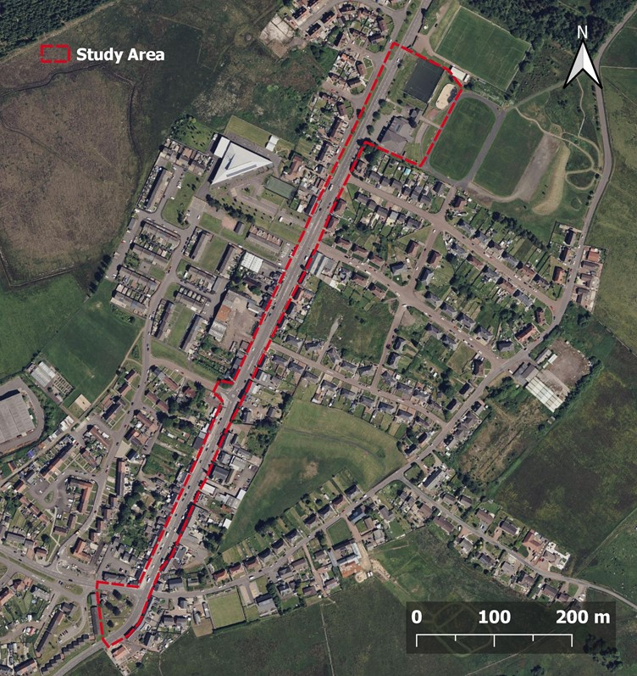
Figure 1 - Forth Study Area

Twelve Quality Criteria Summary

Protection
Protection against traffic and accidents | Protection against harm | Protection against unpleasant sensory experience
The speed limit within Forth is generally 30mph with a 20mph zone school outside the primary school.  There are crossing points throughout the study area, including two signalised pedestrian crossings. A lack of crossing facilities was identified for access to the sports centre.  Footways are a suitable width, increasing safety, although the road is moderately busy with traffic.  There are not any dedicated facilities for cyclists within the study area, requiring cyclists to be on carriageway. | Street light provision appeared to be sufficient, with moderate levels of daytime and night-time activity expected.  The area has residential properties along its length which supports the feel of personal safety. | The study area has limited places of shelter.  Overall, no significant pollution affecting the sensory experience was noted during the assessment.
Score: 3 | Score: 3 | Score: 1

Comfort
Options for mobility | Options stand and linger | Options for sitting
Footways are a suitable width for all users with sufficient crossing points and drop kerbs. Steep gradients were identified at some locations however alternative routes were available. | There are opportunities to stand or linger where the footway is wider, these sections are often alongside benches. | Benches are placed at various locations within the study area providing options for sitting and a small garden area with benches is located to the south of the study area.
Score: 3 | Score: 3 | Score: 3

Options for seeing | Options for talking and listening/hearing | Options for play, exercise, and activities
Seating options adjacent to carriageway present limited options for seeing.  Benches within the garden area offer greater visual amenity. | There are opportunities to have conversations where benches are located and footways are wider however many are adjacent to carriageway which reduced ability due to road noise. | The sports and community centre to the north of the study area provides options of recreational activities. Outwith this, options are limited.
Score: 1 | Score: 2 | Score: 3

Enjoyment
Scale | Opportunities to enjoy positive aspects of climate | Experience of aesthetic qualities and positive sensory experiences
Buildings are generally two storeys and for the majority adjacent to footway. The proportion of building heights to road width allows the sense of scale to be maintained. | There are opportunities to enjoy positive weather conditions with benches located at varying locations and directions. Some areas are more exposed that others. | The study area acts well as a functional space, further considerations could be made to improve the aesthetic qualities.
Score: 3 | Score: 2 | Score: 1

Photo Record
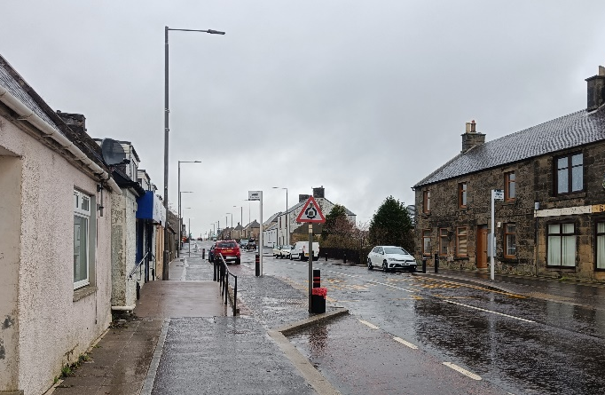  Mobility  Wide footways, mobility ramps and drop kerb crossing points help to create a safe environment for all pedestrians. | 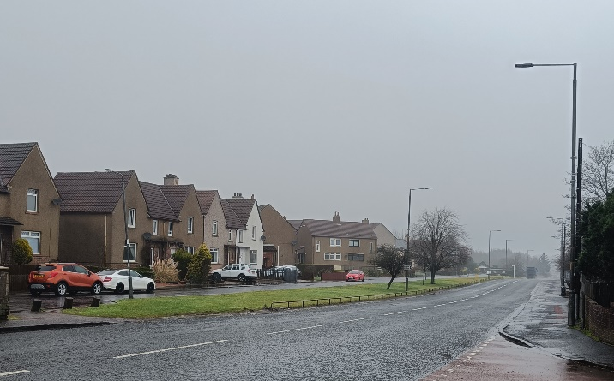  Safety  There are no designated crossing points outside of the Willie Waddell Sports and Community Centre.
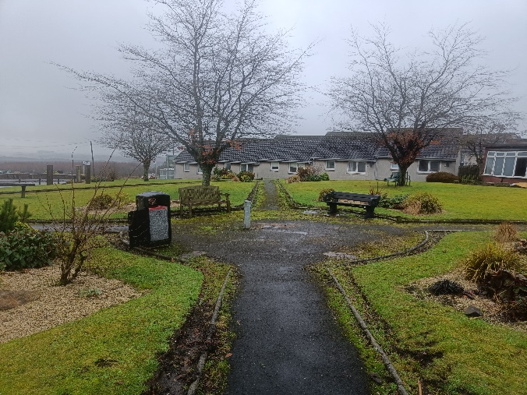  Green Space  This small garden to the south of the study area provides a relaxing space for visitors to linger. | 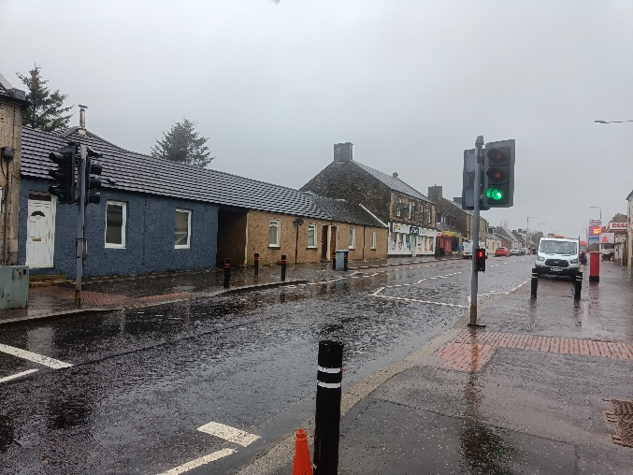  Safety  There are multiple signalled crossing points on Main Street, as well as refuge islands.
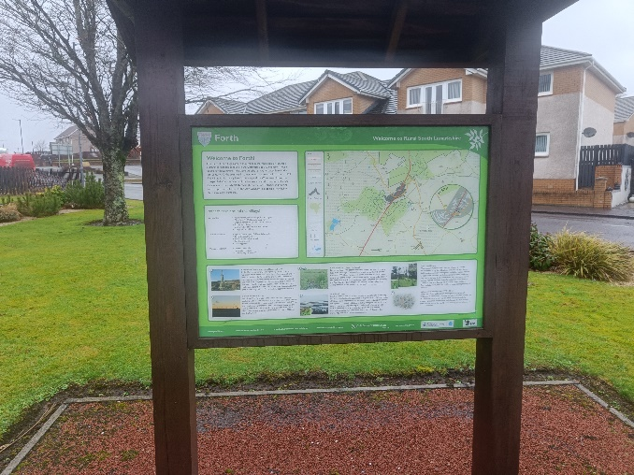  Information  Information signs help pedestrians understand and navigate the area, as well as giving a sense of place. | 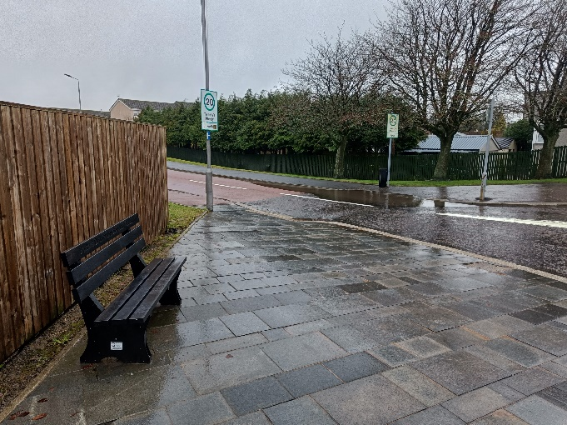  Seating  There are benches placed throughout the study area, but these can seem isolated

Typical Cross Section
A typical cross section has been taken of the Main Street as illustrated in Figure 2 below.
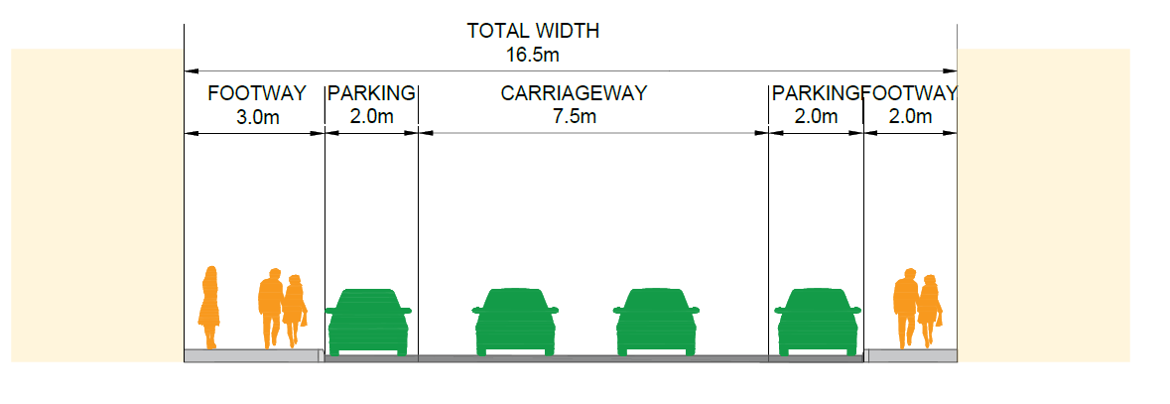
Figure 2 - Typical section through Main Street

Summary and Recommendations
The scoring summary diagram for Forth is shown in Figure 3 below based on the outcomes of the twelve criteria. As shown, the scores varied across the three categories of protection, comfort and enjoyment.
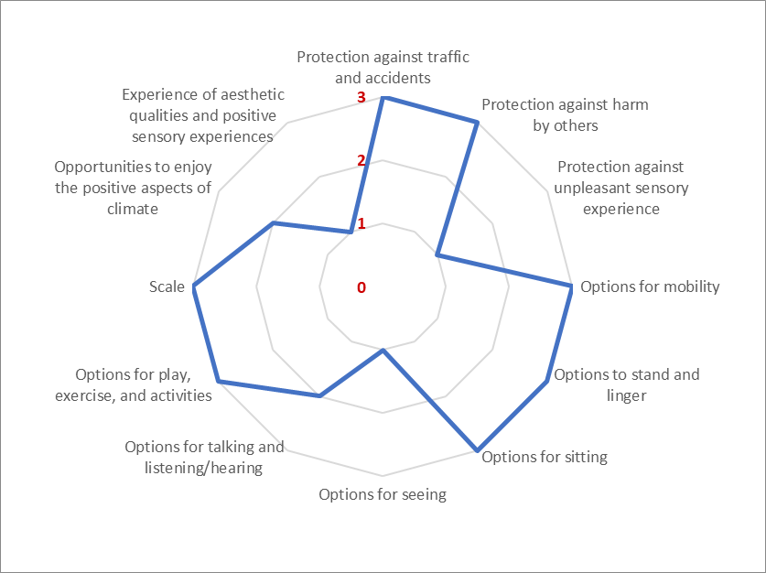
Figure 3 - Forth Scoring Summary

Category | Summary Observations
Protection | In general, Forth provides a good level of protection against road traffic and harm by others through footway width, crossing provision, street lighting and adjacent properties. The area does however offer little protection against weather conditions.
Comfort | The study area performed strongly against the comfort criteria with various opportunities for sitting and socialising with others, however it was noted that there was limited visual interest at these locations.
Enjoyment | Whilst the area functions well, opportunities for enjoyment are hindered through limited shelter and visual interest.

Recommendation
The study area is open, and you are able to appreciate the availability of space. There are opportunities to enhance placemaking and support safety and mobility, particularly at higher demand areas.
Recommendations for this area are to:
- Introduce placemaking features such as seating and planters where space permits to support visual amenity
- Provide crossing points on key desire lines such as to facilitate access to the sports centre
- Options to improve shelter could also be considered to create a more desirable place to spend time outdoors
- Consider measures to support the safety of cyclists, carriageway width would support the introduction of facilities

Biggar
The study area within Biggar was centred along the High Street, as shown in Figure 4 below. Due to amenities and community venues located along its length.
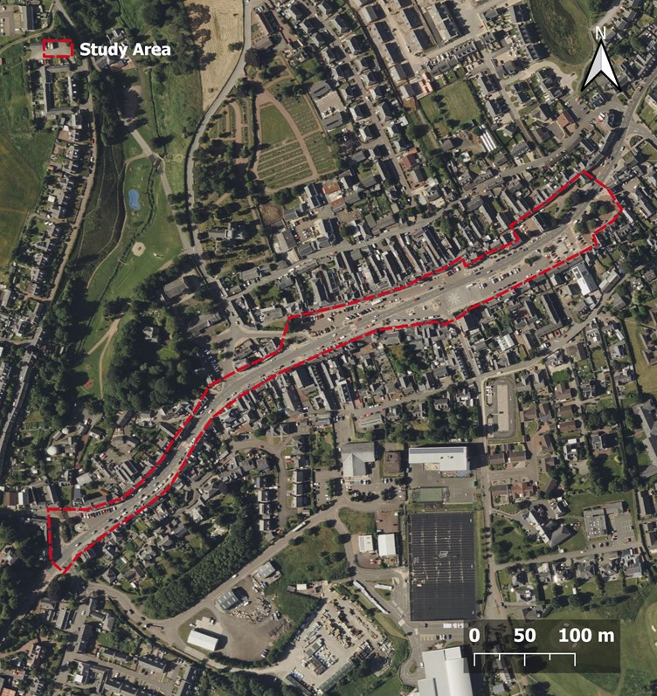
Figure 4 – Biggar Study Area

Twelve Quality Criteria Summary

Protection
Protection against traffic and accidents | Protection against harm | Protection against unpleasant sensory experience
There are sufficient crossing points, although crossing from one side of the carriageway to the other can involve crossing the main road and a car park.  There is a 20mph zone in the area with the greatest pedestrian activity supporting overall safety, alongside footway widths.  No facilities are available for cyclists requiring them to mix with traffic. Adjacent car parking pays creates a potential conflict risk. | Street lighting is provided throughout and is thought to be sufficient. Daytime activity was observed to be high.  Residential and commercial properties are adjacent to the carriageway which supports personal safety through natural surveillance. | Main Street was observed to have high levels of through traffic and parking which can create an unpleasant atmosphere for pedestrians.  There are bus shelters located throughout the area which allows protection for waiting passengers.
Score: 2 | Score: 3 | Score: 2

Comfort
Options for mobility | Options stand and linger | Options for sitting
Footways are of a suitable width for all users and there are multiple signalised and uncontrolled crossings throughout the area. Car parking adjacent to carriageway can prevent options for informal crossing of the carriageway.  Disabled car parking is provided at several locations to support amenity access for disabled people. | There are variety of options to stand and linger with wide footways and benches situated throughout. | Benches are spread throughout the study area, providing several options for sitting, these were seen to be in use during the assessment.
Score: 3 | Score: 3 | Score: 3

Options for seeing | Options for talking and listening/hearing | Options for play, exercise, and activities
Benches are located next to landscaped areas at either end of the study area, otherwise most benches are facing the shopping area. | Seating has been well positioned for talking, although the area can be busy with traffic, making conversation difficult. | There are no play or exercise facilities were identified within the study area.
Score: 3 | Score: 2 | Score: 1

Enjoyment
Scale | Opportunities to enjoy positive aspects of climate | Experience of aesthetic qualities and positive sensory experiences
Buildings are generally two storeys and for the majority and are set back from the footway. This supports an open feel to the corridor. | Seating options are well placed to be enjoyed in good weather. There are some efforts to also shelter them from wind, but little protection from rain. | The buildings are generally aesthetically pleasing with period features, and the landscaped areas are well designed and maintained.  The volume of traffic and parked vehicles reduces positive sensory experience.
Score: 3 | Score: 2 | Score: 3

Photo Record

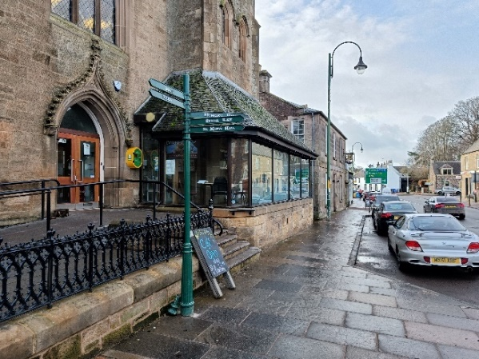  Design  Features such as wayfinding signposts and streetlights complement each other and the surrounding elements in terms of design. | 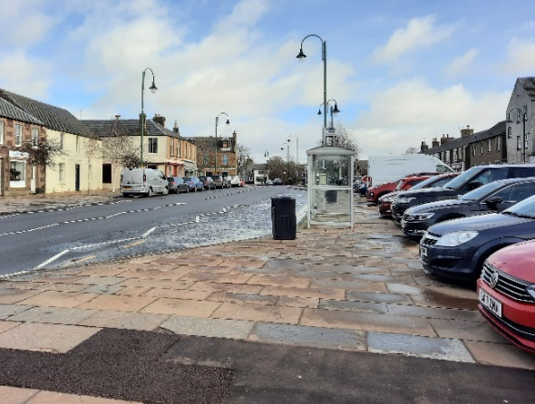  Vehicles  There are many parking spaces in the town centre, but the volume of cars reduces mobility and diminishes sensory experience.
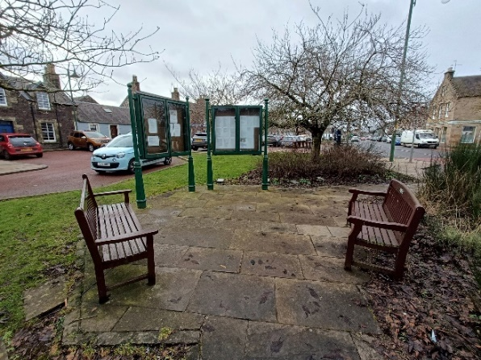  Information  Notice boards help to create an enclosed space and develop a sense a community. | 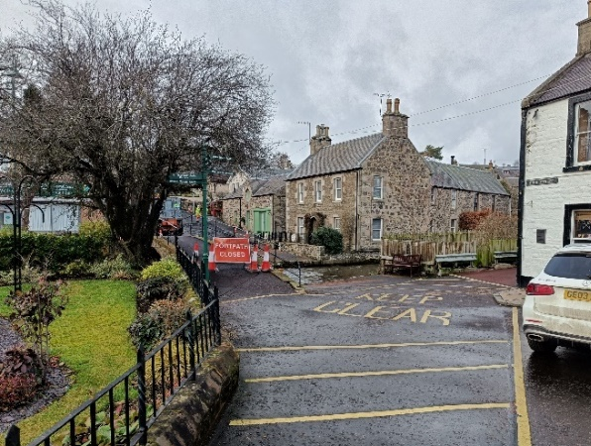  Environment  Gardens, waterways, and bridges are integrated to create a space that’s functional, pleasant, and easy to navigate.
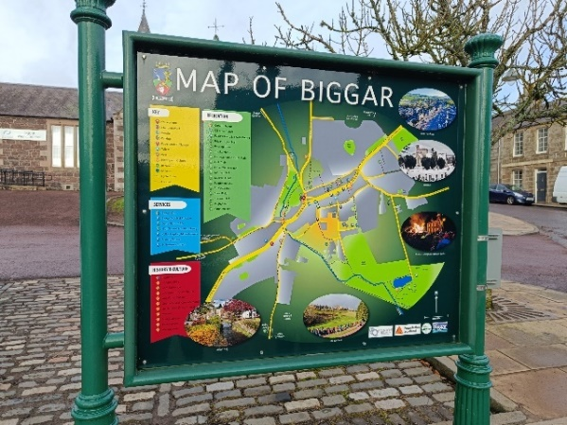  Information  Maps can act as a design feature as well as a source of information. | 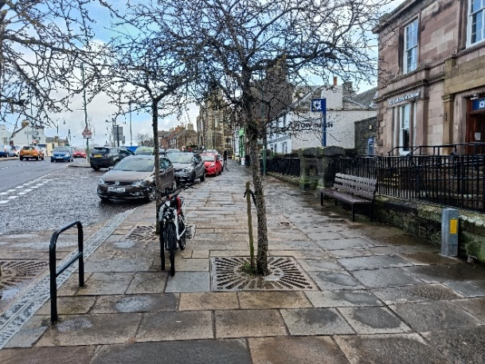  Mobility  Footways incorporate multiple elements while still allowing high levels of mobility.

Typical Cross Section
As the cross section varies significantly along Main Street, two typical cross sections have been taken and illustrated in the figures below. Within the central area, there are often car parks on either side of the carriageway outwith these sections a single carriageway with on street parking provision layout is adopted. 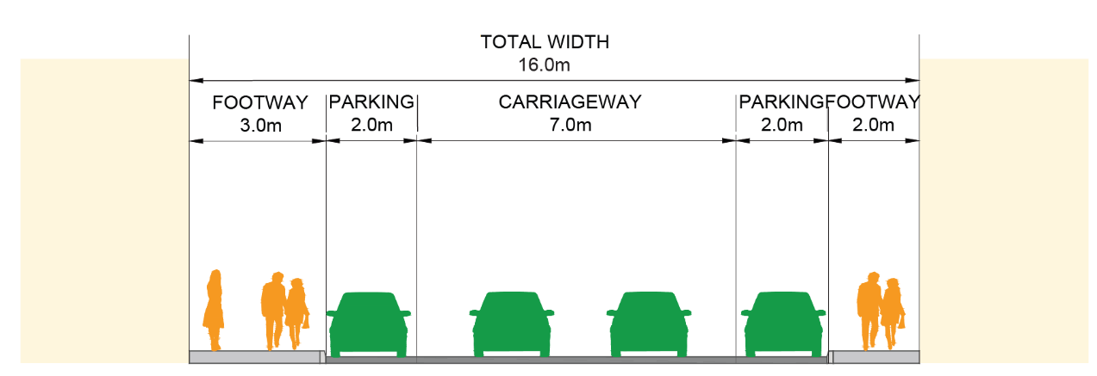
Figure 5 - Typical Cross Section Main Street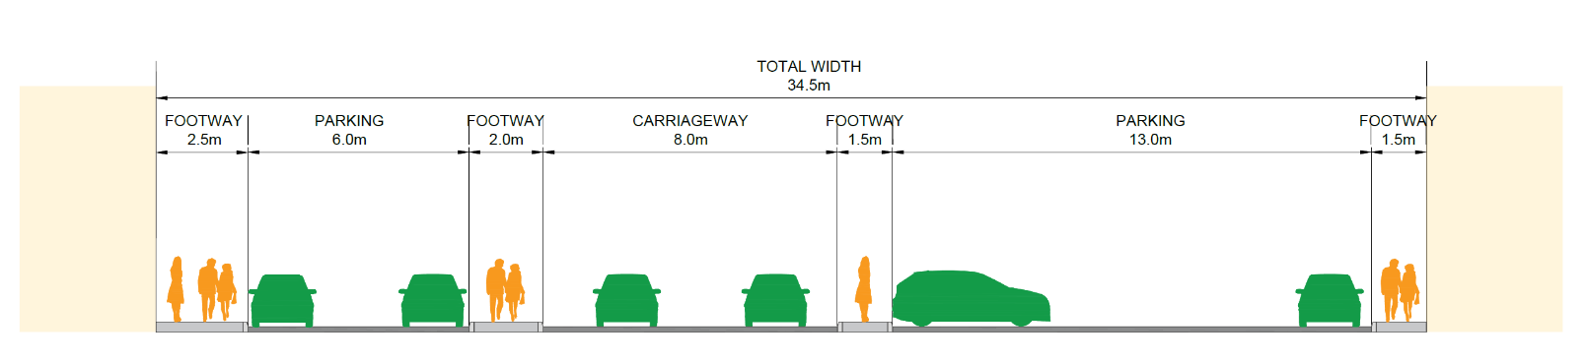
Figure 6 - Typical Cross Section Main Street (Central)

Summary and Recommendations
The scoring summary diagram for Biggar is shown in Figure 7 below based on the outcomes of the twelve criteria. As shown, the scores varied across the three categories of protection, comfort and enjoyment.
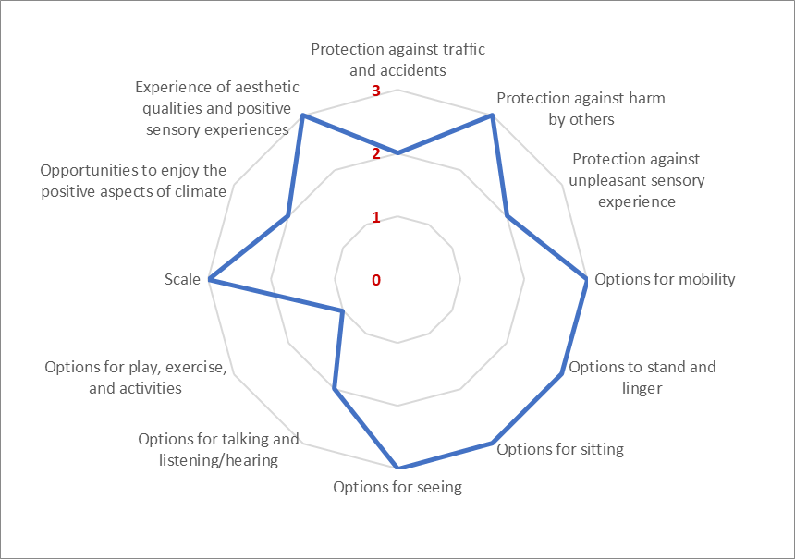
Figure 7 – Biggar Summary Scoring
Category | Summary Observations
Protection | Protection is generally available throughout the study area with adequate footway widths, crossing, lighting and shelter provision. However, it was noted that car parking both on street and in car parks can limit pedestrian movement and informal crossing opportunities.
Comfort | There is a good number of seating locations throughout Main Street, providing opportunities for conversations and for the most part visual interest. Options for play, exercise and activities where limited.
Enjoyment | Biggar scored well against the enjoyment criteria with the corridor width proportion against adjacent properties able to create an open feel and centre designed well to incorporate landscaping and placemaking features.

Recommendation
Biggar’s Main Street generally performed well against the twelve quality criteria; it is noted that some aspects could be considered for improvement. Recommendations are as follows:
- Consider level of car parking provision particularly within the central area, opportunities exist to reallocate space for walking, wheeling and cycling and support desired movements
- Introduce improved shelter provision particularly at seating locations to create a more enjoyable environment to spend outdoors
- Consider opportunities to introduce play or exercise facilities particularly in wider sections of footway

