Clydesdale Active Travel Study
Public Life Study: Blackwood & Kirkmuirhill and Lesmahagow

South Lanarkshire Council
June 2023


Quality information
Prepared by |  | Checked by |  | Verified by |  | Approved by
Guy Newham  Graduate Consultant |  | Fiona Bebbington  Engineer |  | Steven Smith  Principal Engineer |  | Peter Leslie  Associate Director

Revision History
Revision | Revision date | Details | Authorized | Name | Position
0 | 13-03-2023 | First Issue | PL | Peter Leslie | Project Manager

Distribution List
# Hard Copies | PDF Required | Association / Company Name

Prepared for:
South Lanarkshire Council

Prepared by:
Guy Newham
Graduate Consultant

‌AECOM Limited
1 Tanfield
Edinburgh EH3 5DA
United Kingdom

T: +44 131 301 8600
aecom.com

© 2023 AECOM Limited. All Rights Reserved.
This document has been prepared by AECOM Limited (“AECOM”) for sole use of our client (the “Client”) in accordance with generally accepted consultancy principles, the budget for fees and the terms of reference agreed between AECOM and the Client. Any information provided by third parties and referred to herein has not been checked or verified by AECOM, unless otherwise expressly stated in the document. No third party may rely upon this document without the prior and express written agreement of AECOM.

Table of Contents
Introduction 5
Methodology 5
Twelve Quality Criteria Method 5
Limitations 6
Lesmahagow 6
Twelve Quality Criteria Summary 7
Protection 7
Comfort 7
Enjoyment 8
Photo Record 9
Typical Cross Section 10
Summary and Recommendations 10
Recommendation 11
Kirkmuirhill & Blackwood 12
Twelve Quality Criteria Summary 13
Protection 13
Comfort 13
Enjoyment 14
Photo Record 15
Typical Cross Section 16
Summary and Recommendations 16
Recommendation 17
Appendix A Twelve Quality Criteria 18

Figures
Figure 1 - Lesmahagow Study Area 7
Figure 2 - Lesmahagow Scoring Summary 11

Tables
No table of figures entries found.

Introduction
South Lanarkshire Council have commissioned AECOM to undertake a Public Life Survey in the areas of Lesmahagow and Kirkmuirhill and Blackwood using the Gehl ‘Twelve Quality Criteria’. This will support the development of the active travel feasibility study being undertaken in the northwest of Clydesdale.
The following report details the outcomes and recommendations of this study, for consideration as part of the overall feasibility study. The communities of Lesmahagow and Kirkmuirhill and Blackwood were identified in discussion with South Lanarkshire Council for Public Life Surveys to be undertaken. The study areas were further defined to encompass the central areas of these communities, which are further detailed in the following sections.
The structure is as follows:
- Location plan;
- Summary of analysis against the Twelve Quality Criteria, including scoring;
- Annotated photo record;
- Typical section;
- Summary diagram of scoring;
- Observations; and
- Recommendations.

Methodology

Twelve Quality Criteria Method
Gehl’s Twelve Quality Criteria has been developed as a ‘tool for researching how public spaces are experienced by their users’ and to assess if a space has features which are protective, comfortable, and enjoyable, as without these functions the quality of public space is reduced, and people are less likely to want to use the space (Gehl, 2021). It is part of a suite of Public Life Survey tools developed by Gehl.
The study areas were chosen to reflect the main commercial areas and areas of public life within Lesmahagow and Kirkmuirhill & Blackwood and the boundaries were refined following the on-site appraisal to focus on the main area of activity. The assessors used the Gehl Twelve Quality Criteria to conduct an independent appraisal of the study area, looking at the three themes of Protection, Comfort, and Enjoyment.
Each of the criteria have been scored according to the following:
1 = No
2 = In-between
3 = Yes
Therefore, the highest scores represent qualities of the public space that are strongest.

Limitations
There are limitations to the outcomes of this study related to time, date and length of site surveys undertaken alongside weather conditions which would affect use of space.
The site surveys were undertaken on Thursday 2nd February 2023 between the hours of 10am and 2pm. During this time weather conditions were cloudy with light rain showers and temperature ranged from 5°C to 7°C.
The surveys were conducted from only publicly accessible locations within the study areas.

Lesmahagow
The study area within Lesmahagow was centred along the main road, Abbeygreen, as the central area with amenities along its length as shown in Figure 1 below.
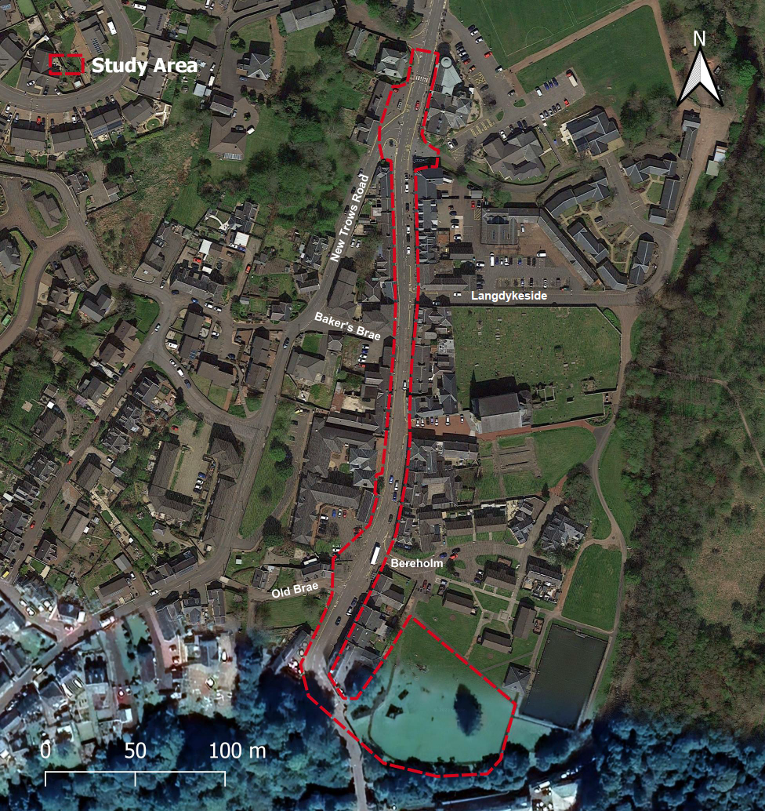
Figure 1 – Lesmahagow Study Area

Twelve Quality Criteria Summary

Protection
Protection against traffic and accidents | Protection against harm | Protection against unpleasant sensory experience
In the study area, the footway and carriageway widths were observed to be narrow with some sections of footway unpassable for less able users.  There are few crossing facilities other than a zebra crossing to the north of study area which facilitates access to local amenities and playing fields. The level of traffic was relatively low with a speed limit of 30mph providing opportunities to cross outwith formal crossing facilities.  Intermittent advisory cycle lanes were identified however these ended abruptly to provide on street parking spaces forcing cyclists back out in the carriageway. | Street light provision appeared to be sufficient, with moderate levels of daytime activity however, it is expected that night-time activity is likely to be lower.  The area has residential properties along its length which supports the feel of personal safety. | The study area has limited places of shelter however the properties along the length provide a degree of protection against the elements. Bus stops have shelters provided to support waiting passengers.  Rainwater was observed to pool at some locations which may be emphasised in more severe weather.
Score: 1 | Score: 2 | Score: 2

Comfort
Options for mobility | Options stand and linger | Options for sitting
Footway widths vary throughout the study area, sections of footway have extremely narrow widths, which would make it unpassable for people with mobility issues and young families. At these points there is also insufficient crossing facilities to provide an alternative route. | There are opportunities to stand or linger where the footway is wider, these sections are often alongside benches and / or a bus shelter. | Benches are placed at various locations within the study area; adjacent to carriageway and within the park. However, some were observed to need replacement or repair.
Score: 1 | Score: 3 | Score: 3

Options for seeing | Options for talking and listening/hearing | Options for play, exercise, and activities
Seating options adjacent to carriageway are orientated towards pedestrian areas or greenspace or local features. Within the park area there are greater options for seeing with greenspace and recreational facilities. | There are opportunities to have conversations where benches are located and footways are wider however many are adjacent to carriageway which reduced ability due to road noise. Within the park area it is generally peaceful and easy to have conversations. | Options exist for play, exercise and activities with a play park situated to the south of the study area and playing fields are located nearby.
Score: 3 | Score: 2 | Score: 3

Enjoyment
Scale | Opportunities to enjoy positive aspects of climate | Experience of aesthetic qualities and positive sensory experiences
Buildings are generally two storeys and for the majority adjacent to footway. This in combination with the narrow overall road width creates an enclosed feel. | There are opportunities to enjoy positive weather conditions with benches located at varying locations and directions. However, some areas are more sheltered than others. | There are aesthetic elements incorporated into the environment, but some need better care and upkeep, such as the broken bench and the feature at the junction of Abbeygreen and New Trows Road. There is some landscaping on the main road and in the park.
Score: 2 | Score: 3 | Score: 2

Photo Record
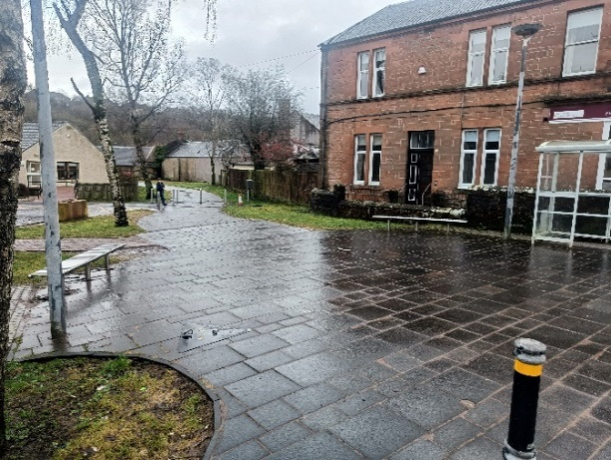  Sitting, standing & talking  There are areas that provide a comfortable space to sit, wait, or linger | 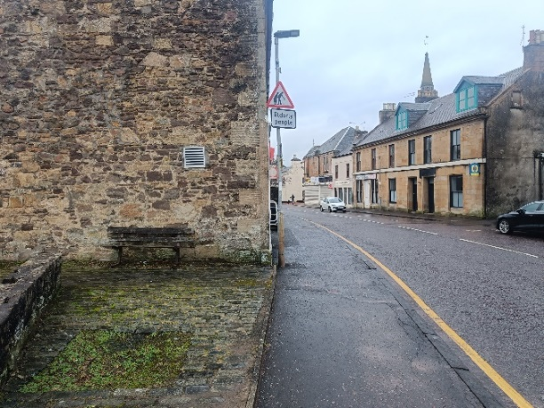Public realm upkeep  There are multiple features in need of upkeep, including the bench shown above
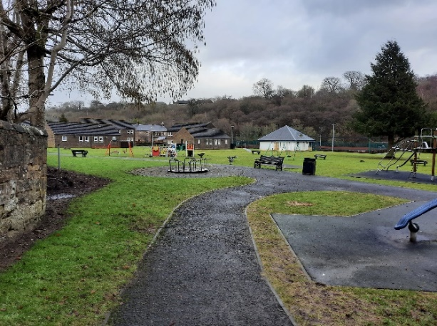  Park  The park to the south of the study area has a range of play facilities, carefully placed seating, and is bordered by the River Nethan | 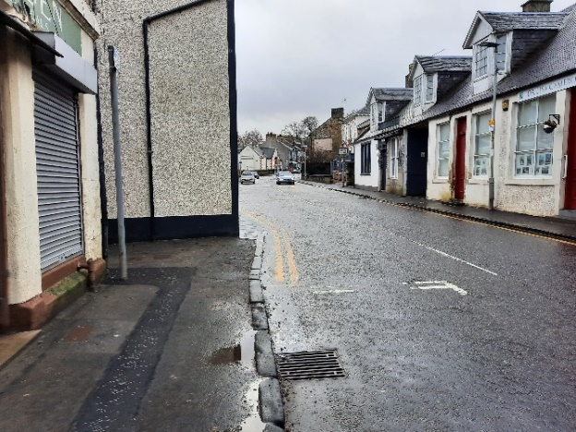Footway Width  There are sections of footway that are difficult to pass without stepping into the road
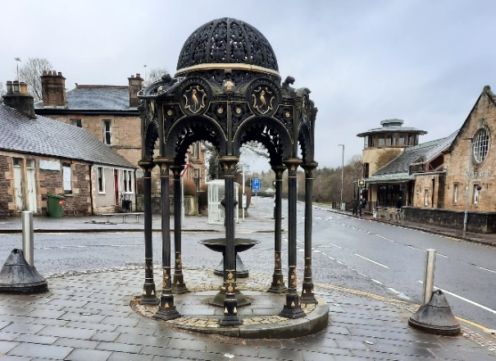  Aesthetics  There are features, such as the one shown above, that aim to improve the aesthetics of the urban environment | 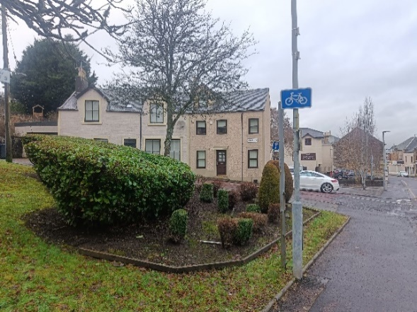Landscape  Landscaping and gardening integrate the urban environment with nearby natural areas

Typical Cross Section
A typical cross section has been taken of the main road within the study area, Abbeygreen, as illustrated by Figure 2 below. The road envelope is constrained by adjacent properties and the proportion against these buildings creates an enclosed environment.
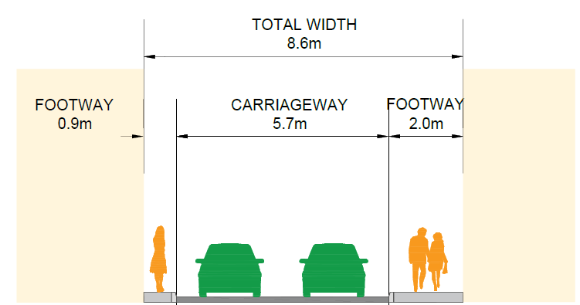
Figure 2 - Typical section through Abbeygreen

Summary and Recommendations
The scoring summary diagram for Lesmahagow is shown in Figure 3 below. 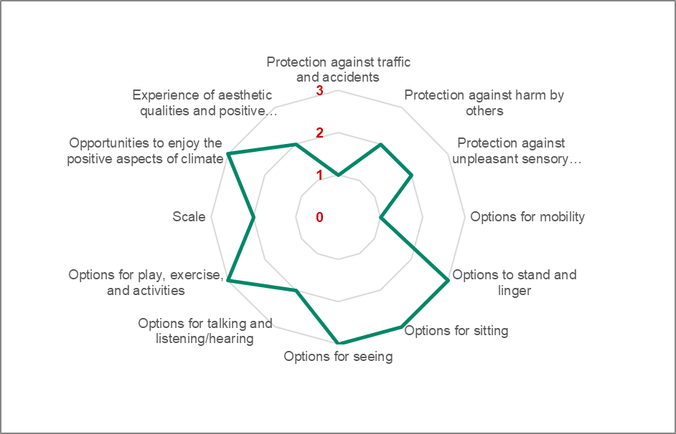
Figure 3 - Lesmahagow Scoring Summary

As shown in the Scoring Summary above, the scores varied across the twelve criteria and within the three categories; protection, comfort and enjoyment.
Category | Summary Observations
Protection | Protection in general is quite low due to the narrow road envelope and limited shelter against the elements. Provision for pedestrians and cyclists is limited due to this and it is further impacted by on street parking. The area is naturally overlooked by adjacent properties however there are sections which are secluded which may raise personal safety concerns.
Comfort | There are various locations which support the comfort criteria through provision of benches and sections of wider footways however this is not consistent throughout the study area with footway widths less than 0.5m at some locations which impacts mobility. Play and recreational opportunities were identified at both ends of the study area.
Enjoyment | The study area can feel very enclosed due to the proportion of building height to the road corridor however this opens at either end of the corridor.

Recommendation
Overall, the street feels enclosed and presents challenges for the movement of pedestrians and cyclists in the central area. There are opportunities for people to socialise at various locations however some of which are isolated and have limited visual aesthetics.
Recommendations for the area are to:
  - improve experience of aesthetic qualities through addressing damaged public realm elements and potentially introducing planters where space permits to create a more attractive setting
  - address mobility issues where achievable through footway widening, provision of dropped kerb crossing points etc.

Kirkmuirhill & Blackwood
The study area within Kirkmuirhill and Blackwood was centred along Carlisle Road and Thornton Road, as shown in Figure 4 below. Due to amenities, places of worship and Blackwood Primary School located along these roads.
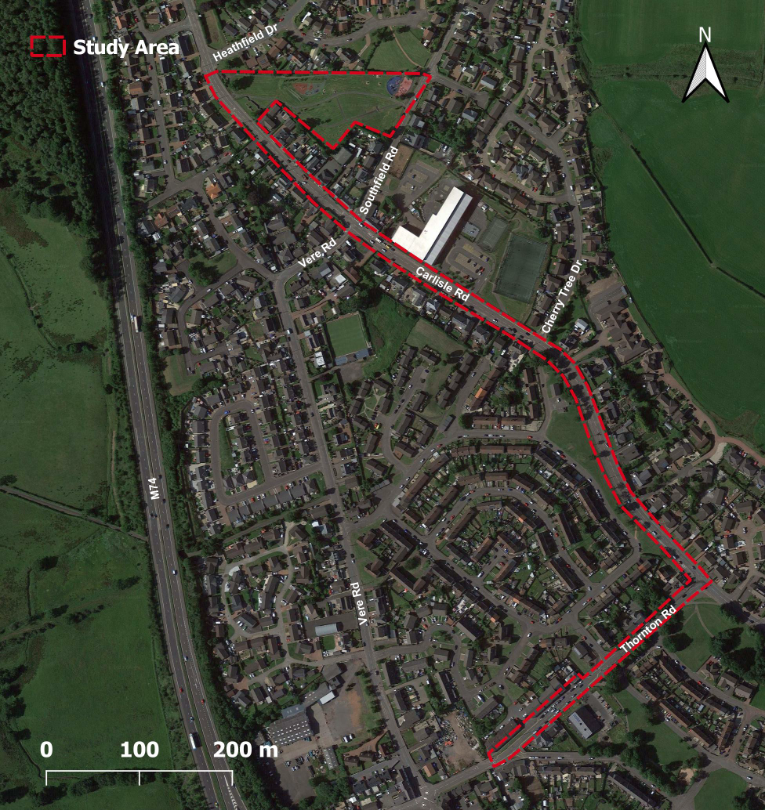
Figure 4 - Kirkmuirhill & Blackwood Study Area

Twelve Quality Criteria Summary

Protection
Protection against traffic and accidents | Protection against harm | Protection against unpleasant sensory experience
Footway provision throughout the study is of a sufficient width and widens outside the primary school to account for greater volumes. Crossing opportunities are limited with sparse formal crossing points and wide carriageway.  The section of study area on Thornton Road has increased facilities for crossing likely to support local amenities along this stretch. Traffic calming measures including ‘give way to oncoming vehicles’ are also present here.  There is no provision currently for cyclists as such will be required to mix with traffic. | Street lighting is provided throughout and is thought to be sufficient. The majority of the study area is residential or daytime businesses.  The road envelope is naturally overlooked in part by residential properties which add to feelings of safety however there are sections where properties are set back therefore does not provide the same natural surveillance. | There is limited shelter provision in the area from the elements. Carlisle Road was observed to be reasonably busy contributing to noise pollution.
Score: 2 | Score: 3 | Score: 1

Comfort
Options for mobility | Options stand and linger | Options for sitting
In general footway provision is suitable for the majority of users however there are sections of poor surfacing and some pinch points which could impact users with mobility issues. Crossing opportunities are also limited. | Sections of wider footway present the opportunity for people to stand and linger. People were observed to be making use of the space for conversations outside local amenities on Thornton Road. | Opportunities for sitting are limited throughout the study area. Benches are located near local amenities however are aged and could be considered for replacement.
Score: 2 | Score: 3 | Score: 2

Options for seeing | Options for talking and listening/hearing | Options for play, exercise, and activities
There in general is limited visual interest nearby to seating locations as the study area is typically urban. Greater aesthetics are however in Blackwood Park. | Local residents were observed to have conversations outside local amenities however in general options are limited due to traffic noise, footway widths etc. | Within Blackwood Park there is a playpark for older and younger children as well as outdoor gym equipment. No other leisure options were identified in the vicinity.
Score: 2 | Score: 1 | Score: 3

Enjoyment
Scale | Opportunities to enjoy positive aspects of climate | Experience of aesthetic qualities and positive sensory experiences
Buildings are generally two storeys and for the majority and are set back from the footway. This supports an open feel to the corridor. | The park area provides opportunities to appreciate positive aspects of climate however this is limited elsewhere due to lack of lingering opportunities or shelter. | Aesthetic qualities are limited and place mainly acts as functional.
Score: 3 | Score: 2 | Score: 2

Photo Record
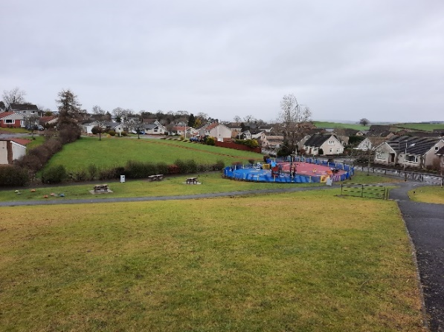  Playground  The park contains a range of play facilities, catered to different ages. | 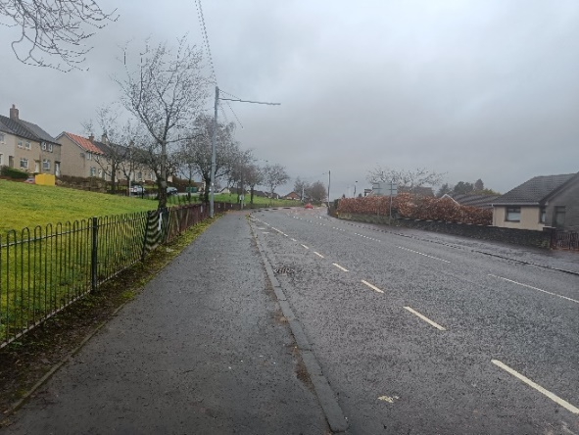  Footways  For the majority footways are of a suitable width for all users.
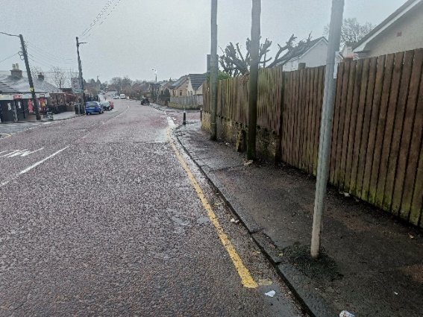  Footways  Footway conditions vary within the area with some sections of narrow and poorly surfaced. | 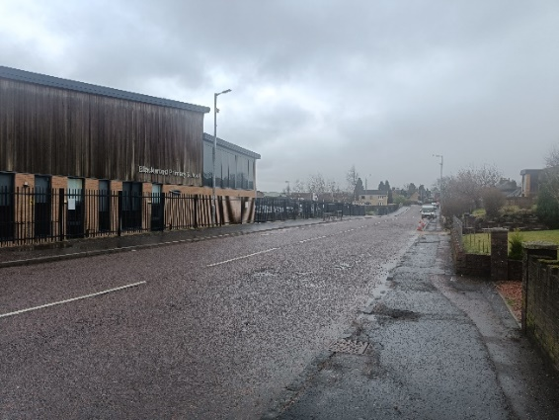  Crossing Points  There are no designated crossing points outside of the primary school.
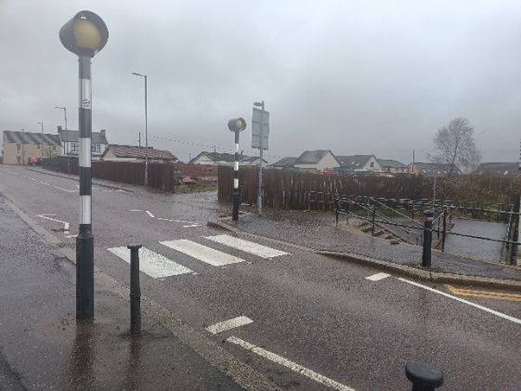  Mobility  At either end of the shopping area on Thornton Road, the carriageway narrows to a single lane with zebra crossings to slow vehicles through the area. | 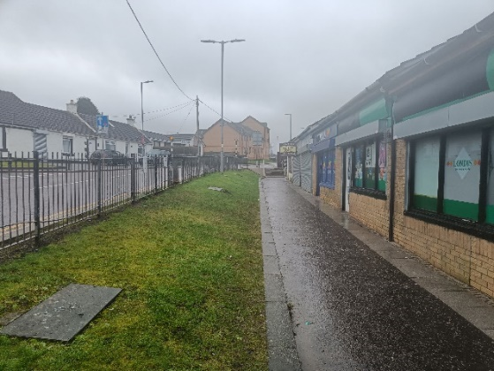  Shopping  Footways alongside the shops on Thornton Road are set back from the carriageway, helping to support the safety and experience of users.

Typical Cross Section
A typical cross section has been taken of one of the main roads within the study area, Carlisle Road, as illustrated by Figure 5 below. The road envelope is open with properties set back from the carriageway.
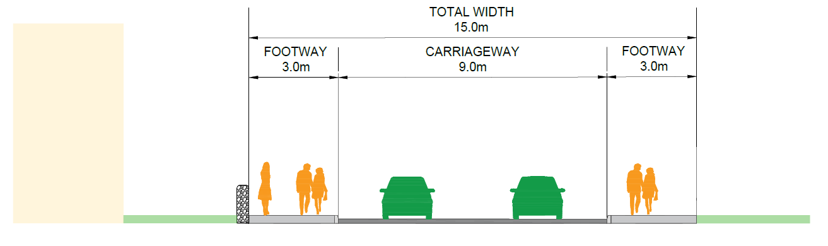
Figure 5 - Typical Cross Section Carlisle Road

Summary and Recommendations
The scoring summary diagram for Kirkmuirhill and Blackwood is shown in Figure 6 below based on the outcomes of the twelve criteria. As shown, the scores varied across the three categories of protection, comfort and enjoyment.
Figure 6 - Kirkmuirhill and Blackwood Summary Scoring

Category | Summary Observations
Protection | Although protection elements could be improved, there are measures currently within the study area which support this. In general shelter from weather elements and noise is poor given the openness of the road corridor.
Comfort | Various elements of the comfort criteria are supported within the study area with footway width supporting mobility of users and providing opportunities for socialising. Seating provision could be enhanced with options sparse and some requiring repair.
Enjoyment | In general, the opportunities associated with enjoyment are focussed within the play park off Carlisle Road elsewhere this is limited.

Recommendation
The study area is reasonably open, and you can appreciate the availability of space. There are opportunities to enhance placemaking and support safety and mobility, particularly at higher demand areas.
Recommendations for this area are to:
  - Introduce placemaking features such as seating and planters where space permits to support visual amenity
  - Provide crossing points on key desire lines such as outside Blackwood Primary School to support the movement of pedestrians
  - Options to improve shelter could also be considered to create a more desirable place to spend time outdoors
  - Consider measures to support the safety of cyclists, carriageway width would support the introduction of facilities

