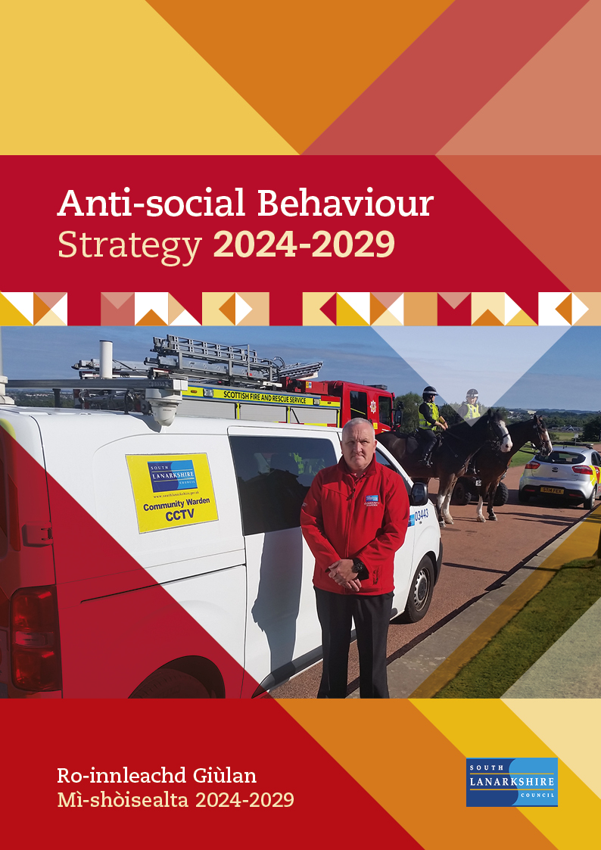

Contents

- Background and context
- What is anti-social behaviour?
- Legislative framework
- Strategic framework
- Anti-social behaviour strategy 2018-2022 – progress and achievements
- The approach to anti-social behaviour
- Strategic themes
- Equalities
- Monitoring and evaluation

Anti-social Behaviour Action Plan

Appendices

Appendix 1: Action Plan 2024-2029

Appendix 2: Links to other plans and strategies

1. Background and context
1.1 Partners in South Lanarkshire have a strong established history of working together to tackle anti-social behaviour. The purpose of this document is to set out partners shared understanding of anti-social behaviour, the priorities that require to be addressed and the actions that will be taken over the next five years to help prevent and tackle anti-social behaviour.

1.2 Anti-social behaviour is a complex, multi-faceted issue and requires a strong partnership approach to prevention, intervention, and enforcement where necessary. Perceptions, experiences, individual circumstances, and vulnerabilities can impact on victims of Anti-social behaviour, perpetrators and also the wider community. It is increasingly understood that complex health and socio-economic factors can influence anti- social behaviour.

1.3 The Anti-social Behaviour Strategy aims to contribute to the Community Planning vision of improving the quality of life for all in South Lanarkshire by ensuring equal access to opportunities and services to meet people’s needs. To do this, the council and its community safety partners adopt a person-centred approach encompassing trauma informed practice, focusing on prevention of anti-social behaviour, early and effective interventions and robust enforcement where necessary. The approach is founded upon a clear appreciation that if left unchecked, anti-social behaviour can escalate into more serious acts of criminality or disorder.

1.4 Building on this approach the anti-social Behaviour Strategy 2024-29 aims to ensure that:

- the impact of disorder, domestic noise, litter and the illegal disposal of waste is reduced across South Lanarkshire.
- responsible behaviour in relation to fire safety and the use of alcohol and drugs is promoted and improved across South Lanarkshire.
- residents across South Lanarkshire are aware of the services and support available to address anti-social behaviour.

2. What is anti-social behaviour?
2.1 Anti-social behaviour is currently defined by Section 143 of the anti-social Behaviour etc. (Scotland) Act 2004, which states that a person engages in anti-social conduct if they “Act in a manner that causes or is likely to cause alarm or distress; or pursue a course of conduct that causes or is likely to cause alarm or distress to at least one person not of the same household”. The legislation requires that “conduct includes speech; and a course of conduct must involve conduct on at least two occasions.”

2.2 It should be recognised that the above definition requires consideration alongside any associated legislation and statutory guidance.

3. Legislative framework
3.1 The Anti-social Behaviour etc. (Scotland) Act 2004 is the primary legislation for dealing with anti-social behaviour in Scotland, however as anti-social behaviour covers such a wide spectrum of behaviours this is supported by other legislation including:

  - Environmental Protection Act 1990
  - Human Rights Act 1998
  - Regulation of Investigatory Powers (Scotland) Act 2000
  - Housing (Scotland) Act 2001 (as amended in 2014)
  - Equality Act 2010
  - Community Empowerment (Scotland) Act 2015
  - Children (Care and Justice) (Scotland) Bill (Currently Stage One)
  - Data Protection Act 1998
  - General Data Protection Regulation 2016

Strategic framework
4.1 Part One of the anti-social Behaviour etc. (Scotland) Act 2004 places a statutory duty on the Local Authority and the Chief Constable of Police Scotland to prepare an anti-social Behaviour Strategy.

4.2 “Promoting positive outcomes: working together to prevent anti-social Behaviour in Scotland 2009” is the Scottish Government’s national framework which established four pillars as providing the basis for a comprehensive response to anti-social behaviour:

- Prevention
- Intervention
- Enforcement
- Rehabilitation

4.3 Prevention: requires foresight and planning in terms of taking measures which are likely to create a physical and social environment where anti-social behaviour is less likely to arise. Such measures can start before the anti-social behaviour is evident through a programme of proactive elements such as CCTV and a strong focus on education, support, community engagement and the creation of strong sustainable family environments.

4.4 Intervention: Early and effective intervention includes putting in place measures that will help to address problems at the earliest opportunity both in relation to individuals and communities. A variety of approaches and services from a range of statutory and voluntary agencies are needed to provide the choices and chances required to offer opportunities to divert people away from anti-social behaviour.

4.5 Enforcement: Enforcement should be considered when effective interventions have been tried, failed, or deemed not appropriate. Enforcement requires to be appropriate, proportionate, timely, and supported by intervention, education, support, and rehabilitation.

4.6 Rehabilitation: There is a need to understand and assess the needs of individuals and communities in order to provide long-term solutions. An understanding and perception of the impact of anti-social behaviour is necessary to fully break the cycle of offending and to provide the focus for services to fully integrate to deliver long-term solutions.

4.7 Locally, through the anti-social Behaviour Implementation Group, the council and its community safety partners identified six anti-social behaviour priority themes to be the focus of this strategy. These are:

- Alcohol and substance related anti-social behaviour.
- Fire safety in relation to anti-social behaviour.
- Disorder, rowdy or undesirable behaviour.
- Domestic Noise.
- Environmental anti-social Behaviour - Littering and fly-tipping (including inappropriate disposal of household waste and other items); Graffiti, vandalism, and property damage.
- Deliberate Fire-setting.

4.8. The themes noted above have been used to inform the outcomes which the strategy will pursue, detailed in section 7.

Anti-social Behaviour Strategy 2019-2023: Progress and achievements
5.1 Detailed below are key areas of progress and achievements made during the last strategy demonstrating the difference the anti-social Behaviour Services have made.

Strategic Outcomes | Progress and Achievements 2019-2023
People behave responsibly in their attitude to alcohol and the impact of drug misuse is reduced | Build customer understanding  During 2019/20 the play ‘Is This Me?’ was developed for schools depicting the negative effects alcohol can have on young people. As well as the play a 20-minute workshop was facilitated to explore the issues of alcohol with young people.  In 2019/20, 1,254 pupils watched the drama and 94% agreed that they would be more confident to say ‘No’ to alcohol and 86% stated they worried about the health problems linked to alcohol.  Due to the success of the play, it was digitalised in 2020/21 enabling schools to utilise on a more regular basis.  Working with shopkeepers  Bottle marking schemes were adopted throughout South Lanarkshire with Community Police carrying out initiatives within locally identified hotspots and licensed premises.  Bottles sold from licensed premises are marked and where alcohol is seized from young people, the bottles can be checked using an ultraviolet light to trace the shop it was bought from and who supplied it. Local police then worked with shopkeepers and local authority licensing authorities to prevent sale of alcohol to underaged young people.  Officers targeted known hotspot areas where large quantities of alcohol were seized from young people under 18. Follow-up visits were carried out to local premises involved in Bottle Marking to highlight the ongoing issues and two offences were detected where people were charged for supplying alcohol to young people under 18.
People behave responsibly in relation to fire safety | Effective engagement with young people  During 2021/22, the Scottish Fire and Rescue Service (SFRS) delivered six Fire Reach courses. The aim of this course is to work with young people known for fire-setting behaviours to help build relationships with SFRS and other public services and build their resilience for not engaging in anti-social behaviour.  In total 53 young people from seven secondary schools from a variety of backgrounds completed the course, including young people known for fire-setting behaviours. This was three more courses than the target, and a 76% rise (23 young people) in participation from 2019/20 when the last face-to-face courses were able to be run.  SFRS have delivered joint inputs to schools around fire related anti-social behaviour, particularly around bonfire night, and during the summer to tackle water hydrant vandalism.  Bonfire Planning  To minimise disorder and to keep people safe in relation to bonfire night, a series of meetings with partners such as SFRS and Police Scotland are set up annually. As well as discussing any issues, a contact card is developed each year and distributed to partners which eases communication between services and helps resolve potential issues quickly, recognised as best practice by the Scottish Government.
The impact of domestic noise is reduced | Early intervention to resolve domestic noise  In February 2021, a new protocol was launched between the council’s Environmental Services and Mediation Services, whereby complaints of domestic noise deemed not excessive and normal daily living noise are referred to Mediation to explore and reach agreement with neighbours to resolve.  Throughout 2021/22, promotion of services to support households experiencing domestic noise issues has continued, including publication of key information on partners’ websites and social media feeds.
Illegally discarded litter and household waste is reduced, improving the safety and attractiveness of communities | Tackling litter and household waste  The Good Neighbour project was developed during 2021/22 to encourage people to use waste collection bins correctly. This includes understanding how bin issues can escalate into neighbour disputes, affect the look of the environment, cause other environmental issues, and contribute to fire-setting.  New CCTV has also been used specifically for inappropriate waste disposal and environmental anti-social behaviour. Priority areas were identified for deployment by all partners involved, sharing information through existing structures including Community Safety HUBs and local Problem Solving Groups.
Levels of disorder are reduced, improving safety within communities | Targeted funding to improve services  Through the winter period 2020/21, enhanced weekend services were provided by Police Scotland and the council's Community Warden Service and anti-social Behaviour Investigation Team over a 20-week period to tackle disorder and anti-social behaviour. In total 1,508 visits and patrols were carried out, with a range of actions taken including arrests for drugs, weapons, breach of the peace, threatening behaviour, issuing of fixed penalty notices.  During this period there was an 83% reduction in crime and anti-social behaviour.
Partners engage with residents to promote and improve the availability of and access to services for those affected by Anti-social behaviour | Facilitating effective engagement  A range of digital and physical publicity materials were developed and delivered by partners to signpost the public to the anti-social behaviour service or partner services. This included social media posts and news articles leading to an increased awareness of the service, with one article on the role of community wardens being viewed 3,090 times.  Positive Intervention  In 2021/22, the number of mediation referrals increased by 39% from the previous year to 246. This continues a positive trend of increasing the use of mediation to prevent anti-social behaviour disputes escalating and to prevent future anti-social behaviour occurring.  Victim Support  The Community Safety Partnership (CSP) allocated funding to Victim Support for an anti-social Behaviour Support Co-ordinator over the lifetime of the previous strategy. During this time, 404 referrals were made to Victim Support in relation to people experiencing anti-social behaviour.  In response to one of these referrals, Victim Support provided emotional and practical support to a family while an anti-social behaviour investigation was carried out. A safety assessment at the property was undertaken and additional security was provided through the Victim Support Scotland Emergency Assistance Fund. As a result, the family felt safer at home while the investigation was completed.

The approach to anti-social behaviour
6.1 All partners involved in the development of this strategy understand the need to work collaboratively to achieve the common goals of keeping local communities safe and making the public feel safe. The council and its community safety partners recognise that tackling anti-social behaviour is not the responsibility of one single agency, and collectively this strategy provides a commitment to ensuring that effective information sharing and joint working approaches will continue to prevent problems and ensure effective early interventions. Prior to implementation the anti-social Behaviour Strategy requires formal approval from South Lanarkshire Council’s Executive Committee and Police Scotland.

6.2 This anti-social Behaviour Strategy provides the framework by which community safety partners will work together to tackle anti-social behaviour across South Lanarkshire over the next five years. It builds upon the strong partnership arrangements which are already in place and have a strong track record in delivering valuable services in South Lanarkshire. The diagram below shows the links between each of the community safety partners.
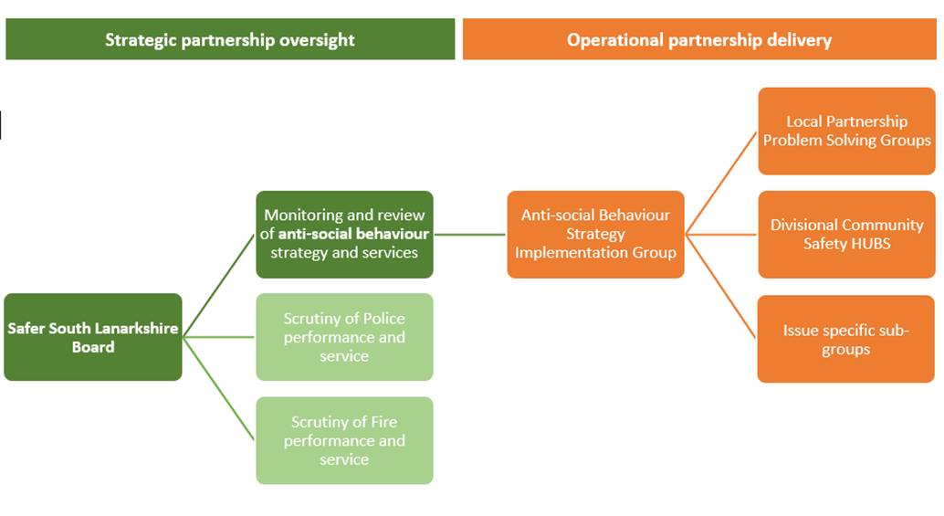

6.3 Strong partnership working is evident throughout this strategy and action plan, which can be found in Appendix 1, in the form of initiatives involving community safety partners such as Police Scotland, the Scottish Fire and Rescue Service, as well as council services and other agencies.

6.4 One example of partnership working, as highlighted within section 5 of the strategy, is where young people were referred by Police Scotland to the Fire Reach Programme which aims to develop key skills including team-working, leadership, confidence building and communication skills. The young people gained a Fire Skills Employability Award, an accredited learning programme which allows them to evidence training and identify transferable skills to help with education and employment opportunities.

6.5 To support the joint approach to tackling anti-social behaviour, a number of strategic, operational, and local groups have been established, as well as a series of specialist services.

6.6 The Safer South Lanarkshire Board delivers the council’s statutory function under the Police and Fire Reform (Scotland) Act 2012 of approving local police and fire plans and scrutinising their implementation. Membership of the Board consists of:

- South Lanarkshire Council
- Police Scotland
- Scottish Fire and Rescue
- Crown Office and Procurator Fiscal Service
- NHS Lanarkshire
- South Lanarkshire Alcohol and Drug Partnership
- Victim Support Scotland

6.7 The Anti-social Behaviour Implementation Group (ASBIG) has been in place since 2004 and is responsible for directing, monitoring, and reporting on progress made in relation to the strategy.

6.8 Local Problem Solving Groups bring together the council and community safety partners to establish a common understanding of anti-social behaviour and deliver a collaborative and consistent approach to tackling it. Six local problem solving groups operate across South Lanarkshire in the following areas:
- Hamilton
- East Kilbride and Strathaven
- Blantyre, Bothwell and Uddingston
- Clydesdale
- Larkhall
- Rutherglen and Cambuslang

6.9 The Joint Problem Solving Unit brings together a range of specialised anti-social behaviour services which provide a co-ordinated response to addressing problems and preventing escalation. The unit is made up of the:

- Police Scotland Local Authority Liaison Officer
- Anti-social Behaviour Investigation Team
- Mediation Service
- Community Warden Service

6.10 The Joint Problem-Solving Unit aims to prevent anti-social behaviour, or where this is unavoidable endeavour to ensure effective interventions are carried out as early as possible. Anti-social Behaviour Investigators may attend interviews with prospective new tenants, formal tenancy agreement signings or new tenant Settling In Visits in partnership with Housing Officers, to ensure that:

- all appropriate supports are in place for successful tenancy sustainment.
- expectations and responsibilities within the tenancy agreement are understood and adhered to.
- the anti-social behaviour approach and the potential consequences of anti-social behaviour are explained.

6.11 Community Safety Hubs originated in 2019 bringing together partners such as Police Scotland and the council’s Joint Problem Solving Unit to discuss and coordinate potential resolutions to anti-social behaviour issues. More recently Scottish Fire and Rescue Service have joined the community safety hubs as well as local housing staff.

6.12 The Community Safety Hubs take place weekly in Cambuslang and Rutherglen, Clydesdale, East Kilbride, and Hamilton housing divisions, and this exchange of information and robust partnership working ensures that the most appropriate support, prevention and early interventions are in place to adopt a problem solving approach and stop matters escalating.

Outcomes
7.1 The strategy intends to deliver the following outcomes:

- People behave responsibly in their attitude to alcohol and are educated in relation to the impact of drugs, with actions including reducing the impact of alcohol related anti-social behaviour by promoting responsible behaviour in the sale of alcohol amongst retailers and delivering drug education workshops to schools in areas assessed as at highest risk.
- People behave responsibly in relation to fire safety, with actions including the delivery of education programs to raise awareness of fire risk from refuse related anti-social behaviour.
- Domestic noise has less impact on people’s lives, with actions including early intervention and joint working with residents responsible for domestic noise to prevent escalation.
- Litter and household waste is reduced, improving the safety and attractiveness of communities, with actions including the development of promotional material to raise awareness of the financial cost of littering, the development of preventative approaches to encourage the safe disposal of household waste, and the delivery of targeted patrols and Fixed Penalty Notices where inappropriate disposal of waste is identified.
- People can live safely in communities, with levels of disorder reduced, with actions the use of CCTV to identify those responsible for disorder and anti-social behaviour, the delivery of targeted diversionary activities to prevent and reduce levels of disorder, and the delivery of intensive support to address problematic behaviours.
- Services for people affected by anti-social behaviour are easily accessible, with actions including the regular promotion of services for people affected by anti-social behaviour including mediation, the warden service, the anti-social Behaviour Investigation Team, and Victim Support.

Equalities
8.1 The council and its community safety partners are committed to encouraging equal opportunities and will work to actively remove any barriers that stop customers getting involved and ensure that all customers have equal access and an opportunity to take part.

8.2 To ensure that customers are treated fairly and are not disadvantaged in any way an Equality Impact Assessment will be carried out on this strategy to identify and mitigate any negative impacts and seek opportunities to promote equality.

8.3 In relation to the Fairer Scotland Duty a Fairer Scotland Duty Assessment will also be completed.

Monitoring and evaluation
9.1 Effectively monitoring and evaluation of the strategy is essential to assess success and ensuring that the required objectives are delivered. An annual review will be carried out to identify the success of the measures in relation to the actions and an annual report will be submitted each year to Executive Committee advising whether:

- the priorities and actions set out in the strategy are being effectively progressed.
- the actions are delivering the strategic objectives.
- any requirement to review actions or measures.

Appendix 1: Anti-social Behaviour Action Plan

Outcome 1: People behave responsibly in their attitude towards alcohol and are educated in relation to the impact of drugs.

Ref. | Action | Start | Milestone/Target | Lead Partner | Progress
A1.1 | Promote responsible behaviour in the sale of alcohol amongst retailers. | 2024/2025 | Annual | Police Scotland
A1.2 | Community Safety HUBs to identify areas/ target groups responsible for anti-social behaviour caused by alcohol consumption. | 2024/2025 | Annual | Police Scotland  (on behalf of Community Safety Hubs)
A1.3 | Partner agencies to co-ordinate and deliver interventions/diversionary activities in identified areas to target groups responsible for anti-social behaviour caused by alcohol. | 2024/2025 | Annual | Police Scotland
A1.4 | Develop annual programme of communication/activities to promote positive behaviours in relation to alcohol consumption among young people. | 2024/2025 | Annual | Education Resources
A1.5 | Deliver drug education workshops to schools in areas assessed as at highest risk | 2024/2025 | Annual | Police Scotland

Ref. | Measures | Baseline | Target | Responsibility | Progress
M1.1 | The number of reported crimes of young people under aged 18 public drinking | 3 | Monitor against baseline
M1.2 | The number of people convicted of supplying alcohol to young people under 18. This applies to people running or working in a pub or shop, a parent or guardian, or anyone else. | 2 | Monitor against baseline
M1.3 | The number of drug education workshops delivered to schools in areas assessed as highest risk | 697 | Maintain against baseline

Outcome 2: People behave responsibly in relation to fire safety.

Ref. | Action | Start | Milestone/Target | Lead Partner | Progress
A2.1 | Community Safety HUBs to identify areas/target groups responsible for secondary fires and anti-social behaviour caused by rubbish accumulations. | 2024/2025 | Annual | Scottish Fire and Rescue Service
A2.2 | Deliver ‘Common Sense’ programme across localities identified as hot spots for secondary fires/rubbish accumulations to raise awareness and educate against refuse related anti-social behaviour. | 2024/2025 | Annual | Joint Problem Solving Unit
A2.3 | Co-ordinate and deliver contact cards to each partner with operational details and support mechanisms in relation to organized fireworks and bonfire activities. | 2024/25 | Annual | Joint Problem Solving Unit

Ref. | Measures | Baseline | Target | Responsibility | Progress
M2.1 | The number of deliberate secondary refuse fires attended by Scottish Fire and Rescue Service | 505 | Reduce against baseline | Scottish Fire and Rescue Service
M2.2 | The number of reported crimes of wilful fire raising | 153 | Reduce against baseline | Police Scotland
M2.3 | The number of fire related education programmes taking place in schools with regard to anti-social behaviour. | 67 | Monitor against baseline | Scottish Fire and Rescue Service

Outcome 3: Domestic noise has less impact on people’s lives.

Ref. | Action | Start | Milestone/Target | Lead Partner | Progress
A3.1 | Early intervention and joint working with residents responsible for domestic noise to remind them of potential consequences | 2024/2025 | Annual | Community and Enterprise Resources/  Housing and Technical Resources
A3.2 | Provide advice and assistance to those experiencing this type of anti-social behaviour | 2024/2025 | Annual | Community and Enterprise Resources/  Housing and Technical Resources

Ref. | Measures | Baseline | Target | Responsibility | Progress
M3.1 | Domestic noise complaints requiring attendance on site by Environmental Health, average time (hours) between time of complaints to attendance on site | 2,775 of which 1,133 required a visit by officers.  Average response time for complaints requiring a visit by officers was 35.4 minutes | No target - for monitoring purposes only | Community and Enterprise Resources  (Environmental Services)

Outcome 4: Litter and household waste is reduced, improving the safety and attractiveness of communities.

Ref. | Action | Start | Milestone/Target | Lead Partner | Progress
A4.1 | Develop promotional materials that will raise awareness of the financial costs of littering and the impact this has on the ability to deliver other council services | 2024/2025 | Annual | Community and Enterprise Resources
A4.2 | Develop and implement prevention and early intervention programmes within targeted communities to encourage local residents to dispose of household waste responsibly, appropriately and safely | 2024/2025 | Annual | Community and Enterprise Resources
A4.3 | Deliver targeted patrols within areas and issue Fixed Penalty Notices to those identified as responsible for inappropriate disposal of litter and household waste | 2024/2025 | Annual | Community and Enterprise Resources

Ref. | Measures | Baseline | Target | Responsibility | Progress
M4.1 | The number of fly-tipping occurrences within the council area. (Grounds Services) | 2994 | Reduce against baseline | Community and Enterprise Resources  (Grounds Services)
M4.2 | The number of Fixed Penalty Notices(FPNs) issued for inappropriate disposal of litter and household waste. (Environmental Services) | Fly Tipping FPNs - 20  Litter FPNs -1 | No target - for monitoring purposes only | Community and Enterprise Resources  (Environmental Services)

Outcome 5: People can live safely in communities, with levels of disorder reduced.

Ref. | Action | Start | Milestone/Target | Lead Partner | Progress
A5.1 | Community Safety HUBs to continue to identify areas/target groups responsible for  anti-social behaviour disorder. | 2024/2025 | Annual | Joint Problem Solving Unit
A5.2 | Deliver a range of actions to tackle reported incidents of anti-social behaviour relating to disorder, including:  - Utilise deployable CCTV to identify those responsible, discourage anti-social behaviour disorder and provide public re- assurance.  - Targeted and structured diversionary activities delivered across South Lanarkshire. | 2024/2025 | Annual | Joint Problem Solving Unit
A5.3 | Problem Solving Groups to develop a multi-agency approach to tackling disorder issues at a local area level through prevention and direction of resources. | 2024/2025 | Annual | Joint Problem Solving Unit
A5.4 | Breaking the Cycle Service will provide intensive housing support to families displaying anti- social behaviour, and other housing management issues, that require input to help them to sustain their tenancy.  A Breaking the Cycle Support Officer will provide representation at the weekly anti-social Behaviour hubs to offer advice and assistance with families identified as benefitting from intervention. | 2024/2025 | Annual | Housing and Technical Resources

Ref. | Measures | Baseline | Target | Responsibility | Progress
M5.1 | Number of ASB incidents discussed at the HUB. | 2724 | No target for monitoring purposes only | Joint Problem Solving Unit
M5.2 | Number of Group Six crimes (anti-social behaviour offences) which include:-  Breach of the Peace | 3462 | Reduce against baseline | Police Scotland
M5.2 | Urinating/defecating in public | 21 | Reduce against baseline | Police Scotland
M5.2 | Drunk and incapable | 5 | Reduce against baseline | Police Scotland
M5.2 | Racially aggravated crimes | 57 | Reduce against baseline | Police Scotland
M5.2 | Licensing offences | 26 | Reduce against baseline | Police Scotland
M5.2 | Drinking in public | 191 | Reduce against baseline | Police Scotland
M5.3 | Number of ASB Vandalism incidents received by the Police. | 1681 | Reduce against baseline | Police Scotland

Outcome 6: Services for people affected by anti-social behaviour are easily accessible.

Ref. | Action | Start | Milestone/Target | Lead Partner | Progress
A6.1 | Promote awareness, availability and encourage uptake of Victim Support Service to victims of anti-social behaviour. | 2024/2025 | Annual | Victim Support Scotland
A6.2 | Continue promoting awareness of ASB services including Anti-social Behaviour Investigation Team, mediation service and warden service to all partners and stakeholders to encourage uptake and reporting. | 2024/2025 | Annual | Partners
A6.3 | Provide advice and assistance to those affected. | 2024/2025 | Annual | Housing and Technical Resources
A6.4 | Develop and deliver an annual programme of engagement to continue promoting awareness through the Communications Strategy on the range of anti-social behaviour services | 2024/2025 | Annual | Joint Problem Solving Unit
A6.5 | Promote the availability of anti-social behaviour performance information to the public, including:  - Anti-social Behaviour Annual Charter Return (Scottish Housing Regulator)  - Local Police Plan  - Local Scottish Fire and Rescue Plan | 2024/2025 | Annual | Partners

Ref. | Measures | Baseline | Target | Responsibility | Progress
M6.1 | Number pf referrals and percentage from South Lanarkshire for ASB to Victim Support  Number and percentage of referrals for ASB who engaged with the service to Victim Support | 81(100%)  60 (74%) | No target for monitoring purposes only | Victim Support Scotland
M6.2 | Number of referrals made to the SLC Mediation Services for community mediation | 418 | Increase against baseline | Joint Problem Solving Unit

Appendix 2: Links to other plans and strategies

The strategy is aligned with a range of other key strategies and plans including:

South Lanarkshire Council Community Plan 2022-2032
The new community plan for South Lanarkshire sets out local outcomes the Community Planning Partnership will prioritise for improvement to achieve better outcomes for people across South Lanarkshire.

Connect 2022-2027, South Lanarkshire Council Plan
The Council Plan sets out the council’s vision, 'to improve the quality of life for everyone in South Lanarkshire'. The strategy identifies nine priority outcomes which contribute to the wider community planning agenda in tackling poverty and disadvantage within communities.

South Lanarkshire Council Local Housing Strategy 2022-2027
The strategy sets out how the council and its partners will ensure South Lanarkshire has good quality housing of the right tenure, type and size in the right places to meet the range of needs and aspirations of residents.

South Lanarkshire Council Housing and Technical Resources Resource Plan 2023-2024
The Resource Plan sets out the intended outcomes and priorities for 2023-2024. This is the main annual business planning document for the Resource and reflects the council’s key priorities as set out in the council plan ‘Connect’ and provides an overview of the Resource’s main areas of activity.

South Lanarkshire Community Justice Outcome Improvement Plan 2024-29
The South Lanarkshire Community Justice Outcome Improvement Plan 2024-2029 sets out the strategic planning and development of community justice services in South Lanarkshire. This comprises of service delivery that enables rehabilitation of people who re-offend by tackling the root causes of why they offend and, by reducing the stigma that causes stress and social isolation for both them and their families.

South Lanarkshire Council Litter Strategy 2022-27
The Litter Strategy aims to make South Lanarkshire a cleaner place to live, work and visit; free of litter, fly-tipping, and dog waste. The strategy sets out a range of objectives, outputs, activities and expected outcomes for the council, its partners and its communities.

Police Scotland - Joint Strategy for Policing 2023-2026
The local police plan for 2023-2026 sets out the three key priorities of protecting communities, safeguarding citizens, and enhancing services to deliver the central aim of improving the safety and wellbeing of the people and communities in South Lanarkshire.

Scottish Fire and Rescue Service – Strategic Plan 2022-2025
The Scottish Fire and Rescue Strategic Plan sets out the intended outcomes and priorities from 2022-2025, in line with the Fire and Rescue Framework for Scotland 2022. These high-level outcomes cover Prevention and Protection, Response, Innovation and Modernisation, Climate Change, Effective Governance and Performance, Partnership and People.

Victim Support Scotland Strategy 2021-2026
The Victim Support Scotland Strategy 2021-2026 aims to empower people affected by crime by providing high quality, outcome focussed support and care to all those who need it and building productive partnerships aimed at improving the experiences of those affected by crime.

If you need this information in another language or format, please contact us to discuss how we can best meet your needs. Phone 0303 123 1015 or email equalities@southlanarkshire.gov.uk

