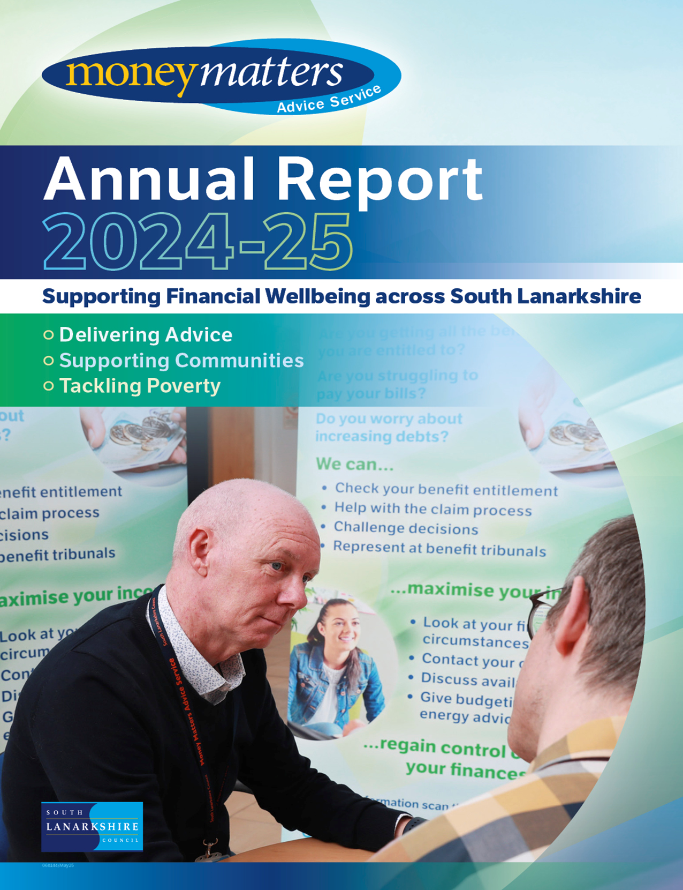

Contents
Introduction
How we calculate financial gains
Community Wellbeing Team
Welfare Rights Team
Money Advice Team
Empowering communities: The role of MMAS community hubs
Supporting vulnerable groups in South Lanarkshire
Cash First project
Overview of scheme delivery (2024-25)
Project work: Targeted support through strong partnerships
Achieving accreditation: Scottish national standards for advice and information providers
Supporting South Lanarkshire’s child poverty commitments
Responding to South Lanarkshire’s housing emergency
Client demographics 2024-25
Clients by Scottish Index of Multiple Deprivation (SIMD)
Reaching clients across South Lanarkshire
Customer satisfaction – listening to the voices of residents
Case studies
Appendix: Electoral ward update

If you need this information in another language or format, please contact us to discuss how we can best meet your needs. Phone 0303 123 1015 or email equalities@southlanarkshire.gov.uk

Introduction
This year’s report provides an overview of our work supporting individuals and families facing financial hardship across South Lanarkshire and highlights the essential role the Money Matters Advice Service (MMAS) continues to play in tackling fuel poverty, child poverty, the housing emergency, and wider inequalities in health and wellbeing.
MMAS is South Lanarkshire Council’s dedicated advice service, offering free, confidential support on welfare benefits, energy advice, problem debt, and crisis assistance. At a time when the cost-of-living crisis continues to impact households across the region, our service has remained at the frontline of support helping people maximise their income, access vital benefits, reduce debt, and stabilise their housing and energy situations.
“Money Matters has possibly been a life saver for me. It was the DWP I was dealing with. It has been almost 6 months now where the pressure was taken off me thanks to Money Matters. There are still a few things to tie up. Then I can get on with enjoying my Retirement without any further issues.”
We have continued to strengthen our response to fuel poverty through our partnerships with SGN and the Fuel Bank Foundation, particularly among residents who rely on prepayment meters. Our advisers provide energy efficiency advice, support access to fuel vouchers, help with charitable energy funds, and ensure clients are on energy providers' Priority Services Registers.
In the fight against child poverty, MMAS plays a critical role by securing benefits such as Scottish Child Payment and Best Start Grants, ensuring that families receive their entitlements and gain the financial security needed to support their children’s wellbeing and future.
Following the council’s declaration of a housing emergency in June 2024, MMAS has expanded its efforts to prevent homelessness. Through advice on mortgage and rent arrears, Discretionary Housing Payment applications, and income maximisation, we support residents to remain in their homes and avoid crisis escalation.
This year also marked significant progress in the council’s involvement with the Marmot Project, which aims to reduce health inequalities by addressing their social causes. MMAS contributes directly to this goal by promoting financial security, enabling people to take control of their circumstances, and offering support that upholds dignity and fairness.
As this report shows, MMAS remains a key strategic partner in building a fairer, healthier South Lanarkshire.

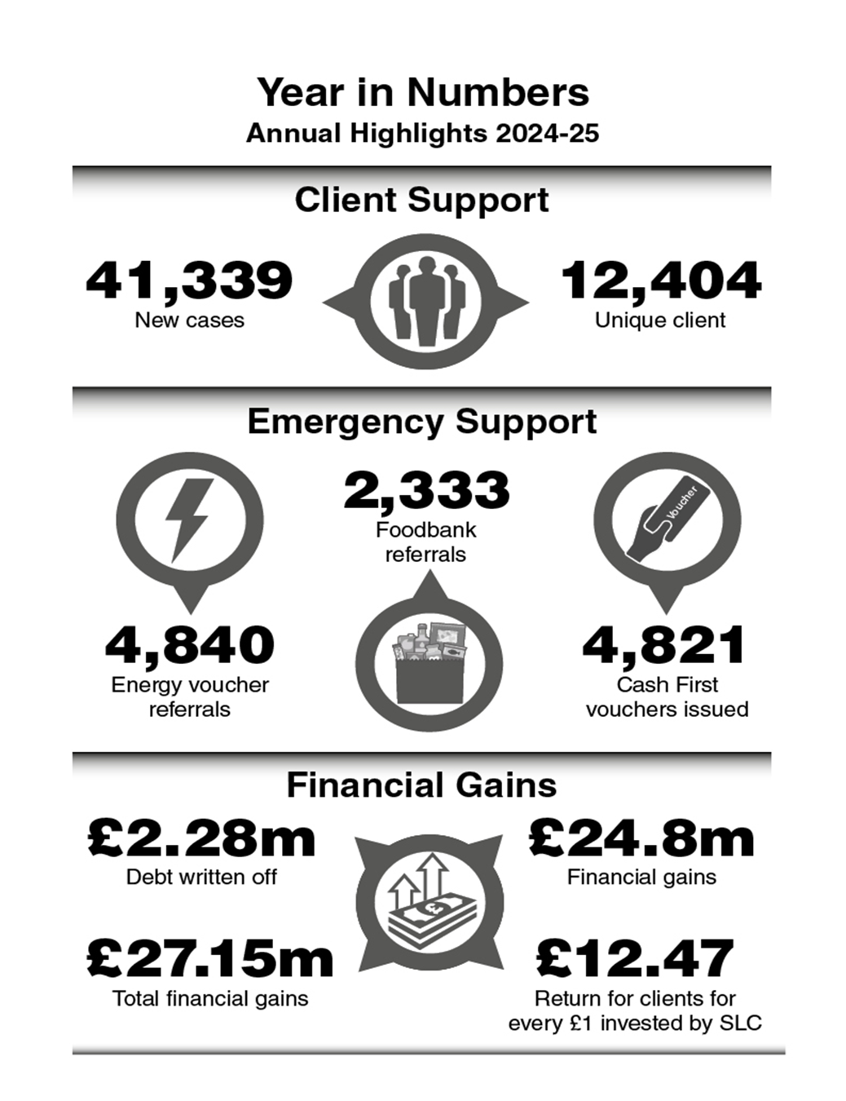

How we calculate financial gains
MMAS is frequently asked how it calculates and report the financial gains achieved on behalf of our service users. Transparency and confidence in our reporting are essential, as these figures are a critical measure of our impact across South Lanarkshire.
We use the AdvicePro case management system, developed by Advice UK, a national charity supporting advice services. This system is widely used across the UK, particularly within local authority advice services and is tailored to record welfare rights, energy, and money advice outcomes. Advisers input financial results in real time, which are then aggregated using an automated, nationally recognised calculation process.
Our methodology aligns with standards agreed in partnership with the Improvement Service under the Scottish Government-funded Advice Insights Project. This framework ensures that all local authorities and funded advice agencies report data consistently, allowing for benchmarking and performance evaluation across services such as MMAS and Citizens Advice Bureaux.
Financial gains from welfare benefits are calculated in two parts: (1) ongoing entitlements are annualised, projected over a 12-month period or shorter if applicable, and (2) lump-sum, backdated, or one-off payments are added to determine the total gain. For instance, a client receiving £110.40 per week in Adult Disability Payment and a backdated award of £3,292.68 would have an annual gain of £9,033.48 (£3,292.68 + (£110.40*52)).
Debt-related gains are reported only when debts are formally written off through negotiation, dispute resolution, or statutory options like bankruptcy. While reduced monthly payments (such as through the Debt Arrangement Scheme) can significantly benefit clients, these are not included under national reporting guidance, meaning the true financial benefits of the service are often underreported.
Return on Investment (ROI) is another key metric for evaluating the value of our service. This compares the total financial gain achieved for clients against the cost of running the service. In 2024-25, MMAS helped secure over £27.1 million in financial gains. With annual running costs for South Lanarkshire Council of around £2.18 million, this equates to a return of more than £12.47 for every £1 invested by South Lanarkshire, a strong ROI that underscores the economic and social value of our work.
All reported gains are verified, either through client confirmation or official award letters, unless awards are automatic (such as, Child Benefit), in which case verification is not needed. Our robust internal audit process, recently validated through the Scottish National Standards accreditation process, ensures continued accuracy and integrity in our reporting.

Community Wellbeing Team
The Community Wellbeing Team continues to be the first point of contact for clients accessing the MMAS. Since taking over the triage function in late 2023, the team has been instrumental in delivering same-day crisis support while ensuring that clients are swiftly directed to the most appropriate service within the wider team.
In 2024-25, the team handled more than 23,263 telephone enquiries (an increase of 5% on 2023-24 figures) and processed 5,943 digital referrals via the council’s website (up 23% from 2023-24). With a 97% success rate for same-day processing of foodbank and fuel support referrals, the team remains a vital safety net for South Lanarkshire residents facing immediate hardship.
As part of its crisis response, the team administered 4,634 Cash First cases and made 2,333 referrals to food banks, often acting as a major line of support for clients struggling with sudden financial shocks, such as bereavement, unemployment, or unexpected household costs. The team worked in close partnership with Hamilton, East Kilbride, and Clydesdale Citizens Advice Bureaux to deliver the Cash First initiative, ensuring clients had access to practical and immediate financial help.
“Have used this service a few times and can honestly say all staff that I have interacted with have been very helpful and supportive.”
Beyond crisis intervention, the Community Wellbeing Team conducts financial wellbeing checks, including benefit checks, to identify income maximisation opportunities and ensure no entitlement goes unclaimed. Many clients are also signposted to the Money Advice or Welfare Rights Teams for ongoing support with debt or benefit issues, ensuring that short-term help is matched with longer-term solutions.
The human impact of this work is significant. Whether helping a bereaved widow navigate new entitlements or supporting a single father with children during the school holidays, the team’s work consistently prevents financial distress from escalating into deeper poverty.
Feedback from both clients and external reviews has highlighted the professionalism, compassion, and efficiency of the team. As MMAS’ first line of defence against financial hardship, the Community Wellbeing Team continues to deliver accessible, person-centred support that reflects the values and aims of the wider Service.

Welfare Rights Team
The Welfare Rights Team plays a central role within the MMAS, ensuring that South Lanarkshire residents can access the full range of social security benefits and entitlements available to them. In 2024-25, the team continued to make a meaningful impact by securing financial stability for thousands of households, particularly those facing disadvantage due to ill-health, disability, unemployment, or low income.
This year, the team supported over 10,798 individuals and families, delivering advice and tribunal representation across a wide range of benefit issues. A total of £24.8 million in financial gains was generated on behalf of clients. These gains represent not only backdated awards and ongoing entitlements but also a lifeline for households struggling with the cost-of-living crisis, and emergency support provided by the Community Wellbeing Team.
The team’s work spans the full spectrum of welfare rights support, including benefit checks, form-filling assistance, challenging decisions, return to work calculations and representation at tribunals. Specialist knowledge of complex benefits such as Adult Disability Payment (ADP), Pension Age Disability Payment (PADP), and Universal Credit (UC) ensures that residents receive expert help at every stage of the process.
“Money matters have been a big help for me as I suffer from Dyslexia Dyscalculia and Dyspraxia. They have always been very understanding and helpful, helping me to fill out forms and understand information “
An essential part of the Welfare Rights Team’s success lies in its collaborative working across council services and with external partners, including NHS Community Link Workers who are embedded in GP surgeries and our own Cost of Living worker who is embedded in Hairmyres Hospital.
The team continues to prioritise early intervention and prevention. This year, to support this a focus was placed on assisting residents with managed migration onto Universal Credit and in supporting Kinship Carers who were at risk of experiencing a significant disadvantage as part of the transfer from legacy benefits like Child Tax Credits to Universal Credit.
The Welfare Rights Team also delivered training sessions for front-line staff across the council along with external partners, helping to strengthen the organisation’s ability to identify potential benefit entitlement and make timely referrals.
By maximising household income, improving financial resilience, and reducing inequality, the Welfare Rights Team continues to be a vital part of South Lanarkshire’s efforts to address poverty and support the most vulnerable in our communities.

Money Advice Team
The Money Advice Team provides essential support to individuals and families struggling with problem debt and financial insecurity. In 2024-25, the team worked with over 1,990 unique new clients, helping them manage unmanageable debt, avoid crisis situations, and regain control over their finances.
The team offers free, confidential, and impartial advice on a wide range of money matters, including rent and mortgage arrears, council tax debt, fuel debt, and credit card and loan issues. Advisors provide tailored budgeting support, negotiate affordable repayment plans with creditors, and offer support on formal debts solutions such as Debt Arrangement Schemes, Trust Deeds, and bankruptcy where appropriate.
Over the past year, the Money Advice Team helped clients manage more than £11 million of problem debt. Beyond the figures, the impact on people’s lives has been profound helping to reduce stress, prevent eviction and homelessness, and improve overall wellbeing.
With the cost-of-living crisis continuing to affect households across South Lanarkshire, demand for debt advice has remained high. The team has responded by increasing outreach through community hubs and working closely with other council services such as Housing, Social Work and Benefit and Revenue services, to ensure that help is accessible when and where it is needed most.
“I approached money matters 8 years ago to help with my debt, and they really helped. I am now out of the debt due to the help they provided and am extremely grateful. Thanks so much!”
A key focus this year, has been on early intervention and prevention. The team has strengthened referral pathways with internal council services and third-sector partners, ensuring that clients are signposted to money advice at the earliest signs of financial difficulty.
Also, in response to South Lanarkshire Council’s declared housing emergency, the Money Advice Team plays a vital role in preventing homelessness. The team supports residents facing rent or mortgage arrears by offering expert debt advice and negotiating affordable repayment plans. By addressing housing-related debt early, the service helps individuals and families to remain in their homes. This targeted intervention is a key part of the council’s wider strategy to respond to growing housing pressures and continuing high demand for support.
By helping residents to stabilise their financial situation and build long-term resilience, the Money Advice Team continues to play a vital role in reducing poverty and promoting financial inclusion across South Lanarkshire.

Empowering communities: The role of MMAS community hubs
MMAS participates in several community hubs, and this is a cornerstone of our outreach strategy, bringing essential advice directly into South Lanarkshire’s neighbourhoods. These hubs operate as monthly drop-in centres, offering residents accessible, face-to-face support on issues ranging from benefit entitlements, energy advice and debt management.
The hubs that MMAS participates in are community-led events, organised by local groups, with venues carefully selected to ensure they are within walking distance for many residents, especially those who may face challenges accessing online or centralised services.
The importance of these hubs extends beyond convenience. They serve as vital touchpoints for early intervention, helping individuals and families address financial concerns before they escalate. By providing timely advice on benefit claims, debt solutions, and budgeting, the hubs play a crucial role in enhancing financial resilience within the community.
“Amazing service. Invaluable to see and talk to someone face-to-face. Kept in touch by phone and email. Need more face-to-face appointments for people my age.”
Moreover, the hubs foster a sense of community empowerment. Residents are not only recipients of advice but also active participants in their own wellbeing. This collaborative approach builds trust and encourages ongoing engagement with MMAS services.
In addition to advice, the hubs also offer access to other resources such as carbon monoxide monitors, provided by our partners, SGN to address broader aspects of household safety and wellbeing.
The success of the community hubs underscores the value of localised, accessible support services. As we look to the future, MMAS remains committed to expanding and adapting our community outreach to meet the evolving needs of South Lanarkshire’s residents.
For more information on hub locations and schedules, please visit the MMAS page on South Lanarkshire Council website.

Supporting vulnerable groups in South Lanarkshire
MMAS plays a critical role in supporting vulnerable individuals and families across South Lanarkshire. As detailed in this report MMAS provided tailored support to over 12,400 clients in 2024-25, delivering £27.15 million in financial gains through welfare benefits and debt advice and by providing emergency assistance.
A significant proportion of MMAS clients face multiple vulnerabilities: 56% are women, 30.93% are economically inactive due to sickness or disability, and 51% have incomes under £6,000. Notably, 84% of clients report a health condition, including 38% with mental health challenges. The service also sees high engagement from single-parent households and from individuals over the age of 60, who are at increased risk of isolation and energy poverty.
MMAS plays a crucial role in supporting individuals living in the most deprived communities, with 80% of clients coming from areas ranked within deciles 1–5 of the Scottish Index of Multiple Deprivation (SIMD). These communities often encounter significant barriers to accessing mainstream support, and MMAS provides a vital bridge, ensuring fair and inclusive access to entitlements and advice for those who need it most.
“If the person I was speaking to didn't deal with the issues I brought up, they forwarded me to someone who could.”
Vulnerable groups in South Lanarkshire often face complex challenges, ranging from delays in accessing benefits to difficulties navigating appeals processes and managing debt. MMAS plays a vital role in addressing these issues by offering timely, expert support that can prevent financial crises and reduce reliance on emergency resources such as food and fuel banks. The service also complements and relieves pressure on other frontline agencies, such as Citizens Advice Bureaux, by offering specialist guidance tailored to individual circumstances.
MMAS remains committed to prioritising those most in need, ensuring that disabled individuals, single parents, older adults, and low-income households receive the support they require. By focusing on emergency triage and holistic advice, MMAS helps clients build long-term financial resilience and navigate periods of hardship with greater confidence and stability.
In short, MMAS does more than provide advice, it protects the most vulnerable, reduces poverty, and helps uphold the dignity and wellbeing of South Lanarkshire’s residents. The service is essential for many of our clients and often transformative for those most in need.

Cash First project
Launched in October 2023 by MMAS and funded by South Lanarkshire Council through the Local Authority COVID Economic Recovery (LACER) Fund, the Cash First Scheme has been delivering rapid financial relief to residents in crisis. Building on the success of the Financial Wellbeing Support Fund (June 2022-June 2023), this initiative has taken a more direct and responsive approach, providing £50 emergency PayPoint vouchers for households experiencing food or fuel insecurity.
Unlike its predecessor, which linked support to advice engagement, Cash First puts dignity and autonomy at the heart of its intervention. Vouchers can be used at local retailers, offering recipients choice and control in times of acute financial stress.
The program was awarded £425,000 in August 2023, aiming to assist 4,250 households annually through to August 2025. Eligibility criteria remain deliberately inclusive: any South Lanarkshire resident experiencing a food or fuel emergency, and who has not accessed the scheme within the past three months, may apply—regardless of employment status.

“Considering how busy they are, I found accessing the service really easy and they also explained very clearly the waiting times due to high demand”
In recognition of the hardship caused by the transition to Universal Credit, the scheme was further expanded in Autumn 2024 to support claimants migrating from legacy benefits.
Administered by MMAS’s Community Wellbeing Team, Cash First also benefits from trusted delivery partnerships with East Kilbride, Lanark, and Hamilton Citizens Advice Bureaux.

These organisations provide same-day responses and address underlying issues through referral to specialist welfare rights, money, or energy advice services. In doing so, the scheme not only resolves immediate emergencies but also strengthens long-term financial resilience across South Lanarkshire.

Overview of scheme delivery (2024–25)
During the financial year 2024-25, the scheme continued to provide vital assistance across all 20 South Lanarkshire electoral wards.
- Total unique clients assisted: 3,287
- Total Cases Managed: 4,634
- Number of Vouchers issued (including re-issues): 4,821
- Delivery Time: 96.4% delivery on same day of application

Cash First client profile and impact summary (2024-25)
Age profile:
  - Majority working age clients (16-59 years = 84%)
  - Largest age groups: 35-44 (27%) and 45-59 (31%)
  - Older clients (60+) represent 15%

Gender breakdown:
  - Female clients: 55%
  - Male clients: 43%
  - Small % prefer not to say or not recorded

Household composition:
  - Single adult households: 65%
  - Single parent households: 25%
  - Couples with children: 4%
  - Couples without children: 6%

Economic status:
  - Permanently sick or disabled: 33%
  - Registered unemployed: 32%
  - Employed (full or part-time): 10%
  - Carers, students, others make up remainder

Housing status:
  - South Lanarkshire Council and registered social landlord tenants: 68%
  - Private rentals: 8%
  - Temporary accommodation: 5%
  - Homeowners (mortgage/no mortgage): 7%
  - Nearly 80% live in most deprived areas (Scottish Index of Multiple Deprivation)

Reasons for referral:
  - Rising cost of essentials: 33%
  - Impact of physical/mental health conditions: 25%
  - Priority debt: 7%
  - Unexpected expenses and benefit delays also noted

Financial gains (2024-25): *
  - Over £6.5 million in additional benefits gained
  - £920,000 in debt written off
  - Reflects effective holistic and person-centred support

* These outcomes reflect both enhanced support for existing MMAS clients who accessed Cash First and successful referrals from the Community Wellbeing Team to the Money and Welfare Benefits Teams following initial engagement with Cash First. This illustrates the substantial financial gains made possible through the holistic, person-centred approach taken by Cash First.

Project work: Targeted support through strong partnerships
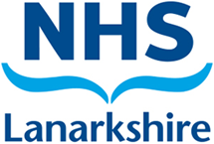
The MMAS continues to deliver a range of targeted projects in partnership with key agencies, ensuring that support reaches those most at risk of poverty, poor health, and financial exclusion. In 2023-24, our project work has expanded both in reach and impact, offering tailored advice and income maximisation support across diverse settings.
SGN Energy project
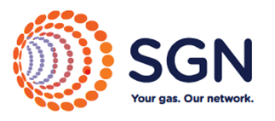
Funded by SGN, this project focuses on reducing fuel poverty for vulnerable households. Advisors offer support to residents through our helpline and community hubs and help clients access energy vouchers, CO monitors, apply for Warm Home Discounts, and challenge high energy bills. This project is the latest development in MMAS’s efforts to play a vital role in supporting households during the ongoing cost-of-living crisis and has now expanded to include increasing take up or Priority Service Registration with energy providers and Scottish Water and having discussions with residents on the risk of CO poisoning.
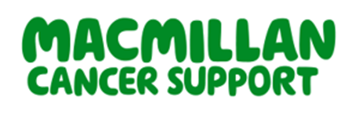
Macmillan cancer support project
In partnership with Macmillan Cancer Support, this project provides specialist welfare rights advice to people living with cancer. Advisors work closely with patients and clinical teams to ensure individuals and families receive the financial support they are entitled to at every stage of their cancer journey. The service helps reduce stress and financial hardship during a profoundly difficult time.

Telephone advice line – Families with young children
Our Telephone Advice Line Service offers tailored support for families with children under five or expecting their first child. This service helps young families navigate the benefits system, access maternity and early years entitlements, and address debt issues. The project supports early intervention and contributes to reducing child poverty from the earliest stage.

NHS financial wellbeing project
Working in partnership with NHS Lanarkshire, this project provided specialist welfare rights advice to clients of GP-based NHS Community Link Workers. Together with MMAS, they provided a holistic approach to health and wellbeing by addressing underlying money worries. Clients were supported with benefit checks, debt advice, and onward referrals to other specialist services.

NHS cost of living project – Hairmyres Hospital
Embedded within Hairmyres Hospital, this project offers immediate financial advice and support to NHS Teams and their patients affected by the cost-of-living crisis. The on-site advisor works with clinical staff to raise awareness of support available and identify the needs of patient, whilst delivering rapid, compassionate support when needed.

Employability project – South Lanarkshire Council’s employability services
In partnership with South Lanarkshire Council’s employability services, this project helps individuals overcome financial barriers to work. Our adviser provides benefits and debt advice to support clients as they prepare for, return to, or sustain employment, ensuring they can transition into work without risking financial hardship.
Together, these projects demonstrate the value of integrated services that meet people where they are at home, in hospital, or in the community and ensure that financial wellbeing is recognised as a fundamental part of wider health and social outcomes.

Households in fuel crisis – Fuel Bank Foundation
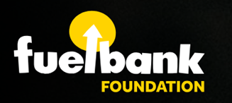
In 2024-25, MMAS continued its valuable partnership with the Fuel Bank Foundation to support households facing energy hardship. Over the year, 4,769 referrals were made on behalf of 2,309 individual clients, providing comprehensive energy advice and tailored assistance.
As part of this support, 4,300 emergency top-up vouchers were issued to help clients maintain access to gas and electricity during times of acute need. These vouchers, totalling £214,496 in value, provided a vital safety net for vulnerable individuals and families experiencing fuel poverty.

Achieving accreditation: Scottish National Standards for Advice and Information Providers
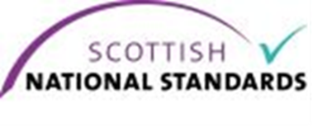
This year, MMAS proudly achieved accreditation to Type II and Type III under the Scottish National Standards for Advice and Information Providers. This recognition reflects our ongoing commitment to delivering high-quality, person-centred advice services that meet the rigorous standards expected across Scotland.
Accreditation to Type II demonstrates that our organisation provides casework support, where staff take active steps on behalf of clients, often involving more complex issues that require intervention, representation, or negotiation. Our advisors work directly with clients to manage multiple issues, liaise with creditors or benefit agencies, and ensure follow-up until matters are resolved. This level of support is particularly important for individuals experiencing significant financial distress or multiple vulnerabilities.
Our Type III accreditation is a testament to our ability to deliver specialist advice, particularly in the areas of welfare rights and debt. Type III services require specialist knowledge and technical expertise, with strict quality assurance processes in place. This level of recognition confirms that Money Matters is equipped to handle the most complex cases, providing in-depth advice and robust representation where needed, including appeals and tribunal work.
Achieving and maintaining these standards needed a comprehensive internal review, staff development, and investment in our systems and processes. We are proud of the hard work and dedication shown by our entire team throughout the accreditation process
These accreditations give our clients, funders, and partners confidence in the quality and professionalism of the services we provide. They also affirm our place as a trusted advice provider, committed to the continuous improvement and delivery of vital support to those who need it most.
Money Matters will continue to uphold these standards as we look to the future, ensuring we remain a reliable and expert source of money and welfare guidance.

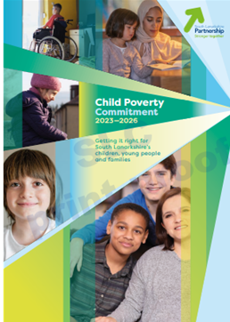
Supporting South Lanarkshire’s child poverty commitments
The Child Poverty (Scotland) Act 2017 places a legal duty on local authorities to take meaningful action to reduce child poverty. South Lanarkshire Council’s Child Poverty Action Report 2023-2026 outlines a strategic commitment to address the three key drivers of poverty: income from employment, cost of living, and income from social security and benefits in kind. The MMAS is central to the delivery of this agenda, providing essential frontline support to families across the region.
In 2024-25, MMAS made a substantial impact by supporting 14,248 unique clients, 12,404 of them new, and securing £27.15 million in financial gains for residents. This direct injection of income into low-income households has a powerful stabilising effect, helping to reduce financial stress and lift children out of poverty.
A core function of MMAS is ensuring families receive their full entitlement to benefits. The service assists with claims, provides support through appeals, and helps manage debt, work that significantly boosts household income. In cases of acute need, MMAS facilitates crisis intervention by providing emergency support such as fuel top-ups, with 4,840 referrals for vouchers issued last year alone.
To address the growing pressure of living costs, MMAS also played a key role in administering the council’s Cash First scheme. Over 4,821 cash payments of £50 were issued to households facing food and fuel insecurity (including reissues), with 96% of successful applicants receiving funds on the same day. This fast, stigma-free support helped families meet urgent needs with dignity.
Beyond direct financial support, MMAS strengthens the council’s broader poverty response through partnership working. The service collaborates with community groups, shares training and resources with other council teams, and supports early intervention. It also works closely with the council’s Employability Service to help families boost their long-term earning potential.
Through this holistic, rights-based approach, MMAS continues to be a cornerstone of South Lanarkshire’s efforts to reduce child poverty and meet its statutory obligations, ensuring children and families have the support they need to thrive.

Responding to South Lanarkshire’s housing emergency
In June 2024, South Lanarkshire Council officially declared a housing emergency in response to a sharp rise in homelessness and housing insecurity across the region. With a 28% increase in homelessness applications and a doubling of the backlog of households in urgent need, the scale of the crisis is both significant and concerning.
MMAS has played a central role in helping to mitigate the worst effects of this emergency by supporting residents to stay in their homes, prevent homelessness, and access the help they are entitled to. Our specialist teams deliver advice that addresses the underlying causes of housing instability, such as rent arrears, delays in benefit payments, unaffordable debt, and gaps in income.
Our Welfare Rights Team works to ensure clients receive the full range of benefits available to them, including Discretionary Housing Payments (DHP), Housing Costs in Universal Credit and Housing Benefit, and challenges unfair decisions that threaten housing stability. The Money Advice Team supports individuals to manage problem debt, negotiate repayment plans for rent or mortgage arrears, and access statutory debt solutions that can relieve pressure and protect homes.
MMAS also provides a vital frontline response through the Community Wellbeing Team, who deliver same-day emergency support, such as Cash First vouchers, to residents in food and fuel crises, often helping to bridge gaps that might otherwise lead to people going into arrears.
Our person-centred, holistic approach reflects the council’s wider commitment under the Marmot Project to tackle the social determinants of poor health, such as inadequate housing and financial insecurity. By reducing eviction risk, improving income stability, and linking individuals with long-term support, MMAS directly contributes to housing security and better life outcomes.
As the housing emergency continues, MMAS remains committed to playing a proactive, integrated role in helping the most vulnerable residents of South Lanarkshire stay housed, supported and empowered.

Client demographics 2024-25
The demographic profile of MMAS clients in 2024-25 offers valuable insight into the diversity and needs of the individuals and households we support.
Gender and age
Our client base continues to be predominantly female, with women accounting for 56% of all service users, compared to 42% male, and 2% not recorded or identifying otherwise. In terms of age, most clients fall within the 45-59 age bracket (27%), followed by those aged 35-44 (18%) and 25-34 (14%). Notably, 15% of clients are over the age of 71, indicating ongoing engagement with older adults.
Income and economic status
MMAS clients are primarily on low incomes. Over half (51%) have an income below £6,000 per year, with a further 19% earning between £6,001 and £10,000. Employment status data reveals that 14.66% of clients are unemployed, while 14.18% are employed, and 15.80% are retired. Significant numbers are also recorded as sick or disabled (30.93%).
Health and disability
A substantial 84% of clients report having a health problem, with 62% of those health problems relating to physical health and 38% to mental health issues. Only 15% identify as carers, suggesting most clients require support rather than are providing it. Additionally, 30% of clients are registered on the Priority Service Register, indicating vulnerability in relation to utilities and other essential services.
Household and housing circumstances
The most common household type is single person (58%), highlighting the prevalence of isolated individuals within our client base. Couples without children make up 19%, single parents 15%, and couples with children 8%. In terms of housing, the majority live in local authority or housing association accommodation (Scottish Secure Tenancies) (46.45%). Those living in private tenancies only account for 6.45%, whilst homeowners account for 22.54% of all clients.
Conclusion
The demographic data underscores the economic vulnerability, health challenges, and housing insecurity faced by many MMAS clients. This profile strengthens our case for targeted advice and support services tailored to low-income individuals, older adults, single-person households, and those with complex health and housing needs.

Client demographics 2024-25 – information as charts

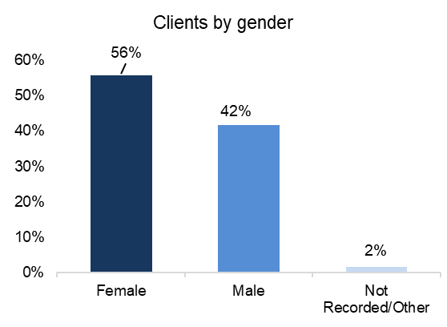
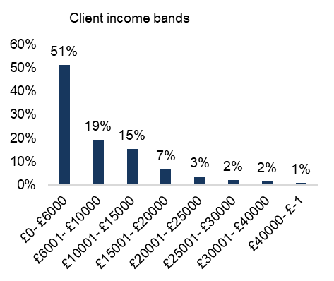

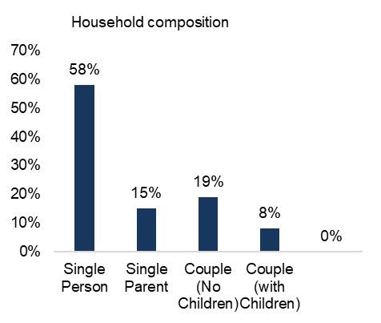

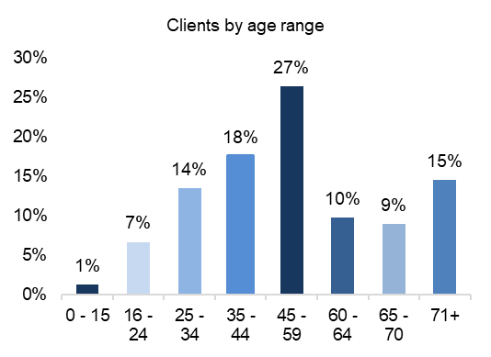

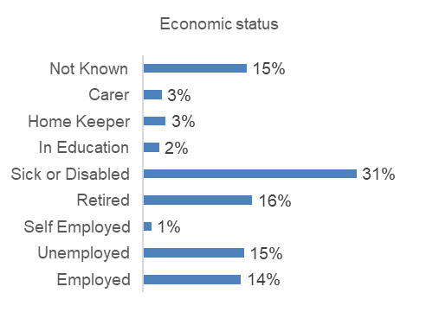
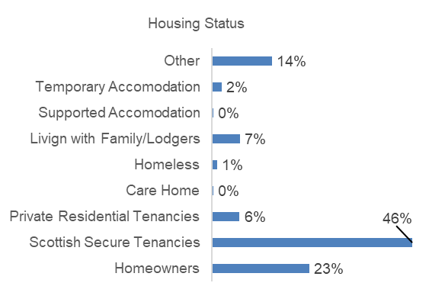
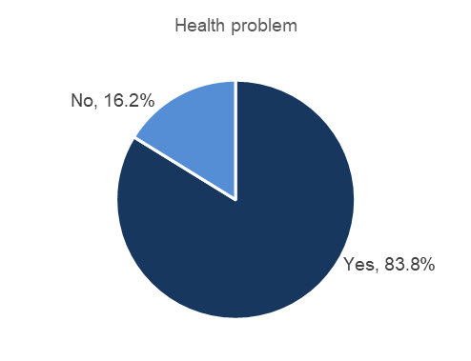
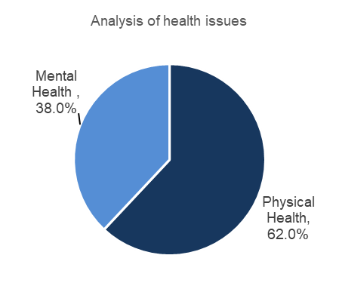

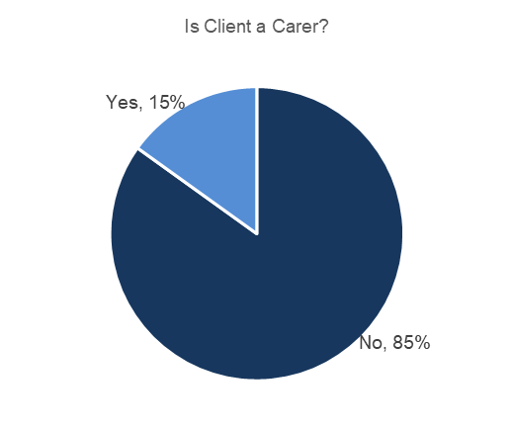
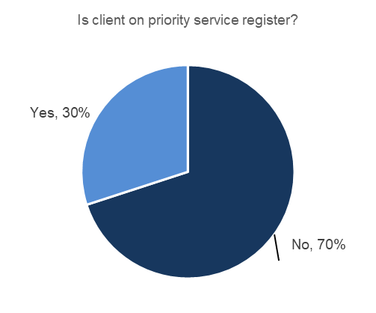

Clients by Scottish Index of Multiple Deprivation (SIMD)
The SIMD is a relative measure used to identify levels of deprivation across 6,976 small geographic areas in Scotland, known as data zones. An area being classified as 'deprived' can indicate low income but also reflects limited access to resources and opportunities.
SIMD assesses deprivation across seven key domains: income, employment, education, health, access to services, crime, and housing. Using client postcodes, Money Matters can map the distribution of its service users across these data zones, with a ranking scale from 1 (most deprived) to 10 (least deprived).
Analysis of this data reveals that:
- 24% of Money Matters clients live in the 10% most deprived areas of Scotland (SIMD 1), representing an increase of 1% from 2023-24.
- A further 16% live in areas ranked within the next most deprived 10% (SIMD 2), representing a 1% decrease from 2023-24.
- In total, 80% of clients reside in data zones within the bottom half of the SIMD rankings, up from 79% in 2023-24.

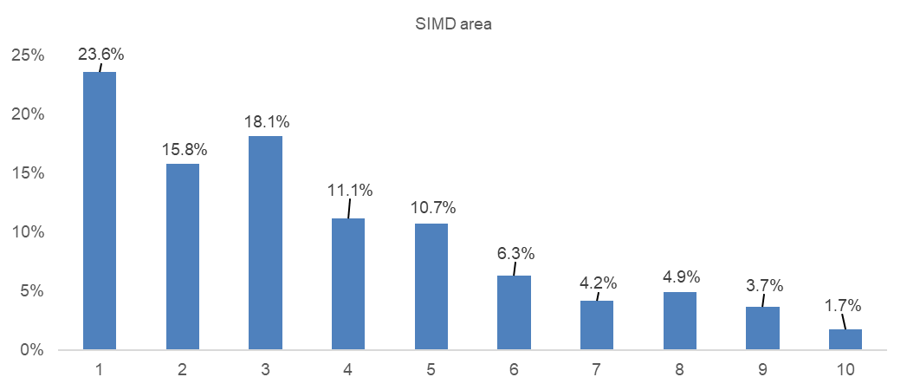
These findings clearly demonstrate that MMAS is effectively reaching those most impacted by deprivation, particularly within South Lanarkshire’s most disadvantaged communities.

Reaching clients across South Lanarkshire
An analysis of MMAS clients by electoral ward, compared with the population distribution across South Lanarkshire, provides insight into how effectively the service is reaching local communities. The following table shows the percentage of the total South Lanarkshire population living in each ward alongside the percentage of MMAS clients from that area.
Electoral Ward | Population as a % | Clients as a %
Avondale and Stonehouse | 5.59% | 1.84%
Blantyre | 4.97% | 8.63%
Bothwell and Uddingston | 4.11% | 1.54%
Cambuslang East | 5.32% | 5.39%
Cambuslang West | 4.70% | 5.33%
Clydesdale East | 3.99% | 2.80%
Clydesdale North | 4.52% | 4.82%
Clydesdale South | 4.62% | 5.28%
Clydesdale West | 6.06% | 6.28%
East Kilbride Central North | 4.84% | 5.25%
East Kilbride Central South | 4.59% | 5.60%
East Kilbride East | 4.66% | 5.15%
East Kilbride South | 5.10% | 4.46%
East Kilbride West | 4.80% | 1.97%
Hamilton North and East | 4.51% | 3.77%
Hamilton South | 6.85% | 9.39%
Hamilton West and Earnock | 5.92% | 4.53%
Larkhall | 5.86% | 8.55%
Rutherglen Central and North | 4.40% | 3.69%
Rutherglen South | 4.61% | 5.73%
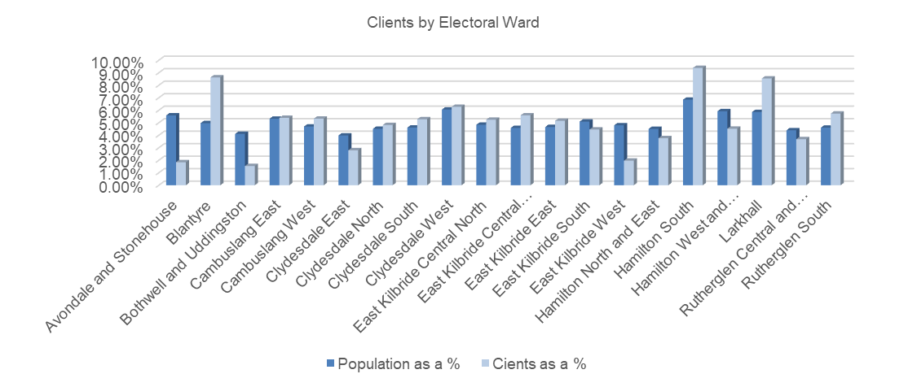

This comparison highlights several important findings:
High engagement in areas of need:
MMAS serves a notably higher proportion of clients than the population share in Blantyre (8.63% of clients vs. 4.97% of population), Hamilton South (9.39% vs. 6.85%), and Larkhall (8.55% vs. 5.86%). These areas are known to experience higher levels of deprivation, indicating that MMAS is effectively reaching residents in need of financial and welfare advice.
Broad reach in Cambuslang and East Kilbride:
Client representation is relatively aligned with the population in Cambuslang East and West and across most East Kilbride wards. Slight overrepresentation in some of these areas, such as East Kilbride Central South (5.60% clients vs. 4.59% population), demonstrates balanced outreach across different parts of the region.
Underrepresentation in affluent or rural areas:
Wards such as Avondale and Stonehouse (1.84% clients vs. 5.59% population) and Bothwell and Uddingston (1.54% vs. 4.11%) show lower client uptake relative to their population share. These areas typically rank higher in SIMD scores (such as less deprived), which may explain the reduced demand for advice services.
This distribution confirms that Money Matters is fulfilling its mission of supporting individuals and families in South Lanarkshire who are most in need.

Customer satisfaction – Listening to the voices of residents
At MMAS, we believe our clients are at the heart of everything what we do. That’s why we place strong emphasis on collecting and analysing feedback to continuously improve the support we offer. The latest customer satisfaction survey reflects our ongoing commitment to service excellence.
Our service achieved an impressive average customer rating of 4.79 out of 5 stars, a testament to the trust and satisfaction of those we support. A striking 87.10% of respondents gave us a full 5-star rating, indicating a high level of overall contentment with their experience.
Accessibility remains a top priority. When asked how easy it was to access the service, considering factors like opening times, location, and contact methods 64.52% described it as “very easy,” and only a small fraction, 8.06% found it difficult. This aligns with our aim to make advice available when and where it’s needed most.
Timeliness of response is another critical element of effective service delivery. 81.82% of users rated our response times as “excellent,” while 15.91% said they were “good.” Only a minimal 2.27% rated it as “poor,” highlighting room for further enhancement but also a solid performance overall.
Communication throughout the process is equally vital. We’re pleased to report that 95.45% of clients felt they were kept up to date with the progress of their case. This ongoing engagement helps clients feel supported and informed every step of the way.
Finally, when asked whether they would use the service again or recommend it to others, 93.55% of respondents answered “yes.” This strong endorsement underscores the value and impact of our work in helping individuals navigate financial challenges.
These results validate the dedication of our team and the effectiveness of our service model. We continue to listen, learn, and adapt, ensuring that Money Matters remains a trusted source of guidance and support for all who turn to us.
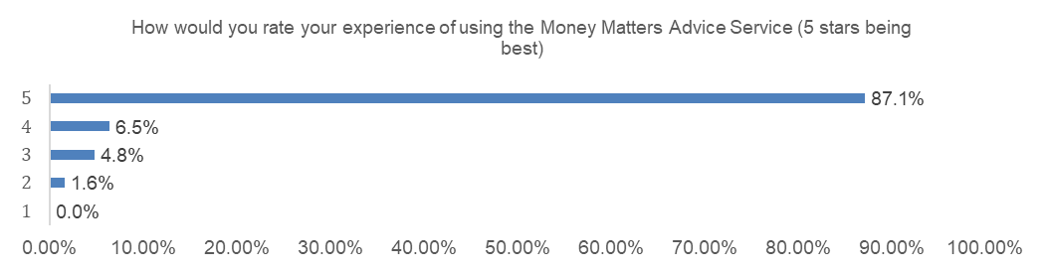

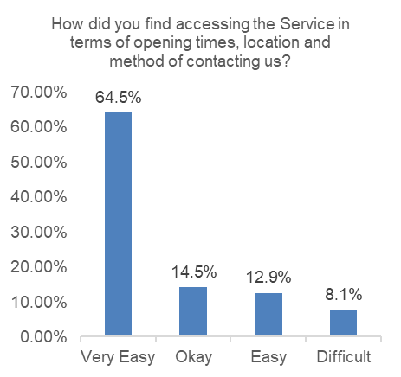
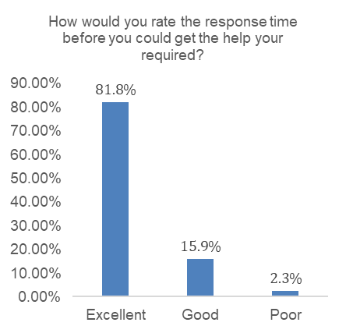

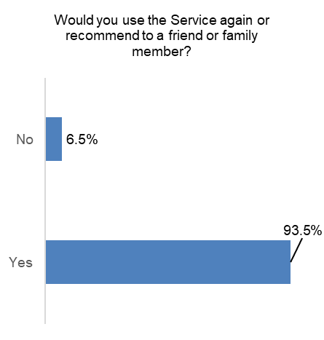
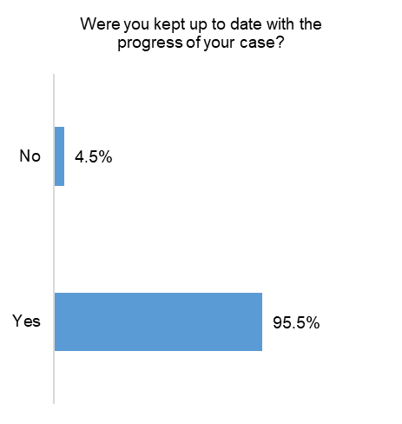

Case studies
Welfare rights
A client with serious health issues was made redundant and used their redundancy to clear debts, leaving them with no income and worsening stress. A full benefits check revealed entitlement to Universal Credit, Council Tax Reduction, and eligibility for Adult Disability Payment, which was claimed. Immediate emergency support was provided via the Community Wellbeing Team in the form or a Cash First grant and fuel vouchers. The client expressed deep relief and gratitude for the timely help and guidance.
Macmillan referral
A single client in a council tenancy was referred after a cancer diagnosis. Though initially hesitant due to savings and a private pension, a full benefits check identified entitlement to Adult Disability Payment and Universal Credit. Successful claims unlocked further support: Motability, Blue Badge, Care of Gardens, Discretionary Housing Payment, and Council Tax Reduction. The client was extremely pleased with the outcome and support received.
Community Wellbeing Team
A 60-year-old man transitioning from Employment and Support Allowance to Universal Credit had no income and couldn’t afford food or utilities. He received food and fuel assistance and a Cash First payment, whilst a Welfare Right Officer assisted him with his Universal Credit. This holistic approach meant he could meet his essential needs while he awaited his first Universal Credit payment.

Money Advice
A client contacted Money Matters after receiving notice that the DWP would recover a historic benefit overpayment through a Direct Earnings Attachment (DEA). The proposed deduction risked 40% of his income, jeopardising essential bills. Referred to Money Matters, a Money Adviser assessed his finances and calculated an affordable repayment. With the adviser’s support, the DWP agreed to reduce the deduction amount. This intervention protected the client’s financial stability and prevented escalating hardship.

Energy Advice
A Client’s daughter contacted Money Matters to check her father’s eligibility for the £200 Alternative Fuel Payment for oil heating. She was unsure how to apply, so an Energy Adviser provided guidance and the direct UK Government link. Using this support, she successfully submitted the online application. She said, “Only by contacting Money Matters was I able to get this payment for him.”

Appendix: Electoral ward update
The following outlines client engagement and service delivery for 2024–25 on a ward-by-ward basis. Please note that not all MMAS clients reside in South Lanarkshire (such as SLC Employees, Kinship carers), so the figures by Electoral Ward may not match the overall totals for the Service.
Avondale and Stonehouse
Engagement/service delivery | Number
Population | 18,030
Unique clients | 200
Number of cases | 461
Financial gain (claims) | £477,918
New debt dealt with | £143,591
Debt written off (not all new debt) | £34,234
Cash First cases | 106
Food bank referrals | 8
Fuel bank referrals | 36

Blantyre
Engagement/service delivery | Number
Population | 16,040
Unique clients | 936
Number of cases | 4,115
Financial gain (claims) | £1,697,207
New debt dealt with | £867,392
Debt written off (not all new debt) | £200,665
Cash First cases | 374
Food bank referrals | 253
Fuel bank referrals | 491

Bothwell and Uddingston
Engagement/service delivery | Number
Population | 13,260
Unique clients | 167
Number of cases | 352
Financial gain (claims) | £393,041
New debt dealt with | £523,623
Debt written off (not all new debt) | £189,651
Cash First cases | 65
Food bank referrals | 3
Fuel bank referrals | 18

Cambuslang East
Engagement/service delivery | Number
Population | 17,180
Unique clients | 585
Number of cases | 1,715
Financial gain (claims) | £1,249,628
New debt dealt with | £269,015
Debt written off (not all new debt) | £23,292
Cash First cases | 158
Food bank referrals | 85
Fuel bank referrals | 171

Cambuslang West
Engagement/service delivery | Number
Population | 15,160
Unique clients | 578
Number of cases | 1,894
Financial gain (claims) | £1,350,816
New debt dealt with | £370,414
Debt written off (not all new debt) | £65,395
Cash First cases | 177
Food bank referrals | 99
Fuel bank referrals | 245

Clydesdale East
Engagement/service delivery | Number
Population | 12,860
Unique clients | 304
Number of cases | 875
Financial gain (claims) | £779,539
New debt dealt with | £270,012
Debt written off (not all new debt) | £44,521
Cash First cases | 114
Food bank referrals | 58
Fuel bank referrals | 78

Clydesdale North
Engagement/service delivery | Number
Population | 14,570
Unique clients | 523
Number of cases | 1,787
Financial gain (claims) | £790,883
New debt dealt with | £455,767
Debt written off (not all new debt) | £87,947
Cash First cases | 293
Food bank referrals | 149
Fuel bank referrals | 217

Clydesdale South
Engagement/service delivery | Number
Population | 14,900
Unique clients | 573
Number of cases | 1,812
Financial gain (claims) | £1,358,438
New debt dealt with | £657,822
Debt written off (not all new debt) | £78,777
Cash First cases | 226
Food bank referrals | 137
Fuel bank referrals | 198

Clydesdale West
Engagement/service delivery | Number
Population | 19,540
Unique clients | 681
Number of cases | 2,135
Financial gain (claims) | £1,308,061
New debt dealt with | £602,274
Debt written off (not all new debt) | £131,710
Cash First cases | 260
Food bank referrals | 166
Fuel bank referrals | 192

East Kilbride Central North
Engagement/service delivery | Number
Population | 15,620
Unique clients | 569
Number of cases | 1,842
Financial gain (claims) | £1,294,270
New debt dealt with | £533,095
Debt written off (not all new debt) | £84,656
Cash First cases | 204
Food bank referrals | 29
Fuel bank referrals | 169

East Kilbride Central South
Engagement/service delivery | Number
Population | 14,800
Unique clients | 607
Number of cases | 1,867
Financial gain (claims) | £1,270,695
New debt dealt with | £432,866
Debt written off (not all new debt) | £21,080
Cash First cases | 213
Food bank referrals | 38
Fuel bank referrals | 211

East Kilbride East
Engagement/service delivery | Number
Population | 15,040
Unique clients | 559
Number of cases | 1,696
Financial gain (claims) | £1,096,901
New debt dealt with | £518,308
Debt written off (not all new debt) | £54,839
Cash First cases | 190
Food bank referrals | 23
Fuel bank referrals | 183

East Kilbride South
Engagement/service delivery | Number
Population | 16,440
Unique clients | 484
Number of cases | 1,295
Financial gain (claims) | £1,329,016
New debt dealt with | £698,559
Debt written off (not all new debt) | £466,871
Cash First cases | 125
Food bank referrals | 16
Fuel bank referrals | 94

East Kilbride West
Engagement/service delivery | Number
Population | 15,480
Unique clients | 214
Number of cases | 472
Financial gain (claims) | £449,334
New debt dealt with | £301,191
Debt written off (not all new debt) | £119,909
Cash First cases | 32
Food bank referrals | 5
Fuel bank referrals | 18

Hamilton North and East
Engagement/service delivery | Number
Population | 14,550
Unique clients | 409
Number of cases | 1,172
Financial gain (claims) | £906,681
New debt dealt with | £261,326
Debt written off (not all new debt) | £39,455
Cash First cases | 359
Food bank referrals | 76
Fuel bank referrals | 141

Hamilton South
Engagement/service delivery | Number
Population | 22,090
Unique clients | 1,018
Number of cases | 4,090
Financial gain (claims) | £1,789,872
New debt dealt with | £1,017,537
Debt written off (not all new debt) | £150,900
Cash First cases | 531
Food bank referrals | 319
Fuel bank referrals | 599

Hamilton West and Earnock
Engagement/service delivery | Number
Population | 19,110
Unique clients | 491
Number of cases | 1,321
Financial gain (claims) | £1,156,727
New debt dealt with | £449,591
Debt written off (not all new debt) | £132,558
Cash First cases | 442
Food bank referrals | 47
Fuel bank referrals | 161

Larkhall
Engagement/service delivery | Number
Population | 18,900
Unique clients | 927
Number of cases | 3,028
Financial gain (claims) | £2,139,494
New debt dealt with | £878,706
Debt written off (not all new debt) | £86,690
Cash First cases | 343
Food bank referrals | 190
Fuel bank referrals | 303

Rutherglen Central and North
Engagement/service delivery | Number
Population | 14,190
Unique clients | 399
Number of cases | 1,175
Financial gain (claims) | £920,960
New debt dealt with | £125,747
Debt written off (not all new debt) | £1,857
Cash First cases | 202
Food bank referrals | 71
Fuel bank referrals | 166

Rutherglen South
Engagement/service delivery | Number
Population | 14,870
Unique clients | 622
Number of cases | 2,138
Financial gain (claims) | £1,274,071
New debt dealt with | £590,584
Debt written off (not all new debt) | £40,740
Cash First cases | 220
Food bank referrals | 126
Fuel bank referrals | 296

