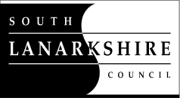

Standby Duty payments April 2025- 2026

 | Rates from 1 April 2025 | Rates from 1 April 2026
Standby (Element 337)  Local Government Employees (except Social Workers)  For each complete week of standby duty performed  Plus  For each public or extra statutory holiday in that week | £114.47  £21.52 | £118.48  £22.27
Social Workers only  Standby duty allowance (per session) | £38.29 | £39.63
For broken periods of standby duty:  Monday to Friday (per night)  Saturday (for 24 hours)  Sunday, public and extra statutory holiday (for 24 hours) | £11.41  £24.30  £33.12 | £11.81  £25.16  £34.28
Call out (Element 336)  Disturbance and call out payments  Payments for employees not on standby | £18.30  £25.18 | £18.94  £26.06

If you need this information in another language or format, please contact us to discuss how we can best meet your needs.
Phone 0303 123 1015 or email equalities@southlanarkshire.gov.uk

