

South Lanarkshire Local Development Plan 3

Topic Paper #8 (of a series of 21)

Sustainable Transport

(May 2025)

If you need this information in another language or format, please contact us to discuss how we can best meet your needs.
Phone 0303 123 1015 or email equalities@southlanarkshire.gov.uk

1. Introduction
South Lanarkshire Council has started preparation of Local Development Plan 3 (LDP3) which will set out the proposals and policies for the future use and development of land and buildings in South Lanarkshire.

What this involves and the timescales can be found in the council’s Development Plan Scheme.

More detail is set out in the Scottish Government’s Local development planning guidance.

The first part of this process requires the preparation of an Evidence Report. This involves the gathering and assessment of data and information for each policy topic, in collaboration with stakeholders and interested parties to help identify the issues which LDP3 needs to address.

Topic papers have been produced which describe the evidence identified so far, our assessment and understanding of it and what this might mean for LDP3. We want to know if the correct evidence has been identified and whether there is any other data and information that should be considered. We are also looking for feedback on the initial assessment of the evidence.

2. Topic paper
This topic paper will cover the following National Planning Framework 4 (NPF4) Policies:
- Policy 13: Sustainable Transport

This topic paper provides background information and data in relation to how transport issues will inform future development in South Lanarkshire. It describes the current transport network across the area in terms of road, rail and bus, active travel provision and confirms a commitment to produce a transport appraisal to support the Proposed Plan. The topic paper also reviews current policies and guidance regarding transport and active travel and how these will shape the spatial strategy.
The provision of appropriate transport infrastructure is critical to ensuring that new developments have access to sustainable means of transport to give access to work, schools and local facilities. Improving local access, providing more sustainable and inclusive transport choices, influencing land use patterns around existing transport infrastructure and providing reliable, convenient connections between places should be key requirements of a future transport network.

3. NPF4 policy context

Policy 13: Sustainable Transport

Policy intent:
To encourage, promote and facilitate developments that prioritise walking, wheeling, cycling and public transport for everyday travel and reduce the need to travel unsustainably.

Policy Outcomes:
Investment in transport infrastructure supports connectivity and reflects place-based approaches and local living.

More, better, safer and more inclusive active and sustainable travel opportunities.
Developments are in locations which support sustainable travel.

NPF4 National Developments

Eighteen national developments support the national spatial strategy of NPF4. Of relevance to this Topic paper are:

- 6 - Urban Mass/Rapid Transit Network which includes development of the Clyde Metro.

- 8 - National Walking, Cycling and Wheeling Network which links to the need to facilitate the shift from vehicles to walking, cycling and wheeling for everyday journeys and therefore contributing to reducing greenhouse gas emissions from transport; and the benefits for health and wellbeing

- 18 - High Speed Rail which supports the implementation of increased infrastructure to improve rail capacity and connectivity on the main cross-border routes, the east and west coast mainlines.

LDP3 Considerations
NPF4 states that LDPs should prioritise locations for future development that can be accessed by sustainable modes and emphasises using the ‘place principle’ to facilitate the delivery of sustainable development within the local built environment. The spatial strategy should reflect the sustainable travel hierarchy and sustainable investment hierarchy by making best use of existing infrastructure and services. The LDP must consider the relationship between an area’s land use supply and transport network.

LDPs are to be informed by a transport appraisal undertaken in line with relevant transport appraisal guidance. The appraisal will consider how an area’s transport network enables or impedes the ability of people to reach everyday destinations; and how existing service provision interacts with this transport network and in turn identify development sites for the Proposed Plan.

4. Evidence and data Sets
The evidence and data presented in this section includes the strategies, plans, proposals and data sources that we have used to build our understanding of these policy areas in South Lanarkshire. We will use this evidence as a base for informing the next Local Development Plan.
It is important to note that some of this evidence may change and be updated over time.

- Climate Chane Plan - Update (2020)
- National Transport Strategy for Scotland (NTS2)
- Strategic Transport Projects Review (STPR2)
- Infrastructure Investment Plan (IIP) 2021-22 to 2025-26
- Programme for Government 2025-26
- A route map to achieve a 20 per cent reduction in car kilometres by 2030
- Strathclyde Partnership for Transport (SPT) Regional Transport Strategy
- Clyde Metro
- Strathclyde Partnership for Transport Active Travel Strategy (ATS)
- Strathclyde Regional Bus Strategy (SRBS)
- The SPT Delivering for South Lanarkshire
- Park and Ride Strategy 2018-2027 - South Lanarkshire Council
- Local transport strategy - South Lanarkshire Council
- Park and Ride Strategy 2018-2027 - South Lanarkshire Council
- Public and community transport STAG Part 2 Transport Appraisal - South Lanarkshire Council
- Active Travel Network Plans
- uSmart cycling open data forum
- Estimates of station usage | ORR Data Portal
- Sustainable Development and Climate Change Strategy - South Lanarkshire Council
- SLC State of the Environment Report 2023
- Key Reported Road Casualties Scotland 2021 | Transport Scotland
- Scottish Transport Statistics 2024 | Transport Scotland
- Park and Ride | SPT | Strathclyde Partnership for Transport
- Network Rail’s Sustainable Travel to Stations strategy
- Passenger rail usage | ORR Data Portal
- Transport poverty: a public health issue 2024 - Public Health Scotland

5. Review and assessment of evidence

Transport in South Lanarkshire – an overview
Travel and transport is a derived demand for goods and people needing to move between two places. Travel behaviour is influenced by a range of factors including settlement pattern, economic and social factors, technology and available transport infrastructure, and by the purpose of the trip including access to employment, essential services, healthcare, education, and leisure.
Transport investment in Scotland is changing with the focus now on sustainable modes of travel, facilitating the transition towards net zero and supporting people to make better, more informed choices about how they travel. LDP3 and other supporting transport plans and programmes are important tools in delivering the strategic approach which is needed to deliver these ambitions.
CO2 emissions generally have reduced over recent years; however transport remains the largest emitting sector in South Lanarkshire with reductions largely bottoming out over the last decade. Alternative fuels and environmentally friendly technologies will be important factors in reaching net zero ambitions including electric vehicles, hydrogen and biofuels. Hydrogen can be used to decarbonise many parts of our economy, including transport through the provision of zero-carbon energy-dense fuels. South Lanarkshire compromises both a dense urban area focussed on a number of main towns such as Hamilton, East Kilbride, Rutherglen and Cambuslang together with smaller town such as Larkhall, Blantyre, Uddingston and Bothwell where public transport and active travel provision is well established; and an extensive rural hinterland which includes several smaller towns that serve the wider area (Strathaven, Lanark, Biggar and Carluke) and remote rural communities poorly served by public transport.
Outward commuting patterns and high rates of car use for all journeys, with the associated travel implications, indicates a shift to more sustainable travel in the future will be challenging. Continued traffic growth is also resulting in slow and unreliable journey times on some key routes.
Overall, car ownership and usage are increasing within the area. 78% of residents in South Lanarkshire own a car/van compared to 74% across Scotland based on 2022 census figures. The percentage of households with 2 or more cars/vans is also higher in South Lanarkshire than Scotland. Nevertheless, it is often those living in SIMD areas that experience lower levels of car ownership or forced car ownership when there is a lack of alternative options.
Analysis of travel to work patterns shows that the vast majority of residents travel out-with the authority to work. Only 5% of the population travel to work using trains which is slightly higher than the figure for Scotland of 3%. The proportion of residents who walk or cycle to work is lower than across Scotland.
Travel behaviour has been changing as a result of social and technological trends, some of which were accelerated by the Covid 19 pandemic. Key changes included increased home working or hybrid working patterns, increased online meetings and the increase in the use of digital means for shopping and other services.
Generally, there are good rail and bus connections from most of the larger settlements into Glasgow City Centre itself and within the built-up areas in South Lanarkshire, however travel by public transport across the area is less reliable. There is also a lack of frequent services to those living in outlying peripheral or rural areas. In many instances, public transport connectivity does not provide effective links to key health, employment, education, and retail service destinations. Public transport is often seen as unreliable, inflexible and an unattractive mode of transport.
In 2019 65% of adults reported that they were Very or Fairly Satisfied with Public Transport in South Lanarkshire. This is slightly lower than the national figure of 68% from statistics Scotland.
The council has developed active travel plans for the main settlements. However, the current network generally does not provide links to a range of key services, facilities and destinations, thus limiting any significant modal shift. Walking mode share remains below regional and national averages, suggesting fewer journeys being undertaken by active travel relative to other areas.
Although active travel among school pupils is generally increasing (with pupils driven to school decreasing), car use continues to have a disproportionate impact around schools.
The Local Living neighbourhood concept will be a key element in planning and transport policy going forward across both urban and rural settlements. The Local Living Topic Paper (10) provides a high-level assessment of the analysis of the services and facilities that currently exist across our communities. However, other factors undermine this such as the outward growth of urban areas and the recent tendency to centralise some facilities and services such as health care.
Findings from Transport Scotland shows the following data in terms of the amount of traffic on trunk roads and local authority roads in million KMs. This demonstrates that, while the gradual increase up 2019 was arrested by the pandemic, traffic volumes have returned to previous levels and the figure is now slightly higher that it was pre-2020.
Year | Trunk Roads | SLC roads | Total
2013 | 1,236 | 1,277 | 2,513
2014 | 1,261 | 1,325 | 2,585
2015 | 1,264 | 1,343 | 2,608
2016 | 1,328 | 1,385 | 2,713
2017 | 1,395 | 1,401 | 2,796
2018 | 1,501 | 1,308 | 2,809
2019 | 1,535 | 1,301 | 2,836
2020 | 1,126 | 1,055 | 2,181
2021 | 1,375 | 1,183 | 2,559
2022 | 1,526 | 1,267 | 2,793
2023 | 1,564 | 1,291 | 2,855

The transport section in the State of the Environment Report 2023 includes data on traffic growth and congestion. In 2019, traffic growth decreased at only 10% of the council’s strategic monitoring sites. In 2020, 100% of strategic monitoring sites had a reduction in traffic growth which coincides with the period before and immediately following Covid19 restrictions in mid-March. In 2021, 18% of the strategic monitoring sites experienced a decrease. In 2022, the figure was 35%.
Events which have had a significant effect on traffic flows include the opening of the M74 widening works, the completion of the M74/A725 Raith Interchange Improvement and the Cathkin Relief Road pre-pandemic. The effects that the pandemic and associated travel restrictions had on traffic growth is evident, however, traffic growth now slightly exceeds pre pandemic levels.
A number of external factors inform these patterns which must be addressed if the council is to achieve a reduction in the road traffic. These include:
- The reducing cost of motoring in real terms and the increasing cost of public transport.
- The deregulation of bus services (taking them outwith the council’s control).
- Availability of funding for transport improvements.
- The decline of traditional urban shopping and employment centres leading to people travelling further for the same services.
- Safety of accessing transport stops e.g. unlit/no footway/60mph speed limit in rural area.
- Less attractive public transport if e.g. service frequency, reliability of services and the quality of waiting environments
However, there are other measures available to the council and its partners that, through policy direction in LDP3, could slow down the rate of traffic growth. These are:
- Encouraging and facilitating the aspirations for local living
- Travel plans for all major generators of private car traffic
- School travel plans.
- Travel awareness and safety campaigns.
- Improvements to the walking and cycling infrastructure.
- Introducing significant park and ride provision at rail stations.
- Community led schemes to increase public transport use to aid climate crisis e.g. Strathaven climate ready bus.
- Increased use of developer contribution to support more sustainable transport infrastructure.
- Provide hiring facilities for bikes/ebikes, cycle parking/shelter/showering facilities.
The number of South Lanarkshire residents who did not experience congestion for the period 2012 - 2013 increased to 92.5% and reduced to 85.4% and 78.2% in 2013 – 2014 and 2014 – 2015, respectively. This coincided with the improvement works to the M74/A725 Raith Interchange which had a significant impact on journey times. In 2015 – 2017, this increased to 80.8% and increased again to 85% in 2017 – 2019. In 2019 – 2021, this remained at 85%. Nationally, during the period 2019 – 2021, 88.9% of residents did not experience congestion.

6. Strategies and Plans

a) National
The Climate Change Plan Update (2020) commits to reducing car kilometres by 20 per cent by 2030 to achieve the net zero emissions target by 2045. This is discussed further under the Climate Mitigation and Adaptation Topic Paper.
The National Transport Strategy for Scotland (NTS2) sets out the Government’s strategy and objectives for the transport network in Scotland with an increased focus on the social, economic and environmental impacts of transport, as well as an emphasis on inclusive growth and greater equality. The priorities of the NTS are to reduce inequalities; tackle climate change; help deliver inclusive economic growth; and improve health and wellbeing.
NTS2 includes a Sustainable Travel Hierarchy which promotes walking, wheeling, cycling, public transport and shared transport options in preference to single occupancy private car use. It ensures transport options maintain and safely operate existing assets, taking due consideration of the need to adapt to the impacts of climate change.
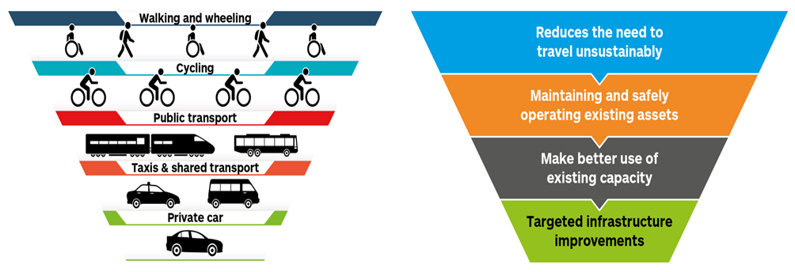
Transport Scotland’s second Strategic Transport Projects Review (STPR2) sets out a high-level, strategic programme for national level investment in major transport projects over 20 years from 2022-2042 to deliver NTS2. The Review makes 45 recommendations under 6 key themes which seek to make transport in Scotland more sustainable and support people to make better, more informed choices on how they travel. The 6 key themes are:
- Improving active travel infrastructure;
- Influencing travel choices and behaviours;
- Enhancing access to affordable public transport;
- Decarbonising transport;
- Increasing safety and resilience on the strategic transport network; and
- Strengthening strategic connections.
These ambitions require locally developed approaches and therefore it will be important to ensure the aims of STPR2 required could influence future travel across the area and ensure timely delivery in association with other infrastructure projects and new development are embedded in LDP3. Of direct relevance to South Lanarkshire are the following;
Recommendation 1: Connected Neighbourhoods
This recommendation promotes active travel by integrating walking, cycling and wheeling paths to connect homes with schools, services and transport hubs, reducing car dependency and supporting sustainability.

Recommendation 11: Clyde Metro
The Clyde Metro is a major public transport initiative designed to improve connectivity in the Glasgow City Region. It aims to address transport challenges by providing better access to employment, education and healthcare, particularly in underserved areas, while supporting goals to reduce emissions and promote sustainable travel. Recent work has included defining the potential scale of Clyde Metro and the associated resource and programme requirements. The next stage will be to undertake a case for investment.

Recommendation 21: Improved public transport passenger interchange facilities
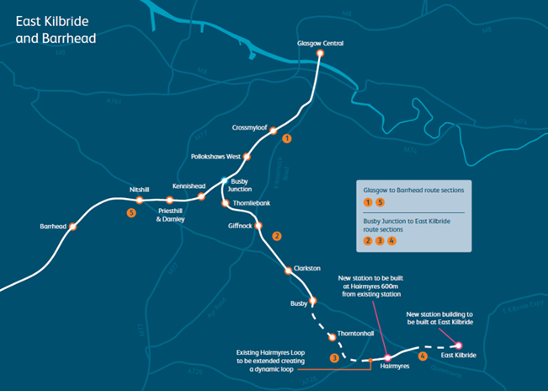

East Kilbride and Barrhead Rail Project
Total investment of £139.8m to deliver
- 22.4 Single Track km of new electrification between Busby Junction and East Kilbride.
- New two-platform at Hairmyres Station with accessible station building and footbridge with lifts.
- New accessible station building at East Kilbride Station with enhanced passenger facilities and platform extension
- 1.4km extension of Hairmyres Loop, to improve performance, capacity and timetable flexibility.

Hairmyres Station
The relocation of Hairmyres Station, 600m to the west, will result in an improved transport interchange for the local community, with increased capacity, car parking and upgraded station facilities. The new location will also serve new housing at the East Kilbride Community Growth Area. It will provide the following:
- the provision of two new traffic signal-controlled junctions for the south and north areas
- park and ride provision including disabled spaces and EV charging spaces
- integrated public transport access and connections to the active travel network
- the potential for a community EV charging facility
- a new active travel bridge over the upgraded rail line
- secure cycle storage at the station building area
- street lighting, CCTV coverage and suitable landscaping

Recommendation 25: Decarbonisation of the rail network
This focuses on decarbonising Scotland's rail network by replacing diesel trains with cleaner technologies. Electrification improves journey times, reliability, and capacity and encourages a shift from road to rail. Electric rolling stock reduces operational costs, and battery or hydrogen options support decarbonisation on routes unsuitable for overhead electrification.

More generic recommendations in STPR2 that have a spatial element that can be addressed in LDP3 are described as follows under the 6 key themes:

Active travel infrastructure - village-town active travel connections (3), connecting towns by active travel (4) and long-distance active travel network (5) work together with existing networks and links to provide high quality connections for people walking, wheeling and cycling within and between communities. These would integrate with existing networks including the National Cycle Network and provide links into and within urban areas via the STPR2 recommendations of connected neighbourhoods (1) and active freeways (2).

Influencing Travel Choices and Behaviours to make healthier, more sustainable and safer travel choices. Increasing active travel to school (8) and increasing access to bikes (9) seek to encourage and enable more people to make use of active, public and shared modes of transport.

Enhancing Access to Affordable Public Transport allows access to jobs, education and key services. This includes improvements to transport stations and interchanges (18, 19, 21 and 22), measures that deal with more heavily populated city regions such mass transit (11, 12 and 13), and focusing on strategic routes or corridors where bus and rail provide the most effective service (14 to 17).

Decarbonising Transport to address climate change through the decarbonisation of passenger and freight transport, a reduction in vehicle usage by switching to public transport and active travel, reduced demand through shorter trips and, where possible, avoiding trips. STPR2 recommendations aimed at rapid decarbonisation of passenger and freight transport include decarbonisation of the rail network (25), decarbonising the bus network (26) and zero emission vehicles and infrastructure transition (28).

Increasing Safety and Resilience on the Strategic Transport Network through a programme of renewals and measures that would address safety (30), climate change adaptation (31) and resilience (32). STPR2 also recommends a detailed national audit and review of lorry parks to address barriers hampering their development (36).

The Infrastructure Investment Plan (IIP) is the Scottish Governments commitment to infrastructure investment in order to achieve inclusive economic growth with a focus on stimulating growth and protecting and creating jobs. It sets out how the Scottish Government will deliver the National Infrastructure Mission and sets a long-term vision of infrastructure supporting an inclusive, net zero carbon economy in Scotland.
The regional or sub-regional projects that relate to South Lanarkshire are as follows:
- East Kilbride Rail Enhancement
- Clyde Mission Low Carbon Infrastructure which involves investment of £25m in zero carbon energy infrastructure and heat networks for residential and commercial premises along the river Clyde.
- Clyde Gateway Regeneration Capital to support Clyde Gateway's 20-year programme of regeneration and attract other inward investment.
The Programme for Government 2025-26 outlines the Government’s priorities for the year ahead. In relation to transport this includes support for transport services, people and business to reduce their emissions and adapt to climate change, including:
- Introducing new rural and island EV infrastructure grants to help deliver approximately 24,000 additional public electric vehicle charge points by 2030.
- Introducing a new pilot grant scheme to help households without off-street parking to install cross-pavement EV charging solutions.
- Providing up to £4 million to increase the shift of freight from road to rail through the Freight Facilities Grant, and a first round of funding for the HGV sector to explore investments in decarbonised vehicles, charging and fuelling options.
- Publishing jointly with COSLA a renewed policy statement on reducing car use in Scotland, which will set a successor target for car use reduction aligned with the development of the draft Climate Change Plan, and working with COSLA and regional transport partnerships to develop delivery plans for car use reduction, reflective of different communities and places.
- Making it easier for people to walk, wheel, and cycle on everyday journeys by delivering projects through our 2025-26 sustainable travel programmes, including the new Bus Infrastructure Fund.
- Completing electrification and enhancement of the East Kilbride rail line in 2025-26, enabling the introduction of electric trains on the route from December 2025.
- Upgrading and reconfiguring rail power supplies to support existing and future electrification, with a new ‘feeder station’ planned to enter service at Newton in Lanarkshire during 2025-26.
- Making roads safer and reducing the numbers killed or injured, through delivery of 20 mph speed limits on appropriate roads by the end 2025-26 and of road safety funding for road authorities.
A route map to achieve a 20 per cent reduction in car kilometres by 2030 is a strategic document that details the interventions that will be put in place to achieve this ambitious target. It sets out ways to achieve 4 key behaviour changes including reducing the need to travel, living well locally, switching modes and combining trips or sharing journeys.
National Planning Framework 4 (NPF4) includes eighteen national developments to support the national spatial strategy. These actions will play a key role in tackling the challenges of climate change and biodiversity loss including by building and strengthening nature networks. A greener approach to development will improve placemaking and can contribute to the roll-out of 20-minute neighbourhoods. Of relevance to this Topic paper are:
- Urban Mass/Rapid Transit Networks including the Clyde Metro
- The National Walking, Cycling and Wheeling Network which is intended to deliver a shift from vehicles to walking, cycling and wheeling for everyday journeys. It will support the upgrading and provision of additional active travel infrastructure to enable better access to settlements, key services and amenities, employment and multi-modal hubs.
- The Central Scotland Green Network - important in tackling climate change and biodiversity loss by building and strengthening nature networks. A greener approach to development will improve placemaking, contribute to the roll-out of 20-minute neighbourhoods and benefit biodiversity connectivity.

B) Regional
A Call to Action: The Regional Transport Strategy for the west of Scotland published by Strathclyde Partnership for Transport in July 2023 and the associated Delivery Plan sets policy framework, targets and strategic programme of projects and initiatives in the west of Scotland for the next 20 years. Its aim is to support the creation of an attractive, resilient and well-connected place with active, liveable communities and accessible, vibrant centre facilitated by high quality, sustainable and low carbon transport shaped by the needs of all. Key priorities include:
- a healthier environment, supported by a transport system that helps the region become a low carbon place with healthier natural and built environments for the benefit of all;
- inclusive economic growth, supported by a transport system that supports the regional economy to develop and grow with better opportunities and fairer outcomes for all; and
- improved quality of life, supported by a transport system that helps everyone to have better health and wellbeing and lead active lives.
Targets include:
- A reduction on the car kilometres in the region by at least 20% in line with national targets
- A reduction in transport emissions by at least 56% from the 1990 baseline in line with national climate change targets for transport; and
- At least 45% of all journeys will be made by means other than private car.

A number of RTS policies are of direct relevance to development planning:
1 – Accessible transport
3 – Availability and coverage of transport
5 – Integration of transport and land use
6 – 20-minute neighbourhoods
8 – Road space reallocation
9 – Parking
12 - Shared transport and shared journey
13 – Regional active travel network
14 – Enable accelerated provision of active travel infrastructure
16 – Integration of walking, wheeling and cycling with other sustainable transport modes
17 – Integration of micromobility and walking, wheeling and cycling
18 – Integrated public transport system
21 – Bus quality and integration
22 – Rail quality and integration
25 – Clyde Metro
26 – Integration of public transport with other sustainable modes
27 – Park and ride
28 – Interchanges and sustainable mobility hubs
39 – Strategic Freight Transport

SPT’s regional Active Travel Strategy (ATS)
The active travel strategy was published in December 2024. Active travel is recognised as playing a key role in delivering the Regional Transport Strategy particularly with respect to enhancing social inclusion, lowering transport emissions, and promoting health and wellbeing. Across the region, personal travel data shows 27% of journeys are under 1km; 44% of journeys are under 2km; while 67% of journeys are under 5km. Many of these journeys transcend local authority boundaries, with cross-boundary travel patterns commonly being seen in trips to/from work, education, hospital and healthcare locations, and retail destinations
The ATS includes a regional active travel network and associated infrastructure delivery plan. Combined, these will help guide and co-ordinate strategic, cross-boundary active travel infrastructure projects and investments across the region. The ATS also considers strategic routes that span the region and seeks to remove any ‘false’ boundaries and barriers a user may experience when crossing between local authority areas. It sets out how the people and places of the west of Scotland will be better connected by active travel and provides a strong justification for active travel interventions by delivering benefits across the region.
The RTS identified a need for a Strathclyde Regional Bus Strategy to enhance and integrate the bus network, provide reliable, attractive bus services and offer good value for money to passengers. The RTS also established that the powers in the Transport (Scotland) Act 2019 should be further investigated and implemented, where appropriate. SPT determined that developing a strategy specifically for bus would be a pragmatic first step towards improving the bus network.
The SRBS process commenced in 2023 by establishing a Case for Change followed by an options appraisal. SPT held a public consultation on the recommendations from the options appraisal in April - May 2024. The draft strategy was then developed in the latter half of 2024, guided by the consultation outcomes and the direction of the SPT Partnership. A consultation on the draft strategy is currently underway during March – May 2025.
The draft strategy sets out the case for change, policies and measures to deliver an improved bus network, a delivery plan and monitoring plan. The strategy has two goals: (1) More people using buses, and people using buses more often; and (2) More communities have access to bus for everyday travel. The strategy’s policies and measures are framed within seven themes:
- Buses where they are needed, when they are needed;
- Reliable and quicker bus journeys;
- Affordable and attractive fares and ticketing;
- Accessible and safer bus journeys;
- A trusted and recognisable bus network;
- A seamless and integrated bus network; and,
- A more environmentally sustainable, resilient and adaptable bus network and fleet. The draft strategy also proposes to progress with the development of a bus franchising model for the region and sets out actions for bus infrastructure.
SPT anticipates that a final version of the strategy will be reported to the SPT Partnership in September 2025, with delivery of the strategy to follow.
Clyde Metro is a key action of STPR2 and a National Development in NPF4. As part of the STPR2 proposals, Transport Scotland published an indicative plan for a potential Clyde Metro network. It identified a potential network map predominantly based around:
- Conversion of parts of the Heavy Rail network to Metro Rail
- Extensions to those converted Metro Rail routes to serve new destinations
- Creation of new Light Metro lines
More detailed analysis will be undertaken to identify potential network options which will be explored through the business case process. This work is underway and is programmed to complete early to mid-2027.
In January 2024 SPT commenced a Rural Transport Appraisal and Action Plan to examine the transport needs of the SPT region’s rural, remote and island communities, appraise a range of options to improve transport in these areas and develop an action plan to take forward recommended options. Baseline and connectivity analysis has provided a detailed understanding of existing conditions and constraints in study area. This highlights that bus is the main mode of public transport for rural communities but that several communities do not have commercial/subsidised bus network access.
The Case for Change (CfC) has helped define transport problems, opportunities, and objectives, and providing rationale for intervention. Findings included:
- A lack of early morning and evening services prevents travel for certain purposes by public transport. In most cases, there may be an outbound option but no inbound option.
- Frequency was a key issue with respondents indicating the inability to travel when they wanted.
- Lack of integration between modes makes rural journeys more challenging/time consuming.

A rural options appraisal has commenced and will consider of the study’s emerging findings. This appraisal stage will examine opportunities for enhancing the existing bus network, consider opportunities for Demand Responsive Transport (DRT) and Community Transport, consider ways to improve integration and connectivity, explore potential new funding models as well as opportunities for complementary measures such as with active travel (walking, wheeling and cycling). Rural Transport Action plan is expected to be prepared by Autumn 2025.
The SPT Delivering for South Lanarkshire published in 2022 identifies that between 2017 and 2021 SPT invested £5.576 million of capital funding in South Lanarkshire to support a range of sustainable transport projects. In 2021/22 capital funding totalling £2.5 million was awarded to South Lanarkshire Council to support the continued delivery of these projects. The actions include:
- Supporting the council’s Route Action Plan (RAP) Programme by helping deliver road safety interventions on over 30 strategic routes across South Lanarkshire’s regional road network, targeted on roads that historically have had accident rates above the national average. This investment has contributed towards a continual reduction in road traffic casualties with a 67% reduction in all casualties when compared to 2004-2008.
- Strategic Park and Ride facilities including the development, design and delivery of park and ride facilities at Cambuslang, Carstairs and Hairmyres rail stations.
- Bus Route Congestion Reduction Measures to improve strategic routes experiencing unreliable journey times caused by traffic congestion. The project has focussed on improving junction performance through junction re-designs and new or improved Urban Traffic Control (UTC) signalling systems. The key main bus routes impacted most by congestion where improvements have been delivered include Blairbeth Road, Rutherglen; Main Street, Cambuslang; Montrose Crescent, Hamilton and Main Street, Uddingston.
- Delivering active travel measures including the East Kilbride Cycle Network and the Bothwell/Uddingston Cycle Network; a segregated cycle network construction works in East Kilbride on West Mains Road between Strathfillan Road and Kirktonholm Avenue near East Kilbride Railway Station, the town centre and The Village; the construction of an on-street cycle network through the village of Carstairs which provides part of a phased implementation of a new route to Carluke; the widening of the remote footpath of NCN75 between Bellshill Road and North British Road; and support for cycle network and active travel route design works in various towns including Carluke, Lanark, Carstairs, Cambuslang, Uddingston, Bothwell and Newton.
- Improvements to bus infrastructure for delivery of new shelters, raised kerbs bus build-out and Real-Time Passenger Information Systems (RTPI). In 2022 a new bus turning circle area at Belstane Gate in Carluke was completed which will improve safely at the start/end of the service route in this residential area.
- Lanark bus and rail interchange improvements including relocation of existing park and ride spaces has been completed which has led to the reconfiguration of the existing bus station area.
South Lanarkshire Council participates in the Glasgow City Region City Deal initiative. It has helped deliver the Cathkin bypass to ease congestion in that part of the council’s area and road improvements at Greenhills Road in East Kilbride which will assist with unlocking the development potential of key sites in that part of the town in support of LDP2’s Development Strategy.
Current transport-related City Deal projects include improvements along Stewartfield Way in East Kilbride which are expected to be completed by October 2028. This involves 2km of enhanced road network to widen the existing carriageway on the A749 and Stewartfield Way; five improved junctions at the Mavor and Nerston roundabouts which will be re-designed to new three or four-way traffic signal-controlled junctions; a traffic signal-controlled junction constructed at the existing entrance to Play Sport and a new route into the Kingsgate retail area. Over 1km of new shared cycle routes will be introduced, improving, and adding to the existing off-road cycleway adjacent to the carriageway. The cycle way will extend and tie into existing cycle routes in the area. Further investment is being directed to the council's proposals for the East Kilbride Town Centre Masterplan.

C) Local
South Lanarkshire is located in the central belt of Scotland and straddles the upper reaches of the River Clyde, extending into the Southern Uplands. It is the fifth largest local authority area in Scotland in terms of population (327,056 residents in the 2022 Census) and the 11th largest in terms of geographical area at 1,772 square kilometres. The following statistics have been taken from the 2022 Census and the Scottish Household Survey (SHS).
Travel to work data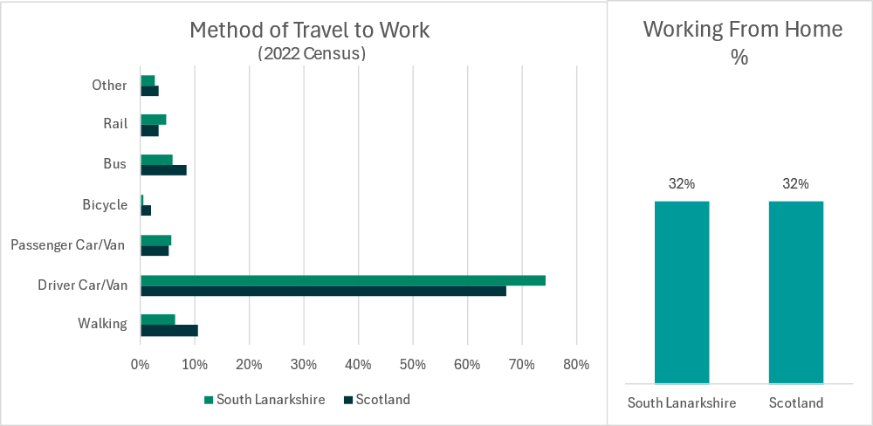
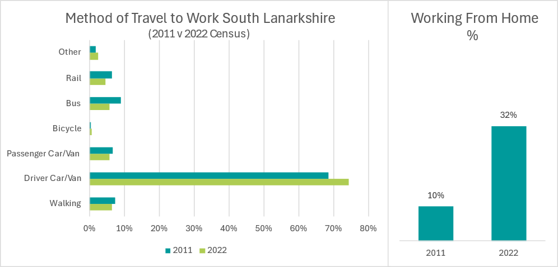
- 74% of journeys to work were made by car/van as a driver in 2022, which is higher than the Scottish average of 67%. Car/van mode share has increased in South Lanarkshire since 2011, however the actual number of people travelling by car to work has reduced as a result of a significant increase in working from home.
- Walking to work is lower in South Lanarkshire (6%) compared to the Scottish average (11%). The mode share of journeys to work by walking has decreased marginally since 2011.
- Cycling to work is lower in South Lanarkshire than the Scottish average and there has been little change observed between 2011 and 2022.
- Bus as the main mode of travel to work is lower in South Lanarkshire than the Scottish average. In South Lanarkshire, bus has experienced a decrease in mode share from 9% in 2011 to 6% in 2022.

Mode of travel for short journeys
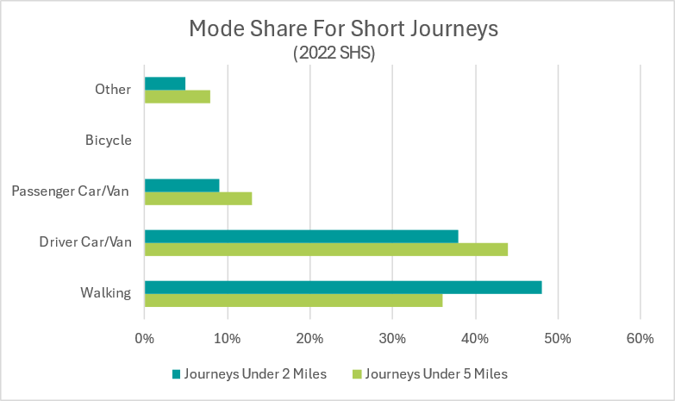
For journeys for all purposes, those under two miles are most commonly undertaken by walking at 48% mode share, compared to car/van driver at 38%. For journeys under five miles, car/van driver is the most common mode of travel with 44% mode share.

Car/van and bike availability
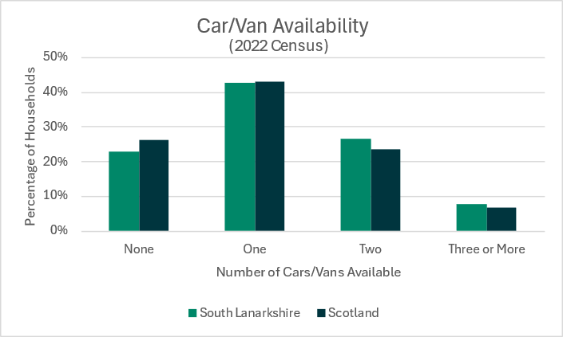
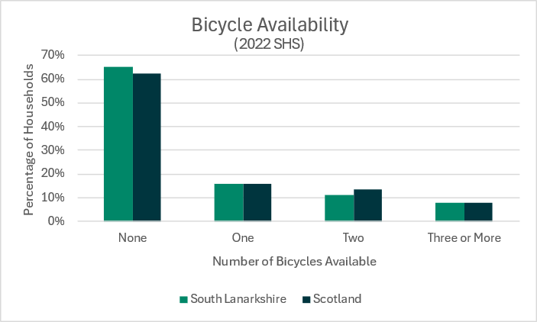
Car availability levels, by household, within South Lanarkshire are slightly higher than the national average with a greater proportion of households having access to more than two vehicles. Bike availability per household is lower in South Lanarkshire when compared to the national average. Rail as the main mode of travel to work has a higher share in South Lanarkshire than the Scottish average but has experienced minimal change since 2011.
Inclusive mobility
NRS population projections estimate that the older population will continue to grow significantly in size in both South Lanarkshire and Scotland, with the group aged 65-74 increasing by 12.5% and aged 75+ increasing by 77.4% in South Lanarkshire by 2043 compared to a 2018 baseline. In Scotland, those groups are projected to grow by 7.7% (aged 65-74) and 70.6% (aged 75+). Factors impacting on older people include inaccessible vehicles (particularly taxis, buses and trains), journey comfort, frequency of bus services and poor integration between different transport services.
The 2022 Census indicates that 25% of people in South Lanarkshire have a long-term health condition or disability, compared to 24% of the Scottish population. Key challenges disabled people face on the transport system include access public transport interchanges; access public transport vehicles; being able to interchange between all modes; and concerns regarding safety and comfort on the public transport network. Feedback at engagement events has shown disabled people rely on taxis where no bus/train provision is nearby, but availability of taxis adapted for disabled use are very low in SLC. Neurodiverse people struggle to use public transport as they can become over stimulated. As a result, more provision is needed for individual travel on demand for example my bus/dial a bus/taxi/community transport.
Key issues for young people include the availability and cost of public transport, particularly to further and higher education sites and personal safety when using transport services.
Women are more likely to experience affordability barriers to transport: they are less likely to drive and are more likely to use public transport, particularly buses. Many women feel vulnerable when using public transport – particularly at bus stops, train stations or other transport interchanges. Women who work part-time are more likely to have a multi-stop journey (for example to drop off/pick up children to/from school) than women that work full-time or men, whatever their working status. Women are more likely to feel very or fairly worried about being sexually assaulted and are also less likely to report feeling very or fairly safe walking alone at night compared to men (66% compared to 89%).
The council’s current Local transport strategy was published in 2013 and presented a 10-year vision for transport in the local authority area.
A new strategy is being prepared that will cover the period up to 2034. This will set the future direction for the development and upkeep of the transport infrastructure and policy within the area. The strategy will also set out how the council will contribute to the delivery of the obligations set out in the National and Regional Transport Strategies and other key policy drivers.
A review of the outcomes of the existing LTS has been carried out as part of the preparation of the new version. The key findings are as follows;
- Between 2008 and 2019 the council invested £126 million to improve the road network (including footways), with further investment of £47.9 million between 2019 and 2023.
- A continual reduction in road traffic casualties with the 2019-2023 5-year average showing the lowest ever number of casualties recorded, representing a 43% reduction compared to the 2014-2018 target baseline used within the Scottish Government’s Road Safety Framework 2020-2030.
- Four of the six road schemes identified to be developed by the council have been progressed: the Cathkin Relief Road opened in February 2017; sections of the Downiebrae Road Upgrade (forming part of the Clyde Gateway Regeneration Project) have been completed; A726 and Greenhills Road, East Kilbride widening opened in July 2022; and A71/B7011 Junction Improvements opened in November 2022. The remaining two road schemes – Stewartfield Way Enhancement and Lanark Gyratory (Lanark Town Centre Circulatory System) – are progressing and are at Outline Business Case and Option Generation stage, respectively.
- Supported Transport Scotland in the development and delivery of the M8/M73/M74 Improvements at Raith Interchange.
- The cycle network has been extended through construction of new schemes including sections of National Cycle Network (NCN) 74 between Uddingston and Larkhall via Hamilton, Lesmahagow and Blantyre; NCN 75 in Uddingston; and NCN 756 between East Kilbride and Glasgow. There has been delivery of the East Kilbride Cycle Network and the Bothwell/Uddingston Cycle Network as well as the implementation of cycle counters and cycle parking shelter facilities at various locations across the council area.
- Active Travel Studies have been completed for all major settlements in South Lanarkshire. These include aspirational active travel networks linking key destinations, towns and villages. These studies will form the basis for future identification and investment in the cycle network over the lifetime of the new LTS.
- On-street cycle parking facilities at 28 locations across South Lanarkshire which are accessible for members of the public. Feasibility studies for the provision of cycle hire schemes in Cambuslang and Rutherglen have been carried out.
- In 2024, 83 schools had implemented school travel plans and a further 55 had plans in development. They have contributed to approximately 55% of South Lanarkshire pupils travelling in an active and sustainable way.
- New and improved bus stop infrastructure, including new shelters, Real-Time Passenger Information Systems (RTPI) and high access kerbs, on various bus corridors, for example Stonelaw Road and Fernhill Road, Rutherglen. Bus priority has been introduced at 58 strategic junctions in Hamilton, Cambuslang, Rutherglen and Blantyre.
- Since 2013 SPT has provided funding towards the development, design and delivery of Park and Ride facilities in Newton, Carstairs, Cambuslang and Lanark. The council has a Park and Ride Strategy (2018-2027) to prioritise the introduction of Park and Ride facilities across the council area.
- Delivery of the East Kilbride Rail Enhancement project involving the provision of interchange, active travel and parking facilities at a new Hairmyres Station. In addition, new active travel connections have been made to the new station building at East Kilbride Station.
- Installation of 154 dual outlet electric vehicle chargers across South Lanarkshire which include a combination of standard, fast and rapid chargers.
Work on the draft LTS has identified the drivers for change over the next 10 years as including priorities to address the climate emergency, support economic growth, reduce inequalities and improve people’s health and wellbeing/quality of life. Transport is vital to improve access to a range of services and key sites, including employment, healthcare and leisure.
Engagement on the draft LTS has revealed the following outcomes for local residents and communities:
- The frequency and provision of public transport (37.2%), reliance on private car for small journeys (14.0%) and personal safety concerns when travelling (9.3%) are the main pressures currently affecting transport within South Lanarkshire.
- The biggest opportunities respondents identified for transport were reducing emissions (17.6%), demand responsive transport (16.4%) and increasing awareness of active travel benefits (16.2%).
- Increased support for public transport (23.2%), better maintenance of the road network (17.1%) and an improved local bus network (11.2%) were identified by respondents as the most important factors that should be considered for the LTS to address.
- More opportunities and facilities for cyclists (18.6%), increasing the number of low emission vehicles used by the council and its partners (14.7%) and more opportunities for people walking (12.2%) were identified by respondents as the least important factors that should be considered for the LTS to address.
- Respondents felt that improved infrastructure (41.2%), more traffic free routes (8.9%) and better lighting (8.8%) would encourage people to walk more often in South Lanarkshire.
- Respondents felt that improved infrastructure (34.6%) and better road conditions (24.1%) would encourage people to cycle more often in South Lanarkshire.
- Respondents felt that more frequent services (39.9%), improved reliability (15.0%) and lower fares (13.4%) would encourage more people to travel by public transport.
LDP3 will require to be consistent with, and contribute to, the implementation of the new LTS once it is approved but it will also consider the wider context of Glasgow City Region aspirations.
In January 2020, AECOM was commissioned by South Lanarkshire Council (SLC) to carry out a STAG Part 2 Transport Appraisal of sustainable transport options within the Clydesdale area of South Lanarkshire. The report can be viewed here Public and community transport - South Lanarkshire Council. It sets out a summary of key problems, opportunities, issues, constraints and uncertainties pertaining to the study area, and the recommended options identified during the STAG Part 1 study. Additional technical work has been undertaken to provide further detail on these options The eight options appraised within this report are;
- Creation of new passenger rail services (more frequency) between Carluke- Carstairs-Edinburgh and a new service between Lanark and Edinburgh through the introduction of a new section of line.
- New rail station at Law
- New rail station at Symington
- Bus service improvements
- Lanark Interchange Improvements (most of these works are now complete)
- Demand Responsive Transport in southern Clydesdale
- Active Travel Infrastructure between: Law, Carluke and Braidwood; Biggar and Symington; and Carnwath and Carstairs, and the provision of appropriate walking access to transport hubs and stops across the study area
- Carstairs Park and Ride (most of these works are now complete)
These options are being appraised as part of the preparation of the LTS. LDP3 will be required to address those options with a spatial context.
The council’s Sustainable Development and Climate Change Strategy recognises the council has a key role in the transition to a low-carbon economy and society, with a legislative requirement to contribute to the national greenhouse emissions reduction target of net-zero by 2045. The council can contribute to this transition through policies and regulatory powers in areas including local transport planning and land use planning. The council also has a duty to prepare for and take adaptive measures to reduce the impacts that changes in climate may have on communities and roads and infrastructure. Priority 4 - Improve affordable, sustainable, and accessible transport options includes a series of measures linked to transport;
- Extend South Lanarkshire’s cycle network and associated facilities
- Expand the provision of publicly available Electric Vehicle Charging infrastructure in South Lanarkshire
- Complete a variety of projects to enhance the attractiveness of public transport
- Progress towards decarbonising the fleet of South Lanarkshire Council vehicles
- Ensure climate change, access to services and active travel forms part of the design of new residential developments
- Utilise ultra-low carbon vehicles or public transport for Education related travel
- Consider sustainable travel within the council’s employee travel plan
- Continue to achieve Cycle Friendly Employer status

7. Existing Transport Network in South Lanarkshire

Public road network
South Lanarkshire is well connected to other parts of the region and Scotland in respect of the national transport network with the M74 motorway and the Glasgow Southern Orbital (GSO) and the West Coast rail line passing through the area and with good accessibility to Glasgow and beyond by public transport routes. Glasgow airport is around a 30-minute drive and Edinburgh airport is around an hour’s drive away. The plan below shows the distribution of the M74, classified roads and the rail network in South Lanarkshire.
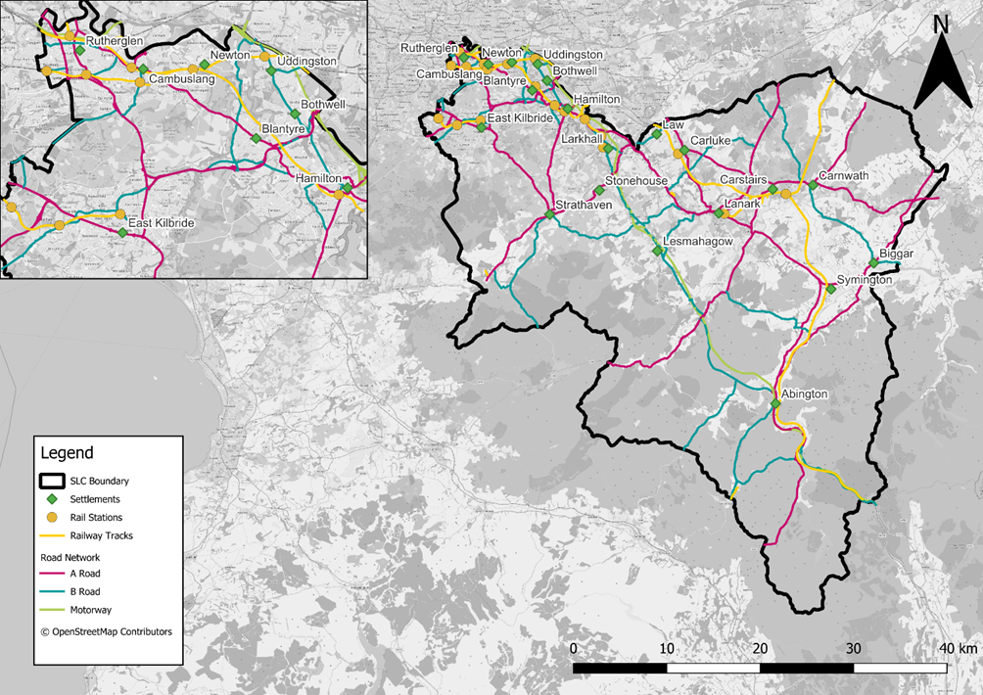

South Lanarkshire Council is responsible for a road network that is 2,295 km (1,426 miles) in length and comprises of 290 km of A class roads, 250 km of B class roads, 407 km of C class roads and 1,348 km of unclassified roads. This excludes the motorway and trunk road network which is the responsibility of Transport Scotland.

The trunk roads in South Lanarkshire are;
- M74 linking with the Dumfries and Galloway and the M6 to the south and the M73/M8 to the north
- A725 East Kilbride Expressway linking East Kilbride with the A726 Glasgow Southern Orbital/M77 to East Kilbride to the west and the M8/North Lanarkshire to the north
- A702 linking the M74 with eastern Scotland via Biggar

The table below shows average daily traffic flows at selected points on the M74
Year | M74 J18-J19 | M74 J9
2013 | 31,410 | 33,302
2014 | 32,906 | 0
2015 | 33,313 | 35,795
2016 | 34,718 | 33,385
2017 | 0 | 21,905
2018 | 34,694 | 40,052
2019 | 35,156 | 38,237
2020 | 24,896 | 26,607
2021 | 32,453 | 14,483
2022 | 35,968 | N/A
2023 | 36475 | 31109

A baseline is being prepared as part of the review of the Local Transport Strategy which will identify where traffic growth has been prevalent and the congestion hotspots on the public road network. The outcomes will be used in developing the spatial strategy through the work on the Transport Appraisal.

Information on the condition of local authority roads is collected in the annual Scottish Road Maintenance Condition Survey organised by the Society of Chief Officers of Transportation in Scotland (SCOTS). The survey is taken on all A class roads in one direction, with the other direction being surveyed the following year. Fifty per cent of B and C class roads in South Lanarkshire are surveyed, meaning that all the B and C class network is surveyed over a four year period. Only 10% of the unclassified road network is completed each year. The survey produces a Road Condition Index and identifies, for each 10 metre section of road, the percentages within three categories - requiring maintenance, should be considered for maintenance, and serviceable. The Road Condition Index is published annually as a national performance indicator. The results for South Lanarkshire and the Scottish average are set out in the table below

Carriageway condition - % of network that should be considered for maintenance treatment
Year | South  Lanarkshire | Scotland average | Year | South Lanarkshire | Scotland average
2022/2023 | 30.8 | 33.6 | 2012/2013 | 36.8 | 36.2
2021/2022 | 29.7 | 34.2 | 2011/2012 | 37.5 | 36.4
2020/2021 | 30.6 | 35.5 | 2010/2011 | 38.0 | 37.9
2019/2020 | 30.3 | 35.8 | 2009/2010 | 37.5 | 36.1
2018/2019 | 31.2 | 36.3 | 2008/2009 | 37.5 | 34.2
2017/2018 | 31.8 | 36.7 | 2007/2008 | 39 | 37
2016/2017 | 33.1 | 36.4 | 2006/2007 | 51 | 47
2015/2016 | 33.5 | 36.7 | 2005/2006 | 49 | 42
2014/2015 | 33.8 | 37.0 | 2004/2005 | 48 | 42
2013/2014 | 35.9 | 36.7 | 2003/2004 | 53 | 45
Figures have been rounded
Source: South Lanarkshire Scotland; SCOTS

The roads across South Lanarkshire have undergone an extensive maintenance programme over the last decade which has resulted in a drop in the percentage of network requiring maintenance. However, some regression has been noted in recent years with the most significant during the latest survey year of 2022/2023. Emerging data for 2023/2024 also indicates further regression. Nevertheless, the condition of roads in the area are better than across Scotland as a whole.

In terms of road safety Transport Scotland statistics Key Reported Road Casualties Scotland 2021 | Transport Scotland on the average number of reported road casualties, 2017-2021 shows South Lanarkshire has the 5th highest Local Authority figure (408) with Orkney the lowest at 17 and Glasgow the highest at 999. The tables below show trends in fatal casualties and serious injuries in South Lanarkshire between 2016 and 2022 against a Scottish Government target of a 50% reduction up to 2030.
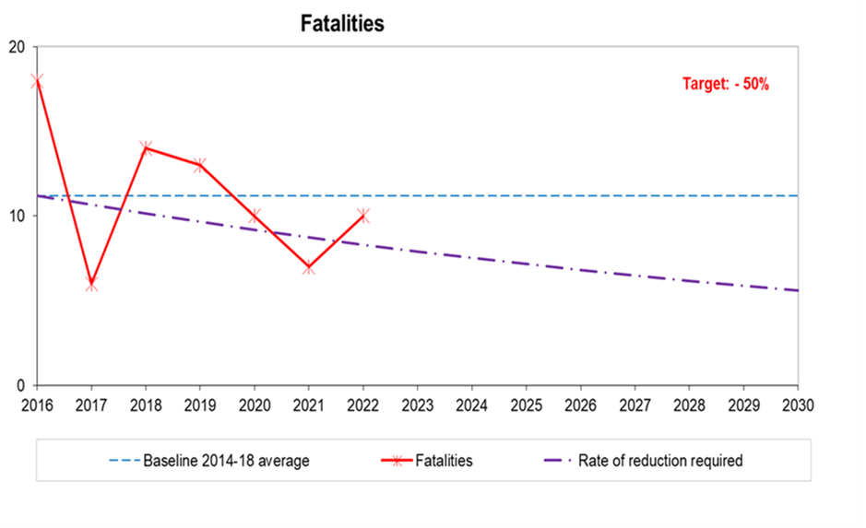
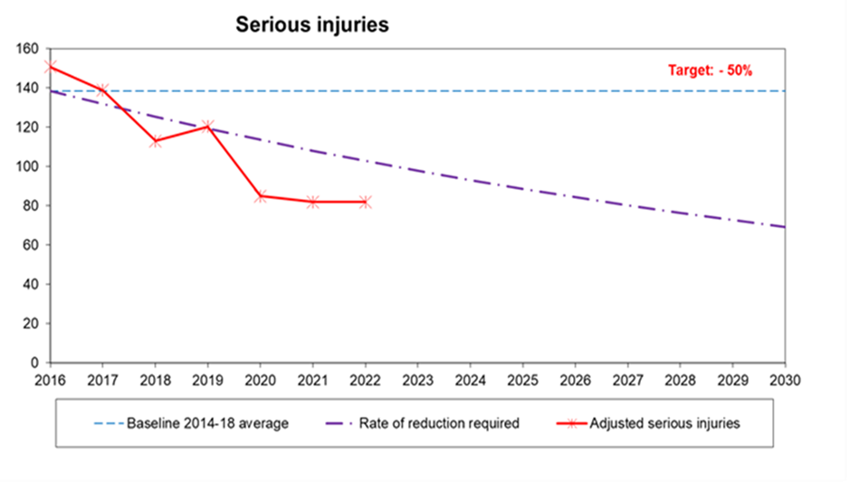
The graphs show the progress in lowering casualties across all severities and categories when compared to the 2014 to 2018 average baselines. The council is making progress towards the 2030 targets.
South Lanarkshire Council is also responsible for a total of 778 road bridges, footbridges, subways, culverts and cattle grids. This figure includes structures with spans greater than 0.9 metres owned by South Lanarkshire Council but does not include retaining walls. In addition, there are 92 structures owned by other bodies which are over or under council roads. Inspection records held for each structure indicate that the council owned structures remain in good to fair condition. The council has a bridge strengthening programme which is prioritised depending on the class of road carried, assessed capacity and condition of the structure. The programme for planned maintenance is compiled from the results and recommendations obtained from a robust routine bridge inspection regime.

Active Travel Network
Walking and cycling are the most sustainable forms of transport and can also be enjoyable leisure activities. It is also a crucial form of access to public transport. A high proportion of journeys in South Lanarkshire are made on foot. South Lanarkshire Council maintains an extensive path and footway network but there are limited opportunities for walking and cycling between communities, especially in the rural areas.
South Lanarkshire Council maintains an extensive active travel network, comprising 289 kilometres of cycle paths (89 kilometres off-road and 209 kilometres on-road) and 2,425 kilometres of urban footways. Working with key partners including SPT, Sustrans and others, the council has made substantial progress in enhancing the active travel network since the publication of the previous LTS. Active Travel Network Plans have been developed for Carluke; Lanark; Hamilton; East Kilbride; Rutherglen; Cambuslang; Strathaven, Stonehouse and surrounding villages; Clydesdale; Larkhall; Bothwell; Blantyre; and Uddingston.
The cycle network has been extended while the first fully segregated cycle route continues to be developed in East Kilbride in the West Mains and Town Centre areas. The council has implemented on-street cycle parking and storage facilities in 28 locations across South Lanarkshire. The cycling open data forum provides data on active travel in South Lanarkshire uSmart. The South Lanarkshire Cycling Partnership was formed in January 2014 to ensure that partners could maximise the benefits cycling can bring to the area’s residents. Alongside this, the council implemented its Cycling Strategy for South Lanarkshire 2015 – 2020 (extended to 2023) which accords with key aims within the Scottish Government’s Cycle Action Plan for Scotland and latterly the Cycling Delivery Plan for Scotland. The new forthcoming South Lanarkshire Transport Strategy will encompass the Cycling Strategy and set out aims to 2034. However, it is recognised that further investment is crucial to achieve the level of change required to meet climate targets, tackle poor health and address social exclusion. The LTS and LDP3 are key drivers to deliver and extend the active travel network.
The council has recently received funding for the creation of the Clydesdale Way which is a long-distance path linking the existing Clyde Walkway into Scottish Borders and Dumfries and Galloway. Information on walking and cycling is collected biennially in South Lanarkshire for the Scottish Household Survey along with information from previous years.

People who walk or cycle as main mode of transport (%)
Mode | 1999/ 2000 | 2003/  2004 | 2005/  2006 | 2007/ 2008 | 2009/ 2010 | 2011/ 2012
Walking | 16 | 12 | 10 | 19 | 13 | 23
Bicycle | 0 | 0 | 0 | 0 | 0 | 1
Mode | 2013/  2014 | 2015/  2016 | 2017/  2018 | 2019/  2020 | 2020/  2021 | 2021/ 2022
Walking | 19 | 14 | 17 | 17 | * | 20
Bicycle | 1 | 0 | 0.5 | 1 | * | 0
*Data not available
Source: Scottish Household Survey
There has been a decline in walking since 2011/2012, however, a slight improvement was noted in 2017/2018. There has been a slight increase in the number of people cycling in 2019/20. In 2021, there was a decline in people cycling as their main mode of transport, however, there has been a 3% increase in people walking in the same year.

The council’s Core Path Network can be found here. The table below provides a summary of the level of use of sections of the path network at various locations across South Lanarkshire. Based on the data available it appears that access activity has generally remained steady over recent years. However, it is notable that there was a significant increase in usage in some popular locations like country parks.

Summary of path network use

Path network | 2014 | 2015 | 2016 | 2017 | 2018 | 2020
Clyde Walkway - Rosebank | - | 16,500 | 10,000 | 9,000 | 6,000  (Jan – Nov) | 12,000  (August 20 – May 21)
Clyde Walkway - Crossford | 27,500 | 44,000 | 42,500 | 23,500 | 35,500 | 48,000  (August 20 – May 21)
Clyde Walkway – West Brownlee | 7,500 | 12,000 | 9,500 | 3,000  (Jan – Mar) | 11,000  (June – Dec) | -
Falls of Clyde – Bonnington Linn | 9,000 | 10,000 | 8,500 | 5,500  (Jan – Oct) | - | -
Falls of Clyde –  Corra Linn | 25,500 | 27,000 | 27,000 | 38,000  (Jan – Oct) | - | -
Chatelherault – Riccarton Path | 66,500 | 68,500 | 61,500 | 66,000 | - | 71,000  (June 20 – May 21)
Chatelherault – Old Avon Bridge (NCR 74) | 83,000 | 90,000 | 64,500 | 38,500  (Jan – July) | - | -
Chatelherault – Sunnyside Path | 17,000 | 31,000 | 26,500 | 30,000 | 39,000 | 42,000  (June 20 -June 21)
Morgan Glen –  Avon Road entrance | 14,000 | 97,000 | 16,000 | 12,500 | - | 21,000  (April 20 – May 21)
Morgan Glen –  Millheugh entrance | 23,000 | 13,000 | 16,000 | 11,500 | 25,000 | 33,000  (April 20 – May 21)
Braidwood | 6,500  (July – Dec) | 40,500 | 36,500 | 27,000 | 21,500 | 27,000  (August 20 – June 21)
Lower Nethan Reserve (Crossford) | - | - | 2,500  (June – Dec) | 4,500 | 5,000 | 5,000  (August 20 – June 21)
Redlees Park, Blantyre | 8,000 | 19,000 | 25,000 | 17,000 | 18,500 | 28,000  (Nov 20 – July 21)
Langlands Moss LNR,  East Kilbride | 25,500 | 27,000 | 23,500 | 12,500  (Jan – Aug) | 9,000  (Apr – Dec) | -
Ashgill Path, Ashgill | - | - | 4,000  (May – Dec) | 5,500 | 6,000 | 7,000  (June 20 – May 21)
Goose Pond, South Haugh, Hamilton | - | - | 26,500  (Apr – Dec) | 32,000 | 37,000 | 26,000  (June 20 – June 21)
Law | - | - | 7,000  (May – Dec) | 12,000 | 14,000 | 11,000  (Aug 20 – June 21)
The Ditches, Nemphlar | - | - | 1,500  (June – Dec) | 3,000 | 3,000 | 3,000  (Aug 20 – June 21)
Calderglen Country Park* | 910,000 | 896,500 | 1,069,500 | 986,500 | 1,006,500 | -
Whitelee Windfarm | 51,500 | 47,000 | 42,000 | 104,000 | 99,500 | -
Cambuslang Park | 158,500 | 153,500 | 170,000 | 147,500 | 194,000 | 300,000 (June 20 – May 21)
Fernbrae Park – car park | - | - | - | - | - | 180,000 (July 20 – May 21)
Tinto Hill | - | - | - | - | - | 25,000  (Dec 20 – June 21)
Glen Esk 1, East Kilbride | - | - | - | - | - | 101,000  (Oct 20 – July 21)
Galloway Road,  East Kilbride | - | - | - | - | - | 24,000  (Oct 20 – July 21)
Lothian Road,  East Kilbride | - | - | - | - | - | 42,000  (Oct 20 – July 21)
Notes: Figures rounded to the nearest 500. Data gaps due to equipment malfunctioning or counters being moved or becoming inactive. No data available for years 2019, 2021 and 2022. *Visitor numbers to the Park.

In terms of cycling a summary of the usage at sites across South Lanarkshire is set out below

Summary of cycling path location and usage
Location | 2014 | 2015 | 2016 | 2017 | 2018 | 2019 | 2020
Pankhurst Road, East Kilbride | 5,173 | 4,406 | 5,188 | 5,581 | 5,141 | 4,924 | 11,199
Ferry Road, Uddingston (west of school) | 8,590 | 8,385 | 8,203 | 8,030 | 8,433 | - | -
A70, South of Hyndford Bridge, Lanark | 1,739 | 1,805 | 2,772 | 1,770 | 1,729 | 1,327 | 2,788
North British Road, Uddingston | - | - | 14,788 | 17,340 | 16,165 | 17,052 | 21,613
A749, North of Nerston, East Kilbride | - | - | 6,048 | 7,252 | 6,881 | 7,181 | 14,322
A724, Glasgow Road, Cambuslang (north bound) | - | - | 11,820 | 10,946 | 10,629 | 10,060 | 14,120
A730, Glasgow Road, Rutherglen | - | - | 26,376 | 31,209 | 32,908 | 36,451 | 37,982
Burnbrae Street, Larkhall (via Fairholm Park) | - | - | 9,344 | 14,394 | 12,735 | 11,374 | 23,206
B7078, Kirkmuirhill to Lesmahagow | - | - | 13,595 | 13,799 | 12,029 | 12,328 | 23,206
Cathkin Relief Road | - | - | - | 4,940 | 5,729 | - | -
Calderwood Road, East Kilbride | - | - | - | 3,683 | 4,441 | 4,644
Main Street, High Blantyre | - | - | - | 6,998 | 6,566 | 6,669 | -
Clyde Walkway, near Blantyrefarm Road, Uddingston | - | - | - | 8,314 | 8,203 | - | -
A724, Glasgow Road, East of Blantyre | - | - | - | 13,099 | 11,114 | - | -
A724, Clydesford Road, Cambuslang, (south bound) | - | - | - | 10,242 | 10,027 | 9,798 | -
A724, Clydesford Road, Cambuslang, (north bound) | - | - | - | 11,948 | 11,937 | 12,037 | -
B7078, Cairnhouse, South of Coalburn | - | - | - | 12,517 | - | 12,192 | -

The various restrictions in place during Covid19 resulted in travel patterns and peoples’ leisure activities altering. Cycling increased during the pandemic. Daily flow data from a selection of the council’s cycle monitoring sites operational during the pandemic period was collated for 2021 and compared to the cycle flows from 2019 and 2020.

Cycling activity before and during Covid19 pandemic
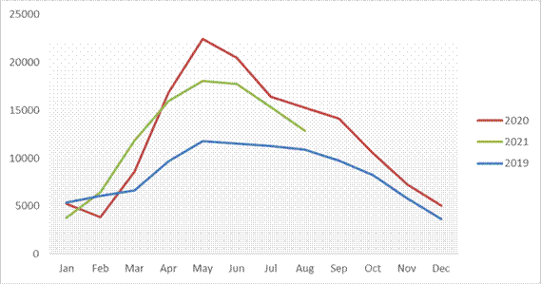
Source: South Lanarkshire Council

Cycle trips increased significantly at these sites during the pandemic period, particularly over spring, summer and autumn. Even during November and December the number of cycling trips remained higher in 2020 than in 2019 at most sites. In 2021, the number of cycle trips remained higher than in 2019, however, there was a slight reduction when compared to 2020 at most locations.

Bus travel
Buses have a vital role in supporting modal shift away from private vehicle usage in South Lanarkshire. Bus patronage numbers across Scotland have decreased steadily since 2013. Nationwide the number of passenger journeys has fallen from 421 million in 2013/14 to 301 million passenger journeys in 2022/23. The impact of the COVID-19 pandemic on bus patronage was significant; bus passenger numbers nationwide were 361 million in 2019/20 and decreased by 17% in the three-year period to 2022/23. In the Southwest and Strathclyde region the decrease over this three-year period has been more pronounced with a 20% decrease in this region.
The highest quality and most frequent bus services in South Lanarkshire are those that connect to Glasgow. Services are less frequent and convenient between the towns within South Lanarkshire, and for trips around the residential areas of larger towns. Some services were withdrawn during the COVID-19 pandemic and have not been reinstated. Bus services in rural areas are often infrequent and generally limited to main roads. Links from Clydesdale to Livingston and Edinburgh are limited.
SPT provides subsidies for a number of services which operate in South Lanarkshire, including services between Lanark – Douglas – Glespin; East Kilbride – Strathaven – Hamilton; and Hamilton – Larkhall – Crossford. It is noted however that limited funds are available to subsidise bus services and as such it is not possible for all desired routes to be subsidised. SPT also provide demand responsive transport (DRT) services for residents of South Lanarkshire and are unable to or have difficulty using standard bus services. MyBus provides essential services for those unable to easily access public transport due to their age, disability or location. These services require to be pre-booked. It is noted that there are gaps in coverage, which impacts rural parts of South Lanarkshire in particular.
Bus services in South Lanarkshire could provide a more attractive alternative to the car if waiting facilities and timetable information were improved. The council, in partnership with SPT, has been improving facilities at bus stops, including the provision of high-quality bus shelters, improving accessibility at bus stops and providing timetable information at all bus stops. Real-time passenger information has been implemented at stops on some strategic bus routes. Bus priority has also been implemented at traffic signals along strategic corridors to improve bus journey times.
SPT and the council continue to invest in high-quality transport interchanges. In 2012 the new Hamilton Interchange opened, and since then passenger numbers at the station have increased substantially. Improvements to Lanark Interchange Interchange will enhance integration with the rail station and improve the overall passenger experience at the station.

Community Transport
Community transport services are community-led transport solutions, offered by locally owned organisations or volunteers and developed in response to unmet local transport needs. They often represent the only means of transport for many vulnerable and isolated people, including older people or people with disabilities. Community transport services include voluntary car schemes, community bus services, school transport, hospital transport and group hire services. Community transport groups are based in Carluke, Blantyre, Forth, Hamilton, Larkhall, Lesmahagow, Strathaven, Douglas Water and East Kilbride.
SPT has provided £623,000 to support six CT organisations in South Lanarkshire in recent years: Blantyre Volunteer Group; East Kilbride Community Transport; Larkhall and District Volunteer Group; The Rural Development Trust; Voluntary Action South Lanarkshire; and Royal Voluntary Service.

Rail
There are 19 rail stations located within South Lanarkshire. There are gaps in this network of stations, particularly in the Clydesdale area. The majority of train services in South Lanarkshire provide connections to Glasgow; however, there are direct connections to a number of other areas including North Lanarkshire, Edinburgh, West Lothian, East Renfrewshire and West Dunbartonshire. The Office of Rail Regulation compiles a list of the number of passengers using railway stations in South Lanarkshire Passenger rail usage Estimates of station usage | ORR Data Portal. Rail patronage within South Lanarkshire has declined with passenger numbers dropping from over 8.8 million in 2013/14 to just over 5.5 million in 2022/23. Passenger numbers peaked in 2016/17 with over 9.3 million entries and exits at South Lanarkshire stations and severely declined in 2020/21. The numbers for 2023/24 are now at 80% of 2019/20 levels.

Rail patronage for all South Lanarkshire Stations (entries/exits)
Station | 2023/24 | 2022/23 | 2021/ 22 | 2020/ 21 | 2019/ 20 | 2018/ 19 | 2017/  18
Blantyre | 377,508 | 312,248 | 234,322 | 64,912 | 515,938 | 511,822 | 551,508
Burnside | 215,682 | 182,226 | 132,112 | 30,194 | 263,304 | 272,764 | 282,282
Cambuslang | 767,634 | 629,278 | 443,054 | 165,944 | 769,008 | 758,836 | 850,510
Carluke | 287,912 | 230,770 | 154,426 | 35,624 | 399,962 | 405,328 | 420,170
Carstairs | 28,352 | 13,506 | 6,986 | 4,138 | 60,948 | 62,376 | 84,166
Chatelherault | 73,765 | 61,912 | 45,960 | 13,102 | 114,042 | 108,456 | 111,076
Croftfoot | 226,428 | 185,492 | 145,018 | 56,688 | 269,538 | 258,692 | 256,420
East Kilbride | 756,936 | 573,718 | 445,832 | 134,146 | 991,900 | 1,055,414 | 1,031,100
Hairmyres | 518,614 | 409,734 | 309,320 | 97,650 | 655,570 | 673,386 | 647,622
Hamilton Central | 648,720 | 526,570 | 378,966 | 103,426 | 757,450 | 756,528 | 811,104
Hamilton West | 630,746 | 507,912 | 344,710 | 91,530 | 775,536 | 774,500 | 866,144
Kirkhill | 65,226 | 58,128 | 38,876 | 5,950 | 71,430 | 78,116 | 69,104
Lanark | 246,840 | 203,190 | 143,656 | 30,996 | 279,864 | 292,294 | 303,834
Larkhall | 243,898 | 204,948 | 151,558 | 32,382 | 354,144 | 354,604 | 385,942
Merryton | 67,814 | 56,250 | 39,622 | 7,590 | 127,852 | 121,356 | 107,220
Newton | 546,872 | 434,300 | 305,856 | 88,638 | 719,034 | 678,490 | 669,530
Rutherglen | 812,876 | 549,318 | 489,766 | 213,110 | 1,015,208 | 1,027,812 | 1,072,296
Thorntonhall | 19,642 | 14,880 | 11,130 | 3,098 | 24,034 | 22,026 | 21,310
Uddingston | 701,672 | 567,802 | 408,504 | 138,094 | 863,522 | 898,176 | 888,052
Total |  |  | 4,229,674 | 1,317,212 | 9,028,284 | 9,110,976 | 9,429,390

The council has increased the provision of Park and Ride facilities at rail stations throughout the area as these encourage the choice of rail travel as part of a multi-modal journey, particularly for commuters. Since 2013, SPT has provided funding towards the development, design and delivery of Park and Ride facilities in Newton, Carstairs, Cambuslang, Haimyres and Lanark. A Park and Ride Strategy 2018-2027 - South Lanarkshire Council has been developed to prioritise the further opportunities to introduce Park and Ride facilities across the council area to encourage even greater use of rail. Details of the characteristics of each station in terms of accessibility, car park spaces and cycling spaces is provided below.

Station | Entries and Exits (March 2024) | Accessibility Category | Access – Stations and Platforms | Car Park Spaces | Cycling Spaces
Blantyre | 377,508 | B | Level to both platforms and connecting footbridge with stairs between platforms | 54 | 10
Burnside | 215,682 | C | No step free access – stairs to island platform | 0 | 6
Cambuslang | 767,364 | C | Ramps to lower ground platforms | 0 | 14
Carluke | 287,912 | B | Level to platform 2, ramp to platform 1 and connecting footbridge with stairs between platforms or long route via public road | 350 | 16
Chatelherault | 73,122 | A | This station has step-free access to both platforms | 100 | 6
Croftfoot | 226,428 | C | No step free access – stairs up to island platform | 0 | 10
East Kilbride | 756,936 | A | This station has step-free access to both platforms | 287 | 31
Hairmyres (under construction) | 518,614 | A | This station has step-free access to both platforms | 500 | tbc
Hamilton Central | 648,720 | A | This station has step-free access to both platforms | 296 | 24
Hamilton West | 630,746 | B | Ramps to both platforms | 41 | 16
Kirkhill | 65,226 | B | Ramps to both platforms | 10 | 6
Lanark (at present) | 246,840 | A | This station has step-free access to all platforms | 92 | 26
Lanark (with bus interchange extension) | 246,840 | A | This station has step-free access to all platform | 62 | 26
Merryton | 67,814 | A | This station has step-free access to single platforms | 86 | 6
Newton | 546,872 | A | This station has step-free access to both platforms | 245 | 16
Rutherglen | 812,876 | A | This station has step-free access to island platform | 0 | 4
Thorntonhall | 19,642 | A | This station has step-free access to single platform | 4 | 6
Uddingston | 701,672 | A | Level to both platforms and connecting footbridge with lifts between platform | 228 | 24

Notwithstanding the increased provision of park and ride provision at stations Network Rail’s Sustainable Travel to Stations strategy establishes a focus on high-quality walking, wheeling, cycling, and bus connections to stations rather than encouraging the use of private cars. Delivering the strategy will integrate railway stations into the communities they serve, anchoring them to their station, and increasing passenger numbers getting to the station actively and sustainably. Its practical delivery will reduce driving to stations and increase active and sustainable travel and help deliver the target of a 20% reduction in driven car kilometres by 2030. In addition, delivering stations that integrate better with the communities they serve will open access to public transport and help narrow the gap in opportunity to access education, employment, and opportunity. The strategy recognises that transport is not just physical but also social infrastructure and has a key role to play in delivering a more just and socially open society.

Scotland’s Railway aspires to carry twice as many customers as it did pre-pandemic which would mean at least 190 million passenger journeys in 2035. To achieve this aspiration, Scotland’s Railway need to increase passenger journeys by 126 million from the 64 million carried in 2022/23. Key targets in terms of different modes of transport include

- Increase walking/wheeling trips to stations from 33% in 2022 to 50% in 2035. From 21 million in 2022 to 95 million trips in 2035.
- Increase cycling trips to stations from 9% in 2022 to 20% in 2035. From 6 million trips in 2022 to 38 million trips in 2035.
- Increase bus trips to stations from 14% in 2022 to 20% in 2035. From 9 million trips in 2022 38 million trips in 2035.
- Reduce percentage driving/being driven to stations from 27% in 2022 to 10% in 2035. • From 17 million trips in 2022 to 19 million in 2035.

A separate report by Arup for Transport Scotland ‘The effects of Park and Ride supply and pricing on public transport demand’ suggests that building a hundred new car parking spaces might generate only between four and ten new/extra rail trips a day – indicating that building large car parks largely encourages short-distance driving from people who currently travel to railway stations actively or sustainably. Network Rail has committed to work with the council to improve the public realm at and around railway stations including active travel and bus connections. The Active Travel Network plans referred to above can consider links to the relevant stations to enable onward travel by rail.

Freight Transport
Safe and sustainable transportation of freight and goods is essential for the economic wellbeing of South Lanarkshire. The number of goods vehicle trips, if left unchecked, is forecast to increase, which will negatively impact on journey times and peak-period delays. Transporting goods by road has a substantial impact on the structural integrity of roads and bridges and can shorten the lifespan of these assets, with an associated impact on maintenance costs. Freight transport can also have a detrimental effect on town centres if it is unregulated. Deliveries during peak periods can cause congestion and make town centres less attractive to customers.

In 2017, Heavy Goods Vehicle (HGV) emissions across Scotland were 3.5% higher than in 2016 and 5.2% above the 1990 baseline figure. Light Goods Vehicle (LGV) emissions were 6.5% more than 2016 and 95.6% higher than the 1990 baseline figure. The increase in emissions from LGVs reflects increasing vehicle kilometres. Whilst recognising the importance of freight within the economy, a key challenge will be to ensure that the negative impacts generated by the movement of goods vehicles are addressed.

The draft LTS commits to exploring opportunities to transfer freight from road to rail. There is scope to improve the sustainability of the movement of freight and goods in built-up areas, including town centres. The efficient movement and delivery of goods may require the implementation of waiting and loading restrictions or alterations to the circulation system. Developing freight consolidation hubs and improved network planning can reduce the amount of freight traffic on local roads and streets, particularly HGVs. Cycle logistics, which use cargo bikes for last-mile deliveries, is another opportunity that can reduce motorised freight traffic within urban centres and some neighbourhoods. The council will encourage and support these measures through the LTS and the proposed LDP3.

School Travel
78 schools had developed travel plans by June 2023 and a further 60 schools had travel plans in development. As part of a national travel study, mode share data was collected from over 22,100 children in September 2021 and over 27,200 children in September 2022, who attended school in South Lanarkshire. The results for all pupils are set out below. Separate data for primary and secondary schools only can be found in the State of Environment report 2023.
All school pupils’ journey to school
Year | Walk | Cycle | Scooter/ Skate | Park and Stride | Driven | Bus | Taxi | Other | Sample Size
2012 | 41.0% | 1.5% | 0.8% | 8.3% | 25.3% | 20.4% | 2.1% | 0.7% | 33,081
2013 | 41.8% | 2.2% | 2.4% | 8.0% | 22.3% | 20.3% | 2.5% | 0.5% | 34,347
2014 | 41.7% | 2.2% | 2.0% | 8.1% | 22.7% | 20.5% | 2.2% | 0.5% | 34,467
2015 | 40.5% | 2.7% | 2.3% | 8.2% | 25.2% | 17.9% | 2.7% | 0.5% | 33,503
2016 | 40.0% | 2.2% | 2.1% | 9.6% | 24.8% | 18.1% | 2.4% | 0.7% | 34,646
2017 | 39.6% | 2.3% | 2.5% | 9.8% | 26.1% | 17.1% | 2.3% | 0.4% | 31,714
2018 | 38.4% | 2.3% | 1.6% | 9.9% | 27.7% | 17.4% | 2.4% | 0.4% | 31,118
2019 | 37.6% | 2.8% | 1.9% | 9.5% | 28.2% | 17.0% | 2.5% | 0.5% | 31,917
2020 | 39.4% | 2.8% | 1.9% | 10.5% | 27.4% | 15.7% | 2.0% | 0.4% | 19,891
2021 | 40.4% | 2.9% | 2.3% | 11.5% | 26.9% | 13.4% | 2.1% | 0.5% | 22,148
2022 | 37.3% | 3.0% | 2.6% | 10.4% | 26.4% | 17.0% | 2.6% | 0.7% | 27,235
Source: South Lanarkshire Council; Sustrans

The 2022 survey results demonstrate that walking to school is the most popular mode of transport with 37.3% of all pupils choosing this method. Park and stride proved popular with primary pupils (10.9%). More primary pupils (8.8%) than secondary pupils (0.3%) travelled to school by cycle or scooter. However, 34.7% of primary pupils and 19.2% of secondary pupils were driven to school (including by taxi). The number of secondary pupils using the bus to commute to school has increased significantly (34.1%) in 2022 compared to previous years. This may be due to the high number of pupils using the Young Persons’ Free Bus Travel Scheme.

“Be Safe, Bus Safe” resources are used to provide primary school aged pupils with important information about keeping safe whilst waiting, boarding and travelling on buses. Some schools have cycle and scooter storage facilities to encourage active travel. A ‘Bike Bank’ is available to schools to support cycle training. Most schools have part-time mandatory 20mph zones and many have enforceable parking restrictions. The recent focus on speed awareness has seen a significant number of schools benefiting from new carriageway road markings and signing which creates a ‘school’ environment and enhanced awareness of the 20mph speed limit. Two schools have Car Free School Zones (CFSZ) in place. Other measures such as ‘Parking Buddies’ are used to encourage responsible parking.

Electric vehicle charging
All new petrol and diesel cars and vans is intended to be phased out by 2030. As such, the creation of a robust EV Charging network is vital to help contribute towards meeting this goal. This link Charge Place Scotland shows the location and number/type of all council owned and commercially owned chargers in South Lanarkshire. Charging points are focused on town centres and retail parks, council offices and other community and sports centres. The council is continuing to work with Glasgow City Region on an EV infrastructure strategy expansion plan.

Parking
In terms of new development, the council applies the parking standards in the National Roads Development Guide (NRDG), with a local variation related to residential garages not contributing to required provision. The NRDG gives flexibility to reduce parking standards in town centres and urban areas where there are good links to sustainable transport. NPF4 Policy 13 emphasises the role which minimising space dedicated to car parking, including a shift to low/no car developments, can play in reducing car use. A review of policy on parking standards will be carried out during LDP3.

Transport Appraisal
Policy 13 of National Planning Framework 4 states that a critical part of LDP preparation will be a transport appraisal, which should be completed in time to inform the Proposed Plan and published alongside it. The appraisal should be carried out in line with Transport Scotland’s Transport Appraisal Guidance to understand any cumulative multi modal transport impacts and required mitigation to deliver the spatial strategy, whether this is for local or strategic transport.
The council is committed to undertake the appraisal work. Transport Scotland’s Appraisal Guidance is currently being updated in line with NTS2, NPF4 and the LDP Guidance. It will become DPTAG once published in 2025 with a greater focus on the NTS2 sustainable travel and investment hierarchies and multi modal impacts and mitigation. Work on scoping the appraisal will start once the revised guidance is published. The baseline created for the new LTS will be a key element in preparation of the appraisal.

Transport Poverty
Transport poverty: a public health issue published by Public Health Scotland in 2024 highlights the need to ensure the causes of transport poverty are addressed and that there are more equitable transport options for all. The link between transport poverty and the harm it can cause to health and wellbeing is established. Addressing transport poverty is particularly important for Scotland at a time when life expectancy and healthy life expectancy are falling and health and social inequalities are widening.
Transport poverty relates to the lack of transport options that are available, reliable, affordable, accessible or safe that allow people to meet their daily needs and achieve a reasonable quality of life. Transport poverty can affect health in various ways. It can:
- limit access to the building blocks of good health, such as good work, training and education
- reduce access to health and care services
- increase exposure to transport-related health harms, such as pollution and injury from collisions
- reduce community engagement
The report recommends the following actions.
- increase investment in sustainable transport to improve the frequency, reliability, accessibility, integration, affordability and safety of services and infrastructure
- ensure new developments support the sustainable transport hierarchy and take account of the five dimensions of transport poverty
- promote greater dialogue between service providers – including the NHS – and the transport sector to enable everyone to reach the services they need in a timely manner and have access to adequate facilities, such as bike storage, to support the use of sustainable transport options
- ensure all plans and strategies in transport, planning, housing and service provision meet the needs of those populations most vulnerable to transport poverty. This includes people on low incomes, people living in rural and island communities, women and disabled people
Figure 26 in the Initial Appraisal: Case for Change – Glasgow City Region Strategic Transport Projects Review (STPR2) shows the assessment for the Glasgow City Region.
Areas in and around Glasgow City generally have a lower risk of transport poverty with surrounding areas having medium risk and some areas high risk of transport poverty. In the Glasgow City region, 31% of data zones were classified as high risk for transport poverty compared to 38% in Scotland; 42% were classified as medium risk compared to 41% in Scotland; and 27% were classified as low risk compared to 21% in Scotland. This suggests that the region is more likely to suffer from transport poverty than other parts of the country. South Lanarkshire had the highest proportion of high-risk data zones, with 51%.

Transport Connectivity
NPF4 requires LDPs to prioritise locations for future development that can be accessed by sustainable modes and emphasises using the ‘place principle’ to facilitate the delivery of sustainable development within the local built environment. From a transport perspective, any such analysis needs to consider the relationship between land use supply and the transport network.
Travel is a derived demand, so analysis needs to consider how an area’s transport network enables or impedes the ability of people to reach everyday destinations; and how existing service provision interacts with this transport network and therefore help understand the relationship between land use and transport within the area. Doing so would help identify required development site / land safeguarding opportunities that would promote an ‘Infrastructure First’ approach within the LDP development process.
Strathclyde Partnership for Transport has provided connectivity analysis which considers peoples’ connectivity to the transport network, for example the walk to the local bus stop, and the connectivity of the transport network, for example how the transport network connects people to everyday destinations such a as jobs or healthcare. This identifies, relatively, how connected each data zone within South Lanarkshire is to local and regional destinations, creating a comparative dataset showing if an area is more connected that another.
The analysis considers both strategic connectivity (an area’s level of connectivity to regionally significant land use destinations) and local connectivity (an area’s level of connectivity to leisure destinations, everyday destinations such as healthcare, retail and education, and to the local transport network.
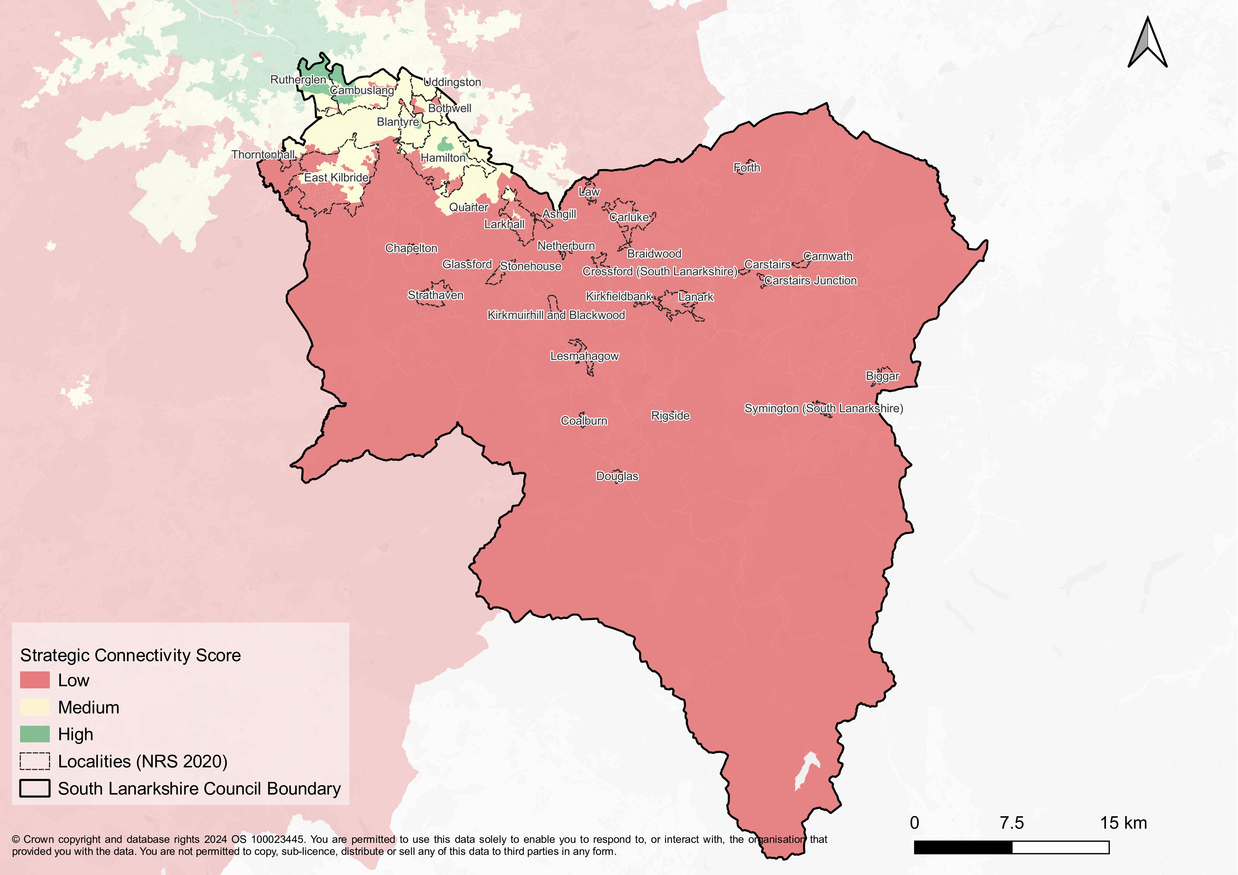

Marmot Place
South Lanarkshire Council and the Community Planning Partnership has been designated as one of the three places in Scotland to work with Public Health Scotland (PHS) and the University College London Institute of Health Equity, headed by Sir Michael Marmot, who have partnered to create the “Collaboration for Health Equity in Scotland (CHES)” Marmot Places - IHE. Aberdeen City and North Ayrshire have also been successful, and we are what is termed a Marmot Place. Through the Improvement Service the planning policy teams in each of the Marmot Places will work together to share approaches to the delivery of the Marmot principles within our plans.
The aim to strengthen and accelerate existing work that is ongoing to improve Scotland’s health, promote wellbeing and address health inequalities. This will be delivered over 18 months for South Lanarkshire. The work will also support the public sector reform agenda through two key strands. At a national level to provide new insights into the most effective ways to secure progress with health equity in Scotland through the lens of the Marmot eight (see below).
The planning system has a key role in delivering these ambitions. LDP3 will be the vehicle to identify place-based solutions to support better health and wellbeing. This may include
- Alignment of the Marmot principles with the Place and Wellbeing Outcomes and embedding these frameworks early in the Development Planning processes, in particular by referencing the work in the evidence report.
- Incorporating the delivery of the principles in Site Assessment Methodologies
- Use national and local data sets to produce data packs identifying health inequalities and the social determinants of health with a focus on particular groups and the Marmot eight principles. This will help identify the prioritisation of specific issues, places and population groups. An officer data working group has been established in South Lanarkshire and the outcomes will be incorporated into the evidence report.
- The Community Profiles that are being prepared will strengthen a place-based approach and maximise local insights in the plan.
The table below describes the 8 Marmot principles and how the topic the subject of this paper could help deliver interventions and policies.

Marmot Principle | Contribution to this topic paper
- Give every child the best start in life. | x
- Enable all children, young people and adults to maximise their capabilities and have control over their lives. | x
- Create fair employment and good work for all. | x
- Ensure a healthy standard of living for all.
- Create and develop healthy and sustainable places and communities. | x
- Strengthen the role and impact of ill health prevention
- Tackle racism, discrimination and their outcomes.
- Pursue environmental sustainability and health equity together. | x

8. Implications for LDP3
- Transport is a key contributor to wider societal benefits such as health and well-being, placemaking and economic growth. LDP3 will be crucial to delivering embedding the sustainability ambitions of the council including managing where development is located, and how future travel demand is delivered.

- To accommodate housing and other growth sustainably, communities and visitors must be provided with a choice of sustainable travel modes. LDP3 will seek to ensure that growth is delivered as part of the drive to decarbonise the transport network by following the sustainable transport hierarchy.
- LDP3 will develop a place-based approach to support infrastructure requirements and the council will work collaboratively with Transport Scotland, SPT and other partners to support and deliver this. The transport implications of the potential economic and housing aspirations will be considered in LDP3.
- LDP3 will be informed by evidence of the area’s transport infrastructure capacity, and an appraisal of the spatial strategy on the transport network. This will be informed by the new Local Transport Strategy and the associated action plan which will help identify any potential cumulative transport impacts and deliverable mitigation proposed to inform the plan’s infrastructure first approach.
- The plan will be subject to a Transport Appraisal which will provide an understanding of changes in travel demand arising from changes in land use, population and economic activity and the resultant changes in transport supply and will help inform investment decisions. Transport Scotland’s Transport Appraisal Guidance is currently being updated and, once published, will be followed in the carrying out of the appraisal. The appraisal will be undertaken following the Call for Ideas in early 2026. It will be able to utilise recent transport modelling for the area. The strategy will need to take into account the various transport capacity issues outlined in the evidence
- The council will also continue to work in partnership with Network Rail and Transport Scotland to ensure rail services within and beyond the council boundary are enhanced. Spatial planning issues will be addressed in LDP3.

- The Plan will link with the emerging Local Transport Strategy (LTS) to ensure its aspirations are met particularly in relation to public transport connectivity, enhanced public transport service connectivity between settlements and essential services, reducing car dependency, enhanced coverage of electric vehicle charging infrastructure and a transition from car-based design in order to support wider place and wellbeing outcomes. It is recognised that further investment in public transport and active travel infrastructure is needed and new development can help to deliver this where appropriate.
- The Plan will seek to deliver equitable and inclusive transport for all, by providing a range of travel opportunities and helping increase sustainable travel. This is especially relevant in the rural areas which experience poorer access to public transport and more limited access to services and facilities. It is not always possible to provide easy walking and cycling distances to all everyday services and facilities in rural areas so there will have to be recognition of some reliance on private vehicles.
- LDP3 can support delivery of active travel, public transport and shared transport connectivity to support town centres and areas of employment. An enhancement of transport connectivity for rural communities - particularly to town centres, places of employment and key public transport and shared transport interchange points.
- LDP3 will support the improvement of freight transport facilities in South Lanarkshire to enable a sustainable, efficient, resilient and reliable strategic freight transport network.
- LDP3 will identify proposed strategic transport improvements as potential development sites and ensure they are not developed for other inappropriate uses until they have been discounted. This will include the following longer-term potential projects such as a direct Lanark to Edinburgh service; extension of the Larkhall railway to Stonehouse and beyond to the Avon Valley; New stations at Symington and Law; and improved services between Carluke, Carstairs and Edinburgh. Several strategic and local road upgrades in LDP2 remain outstanding. The continuing relevance and deliverability of these schemes will have to be assessed.
- LDP3 will support the expansion of Park and Ride provision, adequate cycle parking at public transport interchange locations; ensuring hire/access points for shared mobility schemes are well-served by public transport links; and exploring the concept of Mobility Hubs where appropriate.
- The plan will support the implementation of the Active Travel Network Plans for Carluke; Lanark; Hamilton; East Kilbride; Rutherglen; Cambuslang; Clydesdale, Strathaven, Stonehouse and the Surrounding Villages; Bothwell, Blantyre and Uddingston; and Larkhall.
- LDP3 will be required to address the future aspirations of the Clyde Metro project as the concept develops.
- The Plan can support local living through the promotion of good design and placemaking, sustainable travel, enhancing green space and biodiversity and mixed-use development including local employment and community opportunities.

