

Education Resources

Education Resource Plan 2025-26

Section Contents

- Introduction
- Key areas of focus for the year ahead
- Resource outcomes
- Measures and actions
- Resourcing the plan

Section One – Introduction

I am pleased to introduce our Resource Plan for 2025-26. This is the main planning document for Education Resources and sets out our outcomes and priorities for the year ahead. These priorities align closely with those in the Council Plan and in the Scottish Government’s National Improvement Framework.

This alignment is important and helps us provide common goals that we can share with our nurseries, schools, services, parents and carers. This also helps ensure that we can work closely together to identify, design and deliver solutions, we can use our given resources effectively and efficiently, and we can enhance our accountability by sharing open and transparent data on our performance.

Education is the largest resource within South Lanarkshire Council with an annual budget of around £490 million per year. Much of this is used to employ over 7000 people to provide direct services to the 60,000 or so children, young people and their families who are in our care every day.

We do this mostly through our work in 129 primary schools (including four ASN schools), 20 secondary establishments (including two ASN schools and one SEBN establishment) and 89 Early Learning and Childcare establishments comprising 67 nursery classes and 22 standalone nurseries working alongside a further 98 funded external early years providers. Education Resources also supports community learning and development through the Youth, Family, and Community Learning Service. Our Educational Psychology Service, along with other centrally based services, provides a wide range of specialist help and support to children, young people, families and establishments.

Our commitment to ensuring that the individual needs of every child and young person are met, regardless of age, background or ability means that our service provision is extensive, complex and nuanced.

We will continue this work in 2025/26 and address other key areas which people have told us are important to them in the coming months and beyond. These areas will provide an additional focus for us in 2025/26 and are outlined in more detail within this plan.

2024/25 has been a challenging year for many of us. We are not immune to the impacts of budget cuts across the wider public sector, nor can we escape the impacts of the continuing financial difficulties that many of our families live with each day. However, we have succeeded yet again in tackling the worst effects of these thanks in great part to the effort, skill, experience, care and resilience of our people.

We should take encouragement from this as we go forward with renewed commitments to our shared efforts in helping eradicate inequality, embracing new technologies, safeguarding children’s rights, providing safer and more inclusive environments, supporting national reform and working with our parents and carers to help us all achieve better outcomes.

As we look forward to the year ahead, I encourage everyone to reflect purposefully on the content of this plan and consider how each of us can play our part in delivering positive outcomes for our young learners and their families.

Anne Donaldson
Interim Executive Director
Education Resources

.

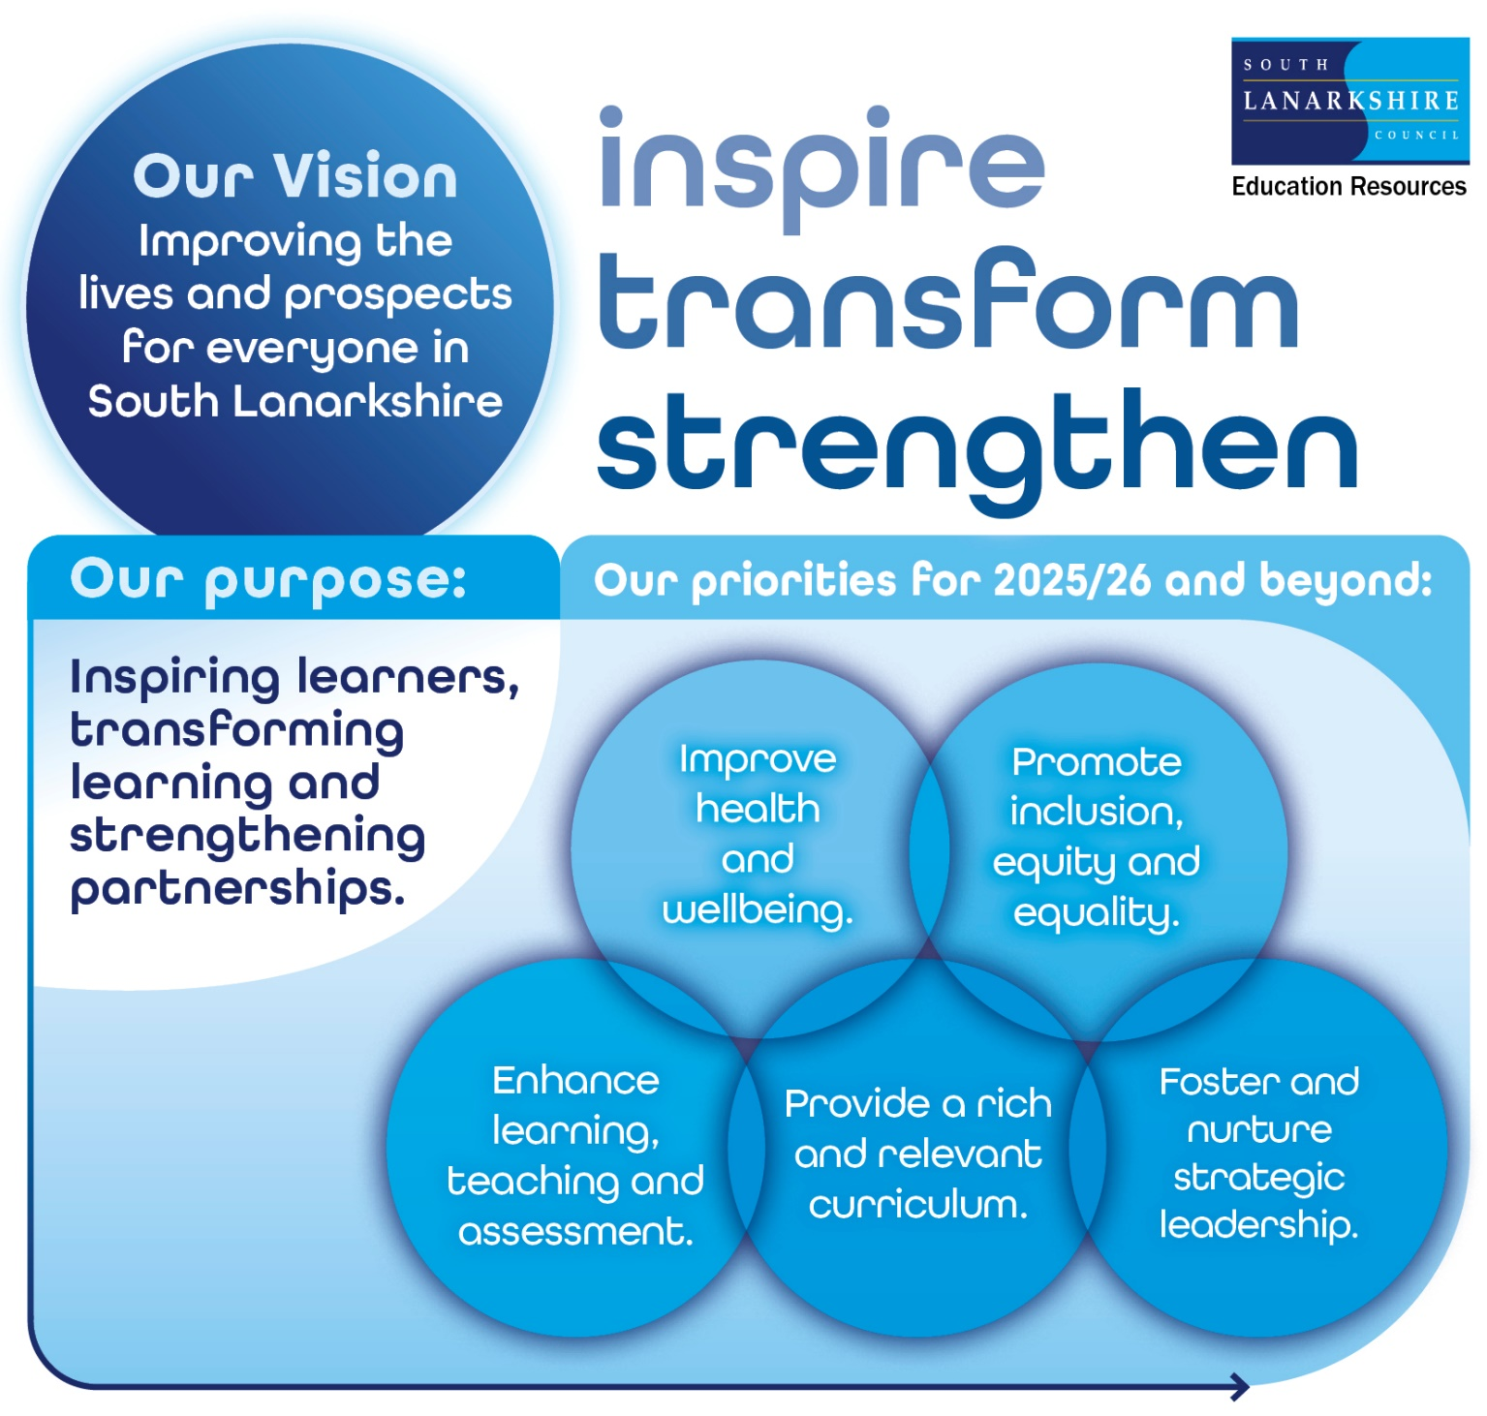

Section Two – Key areas of focus for the year ahead

2.0. Overview
Through ongoing consultation and dialogue with our employees, children, young people and their families, the Resource has identified the following key challenges, risks and new developments which are likely to have a more significant impact on the delivery of services this coming year.

2.1. Children’s rights in education
The adoption of the United Nations Convention on the Rights of the Child (UNCRC) into Scots Law on 16 July 2024 was a landmark moment for children’s rights in Scotland. It ensures that these rights are at the forefront of our decision-making, our policy development and our practices and that children have a legal recourse if their rights are violated.
This is a holistic framework within which our work in South Lanarkshire will include:
- Upholding the right to education without discrimination and ensuring that socio-economic status does not hinder a child's educational opportunities (Closing the attainment gap)
- Providing access to digital learning as essential for modern education
- Upholding the right to the highest attainable standard of health, including mental health
- Incorporating human rights education and life skills into the curriculum to promote awareness and respect for rights
- Increasing access to early learning to fulfil obligations supporting overall developmental rights
- Preparing children for a sustainable future, respecting intergenerational rights
- Ensuring all children and young people have a voice in decisions that affect them, including in how they learn. This includes ensuring that pupil voice is in our improvement plans as well as providing meaningful input into policies and practice via forums such as school councils, eco groups, our complaints process and digital and other champion roles.

2.2. Health and wellbeing
We know that health and wellbeing are integral to ensuring that our children and young people can live happier lives. Learning about health and wellbeing underscores this by helping learners make informed choices about their health now and in the future. This is crucial for nurturing emotional intelligence and helping young people cope with the pressures they face.

We will therefore also renew our commitment to ensuring that all our establishments are able to foster mental, emotional, social and physical wellbeing through a whole school approach that promotes positive relationships, resilience and informed health choices.

This is a challenging and long-term strategic objective but our work on this for the coming year will include:

- Strengthening our partnership working with NHS on co-ordinating and widening access to early intervention programmes for vison, dental and immunisation offers
- Strengthening our partnership working with Community Resources to inform healthy eating options
- Strengthening our partnership working with South Lanarkshire Leisure and Culture to promote an increase in engagement with the work of Active Schools teams
- Monitoring the uptake and impact of our counselling services and revise accordingly
- Further expanding training on our Attachment Strategy and increasing awareness of benefits of adopting trauma-informed practices

2.3. The curriculum, strategic leadership and professional practice
We know that a robust curriculum and ongoing professional development are crucial for improving educational outcomes and preparing our young learners for future challenges. Our curriculum in South Lanarkshire will continue to meet the aspirations for all learners and help them gain the knowledge, skills and personal attributes they will need to cope with the pace of change, risk and opportunity that modern society will continue to present.

In the coming year our work on this will include:

- Maintaining a focus on literacy, numeracy and critical thinking to address the attainment gap and further develop skills
- Exploring new models to optimise senior phase specialisation and choice
- Further expanding our CLPL for leaders and managers, including a revised Headteacher induction programme, to foster a culture of professional growth, innovation and collaboration.
- Encourage evidence-based practice making best use of data to improve outcomes
- Reviewing outcomes of our Support to Schools thematic inspection

2.4 Inclusion, equity and equality
We will continue our important work to support early learning and childcare settings, schools and wider communities in understanding and implementing the principles of inclusion, equity and equality. We will do this by helping our schools and nurseries identify their priorities for action and to create locally informed and well-structured improvement plans that will positively impact on all learners.

Alongside ambitious stretch aims for attainment, we will support those priorities that address the needs of learners and families with protected characteristics and help remove obstacles such as poverty, discrimination, cultural and language barriers.

2.5. Safe and respectful environments
We will renew our commitment to ensuring that our educational environments are safe, respectful and supportive. In doing so, we aim to ensure that our schools, nurseries, offices and other spaces are places where every learner and employee feels safe, valued and empowered to achieve their full potential. We will work collaboratively with families and local communities to identify and address barriers to these efforts. To assist, we will close potential policy gaps by supporting the introduction of new and revised guidance for our establishments including:

- SLC Education Resources Framework for Inclusion and Equality (Update 2024)
- SLC Education Resources Attendance Guidelines (2024)
- SLC Education Resources Unacceptable Actions Protocol (2025)
- National Action Plan for Relationships and Behaviour in Schools (2024-2027)
- Mobile Phones: Guidance for Scotland’s Schools (2024)
- Respect for All: The National Approach to Anti-Bullying (Update 2024)

2.6. Climate justice and sustainability
We will encourage and support the development of climate justice and sustainability within education in South Lanarkshire. We aim to create and foster learning environments where these values are actively promoted, integrated into the curriculum and embraced by our people, our learners and their families. By working together in this way, we can aim for a deeper understanding and commitment to environmental stewardship.

Section Three – Resource outcomes

3.1. Resource outcomes
Education Resources has established the following Resource outcomes to support the delivery of Connect Outcomes in 2025-26.

Connect Outcome | Resource Outcomes
Communities and Environment | • Support climate justice through learning for sustainability
Education and Learning | • Provide a rich and relevant curriculum that helps raise standards in literacy and numeracy  • Support children and young people to develop their skills for learning, life and work
Health and Wellbeing | • Improve physical, mental and emotional health of learners and their families
Children and Young People | • Ensure inclusion, equity and equality for all learners
Housing and Land | No Resource Outcomes for this Connect Outcome
Our Economy | No Resource Outcomes for this Connect Outcome

3.2. Delivering the Plan and achieving Best Value
In working towards the six Connect Outcomes above, the council aims to continually improve and ensure effective and efficient use of resources and ensure that our business will be conducted with integrity, transparency and will operate to the highest standards.

Education Resources has established the following Resource Outcomes to support Delivering the Plan and achieving Best Value.

Delivering the Plan and achieving Best Value | Resource Outcomes  - The council demonstrates high standards of governance and sound financial stewardship.  - The workforce has the skills, flexibility and capacity to deliver the council’s outcomes.  - Digital and ICT services meet the needs of the council and its customers.

Section Four – Measures and actions

4.0. Performance measures and action plan
This section of the Resource Plan is divided into two parts: part (a) sets out our main performance measures against our outcomes; and part (b) describes the key actions we will take in the coming year to respond to the challenges ahead and improve services and outcomes.

4.a. How we will measure our performance
The table below shows our key performance measures, with the actual data last reported to Committee and the target for the last financial year and 2025-26. Additional context for the results/targets is provided within the notes column, where applicable.

Resource Outcome: Provide a rich and stimulating curriculum that helps raise standards in literacy and numeracy

Measure | 2023-24 Actual | 2024-25  Target | 2025-26  Target | Links | Service | Notes
- Percentage of P1, P4 and P7 pupils attaining the appropriate Curriculum for Excellence level for their stage or better in Literacy | 74.6% | 73.5% | 77.2% | 02.03 | CQIS (BGE) | 2023/24 figures reflect Insight data at February 2025
- Percentage gap between P1, P4 and P7 pupils from the least and most deprived areas attaining the appropriate Curriculum for Excellence level for their stage or better in Literacy | 21.8% | 21.5% | 16.0% | 02.03 | CQIS (BGE)
- Percentage of P1, P4 and P7 pupils attaining the appropriate Curriculum for Excellence level for their stage or better in Numeracy | 81.5% | 82.0% | 84.9% | 02.03 | CQIS (BGE)
- Percentage gap between P1, P4 and P7 pupils from the least and most deprived areas attaining the appropriate Curriculum for Excellence level for their stage or better in Numeracy | 17.4% | 18.0% | 14.0% | 02.03 | CQIS (BGE)
- Percentage gap between the attendance of the least and most deprived children and young people at primary school | 4.8% | 4.6% | 3.4% | 02.04 | CQIS (BGE)
- Percentage gap between the attendance of the least and most deprived children and young people at secondary school | 7.3% | 8.0% | 5.0% | 02.04 | CQIS (BGE)
- Percentage of pupils gaining 1 or more awards at SCQF Level 5 or better | 89.9% | 90.6% | 91.5% | 02.03 | CQIS (SP)
- Percentage of pupils gaining 1 or more awards at SCQF Level 6 or better | 69.1% | 70.0% | 72.0% | 02.03 | CQIS (SP)

Resource Outcome: Support children and young people to develop their skills for learning, life and work

Measure | 2023-24 Actual | 2024-25  Target | 2025-26  Target | Links | Service | Notes
- Percentage of pupils entering positive destinations (initial destinations) | 96.5% | 96.5% | 97.0% | C02.05 | CQIS (SP)
- Percentage gap between pupils from the least and most deprived areas entering positive destinations | 3.2% | 5.5% | 3.0% | C02.05 | CQIS (SP)

Resource Outcome: Improve physical, mental and emotional health of learners and their families

Measure | 2023-24 Actual | 2024-25  Target | 2025-26  Target | Links | Service | Notes
- Percentage of children and young people attending primary school | 92.9% | 93.0% | 94.6% | C03.03 | CQIS (BGE)
- Percentage of children and young people attending secondary school | 87.9% | 89.0% | 93.0% | C03.03 | CQIS (SP)

Resource Outcome: Ensure inclusion, equity and equality for all learners

Measure | 2023-24 Actual | 2024-25  Target | 2025-26  Target | Links | Service | Notes
- Percentage gap between pupils from the least and most deprived areas gaining 1 or more awards at SCQF Level 5 or better | 17.2% | 15.0% | 11.3% | 03.06 | CQIS (SP)
- Percentage gap between pupils from the least and most deprived areas gaining 1 or more awards at SCQF Level 6 or better | 35.8% | 30.0% | 31.0% | 03.06 | CQIS (SP)
- Increase the number of English as a Second or Other Language (ESOL) learners who have improved their English language skills | 348 | 507 | 512 | 02.02 | IS (YFCL) | 2024/25 is actual
- Increase the number of learners achieving nationally recognised awards | 1279 | 1286 | 1298 | 04.02 | IS (YFCL) | 2024/25 is actual
- Increase the number of adult learners improving their literacy skills | 382 | 372 | 376 | 04.02 | IS (YFCL) | 2024/25 is actual

4.b. What actions we will take in 2025-26

Resource Outcome: Support climate justice through learning for sustainability

Action | Milestones/Steps we will take to deliver our actions | Links | Service
1. Empower children and young people to influence climate justice and sustainability. | Continue to support the Youth Forum in using their pupil voice to influence change. Deliver a pupil led COS4 conference involving primary, secondary and ASN schools to build on pledges to improve climate change and sustainability. | 01.12 | SS
 | Provide learning for sustainability opportunities by supporting projects and initiatives in early learning establishments. | 01.12 | ELC

Resource Outcome: Provide a rich and relevant curriculum that helps raise standards in literacy and numeracy

Action | Milestones/Steps we will take to deliver our actions | Links | Service
- Raise attainment in reading, writing and numeracy. | Stretch Aims have been set to measure and assess progress, and a progress report will be presented to the Scottish Government and the Education Resources Committee. | 02.03 | CQIS
- Continue to focus on closing the poverty related attainment gap. | Schools will track progress of individual learners (P1/P4/P7) three times a year to secure improvement and share practice, and a progress report will be presented to the Education Resources Committee. | 02.02 | CQIS (BGE)
- Raise attainment of pupils in the senior phase of education and close the poverty related attainment gap. | Secondary schools will through the statistical summary report assess learner outcomes and this will be presented through a progress report to the Education Resources Committee. | 02.02 | CQIS (SP)
- Develop further the access to digital learning and courses for secondary aged pupils. | Remote learning access for identified Advanced Higher courses for secondary aged pupils will be offered. | 02.01 | CQIS  (SP)
- Deliver continuous professional learning training for employees and build leadership capacity. | Provide a programme of continuous professional development training and opportunities to up-skill employees and build leadership capacity across the Resource. | 07.03 | CQIS
- Invest in the ICT infrastructure and digital technology to support anytime, anywhere learning, raise attainment and promote inclusion. | Ensure a smooth transition into the new Education Digital Futures managed service contract. Agree and deliver the programme of work and ensure successful implementation of technology change and digital solutions. | 04.03 | ITS
- Raise attainment in literacy and numeracy in early education settings | Developing a common understanding and application of the CFE benchmarks and moderation process to enable all staff to identify gaps in individual children’s learning. This will support better outcomes for all children. | 02.03 | ELC
- Increase practitioner knowledge and understanding of STEM and further develop STEM opportunities across the early years curriculum | Further develop the STEM leader programme and begin to work with establishments on the STEM Nation Award. | 02.01 | ELC

Resource Outcome: Support children and young people to develop their skills for learning, life and work

Action | Milestones/Steps we will take to deliver our actions | Links | Service
- Provide opportunities for young people to participate in work-based learning opportunities in the senior phase. | Deliver GradU8 and Foundation Apprenticeship programmes in partnership with colleges to provide young people with a range of work-based learning opportunities. | 02.05 | Employability
- Support young people to progress to positive post-school destinations. | Deliver targeted Aspire one-to-one and winter/summer leaver programmes with reviewed referral processes. | 02.05 | Employability
- Ensure smooth transition into the new ICT managed service contract - Education Digital Futures (EDF | Complete exit from NGLS2 and related projects. Required governance and communication models in place to support effective transition. | 04.02 | ITS
- Deliver Year one of EDF contract and related support structures | Successful delivery of year 1 programme of projects including infrastructure and equipment refresh; upgraded WAN set up and revised governance. | 04.02 | ITS

Resource Outcome: Improve physical, mental and emotional health of learners and their families

Action | Milestones/Steps we will take to deliver our actions | Links | Service
- Implement the recommendations from the 2024-25 Council Review of Secondary Social, Emotional, Behavioural Needs Provision | Provide phased inclusive, safe and caring environments for Secondary aged children and young people with social, emotional and behavioural needs through multiagency implementation group. | 03.03 | IES
- Promote children’s rights in line with the United Nations Convention on the Rights of the Child within early years settings | Termly showcase events to support staff to embed children’s rights within all settings. | 02.02 | ELC
- Roll out Infant Mental Health (IMH) training to all establishments | All settings will have appropriately trained staff in relation to the IMH programme. | 03.06 | ELC
- Enable children’s voice regarding their own wellbeing | Deliver a health and wellbeing survey to P5-S6 children and young people. | 04.01 | EPS
- Facilitate and encourage children’s participation in our complaints process | Develop and implement a child friendly complaints system for schools and services. | 04.01 | IES/SS

Resource Outcome: Ensure inclusion, equity and equality for all learners

Action | Milestones/Steps we will take to deliver our actions | Links | Service
- Deliver an anti-racist curriculum and support learners to be anti-racist. | Embed the anti-racist and decolonised curriculum and measures for tackling racist incidents in schools. | 04.02 | CQIS
- Focus on supporting young people to overcome any disadvantage and take forward our targets for excellence and equity. | Locally identified stretch aims including Equity targets focussed on the gap between learners in SIMD quintile 1 and SIMD quintile 5 have been set, and we will report on progress to the Education Resources Committee. | C04.02 | CQIS
- Reduce the cost of the school day (COTSD) to help tackle Child Poverty. | Implement the roll-out of the Cost of the School Day guidance across schools and early years establishments. | 03.03 | CQIS
- Sustain early years uptake for vulnerable two-year-olds to provide early access to quality ELC whilst providing families with flexible free early learning and childcare to support return to work. | Continue to engage with a range of partners to increase uptake of eligible 2-year-old places, and report on progress to Education Resources Committee. | C04.05 | ELC
- Support parents and carers to develop their knowledge and understanding of child development including numeracy and literacy | To develop materials to support settings to develop this knowledge and understanding with parents | 04.03 | ELC
- Update PPRUDB guidance and training presentation to incorporate updated National Guidance. | Revise and update the current PPRUDB guidance and training presentation, in line with updated National Guidance, to support  safe and inclusive learning environments. | C02.02 | IES
- Develop and implement an Inclusion HGIOASL audit tool for ASN establishments. | Improve self-evaluation processes within establishments in relation to meeting Additional Support Needs. | 02.02 | IES
- Provide an enhanced CPD offer with a Learning and Teaching focus for ASN establishments to encourage a rich and stimulating learning environment which meets needs of our learners. | Evaluation of current CPD offer in consultation with re-established ASN Building Capacity Group.  Complete GAP analysis of ASN curriculum development.  Expansion of CPD offer for meeting learners needs for more complex profile learners – in particular AAC and sensory curriculum. | 02.02 | IES
- Promote children’s rights in line with the United Nations Convention on the Rights of the Child. | Child Friendly Complaint Principles – develop and implement guidelines to support all children to be included in this process | 04.01 | IES
- Continue to build capacity in supporting learners with ASN across the sectors by continuing the commitment to upskilling SSAs as recommended in the National ASL (Morgan) Review. | Continue the commitment to in-service training for all SSAs across SLC in every education sector with a focus on supporting Emotional Regulation of young people -delivering training on the current ASN landscape as well as engaging specialist trainers in Emotion Coaching and Tree of Knowledge to help inspire, empower and motivate the SSA workforce.  Report progress to Education Resources Committee. | 02.02 | IES
- Adapt the school estate in respect of ASN as required. Undertake ASN related works as requested and as funding allows. | Complete the programme of Additional Support Needs adaptations in Primary and Secondary Schools. | 05.11 | SE
- Enhance the school estate with targeted investment to increase capacity. | Implement expansion and adaptations at Holy Cross HS, St Andrew’s and St Bride’s HS, Stonelaw HS, Uddingston HS and St John Ogilvie HS. | 05.11 | SE
- Assist the delivery of the Scottish Government UFSM Programme by improving kitchen and dining facilities | Complete works to St Kenneth’s, Kirktonholme, St John the Baptist Primary Schools. | 05.11 | SE
- Deliver on the actions in the South Lanarkshire Community Learning and Development Plan 2024-2027. | Report on the progress of actions in the South Lanarkshire Community Learning and Development Plan 2021-2024 to the Education Resources Committee. | 01.01 | IS (YFCL)
- Deliver on the improvement actions in the Youth Strategy 2022-2025. | Report on progress made by young people in taking forward the actions in the Youth Strategy for 2022-2025. | 04.02 | IS (YFCL)
- Support young people to gain nationally recognised awards through Youth Family and Community Learning programmes. | Provide young people with opportunities to receive accreditation through recognised awards. | 02.02 | IS (YFCL)
- Support young people to regulate their emotions and minimise distressed behaviours | Provide emotion coaching training to employees working with young people. | 03.03 | IS (EPS)
- To further embed attachment-informed, trauma sensitive practice in educational establishments | Support establishments to become accredited in attachment informed, trauma sensitive practice by achieving at least one pledge award. | 03.03 | IS (EPS)

CQIS (BGE) - Curriculum and Quality Improvement Service (Broad General Education)
CQIS (SP) - Curriculum and Quality Improvement Service (Senior Phase)
ELC - Early Learning and Childcare Service
IMS - Instrumental Music Service
ITS - IT Services

IS (CS) - Inclusion Services (Children’s Services)
IS (EPS) - Inclusion Services (Educational Psychology Service)
IS (IES) - Inclusion Services (Inclusive Education Service)
IS (YFCL) - Inclusion Services (Youth, Family and Community Learning)

PPO - Performance, Planning and Operations
SE - Schools Estate
SS - Support Services

Section Five – Resourcing the Plan

5.0. Introduction
In this section we consider the resources needed to implement our plan, including funding and staffing.

5.1. Revenue Budget 2025-26
The Resource has a Net Revenue Budget of £486.777 million. The table below allocates this budget across services:

Net Budget by Service 2025-26 | £ million | %
Central admin | 1.650 | 0.34%
Curriculum and Quality Improvement Service | 1.288 | 0.26%
Directorate | 0.718 | 0.15%
Early Years and Childcare | 67.588 | 13.88%
Inclusion | 1.222 | 0.25%
Learning Community | 4.248 | 0.87%
Operations | 0.167 | 0.03%
Primary Schools | 167.204 | 34.35%
Psychological Services | 3.147 | 0.65%
School Modernisation | 47.232 | 9.70%
Secondary Schools | 157.242 | 32.30%
Special School | 25.669 | 5.27%
Support Services | 3.193 | 0.66%
Youth, Family and Community Learning | 6.128 | 1.26%
Youth Employability (transferring to Community & Enterprise 24/25) | 0.081 | 0.02%
Total | 486.777 | 100%

5.2. Capital Budget 2025-26
The following capital budget of £2.903 million is allocated:

Capital Programme 2025-26 | £ million
Schools ICT Development | 1.300
Secondary School Estate | 1.603
Total | 2.903

5.3. Resource employees
Education Resources has 7216 employees as of January 2025. We support these employees to deliver their duties through a range of policies including personal appraisal and a robust training framework.

The number of employees by type is as follows:

Employee Type | Number of employees
Teaching staff | 4014
Local Government staff | 3202
Total | 7216

If you need this information in another language or format, please contact us to discuss how we can best meet your needs. Phone 0303 123 1015 or email equalities@southlanarkshire.gov.uk

