

Local Development Plan 3

Topic Paper #4 (of a series of 21)
Green belts

(June 2025)

If you need this information in another language or format, please contact us to discuss how we can best meet your needs. Phone 0303 123 1015 or email equalities@southlanarkshire.gov.uk

Introduction

South Lanarkshire Council has started preparation of Local Development Plan 3 (LDP3) which will set out the proposals and policies for the future use and development of land and buildings in South Lanarkshire.

What this involves and the timescales can be found in the council’s Development Plan Scheme.

More detail is set out in the Scottish Government’s Local development planning guidance.

The first part of this process requires the preparation of an Evidence Report. This involves the gathering and assessment of data and information for each policy topic, in collaboration with stakeholders and interested parties to help identify the issues which LDP3 needs to address.

Topic papers have been produced which describe the evidence identified so far, our assessment and understanding of it and what this might mean for LDP3. We want to know if the correct evidence has been identified and whether there is any other data and information that should be considered. We are also looking for feedback on the initial assessment of the evidence

2. Topic paper
This paper covers NPF4 policy 8 Green belts.

This paper looks at the data we have used to understand the new approach to Green belts as set out in NPF4 policy 8, and how this can be applied to South Lanarkshire. A review of the existing Green belt is being carried out which will be fundamental in providing evidence to our interpretation of the Green belt requirements in South Lanarkshire.

3. National Planning Framework 4 policy context

Policy 8 Green belts is particularly relevant to this topic paper. The highlights of the policy are provided below:

Policy intent:
To encourage, promote and facilitate compact urban growth and use the land around our towns sustainably.

Policy outcomes:
- Development is directed to the right locations, urban density is increased and unsustainable growth is prevented.
- The character, landscape, natural setting and identity of settlements is protected and enhanced.
- Nature networks are supported and land is managed to help tackle climate change.

LDP3 considerations:
LDPs should consider using Green belts, to support their spatial strategy as a settlement management tool to restrict development around towns and cities.

Green belts will not be necessary for most settlements but may be zoned around settlements where there is a significant danger of unsustainable growth in car-based commuting or suburbanisation of the countryside.

Green belts should be identified or reviewed as part of the preparation of LDPs. Boundary changes may be made to accommodate planned growth, or to extend, or alter the area covered as Green belt. Detailed Green belt boundaries should be based on evidence and should be clearly identified in plans.

4. Evidence and data sets

Listed below are the documents used to inform the evidence report:
- National Planning Framework 4
- Monitoring of previous planning applications and appeal decisions for development in the Green belt.
- SLC Landscape Character Assessment Final - Nov 2010
- Local Development Plan 2 (LDP2) - South Lanarkshire Council
- South Lanarkshire Council Green Belt Review 2004 and 2025
- Sustainable development and climate change strategy 2022 -2027 Climate change and sustainability - South Lanarkshire Council
- Biodiversity Strategy 2024 - 2030 Plans and policies - South Lanarkshire Council
- Forestry and Woodland Strategy - Glasgow City Council

5. Review and assessment of the evidence

National Planning Framework 4 (NPF4)
National Planning Framework 4 (NPF4) aims to guide Scotland's development in a sustainable and inclusive manner, aligning with national priorities such as tackling climate change, fostering economic growth, and enhancing quality of life. One of its key objectives is to promote the protection and enhancement of the environment, which includes safeguarding Green belts.

Green belts are designated areas of land around urban centres that are protected from development to preserve open space, encourage biodiversity, and prevent urban sprawl. NPF4 seeks to ensure that Green belt policies continue to play a vital role in maintaining Scotland's natural landscape, promoting sustainable land use, and supporting the health and well-being of communities.

South Lanarkshire’s Local Development Plan 2 (SLLDP2)
The SLLDP2 was adopted in January 2021 and sets out the spatial strategy for land use and development across South Lanarkshire. A key component of this strategy is the designation and management of Green belt areas. These zones are intended to prevent urban sprawl, protect the identity and landscape setting of towns, and provide accessible open spaces for recreation and biodiversity.

Policy 4 – Green Belt and Rural Area in volume of SLLDP2 establishes the high-level approach to managing development in the Green Belt. Further detailed policy is set out in chapter 3 of volume 2. Policy GBRA1 provides a framework that is applicable to all forms of residential and non-residential development within the countryside. Thereafter, policies GBRA2 and GBRA3 provide policy relating to the formation of rural businesses. 3.3 Policies GBRA4 and GBRA5 relate to conversion and reuse of existing buildings and the reuse of previously developed land. This predominantly relates to residential developments but other uses appropriate in the countryside will also be assessed against these policies. Thereafter, policies GBRA6 to GBRA11 relate to specific forms of residential development which may be considered acceptable within the Green Belt and Rural Area.

South Lanarkshire’s Green belt
The Green Belt is a national, strategic and local resource. The current South Lanarkshire Green Belt forms part of a much larger, coherent regional Green Belt across the eight Glasgow City Region local authorities. Within South Lanarkshire the Green Belt encircles the urban settlements of Cambuslang, Rutherglen, East Kilbride, Strathaven, Hamilton, Bothwell, Uddingston, Blantyre, Larkhall, Stonehouse and Carluke. This area is well served by a range of services and has high levels of road, rail and path connectivity. Consequently, there is continued pressure for development, particularly on the edges of the established urban centres.

The outer boundary of South Lanarkshire’s Green Belt forms part of the strategic Green Belt for the Glasgow conurbation and neighbouring local authority Green Belts include East Renfrewshire, Glasgow City and North Lanarkshire.

The most recent Green Belt Review was carried out in 2004. Given the length of time that has elapsed since this work was carried out and the revised policy approach on Green Belts in NPF4 it was considered that a comprehensive review is now needed. This mirrors the guidance on local development planning which requires evidence to be provided to inform Green belt boundaries.

Green Belt monitoring
Monitoring of planning decisions for new housing since 01 April 2021 show 56 approvals and 37 refused. We have split this into pre and post the implementation of NPF4 (13 February 2023) to establish any change in the decision-making process when NPF4 policies were incorporated into the development plan.

Chart 1: Number of planning applications approved and refused pre-13 February 2023

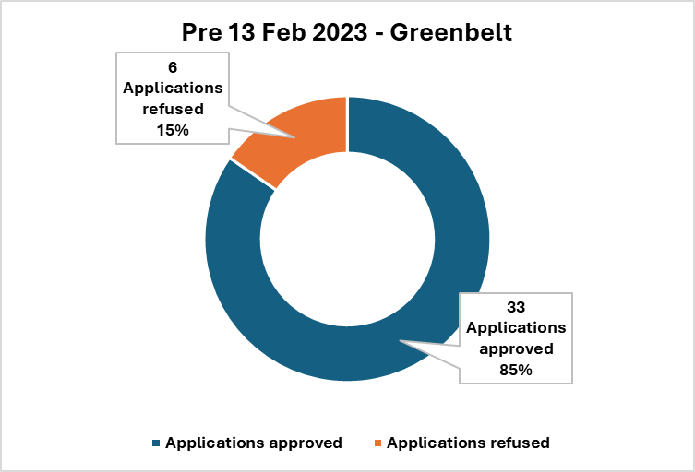

Chart 2: Number of planning applications approved and refused post-13 February 2023

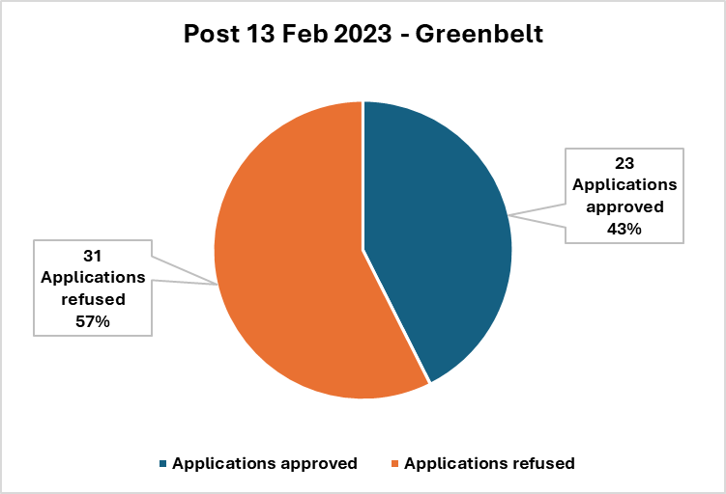

The data shows that fewer applications were approved (40%) following the implementation of NPF4, than when LDP2 policies were the driver in decision making. It can be suggested from this data that LDP2 had additional allowances and unique criteria for new housing in the Green belt that did not have a balanced approach – resulting in excessive approvals (85%). Engagement with South Lanarkshire Council Planning officers will be taken into account when considering the effectiveness of unique LDP2 criteria for new build houses in the Green belt.

Green belt review 2025
South Lanarkshire Council has appointed Land Use Consultants (LUC) to carry out this review. The purpose of the review is to:

- Consider the strategic role of the Green Belt and undertake a review of the outer Green Belt boundary.
- Review existing settlement boundaries for individual towns, with a methodology which can also be applied for towns within the rural area, outside of the Green Belt.

The outcomes will inform the Spatial Strategy for LDP3, the assessment of proposed development sites from the Call for Ideas, and the preparation of the Open Space Strategy.

The method statement recognises that the policy context for the existing Green Belt has changed following the publication of NPF4 and therefore the study will ensure consistency of the future extent of the Green Belt boundary with the current policy framework. The methodology for review recognises that the Green Belt forms part of the strategic Green Belt for the Glasgow conurbation and neighbouring local authority Green Belts include East Renfrewshire, Glasgow City and North Lanarkshire. The study will consider the existing Green belt boundaries within these local authority areas and work those Councils have carried out in the preparation of their evidence reports.

Key principles which will be reflected in the study include:

- The use of land for the storage and conveyance capacity of the functional flood plain.
- The protection and enhancement of the strategic and local green network together with designated sites, prime agricultural land, ancient semi-natural woodland, local nature reserves, woodland, peatlands, local landscape designations, recreational spaces and routes.
- The role of the Green Belts in supporting biodiversity and climate mitigation and adaptation. The aims and objectives of the council’s Sustainable Development and Climate Change Strategy 2022-2027 and Biodiversity Strategy 2024-2030 will influence this with a focus on protecting local biodiversity, the protection, enhancement, and creation of habitats and addressing the fragmentation of habitats affecting connectivity of systems.
- The Green Belt can also deliver the aims of the Glasgow City Region Forestry and Woodland Strategy, which is to guide woodland expansion and management of woodlands in the Glasgow City Region area, Clyde’s Climate Forest aim for 18 million trees planted in both urban and rural parts of Glasgow City Region, including South Lanarkshire, over the next decade.

In terms of the first phase of the study involving establishing a long term outer edge, the existing outer Green Belt edge will be compared with the landscape character areas and types in the South Lanarkshire Landscape Character Assessment 2010 to identify areas of broad alignment or divergence. This process will include identifying areas adjacent to the Green Belt which may be contributing to Green Belt purposes. The extent of additional areas will also be informed by their proximity to other potential robust Green Belt boundary features.

For the second phase of the study review framework has been established for the inner and outer Green Belt parcels. criteria for the Green Belt review will cover the following main criteria:

a) Planning constraints – this will consider the presence of existing features and land uses within the Green Belt or surrounding area as well as other important land uses and their need for protection such as:
- designated natural heritage sites
- historic environment sites
- sport and recreational areas including open space
- core paths and active travel routes
- prime agricultural land
- The surrounding development pattern
- major educational and research use
- major businesses and industrial operations, and
- any other significant areas of brownfield, vacant and derelict land

b) Known development pressures: - this will consider future development pressures based upon:
- previous submissions at call for sites
- sites subject to earlier examination
- previous planning applications

c) Landscape character assessment - as outlined above, this will identify land parcels on the basis of the role of different LCA in contributing to the character, landscape, natural setting and identity of settlements based on the South Lanarkshire Landscape Character Assessment 2010

d) Nature Networks – including environmental and nature conservation designations and opportunities to enhance biodiversity

e) Opportunities to manage climate change to reflect climate change mitigation and adaptation.

f) Extent of Green Belt boundaries in neighbouring authorities

g) The role of Green Belts in protecting, enhancing and providing access to multifunctional blue and green networks and open space.

To inform the settlement boundary recommendations in Phase 2 of the study an inner Green Belt boundary review will be carried out to assess the strength of the boundary features using clear criteria based on different types and combinations of features.

Planning application submissions will be considered to feed into the assessment of development pressure within or adjoining the Green belt.

It is anticipated the report of the review will be available in time to include in the final evidence report.

Landscape Character Assessment
As noted above the Green Belt review will be informed by an assessment of the existing landscape character of the area. The landscape character of South Lanarkshire has been assessed through the South Lanarkshire Landscape Character Assessment 2010 (SLLCA) Landscape character assessment - final report, November 2010 Planning and building standards - South Lanarkshire Council and the accompanying South Lanarkshire Validating Local Landscape Designations (SLVLLD) document Landscape designations report, November 2010 Planning and building standards - South Lanarkshire Council.

Figure 4 on page 15 of the SLLCA identifies the Landscape Character Areas that were developed as a result of the assessment. The number of LCAs were increased and a further sub-division of landscape types was carried out where this was considered appropriate.

The Validating Local Landscape Designations identifies six special landscape areas (SLAs) based on the areas of highest landscape quality and value in South Lanarkshire. These are:

- Lower Clyde and Calderglen
- Middle Clyde Valley
- Upper Clyde Valley and Tinto
- Douglas Valley
- Pentland Hills and Black Mount
- Leadhills and the Lowther Hills

The extent of the designations can be seen in figure on page 15 of the document.

Conclusion
A Green belt designation provides both a strategic and local function that can check unrestricted sprawl of built-up areas and prevent settlements merging (coalescing) into one another. It also assists in protecting the countryside from unnecessary intrusion and helps protect and enhance the landscape setting and identity of settlements. At a more localised level a Green belt can become more important for functions such as providing a green buffer for separating urban areas and the countryside.

Whilst a Green belt designation brings an additional constraint to development, it is not intended to stop development expansion in perpetuity. It is often misunderstood as an environmental protection, whereas a Green belt does not function as a nature conservation or landscape designation. Rather, it is a settlement management tool for planning purposes. The designation is principally concerned with preventing unsustainable growth, to avoid incremental development, and/or suburbanisation of the countryside associated with high demand close to the amenities of the city/town.

As well as the Green belt being a sustainable settlement management tool, NPF4 policy 8 also ensures that land close to settlements provides wider ecosystem services in terms of nature networks, climate adaptation and mitigation.

The review of the existing Green belt within South Lanarkshire will utilise multiple data to inform any changes required. This will be available and submitted as part of the evidence report. We would emphasise that it is the Proposed Local Development Plan where are all the different ‘parts’ come together, not the Green Belt itself, that provides the wider spatial strategy.

Marmot Place
South Lanarkshire Council and the Community Planning Partnership has been designated as one of the three places in Scotland to work with Public Health Scotland (PHS) and the University College London Institute of Health Equity, headed by Sir Michael Marmot, who have partnered to create the “Collaboration for Health Equity in Scotland (CHES)” Marmot Places - IHE. Aberdeen City and North Ayrshire have also been successful, and we are what is termed a Marmot Place. Through the Improvement Service the planning policy teams in each of the Marmot Places will work together to share approaches to the delivery of the Marmot principles within our plans.

This will be delivered over 18 months for South Lanarkshire. The work will also support the public sector reform agenda through two key strands:
- At a national level to provide new insights into the most effective ways to secure progress with health equity in Scotland through the lens of the Marmot eight (see below).
- Collaborate with the three successful places to develop and implement interventions and policies to enhance health equity. The focus includes embedding health equity approaches in local systems and adopting a long-term, holistic strategy for improving health equity.

The planning system has a key role in delivering these ambitions. LDP3 will be the vehicle to identify place-based solutions to support better health and wellbeing. This may include:
- Alignment of the Marmot principles with the Place and Wellbeing Outcomes and embedding these frameworks early in the Development Planning processes, in particular by referencing the work in the evidence report.
- Incorporating the delivery of the principles in Site Assessment Methodologies
- Use national and local data sets to produce data packs identifying health inequalities and the social determinants of health with a focus on particular groups and the Marmot eight principles. This will help identify the prioritisation of specific issues, places and population groups. An officer data working group has been established in South Lanarkshire and the outcomes will be incorporated into the evidence report.
- The Community Profiles that are being prepared will strengthen a place-based approach and maximise local insights in the plan.

Table 3 below describes the 8 Marmot principles and how the topic the subject of this paper could help deliver interventions and policies.
Table 3: Marmot Place Principles and linkages to this topic paper.

Marmot Principle | Contribution to this topic paper
- Give every child the best start in life.
- Enable all children, young people and adults to maximise their capabilities and have control over their lives.
- Create fair employment and good work for all.
- Ensure a healthy standard of living for all.
- Create and develop healthy and sustainable places and communities. | X
- Strengthen the role and impact of ill health prevention | x
- Tackle racism, discrimination and their outcomes.
- Pursue environmental sustainability and health equity together. | X

6. Implications for LDP3

The spatial strategy will be informed by the Green belt review that is currently being carried out. In broad terms the objectives of the study are twofold;
- Consider whether modifications to the inner and outer Green belt are appropriate based on the policy direction in NPF4 and
- A review all settlement boundaries within the Green belt to ensure long term defensible edges to settlements are established for the lifetime of the plan.

In turn the review will determine whether there is a need to release from the Green belt any areas of land for planned growth. This will be informed by the Local Housing Land Requirement and any requirements for additional employment land.

The review will also be of relevance in considering the principles of local living, compact urban growth, rebalanced development, rural revitalising, the delivery of a just transition approach to climate change, nature networks and landscape character. Consideration will be given to any additional areas of land that the Green belt will extent to.

The Green Belt continues to be subject to development pressure at the urban fringe. The Landscape Character Assessment (LCA) and other supporting landscape studies, Site Assessment Framework and SEA will be crucial in identifying potential spatial options for the Proposed Plan to meet these housing requirements and will be used, if growth cannot be fully accommodated in the urban area, to identify opportunities on the land most suitable and capable of accommodating development on land out-with the urban area. Assessment will be undertaken alongside the availability of infrastructure and meeting Local Living requirements.

It is considered that the 2010 Landscape Character Assessment (LCA) still remains the most up to date evidence base to inform LDP3 and potential spatial growth options. It will be used to assess proposals submitted as part of the ‘call for sites’ process.

