

South Lanarkshire Local Development Plan 3

Topic Paper #15 (of a series of 21)
Flood Risk and Water Management

(June 2025)

If you need this information in another language or format, please contact us to discuss how we can best meet your needs. Phone 0303 123 1015 or email equalities@southlanarkshire.gov.uk

Introduction

South Lanarkshire Council has started preparation of Local Development Plan 3 (LDP3) which will set out the proposals and policies for the future use and development of land and buildings in South Lanarkshire.

What this involves and the timescales can be found in the council’s Development Plan Scheme.

More detail is set out in the Scottish Government’s Local development planning guidance.

The first part of this process requires the preparation of an Evidence Report. This involves the gathering and assessment of data and information for each policy topic, in collaboration with stakeholders and interested parties to help identify the issues which LDP3 needs to address.

Topic papers have been produced which describe the evidence identified so far, our assessment and understanding of it and what this might mean for LDP3. We want to know if the correct evidence has been identified and whether there is any other data and information that should be considered. We are also looking for feedback on the initial assessment of the evidence

2. Topic paper
This paper covers NPF4 policy 22 - Flood Risk and Water Management

The paper includes a Strategic Flood Risk Assessment (SFRA0 which is a strategic overview of the flood risk in South Lanarkshire that will assist the preparation of LDP3, particularly in regard to making decisions about preferred site allocations through site assessment methodology. It will also contribute to baseline monitoring for Strategic Environmental Assessment, assist in policy development and enable the planning of new flood management schemes. Equally a holistic approach to water management is also required, including designing adaptation and mitigation measures that address water scarcity and manage surface water and flooding.

3. National Planning Framework 4 policy context

Policy 22 Flood Risk and Water Management is particularly relevant to this topic paper. The highlights of the policy are provided below:

Policy Intent:
To strengthen resilience to flood risk by promoting avoidance as a first principle and reducing the vulnerability of existing and future development to flooding.

Policy Outcomes:
• Places are resilient to current and future flood risk.
• Water resources are used efficiently and sustainably.
• Wider use of natural flood risk management benefits people and nature

LDP3 considerations:
LDPs should strengthen community resilience to the current and future impacts of climate change, by avoiding development in areas at flood risk as a first principle. Resilience should also be supported by managing the need to bring previously used sites in built up areas into positive use; planning for adaptation measures; and identifying opportunities to implement improvements to the water environment through natural flood risk management and blue green infrastructure.

Plans should take into account the probability of flooding from all sources and make use of relevant flood risk and river basin management plans for the area. A precautionary approach should be taken, regarding the calculated probability of flooding as a best estimate, not a precise forecast. For areas where climate change is likely to result in increased flood exposure that becomes unmanageable, consideration should be given to alternative sustainable land use.

4. Evidence and data sets

Listed below are the documents used to inform the evidence report:
- SEPA sfra guidance for planning authorities.

- SEPA Planning Advice Note

- SEPA Flood Hazard Maps version 3.0 published March 2025 SEPA Flood Maps including
- SEPA River Flood Maps
    - Present Day 1 in 10-year return period (high probability)
    - Present Day 1 in 200-year return period (medium probability)
    - Present Day 1 in 1000-year return period (low probability)
    - Future Flood Map 1 in 200-year return period (medium probability plus climate climate)

    - SEPA Surface Water and Small Watercourses Flood Maps
- Present Day 1 in 10-year return period (high probability)
- Present Day 1 in 200-year return period (medium probability)
- Future Flood Map 1 in 200-year return period plus climate uplift (low)

- Future Flood Maps

- SEPA Natural Flood Management Maps

- SEPA (2018) National Flood Risk Assessment

- SEPA Reservoirs Map

- Clyde and Loch Lomond Local Plan District Flood Risk Management Plan (2021)

- Clyde and Loch Lomond Local Plan District. Flood Risk Management Strategies | SEPA

- Tweed Local Plan District Local Flood Risk Management Plan

- The River Basin Management Plan for Scotland 2021-27

- Water Framework Directive (WFD) Classification

- RBMP3 pressures data

- National Flood Resilience Strategy - gov.scot

- Scottish Water Climate Change Adaptation Plan 2024

- Scottish Water Strategic Plan

- Water Classification Hub.

- Scotland’s National Water Scarcity Plan

- Water scarcity | Beta | SEPA | Scottish Environment Protection Agency

- Scotland Wetland Inventory Map | Scotland's environment web

- Water Environment Fund – existing and proposed projects – available to view on the Scottish Flood Defence Asset Database via licence

5. Strategic flood risk assessment
A Strategic Flood Risk Assessment (SFRA) for South Lanarkshire has been produced to support the Evidence Report for the council’s Local Development Plan 3 (LDP3). It provides a high-level overview of the scope and nature of all sources of existing and future flood risk within the LDP area. It will inform the broad direction of the Spatial Strategy of LDP3 and help deliver the outcomes of National Planning Framework 4 (NPF4) Policy 22 by strengthening resilience to flood risk through the promotion of avoidance as a first principle and reducing the vulnerability of existing and future development to flooding
The SFRA has been produced in line with SEPA’s sfra-guidance-for-planning-authorities.pdf. This states that an SFRA has several purposes;
- To inform the development planning process, primarily to avoid increasing overall flood risk by avoiding areas of flood hazard.
- To identify gaps in flood risk information and propose how these gaps will be addressed at the later stages of the LDP3’s preparation;
- To identify actions in the local flood risk management plans that are relevant to LDP3;
- To inform both the site assessment and strategic environmental assessment of LDP3 so that flood risk is fully taken into account when considering the allocation of land and the preparation of the spatial strategy, development proposals and planning policies;
- To help identify the need for site-specific flood risk assessments in particular locations;
- To provide evidence that LDP3 preparation has taken account of National Planning Framework 4 policies that are relevant to sustainable flood risk management and the climate and nature crises; and
- To inform blue and green infrastructure audits, and strategies.

Following early engagement with SEPA in June 2025 it is recognised that SEPA's primary objective in engaging with council’s on the preparation of their LDPs on the issue of flood risk is to minimise the number of sites allocated that are not in accordance with NPF4 policies on flooding. One way of achieving this will be to include in the Site Appraisal Methodology criteria related to flood risk. In that respect landowners and developers will be expected to show that flood risk at a site is fully understood. This can be achieved by reference to the SFRA and/or the submission of a Flood Risk Assessment. This will provide certainty at an early stage in the plan preparation process and ensure that only sites that are in accordance with NPF4 are included in the Proposed Plan.
Flood risk evolves both spatially and over time and therefore the SFRA will be reviewed and updated as appropriate as new or updated flood risk information becomes available.

South Lanarkshire Council area
The River Clyde and its tributaries are essential to the character of South Lanarkshire. Rising in the Lowther Hills, the River Clyde meanders its way through South Lanarkshire towards the outer reaches of the City of Glasgow before flowing into the Clyde Estuary and Firth of the Clyde. There are 25 principal watercourses which flow through South Lanarkshire listed in the table below. Many of these are tributaries of the River Clyde
Principal watercourse | Span (km) | General information
Avon Water | 46 | A tributary of the River Clyde, the Avon flows through Strathaven and Larkhall from its source on Weddle Hill, East Ayrshire.
Biggar Water* | 7 | The Biggar Burn rises at the southern end of the Pentland Hills and flows south through Biggar, turning into Biggar Water, flowing through Broughton before joining the River Tweed.
Calder Water | 15 | Calder Water rises on the slopes of Laird’s Seat joining with the Rotten Burn to form the Rotten Calder. The river flows down through Calderglen joining the River Clyde west of Uddingston.
Camps Water | 6 | Flowing from Camps Reservoir, Camps Water joins the River Clyde north of Crawford.
River Clyde | 138 | Formed by two streams, the Daer and the Potrail Waters that meet at Watermeetings high in the Lowther Hills. The river flows down through many of the main urbanised areas, including Hamilton, Blantyre and Rutherglen.
Culter Water | 8 | Culter Water rises in hills south of Biggar, flowing through the Culter Water Reservoir before passing Coulter and joining the River Clyde.
Daer Water | 16 | Daer Water rises on Queensberry Hill in the Lowther Hills and flows through the Daer Reservoir before joining Potrail Water to form the River Clyde.
Douglas Water | 32 | The Douglas Water rises in the hills in East Ayrshire, flowing through Douglas before joining the River Clyde.
Duneaton Water | 30 | A tributary of the River Clyde, Duneaton Water flows passed Crawfordjohn before joining the Clyde at Abington.
Elvan Water | 11 | From the Lowther Hills the Elvan Water joins the Clyde near Elvanfoot.
Evan Water | 19 | Evan Water rises in the south Lowther Hills and flows south to join the River Annan at Three Waters Foot.
Garf Water | 11 | Garf Water rises on the slopes of Robert Law and flows east to join the River Clyde near Wiston.
Glengavel Water | 6 | Glengavel Water passes through the Glengavel Reservoir before meeting the Avon Water.
Glengonnar Water | 11 | Glengonnar Water rises in the Lowther Hills and is a tributary to the River Clyde.
Kype Water | 10 | Kype Water flows from the Kype Reservoir joining River Avon near Strathaven.
Lochar Water | 7 | Flowing from Lambhill the Lochar Water joins the Avon Water before Strathaven.
Logan Water | 11 | Rising in Spirebush Hill the Logan Water flows through the Logan Reservoir before joining with the River Nethan and then the River Clyde.
Medwin Waters (North) | 17 | Rises in the Pentland Hills, close to West Lothian and flows south to join with the South Medwin to form Medwin Waters
Medwin Waters (South) | 25 | Rises in the Pentland Hills flowing south to form the border between South Lanarkshire and the Scottish Borders before joining the North Medwin to form Medwin Waters and then the River Clyde.
Midlock Water | 10 | Rising near Clyde Law the Midlock Water joins the River Clyde near Crawford.
Mouse Water | 26 | Mouse Water is a tributary of the River Clyde flowing from south of Forth to join the Clyde near Lanark.
Nethan Water | 27 | The River Nethan flows northwards to the River Clyde from the hills south of Lesmahagow. Its upper reaches are extensively afforested and there are also abandoned mines in the catchment. The main river passes along the edge of the huge Dalquhandy Opencast Coal Site. A tributary of the River Nethan, the Logan Water, is used to fill the Logan and Dunside reservoirs.
Potrail Water | 12 | Rises on Ballencleuch Law in the Lowther Hills and joins Daer Water near Elvanfoot to form the River Clyde.
Snar Water | 10 | Rising on the slopes of Wanlock Dod, Snar Water joins Duneaton Water near Crawfordjohn.
White Cart Water** | 36 | Rises in the foothills of the Eaglesham Moors on the slopes of Corse Hill, flowing through the East Renfrewshire and South Lanarkshire border before joining Black Cart Water at Paisley.
* does not flow into Clyde catchment
** borders with East Renfrewshire and South Lanarkshire

In addition, there are a number of burns of strategic significance across South Lanarkshire:

- Cambuslang: Black, Kirk, Lightburn/Newton and Whitelaw/Eastfield.
- Clydesdale: Devon and Roberton.
- East Kilbride: Darngaber, Kittoch Water and Powmillon.
- Hamilton: Cadzow, Covan and Earnock/Wellshaw.
- Rutherglen: Cityford/West and Scion.

All watercourses provide many important benefits to the area including contributing to sustainable flood management by storing large amounts of water and reducing peak flows; supplying fresh drinking water to communities, businesses and agriculture; and supporting recreation and tourism by offering attractive places to play, visit and enjoy the area’s natural and built heritage. They are also home to many habitats and wildlife including birds, fish, invertebrates and mammals.

Sources of data
This topic paper considers the sources of information suggested in the SEPA guidance. In a South Lanarkshire context, they are

- SEPA Flood Hazard Maps version 3.0 published March 2025 SEPA Flood Maps described in section 4 above
- SEPA Natural Flood Management Maps
- SEPA (2018) National Flood Risk Assessment
- SEPA Reservoirs Map
- Clyde and Loch Lomond Local Plan District Flood Risk Management Plan (2021)
- Clyde and Loch Lomond Local Plan District. Flood Risk Management Strategies | SEPA
- Tweed Local Plan District Local Flood Risk Management Plan Tweed plan

A map including all of the layers of flood risk information that have been used to inform the SFRA will be produced in time for the evidence report. The map will also include spatial details of the council’s own flood risk studies and Flood Protection Schemes in South Lanarkshire. A commitment has been given to share the map with SEPA once it is available.

Legislative and policy context
The Flood Risk Management (Scotland) Act 2009 provides the statutory framework for delivering a sustainable and risk-based approach to managing flooding. It places a duty on responsible authorities to use their flood risk related functions to reduce overall flood risk and promote sustainable flood risk management.
The Act requires the preparation of flood risk management plans in order to coordinate efforts to tackle flooding in Scotland. The plans are to identify the main flood hazards and impacts, setting out objectives for reducing risk and the best combination of actions to achieve this. This information should be used as a basis for better decision-making across flood risk management organisations like local councils and Scottish Water.
The council was identified as a potential participant in four of the fourteen Local Flood Risk Management Districts proposed in Scotland, namely Forth, Clyde and Loch Lomond, Tweed and Solway. However, as there is no significant flood risk or any properties within potentially vulnerable areas identified within South Lanarkshire in the Solway and Forth districts, it was proposed that the council would not actively participate in those areas.
In South Lanarkshire the vast majority of the LDP area is covered by the Clyde and Loch Lomond Local Flood Risk Management Plan (2021) and the Clyde and Loch Lomond Local Plan District Local Flood Risk Management Plan 2022 – 2028.
The 2021 document sets out the short to long term ambition for flood risk management for the Clyde and Loch Lomond Plan District in terms of river, surface water and coastal flood risk in the Local Plan District, with the main risk identified as coming from surface water flooding. 23 Potentially Vulnerable Areas (PVAs) are identified including six within South Lanarkshire.
The 2022 – 2028 (Cycle 2) plan sets out detailed actions to avoid and reduce the risk of flooding and prepare and protect communities within the PVAs including flood protection schemes or works; flood protection studies; as well as flood warning schemes, surface water Flood Risk management plans, and natural flood management studies and works. This is described in more detail in section 5.9.
An area in the southeastern part of the council area is covered by the Tweed Local Plan District Local Flood Risk Management Plan Flood Risk Management Strategies | SEPA. 12 Potentially Vulnerable Areas (PVAs) are identified including one within South Lanarkshire.
SEPA’s River Basin Management Plan (2021 - 2027) sets objectives to the end of 2027 as a strengthened programme of measures for achieving them in order to protect and improve the water environment of the Scotland River basin district. SEPA are aiming to deliver up to 51 new restoration projects that have the potential to improve the ecological condition of rivers. Projects have been identified for the communities that could benefit most based on Scottish Index of Multiple Deprivation (SIMD; Regeneration and development plans; Opportunities for active travel; River and surface water flood risk; and Vacant and derelict land. The potential projects are highlighted in the Water Environment Hub.
National Planning Framework 4 (NPF4) is the national spatial strategy for Scotland. NPF4’s overarching policy intent for flood risk and water management is “to strengthen resilience to flood risk by promoting avoidance as a first principle and reducing the vulnerability of existing and future development to flooding”.
Policy 22 states that development proposals at risk of flooding or in a flood area will only be supported if they are for:
- Essential infrastructure where the location is required for operational reasons;
- Water compatible uses;
- Redevelopment of an existing building or site for an equal or less vulnerable use; or
- Redevelopment of previously used sites in built up areas where the LDP has identified a need to bring these into positive use and where proposals demonstrate that long term safety and resilience can be secured in accordance with relevant SEPA advice.
NPF4 defines ‘at risk of flooding’ or ‘in a flood risk area’ as land or built form with an annual probability of being flooded of greater than 0.5% that includes an appropriate allowance for future climate change. SEPA’s Future Flood Maps indicate this risk of flooding.
The Scottish Water Climate Change Adaptation Plan 2024 sets out measures to make services and infrastructure more resilient to extreme weather by adapting assets and services to ensure they remain reliable, resilient and sustainable. It describes the consequences on water supplies, water quality, sewer systems, infrastructure and the environment without adaptation. The Climate Change Adaptation Plan outlines several issues, including:
- Drought
- Deteriorating water quality
- Customer flooding and environmental pollution
- Waste water and environmental quality

The National Flood Resilience Strategy 2024 focuses on the actions required to make local communities more resilient to flooding. It sets out a series of outcomes around the themes of people, places and processes and a range of priority action areas. These include improving land use for flood mitigation; supporting a broader range of flood action; and supporting the implementation of long-term adaptation planning. The principle of a Just Transition to ensure a fairer future for all is highlighted.

Flood risk in South Lanarkshire
The SEPA Flood Hazard Maps provide detailed information on the areas that may flood due to climate change based on a risk of river or coastal flooding in a 0.5% Annual Exceedance Probability event. The Maps are based on the UK Climate Projections’ high emission scenarios assuming limited or no global action to reduce greenhouse gas emissions by the 2080s. They also indicate, for planning purposes, “areas at risk of flooding”, or “in a flood risk area” in terms of NPF4 Policy 22.

Version 3.0 of the SEPA Flood Hazard Maps was published by SEPA in March 2025. They now include a surface water and small watercourses flood hazard map, and a new dataset which shows the potential effects of climate change on surface water flooding. The maps overall provide a single source of data on flood hazards across South Lanarkshire and include information on different likelihoods of river (fluvial), coastal and surface flooding.

Fluvial Flooding is caused by excessive rainfall or snow melt within a limited period, which overwhelms the capacity of the watercourse or river channel, particularly when the ground is already saturated. It can also arise because of the blockage of a channel and/or associated structures such as small bridges and culverts. Most of the length of the River Clyde is at a high risk of flooding along with the immediate river floodplains of most of the other watercourses in the area.
Pluvial Flooding occurs when rainwater ponds or flows over the ground (overland flow) before it enters a natural or man-made drainage systems (a river or sewer/drain). It can also occur when drainage systems are at full capacity. It is often combined with sewer flooding and groundwater flooding. This map gives indication that a large number of areas in South Lanarkshire may be at a risk from pluvial flooding including parts of all the main settlements.

Roads Drainage and Sewers Flooding occurs when the sewerage infrastructure has to deal with loads beyond its design capacity. This occurs most often because of high intensity rainfall events. The SEPA surface water maps include the risk of flooding from the sewer network, identified by Scottish Water risk mapping.

Groundwater Flooding is caused by the emergence of water from beneath the ground, either at point or diffuse locations. The occurrence of groundwater flooding is usually local and unlike flooding from rivers, does not generally pose a significant risk to life due to the slow rate at which the water level rises. However, groundwater flooding can cause significant damage to property, especially in urban areas and can pose further risks to the environment and ground stability.

In terms of the future impacts of Climate Change on flood risk Policy 22 in NPF4 aims to ensure that places are resilient to current and future flood risk. Measures to reduce and mitigate the effects of climate change are central to NPF4 in relation to flooding and drainage. The implementation of sustainable water management solutions is important in ensuring the reduction, adaptation and mitigation of the impacts from climate change is addressed. This is already supported by the policies and proposals in the adopted South Lanarkshire Local Development Plan 2 and seen through the successful implementation and adoption of Sustainable Urban Drainage systems across South Lanarkshire.

The most up-to-date SEPA’s Flood Maps can help inform the design of new development however they contain only high-level information and there will be a need to consider localised features that may have an impact.

A climate change allowance is a prediction of anticipated change in peak river flow, peak rainfall intensity or sea level rise caused by future climate change. The type of allowance used will be identified on a case-by-case basis and will depend on the type of flooding being considered and, for river (fluvial) flooding, the size of catchment or location. The types of climate change allowances to use in a flood risk are peak rainfall intensity, highest of peak rainfall intensity or peak river flow. Peak rainfall intensity allowances should be used for river catchments less than 30km2 and surface water. Highest of peak rainfall intensity or peak river flow should be used for river catchments between 30km2 and 50km2. Peak river flow should be used for river catchments over 50km2.

Rainfall allowances can be used to provide a more accurate estimation for surface water (pluvial flooding) and areas known to be subject to flash floods. Small watercourses are impacted because of the high volume of runoff relative to their channel capacity. Increases in rainfall intensity due to climate change are likely to result in an increase in the severity and frequency of flooding incidents on small watercourses.

The relevant regional flow allowance as identified in Table 1 and 2 of SEPA’s Climate Change Allowance for Flood Risk Assessment in Land Use Planning Guidance for the Clyde River Basin Region is 49% total change to the year 2100 for peak river flow allowance. Total change to the year 2080 is 41% for peak rainfall intensity allowance.

The table below sets out the number properties predicted within SEPA’s 2018 National Flood Risk Assessment to be at flood risk within South Lanarkshire during the medium likelihood (1:200yr) flooding scenario. The figures stated identify more than twice as many homes, businesses and services to be at flood risk compared to figures published in 2015. Scientific knowledge and understanding of flood risk is constantly evolving. More comprehensive data and access to improved mapping and modelling has advanced our understanding of the locations and properties at risk. This means that more properties which were previously unknown to us have been identified within SEPA’s 2018 National Flood Risk Assessment as being at flood risk.

Properties in South Lanarkshire at flood risk during medium likelihood (1:200yr) flooding scenario
Homes |  |  | Businesses and Services |  |  | Homes, Businesses and Services
Total | Predicted number at flood risk | Ratio | Total | Predicted number at flood risk | Ratio | Total | Predicted number at flood risk | Ratio
148,200 | 6600 | 1 in 22 | 17,500 | 1,900 | 1 in 9 | 165,700 | 8,500 | 1 in 19
Source: Scottish Environment Protection Agency

Reservoirs
The revised Reservoir (Scotland) Act 2011 has provisions in relation to the risk of flooding from reservoirs and facilitation of more environmental objectives relating to reservoirs and river basin management. It requires SEPA to establish and maintain a register including information such as the name (if any), location and maximum water capacity of the controlled reservoir. The register also assigns a risk designation (of high, medium or low) to each controlled reservoir taking into account the impacts of an uncontrolled release of water on features below the reservoir. These features could include residential properties, businesses, communities, transport links, agriculture, cultural heritage and the environment.

There are 20 reservoirs across South Lanarkshire. SEPA is the Enforcement Authority for these reservoirs under the Reservoirs (Scotland) Act, 2011, responsible for ensuring the Statutory Undertakers (owners) comply with their statutory requirements. The council is ‘Reservoir Manager’ for the James Hamilton Heritage Loch and Lanark Loch.
Principal reservoirs in South Lanarkshire
Principal water bodies | Area (km2) | General information
Camps Reservoir | 0.71 | Provides drinking water to the Hamilton area
Cowgill Lower Reservoir  Cowgill Upper Reservoir | 0.03  0.09 | Provides drinking water to the Lothians
Coulter Reservoir | - | Serves Motherwell, Wishaw and Biggar with drinking water
Daer Reservoir | 1.97 | Fed by Daer Water, the reservoir is the principal drinking water supply for South Lanarkshire
Kype Reservoir | 0.11 | South of Strathaven, serving the area with drinking water

Smaller water bodies in South Lanarkshire, including covered reservoirs
Reservoir | National Grid reference | Reservoir | National Grid reference
Boghead | NS 764409 | James Hamilton Heritage Loch | NS 631559
Cleuch | NS 937355 | Kittoch Bridge Flood Storage | NS 589568
Dunside Lower | NS 749373 | Lanark Loch | NS 899431
Dunside Upper | NS 747373 | Loch Lyoch | NS 932357
East Rogerton Tank | NS 630567 | Logan | NS 745361
Glen Franka Dam | NS 890133 | Peden | NS 941124
Glengavel | NS 664350 | Springfield | NS 905520

SEPA Reservoir Inundation Maps shows the parts of South Lanarkshire that would be likely flooded in the event of an uncontrolled release of water from a reservoir. Areas at highest risk of flooding in the event of an uncontrolled release of water from a reservoir are found throughout the council area. Although none of the main settlements would be affected a wide part of the rural area and some of the smaller settlements within it are at risk.

Historical flooding events
Historic Flooding events within South Lanarkshire are not currently mapped. However, SEPA has an Observed Flood Event Database which is available under data licensing to local authorities. This will be used during the site assessment process. In addition, a database is retained which the Flood Management team are able to refer to when commenting on planning applications and this will be the case when carrying out site assessments for LDP3.

Between 2007 and 2022 11,600 recorded flooding incidents in South Lanarkshire were recorded. These incidents have not been mapped. Most of these incidents were relatively minor category 1 or 2 occurrences. However, 8.9% of incidents resulted in flooding of residential and/or commercial property. In the same period, there have been 16 incidents of significant river flooding.

Flooding occurrences reported in South Lanarkshire
Year | Category 1  Choked gully | Category 2  Minor flooding | Category 3  Property flooding | Category 4  River flooding | Total
2010 | 192 | 127 | 26 | 0 | 345
2011 | 290 | 413 | 118 | 1 | 822
2012 | 387 | 317 | 144 | 0 | 848
2013 | 334 | 192 | 59 | 2 | 587
2014 | 312 | 165 | 58 | 1 | 536
2015 | 379 | 222 | 57 | 0 | 658
2016 | 251 | 149 | 32 | 2 | 434
2017 | 266 | 195 | 31 | 0 | 492
2018 | 372 | 264 | 38 | 1 | 675
2019 | 479 | 396 | 45 | 2 | 922
2020 | 731 | 440 | 42 | 1 | 1,214
2021 | 421 | 234 | 50 | 0 | 705
2022 | 568 | 431 | 52 | 3 | 1,054
2023 | 359 | 343 | 35 | 0 | 737
2024 | 302 | 239 | 28 | 3 | 572
Source: South Lanarkshire Council

South Lanarkshire Council has discretionary powers to promote flood protection schemes and a duty to assess water bodies. The council has established ‘Managing Flood Risk’ procedures which set out the level of action required at various priority locations to manage the risk of flooding across the council area. Historically the activation of the council’s flooding response was dependent upon forecast weather conditions, however, due to improvements in the council’s flooding infrastructure and remote monitoring capabilities, its ‘Managing Flood Risk’ procedure is now more proactive and consists of regular planned action at agreed frequencies at the most vulnerable flood sites. From 1 May 2016, the locations listed within the procedure which have implications for residential properties are attended to every two weeks, whereas all other locations are attended to monthly between September and March.

Existing flood defence schemes
Details of existing flood defence schemes in South Lanarkshire can be found on the Scotland Flood Defence Asset Database. They will also be mapped on the GIS tool that is under development. There are currently 7 flood defence schemes in the council area.
- Golf Gardens in Larkhall
- Backmuir Road in Hamilton
- Kenmar Terrace in Hamilton
- Clydesmill in Cambuslang
- Cityford Burn in Rutherglen
- Meadowbank Flood Bund in Uddingston
- Dalmarnock Flood Bund in Rutherglen

Potential vulnerable areas (PVAs)
Potentially Vulnerable Areas (PVA) are areas where the highest flood risk exists now or is likely to occur in the future. They help understand and prioritise where actions to manage flooding would be of most benefit.

6 PVAs within South Lanarkshire have been identified in the Clyde and Loch Lomond Local Flood Risk Management Plan based on the potential current or future risk from all sources of flooding. Another PVA is identified in the Tweed Local Plan District Local Flood Risk Management Plan.
PVA Reference | Name | Local authority's affected | Target areas
02/11/10 | East of Glasgow to Strathaven | Glasgow, SLC | Hamilton west  Uddingston  Strathaven  East Kilbride  Cambuslang west  Cambuslang east
02/11/11 | Clyde catchment – Motherwell to Larkhall | North Lanarkshire, SLC | Larkhall  Hamilton East
02/11/12 | Clyde catchment – Lanark to Lesmahagow | SLC | Crossford  Kirkfieldbank  Lesmahagow
02/11/15 | Symington and Coulter | SLC | Symington  Coulter
02/11/16 | Rutherglen | Glasgow, SLC | Rutherglen
02/11/17 | White Cart catchment | East Renfrewshire, Glasgow City, Renfrewshire, South Lanarkshire | East Kilbride West
02/13/01 | Biggar | SLC | Biggar

For each target area information is provided in relation to a summary of the current flood risk and actions points that have been prepared to address the flood risk. Each target area has a defined area shown on a map.

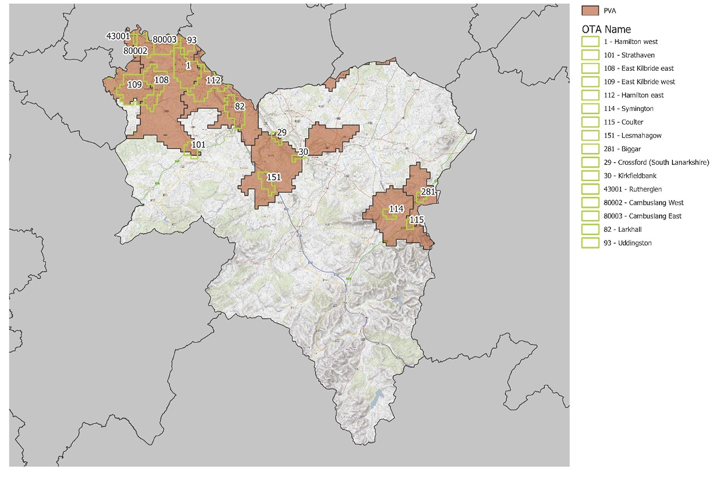
Source: SEPA

Flood risk studies
Since 2013 the council has carried out a number of flood risk studies. These include Cathkin Braes, Cityford Burn, Crossford, Lammermoor, Symington, Glen Doll East Kilbride, Carluke, Lamington and the River Clyde.

In addition, there have been numerous drainage investigations / repair and flood alleviation projects as well as other improvement works across South Lanarkshire. Also, the council monitors watercourse / culverts and has undertaken maintenance to these. Future flood studies are dependent on finding available funding and may not have commenced or be complete within the timescales of LDP3 preparation.

In terms of the Development Management process the council’s Flood management team seek Flood Risk Assessment (FRA) and Sustainable Urban Drainage Systems (SuDS) to be provided by Developers to support Planning Applications. This includes independent checks for both. Future maintenance of (SuDS) apparatus is also be identified and agreed with the council.

Natural flood management map
The Natural Flood Management Map on SEPA’s website identify areas with catchments and along coastlines where implementing a specified nature-based solution could be most effective for sustainable flood risk management and merit further investigation. A map has been produced by SEPA for each of the following solutions:
- Areas of high runoff to help target runoff reducing activities. Areas of high run off can be more susceptible to faster flooding.

- Areas where there is the potential for floodplain storage. This is where flood water may be stored and slowed by natural features of the land.
- Areas where improving sediment management could contribute to reducing flood risk.
- Estuaries that may be affected by coastal surges caused by tides or winds where flooding occurs further up the estuary.

Gap analysis
SEPA guidance on the preparation of SFRAs require gaps in the evidence to be identified once all of the available information is gathered. During the preparation of the SFRA following gaps have been identified. A summary of the issue is included together with potential actions to address them during the later stages of LDP3 preparation.
- The council does not currently have a GIS based map showing the layers contained within the SEPA Flood Risk maps, areas covered by the council’s flood studies and flood defence schemes in the area. This is currently being prepared and will be available for submission with the evidence report and used in the site assessment process following the Call for Ideas. In the meantime, the individual flood layers have been assessed.
- The council does not have a map base of historic flooding events. Reliance will therefore be on the lists of events and local knowledge and SEPAs database.
- The Natural Flood Management Maps are high-level in nature and therefore not site specific. Opportunities for natural flood management (such as deculverting and the creation of storage ponds and wetlands) at a site-specific level can be established by individual flood studies, river basin management plans, the strategic environmental assessment and site-specific flood risk assessments. The master planning of allocated sites in LDP3 will address this issue in detail on a site-specific basis.
- The Reservoir Inundation Maps are limited as they identify risk designations but not for other purposes, such as land use planning. It is therefore not possible to assess the probability of an uncontrolled release of water from a reservoir consistent with the requirements of NPF4 for development to be free of flood risk up to 0.5% probability (including allowance for climate change). In addition, the probability of failure of a controlled reservoir is considered low and is beyond the scope of risk considered within NPF4. The council will consider the risk of reservoir inundation for potential sites on a case-by-case basis using the maps.
- In Potentially Vulnerable Areas some actions (such as flood studies, surface water management plans, sewer flood risk assessment) identified for a PVA may not have commenced or be complete within the timescales of LDP3 preparation. To address any potential information gap, a site-specific FRA will be required for sites within a PVA.
- In addition, any future council led flood studies are dependent on finding available funding and may not have commenced or be complete within the timescales of LDP3 preparation. Where appropriate a site-specific FRA will be required at the site assessment stage and/or as part of the master planning exercise if it is identified as suitable for allocation.

6. Water management

River water quality
SEPA produce an annual Water Framework Directive (WFD) Classification for all the water bodies in Scotland. Classification results for 2007 to the current year can be found on the Water Classification Hub.

In particular the database includes details of pressures on the water environment in terms of both surface water and groundwater across South Lanarkshire and the source of that pressure RBMP3 further information on each watercourse and the actions required to address the pressure is also provided.

The three main causes in relation to surface water are rural diffuse pollution (related to agricultural activity largely beyond the scope of the planning system), modifications to physical condition, and man-made barriers to fish migration.

In terms of groundwater the main causes of concerns relate to previous mining and quarrying activity and contamination of previously developed sites.

These specific pressures on waterbodies in the council area will be used to inform later stages of the plan preparation in terms of the implications of site allocations on the water environment and identifying where actions are needed and/or opportunities for enhancement can be realised.

Most of Scotland’s water environment is generally already in a good condition and subject to fewer pressures than most other European waters. However, there are significant environmental problems caused by a number of pressures, including diffuse and point source pollution, alterations to beds, banks and shores, alterations to water levels and flows and the presence of invasive non-native species. In order to measure these pressures and their potential effects, SEPA monitors the quality of rivers across South Lanarkshire, collecting data and classifying the rivers in terms of their status. The parameters for recording the quality of the water environment include ecological status (natural and the presence of alien species), the natural and modified river flow, the presence of engineering works, such as culverting and flood defence or any other manmade barriers that affect the morphology and habitats of the river, for instance preventing migratory movements.

Surface water bodies are classified using a system of five quality classes – high, good, moderate, poor and bad. In general, the classification of water bodies describes by how much their condition or status differs from near natural conditions. Water bodies in a near natural condition are at high status, while those whose quality has been severely damaged are at bad status.

The WFD classification data for rivers across South Lanarkshire has been divided into Surface Water bodies and Heavily Modified Water bodies (HMWB). For river surface water bodies of the 68 watercourses monitored in 2023 38.4% were classified with an overall status of good, 35.8% as moderate, with 21.7% being assessed as poor. The Malls Mire Burn/Polmadie Burn/Cityford Burn was assessed as being bad.

A summary in relation to physico-chemical, biological and hydromorphological classification recorded is summarised in the table below.

WFD water classifications for river surface water bodies (overall status), 2023
 | Overall status |  | Physico-chemical |  | Biological elements |  | Hydromorphology
 | No. | % | No. | % | No. | % | No. | %
High | 0 | 0 | 44 | 62.0 | 12 | 16.9 | 10 | 14.1
Good | 30 | 42.3 | 19 | 26.8 | 26 | 36.6 | 35 | 49.3
Moderate | 25 | 35.2 | 5 | 7.0 | 18 | 25.4 | 15 | 21.1
Poor | 15 | 21.1 | 3 | 4.2 | 14 | 19.7 | 7 | 9.9
Bad | 1 | 1.4 | 0 | 0 | 1 | 1.4 | 4 | 5.6
Source: Scottish Environment Protection Agency

Heavily Modified Water Bodies are surface water bodies which have been substantially altered in character for purposes such as flood protection, navigation, hydroelectricity generation, public water supply, recreation, land drainage, other important human sustainable development activities and where their physical characteristics cannot be restored without significant adverse impacts on the uses served by the alterations or on the wider environment. For water bodies designated as HWMB, their classification is defined in terms of ecological potential, a measure of how the ecological quality of such a water body compares with the maximum quality achievable given the physical constraints imposed by its use.
WFD water classifications for river surface water bodies (overall status), 2023
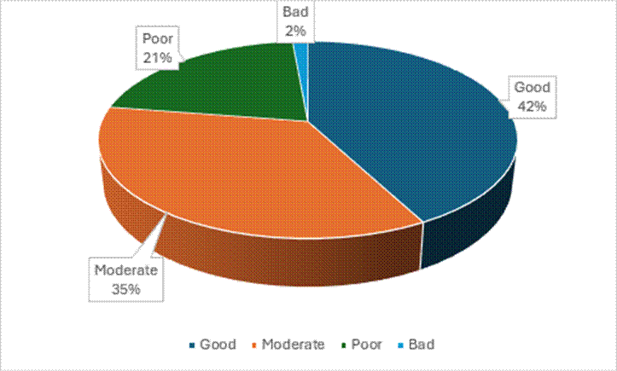
Source: Scottish Environment Protection Agency

The water bodies designated as HMWB in 2020 in South Lanarkshire are set out below. Water bodies designated as HMWB cannot achieve ‘good ecological status’ as prescribed in the Directive, instead they must achieve ‘good ecological potential’

Water bodies designated as HMWB in South Lanarkshire, 2020
ID | Name | ID | Name
10002 | Kittoch Water | 10040 | River Clyde (North Calder to Tidal Weir)
10043 | Daer Water (d/s Daer Reservoir) | 10071 | Wellshaw/Earnock Burn
10107 | Culter Water | 10108 | Cow Gill/Eastside Burn/Duncan Gill
10117 | Camps Water | 10930 | Malls Mire Burn/Polmadie/Burn/Cityford Burn
Source: Scottish Environment Protection Agency

Of the river water bodies designated as heavily modified, 2 achieved good ecological potential in 2023 (Culter Water and Cow Gill) and 1 (River Clyde (North Calder to Tidal Weir)) was assessed as poor. Malls Mire Burn was assessed as having bad ecological potential. The remaining water bodies were assessed as having moderate ecological potential.

WFD water classifications for HMWB in South Lanarkshire, 2023
Class | Overall Status  (ecological potential) | Physico-chemical | Biological elements | Hydromorphology
High | 0 | 0 | 2 | 0
Good | 2 | 1 | 0 | 0
Moderate | 4 | 1 | 4 | 5
Poor | 1 | 2 | 1 | 1
Bad | 1 | 0 | 1 | 2
Source: Scottish Environment Protection Agency

The maps below provide an overview on the location for WFD water classifications in South Lanarkshire. It is important to note that the classification tools for some elements of the WFD system continue to be refined which may result in a future change of status for some water bodies.

Distribution of WFD status of water bodies in South Lanarkshire, 2023

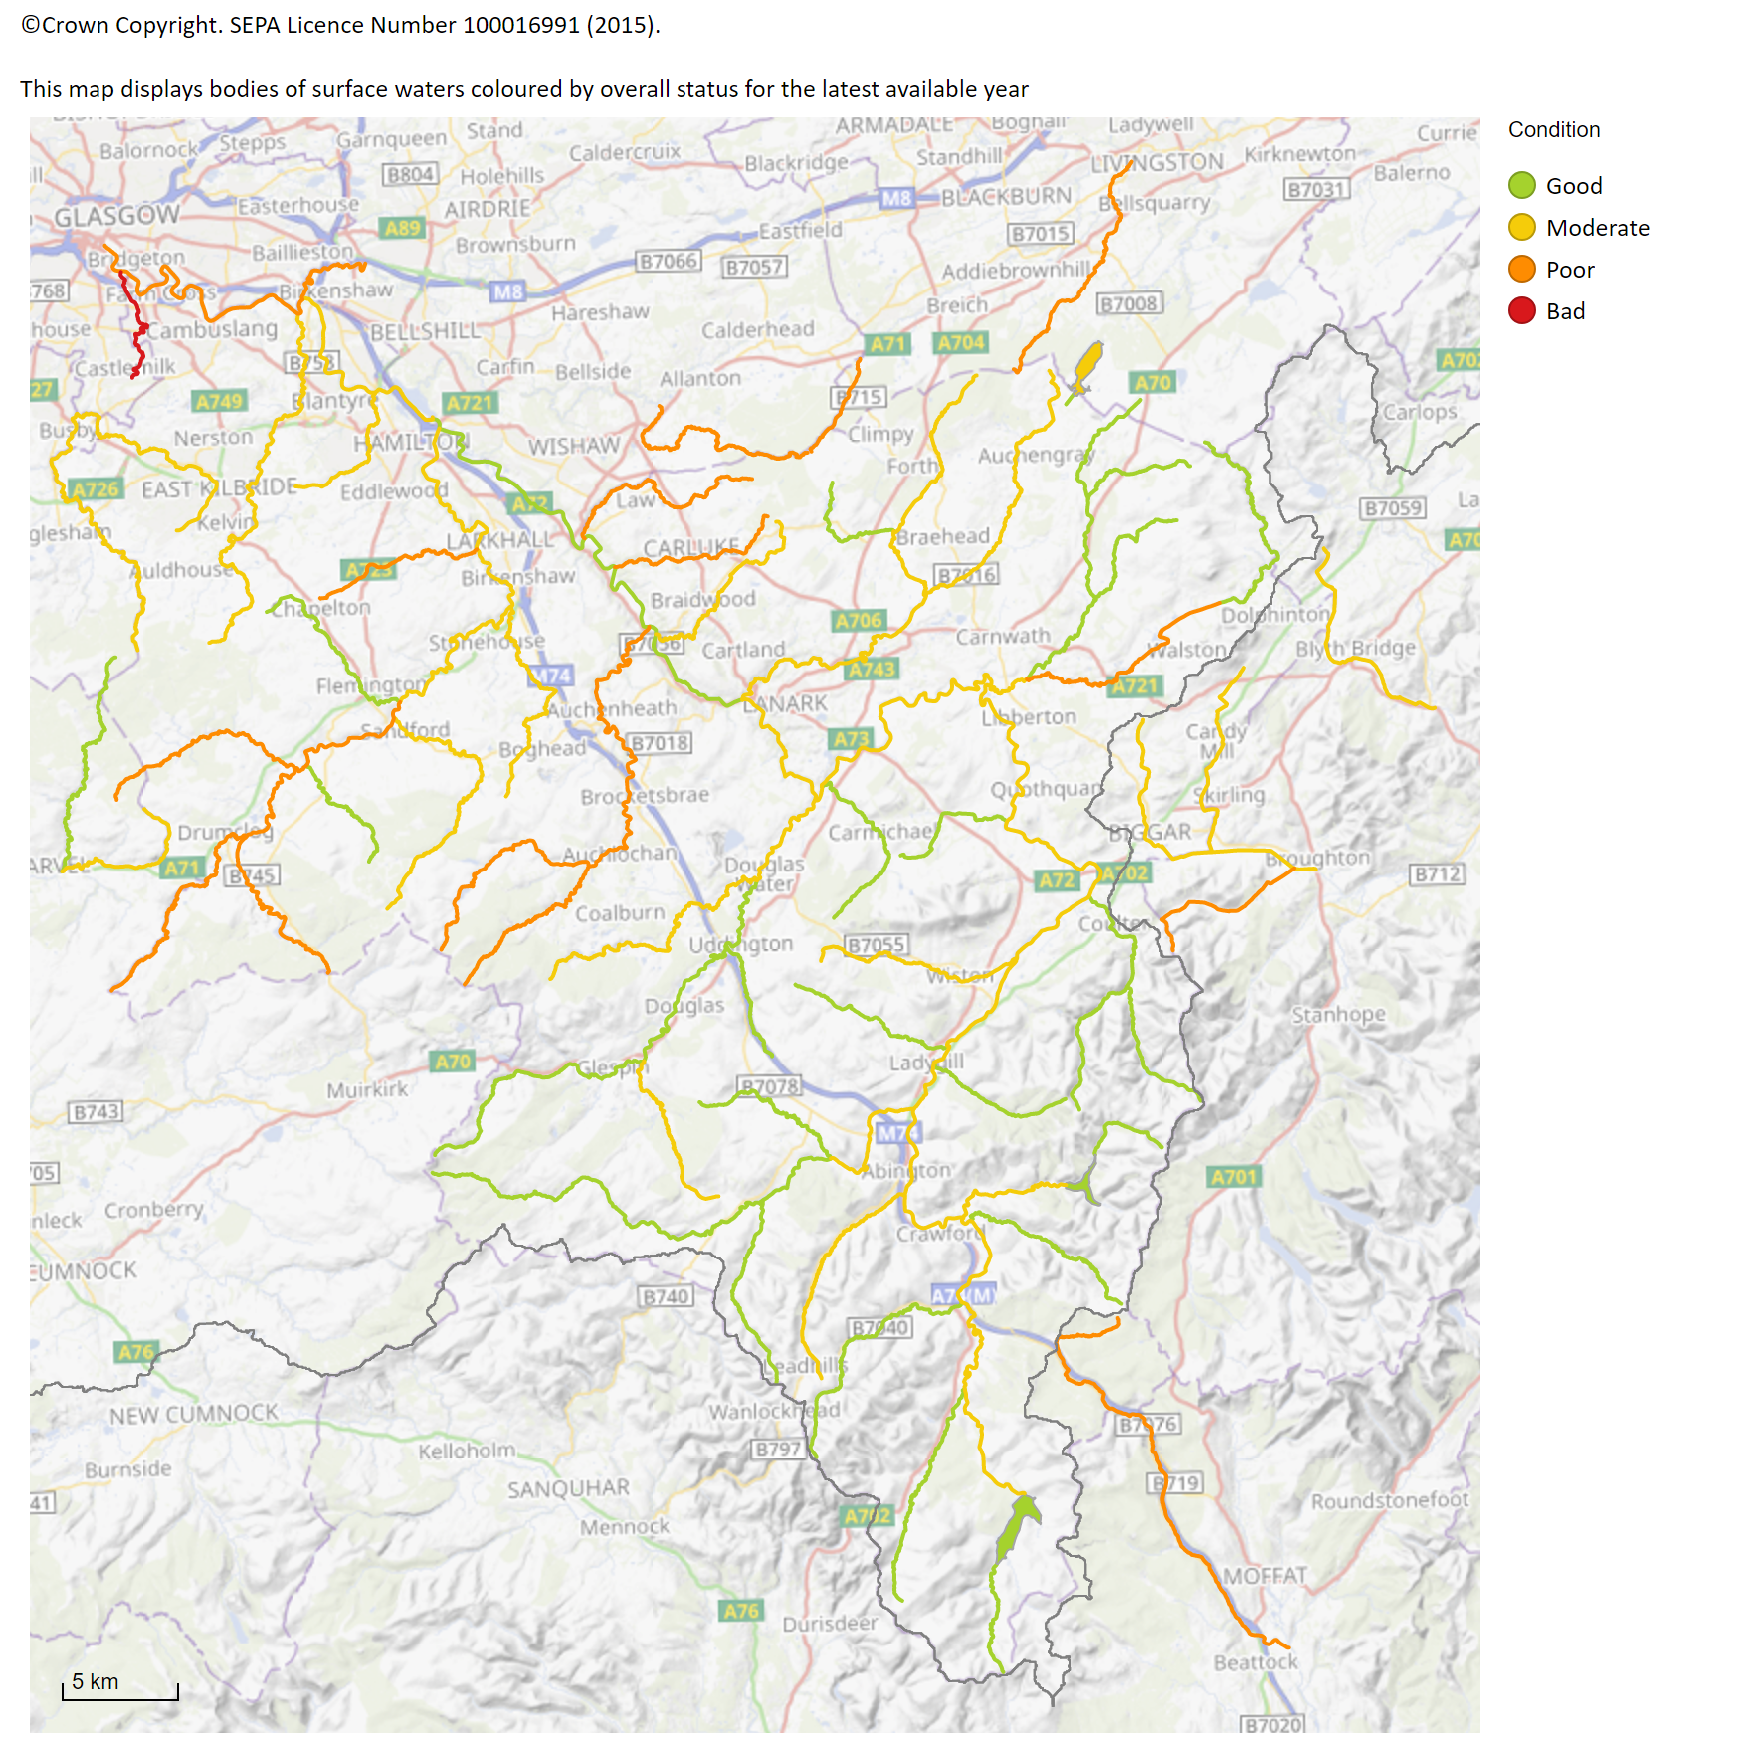
Source: Scottish Environment Protection Agency: Scotland’s Environment Web

Lochs and reservoirs
Similar to the river quality, the quality of standing waters (reservoirs and lochs) is assessed using the WFD classification system. This is based on chemical, biological/ecological and hydrological indicators. However, this classification is only applied to lochs larger than 1 km2 and smaller lochs of particular importance. In South Lanarkshire two standing water bodies, the Daer Reservoir and the Camps Reservoir fulfil the criteria.

Based on the WFD criteria, both the Daer and Camps Reservoirs are classified as HMWB. Both reservoirs have been classified as having good ecological potential. Both reservoirs have poor hydromorphology, a low ecological status in the water quality because of the physical characteristics of the water. This is due to dam structures adversely affecting the natural flows in the catchment. However, both reservoirs have been classified as having good status for physico-chem, with Daer Reservoir being classed as having good biological elements and the Camps Reservoir being classified as high.

WFD classifications in South Lanarkshire, 2020
Reservoir | Overall status | Physico-chem | Biological elements | Hydro-morphology
Daer | Good EP | Good | Good | Poor
Camps | Good EP | Good | High | Poor
Source: Scottish Environment Protection Agency

River flow
There has been limited change over the years to the location of the principal watercourses across South Lanarkshire. Modifications to smaller watercourses including culverting have been done within urban areas (notably East Kilbride). No records exist to identify the extent of any such alterations to watercourses but these will rarely alter the overall flow of the rivers significantly. A greater potential for influencing river flow rates is through an increased input (increasing the input from surface drainage) or extraction (extracting the water for general usage). Weirs and other physical barriers can alter the fluctuation within the flow rates but offer greater resistance to migration of fish upstream. Climate change offers the greatest threat to altering river flow rates, particularly with increasing annual rainfall.

Average annual rainfall varies across South Lanarkshire, from over 1,500mm across the Southern Uplands to around 1,100mm over the northern urbanised lowland areas. Most of the area is predominantly drained by the tributaries that flow into the River Clyde and precipitation changes within the Clyde catchment will have a significant effect on the flow characteristics of the rivers. There are 15 gauging stations in South Lanarkshire.

- River Avon at Avonbank
- Avon Water at Fairholm
- Cander Water at Candermill
- River Clyde at Abington, Blairston, Daldowie, Hazelbank, Kirkfieldbank, Sills of Clyde and Tulliford Mill
- Douglas Water at Happendon
- Duneaton Water at Maidencots
- Kittoch Water at Waterside
- River Nethan at Kirkmuirhill
- Rotten Calder at Redlees

Two stations have been used to provide river flow data representing the lower River Clyde at Blairston near Bothwell and the upper contributory Duneaton Water at Maidencots near Abington. The annual mean flow rates on both the River Clyde and Duneaton Water increased from 1970 to 2006 by approximately 15% and 25% respectively. Annual mean flow rates at both stations have remained fairly consistent over the last few years, except for 2020 which evidenced a significant increase.

Annual mean water flow rates
Year | River Clyde at Blairston |  | Duneaton Water at Maidencots
Year | Annual flow  (m3 s-1) | Annual rainfall (mm) | Annual flow  (m3 s-1) | Annual rainfall (mm)
1970 | 42.00 | 1198 | 3.06* | 1375
1980 | 45.03 | 1170 | 3.09 | 1411
1990 | 58.80 | 1527 | 4.03 | 1783
2000 | 54.70 | 1439 | 4.19 | 1671
2006 | 44.75 | 1332 | 3.62 | 1571
2007 | 55.25 | 1260 | 3.99 | 1855
2008 | 51.62 | 1230 | 3.74 | 1460
2009 | 48.43 | 990 | 3.34 | 1381
2010 | 35.89 | 924 | 2.85 | 1162
2011 | 60.91 | Unavailable | 4.03 | Unavailable
2012 | 58.95 | Unavailable | 3.97 | Unavailable
2013 | 44.09 | Unavailable | 3.46 | Unavailable
2014 | 53.84 | Unavailable | 3.94 | Unavailable
2015 | 62.70 | Unavailable | 4.41 | Unavailable
2016 | 44.45 | Unavailable | 3.06 | Unavailable
2017 | 41.88 | Unavailable | 3.26 | Unavailable
2018 | 41.32 | Unavailable | 3.07 | Unavailable
2019 | 42.43 | Unavailable | 3.03 | Unavailable
2020 | 62.49 | Unavailable | 4.34 | Unavailable
2021 | 41.91 | Unavailable | 3.02 | Unavailable
2022 | 33.05 | Unavailable | 2.18 | Unavailable
2023 | 43.89 | Unavailable | 3.04 | Unavailable
2024 | 45.17 | Unavailable | 3.08 | Unavailable
Source: CEH www.nwl.ac.uk/ Environment Protection Agency

Groundwater, ponds and wetlands
Groundwater is water under the surface of the land. In 2023, there were 37 groundwater water bodies within or intersecting South Lanarkshire which vary in area from just under 7km2 to over 800km2. Of these, 24 have an overall status of good, while the remaining 13 are classified with a poor status.

The Countryside Survey defines ponds as ‘a body of water between 25 m2 and 2 ha in area which usually hold water for at least four months of the year’. Ponds can be in many forms both, natural or man-made and can be permanent or seasonal (or temporary). Ponds are important habitats for a range of fauna and flora, including amphibians, invertebrates and ferns.

The 2007 survey estimates there are 198,000 ponds in Scotland, an increase of 6% since 1998. In total 9.9% of ponds met Priority Habitat status based on the quality criteria for plants. Pond quality measurement has not yet been developed for Scotland, however, findings from surveys such as the National Pond Survey suggest that, although there is likely to be degradation of some Scottish ponds, overall quality is likely to be higher than in England and Wales. Pond deterioration can be contributed to a combination of urban development and rural land use intensification. In South Lanarkshire, threats to pond quality mainly come from pollution, for example, agricultural and urban runoff and acidification and infilling for land development or agricultural use. Sustainable Urban Drainage Systems (SUDS) can use ponds and similar water bodies to prevent flooding.

Scotland’s wetlands, including peatlands, are home to a special range of plants and animals and contribute uniquely to storing carbon as well as sustaining clean water. They can help reduce flooding and provide valuable grazing. Wetlands are areas where water covers the soil, or is periodically present either at, or near, the surface of the soil. The prolonged presence of water promotes the development of characteristic wetland soils and favours the growth of specially adapted types of plant. The Scottish Wetlands Inventory can be found on SEPA’s webpage.

Pressures affecting wetlands include intensive land management and change in use, land-take for development such as buildings, roads and windfarms, climate change, nutrient pollution from water and the atmosphere and drainage or removal of groundwater flow as a result of developments. There is little survey data for South Lanarkshire, with only specific habitats monitored (such as Langlands Moss). There are no designated or proposed wetlands of international importance in South Lanarkshire as set out by the Ramsar Convention.

Water pollution
Water quality has continually got better through improvements in the treatment of sewage and effluent discharges but point source pollution still remains an important threat to water quality. Point sources of water pollution include discharges from municipal sewage treatment works and industrial installations. Discharges from sewage treatment works can contribute to water pollutants in the form of oxygen-depleting nutrients and pathogens that can be a serious health hazard. Industrial discharges can contribute in the form of toxic chemicals and heavy metals. SEPA regulates point source discharges through licensing and by monitoring potential impacts on water bodies under the following legislation and their further amendments:

  - The Water Environment (Controlled Activities) (Scotland) Regulations 2011 and subsequent amendments: Outlines the different levels of authorisations to allow for proportionate regulation depending on the risk an activity poses to the water environment. Some activities require authorisation including Point Source discharges, engineering activities, impoundments and abstractions.
  - The Pollution Prevention and Control (Scotland) Regulations 2012. Known as the PPC Regulations they regulate specified large-scale industrial activities.

At September 2019, there were around 2,697 CAR authorisations in South Lanarkshire covering a range of operations and licensed activities. These include 2,125 Registration level activities, 226 simple licenses and 204 complex license activities. This includes authorisations held by Scottish Water for a number of discharges ranging from village septic tanks, wastewater treatment works and their associated sewerage networks

Diffuse pollution into water bodies (including ground-waters) is usually associated with land use, with agricultural activity and urban runoff the most significant causes. Diffuse pollution from agriculture is derived from heavy and inappropriate fertiliser use including ammonia release, field runoff containing suspended soil particulates and other solids washed out during periods of high rainfall, phosphates and pesticide use. Urban runoff is associated with surface water contaminated with a range of suspended solids, sewage contamination and a mixture of chemicals including oils.

In rivers, the largest impacts are caused by diffuse pollution from farmland and urban areas and the disposal of sewage through small-scale septic tanks. Ground-waters are particularly vulnerable to a build-up of nitrate levels associated with fertiliser and pesticides washed down through the soil. Diffuse pollution from both agricultural and urban pollution has significant impacts on water quality in South Lanarkshire.

Nitrate Vulnerable Zones (NVZ) are designated in accordance with the requirements of the Nitrates Directive which aims to reduce water pollution caused by nitrates from agricultural sources. In Scotland, there are five designated NVZs. None of these are in South Lanarkshire, however, the area does fall within zones identified for the catchments that drain to nutrient sensitive areas.

Water scarcity
The need to create climate resilient places is a central theme in NPF4. To achieve this there is a need to understand the challenges and opportunities presented by the water environment for places. An increasing risk water scarcity due to predicted drier summers or instances of prolonged drier weather, presents a significant challenge in terms of increased frequency, intensity, and duration of water scarcity events. Water scarcity can result in:

- Pressures on public and private water supplies.
- Impacts on businesses and the agricultural industry from reduced or stopped water abstraction.
- Impacts on ecological interests.
- Drier soil conditions which can exacerbate or cause flash flooding.
- Impacts on discharge processes caused by lower river flows.
- Increased risk of wildfire events during periods of drought.

The planning system plays a key role in managing how land is used and where development should be located. NPF4 places a significant emphasis on addressing the climate and nature crises. Water scarcity is regarded as a key risk from climate change and can itself result in significant impacts on ecological interests. Through a planned and collaborative approach, LDPs can support efforts in avoiding or minimising the impacts of water scarcity, including:

- Taking an integrated infrastructure-first approach to planned development.
- Supporting a holistic approach to how the water environment is managed including developing spatial strategies where existing land and proposals for new development can be best managed/planned for sustainable water management.
- Maximising opportunities for multi-functional blue and green infrastructure and nature networks.
- Protecting and restoring land that provides multiple benefits including natural flood management measures, sustainable soil management, and peatland protection/restoration.
- Avoiding new private water supplies in areas which are vulnerable to water scarcity.

SEPA has published a Planning Advice Note for Planning Authorities to support LDP Evidence Gathering on water scarcity issues. This advice note provides guidance on evidence sources relating to water scarcity that are relevant in preparing Local Development Plans (LDPs). In the context of a changing climate where water scarcity events are already happening and are predicted to become more prevalent, intensify and lengthen in duration, there is a growing need for evidence to ensure that LDPs can support water resilient places, alongside wider water resource management actions. This advice note includes a summary of current relevant evidence and outlines how it can be used to support National Planning Framework (NPF4) policy delivery.

SEPA and Scottish Water have published plans that set out actions for dealing with water scarcity in Scotland’s National Water Scarcity Plan and Scottish Water Adaptation Plan (2024). Scottish Water have also published a Draft Long-Term Strategy (2024) setting out key challenges facing the water industry over the next 25 years and the actions needed to tackle these. This includes challenges around the changing climate which is expected to bring more extreme weather to Scotland. The Scottish National Adaptation Plan (2024-2029) sets out actions the Scottish Government and partners will take to respond to the impacts of climate change, including increasing risks from water scarcity. In particular, the Scottish Government is committed to undertaking a review of water industry policy, and continuing to assess how water, sewerage and drainage services can adapt to the impacts of climate change to avoid water scarcity through future legislation.

SEPA data on water scarcity identifies areas which are currently at risk of water scarcity/drought. This includes water scarcity seasonal reports and a Drought Risk Assessment Tool. This provides a snapshot of current water scarcity/drought risk levels across Scotland which can provide some indication of areas already susceptible to water scarcity.

LDP3 will be informed by the impact of future climate risks, including the probability of water scarcity/drought events in particular where new private water supplies are being considered as these are particularly susceptible to periods of drought. NPF4 Policy 22 presumes against the use of private water supplies unless these are sourced from a sustainable water source that is resilient to periods of water scarcity.

Nature networks
The network of rivers, burns, reservoirs and lochs in South Lanarkshire together form a blue network of rivers and wetlands. They can contribute to the provision and enhancement on blue infrastructure and this topic is covered in more detail in the topic paper on play, recreation and blue and green infrastructure.

The linear nature of the river network provides long wildlife corridors through built up areas and intensively farmed land. Rivers and burns have potential to become key components of the nature networks which will be identified for LDP3. Functioning riparian corridors can help increase the resilience of a place to the impacts of climate change, help address the nature crisis, provide environmental benefits and a wide range of public services. The condition of the district’s larger watercourses can be checked on SEPA’s Water Classification Hub.

SEPA require the evidence report to refer to water environment evidence to establish and identify opportunities to enhance nature networks and blue and green infrastructure.

Geomorphic risk layer – was produced for the National Flood Risk Assessment (NFRA) 2 in recognition that flooding poses risks from erosion as well as inundation. The layer identifies sections of rivers where channel adjustment is likely to be significant due to high erosion or deposition and where infrastructure is at risk due to high channel mobility in terms of slope, channel width and flow, and energy. The data has been used to model potential erosion, transport and deposition and identify areas where significant channel erosion and deposition are expected. It allows consideration to be given to the potential risk posed to existing infrastructure adjacent to these areas and the implications for future infrastructure provision and development. While there may be options to mitigate this risk hard engineering techniques are not recommended unless completely necessary and may increase the risk of erosion in adjacent reaches. Consideration of a riparian corridor within these spaces is considered a far more beneficial approach.

Riperian vegetation enhancement opportunities – this layer has the aim of identifying, at a catchment scale, areas where riverbanks could be protected from erosion by improved riparian vegetation ideally including riparian woodland. It identifies areas where tree planting will benefit geomorphology through river restoration when morphological pressures were present in a particular section. It can be used as a source of evidence at a strategic scale to identify where riparian vegetation, and particularly woodland could be beneficial to the water environment within a catchment. It is noted that site specific assessments would be required to inform individual projects It is noted that further work is currently being undertaken by SEPA to consider other existing morphological pressures. The mapped outputs of this work will be made available in due course and could inform more detailed project stages.

Riparian corridor layer - a buffer zone that extends from the banks of all natural watercourses in Scotland. The Riparian Corridor buffer has 3 size categories: 10 m 15 m, and 30 m. Riparian corridors provide a wide range of environmental, ecological, economic and social benefits where they are threatened by expansion of urban areas. It can also show areas that can contribute to climate change resilience by giving rivers room to adjust to changes in flood frequency and magnitude brought about by climate change.

Obstacles to fish migration Natural and artificial obstacles to the migration of fish, mainly salmonids in Scotland

The Water Environment Fund is managed by SEPA is recognition of the pressure rivers are under and, in places, damaged. This includes straightened and embanked channels which are cut off from natural flood plains, heavily concreted urban river corridors with little chance for the creation of wild habitats, a lack of attractive green spaces, and rivers made impassible to fish migration by barriers. The Water Environment Fund enables rivers to be restored by repairing damaged urban rivers often in deprived areas to enhance the environment for the communities that live there that can be used for active travel and recreation and improve health and wellbeing; and removing and easing barriers to migrating fish and improving vital fish stocks.

Funding priorities include improving Fish Migration Past Redundant Structures; improving river corridors by restoring damaged river corridors to enhance the ecological value of the river and improve public amenity and well-being opportunities, including the reduction of flood risk.; and eradicate invasive non-native species (INNS).

The location of projects within South Lanarkshire shown in the map below.
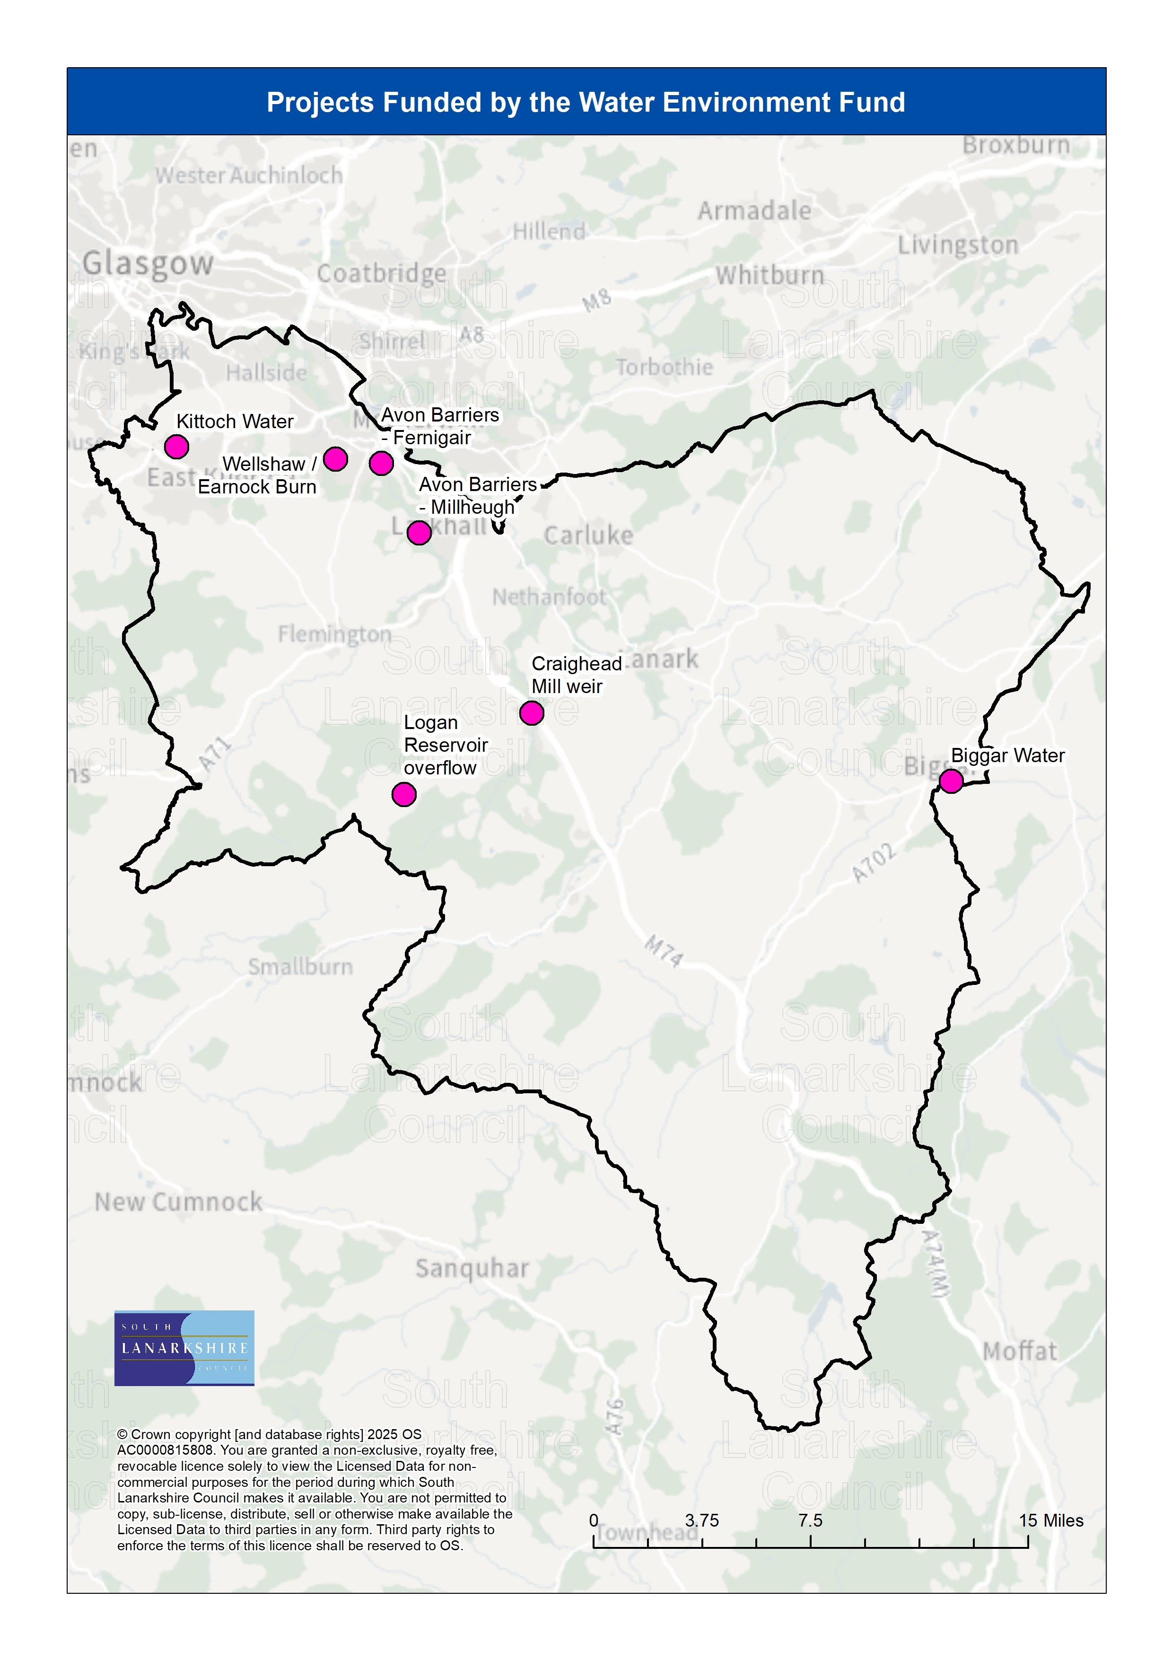

Scotland's wetland inventory shows known wetlands and data including wetland type, the original habitat survey information and whether the wetland polygon is within a statutory designated site.

It is intended that these layers will be mapped and submitted with the evidence report.

7. Implications for LDP3
- The Strategic Flood Risk Assessment has been carried out to assist with the preparation of LDP3, particularly in regard to making decisions about preferred site allocations. It takes into account the aims of NPF4 Policy 22 and will form the basis as a core component of the Site Assessment methodology.
- The council will continue to explore the effectiveness and deliverability of all sites currently included within the adopted LDP2, including exploring whether flood risk is a constraint to development.
- The flood maps prepared by SEPA and the relevant Local Plan District Flood Risk Management Plans will be used by the council in preparation of LDP3. The council will use the information collected to develop the SFRA, in GIS form
- There are some data gaps identified in the SFRA at the moment. There are also some flood risk factors that are difficult to directly map and will need case by case review in site assessment.
- The need for potential additional flood areas adjacent to the future flood risk zone with climate change extent may be required once the latest climate change inputs are accounted for. These will be issues for LDP3 to consider in its development strategy and policy framework.
- The River Basin Management Plan for Scotland will have implications for LDP3 in terms of action to create healthier and more resilient communities, the creation of nature networks and removing barriers to fish migration
- LDP3 will also include actions to improve the water environment as identified by the SEPA Water Environment Hub as well as the implications for the Plan in terms of the pressures on relevant waterbodies highlighted in the RBMP3 data - including any site allocation considerations and the mitigation necessary/enhancement opportunities.
- Through application of SUDS in new development and retrofit in established areas there is potential to improve the quality of water run-off and reduce the frequency of sewer discharges, as well as realising biodiversity and amenity benefits. This can be addressed in detail in the master planning for allocated sites.
- Identifying a blue green network of existing assets and new linkages is a role for LDP3. NPF4 requires LDPs to identify areas where climate change is resulting in unmanageable flood exposure, and so where alternative land use is needed. For areas at risk of surface water flooding, the move to a blue green network over time may offer potential for alleviation of the risk.

