South Lanarkshire’s Nature Emergency Declaration

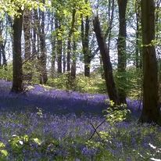
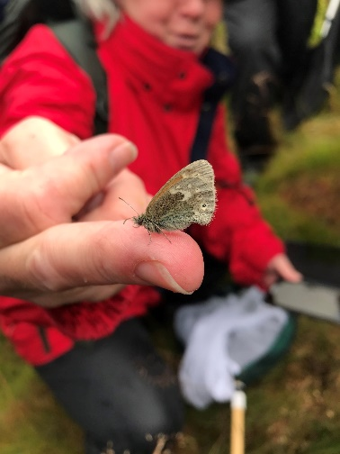
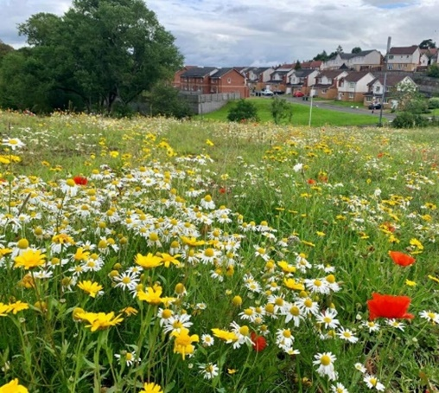

If you want this information in a different format or language, phone 0303 123 1015 or email equalities@southlanarkshire.gov.uk

Content

Background

National targets

Current approach in South Lanarkshire

Actions to support the nature emergency

References

Background
We are facing a climate and nature emergency. Biodiversity has declined dramatically in recent decades. Strong and bold action is now required to bring about the transformative change needed to halt this loss. It is important that all society’s activities not only avoids further damage and loss of nature, but helps to protect, monitor, and restore it.

The Intergovernmental Platform on Biodiversity and Ecosystems Services (IPBES) 2019 Global Assessment identified land and sea use change, is in part driven by five key drivers: direct exploitation, development, pollution, climate change and invasive non-native species. These direct drivers are associated with a range of indirect drivers of biodiversity loss, including socio-cultural values and behaviours, demographic and consumption factors, poor governance and the impacts of some technological innovations.

Centuries of habitat loss, over exploitation, intensification of farming, development, invasive species and persecution means Scotland is one of the most nature depleted countries in the world, ranking 28th from the bottom out of more than 240 countries and territories in terms of the biodiversity it has remaining.

The State of Nature Report 2023 provides compelling evidence that Scotland’s wildlife continues to decline. The report reveals one in nine species are threatened with national extinction, with a 15% decline in average species abundance across closely monitored wildlife since 1994. In the last decade alone 43% of species have declined strongly with some of the worst declines in familiar species like swift, greenfinch, kestrel and lapwing. Lichens, bryophytes and flowering plants have suffered massive declines in distribution since 1970, showing the importance of restoring key ecosystems, expanding native woodlands in tackling climate change and helping wildlife withstand its effects.

Species are the building blocks of our ecosystems. Every time we allow a species to go into decline, we progressively undermine the health and functions of our ecosystems. We must not forget that these ecosystems are not only a fundamental part of the natural world but also provide us with the essential basics of life: our food, water and the air we that we breathe.

A set of international biodiversity targets have been agreed under the UN Convention on Biological Diversity through the Global Biodiversity Framework 2022. The Framework aims to address the biodiversity loss and restore ecosystems. The plan includes measures to halt and reverse nature loss, putting 30% of the planet and 30% of degraded ecosystems under protection by 2030. The Scottish Government played a leading role in highlighting the role of sub-national governments in securing these global aims, via The Edinburgh Declaration.

To support the delivery of these, the Scottish Government has committed to a national biodiversity strategy, the Nature Restoration Fund and to putting in place legally binding targets to restore nature, these aim to halt and reverse long-standing national declines in biodiversity. Guidance from the Scottish Government states that we need to be nature positive by 2030. Where there is more nature than there is today, and by 2045 Scotland’s nature is well on its way to full recovery. Net zero and nature positive can and must be achieved together: restoring nature can be a huge part of the climate solution, as restoring our peatlands, native woodland, and grasslands to a healthy state will help lock up carbon, as well as helping our wildlife to thrive.

We all benefit from and depend on biodiversity to stay alive and we all contribute to biodiversity loss through our actions and choices – so the Nature Emergency is everybody’s problem. At the same time, that means it’s in our hands to make the choices which will reverse biodiversity loss in Scotland by 2045.

National Targets
The Scottish Biodiversity Strategy 2045 along with the Scottish Biodiversity Delivery Plan 2024 to 2030 articulate a vision for a future where Scotland’s natural environment is restored and is supporting thriving communities and wildlife alike. The Scottish Biodiversity Strategy sets out clear ambitions for Scotland to be Nature Positive by 2030, and to have restored and regenerated biodiversity by 2045.
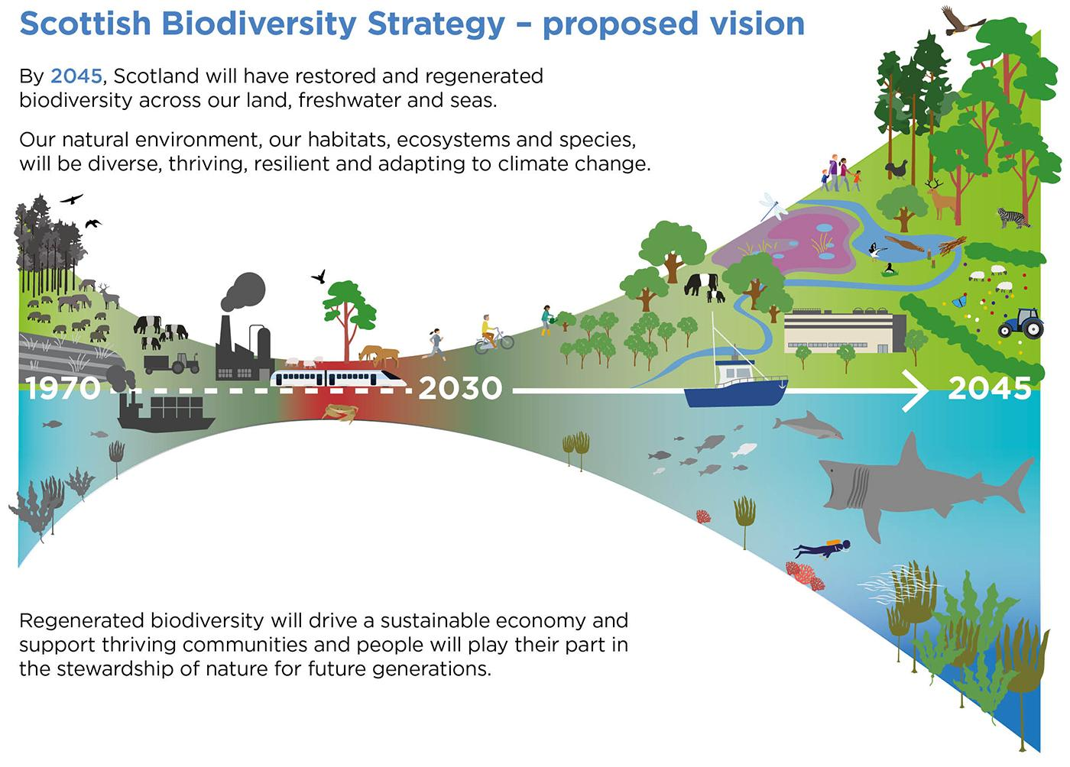

Figure 1: A Nature Positive Scotland by 2030, adapted from the Global Goal for Nature.

The Scottish Biodiversity Strategy identifies the following six objectives which have shaped the development of actions to deliver the aim of halting the loss of biodiversity and being nature positive by 2030.

These actions will:
- Accelerate restoration and regeneration.
- Protect nature on land and sea, across and beyond protected areas.
- Embed nature positive farming, fishing and forestry.
- Protect and support the recovery of vulnerable and important species and habitats.
- Invest in nature.
- Act on the indirect drivers of biodiversity loss.

The vision by 2045

“Scotland will have restored and regenerated biodiversity across our land, freshwater, and seas. Our natural environment, our habitats, ecosystems, and species, will be diverse, thriving, resilient and adapting to climate change. Regenerated biodiversity will drive a sustainable economy and support thriving communities and people will play their part in the stewardship of nature for future generations”.

The vision encapsulates three core ideas:
- that urgent action is needed at scale across our land and seascapes.
- that we are looking to the future regenerating biodiversity and building resilience to climate change.
- that people and communities are central to a nature positive future.

where:

- Ecosystems will be diverse, healthy, resilient and deliver a wide range of ecosystem services.

- Protected areas will be larger, better connected and in good condition.

- The abundance and distribution of species will have recovered and there will be no loss of diversity within species.

- Scotland’s internationally important species will have increased in numbers and have healthy resilient populations.

- Natural capital will be embedded in policy making.

- Nature based solutions, such as tree planting, peatland and blue carbon habitat restoration, will be central to our efforts to deliver Net Zero and adapt climate change.

- Harmful invasive non-native species will be managed so that established INNS no longer degrade native habitats and species or impede their restoration and regeneration and new introductions are managed quickly and effectively.

- Biodiversity as a concept will be understood and valued across the population and embedded in educational curriculums.

The Scottish Biodiversity Strategy state that to achieve the targets within the plan

“We want all levels of government to participate fully in the delivery of our goals for biodiversity, in line with the principles identified in the Edinburgh Process led by the Scottish Government for the Convention on Biological Diversity for COP15, and with the Edinburgh Declaration. In particular, cities and local authorities play key roles in conserving, restoring and reducing threats to biodiversity, in meeting people’s needs through sustainable use and equitable benefit sharing, in developing the tools and solutions needed for implementing biodiversity protection actions, and in monitoring and reporting. Their actions in mainstreaming biodiversity ensure that support is in place at all levels. They are uniquely positioned to deliver the outreach, awareness, and uptake of our goals for biodiversity across the whole of society, facilitating engagement with key stakeholders to implement our Strategic Framework”.

Key Actions identified within the Strategic Biodiversity Framework Delivery Plan 2024 to 2030 for local delivery are to:

- Ensure spatially defined Nature Networks are being implemented in every Local Authority area to provide connectivity between important places for biodiversity, deliver local priorities and contribute to strategic priorities at local, regional and national scales.

- Undertake mapping of opportunities for creating Local Authority wide nature networks that connect locally important areas for biodiversity, provide linkages with 30 by 30 sites, and address local and regional priorities for climate and nature.

- Ensure that development provides positive effects for biodiversity, by developing clear guidance on the implementation and delivery of NPF4 policies which support the cross-cutting outcome ‘improving biodiversity’.

- Ensure that by 2030 every park, reserve or publicly owned green space has a management and maintenance plan that reflects the Open Space Strategy and Local Biodiversity Action Plan outcomes.

- Ensure every new transport and active travel infrastructure project incorporates elements of blue green infrastructure and seek opportunities for enhancing/ expanding blue green infrastructure.
The strategy highlights that we are at a critical juncture. The global climate emergency and the nature emergency are twin reinforcing crises: our failure to address biodiversity loss and climate change is already impacting on our economy, society, and wider wellbeing. There is now an indisputable body of evidence that biodiversity, both globally and in Scotland, is in real trouble, our natural environment has been heavily degraded, with continued declines across much of our land and seascapes.

Our efforts to address the crisis to date have generated some successes, but we urgently need to accelerate and scale up those efforts to drive a landscape scale recovery. No one can tackle these emergencies alone, so we need to have an inclusive nature positive approach that engages with communities, businesses, landowners, managers and decision makers, recognises the fundamental importance of our natural environment and to reverse biodiversity loss by 2030, where we regenerate our ecosystems, protect our most important nature sites and create wider nature networks, so nature thrives everywhere.

Current approach in South Lanarkshire

The Nature Conservation Act (Scotland) 2004 creates a duty on public bodies to “further the conservation of biodiversity “

Our role is to support biodiversity through

- direct action
- educating others
- raising awareness

- The fourth South Lanarkshire Biodiversity Strategy 2024 to 2030 (SLBS) sets out aims and objectives to protect and enhance local biodiversity where we:

- Provide a partnership approach to guide the conservation and enhancement of biodiversity in South Lanarkshire to 2030, to ensure a focus on being nature positive.

- Outline how our local biodiversity can contribute to national and global priorities.

- Help promote the protection, enhancement, and creation of habitats.

- Facilitate a wider understanding of locally important habitats and species.

- Create wider nature networks, so nature thrives everywhere.

- The SLBS was produced through the South Lanarkshire Biodiversity Partnership, which includes representatives from both national environmental agencies and local biodiversity organisations partners include: SLC, NatureScot, RSPB, SWT, GCV Green Network, The Clyde River Foundation, Glasgow Museums Biological Recording Centre, SEPA, Scottish Forestry, The Tweed Forum and Butterfly Conservation. The partnership brings together expertise and resources, creating links between sectors to raise awareness, promote biodiversity and work together where biodiversity is enhanced and better connected on a landscape scale.

- The partnership meet annually to provide information and progress on biodiversity projects. Individuals from the partnership meet throughout the year to discuss and develop projects including the creation and enhancement of our designated sites, Clyde Grasslands, Clyde Wetlands, Clyde Climate Forest and expansion of the Clyde Waders project, all helping to expand our regional and cross boundary nature networks.

- Our Biodiversity Duty Implementation Plan (BDIP) 2024-2026 reflects the council’s duty to biodiversity and reflects the principles and outcomes set within the SLBS and articulates how we can achieve our duty to conserve biodiversity.

- We report every three years to the Scottish Government through the SL Biodiversity Duty Report on the actions and outcomes achieved by the council for biodiversity, each resource is contacted highlighting the work they have achieved for biodiversity.

- At the time of writing this report South Lanarkshire council’s Countryside and Greenspace Service employs 17 staff: a Countryside and Greenspace Manager, a Biodiversity Officer, a Countryside Ranger Team Leader, four Countryside Rangers, an Access Development Officer, Arboricultural Officer (strategic), Arboricultural Assistant, a Sites and Volunteers Officer, two Landscape Development Officers, a Senior Landscape Officer and three Landscape Support Officers.

- In 2023 The Making Space for Pollinators report was written to support the national Pollinator Strategy 2017-2027 and our aims within the SLBS. The report highlights the work we have achieved for pollinators, expanding our areas of wildflower meadows and naturalised grass and our commitment for the future. The report reviews grassland management, the use of glyphosate, the planting of pollinator friendly species, and highlights project working with other organisations and volunteers.

- We report annually to NatureScot on our achievements for pollinators. In 2024 we embarked on a pilot project in East Kilbride, working with Grounds Services and volunteers in converting amenity grassland to naturalised grassland. Initial results showed a 300% increase in plant species diversity in the longer grass after one growing season. The pollinator project in East Kilbride has provided an opportunity to work with other services, allowing the transfer of knowledge and skills to widen the understanding and importance of biodiversity.

- Continue to review and reduce our use of herbicides. Since 2023 there has been a 30% reduction in the use of herbicides. Grounds Services have purchased equipment using Frontline First funding, which will be used throughout the authority as an alternative to weed control helping the service to reduce further in future years.

- We provide annual updates for the Sustainable Development and Climate Change Action Plan, which includes actions to increase biodiversity across South Lanarkshire. The Biodiversity Officer attends the Climate Change and Sustainability Officers group meetings.

- All the council’s principal strategies and plans are subject to full Strategic Environmental Assessment (SEA) as they are prepared. This is one of the primary ways in which potential significant negative and positive effects on South Lanarkshire’s biodiversity, fauna and flora are considered. Where any effects are identified, recommendations are given to avoid or mitigate negative effects and suggestions given for enhancing positive effects. Council led plans which have been subject to full SEA include, the council Plan ‘Connect’, the Community Plan, Local Development Plan, the Biodiversity Strategy and the Sustainable Development and Climate Change Strategy.

- The Strategic Environmental Assessment Officers group meet throughout the year with officers representing each resource. Staff from the CAG team attend meetings and have shared presentations and progress on the Biodiversity Strategy, reports and projects.

- The council’s biennial State of the Environment Report is the main mechanism for monitoring changes within the local environment and includes five indicators within the biodiversity, fauna and flora chapter. The findings from the State of the Environment are reported to the council’s Executive Committee following the completion of each edition. The data is used in the development of many strategies and plans and is also highlighted on the GLOW Educational platform.

Listed below are a few examples of the work we are currently involved in promoting and enhancing biodiversity, for more information on our projects visit our current Biodiversity Duty Report and our Countryside Rangers Facebook page.

- Continue to reduce the spread of Invasive and Non Native Species within our Local Nature Reserves (LNR) and greenspaces to lower the impact on our native species. Guidance is provided on our webpage Information on Invasive Non-Native Species providing information on identification, together with links to contacts for guidance on monitoring and control, along with a mission statement on how we will respond to INNS.

- Committed £2 million through the Governments Nature Restoration Funds, restoring and creating habitats in our Local Nature Reserves (LNRs), country parks and local greenspaces. Projects included removing INNS, tree planting, purchase of equipment to help create, maintain and manage wildflower meadows, production of woodland reports for future management plans and small infrastructure work to improve access to our designated sites.

- Expanding our network of sites designated for nature:

  - 16 new Local Nature Reserves and the expansion of our original LNR.

  - In 2024 we completed the assessment and designated of 104 Local Nature Conservation Sites (LNCS) covering 2355 ha of land and water throughout South Lanarkshire. We also identified a further 70 potential sites for future assessment. These sites will feature within our next Local Development Plan.

Designated sites are a key component of our commitment to expand and improve our nature networks and commitments to the Scottish Biodiversity Strategy. These sites support a range of priority and species rich habitats including ancient woodland, grassland, wetland and significant areas of peatland. The LNCS work has taken over five years to complete and through this process we have identified 27 sites owned by the council, so scope to improve these site for nature in the future.

- We continue to work with Glasgow City Region Green Network in the development of the Clyde Grasslands, Clyde Wetlands and Clyde Climate Forest initiatives, in the expansion of our Nature Networks. In 2024/5 we produced an Evidence Report for our next Local Development Plan highlighting our proposed Nature Networks. This has taken two years to produce and we are now identifying opportunities on the ground to physically create and enhance key habitats (woodland, peatland, wetland and grassland) to strengthen these networks through south Lanarkshire. We recently promoted the wetland project within an article in South Lanarkshire View on mapping wetlands for Clyde Wetlands project.

- We continue to work with volunteers, local community, friends and school groups in promoting biodiversity through events, activities, training days and practical conservation projects. This work equates to an average of 4746 volunteer days each year, equivalent to almost £500,000. We have improved 900 hectares of land for nature and improve access to nature in this way, working with volunteers is vital in promoting and enhancing our local wildlife and provides many health and wellbeing benefits to our local communities.

- We provide support and advice to schools and promote the use of their local greenspaces for education through the Countryside Ranger Service. We continue to support undergraduate and postgraduate students, allowing them to access our reserves and greenspaces for research purposes, projects include protect species monitoring to carbon dioxide and methane testing from our peatland reserves.

- We are currently working with Butterfly Conservation in monitoring peatland sites with volunteers for large heath and small pearl-bordered fritillary butterflies, both vulnerable species highlighted on the red species list in Great Britain and a high priority for conservation.

- As part of a successful Heritage Lottery Fund bid (HLF), Froglife over the next three years (2025-2028) are working with the CAG team in creating and enriching habitats for biodiversity, with a focus on amphibians in South Lanarkshire. We are creating new ponds and enhancing existing wetlands within five of our LNRs and Chatelherault Country Park, expanding wetland habitat for wildlife.

- Staff attend meetings, conferences and webinars throughout the year to expand their knowledge, skills and share good practices and case studies. Groups include the APSE Biodiversity sub-group, National Nature Reserve (NNR) Partnership, NNR Steering Group, Windfarm Habitat Management Plan groups, Strategic Environmental Assessment Officer Group, Climate Change and Sustainability Officer Group, the Biodiversity Officers Group. We also support and attend meetings with our local volunteers and friends groups linked to our greenspaces and LNRs. We also co-ordinate the Biodiversity Partnership.

- We continue to send our biological records to Glasgow Museum Biological Record Centre, the centre collects, collates and disseminates information about wildlife in the Greater Glasgow and surrounding area to help us understand species distribution and wildlife health. The centre also sends us monthly species records, this includes species data from iRecorder, iNaturalist, local surveyors, ecologists and volunteers throughout the region. The data highlights species of interest and UK Biodiversity priority species.

- Buglife - 'Guardians of our rivers' A partnership project that connects communities across Scotland with their local rivers. Freshwater wildlife in the UK is under threat as our habitats have been damaged and or polluted. We have four locations in South Lanarkshire where we take monthly samples of the rivers invertebrate population to establish the health of the insect population, whilst giving us an idea on the quality of the water and help to identify any significant pollution incidents.

- Peatland restoration projects: including a successful £200,000 Peatland Action Fund bid for Langlands Moss LNR. We continue to work with Butterfly Conservation’s ‘Bog Squad’; offering species identification training to practical conservation days where volunteers remove trees from the surface of the bog to protect the habitat for the large heath butterfly, a Scottish Biodiversity listed and GB RED endangered species.

- In January 2025, the Ground Services Team removed approximately 200 trees from the surface of the raised bog at Langlands Moss Local Nature Reserve to help retain water within the peat. Through the process of evapotranspiration the trees remove water from the peat and dry out the soil, active peat requires high water levels. We are going to install water monitoring probes later in the year to monitor the water levels at the reserve and hopefully the impact of removing the trees will have a significant impact on the water level at the reserve and protect the future of the peat. The management at the reserve will hopefully expand suitable habitat for our resident large heath butterfly.

- We are committed to using and purchasing peat free products, using peat free alternatives instead such as tree planting compost and recycled green materials derived from green waste and food.

- Work with and support the RSPB to increase the capacity of the Clyde Valley Waders project. Working in partnership with landowners, farmers, NatureScot and other organisations improving large areas of grassland and wetland from Elvanfoot to Tarbrax to increase breeding grounds for endangered wading bird species; lapwing, curlew and oystercatcher, whilst strengthening our Nature Networks in the rural landscape.

- We utilise South Lanarkshire’s webpage and other social media outlets to highlight and promote projects and activities for biodiversity. Our webpage provides information on INNS, wildflower grasslands, links to national documents and volunteering opportunities. We also offer a Learning online course entitled ‘Biodiversity it’s your duty’ which relates to the information within the Scottish Biodiversity Strategy and South Lanarkshire’s Biodiversity Strategy along with useful tips and links on how people can help and get involved in providing for nature. To date 538 people have completed this course. The course will be promoted to both elected members and officers.

- Identify projects and funding opportunities to enhance our nature reserves, and local greenspaces for biodiversity, access improvements and where nature plays a key role in meeting climate targets, particularly for climate change adaptation and resilience. For example: we are currently working with the regional peatland officer in identifying funding for peat depth and feasibility surveys at our two peatland Local Nature Reserves. This will allow us to access Peatland Action Funds, so we can further enhance our degraded peatland sites and protect our peatland soils for biodiversity.

Actions to support the nature emergency
- Continue to note the body of evidence which outlines the extent of the global nature and biodiversity crisis due to in part driven by five key drivers: direct exploitation, development, pollution, climate change and invasive non-native species.

- Continue to recognise the statutory targets for public bodies to halt biodiversity loss by 2030 and restore it by 2045 within the Scottish Biodiversity Strategy 2045 and the Strategic Biodiversity Framework Delivery Plan 2024 to 2030 (published December 2024). Report every three years on the projects and actions achieved by the biodiversity partnership and council to further the conservation of biodiversity. Ensuring that the council plays its part in the national commitments to protect and restore nature, and to help tackle climate change and reduce its impacts.

- Continue to develop projects that identify key habitats and species that focus on enhancing and increasing suitable habitat for them to sustain a viable and healthy population.

- Continue to develop projects for pollinators and report annually to NatureScot on the projects we have achieved towards our commitment to the National Pollinator Strategy.

- Continue working in partnership with GCV Green Network and the Grounds Services team in identifying projects and funds in the development of our nature networks to improve ecological connectivity across the region connecting to neighbouring local authorities. The network will be evolving, flexible and resilient connecting nature-rich areas, allowing wildlife and natural processes to move and adapt to land use and climate change pressures. The landscape scale project will help build people’s connection to nature, providing biodiversity-rich spaces that deliver benefits, and meet the priorities of local communities for nature. They will provide linkages with 30 by 30 sites (the commitment to protect at least 30% of land and sea for nature by 2030) and address local and regional priorities for climate and nature.

- Continue to ensure that all council principal strategies and plans are subject to full Strategic Environmental Assessment (SEA) as they are prepared.

- Continue to develop projects that act on the indirect drivers of biodiversity loss and strengthen the connection between people and nature by providing opportunities for people to experience and care for nature to increase the understanding of our relationship with nature and positive action needed to secure its sustainable use through education, training and events.

- Ensure that development provides positive effects for biodiversity, by developing clear guidance on the implementation and delivery of National Planning Framework 4 (NPF4) policies, which support the cross-cutting outcome ‘improving biodiversity’. Continue to attend workshops and meetings provided by NatureScot in the development of a Biodiversity Metric to deliver NPF4 Policy 3 and securing positive effects from local development to support NPF4 policy 3 (c): Developing with nature. For example the inclusion of swift bricks, insect homes and minimising the effects of light pollution will be included in best practice guides for developers.

- Develop and offer corporate conservation volunteering opportunities for all council employees and promote the online learning course to ensure that the current and future workforce understands the importance of biodiversity.

- Continue to build on existing communications to highlight biodiversity projects, utilising the council’s website, SLC and Countryside Ranger Facebook pages, View articles, installation of signage Et cetera. Emphasis why projects are happening and what the benefits are to the environment and community.

- Continue to work with the Biodiversity Partnership and the Biodiversity Officer group in achieving the targets set within the Scottish Biodiversity Strategy and Delivery Plan and investigate opportunities to contribute to the Community Planning Partnership Group.

- Identify resources to ensure that every park, reserve or publicly owned green space has a management and / or maintenance plan that reflects the Biodiversity Strategy outcomes.

- Continue to work with volunteers, local community, friends and school groups in promoting biodiversity through events, activities, training days and practical conservation projects.

- Continue to promote citizen science projects and offer qualifications and training in schools through various schemes for example: John Muir Award, Eco Schools, Forest Schools and the SCQF accredited training Forestry and Outdoor Learning Award.

- Continue to plant trees as part of our commitment to the Clyde Climate Forest over the next decade to increase canopy cover, connectivity and carbon store.

- Continue to remove damaged trees infected with ash-die back and plant suitable replacement trees.

- Continue to identify funding opportunities to target the delivery of biodiversity projects.

References
State of Nature Report
The Edinburgh Declaration.
Scottish Biodiversity Strategy 2045
Strategic Biodiversity Framework Delivery Plan 2024 to 2030
Biodiversity Duty Implementation Plan
Biodiversity Duty Report
Making Space for Pollinators report
South Lanarkshire Biodiversity Strategy 2024-2030.
South Lanarkshire State of the Environment Report
South Lanarkshire Countryside Rangers Facebook page
Nature networks
30 by 30
Advising on peatland, carbon-rich soils and priority peatland habitats in development management | NatureScot
Our Blueprint GCV Green Network
Clydeplanforestryandwoodlandstrategy.pdf (storyblok.com)
Clyde Grasslands GCV Green Network
Clyde Wetlands GCV Green Network
Invasive non-native species position statement
Green Networks and Greenspace
NatureScot developing nature guidance
National Planning Framework 4

