
Housing and Technical Resources

Redevelopment opportunity: Former Cathkin Library, Lovat Place, Rutherglen G73 5HS

Summary
Closing date: 12pm, Friday 23 January 2026
Site size: N/A
Location: Above neighbourhood shops in the Springhall area of Rutherglen.
Suitable for: Redevelopment opportunity

Further information
If you need this information in another language or format, please contact us to discuss how we can best meet your needs. Phone 0303 123 1015 or email equalities@southlanarkshire.gov.uk

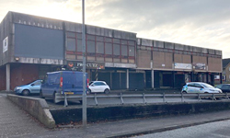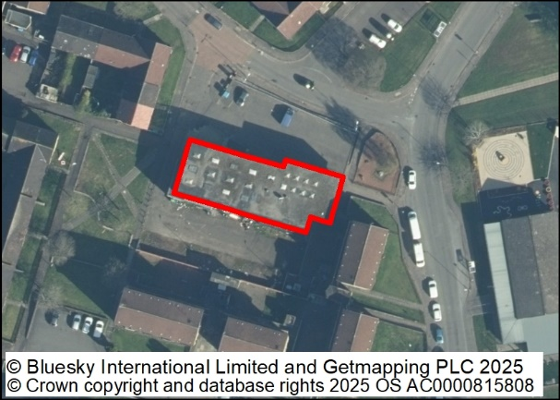
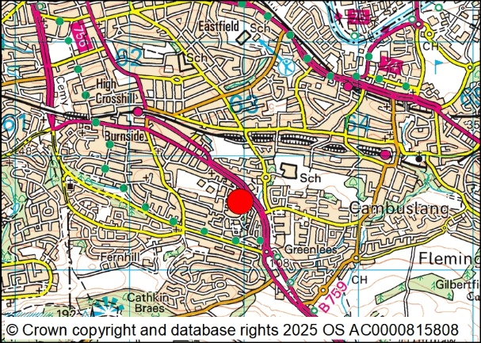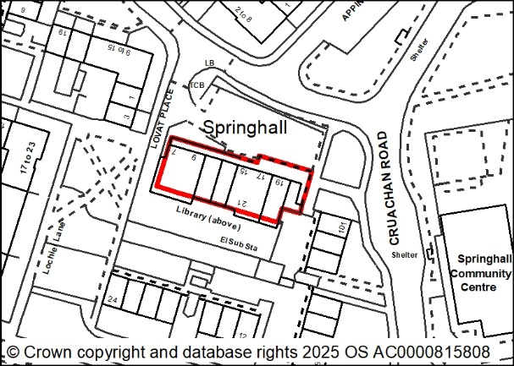

Marketing brief

Location and description
The subject is situated in Springhall, an area of Rutherglen consisting primarily of ex-Local Authority built residential properties. Rutherglen is a town that sits to the south east of Glasgow and has a population of approximately 31,000 people. The property sits on the south eastern fringes of the town, bordering the Whitlawburn area of Cambuslang and is approximately 7 miles to the south east of Glasgow city centre.

The subject comprises the upper floor of a two-storey reinforced concrete frame building with infill brickwork and precast concrete panels. There is a flat concrete roof. The property has single glazed timber windows and internal downpipes. There is a tarmac surface carpark to the front of the building and a service yard to the rear, but these are not within the defined asset extent; the footprint of the subject extends to 563 square metres or thereby.

It should be noted that the subject is in a poor state of repair, and any prospective purchaser should undertake their own due diligence regarding its construction type, condition and structural integrity.

Travel
(Postcode for SatNav – G73 5HS)

Travelling from Hamilton – enter the East Kilbride Expressway (A725), travelling west. Continue along this road and keep right to stay on the A725. At the first roundabout, take the 3rd exit onto Glasgow Road (A749) before taking the third exit at the next roundabout to continue along this road until reaching the next roundabout. Take the 2nd exit onto East Kilbride Road (A749) and travel for approximately 0.4 miles before turning left into Cruachan Road and then taking the first right turning into Lochaber Drive. The building in which the subject is located can be seen on the left-hand side. To access the car park, take first left into Lovat Place.

Planning
The site is covered by Policy 3 – general urban areas in the South Lanarkshire Development Plan 2. (SLLDP2). This states that proposals which are compatible with residential areas are generally acceptable. Developments which would be detrimental to the amenity of residents by the nature of visual impact, noise, smell, air pollution or traffic or public safety would not be permitted.

The site could accommodate a range of development types including residential, commercial or leisure uses provided standards for amenity space, access and car parking can be achieved in the design. Early discussions with the Planning Department are recommended.

All local plan documents and supplementary guidance can be accessed on the council’s website www.southlanarkshire.gov.uk

Planning enquiries should be directed to:
Planning and Building Standards
Phone 0303 123 1015
Email: planning@southlanarkshire.gov.uk

Roads enquiries should be directed to:
Roads and Transportation
Phone 0303 123 1015
Email: roads@southlanarkshire.gov.uk

Services
Mains services are understood to be available however no guarantee is given as to the existence or condition of any of these services. Mains services are understood to be available; however, no guarantee is given as to the existence or condition of any of these services. The successful purchasers must satisfy themselves in this respect.

Legal costs
The purchaser shall be responsible for the payment of both parties’ legal costs in respect of the transaction.

Viewings
For further information or to request a viewing please contact:
Property Services (Estates)
Housing and Technical Resources
Almada Street
Hamilton
ML3 0AA
Phone: 01698 455154
Email: LandAndProperty@southlanarkshire.gov.uk

Offers
Offers are invited to purchase the heritable interest in the property. Offers together with details of the proposed development, including layout, must be submitted to the following e-mail address only.
Property.Disposals@southlanarkshire.gov.uk

Closing date 12pm, Friday 23 January 2026. Offers will be judged on their individual merits. Late offers will not be considered under any circumstances.

Formal legal missives will require to be entered into and will require to incorporate the Conditions of Sale noted overleaf.

These particulars are believed to be correct but their accuracy is not guaranteed. All interested parties should satisfy themselves as to their accuracy.

South Lanarkshire Council are under no obligation to accept the highest or any offer. These particulars do not form, nor are they intended to form part of any contract.

Conditions of sale

Instructions to purchasers
Please read these instructions carefully. They detail essential conditions which the council will insist on in this transaction and explain how the council wishes you to bid for this property. If you are instructing a solicitor you should pass these to him/her.
- Bids must be received on or before 12pm on the closing date. Bids in any other format may be disregarded. Late bids will not be considered.
- Bids will be assessed in respect of the best price (which consideration shall, for the avoidance of doubt, include the bidders ability to pay the price).
- The council are under no obligation to accept any of the bids. In the event that no bid is accepted, bidders will be notified and will be advised if the property is to be re-marketed.
- Planning Services would consider the proposed alternative use in terms of the Local Plan and any proposal would be considered on its own merits.
- The price in the formal bid should be exclusive of VAT. The council may elect to charge VAT on the price and will endeavour to notify the successful bidder as soon as possible if they so elect.
- The price in the formal bid should be exclusive of any costs for planning gain and/or contributions to amenities.
- Subject to 13, no discussions will be entered into before the closing date.
- The council’s acceptance or rejection of any timeous bid is subject to the approval of the council’s Housing and Technical Resources Committee or the expedited powers vested in the members of the committee or the powers delegated by the council to council officers.
- Timeous bids will be acknowledged within seven days of the closing date. A decision on the success or otherwise of bids will not be given until a decision has been formally approved by the council.
- No formal or contractual discussions will be entered into before the closing date or the grant of the council’s formal approval.
- When the successful bidder is approved by the council, the council’s legal team will contact the preferred bidder’s solicitors to progress missives.
- The offer to sell will contain, amongst other conditions, the following specific conditions :
- The purchasers must satisfy themselves in respect of the ground conditions, suitability of existing building services, suitability of the property for the purchasers intended use and the terms of the title deeds. The council will make no warranty in respect of any of these issues.
- The purchaser must submit an application for planning consent if appropriate in support of their bid, and taking account of the information in the planning statement within a prescribed timescale.
- Any supplementary information requested by planning services must be provided by the purchasers within 14 days of the date of the request.
- The purchaser will bear the cost of the council’s reasonably incurred legal fees.
- Any queries regarding the marketing brief should be addressed to:
The Estates Manager, Property Services, Housing and Technical Resources, Almada Street, Hamilton, ML3 0AA in writing as soon as possible and no later than five working days before the closing date.

Disclaimer

The particulars are set out as a general outline, only for the guidance of intended purchasers or lessees and do not constitute, nor constitute part of, an offer or contract.

All descriptions, dimensions, reference to condition, any necessary permissions for use and occupation, and other details are given without responsibility and any intending purchasers or tenants should not rely on them as statements or representations of fact but must satisfy themselves by inspection or otherwise as to the correctness of each of them.

No person in the employment of South Lanarkshire Council has any authority to make or give any representations or warranty whatever in relation to this property.

The information contained in these particulars has been checked and unless otherwise stated, it is understood to be materially correct at the date of publication.

The council does not bind itself to accept the highest or any offer and in supplying these particulars, is not issuing instructions and will not, therefore, bear liability for agents or other fees.

Freedom of Information (Scotland) Act 2003
The council is bound by the terms of this Act. This means that the council cannot in certain circumstances be party to a confidentially clause.

