Budget consultation feedback report

Each year the council consults on its budget options, seeking views from individuals and
representative groups within the community and the workforce. The results of the
consultation are shared with all Elected Members to help inform their discussions as they
work to agree the budget for the following financial year. Details of the budget agreed for
2026-27 can be found on South Lanarkshire View.

The consultation took place between 5 November 2025 and 14 January 2026. The focus
was on 17 savings options that officers presented to councillors on 5 November 2025 for
their consideration. Local residents were also asked to indicate the level of Council Tax
rise they would accept it if meant council services could be protected.

As with previous budget consultations, the most popular way to take part in the
consultation was through an online survey, with a total of 2,502 responses received.
Further opportunities to participate were through a dedicated email address
savings@southlanarkshire.gov.uk, and a postal option. The survey was promoted
extensively using the council’s communications channels, and through direct
correspondence with community groups and local residents.

In the survey participants were asked to give a single response to each of the 17 savings
options – either strongly agree, agree, neither agree nor disagree, disagree, or strongly
disagree. The results of this were presented to Elected Members in bar charts.
Participants were also asked to pick two words to describe their feelings about each
saving option, from bad, unacceptable, unnecessary, indifferent, undecided, necessary,
acceptable, and good. The results of this were presented as bar charts and word clouds.

The bar chart results are shown below.

CER01: End the current council-provided Christmas switch-on events in six town centres. Saving would be £45,000 with no impact on posts.

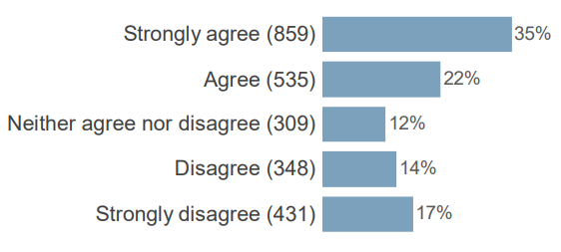

CER02: Reduce Christmas trees and festive lighting provision, to provide for eight main areas. Saving would be £37,000 with no impact on posts.
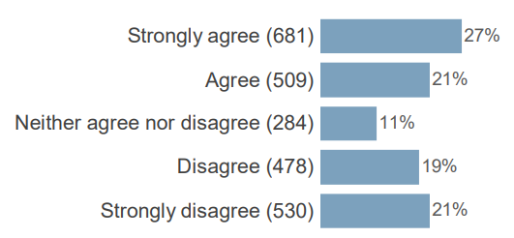

CER03: Reduce weed killing from two applications to one per annum. Saving would be £525,000 with a reduction of 14.5 FTE.
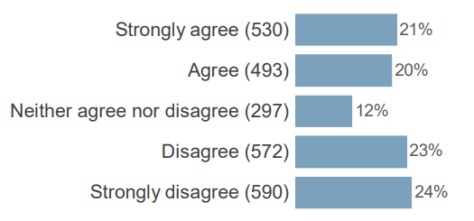

CER04: Remove grounds staff support for gala days, including costs of bunting. Saving would be £55,000 with no impact on posts.

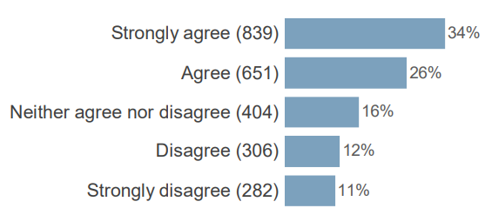

CER05: Reduce mechanical sweeping on footpaths by 27%. Saving would be £290,000 with a reduction of 6 FTE.

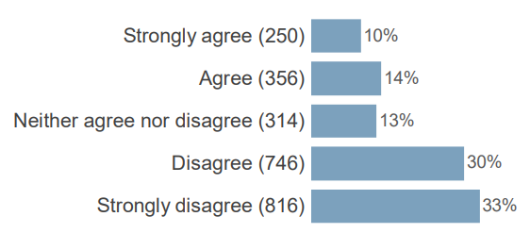

CER06: Reduce litter picking and bin emptying by 10%. Saving would be £264,000 with a reduction of 10 FTE.

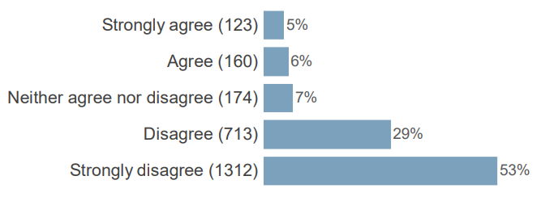

CER07: Replace precautionary gritting of footpaths with a reactive approach, responding to severe weather conditions. Saving would be £300,000 with no impact on posts.

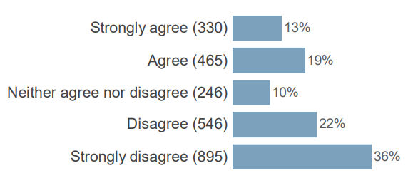

CER08: Reduce carriageway gritting from 49% to 45% of roads, in line with the Scottish average. Saving would be £130,000 with no impact on posts.
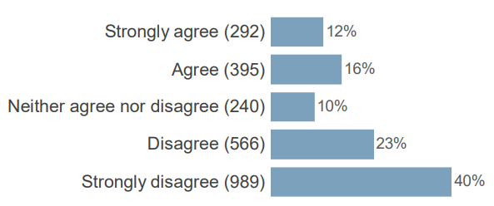

CER09: Reduce the number of grit bins across communities by 25%. Saving would be £65,000 with no impact on posts.

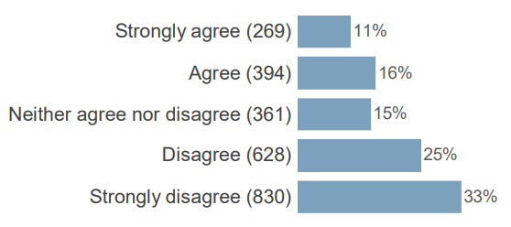

CER10: Reduce grass-cutting from 18 to 14 cuts per annum for high amenity areas and from 14 to 7 cuts for low amenity areas. Saving would be £1,050,000 with a reduction of 36 FTE.

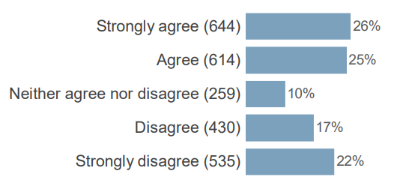

CER11: Change frequency of cleaning nursery, primary and secondary schools. Saving would be £260,000 with a reduction of 25 FTE.

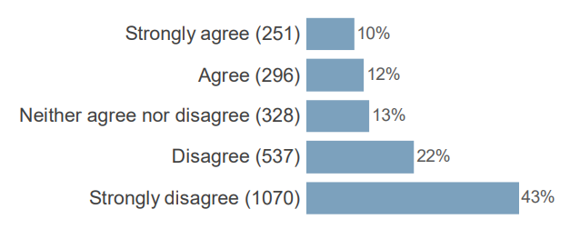

CER12: Introduce charges for enhanced pre-application advice, purification of conditions on planning consents and other discretionary charges in Planning. This will generate additional income of £100,000.

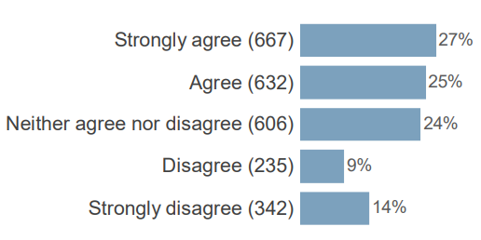

CER01: End the current council-provided Christmas switch-on events in six town centres. Saving would be £45,000 with no impact on posts.

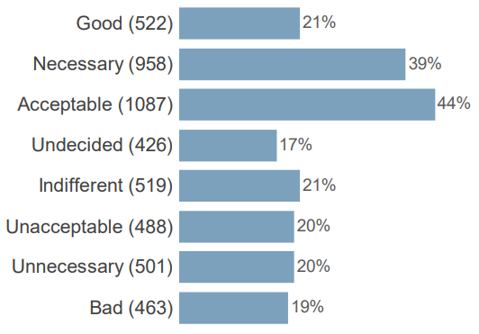

CER02: Reduce Christmas trees and festive lighting provision, to provide for eight main areas. Saving would be £37,000 with no impact on posts.

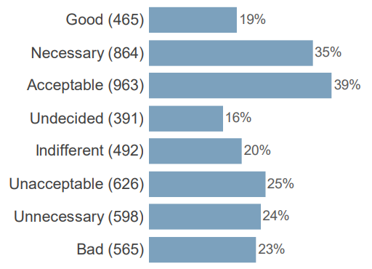

CER03: Reduce weed killing from two applications to one per annum. Saving would be £525,000 with a reduction of 14.5 FTE.

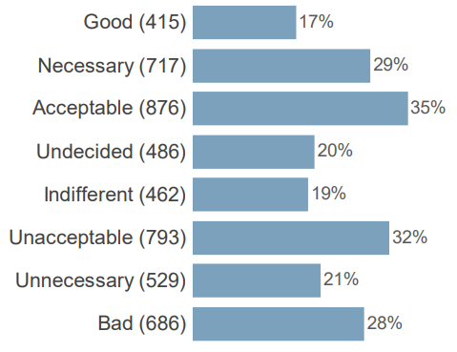

CER04: Remove grounds staff support for gala days, including costs of bunting. Saving would be £55,000 with no impact on posts.

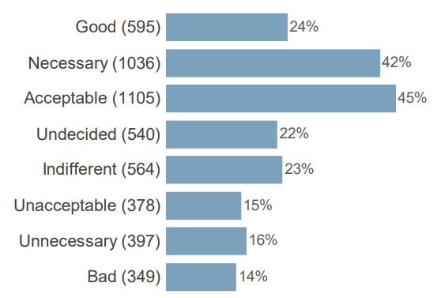

CER05: Reduce mechanical sweeping on footpaths by 27%. Saving would be £290,000 with a reduction of 6 FTE.

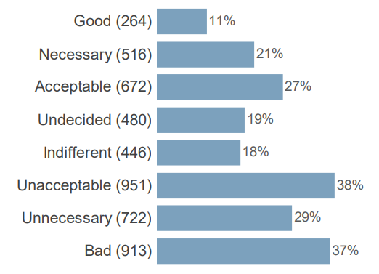

CER06: Reduce litter picking and bin emptying by 10%. Saving would be £264,000 with a reduction of 10 FTE.

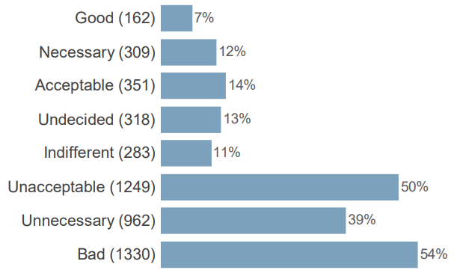

CER07: Replace precautionary gritting of footpaths with a reactive approach, responding to severe weather conditions. Saving would be £300,000 with no impact on posts.

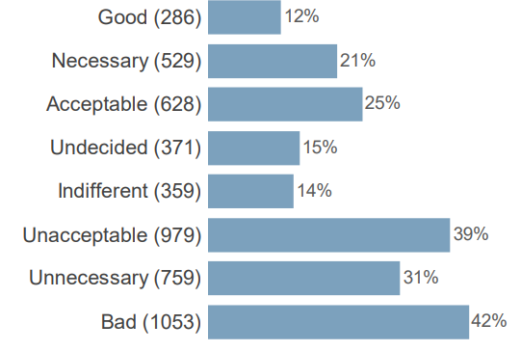

CER08: Reduce carriageway gritting from 49% to 45% of roads, in line with the Scottish average. Saving would be £130,000 with no impact on posts.

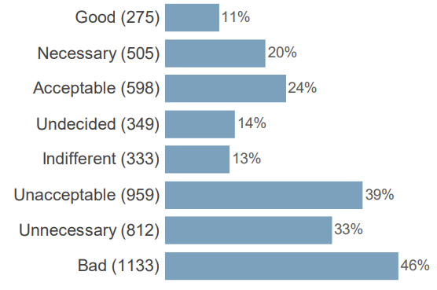

CER09: Reduce the number of grit bins across communities by 25%. Saving would be £65,000 with no impact on posts.

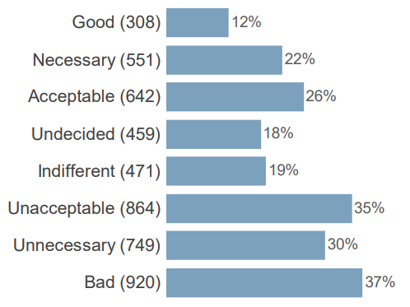

CER10: Reduce grass-cutting from 18 to 14 cuts per annum for high amenity areas and from 14 to 7 cuts for low amenity areas. Saving would be £1,050,000 with a reduction of 36 FTE.

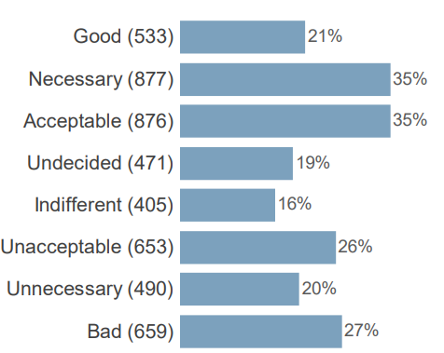

CER11: Change frequency of cleaning nursery, primary and secondary schools. Saving would be £260,000 with a reduction of 25 FTE.

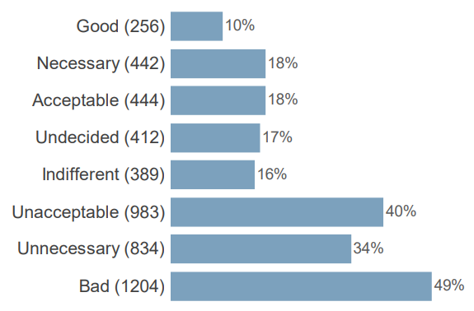

CER12: Introduce charges for enhanced pre-application advice, purification of conditions on planning consents and other discretionary charges in Planning. This will generate additional income of £100,000.

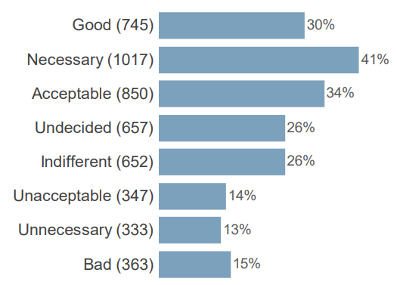
EDR01: Reduce the management spend devolved to early years, primary and secondary schools by 14%. Saving would be £480,000 with no impact on posts.

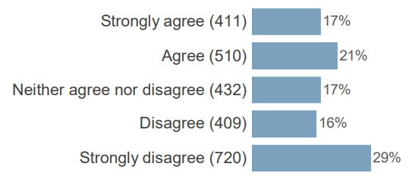

EDR02: Introduce a fee for primary school breakfast clubs, in line with the majority of councils. Fee to be £1.50, with children exempted if entitled to free school meals. Overall saving would be £350,000 after 1 FTE administration post added.

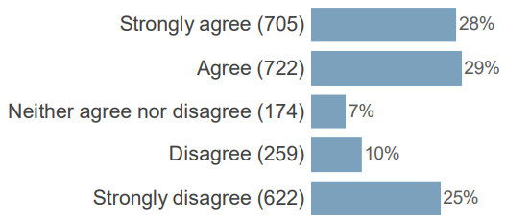

EDR03: Reduce the number of Instrumental Music Service instructors from 29.5 FTE to 26.5 FTE. Saving would be £184,000 with a reduction of 3 FTE.

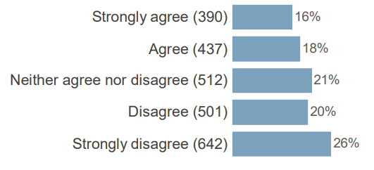

EDR04: Restructure Youth, Family and Community Learning Team to provide a greater focus on early intervention and locality-based planning for whole family support. Saving would be £465,000 with a reduction of 9 FTE.

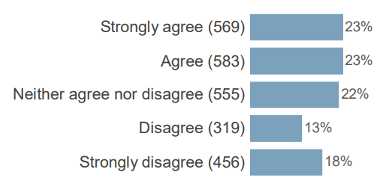
EDR01: Reduce the management spend devolved to early years, primary and secondary schools by 14%. Saving would be £480,000 with no impact on posts.

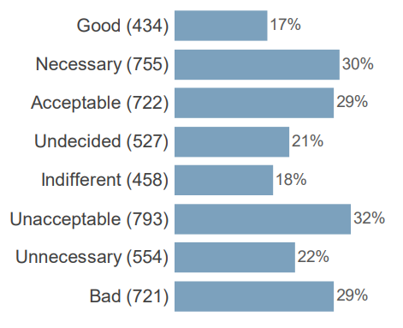

EDR02: Introduce a fee for primary school breakfast clubs, in line with the majority of councils. Fee to be £1.50, with children exempted if entitled to free school meals. Overall saving would be £350,000 after 1 FTE administration post added.

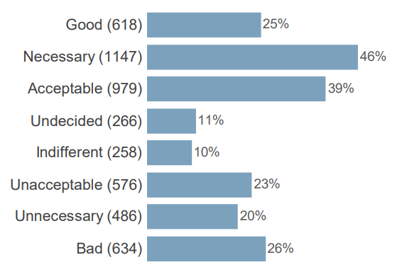

EDR03: Reduce the number of Instrumental Music Service instructors from 29.5 FTE to 26.5 FTE. Saving would be £184,000 with a reduction of 3 FTE.

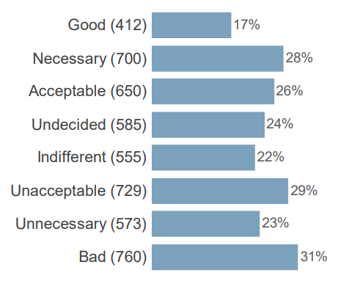
EDR04: Restructure Youth, Family and Community Learning Team to provide a greater focus on early intervention and locality-based planning for whole family support. Saving would be £465,000 with a reduction of 9 FTE.

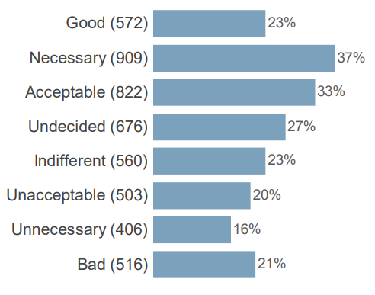

HTR01: Reduce the council’s contribution to the Community Safety Partnership to £37,000, saving £18,000 with no impact on posts.

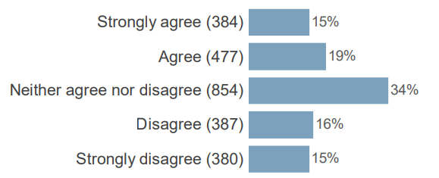

HTR01: Reduce the council’s contribution to the Community Safety Partnership to £37,000, saving £18,000 with no impact on posts.

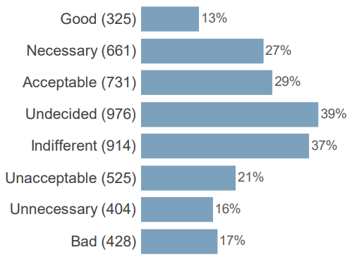

Council Tax
Of the 2,502 people who completed the survey, 2,482 gave an opinion of the rate of Council Tax increases that would be acceptable. 75% backed an increase of some kind, while 25% opted for no increase. Of those who supported an increase, the largest number opted for 5%. A full breakdown of responses is shown below.

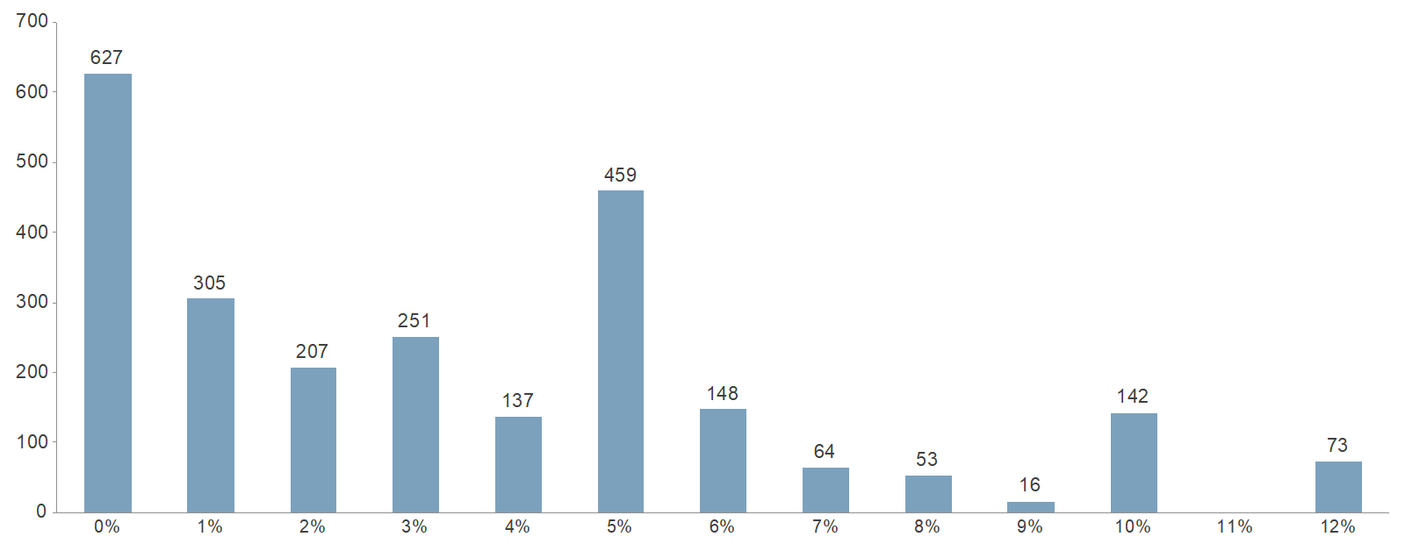

Young People engagement
A separate consultation was held with children and young people, in recognition of the fact
that their views have been historically more difficult to capture as part of the wider budget
consultation.

This built on a consultation carried out in January 2025, with focus group conversations
held with more than 250 children and young people in January 2026. Over the two
exercises a total of 1500 children and young people were consulted.

When asked their priorities for council spending and “keeping what matters”, the
participants identified:

- Adequate resources for schools
- Access to sports and youth facilities and safe places to play
- More affordable homes for families and communities
- Accessible transport options
- Keeping the area clean and safe
- Accessible hygiene products for women and girls

On specific saving options, the children and young people expressed opposition to
reductions in Christmas lights and events, grass cutting, weed killing, street cleaning, road
and pavement gritting, music tuition and school cleaning. They also opposed the
introduction of fees for primary school breakfast clubs.

If you need this information in another language or format, please contact us to discuss how we can best meet your needs. Phone 0303 123 1015 or email equalities@southlanarkshire.gov.uk.

