6. Soils
SEA objectives that relate to soils
Protect soils and geology and maintain ecosystems functionality.

Sustainable Development Goals
The Goals relevant to this chapter are:
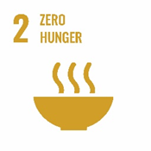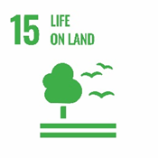

Introduction
Soil is a complex, variable and living medium. It has a role in providing a habitat and gene pool, is important for human activities, landscape and heritage and acts as a provider of raw materials.

The European Union has defined soil as ‘…the top layer of the Earth’s crust and is formed by mineral particles, organic matter, water, air and living organisms’.

Soil performs many vital functions: as a growing medium for food, forestry and other biomass production, storage, filtration of water, carbon, and nitrogen. Soil in its many forms is considered as an important carbon store. Scottish soils are estimated to contain approximately 3,200 million tonnes (Mt) of carbon, which is more than half the UK’s soil carbon and 60 times as much as all the vegetation in Scotland. In particular, peat soils hold over 70% of Scotland’s carbon but only accounts for around 11% of its land area.

Scotland’s soils are generally in good health but there is a lack of national trend data from which evidence of change or damage to soils might be determined. There is some evidence that levels of organic matter in Scottish soils may be declining and this may result in a significant reduction in the UK stock of terrestrial carbon. The key cause of this decline is intensive agricultural practices which disturb the soil and lead to changes in soil carbon levels. The rate of organic matter loss from soils is far quicker than the rate of organic matter gain meaning that once the organic matter is lost it is impossible to replenish.

The 2005 Scottish Greenhouse Gas Inventory estimated that soil carbon stock changes in land converted to cropland emitted 6.5 Mt carbon dioxide – about 15% of Scotland's net carbon dioxide emissions. In comparison, soil carbon stock changes in land converted from arable to grassland gave a sink of 2.8 Mt carbon dioxide even though the area was larger (1200 kha compared to 1000 kha for land converted to cropland). Many of these emissions/removals are due to historical land use change (pre-1990).

In 2006, a Soil Framework Directive was proposed to protect soils across the EU. The main issues identified included erosion, loss of organic matter and contamination. Soil damage and degradation can potentially have negative effects on human health, natural ecosystems and climate change and our ability to grow crops and other food sources for humans and animals. The Scottish Soils Framework was published by the Scottish Government in 2009 with a main aim to promote sustainable management and protection of soils.

There is a wide range of soil types in South Lanarkshire, some characterised by historical contamination from industrial activities, agricultural land, woodlands and peatlands. In 2006, it was estimated that approximately 361 kilo tonnes of carbon dioxide were removed from the atmosphere in South Lanarkshire through existing carbon sinks, including trees and other plants.

A summary of the indicators used in assessing the state of South Lanarkshire is presented, highlighting the current status of each indicator and the directional trend.

G | Good | F |  | Fair |  |  |  |  | Improving
 |  |  |  |  |  |  |  |  | No change
P | Poor |  |  |  |  |  |  |  | Deteriorating
 |  |  |  |  |  |  | Note: The most recent data available was used in assessing the environmental indicators
Indicator |  |  | Current status |  | Trend direction |  |  | Explanation
Soil quality and capacity |  |  | G |  |  |  |  | Current data indicates good soil quality in a Scottish or regional context. At present there is limited data on soil quality specifically within South Lanarkshire.
Contaminated land |  |  | F |  |  |  |  | Approximately 82% of contaminated land sites have been investigated and remediated since 2000 under the Environmental Protection Act 1990.
Peatland |  |  | P |  |  |  |  | The overall condition of raised and blanket bogs across the area is relatively poor with a number of designated sites recorded as unfavourable.

Baseline situation
Soil quality in South Lanarkshire is considered to be generally good although baseline data is difficult to gather and is rarely updated. Human activity, land use and intensity and global climatic effects can be detrimental to soils, reducing their distribution, function and sustainability. Healthy and diverse soils are important for crop growth, carbon storage and sustaining biodiversity across a range of habitat types.

6.1 Soil quality
Geology and hydrology
South Lanarkshire’s diverse range of landscapes indicates the presence of an equally diverse geology. In terms of solid geology the area can be divided into five broad regions. The very south of the area around the Lowther Hills is indicated to be underlain by sandstone and shales with intrusions of mudstones. Further north into the lower central region the underlying geology is also sandstone and shales with volcanic intrusions.

The central region of South Lanarkshire is indicated to be predominantly underlain with sandstone, conglomerates and lavas. The western portion of the central region is shown to be underlain with coal measures and partly by millstone grit. The route of the River Clyde and its tributaries is defined by deposits of sands and gravels.

The northeastern region of South Lanarkshire is principally underlain by sandstone while further west there are more coal measures. The coal seams in the Hamilton area have been extensively worked by both open cast and deep mining methods in the past. In common with the majority of Scotland the drift geology comprises till, sand and gravel from the last and earlier ice sheets. Additional deposits from rivers include substantial areas of peat.

In terms of hydrogeology coal measures are categorised as locally important aquifers where flow is dominantly in fissures and other discontinuities. Mine workings have been heavily pumped in the past, however, yields are typically low and water quality is poor. Sandstone provides locally important aquifers however borehole yields can vary significantly within the region.

Soil data
Soil quality can be considered as ‘fit for purpose’ for the range of functions we expect soils to perform. Based on existing information, Scottish soils are generally of good quality. Outwith the urban areas there is no indication that South Lanarkshire’s soils are radically different. Only a few soils located in the Cambuslang and Rutherglen area have high concentrations of contaminants due to industrial land uses with concentrations in the remainder being generally low. The area surrounding Leadhills has high concentrations of lead and other heavy metals naturally occurring in the soils as a consequence of the solid geology and historic metalliferous mining in the area. There is little evidence to suggest that South Lanarkshire suffers from serious soil erosion, compaction or other problems related to land management.

At present there is no valid data available to enable a robust assessment of soil quality.

6.2 Soil capacity
Soil capacity includes the ability to grow a range of crops, to catch and retain flood waters, carbon storage and to enhance biodiversity. Although available datasets detail soil capacity they are rarely updated making trend analysis impossible.

The Scottish Government has collected agricultural census statistics on a national and regional basis since 1982. There are no South Lanarkshire area specific figures and efforts should be made to close this identified data gap. These statistics will indicate whether soil capacity is changing (the amount of land being used for different types of crops) and the total area under cultivation. Topsoil carbon mapping is another area of research which potentially could be beneficial in terms of quantifying soil health.

Land use
The MacAulay Land Use Research Institute, now the James Hutton Institute, developed maps and datasets related to land use and agricultural capabilities. However, the available data is 20-30 years old and is being updated.

The types of land are set out in seven classes. Land in classes 1 to 4 is suited to arable use. These are:

Class 1: Land capable of producing a very wide range of arable crops. Cropping is highly flexible and includes the more exacting crops such as winter harvested vegetables. The levels of yield are consistently high.

Class 2: Land capable of producing a wide range of arable crops. Cropping is very flexible and a wide range of crops may be grown but difficulties with winter vegetables may be encountered in some years. The level of yield is high but less consistently obtained than in Class 1.

Class 3: Land capable of producing a moderate range of crops. The land is capable of producing consistently high yields of a narrow range of crops (cereal and grass) or moderate yields of a wider range (potatoes, field beans and other vegetables and root crops). The land is capable of average production but high yields of grass, barley and oats.

Class 4: Land capable of producing a narrow range of crops. Long ley grassland is commonly encountered but the land is capable of producing forage crops and cereals for stock. The land is primarily grassland with some limited potential for other crops.

Land in classes 5 to 7 is unsuited to arable use and are suited only to improved grassland and rough grazing. These are:

Class 5: Land capable of use as improved grassland. Land well, moderately or marginally suited to reclamation and to use as improved grassland.

Class 6: Land capable only of use as rough grazing. Land with high, moderate or low grazing value.

Class 7: Land of very limited agricultural value.

The council’s Local Development Plan is an important source of information as it records current land use (at a certain point in time) and plots out the areas where development will take place over the life of the plan. Departures from the Local Development Plan can be used as indicators for both soil protection and capacity.

Agriculture is the single largest use of land across South Lanarkshire. However, there are limited areas that have high yield growing capacities within classifications 1 and 2. The majority of agricultural areas in South Lanarkshire are considered suitable for grazing (Figure 6.1).

Figure 6.1: Land classification across South Lanarkshire
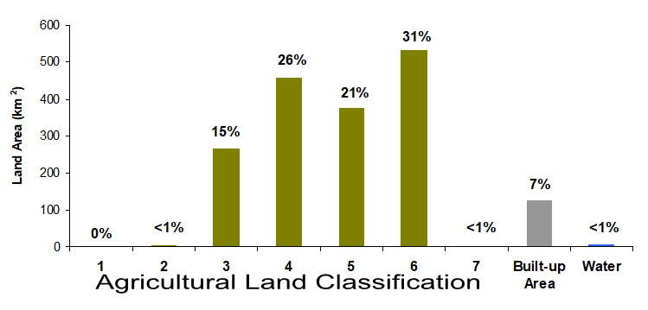
Source: The Scottish Government

The total South Lanarkshire agricultural area in 2024 was 124,449 hectares, 70.2% of South Lanarkshire’s total land area. Of all agricultural land in South Lanarkshire, 92.8% (115,514 ha) was utilised agricultural area, 6.2% (7,672 ha) was woodland and 1% (1,264 ha) was other land.

6.3 Contaminated land
The contaminated land regime set out in Part IIA of the Environmental Protection Act 1990 as inserted by section 57 of the Environment Act 1995, came into force in Scotland in July 2000.

Statutory guidance defines ‘contaminated land’ as:
‘…any land which appears to the local authority in whose area it is situated to be in such a condition, by reason of substances in, on or under the land, that
(a) significant harm is being caused or there is a significant possibility of such harm being caused; or
(b) significant pollution of the water environment is being caused or there is a significant possibility of such pollution being caused’.

The council has a statutory duty to investigate its land area specifically to find and resolve contaminated land issues which relate to harm to people, pollution to the water environment or damage to property. Soil quality is improved through the remediation of sites by reducing its ability to cause harm or pollution and soil capacity may also be improved. Some remediation techniques are highly destructive with regard to soil structure, flora and fauna, and organic content. Although improvements to soil capacity and quality are not contaminated land regime aims the processes involved frequently favour them. The regime’s stated intent is to ensure land is suitable for its intended use. This is achieved through an iterative process of creating a list of potential sites and investigating them in a methodical manner. A proportion of sites are remediated through the planning process using the same philosophy.

A list of potentially contaminated sites is compiled by the council and prioritised for inspection. This list has about 5,800 entries and to date some 5,100 sites have been initially investigated by way of a site walkover. No walkovers have been carried out recently. The areas of potential contamination are mainly centred on the urban areas with the majority of the industrial land uses based on mining, manufacturing and chemical works.

Progress of the contaminated land regime
The council through its Planning and Regulatory Services has been investigating these sites since 2000. Progress has been good with approximately 82% of the total number of sites investigated and remediated through the Part IIA regime.

From 2005 – 2025, some 2,465 sites have been, in whole or part, investigated and remediated under the planning system. Initial investigation is expected to continue with the numbers of sites being investigated per annum falling from a high in 2007/2008 as sites become more difficult to access due to topography and remote location. Limited activity had been permitted on site for significant periods of time due to lockdown restrictions. Similarly, the physical area investigated will decline each year as the larger sites are investigated leaving the smaller sites (sub 100m2) for later years.

In 2011, implementation of the contaminated land regime resulted in one area of land being identified as statutorily contaminated. This area was subsequently designated as contaminated land and a ‘Special Site’. This type of site is regulated by SEPA and consultation with them has resulted in the area being sub-divided into seven contaminated land sites which are also special sites. The location of these sites can be found on the council’s Contaminated Land Public Register.

6.4 Peatland
Peatlands are a group of habitats such as bogs and fens which develop peat soils. They form important carbon stores and deliver key ecosystem services such as clean water and flood control. They are also important for biodiversity, supporting distinctive plant and animal communities. There are extensive areas of peatlands in South Lanarkshire (Figure 6.2), with some of the best quality areas protected under international and national legislation, (see section 2.1).

The condition of peatland is influenced by historic and current land management which affects its ability to function. In South Lanarkshire, many peatland areas are in unfavourable condition for this reason. The Scottish Government has identified peatland restoration as a priority and a number of restoration projects are underway to improve peatland condition. Safeguarding peatlands continues to be a high priority for the council. Protective policies are included in the South Lanarkshire Biodiversity Strategy, the Biodiversity Duty Implementation Plan, the Local Development Plan and the Sustainable Development and Climate Change Strategy.

South Lanarkshire supports a wide range and significant proportion of deep peat and peatland habitats, which is an irreplaceable resource. NatureScot’s Lowland Raised Bog Inventory (1989) map the location, condition and potential threats to lowland raised bogs across Scotland, which is just one type of peatland habitat. These sites have varying conditions which affects their ability to function properly as carbon stores and sites of biodiversity value.

Figure 6.2: Distribution of peatland and deep peat soils throughout South Lanarkshire
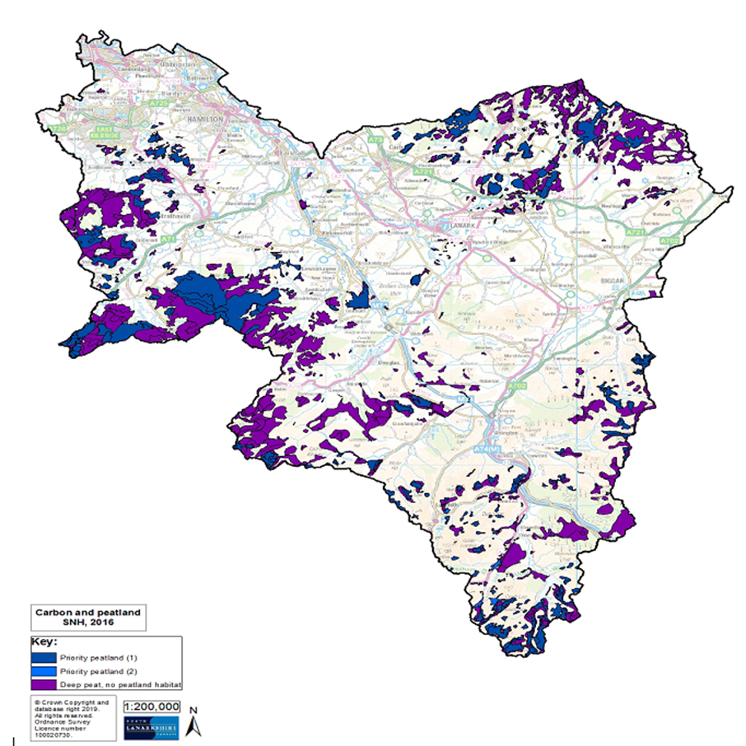
Source: South Lanarkshire Council

There are 69 sites listed on the Inventory in South Lanarkshire (Table 6.1).

Table 6.1: Lowland raised bog sites identified within South Lanarkshire
Site name | Grid reference | Site name | Grid reference
Carnwath Moss | NS967482 | Drumbuie (north) | NS647510
Torfoot | NS637377 | Drumbuie (south) | NS653506
Avonside | NS633368 | Brackenridge | NS777388
East Dykenook | NS658377 | Cleughhead | NS770372
High Drumclog | NS660487 | Blood Moss (west) | NS760399
Mid Drumclog | NS636397 | Blood Moss (east) | NS760399
Rench (north) | NS632388 | Cander Moss | NS781460
Rench (south) | NS633385 | By Red Moss | NS870267
Drumclog | NS626387 | Red Moss A | NS871263
Roughdiamond | NS623380 | Red Moss B | NS874260
Fieldhead | NS660435 | Red Moss C | NS882260
Cladance Moss NE | NS670488 | Crawick Moss | NS837204
Cladance Moss SW | NS660487 | Mountherrick (south) | NS853216
Cladence Moss N | NS660494 | Mountherrick (north) | NS855223
Scobieside | NS627400 | Auchren | NS830382
Westlinbank | NS672400 | Hollandbush | NS805362
Meadowhead (west) | NS643483 | Coalburn Moss | NS827365
Meadowhead (north) | NS649488 | Threepwood Moss | NS803474
Meadowhead (central) | NS649485 | Kingshaw Moss | NS865518
Meadowhead (south) | NS649484 | Gair Farm | NS873529
Rigfoot Moss | NS675471 | Crawford | NS960218
Maidenburn (north) | NS680462 | No data | NS948472
Maidenhead (south) | NS680458 | Carnwath Moss | NS978480
Stewartfield (NW) | NS668542 | Shodshill Moss | NS938488
Crutherland (east) | NS668514 | Cranley Moss | NS935475
Crutherland (west) | NS660513 | No data | NS958465
Drumloch | NS683514 | Burnfoot | NS988553
Drumloch | NS678518 | Forth | NS940541
Waukenwae (west) | NS680508 | Braehead Moss | NS959515
Waukenwae (east) | NS688504 | Cableburn south | NT038458
Whitefield | NS693498 | Cableburn | NT040463
Stewartfield | NS662537 | Cableburn north | NT040466
Westwood | NS613536 | Borland Moss west | NT060470
Shields Moss | NS623518 | Borland Moss | NT065472
Langlands Moss | NS635512
Source: NatureScot
The council’s Countryside and Greenspace Team continue to work with the Friends of Langlands Moss community group at one of the area’s peatland Local Nature Reserves in promoting this unique and internationally important habitat. Lowland raised bogs are incredibly important for various reasons, including flood prevention, carbon storage and supporting distinctive biodiversity. They act as natural sponges, slowing down rainfall and help to prevent flooding. Additional they store huge amounts of carbon, playing a vital role in climate change mitigation. For the past fifteen years the council has worked in partnership with volunteers through Butterfly Conservations Bog Squad providing conservation and training days to protect and monitor the health of the rare and localised large heath butterfly associated with the peatland habitat within the reserve.

If you need this information in another language or format, please contact us to discuss how we can best meet your needs. Phone 0303 123 1015 or email equalities@southlanarkshire.gov.uk

