4. Material assets and landscape
SEA objective that relates to material assets and landscape
Promote the effective and sustainable use of land and other material assets

Sustainable Development Goals
The Goals relevant to this chapter are:

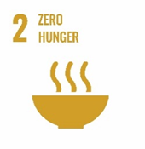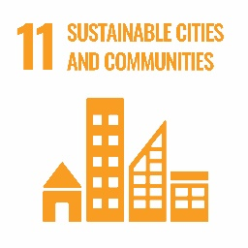
Introduction
Material assets can be described as the infrastructure of the council and the resource of the area. Landscape relates directly to land use and the area’s characteristics. This can include land reserved for development and the extent the public has access to facilities and services. These issues are closely related with particular overlap in some areas including land use and public access. It is logical, therefore, that both material assets and landscape are considered in this chapter and that the environmental issues are jointly considered. The council provides a range of services through managed facilities. It is important these facilities match the needs of the population and also conserve the character of the area.

South Lanarkshire has a diverse landscape rich in scenic value and characterised by its diverse range of land uses. The area is dominated by features such as the Lowther Hills and the Clyde Valley. The diversity of the landscape across the area is a key feature of South Lanarkshire and it is important it is preserved and promoted for wider public use through a range of opportunities.

A summary of the indicators used in assessing the state of South Lanarkshire is presented, highlighting the current status of each indicator and the directional trend.

G | Good | F | Fair |  |  | Improving
 |  |  |  |  |  | No change
P | Poor |  |  |  |  | Deteriorating
 |  |  |  |  | Note: The most recent data available was used in assessing the environmental indicators

Indicator | Current status | Trend direction | Explanation
Vacant and derelict land | G |  | The remediation and redevelopment of vacant and derelict land continue to be a priority for the council. The number and area of vacant and derelict land sites continue to decrease through re-development and greening,
Recreational land | F |  | Investment in greenspace will be informed by the Open Space Strategy that is under preparation. The number of community allotments and plot holders has increased considerably from previous years.
Countryside and outdoor access | F |  | There is an extensive path network across South Lanarkshire. Investment to maintain and improve the condition and standards of paths and other access infrastructure is kept under review.
Built facilities | G |  | There are a wide range of education, academia, sport, leisure and cultural facilities in South Lanarkshire. A number of halls and community centres across the area have been subject to Community Asset Transfer.
Housing | F |  | Good progress is being made in delivering the Local Housing Strategy with 77% of indicators on track or fully delivered by December 2025. The housing stock across tenures has increased to 159,645 homes since the last Report.
Landscape | G |  | The importance of quality landscapes in the area continues to be recognised and protected through the local planning process.
Minerals | F |  | Minerals remain an economically important resource across South Lanarkshire. Mineral recycling is being further developed.
Baseline situation
South Lanarkshire offers a wide variety of recreational activities, with many areas well serviced by both recreational greenspace and built facilities. Public access to the wider environment is promoted through the Country Parks and the Core Paths Network.

South Lanarkshire has areas of dense population, where development poses a risk to the very landscape that provides the area with its local characteristics. It is important that the green belt, local recreational and greenspace networks are safeguarded and appropriate vacant and derelict land developed.

4.1 Vacant and derelict land
There can be a blighting effect on the local environment associated with vacant and derelict land. One of the main environmental objectives considered in South Lanarkshire Council’s Local Development Plan is to address local vacant and derelict land, through reclamation and redevelopment in order to revitalise and regenerate the local environment. However, some sites can also provide localised pockets of wildlife habitat, providing their own beneficial effects on the local environment.

Between 2003 and 2024, vacant and derelict land decreased by 31% in South Lanarkshire (Figure 4.1). In 2003, there were 269 sites, totalling 635 ha in South Lanarkshire. This decreased to 185 sites and a total of 327 ha in 2024 representing a decrease in both site numbers and total area of vacant land during these periods.

Figure 4.1: Total vacant and derelict land in South Lanarkshire (ha)

Source: South Lanarkshire Council: The Scottish Government
Two thirds (67%) of vacant and derelict land in South Lanarkshire is in urban areas (Table 4.1). There remains, however, a legacy of large rural derelict sites associated with the area’s mining and industrial past, particularly in Clydesdale.

Table 4.1: Vacant and derelict land (ha) in South Lanarkshire, 2024
Area | Urban | Rural | Total | % Total Area
Clydesdale | 42.56 | 87.68 | 130.24 | 39.84
East Kilbride | 53.15 | 8.34 | 61.49 | 18.81
Hamilton | 40.94 | 14.99 | 55.93 | 17.11
Cambuslang/Rutherglen | 77.82 | 1.36 | 79.18 | 24.22
South Lanarkshire | 214.47 | 112.37 | 326.84 | 100%
Source: South Lanarkshire Council

The remediation and redevelopment of vacant and derelict land is a priority for the council. Such action is critical to the process of area renewal and regeneration, providing opportunities for economic development, new housing, recreation provision and enhancement of the environment. The council’s Biodiversity Strategy encourages the removal from the register of derelict sites which have become naturalised. Between 2006 and 2024, 502.35 ha of previously vacant and derelict land have been taken forward for development or greening in South Lanarkshire.

The 2024 take up figure includes isolated former coal bings which have become naturalised and have been removed for definitional reasons. Only one new site, Ryelands Goods Yard in Strathaven, was added to the register during 2023/2024.

4.2 Recreational land
Allotments and raised beds
Allotments and raised beds provide a range of benefits, from a healthier lifestyle to greater diversity in the local environment. The opportunity to grow your own food gives access to regular outdoor physical activity as well as the added benefit of improving mental health and wellbeing and reducing isolation. In addition, these sites provide a habitat network for wildlife and plant species which will improve biodiversity. Creating more greenspace and growing your own fruit and vegetables will reduce the carbon footprint by providing locally produced food and reducing food waste.

Total plot numbers can vary depending on people requesting a reduction in plot size. As of April 2025, there are 7 food growing sites owned and managed by South Lanarkshire Council with a total of 444 plot holders. The council’s provision is:

- Allers Allotments, East Kilbride: (approximately 17,500 m2) – 115 plot holders.
- Richmond Place, Rutherglen: (approximately 4,060 m2) - 38 plot holders.
- Fernbrae Meadows, Rutherglen: (approximately 6,660 m2) – 69 plot holders.
- Murray Recreation, East Kilbride: (approximately 2,000 m2) – 70 plot holders.
- Lammermoor, East Kilbride: (approximately 6,415m2) – 65 plot holders.
- Lesmahagow Road, Strathaven: (approximately 1,191m2) – 23 plot holders
- Chatelherault, Hamilton: (approximately 3,652m2) – 64 plot holders

The proposed allotment site at Cuningar, Rutherglen is currently under construction.

Recreational open space and greenspace
Good quality greenspace can improve urban neighbourhoods and offer many benefits to the people who live there. The converse is also true and the problems associated with poorly designed or neglected open spaces can have a significant, negative effect on people’s quality of life, their perceptions of safety and the way they view their community and the local environment.
With sustainability and action against climate change high on the agenda for all local authorities, there are opportunities to improve greenspace for people and biodiversity through development planning and land management. For example, creating a wider range of habitats in amenity greenspaces could potentially substantially increase biodiversity on a local scale while also contributing to the green network that facilitates the movement of wildlife. This would increase the quality of the environment and potentially improve amenity greenspace benefits by make spaces more attractive and welcoming.

From December 2017 to March 2023, a greenspace audit of the main settlements in South Lanarkshire was undertaken using a classification and methodology recommended in Planning Advice Note (PAN) 65, Planning for Open Space. The audit identified and assessed greenspace which was accessible and deemed useable for informal recreation (formal sports areas were not assessed). Spaces had to be at least 0.2 ha in size. Many of South Lanarkshire’s settlements are bordered by quite extensive areas of woodlands and other accessible, semi-natural areas and these were included in the audit rather than restricting it to spaces within settlement boundaries.

Table 4.2 gives a breakdown of the area of greenspace by primary land use type servicing each of the larger settlements. Formal sports areas are not included. For ‘Amenity’, only residential amenity greenspace was assessed and not that associated with business or transport infrastructure. Typically, this may include, for example, mown grass, semi-natural areas, play areas and Multi-Use Games Areas. The ‘Parks and Gardens’ are mostly town parks and country parks, incorporating formally managed areas, play spaces and other facilities, the latter also incorporating significant semi-natural areas. The Semi-natural’ category used in the table incorporates the woodland and open semi-natural primary land use categories.

Table 4.2: Greenspace type (ha) by settlement, 2023
Settlement | Amenity | Parks and gardens | Semi-  natural | Total
Blantyre | 15 | 53 | 90 | 158
Bothwell/Uddingston | 6 | 24 | 82 | 112
Cambuslang/Rutherglen | 58 | 296 | 156 | 510
Carluke | 20 | 10 | 27 | 57
East Kilbride | 145 | 192 | 161 | 498
Hamilton | 45 | 651 | 164 | 860
Lanark | 6 | 83 | 97 | 186
Larkhall | 27 | 245 | 100 | 372
Stonehouse | 3 | 4 | 9 | 16
Strathaven | 14 | 13 | 12 | 39
Source: South Lanarkshire Council

East Kilbride has the highest area of amenity greenspace (145 ha), reflecting its development as a ‘new town’ for which greenspace was a key component to the planning provisions. The sizeable country parks significantly affect the ‘Parks and Gardens’ totals for Cambuslang/Rutherglen (Cathkin Braes is mostly in the Glasgow City Council area), East Kilbride (Calderglen) and Hamilton and Larkhall (Chatelherault). Stonehouse has the least greenspace in all categories.

There is variation in the area of greenspace components per 1,000 population across settlements (Table 4.3). Stonehouse has the least available greenspace, whereas, Hamilton, Lanark and Larkhall have the most. These settlements benefit from access to large areas of greenspace – Hamilton (Chatelherault Country Park), Lanark (Lanark Moor Park and Falls of Clyde Scottish Wildlife Trust Reserve), Larkhall (Chatelherault Country Park and Morgan Glen Local Nature Reserve).

Table 4.3: Greenspace ha/1,000 population servicing settlements, 2023
Settlement | Amenity | Parks and gardens | Semi-  natural | Total
Blantyre | 0.9 | 0.3 | 5.4 | 6.6
Bothwell/Uddingston | 0.5 | 1.8 | 6.2 | 8.5
Cambuslang/Rutherglen | 0.9 | 4.8 | 2.5 | 8.2
Carluke | 1.4 | 0.7 | 1.2 | 3.3
East Kilbride | 1.9 | 2.5 | 2.1 | 6.5
Hamilton | 0.8 | 12 | 3 | 15.8
Lanark | 0.7 | 9.32 | 1 | 11.0
Larkhall | 1.8 | 3 | 6.7 | 11.5
Stonehouse | 0.5 | 0.7 | 1.6 | 2.8
Strathaven | 1.7 | 1.6 | 1.5 | 4.8
Source: South Lanarkshire Council; National Register of Scotland

Table 4.4 shows available greenspace as a percentage of settlement area. It should be noted that the figures include areas of accessible greenspace that are not within or fully within settlement boundaries, specifically country parks and semi-natural areas. Three settlements stand out where this is concerned: Hamilton access to Chatelherault Country Park, Lanark access to Lanark Moor Park and Falls of Clyde Scottish Wildlife Trust Reserve, and Larkhall access to Chatelherault Country Park and Morgan Glen Local Nature Reserve.

Table 4.4: Provision of greenspace as a percentage of settlement area, 2023
Settlement | Amenity | Parks and gardens | Semi-  natural | Total
Blantyre | 2.5 | 9 | 15.2 | 27
Bothwell/Uddingston | 0.8 | 3.1 | 10.7 | 15
Cambuslang/Rutherglen | 3.3 | 17.1 | 9 | 29
Carluke | 4.5 | 2.3 | 6.1 | 13
East Kilbride | 5.7 | 7.6 | 6.4 | 20
Hamilton | 3 | 43.2 | 10.9 | 57
Lanark | 1.9 | 26.9 | 31.4 | 60
Larkhall | 4.3 | 39.3 | 16 | 60
Stonehouse | 1.9 | 2.6 | 5.8 | 10
Strathaven | 5 | 4.7 | 4.3 | 14
Source: South Lanarkshire Council

The GCV Green Network is a partnership which aims to provide well connected, high quality, multi-functional greenspaces throughout the Glasgow City Region, including South Lanarkshire. The Network published its Green Network Strategy in 2017, followed by the publication in 2019 of ‘The Blueprint’, its framework for the creation of a strategic Green Network in the City Region. This incorporates both an ‘Access’ and a ‘Habitats’ network for facilitating the movement of people between communities through greenspace and wildlife through the landscape. The Blueprint also identifies for both networks:

- Existing Green Network assets.
- Where protection and enhancements are required.
- Where there are gaps in the networks.
- Opportunities to address those gaps.

The council is currently developing a new Open Space Strategy for South Lanarkshire which will embrace the strategic aims and ambitions set out within both the GCV Green Network Strategy and Blueprint. Consultants acting on behalf of the council have published their findings in a draft Open Space Technical Report. Following analysis of the quantitative data, the council are currently engaging with the public to gain qualitative data.

4.3 Outdoor access
Outdoor access to the network of urban greenspace and the rural countryside is essential to provide residents and visitors with opportunities for recreational pursuits such as walking, cycling and horse riding. It is also important as it contributes to sustainable transport and health and wellbeing priorities by encouraging people to choose to walk or cycle for short journeys and adopt more active lifestyles. The network of paths and tracks identified in the South Lanarkshire Core Paths Plan is an important asset and contributes to the ability of individuals to enjoy the rich and diverse cultural and natural heritage of the area. Many of the footways and cycle path routes, particularly those in towns and villages, also function as components of the sustainable transport network infrastructure providing people with alternative non-motorised routes for commuting, safe routes to school and access to local services and facilities.

Rights of Way
There are 342 recorded Rights of Way across South Lanarkshire, representing 500 km of recognised access routes. The majority of these routes are located within rural areas. Rights of Way are identified in the South Lanarkshire Core Paths Plan as core paths, aspirational core paths or wider network routes.

Core paths network
The Land Reform (Scotland) Act 2003 gives everyone statutory access rights to most land and inland water, however, these rights must be exercised responsibly. In accordance with the Act, the council has an adopted Core Paths Plan. In South Lanarkshire there is a mapped core path network extending to 773 km, a network of aspirational core paths extending to 232 km and 1,237 km of existing wider network routes. There are 114 km of core water routes and 33 water access points. In total, this represents an existing and recorded land and water-based access network of 2,356 km (Table 4.5).

Table 4.5: Distribution of network paths across the council areas, 2025
Category | Area | Length (km)
Core path | Clydesdale  East Kilbride  Hamilton  Cambuslang/Rutherglen  Total core path length | 343  178  185  67  773
Aspirational core path | Clydesdale  East Kilbride  Hamilton  Cambuslang/Rutherglen  Total aspirational core path length | 148  56  21  7  232
Wider network – off public road | Clydesdale  East Kilbride  Hamilton  Cambuslang/Rutherglen  Total wider network path length (off-road) | 571  149  109  49  878
Wider network – on public road (cycle lanes/routes, quiet roads) | Clydesdale  East Kilbride  Hamilton  Cambuslang/Rutherglen  Total wider network path length (on-road) | 196  105  46  12  359
Core water routes | River Clyde: Abington to Falls of Clyde  River Clyde: Stonebyres to Cambuslang  Avon Water: Glassford Bridge to River Clyde  Total core water routes length | 49  46  19  114
Source: South Lanarkshire Core Paths Plan, South Lanarkshire Council

There is a more extensive network of paths and tracks including pavements, other informal or unrecorded routes which are available for public use under the general access rights provisions of the Land Reform (Scotland) Act, 2003.

On an area basis, Clydesdale has 20 km/1000 population of path network, however, due to the size of the area this equates to 9 km/1000 ha area. In contrast, the densely populated areas of Cambuslang and Rutherglen have 2 km/1000 population of path network but due to the actual size of the area this equates to 49 km/1000 ha area. The Core Paths Plan provides people with a network of 'key' paths that will be maintained and signposted. The path network has been selected in a manner that balances public access with the land-management and privacy needs of land and property owners while considering sensitive environmental constraints.

Active travel network
The National Cycle Network, often known as the NCN, is a series of safe, traffic-free paths and quiet on-road cycling and walking routes that connect to every major town and city. The Network passes within a mile of half of all UK homes and now stretches over 14,000 miles across the length and breadth of the UK. Almost 5 million people use the NCN, and despite its name, it is also popular with walkers, joggers, wheelchair users and horse riders.

The council works with partners such as Transport Scotland, Strathclyde Partnership for Transport (SPT), Walk, Wheel, Cycle Trust Scotland, formerly Sustrans and Cycling Scotland to fund and develop cycling projects across the area. Recent projects include:

- Design and implementation of cycle networks across South Lanarkshire.
- Provision of active travel infrastructure and amenities, including street furniture, enhanced street lighting and safer crossing points.
- New cycle shelters in town centres and within schools.
- Improved maintenance of existing cycle/pedestrian counters.

4.4 Built facilities
South Lanarkshire has a number of purpose-built facilities ranging from sports facilities to community halls. The purpose of such facilities is to promote an active lifestyle, provide a sense of community identity and encourage learning. These facilities are important for promoting wellbeing and improving health of the general population in the area.

Arts and craft facilities
South Lanarkshire has 5 performing arts venues/theatres in East Kilbride, Hamilton, Lanark and Rutherglen.

Care services
There are 35 care homes for older people and 15 care homes for adults (mental health, learning disability, physical disability and addictions) in South Lanarkshire registered with the Care Inspectorate. In addition, there are 39 ‘Care at Home’ services, 30 housing support services, 4 support services (day supports), 3 nurse agencies and 1 adult respite service. There are 27 children’s homes/houses in South Lanarkshire. These are all operated by the private, independent or voluntary sector.

South Lanarkshire Council is responsible for 41 registered in-house services (some of these services are delivered from alternative sites). The council manages 3 care homes for older people, 9 day services for adults and older people, 8 Care at Home services and 11 housing support services. It also manages 6 children’s houses and 4 child and family services (fostering, adoption and Adult Placement Services).

Community centres and halls
The council owns 22 halls and community centres across South Lanarkshire for community use, from community groups to organised activity classes. A wide range of halls and community centres have been transferred to community groups under Community Asset Transfer.

Nursery and Primary schools
The council has 125 primary schools for children aged 5-12 years throughout South Lanarkshire providing education for over 25,000 primary aged children. Many of the schools contain integrated nursery class provision and some have bases to help provide support for children with additional needs. All schools provide modern, fit for purpose accommodation following on from the successful delivery of South Lanarkshire’s primary school modernisation programme.

There are 23 standalone nursery establishments in addition to the primary schools who have nursery class provision.

Secondary schools
The council has 17 secondary schools which cater for over 20,000 pupils aged 12 to18 years.
Additional support schools
In addition to support bases within schools, the council has 7 dedicated additional support needs schools as part of its provision. Some of these share a campus with other schools and provide specialist support for pupils of primary and secondary school age. These are:

- Greenburn School in East Kilbride caters for children with complex health needs as well as moderate to severe learning difficulties and shares a campus with Maxwellton Primary.
- Hamilton School for the Deaf caters for children with significant hearing impairment from both North and South Lanarkshire and shares a campus with Glenlee Primary.
- KEAR Campus, Blantyre provides a modern facility designed to accommodate the specific educational needs of pupils with social, emotional and behavioural difficulties and incorporates a separate ‘cottage’ provision that offers more intensive support.
- Rutherglen High and Sanderson High cater for secondary pupils with a broad range of support requirements.
- Victoria Park School in Carluke focuses on children with severe and complex needs and shares a campus with High Mill Primary School..
- West Mains School in East Kilbride caters for young children with speech, language and communication disorders as well as pupils with a broad range of support requirements and shares a campus with Halfmerke Primary.

Community learning and development
The Youth, Family and Community Learning Service operates a network of 9 dedicated centres delivering a wide range of learning activities, including youth work, adult learning, family learning, English for Speakers of Other Languages, adult literacy and numeracy, supported volunteering and participation/engagement activity, supporting learners to raise and take forward issues through groups such as the South Lanarkshire Youth Council and the Scottish Youth Parliament.

Colleges and Universities
South Lanarkshire College was founded in 1948. The state-of-the-art campus located in the Scottish Enterprise Technology Park in East Kilbride was completed in 2008 for around 4,000 students of construction, business and care. In 2009, the College launched a low carbon house project with over 53 partner companies to construct the first affordable low-energy low-carbon house for the mass market. In 2016, the College opened a new building within the campus which achieved the first five-star BREAAM (Building Research Establishment Environmental Assessment Method) ‘outstanding’ accreditation in the UK.

The University of the West of Scotland’s new Lanarkshire campus development located in Hamilton International Park opened to students in August 2018. The £110m investment is one of the UK’s greenest educational environments. It is an energy neutral development, powered by 100% renewable energy from a nearby windfarm.

Libraries
There are 15 public libraries across South Lanarkshire, offering a range of services to promote literacy development, support digital learning and encourage pastime reading.

Museums
South Lanarkshire is rich in heritage, reflected in the 10 museums across the area.

Sports and leisure facilities
The health of South Lanarkshire’s people is a continual concern, with Scottish health statistics indicating that two thirds of the Scottish adult population are at risk from physical inactivity and the health factors associated with this, including coronary heart disease. Therefore, it is important for the council to encourage adults and young people to become more active throughout their lives, whether through participation in active sports or by increasing their leisure activities. Many of the sports and leisure facilities are managed by South Lanarkshire Leisure and Culture including:

- 22 sports and leisure facilities including health suites, gyms, fitness studios, sports halls and running tracks.
- 6 municipal golf courses: four 18-hole courses and two 9-hole courses. There are also several private courses in the area.
- 1 ice rink that caters for skating and curling. The private ice rink in Hamilton allows public use.
- 55 outdoor recreation facilities, including tennis courts, football pitches, putting greens, bowling greens and boating ponds. In addition, a purpose-built outdoor recreational teaching facility at James Hamilton Heritage Park has a 16 acre loch and provides a range of water sports, from canoeing to windsurfing.

4.5 Housing
Housing is one of the most basic human needs and having somewhere to live that is safe, warm and sustainable provides a firm basis for other aspects of life. There are around 159,645 homes in South Lanarkshire, with 78.9% of households being either privately owned or rented, and 21.1% rented from a social landlord (Table 4.6).

Table 4.6: Housing stock by tenure and area, 2024
Tenure | Clydesdale | East Kilbride | Hamilton | Rutherglen/ Cambuslang | South Lanarkshire
Council | 4,921  (16.2%) | 6,254  (13.3%) | 9,722  (18.7%) | 5,026  (16.5%) | 25,923 | 16.2%
Registered Social Landlord | 1,668  (5.5%) | 1,406  (3.0%) | 2,496  (4.8%) | 2,166  (7.1%) | 7,736 | 4.9%
Private Rented | 2,843  (9.3%) | 5,144  (11.0%) | 6,014  (11.6%) | 2,712  (8.9%) | 16,713 | 10.5%
Owner occupied | 21,015  (69.0%) | 34,084  (72.7%) | 33,651  (64.9%) | 20,523  (67.4%) | 109,273 | 68.4%
All tenures | 30,447 | 46,888 | 51,883 | 30,427 | 159,645 | 100%
Source: South Lanarkshire Council

The Local Housing Strategy (LHS) sets out how the council and its partners plan to address housing issues and demand in the area over a five-year period from 2022 to 2027. The evidence for the Strategy comes from a housing need and demand assessment which estimates the need for both private and social housing in the area. The main purpose of the LHS is to ensure there is an effective housing system which is defined as having a sufficient number of homes, of the right size, type and tenure, in the right locations to meet the current and future needs of households in South Lanarkshire.

The LHS priority outcomes are integrated and overlapping. They contribute towards meeting a wide range of national objectives with housing suitability and sustainability at the core of the Strategy. For example, actions on housing quality and energy efficiency while important for addressing climate change, also contribute towards improving health and wellbeing and tackling potential fuel poverty and inequality.

Two annual reviews of the LHS 2022 – 2027 have been undertaken which show good progress in delivering 77% of the indicators, with the remainder in line to be delivered by 2027.

The LHS links closely and aligns with other key plans and strategies including the Local Development Plan, the Health and Social Care Strategic Commissioning Plan, the Local Heat and Energy Efficiency Strategy and the Sustainable Development and Climate Change Strategy.

To improve the availability of affordable housing in South Lanarkshire, a total of 671 additional council homes for social rent have been provided during the duration of the LHS so far to December 2025. This includes 225 new build properties and 446 acquired through the council’s Market Purchase Scheme. A further 338 new build homes have also been completed by Registered Social Landlords across South Lanarkshire in priority areas.

Additionally, ongoing work with owners of long-term empty homes and partner services has resulted in a total of 87 empty homes being brought back into use during the duration of the LHS so far to December 2025.

4.6 Landscape
South Lanarkshire’s landscape is diverse. A mixture of rolling farmland and river valleys stretch across the majority of South Lanarkshire, the Lowther hills dominate its southern fringes and more urbanised landscapes are prevalent in the north of the area. The landscape and its subsequent components give South Lanarkshire its distinctive character. Landscapes enhance the quality of people’s lives and provide attractive settings which promote community wellbeing, local biodiversity and contribute to social development and the local economy.

Landscape is a significant asset and it is important to assess and understand our landscape resource to ensure their distinct identity, diverse character and scenic quality is safeguarded and enhanced. The South Lanarkshire Landscape Character Assessment (LCA) documents the individual characteristics of the area and provides a baseline to develop policies for the care, enhancement and sustainable use of the landscape. The Local Development Plan and other strategies and plans, such as forestry, agricultural and design, must take cognisance of the LCA which can be used for more detailed assessment of the sensitivity of landscapes to specific developments. The LCA is an important tool in understanding the landscape and the relationship with change and landscape management.
It is important to guide and manage change in the landscape, to safeguard the qualities of landscapes in accordance with broad principles:
- Landscapes evolve but change should be guided.
- Landscape change should be positive in effect.
- All landscapes deserve care.
- Some landscapes warrant special safeguard.
- Quality should be the goal.
- Landscapes are a shared responsibility.

An understanding and awareness of the landscape features and special qualities that make specific places distinctive is vital in giving communities a ‘sense of place’. Special Landscape Areas are part of this approach.

Landscape Character Areas
South Lanarkshire has a mosaic of distinct landscape types that inter-relate the natural, physical, cultural and historical characteristics of the area. Figure 4.2 illustrates the different landscape character types and Table 4.7 provides a summary of the area covered by each landscape character type. The majority of the area is dominated by upland landscapes (49%), which include plateau moorland, southern upland and foothills. The River Clyde and its tributaries account for 26% through upland glen, upland river valley, incised river valley and broad urban valley.

Table 4.7: Areas covered by individual landscape character types within South Lanarkshire
Landscape Characteristic | Area covered | % of South Lanarkshire area
Broad urban valley | 1,604* | 1%
Urban | 7,239* | 6%
Foothills | 20,575 | 16%
Incised river valley | 7,880** | 6%
Plateau farmlands | 15,745 | 12%
Upland river valley | 19,855 | 15%
Rolling farmlands | 5,616 | 4%
Old red sandstone hills | 4,394 | 3%
Plateau moorland | 10,427 | 8%
Upland glen | 5,791 | 4%
Southern upland | 32,144 | 25%
*includes areas shared with North Lanarkshire
**includes areas shared with North Lanarkshire and Glasgow
Source: South Lanarkshire Council

Landscape designations
Protected Landscapes are areas designated under UK or international status. Such designations in Scotland include National Parks and National Scenic Areas. There are no UK or international protected landscape areas defined in South Lanarkshire.

Special Landscape Areas
A landscape designation serves three main purposes which are interrelated:
- Recognises quality: recognition that a specific area has special importance or value and should be celebrated and/or promoted.
- Identifies policy priorities and objectives: recognition that decisions need to be made about the acceptability of landscape change.
- Management tool: recognition of the need to prioritise effort and resources for management.

In 2010, the council approved a review of local landscape designations in South Lanarkshire. This review identified 6 Special Landscape Areas (SLA) (Figure 4.2) which replaced the former Regional Scenic Area (RSA) and Areas of Great Landscape Value (AGLV).

The SLAs are largely based on similar areas to the former RSA and AGLV. However, a new SLA was identified at Lower Clyde and Calderglen which recognised the local landscape value of the river valleys in the area. The Special Landscape Areas in South Lanarkshire are:

- Lower Clyde and Calderglen | - Middle Clyde Valley
- Upper Clyde Valley and Tinto | - Douglas Valley
- Pentland Hills and Black Mount | - Leadhills and the Lowther Hills

Figure 4.2: Landscape character types across South Lanarkshire
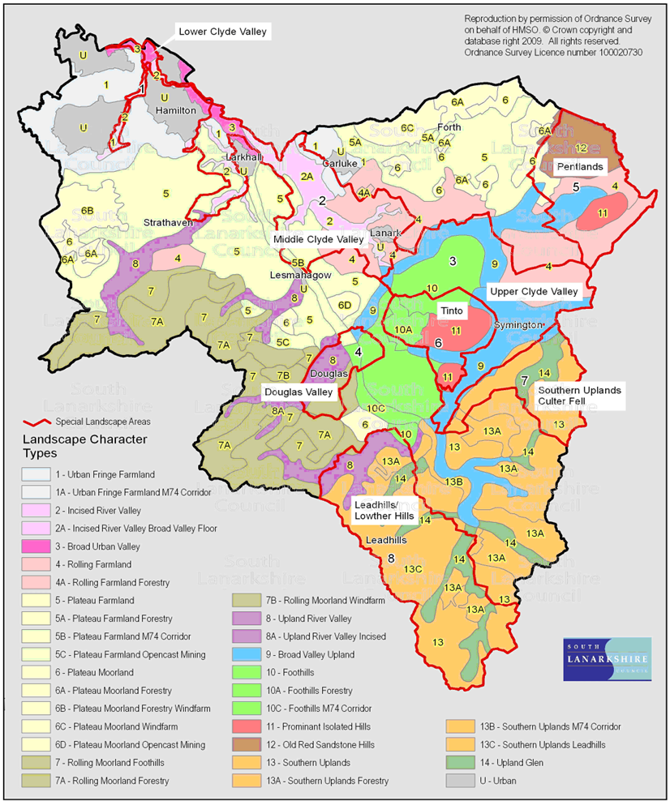
Source: South Lanarkshire Council

Approximately half of the land area of South Lanarkshire is designated as Special Landscape Areas, the majority concentrated in the west and south including most of upper Clydesdale.
Although local landscape designations do not afford any statutory protection of the landscape, the council recognises their importance and the quality of the landscape in these areas and policies in the Local Development Plan require that any new development must not adversely affect the quality for which these areas have been recognised.

Greenbelt
Areas of greenbelt in South Lanarkshire are confined to areas surrounding larger settlements in the north. These areas are under pressure from further development. Although these areas are not defined as an environmental asset, they are important to the overall value of the area, particular in maintaining local access to the countryside. The greenbelt in South Lanarkshire surrounds East Kilbride and Hamilton, extending down to Strathaven and across to Carluke, covering an area of 217.497 km2 (Figure 4.3).

Figure 4.3: Expansion of the greenbelt within South Lanarkshire, July 2025
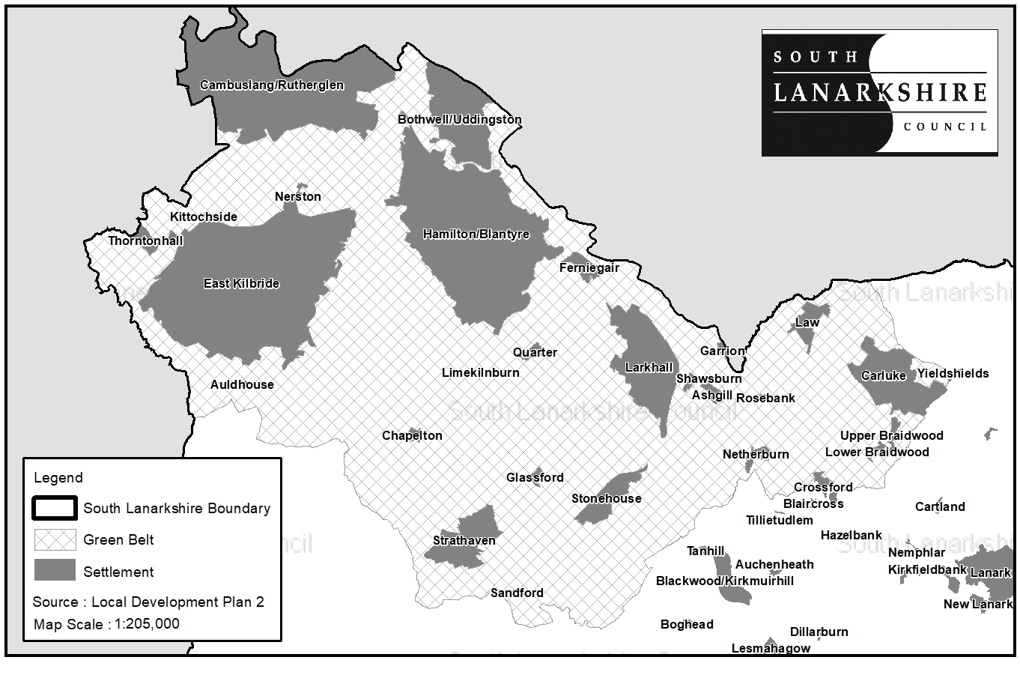
© Crown copyright and database rights 2025 OS AC00008 15808. You are granted a non-exclusive, royalty free, revocable licence solely to view the Licensed Data for non-commercial purposes for the period during which South Lanarkshire Council makes it available. You are not permitted to copy, sub-license, distribute, sell or otherwise make available the Licensed Data to third parties in any form. Third party rights to enforce the terms of this licence shall be reserved to OS.
Contains data © SLC
Source: South Lanarkshire Council

Historic Gardens and Designed Landscapes
Gardens and designed landscapes are grounds which have been laid out for artistic effect. They are formally recognised for their local historic and cultural importance. There are 6 designated gardens and designed landscapes in South Lanarkshire and these are described in Table 3.5.

Country Parks
There are 3 designated country parks in South Lanarkshire, which South Lanarkshire Council wholly or partially manage. These are Chatelherault Country Park, Calderglen Country Park and Hamilton Low Parks which forms part of Strathclyde Country Park. The country parks provide general outdoor access within a managed countryside setting.

4.7 Minerals
Minerals have an important role in the local economy. As well as for construction purposes they are used in a diverse range of processes and products including iron and steel smelting and the manufacture of glass, plastics, cements, medicines, food and cosmetics. They are required for all construction projects, including homes, schools, hospitals and maintenance of transport networks.
To fully adopt the principles of environmentally sustainable development a reassessment of the use of finite and environmentally sensitive natural resources such as minerals is required. However, until sustainable alternative material, particularly for aggregates, is identified and used, it is essential that the future extraction of minerals is carefully planned.
Geology
South Lanarkshire has a diverse geology consisting of sedimentary, igneous and metamorphic rocks. These are suitable for producing hard-rock aggregates, natural building stone and provide coal, fireclays and mudstones suitable for brick making. There are also deposits of sand and gravel which provide natural aggregates for construction industries. These are found particularly along the river valleys of the Avon, Mouse, Medwin and Clyde. South Lanarkshire can be divided into a number of discrete geographical areas, each having its own minerals resource potential. The principal mineral resources within geological areas in South Lanarkshire are:

Avon Valley: Sand and gravel, clay, iron ore, coal and peat.
Douglas Valley: Coal, fireclay, peat, sand and gravel.
Forth Plateau: Coal, and fireclay.
Mouse/Medwin Valley: Sand and gravel and peat.
Clyde Valley: Sand and gravel, sandstone, whinstone, coal, clay and peat.

Mineral extraction falls within the geological layout of the area.

Sand and gravel
South Lanarkshire contains extensive deposits of sand and gravel along the Clyde and Avon valleys and, to a lesser extent, deposits in the valley of Medwin and the Douglas Water valley. Estimates for 2025 indicate that South Lanarkshire is producing 1.8 Mt of sand and gravel per annum across 7 operational sites, which is an increase of 0.1 Mt from 2023 production levels. The sites which benefit from planning permission have an estimated reserve of approximately 14.9 Mt. The growth of policy emphasis on sustainable development and the encouraged use of secondary and recycled aggregate materials, including construction and demolition waste as alternatives to primary aggregates, have been widely adopted.

Hard rock
Aggregates are sourced from a variety of places. The majority of aggregates occur as natural materials, including hard rocks crushed to the required particle sizes. Crushed rock is used primarily as a road-stone and in concrete. South Lanarkshire is a net importer of hard rock materials because the quality and quantity of indigenous aggregates are unsuitable for use in road surfacing application. Sources of suitable aggregate are located to the immediate north of the authority area.

There are 3 operational hard rock quarries in South Lanarkshire providing aggregate material for a variety of end uses including concrete aggregate, rail ballast, building blocks and synthetic cobbles and paviors. These quarries are expected to produce approximately 1.6 Mt of aggregate per annum, with the sites estimated, as at 2025, to have 47.1 Mt in reserve.

There is one pending application to extend the current operations at Cloburn Quarry which could add a further 42 Mt to the existing reserve of hard rock.

Coal
There are currently no operational coal extraction sites within South Lanarkshire. Policy 33 of NPF4, with few exceptions, carries a presumption against fossil exploration, development and production. As such there is little, if any, prospect that any new coal sites will come forward in the future

The 4 former coal sites which historically were operated by Scottish Coal have now been fully restored.

Peat
Although there are extensive areas of peat across South Lanarkshire, extraction is limited to 4 sites, one located near East Kilbride, one close to Douglas Water and two near Carnwath. The peat is principally used within the horticulture sector. These sites currently extract about 40,000 cubic metres (m3) of peat per annum. All of these sites are set to cease peat extraction by the end of 2025 and are to be restored.

Mineral recycling
The aim of sustainable development is to decrease the quantity of minerals used without slowing economic growth. This can be achieved by increasing the efficiency of use, increasing the recycling of inert material and using alternative material. Segregation of all recoverable materials helps to maximise efficient use of bulk mineral material. As well as mineral recycling, soil recycling and green composting provide efficient methods for increasing the recycling of inert material.

Within South Lanarkshire, there are 2 mineral recycling facilities, providing recycled mineral-based material, at Quay Industrial Estate, Rutherglen and Dovesdale Farm, Stonehouse.

Bings
Waste heaps or ‘bings’ arise from various types of mineral workings. The main bings found in South Lanarkshire are coal spoil from deep mining although other wastes such as spent oil shale, ironstone, slags, metal ore waste and lime wastes do occur. Bings are normally regarded as having a negative environmental impact in an area due to their visual intrusion and potential contamination to the land and water courses. However, bings can also be important in terms of nature conservation interest because of their highly distinctive environments (for example, acidic, nutrient poor, high heavy metal content) and can often support distinct vegetation or rare species worthy of protection.

There are 24 bings across South Lanarkshire, and these provide an additional mineral resource within the area. There are 3 bings with planning permission for the extraction of their mineral content, (Cadzow Bing in Hamilton, Douglas Water Bing near Rigside and Auchlochan Bing No. 9, Coalburn).

If you need this information in another language or format, please contact us to discuss how we can best meet your needs. Phone 0303 123 1015 or email equalities@southlanarkshire.gov.uk

