8. Water
SEA objective for water
Protect, manage and enhance the water environment and avoid, or where not possible, reduce flood risk.

Sustainable Development Goals
The Goals relevant to this chapter are:

Introduction
Scotland’s water provides a wide range of benefits, supporting our health and prosperity. These include the provision of drinking water, water for use in industry and agriculture and recreation opportunities. Our water supports a diverse array of habitats and nationally and internationally important species.

The main pressures currently affecting the condition of rivers and lochs in Scotland are man-made barriers to fish migration; physical changes to the beds and banks and rural diffuse pollution. Groundwater quality is affected by diffuse pollution from rural sources and discharges from industries such as mining and quarrying. Groundwater flows and levels are affected by agricultural irrigation and industry.

The River Clyde and its tributaries are essential to the character of the area. Rising in the Lowther Hills, the River Clyde meanders its way through South Lanarkshire towards the outer reaches of the City of Glasgow before flowing into the Clyde Estuary and Firth of the Clyde.

A summary of the indicators used in assessing the state of South Lanarkshire is presented, highlighting the current status of each indicator and the directional trend.

The current status is shown by the following colours: The trend direction is shown with the following arrows:
G | Good | F | Fair |  |  | Improving
 |  |  |  |  |  | No change
P | Poor |  |  |  |  | Deteriorating
 |  |  |  |  | Note: The most recent data available was used in assessing the environmental indicators

Indicator | Current status | Trend direction | Explanation
Water quality | F |  | The overall status of rivers under the Water Framework Directive (WFD) has remained consistent over recent years.
River flow | F |  | The annual water flow rates in the rivers across the region have remained similar to previous years with the exception of 2020. The high level is closely linked to the increase in annual precipitation rates, associated with severe weather events.
Groundwater and wetlands | F |  | The number of groundwater bodies with a good status in South Lanarkshire has remained the same since the previous Report. The data available on ponds and wetlands remains limited.
Water pollution | G |  | There has been continuous improvement in the treatment of sewage and effluent discharges, however, point source pollution remains a threat to the quality of the water environment. This is closely monitored by SEPA.
Flooding | P |  | Severe weather events continue to impact and have resulted in flood incidents across the council area. The council’s approach to flood management continues to develop and improve as available resources permit.

Baseline situation
The water environment is important for South Lanarkshire in terms of the local economy, the health and wellbeing of the people who live, work and visit the area and for wildlife. Human activity can damage the water environment, affecting the quality of the water itself or through inputs associated with activities on land or the deposition of air pollutants.

Water quality in South Lanarkshire is relatively good and improving. Annual water flow rates remain high and consistent in line with increasing precipitation across the region. The number of flooding occurrences reported to the council has remained fairly consistent over recent years.

8.1 Principal watercourses
There are 25 principal watercourses which flow through South Lanarkshire. Many of these are tributaries of the River Clyde (Table 8.1).

Table 8.1: Principal watercourses in South Lanarkshire
Principal watercourse | Span (km) | General information
Avon Water | 46 | A tributary of the River Clyde, the Avon flows through Strathaven and Larkhall from its source on Weddle Hill, East Ayrshire.
Biggar Water* | 7 | The Biggar Burn rises at the southern end of the Pentland Hills and flows south through Biggar, turning into Biggar Water, flowing through Broughton before joining the River Tweed.
Calder Water | 15 | Calder Water rises on the slopes of Laird’s Seat joining with the Rotten Burn to form the Rotten Calder. The river flows down through Calderglen joining the River Clyde west of Uddingston.
Camps Water | 6 | Flowing from Camps Reservoir, Camps Water joins the River Clyde north of Crawford.
River Clyde | 138 | Formed by two streams, the Daer and the Potrail Waters that meet at Watermeetings high in the Lowther Hills. The river flows down through many of the main urbanised areas, including Hamilton, Blantyre and Rutherglen.
Culter Water | 8 | Culter Water rises in hills south of Biggar, flowing through the Culter Water Reservoir before passing Coulter and joining the River Clyde.
Daer Water | 16 | Daer Water rises on Queensberry Hill in the Lowther Hills and flows through the Daer Reservoir before joining Potrail Water to form the River Clyde.
Douglas Water | 32 | The Douglas Water rises in the hills in East Ayrshire, flowing through Douglas before joining the River Clyde.
Duneaton Water | 30 | A tributary of the River Clyde, Duneaton Water flows passed Crawfordjohn before joining the Clyde at Abington.
Elvan Water | 11 | From the Lowther Hills the Elvan Water joins the Clyde near Elvanfoot.
Evan Water | 19 | Evan Water rises in the south Lowther Hills and flows south to join the River Annan at Three Waters Foot.
Garf Water | 11 | Garf Water rises on the slopes of Robert Law and flows east to join the River Clyde near Wiston.
Glengavel Water | 6 | Glengavel Water passes through the Glengavel Reservoir before meeting the Avon Water.
Glengonnar Water | 11 | Glengonnar Water rises in the Lowther Hills and is a tributary to the River Clyde.
Kype Water | 10 | Kype Water flows from the Kype Reservoir joining River Avon near Strathaven.
Lochar Water | 7 | Flowing from Lambhill the Lochar Water joins the Avon Water before Strathaven.
Logan Water | 11 | Rising in Spirebush Hill the Logan Water flows through the Logan Reservoir before joining with the River Nethan and then the River Clyde.
Medwin Waters (North) | 17 | Rises in the Pentland Hills, close to West Lothian and flows south to join with the South Medwin to form Medwin Waters
Medwin Waters (South) | 25 | Rises in the Pentland Hills flowing south to form the border between South Lanarkshire and the Scottish Borders before joining the North Medwin to form Medwin Waters and then the River Clyde.
Midlock Water | 10 | Rising near Clyde Law the Midlock Water joins the River Clyde near Crawford.
Mouse Water | 26 | Mouse Water is a tributary of the River Clyde flowing from south of Forth to join the Clyde near Lanark.
Nethan Water | 27 | The River Nethan flows northwards to the River Clyde from the hills south of Lesmahagow. Its upper reaches are extensively afforested and there are also abandoned mines in the catchment. The main river passes along the edge of the huge Dalquhandy Opencast Coal Site. A tributary of the River Nethan, the Logan Water, is used to fill the Logan and Dunside reservoirs.
Potrail Water | 12 | Rises on Ballencleuch Law in the Lowther Hills and joins Daer Water near Elvanfoot to form the River Clyde.
Snar Water | 10 | Rising on the slopes of Wanlock Dod, Snar Water joins Duneaton Water near Crawfordjohn.
White Cart Water** | 36 | Rises in the foothills of the Eaglesham Moors on the slopes of Corse Hill, flowing through the East Renfrewshire and South Lanarkshire border before joining Black Cart Water at Paisley.
* does not flow into Clyde catchment
** borders with East Renfrewshire and South Lanarkshire

In addition to the principal watercourses, there are a number of burns of strategic significance across South Lanarkshire:

Cambuslang: Black, Kirk, Lightburn/Newton and Whitelaw/Eastfield.
Clydesdale: Devon and Roberton.
East Kilbride: Darngaber, Kittoch Water and Powmillon.
Hamilton: Cadzow, Covan and Earnock/Wellshaw.
Rutherglen: Cityford/West and Scion.

There are 20 reservoirs across South Lanarkshire, (Table 8.2 and Table 8.3). SEPA is the Enforcement Authority for these reservoirs under the Reservoirs (Scotland) Act, 2011, responsible for ensuring the Statutory Undertakers (owners) comply with their statutory requirements. The council is ‘Reservoir Manager’ for the James Hamilton Heritage Loch and Lanark Loch.

Table 8.2: Principal reservoirs in South Lanarkshire
Principal water bodies | Area (km2) | General information
Camps Reservoir | 0.71 | Provides drinking water to the Hamilton area
Cowgill Lower Reservoir  Cowgill Upper Reservoir | 0.03  0.09 | Provides drinking water to the Lothians
Coulter Reservoir | - | Serves Motherwell, Wishaw and Biggar with drinking water
Daer Reservoir | 1.97 | Fed by Daer Water, the reservoir is the principal drinking water supply for South Lanarkshire
Kype Reservoir | 0.11 | South of Strathaven, serving the area with drinking water

Table 8.3: Smaller water bodies in South Lanarkshire, including covered reservoirs
Reservoir | National Grid reference | Reservoir | National Grid reference
Boghead | NS 764409 | James Hamilton Heritage Loch | NS 631559
Cleuch | NS 937355 | Kittoch Bridge Flood Storage | NS 589568
Dunside Lower | NS 749373 | Lanark Loch | NS 899431
Dunside Upper | NS 747373 | Loch Lyoch | NS 932357
East Rogerton Tank | NS 630567 | Logan | NS 745361
Glen Franka Dam | NS 890133 | Peden | NS 941124
Glengavel | NS 664350 | Springfield | NS 905520

8.2 Water quality
The quality of the water environment can have a significant effect on the health of people, flora and fauna. For example, pathogens derived from sewage effluent or livestock can enter watercourses and excessive nutrients in lochs and streams can lead to blue-green algae blooms which are toxic to humans and fauna.

Rivers support a wide variety of wildlife, providing important habitat corridors that enable the dispersion and migration of many species. The quality of river water is important for supporting wildlife and as a major resource for providing drinking water and water used by industry. The quality and flow of rivers is directly affected by the level of abstraction and discharge into the river and from the quality of ground waters that support them. The Water Framework Directive provides the legal framework for the protection, improvement and sustainable use of waters.

The Water Framework Directive (WFD) (2000/60/EC) – The aim in implementing the WFD in Scotland is to achieve an effective balance between the protection of Scotland’s water environment and the interests of those who depend upon it for their prosperity and quality of life.

One of the principal aims of River Basin Management is the protection of the country’s high-quality environment balanced against the need for sustainable development.

River water quality
SEPA monitors the quality of rivers across South Lanarkshire, collecting data and classifying the rivers in terms of their status. The WFD monitoring framework is aimed at improving and protecting the whole water environment. It introduced new parameters for recording the quality of the water environment including ecological status (natural and the presence of alien species), the natural and modified river flow, the presence of engineering works, such as culverting and flood defence or any other manmade barriers that affect the morphology and habitats of the river, for instance preventing migratory movements.

Surface water bodies are classified using a system of five quality classes – high, good, moderate, poor and bad. In general, the classification of water bodies describes by how much their condition or status differs from near natural conditions. Water bodies in a near natural condition are at high status, while those whose quality has been severely damaged are at bad status.

The WFD classification data for rivers across South Lanarkshire has been divided into Surface Water bodies and Heavily Modified Water bodies (HMWB) (Table 8.4 and Table 8.6 respectively). For river surface water bodies, 42.3% were classified with an overall status of good, with 21.1% being assessed as poor and 1 (1.4%) assessed as being bad. The physico-chemical classification recorded 88.8% of river water bodies in South Lanarkshire as being either high or good, 4.2% poor and none recorded as bad. There was a wide range of classifications recorded for biological elements, with 53.5% recorded as either high or good, 25.4% as moderate and 21.1% with a poor or bad status. In terms of hydromorphology classification, 45 river surface water bodies achieved either high or good status (63.4%). However, 7 (9.9%) were recorded as poor and 4 (5.9%) were recorded as bad. These findings are further reflected in Figure 8.1.
Table 8.4 WFD water classifications for river surface water bodies (overall status), 2023
 | Overall status |  | Physico-chemical |  | Biological elements |  | Hydromorphology
 | No. | % | No. | % | No. | % | No. | %
High | 0 | 0 | 44 | 62.0 | 12 | 16.9 | 10 | 14.1
Good | 30 | 42.3 | 19 | 26.8 | 26 | 36.6 | 35 | 49.3
Moderate | 25 | 35.2 | 5 | 7.0 | 18 | 25.4 | 15 | 21.1
Poor | 15 | 21.1 | 3 | 4.2 | 14 | 19.7 | 7 | 9.9
Bad | 1 | 1.4 | 0 | 0 | 1 | 1.4 | 4 | 5.6
Source: Scottish Environment Protection Agency

Heavily Modified Water Bodies are surface water bodies which have been substantially altered in character for purposes such as flood protection, navigation, hydroelectricity generation, public water supply, recreation, land drainage, other important human sustainable development activities and where their physical characteristics cannot be restored without significant adverse impacts on the uses served by the alterations or on the wider environment. For water bodies designated as HWMB, their classification is defined in terms of ecological potential, a measure of how the ecological quality of such a water body compares with the maximum quality achievable given the physical constraints imposed by its use.
Figure 8.1: WFD water classifications for river surface water bodies (overall status), 2023

Source: Scottish Environment Protection Agency

The water bodies designated as HMWB in 2020 in South Lanarkshire are set out in Table 8.5. Water bodies designated as HMWB cannot achieve ‘good ecological status’ as prescribed in the Directive, instead they must achieve ‘good ecological potential’.

Table 8.5: Water bodies designated as HMWB in South Lanarkshire, 2020
ID | Name | ID | Name
10002 | Kittoch Water | 10040 | River Clyde (North Calder to Tidal Weir)
10043 | Daer Water (d/s Daer Reservoir) | 10071 | Wellshaw/Earnock Burn
10107 | Culter Water | 10108 | Cow Gill/Eastside Burn/Duncan Gill
10117 | Camps Water | 10930 | Malls Mire Burn/Polmadie/Burn/Cityford Burn
Source: Scottish Environment Protection Agency

Of the river water bodies designated as heavily modified, 2 achieved good ecological potential in 2023 (Culter Water and Cow Gill) and 1 (River Clyde (North Calder to Tidal Weir)) was assessed as poor. Malls Mire Burn was assessed as having bad ecological potential. The remaining water bodies were assessed as having moderate ecological potential (Table 8.6).

Table 8.6: WFD water classifications for HMWB in South Lanarkshire, 2023
Class | Overall Status  (ecological potential) | Physico-chemical | Biological elements | Hydromorphology
High | 0 | 0 | 2 | 0
Good | 2 | 1 | 0 | 0
Moderate | 4 | 1 | 4 | 5
Poor | 1 | 2 | 1 | 1
Bad | 1 | 0 | 1 | 2
Source: Scottish Environment Protection Agency

Figure 8.2 provides an overview on the location for WFD water classifications in South Lanarkshire. It is important to note that the classification tools for some elements of the WFD system continue to be refined which may result in a future change of status for some water bodies.
Figure 8.2: Distribution of WFD status of water bodies in South Lanarkshire, 2023
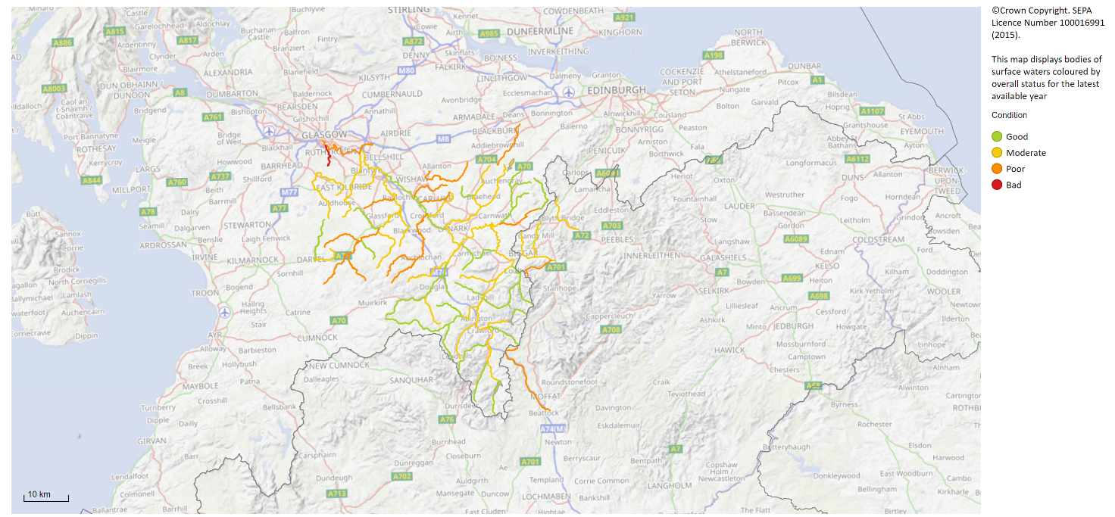
Source: Scottish Environment Protection Agency: Scotland’s Environment Web

Lochs and reservoirs
Similar to the river quality, the quality of standing waters (reservoirs and lochs) is assessed using the WFD classification system. This is based on chemical, biological/ecological and hydrological indicators. However, this classification is only applied to lochs larger than 1 km2 and smaller lochs of particular importance. In South Lanarkshire two standing water bodies, the Daer Reservoir and the Camps Reservoir fulfil the criteria.

Based on the WFD criteria, both the Daer and Camps Reservoirs are classified as HMWB. In 2023, both reservoirs have been classified as having good ecological potential. Both reservoirs have poor hydromorphology, a poor ecological status in the water quality because of the physical characteristics of the water (Table 8.7). This is due to dam structures adversely affecting the natural flows in the catchment. However, both reservoirs have been classified as having good status for physico-chem, with Daer Reservoir being classed as having good biological elements and the Camps Reservoir being classified as high.

Table 8.7: WFD classifications in South Lanarkshire, 2023
Reservoir | Overall status | Physico-chem | Biological elements | Hydro-morphology
Daer | Good EP | Good | Good | Poor
Camps | Good EP | Good | High | Poor
Source: Scottish Environment Protection Agency (Water Classification Hub)

8.3 River flow
There has been limited change over the years to the location of the principal watercourses across South Lanarkshire. Modifications to smaller watercourses including culverting have been done within urban areas (notably East Kilbride). No records exist to identify the extent of any such alterations to watercourses but these will rarely alter the overall flow of the rivers significantly.
A greater potential for influencing river flow rates is through an increased input (increasing the input from surface drainage) or extraction (extracting the water for general usage). Weirs and other physical barriers can alter the fluctuation within the flow rates but offer greater resistance to migration of fish upstream. Climate change offers the greatest threat to altering river flow rates, particularly with increasing annual rainfall.

Average annual rainfall varies across South Lanarkshire, from over 1,500mm across the Southern Uplands to around 1,100mm over the northern urbanised lowland areas. Most of the area is predominantly drained by the tributaries that flow into the River Clyde and precipitation changes within the Clyde catchment will have a significant effect on the flow characteristics of the rivers.

There are 15 gauging stations in South Lanarkshire. These are:

- River Avon at Avonbank
- Avon Water at Fairholm
- Cander Water at Candermill
- River Clyde at Abington
- River Clyde at Blairston
- River Clyde at Daldowie
- River Clyde at Hazelbank
- River Clyde at Kirkfieldbank
- River Clyde at Sills of Clyde
- River Clyde at Tulliford Mill
- Douglas Water at Happendon
- Duneaton Water at Maidencots
- Kittoch Water at Waterside
- River Nethan at Kirkmuirhill
- Rotten Calder at Redlees

Two stations have been used to provide river flow data representing the lower River Clyde at Blairston (Station no. 84005), near Bothwell and the upper contributory Duneaton Water at Maidencots (Station no. 84022), near Abington. The annual mean flow rates on both the River Clyde and Duneaton Water increased from 1970 to 2006 by approximately 15% and 25% respectively (Table 8.8 and Figure 8.3). Annual mean flow rates at both stations have remained fairly consistent over the last few years, except for 2020 which evidenced a significant increase.
Table 8.8: Annual mean water flow rates
Year | River Clyde at Blairston |  | Duneaton Water at Maidencots
Year | Annual flow  (m3 s-1) | Annual rainfall (mm) | Annual flow  (m3 s-1) | Annual rainfall (mm)
1970 | 42.00 | 1198 | 3.06* | 1375
1980 | 45.03 | 1170 | 3.09 | 1411
1990 | 58.80 | 1527 | 4.03 | 1783
2000 | 54.70 | 1439 | 4.19 | 1671
2006 | 44.75 | 1332 | 3.62 | 1571
2007 | 55.25 | 1260 | 3.99 | 1855
2008 | 51.62 | 1230 | 3.74 | 1460
2009 | 48.43 | 990 | 3.34 | 1381
2010 | 35.89 | 924 | 2.85 | 1162
2011 | 60.91 | Unavailable | 4.03 | Unavailable
2012 | 58.95 | Unavailable | 3.97 | Unavailable
2013 | 44.09 | Unavailable | 3.46 | Unavailable
2014 | 53.84 | Unavailable | 3.94 | Unavailable
2015 | 62.70 | Unavailable | 4.41 | Unavailable
2016 | 44.45 | Unavailable | 3.06 | Unavailable
2017 | 41.88 | Unavailable | 3.26 | Unavailable
2018 | 41.32 | Unavailable | 3.07 | Unavailable
2019 | 42.43 | Unavailable | 3.03 | Unavailable
2020 | 62.49 | Unavailable | 4.34 | Unavailable
2021 | 41.91 | Unavailable | 3.02 | Unavailable
2022 | 44.38 | Unavailable | 3.15 | Unavailable
2023 | 43.89 | Unavailable | 3.04 | Unavailable
2024 | 45.17 | Unavailable | 3.08 | Unavailable
Source: CEH www.nwl.ac.uk/ Environment Protection Agency

Figure 8.3: Trends in annual mean water flow rates 1970 – 2024

(Created using flow archive data CEH www.nwl.ac.uk/ Scottish Environment Protection Agency

8.4 Groundwater and wetlands
Groundwater
Groundwater is water under the surface of the land. In 2023, there were 37 groundwater water bodies within or intersecting South Lanarkshire which vary in area from just under 7km2 to over 800km2. Of these, 24 have an overall status of good, while the remaining 13 are classified with a poor status.

Ponds
The Countryside Survey defines ponds as ‘a body of water between 25 m2 and 2 ha in area which usually hold water for at least four months of the year’. Ponds can be in many forms both, natural or man-made and can be permanent or seasonal (or temporary). Ponds are important habitats for a range of fauna and flora, including amphibians, invertebrates and ferns.

The 2007 survey estimates there are 198,000 ponds in Scotland, an increase of 6% since 1998. In total 9.9% of ponds met Priority Habitat status based on the quality criteria for plants. Pond quality measurement has not yet been developed for Scotland, however, findings from surveys such as the National Pond Survey suggest that, although there is likely to be degradation of some Scottish ponds, overall quality is likely to be higher than in England and Wales. Pond deterioration can be contributed to a combination of urban development and rural land use intensification. In South Lanarkshire, threats to pond quality mainly come from pollution, for example, agricultural and urban runoff and acidification and infilling for land development or agricultural use. Sustainable Urban Drainage Systems (SUDS) can use ponds and similar water bodies to prevent flooding.

Wetlands
Scotland’s wetlands, including peatlands, are home to a special range of plants and animals and contribute uniquely to storing carbon as well as sustaining clean water. They can help reduce flooding and provide valuable grazing. Wetlands are areas where water covers the soil, or is periodically present either at, or near, the surface of the soil. The prolonged presence of water promotes the development of characteristic wetland soils and favours the growth of specially adapted types of plant.

Pressures affecting wetlands include intensive land management and change in use, land-take for development such as buildings, roads and windfarms, climate change, nutrient pollution from water and the atmosphere and drainage or removal of groundwater flow as a result of developments. There is little survey data for South Lanarkshire, with only specific habitats monitored (such as Langlands Moss). There are no designated or proposed wetlands of international importance in South Lanarkshire as set out by the Ramsar Convention.

8.5 Water pollution
Point source
Water quality has continually got better through improvements in the treatment of sewage and effluent discharges but point source pollution still remains an important threat to water quality. Point sources of water pollution include discharges from municipal sewage treatment works and industrial installations. Discharges from sewage treatment works can contribute to water pollutants in the form of oxygen-depleting nutrients and pathogens that can be a serious health hazard. Industrial discharges can contribute in the form of toxic chemicals and heavy metals. SEPA regulates point source discharges through licensing and by monitoring potential impacts on water bodies under the following legislation and their further amendments:

- The Water Environment (Controlled Activities) (Scotland) Regulations 2011 and subsequent amendments (2013, 2017 and 2021): Outlines the different levels of authorisations to allow for proportionate regulation depending on the risk an activity poses to the water environment. Some activities require authorisation including Point Source discharges, engineering activities, impoundments and abstractions.
- The Pollution Prevention and Control (Scotland) Regulations 2012. Known as the PPC Regulations they regulate specified large-scale industrial activities.

As of 1 August 2025, there were around 3,336 CAR authorisations in South Lanarkshire covering a range of operations and licensed activities. These include 2,909 Registration level activities, 285 simple licenses and 142 complex license activities. This includes authorisations held by Scottish Water for a number of discharges ranging from village septic tanks, wastewater treatment works and their associated sewerage networks (Figure 8.4).

Diffuse pollution
Diffuse pollution into water bodies (including ground-waters) is usually associated with land use, with agricultural activity and urban runoff the most significant causes. Diffuse pollution from agriculture is derived from heavy and inappropriate fertiliser use including ammonia release, field runoff containing suspended soil particulates and other solids washed out during periods of high rainfall, phosphates and pesticide use. Urban runoff is associated with surface water contaminated with a range of suspended solids, sewage contamination and a mixture of chemicals including oils.

In rivers, the largest impacts are caused by diffuse pollution from farmland and urban areas and the disposal of sewage through small-scale septic tanks. Ground-waters are particularly vulnerable to a build-up of nitrate levels associated with fertiliser and pesticides washed down through the soil. Diffuse pollution from both agricultural and urban pollution has significant impacts on water quality in South Lanarkshire.

Nitrate Vulnerable Zones
Nitrate Vulnerable Zones (NVZ) are designated in accordance with the requirements of the Nitrates Directive which aims to reduce water pollution caused by nitrates from agricultural sources. In Scotland, there are five designated NVZs. None of these are in South Lanarkshire, however, the area does fall within zones identified for the catchments that drain to nutrient sensitive areas.

Figure 8.4: Main wastewater and sewage treatment works in South Lanarkshire, 2025
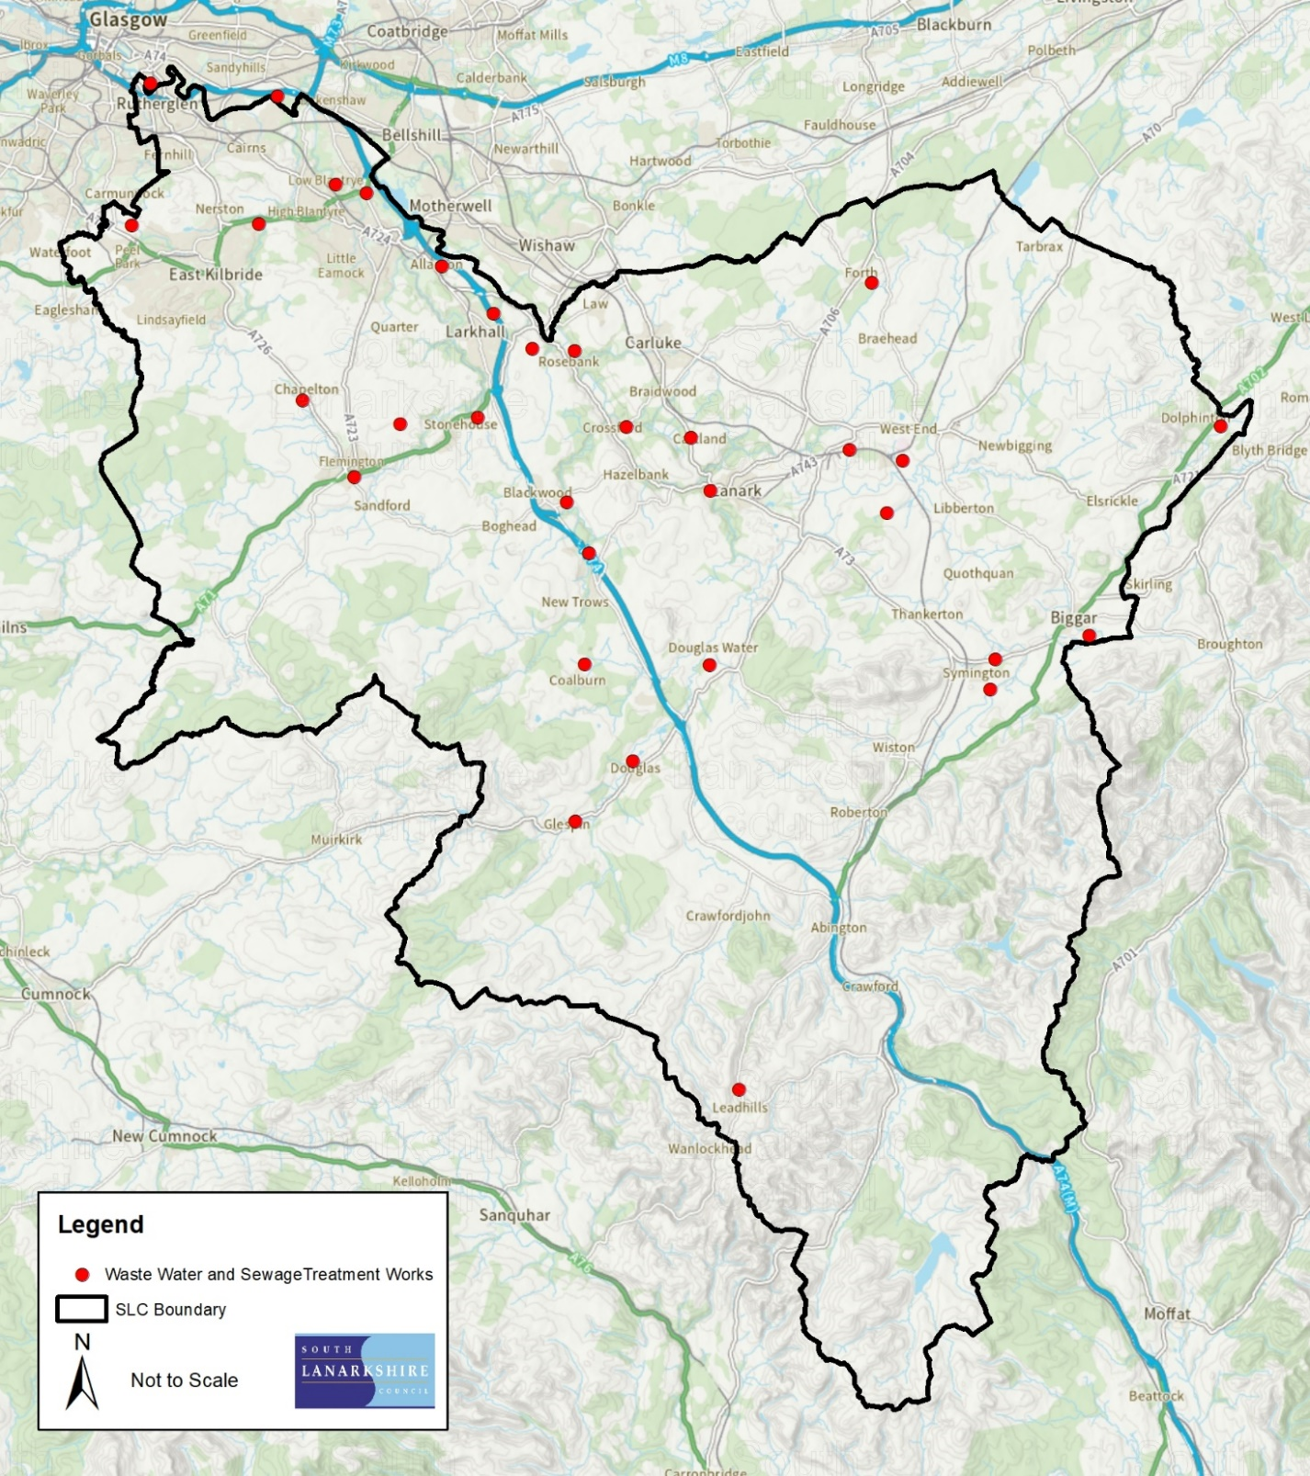
© Crown copyright and database rights 2025 OS AC00008 15808. You are granted a non-exclusive, royalty free, revocable licence solely to view the Licensed Data for non-commercial purposes for the period during which South Lanarkshire Council makes it available. You are not permitted to copy, sub-license, distribute, sell or otherwise make available the Licensed Data to third parties in any form. Third party rights to enforce the terms of this licence shall be reserved to OS.
Contains Scottish Water data © Scottish Water and database right 2025. All rights reserved
Source: Scottish Water

8.6 Flooding
Incidents of flooding can have devastating social and economic consequences for people, businesses and communities. In general terms, South Lanarkshire has experienced flooding. In recent years summer flash floods have tended to cause more problems than winter flooding. Evidence suggests that flooding incidents have increased, particularly over the past few decades and this is the case in South Lanarkshire. The increased frequency and intensity of flooding is likely to continue because of the changes in local weather patterns associated with climatic change. Changes in weather patterns associated with climate change have been attributed to increased seasonal tidal surges, increased annual rainfall and increased river flow rates which can increase the risk and frequency of flooding in the future.

Current climate change predictions suggest Scotland will experience an increasing warmer and wetter weather shift. South Lanarkshire is predicted to have more intense or prolonged rainstorms resulting in greater water surges through our river networks, leading to an increase both in intensity and frequency of flooding episodes. In South Lanarkshire, there has been an increase in both rainfall and water flow rates across river networks. The increased threat of flooding can potentially cause further damage to South Lanarkshire’s economy and society, disruption to transport links, the public water supply and increased vulnerability to personal and commercial property.

The Flood Risk Management (Scotland) Act 2009 introduced new duties for the council, as a Responsible Authority under the Act, in relation to assessing and managing flood risk. The council was identified as a potential participant in four of the fourteen Local Flood Risk Management Districts proposed in Scotland, namely Forth, Clyde and Loch Lomond, Tweed and Solway (Figure 8.5). However, as there is no significant flood risk or any properties within potentially vulnerable areas identified within South Lanarkshire in the Solway and Forth districts, it was proposed that the council would not actively participate in those areas.

Figure 8.5: Potentially Vulnerable Areas of flooding in South Lanarkshire
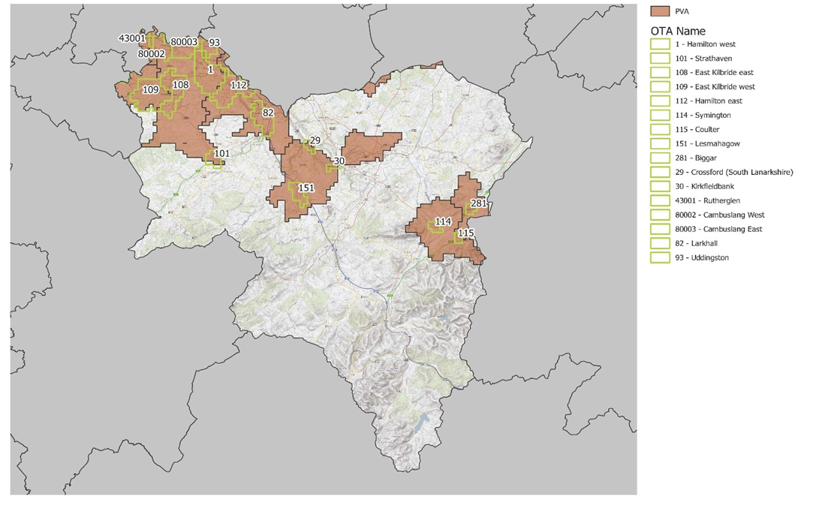
Source: Scottish Environment Protection Agency; South Lanarkshire Council

Table 8.9 sets out the properties predicted within SEPA’s 2018 National Flood Risk Assessment to be at flood risk within South Lanarkshire during the medium likelihood (1:200yr) flooding scenario. The figures stated identify more than twice as many homes, businesses and services to be at flood risk compared to figures published in 2015. Scientific knowledge and understanding of flood risk is constantly evolving. More comprehensive data and access to improved mapping and modelling has advanced our understanding of the locations and properties at risk. This means that more properties which were previously unknown to us have been identified within SEPA’s 2018 National Flood Risk Assessment as being at flood risk.
Table 8.9: Properties in South Lanarkshire at flood risk during medium likelihood (1:200yr) flooding scenario
Homes |  |  | Businesses and Services |  |  | Homes, Businesses and Services
Total Number | Predicted number at flood risk | Ratio | Total Number | Predicted number at flood risk | Ratio | Total Number | Predicted number at flood risk | Ratio
148,200 | 6600 | 1 in 22 | 17,500 | 1,900 | 1 in 9 | 165,700 | 8,500 | 1 in 19
Source: Scottish Environment Protection Agency

Flooding incidents
In the years between 2007 and 2024 there have been 12,909 recorded flooding incidents in South Lanarkshire. The majority of these incidents were relatively minor category 1 or 2 occurrences. However, 8.5% of incidents resulted in flooding of residential and/or commercial property. In the same period, there have been 19 incidents of significant river flooding. (Table 8.10).

Table 8.10: Flooding occurrences reported in South Lanarkshire
Year | Category 1  Choked gully | Category 2  Minor flooding | Category 3  Property flooding | Category 4  River flooding | Total
2007 | 229 | 234 | 48 | 1 | 512
2008 | 438 | 555 | 175 | 1 | 1,169
2009 | 296 | 270 | 60 | 1 | 627
2010 | 192 | 127 | 26 | 0 | 345
2011 | 290 | 413 | 118 | 1 | 822
2012 | 387 | 317 | 144 | 0 | 848
2013 | 334 | 192 | 59 | 2 | 587
2014 | 312 | 165 | 58 | 1 | 536
2015 | 379 | 222 | 57 | 0 | 658
2016 | 251 | 149 | 32 | 2 | 434
2017 | 266 | 195 | 31 | 0 | 492
2018 | 372 | 264 | 38 | 1 | 675
2019 | 479 | 396 | 45 | 2 | 922
2020 | 731 | 440 | 42 | 1 | 1,214
2021 | 421 | 234 | 50 | 0 | 705
2022 | 568 | 431 | 52 | 3 | 1,054
2023 | 359 | 343 | 35 | 0 | 737
2024 | 302 | 239 | 28 | 3 | 572
Source: South Lanarkshire Council

Flood response work
South Lanarkshire Council has discretionary powers to promote flood protection schemes and a duty to assess water bodies. The council has established ‘Managing Flood Risk’ procedures which set out the level of action required at various priority locations to manage the risk of flooding across the council area. Historically the activation of the council’s flooding response was dependent upon forecast weather conditions, however, due to improvements in the council’s flooding infrastructure and remote monitoring capabilities, its ‘Managing Flood Risk’ procedure is now more proactive and consists of regular planned action at agreed frequencies at the most vulnerable flood sites. From 1 May 2016, the locations listed within the procedure which have implications for residential properties are attended to every two weeks, whereas all other locations are attended to monthly between September and March.

If you need this information in another language or format, please contact us to discuss how we can best meet your needs. Phone 0303 123 1015 or email equalities@southlanarkshire.gov.uk

