2. Biodiversity, fauna and flora
SEA objective for biodiversity
Protect and enhance biodiversity and increase functioning habitats to avoid irreversible loss

Sustainable Development Goals
The Goals relevant to this chapter are:

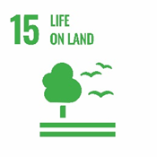
Introduction
Biodiversity plays a key role in the functioning of ecosystems and supports our lives through the provision of crucial resources like fresh air, clean water and food. 'Biological diversity' encompasses all the species of plants, animals, and micro-organisms within an ecosystem, as well as the places they live. The individual components that contribute to the diversity of an ecosystem can be subject to a number of pressures and threats, globally and locally, including pollution, fragmentation, land use and changes in climate.

The distribution and diversity of the ecological resource within South Lanarkshire is influenced by the variety in the geography and topography of the area. There are a series of distinct landscape character areas, each with varied and valuable biodiversity assets. Some of these biodiversity assets are internationally important, with others of national or local significance.

The natural environment is an asset which can contribute to the economic growth of South Lanarkshire if it is managed and used in a sustainable manner. Its continuing health and improvement are vital to sustainable economic growth. Many of Scotland’s growth sectors, such as tourism and food and drink, depend on the provision of ecosystem services from a high-quality natural environment. There are many other less tangible ways in which nature sustains us, contributing to our health, wellbeing, enjoyment, sense of place and our cultural identity.

We are facing a nature emergency alongside the climate crisis. Biodiversity has declined dramatically in recent decades, with action now required to bring about the transformative changed needed to halt this loss. The Scottish Biodiversity Strategy 2045 ‘Tackling the Nature Emergency in Scotland’ was published in December 2022, the Scottish Government’s response to the nature crisis. The Strategy sets out clear ambitions for Scotland to be Nature Positive by 2030 and to have restored and regenerated biodiversity by 2045.

Net Zero and Nature Positive can and must be achieved together. Nature based solutions typically result in thriving ecosystems that store more carbon, help meet carbon reduction targets while providing homes for greater diversity of plants and animals. They can also help reduce flood risk or provide much needed shade as temperatures rise. The potential of nature-based solutions depends on a variety of factors, including habitat condition, how carbon is sequestered and the management of the land.

On a landscape scale, action is required to protect and restore nature, to regenerate ecosystems, protect our most important sites and create wider, flexible and resilient nature networks connecting nature-rich areas allowing wildlife and natural processes to move and adapt to land use and climate change pressures. The networks will build people’s connection to nature, providing biodiversity-rich spaces that deliver benefits and meet the priorities of local communities for nature.
A summary of the indicators used in assessing the state of South Lanarkshire is presented, highlighting the current status of each indicator and the directional trend.

G | Good | F | Fair |  |  | Improving
 |  |  |  |  |  | No change
P | Poor |  |  |  |  | Deteriorating
 |  |  |  |  | Note: The most recent data available was used in assessing the environmental indicators

Indicator | Current status | Trend direction | Explanation
Designated areas | F |  | More sites have been surveyed since the previous report as part of NatureScot’s drive to improve nature networks and meet biodiversity commitments for 2030. Although there has been some isolated improvement, in general the condition of the designated features remains similar to previous reports.
Local Nature Reserves | G |  | The council continues to monitor and improve the LNRs within South Lanarkshire for people and nature. This has been supported by accessing national funding.
Native woodland | F |  | Although total native woodland cover is increasing, further work is required to improve connectivity of habitats, expanding native broadleaf woodland cover.
Ancient woodland | F |  | There is no change in the area of ancient semi-natural woodland cover. There is limited data on the overall condition of this habitat.
Tree canopy cover | P |  | There is no significant change in the area of tree canopy cover or urban tree canopy cover. However, work is ongoing at a regional level through Clyde Climate Forest to increase canopy cover in the longer term.

Baseline situation
South Lanarkshire has a wide range of landscapes and habitats. Although the area is mainly agricultural land, there are pockets of natural and semi-natural habitats, including ancient woodland, peatland and upland moorland. The lack of detailed information on the range of species and habitats, their condition and the level of fragmentation is an issue in determining the overall status of biodiversity within South Lanarkshire.

While fragmentation is detrimental to the connectivity of habitat systems, the additional environmental pressures having an adverse effect on biodiversity within the area include the invasion of non-native species and the inappropriate location of urban development or development that is insensitive to the local natural environment. Arguably, the greatest potential pressure on ecosystem function is climate change, with habitat fragmentation restricting the movement of species in response to this. Colonisation by non-native, invasive species is placing further pressure on remaining natural habitats.

The South Lanarkshire Biodiversity Strategy and the council’s Biodiversity Duty Implementation Plan set out targets and actions for a wide range of biodiversity related issues, including biodiversity assets, ecosystems, habitats, species and community engagement.

2.1 Designations
There are many different designations for preserving ecologically important habitats and species across South Lanarkshire (Figure 2.1), ranging from international to local designated sites. Internationally important wetlands are designated under the Ramsar Convention. The European Wild Birds and the Habitats Directives designate sites of importance for birds, designated as Special Protection Areas (SPAs) or sites of importance for other species or habitats, designated as Special Areas of Conservation (SACs) under the EC Habitats Directive. Sites of Special Scientific Interest (SSSIs) are the main nature conservation designation in Great Britain, whilst locally important sites are designated as Local Nature Conservation Sites (LNCS) (formerly Sites of Importance for Nature Conservation) or Local Nature Reserves (LNR).

Figure 2.1: Designated nature conservation sites throughout South Lanarkshire
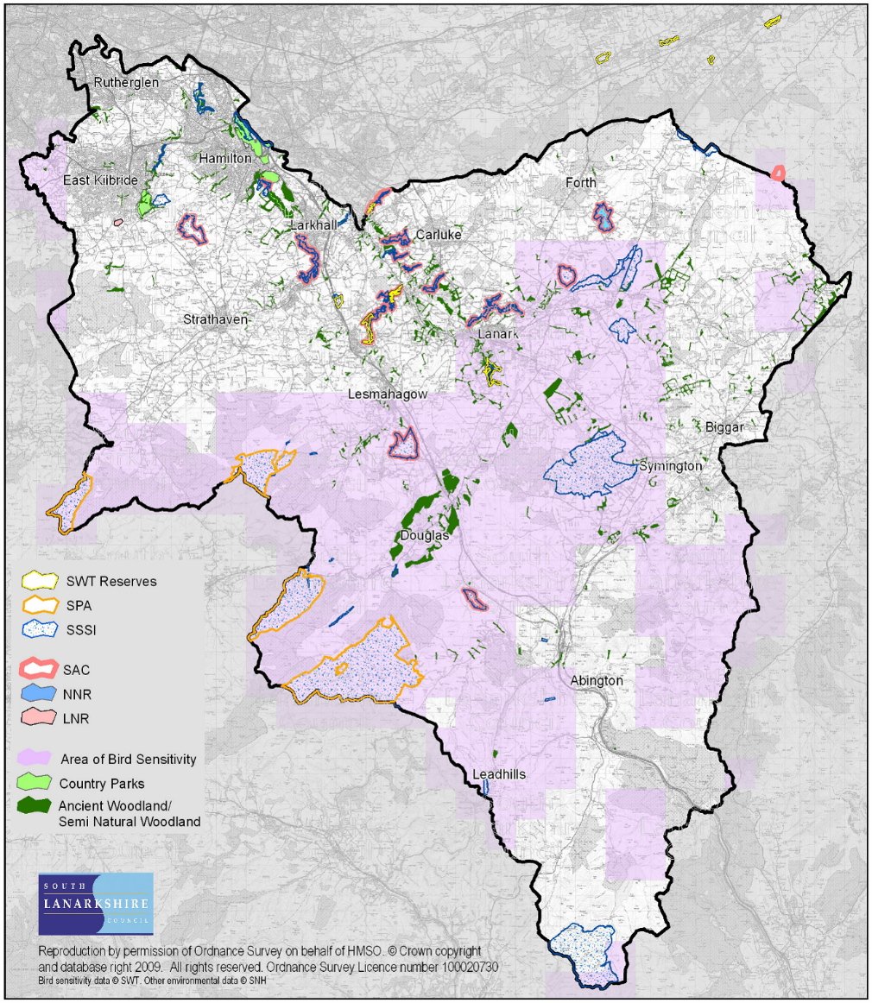
Source: South Lanarkshire Council

Ramsar Sites
Ramsar sites are designated under the terms of the Convention on Wetlands of International Importance (the Ramsar Convention), ratified by the UK Government in 1971. Under this convention, a wetland is considered internationally important if it either regularly holds 1% of the individuals within a bio-geographical population of one species of waterfowl or regularly holds a total of 20,000 waterfowl. There are no designated or proposed Ramsar sites in South Lanarkshire.

Special Protection Areas (SPAs)
Special Protection Areas are areas classified under Article 4 of the European Directive on the Conservation of Wild Birds, 1979 (Wild Birds Directive). In Great Britain, the designation is underpinned by the SSSI mechanism for terrestrial sites. SPAs are created to safeguard the habitats of migratory and certain particularly threatened species of birds. Along with SACs, they constitute the ‘Natura 2000’ network of protected areas. There is one SPA in South Lanarkshire.

Muirkirk and North Lowther Uplands SPA (26,832 ha)
The SPA is an extensive area of moorland extending south from near Darvel in South Ayrshire to near Kirkconnel in Dumfries and Galloway. Four areas of the SPA lie within South Lanarkshire – south of Glentaggart, west of Glespin, around Logan Reservoir and west of Glengavel Reservoir. It is of outstanding interest for its variety of upland habitats and breeding birds. There are large tracts of blanket bog, wet and dry heaths and upland grasslands which support a rich variety of moorland breeding birds. The SPA has been designated with international importance for its breeding short eared owl, hen harrier, merlin, peregrine and golden plover and its wintering population of hen harriers. The SPA takes in the Muirkirk Uplands Site of Special Scientific Interest (SSSI) and North Lowther Uplands SSSI together with Blood Moss and Slot Burn SSSI, Garpel Water SSSI and Ree Burn and Glenbuck Loch SSSI.

Site Condition: Golden plover: Unfavourable Declining (June 2015)
Hen harrier, breeding: Unfavourable Declining (July 2008)
Hen harrier, non-breeding: Unfavourable Declining (December 2004)
Merlin, breeding: Unfavourable No change (July 2009)
Peregrine, breeding: Unfavourable No change (August 2004)
Short-eared owl, breeding: Favourable Maintained (July 1998)

Special Areas of Conservation (SACs)
Special Areas of Conservation are areas designated under the European Directive on the Conservation of Natural Habitats and Wild Fauna and Flora (1992), known as the Habitats Directive, set out to protect all forms of wildlife and their habitats. These sites, together with SPAs, are called Natura sites and are internationally important for threatened habitats and species. There are 7 SACs spread out across South Lanarkshire.

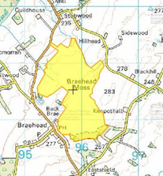

Braehead Moss (122.2ha). This site is designated for supporting extensive areas of active raised bog and areas of degraded bog that has potential for regeneration. The peat bog has arisen from peat developing in two separate basins which have fused. The upper and lower bogs are dominated by hummocks largely formed of Sphagnum species, including rusty bogmoss, and are rich in ling heather and cottongrasses. Feathery bogmoss also occurs in hollows.

Site Condition: Active raised bog: Unfavourable Recovering (September 2003)

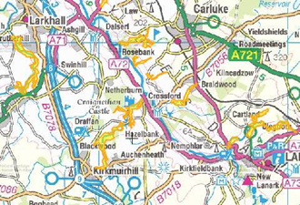
Clyde Valley Woods (432.89ha) This SAC is designated as it supports the Annex 1 habitat: Tilio-Acerion forests of slopes, screes and ravines. These are woods of ash, wych elm and lime, often with sycamore. The site represents the most extensive complex of woodland gorges with this type of forest in Scotland. Although, like all Scottish sites, Clyde Valley Woods is beyond the northern distribution limit of lime, it possesses otherwise characteristic features of this mixed woodland. Ground flora typical of this habitat can be found, with some southern species such as herb Paris and pendulous sedge also present.

Site Condition: Broadleaved, mixed and yew woodland: Favourable Maintained (September 2002)

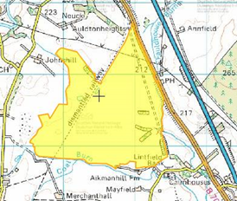
Coalburn Moss (223.65ha). This site supports extensive areas of the Annex 1 habitat, active raised bog and areas of degraded bog that has potential for regeneration. It retains an extensive primary dome confined by two abandoned railway lines. It has one of the larger tracts of vigorous bog-moss-dominated vegetation in central Scotland, with distinctive wet Sphagnum hollows. Typical bog-mosses include the papillose bogmoss and magellanic bogmoss. Hare’s-tail cottongrass, cranberry and reindeer-moss lichen are also common. The hollows, rich in feathery bogmoss are occasionally fringed by great sundew. Some of the margins of the site support wetland communities.

Site Condition: Active raised bog: Favourable Maintained (August 2012)
Degraded raised bog: Unfavourable Recovering (August 2012)

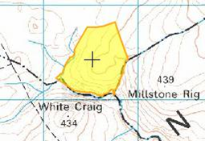
Craigengar (37.16ha). The majority of this site is situated in West Lothian with only small sections encroaching into South Lanarkshire. It maintains habitats present as a qualifying feature but the primary reason for site selection is that it has the largest population of marsh saxifrage in Scotland. It is the largest single colony outside the North Pennines, supporting in 1999, an estimated 9,666 plants in base-rich flushes in an area of upland heather moorland.

Site Condition: Dwarf shrub heath (dry heaths): Unfavourable No Change (July 2023)
Vascular Plants (marsh saxifrage): Unfavourable Recovering (October 2007)
Calcareous Grassland (species rich grassland with mat-grass in upland areas): Unfavourable No change (September 2023)

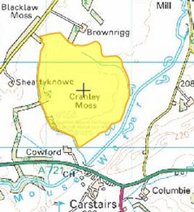

Cranley Moss (101.55ha). This site supports extensive areas of the Annex 1 habitat, active raised bog, as well as areas of degraded bog that has potential for regeneration. Situated in the central belt of Scotland it is important because it is a ‘classic’ raised bog, with a distinct and clearly defined active dome rising from a flat floodplain long since converted to agricultural use. Much of the bog margin is intact but although marshy ground surrounds parts of the site, most of the original lagg fen transition is thought to have been lost. The bog has extensive Sphagnum carpets, which show vigorous growth throughout.

Site Condition: Active raised bog: Unfavourable No change (September 2014)
Degraded raised bog: Unfavourable Recovering (October 2002)

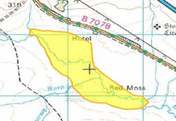

Red Moss (75.85ha). Red Moss is a small site in Clydesdale comprising three areas of active raised bog together with associated lagg fen communities. The slightly domed areas of mire support typical raised bog vegetation with a good cover of Sphagnum including frequent hummocks and occasional rusty bogmoss. Cranberry also occurs.

Site Condition: Active raised bog: Unfavourable Recovering (August 2015)

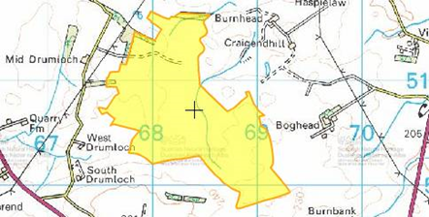
Waukenwae Moss (154.32ha). The site has extensive areas of active raised bog. It displays some of the best Sphagnum-hollow patterning found in bogs in this part of Scotland and also has several hummocks. The bulk of the site is relatively intact, having suffered little from marginal domestic peat cutting.

Site Condition: Active raised bog: Favourable Recovered (February 2011)
National Nature Reserves
Under the provisions of Section 35 of the Wildlife and Countryside Act 1981 (WCA 1981), NatureScot may designate as National Nature Reserves (NNRs), known sites of national importance already managed as a reserve. This designation confers additional protection for an area as specific byelaws can be created to protect the site. There is 1 NNR in South Lanarkshire at Clyde Valley Woodlands (318.42ha). Clyde Valley Woodlands is Scotland’s oldest and richest forest. Ancient woods of oak, ash, rowan and hazel grow here and the reserve is home to a rich diversity of birds, mammals and invertebrates.

Sites of Special Scientific Interest
Site of Special Scientific Interest (SSSI) is the main nature conservation designation in Great Britain. These sites are special for their plants, animals or habitats, their rocks or landforms or a combination of these. SSSIs are notified under the provisions of Section 28 of the Wildlife and Countryside Act 1981 (as amended).

SSSIs are chosen by virtue of the special interest of any of their flora, fauna, geological or physiological features, to represent the best national and regional examples of natural habitat, physical landscape features or sites of importance for rare or protected species. There are 45 SSSIs in South Lanarkshire and bordering with other local authorities (Table 2.1).

Table 2.1: Sites of Special Scientific Interest within South Lanarkshire, April 2025
Site Name | Area (ha) | Designated Features | Site Condition | Date
Avondale | 105.59 | Woodland | Unfavourable No change | May 2002
Birk Knowes | 4.00 | Earth sciences  Earth sciences | Favourable Maintained  Favourable Maintained | November 2009  November 2012
Birkenhead Burn | 3.73 | Earth sciences | Favourable Maintained | November 2012
Blantyre Muir | 51.18 | Raised bog | Unfavourable No change | November 2021
Blood Moss and Slot Burn* | 162.49 | Blanket bog  Earth sciences | Unfavourable No change  Favourable Maintained | August 2014  August 2014
Bothwell Castle Grounds | 71.38 | Invertebrates  Woodland | Favourable Maintained  Unfavourable Declining | June 2016  August 2014
Braehead Moss | 122.6 | Intermediate bog (raised) | Unfavourable No change | November 2012
Calder Glen | 10.24 | Earth sciences | Favourable Maintained | December 2014
Cander Moss | 29.58 | Raised bog | Unfavourable No change | September 2015
Carnwath Moss | 145.46 | Raised bog | Unfavourable No change | February 2015
Carstairs Kames | 160.27 | Earth sciences | Favourable Maintained | April 2010
Cartland Craigs | 16.67 | Woodland | Unfavourable Declining | April 2023
Cleghorn Glen | 70.72 | Invertebrates  Woodland | Favourable Maintained  Unfavourable Declining | June 2016  April 2023
Coalburn Moss | 224.35 | Raised bog | Unfavourable Recovering | October 2009
Cobbinshaw Moss* | 490.66 | Intermediate bog (blanket) | Unfavourable No change | November 2022
Cobbinshaw Reservoir* | 61.87 | Open water transition fen (wetland) | Unfavourable Recovering | September 2023
Craigengar* | 303.5 | Blanket bog; Upland habitat  Vascular plants  Spring-head, rill and flush  Subalpine dry heath | Favourable Recovered  Unfavourable No change  Unfavourable Declining  Unfavourable Recovering | March 2023  October 2006  September 2013  March 2023
Craighead Hill Quarry | 4.27 | Earth sciences | Favourable Maintained | January 2007
Cranley Moss | 101.27 | Raised bog | Unfavourable No change | September 2014
Dunside | 1.19 | Earth sciences | Favourable Maintained | February 2000
Falls of Clyde | 18.07 | Earth sciences  Earth sciences (Quaternary)  Woodland | Favourable Maintained  Favourable Maintained  Unfavourable Recovering | June 2021  June 2021  May 2013
Fiddler Gill | 29.85 | Invertebrates  Woodland | Favourable Maintained  Unfavourable No change | November 2013  November 2013
Garrion Gill* | 39.75 | Woodland | Unfavourable Declining | April 2023
Gills Burn and Mare Gill | 8.73 | Woodland | Unfavourable Declining | April 2023
Hamilton High Parks | 30.77 | Invertebrates  Woodland (upland)  Woodland (parkland) | Favourable Maintained  Unfavourable Declining  Favourable Maintained | March 2015  April 2023  December 2023
Hamilton Low Parks | 105.9 | Breeding birds (Grey heron) | Favourable Maintained | March 2003
Jock’s Gill Wood | 55.07 | Woodland | Unfavourable Declining | April 2023
Kennox Water | 16.8 | Earth sciences | Favourable Maintained | March 2007
Leadhills –  Wanlockhead* | 48.77 | Earth sciences | Favourable Maintained | March 2008
Millburn | 14.01 | Woodland | Unfavourable Declining | April 2023
Miller’s Wood | 12.75 | Woodland | Unfavourable No change | June 2021
Milton-Lockhart Wood | 11.89 | Invertebrates | Favourable Maintained | August 2010
Muirkirk Uplands* | 19,154.0 | Blanket bog  Breeding bird assemblage  Hen harrier (breeding)  Hen harrier (non-breeding)  Short-eared owl (breeding)  Earth sciences  Upland assemblage | Unfavourable No change  Favourable Maintained  Favourable Maintained  Unfavourable Declining  Favourable Maintained  Favourable Maintained  Favourable Maintained | October 2005  August 2008  July 2008  December 2004  August 2002  September 2005  October 2005
Nethan Gorge | 39.8 | Invertebrates  Woodland | Favourable Maintained  Unfavourable Declining | August 2010  April 2023
North Lowther Uplands* | 7,833.3 | Breeding bird assemblage  Hen harrier (breeding)  Earth sciences  Upland assemblage | Unfavourable No change  Unfavourable No change  Favourable Maintained  Unfavourable Recovering | May 2015  July 2008  May 2016  May 2015
Raven Gill | 6.52 | Earth sciences | Favourable Maintained | February 2007
Red Moss | 75.86 | Raised bog | Unfavourable Recovering | August 2015
Ree Burn and Glenbuck Loch* | 8.25 | Earth sciences | Favourable Maintained | March 2010
River Clyde Meanders | 140.91 | Earth sciences | Unfavourable Declining | January 2017
Shiel Burn | 2.41 | Earth sciences | Favourable Maintained | March 2010
Shiel Dod* | 1,187.78 | Upland assemblage | Favourable Maintained | October 2005
Tinto Hills | 1,479.96 | Earth sciences  Subalpine dry heath  Upland assemblage | Favourable Maintained  Unfavourable No change  Favourable Maintained | June 2021  August 2014  August 2005
Townhead Burn | 11.07 | Woodland | Unfavourable Declining | April 2023
Upper Nethan Valley Woods | 76.82 | Woodland (upland)  Woodland (wet) | Unfavourable Declining  Unfavourable Declining | April 2023  April 2023
Waukenwae Moss | 155.49 | Raised bog | Unfavourable No change | September 2014
*Sites that cross between other local authority borders
Source: NatureScot

All the SSSI sites detailed in Table 2.2 are either within or adjacent to land owned by South Lanarkshire Council. Where the site is in its complete ownership the site condition is exclusively the responsibility of the council.

Table 2.2: Condition status of SSSI partially or exclusively owned by South Lanarkshire Council
SSSI | Notified Feature | Note
Avondale | Upland mixed ash woodland (Avon Gorge) | Partially owned by SLC. Unfavourable condition does not imply the woodland is not of continuing importance.
Blantyre Muir (Calderglen Country Park) | Lowland raised bog | The site has areas of actively growing vegetation demonstrating regeneration of natural bog plant communities. The site is outwith the Country Park boundary.
Calder Glen (Calderglen Country Park) | Earth sciences  Geology (Stratigraphy) | The site is located within the Country Park and benefits from an active management programme associated with the Park.
Hamilton High Parks (Chatelherault Country Park) | Beetle assemblage and wood pasture and parkland (Cadzow Oaks)  Upland mixed ash woodland (Avon Gorge) | Unfavourable condition does not imply that the woodland is not of continuing importance. Partially owned by SLC and managed within the Country Park.
Hamilton Low Parks (Chatelherault Country Park) | Grey heron, breeding | Scotland’s largest mainland heronry. The active management in the area focuses on monitoring heronry and wider species and habitats.
Jock’s Gill Wood | Upland oak woodland | Unfavourable condition does not imply the woodland is not of continuing importance. Only partially owned by SLC.
Source: South Lanarkshire Council
National Scenic Areas
National Scenic Areas (NSA) are nationally important areas of outstanding natural beauty, comprising some of the best examples of Scotland’s finest landscapes. They were first identified by the Countryside Commission for Scotland (a predecessor body to Scottish Natural Heritage and now NatureScot) in their report on ‘Scotland’s Scenic Heritage’ in 1978 and confirmed by the UK Government through the issue of Circular 20/1980. There are no designated or proposed NSAs in South Lanarkshire.

Regionally Important Sites
Although no statutory designation applies to regionally important sites, features such as Important Bird Areas (IBAs) identified by the Royal Society for the Protection of Birds (RSPB) are considered to be of regional importance. The IBA Programme of Bird Life International is a worldwide initiative aimed at identifying and protecting a network of sites critical for the conservation of the world's birds. There are no IBAs in South Lanarkshire.

Wet grassland and breeding waders
Some of the river valleys in South Lanarkshire hold regionally and, in some cases, nationally important numbers of breeding wading birds, including lapwings, redshanks and curlews. This suite of species has suffered dramatic declines across the UK, largely due to changes in agriculture. The maintenance of low intensity farming and open, unforested landscapes in key wader areas is critical to ensuring that populations of these birds remain viable. RSPB Scotland, with assistance from SAC Consulting is working with farmers in the area to try and safeguard these key habitats.

2.2 Local authority designated sites
There are two levels of local designations for sites of nature conservation interest, as either a nature reserve or as recorded sites of known nature conservation interest. The latter of these is the lowest level of site designation commonly found in Scotland.

Local Nature Reserves
Local Nature Reserves (LNRs) are designated by a local planning authority. Wildlife Trusts and other nature conservation bodies, such as the RSPB, may also own and manage them. In April 2022, South Lanarkshire Council designated a total of 17 LNRs, with 16 new sites adding to the existing one at Langlands Moss (Table 2.3). Covering 592 hectares in total, these encompass a broad spectrum of habitats, including ancient woodland, open water, wetlands and grasslands. Local Nature Reserves are local important areas of natural heritage, usually close to our towns and cities. Each site has a draft management statement prepared by the council which provides information on why it is important and the aims for the site in the future. Since 2020, the council has been able to access funding from the Nature Restoration Fund to progress work on these sites.

Table 2.3: Local Nature Reserves in South Lanarkshire
Site name | Location | Area (ha)
Backmuir Woods | Hamilton | 21.45
Blantyre, Bothwell and Uddingston | Hamilton | 166.47
Cadzow Glen | Hamilton | 3.36
Fernbrae Meadow | Fernhill/Cathkin | 22.34
Greenhall, Millheugh and Barnhill | Blantyre | 30.14
Hamilton Low Parks | Hamilton | 135.77
Holmhills Wood Community Park | Cambuslang | 15.55
James Hamilton Heritage Park | East Kilbride | 0.87
Jock’s Burn | Carluke | 7.65
Langlands Moss | East Kilbride | 47.0
Milton | Carluke | 14.37
Morgan Glen | Larkhall | 42.81
Mossneuk | East Kilbride | 22.76
Neilsland and Earnock | Hamilton | 43.97
Stonehouse Park | Stonehouse | 7.47
Udston and Glenlee Woods | Hamilton | 6.16
Westburn | Cambuslang | 4.05

Local Nature Conservation Sites
Local Nature Conservation Sites (LNCS) identify locally important natural heritage that could be lost or damaged by development. LNCS are those with biodiversity (Local Biodiversity Sites) or geodiversity interest (Local Geodiversity Sites). It is the responsibility of the local authority to implement a system to identify, review and promote good management of these sites. LNCS have not legal status, duties or powers associated with them; their designation is not a complex process as associated with other designations such as Local Nature Reserves, Sites of Scientific Interest or Special Areas of Conservation. Maintaining a LNCS system will:

- Help to tackle the climate crisis and nature emergency by increasing the resilience of nature, protect biodiversity and enhance carbon sequestration by natural habitats.
- Assist local authorities to consider the impacts of their activities and wider developments on biodiversity, as required by the Scottish Biodiversity Strategy and National Planning Framework 4.
- Contribute to the identification of local nature networks.
- Provide opportunities for people to find out about and enjoy what is special about biodiversity in their local area.

South Lanarkshire Council has identified and assessed 104 LNCSs, produced a GIS layer mapping the proposed sites with suggested boundaries. The area of land and water covered by the designation is approximately 2,355 ha, supporting ancient woodland, peatland, grassland and wetlands (Table 2.4). A further 70 sites have been identified and mapped for future assessment.

Table 2.4: Potential Local Nature Conservation Sites in South Lanarkshire, May 2025
Name | Area (ha) | Location | Grid reference
Allanton Bing | 11 | Hamilton | NS7479 5383
Bardykes Bing | 44 | Blantyre | NS6730 5911
Belvidere Plantation | 11 | Hamilton | NS7467 5277
Bent Cemetery | 8 | Hamilton | NS7120 5516
Blackbog and Simpsonland Glen | 18 | Hamilton | NS7201 5197
Borgie Glen | 10 | Cambuslang | NS6452 5968
Bothwell Golf Course Woodlands | 22 | Bothwell | NS6962 5946
Bothwell Nature Trail | 4 | Bothwell | NS7016 5849
Bothwell Laighland Wetlands | 27 | Bothwell | NS7143 5897
Braidwood Ponds | 61 | Braidwood | NS8388 4708
Broomelton woods | 23 | Larkhall | NS7496 5019
Brownlee Woods | 17 | Dalserf | NS8036 5118
Cadzow Woods | 5 | Hamilton | NS7150 5543
Calderglen (Calderwood) | 6 | East Kilbride | NS6572 5441
Calderglen (St. Leonards) | 7 | East Kilbride | NS6569 5441
Calderside Moss | 16 | East Kilbride | NS6623 5384
Carmunnock Reservoirs | 12 | Cambuslang | NS6203 5743
Castlehill | 29 | Carluke | NS8382 5179
Cathkin Quarry | 11 | Cambuslang | NS6181 5819
Cathkin Road | 5 | Cambuslang | NS6300 5864
Cauldron Gill | 7 | Carluke | NS8636 5051
Cityford Burn | 2 | Rutherglen | NS6093 6099
Cleughern Woods | 15 | East Kilbride | NS6304 4829
Crutherland Moss (West and East) | 111 | East Kilbride | NS6670 5135
Cuningar Woodland (Loop) | 27 | Rutherglen | NS6231 6292
Curlingmire (Murray/Whitehills Plantation) | 12 | East Kilbride | NS6359 5282
Dalserf Burn | 36 | Dalserf | NS7979 5031
Dechmont Hill and Woodlands | 70 | Cambuslang | NS6561 5834
Devonhill Wood | 20 | East Kilbride | NS6811 5262
Drumbuie North and South | 6 | East Kilbride | NS6520 5062
Dykehead woodland | 54 | Hamilton | NS6814 5477
Earnock Bing | 11 | Hamilton | NS7067 5282
Earnock Bing and Cadzow Burn | 10 | Hamilton | NS7135 5386
East Cladence Bog Remnant | 47 | East Kilbride | NS6658 4877
Garrion North | 28 | Law | NS8213 5318
Gills Cottage | 5 | Braidwood | NS8227 4757
Glen Esk | 9 | East Kilbride | NS6554 5505
Hallside Bing | 10 | Cambuslang | NS6739 6084
Hallside Regeneration Woodland | 35 | Cambuslang | NS6696 6016
Hamilton Park Racecourse woods | 5 | Hamilton | NS7156 5717
Hamilton Technology Park | 11 | Hamilton | NS6792 5580
Jock's Gill 1 | 5 | Carluke | NS8264 4989
Jock's Gill 2 | 8 | Carluke | NS8211 4987
Kelvin Woods | 15 | East Kilbride | NS6438 5251
Kittoch Field | 3 | East Kilbride | NS6402 5396
Kittoch Water Woods | 28 | East Kilbride | NS6160 5553
Knowetop and Burnbrae | 20 | Larkhall | NS7281 5069
Lightburn | 5 | Cambuslang | NS6599 5914
Limekiln Burn | 14 | Hamilton | NS7155 5124
Loch Wood | 76 | Kirkmuirhill | NS7707 4362
Lower Blantyre Woods | 32 | Hamilton | NS6960 5789
Maidenburn Moss | 21 | Strathaven | NS67804568
Mauldslie Bridge | 39 | Carluke | NS8106 5004
Meadowhead Bog | 60 | East Kilbride | NS6458 4859
Merryton Braes | 79 | Larkhall | NS7537 5155
Merryton Haugh | 126 | Hamilton | NS5780 5436
Mid-Lettrick Wood | 10 | Blantyre | NS6712 5703
Millburn | 60 | Larkhall | NS7787 5102
Milton Lockhart | 29 | Rosebank | NS8147 4956
Morgan Glen | 31 | Larkhall | NS7560 5059
Murray Drive, Stonehouse | 7 | Stonehouse | NS7616 4682
Murray Housing Estate (Livingstone Drive) | 5 | East Kilbride | NS6286 5363
Neilsland Park and woodland | 17 | Hamilton | NS6994 5368
Newlandsmuir | 15 | East Kilbride | NS6136 5290
Newton Farm | 10 | Cambuslang | NS6632 6186
Newton SUDS | 2 | Cambuslang | NS6594 6131
NTS Kittochside | 77 | East Kilbride | NS6085 5642
Orchard House | 3 | Braidwood | NS82854714
Overton to Rosebank | 37 | Clyde Valley | NS8089 4897
Peel Park | 18 | East Kilbride | NS6052 5455
Powforth Glen | 30 | Larkhall | NS7448 5053
Powmillon Burn | 21 | Strathaven | NS6947 4571
Powmillon Railway Line | 30 | Strathaven | NS7104 4434
Priestgill Burn Ravine | 5 | Strathaven | NS7049 4268
Rigfoot Moss | 36 | Strathaven | NS6754 4718
Rotten Calder (Clyde confluence) | 3 | Newton | NS6769 6100
Rotten Calder - Westburn Road to Priory Bridge | 24 | Blantyre | NS6811 5927
Rotten Calder - Priory Bridge to Malcolmwood | 12 | Blantyre | NS6794 5795
Rotten Calder – Crossbasket | 8 | Hamilton | NS6672 5645
Rotten Calder - Calderglen to Newhousemill | 52 | Blantyre | NS6794 5795
Rotten Calder - Calderglen (Newhousemill to Holmbarnes) | 17 | East Kilbride | NS6578 5271
Rotten Calder - Calderglen Flatt Bridge to Rotten Burn | 24 | East Kilbride | NS6562 5203
Rotten Calder Langlands Loop | 17 | East Kilbride | NS6444 5120
Sandford Moor | 9 | Sandford | NS7226 4337
Sandford Woodland | 7 | Sandford | NS7212 4286
Shawgill Tip | 16 | Law | NS8089 5211
Shields Moss | 8 | East Kilbride | NS6227 5161
Skelly Gill and Whittrick Burn | 16 | Larkhall | NS7741 5222
Skellyton Wood | 14 | Larkhall | NS7727 5158
Stewartfield Woodlands | 8 | East Kilbride | NS6306 5510
Stoneymeadow Woods | 29 | East Kilbride | NS6306 5510
Swinhill | 10 | Larkhall | NS7764 4860
Townhead Burn | 3 | Braidwood | NS8296 4893
Tweediehall | 12 | Strathaven | NS7241 4470
Udston and Glenlee | 11 | Hamilton | NS6948 5606
Upper Avondale | 90 | Stonehouse | NS7416 4655
Upper Gillsburn | 3 | Braidwood | NS8303 4841
Upper Jock's Burn/ Jock's Burn | 9 | Carluke | NS8332 5015
Waterbank Wood | 2 | East Kilbride | NS6045 5646
Waterfoot | 13 | Waterfoot | NS5727 5520
Waterlands pools | 21 | Carluke | NS8328 5248
Wellbog | 35 | Larkhall | NS7285 5015
Wellbrae Reservoir and Earnock Glen | 22 | Hamilton | NS6878 5379
Westburn Railway | 8 | Cambuslang | NS6497 6146
Total | 2,355 | - | -
Source: South Lanarkshire Council

The LNCS designation signals to planners and developers where there are natural features of some merit. It encourages them to consider early on these sensitive sites and opportunities to enhance the local environment. The designation does not affect how landowners and land managers manage the land within a LNCS. The prime function of the LNCS designation is to retain and enhance their feature(s) of interest through management, where appropriate.

The council has produced a Site Statement for each LNCS to record key information, including the reasons for which the site has been identified, listing the key habitats, species and features present.

Biodiversity Assets
Many of South Lanarkshire’s most valuable biodiversity assets fall outwith designated sites and rely upon the planning system to conserve and protect them. The South Lanarkshire Biodiversity Partnership prepared guidance to ensure development proposals take cognisance of non-designated sites and habitats in the area. This has been incorporated within the Local Development Plan.

2.3 Woodland
Woodlands and forests provide the most biologically diverse habitat in South Lanarkshire, mostly associated with the complex ecological communities in woodland soils. Woodland cover across southern Scotland has been greatly diminished over the last thousand years through the clearance of land for agriculture and other land use changes. The remaining ancient and semi-natural woodlands in South Lanarkshire are an irreplaceable resource but are fragmented and have suffered from mismanagement. Further clearance of tree-lined hedgerows and increased development has intensified the fragmentation of woodland habitats. Large areas of new woodland have been created over the past century, mostly in the form of upland conifer plantations, which while economically important, do not support high levels of biodiversity.

Much of the remaining ancient, semi-natural woodland is found on the steep slopes and ravines of the River Clyde and its tributaries and is a nationally significant biodiversity resource. Some areas of this ancient woodland were felled and replanted with conifers in the mid-20th century and are listed as Plantation on Ancient Woodland Sites (PAWS). The restoration of these sites to native tree cover is a priority for both local and national biodiversity action plans.

The National Forestry Inventory (NFI) is updated on a five-year cycle, with online data being updated annually based on aerial photography, satellite imagery and detailed site surveys.
The NF1 2023 (Table 2.5, Figure 2.2), shows South Lanarkshire as having a total of 35,453 ha of woodland cover. The percentage cover of commercial conifers has decreased since the last report produced in 2020 by 30%, due to the felling of 12,746 ha, reflecting crop maturation. This has been compensated for to an extent by 3,879 ha of new planting. Broadleaved and mixed woodland has increased by 18.2% to 7,058 ha, representing 20% of the total woodland cover.

Table 2.5: Woodland types in South Lanarkshire by area (ha)
Woodland Type | NFI 2014 | NFI 2017 | NFI 2020 | NFI 2023 | % Total | % Change  2020 to 2023
Broadleaved and mixed woodland | 4,814 | 5,757 | 5,970 | 7058 | 20 | +18.2
Coniferous and other plantation woodland | 21,112 | 16,194 | 16,837 | 11,770 | 33 | - 30
Recently felled | 8,257 | 7,542 | 7,300 | 12,746 | 36 | +74
New Woodland (including permissions) | 4,846 | 5,114 | 3,792 | 3879 | 11 | +2.2
Total woodland cover (before felling) | 39,029 | 34,607 | 33,901 | 35,453 | - | -
Woodland cover (less felled areas) | 35,618 | 27,065 | 26,600 | 22,707 | - | -
Source: South Lanarkshire Council; Scotland’s Environment website and the Forestry Commission

The Native Woodlands Survey of Scotland was carried out from 2006 to 2013, with results published in 2014 to give an authoritative picture of the location, extent, type and condition of Scotland’s native woodlands. There are three broad categories:

- Native woodland: greater than 50% native species in the canopy.
- Nearly native woodland: between 40% and 50% native species in the canopy.
- PAWS: a woodland area wholly or partially identified as Plantation on Ancient Woodland.

Table 2.6 shows the proportion of each of these woodland types in South Lanarkshire. Most of the native woodland has a high proportion on canopy comprising of native species.

Table 2.6: Proportion of woodland types in South Lanarkshire, 2014
Category | Area (ha) | % of total
PAWS | 282 | 6
Nearly native woodland | 722 | 15
Native woodland | 3,796 | 79
Total | 4,799 | 100
Source: Native Woodland Survey of Scotland

About 730 ha of woodland, particularly within the urban area, are owned by the council. Of this holding:

- 575 ha (79%) is of predominately native, broadleaved woodland.
- 490 ha (67%) is ancient woodland.
- The council owns more than 11% of the total area of native woodland in South Lanarkshire and 32% of the remaining ancient woodland.

Of the council owned woodland, 63 ha is listed as PAWS, representing 22% of the South Lanarkshire total. This represents a reduction in PAWS since 2004, as approximately 32 ha has been felled and native tree cover is being restored. Data on the council’s woodland holding will continue to be refined by improving the council’s tree and woodlands policies and through delivery of the Biodiversity Duty Implementation Plan (BDIP).

Figure 2.2: Distribution of woodland types in South Lanarkshire
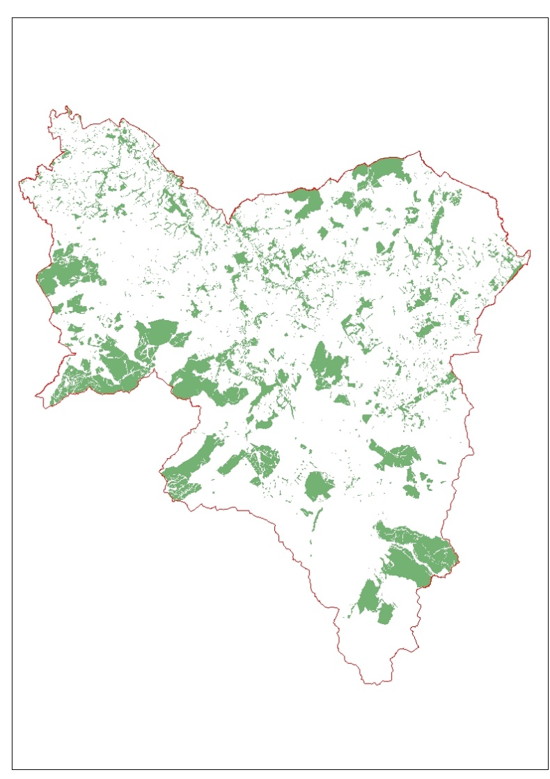
Source: National Forest Inventory data; South Lanarkshire Council

Ancient woodland
Ancient woodland contains a wide range of species and complex ecological processes developed over thousands of years. These cannot be replicated effectively. The current extent of ancient woodland in South Lanarkshire is the result of a long period of fragmentation, with the few remaining patches on the steeper slopes of the Clyde Valley and its tributaries (Figure 2.3). These are amongst the last remnants of native, broadleaved woodland in southern Scotland and make up the Clyde Valley Woodlands National Nature Reserve.

Ancient, native woodlands are by far the most diverse terrestrial habitats in Scotland and hold many thousands of species. The complex associations of species in ancient woodland soils are the source of all of our agricultural soils and it is essential these irreplaceable resources are maintained for future generations.

Figure 2.3: Distribution of ancient semi-natural woodland in South Lanarkshire
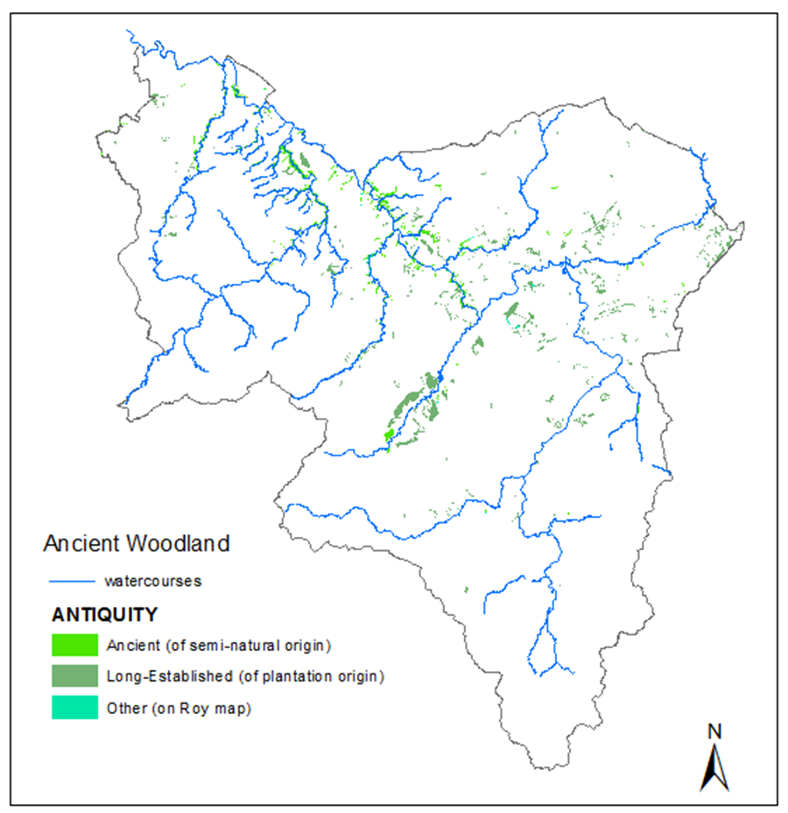
Source: South Lanarkshire Council

The Ancient Woodland Inventory (AWI) of Scotland shows land where woodland has continuously existed since at least 1750. The AWI comprises three categories:

- Ancient Woodland: semi-natural woodland from maps of 1750 or 1860 and continuously wooded to the present day. If planted with non-native species during the 20th century they are referred to as Plantations on Ancient Woodland Sites.
- Long-established woodlands of plantation origin: planted woodland from maps of 1750 or 1860 and continuously wooded since. Many of these sites have developed semi-natural characteristics, especially the oldest ones, which may be as rich as Ancient Woodland.
- Other woodlands on ‘Roy’ woodland sites: unwooded on the 1st edition maps but as woodland on the Roy maps. Such sites have, at most, had only a short break in continuity of woodland cover and may still retain features of ancient woodland.

In South Lanarkshire, 1,528 ha of woodland is on the Ancient Woodland Inventory. Ancient, semi-natural woodland makes up 32% of all native woodlands but less than 4% of the area’s total woodland cover. There are 283 ha of Plantation on Ancient Woodland Sites in South Lanarkshire. A reduction in this figure through conversion back to native tree cover would be a positive indicator for biodiversity enhancement.

Tree canopy cover
Trees are part of the solution to some of the key challenges of our age, from climate change and biodiversity crisis to declining health and wellbeing. Trees are assets working to restore the environmental and social balance in our neighbourhoods and rural environments contributing to the conditions for economic success. Trees play a vital role to making South Lanarkshire resilient to the impacts of a changing climate, helping to achieve ‘Net Zero’, and repairing our damaged ecosystems.

‘Tree Canopy Cover’ is the two-dimensional area of leaves, branches, and stems of trees, woodlands, and forests covering the ground from a bird’s eye view and is provided as a percentage. This easy-to-understand metric is used globally to indicate trees, woodlands and forest cover across a given area irrespective of what other land cover classes or ownership may lie underneath. This metric allows us to provide an overall baseline for what we have, and set meaningful targets as part of CCF - Clyde Climate Forest and help focus attention on trees as a key component of community and development planning, corporate policy and investment documents. The overall tree canopy cover of the South Lanarkshire area is 17% (Table 2.7).

Table 2.7: Tree canopy cover in South Lanarkshire by area
Ward | %
Avondale and Stonehouse | 19.2%
Blantyre | 20.5%
Bothwell and Uddingston | 23.8%
Cambuslang East | 14.7%
Cambuslang West | 11.4%
Clydesdale East | 16.6%
Clydesdale North | 15.6%
Clydesdale South | 14.2%
Clydesdale West | 20.4%
East Kilbride Central North | 23.4%
East Kilbride Central South | 21.1%
East Kilbride East | 20.3%
East Kilbride South | 17.2%
East Kilbride West | 11.4%
Hamilton North and East | 26.3%
Hamilton South | 20.5%
Hamilton West and Earnock | 12.6%
Larkhall | 12.4%
Rutherglen Central and North | 11.8%
Rutherglen South | 11.3%
Source: i-tree, South Lanarkshire Council

The TES - Tree Equity Score UK by Woodland Trust measures not only tree cover but its fair distribution across communities, highlighting areas with low canopy that may need more investment.

Urban Tree Canopy cover
Urban Tree Canopy Cover is the ‘engine room’ for our urban ecosystem and is also a useful gauge of the number of benefits being delivered by trees to the people who live and work there. The amount of canopy cover for the urban areas has been assessed by CCF - Clyde Climate Forest as 17.2%, and TES – Tree Equity Score Uk by the Woodland Trust.

2.4 Invasive, non-native species
Invasive, non-native species (INNS) are those that have been introduced to the UK by people, whether intentionally or accidentally, and are causing a problem. This may be because they have no natural predators and are able to spread easily as they come from similar climates. This can result in damage to our environment and economy. In Scotland, various species are noted as INNS, including North American signal crayfish, rhododendron and American mink.

In South Lanarkshire, priority species for control are Japanese knotweed and giant hogweed. Also of interest are Himalayan balsam and rhododendron. Chemical and physical control of various species takes place across the area. Table 2.8 details the council’s records for Japanese knotweed.
Table 2.8: Japanese knotweed in South Lanarkshire, May 2025
Record entry | No.
INNS records | 531
Records on SLC land | 431
Records on private land | 98
Source: South Lanarkshire Council

If you need this information in another language or format, please contact us to discuss how we can best meet your needs. Phone 0303 123 1015 or email equalities@southlanarkshire.gov.uk

