

Development Plan Scheme and Participation Statement 2026-27

(May 2026)

If you need this information in another language or format, please contact us to discuss how we can best meet your needs. Phone 0303 123 1015 or email equalities@southlanarkshire.gov.uk
Contents

1. What is the Development Plan Scheme? 3
2. The Current Development Plan for SLC – National Planning Framework 4 (NPF4) And Local Development Plan 2 (LDP2) 3
3. Local Development Plan 3 (LDP3) 5
4. LDP3 timetable 7
5. Key stages and actions 8
6. Participation statement 10
7. Mediation 14
Annex 1 – NPF4 and Council Plans/Strategies Links 15
Annex 2 Matters addressed in the LDP3 Evidence Report 17
Annex 3 Additional Assessments 18

What is the Development Plan Scheme?

A Development Plan Scheme (DPS) is required to be prepared and updated by the council every year setting out our programme for preparing and reviewing the Local Development Plan (LDP) for the area. It is to include the proposed timetabling; details of what is likely to be involved at each stage of preparation or review; and a participation statement of when and how consultation is likely to take place.

The DPS for 2026-27 highlights the work that has been carried out to date on the preparation of the council’s next LDP3 and describes the projected timetable for delivery of the different stages of the plan making process, as well as an updated Participation Statement which explains how and when stakeholders including local communities and key agencies will be involved at future stages.

2. The Current Development Plan for SLC – National Planning Framework 4 (NPF4) And Local Development Plan 2 (LDP2)

Development plans are important as they define how we use our land and what areas requires greater protection. They also provide policy which guides decisions on applications for planning permission. The statutory Development Plan is made up of the council’s Local Development Plan (LDP) and the National Planning Framework (NPF), which contains the Scottish Government's policies and proposals for the development and use of land, as shown in Figure 1 below.

The current National Planning Framework is National Planning Framework 4 (NPF4), which was published and adopted by the Scottish Government on 13 February 2023. It sets out 33 national planning policies which represent the Scottish Government’s long term spatial strategy for Scotland. These policies are used to assess planning applications and provide the direction for what the council’s Local Development Plan should include.

The current Local Development Plan is South Lanarkshire Local Development Plan 2 (LDP2), which was adopted in April 2021 and represents the council’s spatial policy for its area. It includes sites that are allocated for development as well as detailed policies on matters such as climate change, the green belt and rural area, housing, town centres and transport. It will set out how our places look in the future, where new houses and places of work will be built, how services and facilities such as schools and travel will be provided and identify places and buildings to be protected.

It is accompanied by other documents including Supporting Planning Guidance covering Developer Contributions, Renewable Energy, and Development at a Dwellinghouse.

The table in Annex 1 shows how these policies link to other national and the council’s own strategies and policies.

Figure 1: Development Plan and associated plans
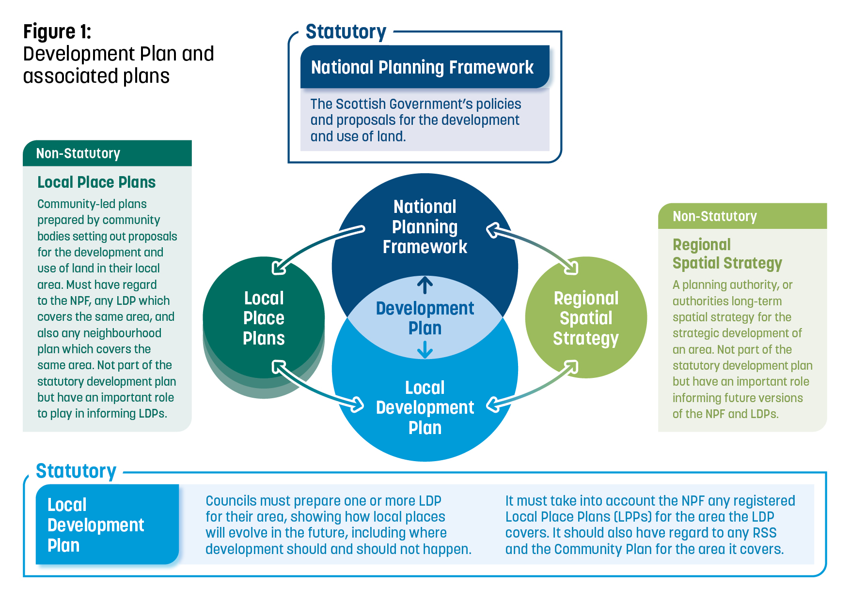

3. Local Development Plan 3 (LDP3)

The council formally agreed the preparation of the next Local Development Plan (to be known as LDP3) in summer 2023. The first stage involves the preparation of an Evidence Report. This includes qualitative and quantitative information and data that will inform the spatial strategy of LDP3 as well as the outcomes of extensive engagement that has been carried out. It was submitted to Scottish Ministers for a Gate Check in December 2025. The report and the associated documents can be viewed here Scottish Government - DPEA - Case Details.

The Gate Check process is an assessment by an independent Reporter of whether the evidence is sufficient to allow the start of the preparation of the Local Development Plan. It also checks that that sufficient engagement and consultation have been carried out. The Evidence Report was approved by Scottish Ministers in April 2026, allowing the council to progress with preparing a Proposed LDP3.

Having passed the Gate Check stage, work has now commenced on the Proposed Plan. A Call for Ideas will be carried out early on in this stage of plan preparation so that proposals for any part of the plan can be submitted. This includes suggestions on policy, views on which places or resources should be protected and the submission of proposals for new development sites.

A site assessment process will be carried out on all proposals for new development that are sent to us to help decide which are allocated in the plan. Sites must generally be deliverable and free from constraints and be able to be served by the appropriate infrastructure and services. Information will be sought from developers, key agencies and any other relevant parties to evidence this. Undeveloped sites in LDP2 will be looked at again and may not be promoted through LDP3 if they are shown to be no longer deliverable or viable or do not accord with the policy direction in NPF4.

There are some other key assessments that need to be developed alongside the LDP which help to inform decisions on the plan-making process and ensure that the plan meets other legislative requirements. A list of these is provided in Annex 2.

There is currently no Regional Spatial Strategy (RSS) covering South Lanarkshire however the council is working with the other authorities who make up the Glasgow City Region to progress work on this. Regional Spatial Strategies will look at strategic development issues – in the case of South Lanarkshire across the Glasgow City Region. RSS are not part of the statutory development plan but have an important role informing future versions of the NPF and LDPs.

Local Place Plans (LPP) are a new opportunity for communities to get involved in the planning system by setting out proposals for the development and use of land in their area. Once registered by the planning authority, they are required to be taken into account in the preparation of the next LDP, although they do not form part of the statutory development plan. Communities have been invited to prepare Local Place Plans and five have been registered to date; Lanark, Strathaven and Glassford, Stonehouse, Lesmahagow, and Blackwood, Kirkmuirhill and Boghead. For further information please refer to Planning circular 1/2022: Local Place Plans and the Register Local Place Plans.

Once the Proposed LDP has been prepared there will be a formal consultation for a minimum period of 12 weeks. This will include neighbour notification for anyone who owns, or leases sites or neighbouring land affected. During this period anyone can make representations to the council either in support of the plan or if they wish to object.

After the consultation period the Proposed Plan can be modified to take account of representations made to the council or consultation responses from key agencies.

When modifications cannot be agreed then the representation is considered unresolved. When this happens, the Proposed Plan is submitted to Scottish Ministers for examination carried out by a reporter from the Planning and Environmental Appeals Division. Once the Examination is complete the Reporter will prepare a report setting out their recommendations and any modifications they require to be made. The report will be submitted to the council along with anyone who has made unresolved representations. The council are to make the modifications except in limited circumstances. After this process has been carried out the plan can be formally adopted.

4. LDP3 timetable
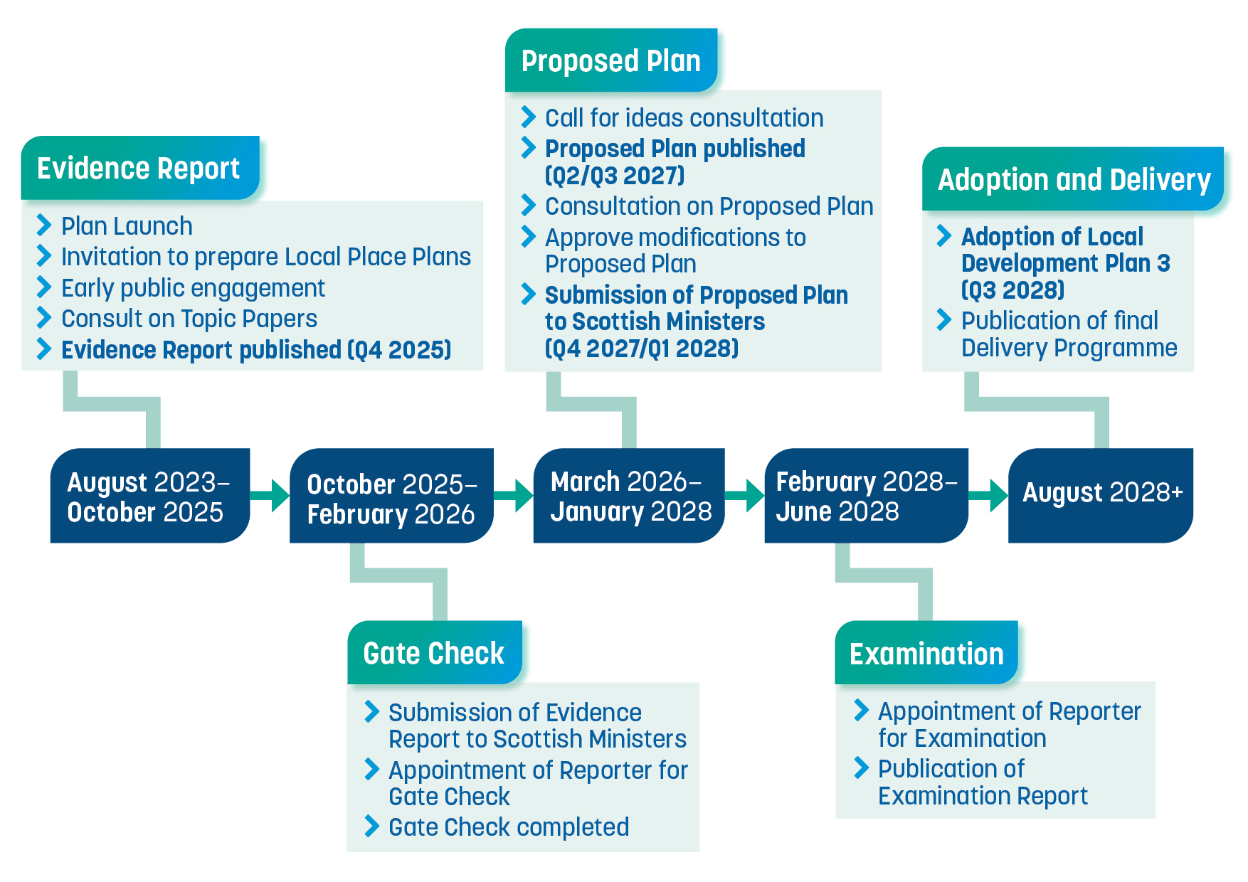

5. Key stages and actions

TIMELINE | KEY STAGES | ACTIONS
 | Evidence Report
COMPLETE | Evidence gathering | Includes: Local Place Plan register, Self-build register, Urban Capacity Study, Green Belt Review, Settlement Boundary Review, Play Sufficiency Assessment, Retail Studies, Town Centre appraisals, Vacant and Derelict Land Survey, Housing Land Audit, Employment Land Audit, Conservation Area Appraisals
COMPLETE | Early engagement | Comprehensive early sense check on evidence gathering to identify areas of conflict or disagreement in terms of data interpretation. Engagement requires capturing hard to reach, young people, minority groups and place-based communities to ensure we capture the lived experience.
COMPLETE | Preparation of Evidence Report | The evidence report will identify any gaps in the evidence required; our interpretation of the evidence gathered and the implications for the proposed plan; and a summary of any conflicting views on the evidence and lived experience. Approval of Full council required prior to submission for the Gate Check.
Current Stage | Publish Approved Evidence Report and submit for Scottish Government Gate Check | Submission of evidence report to Scottish Government who will appoint a Reporter to identify any unresolved issues and provide evidence base for developing strategy is robust.
Q2 2026 | Gate Check approval | Based on average 3 month returns.
 | Proposed LDP3
Q2 2026 | Strategy development for Proposed LDP3 | Development of key strategies to support development of LDP, including Open Space Strategy, Local Housing Land Requirement and Employment Land review.
Q2 2026 | Call for ideas and continuing engagement | The call for ideas will be an invitation open to everyone to propose ideas for any aspect of the new local development plan including local policy/guidance and land allocations.
 | Proposed LDP3 (continued)
Q3 2026 | Development of LDP3 Policy and sites | Development of Policies if required to supplement NPF4 policies or address new topics.
Q3 2027 | Publish Proposed Plan and consult | Proposed Plan presented to Full council for approval.  One approved statutory consultation of minimum 12 weeks to allow any representations from stakeholders, including the public, which seek to make changes to the plan. This stage will include targeted engagement with key stakeholders and communities most affected by the proposals.
 | Modification of the Proposed Local Development Plan | Modifications carried out to proposed plan. The Regulations state that there is no requirement to invite comment on the Modification Report. However, this depends on whether new information has been submitted that challenges the evidence position in terms of strategy development.  Approval of Full council required for any modifications.
Q1 2028 | Examination | Council submits Proposed LDP3 to Scottish Government for examination of any unresolved issues. DPEA issues Examination Report providing council with recommendations on how to resolve these issues.
 | Adopted LDP3
Q3 2028 | Adoption and Publish LDP3 | Modifications and any new material considerations incorporated into Proposed LDP and presented to council for adoption.
Q3 2028 | Publish Delivery Programme and Post-Adoption monitoring | Monitoring and delivery programme for LDP established and updated regularly to identify any modifications or requirements to ensure delivery.

6. Participation Statement
As we develop Local Development Plan (LDP3), we have committed to actively asking for thoughts and ideas from local communities and stakeholders on how to create successful and enjoyable places within South Lanarkshire. The Participation Statement outlines the range of engagement which have been carried out and with whom. And how we will further consult and engage as the plan progresses. The aim is to engage with as many people as possible to collect the information needed to reflect the strengths and opportunities that can be built upon. If done well, LPD3 will embody everything learned from stakeholders and will provide local approaches to meet these identified needs.

The Participation Statement recognises that everyone has the right and the ability to get involved, and by doing so will be making a valuable contribution to the improvement and wellbeing of their area. This is everybody’s plan, and it needs to embody your views and the diverse needs of communities within South Lanarkshire. To reflect these diverse needs, we have targeted engagement in specific communities and interest groups. Initiatives to reach underrepresented groups are included in this. Our Engagement Report, which describes the range of activity and outcomes during the preparation of the Evidence Report.

The Participation Statement is a ‘living’ document that will be regularly updated to reflect good practice and changing circumstances. We will listen to feedback from experiences of engagement and will take steps to make improvements going forward. We hope the Participation Statement helps you to feel empowered, welcomed, and that your input and lived experience of South Lanarkshire is hugely valuable to us.

What general principles will we follow?
- The approach to engagement on LDP3 will be shaped by the principles highlighted in the National Standards for Community Engagement.
- People with protected characteristics (including race, age, gender, sex, sexual orientation and disability) will not be discriminated against, and will be actively included in the engagement process.
- The contents of the draft Effective community engagement in local development planning guidance: consultation (May 2023) will be used to shape engagement activities with local communities.
- We will consult directly with the group that are identified in the Scottish Government’s Local Development Planning guidance.
Our inclusive approach
- We will encourage participation from as wide a range of stakeholders as possible throughout the LDP process. We want to make it as easy as possible for everyone with an interest to engage in its preparation.
- Information will be provided in accessible formats to meet the needs of our varied stakeholders. We can exchange and gather information using graphics and audio to remove the barrier for those with vision impairment or literacy and numeracy challenges. We understand that using technology won’t always be the best method for everyone, and in these cases we will use alternative methods. In addition to English, we can provide the document in additional language formats.
- Engagement with children and young people, older people, disabled people and Gypsy/Travellers is a statutory requirement. We will continue to work with the council’s Education Service and individual schools as well as organisations such as the Youth Panel, Seniors Together, the Access Panel, Lanarkshire Ethnic Minorities Action Group and Minority Ethnic Carers of People Project to develop appropriate methods to engage.
- We will develop a programme with Voluntary Action South Lanarkshire to facilitate engagement with the many local voluntary groups across the council’s area.
How will we publicise engagement opportunities and provide feedback?
We propose to use:
- Email and letter mailings.
- Adverts in local newspapers and South Lanarkshire View.
- Documents held at local libraries.
- South Lanarkshire council website.
- Social media.
- Collaboration with Community Planning colleagues.
- Posters and flyers.
- For underrepresented groups we will use representative organisations to reach a wider audience.
An emphasis on good communication
- We will identify the method of engagement by asking those we want to hear from. For large groups we may focus on the method that is most preferred.
- We will use the relationships that already exist within communities, in particular where there has already been extensive engagement to produce Neighbourhood Plans.
- We won’t over consult, and we may focus on topics or issues that people are most interested in.
- Where it would be advantageous to the stakeholder, we will facilitate other services to provide questionnaires on our behalf.
- We will participate in other consultations being carried out by the council and its partners.
- We will attend events within communities and work closely with colleagues in Community Planning who have already established strong links to communities.
- We will ensure that the format of communication is led by accessibility and ease of use.
- We want to involve communities who may be excluded from participating due to disadvantage relating to social or economic factors.
Ways in which we will gather information and comments include:
- Using the Place Standard Tool, including a simplified version for children and young people.
- Holding Exhibitions and workshops.
- Online surveys.
- Work closely with our Community Planning Partnership partners to engage with people living in communities experiencing socio-economic difficulties to gain a better understanding of their place.
- We will promote and facilitate the participation of children and young people under the age of 25 to seek views on their lived experience. Proposed methods of engagement will include the Place Standard Toolkits to support conversations between educators/teachers and children, and capture views about play needs and opportunities in their area, including likes and dislikes about their places. We will engage through South Lanarkshire Youth Council, Youth Parliament Representatives, student representatives in higher education and the council's Education Services.
- We will seek the views of and engage with Gypsies and Travellers to help gain a perspective on their distinct planning needs. Positive engagement with Gypsies and Travelling People will be facilitated through dialogue with representative organisations and the council’s Gypsy/Traveller Liaison Officer. Attention will also be given to non-written and face-to-face on-site engagement.
- We will work with groups and organisations representing disabled people and older people to establish the most suitable methods of engagement and multimedia formats to share and collect information.
Who can participate?
Participation in the preparation of Local Development Plan 3 is open to everyone and inclusion will be encouraged, including (this is not an exhaustive list):
- South Lanarkshire residents and those with an interest in the area
- Landowners, developers and housing providers
- Business, industry, and tourism groups
- Elected members
- Underrepresented and minority groups
- Religious bodies and organisations
- Voluntary organisations
- Neighbouring authorities
- Rural communities
Other key groups:
- Children and young people
- Disabled people
- Gypsies and Travellers, and Travelling Showpeople
- Community councils
- Older people
- Communities experiencing socio-economic disadvantage
- Community bodies who have expressed an interest in, or have completed, a Local Place Plan
Key agencies:
The key agencies are set out in the Town and Country Planning (Development Planning) (Scotland) Regulations 2023 as follows:
- NatureScot
- Scottish Environment Protection Agency (SEPA)
- Scottish Water
- Scottish Enterprise
- Strathclyde Partnership for Transport (SPT)
- NHS Lanarkshire
- Historic Environment Scotland (HES)
National and Regional agencies:
- Transport Scotland
- Scottish Forestry
- SportScotland
- Architecture and Design Scotland
- Central Scotland Green Network Partnership
A sample of topic interest groups:
- Natural Environment and Climate
- Historic Environment
- Art, Leisure and Culture
- Active travel and transport
- Town centre and business groups
- Food growing and local living

7. Mediation

The use of mediation to help build bridges between stakeholders and explore, reduce or resolve issues of dispute in development planning is highlighted in the Scottish Government - Circular 2/2021: Guidance on the promotion and use of mediation in the Scottish Planning System. Mediation has the potential benefits of opening up communication, improving relationships and encouraging a way to move forward from disputes, however this does not guarantee dispute resolution or an agreement between parties. It is a voluntary process and be facilitated either by an impartial third party or through ‘informal mediation’ where planners and other relevant stakeholders take a mediation-style/faciliatory approach in their work. We will have regard to any requests for the use of mediation through the consultation process of the Participation Statement. Where the council has been requested to enter into mediation during the local development plan process, each case will be considered on its individual merits.

Annex 1 – NPF4 and Council Plans/Strategies links

Sustainable Places
NPF4 Policies | Key Scottish Government links | Council Plans/Strategies
- Tackling the climate and nature crises  - Climate mitigation and adaptation  - Biodiversity  - Natural places  - Soils  - Forestry, woodland and trees  - Historic assets and places  - Green belts  - Brownfield land, vacant and derelict land and empty buildings  - Coastal development  - Energy  - Zero waste  - Sustainable transport | - Land Use – getting the best from our land: strategy 2021 – 2026  - Making things last: a circular economy strategy for Scotland  - Scotland’s Energy Strategy  - Scotland’s Environment Strategy  - Scotland’s Forestry Strategy  - Scottish Biodiversity Strategy | - Council Plan – Connect  - Community Plan  - Various neighbourhood plans  - Sustainable Development and Climate Change Strategy  - Carbon Management Plan  - Biodiversity Strategy  - Glasgow and Clyde Valley Forestry and Woodland Strategy  - Local Transport Strategy  - Park and Ride Strategy  - Various active travel studies

Liveable Places
NPF4 Policies | Key Scottish Government links | Council Plans/Strategies
14. Design, quality and place  15. Local living and 20-minute neighbourhoods  16. Quality homes  17. Rural homes  18. Infrastructure first  19. Heat and cooling  20.Blue and green infrastructure  21.Play, recreation and sport  22.Flood risk and water  management  23.Health and Safety  24.Digital infrastructure | - A Connected Scotland  - A Healthier Future: Scotland’s diet and healthy weight delivery plan  - Cleaner Air for Scotland 2  - Creating Places  - Culture Strategy  - Heat in Buildings Strategy Housing to 2040  - Learning Estate Strategy/Learning Estate Investment Programme  - Public Health Priorities for Scotland  - Remote, Rural and Islands Housing Action  - Scotland’s Population Strategy | - Local Housing Strategy  - Food Strategy  - Air Quality Strategy  - Local Heat and Energy Efficiency Strategy  - Estates Strategy (under preparation)

Productive Places
NPF4 Policies | Key Scottish Government links | Council Plans/Strategies
25. Community wealth building  26. Business and industry  27. City, town, local and commercial centres  28. Retail  29. Rural development  30. Tourism  31. Culture and creativity  32. Aquaculture  33. Minerals | - National Strategy for Economic Transformation  - Retail Strategy for Scotland  - Report of the City Centre Recovery Taskforce  - Scottish land rights and responsibilities statement  - Town Centre Action Plan 2 | - Economic Strategy  - Community Wealth Building Strategy  - Social Enterprise Strategy  - Tourism Strategy  - Various town centre strategies

Annex 2 Matters addressed in the LDP3 Evidence Report
- The principal physical, cultural, economic, social, built heritage and environmental characteristics of the district;
- The principal purposes for which the land is used;
- The size, composition, health and distribution of the population of the district;
- The housing needs of the population of the area, including the needs of persons undertaking further and higher education, older people, disabled people;
- The availability of land in the district for housing, including for older people and disabled people;
- The desirability of allocating land for the purposes of resettlement;
- The health needs of the population of the district and the likely effects of development and use of land on those health needs;
- The education needs of the population of the district and the likely effects of development and use of land on those education needs;
- The extent to which there are rural areas within the district in relation to which there has been a substantial decline in population;
- The capacity of education services in the district;
- The desirability of maintaining an appropriate number and range of cultural venues and facilities (including in particular, but not limited to, live music venues) in the district;
- The infrastructure of the district (including communications, transport and drainage systems, systems for the supply of water and energy, and health care and education facilities); [the reference to energy includes land available for the development and use of facilities for renewable sources of energy.
- How that infrastructure is used; and
- Any change which the planning authority thinks may occur in relation to any of the matters mentioned above.

The Evidence Report also sets out the following:
- A summary of the action taken by the planning authority to support and promote the construction and adaptation of housing to meet the housing needs of older people and disabled people in the authority's area, and analysis of the extent to which the action has helped to meet those needs.
- A summary of the action taken by the planning authority to meet the accommodation needs of Gypsy/Travellers in the authority’s area, and an analysis of the extent to which that action has helped to meet those needs.
- How the authority has invited local communities to prepare LPPs, and what assistance they have provided.

Annex 3 Additional assessments

Other impact assessments are required to be carried out alongside the plan preparation process. The assessments include:

Strategic Environmental Assessment | This is a statutory requirement to ensure the environment is a primary consideration when preparing the plan and that the environmental and sustainability implications of the emerging plan and its proposals are assessed. It allows a better understanding of the environmental context and sets out the steps to avoid, mitigate or reduce significant adverse impacts, or indeed enhance any positive ones. SEA will be based on the council’s State of the Environment report. A link to 2023 version is here, South Lanarkshire State of the Environment Report 2023. Scoping of the Evidence Report will be done in tandem with the scoping report for the SEA.
Habitats Regulations Assessment | This is a statutory requirement to consider the potential impacts of the proposed plan on internationally important wildlife sites. The HRA will be done as we consider the ideas presented to us during the preparation of the proposed plan. Any policy content in LDP3 will also be subject to HRA assessment.
Integrated Impact Assessment | The IIA process brings together a number of assessments within a single document ensuring that all relevant legal duties are addressed in terms of the impacts on different groups in the communities, at the same time within the one consistent process. Duties within the IIA are;  - Equality Act 2010 protected characteristics  - Socio-Economic  - Human Rights  - Children and Young People’s Rights  - Armed Forces Duty  - Consumer Duty  - Sustainability
Health Impact Assessment | Health impact assessment (HIA) considers the potential, and sometimes unintended, effects a policy, strategy or service plan may have on the health of a population. It is particularly useful for considering effects on vulnerable or disadvantaged groups. HIA considers the socioeconomic determinants of health and how they influence health outcomes. Evidence from research, data and the experience of stakeholders is used to inform the assessment.

