
Housing and Technical Resources

Pavilion/ Redevelopment Opportunity Kirkfieldbank Pavilion, Orchard View Drive, Kirkfieldbank, ML11 9TJ

Summary
Closing date: Friday 10 July 2026, 12pm
Site size: Site of 642 square metres or thereby.
Location: Set within a residential area in the village of Kirkfieldbank.
Suitable for: Pavillion/ Redevelopment opportunity

Further information
If you need this information in another language or format, please contact us to discuss how we can best meet your needs. Phone 0303 123 1015 or email equalities@southlanarkshire.gov.uk

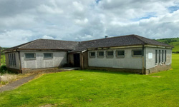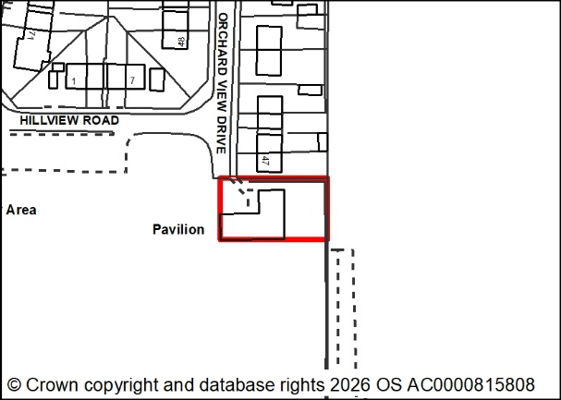
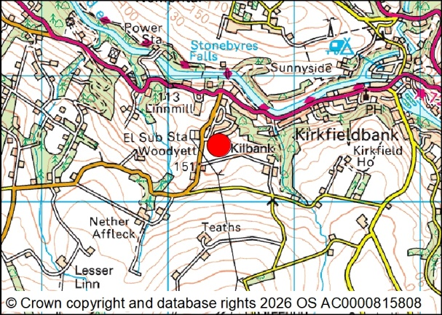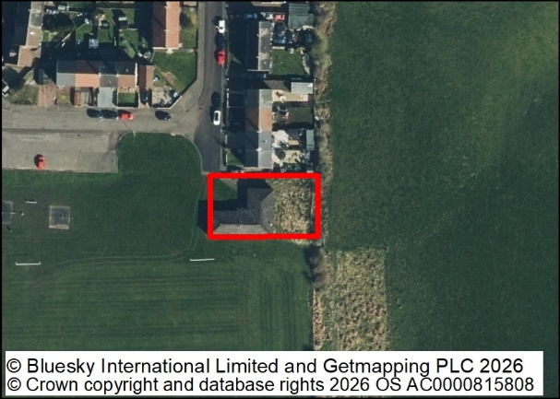

Marketing brief

Location and description

The subjects are located at the southern side of a Local Authority built housing area in the village of Kirkfieldbank. The village has a population of approximately 950 people and is located in the Clyde Valley area, close to the historic town of Lanark. The cities of Glasgow and Edinburgh are approximately 26 and 35 miles distant respectively, travelling by car.

The village benefits from having local convenience store/sub post office, a primary school and village hall. More comprehensive facilities are available in the nearby town of Lanark. There is a regular public bus service providing travel through the Clyde Valley area connecting with Hamilton and Lanark. Each of the towns has a main line railway station.

The subjects comprise a former sports pavilion which is estimated to be in the region of 70 years old. The building is of traditional brick built construction under a platform roof structure clad with felt or similar type material. It should be noted that the building is in a poor state of repair, and any prospective purchaser should undertake their own due diligence regarding its construction type and condition.

The building is situated on a generally flat site which is rectangular in form with the land surrounding the building mainly grass surfaced. There is a public car park in close proximity to the subjects.

Travel

(Postcode for satellite navigation – ML11 9TJ)

Travelling from Hamilton - Take the M74 motorway southbound at junction 6 exiting at junction 7. Take the left hand lane onto Lanark Road (A72) and travel approximately 7 miles along this road until arriving at Kirkfieldbank. On entering the village, take the right hand turn into Lesmahagow Road (B7018), after a short distance, take a left hand turn into Hill View Road, the property is situated at the end of the road on the right hand side.

Planning

The site is affected by Policies 3 and 5 of the adopted South Lanarkshire Local Development Plan 2. These Policies establish that residential developments, and those of an ancillary nature, may be considered acceptable provided that they do not have a significant adverse impact on the amenity and character of the area.

Any proposed use would require detailed Planning Consent. Early discussions with the Planning Department are recommended.

All local plan documents and Supplementary Guidance can be accessed on the council’s website.

Planning enquiries should be directed to:

Planning and Building Standards
Phone 0303 123 1015
Email: planning@southlanarkshire.gov.uk

Road enquiries should be directed to:

Roads and Transportation
Phone 0303 123 1015
Email: roads@southlanarkshire.gov.uk

Services

Mains services are understood to be available however, no guarantee is given as to the existence or condition of any of these services. The successful purchasers must satisfy themselves in this respect.

Legal costs

The purchaser shall be responsible for the payment of both parties’ legal costs in respect of the transaction.

Viewings

For further information or to request a viewing please contact:
Property Services (Estates)
Housing and Technical Resources
Almada Street
Hamilton
ML3 0AA
Phone: 01698 455154
Email: landandproperty@southlanarkshire.gov.uk

Offers

Offers are invited to purchase the heritable interest in the property. Offers together with details of the proposed development, including layout, must be submitted to the following e-mail address only: Property.Disposals@southlanarkshire.gov.uk
Closing date 12pm, Friday 10 July 2026. Offers will be judged on their individual merits. Late offers will not be considered under any circumstances.
Formal legal missives will require to be entered into and will require to incorporate the Conditions of Sale noted overleaf.

These particulars are believed to be correct but their accuracy is not guaranteed. All interested parties should satisfy themselves as to their accuracy.
South Lanarkshire Council are under no obligation to accept the highest or any offer. These particulars do not form, nor are they intended to form part of any contract.

Conditions of sale

Instructions to purchasers
Please read these instructions carefully. They detail essential conditions which the council will insist on in this transaction and explain how the council wishes you to bid for this property. If you are instructing a solicitor you should pass these to him/her.

- Bids must be received on or before 12pm on the closing date. Bids in any other format may be disregarded. Late bids will not be considered.
- Bids will be assessed in respect of the best price (which consideration shall, for the avoidance of doubt, include the bidders ability to pay the price).
- The council are under no obligation to accept any of the bids. In the event that no bid is accepted, bidders will be notified and will be advised if the property is to be re-marketed.
- Planning Services would consider the proposed alternative use in terms of the Local Plan and any proposal would be considered on its own merits.
- The price in the formal bid should be exclusive of VAT. The council may elect to charge VAT on the price and will endeavour to notify the successful bidder as soon as possible if they so elect.
- The price in the formal bid should be exclusive of any costs for planning gain and/or contributions to amenities.
- Subject to 13, no discussions will be entered into before the closing date.
- The council’s acceptance or rejection of any timeous bid is subject to the approval of the council’s Housing and Technical Resources Committee or the expedited powers vested in the members of the committee or the powers delegated by the council to council officers.
- Timeous bids will be acknowledged within seven days of the closing date. A decision on the success or otherwise of bids will not be given until a decision has been formally approved by the council.
- No formal or contractual discussions will be entered into before the closing date or the grant of the council’s formal approval.
- When the successful bidder is approved by the council, the council’s legal team will contact the preferred bidder’s solicitors to progress missives.
- The offer to sell will contain, amongst other conditions, the following specific conditions:
- the purchasers must satisfy themselves in respect of the ground conditions, suitability of existing building services, suitability of the property for the purchasers intended use and the terms of the title deeds. The council will make no warranty in respect of any of these issues.
- the purchaser must submit an application for planning consent if appropriate in support of their bid, and taking account of the information in the planning statement within a prescribed timescale.
- any supplementary information requested by planning services must be provided by the purchasers within 14 days of the date of the request.
- the purchaser will bear the cost of the council’s reasonably incurred legal fees.
- Any queries regarding the marketing brief should be addressed to:
The Estates Manager, Property Services, Housing and Technical Resources, Almada Street, Hamilton, ML3 0AA in writing as soon as possible and no later than five working days before the closing date.

Disclaimer

The particulars are set out as a general outline, only for the guidance of intended purchasers or lessees and do not constitute, nor constitute part of, an offer or contract.

All descriptions, dimensions, reference to condition, any necessary permissions for use and occupation, and other details are given without responsibility, and any intending purchasers or tenants should not rely on them as statements or representations of fact but must satisfy themselves by inspection or otherwise as to the correctness of each of them.

No person in the employment of South Lanarkshire Council has any authority to make or give any representations or warranty whatever in relation to this property.

The information contained in these particulars has been checked and unless otherwise stated, it is understood to be materially correct at the date of publication.

The council does not bind itself to accept the highest or any offer and in supplying these particulars, is not issuing instructions and will not, therefore, bear liability for agents or other fees.

Freedom of Information (Scotland) Act 2003
The council is bound by the terms of this Act. This means that the council cannot in certain circumstances be party to a confidentially clause.

