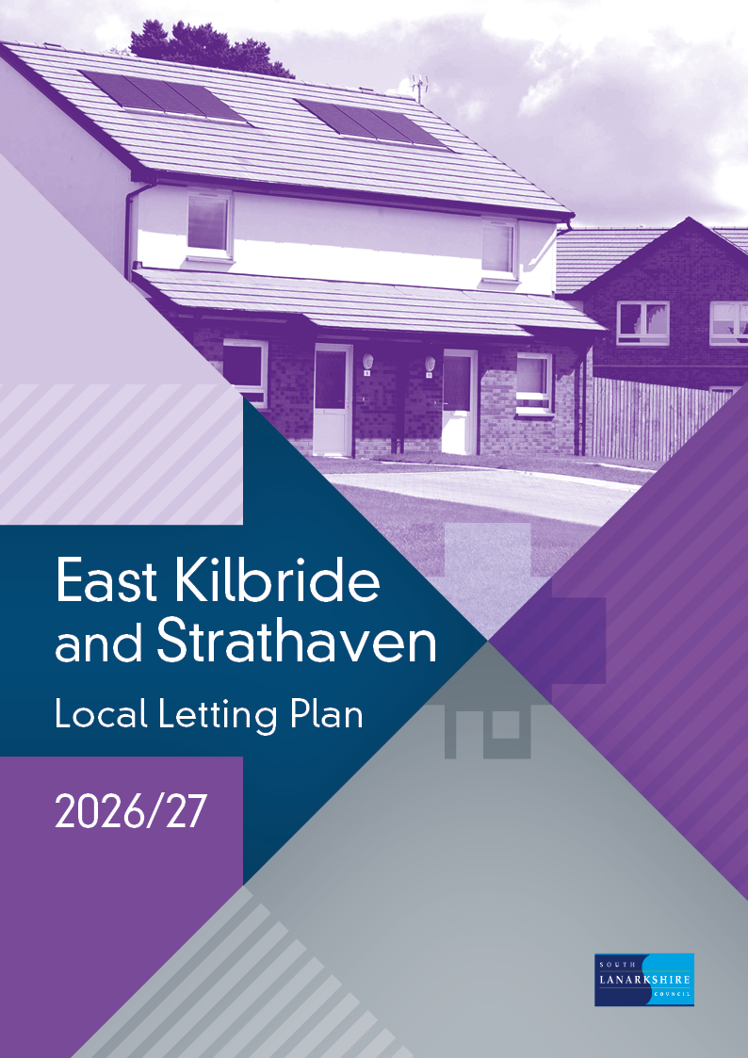

Contents
Section one.
Introduction.
1.1 What is a local letting plan?
1.2 Why do we need a local letting plan?

Section two.
Letting targets 2026/27.
2.1 Housing list targets
2.2 HomeFinder partner targets

Section three.
Supply and demand analysis for general need properties.
3.1 Council properties
3.2 Housing association properties
3.3 Turnover in council properties
3.4 Demand for housing
3.5 Applicant profile
3.6 Urgent housing need applicants

Section four.
Letting initiatives.
4.1 East Kilbride local letting initiative.
4.2 South Lanarkshire letting initiatives.
Section five.
Supply and demand analysis for properties designed for older people.
5.1 Council and housing association sheltered properties.
5.2 Turnover in council sheltered properties.
5.3 Demand for council sheltered properties.
5.4 Council owned amenity properties.
5.5 Turnover in council owned amenity properties.

Section six.
Housing options advice and information to applicants.

Section seven.
Monitoring our performance.

Contact details.

Section one – Introduction

  - What is a local letting plan?
A local letting plan is an open and transparent framework which is updated annually. The plans are based on supply and demand analysis and considers specific local needs and circumstances.
The local letting plan sets out:
- the target of general needs lets to each housing list.
- the target of sheltered lets to each housing list.
- any local letting initiatives.

  - Why do we need a local letting plan?
The plan allows us to set out in detail how we intend to let houses to best meet the aims and objectives of our housing allocation policy.
Housing allocation policy aims and objectives:
- be responsive to local needs, demands and aspirations to ensure the best use of available council housing stock.
- make sure that those assessed as being in most housing need are prioritised.
- achieve balanced and sustainable communities.

In addition, the sheltered housing aspect of the policy aims to:

- allocate sheltered housing to applicants who enjoy living independently but also need the reassurance and support provided by the sheltered housing service.

Section two - Letting targets 2026/27.

2.1 Housing list targets

Taking into account earlier trends, we estimate that we will have between 420 to 460 general needs properties, 50 to 60 sheltered properties and 30 to 50 amenity properties to let in the East Kilbride and Strathaven area during 2026/27.

Based on our analysis of supply and demand, separate letting targets for general needs and sheltered properties have been set for 2026/27 against the four housing lists described within our housing allocation policy.

Housing list | General Needs properties (including amenity) | Sheltered properties
Urgent housing need list | 60-65% | 20-25%
Transfer list | 15-25% | 45-55%
Waiting list | 10-20% | 20-30%
Other categories | 0-5% | 0-5%

2.2 HomeFinder partner targets

In addition to targets set by the council, our HomeFinder partners also set a target of lets which they will work towards to help homeless households access a settled home.

Section three - Supply and demand analysis for general needs properties

3.1 Council properties

As of December 2025, there were 5034 general needs properties across fifteen areas.

East Kilbride properties by size and area
Letting Areas | 0/1 bed | 0/1 bed % | 2 bed | 2 bed % | 3 bed | 3 bed % | 4+ bed | 4+ bed % | Total | Total %
Calderwood | 358 | 31% | 562 | 50% | 166 | 15% | 46 | 4% | 1132 | 100%
East Mains | 71 | 21% | 157 | 47% | 85 | 26% | 20 | 6% | 333 | 100%
Greenhills | 71 | 11% | 181 | 28% | 272 | 42% | 121 | 19% | 645 | 100%
Murray | 221 | 32% | 309 | 45% | 144 | 21% | 11 | 2% | 685 | 100%
Newlandsmuir | 4 | 2% | 72 | 43% | 76 | 45% | 16 | 10% | 168 | 100%
St Leonards | 186 | 32% | 250 | 43% | 120 | 20% | 28 | 5% | 584 | 100%
West Mains | 45 | 15% | 157 | 52% | 85 | 28% | 15 | 5% | 302 | 100%
Westwood | 187 | 29% | 276 | 44% | 144 | 23% | 27 | 4% | 634 | 100%
Whitehills | 9 | 4% | 80 | 37% | 113 | 51% | 18 | 8% | 220 | 100%
Grand Total | 1152 | 24% | 2044 | 44% | 1205 | 26% | 302 | 6% | 4703 | 100%

Strathaven properties by size and area
Letting Areas | 0/1 bed | 0/1 bed % | 2 bed | 2 bed % | 3 bed | 3 bed % | 4+ bed | 4+ bed % | Total | Total %
Chapelton | 8 | 47% | 5 | 29% | 4 | 24% | 0 | 0% | 17 | 100%
Glassford | 4 | 9% | 30 | 63% | 9 | 19% | 4 | 9% | 47 | 100%
Locharmill | 0 | 0% | 0 | 0% | 1 | 100% | 0 | 0% | 1 | 100%
Sandford | 0 | 0% | 0 | 0% | 5 | 100% | 0 | 0% | 5 | 100%
Strathaven | 33 | 13% | 151 | 58% | 70 | 27% | 5 | 2% | 259 | 100%
Strutherhead | 0 | 0% | 0 | 0% | 2 | 100% | 0 | 0% | 2 | 100%
Grand Total | 45 | 14% | 186 | 56% | 118 | 27% | 9 | 3% | 331 | 100%

3.2 Housing association properties

There are also eleven housing associations with a total of 1350 properties (excluding Sheltered Accommodation) in the East Kilbride and Strathaven area:

- Blackwood Homes
- Cairn Housing Association
- Clyde Valley Housing Association
- East Kilbride Housing Association
- Hanover Housing Association
- Key Housing Association
- Link Housing Association
- Loretto Housing Association
- Sanctuary Housing Association
- Trust Housing Association

3.3 Turnover in council properties

- West of Scotland Housing Association

In any year, only a small proportion of properties become available to let.
From April 2025 to December 2025, we let a total of 291 general needs properties in East Kilbride and Strathaven.
East Kilbride turnover by size by area (April 2025 to December 2025)
Letting Areas | 0/1 bed | 0/1 bed % | 2 bed | 2 bed % | 3 bed | 3 bed % | 4+ bed | 4+ bed % | Total | Total %
Calderwood | 22 | 36% | 31 | 51% | 8 | 13% | 0 | 0% | 61 | 100%
East Mains | 6 | 32% | 10 | 53% | 1 | 5% | 2 | 10% | 19 | 100%
Greenhills | 2 | 7% | 12 | 43% | 9 | 32% | 5 | 18% | 28 | 100%
Murray | 15 | 39% | 18 | 47% | 4 | 11% | 1 | 3% | 38 | 100%
Newlandsmuir | 0 | 0% | 22 | 49% | 18 | 40% | 5 | 11% | 45 | 100%
St Leonards | 12 | 32% | 14 | 37% | 10 | 26% | 2 | 5% | 38 | 100%
West Mains | 1 | 8% | 10 | 77% | 2 | 15% | 0 | 0% | 13 | 100%
Westwood | 13 | 36% | 12 | 33% | 9 | 25% | 2 | 6% | 36 | 100%
Whitehills | 0 | 0% | 1 | 17% | 5 | 83% | 0 | 0% | 6 | 100%
Grand Total | 71 | 25% | 130 | 46% | 66 | 23% | 17 | 6% | 284 | 100%

Strathaven turnover by size by area (April 2025 to December 2025)
Letting Areas | 0/1 bed | 0/1 bed % | 2 bed | 2 bed % | 3 bed | 3 bed % | 4+ bed | 4+ bed % | Total | Total %
Glassford | 0 | 0% | 1 | 100% | 0 | 0% | 0 | 0% | 1 | 100%
Strathaven | 1 | 17% | 5 | 83% | 0 | 0% | 0 | 0% | 6 | 100%
Grand Total | 1 | 14% | 6 | 86% | 0 | 0% | 0 | 0% | 7 | 100%

Size of properties available

The breakdown in size of council properties that became available for let from April 2025 to
December 2025 was:

- 25% (72) general needs properties were 1 bedroom.
- 47% (136) general needs properties were 2 bedrooms.
- 22% (66) general needs properties were 3 bedrooms.
- 6% (17) general needs properties of 4+ bedrooms.

Where are properties most likely to become available?

From April 2025 to December 2025, 75% of the general needs properties that became available for let were located in the following five areas:

- Calderwood
- Murray
- Newlandsmuir
- St Leonards
- Westwood

Where are properties least likely to become available?

From April 2025 to December 2025, there were three areas which had six or less lets:

- Whitehills
- Glassford
- Strathaven

3.4 Demand for housing

As of December 2025, there were 5257 applicants looking for housing in the East Kilbride and Strathaven area.

Housing applications by list category and size of property as of December 2025
Application Category | 0/1 bed | 0/1 bed % | 2 bed | 2 bed % | 3 bed | 3 bed % | 4+ bed | 4+ bed % | Total | Total %
Urgent housing need | 324 | 51% | 217 | 34% | 76 | 12% | 21 | 3% | 638 | 100%
Transfer | 276 | 34% | 311 | 38% | 161 | 19% | 72 | 9% | 820 | 100%
Waiting | 1838 | 49% | 1181 | 32% | 523 | 14% | 169 | 5% | 3711 | 100%
Other category | 68 | 77% | 16 | 18% | 3 | 4% | 1 | 1% | 88 | 100%
Total | 2506 | 48% | 1725 | 33% | 763 | 14% | 263 | 5% | 5257 | 100%

3.5 Applicant profile

- 51% (2697) were single people.
- 23% (1227) were lone parents.
- 80% of all applicants require 1 or 2 bedroom properties.

3.6 Urgent housing need applicants

Applicants on our HomeFinder housing register have a range of housing needs. Some have been assessed as having an urgent need for housing, for example applicants who are homeless and to whom the council has a legal duty to provide settled accommodation.
Across the East Kilbride and Strathaven Housing Management Areas, 418 applicants were assessed as homeless or potentially homeless during 2025/2026. We maintain our commitment to providing housing options with a focus on individual needs, aiming to prevent homelessness.

Section four - Letting initiatives.

Letting initiatives set out where any variation to the housing allocation policy is needed to take account of and address particular needs and circumstances.
4.1 East Kilbride local letting initiative (LLI)
Local letting initiatives allow us to tackle a variety of issues within a specific area, including:

- demand for different types of properties.
- estate management issues.
- maintaining stable communities.
- high levels of need from certain groups of applicants.

During 2025/26, there are no local letting initiatives in operation within the East Kilbride and Strathaven area.
4.2 South Lanarkshire letting initiative
During 2026/27, there are two letting initiatives in operation across all areas of South Lanarkshire. Details of the initiatives are set out below.
Details of letting initiative 1
Priority will be given to applicants who meet the criteria for amenity housing, taking into account their individual needs and circumstances
Area Covered
All areas of East Kilbride and Strathaven
Property types
General needs flatted properties situated in blocks where ground and first floor properties are designated and utilised as amenity flats

Details of letting initiative 2
During 2026/27, there is a letting initiative in operation across all areas of South Lanarkshire, to support council tenants, living in larger sized homes to downsize to a smaller property.

Priority for rehousing will be awarded and appropriate support provided to South Lanarkshire Council tenants, under occupying a property, who wish to move to a smaller property and who meet the criteria.
Area Covered
All areas of East Kilbride and Strathaven
Property types
House or Flats with 3 or more bedrooms

Section five - Supply and demand analysis for properties designed for older people.

5.1 Council and housing association sheltered properties.

There are a number of sheltered housing developments within the East Kilbride area. The table below details the developments that exist, and the number of properties contained within each.

East Kilbride sheltered properties as at December 2025
Landlord | Area | Development | Very Sheltered | Sheltered | 0/1 Bed | 2/3 Bed | Total
South Lanarkshire Council | Calderwood | Wingate Park | No | Yes | 39 | 0 | 39
South Lanarkshire Council | East Mains | Bosfield Place | No | Yes | 31 | 3 | 34
South Lanarkshire Council | East Mains | Ladybank | No | Yes | 30 | 0 | 30
South Lanarkshire Council | East Mains | Wellbeck House | No | Yes | 14 | 0 | 14
South Lanarkshire Council | Greenhills | Castlefield Gardens | No | Yes | 34 | 2 | 36
South Lanarkshire Council | Greenhills | Pine Crescent | No | Yes | 28 | 0 | 28
South Lanarkshire Council | Greenhills | Plover Drive | No | Yes | 35 | 0 | 35
South Lanarkshire Council | Murray | Headhouse Court | No | Yes | 22 | 0 | 22
South Lanarkshire Council | Murray | Strathcona House | No | Yes | 29 | 3 | 32
South Lanarkshire Council | St Leonards | Davaar | No | Yes | 28 | 0 | 28
South Lanarkshire Council | Westwood | Alberta Park | No | Yes | 22 | 0 | 22
South Lanarkshire Council | Westwood | Canberra House | No | Yes | 29 | 4 | 33
South Lanarkshire Council | Whitehills | Drumduff | No | Yes | 19 | 0 | 19
South Lanarkshire Council | Strathaven | Park Crescent | No | Yes | 24 | 1 | 25
Hanover Housing Association | Murray | Archibald Kelly Court | Yes | No | 24 | 0 | 24
Trust Housing Association | Lindsayfield | Germiston Crescent | Yes | No | 17 | 0 | 17
Total |  |  |  |  | 425 | 13 | 438

5.2 Turnover in council sheltered properties.

In any year, only a small proportion of sheltered properties become available to let. From April 2025 to December 2025, we let a total of 45 council owned sheltered properties in the East Kilbride and Strathaven area.

Turnover of sheltered properties (April 2025 to December 2025)
Letting Area | Sheltered development | 0/1 Bed | 2 Bed | Total
Calderwood | Wingate Park | 2 | 0 | 2
East Mains | Bosfield Place | 5 | 0 | 5
East Mains | Ladybank | 5 | 0 | 5
East Mains | Wellbeck House | 1 | 0 | 1
Greenhills | Castlefield Gardens | 4 | 0 | 4
Greenhills | Pine Crescent | 4 | 0 | 4
Greenhills | Plover Drive | 4 | 0 | 4
Murray | Strathcona House | 1 | 2 | 3
Murray | Headhouse Court | 9 | 0 | 9
St Leonards | Davaar | 5 | 0 | 5
Westwood | Alberta Park | 1 | 0 | 1
Westwood | Canberra House | 1 | 0 | 1
Whitehills | Drumduff | 1 | 0 | 1
Strathaven | Park Cres | 0 | 0 | 0
Total |  | 43 | 2 | 45

5.3 Demand for council sheltered properties.

The table below shows the number of applicants queued for each of the council owned sheltered housing developments in the East Kilbride area.

Demand for sheltered properties as of December 2025
Letting Area | Sheltered development | Total
Calderwood | Wingate Park | 197
East Mains | Bosfield Place | 166
East Mains | Ladybank | 227
East Mains | Wellbeck House | 193
Greenhills | Castlefield Gardens | 114
Greenhills | Pine Crescent | 112
Greenhills | Plover Drive | 111
Murray | Headhouse Court | 173
Murray | Strathcona House | 136
St Leonards | Davaar | 207
Westwood | Alberta Park | 180
Westwood | Canberra House | 110
Whitehills | Drumduff | 67
Strathaven | Park Crescent | 33

The figures in the table above represent the actual number of applicants who wish to be housed within each development. It should be noted that applicants are able to choose more than one sheltered housing development.

  - Council owned amenity properties

There are a number of properties which have been specifically designed or adapted to suit the needs of older people or those with particular needs, such as a disability. These are known as amenity properties. The table below provides details of the number and location of council owned amenity properties. We continue to increase our supply of amenity properties to help meet demand.

Council owned amenity properties as of December 2025
Area | 0/1 Beds | 2 Beds | 3 Beds | 4+ Beds | Total
Calderwood | 102 | 10 | 1 | 3 | 116
Chapelton | 1 | 0 | 0 | 0 | 1
East Mains | 24 | 0 | 0 | 0 | 24
Glassford | 2 | 0 | 0 | 0 | 2
Greenhills | 56 | 0 | 0 | 0 | 56
Murray | 33 | 3 | 4 | 0 | 40
Newlandsmuir | 12 | 20 | 0 | 0 | 32
Strathaven | 10 | 4 | 0 | 0 | 14
West Mains | 62 | 0 | 0 | 0 | 62
Westwood | 34 | 21 | 0 | 2 | 57
Whitehills | 38 | 0 | 0 | 0 | 38
Total | 374 | 58 | 5 | 5 | 442

  - Turnover in council owned amenity properties

From April 2025 to December 2025, we let a total of 26 council owned amenity properties in the
East Kilbride and Strathaven area, 21 were one-bedroom properties and 5 were two-bedroom properties.

Turnover in council owned amenity properties.
Area | 1 Bed | 2 Bed | Total
Calderwood | 6 | 0 | 6
East Mains | 0 | 0 | 0
Greenhills | 0 | 0 | 0
Murray | 2 | 0 | 2
Newlandsmuir | 0 | 0 | 0
West Mains | 5 | 0 | 5
Westwood | 1 | 5 | 6
Whitehills | 4 | 0 | 4
Strathaven | 3 | 0 | 3
Total | 21 | 5 | 26

Section six - Housing options advice and information to applicants

Both the council and housing associations in South Lanarkshire have a limited supply of properties available to let each year. This means that many applicants on the HomeFinder housing register are unlikely to receive an offer of housing.

Depending on their individual circumstances and preferences, applicants may wish to consider other available housing options. There is a range of information and advice available to help applicants make informed choices about their housing needs, including:

- letting area guides which provide details of council and housing association properties, including turnover in each area, as well as details of local facilities, amenities, and transport links.
- mutual exchange information for existing council and housing association tenants.
- assistance to remain at home, including carrying out adaptations to meet specific needs.
- housing within the private sector.
- low-cost home ownership options.
- help with paying rent and council tax.

There are also a range of services available from the council and other agencies which offer
housing related information and advice including:

- Money Matters Advice Service
- Mediation Service
- Social Work Resources
- Citizens Advice Bureau
- Shelter
- Care and Repair

The council’s website www.southlanarkshire.gov.uk provides additional information and advice on housing options and the above services.

Section seven - Monitoring our performance.

We closely monitor letting outcomes to ensure the plan delivers the aims of our Housing Allocation Policy and if necessary, revise the letting targets for the year ahead.

On an annual basis, we report our performance to Housing and Technical Resources Committee and at the same time seek approval for the following year’s targets.

We also publish details of our performance each year on the council’s website.

Contact details

To contact your area housing office please phone 0303 123 1012 (automated service)

Cambuslang and Rutherglen Area Housing Office
Cambuslang Gate
27 Main Street
Cambuslang G72 7EX
Email: housing.cambuslang@southlanarkshire.gov.uk
Email: housing.rutherglen@southlanarkshire.gov.uk

Clydesdale Area Housing Office
South Vennel,
Lanark ML11 7JT
Email: housing.carluke@southlanarkshire.gov.uk
Email: housing.lanark@southlanarkshire.gov.uk

East Kilbride Area Housing Office
Civic Centre,
Andrew Street,
East Kilbride G74 1AB
Email: housing.eastkilbride@southlanarkshire.gov.uk

East Kilbride, Blantyre and Larkhall Area Housing Office
Brandon Gate,
1 Leechlee Road,
East Kilbride ML3 0XB
Email: housing.hamilton@southlanarkshire.gov.uk
Email: housing.blantyre@southlanarkshire.gov.uk
Email: housing.larkhall@southlanarkshire.gov.uk

If you or someone you know needs this information in another language or format, please contact us to discuss how we can best meet your needs. Phone: 0303 123 1015 or Email: equalities@southlanarkshire.gov.uk

