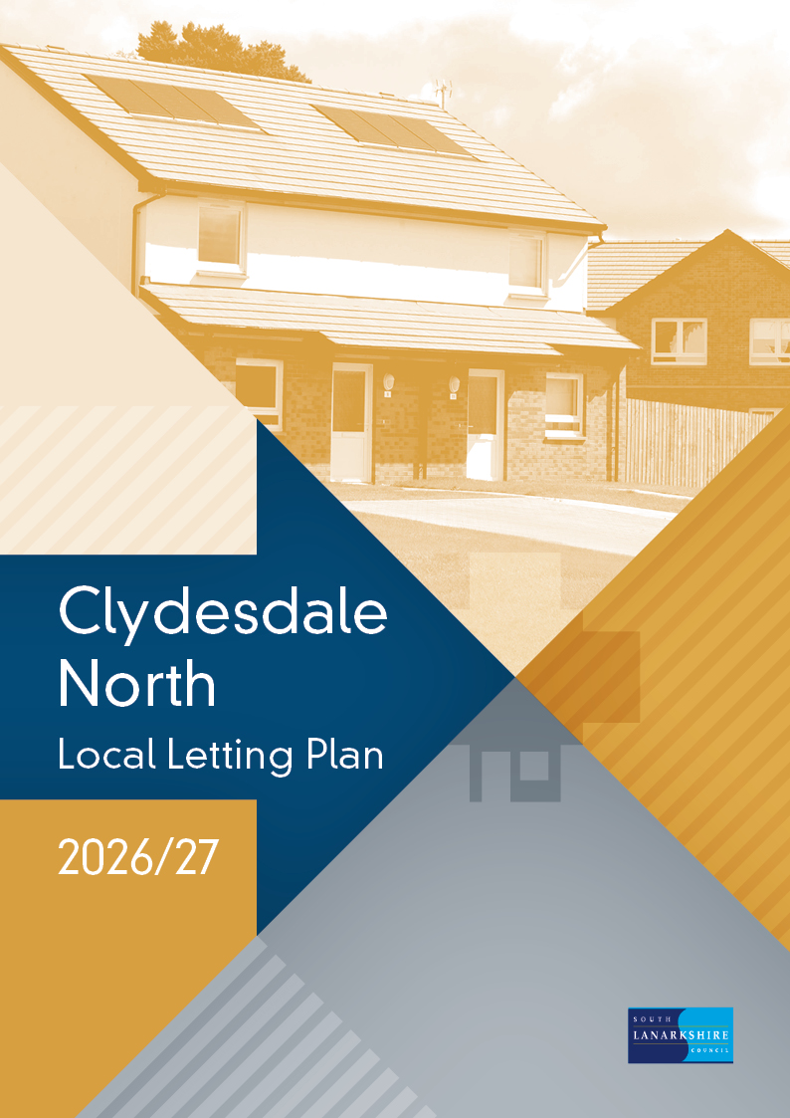

Contents
Section one.
Introduction.
1.1 What is a local letting plan?
1.2 Why do we need a local letting plan?
Section two.
Letting targets 2026/27.
2.1 Housing list targets
2.2 HomeFinder partner targets
Section three.
Supply and demand analysis for general need properties.
3.1 Council properties.
3.2 Housing association properties.
3.3 Turnover in council properties.
3.4 Demand for housing.
3.5 Applicant profile.
3.6 Urgent housing need applicants.
Section four.
Letting initiatives.
4.1 Clydesdale North local letting initiative.
4.2 South Lanarkshire letting initiatives.
Section five.
Supply and demand analysis for properties designed for older people.
5.1 Council and housing association sheltered properties.
5.2 Turnover in council sheltered properties.
5.3 Demand for council sheltered properties.
5.4 Council owned amenity properties.
5.5 Turnover in council owned amenity properties.
Section six.
Housing options advice and information to applicants.
Section seven.
Monitoring our performance.
Contact details.
Appendix 1.
Clydesdale North letting areas.

Section one – Introduction

  - What is a local letting plan?
A local letting plan is an open and transparent framework which is updated annually. The plans are based on supply and demand analysis and considers specific local needs and circumstances.
The local letting plan sets out:
- the target of general needs lets to each housing list.
- the target of sheltered lets to each housing list.
- any local letting initiatives.

  - Why do we need a local letting plan?
The plan allows us to set out in detail how we intend to let houses to best meet the aims and objectives of our housing allocation policy.
Housing allocation policy aims and objectives:
- be responsive to local needs, demands and aspirations to ensure the best use of available council housing stock.
- make sure that those assessed as being in most housing need are prioritised.
- achieve balanced and sustainable communities.

In addition, the sheltered housing aspect of the policy aims to:

- allocate sheltered housing to applicants who enjoy living independently but also need the reassurance and support provided by the sheltered housing service.

Section two - Letting targets 2026/27.

2.1 Housing list targets

Taking into account earlier trends, we estimate that we will have between 140 to 170 general needs properties, 10 to 20 sheltered properties and 10 to 20 amenity properties to let in the Clydesdale North area during 2026/27.

Based on our analysis of supply and demand, letting targets for general needs and sheltered properties have been set for 2026/27 against the four housing lists described within our housing allocation policy. The letting targets apply across the Clydesdale North and South housing management areas, the properties let in the Clydesdale North area will contribute towards the achievement of the targets.

Housing list | General Needs properties (including amenity) | Sheltered properties
Urgent housing need list | 45-55% | 15-20%
Transfer list | 20-30% | 35-45%
Waiting list | 20-25% | 35-45%
Other categories | 0-5% | 0-5%

2.2 HomeFinder partner targets

In addition to targets set by the council, our HomeFinder partners also set a target of lets which they will work towards to help homeless households access a settled home.

Section three - Supply and demand analysis for general needs properties

3.1 Council properties

As of December 2025, there were 2138 general needs properties across seven areas.

Clydesdale North properties by size and area
Letting Areas | 0/1 bed | 0/1 bed % | 2 bed | 2 bed % | 3 bed | 3 bed % | 4+ bed | 4+ bed % | Total | Total %
Braidwood | 10 | 26% | 22 | 56% | 7 | 18% | 0 | 0% | 39 | 100%
Carluke | 134 | 13% | 584 | 59% | 244 | 25% | 29 | 3% | 991 | 100%
Carnwath | 38 | 20% | 96 | 51% | 52 | 27% | 4 | 2% | 190 | 100%
Carstairs | 20 | 8% | 120 | 49% | 96 | 40% | 7 | 3% | 243 | 100%
Crossford | 12 | 26% | 33 | 70% | 2 | 4% | 0 | 0% | 47 | 100%
Forth | 73 | 18% | 215 | 52% | 113 | 27% | 14 | 3% | 415 | 100%
Law | 20 | 9% | 131 | 62% | 53 | 25% | 9 | 4% | 213 | 100%
Total | 307 | 14% | 1201 | 56% | 567 | 27% | 63 | 3% | 2138 | 100%

(Appendix 1 details the individual letting areas grouped within each of the above areas)

3.2 Housing association properties

There are also seven housing associations with a total of 630 properties (excluding Sheltered Accommodation) in the Clydesdale North area:

- Bield Housing Association
- Blackwood homes
- Clyde Valley Housing Association
- Clydesdale Housing Association
- Loretto Housing Association
- Melville Housing Association
- West of Scotland Housing Association
3.3 Turnover in council properties

In any year, only a small proportion of properties become available to let.
From April 2025 to December 2025, we let a total of 93 general needs properties in Clydesdale North.

Council turnover by size by area (April 2025 to December 2025)
Letting Areas | 0/1 bed | 0/1 bed % | 2 bed | 2 bed % | 3 bed | 3 bed % | 4+ bed | 4+ bed % | Total | Total %
Braidwood | 0 | 0% | 0 | 0% | 0 | 0% | 0 | 0% | 0 | 100%
Carluke | 10 | 23% | 28 | 65% | 5 | 12% | 0 | 0% | 43 | 100%
Carnwath | 2 | 20% | 8 | 80% | 0 | 0% | 0 | 0% | 10 | 100%
Carstairs | 2 | 13% | 11 | 74% | 2 | 13% | 0 | 0% | 15 | 100%
Crossford | 1 | 100% | 0 | 0% | 0 | 0% | 0 | 0% | 1 | 100%
Forth | 4 | 22% | 9 | 50% | 4 | 22% | 1 | 6% | 18 | 100%
Law | 1 | 17% | 4 | 66% | 1 | 17% | 0 | 0% | 6 | 100%
Total | 20 | 21% | 60 | 65% | 12 | 13% | 1 | 1% | 93 | 100%

(Appendix 1 details the individual letting areas grouped within each of the above areas)

Size of properties available

The breakdown in size of council properties that became available for let from April 2025 to
December 2025 was:

- 21% (20) general needs properties were 1 bedroom.
- 65% (60) general needs properties were 2 bedrooms.
- 13% (12) general needs properties were 3 bedrooms.
- 1% (1) general needs properties of 4+ bedrooms.

Where are properties most likely to become available?

From April 2025 to December 2025, 82 % of the general needs properties that became available for let were located in the following three areas:

- Carluke
- Carstairs
- Forth
Where are properties least likely to become available?

From April 2025 to December 2025, two areas had less than two lets:

- Braidwood
- Crossford
3.4 Demand for housing

As of December 2025, there were 1773 applicants looking for housing in the Clydesdale North area.

Housing applications by list category and size of property as of December 2024
Application Category | 0/1 bed | 0/1 bed % | 2 bed | 2 bed % | 3 bed | 3 bed % | 4+ bed | 4+ bed % | Total | Total %
Urgent housing need | 46 | 46% | 29 | 28% | 20 | 20% | 6 | 6% | 101 | 100%
Transfer | 116 | 31% | 138 | 37% | 98 | 26% | 22 | 6% | 374 | 100%
Waiting | 593 | 46% | 467 | 37% | 169 | 13% | 48 | 4% | 1277 | 100%
Other category | 16 | 76% | 4 | 19% | 1 | 5% | 0 | 0% | 21 | 100%
Total | 771 | 42% | 638 | 36% | 288 | 16% | 76 | 4% | 1773 | 100%

3.5 Applicant profile

- 49 % (866) were single people.
- 25 % (439) were lone parents.
- 79 % of all applicants require 1 or 2 bedroom properties.

3.6 Urgent housing need applicants

Applicants on our HomeFinder housing register have a range of housing needs. Some have been assessed as having an urgent need for housing, for example applicants who are homeless and to whom the council has a legal duty to provide settled accommodation.
Across the Clydesdale North and South Housing Management Areas, 266 applicants were assessed as homeless or potentially homeless during 2025/2026. We maintain our commitment to providing housing options with a focus on individual needs, aiming to prevent homelessness.

Section four - Letting initiatives.

Letting initiatives set out where any variation to the housing allocation policy is needed to take account of and address particular needs and circumstances.

4.1 Clydesdale North local letting initiative (LLI).
Local letting initiatives allow us to tackle a variety of issues within a specific area, including:
- demand for different types of properties.
- estate management issues.
- maintaining stable communities.
- high levels of need from certain groups of applicants.

During 2026/27, there is one local letting initiative in operation within the Clydesdale North area. Details of the initiative is provided in the table below.

Details of letting initiative.
Priority for housing will be given to applicants who have a social or economic connection with the area. To encourage tenancy sustainment, discussions will take place with prospective tenants to ensure that they fully understand the context to living in a rural location.

Letting area covered by LLI.
Forth East

Property types/sizes.
All property types and sizes.

4.2 South Lanarkshire letting initiative
During 2026/27, there are two letting initiatives in operation across all areas of South Lanarkshire, which will promote tenancy sustainment and consider the individual needs and circumstances of prospective tenants

Details of letting initiative 1
Priority will be given to applicants who meet the criteria for amenity housing, taking into account their individual needs and circumstances.

Area Covered
All areas of Clydesdale North.

Property types
General needs flatted properties situated in blocks where ground and first floor properties are designated and utilised as amenity flats.

Details of letting initiative 2
During 2026/27, there is a letting initiative in operation across all areas of South Lanarkshire, to support council tenants, living in larger sized homes to downsize to a smaller property.
Priority for rehousing will be awarded and appropriate support provided to South Lanarkshire Council tenants, under occupying a property, who wish to move to a smaller property and who meet the criteria.

Area Covered
All areas of Clydesdale North.

Property types
House or Flats with 3 or more bedrooms.

Section five - Supply and demand analysis for properties designed for older people.

5.1 Council and housing association sheltered properties.

There are a number of sheltered housing developments within the Clydesdale North area. The table below details the developments that exist, and the number of properties contained within each.

Clydesdale North sheltered properties as of December 2025
Landlord | Area | Development | 0/1 Bed | 2 Bed | Total
South Lanarkshire Council | Carluke | Kirkton Court and Fleming Court | 41 | 1 | 42
South Lanarkshire Council | Carluke | Needle Green | 26 | 5 | 31
South Lanarkshire Council | Forth | Bank Terrace | 20 | 0 | 20
Hanover Housing Association | Carluke | Rosemount Court | 20 | 2 | 22
TOTAL |  |  | 107 | 8 | 115

5.2 Turnover in council sheltered properties.

In any year, only a small proportion of sheltered properties become available to let. From April 2025 to December 2025, we let a total of 8 council owned sheltered properties in the Clydesdale North area, all of which were one-bedroom properties.

Turnover of sheltered properties (April 2025 to December 2025)
Area | Sheltered development | 0/1 Bed | 2 Bed | Total
Carluke | Kirkton Court and Fleming Court | 0 | 0 | 0
Carluke | Needle Green | 1 | 0 | 1
Forth | Bank Terrace | 7 | 0 | 7
Total |  | 8 | 0 | 8

5.3 Demand for council sheltered properties.

The table below shows the number of applicants queued for each of the council owned sheltered housing developments in the Clydesdale North area.

Demand for sheltered properties as of December 2025
Letting Area | Sheltered development | Total
Carluke | Kirkton Court and Fleming Court | 75
Carluke | Needle Green | 71
Forth | Bank Terrace | 8

The figures in the table above represent the actual number of applicants who wish to be housed within each development. It should be noted that applicants are able to choose more than one
sheltered housing development.

  - Council owned amenity properties

There are a number of properties which have been specifically designed or adapted to suit the needs of older people or those with particular needs, such as a disability. These are known as amenity properties. The table below provides details of the number and location of council owned amenity properties. We continue to increase our supply of amenity properties to help meet demand.

Council owned amenity properties as of December 2025
Area | 0/1 Beds | 2/3 Beds | Total
Braidwood | 5 | 0 | 5
Carluke | 47 | 11 | 58
Carnwath | 17 | 0 | 17
Carstairs | 27 | 0 | 27
Crossford | 6 | 0 | 6
Forth | 9 | 2 | 11
Law | 16 | 6 | 22
Total | 127 | 19 | 146

  - Turnover in council owned amenity properties

In any year, only a small proportion of amenity properties become available to let.

From April 2025 to December 2025, we let a total of 9 council owned amenity properties in the
Clydesdale North area. all of which were one-bedroom properties.

Turnover in council owned amenity properties.
Area | 0/1 Bed | 2 Bed | Total
Carluke | 3 | 0 | 3
Carnwath | 2 | 0 | 2
Carstairs | 2 | 0 | 2
Law | 2 | 0 | 2
Total | 9 | 0 | 9

Section six - Housing options advice and information to applicants

Both the council and housing associations in South Lanarkshire have a limited supply of properties available to let each year. This means that many applicants on the HomeFinder housing register are unlikely to receive an offer of housing.

Depending on their individual circumstances and preferences, applicants may wish to consider other available housing options. There is a range of information and advice available to help applicants make informed choices about their housing needs, including:

- letting area guides which provide details of council and housing association properties, including turnover in each area, as well as details of local facilities, amenities, and transport links.
- mutual exchange information for existing council and housing association tenants.
- assistance to remain at home, including carrying out adaptations to meet specific needs.
- housing within the private sector.
- low-cost home ownership options.
- help with paying rent and council tax.

There are also a range of services available from the council and other agencies which offer
housing related information and advice including:

- Money Matters Advice Service
- Mediation Service
- Social Work Resources
- Citizens Advice Bureau
- Shelter
- Care and Repair

The council’s website www.southlanarkshire.gov.uk provides additional information and advice on housing options and the above services.

Section seven - Monitoring our performance.

We closely monitor letting outcomes to ensure the plan delivers the aims of our Housing Allocation Policy and if necessary, revise the letting targets for the year ahead.

On an annual basis, we report our performance to Housing and Technical Resources Committee and at the same time seek approval for the following year’s targets.

We also publish details of our performance each year on the council’s website.

Contact details

To contact your area housing office please phone 0303 123 1012 (automated service)

Cambuslang and Rutherglen Area Housing Office
Cambuslang Gate
27 Main Street
Cambuslang G72 7EX
Email: housing.cambuslang@southlanarkshire.gov.uk
Email: housing.rutherglen@southlanarkshire.gov.uk

Clydesdale Area Housing Office
South Vennel,
Lanark ML11 7JT
Email: housing.carluke@southlanarkshire.gov.uk
Email: housing.lanark@southlanarkshire.gov.uk

East Kilbride Area Housing Office
Civic Centre,
Andrew Street,
East Kilbride G74 1AB
Email: housing.eastkilbride@southlanarkshire.gov.uk

Hamilton, Blantyre and Larkhall Area Housing Office
Brandon Gate,
1 Leechlee Road,
Clydesdale North ML3 0XB
Email: housing.hamilton@southlanarkshire.gov.uk
Email: housing.blantyre@southlanarkshire.gov.uk
Email: housing.larkhall@southlanarkshire.gov.uk

If you or someone you know needs this information in another language or format, please contact us to discuss how we can best meet your needs. Phone: 0303 123 1015 or Email: equalities@southlanarkshire.gov.uk

Appendix 1

Clydesdale North Letting Areas

Carluke
Cairneymount
Carluke West
Crawforddyke East
Crawforddyke North
Crawforddyke West
Douglas Street
Kilncadzow
Whitehill
Whitehill West
Yieldshields

Law
Law

Crossford
Crossford
Nemphlar

Braidwood
Braidwood
Cartland

Forth
Braehead
East Hinshelwood
Forth East
Forth West
Harelaw
Mossplatt
Shodshillmill
Tashieburn

Carnwath
Anston
Auchengray Area
Carnwath
Cobbinshaw
Dolphinton
Dunsyre
Kersewell
Newbigging
Tarbrax
Walston
Weston

Carstairs
Carstairs Junction
Carstairs Village
Cleghorn
Ravenstruther

