Local Transport Strategy 2026-2036

Table of contents
- Introduction
- About South Lanarkshire
- Background information, trends and issues
- Progress from the previous LTS
- The need for change
- Consultation
- Vision statement and objectives
- Potential LTS approaches
- Maintenance and asset management
- Improving road safety
- Economy and regeneration
- Sustainable transport
- Walking, wheeling and cycling
- Environment
- Inclusive mobility
- Spatial planning
- Technology
- Implementation and monitoring

Appendix A – Performance of the previous LTS

Glossary of terms
Asset management - The monitoring of road condition, bridges, and other infrastructure.
Bus Lane - Provision of dedicated road space for buses to reduce journey times and improve service reliability. The aim of bus lanes is to encourage people to change from cars to buses and thus reduce traffic congestion.
Car sharing - Car sharing programmes match car drivers with other individuals who travel to similar places. Driver and passengers share the cost of the trip, thereby reducing the cost of transport. Through car sharing, congestion on roads can be reduced, and the environmental impact of using a car can be minimised.
Demand Responsive Transport (DRT) - Any programme or scheme that offers individualised passenger service based on passenger locations and particular needs. Common examples include Dial-a-Bus, Ring-and-Ride and Dial-a-Taxi.
Junior Road Safety Officer Scheme - Road safety initiative encouraging pupils to take responsibility for conveying road safety within their school. Aimed at P6 and P7 pupils.
Just Transition - Making the shift to net-zero in a way that is fair for everyone. It means sharing the costs and benefits equally, reducing inequality, and involving the people most affected in the decisions.
Local Development Plan - Document prepared and adopted by the Planning Authority to detail policies and proposals for the future development of land use in the area.
National Cycle Network - A comprehensive network of safe and attractive routes to cycle throughout the UK.
Peak Period - Peak period refers to times of the day when there is the heaviest demand on the transport network, usually in the mornings and after work in the early evenings.
Real-Time Passenger Information (RTPI) - A method of giving passengers the ability to know exactly when their public transport service will arrive, whether there are hold ups or a clear run.
School Travel Plan - A working document identifying aims and objectives to reduce car use and promote more sustainable transport options for the school journey.
SCOTS - Scottish Collaboration of Transportation Specialists. The organisation has a mandate to “give policy advice on a national basis and to act as a forum for professional advice and interchange of information on all policy matters affecting transportation in the widest sense; including roads, traffic management, road safety, lighting, public transport and issues related to land use, development and the physical environment.”
Strathclyde Partnership for Transport (SPT) - The statutory regional transport partnership for the West of Scotland.
Sustainable transport - Any form of transport that keeps damage to the environment, and therefore to the future, to a minimum, for example public transport, car sharing, walking, wheeling and cycling.
Traffic Regulation Order (TRO) - Legislation which allows restrictions to be placed on roads and car parks specifying places and times when vehicles can / cannot park, wait, load and unload. Can also be used to restrict vehicle movements, manoeuvres at junctions, introduce one-way streets and implement speed restrictions.
Transport Assessment - An assessment that identifies and considers the likely transport impacts of a development proposal and focuses attention on the delivery of multi-modal access to the development.
Transport Scotland - The National Transport Agency for Scotland. Transport Scotland deals with issues of day-to-day concern to the people of Scotland. From a transport and access perspective, this includes overseeing the safe and efficient running of the Scottish Trunk Road and Rail Networks; sustainable transport, road safety and accessibility; aviation, bus, freight and taxi policy; ferries, ports and harbours; as well as establishing and running the national scheme for concessionary travel in Scotland and the blue badge scheme for people with disabilities.
Travel Plan - A package of measures and initiatives that aim to reduce the number of car journeys made, by encouraging the use of sustainable transport modes and providing people with greater transport choices.

List of acronyms

AIP | Accident Investigation and Prevention
APR | (Air Quality) Annual Progress Report
AQMA | Air Quality Management Area
BNG | Biodiversity Net Gain
BRES | Business Register and Employment Survey
CaLL LPD | Clyde and Loch Lomond Local Plan District
CFSZ | Car Free School Zones
CRWIA | Children’s Rights and Wellbeing Impact Assessment
DPE | Decriminalised Parking Enforcement
DRT | Demand Responsive Transport
ECO Stars | Efficient Cleaner Operations
END | Environmental Noise Directive
EqIA | Equalities Impact Assessment
FBC | Final Business Case
FIDAS | Fine Dust Analysis System
FRA | Flood Risk Assessment
FSDA | Fairer Scotland Duty Assessment
GPS | Global Positioning System
GVA | Gross Value Added
HGV | Heavy Goods Vehicle
HIIA | Health Inequalities Impact Assessment
HRA | Habitats Regulations Appraisal
LDP2 | South Lanarkshire Local Development Plan Two
LFRMP | Local Flood Risk Management Plan
LGV | Light Goods Vehicle
LPDs | Local Plan Districts
LTS | Local Transport Strategy
MaaS | Mobility as a Service
MOVA | Microprocessor Optimised Vehicle Actuation
MP | Member of Parliament
MSP | Member of the Scottish Parliament
NCN | National Cycle Network
NEC | National Entitlement Card
NHS | National Health Service
NO₂ | Nitrogen Dioxide
NOx | Nitrogen Oxides
NPF4 | National Planning Framework 4
NTS2 | National Transport Strategy 2
OBC | Outline Business Case
ONS | Office for National Statistics
oSRWC | Office of the Scottish Road Works Commissioner
PM10 | Particulate Matter
RAMP | Roads Asset Management Plan
RAUCS | Roads Authorities and Utilities Committee Scotland
RTPI | Real-Time Passenger Information Systems
RTS | Regional Transport Strategy
SABI | Scottish Access to Bus Indicator
SAC | Special Areas of Conservation
SBC | Strategic Business Case
SCI | Sites of Community Interest
SCOOT | Split Cycle and Offset Optimisation Technique
SCOTS | Scottish Collaboration of Transportation Specialists
SDP2 | Strategic Development Plan 2
SEA | Strategic Environmental Assessment
SEPA | Scottish Environmental Protection Agency
SHS | Scottish Household Survey
SIMD | Scottish Index of Multiple Deprivation
SNH | Scottish Natural Heritage
SPA | Special Protected Areas
SPT | Strathclyde Partnership for Transport
SRWR | Scottish Road Works Register
SSCQ | Scottish Surveys Core Questions
STAG | Scottish Transport Appraisal Guidance
SuDS | Sustainable Urban Drainage Systems
TRO | Traffic Regulation Order
UKCP | UK Climate Projections
WoW | Walk on Wednesday

List of figures

1. LTS Development Process
2. Equality Act 2010: Protected Characteristics
3. Selected Transport Roles and Responsibilities
4. Policy Landscape for South Lanarkshire’s Local Transport Strategy
5. Sustainable Travel Hierarchy and Sustainable Investment Hierarchy
6. South Lanarkshire Council Area
7. Urban / Rural Population Proportions in South Lanarkshire
8. Travel to Work Mode Choice, South Lanarkshire and Scotland 2022
9. Travel to Work in South Lanarkshire by 2011 and 2022 Comparison
10. Main Mode of Travel for All Journeys Under 2 miles and Under 5 miles
11. Car Availability South Lanarkshire and Scotland, 2022
12. Bike Availability South Lanarkshire and Scotland, 2023
13. Public Transport Satisfaction Rates South Lanarkshire, 2014 - 2023
14, Distance Travelled South Lanarkshire
15. Potential Strategy Approaches
16. Five Pillars of the Safe System
17. The 4Es of Road Safety
18. Candidate Noise Management Area, Cambuslang
19. National Performance Framework
20. FUSION Smart Signal Software
21. Better Points App

Foreword

Since the publication of the previous Local Transport Strategy (LTS) in 2013, the council has delivered a range of transport improvements across South Lanarkshire, working in partnership with a range of public and private sector organisations. Significant investment has been made in the road and footway network over this period, contributing to a continued reduction in road traffic casualties, with the 2019–2023 5-year average the lowest ever number of casualties recorded.
Improvements have also been made to public transport infrastructure and the wider transport network, including the delivery of the Hairmyres Park and Ride interchange and enhancements at Lanark Interchange, improving access to rail and bus services and supporting more sustainable travel choices. In addition, public transport provision has been improved through targeted bus priority measures, the introduction of Real Time Passenger Information systems and upgrades to traffic signal infrastructure to improve network efficiency and support safer, more reliable journeys.
Progress has also been made in expanding the active travel network, including the continued development of the East Kilbride cycle network and other urban and rural active travel routes across South Lanarkshire.
However, while this progress is recognised, there remains a need to build on these achievements to address emerging challenges and future transport demands. In the context of increasing awareness of climate change, the longer-term impacts of the COVID-19 pandemic, and ongoing technological change, continued investment in the transport network remains essential. This will ensure South Lanarkshire is well positioned to support inclusive and sustainable economic growth, while maintaining a resilient and well-managed network capable of adapting to emerging challenges.
Reflecting this, the LTS places a renewed emphasis on promoting sustainable travel, supporting shared mobility, and improving health and wellbeing outcomes for residents.
The LTS for the period 2026 to 2036 sets out how the council will maintain and further develop the transport network, alongside delivering key policy priorities in partnership with a range of organisations. The Strategy has been prepared to support a long-term, integrated approach to transport, aligned with the SPT Regional Transport Strategy, the Scottish Government’s National Transport Strategy, and National Planning Framework 4 (NPF4). Delivery of the Strategy will be dependent on securing appropriate levels of funding and continued collaboration with partners.
The development of the LTS has been informed by public and stakeholder consultation, which has shaped its vision, objectives, policies and actions, ensuring the Strategy reflects the needs of communities across South Lanarkshire. The council would like to thank all those who contributed to its development.

1. Introduction
This South Lanarkshire Local Transport Strategy (LTS) covers the ten-year period from 2026 to 2036. It is an ambitious and forward-thinking strategy that sets out a strategic vision and objectives, alongside proposals for a ten-year Action Plan.
This LTS has been developed in line with the national and regional policy landscape, to develop sustainable, healthy and innovative transport opportunities in South Lanarkshire over the next ten years. It sets out the actions and priorities for South Lanarkshire over the lifetime of the LTS and adopts Just Transition principles.
This LTS will be used to guide the transport actions and priorities of South Lanarkshire Council. It will also be used to influence the actions of a range of partner organisations who deliver aspects of transport within South Lanarkshire.

1.1 LTS preparation
This LTS has been prepared following analysis of relevant background information, trends and issues, and public and stakeholder engagement, the purpose of which was to identify the transport problems, issues and opportunities in South Lanarkshire now and in future years, and to obtain feedback on the measures proposed for the LTS. The process of developing the LTS is shown in Figure 1.
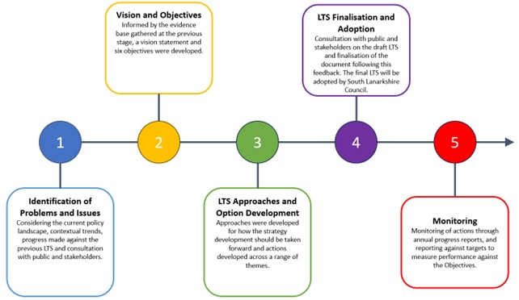
Figure 1: LTS Development Process

1.1.1 Problems and issues
In identifying the problems and issues to be addressed in the LTS, South Lanarkshire Council has taken account of the updated transport and planning policy landscape in Scotland.
As well as meeting the local transport needs of the people of South Lanarkshire, the LTS will consider and address the implications for transport in the wider regional context. South Lanarkshire shares its boundaries with seven neighbouring local authorities – Dumfries and Galloway, East Ayrshire, East Renfrewshire, Glasgow City, North Lanarkshire, Scottish Borders and West Lothian – and therefore the LTS gives consideration to cross-boundary issues and partnership opportunities.
This LTS has been produced in accordance with Transport Scotland’s latest guidance and its development has been subject to engagement and consultation. This LTS:
a) Replaces the previous LTS produced in 2013;
b) Sets out how South Lanarkshire Council will deliver on Scotland’s national transport objectives at a local level, and provides an Action Plan for meeting local challenges and objectives;
c) Guides partnership working, and influences the allocation of resources and funding;
d) Sets out where the LTS complements and supports other policies and strategies aimed at achieving common goals;
e) Supports the policies and aims of the Strathclyde Partnership for Transport (SPT) Regional Transport Strategy (RTS) (July 2023);
f) Supports the policies and aims of Scotland’s Second National Transport Strategy (NTS2) (Transport Scotland, 2020) and National Planning Framework 4 (NPF4);
g) Supports the policies and aims of the council’s Local Development Plan Two (LDP2) (2021), Community Plan 2022-2032, Sustainable Development and Climate Change Strategy 2022-2027 and the Council Plan known as “Connect” 2022-2027; and
h) Supports the policies and aims of a wide range of other local strategies as set out in Paragraph 1.3, including, for example, South Lanarkshire’s Park and Ride Strategy 2018-2027, Cycling Strategy 2015-2020 (and extended to 2023), Economic Strategy 2022-2027 and Digital Strategy 2022-2027.
In addition, it will inform preparation of the council’s next Local Development Plan (LDP3).

1.1.2 Strategic Environmental Assessment
The Environmental Assessment (Scotland) Act 2005 requires that all plans, programmes and strategies which are likely to have a significant environmental impact be subject to a Strategic Environmental Assessment (SEA).
In parallel with the production of the LTS, an Environmental Assessment of the Strategy has been undertaken in accordance with the provisions of the 2005 Act. This is an integral part of the decision-making process that has informed the policies identified within this LTS.
The SEA is a decision-making tool, used to inform the content of a qualifying plan or programme. It does not make the final decision but assesses all options against environmental considerations, which are taken into account when preparing a plan or programme. Where adverse impacts are apparent, the SEA will suggest relevant mitigation measures and introduce monitoring arrangements to assess the impact of the particular plan or programme, during its lifetime, on the environment.
The overall purpose of the LTS SEA is to identify, describe and evaluate the likely significant environmental effects that the LTS may have. SEA is also a transparent process as it clearly demonstrates how environmental considerations have been assessed.
Full details of the SEA of this LTS are contained in the accompanying document “The South Lanarkshire LTS 2026-2036 – Strategic Environmental Assessment: Environmental Report.”

1.1.3 Habitats Regulations Appraisal
A Habitats Regulations Appraisal (HRA) has been undertaken to identify potential impacts which could arise from transport infrastructure developments supported by this LTS.
The HRA sets out the requirement for a range of design and specific mitigation measures which should be adopted, alongside the implementation of general environmental protection mitigation measures. With these measures in place, together with the inclusion of policy protection in this LTS, the South Lanarkshire LDP2 and the National Planning Framework (NPF4), it is considered that transportation infrastructure developments of the type proposed within this LTS could be progressed without adverse effects on the integrity of European sites (including Special Areas of Conservation (SAC), Special Protection Areas (SPA) and Sites of Community Interest (SCI)).

1.1.4 Integrated Impact Assessment
This LTS has been subject to an Integrated Impact Assessment, which has incorporated the following:
- Equalities Impact Assessment (EqIA) including human rights’ considerations;
- Children’s Rights and Wellbeing Impact Assessment (CRWIA);
- Fairer Scotland Duty Assessment (FSDA); and
- Health Inequalities Impact Assessment (HIIA).
The assessment has considered sex, age, disability, race, religion / belief, gender reassignment, sexual orientation, pregnancy and maternity, and marriage and civil partnership as well as other relevant issues such as mental health and wellbeing. This assessment has been undertaken to ensure that actions identified within the LTS have a positive impact on different groups in society, including groups with protected characteristics, as defined by the 2010 Equality Act, children and young people, and those experiencing inequalities as a result of socio-economic disadvantage.
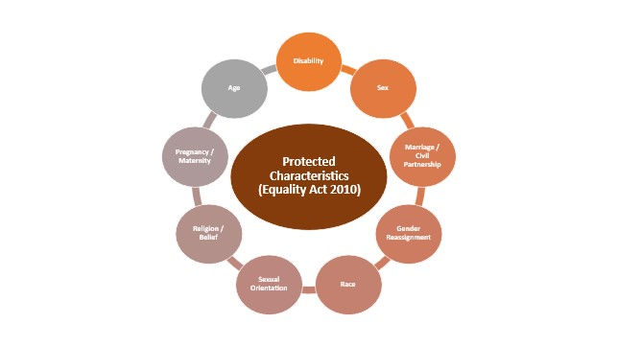
Figure 2 - Equality Act 2010: Protected Characteristics
The findings of the Assessment have been used to shape the LTS and associated Action Plan.

1.2 Roles and responsibilities

1.2.1 South Lanarkshire Council
South Lanarkshire Council has a duty to manage and maintain local carriageways, footways, footpaths, cycleways, structures, street lighting, traffic management systems and street furniture across the council area and has the power to improve infrastructure as necessary. The council also has responsibility for road safety and flood risk management.
The council’s multi-functional and multi-disciplinary Roads, Transportation and Fleet Services is responsible for the maintenance and management of 2,295 kilometres of carriageway; 2,425 kilometres of urban footway; 778 road bridges and other structures; winter maintenance; road safety; street lighting; flood risk management; geotechnical engineering; road and bridge design; parking management; development management; fleet management; road works control; and traffic and transportation engineering. The council also provides an emergency response to extreme weather events and other incidents affecting the road and active travel networks and undertakes improvement and maintenance projects.

1.2.2 Partnership with other organisations and operators
The council is committed to working in partnership with other organisations and operators who are responsible for delivering transport infrastructure and services.
The roles and responsibilities of the principal organisations responsible for transport infrastructure and services in South Lanarkshire are shown in Figure 3. In addition to these key organisations, the council works with many more to deliver and improve transport services in South Lanarkshire.
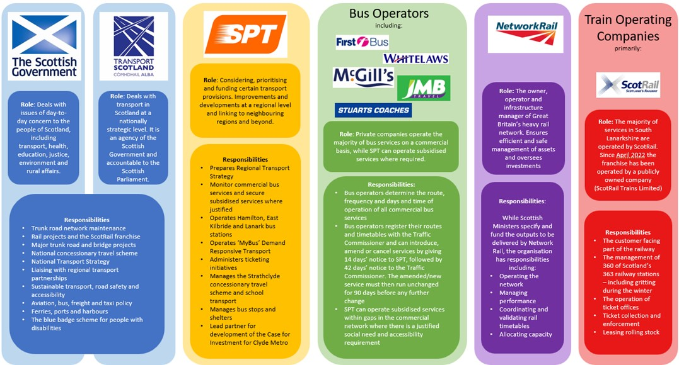

Figure 3 - Selected Transport Roles and Responsibilities

1.3 Policy linkages
The national, regional and local policy landscape has been reviewed as part of the development of this LTS. A selection of the key policies is summarised in Figure 4.
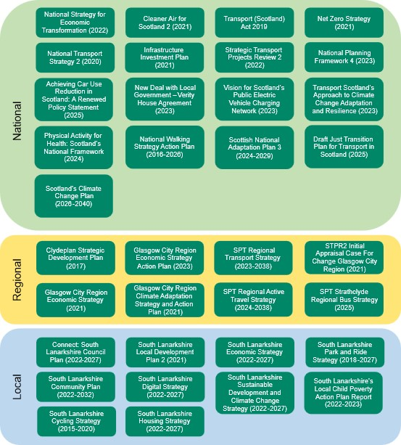
Figure 4 - Policy Landscape for South Lanarkshire’s Local Transport Strategy
The South Lanarkshire Cycling Strategy (2015-2020) is now incorporated into this LTS. A number of other policies and strategies have also been considered during the development of this LTS, including those pertinent to the SEA, HRA and IIA – these are detailed within the reporting of these assessments. In addition, the LTS will be a key component in the preparation of LDP3 in terms of informing the evidence report, developing policy responses on transport material and in the site assessment process.
The policy, planning and investment landscape focusses on an overarching and urgent imperative to address climate change and to achieve net-zero carbon by 2045. There is a focus on sustainable transport interventions that support the NPF4 and priorities of NTS2. Alongside this are the needs to improve health and wellbeing and implement ‘place’ principles. There is also a clear need to deliver inclusive economic growth and to reduce inequalities.

The Sustainable Travel Hierarchy, captured within NTS2, aims to prioritise interventions that increase the modal share of shorter everyday trips by walking, wheeling and cycling, short- to medium-length trips by public transport, and longer trips by rail and low emission vehicles. The Sustainable Investment Hierarchy, also captured within NTS2, notes that consideration should be given to reducing the need to travel unsustainably, maintaining and safely operating existing assets, and making better use of existing capacity, before proposing targeted infrastructure improvements. The Sustainable Travel Hierarchy and Sustainable Investment Hierarchy are shown in Figure 5.
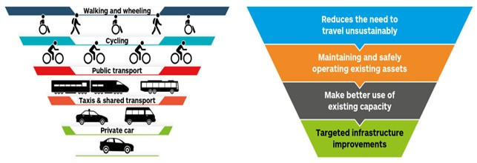
Figure 5 - Sustainable Travel Hierarchy and Sustainable Investment Hierarchy
This policy context provides a foundation on which the 2026-2036 LTS for South Lanarkshire has been developed.

1.4 Scheme development and delivery
This LTS provides an overarching framework for the development of policies and actions. However, it is noted that scheme development and delivery will be influenced and informed by numerous factors, most notably those listed below:
a) The availability of funding, either from the council or its partners;
b) The outcomes of community consultation;
c) Alignment with local, regional and national strategic objectives, the council’s own policies and priorities, and, where relevant, those of South Lanarkshire Council’s partners;
d) The outcomes of evidence-based scheme appraisal processes, such as those undertaken using Transport Scotland’s Scottish Transport Appraisal Guidance (STAG);
e) The outcomes of specific audits and assessments – such as Transport Assessments for new developments, road safety audits, cycle audits and pedestrian audits; and
f) Technical guidance and operational routines published and operated by specific Services within the council.

2 About South Lanarkshire
South Lanarkshire is located in the central belt of Scotland and straddles the upper reaches of the River Clyde, extending into the Southern Uplands.
It is the fifth largest local authority area in Scotland in terms of population (327,056 residents in the 2022 Census) and the 11th largest in terms of geographical area at 1,772 square kilometres, almost 80% of which is in agricultural use.
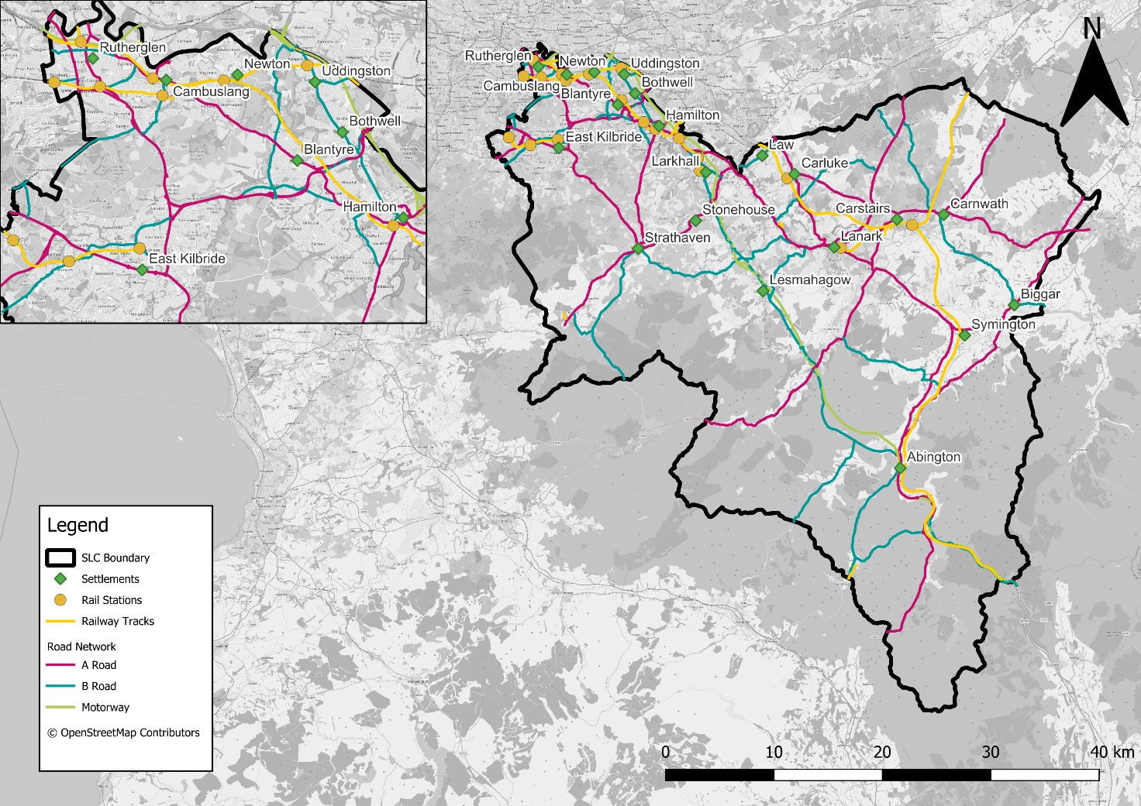
Figure 6 - South Lanarkshire Council Area
Together with the classified roads and rail network detailed in Figure 5, the below link displays the current cycle infrastructure throughout South Lanarkshire. This map includes cycle lanes and paths as well as the locations of trip-end facilities such as lockers, charging and parking. South Lanarkshire Cycle Routes Map
South Lanarkshire encompasses a mix of urban and rural areas covering four main areas:
- Clydesdale – represents the rural area and is characterised by farming in the Clyde Valley and uplands to the South;

- East Kilbride – in the north-west of the area and centres on the town, with farming communities in the landward area;

- Hamilton – including the settlements of Blantyre, Uddingston, Bothwell, Larkhall and Stonehouse; and

Rutherglen and Cambuslang – located in the north of the council area and close to the city of Glasgow.
South Lanarkshire is a diverse area, with heavily populated towns and extensive rural areas.
The diverse nature of South Lanarkshire presents distinct transport and access challenges across both urban and rural areas and these have been considered in the development of this LTS.

3. Background information, trends and issues
This Section provides an overview of key background context for this LTS, highlighting some of the key problems and opportunities within the local authority area as well as highlighting the differing needs of people within South Lanarkshire. This information has helped inform the identification of transport-related problems and opportunities that have informed the development of this LTS.

3.1 South Lanarkshire overview

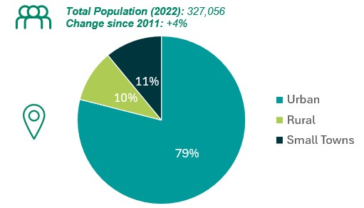
Figure 7 - Urban / Rural Population Proportions in South Lanarkshire
As shown in Figure 7, 79% of residents live in urban areas; 10% live in rural areas and 11% live in accessible small towns.

3.2 Deprivation and employment
20% of the 431 datazones of South Lanarkshire are within the lowest two deciles for overall deprivation across Scotland (most deprived 20%) as indicated by the Scottish Index of Multiple Deprivation (SIMD), whilst 17% of South Lanarkshire’s datazones are in the top two deciles (20% least deprived). This demonstrates that the proportion of deprivation across South Lanarkshire is broadly in line with Scotland as a whole.
The majority of the 20% most deprived zones are located within the north-west of the local authority area - in parts of Rutherglen, Cambuslang, Hamilton and Blantyre, with other clusters in Larkhall, Carnwath, Rigside and Carluke. Some areas, particularly those in the north-west part of South Lanarkshire, also record lower levels of deprivation, such as in parts of East Kilbride; as well as areas such as Uddingston and Strathaven. There is a mix of deprived areas within Rutherglen and Hamilton with some areas falling within the lower and others falling within the upper deciles.
The Business Register and Employment Survey (BRES) conducted by the Office for National Statistics (ONS) showed that there was a total of around 118,000 full or part time employees in work within South Lanarkshire in 2023. This does not, however, necessarily mean that all employees in South Lanarkshire are people who live in South Lanarkshire, as some may travel in from other council areas.

3.3 Transport and travel
The following statistics have been taken from the 2022 Census (where outputs are available at time of writing) and the Scottish Household Survey (SHS), which is an annual survey conducted by the Scottish Government containing information regarding transport and travel movements across Scotland. Note that no data was collected in 2020 due to the COVID-19 pandemic and its associated impacts. From the 2022 Census, overall mode of travel to work and car/van availability is presented. The 2023 Scottish Household Survey has been used to determine mode share for short journeys (for any purpose), access to a bicycle and overall satisfaction with public transport, between 2013 and 2023. It should be noted that due to the COVID-19 pandemic, transport patterns and behaviours changed substantially and therefore trends in transport from 2020 and 2021 may be anomalous rather than reflective of the overall trend in transport behaviour.

3.3.1 Travel to work
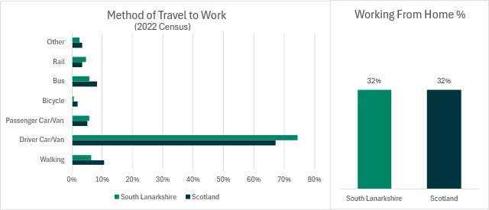
Figure 8 - Travel to Work Mode Choice, South Lanarkshire and Scotland 2022 (Source: 2022 Census)
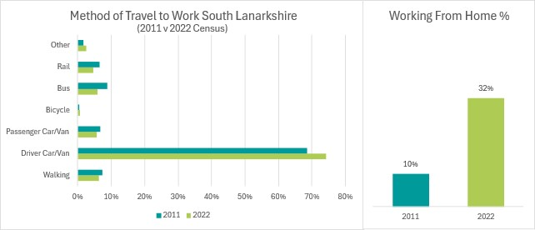
Figure 9 - Travel to Work in South Lanarkshire by 2011 and 2022 Comparison (Source: 2011 and 2022 Census)
Key points:
- 74% of journeys to work were made by car/van as a driver in 2022, this is higher than the Scottish average of 67%. Car/van mode share has increased in South Lanarkshire since 2011, however the actual number of people travelling by car to work has reduced as a result of a significant increase in working from home.

- Walking to work is lower in South Lanarkshire (6%) compared to the Scottish average (11%). The mode share of journeys to work by walking has decreased marginally since 2011.

- Cycling to work is lower in South Lanarkshire than the Scottish average and there has been little change observed between 2011 and 2022.

- Bus as the main mode of travel to work is lower in South Lanarkshire than the Scottish average. In South Lanarkshire, bus has experienced a decrease in mode share from 9% in 2011 to 6% in 2022.

- Rail as the main mode of travel to work has a higher share in South Lanarkshire than the Scottish average but has experienced minimal change since 2011.

- 60% of people who travel to work travel to a workplace destination in South Lanarkshire, with 19% travelling to Glasgow and 10% travelling to North Lanarkshire.

3.3.2 Travel for all journeys
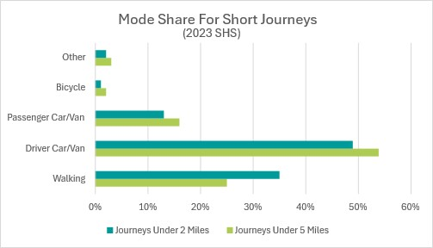
Figure 10 - Main Mode of Travel for All Journeys Under 2 miles and Under 5 miles in South Lanarkshire, 2023 (Source: SHS)
Figure 10 indicates that considering journeys for all purposes, those under two miles are most commonly undertaken by driving at 49%, compared to walking at 35%. The proportions for journeys under 5 miles are broadly similar with 25% of trips walked, compared to 54% driven.

3.3.3 Car/van and bike availability
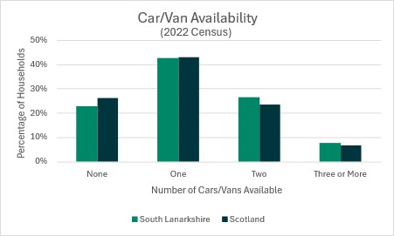
Figure 11 - Car Availability South Lanarkshire and Scotland, 2022 (Source: 2022 Census)

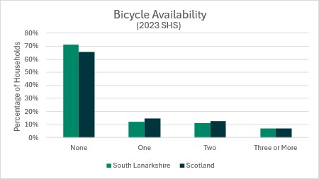
Figure 12 - Bike Availability South Lanarkshire and Scotland, 2023 (Source: SHS)
Key points:

- Car availability levels, by household, within South Lanarkshire are slightly higher than the national average with a greater proportion of households having access to more than two vehicles.

- Bike availability per household is lower in South Lanarkshire when compared to the national average.

3.3.4 Satisfaction with public transport
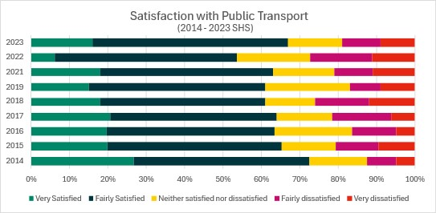

Figure 13 - Public Transport Satisfaction Rates South Lanarkshire, 2014 - 2023 (Source: SHS)

Key points:
- Satisfaction rates with public transport in South Lanarkshire have generally decreased since 2014 with a marked decrease in satisfaction levels in 2022, returning to stronger satisfaction levels in 2023.

- Dissatisfaction rates have fluctuated since 2014, peaking at 27% in 2022.

3.3.5 Distance travelled
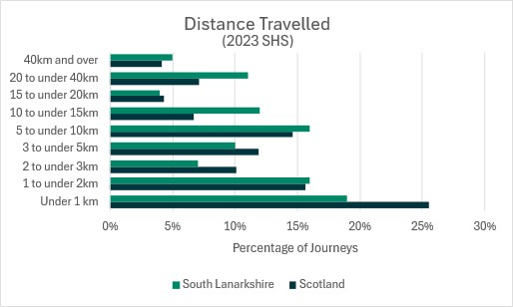
Figure 14 - Distance Travelled South Lanarkshire (Source: SHS 2023)
Key points:
- 52% of all trips made in South Lanarkshire are under 5 kilometres in length, with 68% under 10 kilometres.

3.4 Economic performance
Since the publication of the previous LTS in 2013, the Gross Value Added (GVA) - a measure of the value of goods and services produced in an area, industry or region of an economy given in June 2025 prices - per head of South Lanarkshire population peaked in 2023 at £25,048, continuing to recover from a dip in 2020. Prior to this, GVA per head in South Lanarkshire had seen overall sustained growth since 2013 with 2018 being the only year where GVA per head dropped (out-with the COVID-19 pandemic).
The GVA per head in South Lanarkshire is lower than the Scotland-wide figure (£25,049 compared to £33,419) and South Lanarkshire is also lower than the neighbouring local authorities of Glasgow City and North Lanarkshire, which have GVAs per head of £46,507 and £30,394 respectively.
Implementation of the policies and actions in this LTS, including improved access to economic centres and services, will support the economic potential of South Lanarkshire.

3.5 Health and wellbeing
Compared to Scotland as a whole, using ScotPHO Profiles, South Lanarkshire has a lower life expectancy and higher rates of asthma patient hospitalisations, emergency patient hospitalisations, deaths aged 15-44, and lower uptakes of bowel and breast screening. Whilst there has been an increase in the number of drug-related hospital admissions since 2008, the rate is lower than for Scotland overall, and South Lanarkshire also has higher rates of immunisation uptake at 24 months and better children’s dental health.
The results of the 2023 Scottish Surveys Core Questions (SSCQ) indicate that 24.1% of people in South Lanarkshire struggle with a limiting long-term physical or mental health condition, compared to 28% of the Scottish population.
Implementation of the policies and actions in this LTS will increase opportunities for active and sustainable travel with associated positive impacts on health and wellbeing South Lanarkshire.

4 Progress from the previous LTS
The outcomes and lessons learned from the implementation of the previous South Lanarkshire LTS have been used to shape the development of this updated LTS.
The previous LTS, produced in 2013, sought to provide a choice of alternative modes of transport to reduce dependency on the private car and encourage travel by sustainable modes. An Action Plan was developed to identify measures and initiatives to bring this forward.
A review has been undertaken of the progress made in delivering the Action Plan set out in the previous LTS. Further details can be found within Appendix A.

4.1 Maintenance and asset management
In 2021 the council developed a Corporate Asset Management Plan which outlines the range of council-owned assets including housing, property and roads. A revision to the Roads Asset Management Plan was also completed in 2023. Between 2008 and 2019 the council invested £126 million to improve our road network (including footways), with further investment of £47.9 million between 2019 and 2023.
95.9% of Category 2 safety defects were completed within agreed timescales. Category 2 safety defects require to be repaired within seven working days. These defects represent a medium risk to road users or a risk of short-term structural deterioration. Category 2 defects include potholes exceeding 50mm in all road categories of a size and location likely to cause loss of control; defective ironwork; unstable wires, trees and structures; and damaged or missing pedestrian fencing.

4.2 Road safety
SPT’s capital funding programme has supported the council’s long-established Accident Investigation and Prevention (AIP) Programme to deliver road safety interventions on over 30 strategic routes across South Lanarkshire’s regional road network, targeted on roads that historically have had accident rates above the national average or featured clusters of collisions with treatable factors. The type of infrastructure investment put in place has included improved signage, lining, hi-visibility verge markers and upgraded high friction surfacing.
Our investment has contributed towards a continual reduction in road traffic casualties with the 2019-2023 5-year average the lowest ever number of casualties recorded, representing a 43% reduction compared to the 2014-2018 target baseline used within the Scottish Government’s Road Safety Framework 2020-2030. This reduction is likely linked (at least in part) to the impact of lockdown restrictions associated with the COVID-19 pandemic.
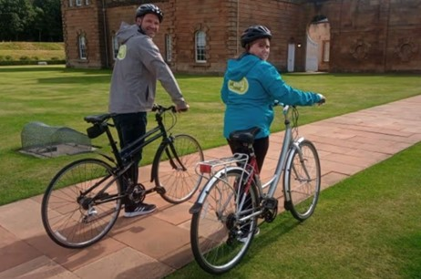
Photo 1 - Bikeability Scotland – Chatelherault Country Park
The council promotes the Junior Road Safety Officer scheme, Living Streets Walk Once a Week and Travel Tracker scheme, Living Streets National Walk to School Week, Walk Wheel Cycle Trust, ‘Big Walk and Wheel’ Challenge and Bikeability Scotland Cycle Training. Working in partnership with Police Scotland and the Scottish Fire and Rescue Service, the council supports and promotes national road safety campaigns including those focussing upon speed, motorbikes, fatigue, drink/drug driving, vulnerable road users and seatbelts.
Overall, our approach to casualty reduction has been industry recognised with South Lanarkshire Council being the winner of the ‘most effective road safety, traffic management and enforcement’ category as part of the Scottish Transport Awards 2022.

4.3 Economy

4.3.1 Transport assessments
Transport Assessments consider the accessibility of developments by all modes of transport, focusing on public transport, walking, wheeling and cycling as well as the road network. The council has ensured all submitted Transport Assessments continue to be audited in line with national and council guidance, where the threshold requires.

4.3.2 Travel plans
Travel plans encourage modal shift from the use of the private car to more sustainable modes. The inclusion of a dedicated Travel Plan Framework chapter within Transport Assessments for larger developments has ensured residents of new developments are informed of bus and train times and the provision of footways and cycleways in the area.

4.3.3 Traffic Regulation Orders
As part of the Statutory Traffic Regulation Order (TRO) process, a dedicated section of the South Lanarkshire Council website has been developed to enable members of the public to access details of all current and ongoing TROs.

4.3.3 Road scheme development
Four of the six road schemes identified to be developed by the council have been progressed: the Cathkin Relief Road opened in February 2017; sections of the Downiebrae Road Upgrade (forming part of the Clyde Gateway Regeneration Project) have been completed; A726 and Greenhills Road, East Kilbride widening opened in July 2022; and A71 / B7011 Junction Improvements opened in November 2022. The remaining two road schemes – Stewartfield Way Enhancement and Lanark Gyratory (Lanark Town Centre Circulatory System) – are progressing and are at Outline Business Case and Option Generation stage, respectively.
The council has also supported Transport Scotland in the development and delivery of the M8 / M73 / M74 Improvements at Raith Interchange.

4.4 Sustainable transport

4.4.1 Walking, wheeling and cycling
Funding from various bodies such as the Scottish Government (Cycling, Walking, Safer Routes), SPT and Walk Wheel Cycle Trust has been invested in the active travel network in South Lanarkshire over the last 10 years as part of a bid to increase the uptake of active travel.
The cycle network has been extended through construction of new schemes including sections of National Cycle Network (NCN) 74 between Uddingston and Larkhall via Hamilton, Lesmahagow and Blantyre; NCN 75 in Uddingston; and NCN 756 between East Kilbride and Glasgow.
There has been a continued delivery of the East Kilbride Cycle Network and the Bothwell / Uddingston Cycle Network, which involves the re-routing of NCN 74 through Bothwell and upgrading of existing sections of the route, as well as the implementation of cycle counters and cycle parking shelter facilities at various locations across the council area.

Active Travel Studies have been compiled for all major settlements in South Lanarkshire. These include aspirational active travel networks linking key destinations, towns and villages. These studies will form the basis for future identification and investment in the cycle network over the lifetime of this LTS.
The council has implemented on-street cycle parking facilities at 28 locations across South Lanarkshire which are accessible for members of the public and has commissioned feasibility studies for the provision of cycle hire schemes in Cambuslang and Rutherglen.
The council has supported partners to develop the Cambuslang Green Network greenspace masterplan to provide new opportunities for active travel, corridors for wildlife and an overall improvement to the environment of Cambuslang.
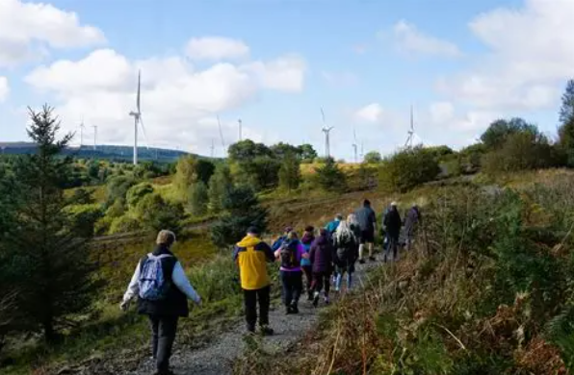
Photo 2 - New off-road walking routes, Coalburn

4.4.2 School travel
In 2024, 83 schools had implemented school travel plans and a further 55 had plans in development. These aim to support, develop or encourage children, parents and staff to choose safe, active and sustainable modes of travel and have contributed to approximately 55% of South Lanarkshire pupils travelling in an active and sustainable way.

4.4.3 Public transport
The council has received year-on-year funding from SPT for investment in bus infrastructure across the council area.
The council has implemented new and improved bus stop infrastructure, including new shelters, Real-Time Passenger Information Systems (RTPI) and high access kerbs, on various bus corridors, for example Stonelaw Road and Fernhill Road, Rutherglen. The council has introduced bus priority at 58 strategic junctions in Hamilton, Cambuslang, Rutherglen and Blantyre. In addition, a new bus turning circle area at Belstane Gate in Carluke was completed in 2022, which enables buses to manoeuvre safely at the start / end of the service route in this residential area.
Since 2013 SPT has provided funding towards the development, design and delivery of Park and Ride facilities in Newton, Carstairs, Cambuslang and Lanark. The council has developed a Park and Ride Strategy (2018-2027) to prioritise the introduction of Park and Ride facilities across the council area.
The council has been working with Transport Scotland, Network Rail and SPT to help deliver parts of the East Kilbride Rail Enhancement project. This will see the provision of interchange, active travel and parking facilities at a new Hairmyres Station. In addition, new active travel connections have been made to the new station building at East Kilbride Station.

4.4.4 Electric vehicle charging
The council has installed 153 electric vehicle chargers across South Lanarkshire which include a combination of standard, fast and rapid chargers.
In line with the Supplementary Planning Guidance on Electric Vehicle Charging Points, and facilitating a Just Transition, the council has ensured that all new developments within South Lanarkshire include electric vehicle infrastructure as a requirement for granted planning permission.

4.5 Environment

4.5.1 Air quality
Improvements in air quality have been recorded in recent years. The council has revoked all Air Quality Management Areas (AQMAs) which were formerly in place in Lanark, Rutherglen and Whirlies Roundabout.

4.5.2 Flood risk management plans
The council supported the development and publication of Local Flood Delivery Plans for Clyde and Loch Lomond and Tweed in 2019.
Throughout the previous Strategy a number assessments / studies have been undertaken. These include Cathkin Braes, Cityford Burn, Crossford, Lammermoor, Symington, Glen Doll East Kilbride, Carluke, Lamington and the River Clyde.
In addition, there have been numerous drainage investigations / repair and flood alleviation projects as well as works other improvement works across South Lanarkshire. Also, the council monitors watercourse / culverts and has undertaken maintenance to these.

4.5.3 Lighting
All our streetlights have been converted to LED. Of the 61,492 units, 54,616 are dimmed (set to 70% power between 00.00 hrs and 06:00 hrs), 5,965 are dimmable (to whatever the council choose) and 911 are part of a Central Management System which facilitates remote reporting and control.

5 The need for change

5.1 Introduction
Having a robust transport network is required to support priorities set out in the NTS2 and SPT’s RTS; including priorities to address the climate emergency, to support economic growth, to reduce inequalities and to improve people’s health and wellbeing / quality of life. Transport has an important role to play in achieving these priorities and is vital to improve access to a range of services and key sites, including employment, healthcare and leisure. Transport also has a role to play in supporting economic growth and to help revitalise town centres across South Lanarkshire.
This Section sets out the need for change to the ways in which we travel and how sustainable transport has a large role to play in helping South Lanarkshire meet its legislative requirement to contribute to the national greenhouse gas reduction target of net-zero by 2045.

5.2 Climate emergency
In October 2025, South Lanarkshire Council declared a Climate Emergency in the face of overwhelming evidence that human activity is a driving factor in climate change. The policy landscape has therefore evolved since the previous LTS was published in 2013, with a strong emphasis on reducing carbon emissions. South Lanarkshire Council’s Sustainable Development and Climate Change Strategy sets out how South Lanarkshire can contribute towards this through areas such as waste management, housing strategy, development planning, local transport planning, countryside and greenspace management, air quality and environmental protection. There is also a large role for individuals to play, including through the way in which we travel.
Section 1 provides details of the policy landscape, including reference to the Sustainable Investment Hierarchy and Sustainable Travel Hierarchy. These are captured in the NTS2 and set out the prioritisation of sustainable modes such as walking, wheeling, cycling, bus, rail, shared transport and taxis above travelling by car and a focus on investment to reduce the need to travel unsustainably. It is recognised that non-transport approaches such as spatial, mobility and digital can also reduce or minimise the need to travel.
The NTS2 clearly articulates the need for change in transport provision in Scotland and includes four Priorities that underpin the Vision, namely to: Reduce inequalities; Take climate action; Help deliver inclusive economic growth; and Improve our health and wellbeing. The Priority to take climate action is underpinned by three outcomes:
- Will help deliver our net-zero target;
- Will adapt to the effects of climate change; and
- Will promote greener, cleaner choices.
South Lanarkshire Council’s Sustainable Development and Climate Change Strategy includes improving affordable, sustainable and accessible transport options as a priority, recognising that in 2023 transport was the single biggest contributor to greenhouse gas emissions in South Lanarkshire, producing 38% of all emissions in the area. The focus on addressing climate change is therefore a key objective for this LTS which will support wider efforts in addressing climate change.

5.3 Adapting to climate change
South Lanarkshire and Scotland as a whole already experience the impacts of climate change, with warmer summers, wetter winters and generally more severe and less predictable weather conditions. Specific risks to transport include increased flood risks and landslides. As such, there is a need for infrastructure to adapt to the changing climate whilst continuing efforts to reduce carbon emissions. The Scottish Government funds Adaptation Scotland, which provides advice and support to help Scotland be prepared and resilient to the effects of climate change.
There is a need to ensure all transport infrastructure is resilient to weather-related disruption caused by climate change. Without taking action to adapt to the effects of climate change, the transport network will be more vulnerable to the deterioration of assets, disruption to networks and potentially hazardous incidents that may cause fatalities or serious injuries.

5.4 Changing travel behaviour
Travel to Work statistics from the 2022 Census demonstrate that car (as a driver) was the most popular mode of travel in South Lanarkshire by a significant margin in 2022, accounting for 74% of journeys; this is higher than the 67% mode share for all of Scotland. This compares to 6% mode share for bus, 5% for rail, 6% for walking and 1% for cycling.
Measures to encourage behaviour change include interventions such as free bus travel for under-22s, prohibition of pavement parking, free cycles for school children that cannot afford them, introduction of Low Emission Zones and investment in the rail network.
There can be a multitude of benefits associated with travelling by sustainable modes, including those related to health, socio-economic factors, reduced congestion and improved air quality. Whilst high quality infrastructure is a vital element to ensure sustainable modes are accessible, having support in place that allows people to change travel behaviour is also key. It is therefore important to ensure that sustainable modes are easy to use, affordable and attractive for people to use, thus supporting modal shift.
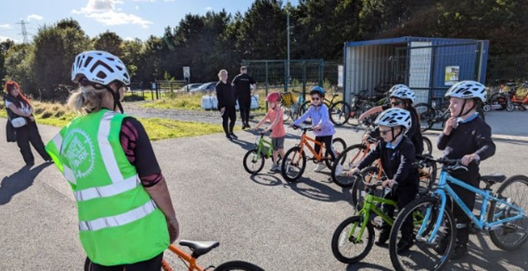
Photo 3 - Clyde Cycle Park, Cambuslang

6. Consultation
Consultation has been key in supporting the development of this LTS, with consultation findings directly informing the themes, which in turn shaped the policies and actions which sit within this LTS.
The consultation took several forms, as outlined below.

6.1 Identifying problems, issues and opportunities
During the period between July and September 2023, a consultation exercise was undertaken to gather feedback on the key problems, issues and opportunities relating to transport and access in South Lanarkshire that the new LTS should seek to address.
This feedback has shaped the Vision Statement, Objectives and Indicators for the strategy.

6.1.1 Stakeholder engagement
Stakeholder engagement was undertaken via facilitated online workshops with:
- South Lanarkshire Council Elected Members (local Councillors).
- Key Stakeholders, including representatives from SPT, Walk Wheel Cycle Trust, Police Scotland, NHS Lanarkshire and departments from across South Lanarkshire Council.

6.1.2 Online survey
The online survey was promoted through the council’s website and social media platforms, and posters were displayed in libraries across South Lanarkshire. A link to the survey was shared with Members of the Scottish Parliament (MSPs), Members of Parliament (MPs), Elected Members, community groups, business groups, tourism groups, transport operators, active travel groups / organisations, health providers, education providers, enterprise networks, emergency service providers, neighbouring authorities, community planning and disability and other vulnerable user groups, and others.
This was aimed at gathering feedback from stakeholders and members of the public on problems, issues and opportunities and views on transport and access themes that should be considered within the new LTS. Copies of the survey in other languages or formats (including hard copies) were available on request.
A total of 1,035 survey responses were received.

6.1.3 Website and e-mail
Information about the consultation and a link to the online survey was made available on a dedicated section of the South Lanarkshire Council website, throughout the duration of the four-week consultation period.
Dedicated e-mail and postal addresses were provided to enable the public and others to participate directly in the consultation. Both the survey link and e-mail address were used on all correspondence and other materials relating to the LTS.

6.1.4 Consultation feedback
Analysis of survey returns, both written and online show that:
- Respondents felt that the frequency and provision of public transport (37.2%), reliance on private car for small journeys (14.0%) and personal safety concerns when travelling (9.3%) are the main pressures currently affecting transport within South Lanarkshire.
- The biggest opportunities respondents identified for transport were reducing emissions (17.6%), demand responsive transport (16.4%) and increasing awareness of active travel benefits (16.2%).
- Increased support for public transport (23.2%), better maintenance of the road network (17.1%) and an improved local bus network (11.2%) were identified by respondents as the most important factors that should be considered for the LTS to address.
- More opportunities and facilities for cyclists (18.6%), increasing the number of low emission vehicles used by the council and its partners (14.7%) and more opportunities for people walking (12.2%) were identified by respondents as the least important factors that should be considered for the LTS to address.
- Respondents felt that improved infrastructure (41.2%), more traffic free routes (8.9%) and better lighting (8.8%) would encourage people to walk more often in South Lanarkshire.
- Respondents felt that improved infrastructure (34.6%) and better road conditions (24.1%) would encourage people to cycle more often in South Lanarkshire.
- Respondents felt that more frequent services (39.9%), improved reliability (15.0%) and lower fares (13.4%) would encourage more people to travel by public transport.
- Supporting local E-Bike hire schemes (28.1%) was the most important factor identified by survey respondents in encouraging use of e-bikes and e-cargo bikes in both rural and urban communities. Providing financial incentives or support (19.0%) was also a key factor identified.
- When asked about initiatives the council is trialling or considering, respondents supported greater publicity about scheduled road maintenance (62.2%), Mobility Hubs in key locations where various types of transport, and potentially other services, inter-connect (55.7%) and greater publicity about winter road maintenance (51.4%) most frequently.

6.2 Draft LTS Consultation
A second round of consultation was undertaken in winter 2025 in order to support the finalisation of this LTS. This consultation sought feedback on the Vision Statement, themes, policies and actions of the strategy. A total of 126 responses were received to the online survey.
This round of consultation also sought written responses from a number of stakeholders. A total of 18 responses were received from a range of stakeholders including community councils, public transport operators, neighbouring local authorities and internal stakeholders within South Lanarkshire Council.
The responses received from this consultation directly informed the finalisation of this LTS.
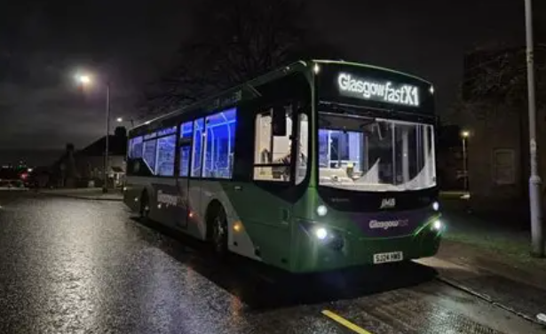
Photo 4 - Provision of public transport is a main concern for South Lanarkshire residents

7. Vision statement and objectives
Our vision builds on the themes developed through the previous LTS and reflects the views and priorities expressed by the community during consultations. It has also been informed by a review of problems, issues and opportunities and policy context relating to South Lanarkshire. The new vision statement details what the council is aiming to achieve, whilst having regard for the funding challenges facing the council and the need to focus on core activities.

7.1 Vision
The Vision Statement for this LTS is as follows:
Our transportation network will support net-zero carbon emission targets and make it easier to move around by sustainable modes, helping to support improved health and wellbeing. It will be accessible, affordable and integrated and provide strengthened connectivity for urban and rural areas and increase the attractiveness of South Lanarkshire as a place to live, visit, work, study and invest. All transport infrastructure operated and maintained by South Lanarkshire Council will be well maintained, safe to use and support sustainable economic growth.

7.2 Objectives
The following objectives have been developed through analysis of the issues identified through local knowledge, and a number of consultations and surveys which are described in more detail in Section Six. They have been designed to link seamlessly with the aims and objectives of other key local strategies, as well as the local, regional and national policy drivers identified in Section One.
1. Improve access for all to education and employment opportunities and key services in urban and rural areas of South Lanarkshire, facilitating social inclusion
2. Ensure that South Lanarkshire is well-connected and integrated, to support inclusive and sustainable economic growth
3. Ensure that the transport network and assets are resilient, responsive to the effects of climate change, and are well maintained
4. Improve the safety of South Lanarkshire’s transport network through a reduction in the number and severity of accidents
5. Support decarbonisation of the transport network, including through mode shift, reducing the need to travel and support for shared mobility practices
6. Improve the health and wellbeing of South Lanarkshire residents through the facilitation and encouragement of walking, wheeling and cycling.
A set of indicators has been developed to assist in monitoring the LTS and the extent to which objectives have been achieved. Monitoring and evaluation indicators are set out in Section 19.

8. Potential LTS approaches
There are many possible alternative transport strategies that could be pursued within South Lanarkshire to address the demands of the various disparate stakeholder groups. As with the previous LTS, different strategy approaches have been considered and these are summarised within Figure 15.

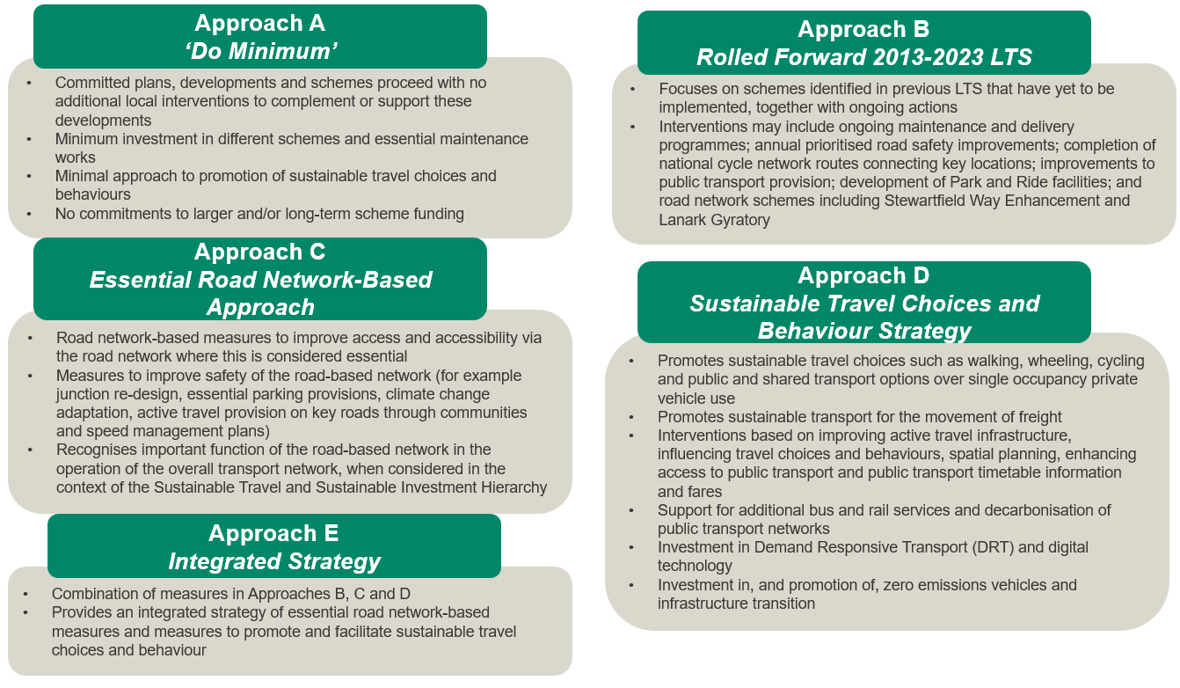
Figure 15 - Potential Strategy Approaches
These potential strategy approaches have undergone a high-level appraisal using the broad principles of Transport Scotland’s STAG. This process has involved consideration of each of the different approaches against the LTS objectives, the Government’s five key objectives (Environment; Climate Change; Health, Safety and Wellbeing; Economy; and Equality and Accessibility), and the likely feasibility, affordability and public acceptability of each approach.
On balance, an Integrated approach has been identified as most appropriate for the updated LTS. This approach would build upon the Rolled Forward 2013-2023 LTS approach which generally addresses each of the LTS objectives. An Integrated approach would further emphasise the importance of sustainable transport and access, including travel choices and awareness, to deliver environmental, economic, health, safety and wellbeing, and wider societal benefits. In addition, an Integrated approach recognises that the road network has an important function in the operation of the overall transport network, when considered in the context of the Sustainable Travel Hierarchy and Sustainable Investment Hierarchy, and takes cognisance of the role of road network-based interventions where this is considered essential. An Integrated approach therefore provides a balanced approach to improve transport and access across South Lanarkshire.
The implementation of an Integrated approach would address the LTS objectives and would address many of the key concerns raised during the consultation process. In addition, it would contribute to the Government’s five key objectives and align with the current policy landscape.

Table 1 - Outcome of High-Level Appraisal of Potential LTS Approaches
Objective |  | Approaches
 |  | Rolled Forward 2013-2023 LTS | Essential Road Network-Based Approach | Sustainable Travel Choices and Behaviour Strategy | Integrated Strategy
LTS Objectives | Objective 1: Improve access for all to education and employment opportunities and key services in urban and rural areas of South Lanarkshire, facilitating social inclusion | ✓ | ✓ | ✓✓ | ✓✓✓
LTS Objectives | Objective 2: Ensure that South Lanarkshire is well-connected and integrated, to support inclusive and sustainable economic growth | ✓✓ | - | ✓✓ | ✓✓✓
LTS Objectives | Objective 3: Ensure that the transport network and assets are resilient, responsive to the effects of climate change, and are well maintained | ✓ | ✓ | ✓✓ | ✓✓✓
LTS Objectives | Objective 4: Improve the safety of South Lanarkshire’s transport network through a reduction in the number and severity of accidents | ✓ | - | ✓✓ | ✓✓✓
LTS Objectives | Objective 5: Support decarbonisation of the transport network, including through mode shift, reducing the need to travel and support for shared mobility practices | ✓ | ✗✗ | ✓✓ | ✓✓✓
LTS Objectives | Objective 6: Improve the health and wellbeing of South Lanarkshire residents through the facilitation and encouragement of walking, wheeling and cycling. | ✓ | - | ✓✓✓ | ✓✓✓
Scottish Government Appraisal Criteria | Environment | ✓ | ✗✗ | ✓✓ | ✓✓✓
Scottish Government Appraisal Criteria | Climate Change | ✓ | ✗ | ✓✓ | ✓✓✓
Scottish Government Appraisal Criteria | Health, Safety and Wellbeing | ✓ | - | ✓✓✓ | ✓✓✓
Scottish Government Appraisal Criteria | Economy | ✓✓ | - | ✓✓ | ✓✓
Scottish Government Appraisal Criteria | Equality and Accessibility | ✓✓ | ✓ | ✓✓✓ | ✓✓✓

9. Maintenance and asset management

9.1 Responsibilities
The council has a statutory duty, under the Roads (Scotland) Act to manage and maintain the local public road network, and a statutory duty under the Road Traffic Regulation Act 1984 to secure the convenient and safe movement of vehicular and other traffic (including pedestrians). Within South Lanarkshire, the local authority road network comprises 268 kilometres of A-class roads, 247 kilometres of B-class roads, 444 kilometres of C-class roads and 1,318 kilometres of unclassified roads. 1,082 kilometres of the road network is located within rural locations, and 1,213 kilometres is within urban settings. There is 209 kilometres of on-road cycle route across South Lanarkshire.
Activities undertaken as part of Network Maintenance and Asset Management are:
- Asset management (including structural, routine and cyclical maintenance);
- Winter service;
- Street lighting;
- Traffic management;
- Management of roadworks;
- Bridges and structures; and
- Network safety inspections and repairs.

9.2 Asset management
Asset management is widely accepted as a means to deliver a more efficient and effective approach to management of highway infrastructure assets through longer-term planning and ensuring that levels of service are defined and achievable for available budgets. It supports making the case for funding, for better communication with stakeholders, and facilitates a greater understanding of the contribution highway infrastructure assets make to economic growth and social well-being of local communities. In order for asset management to remain effective, it will be required to adapt to the effects of climate change. South Lanarkshire Council follows established asset management processes regarding the scheduling and communication of asset repairs and renewals.
The roads asset is the single biggest asset that the council owns and has a gross replacement cost of £4.629 billion, as of March 2023. The roads asset is made up of the following major elements: carriageway; footway, footpath and cycleway; structures; street lighting; traffic management systems; and street furniture – vehicle safety fencing.
The level of service is driven by available budget, each activity being assessed annually and prioritised on the basis of greatest need, taking into account the council’s statutory requirements and Community Planning themes.
The definition of asset management adopted by South Lanarkshire Council is that contained within the Well-Managed Highway Infrastructure Code of Practice:
“Asset management is a means to deliver a more efficient and effective approach to management of highway infrastructure assets through longer-term planning and ensuring that levels of service are defined and achievable for available budgets. It supports making the case for funding, for better communication with stakeholders, and facilitates a greater understanding of the contribution highway infrastructure assets make to economic growth and social well-being of local communities.”
This definition embodies the key principles of asset management:
- Strategic Approach – a systematic process that takes a long-term view.
- Whole of Life – the whole-life/life-cycle of an asset is considered.
- Optimisation – maximising benefits by balancing competing demands.
- Resource Allocation – allocation of resources based on assessed needs.
- Customer-focused – explicit consideration of customer expectations.
Although asset management introduces new practices it does not replace existing good practice. Instead, it provides the overall framework and logic within which existing good practice may be more effectively applied and enhanced by new practices.
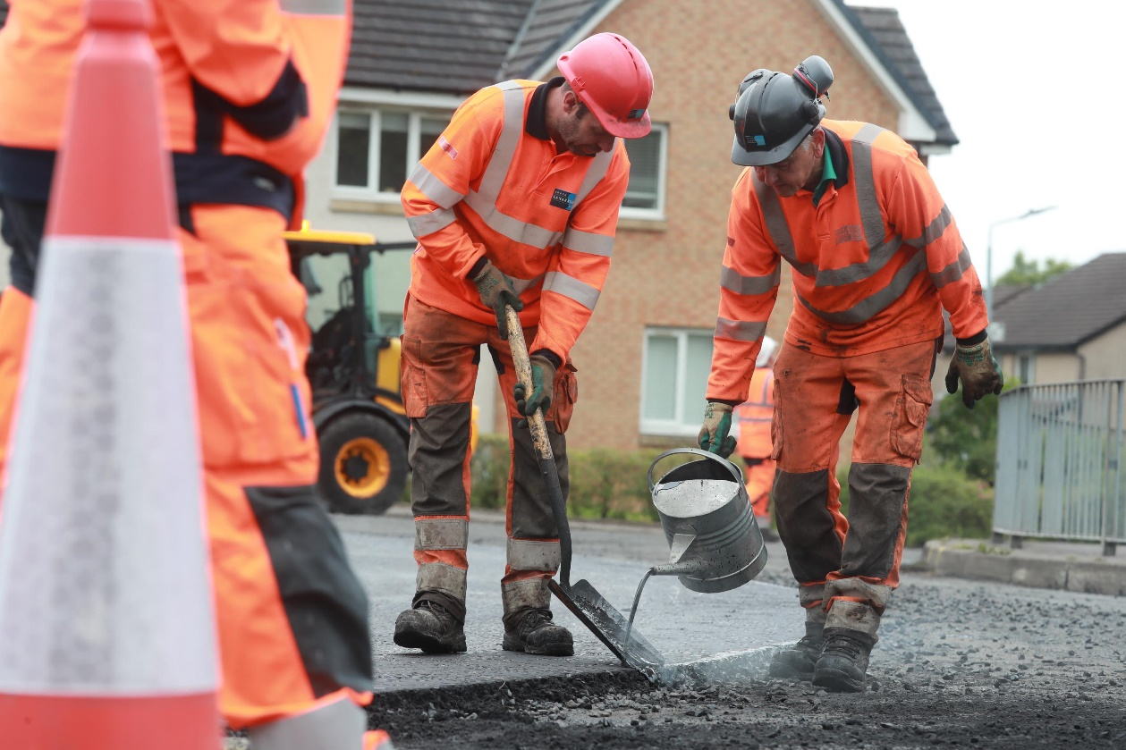
Photo 5 - Carriageway resurfacing
South Lanarkshire Council’s Roads Asset Management Plan (RAMP) (2024) sets out the council’s approach to asset management, including an objective assessment of the maintenance requirements of the network and the level and balance of funding and resources that best meets needs. This includes the adopted road network (2,295 kilometres), urban footway (2,425 kilometres); cycle paths (89 kilometres off-road and 209 kilometres on-road), 778 road bridges, footbridges, culverts and cattle grids; 242 sets of traffic signals and controlled pedestrian crossings; 67,091 street lighting units; and 515 vehicle restraint systems.
As part of the development of the RAMP, the council has created Life Cycle Plans to document how the major asset groups that make up the road infrastructure are managed. Each Life Cycle Plan provides definition of the standards that are applied to the management of the asset group in question and details of the processes that are used to ensure that these standards are delivered.
Production and updating of these Life Cycle Plans enables local knowledge and the knowledge of key individuals to be captured, shared and developed. At this stage, only the major asset groups, such as carriageways, footways, footpaths and cycleways, structures and street lighting have a full Life Cycle Plan.
The output from the Life Cycle Planning process is a long-term prediction of the cost of the continued management and operation of the asset in question. These are in the form of financial projections and are linked to target levels of service.
Within the lifetime of this LTS, the council will pursue the following policies and actions in relation to asset management and maintaining the existing roads-based network:
Policy P1 – The council will seek to inspect and maintain footways, cycleways and roads infrastructure in a safe condition in accordance with the Roads Asset Management Plan.
Policy P2 – The council will explore ways to enhance the level of investment available for maintenance of assets and infrastructure across all modes and will seek new funding sources to upgrade and move towards low carbon assets where appropriate.
Policy P3 – The council will seek to reduce the volume of and cost of public liability claims.

Action A1 – Provide prioritised maintenance of footways, cycleways and roads infrastructure.
Action A2 – Implement the Roads Asset Management Plan for footways, cycleways and road and footway improvements.
Action A3 – Prioritise and undertake repairs to reported road defects.
Action A4 – Continue to invest in new technology with respect to maintenance techniques, to improve output, quality, health and safety and sustainability.

9.3 Traffic signals and pedestrian crossings
Traffic signals and controlled pedestrian crossings are used to assign vehicular (including cyclist) and pedestrian priority at locations where there are heavy traffic flows or where they will reduce accidents. They can improve safety, reduce congestion and maximise the capacity of junction approaches.
South Lanarkshire Council is responsible for 242 sets of traffic signals and controlled pedestrian crossings.
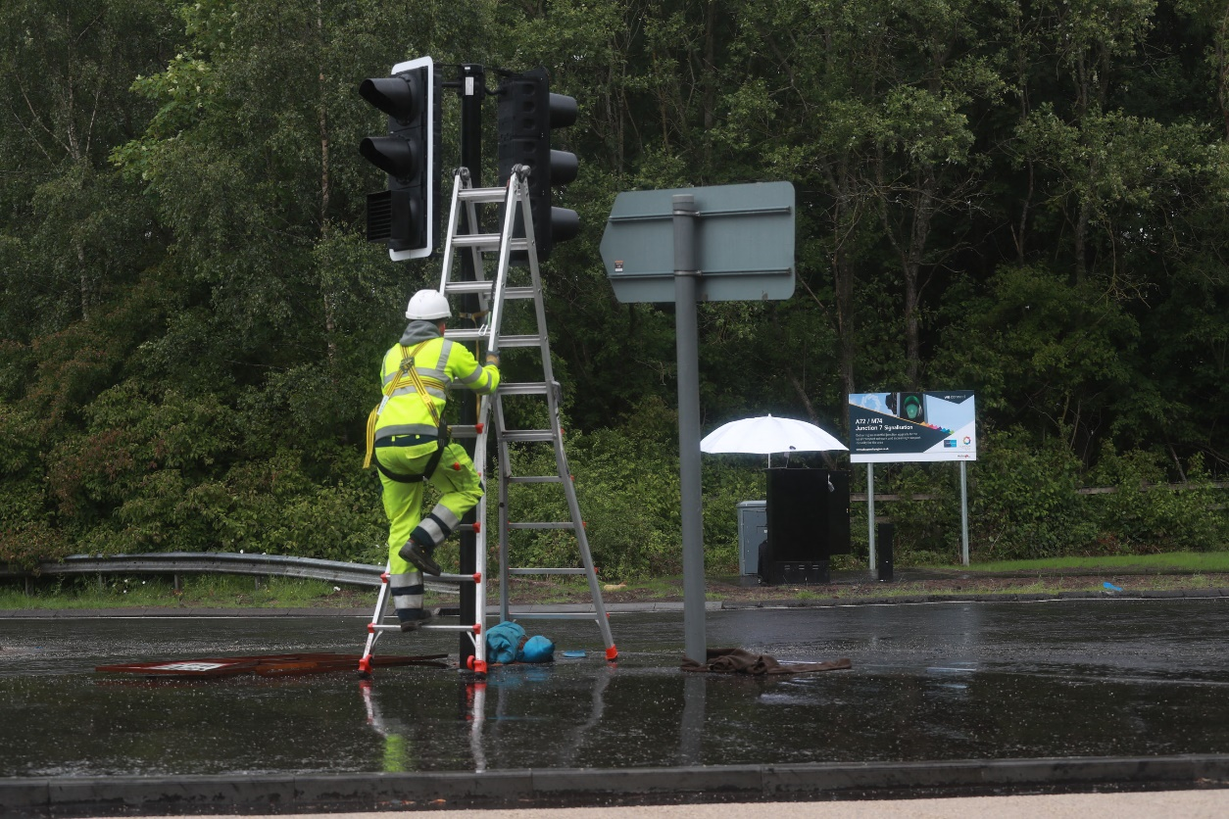
Photo 6 - Traffic signal installation, Larkhall

In recent years the council has undertaken a comprehensive refurbishment programme to bring traffic signals and pedestrian crossings up to the latest standards, including the use of low voltage LED signal heads. Urban Traffic Control Systems such as Split Cycle and Offset Optimisation Technique (SCOOT) and Microprocessor Optimised Vehicle Actuation (MOVA) have also been introduced to manage and control traffic signals in more urban areas. These are adaptive systems that respond automatically to fluctuations in traffic flow through the use of on-street detectors embedded in the road.
South Lanarkshire Council monitors performance to ensure a high-quality service. Inspections and tests on the electrical network are carried out every six years, and inspections of traffic signals are undertaken annually, depending on location.
Where appropriate, the council will start to utilise FUSION software. This is a completely new intelligent adaptive traffic control application that uses data from multiple sources and new advanced decision-making approaches to control and optimise the road network. This provides the user with greater levels of control to optimise traffic flows for the benefit of all road users including pedestrians, cyclists, and public transport.
The council will pursue the following policies and actions in relation to traffic signals and pedestrian crossings:
Policy P4 – Continue to invest in traffic management systems and traffic signals infrastructure and seek new funding sources to upgrade and move towards low carbon assets.
Policy P5 – Ensure that a high-quality traffic signal maintenance system is in place to ensure the safe operation of junctions and pedestrian / cycle crossings.
Policy P6 – Prioritise the replacement of outdated equipment and installations by means of a criteria-based scoring system.
Policy P7 – Improve walking and cycling facilities at traffic signals and carriageway crossings, including detection for cyclists and improving crossing facilities for disabled users, where appropriate.
Policy P8 – Identify and implement suitable Intelligent Bus Priority at signalised junctions to minimise bus journey times and improve their reliability.
Action A5 – Annual programme of traffic signal improvements, as resources permit.
Action A6 – Ensure that traffic signal faults are responded to within the set timescales and monitor our performance in meeting these timescales.
Action A7 – Provide regular maintenance inspections for all traffic signal infrastructure.

9.4 Winter / adverse weather
The council has statutory responsibilities under Section 34 of the Roads (Scotland) Act 1984 to take such steps as it considers reasonable to prevent snow and ice endangering the safe passage of pedestrians, cyclists and vehicles over those local roads for which it has responsibility. This includes carriageways, footways, and main pedestrian routes within town centres. The council:
- Has 2,295 kilometres of road within South Lanarkshire;
- Treats 48% of the council road network on a precautionary basis before frost/freezing;
- The hierarchy is designed to ensure that all the strategic routes through South Lanarkshire remain open;
- Has 2,425 kilometres of footway within South Lanarkshire;
- Treats 4% of the council footway network on a precautionary basis;
- Has approximately 3,100 salt bins sited on the network;
- Does not treat the remainder of the carriageway or footway network on a routine basis;
- Has 34,100 tonnes of salt under cover;
- Uses 34,000 tonnes of salt during an average winter;
- On average the council treats the precautionary carriageway network 195 times per winter, and the precautionary footway network 91 times per winter; and
- Has nine weather stations that assist the council’s weather forecast provider in forecasting road temperature and condition.
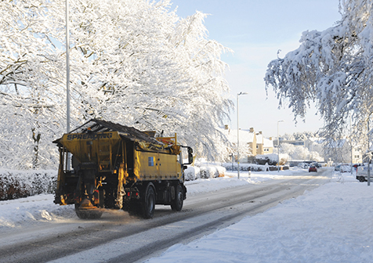
Photo 7 - South Lanarkshire Council gritting lorry
The council’s approach to winter service is reviewed annually and published and implemented through the Winter Service Policy and Procedures document.
Information about the council’s approach to winter service is made available to the public before the beginning of the winter period, describing the level of service provision and operational contact points. During the winter period, and particularly during prolonged spells of snow and ice, information is made available to the public via corporate communications, which includes local press and media channels.
General advice and information for the public concerning winter service is also provided by online methods such as social media and South Lanarkshire View.
The council will pursue the following policies and actions in relation to winter service:
Policy P9 – Take reasonable steps to prevent snow and ice endangering the safe passage of pedestrians and vehicles over public roads.
Policy P10 – Implement a method of working which will minimise delays, diversions or road closures due to adverse weather as far as is reasonably practical.
Policy P11 – Respond to serious hardship during extended periods of severe weather.
Action A8 – Update annually and implement the Winter Service Procedures and Resources document.
Action A9 – Following receipt of adverse winter conditions forecast treat the road network on a precautionary basis in accordance with the Winter Service Plan.
Action A10 – Following receipt of adverse winter conditions forecast treat the footway network on a precautionary basis in accordance with the Winter Service Plan.
Action A11 – During extreme weather conditions treat secondary and extreme (road) routes as resources permit.
Action A12 – During extreme weather conditions treat (footway) accessibility routes and the rest as resources permit.
Action A13 – Continue to embrace new technology where this is proven to be of economic, environmental and operational benefit.
Action A14 – Continue to be involved in national working groups through the Scottish Collaboration of Transportation Specialists (SCOTS) and local groups to enable joint working.

9.5 Street lighting
The council is empowered under Section 35 of the Roads (Scotland) Act 1984 to provide and maintain lighting for roads, or proposed roads, which are, or will be, maintainable by the council and in the council’s opinion should be lit.
The Street Lighting asset within South Lanarkshire Council comprises of 63,273 street lights and 3,818 illuminated signs and bollards of various types.
The provision of street lighting is important to reduce road traffic accidents, reduce crime and the fear of crime, and increase the attractiveness of communities. It can also improve community safety, particularly when installed with other traffic safety measures, and help develop attractive and safe streets within communities.
Activities undertaken by the council include:
- Replacement of defective lights;
- Repair and replacement of defective electrical equipment;
- Structural inspection of lighting columns and column maintenance;
- Electrical testing and inspection of electrical plant;
- Planned replacement of lights;
- Column, sign and bollard replacement;
- Complete replacement of lighting installations;
- Determination of planning consent applications; and
- Installation of Christmas lighting.
Services are provided in accordance with current legislation and subject to available resources and relevant Codes of Practice.
The council is working towards renewal of all potentially defective columns. Wherever possible, existing cables are used to minimise expenditure. New luminaries are being installed to improve lighting performance and reduce light pollution, and rechargeable apparatus is used where possible. All street lighting luminaires are now LED units, installed at a five-degree angle to minimise light pollution with full “cut-off” to reduce back spill.
The council will pursue the following policies and actions in relation to street lighting:
Policy P12 – Provide and maintain a high quality, safe and sustainable street lighting service across South Lanarkshire.
Policy P13 – Pursue technological development in materials including longer lamp lives and rechargeable apparatus and Intelligent Street Lighting to deliver energy efficient and low carbon street lighting.
Policy P14 – Prioritise the works by means of a criteria-based scoring system, for example presence in crime hot-spots.
Policy P15 – Minimise vandalism by installing suitably robust equipment in potentially problematic areas.
Action A15 – Continue an annual programme of street lighting improvements to identify priorities for column renewal and other maintenance requirements.

9.6 Management of roadworks
Under the New Roads and Street Works Act 1991 and the Transport (Scotland) Act 2019, the council has a responsibility for managing and coordinating all work carried out on its local road network including works by public utilities. There is additional secondary legislation and a number of Codes of Practice and Advice Notes that guide compliance for Roads Authorities and Public Utilities.
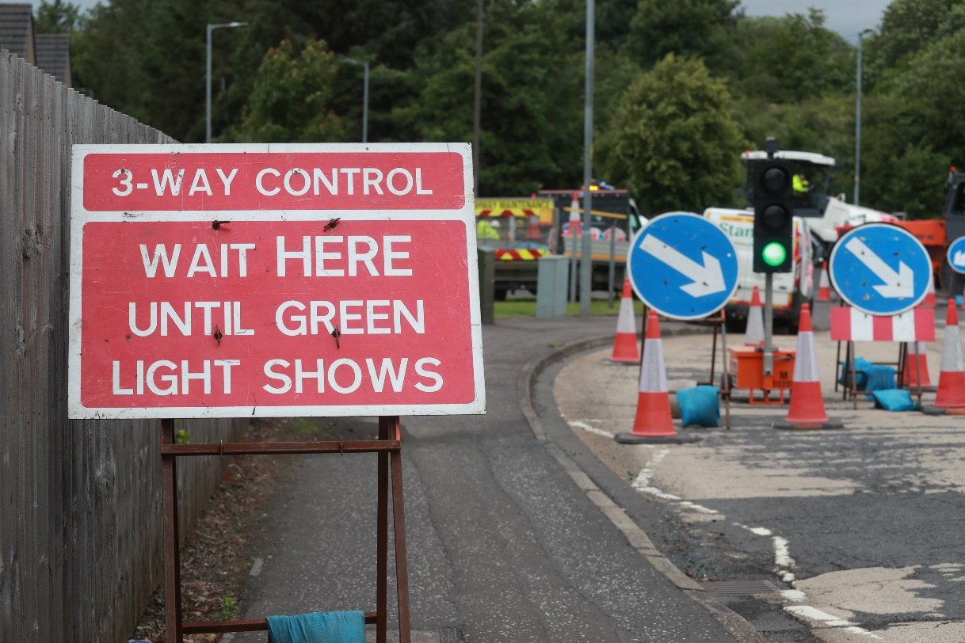
Photo 8 - Roadworks setup
Any “works in roads” and “works for road purposes” must be registered within the Scottish Road Works Register (SRWR)
The council is empowered to impose fixed penalties in accordance with the aforementioned legislation on any party who fails to comply. The Office of the Scottish Road Works Commissioner (oSRWC) also has powers to issue improvement notices and substantial fines to any party that continually fails to meet the legislative requirements.
The Roads Authorities and Utilities Committee Scotland (RAUCS) and sub-groups provide a platform for joint consultations and discussion on activities carried out on the roads under the aforementioned legislation.
The quality of reinstatement work by public utilities is monitored via a National Coring programme and the Commissioner can impose improvement notices and fines for continual failures. This is currently on a two to three-year frequency and has driven a continual improvement in the quality of reinstatements.
The council will pursue the following policies and actions in relation to the management of road works:
Policy P16 – Under the powers available, take steps to improve the quality of public utility reinstatements thus ensuring the long-term integrity of the road-based network.
Policy P17 – Ensure effective management of works on the road network to minimise delays for all users.
Action A16 – Work with Statutory Undertakers to improve the quality of public utility reinstatement work.
Action A17 – Co-ordinate roadworks through the SRWR to ensure that delay and disruption to the network users is minimised.
Action A18 – Continue to establish and approve diversion routes for planned maintenance works.

9.7 Bridges and structures
South Lanarkshire Council is responsible for a total of 778 road bridges, footbridges, subways, culverts and cattle grids. This figure includes structures with spans greater than 0.9 metres owned by South Lanarkshire Council but does not include retaining walls. In addition, there are 92 structures owned by other bodies which are over or under council roads.
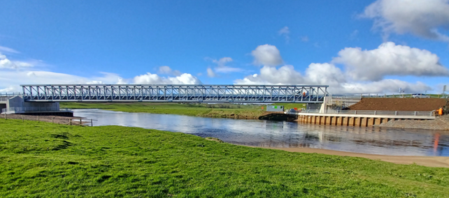
Photo 9 - Clyde Road bridge replacement, Carstairs
Inspection records held for each structure indicate that the council owned structures remain in good to fair condition. The council has a bridge strengthening programme which is prioritised depending on the class of road carried, assessed capacity and condition of the structure. The programme for planned maintenance is compiled from the results and recommendations obtained from a robust routine bridge inspection regime.
The council will pursue the following policies and actions in relation to bridges and structures:
Policy P18 – Prioritise investment to bridges and structures for which the council is responsible, seeking to ensure they are safe for use and fit for purpose.
Action A19 – Deliver strengthening programme for substandard publicly owned bridges.
Action A20 – Progress the upgrading of vehicle containment characteristics at bridges with substandard capability.
Action A21 – Programme the strengthening or implementation of alternative interim measures at substandard privately owned bridges carrying public roads.

10. Improving road safety

10.1 Scotland’s targets for ‘Vision Zero’
Scotland’s Road Safety Framework to 2030 sets out a vision for Scotland to have the best road safety performance in the world by 2030 and a long-term goal of Vision Zero where there are zero fatalities and serious injuries on Scotland’s roads by 2050, with ambitious interim targets for the number of people killed or seriously injured to be halved by 2030.
Four Interim Outcome Targets to 2030 have been set, based on a national 2014-2018 baseline, and the council will monitor and report on these on an annual basis:
- 50% reduction in people killed;
- 50% reduction in people seriously injured;
- 60% reduction in children (aged <16) killed; and
- 60% reduction in children (aged <16) seriously injured.
The Framework embeds the Safe System approach to road safety delivery, which consists of five key pillars focusing efforts not only on road traffic casualty reduction (vulnerability of casualties) but also on road traffic danger reduction (sources of danger), as displayed within Figure 16.
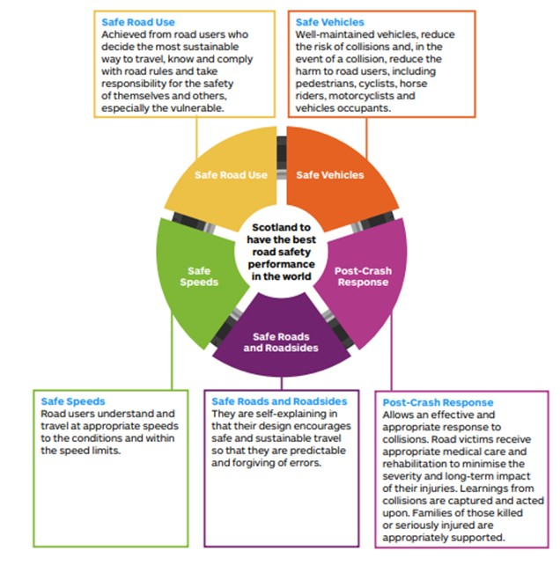
Figure 16 - Five Pillars of the Safe System
South Lanarkshire Council has a statutory duty under Section 39 of the Road Traffic Act 1988 to prepare and carry out a programme of measures designed to promote road safety. To fulfil this statutory obligation, each year accident records are analysed to ascertain where accident clusters are occurring, the primary causations, and to identify the most vulnerable road users. This information is used to develop the council’s data-led and evidence-based road safety programme.

10.2 Road safety in South Lanarkshire
The council’s well established Accident Investigation and Prevention (AIP) Programme sets out a comprehensive strategy, programmes and objectives to improve road safety with the aim of realising the Government’s national casualty reduction targets.
Assessments of both Route and Single Site locations are undertaken to take cognisance of road traffic collision trends, for example increases or decreases when compared to the previous study period, road user type, causation factors which are attributed to each accident, and common factors present at each location. Casualty injury severities and vulnerable road user groups are also given due consideration. The AIP report details measures which the council will be taking in response to identified traffic accident problems.
Road safety initiatives are generally in accordance with the 4Es of road safety, as shown in Figure 17.
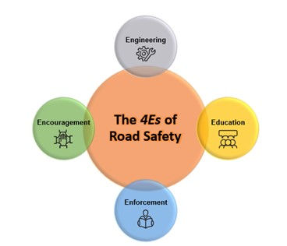
Figure 17 - The 4Es of Road Safety
Road safety initiatives will be prepared to improve safety on South Lanarkshire’s roads, and fulfil and, if possible, exceed national casualty reduction targets.

10.3 Reducing road casualties
South Lanarkshire Council has made good progress in contributing towards the national road safety targets. Based on a 2019-2023 5-year average, against a 2014-2018 baseline, the council has achieved:
- 11% reduction in people killed;
- 27% reduction in serious injuries;
- There have been no children killed; and
- 27% reduction in children seriously injured.
Based on a five-year average (2019-2023) for all casualties, there has been a 43% reduction when compared to the 2014-2018 baseline.
However, much still requires to be accomplished to further improve road safety in line with the Road Safety Framework aspirations.

10.4 Road safety considerations
To effectively reduce casualties in South Lanarkshire, the council and its partners need to address a wide variety of issues, including vulnerable road users, road user behaviour and the road environment. This includes:
- Pedestrians;
- Cyclists;
- Motorcyclists;
- Horse Riders;
- Children;
- Young Drivers and New Drivers;
- Older road users;
- Users in SIMD areas;
- Rural roads;
- Urban roads;
- Speeding;
- Driving under the influence of drink and / or drugs;
- Driving whilst using a mobile phone; and
- Driving for work.
South Lanarkshire Council is responsible for road safety engineering solutions and much of road safety education. Other partners, such as Police Scotland, the Scottish Fire and Rescue Service, and the council’s Education Department also contribute to road safety education. Police Scotland are responsible for road safety enforcement, whilst all partners have a role to play in encouraging road safety.
The council has been proactive in reducing casualties on the road network. Through the efforts of the council, and by working in partnership with other bodies such as SPT, NHS Lanarkshire, Police Scotland and the Scottish Fire and Rescue Service the council aims to have fewer people injured in road accidents, contributing to the delivery of Scotland’s Vision Zero targets.
However, more can be done, particularly to improve road safety for vulnerable road users and to encourage more walking, wheeling and cycling. Changing how speeds are managed has the potential to help meet net-zero emission targets by reducing vehicle fuel consumption. Reducing speed limits in communities and improving road safety can also improve the sense of place and encourage active travel, with a positive impact on health and wellbeing.
The council will pursue the following policies and actions in relation to improving road safety:
Policy P19 – Reduce the number and severity of road traffic collisions across South Lanarkshire, supporting the Road Safety Framework and contributing towards the achievement of national casualty reduction targets.
Policy P20 – Develop annual programme that targets resources and improvements on routes where three or more injury accidents have occurred in the previous three years or on routes that have an injury accident rate greater than the national average for the type of route.
Action A22 – Monitor and investigate accidents and their causes to inform the design and introduction of accident reduction measures and initiatives.
Action A23 – Support and encourage the implementation of 20mph speed limits in towns / neighbourhood centres, residential areas and outside schools.
Action A24 – Support investigation and implementation of reduced speeds on rural roads, where appropriate.
Action A25 – Ensure that the design and implementation of major road-based schemes is subject to a Safety Audit, as necessary.
Action A26 – Continued promotion of road safety education and training initiatives.
Action A27 – Continue to collaborate with other local authorities in the Road Safety Framework Local Partnership Forum (West) to share best practice education and engineering in relation to road safety initiatives.

11. Economy and regeneration

11.1 Economy and regeneration
A high-quality transport network can support economic growth and competitiveness, regeneration and social cohesion. Transport systems must be reliable, fast, convenient, safe and easily accessible for local businesses to access markets and encourage new development and inward investment that South Lanarkshire needs to thrive, whilst acknowledging the need to adopt a sustainable environmental approach.
South Lanarkshire’s Local Development Plan 2, together with NPF4, forms the spatial strategy for South Lanarkshire. It sets out the planning policies and proposals for the use and development of land throughout this LTS. It is recognised that the provision and improvement of strategic transport infrastructure is central to encouraging sustainable economic growth and regeneration.
A number of strategic economic investment locations have been identified, are promoted and safeguarded in the Local Development Plan. These include Clyde Gateway (Shawfield), Poniel, Hamilton International Park, Scottish Enterprise Technology Park (East Kilbride) and Peel Park North (East Kilbride). Six Community Growth Areas have been identified across the council area at Hamilton, East Kilbride, Newton, Ferniegair, Carluke and Larkhall. Glasgow Region City Deal funding has been secured to deliver a number of education, transport and community infrastructure projects to enhance the lives of the people living in each of these areas and beyond.
There are also a wide range of other mixed use Development Framework sites at the former UWS site in Hamilton; Langlands and Redwood Crescent in East Kilbride; and Bridge Street and Duchess Road in Cambuslang/Rutherglen. There are also a number of business locations and industrial estates in South Lanarkshire which require an effective transport system to be successful. All of these areas play a vital role in providing local employment opportunities. In addition the council area includes an extensive rural area which requires a separate approach to achieve enhanced rural connectivity.
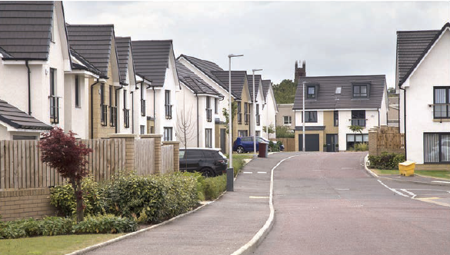
Photo 10 - Transport connectivity is essential to new developments
In addition, across South Lanarkshire, there is a strong network of town, village and neighbourhood centres which support a range of economic, civic and social functions. Transport connectivity is essential to support these functions, particularly for rural communities. There are current proposals for the redevelopment of the East Kilbride and Hamilton town centres.
The underlying principle in the selection of locations suitable for development is that they are highly accessible with high quality walking, wheeling, cycling, public and shared transport facilities.
The council will pursue the following overarching policies in relation to economy and regeneration:
Policy P21 – Support the increase and enhancement of active travel, public transport and shared transport connectivity to support town centre economies and areas of employment.
Policy P22 – Support the increase and enhancement of transport connectivity for rural communities - particularly to town centres, places of employment and key public transport and shared transport interchange points.
Policy P23 – Facilitate increased and enhanced active travel and public transport connectivity to support major new developments such as the Community Growth Areas in South Lanarkshire and the redevelopment of our town centres.

The wider actions set out within the Paragraphs below will contribute to the delivery of these policies.

11.2 Reducing traffic growth
Transport is the single biggest contributor to greenhouse gas emissions in South Lanarkshire, producing 38% of all emissions in the area. Furthermore, research commissioned by Transport Scotland in 2021 concluded it would not be possible to reach net-zero emissions through solely a transition to electric vehicles, which would additionally require a reduction in overall car use. The Climate Change Committee Scotland’s Carbon Budget advised that a 6% reduction in car kilometres would be required to meet the balanced pathway to carbon reduction.
Achieving a reduction in car use is a shared ambition of the Scottish Government and COSLA, which was affirmed in a June 2025 Policy Statement and in plans for a Just Transition. The statement notes that the policy approach will take account of more rural and car dependent areas. To enable a car use reduction the approach taken should encompass changing behaviours, creating an enabling environment and collaborative working. The statement has made four commitments to guide further development of the strategy which include developing a new, longer-term car use reduction target to support the commitment to net-zero by 2045, undertaking a regulatory check of existing powers to allow local authorities and/or regional transport partnerships to implement local road charging schemes, working with stakeholders to develop place-based and experience-specific delivery plans to support reduced car use, and to drive a national communication and engagement campaign, setting out a positive vision for how a car use reduction can deliver outcomes for public health, air quality and the environment.
Following the introduction of the Road Traffic Reduction Act 1997 which came into effect in Scotland in 2000, all local authorities are required to monitor traffic growth, assess current traffic levels, forecast future trends in traffic growth and set targets to reduce growth in the future. South Lanarkshire Council has a network of 76 traffic counters and 40 cycle and pedestrian counters across the council area to measure volumes and provide data each year.
In 2019, traffic growth decreased at 10% of the council’s strategic monitoring sites and increased at 90% of sites. In 2020, all strategic monitoring sites recorded a reduction in traffic growth which coincided with the period before and immediately following COVID-19 restrictions. Traffic levels have increased again in recent years.
The council must respond to the Sustainable Travel Hierarchy which underpins national transport policy. To do so, there is a need to manage car vehicle use in South Lanarkshire and support those walking, wheeling, cycling, using public transport and shared transport, taking cognisance of place-making and spatial planning concepts to reduce or minimise the need to travel. The council’s approach to each of these is set out within the relevant Paragraphs of this LTS.
It is recognised that there are some instances where the use of vehicles is necessary, for example for shift workers, those living in remote rural areas with few alternative travel options, or for those who rely upon a car due to disabilities. However, the use of private vehicles needs to be managed to ensure it is not a significant barrier to sustainable ways of travel. Vehicles that are used should increasingly be low emission, more effectively used and, where possible, shared-use.
The council will pursue the following policy in relation to reducing car vehicle kilometres:
Policy P24 – Work with partners to aim to reduce car vehicle kilometres across South Lanarkshire to contribute to national targets.

The actions set out within this LTS will contribute to the delivery of this policy.

11.3 Parking and demand management
Car parking within urban areas plays a key role in facilitating a healthy economy in South Lanarkshire. However, the presence of car parking can lead to increased vehicle use and, if not controlled appropriately, can result in not only environmental impacts but also increases in congestion and associated safety concerns.
In 2005, South Lanarkshire Council decriminalised parking through the Decriminalised Parking Enforcement (DPE) regime. The regime enables the council to enforce its own parking policies using parking attendants.
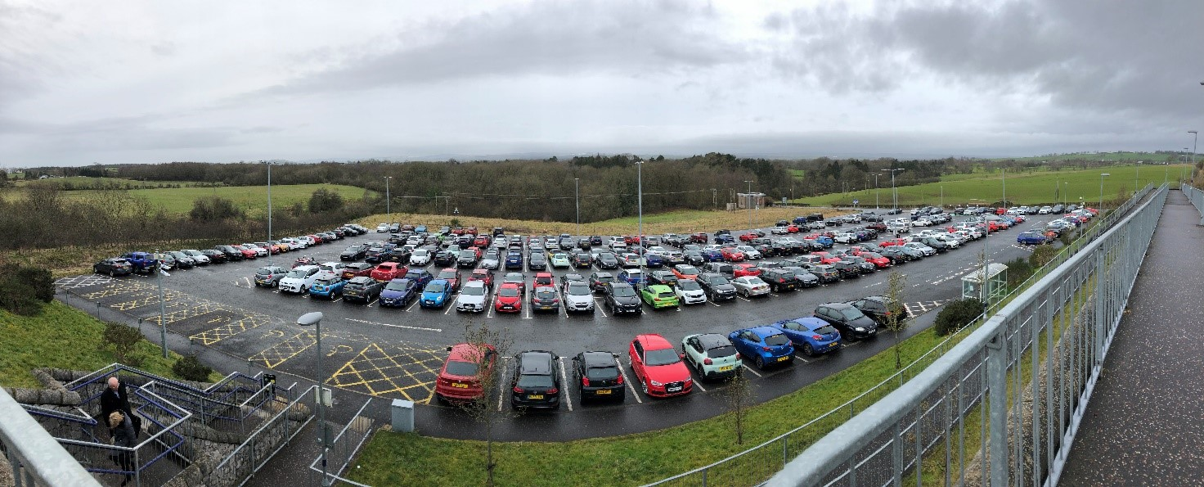
Photo 11 - Carluke Park and Ride
Parking management allows the council to keep streets clear of illegally parked vehicles to ensure that traffic can flow more freely, buses can use the bays provided, deliveries can be made on time, and parking spaces, including disabled bays and those for electric vehicle charging, are used appropriately. The Transport (Scotland) Act 2019 makes it illegal to park on any footway, except on streets where the council makes an Exemption Order to allow such parking. The council enforces the national prohibitions on pavement parking, double parking and parking at dropped kerbs on appropriate roads in a balanced, proportionate and pragmatic way taking cognisance of the advice given to local authorities that exemptions should be minimised. Exemptions have been considered following feedback from members of the public, elected members, frontline officer experience, bus operators, and emergency services, noting impacts on certain routes in relation to access for buses, fire and rescue vehicles and refuse collection vehicles.
Controlling road space can also give priority to certain classes of vehicle or pedestrians, at all times or at certain times of the day. Pedestrian priority schemes currently operate in Carluke and Hamilton. Bus lanes are a key mechanism for giving public transport priority and are in operation in Rutherglen during peak times. Cycle lanes, either for exclusive use of bikes or for shared use with pedestrians, have been used to reallocate road-space on roads throughout South Lanarkshire.
The council will pursue the following policies and actions in relation to parking and demand management:
Policy P25 – Encourage and support the development of parking practices and measures that encourage more sustainable travel behaviours, in line with the Sustainable Travel Hierarchy.
Policy P26 – In town centres, if it becomes necessary to improve and / or regulate service access to shops and businesses, the council will consider revised traffic / parking management.

Action A28 – The council will review existing and consider the introduction of new Traffic Regulation Orders (TROs) in areas where parking causes safety and/or congestion issues.
Action A29 – Implement the national pavement parking prohibitions on appropriate roads as set out in the Transport (Scotland) Act 2019.
Action A30 – The council will ensure that all temporary TROs are accessible to the public through the council’s internet site.

11.4 Freight transport
Safe and sustainable transportation of freight and goods is essential for the economic wellbeing of South Lanarkshire. Freight is transported around South Lanarkshire by both road and rail. The number of goods vehicle trips, if left unchecked, is forecast to increase, which will negatively impact on journey times and peak-period delays.
Transporting goods by road has a substantial impact on the structural integrity of roads and bridges and can shorten the lifespan of these assets, with an associated impact on maintenance costs.
Freight transport can also have a detrimental effect on town centres if it is unregulated. Deliveries during peak periods can cause congestion and make town centres less attractive to customers.
Given the economic importance of Scotland’s freight haulage industry, these factors will ultimately impact on the performance of the economy if they are not managed appropriately.
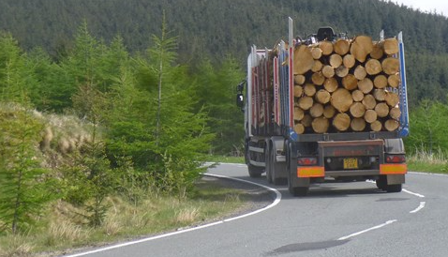
Photo 12 - Timber transport
There will also be an impact on the environment. In 2022 while Heavy Goods Vehicle (HGV) emissions across Scotland were 11% lower than the 1990 baseline figure, Light Goods Vehicle (LGV) emissions were 101% higher than the 1990 baseline figure, and 39% higher than the emissions from 2012. The increase in emissions from LGVs reflects increasing vehicle kilometres. Whilst recognising the importance of freight within the economy, a key challenge will be to ensure that the negative impacts generated by the movement of goods vehicles are addressed. Freight decarbonisation is a key component of the Draft Just Transition Plan which includes outcomes such as supporting a transition to zero-emission vehicles for businesses currently relying on fossil fuel vehicles.
The council will continue to explore opportunities to transfer freight from road to rail.
There is scope to improve the sustainability of the movement of freight and goods in built-up areas, including town centres. The efficient movement and delivery of goods may require the implementation of waiting and loading restrictions or alterations to the circulation system. Developing freight consolidation hubs and improved network planning can reduce the amount of freight traffic on local roads and streets, particularly HGVs. Cycle logistics, which use cargo bikes for last-mile deliveries, is another opportunity that can reduce motorised freight traffic within urban centres and some neighbourhoods. The council will encourage and support these measures through this LTS.
Encouraging the use of electric and alternative fuelling for motorised freight vehicles can help to reduce emissions. This is considered further within Section 15.
The council will pursue the following policies and actions in relation to freight:
Policy P27 – Support the improvement of freight transport facilities in South Lanarkshire to facilitate a sustainable, efficient, resilient and reliable strategic freight transport network.
Policy P28 – Monitoring of waiting and loading times to ensure that they are appropriate, to support economic wellbeing of urban centres and improve road safety.
Policy P29 – Support the innovation and best practice in freight transport, with partners.
Policy P30 – Encourage developers to consider rail as an alternative to road for moving freight. Where road is the only viable option, we will encourage best practice to be pursued.

Action A31 – Where necessary, undertake assessments of the appropriateness of waiting and loading times in urban centres.
Action A32 – Support partners to improve rail freight connectivity.
Action A33 – Encourage the sustainable movement of goods within built up areas, particularly last-mile deliveries.
Action A34 – Encourage and support the development of urban freight consolidation and distribution hubs and networks in key locations, where appropriate.
Action A35 – Support the growth in cycle logistics and cargo bikes as well as innovation in ‘last mile’ deliveries in South Lanarkshire towns.

11.5 Inclusive economy
Central to delivering inclusive economic growth is providing a transport system that ensures businesses have efficient access to staff, suppliers and customers and to provide fair and affordable access to training and employment.
South Lanarkshire’s Economic Strategy recognises the area’s strong transport links, including those linking to local, regional, national and international markets. The Strategy also dovetails with the council’s Community Plan 2022-2032 which seeks to promote inclusive growth, maximise opportunities and intensify activity to achieve net-zero.
The council will pursue the following policies and actions in relation to an inclusive economy:
Policy P31 – Support and lobby partners to improve affordable access to education, training and employment for South Lanarkshire residents by active and sustainable transport where possible.
Policy P32 – Continue to support economic growth in South Lanarkshire, by supporting and facilitating sustainable access to economic centres for people and goods.
Action A36 – Review, increase and enhance sustainable transport access to town centres and growth areas in South Lanarkshire, particularly from rural areas.

11.6 Road infrastructure
It is recognised that for an integrated strategy the road network has an important function in the operation of the overall transport network, when considered in the context of the Sustainable Travel Hierarchy and Sustainable Investment Hierarchy. Roads are not only vital for essential private car travel, but also for efficient bus services, active travel journeys and many essential local freight and business journeys, in particular those that cannot be undertaken by rail, and sustainable last-mile deliveries. Pinch points on the network require to be minimised and public transport and active travel infrastructure needs to be provided to maximise the efficiency of the road network.
The council will progress road schemes where it can be demonstrated there are clear benefits for the environment, safety, social inclusion and the economy, and in line with the current policy landscape.

11.6.1 Lanark town centre circulatory system
The growth in the historic market town of Lanark has resulted in traffic problems within the town centre and on the main through-routes. Congestion is often experienced within the town, and this has resulted in the area suffering from poor air quality, which can have detrimental effects on health. This congestion may also be adversely affecting the economic vitality of the town.
The construction of a circulatory system at the east end of High Street would help alleviate traffic congestion, improve air quality and assist in improving economic conditions in the town.
Land for this scheme is safeguarded within LDP2.

11.6.2 Stewartfield Way enhancement
The Stewartfield Way Enhancement project, identified in the previous LTS and funded through the Glasgow City Region City Deal, continues to develop. The scheme will aim to improve traffic flow, through capacity improvements, and will also deliver active travel infrastructure, improvements to public transport and low carbon vehicle infrastructure.
Land for this scheme is safeguarded within LDP2 and Strategic Development Plan 2 (SDP2).
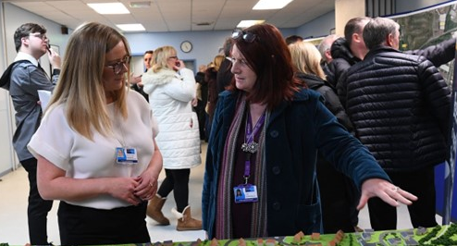
Photo 13 - Stewartfield Way public consultation
The council will pursue the following policies and actions in relation to road infrastructure:
Policy P33 – The council will support new roads infrastructure where this is considered essential, taking cognisance of the Sustainable Travel Hierarchy and Sustainable Investment Hierarchy.

Action A37 – Subject to successful progression through the business case process, progress the Stewartfield Way Enhancement and the Hamilton and East Kilbride town centre projects.
Action A38 – Subject to funding and support from partner organisations, evaluate and progress the Lanark Town Centre Circulatory System project.

12. Sustainable transport
Public and shared transport has a crucial role to play if South Lanarkshire is to succeed in achieving car kilometre reduction, congestion reduction and delivery of carbon budgets as set out in the Climate Change (Emissions Reduction Targets) (Scotland) Act 2024, and reflected in Scotland's Draft Climate Change Plan 2026-2040 and the Draft Just Transition Plan.

12.1 Bus
Buses have a vital role in supporting modal shift away from private vehicle usage in South Lanarkshire. Whilst bus makes up a small proportion of journeys for residents of South Lanarkshire, there is an opportunity through this LTS to promote and support increases in bus passenger numbers across our area, for example through an increase in services or higher frequency.
Buses are vitally important for people to access jobs and services that they need and are key to increasing social inclusion.
Bus patronage numbers across Scotland have decreased steadily since the publication of the previous LTS in 2013. Nationwide the number of passenger journeys has fallen from 421 million in 2013/14 to 334 million passenger journeys in 2023/24 The impact of the COVID-19 pandemic on bus patronage was significant; bus passenger numbers nationwide were 361 million in 2019/20 and decreased by 7% to 2023/24. In the South West and Strathclyde region the decrease over this period has been more pronounced with a 11% decrease in this region.
The highest quality and most frequent bus services in South Lanarkshire are those that connect to Glasgow. Services are less frequent and convenient between the towns within South Lanarkshire, and also for trips around the residential areas of larger towns. Some services were withdrawn during the COVID-19 pandemic and not reinstated. Bus services in rural areas are often infrequent and generally limited to main roads. Links from Clydesdale to Livingston and Edinburgh are limited.
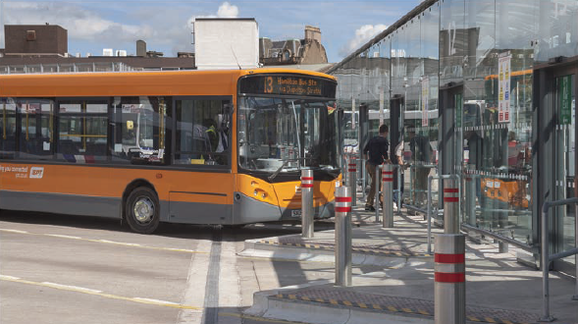
Photo 14 - Hamilton bus interchange
SPT subsidises socially necessary bus services in places and at times when there are no services provided by commercial bus operators. These services often operate in rural areas, in the evening and on Sundays. In South Lanarkshire, this includes services between Lanark – Douglas – Glespin; Lanark – Leadhills – Wanlockhead; East Kilbride – Strathaven – Hamilton; and Hamilton – Larkhall – Crossford and services to Wishaw General from Larkhall and Carluke. SPT also works with other local authorities and regions to deliver cross-boundary bus services including Lanark – Forth – Livingston and Dumfries – Biggar – Penicuik – Edinburgh. It is noted, however, that limited funds are available to subsidise bus services and as such it is not possible for all desired routes to be subsidised.
SPT also provide demand responsive transport (DRT) services through bookable MyBus and MyBus Rural services for residents of South Lanarkshire who are unable to easily access public transport due to their age, disability or location. MyBus / MyBus Rural services will pick up and drop off as close as possible to destinations and aim to provide door-to-door transport where possible. MyBus / MyBus Rural services are provided across the whole of South Lanarkshire, although services are not available in evening hours and journeys cannot be guaranteed prior to a confirmed booking.
Bus services in South Lanarkshire could provide a more attractive alternative to the car if waiting facilities and timetable information were improved. The council, in partnership with SPT, has been improving facilities at bus stops, including the provision of high-quality bus shelters, improving accessibility at bus stops and providing timetable information at all bus stops. Real-time passenger information has been implemented at stops on some strategic bus routes, for example in Rutherglen. Bus priority has also been implemented at traffic signals along strategic corridors to improve bus journey times. Through these interventions the council seeks to make travelling by bus more convenient and desirable.
SPT and the council continue to invest in high-quality transport interchanges. In 2012 the new Hamilton Interchange opened, and since then passenger numbers at the station have increased substantially. Improvements to Lanark Interchange are anticipated to have a similar effect on bus passenger numbers using the station.
Buses are operated by private operators and South Lanarkshire Council does not have direct control on when and where services are run and how much fares for services are. However, local transport authorities have the ability to create a franchising framework under powers provided by the Transport (Scotland) Act 2019. Local transport authorities also have the ability, if required, to work with operators to improve the quality and efficiency of local services (through a Bus Service Improvement Partnership). In September 2025, SPT approved the Strathclyde Regional Bus Strategy and action plan, which outlined plans for future franchising and the need to work collaboratively with the bus industry to deliver better bus services for passengers. South Lanarkshire Council is part of the Glasgow City Region Bus Partnership (GCRBP) which brings together bus operators and local authority stakeholders with the aims of improving bus priority, reducing congestion, exploring options for an integrated ticketing system and ensuring buses are given higher priority in future planning.

12.2 Rail
There are 19 rail stations located within South Lanarkshire. There are gaps in this network of stations, particularly in the Clydesdale area. The majority of train services in South Lanarkshire provide connections to Glasgow; however, there are direct connections to a number of other areas including North Lanarkshire, Edinburgh, West Lothian, East Renfrewshire and West Dunbartonshire.
Rail patronage within South Lanarkshire has declined since the publication of the previous LTS, with passenger numbers dropping from over 8.8 million in 2013/14 to just over 7.2 million in 2023/24. Passenger numbers peaked in 2016/17 with over 9.5 million entries and exits at South Lanarkshire stations and severely declined in 2020/21 owing to the COVID-19 pandemic. Passenger numbers in 2023/24 are only 80% of those in 2019/20 with the slow recovery in passenger numbers possibly attributable to the legacy of the pandemic on working practices, with more people now working from home.
South Lanarkshire Council continues to work with partners to improve the area’s rail provision and some examples are provided below.

12.2.1 East Kilbride rail enhancement project
The East Kilbride Rail Enhancement project is a £139.8 million investment at the centre of the Scottish Government’s Rail Services Decarbonisation Action Plan, for which full funding was granted by the Scottish Government in September 2023. The project is being led by Scotland’s Railway and includes electrification of the East Kilbride to Glasgow rail corridor; relocating Hairmyres station and providing step-free access to platforms and a transport interchange hub (with Park and Ride provision including disabled spaces and electric vehicle charging bays); as well as delivering new accessible station buildings and active travel linkages.

12.2.2 Lanark interchange
The council is taking forward plans to provide improved bus and rail interchange at Lanark. In 2023 improvements were made to the Park and Ride facility at Lanark rail station, with more spaces added and new electric vehicle charging bays installed, to encourage more people to travel by sustainable modes. The next phase of the project is Lanark Interchange improvements, which will be supported by active travel enhancements and a signEage strategy for the area.
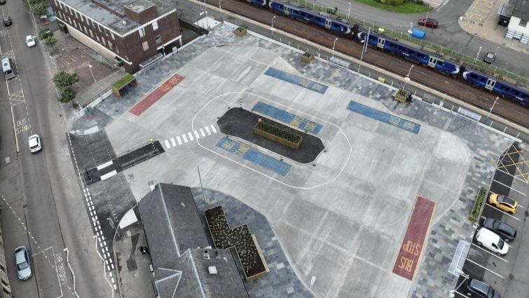
Photo 15 - Lanark interchange

12.2.3 Long-term aspirations
South Lanarkshire Council will continue to work with partners for the delivery of long-term aspirations for rail, including the potential for new stations at Law and Symington, direct rail services from Lanark to Edinburgh and potential for a rail extension from Larkhall to Stonehouse and beyond to Avon Valley.
The council strongly supports the provision of Park and Ride facilities at rail stations as these encourage the choice of rail travel as part of a multi-modal journey, particularly for commuters. Since 2013, SPT has provided funding towards the development, design and delivery of Park and Ride facilities in Newton, Carstairs, Cambuslang and Lanark. The council has developed a Park and Ride Strategy to prioritise the further opportunities to introduce Park and Ride facilities across the council area to encourage even greater use of rail.

12.2.4 Clyde Metro
Clyde Metro emerged as a key recommendation from Transport Scotland’s STPR2 and is embedded in NPF4 as part of the National Spatial Strategy. Clyde Metro is a collaborative project being taken forward by SPT as the lead partner, alongside Glasgow City Council (representing the wider Glasgow City Region) and Transport Scotland in a Project Assurance role.
It aims to provide a step-change in the public transport system of the Glasgow City Region by providing a fully integrated, multi-modal, mass transit system for the region. The Case for Investment is currently under development and due for completion in 2027. This will set out the Programme Level Business Case and arrangements for initial delivery phases, including detailed appraisal, engineering design and ultimately delivery of future lines or routes. The nature and locations of interventions are being considered, and options could take the form of a variety of transport modes such as bus rapid transit, train/tram, tram and metro. New infrastructure will be designed to complement existing bus, rail, subway and active travel connections to provide a truly integrated transport network. Options that could include Hamilton, East Kilbride, Newton, Cambuslang and Rutherglen are being developed.
There are multiple anticipated benefits associated with the proposals, including providing strengthened connectivity to employment, health and education services, tackling social exclusion, reducing greenhouse gas emissions and freeing up rail capacity for longer-distance journeys.
The project is supported by South Lanarkshire Council.

12.3 Community transport
Community transport services are community-led transport solutions, offered by locally-owned organisations or volunteers. The services are developed in response to unmet local transport needs, and often represent the only means of transport for many vulnerable and isolated people, including older people or people with disabilities. Community transport services include voluntary car schemes, community bus services, school transport, hospital transport and group hire services.
Community transport groups operating in South Lanarkshire are listed on the council’s website and include groups based in: Carluke, Blantyre, Forth, Hamilton, Larkhall, Lesmahagow, Strathaven, Douglas Water and East Kilbride. Many of these community transport operators receive funding from SPT to support the delivery of services.

12.4 Taxis and private hire vehicles
Taxis and private hire vehicles are particularly useful for certain journeys where walking, wheeling, cycling or using public transport is difficult, for example late at night, for those that are unable to travel by such modes or where community transport may not operate. Access to these types of on-demand services can also help reduce the need to own a car.

12.5 Shared transport
Car clubs provide an alternative way in which to travel, giving people the flexibility to access cars without being burdened with operating and maintenance costs. There is support from the council for car clubs and car share schemes.
The council will pursue the following policies and actions in relation to public and shared transport solutions:
Policy P34 – Work with partners to examine accessibility to town centres, employment centres, colleges and universities, hospitals and key sustainable transport hubs/interchanges, particularly for rural communities and areas of socio-economic deprivation, to identify the need for enhanced public transport services.
Policy P35 – Work with partners to promote public transport as an integrated, safe and accessible system for all users.
Policy P36 – Support and encourage development of public transport with the aim of increasing the proportion of journeys that are made by bus and rail, to provide continued improvement in the transportation choices in South Lanarkshire to attract inward investment, encourage economic development and improve the environment and health and wellbeing of communities.
Policy P37 – Seek to improve the quality of bus services in partnership with SPT.
Policy P38 – Lobby Transport Scotland for the introduction of new and improved rail services and infrastructure. This will include the following longer-term potential projects:
- Direct Lanark to Edinburgh service;
- Extension of the Larkhall railway to Stonehouse and beyond to the Avon Valley;
- New stations at Symington and Law;
- Improved services between Carluke, Carstairs and Edinburgh.
Policy P39 – Work with SPT and other partners to extend the network of Demand Responsive Transport and Community Transport provision, taxis, shared transport and shared mobility to ensure public transport is available to all communities across South Lanarkshire.
Policy P40 – Continue to support the concessionary fare provision across all forms of public transport in South Lanarkshire.
Action A39 – In partnership with bus operators and SPT, improve the quality, frequency and reliability of bus services as identified within SPT's Regional Bus Strategy.
Action A40 – Support Transport Scotland, SPT and other partners to develop Clyde Metro for the Glasgow City Region, extending into South Lanarkshire.
Action A41 – Work with partners to explore opportunities to introduce new rail infrastructure in South Lanarkshire.
Action A42 – Work with partners to enhance bus network coverage, including in rural areas of South Lanarkshire and to improve connectivity with neighbouring local authorities and Edinburgh.
Action A43 – Work with partners to explore opportunities to increase rail service frequency at stations served in South Lanarkshire.
Action A44 – Work with SPT and bus operators to identify opportunities to pursue the implementation of more direct bus services to hospitals and healthcare facilities from key areas.
Action A45 – Promote an approach to shared transport provision that benefits people across South Lanarkshire.
Action A46 – Provide clear and consistent wayfinding to and from public transport hubs in South Lanarkshire to provide connections to key employment and education sites.

12.6 Low emission vehicles
Low emission vehicles are central to the target of delivering a net-zero transport system, in line with the Scottish Government target to achieve net-zero emissions by 2045. The Climate Change Committee Scotland’s Carbon Budget advised that in the balanced pathway for meeting net-zero targets, 74% of surface transport’s contribution would come from an uptake of electric vehicles. This would mean in 2035, 60% of cars and 54% of vans on the road are electric, up from 2.2% and 0.8% respectively in 2023. The Scottish Government has also committed to phasing out the need for new petrol and diesel cars and vans by 2030 and ensuring all road vehicles are zero emission by 2040.
Uptake in electric vehicles has continued to increase at pace as a result of technological advances in electric vehicle battery performance and it is estimated that uptake could see around 700,000 electric vehicles on the road in the South Lanarkshire region by 2032. However, the continued growth of electric vehicles is subject to the availability of necessary charging infrastructure. South Lanarkshire Council continues to expand the network of electric vehicle charging infrastructure across the council area and recognises that investment in charging infrastructure must continue to support the growing popularity of electric vehicles.

12.7 Decarbonisation of South Lanarkshire Council’s fleet
South Lanarkshire Council has always been committed to reducing carbon emissions from its fleet. In light of the increasing emphasis on climate change and the further reduction in carbon emission and associated environmental impact, this consideration will be an important factor in future procurement choices.
As noted above, the Scottish Government has also committed to phasing out the need for new petrol and diesel cars and vans by 2030 and ensuring all road vehicles are zero emission by 2040. A public sector fleet decarbonisation Action Plan will be published by the Scottish Government which has been developed in partnership with the public sector and reflects the continued commitment of the Scottish Government and the wider public sector to decarbonising its fleet.
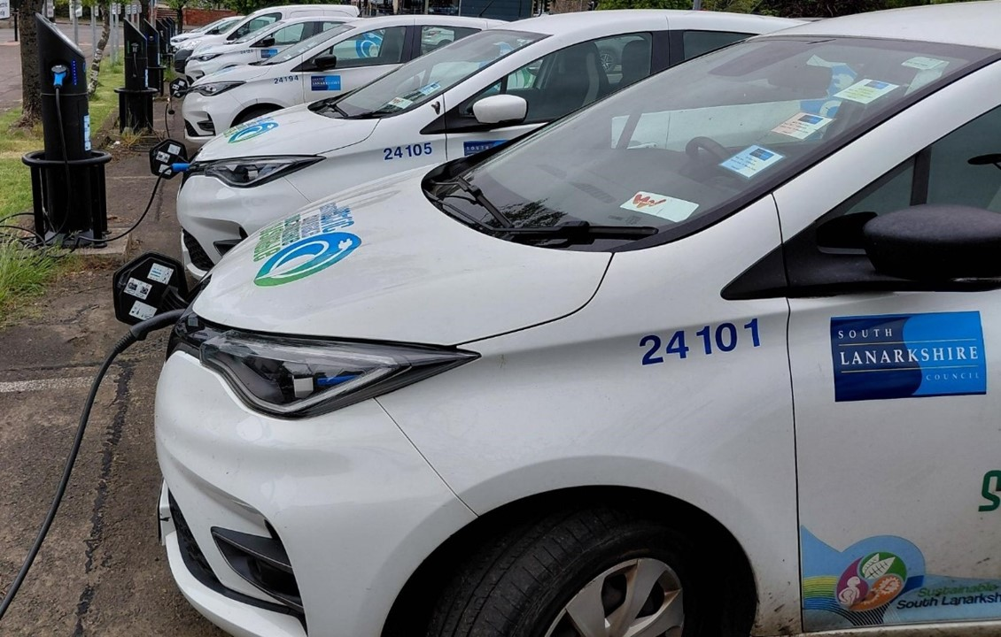
Photo 16 - South Lanarkshire Council electric vehicle fleet
Public sector fleet decarbonisation is a key future priority in the Draft Just Transition Plan. Decarbonisation of the transport sector will accelerate the shift to more environmentally friendly solutions, particularly electric and hydrogen vehicles. To ensure the delivery of this target, work is required to ensure the necessary infrastructure is in place, including charging stations.
The council’s Vision to ‘improve the lives and prospects of everyone in South Lanarkshire’ remains at the heart of the South Lanarkshire Council Plan ‘Connect’ 2022-2027 and along with our values, influences everything that the council does. The council’s Fleet Strategy will support the delivery of all key objectives, directly or indirectly, through the rationalisation, replacement, and deployment of the fleet with efficient, economical, sustainable and appropriately specified vehicles necessary to support operational service needs.
The Fleet Strategy also aligns with and supports the delivery of other council-led strategies and plans, including the Sustainable Development and Climate Change Strategy and the Air Quality Action Plan.
The Fleet Strategy will ensure that the vehicle fleet is appropriately procured, managed, maintained, developed, and receives investment to directly support delivery of the council’s wider organisational and service priorities and objectives.
The council will pursue the following policies and actions in relation to low emission vehicles and the council’s fleet:
Policy P41 – Support the introduction of low emission vehicles as a sustainable alternative to internal combustion vehicles.
Action A47 – Support the City Region in developing a commercial contract that will provide, manage and maintain a network of publicly available electric vehicle charging infrastructure.
Action A48 – Continue to decarbonise the Council’s fleet through delivery of the Fleet Strategy.

12.8 Transport interchange
Transport interchanges provide the means for passengers to interchange between different modes. These facilities vary in size across South Lanarkshire, with bus and rail interchanges offering parking facilities to enable interchange from car to public transport. Out of 19 rail stations in our area, 17 have a Park and Ride facility. There are also bike storage facilities at the majority of stations to allow people to transfer from one sustainable mode to another. Critical to the attractiveness of multi-modal trips is enabling transport interchange to be a seamless transition from one mode to another. The South Lanarkshire Council Park and Ride Strategy (2018-2027) sets out the council’s strategic, rail-based Park and Ride objectives for the area – with an ultimate aim of working with partners including SPT, ScotRail and Network Rail to increase the proportion of multi-modal journeys and reducing private car mileage. It is a supporting document to this LTS.
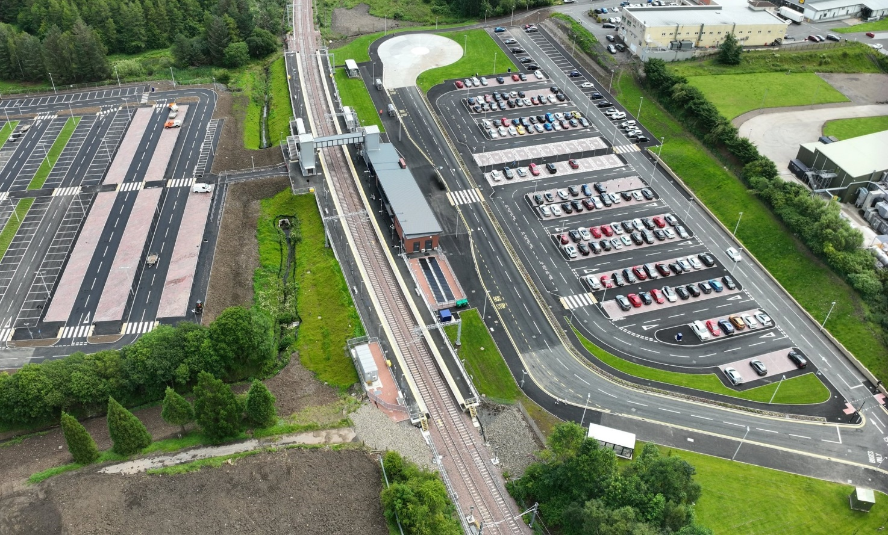
Photo 17 - Hairmyres interchange
The council will pursue the following policies in relation to transport interchange solutions:
Policy P42 – Review and, where appropriate, expand Park and Ride provision to encourage use of public transport for longer journeys.
Policy P43 – Support and encourage multi-modal journeys that allow interchange between rail, bus, car and active travel modes. This includes supporting national government, SPT and public transport operators in their efforts in the development of multi-modal, integrated through-ticketing and promotion of existing integrated tickets including ZoneCard.
Policy P44 – Work with partners to increase modal integration, for example to make it easier to travel on public transport with cycles; ensuring there is adequate cycle parking at public transport interchange locations; ensuring hire / access points for shared mobility schemes are well-served by public transport links; and exploring the concept of Mobility Hubs where appropriate.
Policy P45 – Work with partners to develop fully accessible facilities at transport interchanges.

13. Walking, wheeling and cycling
The importance of encouraging more people to walk, wheel and cycle (active travel) is widely recognised.
The Active Travel Framework, produced collaboratively by Transport Scotland and key delivery partners, was published in February 2020 and brings together the key policy approaches to improving the uptake of walking, wheeling and cycling for travel in Scotland.
The Cycling Framework and Delivery Plan for Active Travel in Scotland, published in April 2023, builds on the progress made through three iterations of the Cycling Action Plan for Scotland (CAPS) between 2010 and 2020. It sets out an ambitious plan for Scotland for the next ten years, to maximise cycling’s contribution in realising the Scottish Government’s long-term Vision for Active Travel in Scotland: “That Scotland’s communities are shaped around people, with walking and cycling the most popular choice for everyday short journeys.”
The National Walking Strategy Action Plan (2016-2026) sets out clear ambitions for increasing the proportion of short journeys undertaken on foot, including trips to and from school.
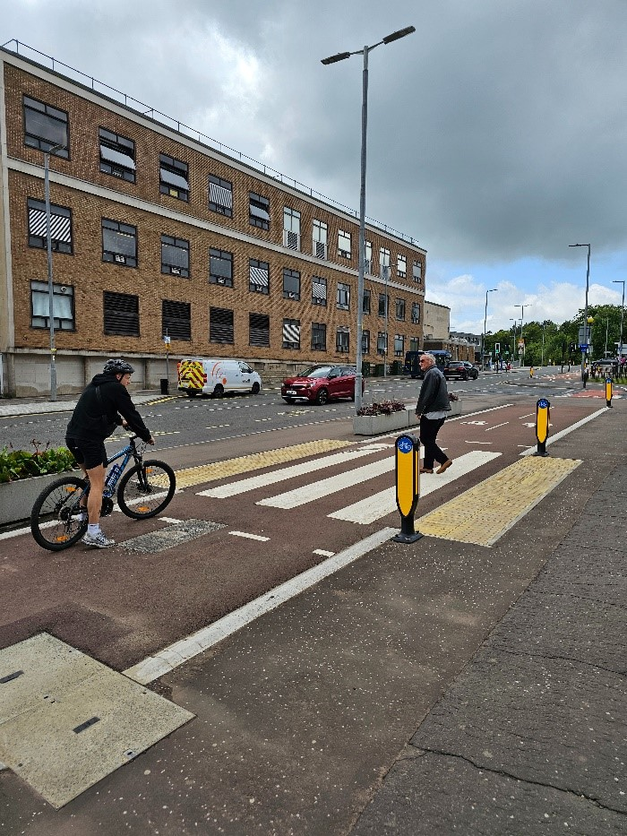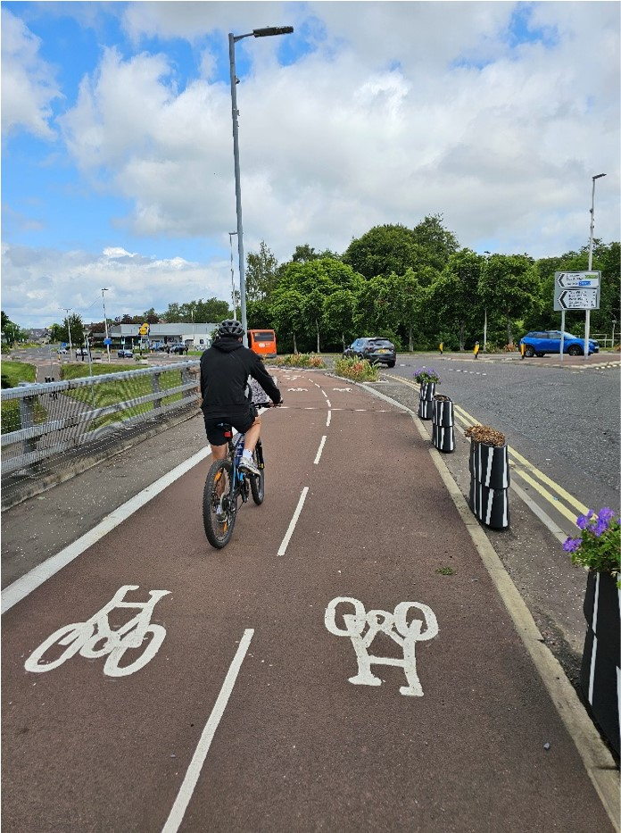
Photo 18 - East Kilbride segregated cycling facilities
At a regional level the SPT Active Travel Strategy sets out a vision for a well-connected, continuous cross-boundary active travel network and emphasises the importance of complementary behaviour change measures to help encourage active travel journeys, particularly in areas with low uptake at present. A key component of the strategy is the development of a Regional Active Travel Network made up of a series of strategic corridors classified as Core Routes, Supporting Routes or Cross Region Routes, each sitting as part of a phased delivery plan.
NPF4 also highlights the importance of place and the benefits associated with a shift from travelling in vehicles to walking, wheeling and cycling for everyday journeys. The aspirations for Local Living are also embedded within NPF4 and will be a key focus for LDP3.
South Lanarkshire Council recognises that encouraging more people to walk, wheel and cycle can return significant benefits for community cohesion, environmental protection, physical and social mobility, road safety, and access to employment and key services. Better active travel routes create particular opportunities for people vulnerable to social exclusion such as disabled, young and older people, and those without access to a car, and reduce inequalities for these groups.
Active travel is beneficial to both physical health and mental wellbeing. Keeping physically active can reduce the risk of heart and circulatory disease and has been shown to reduce the chances of conditions such as asthma, diabetes and high blood pressure. Creating the conditions that encourage and enable people to walk, wheel and cycle, through reducing motorised traffic movements and parking, also has wider benefits on placemaking, the environment and community cohesion, through the provision of safer and quieter streets, reduced transport emissions, improved air quality, and reduced community severance.
South Lanarkshire Council maintains an extensive active travel network, comprising 289 kilometres of cycle paths (89 kilometres off-road and 209 kilometres on-road) and 2,425 kilometres of urban footways. Working with key partners including SPT, Walk Wheel Cycle Trust and others, the council has made substantial progress in enhancing our active travel network since the publication of the previous LTS. Active Travel Network Plans have been developed for Carluke; Lanark; Hamilton; East Kilbride; Rutherglen; Cambuslang; Strathaven, Stonehouse and surrounding villages; Clydesdale; Larkhall; Bothwell; Blantyre; and Uddingston. These Network Plans have been informed by public and stakeholder feedback and include phased delivery plans of interventions for each settlement.
The cycle network has been extended through construction of new schemes including sections of NCN 74 between Uddingston and Larkhall via Hamilton, Lesmahagow and Blantyre; NCN 75 in Uddingston; and NCN 756 between East Kilbride and Glasgow. The first fully segregated cycle route continues to be developed in East Kilbride in the West Mains and Town Centre areas. The Walk Wheel Cycle Trust have provided a Network Development Plan which specifies proposed improvements to every part of the National Cycle Network, in addition to proposed new routes and alignments.
The council has implemented on-street cycle parking and storage facilities in 29 locations across South Lanarkshire.
Other behaviour change measures are being delivered in South Lanarkshire through the People and Place Programme, managed by SPT in the region. SLC has received over £170,000 in funding to deliver programmes including BetterPoints – Think, Move, Breathe; Beat the Street – Cambuslang and Rutherglen; and the Walk ’n’ Roll programme of led walks and rides. South Lanarkshire Council is actively engaging with SPT in planning future programmes.
However, despite our significant efforts to enhance active travel opportunities in South Lanarkshire over the last ten years, it is recognised that further investment is crucial to achieve the level of change required to meet climate targets, tackle poor health and address social exclusion. South Lanarkshire Council will further extend the active travel network during the lifetime of this LTS, including the provision of supporting infrastructure.

13.1 School travel
The importance of instilling good active travel habits in children at an early stage is recognised by the council. Changing people’s travel behaviour to use more sustainable modes will have a positive impact on the environment, as well as on health and wellbeing.
South Lanarkshire Council has a dedicated officer who assists schools in producing travel plans. These are used to improve children's safety on the journey to and from school, and to encourage more pupils to travel actively and sustainably. The plans are developed in partnership with both primary and secondary schools.
A wide range of initiatives are promoted at schools, including walk and wheel to school campaigns, Living Streets Walk Once a Week and Travel Tracker schemes, Living Streets National Walk to School Week, Walk Wheel Cycle Trust ‘Big Walk and Wheel’ Challenge, Park and Stride, road safety within ‘Curriculum for Excellence’ support and resources, Junior Road Safety Officer schemes, and Bikeability cycle training.
“Be Safe, Bus Safe” resources are used to provide primary school aged pupils with important information about keeping safe whilst waiting, boarding and travelling on buses. Some schools have cycle and scooter storage facilities to encourage active travel. A ‘Bike Bank’ is available to schools to support cycle training. The majority of schools have part-time mandatory 20mph zones and many have enforceable parking restrictions. The recent focus on speed awareness has seen a significant number of schools benefiting from new carriageway road markings and signing which creates a ‘school’ environment and enhanced awareness of the 20mph speed limit. Two schools have Car Free School Zones (CFSZ) in place. Other measures such as ‘Parking Buddies’ are used to encourage responsible parking. In 2024, 83 schools had implemented school travel plans and a further 55 had plans in development.
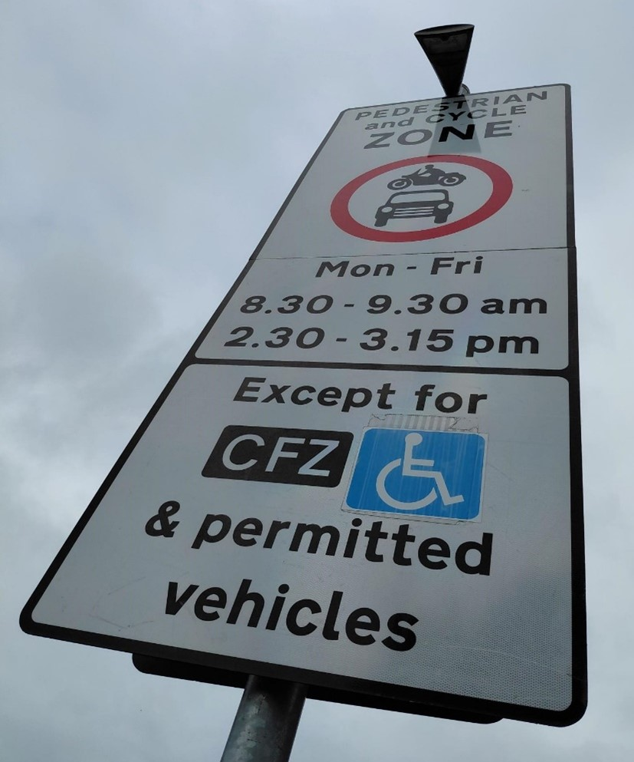
Photo 19 - Car Free Zone, Blantyre

13.2 Inclusive mobility
The Equality Act 2010 makes it unlawful to directly or indirectly discriminate against various groups, including those who have a disability. This can include people with physical, sensory or mental impairment. Many, though not all, people with a disability face barriers to movement when travelling by active modes. South Lanarkshire Council seeks to remove or reduce these barriers through, for example, controlled pedestrian crossing features, tactile paving, tactile cones (fitted underneath the right-hand side of pedestrian push button boxes with a lightly roughened surface and rotates when the “green man” operates to indicate it is safe to cross), audible signals, dropped kerbs and “on crossing detectors” to ensure inclusive mobility. Inclusive mobility is considered further in Section 15.
The council will pursue the following policies and actions in relation to walking, wheeling and cycling:
Policy P46 – Aim to achieve a step-change in the proportion of journeys that are undertaken by walking, wheeling and cycling in South Lanarkshire, and to make active travel the most popular choice for everyday short journeys, thereby supporting the Active Travel Framework.
Policy P47 – Ensure active travel networks are convenient, accessible, inclusive and safe, with segregation from motorised traffic where possible.
Policy P48 – Recognise and support the needs of people with disabilities and other protected characteristics designing new transport schemes or replacing infrastructure.
Policy P49 – Continue to support and encourage children to travel actively with the aim of increasing the proportion of journeys that are made to school by walking, wheeling or cycling.
Policy P50 – Increase access to bicycles, including e-cycles and other adapted and non-standard cycles.
Action A49 – The council will seek to increase the number of schools that develop travel plans.
Action A50 – Support Connected Neighbourhoods through active travel provision (20-minute neighbourhoods).
Action A51 – Support local groups who seek to improve access to bicycles in South Lanarkshire through interventions that would build on existing successful programmes and the work of established support groups.
Action A52 – Increase the availability of cycle training courses, including Bikeability.
Action A53 – Increase the number of cycle parking spaces available, including at key destinations such as bus and rail stations and town centres.
Action A54 – Progress the implementation of the Active Travel Network Plans for Carluke; Lanark; Hamilton; East Kilbride; Rutherglen; Cambuslang; Clydesdale, Strathaven, Stonehouse and the Surrounding Villages; Bothwell, Blantyre and Uddingston; and Larkhall, and support the implementation of the Walk Wheel Cycle Trust Network Development Plans for the National Cycle Network.
Action A55 – Support and promote more sustainable travel behaviours for all journeys in South Lanarkshire, including those made for leisure, recreation and tourism purpose.
Action A56 – Work with SPT to investigate opportunities for a regional, cross-boundary bike hire scheme.

14. Environment

14.1 Air quality
Transport generates just over one-sixth of Scotland’s total particulate matter (PM10) and over one-third of the total emissions of nitrogen oxides (NOx) according to Scotland’s NTS2. The majority of these emissions are caused by road transport. Transport, and road transport in particular, remains a significant contributor to poor air quality. Air pollution increases the risks of diseases such as asthma, respiratory and heart disease, particularly for those who are more vulnerable such as the very young, elderly or those with existing health conditions. Air quality is often worse in areas of deprivation and is a health inequality issue.
The council has eight continuous monitoring stations measuring PM10 and nitrogen dioxide (NO₂). These stations are located at: Blantyre, Cambuslang, East Kilbride, Hamilton, Lanark, Raith Interchange, Rutherglen and Uddingston.
Local authorities have a duty to designate any relevant areas where air quality objectives are not (or are unlikely to be) met as AQMAs. AQMAs must be designated officially by means of an 'order'. The extent of the AQMA may be limited to the area of exceedance or encompass a larger area. Following the declaration of an AQMA, the local authority is required to develop and implement an Air Quality Action Plan to improve air quality in that area.
In 2023 there were three AQMAs in South Lanarkshire:
- Lanark – declared in 2016 due to high levels of NO₂.
- Rutherglen – declared in 2016 due to high levels of PM10, this AQMA covers Rutherglen.
- Whirlies Roundabout – declared in 2008 due to high levels of PM10, this AQMA covers an area around the Whirlies Roundabout in East Kilbride, between the A725, A749 and B783, and extends along all roads leading into the roundabout.
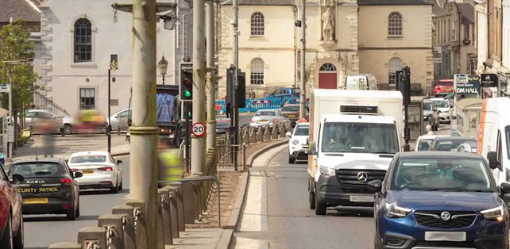
Photo 20 - Lanark Town Centre AQMA. Revoked in February 2024
South Lanarkshire Council has prepared an Air Quality Action Plan (2024) in line with its statutory obligations. It is designed to address the air quality problems identified within the council’s AQMAs. South Lanarkshire’s State of the Environment Report (2021) highlights that air quality within the council area is considered relatively good. However, there are specific ‘hotspot’ areas closely associated with heavily congested roads where air quality is poor. Traffic growth directly contributes to poor air quality and the release of other emissions associated with climate change.
More recently, South Lanarkshire Council’s 2025 Air Quality Annual Progress Report (APR) highlights that air quality is generally good in most parts of South Lanarkshire. Monitoring network data collected during 2024 shows an overall downward trend in the measured concentrations of the main pollutants of concern. Concentrations measured in 2024 are significantly lower than those measured in 2019.
South Lanarkshire Council therefore revoked the Lanark AQMA in February 2024. Following the publication of the Scottish Government Fine Dust Analysis System (FIDAS) equivalence study, the remaining AQMAs at both Whirlies Roundabout and Rutherglen were revoked in November 2025.
South Lanarkshire became Scotland’s sixth ECO Stars (Efficient Cleaner Operations) scheme when it launched in February 2015. ECO Stars is a free scheme that aims to help fleet operators (HGVs, buses, coaches, vans and taxis) improve efficiency, reduce fuel consumption and emissions and make cost savings. Funding from the Scottish Government’s Air Quality Action Plan grant helped set up ECO Stars South Lanarkshire, and areas covered include Hamilton, Lanark and East Kilbride.
South Lanarkshire’s Air Quality Action Plan recognises that increasing modal shift to active travel and public transport is key to further reducing transport emissions. The Action Plan measures will continue to support a transport system that facilitates active travel choices, better public transport provision, embracement of technologies to reduce vehicle emissions, as well as reductions in private vehicle use. This will support a Just Transition vision for a net-zero sustainable transport system, with improved air quality helping to deliver a healthier South Lanarkshire for communities, business workers and visitors.
The council will pursue the following policies and actions in relation to air quality:
Policy P51 – Continue to work with partners to facilitate a switch from conventionally fuelled vehicles to electric, hydrogen and other alternative fuels, including extending the electric vehicle charging infrastructure network.
Policy P52 – Continue to monitor and work to meet, and wherever possible exceed, statutory air quality requirements.
Policy P53 – Place greater emphasis on integrating air quality considerations into strategies, policies and plans.
Policy P54 – Ensure that new developments and schemes undertake Environmental Assessments and minimise carbon and other harmful emissions, where appropriate.
Policy P55 – Support the implementation of transport improvements that reduce emissions and improve air quality across South Lanarkshire, giving particular protection to former Air Quality Management Areas and, where appropriate, contributing to the development of a South Lanarkshire-wide Air Quality Strategy.

Action A57 – The council will continue to operate its continuous monitoring equipment in the areas which are most likely to be closest to breaching the objectives for PM10 and NO₂ Where necessary, detailed assessments will be carried out at locations such as Rutherglen Main Street and Hamilton town centre, and NO₂ in Main Street, Uddingston and these will be reported annually.
Action A58 – We will continue to monitor air quality at key locations across South Lanarkshire, with a focus on protecting, and, where possible, improving air quality.
Action A59 – We will develop a South Lanarkshire-wide Air Quality Strategy.
Action A60 – Encourage bus operators (including Demand Responsive and Community Transport providers) to decarbonise fleets, upgrade depots and develop partnerships with energy providers.
Action A61 – Continue to assist local businesses through the ECO Stars fleet recognition scheme.

14.2 Flood risk management
Evidence presented by the Met Office in the UK Climate Projections 2022 indicates that the UK has experienced a 5% and 11% wetter winter and summer respectively compared to the last decade (2009-2018). The total rainfall on extremely wet days has also increased across the UK, most notably in Scotland.
Increases in flooding can significantly impact the operation of the transport network through closures and diversions, resulting in social and economic impacts including delaying or restricting access to employment, healthcare services and preventing socialising. The effects of potential disruption to transport networks are greater for rural communities due to the reliance on road-based transport and are often more vulnerable to longer diversions.
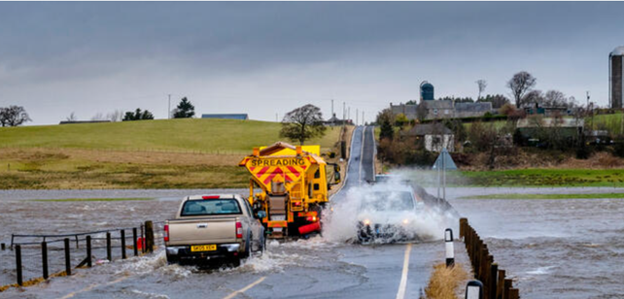
Photo 21 - Flooding, Thankerton
In accordance with the requirements of the Flood Risk Management (Scotland) Act 2009 South Lanarkshire Council is working closely with SEPA, Scottish Water and other Local Authorities to produce new national strategies and local plans to manage flood risk in a more coordinated and sustainable way.
In order to implement the 2009 Act, Scotland has been divided into 14 Local Plan Districts (LPDs) which are based upon river catchments and cross administrative and institutional boundaries. South Lanarkshire Council is one of 10 local authorities who form the Clyde and Loch Lomond (CaLL) LPD, as well being one of two local authorities who form the Tweed LPD.
SEPA has developed a Flood Risk Management Strategy for each LPD and, taken together, these set the national direction for future flood risk management. The Strategies set out the short- to long-term ambition for flood risk in Scotland by stating the objectives and associated actions required to tackle floods in high-risk areas.
Following the development of Flood Risk Management Strategies by SEPA, each LPD has published a Local Flood Risk Management Plan (LFRMP) which turns each Strategy into a more local delivery plan. The Clyde and Loch Lomond LFRMP and the Tweed LFRMP - updated in 2022 - provide detail on how and when the actions from the Strategies will be delivered locally, providing additional specific detail on the costs and benefits, funding and delivery timetable for each action.
The council will pursue the following policies and actions in relation to flood risk management:
Policy P56 – Require Flood Risk Assessment (FRA) and Sustainable Urban Drainage Systems (SuDS) to be provided by developers to support Planning Applications. This will include independent checks for both. Future maintenance of (SuDS) apparatus will also be identified and agreed with the council.
Policy P57 – Encourage provision of infrastructure designed to withstand the impacts of flood events.
Policy P58 – Undertake statutory duties under the Flood Risk Management (Scotland) Act 2009.

Action A62 – Following receipt of a Heavy Rainfall Warning, the council will invoke the procedures outlined in the “Managing Flood Risk” document to assess and maintain the ‘at risk’ flood sites identified in the document. The River Clyde Multi-Agency Incident Response Guide will be used to provide a council response to significant flooding from the River Clyde.
Action A63 – Continue an annual programme of prioritised flooding improvement projects.
Action A64 – Actively participate in the Clyde and Loch Lomond and the Tweed Flood Risk Management Plan Districts and in the development and implementation of future iterations of the associated District Flood Risk Management Plans.

14.3 Light pollution
Artificial light is prominent in transport, coming from many sources including road lighting, illuminated signs and billboards and traffic signals. The presence of transport-related lighting can result in light pollution which is defined as artificial light that intrudes upon areas not intended to be lit.
The Guidance to accompany the Statutory Nuisance Provisions of the Public Health (Scotland) Act 2008 Section 6, which amends the Environmental Protection Act 1990 with respect to artificial lighting, sets out a requirement to ensure that artificial light from sources such as street lighting and temporary works, such as roadworks, are included where the light is causing nuisance.
The council will pursue the following policies and actions in relation to light pollution:
Policy P59 – Continue to lobby the Scottish Government whenever possible to carry out the following:
- Define light pollution as a statutory nuisance and draw up regulations which would enable local authority environmental health officers to deal with it.
- Introduce new regulations, through land use planning legislation, to allow planning authorities to control exterior lighting.
- Ensure any planning policy statements address light pollution and acknowledge the importance of the dark.
- Ensure policies and operations of all government departments and public agencies take account of the need to tackle light pollution.
Policy P60 – Deliver low carbon and energy efficient street lighting.

Action A65 – Minimise environmental impact by not over-lighting, using energy-efficient light sources, and by installing dimmable luminaires wherever possible - including in all new housing developments - in accordance with EN13201: 2015.
Action A66 – A preference for post mounted luminaries rather than post top will be pursued wherever possible.

14.4 Noise pollution
Transportation noise is the greatest source of environmental noise in Scotland, and the management of such noise forms a key component in protecting Scotland’s environment. In addition to environmental pollution, noise can have economic consequences through potential impacts on tourism, learning and workplace productivity.
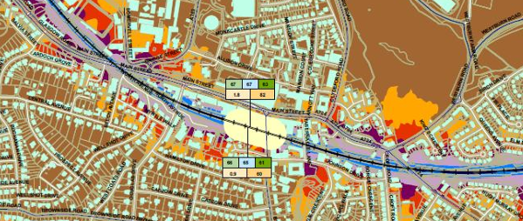
Figure 18 – Candidate Noise Management Area, Cambuslang
The European Parliament and Council Directive for Assessment and Management of Environmental Noise 2002/49/EC, more commonly referred to as the Environmental Noise Directive (END) was transposed into the Environmental Noise (Scotland) Regulations 2006. The regulations require the publishing of Scottish Noise Action Plans. The latest action plan covers the 2024-2028 period. The Noise Action Plan aims to put forward measures which are intended to avoid, prevent, or reduce, on a prioritised area basis, the harmful effects of noise caused by transport. The objectives of the latest action plan are to improve the consideration of environmental noise management within all stages of transport planning, design, construction, and maintenance, manage the exposure to environmental noise in Noise Management Areas, and work with partners and the public to reduce potential exposure to environmental noise and increase awareness of noise control measures and action.
There are currently five candidate Noise Management Areas within South Lanarkshire: two rail-related within the Uddingston and Cambuslang areas and three road-related within Rutherglen and Cambuslang. These have been identified as areas where noise levels and quality within the current environment are unacceptable and action is required to reduce these levels. This can help improve the overall environment for those who live and work within these areas.
There are also two designated Quiet Areas within South Lanarkshire. These are areas which must be protected in terms of both size and noise climate. The two approved areas in South Lanarkshire that this applies to are Cambuslang Public Park and Bothwell Castle grounds.
The council will pursue the following policies and actions in relation to noise pollution:
Policy P61 – Work with partners to reduce noise impacts of transport in line with the Environmental Noise (Scotland) Regulations 2006.
Policy P62 – Seek to ensure any future developments do not negatively impact on the noise climate within areas with designated Quiet Area status.
Action A67 – Give due consideration to designated Noise Management Areas and Quiet Areas in any future relevant strategies, policies and plans.

14.5 Biodiversity
Under the Environment Act 2021, from November 2023 all planning projects, including transport and infrastructure projects, will be required to deliver at least 10% biodiversity net gain (BNG). BNG will be measured using biodiversity metrics, and habitats will need to be secured for at least 30 years. Transport and infrastructure projects offer a unique opportunity to create new / expand upon existing green and blue infrastructure networks, which can utilise roadside verges or be formed alongside active travel routes.
To maintain and improve the condition of biodiversity in the future, it will be important to not only protect and enhance important habitats but the connections between them, in addition to delivering net gains.
The council will pursue the following policies and actions in relation to biodiversity:
Policy P63 – Effectively coordinate the delivery of new transport infrastructure to ensure that opportunities to improve green and blue infrastructure networks and ecological corridors are maximised within South Lanarkshire.
Policy P64 – Actions proposed by the LTS which could rise to likely significant effects on a European site (including existing and proposed such sites), must be subject to an Appropriate Assessment of the implications for the Conservation Objectives of that site.
Action A68 – Encourage the implementation of biodiversity schemes, for example on road-side verges or alongside active travel networks.
Action A69 – Aim to offset the loss of any biodiversity through transport infrastructure development or maintenance within the council’s control.
Action A70 – Restrict impacts of transport in South Lanarkshire which could adversely affect European sites (Special Areas of Conservation / Special Protection Areas).

14.6 Climate change adaptation and resilience
The impacts of climate change in Scotland include warmer summers and wetter winters. Climate change directly affects transport through the increasing number of more severe and frequent extreme weather events and the disruption they cause to the transport system. Disruption often disproportionately impacts on vulnerable communities with fewer and less resilient transport options.
In recent years, there have been several weather events which have led to significant disruption and resulted in associated economic costs. When there are extreme weather incidents and planned or unplanned events which result in network disruption, it is vital that information is given to the public as early as possible so that they can act accordingly. Extreme weather leads to uncertainty about travel conditions for people and businesses. The effective maintenance of transport networks is important in reducing disruption and delivering a resilient and reliable transport system. Providing a resilient transport system requires strong planning, efficient management of disruption and recovery, and effective maintenance regimes and investment.
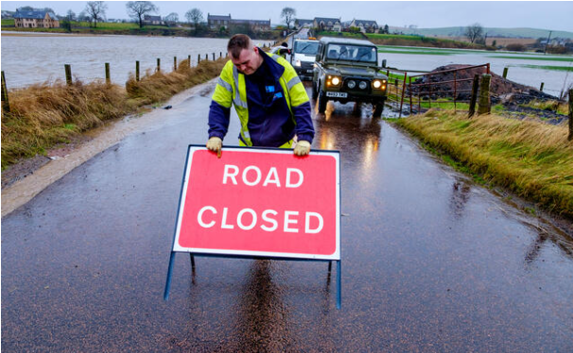
Photo 21 - Extreme weather response
South Lanarkshire Council recognises that it is essential to future-proof the transport network for change and will pursue the following policies and actions in relation to climate change adaptation and resilience:
Policy P65 – Continue to work with partners, including the Scottish Government, to identify new sources of funding for climate change adaptation, including increased funding to replace, upgrade and maintain transport assets.
Policy P66 – Ensure new transport investments are future-proofed for impacts of climate change and a low carbon future
Policy P67 – Facilitate and support adaptation of the local transport network to be resilient to climate change and disruption from extreme weather events.

Action A71 – Support the delivery and monitoring of the council’s Sustainable Development and Climate Change Strategy and Action Plan.
Action A72 – Where possible, increase resilience of South Lanarkshire's transport network to climate change-related disruption, including flooding and extreme heat events.

15. Inclusive mobility
The Equality Act 2010 makes it unlawful to directly or indirectly discriminate against various groups including those who have a disability. Since 1996, it has been unlawful for service providers to treat those with a disability less favourably than other people for a reason related to their disability.
The term “disability” is broad and includes people with physical, sensory or mental impairment. It is estimated that approximately 20% of the population in Scotland have some degree of impairment. Many, though not all, face barriers to movements in the environment and the road network. These barriers can be removed or at least reduced through intervention by the council and examples of this are given below. Planning for inclusive mobility in South Lanarkshire will support Just Transition through delivery of an inclusive and accessible transport system.

15.1 Older people
Scotland’s population is ageing: NRS population projections estimate that the older population will continue to grow significantly in size in both South Lanarkshire and Scotland, with the group aged 65-74 increasing by 12.5% and aged 75+ increasing by 77.4% in South Lanarkshire by 2043 compared to a 2018 baseline. In Scotland, those groups are projected to grow by 7.7% (aged 65-74) and 70.6% (aged 75+).
Older people are healthier, fitter, wealthier and more mobile compared with previous generations: they are likely to want to travel more and the transport system needs to support this to ensure older people, wherever they live, are not socially isolated. Factors impacting on older people include inaccessible vehicles (particularly taxis, buses and trains), journey comfort, frequency of bus services and poor integration between different transport services.

15.2 Disabled people
The results of the 2022 Census indicate that 25% of people in South Lanarkshire have a long term health condition or disability, compared to 24% of the Scottish population. Key challenges disabled people face on the transport system include being able to access accurate and relevant travel information both before and during the journey; being able to access public transport interchanges; being able to access public transport vehicles; being able to interchange between all modes; and concerns regarding safety and comfort on the public transport network.

15.3 Young people
Many young people are communicating more by social media and other digital means rather than in person and therefore may have less need to travel for certain social interactions. More young people are also in further and higher education, having to spend more on housing and are delaying entering employment, therefore having less resources to spend on travel. Key issues for young people include the availability and cost of public transport, particularly to further and higher education sites and personal safety when using transport services.

15.4 Inequalities
Women are more likely to experience affordability barriers to transport: they are less likely to drive and are more likely to use public transport, particularly buses. Many women feel vulnerable when using public transport – particularly at bus stops, train stations or other transport interchanges.
Women who work part-time are more likely to have a multi-stop journey (for example to drop off / pick up children to / from school) than women that work full-time or men, whatever their working status. According to NTS2, women are more likely to feel very or fairly worried about being sexually assaulted and are also less likely to report feeling very or fairly safe walking alone at night compared to men (66% compared to 89%).
Members of the LGBT+ community and those representing ethnic minority backgrounds can also feel vulnerable when using public transport.

15.5 Concessionary travel
It is recognised that people have different incomes and the transport system should not exclude people from mobility by making it unaffordable.
Elderly and eligible disabled residents can save money on public transport with the National Entitlement Card (NEC). The card gives holders free bus travel in Scotland and, through the Strathclyde Concessionary Travel Scheme, reduced fares on trains (and Subway) in the SPT area. All young people and children aged 5-21 years can access the Scottish Government’s Young Persons’ (Under 22s) Free Bus Travel Scheme, which began on 31 January 2022.

Photo 22 - Concessionary bus travel
Transport systems must be designed in an inclusive manner to ensure walking, wheeling, cycling, public transport and shared transport is accessible for all. It is also important to consider those who rely on cars for their mobility needs.
The council will pursue the following policies and actions in relation to inclusive mobility:
Policy P68 – Work towards an accessible, affordable and safe transport system in South Lanarkshire, in services and infrastructure across all forms of travel.
Policy P69 – Continue to remove barriers to inclusive mobility through applying the Equality Act 2010 and Equality Impact Assessment process to transport project design and policy development.
Policy P70 – Promote inclusive design and ensure this is implemented in the design process of new transport facilities.
Policy P71 – Continue to support and work with SPT to develop and promote MyBus and MyBus Rural services to older and disabled residents in South Lanarkshire.
Policy P72 – Prioritise the movement of pedestrians and those with mobility difficulties when planning new transport interventions within pedestrian environments (for example cycle parking and electric vehicle charging infrastructure).
Policy P73 – Enforce pavement parking prohibitions on appropriate roads in line with the Transport (Scotland) Act 2019.
Action A73 – We will support the construction of transport facilities that incorporate inclusive design processes which are safe and convenient for all users, including those with disabilities.
Action A74 – Develop and facilitate the role of active travel as an affordable transport option.
Action A75 – Support the inclusion of adapted bikes and other non-standard bikes in access to bike schemes and projects.
Action A76 – Review signage at existing council owned car parks across South Lanarkshire.
Action A77 – Support the promotion of the Scottish Government’s Young Persons’ (Under 22s) Free Bus Travel Scheme through schools, further education establishments and youth groups.
Action A78 – Work with partners to provide sustainable transport information (for example timetables and route information) in alternative formats and languages, where required, to ensure inclusive communication.
Action A79 – Work with partners / SPT to support the improvement of public transport services in rural and socio-economically disadvantaged areas of South Lanarkshire.
Action A80 – Ensure inclusive access is a key objective when developing new forms of transport services and infrastructure including provision for electric vehicles.

16. Spatial planning
NPF4 is the long-term spatial strategy for Scotland that sets out Scottish Ministers’ policies and proposals for the development and use of land, covering the period to 2045. NPF4 guides spatial development, sets out national planning policies, designates national developments and highlights regional spatial priorities. The council’s LDP3 will implement NPF4 policies at a local level.
From a transport perspective, NPF4 aims to encourage, promote and facilitate developments that prioritise walking, wheeling, cycling and public transport for everyday travel and reduce the need to travel unsustainably. LDP3 will be informed by evidence of the area’s transport infrastructure capacity, and an appraisal of the spatial strategy on the transport network. This should identify any potential cumulative transport impacts and deliverable mitigation proposed. NPF4 also supports an Infrastructure First approach which requires new site allocations to be informed by evidence on infrastructure capacity, condition, needs and deliverability within the plan area, including cross boundary infrastructure. LDP3 will set out the infrastructure requirements to deliver the spatial strategy by identifying the infrastructure priorities, and where, how, when and by whom they will be delivered. LDP3 should align with relevant national, regional and local infrastructure plans and policies and take account of the Scottish Government infrastructure investment hierarchy and sustainable travel and investment hierarchies in developing the spatial strategy. LDP3 therefore will be required to ensure developments integrate with the active travel network and help to enhance the coverage of this network.

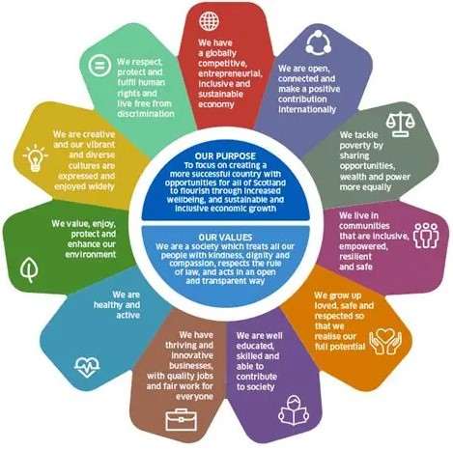
Figure 19 – National Performance Framework
NTS2 recognises that spatial planning can play a key role in addressing a number of challenges for places. The places where people live and work can have important impacts on health and wellbeing. As land use has continuously evolved, some places have become less sustainable and would benefit from improvement. For example, buildings located in areas that are hard to reach and not well served by public transport can result in long journeys to access shopping and work, therefore discouraging walking and cycling and encouraging more car use.
Land use planning, development planning and transport planning go hand in hand to support people’s access to the things they need: the current and future transport needs of people should be at the heart of planning decisions to ensure sustainable places.
South Lanarkshire Council recognises the importance of integrating transport with spatial planning and place-making principles at a local level, ensuring an infrastructure-first approach to planning, promoting the NTS2 Sustainable Travel Hierarchy, Sustainable Investment Hierarchy and Just Transition.
To meet many of the future needs of society it is crucial that services and facilities are easily and affordably accessed. Future places, homes and neighbourhoods should be connected, liveable and thriving places with sustainable travel options and where car dominance is reduced.
Local living, for example through concepts such as 20-minute neighbourhoods where access to the majority of daily needs is possible within a 20-minute walk, wheel or cycle, can play an important role in balancing our relationship with nature and the environment, improve health and wellbeing, boost local economies and enhance quality of life.
These concepts are reflected across both South Lanarkshire’s LDP2 and this LTS. In addition, work has started on the replacement LDP3 which will seek to ensure the aims and objectives of the LTS are reflected in the plan through both its policy direction and in the site assessment process.
The council will pursue the following policies and actions in relation to spatial planning:
Policy P74 – Require that major new developments are accessible by sustainable modes, in line with the Sustainable Travel Hierarchy, including walking, wheeling and cycling for short journeys and links to public transport and shared transport interchange points for longer journeys.
Policy P75 – Require that all new developments have provision for electric vehicle charging.
Policy P76 – Require that the transport implications of major developments be set out in Transport Assessments and, for minor developments, within a Transport Statement.
Policy P77 – Require the preparation and implementation of travel plans for major developments as part of planning / legal agreements.
Policy P78 – Work in partnership with the Planning Service to ensure the preparation of LDP3 is informed by evidence of the area’s transport infrastructure capacity and the carrying out of an appraisal of the spatial strategy on the transport network to identify any potential cumulative transport impacts and its mitigation.
Policy P79 – Require either direct provision of transport infrastructure by developers and landowners, or contributions towards the cost in whole or in part of transportation works (including public transport provision) to be provided by others including the Council itself.
Policy P80 – Require that all new developments consider the principles of Designing Streets, National Roads Development Guide and Cycling by Design.
Policy P81 – Deliver spatial planning concepts, for example the concept of 20-minute neighbourhoods, through planning and economic policies and in collaboration with key stakeholders, to create liveable neighbourhoods that reduce the need to travel.
Action A81 – The council will undertake early engagement with land-use planning teams to deliver an infrastructure-first approach to planning, promoting the NTS2 Sustainable Travel and Investment Hierarchies.
Action A82 – The council will work with community and development planning teams to support spatial planning concepts, guide the development planning process and help deliver more liveable neighbourhoods.
Action A83 – The council will encourage electric vehicle charging to be provided for all new developments and that car clubs will be encouraged through the development management process.
Action A84 – Ensure that the transport implications of major developments be set out in Transport Assessments and, for minor developments, within a Transport Statement.

17. Technology
Technological advances continue to grow at pace and are becoming ever more present in all aspects of society. NPF4 notes that the daily choices that people make about where and when they work, and how companies trade, will be driven as much by changing digital technologies and communications as it will be by transport.

17.1 South Lanarkshire’s digital strategy
South Lanarkshire Council published its Digital Strategy in 2022, highlighting the role of digital technology in providing innovative solutions to achieving the council’s overall vision, together with the digital vision of ‘Transforming Lives with Digital’. The Strategy sets out that this will be achieved through a focus on customer needs and being business driven to ensure that use of information, communication and technologies adds value to the everyday lives of people in South Lanarkshire.

17.2 Technology’s role in transport
Technology’s role in transport is diverse; it supports Just Transition and can yield significant benefits to the areas it is applied to. For example, adaptive control systems enable modal priority through junctions; integrated ticketing facilitates seamless movement between different modes of transport whilst simultaneously reducing ticketing costs; real-time user information at transport hubs and on apps enables improved journey time planning and flexibility; and electric vehicle charging infrastructure facilitates the rising uptake in alternative fuelled vehicles.

17.2.1 Managing traffic flow
In recent years technological solutions have been introduced to manage and control traffic signals in the urban areas of South Lanarkshire. Split Cycle and Offset Optimisation Technique (SCOOT) and Microprocessor Optimised Vehicle Actuation (MOVA) are adaptive systems that respond automatically to fluctuations in traffic flow through on-street detectors embedded in the road to improve the efficiency of vehicle and cycle movements. Similarly, technology which supports buses with advance priority at traffic signals continues to be rolled out along strategic corridors which have historically experienced unreliable bus journey times caused by traffic congestion. Bus priority has been introduced at 58 junctions throughout South Lanarkshire.
As previously mentioned, where appropriate, the council will start to utilise FUSION software to optimise traffic flows for the benefit of all road users including pedestrians, cyclists, and public transport.
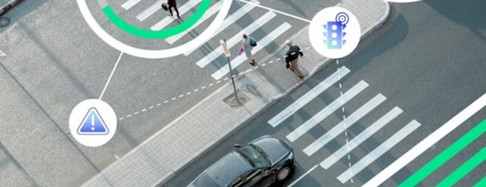
Figure 20 – FUSION Smart Signal Software

17.2.2 Ticketing
Transport Scotland is working with transport operators to modernise equipment and infrastructure to facilitate digital or electronic options for tickets and / or payment when travelling on public transport. Integrated ticketing aims to enhance the public transport experience by allowing users to seamlessly travel between different modes and operators. As smart technology progresses and infrastructure is implemented, more opportunities to integrate ticketing will become available, and South Lanarkshire Council will support partners in the delivery of this.

17.2.3 Mobility as a service
Mobility as a Service (MaaS) is the term for the digital platforms (often smartphone apps) through which people can access a range of public, shared and private transport, using a system that integrates the planning, booking and paying for travel. South Lanarkshire Council will support partners in identifying opportunities for integration between public transport operators and modes to realise the benefits of MaaS, where this is deemed appropriate.

17.2.4 Real-time information systems
As bus operators continue to install Global Positioning System (GPS) tracking devices, there are increased opportunities for the delivery of estimated arrival times via real-time information systems. Arrival time information can be delivered via information screens at transport stops or stations, transport operator websites, text alerts or by apps. This technology allows for passengers to make decisions ‘on the go’, improving user experience leading to increased public transport use.

17.2.5 Electric vehicles
Uptake in electric vehicles has continued to increase at pace as a result of technological advances in battery performance. However, the continued growth of electric vehicles is subject to the availability of necessary charging infrastructure. South Lanarkshire Council continues to expand the network of electric vehicle charging infrastructure across the council area and recognises that investment in charging infrastructure must continue to support the growing popularity of electric vehicles. This will additionally support the vision of a net-zero sustainable transport system, supporting Just Transition.

17.2.6 Self-driving vehicles
Self-driving vehicles are fast approaching commercialisation in markets across the world. It is estimated from the Department for Transport’s Centre for Connected and Autonomous Vehicles that by 2035, 40% of new cars in the UK could have self-driving capabilities. Grocery deliveries and passenger services look likely to be operating in self-driving vehicles within a similar timeframe.

The council will pursue the following policies and actions in relation to technology:
Policy P82 – We will continue to invest in, and apply for funding for, technology that prioritises sustainable modes (for example, pedestrian, cyclist and bus priority) on relevant routes.
Policy P83 – Reduce the need to travel by supporting development of digital and remote access to public services.
Policy P84 – Expand the network of electric vehicle charging infrastructure to encourage greater use of low carbon vehicles.
Policy P85 – Support the planning for refuelling points for alternative-fuelled goods vehicles in the future (such as electric), particularly in close proximity to the strategic road network.
Policy P86 – Consider the role of AI and Connected Vehicle Data in transport service delivery at a local level in South Lanarkshire.

Action A85 – Work with partners to advance digital technology to support sustainable access and travel, including, for example, Mobility as a Service, smart technology and digital ticketing, where appropriate.
Action A86 – Promote the expansion of the current electric vehicle charging point network across South Lanarkshire, supporting the delivery of our Public Electric Vehicle Charging Strategy and Expansion Plan.
Action A87 – Support partners to promote and raise awareness of technology and initiatives that provide passengers with timely and up to date information to help them to make informed decisions in order to complete their journeys to, from and within South Lanarkshire.
Action A88 – Facilitate the introduction of real-time information to allow transport users to respond to extreme weather and incidents.
Action A89 – Take cognisance of, and integrate with, SLC Digital Strategy 2022-2027 where appropriate.
Action A90 – Support development of Mobility as a Service (MaaS) solutions to serve those using the transport network in South Lanarkshire.

18. Implementation and monitoring

18.1 Delivery
The realisation of the LTS objectives and policies will be undertaken through the delivery of the actions detailed under each themed Section of this LTS. The actions outlined throughout this strategy have different timescales associated with their delivery. The timescales for the delivery of the majority of the actions are within the lifetime of this document, however some of the actions relating to long-term projects will extend beyond this period.
Some of the actions identified are directly under the control and remit of South Lanarkshire Council; others require partnership with organisations. In the case of the latter, delivery of the action items in a timely manner will be dependent upon support from respective partner organisations.
There will be a close relationship between the South Lanarkshire LTS and the SPT RTS, and successful partnership working will be central to delivering the respective strategies. For example, in terms of transport functions, the council maintains and manages the majority of the transport assets upon which RTS policies and projects will be implemented, whilst the delivery of projects proposed through this LTS will have a greater likelihood of succeeding and receiving external funding support if it can be demonstrated that they support the vision and objectives of the RTS.
The specific funding details for the delivery of each action are not set out within this document as this will change year on year as the strategy feeds into annual Resource and Service Plans. It is clear that the extent to which policies can be successfully pursued and actions fulfilled is directly linked to the levels of funding available.
All of the actions identified in this LTS are important, however due to factors such as availability of funding there is a need to prioritise actions for implementation. South Lanarkshire Council’s priorities for implementation will relate primarily to measures and initiatives which promote safety, those which are required to maintain the existing transport network and associated assets to at least their present standard, and those that promote sustainable transport and contribute to reducing emissions.
South Lanarkshire Council will seek, wherever possible, to make best use of existing infrastructure and encourage travel and access by sustainable means, in line with the Sustainable Travel Hierarchy and the Sustainable Investment Hierarchy.

Figure 21 – Better Points App

18.2 Funding
On an annual basis, the council’s Roads, Transportation and Fleet Services spends around £31 million. This can be divided into the revenue budget of approximately £14.37 million, and the council funded capital budget of approximately £16.73 million.
The revenue budget includes money from council tax payments, fees and charges and is typically directed towards ongoing maintenance and repair of existing infrastructure, and towards ongoing service operations. Examples include network resurfacing, active travel facilities, winter service, flood risk management, street lighting and bridge refurbishment.
Other sources of funding are critical to the council being able to carry out improvements. Many of these sources are not guaranteed funding streams and often rely on the council successfully bidding for specific schemes.
Sources from which the council has been successful in gaining funding include the Scottish Government / Transport Scotland, both directly and through a number of related funds and bodies set up with specific purposes. Examples include funding for active travel and to support public transport, for example bus service improvements, local rail developments and rail station access. The Scottish Government also provides funding for road safety enhancements and electric vehicle charging infrastructure. South Lanarkshire Council has also secured funding through the Glasgow Region City Deal.
Other bodies that have provided full or part-funding for specific projects include SPT, Walk Wheel Cycle Trust and Cycling Scotland.
Where appropriate, South Lanarkshire Council, through the planning system, seeks financial contributions from developers for transport and access infrastructure to ensure that new developments are accessible by a range of transport modes, and to take cognisance of spatial planning concepts.
Capital grant funding for specific investment programme schemes is occasionally secured and includes grants from the UK Government, Cycling Scotland, Local Transport Bodies, and other private and public companies.
The opportunities for additional funding are welcomed by the council and the strengths of partnership working opens up new possibilities to pursue projects that the council could not achieve alone. However, the unpredictability of funding and resources can compromise the ability to plan strategically and the ever-changing requirements of some funding bodies and bid processes do mean that although funding is required for specific projects, it may not always be secured. This could compromise the council’s ability to deliver the full range of actions which are set out within this LTS as some are dependent on external funding sources.

18.3 Monitoring
A successful LTS consists of objectives, indicators, policies and actions that, when combined, will improve local transport for the people of South Lanarkshire. The council will develop a monitoring regime that will chart the progress of the LTS and identify at an early stage any areas that may need attention to ensure the effective delivery and achievement of intended outcomes.
Where appropriate, opportunities will be sought to improve the efficiency of monitoring through combining efforts and adopting a shared approach with partners including SPT and neighbouring local authorities.
An annual review of the progress of the LTS will be undertaken which will measure performance against the objectives detailed in Section Seven. Included in this review will be monitoring of the actions identified within each themed Section of this LTS. This information will also be used in the monitoring of Resource and Service Plans.
The progress review will inform the monitoring of wider council strategies including, for example, the Council Plan ‘Connect’ and the Sustainable Development and Climate Change Strategy, as well as helping to assess Just Transition delivery.
An annual progress report on this LTS will be produced to determine what has been achieved using the above-mentioned outcome targets and actions. In addition, at the end of the lifetime of this LTS, the final review will determine to what degree actions have been achieved, what the reasons for any failings were, and which actions should be carried forward to the next LTS.
In order to assist in the monitoring process, a range of targets have been identified. Cognisance has been taken of the importance of setting targets which can be monitored within the council’s resource constraints and enable progress to be demonstrated.
Table 2 sets out the targets that South Lanarkshire Council aims to meet over the lifetime of this LTS.
Table 2 - Monitoring targets
Indicator | Baseline | Target | Source | Link to Objective
Mode shift | Proportion of people travelling to work by bus, rail, cycle and on foot (2022: Bus 6%, Rail 5%, Cycle 1%, Walking 6%)  Proportion of pupils travelling to school by bus, cycle and on foot (2023: Walking 38%, Cycle 3.5%, Bus 16%, Scooter/Skate 2.7%, Park and Stride 11%) | Increase the share of people travelling by these modes  Increase the share of school pupils travelling by these modes | Census  Scottish Household Survey (for non-Census years)  Walk Wheel Cycle Trust Hands Up Survey | Objective 5 – Supporting mode shift  Objective 6 – Facilitation and encouragement of walking, wheeling and cycling
Road Traffic | Scottish Transport Statistics 2023:  2,843 million vehicle kilometres driven on SLC roads in 2023  SLC's Strategic Traffic Monitoring Sites: In 2019, traffic growth decreased in 10% of the council’s 74 strategic monitoring sites and increased in 90% of sites | Average decrease in vehicles kilometres driven over strategy lifetime, targeting a reduction in car kilometres in line with the national target  An overall reduction in the number of sites experiencing traffic growth | Scottish Transport Statistics  SLC Traffic Count Data | Objective 5 – Supporting mode shift
Road condition | 2023/24 proportion of South Lanarkshire roads categorised as red or amber, indicating repairs are required (32%) | Reduce the proportion of roads categorised as red or amber condition | Scottish Transport Statistics  South Lanarkshire Council local road condition reports | Objective 3 – Road maintenance
Road safety | 2014-2018 accident levels (All people killed on roads in South Lanarkshire 2014-2018 was 11 (average), 145 people seriously injured in the same period (average)). 2014-2018, 0.6 children killed and 17 seriously injured (average) | Meet Scottish Government national road safety casualty reduction targets for 2030. The targets, against a baseline year of level of 2014-2018, are for a 50% reduction in those killed and a 50% reduction in those seriously injured; and a 60% reduction in children killed and a 60% reduction in children seriously injured | STATS-19 Data Transport Scotland  SLC Road Safety Monitoring Reports | Objective 4 – Improving safety
Rail Patronage | Office of Rail and Road 2023/24 Entries and Exits across the 19 stations within South Lanarkshire  7,236,224 entries and exits in 2023-2024  Top 3 busiest stations:  Rutherglen (812,876) Cambuslang (767,364) East Kilbride (756,936) | Increase number of entries and exits across local authority during the strategy lifetime | Office of Rail and Road Estimates of Station Usage - Table 1410 | Objective 5 – Supporting mode shift
Bus Accessibility | Proportion of data zones in South Lanarkshire in top 50% for access to bus (2019) (Weekday: 38%, Weekend: 42%) | Increase proportion of data zones in top 50% for access to bus | Scottish Access to Bus Indicator (SABI) | Objective 1 – Improving access
Economic Growth | South Lanarkshire’s GVA per head 2023 (£25,048)  2023 number of full and part time employees in South Lanarkshire (118,000) | Increase South Lanarkshire’s GVA per head  Increase the number of full and part time jobs | Office for National Statistics (ONS)  Business Register and Employment Survey (BRES) conducted by the Office for National Statistics (ONS) | Objective 2 – Increasing economic growth  Objective 2 – Increasing number of jobs
Social Inclusion | 2022 proportion of South Lanarkshire residents experiencing loneliness (18%) | Reduce the proportion of people experiencing loneliness | Scottish Household Survey (bi-annually) | Objective 1 – Increasing social inclusion
Emissions | 2023 territorial greenhouse gas emissions attributed to transport: 638.4 kt CO2e | Reduce the amount of greenhouse gas emissions attributed to transport | UK Local Authority Greenhouse Gas Emission Statistics | Objective 5 - Decarbonising the transport network / reducing emissions
Low Carbon Emission Vehicles | Number of ultra low emission vehicles in council fleet: 37 | Increase the number of ultra low emission vehicles in fleet | South Lanarkshire Council Fleet Strategy | Objective 5 - Decarbonising the transport network / reducing emissions
Air Quality | Monitoring of PM10 and NO₂ | Monitoring of PM10 and NO₂ where required, and demonstrating progress in reducing levels | Scottish Government Air Quality Data  SLC local monitoring and reporting | Objective 5 – Decarbonising the transport network / reducing emissions
Active Travel Infrastructure Delivered | Core Paths and National and Local Cycle Routes | Improve quality (surfacing, minimum width, segregated / shared-use) of existing routes and add to this network where new infrastructure would unlock new users and encourage modal shift and improve health and wellbeing | South Lanarkshire Council  SPT | Objective 1 – Improving access  Objective 2 – Improving integration  Objective 5 – Supporting mode shift  Objective 6 – Improving health and wellbeing
Cycle Parking Provision | Audit of existing number of cycle spaces across the local authority | Increase the number of cycle parking spaces at key facilities across the local authority area, facilitating and encouraging cycling and improving health and wellbeing | ScotRail  South Lanarkshire Council  SPT | Objective 1 – Improving access  Objective 2 – Improving integration  Objective 5 – Supporting mode shift  Objective 6 – Improving health and wellbeing

18.4 Working with communities
The successful delivery of the LTS will also require close engagement with communities across South Lanarkshire to understand their needs and to develop measures that are tailored to them.
South Lanarkshire Council is committed to ongoing consultation with stakeholders through, for example, the South Lanarkshire Community Planning Groups. Ongoing consultation with these groups will allow the council to gauge the perception of how well it is meeting the LTS objectives, and if improvements are being made to transport and access across South Lanarkshire. This will help facilitate the tailored delivery of the LTS within communities in order to reduce inequalities and improve quality of life.

Appendix A – Performance of the previous LTS

A.1 - Progress towards 2013-2023 LTS actions

Table A.1.1 - Maintenance and asset management
LTA No. | Description | Achieved | Ongoing | Carry Forward | Comments
1 | Implement the Roads Investment Plan for road and footway improvements |  | ✓ | ✓ | Ongoing. The Roads Asset Management Plan notes the objective to implement the Roads Improvement Programme and is included as part of the Roads and Transportation Service Plan.
2 | Prioritise and undertake repairs to reported road defects |  | ✓ | ✓ | Ongoing. The Roads Asset Management Plan notes the objective to have Category 2 defects repaired within the target timescale and is included as part of the Roads and Transportation Service Plan. The Service Plan notes that 95.9% of Category 2 safety defects were completed within agreed timescales. Category 2 safety defects require to be repaired within seven working days. These defects represent a medium risk to road users or a risk of short-term structural deterioration. Category 2 defects include potholes exceeding 50mm in all road categories of a size and location likely to cause loss of control; defective ironwork; unstable wires, trees and structures; and damaged or missing pedestrian guardrail.
3 | Work with Scottish Local Authority partners / SCOTS to develop an asset management plan and valuation of assets | ✓ |  |  | A Corporate Asset Management Plan (2021) was developed by the council. This captures a range of South Lanarkshire council assets, including housing, property and roads.  Our Roads asset requires steady state funding to maintain the asset in its current condition. The 2024 steady state funding figure is approximately £16.5 million.  Revision of the Roads Asset Management Plan was completed by July 2024. Between 2008 and 2019 the council invested £126 million to improve our road network (including footways), with further investment of £55.2 million between 2019 and 2024.
4 | Maintain recent levels of progress in the strengthening programme for substandard publicly owned bridges |  | ✓ | ✓ | Ongoing.
5 | Continue to progress the upgrading of vehicle containment characteristics at bridges with substandard capability |  | ✓ | ✓ | Ongoing.
6 | Complete the assessment of privately owned bridges by 2015 |  | ✓ | ✓ | Ongoing. The council will continue the assessment of privately owned bridges.
7 | Continue the programme of strengthening or implementation of alternative interim measures at substandard privately owned bridges carrying public roads |  | ✓ | ✓ | Ongoing.
8 | Continue an annual programme of street lighting improvements including the renewal of deteriorated and at-risk column types |  | ✓ | ✓ | Action relates to electronic structural testing of lighting columns (material thickness) to identify priority for column renewal. Columns are no longer renewed based on column type.
9 | Continue annual programme of traffic signal improvements |  | ✓ | ✓ | Ongoing.
10 | We will ensure that traffic signal faults are responded to within the set timescales and monitor our performance in meeting these timescales |  | ✓ | ✓ | Ongoing. The Roads Asset Management Plan (2024) notes that in each year between 2020 and 2024, 99% of traffic signal repairs were completed within 48 hours (against a target of 97%).
11 | Update annually and implement the Winter Maintenance Procedures and Resources document |  | ✓ | ✓ | Ongoing. Winter policy procedures and documents, including gritting routes, are implemented and reviewed as necessary. The Winter Service Policy has been updated for 2024-2025.
12 | Following receipt of adverse winter conditions forecast treat 52% of the road network on a precautionary basis |  | ✓ | ✓ | Ongoing. Update for 2024: following receipt of adverse winter conditions forecast, treat 48% of the road network on a precautionary basis (based on the latest review of gritting distances). Annually, the council’s winter maintenance teams routinely salt over 1,000 kilometres of roads 195 times during an average winter using 34,000 tonnes of salt.
13 | Following receipt of adverse winter conditions forecast treat 4% of the footway network on a precautionary basis |  | ✓ | ✓ | Ongoing.
14 | During extreme weather conditions treat secondary and extreme (road) routes as resources permit |  | ✓ | ✓ | Ongoing. Annually, the council’s winter maintenance teams routinely salt over 1,000 kilometres of roads over 195 times during an average winter using 34,000 tonnes of salt.
15 | During extreme weather conditions treat (footway) accessibility routes and the rest as resources permit |  | ✓ | ✓ | Ongoing. Annually, the council’s winter maintenance teams routinely salt 4% of the footway network on a precautionary basis.
16 | The council will deliver annual prioritised road safety improvements at identified accident locations / routes / areas |  | ✓ | ✓ | Ongoing. Investment towards road casualty reduction is prioritised through Scottish Government grants and SPT funding as it is made available. SPT’s capital programme has supported the council’s long-established road casualty reduction initiatives, with funding helping deliver road safety interventions on over 30 strategic routes across South Lanarkshire’s regional road network, targeted on roads that historically have had road traffic collision rates above the national average or featured clusters of collisions with treatable factors. To improve safety and reduce accident rates, the types of infrastructure investment put in place have included improved signage, lining, hi-vis verge markers and upgraded high friction surfacing.  Measures have contributed towards an overall downward trend in road traffic casualties in South Lanarkshire.  Casualty figures across the 2019-2023 five year average are compared annually to the 2014-2018 target baseline used within the Scottish Government’s Road Safety Framework 2020-2030.  National targets seek to achieve a 50% reduction in people killed, 50% reduction in serious injuries, 60% reduction in children killed and a 60% reduction in children seriously injured. Our contribution to the achievement of these is monitored annually.  Between 2014-18 and 2019-23, the council has achieved:  - 11% reduction in people killed (target 50%)  - 27% reduction in serious injuries (target 50%)  - 100% reduction in children killed (no fatalities) (target 60%)  - 27% reduction in children seriously injured (target 60%)  Based on a five-year average (2019-2023) for all casualties there has been a 43% reduction when compared to the 2014-2018 baseline.
17 | Continued promotion of road safety education and training initiatives |  | ✓ | ✓ | Ongoing.

Table A.1.2 - Economy
LTA No. | Description | Achieved | Ongoing | Carry Forward | Comments
18 | The council will require that all Transport Assessments are submitted for auditing and approval, to ensure that all requirements have been satisfied in relation to national and council guidance and policies |  | ✓ | ✓ | Ongoing. Transport Assessments have been, and will continue to be, audited in line with national and council guidance for all developments where the threshold requires.
19 | The council will monitor the implementation of Travel Plans for developments and will carry out enforcement through the planning process |  | ✓ | ✓ | Ongoing. A Travel Plan Framework forms a chapter within Transport Assessments for larger developments. Travel Plans are submitted by developers and reviewed by the council. These generally highlight the need for new residents to be informed of public transport and footway/cycle provision in the area.
20 | The council will review Traffic Regulation Orders (TROs) in areas where parking causes safety and/or congestion issues |  | ✓ | ✓ | Ongoing.
21 | The council will ensure that all TROs are accessible to the public through the council’s internet site | ✓ |  |  | TROs are accessible to the public through the council’s website. Within this there is a list of all current and ongoing TROs.  Action has been achieved. As this is part of the statutory TRO process this has been removed as a specific action within the updated LTS.
22 | The council will operate a long-term traffic monitoring programme and produce an annual traffic monitoring report |  | ✓ | ✓ | Ongoing.
23 | Subject to availability of funding and support from partner organisations, the council will develop the following road schemes and prepare preliminary designs and programmes for implementation.  - Stewartfield Way Enhancement  - Cathkin Relief Road  - Lanark Gyratory  - Downiebrae Road Upgrade  - A726 and Greenhills Road, East Kilbride widening  - A71 / B7011 Junction improvements |  | ✓ | ✓ | Stewartfield Way Enhancement  - Project is ongoing.  - Strategic Business Case (SBC) Cabinet Approval: June 2021.  - Outline Business Case (OBC): Autumn 2024 (FBCs to follow).  - Phased construction between Winter 2026 to Winter 2028.  Cathkin Relief Road  - Opened February 2017.  Lanark Gyratory  - Project continues to progress.  - Options have been reviewed and consultation undertaken Summer 2023.  Downiebrae Road Upgrade  - Sections completed.  A726 and Greenhills Road, East Kilbride widening  - Opened July 2022.  A71 / B7011 Junction Improvements  - Opened November 2022 (North Lanarkshire Council in partnership with South Lanarkshire Council).
24 | The council will support the development and implementation of the following Transport Scotland and developer’s road schemes:  - M8/M73/M74 Improvements – Raith Interchange (Transport Scotland)  - Stonehouse Link / Relief Road (Development led) | ✓ |  |  | M8/M73/M74 Improvements – Raith Interchange (Transport Scotland)  - Completed/Opened Spring 2017  Stonehouse Link/Relief Road  - Phase 2 of the Stonehouse Bypass. At this time, there is no private development being brought forward that would allow this project to progress.
25 | The council will monitor the number of heavy goods movements, through the long-term traffic monitoring programme and produce a report every three years |  |  |  | This action will be superseded by Action 22 in the revised LTS.

Table A.1.3 – Sustainable travel
LTA No. | Description | Achieved | Ongoing | Carry Forward | Comments
26 | The council will seek to extend our cycling network including further development of the National Cycle Network and development of the local South Lanarkshire network |  | ✓ | ✓ | Ongoing. Funding from various bodies such as the Scottish Government (Cycling, Walking, Safer Routes), SPT and Walk Wheel Cycle Trust has been invested in the cycle network in South Lanarkshire over the last 10 years as part of a bid to increase the uptake of active travel.
27 | Specific routes will be identified and prioritised for implementation. Early projects will include completing the National Cycle network in South Lanarkshire and routes connecting Hamilton, East Kilbride and Rutherglen |  | ✓ | ✓ | Ongoing. Cycle network extended through construction of new schemes including sections of National Cycle Network (NCN) 74 between Uddingston and Larkhall via Hamilton, Lesmahagow and Blantyre; NCN 75 in Uddingston and NCN 756 between East Kilbride and Glasgow.  There has been continued delivery of the East Kilbride Cycle Network and the Bothwell/Uddingston Cycle Network, as well as the implementation of cycle counters and shelters at various locations across the council area.  Active Travel Studies have been compiled for all major settlements in South Lanarkshire. These include aspirational active travel networks linking key destinations, towns and villages.  These studies will form the basis for future identification and investment in the cycle network.
28 | The council will seek to increase the number of schools that develop travel plans |  | ✓ | ✓ | Ongoing. South Lanarkshire Council has assisted 83 schools to introduce travel plans to support and promote safe and sustainable school travel and are working with a further 55 schools to develop their plans.  These aim to support, develop or encourage children, parents and staff to choose safe, active and sustainable modes of travel and have contributed to approximately 55% of South Lanarkshire pupils travelling in a sustainable way.
29 | We will install transport facilities that are safe and convenient to use for all road users, including those with disabilities |  | ✓ | ✓ | Ongoing. The council has received external funding for investment in bus infrastructure and on-street cycle shelters across the council area.  Bus infrastructure improvements include raised kerb build-outs, Real-Time Passenger Information (RTPI) Systems, new bus shelters and high access kerbs. The council has introduced bus priority at 58 strategic junctions in Hamilton, Cambuslang, Rutherglen and Blantyre.  There are on-street cycle parking facilities at 28 locations across South Lanarkshire which are accessible for members of the public.
30 | We will, in conjunction with SPT, implement prioritised public transport infrastructure improvements including bus stops and shelters |  | ✓ | ✓ | Ongoing. There are various ongoing interchange improvement projects including Lanark Interchange and Hairmyres Interchange.  A new bus turning circle area at Belstane Gate in Carluke was completed in 2022, which enables buses to manoeuvre safely at the start/end of the service route in this residential area.  Various corridors, for example Stonelaw Road and Fernhill Road, Rutherglen, have new and improved bus stop infrastructure including new shelters and high access kerbs.
31 | Where necessary we will implement Quality Partnerships, in partnership with bus operators and SPT to improve the quality and frequency of bus services |  | ✓ | ✓ | Ongoing. SPT-supported Bus Route Congestion Reduction Measures project over the previous 10-year period targeted towards improving strategic routes experiencing unreliable journey times caused by traffic congestion. Bus priority has been introduced at traffic signals along several strategic corridors in South Lanarkshire.
32 | We will investigate the further provision of park and ride facilities in South Lanarkshire to facilitate sustainable multi modal journeys |  | ✓ | ✓ | Ongoing. Since 2013, SPT has provided funding towards the development, design and delivery of park and ride facilities in South Lanarkshire. SPT has invested in park and ride facilities in Newton, Carstairs, Cambuslang and Lanark.  The council’s Park and Ride Strategy (2018- 2027) was developed to prioritise the introduction of park and ride facilities across South Lanarkshire. The new LTS will encompass this Strategy.
33 | We will develop a network of ‘fast’ charging stations in council car parks throughout South Lanarkshire to facilitate public electric vehicle charging |  | ✓ | ✓ | Ongoing. As of 2024, there are 102 dual outlet fast chargers in council car parks. There are an additional 12 located out with car parks.
34 | We will investigate the provision of ‘rapid’ charging stations at strategic locations to extend the range of electric vehicles |  | ✓ | ✓ | Ongoing. As of October 2024 there are 38 rapid charging stations at locations across South Lanarkshire.
35 | We will require the provision of electric vehicle recharging infrastructure in all new developments. |  | ✓ | ✓ | Ongoing. South Lanarkshire Council’s Planning and Regulatory Services issued Supplementary Planning Guidance on Electric Vehicle Charging Points and all new developments now have a requirement to include this provision. When consulted, Roads, Transportation and Fleets Services review planning applications to ensure such provision is provided.

Table A.1.4 - Environment
LTA No. | Description | Achieved | Ongoing | Carry Forward | Comments
36 | Action Plan measures which have been identified through the Air Quality Steering Group, in an attempt to reduce road transport pollution around the Whirlies AQMA in East Kilbride, will be monitored and evaluated to determine their impact on air quality at the AQMA | ✓ |  | ✓ | Achieved.  All AQMAs in South Lanarkshire have been revoked.  The council will continue to monitor air quality at these locations as well as at other key locations across South Lanarkshire.
37 | Detailed Assessments will be carried out including assessment of PM10 and NO₂ at Rutherglen Main Street and Hamilton town centre, and NO₂ in Lanark town centre and Main Street, Uddingston | ✓ | ✓ | ✓ | Ongoing. Air Quality Annual Progress Reports (APRs) are published by the council. These set out actions to improve air quality and provide monitoring data, and compare this with air quality objectives.  Detailed Assessments have been completed. Further modelling work has also been undertaken for the Lanark area as part of the review of air quality to support revocation of the AQMA.  Progress reports are submitted on an annual basis reporting on measured data as well as progress in terms of action plan measures.
38 | The council operates their continuous monitoring equipment in the areas which are most likely to be closest to breaching the 2010 objectives for PM10 |  | ✓ | ✓ | Ongoing. The council has eight continuous monitoring stations measuring PM10 (particulate matter less than 10 microns) and NO₂ (Nitrogen dioxide). These stations are located at: Blantyre, Cambuslang, East Kilbride, Hamilton, Lanark, Raith Interchange, Rutherglen and Uddingston.
39 | Consideration is given to the deployment of additional monitoring sites along the new M74 extension to inform future review and assessment of air quality | ✓ |  |  | Achieved. In 2010 approximately 17,500 vehicles travelled along Main Street, Rutherglen on a daily basis. After the opening of the M74 extension in 2011 the numbers travelling through Main Street, Rutherglen reduced by approximately 5,000 vehicles per day.  Air quality was modelled pre- and post-M74 extension opening and showed significant improvements in air quality in this area.
40 | The council will actively participate in the Lomond and Clyde Loch Lomond and the Tweed Flood Risk Management Plan Districts and in the development and implementation of the associated District Flood Risk Management Plans |  | ✓ | ✓ | Ongoing. Local Flood Risk Management Plans were published in June 2016 for Clyde and Loch Lomond, and Tweed.  In 2022, the council published the second edition of these plans, and these will be updated on an ongoing cyclical basis.
41 | Following receipt of a Heavy Rainfall Warning, South Lanarkshire Council will invoke the procedures outlined in the “Response to Flooding” document to assess and maintain the ‘at risk’ flood sites identified in the document. The River Clyde Multi-Agency Incident Response Guide will be used to provide a council response to significant flooding from the River Clyde |  | ✓ | ✓ | Ongoing. “Response to Flooding” now titled “Managing Flood Risk”.
42 | Continue an annual programme of prioritised flooding improvement projects |  | ✓ | ✓ | Ongoing.
43 | Install luminaires with good optical control that minimise light pollution and trespass by directing the light downwards and into the areas to be lit. | ✓ |  |  | Completed. All street lighting luminaires are LED units, installed at a 5-degree angle to minimise light pollution with full “cut-off” to reduce back spill.
44 | Minimise electricity costs by not over-lighting, using energy-efficient light sources, turning off some lights when they are not required and by installing L.E.D. or dimmable luminaires in new developments whenever possible |  | ✓ | ✓ | Ongoing. Lighting designs are carried out to EN13201:2015 requirements. Majority of existing lighting is dimmed which includes all new housing developments. The council had previously considered turning lights off where not required but have not implemented this strategy.
45 | A preference for post mounted luminaries rather than post top will be pursued wherever possible as post top designs are inherently inefficient and emit excessive amounts of light into the upper hemisphere |  | ✓ | ✓ | Ongoing. The council’s Lighting Unit is fully compliant with this approach.

